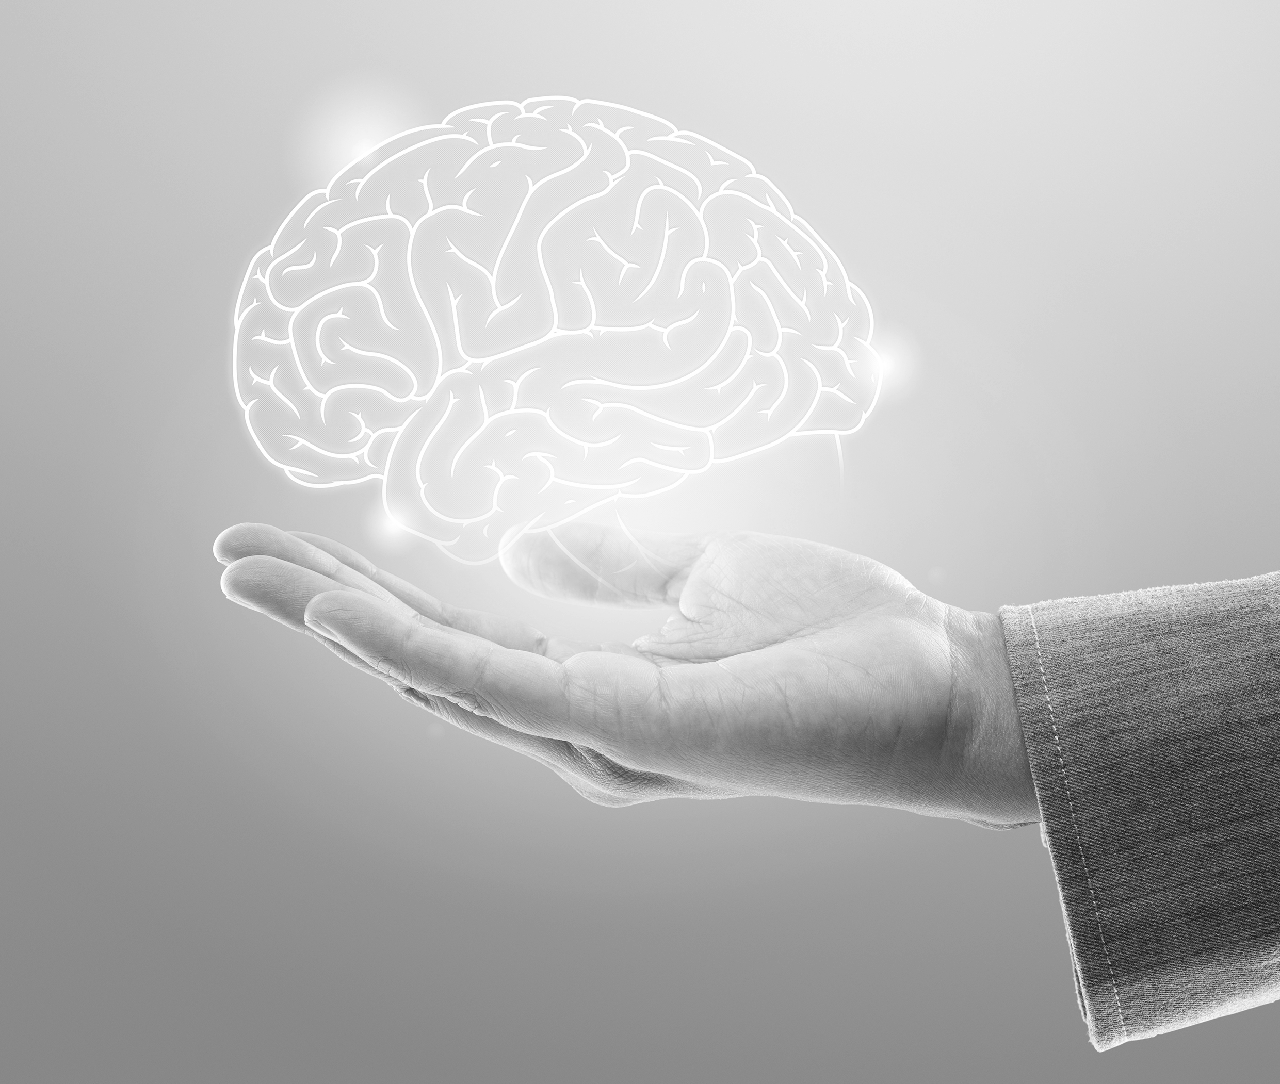

CONCEPTS IN PSYCHOLOGY

**DLMWPWKP01_E**



# LEARNING OBJECTIVES

***anon***

*2024-06-12 12:47:06*

--------------------------------------------

Remove all references to a "course book," "coursebook," etc.

***anon***

*2024-06-12 12:47:06*

--------------------------------------------

Remove all references to "units."

***anon***

*2024-06-12 12:47:06*

--------------------------------------------

Delete

***anon***

*2024-06-12 12:47:06*

--------------------------------------------

Delete

**Concepts in Psychology** is designed to strengthen your understanding of human nature and, from a psychological perspective, show how people feel, think, and behave. Like many academic disciplines, psychology systematically studies the human mind and behavior using scientific methods. At the same time, it is a unique scientific field that com- bines natural science, social science, and the humanities. A large part of psychology over- laps with other disciplines, such as sociology, economics, and biology. It is also an inter- disciplinary science with fields of social psychology, industrial-organizational (I–O) psychology, and biological psychology.

The goal of this course book is to help you develop a fundamental and comprehensive understanding of psychology as a science and discover the field’s essential applications in people’s work and life in the 21st century. The coursebook will help you effectively build up a scientific view of what psychology is and support your self-regulated learning proc- ess.

The course book starts with the fundamental concepts and theories in general psychology (Units 1 and 2), then moves on to the importance of social psychology (Unit 3), and further explores how industrial-organizational psychology is relevant to 21st-century work life (Units 4 and 5). Along with the key concepts and theories, the course book also includes relevant case studies, compelling examples, and up-to-date academic research to support your learning and comprehension. More importantly, the selected content and learning activities are adapted to your level of prior knowledge and learning needs. Enjoy your learning process!

# UNIT 1

## GENERAL PSYCHOLOGY I

**STUDY GOALS**

On completion of this unit, you will be able to ...

* identify the significance of psychology as a science and the goals of psychologists.
* describe how people perceive visual and nonvisual stimuli.
* distinguish between different types of memory and understand how memory works.
* describe Piaget’s stages of cognitive development.
* understand the significance and characteristics of attention.
* explain how to improve problem-solving skills.

***anon***

*2024-06-12 12:47:06*

--------------------------------------------

What's with the commas?

***anon***

*2024-06-12 12:47:06*

--------------------------------------------

Delete. This should be in the text.

***anon***

*2024-06-12 12:47:06*

--------------------------------------------

If you wanted to put this in a side note, that would be fine.

***anon***

*2024-06-12 12:47:06*

--------------------------------------------

A bit short. Use 2-3 paragraphs min.

***anon***

*2024-06-12 12:47:06*

--------------------------------------------

Missing a short paragraph to introduce the subunit.

***anon***

*2024-06-12 12:47:06*

--------------------------------------------

All of this is a bit random without a proper introduction... Give the students some guiding questions.

***anon***

*2024-06-12 12:47:06*

--------------------------------------------

There should NOT be a definition in the text AND a definition in a sidenote! Revise all such instances s.t. the information is EITHER in the text OR the note.

***anon***

*2024-06-12 12:47:06*

--------------------------------------------

Steps 1-2

***anon***

*2024-06-12 12:47:06*

--------------------------------------------

Structure this discussion of the steps using a bullet-point list.

**Psychology** The term refers to the sci- entific study of the indi- vidual’s mental proc- esses, behaviors, and experiences. It provides crucial insights to impor- tant issues of individuals

and society.

**Sensation** the processes whereby a sensory receptor is stimulated and triggers the physiological impulses that result in a reaction inside or out-

side the body

**Perception** the processes that organ- ize information from sen- sory organs and interpret the information based on prior knowledge and

experience

### 1. GENERAL PSYCHOLOGY I

#### Introduction

What do you think the goals of psychology, as a scientific discipline, are? How could psy- chology help people to solve cognitive and behavioral issues? Do you expect psychologists to find out the causes of every human behavior? The word **psychology** is derived from two ancient Greek roots: *psyche*, which refers to the human mind, spirit, or soul; and *logo*, which means reason, study, or word. Conceptually, psychology is the scientific and sys- tematic study of individuals’ mental processes, behaviors, and experiences in natural or experimental conditions (Gerrig et al., 2015). As experts who work in social science, psy- chologists frequently combine their particular interests and practical concerns in various settings. For instance, social psychologists deal with how others influence human emo- tions, thoughts, and behaviors; educational psychologists focus on the enhancement of learning processes and outcomes in schools; and industrial and organizational (I–O) psy- chologists are concerned with human performance in the workplace (Aamodt, 2015). Many specialists work in different occupational settings to explain human-related issues from a psychological perspective. Their psychological research has vital applications to essential issues in people’s lives. There are psychological topics that cross all subdisci- plines, including perception, memory, and cognition. These will be explored in this unit.

#### Perception

##### The Basics of Sensation and Perception

From a psychological perspective, people experience the external environment around them through perceptual processes (shown in Figure 1). Studying the processes of percep- tion helps open the black box of the human mind. First, we live in a physical world full of stimuli, such as light, sound, scents, and temperatures. When people are surrounded by these stimuli and information, sensation appears. **Sensation** refers to the reception of stimuli and the further conversion of them into signals for the human nervous system that result in a reaction inside or outside the body (Goldstein & Cacciamani, 2021). For

instance, light hits a tree and simultaneously reflects from the tree to a person’s eyes (see steps 1–2 in Figure 1). Once the stimulus hits the human sensory organs, such as the eyes, ears, nose, or skin, the sensory receptors transform the energy into specific signals. For instance, visual receptors in the human eyes transform the light energy into electrical energy and send it to the brain via the neuronal system (see steps 2–4 in Figure 1). After the sensory stage, people need to figure out the meaning of the information gathered from the receptors. The next step is **perception** (see steps 4–5 in Figure 1), which refers to the interpretation of stimuli that reach human sensory organs (Gerrig et al., 2015). The final behavioral response of the perceptual process is action, which involves physical

activities in response to the environmental stimulus (see steps 5–6 in Figure 1). Regarding the difference between sensation and perception, sensation consists of collecting signals directly from the environment, whereas perception involves adding and processing infor-

mation based on experience, prior knowledge, and other personal traits (Goldstein & Cac- ciamani, 2021). In other words, we as human beings receive information from the world via the sensation process and construct the perception of the world in our own way.

Figure 1: The Perceptual Process

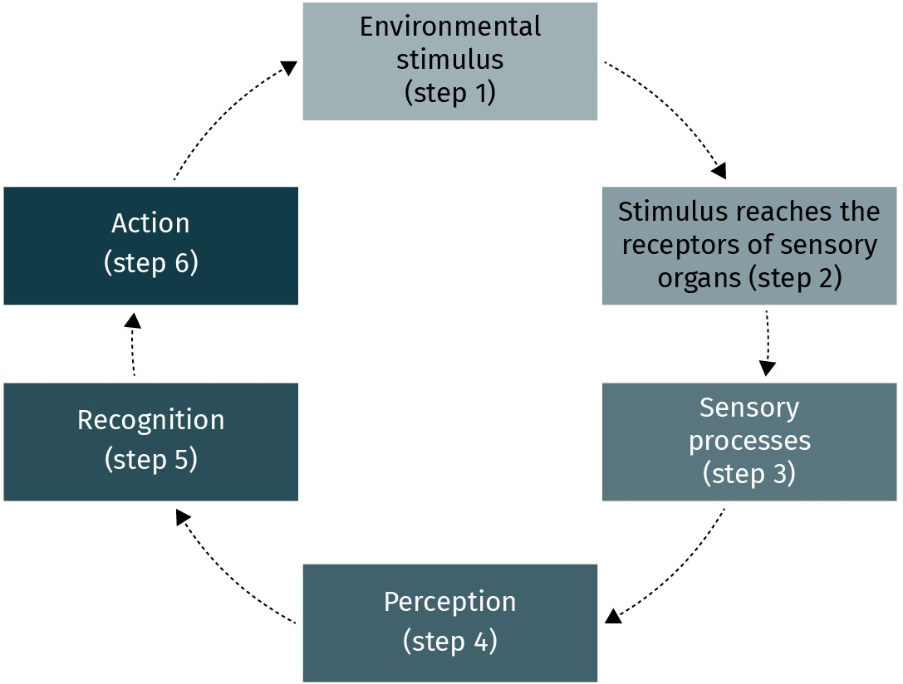

Source: Xian Cheng (2023), based on Goldstein & Cacciamani (2021).

##### Vision

As discussed above, human beings feel and experience the external environment via mul- tiple sensory channels, such as seeing, listening, smelling, and touching. During the day, we receive enormous amounts of environmental information. As shown in Figure 2, the outer surface of the eyeball covers a transparent and fixed structure called the cornea (Gerrig et al., 2015). We see an object when the light is reflected from that object and passes through the cornea and pupil. Surrounding the pupil is the iris, which is the colored structure (e.g., blue or brown). A normal pupil is adjustable and open for external light to enter the eye. Behind the pupil is the lens – a flexible structure that adjusts the focus for objects at various distances. For instance, the lens becomes thinner when we look at a near object. Finally, the object will be projected onto the retina, the visual receptor at the back of the eyeball. The visual information will be transferred from the receptor to our brain.

Figure 2: Structure of the Human Eye

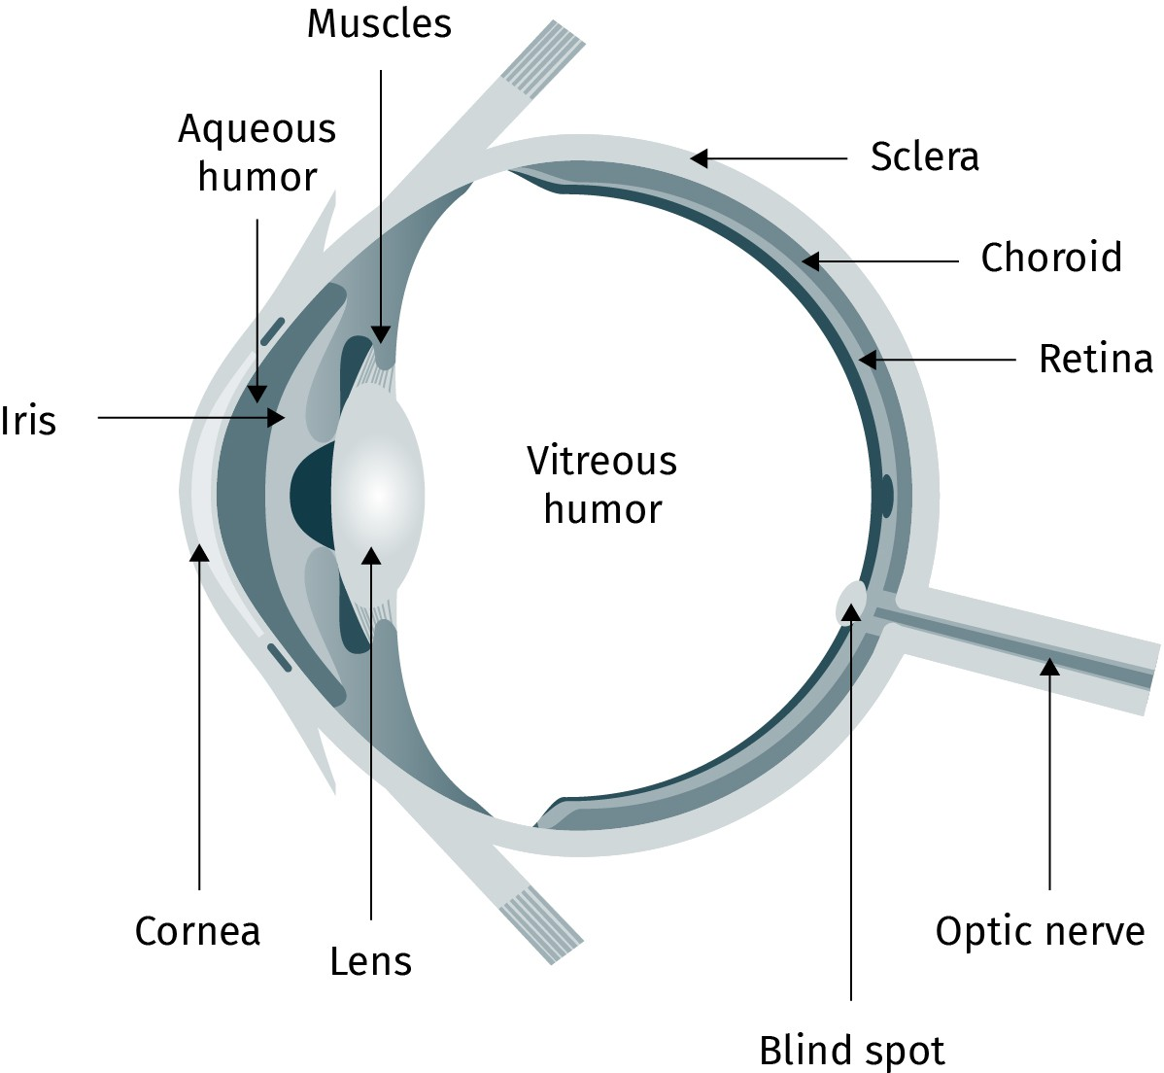

Source: Xian Cheng (2023).

###### Perception of colors

In daily life, seeing color is a unique sensory experience. Our ability to perceive different colors relies on the visual receptors of the eyes, and the human eye needs light to see col- ors. On the electromagnetic spectrum (see Figure 3), the receptors of the human eyes can respond to very limited wavelengths between 400 and 700 nanometers (Gerrig et al., 2015). The colors located within this range are detected and become visible. For instance, a lemon looks yellow because it reflects the color yellow and absorbs all others. Similarly, a cat appears white because it reflects all colors and absorbs none. We cannot see shorter wavelengths, such as Gamma rays (10−3nm), or longer wavelengths, like radio waves (FM = 109nm).

Figure 3: Electromagnetic Spectrum

***anon***

*2024-06-12 12:47:06*

--------------------------------------------

Why is this important to note here?

***anon***

*2024-06-12 12:47:06*

--------------------------------------------

Cite that here.

***anon***

*2024-06-12 12:47:06*

--------------------------------------------

APA7: numbers. Be consistent

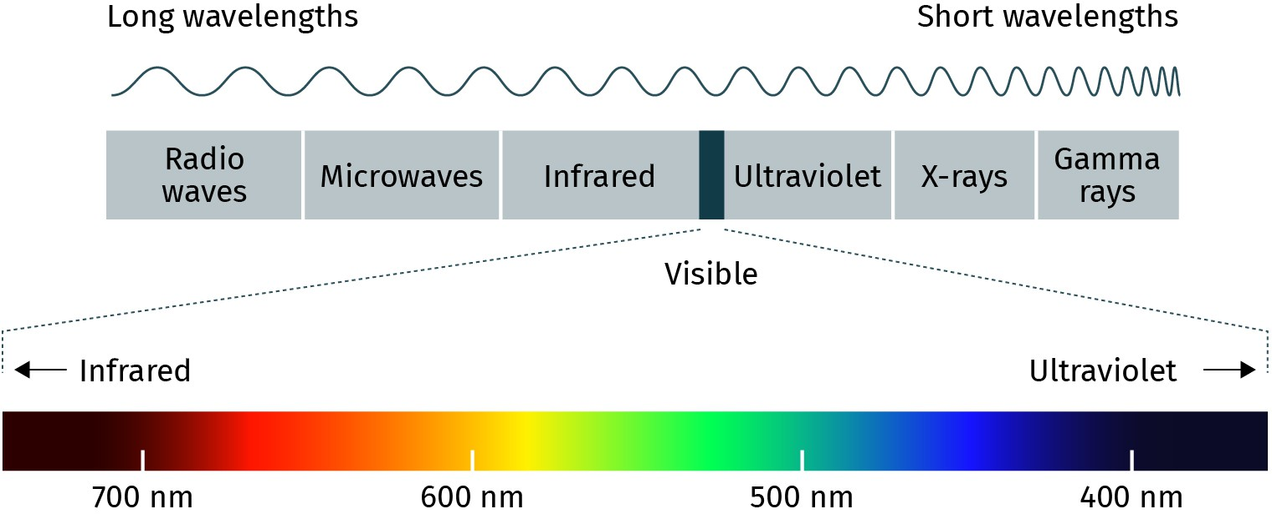

Source: Xian Cheng (2023), based on Leifiphysik (n. d.).

##### The Nonvisual Senses

In addition to the visual sense, people experience the environment via nonvisual senses, such as hearing, smelling, tasting, and touching. These sensory systems also have crucial functions when people come into contact with the world. The ear is a complicated organ that converts sound waves into vibrations and impulses (Gerrig et al., 2015). There are three main dimensions of sound: pitch (e.g., high or low sound), loudness (loud or quiet sound), and timbre (e.g., flat or complex sound wave). Theoretically, we can hear sound from 15–20 hertz to about 15,000–20,000 hertz (Gan et al., 2004).

People’s ability to perceive odors in the external environment relies on the process of olfaction, which is the sense of smell. It happens when molecules in the air interact with olfactory receptors in the nose and once initiated, the nerve impulses send chemical sig- nals to the human brain (Gerrig et al., 2015).

Have you ever drunk a glass of orange juice right after brushing your teeth? The taste receptors activate the sense of taste on the tongue (McLaughlin & Margolskee, 1994). Across different cultures, people have different tastes and food preferences. The sensitiv- ity of human sensory organs enables people to feel and perceive the outside world. The skin is a remarkable sensor on the body that receives sensory information and generates sensations of warmth, and cold, as well as other sensations, such as pressure (Gerrig et al., 2015).

#### Memory

According to the annual World Memory Championship results, the best competitors can spend ten minutes memorizing playing cards and later recall 526 cards correctly within

30 minutes. Another discipline of the championship is the 5 minute random words, where five minutes is given for memorization; the world record is recalling 130 words within

15 minutes (World Memory Championships, 2022). These world records show the superior level of human memory and simultaneously raise the question of how memory works. By exploring human mental processes and different types of memories, the current section guides you to understand how people remember and forget things.

##### The Information-Processing View of Human Memory

**Information-processing**

***anon***

*2024-06-12 12:47:06*

--------------------------------------------

Too many side notes..........

***anon***

*2024-06-12 12:47:06*

--------------------------------------------

Add a more recent citation (2020+)

***anon***

*2024-06-12 12:47:06*

--------------------------------------------

Digression box

***anon***

*2024-06-12 12:47:06*

--------------------------------------------

If paragraphs are this long, consider breaking them up for the sake of readability.

**framework**

This is a basic analytical model of human learning

and memory that presents people’s mental processes as a sequence similar to how computers process information. The human cognitive process involves sensory memory, short-term memory, and long-term memory.

**Sensory memory** This is the memory that receives external stimuli and addresses initial information in the cogni- tive system. It briefly holds information await- ing the process of short-

term memory.

**Short-term memory**

**(STM)**

This is the memory that is involved in attention and associates meaning with stimulation. STM has lim- ited capacity and is able to last up to 20 seconds without rehearsal.

**Long-term memory**

**(LTM)**

This is the memory that stores information over long periods of time. LTM has unlimited capacity

and duration.

What is memory? According to the **information-processing framework**, human memory is viewed as a computer receiving, storing, encoding, and retrieving information in a sequence (see Figure 4). As mentioned, the physical world has different sensory stimuli, such as light, sound, scents, and temperature. When we are exposed to an external stimu- lus, we temporarily construct a **sensory memory** in our minds (Lindsay & Norman, 2013a). The sensory memory lasts less than a second and quickly fades away. As we selectively pay attention to some of the external inputs, we store them in **short-term memory (STM)**. In much academic literature, STM is substituted with another term: working memory (Baddeley, 2002; Schüler et al., 2011). Similarly, STM has limited capacity, and the selected information is only temporarily available. Most people’s STM capacity ranges from five to nine items (Miller, 1956). For example, try to memorize the following numbers quickly then write down as many as you can in the correct order:

75314921504112119051969

How many of these apparently random numbers did you recall correctly? Fortunately, the forgetting of information can be optimized by rehearsal activity in STM.

Let us go back to information processing. After perceiving the stimulus, how does informa- tion get stored in the human brain? When information is repeated enough, it turns into **long-term memory (LTM)**, which has a relatively unlimited capacity and stores data per- manently. When information is transferred from STM to LTM, the mental process integrates the new information with prior knowledge and can carry out retrieval when required (Lindsay & Norman, 2013b). This cognitive process is called encoding. For instance, when selecting a smartphone, you might need to combine the new function of the product with your past experiences when using the smartphone. In other words, the encoding process helps people imagine the real thing and build a connection with their experience. Once the information is encoded and stored in LTM, it is possible to retrieve it when needed. For instance, the moment you actively recall a scene of the first party you went to is a retrieval process. When people try to remember what happened at the party, the retrieval process is more straightforward when a particular clue is provided, such as the organizers and location of the event. In sum, the information processing model opens the black box of human memory by explaining how people receive, store, encode, and retrieve information (Lindsay & Norman, 2013b).

Figure 4: The Flow of Human Memory

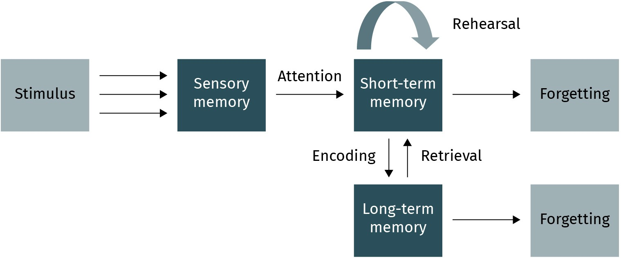

Source: Xian Cheng (2023), based on Gerrig (2015).

##### Memory Improvement

Let us go back to the memorizing task mentioned at the beginning of this section (also see Figure 5). On average, people can correctly recite five to nine items. However, is it possible to overcome the limitations of short-term memory? Cognitive psychologists suggest breaking the numbers down into sequences and linking them with important events in human history. In this way, it might be easier to memorize more than nine items (Gobet et al., 2001). This mechanism of grouping meaningful units is called **chunking**. Compared to a list of random numbers, chunking allows people to remember more items by constructing meaningful chunks that connect to prior knowledge (Burtis, 1982). Doing so turns the information into significant material that is easier to process (Siegler, 1996). The strategy of chunking or generating meaningfulness is widely used to help learning and professional training, such as enhancing expert chess memory (Gobet & Simon, 1998). With further training and practice, prior knowledge is easier to activate and retrieve. Thus, people can remember longer chunks (Dingfelder, 2005; Nuthall, 2000).

Figure 5: The Limited Capacity of Short-Term Memory and the Chunking Mechanism

**Chunking**

a strategic mechanism of grouping meaningful information into units to improve memory

***anon***

*2024-06-12 12:47:06*

--------------------------------------------

We need a more recent study in such cases if possible (i.e., when acting as EVIDENCE that something is true).

***anon***

*2024-06-12 12:47:06*

--------------------------------------------

ALWAYS pair older studies with 2020+ studies when possible. Discuss recent results in some detail if appropriate.

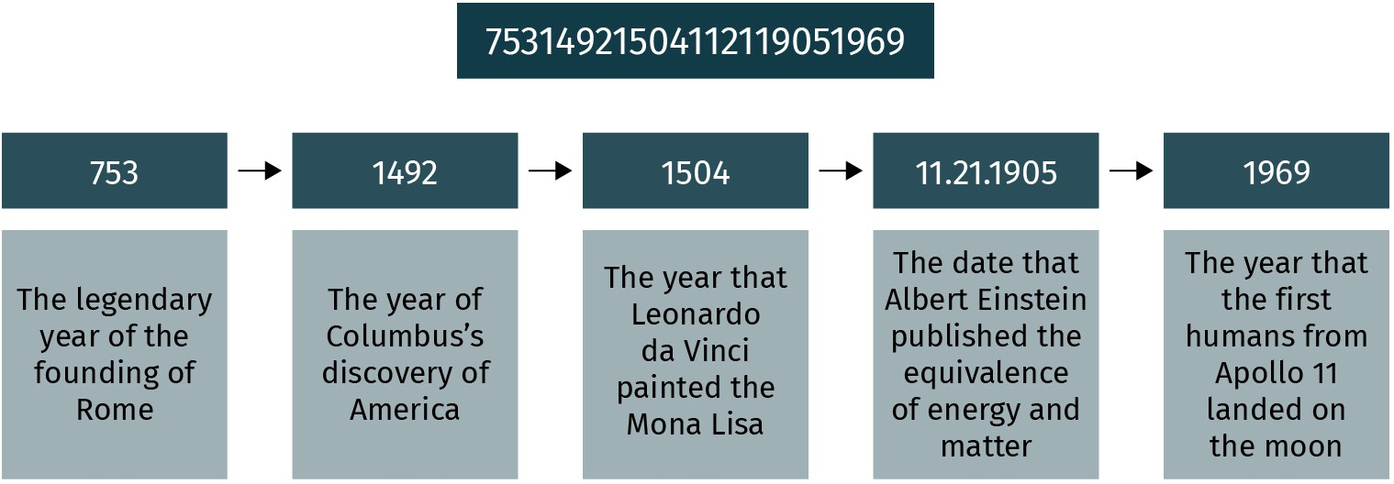

Source: Xian Cheng (2023).

In addition to chunking, cognitive psychologists suggest another strategy to leverage memory: “the recency effect,” which means that the most recently presented information is remembered better than the one presented earlier (Baddeley & Hitch, 1993). According to the empirical results of foreign language studies, previous researchers found that study- ing as close as possible to the examination can help one remember the learning content. However, forgetting the learned information also occurs rapidly after the test is over (Con- way et al., 1992). Another learning strategy to help remember more information is called “spaced repetition” (Ebbinghaus, 1885/2013). To implement spaced repetition, learners

should repeat the learned information and extend the repetition practice over a period of time. For instance, a student who is preparing for a final examination can set up a review schedule that gradually increases the time between each review session (e.g., one day

***anon***

*2024-06-12 12:47:06*

--------------------------------------------

Needs evidence to show if this is effective or not. Do so in all such cases.

***anon***

*2024-06-12 12:47:06*

--------------------------------------------

Just reintroduce the short versions if they're in different units........

***anon***

*2024-06-12 12:47:06*

--------------------------------------------

their

later, in three days, in five days, after one week, and at longer intervals).

##### Memory Loss

According to the information processing model, forgetting refers to a failure to recall infor- mation at a particular time (Lindsay & Norman, 2013b). It happens not only in short-term memory (STM) but also in long-term memory (LTM). What are the causes of memory loss? In sensory memory, the loss of information occurs when attention is not directed to items in this memory store. Furthermore, memory decay is also caused by the limited capacity of STM and the lack of rehearsal in STM. “Use it or lose it” vividly explains memory loss. In addition, cognitive psychologists found that the effect of aging describes the decay of LTM over time (Maylor et al., 2002). For instance, as they age, people have more difficulty remembering names and words (Craik, 1994). Another possible explanation for forgetting is the absence of relevant retrieval cues. For instance, when you try to recall details of your fifth-grade classroom setting, the related contextual clues (e.g., information about your classmates and the city where the secondary school is located) are missing too.

#### Cognition

##### Piaget’s Cognitive Development Theory

Jean Piaget (1976/2013) developed one of the most influential theories of cognitive devel- opment. He suggested that cognition and intelligence develop through four main stages (see Table 1), each of which deals with specific mental activities. The first stage of cogni- tive operations development is the “sensorimotor stage,” which lasts from birth until two years of age. In this stage, infants show simple motor responses to sensory stimuli in the external environment, such as light, sound, scents, temperature, and the texture of objects. The second stage is the “preoperational stage,” which covers early childhood between the ages of two and seven. Most children develop their language abilities at this stage and can distinguish appearance from reality. For instance, a three-year-old child who sees a red color on his nose in the mirror will touch his nose instead of pointing at the mirror.

The third stage is the “concrete operational stage,” which starts at age seven and ends at age 12. At this stage, children understand the concept of conservation with respect to physical objects. For instance, when children in this stage of development are told that the taller but thinner container has the same amount of water as the shorter but wider con- tainer, they will not be confused (conservation of volume). Similarly, children in the con- crete operational stage understand that changing the shape of dough will not change its weight (conservation of mass). Starting from age 12, most individuals enter the stage of “formal operational.” Piaget contended that children would gradually develop logical rea- soning, systematic planning, and an understanding of abstract concepts during this stage. For example, a teenager might be capable of sharing their opinion about “what is free- dom” in the philosophy class. In summary, Piaget’s theory provides a milestone for cogni-

tive development and has wide educational applications, informing teachers’ preparation of adaptive teaching materials based on learners’ cognitive abilities (Houtveen et al., 1999;

Ojose, 2008).

Table 1: Piaget’s Stages of Cognitive Development

**Stage (ages) Characteristics and achievement**

|  |  |
| --- | --- |
| Sensorimotor (0–2) | Response to the sensory stimuli |
| Preoperational (2–7) | Developing language skills (e.g., ability to speak and understand conversation), distinguishing appearance from reality |
| Concrete operational (7–12) | Understanding the conservation of number, vol- ume, and mass |
| Formal operational (12–adult) | Understanding abstract concepts; being able to do hypothetical thinking, planning, and reasoning |

Source: Xian Cheng (2023), based on Gerrig (2015).

##### Attention

As mentioned earlier, attention plays a vital role when people process external stimuli from the external environment in sensory memory. From a psychological perspective, **attention** refers to a natural state of focused awareness of the available perceptual infor- mation in the external environment. For instance, people are susceptible to hearing their names in a loud background. This perceptual ability to pay attention to a specific person and situation is called the “cocktail party effect” (Shapiro et al., 1997).

According to the split-attention effect, people’s working memory processes information via separate visual and auditory channels (Pouw et al., 2019). In other words, paying atten- tion to the separated information resources (e.g., text, picture, and audio) will increase the learners’ cognitive load and harm their learning effectiveness. Therefore, in everyday sit- uations, people’s concentration ability will decrease when they focus on two things simul- taneously. This reduction in attention brings debate to the design of multimedia learning environments in the educational field (Ayres & Sweller, 2005; Mayer & Moreno, 1998).

**Attention**

a cognitive state of aware- ness that focuses on the available perceptual information in the physi- cal world

How do people perceive objects and distinguish them from the background? This identifi- cation process requires attention. See the picture in Figure 6. You probably see a white tree against a dark background at a first glance. However, it is also possible to see two faces when the relationship between the figure and the background changes. However, if someone were primed with the word “faces,” they may be more likely to perceive faces rather than a tree in this image.

Figure 6: Tree–Face Stimulus



Source: Xian Cheng (2023), based on Petty Sun (2022).

###### Selective attention

Although most people can simultaneously notice several stimuli, certain information is still lost because of the limits of human attention (Most et al., 2005). On the one hand, selective attention helps individuals focus on a specific task and filter out irrelevant infor- mation sources (e.g., background noise). With this cognitive ability, some people are able to concentratedly read on public transportation. On the other hand, since capturing infor- mation requires mental effort and perceptual load, most people have experienced “look- ing without seeing” (Cartwright-Finch & Lavie, 2007; Mack, 2003). This phenomenon of diverting attention happens when people are conducting multiple tasks. For instance, using a handheld cell phone will increase the difficulty of driving, which means a car that shifts to the lane in front will not grab the driver’s attention and decrease the chances of detecting the potential danger (Strayer & Johnston, 2001). Inattentional blindness is very likely to happen, especially when the phenomenon and event are highly relevant to the people, and consequently, they might fail to notice the changes occurring within their vis- ual field.

##### Problem-Solving

***anon***

*2024-06-12 12:47:06*

--------------------------------------------

APA7 numbers

Problem-solving is an essential cognitive ability that largely influences how people deal with problems in real-life circumstances (van Gog et al., 2005). Problem-solving is a dynamic process that moves an original issue from an unsatisfied condition to the desired state using, ideally, an optimal approach or strategy (Gerrig et al., 2015). Theoreti- cally, people solve their daily or unfamiliar problems through a four-step process:

(1) understanding the problem, (2) generating a plan, (3) carrying out the plan, and

(4) checking the results (Polya, 2004). Imagine you need to carry 90 empty water bottles simultaneously, with only a five-meter rope. When faced with this task, how would you find an effective solution? Alternatively, you might easily conclude that it is an unsolvable problem. Using Polya’s four problem-solving steps, let us figure out the task.

First, you can simplify the problematic situation by collecting concrete answers. For instance, what is the circumference of a water bottle? How do you tie a bottle sling knot with a rope? Later, develop a plan: Use the string to fix twenty-five water bottles as the boundary and fill the middle part with the rest of the bottles. Then, you can carry out your plan to check whether it will work (Polya, 2004). Throughout the above problem-solving process, several personal skills are required and can be applied to other similar problems.

###### Improving problem-solving skills

How can we improve our ability to solve day-to-day problems? The first possibility is to be more creative. Creativity refers to a person’s ability to generate novel ideas, approaches, or products suitable for the current situation (Cropley, 2000). When improving creativity, people should be encouraged to use divergent and convergent thinking, which are the two crucial components of creative potential (Mumford, 2001). Divergent thinking is defined as the ability to generate new and novel solutions to a problem (Runco & Acar, 2012). For instance, during brainstorming, people expand their minds to think of multiple possible solutions to increase job satisfaction. By contrast, convergent thinking refers to a person’s capability to integrate various existing sources of information and apply them to solve a problem (Cropley, 2006). For instance, people recall their knowledge of human resources management and industrial–organizational psychology to enhance employees’ job satis- faction. In the area of both divergent and convergent thinking, multidisciplinary knowl- edge is required. In recent years, more empirical studies found that general domain-inde- pendent skills are essential for people to achieve problem-solving success (Brophy, 1998).

From novice to expert, the second possibility to enhance problem-solving skills is through prolonged practice (Benner, 1984). If people need to solve similar problems habitually, a helpful approach is to practice so that the procedure requires fewer resources. Research- ers have suggested that experts (e.g., musicians and athletes) are made, rather than born, by ten years of repeated practice, which is the so-called “10,000 hours rule” (Gerrig et al., 2015; Margulis, 2013; Patterson & Lee, 2007).

***anon***

*2024-06-12 12:47:06*

--------------------------------------------

Make it shorter, tighter, and more engaging.

###### SUMMARY



In this unit, it has been established that psychology is a science that investigates the human mind and behaviors. Empirical research in psy- chology provides an evidence-based application to essential issues in people’s life. People experience the external environment via perceptual processes. Once the human sensory organs (e.g., eyes, ears, and nose) receive stimuli, people start interpreting the information based on their prior knowledge, experience, and other personal traits. While experienc- ing the physical world, human memory plays a crucial role in perceiving, storing, and retrieving useful information.

According to the information-processing framework, individuals tempo- rarily construct their sensory memory when exposed to external stimuli. Later, people pay attention to the relevant information and store it in short-term memory (STM). With further encoding and rehearsal, infor- mation and concepts are organized and connected with prior knowledge in long-term memory (LTM), which can be retrieved when necessary. Since both sensory and short-term memories have limited capacity, attention plays a significant role as people selectively process external stimuli. Experts frequently use chunking to group meaningful units and associate the new information with prior knowledge to improve mem- ory.

Cognition involves thinking, planning, and problem-solving activities. According to Piaget, the development of cognition and intelligence has four main stages: (1) sensorimotor, (2) preoperational, (3) concrete operational, and (4) formal operational. Problem-solving is an essential cognitive skill. To enhance problem-solving skills and creativity, people train their divergent and convergent thinking and also conduct pro- longed practice.

# UNIT 2

## GENERAL PSYCHOLOGY II

**STUDY GOALS**

On completion of this unit, you will be able to ...

* identify the major learning approaches and learning theories.
* explain classical conditioning and identify the critical factors of the theory.
* outline the nature of operant conditioning and modeling.
* describe the milestones of human language development.
* use self-determination theory and Maslow’s hierarchy of needs theory to understand human motivation.
* identify basic human emotions and recognize their influence on behaviors.

### 2. GENERAL PSYCHOLOGY II

***anon***

*2024-06-12 12:47:06*

--------------------------------------------

break up all such blocks of text. book is already short, and this is hard to read.

***anon***

*2024-06-12 12:47:06*

--------------------------------------------

More recent please

#### Introduction

In general, the goals of psychologists investigating individuals’ mental processes are to describe, explain, predict, and control human behavior (Gerrig et al., 2015). For instance, educational psychologists examine the prerequisites for effective learning (e.g., students’ prior knowledge, adaptive teaching, and technical support) and how these factors would affect the learning process. Psychologists can best explain what happens in the human mind by observing and describing human behavior. For example, what goes on in the human mind when people learn? What conditions could lead to effective learning? Psy- chologists answer these questions by discovering people’s knowledge, desires, needs, and feelings that cause their observable behaviors. Learning, motivation, and emotion cannot be observed; thus, some psychologists investigate behavior and draw inferences from it (Feldon, 2010). More importantly, an accurate understanding of mental processes can help predict future behavior (Van Knippenberg, 2000). The discussion of learning processes focuses on classical conditioning, operant conditioning, and modeling. Motivation plays a crucial role in acquiring knowledge and skills when people learn. Human emotions are the vital signs of people’s psychological states, and these feelings are highly associated with people’s behavior (Humphreys & Revelle, 1984; Pessoa, 2008). To open the black box of the human mind, this unit begins with an overview of three general topics: learning, motivation, and emotion. These basic concepts will help you understand individuals’ motivational, cognitive, and social functioning.

#### Learning

Have you ever wondered how people learn? From a psychological point of view, learning is a lifelong process that covers the acquisition of norms, skills, and other social abilities (Bransford et al., 2000). Generally, knowledge acquisition brings relatively permanent changes in people’s cognition or behaviors. Moreover, learning can occur when an intended or unintended personal experience happens, or people indirectly receive infor- mation from the external environment, such as reading a book (Hidi, 2001). A better understanding of how people learn is critical because it provides insights into the nature of problem-solving. For instance, teachers can purposefully apply learning principles to construct an effective learning environment (Seidel & Shavelson, 2007). In the rest of this section, we shall further uncover the learning process to better understand how people receive knowledge in formal or informal situations.

##### Learning Theories

Over the past few decades, researchers have explained individual learning processes via a merging of psychological and educational perspectives (Bednar et al., 2013; Schunk,

2012). As a result of this integration, learning theories have adopted the fundamental views of behaviorism (Skinner, 1976), cognitivism, and constructivism (Harel & Papert,

1991). These theories have become the conceptual learning frameworks used to explain the nature of learning and what happens during the learning processes (McVee et al., 2005).

###### Constructivism

As one of the most well-accepted frameworks, cognitive constructivism has been applied to explain human learning processes and the crucial factors influencing learning effective- ness (O’Donnell 2012; Schunk 2012). Constructivists, such as Lev Vygotsky (1978), view learning as the cognitive construction of knowledge and understanding that the learners actively build up by themselves.

###### Behaviorism

During the early 20th century, psychologists created a conceptual framework to explain how learning takes place by studying observable behaviors (Watson & Kimble, 1998). This learning theory is called behaviorism. Behaviorist pioneers, such as Ivan Pavlov, Burrhus Frederic Skinner, and John Watson, conducted different empirical experiments to investi- gate the influence of external stimuli (e.g., reward and punishment) on behavioral changes. By examining human adjustment to a given stimulus, psychologists can predict and control the response in the general environment. Behaviorism further develops and offers a wide application in teaching and learning processes (Duit & Treagust, 1998).

###### Social learning theory

Generally, social learning theory understands learning as a consequence of the interaction of individuals with their social environment (Bandura & Walters, 1977). From the social- cognitive perspective, learning is a modeling process that assists people in gaining knowl- edge and understanding many social behaviors.

##### Classical Conditioning

Many people who celebrate Christmas experience positive feelings when listening to Christmas music on the street. How can we explain this phenomenon and the relationship between mood and holiday music? According to Ivan Pavlov, learning is a behavior-chang- ing process, and creatures are born with specific automatic reactions to some stimuli (Clark, 2004; Gerrig et al., 2015). The learning process that pairs two stimuli – (1) a stimulus that triggers a biological response, and (2) a neutral stimulus that subsequently leads to the same reaction – is called “classical conditioning.” Pavlov designed an experiment to study the relationship between stimulus and reflexive response using dogs. During the experiment, he first selected a dog that began to salivate in the presence of food. This con- nection between food and salivation was an automatic or unconditioned reflex. During this process, the food is the “unconditioned stimulus” (UCS), and the salivation is the “unconditioned response” (UCR).

Pavlov then introduced a new stimulus – a bell which does not stimulate the dog’s saliva- tion response (see Figure 7/a). He then served the food a few seconds after ringing the bell. This pairing process was repeated in front of the dog until it started to salivate once it

heard the sound of the bell without the presence of food (see Figure 7/b). Pavlov called the sound of the bell the “conditioned stimulus” (CS) because the dog’s reaction to this neu- tral object is learned via the preceding conditions. Then, he named the salivation follow- ing the bell ring the “conditioned response”(CR) because this response is the result of the training but appears automatically. In this classical conditioning experiment, the dog learned to associate the food with the sound of ringing a bell, which caused salivation (Clark, 2004; Gerrig et al., 2015).

Figure 7: Pavlov’s Experiment of Classical Conditioning

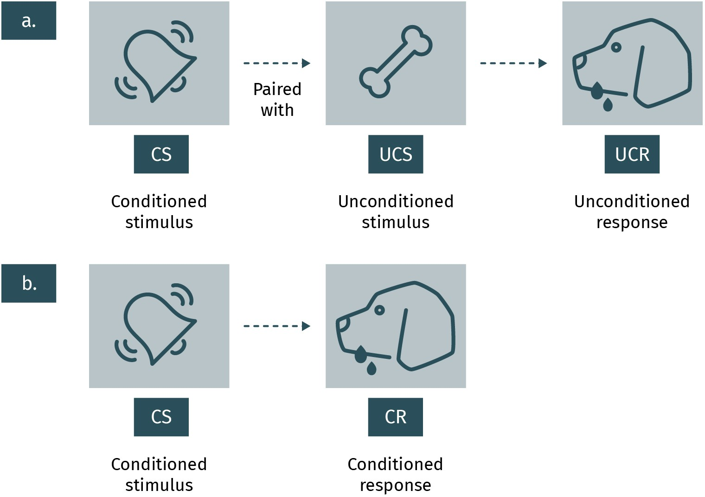

Source: Xian Cheng (2023), based on Pavlov (1897).

Going back to the example of holiday music at the beginning (see Figure 8), how can we explain the relationship between positive feelings and Christmas songs based on the theory of classical conditioning?

Figure 8: Example of Classical Conditioning

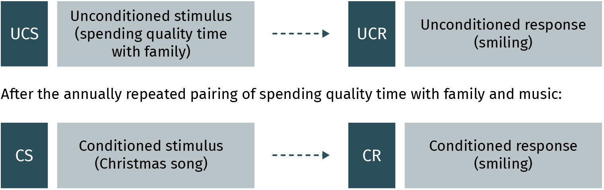

Source: Xian Cheng (2023), based on Gerrig (2015).

##### Operant Conditioning

Operant conditioning is another representative learning theory introduced by a behavio- rist, B. F. Skinner. In the 1940s, Skinner designed a series of experiments to examine the shaping of responses from the environment. In his investigation, he placed a hungry rat in a chamber equipped with a response lever, a food dispenser, and an electrified grid (see Figure 9). In the first condition, the rat randomly moved and touched the equipment in the box. It did not take long for the rat to learn that pressing the lever led to the reward of a food pellet. When the rat repeatedly pressed the lever, it received food every time. In this condition, Skinner called the consequence of receiving food **positive reinforcement**, which increases the future probability of a response, or a particular behavior (Gerrig et al., 2015). Positive reinforcement also works in human beings. For instance, if your parent gives you ten euros each time you clean the bedroom (i.e., a reward), you will be more likely to repeat this cleaning behavior in the future.

**Positive reinforcement** the presence of a pleas- ant stimulus that conse- quently increases the probability of repeating the same response over time

Figure 9: The Skinner Box and Operant Condition

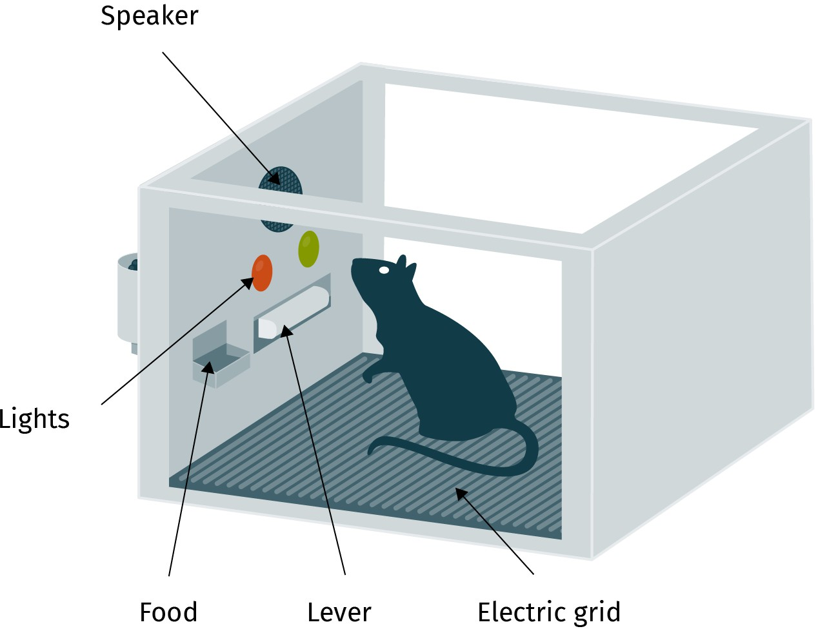

***anon***

*2024-06-12 12:47:06*

--------------------------------------------

Need to cite the PRIMARY SOURCE when discussing what happened in it. Do so throughout the book.

**Negative reinforcement**

the removal of an unpleasant stimulus that consequently increases the probability of the escape response over

time

**Punishment** the delivery of an unpleasant consequence that reduces the probabil- ity of undesired behavior

over time

Source: Xian Cheng (2023), based on Skinner (1976).

The rat was arranged in the same box in the second condition, but an electric shock came from the grid. After a random movement, the rat accidentally pressed the lever that switched off the electric shock. To escape the unpleasant pain, it would repeatedly press the lever. In this setting, Skinner called the elimination of unpleasant events **negative reinforcement** (Gerrig et al., 2015). Let us take cleaning behavior as an example. You must give your parent ten euros if you do not clean your bedroom. Consequently, you will clean your room to avoid the payment.

Furthermore, during Skinner’s investigation, he found that **punishment** (i.e., giving an electric shock to the rat once it pressed the lever) is the opposite of reinforcement. The punishment significantly weakens the rat’s future pressing behavior. Human learning behavior is the same as how rats learn not to press a lever. For instance, you will receive a fine from the police whenever you exceed the speed limit on the highway. The payment of penalties is the punishment that suppresses undesirable behavior (Gerrig et al., 2015).

Skinner concluded that learning occurs as a consequence of a positive (e.g., reward) or negative response (e.g., pain). This is also the fundamental difference between classical conditioning and operant conditioning: Subjects in operant conditioning need to have some responses before their behavior is reinforced or punished (Gerrig et al., 2015). Could you think of more day-to-day examples that can explain operant conditioning?

Table 2: Four Categories of Operant Conditioning

***anon***

*2024-06-12 12:47:06*

--------------------------------------------

Important: ALL theories >10 years old need to be introduced with a critical discussion and FRAMEWORK that highlights (1) issues with the study that students should keep in mind and (2) what the relevancy of the theory/study is in current practice/the field.

|  |  |  |
| --- | --- | --- |
| **Consequence** | **Adding a stimulus** | **Removing a stimulus** |
| Reinforcement (Increases the probability of desired behavior) | Positive reinforcement (The presence of a pleasant stimulus is increased, such as receiving rewards.) | Negative reinforcement (The presence of an unpleasant stim- ulus is decreased, such as using a fan to escape the heat.) |
| Punishment (Reduces the prob- ability of undesired behavior) | Positive punishment (The future response is followed by an unpleasant stimulus, such as pain and getting caught.) | Negative punishment (The future response is followed by removing a wanted stimulus, such as no dessert when refus- ing to eat carrots.) |

Source: Xian Cheng (2023), based on Gerrig (2015).

##### Modeling

Development in human behavior studies revealed that learning could occur through direct experience and also by observing or imitating other people (Bandura, 1965). According to Bandura’s social learning theory (1977), the modeling procedure involves four phases:

(1) In the learning phase, the observer selects an appropriate model and pays attention to that person’s behaviors; (2) in the implementation phase, the observer adopts the model’s behavior, and reinforcement is given when the modeling behavior is achieved; (3) in the reproducing phase, the desired behavior has firmly stayed in the observer’s mind so that he or she can repeat the behavior when requested; and finally, (4) reinforcement of model behavior and motivation of repetition can be continuous. The modeling procedure revealed human aggression and violent behaviors in Bandura’s famous Bobo doll experi- ment.

Are aggression and violence inborn or learned behaviors? In 1963, Bandura and his collea- gues designed an experiment to investigate the role of imitation in learning aggressive behavior in preschool-age children. In the aggressive condition (experimental group), chil- dren watched a cartoon that the character violently hit a Bobo doll and used aggressive words. In contrast, the children in the non-aggressive condition (control group) watched a cartoon that the character did not show any aggressive behavior. After watching the video, the researchers left the children from both groups in a playroom where they placed a Bobo doll. They observed that the children in the experimental group would mimic the cartoon character’s behavior and attack the doll aggressively. Moreover, the observers reported that the boys engaged in more than twice as many acts of agression as the girls. The results of the Bobo doll experiment show that much of human learning results from observing and imitating other people in society (Bandura, 1965, 1997).

##### Language Learning and Development

Language learning is essential for everyone who wants to engage in social interaction and communication. How does a human learn to understand language and develop language skills? From birth to early childhood, children’s language development goes through vari- ous stages and has specific milestones (see Table 3).

Table 3: Milestones of Children’s Language Development

**Average age Characteristics of language development**

|  |  |
| --- | --- |
| Three to six months | Random vocalizations and babbling |
| One year | Beginning to understand language and can say one to two words, such as “Mama” |
| One and a half years | Able to speak single nouns, but no phrases |
| Two years | Learning fifty words and being able to utter two-word phrases |
| Two and a half years | Developing comprehension and ability to phrase short sentences |
| Three years | Reaching around one thousand vocabulary words |
| Four years | Close to essential adult language ability |

Source: Xian Cheng (2023), based on Gerrig (2015).

**The zone of proximal development (ZPD)**

In Vygotsky’s learning theory, individual learn- ers can achieve the ideal learning performance when their actual devel- opment level and task dif- ficulty reach an equili-

brium.

**Intelligence** a general cognitive com- petence to think, plan, decide, reason, solve problems, think abstractly, understand complex ideas, and learn

from experience

Lev Vygotsky developed a sociocultural theoretical concept – **the zone of proximal devel- opment (ZPD)** – to explain people’s range of potential in language learning (Vygot- sky, 1978). For learners, their language or other skill development requires scaffolding activities from teachers, parents, or competent peers. Vygotsky believed that individual learners could achieve the ideal learning performance when there is a balance between their actual developmental level (e.g., knowledge and skills) and task difficulty. In other words, effective teaching should be adaptive to individual students’ prior knowledge, learning styles, and level of potential development (Brühwiler & Blatchford, 2011; Houtveen et al., 1999).

##### Intelligence

In the current section, the discussion of individual learning and cognitive development is closely related to the issue of intelligence. From the psychological perspective, **intelli- gence** refers to a person’s general competence to think, plan, reason, acquire knowledge, solve problems, and conduct other cognitive processes (Gottfredson, 1997; Legg & Hutter, 2007). Intelligence varies between individuals and can be shaped by the time, place, and culture in which they grow up (Neisser et al., 1996). To understand the concept of intelli- gence, psychologists have proposed different theories (Gardner, 2000; Sternberg et al., 1981). According to the multiple intelligences (MI) theory, Gardner (2000) argued that human beings have developed eight forms of intelligence:

1. Linguistic intelligence: the ability to use language well (e.g., poet, journalist)
2. Logical/mathematical intelligence: the ability to process abstract symbols (e.g., scien- tist, IT programmer)
3. Musical intelligence: the ability to create music (e.g., musician, composer)
4. Spatial intelligence: the ability to perceive visual–spatial relationships (e.g., architect, airplane pilot)
5. Bodily kinesthetic intelligence: the ability to use motor skills well (e.g., athlete, dancer)
6. Interpersonal intelligence: the ability to communicate with other people and work collaboratively (e.g., teacher, salesman)
7. Intrapersonal intelligence: the ability to understand one’s inner thoughts and emo- tions (e.g., philosopher)
8. Naturalist intelligence: the ability to understand how the natural environment works (e.g., zoologist, biologist)

Gardner (2000) identifies eight intelligence types and use them as a framework to describe individual patterns of strengths and weaknesses. By exploring different facets of human intelligence, the theory of multiple intelligences has been examined and applied in educa- tion and plays a role in shaping vocational training (Almeida et al., 2010; Chen et al., 2009).

#### Motivation

The previous section discussed the learning process and the prerequisites of effective learning. This section examines another vital factor that influences learning and develop- ment of human cognition: motivation. Generally, motivation refers to a person’s psycho- logical state that directs, changes, and maintains human behavior (Mitchell, 1982; Peters, 2015; Schunk & Mullen, 2013). Two representative theories of motivation discussed in the following section explain the construction of motivation and how these theories have broad implications in modern society.

##### Self-Determination Theory

Ryan and Deci (2002, 2017) introduced the well-known **self-determination theory (SDT)** to systematically explain the crucial motivational factors that contribute to human behav- ior. SDT is an empirically derived theory of human motivation and personality in social contexts that differentiates motivation from being autonomous or controlled. According to SDT, motivations are categorized into two types: intrinsic and extrinsic (Ryan & Deci, 2000). Intrinsic motivation is a person’s internal reasons, such as personal interests, enthusiasm, and curiosity toward a task (Heckhausen, 1991; Lepper et al., 1996). For instance, you may play football simply because you enjoy the sport and experience the excitement of playing with your team members. Your interest and joy in playing football stem from intrinsic motivation. Alternatively, extrinsic motivation results from external stimuli that encourage and trigger human behavior, such as gaining rewards or avoiding failure (Lee et al., 2010; Ryan & Deci, 2000). Let us continue to take football as an example. If you practice your football-playing skills because of the desire to win rewards, your moti- vation is extrinsic. Please remember that sometimes extrinsic rewards can undermine an original intrinsic motivation (Lepper et al., 1996, 1999). In a work setting, when external rewards, such as prizes and bonuses, are given in exchange for achieving a task, the moti- vation theory predicts that these rewards may negatively affect employees’ intrinsic moti- vation because they will be highly controlled by the rewards (Fang et al., 2013).

***anon***

*2024-06-12 12:47:06*

--------------------------------------------

Way too vague. Again, the book STRONGLY needs a critical addition (with recent sources) to its discussions of models, theories, etc.

**Self-determination theory (SDT)**

People’s behaviors are either motivated by inter- nal factors, such as inter- ests and enthusiasm (intrinsic motivation), or external factors such as rewards (extrinsic motiva- tion).

##### Maslow’s Hierarchy of Needs

**Maslow’s hierarchy of**

**needs theory** Basic human motives result from a hierarchy whereby the needs at each level of the hierar- chy must be satisfied before the next level can be achieved. These needs

In 1943, Abraham Maslow proposed a now-classic theory to explain human needs that motivate individuals to pursue one goal after another through their lifetime. He intro- duced five hierarchical categories of needs (see Figure 10). According to **Maslow’s hierar- chy of needs theory**, human beings’ behaviors are motivated by a hierarchy of needs that appear in a sequence from the primary level (e.g., physiological needs and safety needs) to the psychological level (e.g., social and love needs, esteem needs), and eventually to the level of self-fulfillment (e.g., self-actualization needs; Benson & Dundis, 2003; McLeod, 2007).

Figure 10: Maslow’s Hierarchy of Needs Theory

progress from basic bio-

logical needs to the need for self-actualization.

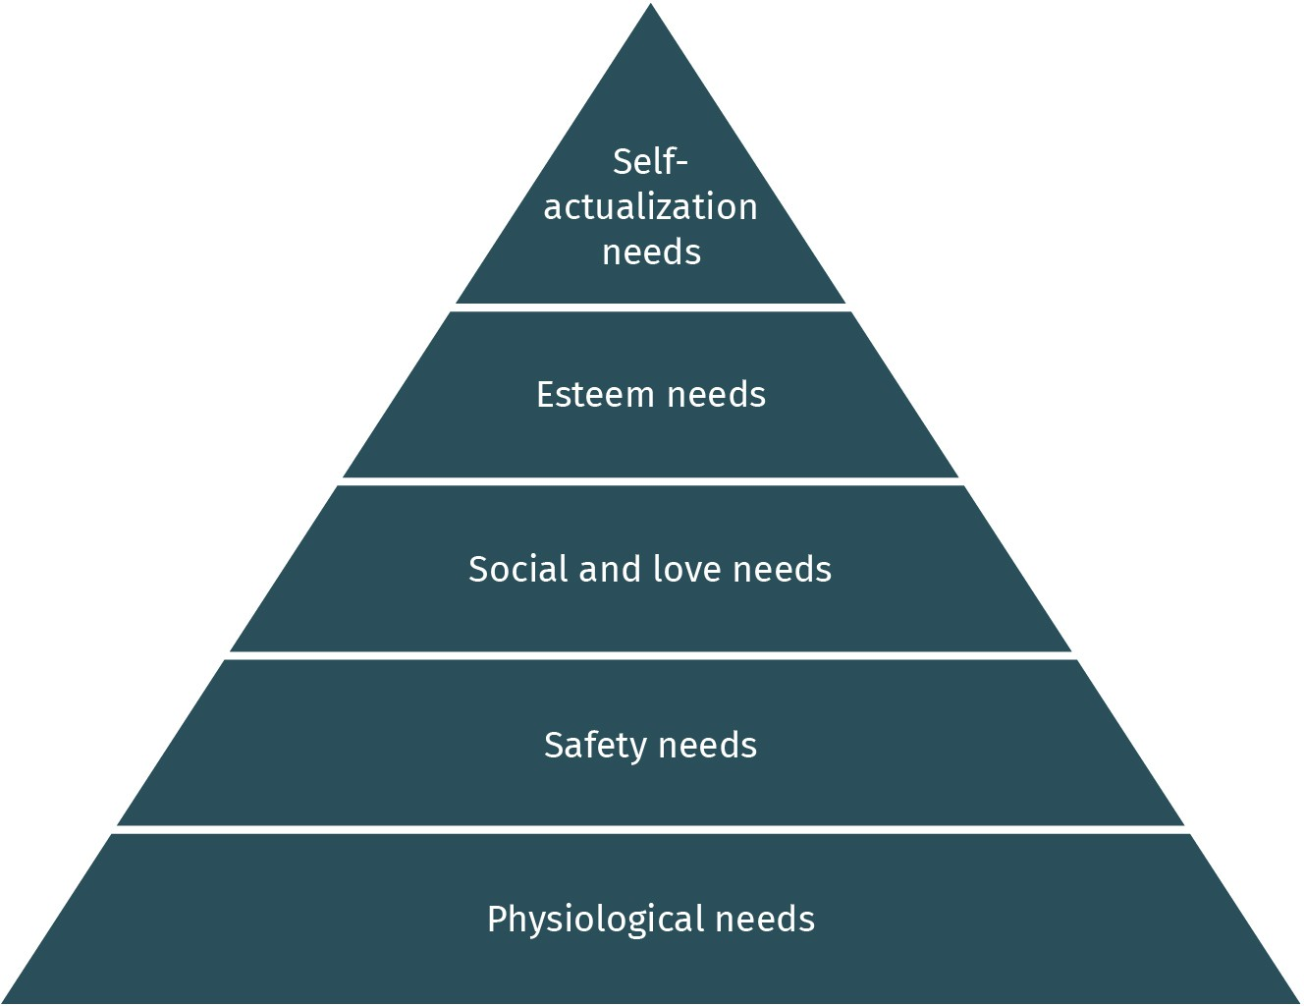

Source: Xian Cheng (2023), based on Gerrig (2015).

Specifically, the most fundamental category consists of a person’s physiological needs, such as food, water, sleep, and warmth. These biological requirements are essential for human survival. According to Maslow, lower-level needs dominate people’s motivation as long as they are unsatisfied. Once the basic needs are adequately met, individuals will try to satisfy their second level of needs: safety needs, including security and safety. For example, a person desires a secure apartment and a safe working environment (Benson & Dundis, 2003; McLeod, 2007).

After satisfying the first two levels of basic needs, the third category is social and love needs, which include a sense of belonging, intimate relationships, friends, and other inter- personal factors. For instance, people wish to be accepted by their colleagues at work or try to develop a sense of connection with friends. On the fourth level, a person’s esteem

needs are the other psychological needs associated with prestige and feeling of accom- plishment, as well as self-esteem. For example, people are eager to be respected for their professional knowledge or hope to have an excellent social reputation in a group. After the previous four levels of needs have been fulfilled, the peak is self-actualization needs. This highest level of needs refers to a person’s self-fulfillment, and only a tiny proportion of people will reach this stage. For instance, a self-actualized person desires to expand their full potential to find an essential meaning in life. This may involve any unique person, such as an artist, a scientist, or an athlete. Maslow’s hierarchy of needs theory explains why people behave in a certain way and the significant drives behind certain behaviors. His model is frequently used in consumer and advertising psychology to guide business practices (Benson & Dundis, 2003).

#### Emotion

We will now focus on another factor that is very important for people’s psychological states. Some people may say that an essential difference between human beings and arti- ficial intelligence is that humans have emotions. How many basic emotions do people have? How can emotions be studied and interpreted? Do people from different cultures identify and understand facial expressions similarly? What is the relationship between human emotion and behavior? This section will help you to answer these questions and develop a comprehensive understanding of emotion.

##### Basic Human Emotions

Suppose you are walking along the hallway and meet a classmate who asks you: “How are you feeling today?” Can you imagine how you would respond in this situation? You are likely to describe your current psychological or physical state, such as happy, unhappy, stressed, or feeling sick. The state you are in is the emotion you are feeling and experienc- ing. People generate and receive feelings daily that change their inner states (Plutchik, 2001). From a biological perspective, the nature of human emotion is the physiological arousal of the autonomic nervous system that evolved over millions of years to increase human survival (Gerrig et al., 2015). In other words, people’s interpretation of external stimuli triggers autonomic reactions and further evokes emotional and physiological responses. For example, when people see a snake, they associate their pounding heart with feelings of threat and fear that help them to stay away from danger.

From a psychological point of view, **emotion** refers to a complex feeling state associated with internal and external events or people that elicit psychological changes (Ekman, 1999; Plutchik, 2001). Psychologists have identified six basic human emotions: happiness, sadness, anger, fear, disgust, and surprise (see Figure 11). According to cross-cultural stud- ies, scholars report a high level of agreement and accuracy in identifying basic emotions across groups of people (Ekman, 1971). Across diverse populations, primary emotions are frequently expressed via visible facial expressions (Ekman, 1992) and behavioral reactions, such as hand gestures and postures (Gerrig et al., 2015). Despite the universality of basic

**Emotion**

a complicated psycholog- ical state that is triggered by internal and external events or people

emotion, facial expressions of emotion can also be shaped by social interaction and cul- ture (Keltner et al., 2003). For instance, the display rules for sadness and anger are found to be culture-specific (Mesquita & Frijda, 1992).

***anon***

*2024-06-12 12:47:06*

--------------------------------------------

A notable example of how old sources need to be (1) introduced as foundational and (2) complemented by more recent studies that are DISCUSSED and used to provide evidence/support.

Figure 11: Six Basic Human Emotions

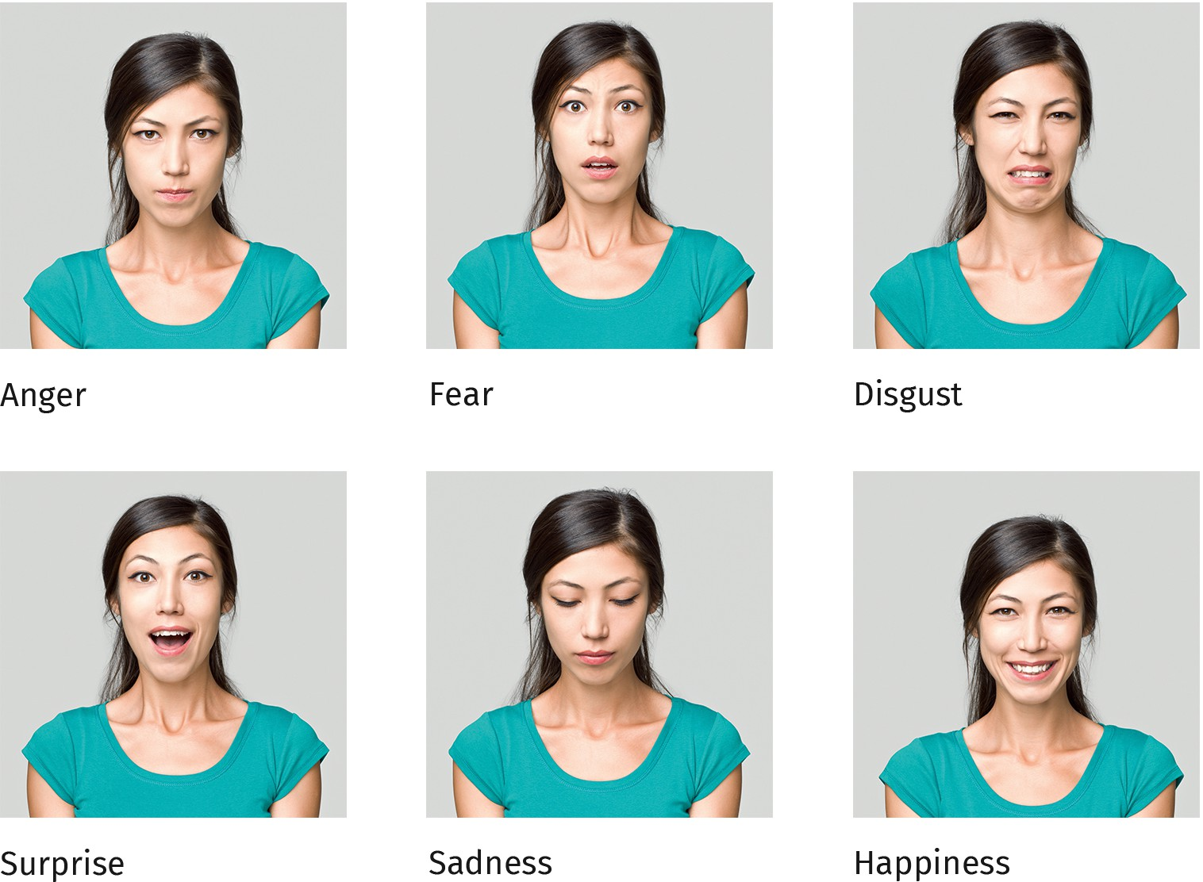

Source: Xian Cheng (2023), based on Kreddig & Karimi (2013, p. 92) and ozgurdonmaz (2012).

##### Emotional Behavior

The interpretation of external stimuli can evoke arousal mechanisms and bring emotional and behavioral changes. What, then, is the relationship between emotion and behavior? In other words, what is the impact of emotions on our daily behaviors? In his attachment theory, Harlow (1958) focused on emotional behaviors. In an experiment, several newborn monkeys were separated from their mothers. Half of the monkeys were kept in a space with two artificial mothers: (a) a wire mother made of metal and equipped with a milk bot- tle in front, and (b) a cloth mother covered with cloth but without a milk bottle. The other group of monkeys also were kept with two artificial mothers in the opposite setting:

(a) a cloth mother with a milk bottle and (b) a wire mother without a bottle (see Figure 12). A team of researchers observed how much time the monkeys spent with the artificial mother with the milk. The results showed that no matter which mother figure provided the milk, they stayed longer with the cloth mother. Harlow’s experiment provided evi- dence of the origins of attachment, that is, seeking contact comfort (Hazan & Shaver, 1994).

Similarly, human attachment also develops between an infant and a parent. The attach- ment bond between a child and the caregiver is about survival, and fulfilling physical and safety needs (Bretherton, 1992). The attachment relationship continually affects adults when they establish a close emotional relationship (Gerrig et al., 2015).

Figure 12: Harlow’s Attachment Experiment

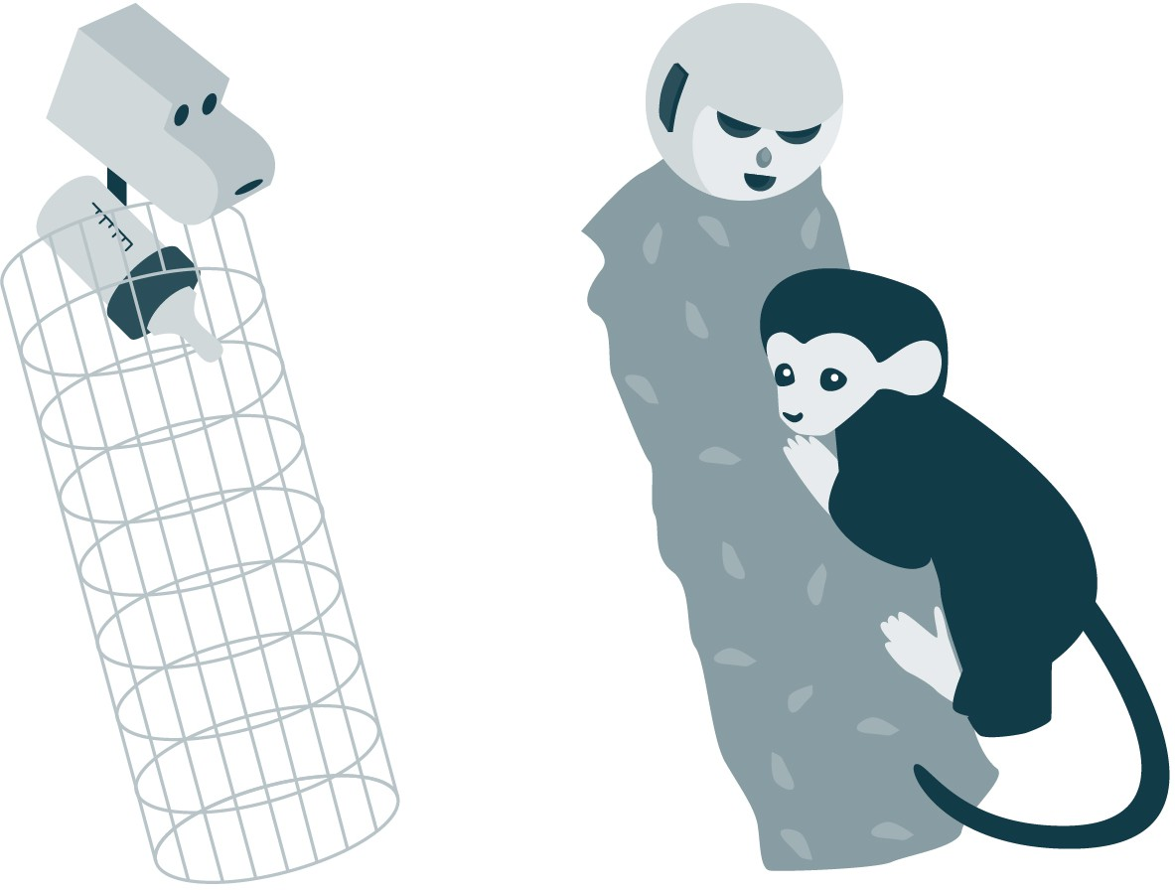

Source: Xian Cheng (2023), based on Harlow (1958) and Petty Sun (2022).



**SUMMARY**

This unit has demonstrated that learning is a lifelong process of acquir- ing knowledge, norms, skills, and other social abilities. When people actively experience or perceive their external environment, it brings rela- tively permanent changes in their cognition or behaviors. Psychologists have investigated the relationship between stimuli and behavior changes. In classical conditioning, researchers suggest that behavior change is achieved when an organism learns a new association between a neutral stimulus and a stimulus that automatically evokes a reflexive response. In operant conditioning, behaviorists understand learning as a consequence of reinforcement or punishment. In other words, a signif- icant influence on human behavior is learning from the external environ- ment. According to Bandura’s (1977) theory, social learning requires attention and behavioral representation. In addition, learners need motivation and the ability to reproduce the behavior.

Motivation explains the causes and drives of human behavior. Ryan and Deci’s (2002; 2017) self-determination theory (SDT) emphasizes the importance of intrinsic (e.g., interests) and extrinsic motivation (e.g., rewards) in encouraging and triggering human behavior. In addition, Maslow’s theory provides a helpful framework for summarizing motiva- tional forces. According to his hierarchy of needs theory, human behav- iors are motivated by different levels of fulfillment: physiological needs, safety needs, love and social needs, esteem needs, and self-actualiza- tion needs (Benson & Dundis, 2003).

Emotion is a complex interplay of people’s physical arousal, cognitive evaluation, and reactions at the psychological and behavioral levels. Across diverse populations and cultures, there are six basic emotions: happiness, sadness, anger, fear, disgust, and surprise. Children often establish an attachment relationship with their caretakers as a crucial emotional behavior to ensure survival and receive contact comfort. The security of attachment also influences adults when they establish close relationships.

# UNIT 3

## SOCIAL PSYCHOLOGY

**STUDY GOALS**

On completion of this unit, you will be able to ...

* describe the attribution process.
* explain the theory of self-fulfilling prophecies.
* know the power of social influence on individuals.
* understand how stereotypes, discrimination, and prejudice arise.
* describe factors that reduce personal biases.
* identify which situations promote prosocial behavior.

***anon***

*2024-06-12 12:47:06*

--------------------------------------------

good but such things should be explained, given that the book/introduction are too short

**Social psychology** the scientific study that investigates the influence of social context regard- ing individuals’ feelings, thoughts, and behaviors

### 3. SOCIAL PSYCHOLOGY

#### Introduction

What is social psychology? Defined broadly, **social psychology** is a branch of psychology that uses scientific methods (e.g., observation, experiment, and survey) to study individu- als in social situations (Gerrig et al., 2015). More specifically, social psychology covers the topics of social beings’ feelings, thoughts, perceptions, and behaviors and explores how these factors are influenced by other people or the environment (Aronson et al., 1994). For example, why do some people perform worse in a group than they would have alone? In addition, social psychology focuses on the role of social context in people’s processes by addressing real social issues (Aronson et al., 1994). For instance, social psychology answers why people have stereotypes and prejudices. Studies of social phenomena are based on empirical and evidence-based research. For example, Milgram’s (1963) famous experiment revealed how obedience to authority occurs.

What are the research interests of social psychologists? From infancy through adulthood, people cannot isolate themselves from the social world in which they interact closely and participate. Based on this context, social psychologists attempt to investigate and under- stand the phenomenon of social influence. Scientists aim to examine assumptions and hypotheses about individual human beings’ behaviors in the social context. For example, researchers try to explain why people hurt or help others. Over the past decades, social psychologists have engaged in studying many social issues, such as the power of social influence, conflict, aggression, prosocial behaviors, and other social interactions. For instance, why do bystanders not call the police when they hear a call for help? This unit provides a comprehensive understanding of social psychology by expanding on the basic concepts and related theories in subsequent sections.

#### The Power of Socialization

Social psychology is a scientific study that focuses on interpersonal interactions in a social context. During interactions, the power of socialization influences people’s perception of society. Social psychologists have attempted to explore the causes of human behavior or events, including internal and external factors. They are interested in knowing the “whys” of social behavior (Gerrig et al., 2015). Based on the available theoretical frameworks, the current section introduces several fundamental concepts of socialization and how people use these principles to explain the behavior of self and others.

##### Social Perception

**Social perception** refers to the processes by which individuals actively collect, interpret, and understand other people’s behaviors in a particular social context (Gerrig et al., 2015). People can make different judgments about the situation or form first impressions of peo- ple with this collected social information. Usually, a person’s social perception is affected

by their beliefs and expectations (Aronson et al., 1994). People tend to process informa- tion from the outer world via automatic, as opposed to reflective, thinking (Kahneman, 2011). People construct assumptions about other people and events based on prior knowledge and experience to save time and effort. These assumptions, called “schemas,” assist people in interpreting information and retrieving relevant information from long- term memory (Aronson et al., 1994; Guo & Wang, 2022). Not surprisingly, schemas have limitations and can be biased, which may lead to stereotypes and prejudice (Wheeler & Petty, 2001).

##### Self-Fulfilling Prophecies

Are schemas always correct? **Self-fulfilling prophecy** theory explains how people actively make their predictions about people or events, and they eventually come true (Ger- rig et al., 2015). Think back to a time when you first met one of your close friends. What was your impression of them? Did this first impression influence your further interaction and expectation about them? Figure 13 explains the process of self-fulfilling prophecies and their consequences.

Figure 13: The Process of Self-Fulfilling Prophecies

**Social perception**

the process by which peo- ple actively collect, inter- pret, understand, and cat- egorize other people’s behavior in different sit- uations

**Self-fulfilling prophecy** a person’s prediction made about a target per- son, some future behav- ior, or an event that modi- fies interactions so as to produce what is expected

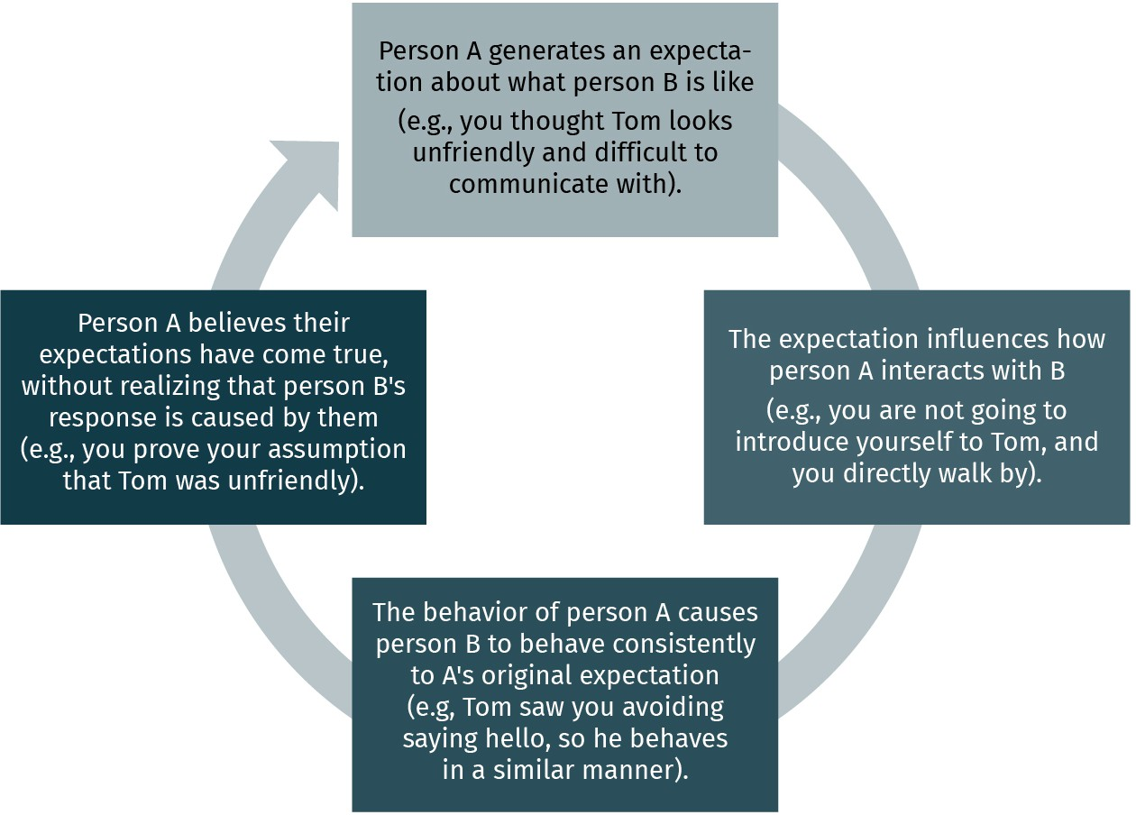

Source: Xian Cheng (2023), based on Aronson et al. (1994).

Moreover, self-fulfilling prophecies are not limited to the way people build their social net- works with other people. This phenomenon of automatic thinking appears in the discus- sion of education equity in school settings. Here is an example of a classroom observation study that revealed a gender stereotype in mathematics learning (Sadker & Zittleman, 2009). During the observation, a fifth-grade teacher assumed that girls’ mathematic ability was not as good as boys. This expectation significantly affected the students’ learning opportunities in the classroom. For instance, the teacher showed more attention and patience to boys but turned back to the girls while explaining the mathematical questions.

Over half of the academic year, the boys had a better learning outcome than the girls in mathematics. Thus, this teacher’s assumptions about her students’ learning abilities came true by treating female students differently from male students. At this moment, the self- fulfilling prophecy circle is now complete.

##### Attribution Theory

***anon***

*2024-06-12 12:47:06*

--------------------------------------------

gendered. rephrase.

**Attribution theory** the psychological theory that describes the judg- ments people use to gen- erate causal explanations about other people’s

behaviors

**Social influence** a psychological phenom- enon whereby people’s attitudes, judgments, decisions, or other behav- iors are affected and changed by social forces

How do you explain why people behave as they do? Heider (1958) introduced the **attribu- tion theory** to explain people’s judgments about the causes of behaviors. He suggested that people usually make one of two attributions to explain why a person behaves in a cer- tain way. One type of attribution is internal attribution – people’s behavior are caused by their attitude, personal traits, and personality. For instance, when you observe someone giving money to a beggar, you assume that this is a generous person. Alternatively, the other attribution is external – the cause of a person’s behavior is something about the sit- uation, such as the external stimuli from the environment. When you make an external attribution to the example of charity, the perceived cause of that man’s merciful behavior is his desire to impress his friends. In day-to-day routine, internal and external attributions play a crucial role in people’s conclusions and expectations about behavior in different sit- uations (Kelley & Michela, 1980).

#### Social Influence

As a social being, you engage in extensive, interactive relationships with other human beings (Aronson et al., 1994). Recall the last time you tried to convince people around you to change their behaviors, such as persuading your friends to eat at your favorite restau- rant on a Friday night. Your attempt to use social influence may have been conscious or unconscious. **Social influence** is a psychological phenomenon in which social forces change one’s attitudes, judgment, decisions, or other behaviors (Cialdini & Goldstein, 2004). Advertising campaigns on television or social media also have a powerful influence on people’s behavior and perception, such as shaping young women’s perception of their body image (Myers & Biocca, 1992). By promoting being thin as the ideal image, mass media convey cognitive biases that could negatively affect young people’s self-perception and increase their body dissatisfaction (Devine et al., 2021). The current section discusses the power of social influence and how it changes individuals’ thoughts and behaviors.

##### Informational Social Influence

When interacting with other people in society, we need to know what is correct and appro- priate. For instance, should you address your professor in an email as “Prof. Dr. Myers,” “Mr. Myers,” or “David”? People require a lot of information to reduce uncertainty and act correctly in daily situations. Asking and observing how others work in a particular case can help people choose an appropriate response. In ambiguous or critical situations as well as in the presence of experienced persons, people tend to conform to others’ behav- ior. This psychological phenomenon is called **informational social influence** (Aron- son et al., 1994). When do people tend to conform to informational social influence? Researchers have suggested that the more critical the decision is to us, the more we rely

on other people’s information and judgments (Levine et al., 2000). Especially when other people are experts (e.g., doctors and scientists), they have a more substantial informa- tional social influence on others under ambiguous situations (Savolainen, 2022). The prin- ciple of informational social influence has been widely applied in marketing to affect con- sumer decision-making, such as creating a professional dentist image in the advertisement of toothpaste to enhance credibility (Lee et al., 2011; Rosen & Olshavsky, 1987).

***anon***

*2024-06-12 12:47:06*

-------------------------------------------- GOOD

##### Normative Social Influence

During your teenage years, did you ever do something to conform and receive social approval? For instance, some people start to smoke because they want to be liked and accepted by their peers. People sometimes do what others do because they do not want to be rejected or become an outsider. This psychological phenomenon is called **norma- tive social influence** (Aronson et al., 1994). In other words, when individuals value the importance of group cohesion and try hard to align with other group members, conform- ity appears in the group (Coultas & van Leeuwen, 2015).

In Figure 14, you see two cards, one with a single line and the other with three lines. Please select one line on the right card that looks the same length as the line on the left. You would probably choose “Line 2,” which is the correct answer. However, Asch (1956) conducted a series of classic studies which showed surprising results.

**Informational social influence**

the influence of other people that we tend to rely on because we view their information as a source of knowing what is right, especially in an ambiguous situation

**Normative social influence**

the influence of other people that leads us to conform because we need to be accepted or liked by them

Figure 14: The Judgment Task in Asch’s Line Study



Source: Xian Cheng (2023), based on Aronson et al. (1994).

In Asch’s line studies, there was only one actual participant, and he was asked which line had the same length as the standard line. After comparing the two cards, the participant gave the same answer and said, “Line 2.” However, in the same group, there were several fake participants. The first one reported that “Line 1 is the correct answer”. As the experi- ment continued, more “participants” also said “Line 1.” Surprisingly, after hearing it six times repeatedly, the actual participant changed his answer and conformed to other group members who gave the apparent wrong answer. Asch’s conformity experiment revealed the importance of being consistent with others (Aronson et al., 1994).

#### Conflict, Aggression, and Cooperation

When you watch TV shows or films, you have probably seen warnings at the beginning, noting that the show is inappropriate for people under a certain age. The aim of this warn- ing is to protect teenagers and children from harmful information. Much research evi- dence has revealed that exposure to media violence significantly increases the risk of aggression in the audience, especially for non-adult viewers (Huesmann, 2007). The cur- rent section focuses on aggressive behavior and discusses whether aggression is innate or learned.

##### Aggressive Behavior

From the perspective of social psychology, **aggressive behavior** refers to people’s inten- tional behavior (e.g., verbal and physical actions) aimed at causing psychological injury or physical pain to others (Geen, 1999a). Violent acts, such as fighting, shooting, and push- ing, are considered to be aggressive behavior. Non-physical behaviors can also be aggres- sive. For instance, sexual harassment or verbal insults in the workplace and the spreading of harmful rumors cause damage to people (Neuman & Baron, 2005).

***anon***

*2024-06-12 12:47:06*

--------------------------------------------

movies

***anon***

*2024-06-12 12:47:06*

--------------------------------------------

A good example of OLD RESEARCH being used as sole evidence of something.........

##### Situational Causes of Aggression

Living in modern society, people directly or indirectly experience aggression and violence daily (Geen, 1999b). You may be wondering why the phenomenon of aggression is com- mon in a particular area or at a particular social event. To answer this question, social psy- chologists attempt to investigate the causes of aggression across various situations.

###### Pain and discomfort

When humans face danger or feel uncomfortable, the situation triggers a fight-or-flight response (McCarty, 2016). This response consists of a sequence of internal activities when an organism faces a threat and must prepare the body for combat or for running away from the danger. Under some circumstances, people will choose to fight when subjected to unexpected pain or other feelings of discomfort (Berkowitz, 1989). For instance, a study about heat and violence found that during the long and hot summers in the United States, domestic crimes and violence are more frequent than in the winter (Anderson, 1989, 2001). Thus, discomfort in hot temperatures is highly associated with aggressive behavior.

###### Social situation

Social psychologists suggest that aggressive behavior usually accompanies negative emo- tions, such as anger (Averill, 2012), frustration (Berkowitz, 1989), and fear (Simu- novic et al., 2013). Particular social situations trigger these unpleasant feelings. Let’s take a day-to-day scenario as an example. When you are stuck in a bad traffic jam on the way to the airport, a sense of frustration and worry can elicit an aggressive manner, such as pressing the horn and frequently changing lanes (Tyson, 1998). When a person is provoked by external stimuli, it can lead to aggressive behaviors, such as fistfights or even shootings (Lawton et al., 1997). Another social situation that causes aggression is war. When a coun-

**Aggressive behavior** people’s intentional behavior aimed at caus- ing physical or psycholog- ical damage to others

try is at war, its population is overexposed to violence and becomes more accepting of aggressive responses (Archer & Gartner, 1992). Compared with people who live in peace, wars can have lasting consequences on people’s attitudes and behavior even after they end (Akresh et al., 2012; Archer & Gartner, 1984).

***anon***

*2024-06-12 12:47:06*

--------------------------------------------

old, undefended.....

***anon***

*2024-06-12 12:47:06*

--------------------------------------------

according to. ?

###### Violence in the media

When watching TV, individuals are likely to see aggressive behaviors and objects (e.g., the presence of weapons). According to social learning theory, people learn behavior by observing and imitating other people’s behavior (Bandura, 1977). Bandura and his collea- gues designed the famous Bobo doll experiment to investigate the role of imitation in learning aggressive behavior in preschool-age children. The results of the experiment sup- port the claim that much aggressive behavior results from imitating other people in soci- ety. This social learning process occurs either when directly experiencing aggression or via indirect exposure to mass media violence. In addition, the repeated presence of objects associated with aggressive behavior (e.g., guns) in people’s childhood may increase their likelihood of participating in aggression years later as adults. Since violence is a crucial societal issue, psychologists have worked intensively on anger and other negative feel- ings.

##### How to Reduce Aggression

So far, we have discussed several situational causes of aggressive behavior. How are we supposed to peacefully resolve private conflicts (e.g., problems between couples) and public conflicts (e.g., long-standing tension between two nations)? If taking a deep breath, running outdoors, or listening to soothing music does not work for you, what will you do with your anger? Regarding the issue of conflict and aggression, empirical studies on empathy and prosocial behavior have shown that the ability to have the same feeling that other people are experiencing can control aggressive behavior (Baron, 1976; Eisenberg & Fabes, 1991). Picture the following scenario: A classmate was pushed and laughed at by others in the hallway. You watch this school bully and remember being taught about empathy last semester. Would you be able to put yourself in the shoes of that classmate? Would empathy education reduce school bullying? The answer is yes. In schools, teaching children to think from other people’s points of view can promote their contextual empathy for aggressive behavior (Phillips & Giancola, 2007) and enhance their empathy-related responses (Malti et al., 2016).

Building feelings of empathy is the first step to reducing violence. To further minimize aggression, social psychologists suggest problem-solving communication training (Fos- ter et al., 1983; Robin & Foster, 1984). For instance, workers in organizations can practice their negotiating skills and defuse their anger by apologizing for the situation (Lee & Chung, 2012). Anger and frustration are part of being human and must be accepted (Aron- son et al., 1994). Once the problem comes from expressing anger and frustration in violent ways, learning nonaggressive strategies (e.g., putting negative feelings into words) can sig- nificantly help solve interpersonal conflicts (Perry, 2019).

#### Theories of Social Psychology

As mentioned, human behavior is influenced by the social environment. Stop for a moment and think about what you do when facing an important decision. Would you prefer to decide on your own or ask for advice from others? If you choose the latter, you engage in a group decision. Theoretically, a **group** refers to two or more people interacting to achieve a common goal that causes them to share similar identities, norms, and bene- fits (Aronson et al., 1994). During the interaction between group members, social norms constitute the shared expectation about which behaviors are acceptable and what atti- tudes are appropriate in a group (Gerrig et al., 2015). Since most people are frequently involved in group activities, it is necessary to consider the influence groups have on indi- viduals.

##### Social Loafing Theory

Let’s imagine a scenario in which you take a psychology exam that determines your semester’s final grade. In this case, you work on the exam as an individual and (hopefully) put in your maximum effort. Alternatively, what if your final grade depended on the out- put of a group project? Would you invest less individual effort in it? Have you ever seen some people perform worse in a group than they would have alone? This phenomenon is called social loafing, which occurs in groups when the presence of others relaxes individu- als and results in a decline in member effort (Comer, 1995). Figure 15 shows the social loafing process to explain how groups influence the behavior of individuals. When individ- ual contributions to a group project cannot be identified, students may become more relaxed, leading to poor performance on simple project work. However, when solving complex tasks, people working collectively can improve performance (Jackson & Williams, 1985; Williams & Karau, 1991).

Figure 15: The Process of Social Loafing

**Group**

two or more interdepend- ent people who interact with each other and share common goals, identities, and needs

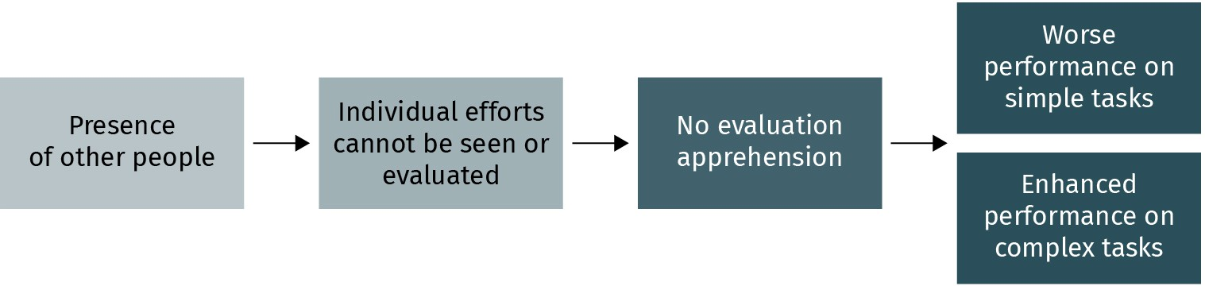

Source: Xian Cheng (2023), based on Aronson et al. (1994).

##### Stereotypes, Discrimination, and Prejudice

As discussed in section 3.1, automatic thinking and schemas are essential in people’s deci- sion-making and judgment processes. However, ready-made assumptions or expectations are not always current and can lead to mistaken judgments, such as stereotypes, discrimi- nation, and prejudice. Personal bias is an attitude toward people, events, or all kinds of social phenomena. Specifically, a **stereotype** is the cognitive component of attitude. It

**Stereotype** the cognitive component of attitudes toward a group of people who have identical characteristics, regardless of their actual

***anon***

*2024-06-12 12:47:06*

--------------------------------------------

Needs to be internationalized. Discuss the study in specific.

***anon***

*2024-06-12 12:47:06*

--------------------------------------------

Discuss the study.

variation

**Prejudice** people’s negative atti- tudes toward another group of people based purely on their member- ship in that group

**Discrimination** people’s harmful behav- ior toward a group of peo- ple, solely based on their involvement in that group

**Prosocial behavior** human behavior that is carried out with the goal of helping other people

refers to a vague generalization about a group of people with some identical and observa- ble characteristics and further assigns them to all group members (Devine, 1989). For instance, close your eyes and imagine the characteristics of a preschool teacher in a kin- dergarten or a data scientist in an IT company. Some people link these careers with a spe- cific gender and appearance.

**Prejudice** is defined as an affective component of people’s attitude about a specific group of people or events, merely based on the minority in that target group. Often, prejudice is explained as a negative emotion bound to particular reactions. For example, those who have a negative attitude toward Asians may assume all Asian immigrants are to be denied leadership opportunities (Gee & Peck, 2017). In addition to the biases against particular ethnic groups, researchers have found prejudice based on gender, age, mental illness (Bis- sell & Parrott, 2013), and social class (Carvacho et al., 2013). Different from stereotypes and prejudice, **discrimination** is the behavioral component of people’s attitudes that can bring physical injury and harmful action toward specific group members (Aronson et al., 1994). Inequities in women employees’ salaries and promotions are deeply rooted in gen- der discrimination (Heilman & Caleo, 2018).

You may wonder what causes these biases. One cause of prejudice is inter-group bias: the differentiation between “them” and “us.” As human beings, we tend to feel favorable and comfortable toward others with similar characteristics, such as biological features, cul- tural background, and past experiences (Allen & Wilder, 1975).

###### How do people reduce cognitive biases?

Cognitive biases can harm people and result in negative consequences for minority groups and people who are not in positions of power (Heilman & Caleo, 2018). How can people adjust their original judgments and control personal biases? Fortunately, people can think about and interpret new information via slow and critical thinking processes (Kahneman, 2011). On the individual level, this high-effort thinking provides a control mechanism against automatic thinking (Aronson et al., 1994). Additionally, more effort could be invested at the social level, such as using education to diminish prejudice (Petti- grew et al., 2007). Social psychologists suggest that when individuals are appropriately educated (e.g., in schools and families) and exposed to accurate information about values, beliefs, and attitudes, it will vastly enhance their willingness to be inclusive and accept social diversity (Jenssen & Engesbak, 1994; Soliz & Harwood, 2003).

#### Prosocial Behavior, Helping Behavior, and Altruism

This section provides a comprehensive overview of basic concepts and theories on proso- cial behavior with examples. **Prosocial behavior** is defined as a wide range of human actions taken to benefit others, such as helping, donating, sharing, and volunteering (Pen- ner et al., 2005). Furthermore, some people may desire to help others even if this action

involves a cost. This tendency to assist and cooperate is human altruism (Batson & Shaw, 1991; Fehr & Fischbacher, 2003). Here, you may ask: Why do people help others? Is proso- cial behavior innate or learned?

##### Basic Motives of Prosocial Behavior

###### Instincts and genes

From an evolutionary psychology perspective, people’s prosocial behaviors can be explained by genetic factors, such as kin selection (Foster et al., 2006). People willing to help their relatives have higher chances of survival. Moreover, individuals who hold a reci- procity norm expect that helping others will increase their likelihood of receiving assis- tance in the future (Ashton et al., 1998).

###### Social exchange

Except for the personal factor, prosocial behavior can be motivated by situational and nor- mative influence factors, such as evaluating the costs and rewards of helping. When peo- ple behave generously, they have a higher chance of receiving rewards and appreciation from others in the future (Aronson et al., 1994). In other words, prosocial behavior is learned via social interaction.

###### Empathy and altruism

At this point, you may be concerned about whether people have a pure motive for helping or not. Batson and Shaw (1991) proposed the empathy–altruism hypothesis and explained that people’s prosocial behavior is because of a feeling of empathy for others. For exam- ple, if you see a woman drop her shopping bag, and all her oranges roll onto the floor, you feel empathy for her situation. Thus, you will likely help her regardless of whether you will be appreciated.

##### When Do People Help?

Previously, we discussed why people engage in prosocial behaviors. However, these explanations are not the only reasons people choose to help others – or not – especially in an emergency. Social psychologists conducted experiments to understand when people help. They found that the more people witness an emergency, the lower the chance of the victim receiving help (Darley & Latané, 1968).

This social phenomenon is called the **bystander effect** (Darley, 1970). Specifically, when people believe that they are the only witness of an emergency, most of them help the vic- tim immediately. Nevertheless, when people assume many others also witness the emer- gency, they are less likely to offer help or react slowly (Latané & Nida, 1981).

***anon***

*2024-06-12 12:47:06*

--------------------------------------------

Missing introduction.

**Bystander effect**

The chance of helpful behavior in an emergency decreases when the num- ber of witnesses increases.

Another situational determinant of prosocial behavior is people’s living environment. Studies have revealed that compared with urban areas (e.g., cities), people in rural areas (e.g., small towns) are more likely to help others (Amato, 1983; Steblay, 1987). For instance, compared with people who live in urban settings, small-town residents are more willing to help strangers involved in an accident or getting lost.

##### How to Increase Prosocial Behavior?

As mentioned, the diffusion of responsibility decreases the likelihood of people’s helping behavior (Darley & Latané, 1968). Would it be possible to enhance the chances of helping, especially in an emergency? Darley and Latané (1970) suggested five decision-making steps that affect whether people will stop to help or not (see figure below).

Figure 16: Bystander Intervention Decision Process

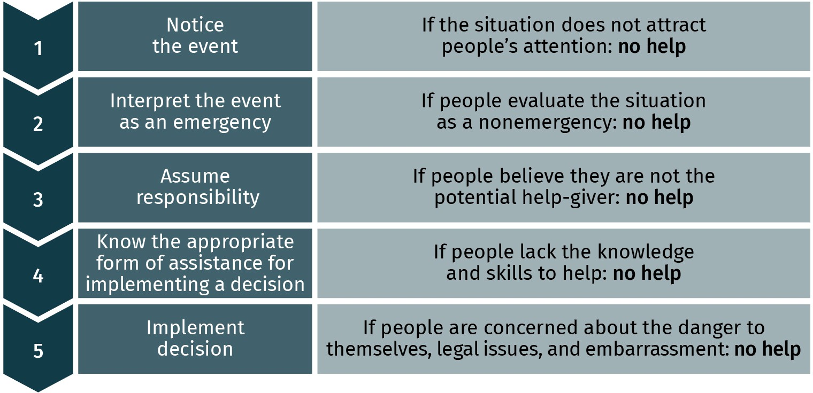

Source: Xian Cheng (2023), based on Aronson et al. (1994).



**SUMMARY**

In this unit, you have learned that social psychology is a branch of psy- chology that studies the influence of social context on individual peo- ple’s thoughts, feelings, and behaviors by using scientific approaches. The power of socialization appears when we consider what other people might think and significantly change our judgments and decisions. We construct our social perceptions when we actively collect, interpret, and understand other people’s behaviors under a particular social context. Self-fulfilling prophecies happen when people actively but often inad- vertently create schemas about people or events and they eventually come true; it strongly affects people’s interactions. According to attribu- tion theory, if people believe the causes of behavior are their attitudes

and personality traits, they have internal attributions. Conversely, exter- nal attribution explains that the reasons for behavior are stimuli from the environment.

The need to know what is suitable and appropriate is called informa- tional social influence. People conform to other people to receive infor- mation about ambiguous situations. In addition, normative social influ- ence occurs when individuals need to be accepted and liked by others. In daily life, social media and advertisements use the effects of conform- ity to change people’s attitudes toward, for example, ideal body image standards.

When people differ in opinions, beliefs, interests, and goals, conflicts arise and lead to aggressive behavior, which refers to people’s inten- tional behavior aimed at causing psychological or physical pain to oth- ers. Pain, discomfort, frustrating situations, and the appearance of media violence are all causes of aggression. Also, aggression is a learned social behavior and can be reduced by building empathy and managing effective communication. According to social loafing theory, the pres- ence of others relaxes individuals and results in a decline in member effort.

Another crucial issue in interpersonal relationships is negative attitude. Stereotypes and prejudice toward people, events, or phenomena are caused by social categorization (e.g., us versus them). Individuals should be encouraged to take up critical thinking and beware of automatic thinking to reduce stereotypes, prejudice, and discrimination. At a broader level, school education and family should provide accurate information about diverse values, beliefs, and attitudes.

People help, donate, share, and volunteer. The primary motives for pro- social behavior may be passing genes, social exchange, and empathy- altruism. Nevertheless, the bystander effect showed that assistance in an emergency would decrease when the number of witnesses increases.

# UNIT 4

## INDUSTRIAL PSYCHOLOGY

**STUDY GOALS**

On completion of this unit, you will be able to ...

* describe industrial–organizational psychology.
* identify work motivation, job satisfaction, and methods of work analysis.
* evaluate methods of work- and worker-oriented analysis.
* understand work stress and methods of stress management.

***anon***

*2024-06-12 12:47:06*

--------------------------------------------

Redundant. Cut.

***anon***

*2024-06-12 12:47:06*

--------------------------------------------

Rephrase not to make assumptions...

**Industrial–organiza- tional (I–O) psychology** a sub-field of applied psy- chology that focuses mainly on human nature at work and explores sol- utions to practical work-

place problems

### 4. INDUSTRIAL PSYCHOLOGY

#### Introduction

Psychology as a science does not only focus on academic research but also has essential applications in improving people’s daily work and solving practical problems for busi- nesses. The term “applied psychology” is frequently used when a large part of psychology overlaps with other disciplines, such as economics, business administration, human resources, health psychology, educational psychology, clinical and counseling psychol- ogy, forensic psychology, sports psychology, and ergonomics. It is primarily concerned with effectiveness and efficiency. As a subfield of applied psychology, **industrial–organi- zational (I–O) psychology** focuses on human nature at work and explores solutions to practical problems in the workplace (Spector, 2021). I–O psychology can be split into industrial and organizational divisions. In this field, I–O psychologists apply scientific prin- ciples and psychological theories to explain and investigate people’s emotions, motiva- tions, and behaviors in the workplace. They have increasingly conducted empirical research and applied evidence-based principles and theories while supporting workers and managers in organizations.

The current unit focuses on industrial psychology and discusses the topics of work analy- sis, motivation, job satisfaction, and some stress management skills used in management practices. In addition, this unit includes some basic assessment methods that correspond to particular topics and concepts. All the selected topics and methodologies are presented to strengthen your understanding of industrial psychology at both conceptual and meth- odological levels.

#### Basics of Industrial Psychology

You probably heard of the saying “A happy employee is a productive employee.” However, have you critically thought about it from a psychological perspective and wondered why job satisfaction is crucial for employees? To increase our understanding of people at work, many scholars and practitioners dedicate their professional knowledge and experience to psychology and business. Industrial psychology is a sub-field of applied psychology that investigates the issues of employee recruitment, the work environment, and the crucial factors that affect work performance (Spector, 2021). Based on the study and observation of individuals, the industry or managers can use the data to match the candidates with specific job requirements. For instance, during the recruiting process, people from human resources (HR) can use a cognitive test designed by industrial psychologists to assess the candidates’ job-related knowledge and professional skills. Psychological tests, such as personality tests (Goldberg et al., 2006), emotional intelligence tests (Joseph & Newman, 2010), and vocational interest tests (Tracey & Rounds, 1993), are frequently applied to sup- port human resource management. Other approaches, such as interviews and work analy- ses, are widely implemented to evaluate employees’ suitability for a particular position.

After successful applicants become part of the organization, industrial psychologists sup- port companies in increasing their new workers’ productivity by studying their motivation, job satisfaction, and work stress.

In general, industrial psychologists attempt to improve organizational efficiency via the optimal use of human resources. Over the past decade, industrial psychologists have focused on the practical issues needed to improve organizational efficiency through the ideal staffing arrangement: selection, placement, training, performance management, and quality work life (Landy & Conte, 2016). Industrial psychologists pay great attention to measuring employees’ knowledge, skills, abilities, and other personal characteristics **(KSAOs)** at work (Krumm & Hertel, 2013). While working with managers and workers, industrial psychologists usually adopt a scientific approach to finding solutions. For exam- ple, industrial psychologists support HR in conducting a work analysis that may be applied to the annual performance appraisals in the organization. More importantly, industrial psychologists use scientific methodologies to collect data, analyze individual behaviors, and explain organizational phenomena while designing and applying various assessments and evaluations.

#### Concepts and Methods of Work Analysis and Evaluation

Imagine you are searching for a position that fits your academic and career background, such as a project manager position in marketing. You find a posting on a job search web- site. As you look into the details, you see that this job description lists a collection of responsibilities and tasks associated with the project manager position, such as planning and organizing the marketing campaigns and managing the project’s budgets.

Have you ever considered how these tasks differ from a job description for a school teacher position? Why do identical job titles from different organizations share many typi- cal duties and tasks? What tasks do people in a position typically perform? In the following section, these questions are addressed by discussing the concept of work analysis and its design and implementation in organizations.

##### Work Analysis

**Work analysis** refers to a method for explicitly providing detailed information on the job unit and ascertaining the essential competencies of an effective worker (Harvey, 1991). Frequently, this term is interchangeable with job analysis in academic journals and the business press. According to a study, a formal work analysis contains two characteristics:

(1) a systematic analysis procedure, and (2) a thorough description of individual job units (Morgeson et al., 2019). During the work analysis procedure, HR uses the collected infor- mation to solve practical problems in organizational management, such as job classifica- tion and performance evaluation (Fine & Cronshaw, 1999). At the same time, a work analy-

**KSAOs**

These refer to a person’s knowledge, skills, abili- ties, and other personal characteristics that are required to succeed at work. These aspects are the main research focus of industrial psycholo- gists.

**Work analysis**

This is a formal evalua- tion approach to collect necessary information about a work unit and present the essential skills of an efficient employee who is respon- sible for the job.

sis offers essential information about the nature and detailed content of a specific job in an organization (Brannick & Levine, 2002). It generally aims to present an accurate picture of the job descriptions and list all the requirements for the employees.

###### Importance of work analysis

The information in a work analysis serves as the basis for many HR activities and can be used in multiple fields of organizational practices (Siddique, 2004). As mentioned earlier, the job description on a career website covers a list of tasks that an employee is expected to complete. This list is important for a work analysis, and applicants can use them to learn about the role, duties, tasks, daily activities, and other smaller work units.

In addition, the organization and HR department receive descriptive reports about specific workers’ capabilities (e.g., professional knowledge, skills) and job performance (e.g., what employees do at work). After knowing what the job requires, the HR department can effec- tively identify the potential candidates for the position during recruitment (Judge, 1994). After reviewing the job analysis results, managers or recruiters get a complete picture of what employees do and the quality of their work (Sanchez & Levine, 2012). Previous research found that a thorough and well-designed work analysis can facilitate the person– environment (PE) fit, person-job (PJ) fit, person–vocation (PV) fit, person–organiza- tion (PO) fit, and person–group (PG) fit (Judge, 1994; Lauver & Kristof-Brown, 2001). A for- mal work analysis can be used for writing a job description, employee selection, perform- ance evaluation, promotion, training, and job assignment, which are all very important for management practices in organizations.

##### Types of work analysis

In daily practice, depending on the specific purposes of organizational management, work analysis is implemented along two dimensions: work-oriented (also called job-oriented) and worker-oriented (also called person-oriented) analysis (Harvey, 1991; Spector, 2021).

**Work-oriented work**

**analysis** an evaluation of the nature of the tasks and duties that are required for a specific position in

an organization

**Work-oriented work analysis** focuses on the nature of tasks and duties that need to be done on the job (Harvey, 1991). Yet how can we break down a job into specifics? According to Brannick and Levine (2002), the work-oriented analysis contains a five-level hierarchy. The levels range from broad to specific: (1) position, (2) duty, (3) task, (4) activity, and (5) element. Table 4 presents each level of specificity with the corresponding examples. With the guidance of this hierarchy, people can effectively identify different classes of units per- formed in a job.

Table 4: Five Levels of Work Specificity

|  |  |  |
| --- | --- | --- |
| **Levels of specificity** | **Definitions** | **Examples** |
| Position | A given job title | Flight attendants working for an airline |
| Duty | A description of significant responsibilities in a position | Responsible for the cabin safety and com- fort of passengers |

|  |  |  |
| --- | --- | --- |
| **Levels of specificity** | **Definitions** | **Examples** |
| Task | A specific part of work duties | Preventing situations that threaten cabin security |
| Activity | Individual units completed to accomplish the task | Conducting a set of preflight safety checks to ensure the airplane is ready for take-off |
| Element | A sequence of actions to achieve the activ- ity | Asking passengers to wear their safety belts and stow their luggage in the over- head bin |

Source: Xian Cheng (2023).

The second approach, **worker-oriented work analysis** concerns what employees do at work, and it systematically assesses the corresponding personal factors required in a job (Harvey, 1991). This work analysis approach typically provides a systematic description of a person’s KSAOs (knowledge, skills, abilities, and other characteristics) that cover facts and information about a qualified worker (Krumm & Hertel, 2013). Table 5 briefly defines each category of KSAOs and illustrates the examples related to the flight attendant job.

Table 5: KSAOs: Definitions and Examples

|  |  |  |
| --- | --- | --- |
| **Category** | **Definition** | **Example** |
| Knowledge | Professional information needed to do a specific job | Having sufficient first aid and medical care knowledge |
| Skill | A practiced capability that enables a per- son to complete a particular task | Excellent communication and language skills |
| Ability | A stable capability, including the physical and psychological aspects | Being able to handle emergencies and pas- sengers’ special needs |
| Other char- acteristics | Personality, related training, and work experience | Being friendly and having high-emotional stability |

Source: Xian Cheng (2023).

##### Methods of Work-Oriented Analysis

There are several approaches to conducting a work-oriented work analysis in organiza- tions. Depending on the evaluation goals (e.g., providing employee feedback, determining salary increases, making promotion decisions), analysts select the optimal method to evaluate employees’ work performance (Aamodt, 2015).

###### Observation and shadowing

First, observing employees’ work-related attitudes and behaviors is a common way of gathering information in organizations (Landy & Conte, 2016). During the observation, the job analyst seeks to examine employee performance and obtains first-hand knowledge that the employee has not previously mentioned. Usually, the results of a task analysis

**Worker-oriented work analysis**

an evaluation of what employees do at work and the corresponding knowledge, skills, abili- ties, and other character- istics that are required in a job

provide an objective baseline for performance appraisal. Shadowing is another option to see how employees do their job (McKenna, 2020). During shadowing, the job analyst spends time participating in the same work as the target of the evaluation. Going through every aspect of a job routine makes it easier for the analyst to generate a complete picture of the task or project.

###### Protocol

The second approach to work-oriented analysis is to write a protocol. It is an effective method for job analysts or supervisors to systematically collect job-related data (McKenna, 2020). A properly written protocol for a specific task should cover several com- ponents: what is done, who is responsible for it, how it is done, why it is done, and when it is done. These critical components are documented in a log format, which can be used to qualify the employees’ long-term work performance. The advantages of administering protocols are that they are inexpensive and efficient. Moreover, since the protocol objec- tively records the individual employee’s actual working behaviors instead of their personal characteristics, it minimizes evaluation biases, such as first impressions and the specific trait that the supervisor expects to see (Aamodt, 2015).

##### Methods of Worker-Oriented Analysis

As mentioned earlier, worker-oriented analyses mainly focus on what employees do at work and the competencies required in their jobs. The techniques and methods used in worker-oriented analysis are primarily for the collection of information about the employ- ees’ professional KSAOs necessary to complete their work. The following are several com- mon approaches to obtaining information on workers’ KSAO characteristics.

###### Interview

The interview is a common approach for conducting a person-oriented work analysis (Campion et al., 1994). For a job analyst, a well-prepared, structured interview is a suitable means of collecting information by asking employees job-related questions. Based on the interviewee’s responses, the job analyst can evaluate each of the answers to decide whether that person meets specific criteria or not (Campion et al., 1997). Usually, a struc- tured interview can take place in a one-to-one format, which involves one analyst inter- viewing one employee. In addition, panel interviews (e.g., multiple analysts evaluate the same employee) and group interviews (e.g., one job analyst asks the question to several employees) are also effective ways for HR managers to collect information about the inter- viewee (Carson et al., 2005).

###### Questionnaires and survey

Designing and administering a questionnaire is a scientific method of obtaining worker- related information, such as individual work performance (Rotundo & Sackett, 2002). Questionnaires can reduce time and cost since many workers are involved, and they can all be asked the same questions. To ensure the reliability and validity of the analysis, the assessment process should be objective and follow a structured method. For example, the individual work performance questionnaire (IWPQ) is a scientific self-report instrument

commonly used to collect and analyze workers’ performance along four dimensions: (1) task performance, (2) contextual performance, (3) adaptive performance, and (4) counter- productive work behavior (Koopmans et al., 2011). The IWPQ contains 128 unique items that cover the crucial elements of jobs that predict individual work performance. While completing the questionnaire, workers must rate their agreement with a series of state- ments on a scale of 1 to 10 (Koopmans et al., 2013). An example of a statement on the task performance scale is “In the past three months, collaborating with others was very pro- ductive.” The company and HR department can reasonably evaluate employees’ working behaviors based on the assessment results. A questionnaire could be a valuable tool for supervisors to understand their employers’ particular skills and behavior (e.g., time man- agement and problem-solving skills) and involvement in the job (McKenna, 2020).

##### Job Evaluation

As noted previously in this section, the written results of work analysis could be used for evaluating employees’ job performance and determining the salary of employees accord- ingly. In general, **job evaluation** refers to a systematic process of determining the mone- tary value of a job related to other jobs in an organization (McKenna, 2020). An objective and thorough job evaluation can be used to ensure both internal and external pay equity. For instance, while evaluating a job by comparing it to other positions within the organiza- tion (i.e., internal equity), the level of responsibility, physical and psychological demands, education, and experience requirements are the main factors that need to be considered. Yet, external equity is achieved when comparing a job to similar positions in other organi- zations, such as the average salary for a specific position in the market. In short, job evalu- ation consists of determining salary increases and ensuring fair promotion decisions (Aamodt, 2015).

**Job evaluation**

a formal and systematic approach to evaluate the worth of a job in relation to other jobs in an organi- zation

Figure 17: The Main Steps of the Job Evaluation Process

***anon***

*2024-06-12 12:47:06*

--------------------------------------------

Need introduction.

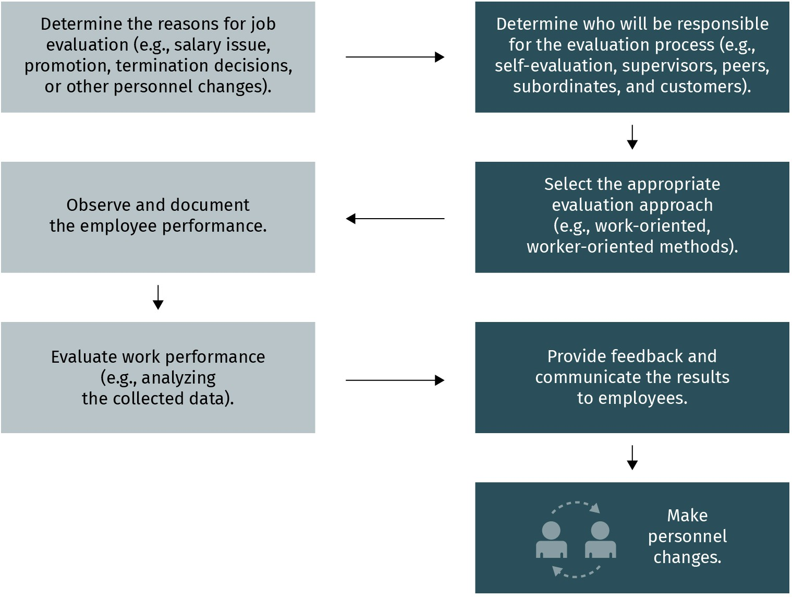

Source: Xian Cheng (2023), based on Aamodt (2015).

Once the purpose of the evaluation is confirmed, the following step (see Figure 17) is to conduct the evaluation process in a certain sequence (Aamodt, 2015). Depending on the requirement, the job evaluation process could take place annually or even quarterly if needed. Of course, the results of the evaluation will vary based on employee performance. In this respect, many I–O psychologists and managers are interested in the crucial factors that could largely influence individual performance in organizations: work motivation and satisfaction (McKenna, 2020). These concepts will be discussed in the next section.

#### Concepts and Methods of Work Motivation and Satisfaction

##### Motivation at Work

Work takes up central space in people’s lives. Why do we work, and what motivates us to work? Before answering these questions, you may also ask how best to define motivation. The answer depends on the individual. Some people view motivation as result of trying to meet intrinsic needs. Some people understand motivation as an internal force that engages them in work-related decisions. From a psychological point of view, **work moti- vation** is defined as the inner force that drives an employee’s work-related behaviors and

encourages them to achieve goals (Locke & Latham, 2002). In the workplace, two employ- ees’ actions can look the same, such as participating in vocational training in their free time. However, the drive, motive, or need behind the choice may vary between individual employees. Regarding this differentiation, I–O psychologists have explored motivation at work and its influence on individual employees’ work behaviors (Pardee, 1990; Ryan & Deci, 2000).

###### The importance of work motivation

In organizations, employees’ work capacities and professional skills determine whether they can accomplish a particular task at work. Yet, their motivation determines whether they are willing to finish the job (Donovan, 2002). When employees are motivated, they will actively respond to work-related conditions and generate positive emotions (e.g., sat- isfaction). Except for the influence on a person’s psychological state, Van Knippenberg’s (2000) systematic review of empirical studies confirmed that employees’ motivation is positively related to their work performance, persistence, and job satisfaction. Motivation is a significant concept not only for employees but also for organizations. Thus, research- ers and practitioners have continued to study work motivation.

##### Motivation Theories

Recognizing the wide range of individual differences in motivation and realizing the impor- tance of the concept, psychologists have proposed various theories of motivation (Pardee, 1990). Many ideas have been put forward regarding why some people perform better than others at work. The following two theories explain employee motivation in terms of job- related goals and needs.

###### Goal-setting theory

According to goal-setting theory, motivation comes from people’s internal intentions, objectives, or goals (Locke & Latham, 2002, 2006; Lunenburg, 2011). For instance, increas- ing social media presence and promoting more products may be an employees’ goal in marketing. The theory states that a person’s goal is what they consciously try to achieve. The goal refers to a desirable objective, which is a priority concern for a person. This goal can be general, such as “to improve the effectiveness of organizational communication,” or specific, such as “encouraging employees to share their feedback at the meeting.”

According to Locke and Latham (1990), employees’ work performance is shaped mainly by goal difficulty and goal specificity. Goal difficulty is the extent to which a goal is demand- ing and challenging. Goal specificity refers to the level of quantitative precision (Locke et al., 1981). Based on this definition, “do your best” is a vague goal with low specif- icity. Compared to a general goal, a specific and challenging goal is more likely to result in the increased performance of people at work (Klein et al., 1990). Over the past three deca- des, as one of the most popular motivation theories in I–O psychology, goal-setting theory has assisted organizations and managers in understanding the close relationship between goals and work performance (Clements & Kamau, 2018; Fried & Slowik, 2004; Tubbs & Eke-

**Work motivation**

the internal force or exter- nal factors that drive an employee’s job-related behaviors and encourage to attain a goal

berg, 1991). Leaders can effectively motivate group members to attain their goals when using this theory in a specific situation. The following are essential prerequisites for goal setting to be successful in practice (Rubin, 2002).

###### Goals need to be specific

As noted previously, rather than having a vague goal, such as “try your best at work,” set- ting a specific goal can help reduce misunderstanding and lead employees to evaluate whether they have achieved the goal (Kleingeld et al., 2011). At the same time, a particular goal means people require less response time to process and interpret the goal.

###### Goals need to be difficult but attainable

Research has suggested a positive relationship between the difficulty of the goal and job performance (Kleingeld et al., 2011). Compared to an easy goal, a more challenging goal that accomplishes an appropriate level of task complexity will result in better perform- ance. However, instead of setting an unrealistic target that is nearly impossible to achieve, the goal should be attainable, based on the employee’s capacity and the organization’s current situation (Tubbs & Ekeberg, 1991).

###### Goals need to be accepted by the members of the organization or team

In addition to the characteristics of the goal, goal commitment among employees is essential in ensuring the goal’s effectiveness (Rubin, 2002). For instance, to meet the group goal, each member must accept the goal and view it as a part of their individual goals.

###### Feedback needs to be provided

Hattie and Timperley (2007) defined feedback as information regarding a person’s behav- ior or performance. To increase goal-setting effectiveness, employers should regularly pro- vide feedback regarding the employees’ progress toward their goals (Locke & Latham, 2002). With this feedback, employees can make timely adjustments when encountering challenging goals. Another function of feedback is that it helps reduce the gap between the current situation and the expected goal (London, 2003). Workers, group leaders, and other professionals in organizations can provide feedback. Some examples of effective feedback include providing diagnostic information on work-related mistakes, rather than on the person’s personality, as well as giving additional resources and suggestions on how job performance can be improved (Kluger & DeNisi, 1996). Feedback also assists people in monitoring their progress (Holt et al., 2012).

###### Two-factor theory

Building on considerable evidence concerning human needs and values, Herzberg and his colleagues (1966) first proposed the two-factor theory, also called the motivation-hygiene theory, to explain the crucial elements behind people’s perception of work. This theory divided the factors into two categories: motivators and hygiene factors. Motivators are the task- and duty-related elements that influence people’s positive attitudes, such as work

achievement and the level of responsibility for making a decision. If people are offered adequate motivators, they will be more motivated and satisfied with their job. Hygiene factors are the environment-related elements that affect people’s negative attitudes toward work conditions, such as security, salary, and interpersonal relationships in the workplace. If these hygiene factors are inadequate, they will cause dissatisfaction among people. More examples of motivators and hygiene factors are listed in Table 6.

Table 6: Examples of Motivators and Hygiene Factors

**Motivators**

**Hygiene factors**

* Achievement
* Control
* Challenge
* Responsibility
* Personal growth
* Interesting work
* Salary
* Security
* Supervision
* Working environment
* Interpersonal relationships
* Company policies and administration

Source: Xian Cheng (2023), based on Herzberg (1966).

##### Job Satisfaction

Many managers try to find out why some employees are satisfied with their job and others are not. Depending on various working conditions, the employees’ feelings about their current job can range from highly positive to extremely negative (Armstrong et al., 2015). As discussed earlier, a person’s work motivation significantly influences job-related emo- tions, such as job satisfaction. From a psychological perspective, job satisfaction is gener- ally defined as the degree to which a person likes their job (Faragher, 2013; Spector, 1997; Vroom, 1964). This positive job-related attitude is multidimensional, including affective, continuance, and normative commitment (Aziri, 2011).

###### Antecedents of job satisfaction

Since many factors affect people who like or dislike their jobs, individual employees from the same organization can show a large variety in job satisfaction. Previous research has shown that the common predictors of job satisfaction can be categorized into environ- mental and personal factors (Spector, 2021). For instance, the ecological antecedents influencing job satisfaction are job characteristics, salary, and perception of justice. In other words, the environmental factors focus more on the job than on the employee. Other researchers suggest that personal characteristics also significantly affect employ- ees’ self-perceived job satisfaction (Staw & Cohen-Charash, 2005). Examples of individual factors are personality, job expectation, gender, perception of equality, and interpersonal relations with coworkers (Spector, 2021).

The job characteristics model (JCM) provides a conceptual framework for designing work that enhances employees’ job satisfaction (Hackman et al., 1978). Hackman and Oldham (1975) developed a Job Diagnosis Survey (JDS) to systematically assess several job- related factors that are crucial antecedents of work outcomes. To test the model, Hack- man et al. (1978) assumed that job satisfaction is neither a direct outcome of the external

work environment nor a direct result of the satisfaction of personal needs. Instead, job satisfaction is influenced by specific job characteristics: skill variety, task identity, task sig- nificance, autonomy, and feedback. These five job characteristics are significantly related to psychological outcomes (e.g., perceived meaningfulness of work, motivation, and job satisfaction) and behavioral outcomes (e.g., absenteeism). A meta-analysis on job charac- teristics suggested that, with the increase in job complexity, employees’ job satisfaction, motivation, and work performance will increase (Fried & Ferris, 1987). Applying the job characteristics model provides employers with an evidence-based principle for designing jobs to promote individuals’ job satisfaction in organizations (Parker et al., 2017).

***anon***

*2024-06-12 12:47:06*

--------------------------------------------

REWORK TO USE AN INTERNATIONAL EXAMPLE...

#### Concepts and Methods of Workplace Design

##### The Design of the Working Environment

The working environment and its design can be divided into two broad categories: (1) the visible environment, and (2) the invisible environment. Office design usually involves a physical and visible environment, with elements such as privacy, color, temperature, and lightness (Davis et al., 2011; Jo et al., 2022). Researchers and practitioners frequently ignore the physical settings of a workspace (Davis, 1984); however, the organizational liter- ature claims that the design of the working environment (e.g., enclosed office or open- plan office) is significantly related to workers’ productivity (Roelofsen, 2002) and psycho- logical outcomes, such as job satisfaction (Veitch et al., 2007). Specifically, researchers found that workplace color is highly associated with people’s creativity (Küller et al., 2009), emotion (Hemphill, 1996), and perceived task demand (Stone & English, 1998). For instance, SIXT is one of Germany’s largest car rental companies; its branches worldwide are designed in a bright orange color. Working within this warm color environment, enter- prise employees reported higher performance and positive perceptions (Ainsworth et al., 1993). In addition to the office interior color, other factors, such as a well-organized work schedule and the design of different aspects of the job, are crucial to constructing a partic- ipatory workspace (Seim & Broberg, 2010).

##### Changes in the Workplace

###### Digital working environment

During regular working hours, many employees work closely with information-communi- cation technology (ICT), such as personal computers, tablets, mobile devices, and various software (Long, 2018). Furthermore, the rapid development of new technology creates new forms of work, and these new work formats reciprocally facilitate new technologies. One of the most apparent benefits of using digital equipment is enhanced human per- formance at work (McKenna, 2020). New technologies transfer most administrative work, such as mailing, reporting, and archiving documents into paperless records. Conse- quently, office settings and work routines have become more customized, productive, and efficient over the past decade (Wheatley, 2017). Innovative technologies shape how peo-

ple work, substantially enhance their productivity, and decrease turnover (Stavrou & Kila- niotis, 2010). The broad implementation of digital technology changes the office environ- ment and provides a new alternative to the workplace: the home office.

***anon***

*2024-06-12 12:47:06*

--------------------------------------------

Lack of sources and academic discussion here should be addressed...

***anon***

*2024-06-12 12:47:06*

--------------------------------------------

Update. The paragraph opens with talk of the pandemic, so seeing sources from 2000 and so on is very confusing.

###### Home office

Due to occupational changes and organizational development, and also as a consequence of the COVID-19 pandemic, more people have started working from home, either full-time or part-time. This new working style has several prerequisites: a home office, digital devi- ces, and internet connection. Rather than having a fixed office space and office hours, employees can work in a new time-space mode. Because of the easy arrangement, the home office, also called remote work or telework, is frequently adapted and implemented

in different business fields, especially in many technology companies. According to a sur- vey by Organisation for Economic Cooperation and Development (OECD), there is an increasing number of employees who reported that the ideal amount of time to spend in the home office is two to three days per week. In general, the home office has many advantages for both employees and employers (Criscuolo et al., 2021):

* At the individual level, one desirable feature of the home office is flexibility with respect to work schedules and location. Employees can save time and expenses by not com- muting to work every day. The necessary communication among coworkers is available via email and online meetings, which contain essential social interaction.
* At the organizational level, the home office contributes to workplace sustainability. It requires less office space, electricity, and other resources. Each organizational member can connect with the central office merely with a computer. Not commuting to work also contriutes to a reduction in the organization’s carbon footprint.

#### Work and Health

##### Current Working Conditions in Organizations

During the COVID-19 pandemic, healthcare professionals have experienced extremely high levels of stress and faced mental health challenges. They were pressured by overtime work, quarantine isolation, fear of infection, lack of supplies, and inadequate information, among other factors (Beehr, 2020). Studies suggest that the pressure frontline workers are

under increase physical and psychological risks that threaten their health (Buddeberg- Fischer et al., 2008). In addition to healthcare professionals, people in other careers, such as managers (Cavanaugh et al., 2000), police officers (Collins & Gibbs, 2003), and teachers (Liu & Onwuegbuzie, 2012), have reported extreme levels of stress in their work life. Research suggests that half of the population in the United States has experienced at least

one stress-related problem (Murphy & Sauter, 2003).

This section deals with a significant issue that affects employee performance and health: workplace stress. Factors contributing to work stress and their consequences are dis- cussed through field studies and experiments. In addition, a self-report measurement of pressure is presented in this section. A set of scale items will assist you in recognizing the

signs that indicate whether you are stressed out. Finally, building on recent research, how to manage stress in the work environment and achieve a work–life balance is also dis- cussed.

##### Stress and Stressors in the Workplace

**Work stress** a person’s physical and psychological reactions to the imbalance between self and work environ-

ment

**Stressors** physical and psychologi- cal factors that generate discomfort and cause temporary or even per- manent distortion

Think about a scenario at work: When you are waiting to find out whether you will be pro- moted, do you believe it depends on how lucky you are, or how hard you work? Which of these two beliefs causes a higher stress level? From the beginning of a career, work stress is a common topic individual employees have to face and cope with. Theoretically, **work stress** refers to a physical and psychological reaction that happens when there is a conflict between the demands in work environment and people’s capabilities or resources to meet these demands (Bickford, 2005; Lazarus, 2000). This reaction is also called occupational stress. According to Lazarus and Folkman (1984), work stress involves an overall transac- tional and dynamic process that arises not only on an individual level (e.g., personal char- acteristics, beliefs, and motives) but is also influenced by external elements (e.g., threats, harm, and challenges). Lazarus and Folkman (1984) developed the transactional model of occupational stress, which explains the internal and external factors that trigger stress, such as coping resources and emotional or cognitive-focused evaluation of the situation. Stress management will be discussed later in this section.

To better understand work stress, it is necessary to address the common factors that lead to it. According to the literature, internal and external factors that generate stress are called **stressors**. These factors can be broken down into two categories: physical and psy- chological stressors (Beehr, 2020; Cooper et al., 2001; Frese, 1985).

###### Physical stressors

Physical stressors result from the biological demands associated with specific tasks or that are stimulated by working environments (Kahn, 1990). Previous investigations of physical stressors suggested that noise, especially chronic noise, is one of the most com- mon factors that causes stress (Evans, 1995, 2000). This stressor usually appears in manu- facturing facilities or factories with poor working conditions, and open offices. When sur- rounded by loud (over 80 decibels), uncontrollable, unwanted, and prolonged sounds, these circumstances will increase the workers’ stress level even though they are often unaware of the fact that they are disturbed (Palmer et al., 2002).

Other everyday physical stressors include extremes of temperature (hot or cold) and vibra- tions, which threaten the workers’ occupational health and reduce their productivity. For instance, in the context of global warming, people who work in high temperatures will be exposed to heat stress (Spector & Sheffield, 2014). Vibration exposure is another physical stressor to which construction workers are frequently exposed (Burström et al., 2010), along with those who work with vibratory machines (Matoba, 2015). Other physical stres- sors include radiation exposure, heavy workload, continued work to meet deadlines, and prolonged sitting and standing positions (Bickford, 2005). Additionally, previous industrial health research also indicated that the impact of the above physical stressors could be accumulated and cause extensive injuries to employee health and well-being (McKenna, 2020).

###### Psychological stressors

In addition to poor working conditions, some psychological factors are also associated with stressful working experiences that further affect employees’ well-being.

###### Locus of control (LOC)

Locus of control (LOC) is conceptualized as people’s beliefs regarding whether their actions or events in their lives are caused by internal or external factors (Lefcourt, 1991, 2014; Weiner, 1982). Lefcourt (2014) argues that people vary in placing the responsibility for what happens to them. If people believe that many facets of their lives (e.g., personal success, job performance, health condition) are essentially under their control, they have an internal LOC. With this characteristic, people tend to work hard and be more persistent. Conversely, people who perceive that they have little or no influence over things that hap- pen to them have an external LOC (Lefcourt, 2014). An example of this is an employee who considers that the success of his promotion is caused by luck or other random events. Not surprisingly, internal LOC is positively related to better health, and external LOC increases the burden on mental well-being (Spector, 1982). Numerous empirical studies support this argument, and researchers have found that a person’s self-perceived LOC is significantly related to their psychological well-being and job performance (Jex, 1998). In this view, a lack of control at work can cause a higher stress level.

###### Interpersonal conflict

Interpersonal conflict is a second psychological stressor (Frone, 2000a). Throughout our lives, we socialize and want to be involved as members of our social network. The quality of interpersonal relationships is crucial for our private lives and our professional careers. Interpersonal conflict includes unkind words and disrespectful behaviors from colleagues, leaders, or clients. Previous studies suggested that a poor social relationship at work, such as conflict with colleagues, supervisors, and clients, is an stressor for employees of all ages (Cooper et al., 1998; Frone, 2000a; Spector & Jex, 1998; Thomas et al., 2005). Several studies have found that interpersonal conflict in the workplace is related to negative psy- chological outcomes, such as low levels of job satisfaction (Cortese et al., 2010), commit- ment (Cooper-Hakim & Viswesvaran, 2005), and self-esteem (Ganster & Schaubroeck, 1991).

###### Role conflict

Role conflict can happen in dual-career families and harm people’s mental health, espe- cially female employees. Women often struggle to maintain a balance between their work

and family lives (Bellavia et al., 2005). Since working women have more than one role, they can be stressed about both family and career-related responsibilities. With this in mind, the concept of **work–family conflict** was introduced (Duxbury & Higgins, 1991;

***anon***

*2024-06-12 12:47:06*

--------------------------------------------

Rework not to be so binary about gender roles...........

***anon***

*2024-06-12 12:47:06*

--------------------------------------------

Needs a more delicate touch for international readers. Contextualize the studies discussed to account for differences and disparities.

Netemeyer et al., 1996). This psychological condition is heavily related to work stress (Lambert et al., 2010) and job satisfaction (Lambert & Paoline, 2008). Although research mainly focuses on the relationship between work–family conflict and female employees’ health, some studies have indicated that work–family conflict negatively affects men as well, such as working men in Scandinavian countries. Additionally, immigrants report

**Work–family conflict** This occurs when individ- uals experience an imbal- ance between work and family responsibilities.

more struggles in maintaining a work–life balance (Frone, 2000b; Knudsen, 2009). In gen- eral, role conflict is a possible source of stress associated with both men’s and women’s well-being (Frone et al., 1992).

###### Self-perceived stress scale

Numerous self-report instruments are available to measure stress. According to organiza- tional needs, the existing stress scales cover different topics in the workplace, such as enjoyment of work (Gross & Seebaß, 2016), interpersonal conflict, job control (Smith, 2000), workplace environment (Maslach et al., 1997), and effort–reward ratio (Sieg- rist et al., 2004). The evaluation of stressors can serve as the basis for self-perceived stress and help you recognize the red flag of work stress in your routines.

The following section presents a theory-driven self-scoring stress test adapted from the Maslach Burnout Inventory (MBI; Maslach et al., 1997). Examples of MBI items are selected (see Table 7) to capture your work stress level. Please indicate how frequently you have experienced the following statements.

Table 7: Example Items of Maslach Burnout Inventory

I feel emotionally exhausted because of my work. I doubt the significance of my work.

I feel I am making an effective contribution to what this organization does. I feel frustrated by my work.

I am not interested in what is happening with many of my colleagues.

* Each item is assessed using a 6-point Likert scale, ranging from 0=never, 1=a few times a year, 2=once a month, 3=a few times a month, 4=once a week, 5=a few times a week, to 6=every day.

For further information, please refer to Maslach et al. (1997).

Source: Xian Cheng (2023), based on Maslach, et al. (1997).

##### Consequences of Stress

The issue of work stress is vital to I–O psychologists and managers (Ganster & Schau- broeck, 1991). If an employee faces pressure that exceeds the tolerance level, it will reflect on facets of their daily life. More importantly, chronic stress can adversely affect employ- ees’ well-being. The negative consequences of work stress can be divided into physical, psychological, and behavioral responses.

###### Physical consequences

How do our physical bodies respond to stress? In an intensive care unit (ICU), the emer- gency doctors are working under constant high pressure because they are responsible for patients’ lives. Such stressful conditions can activate a state of being overwhelmed and affect biological responses. These high work demands and stress can cause sweat, head- ache, fast heart rate, high levels of stress hormones, and shrinking blood vessels (McKenna, 2020). Over the years, the above physical reactions could accumulate and lead to less energy, greater psychic and physical fragility, decreased concentration, forgetful- ness, body aches, hair loss, strokes, and cardiovascular problems.

###### Psychological consequences

Exposure to stress at work also results in psychological consequences, such as anger, dis- satisfaction, anxiety, tension, depression, and burnout (see Table 8). Work stress may present with varying levels of symptom severity and significantly consumes people’s energy resources. Previous literature defined the concept of **job burnout** as a chronic and affective response to a highly stressful working condition beyond a person’s tolerance (Maslach et al., 2001). Exhaustion, pessimistic thinking, and inefficacy are the three dimen- sions in burnout, and together, they decrease quality of work and employee engagement (Leiter, 2021). Burnout is reported in various occupational roles, such as healthcare profes- sionals (Greenglass et al., 2001), teachers (Skaalvik & Skaalvik, 2010), and social workers (Lloyd et al., 2002). According to the results of a meta-analysis, prolonged burnout causes other psychological problems, such as depression, anxiety, loss of control, lack of self-con- fidence, and feeling of frustration (Aronsson et al., 2017).

###### Behavioral consequences

Over time, the influence of occupational stress on work performance has been widely investigated. According to Jex (1998), the relationship between stress and performance at work is presented in an inverted U-shape. The figure indicates that employees’ job per- formance increases when stress levels rise, but this positive relationship ends at a certain point. When the work stress level becomes too high, employees’ performance and produc- tivity will significantly decrease. This inverted U-shape relationship between work stres- sors and job performance has been verified in many industrial professions, such as nurs- ing and sales (Gilboa et al., 2008). Subsequently, the negative consequences of low productivity turn into high turnover (Parker & Kulik, 1995) and absenteeism (Bycio, 1992).

Table 8: Consequences of Work Stress

|  |  |  |
| --- | --- | --- |
| **Physical** | **Psychological** | **Behavioral** |
| * Less energy * Fragility * Decreased concentration * Forgetfulness * Body aches * Hair loss * Strokes * Cardiovascular problems | * Anxiety * Depression * Loss of control * Lack of self-confidence * Feeling of frustration | * Low productivity * Absenteeism * Turnover * Workplace violence |

Source: Xian Cheng (2023).

##### Stress Management

Bearing in mind the negative consequences of work stress, is it possible to get rid of stress in the workplace? Stress resistance is an essential issue for employees’ health. Industrial psychologists have dedicated themselves to different models and methods of promoting healing conditions. As discussed earlier in this unit, work stress can result from both inter- nal and external factors. Knowledge of its causes and consequences can help us to strengthen our stress resistance. In general, stress management strategies focus on three

**Job burnout**

the state of being chroni- cally overwhelmed by extremely stressful work- ing conditions that have negative consequences on employee well-being

levels to construct a healthy workplace: (1) recognizing and solving the problems at the individual level (Van Yperen & Snijders, 2000), (2) encouraging positive interaction at the group level (Fox et al., 2021), and (3) achieving a person–environment fit at the organiza- tional level (Biron & Karanika-Murray, 2014). On the one hand, the three levels of stress management strategy help people disentangle the focus of practices and ensure that the strategies can be implemented to enhance their occupational health. On the other hand, the following prevention strategies are not isolated, but they achieve an optimal effect when individual workers implement them flexibly.

###### Individual-level prevention strategy

When people face stress, they can apply Lazarus and Folkman’s (1984) transactional stress model to evaluate the situation from both internal and external directions. According to the model, no stress will be triggered when people assess the situation and do not per- ceive any threat. This evaluation process is called the primary appraisal of the situation. However, once the threat is perceived, the secondary appraisal (coping responses) will be activated to assess whether the personal coping resources are sufficient or not. The per- ceived stress is positive and valuable for personal growth if effective solutions and coping strategies are available.

Conversely, if people perceive zero coping possibility, negative stress occurs. To visualize the model, Figure 18 shows a simplified procedure of how to evaluate the stressful situa- tion in a sequence. Regarding effective problem-focused strategies, industrial psycholo- gists encourage employees to increase control over their jobs by directly reducing the number of stressors (Johnson et al., 2005). For instance, when dealing with physical stres- sors, individuals can actively reduce the noise, vibration, and other distractions in their work environment. These are practical approaches to protect employees’ physical and psychological well-being from an intrapersonal perspective.

Figure 18: Transactional Model of Stress and Coping

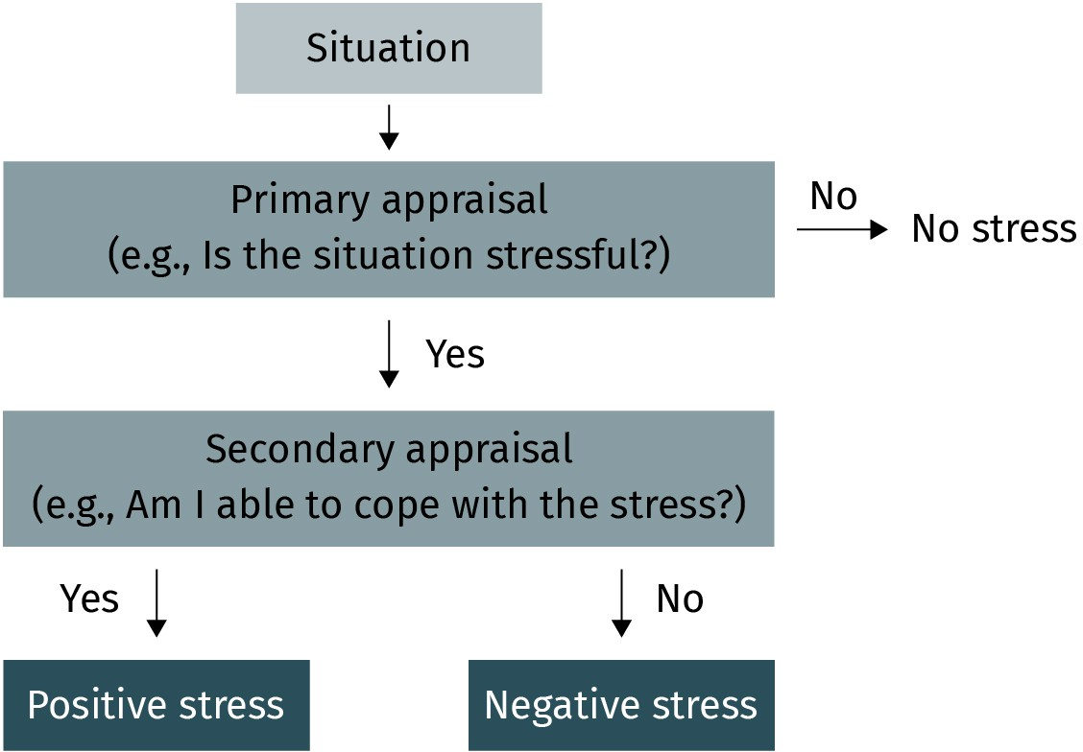

Source: Xian Cheng (2023), based on Lazarus & Folkman (1984).

As discussed previously, loss of control is one of the main psychological stressors. Regard- ing this stressor, employees should increase their autonomy on work content and develop an internal LOC (Schmitz et al., 2000). Specifically, employees can cope with stress by negotiating a flexible work schedule and setting reasonable goals to reduce time pressure (Joyce et al., 2010). With higher control over work characteristics, employees can engage in self-monitoring and pacing, and eventually control work outcomes. An optimal condi- tion is to achieve a work–life balance. Another example of reducing stress at the individual level is to restructure negative thoughts or perceptions of a job and engage in expectation management (Xie & Johns, 1995). This approach encourages workers to develop a clear understanding of the relationship between self and situation, which helps avoid self- doubt or frustration when facing demanding tasks. Rather than solely eliminating stres- sors by individual efforts, a healthy workplace involves effective communication and sup- portive interpersonal interactions at the group level.

###### Group-level prevention strategy

Maintaining social relationships with coworkers and supervisors is important for employ- ees who work in groups (Buunk & Schaufeli, 1999). As mentioned in the previous section, interpersonal conflict is one of the psychological stressors in the workplace (Frone, 2000a). Organizational psychologists recommend that workers build interpersonal rela- tionships within a group to reduce conflict and manage stress (Aamodt, 2015). While resolving interpersonal conflict, each group member should positively interact with others by avoiding unfriendly behaviors and disrespectful arguments. A key to reducing stress via a group-level approach is developing clear role descriptions and avoiding social loafing (Thakore, 2013). For instance, when five coworkers are working as a team, it is necessary to be clear about the responsibilities and job requirements in advance. In sum, many psy- chological stressors are manageable in a supportive and fair group climate (Liden et al., 2000).

###### Organizational-level prevention strategy

In addition to limiting the work stress at individual and group levels, intervention from the organization is also a key component in promoting employees’ well-being (Ivancevich & Matteson, 1987). Although work stress affects the individual, it can be effectively managed at the organizational level by changing the organizational structure and climate (Suther- land & Cooper, 2000). For instance, companies can facilitate a culture of support, respect, and reward fairness, and promote safety in the work environment. After studying an inter- vention in Danish businesses, a group of psychologists found that providing performance feedback and appraisal at the organizational level significantly affects employees’ behav- ioral stress and job satisfaction (Nielsen et al., 2007).



**SUMMARY**

In this unit, you have learned that work analysis can be conducted in two ways: work-oriented analysis, which focuses on the nature of the tasks and duties for a specific role, and worker-oriented analysis, which

evaluates what employees do at work and the corresponding individual characteristics required in a job. Each type of work analysis has its own measurement approaches. In addition, motivation is an essential issue of work performance. The two-factor theory addresses two job-related elements which can affect a person’s work motivation and categorizes them as motivators or hygiene factors. According to the goal-setting theory, goal-setting processes are most effective if the goals are specific, attainable, accepted by the members as legitimate, and accompanied by helpful feedback. In connection to employee health, work stress is asso- ciated with specific physical and psychological stressors. If the stressors chronically occur in the workplace, they could negatively affect different facets of employee well-being.

# UNIT 5

## ORGANIZATIONAL PSYCHOLOGY

**STUDY GOALS**

On completion of this unit, you will be able to ...

* define organizational psychology and its focus.
* describe the organizational culture and understand it from five facets.
* understand how people work as a team.
* learn different levels of work conflicts and causes of conflict.
* know how to manage workplace conflicts.
* understand mergers and acquisitions from a psychological perspective.

### 5. ORGANIZATIONAL PSYCHOLOGY

#### Introduction

Nowadays, various organizations are set up and run in the industrialized world. Their sizes range from a convenience store that hires one cashier from the local community to an oil giant that could employ thousands of employees around the world. Managing a large enterprise is much more complicated than managing a store. To deal with human nature and ensure individuals work effectively in an organization, many psychologists assist man- agers in solving practical problems at work (Cascio, 1995; Sparks et al., 2001). In the United States, organizational psychology has become one of the most rapidly growing fields in psychology and largely influences people at work (Katzell & Austin, 1992).

On the one hand, along with organizational development, the research interests of organi- zational psychologists dynamically shift to people-oriented issues rather than merely focusing on how to enhance work efficiency. On the other hand, the research findings and latest techniques of organizational psychology can influence corporate practices and inspire managers’ problem-solving processes. This unit covers several basic concepts to present the close connection between psychology and organization and how organiza- tional psychologists contribute to enhancing work effectiveness and work conditions for employees. Several case studies and examples are discussed in the unit.

**Organizational psychology**

a sub-field of applied psy- chology that focuses on employees’ work-related emotions, motivations, and behaviors in organi-

zations

**Evidence-based**

**conclusion** The results have to be based on empirical study and scientific methods. It is a crucial principle for psychologists while con- ducting research and applying psychological principles to solve organi- zational problems.

#### Fundamentals of Organizational Psychology and Structure

An organization is a social entity composed of a group of individuals working on a joint mission. **Organizational psychology** is one of the two major divisions of industrial–organ- izational (I–O) psychology. It examines employees’ emotional and motivational issues and their relationship to organizational behaviors (Aamodt, 2015). While combining the research methods from psychology and executive management practices, psychologists insist on making **evidence-based conclusions** that can be used to address practical prob- lems (McKenna, 2020). Evidence-based decision-making has become crucial for research- ers in supporting practitioners’ decision-making at work. The most notable characteristic of evidence-based research is that the results are drawn from an empirical study using the best available methodology (e.g., systematic observation, careful data collection, compre- hensive analysis). It simply means that scientific publications prove the investigation and evidence for practices.

Grounded in the evidence-based principles reflected in studies, researchers have different interests in understanding multiple phenomena in the workplace. Industrial psychologists are concerned with recruitment, selection, job analysis, and work performance (Landy & Conte, 2016). Rather than focusing on people’s attributions and work behaviors, organiza- tional psychologists embrace areas such as employee attitude, motivation, and leadership

in the workplace. In some sense, organizational psychologists are also concerned with team communication, corporate culture, and climate, representing a scientific explana- tion of individuals and organizations.

In organizations, many discussions and work behaviors are assumed to correspond with the development of culture and climate. Accordingly, the next section explores the nature and characteristics of organizational culture, as well as the challenges faced by interna- tional organizations with respect to the issue of diversity. The selected perspectives and theories will help you understand the interactions among individuals, teams, and the organizational environment.

#### Organizational Culture and Climate

##### What is Organizational Culture and Climate

The organizational environment is a popular construct mentioned frequently in academic journals and the business press. Many researchers and practitioners assume that the cor- porate culture and climate are closely related to organizational members’ work perform- ance and productivity (Ogbonna & Harris, 2000; Shahzad et al., 2012). They are highly interested in investigating and understanding the work environments of the organization. According to the literature, **organizational climate** is defined as the corporate members’ interrelated perceptions of the work environment that positively or negatively affects their work behaviors (Glisson, 2000). In other words, the climate is the aggregation of individu- als’ self-perceived experiences that they create and share at work, such as employees’ per- ceptions of support, fairness, stress, and conflict. As another essential concept of the work environment, organizational culture refers to a collection of shared assumptions, norms, values, beliefs, roles, and experiences of the corporate members (Schneider et al., 2013). These shared values and standards influence how employees behave at work.

Climate describes the psychological influence of the organizational environment, and cul- ture addresses the social context of the corporate environment (McKenna, 2020). Theoreti- cally, although the organizational culture and climate have different levels of analysis, they are often interchangeable in practice. Based on a shared culture and climate, corpo- rate members generate a similar way of viewing and interpreting work behaviors and events in practice that are usually distinguished from other organizations. A company’s culture could stem from the vision of the founder(s), who had a belief about what the organization should be. The vision and mission are grounded in the organizational culture that guides the work behaviors of all members.

The work-related culture and climate serve numerous functions within an organization. First, the primary purpose of organizational culture is to convey employees’ sense of iden- tity and enhance individuals’ commitment to the organization. For example, if an organi- zation has a positive, open, and collaborative culture, the high levels of agreement in this culture can facilitate employee creativity (Tesluk et al., 1997) and enhance employee retention (Sheridan, 1992). Second, a transparent and sustainable culture helps the organ- ization set boundaries, which define its role and provide meaning to the actions of

**Organizational climate** This term refers to employees’ self-perceived work environment and their organization as a whole. The primary aspects of organizational climate are organizational members’ perception of support, fairness, stress, and conflict.

employees. In this sense, the core cultural values of an organization are frequently distin- guished from those of other organizations. Every organization tries to create unique char- acteristics that reflect its culture in the workplace.

***anon***

*2024-06-12 12:47:06*

--------------------------------------------

awkward

***anon***

*2024-06-12 12:47:06*

--------------------------------------------

NEEDS to be introduced with far more sensitivity and awareness of the clunky, outdated terminology............

***anon***

*2024-06-12 12:47:06*

--------------------------------------------

this is a good example of a theory that NEEDS to be discussed alongside the criticism, as it comes across as reductive from an international perspective

In international organizations, recruiting international employees from various back- grounds can benefit people’s professional knowledge, innovative ideas, experiences, and global perspectives. Simultaneously, diversity not only provides advantages but may also bring weaknesses and threats. According to the study of Sosnovskikh (2016), domestic workers of a large international automobile manufacturer in Japan were more likely to put the group’s shared interests before their individual goals. The study also found that employees from outside Japan valued their individual contribution more than the group’s shared benefits. Thus, cross-national issues have become an essential topic for practition- ers in international organizations. To address the practical problem of diversity, Hofstede (2011) investigated many organizations worldwide and proposed a multidimensional model that differentiates organizational cultures from five perspectives.

###### Hofstede’s cultural dimensions theory

According to Hofstede (2011), organizational culture can be categorized under five dimen- sions:

* + 1. **Individualism versus collectivism** is related to the degree of integration of individu- als into groups. For example, in an individualist culture, the connection between indi- viduals is relatively loose, and everyone expresses more concern for self than for the group. On the opposite side, people in collectivist cultures are integrated into cohe- sive groups and concerned more about “we” than “I.”
    2. **Power distance** is related to the extent of inequality in power that is expected or accepted by low-power members of organizations. For instance, employees who work in a small power distance culture expect to be consulted instead of being passively told what to do. In contrast, employees in significant power distance cultures tend to be more obedient and accept orders from the upper hierarchy of the organization.
    3. **Uncertainty avoidance** is related to the degree of comfort the organizational mem- bers feel in ambiguous situations. For example, employees in a strong uncertainty avoidance culture avoid unclear rules, unusual structures, and other unknown work conditions. Conversely, people in weak uncertainty avoidance cultures, or uncertainty accepting cultures, are more open to unsure situations at work and are more willing to express deviant opinions.
    4. ​

**Masculinity versus femininity** is related to the distribution of values and emotional roles between men and women. For instance, the masculine culture is expected to be more competitive and ambitious and to emphasize achievement and success. The feminine culture expresses more modest and caring characteristics, and people in this

type of culture focus on interpersonal relationships and emotional needs.

* + 1. **Long-term versus short-term orientation** is related to organizational members’ val- ues that focus on an immediate or delayed sense of satisfaction. For example, people in short-term-oriented cultures think the most critical event happened in the past or is likely to happen in the present. However, people in long-term-oriented cultures believe that gratification will occur in the future and can be achieved with persistence.

The five dimensions of Hofstede’s theory significantly support other researchers and prac- titioners in categorizing organizational cultures. At the same time, it helps us understand the cultural influence in organizations.

#### Interaction and Communication in Organizations

##### Basics of Communication

Imagine the following situation taken from two different perspectives: An employee is frustrated because the team leader has never taken their constructive suggestions or com- ments seriously. Simultaneously, the leader does not understand why this subordinate frequently interrupts their presentations during team meetings. The above situation rep- resents a common communication problem between a speaker and a listener. In organiza- tions, the communication process can be upward; that is, communication flows from sub- ordinates to managers (Miles et al., 1996). The second type of organizational communication is downward; communication flows from managers to subordinates (Lunenburg, 2010). When coworkers are involved in a communication process, the exchange of information may occur in various ways, such as spoken, written, or other non- verbal formats, such as facial expressions, and eye contact (Aamodt, 2015).

Effective communication significantly contributes to trust at work (Zeffane et al., 2011). The importance of communication in organizations has been widely recognized. Training and developing specific basic interpersonal skills are necessary to ensure communication effectiveness. Active listening is the first essential skill for successful practice (Castle- berry & Shepherd, 1993). Unlike passive hearing, an active listener pays attention and tries to understand what the speaker intends to express fully (Weger et al., 2014). How, then, does one become an active listener in a conversation? One essential competency of the active listener is empathizing with the speaker in the workplace to grasp the picture from their point of view. Another value placed on active listeners is attentively hearing all con- veyed information so as to receive the whole meaning of the message (Levitt, 2002). Usu- ally, the message has two components: the content of the message itself and the attitude behind it. As an active listener, it is vital to respond to the factual content (e.g., show inter- est in what has been said) and be attentive to the subjective feeling underlying the con- tent (e.g., note the speaker’s facial expressions, gestures, and eye contact). More impor- tantly, not talking over or interrupting the speaker is also one of the characteristics of active listening.

The second communication skill is providing **performance feedback** (Klueger & DeNisi, 1996,2000). In organizations, performance feedback provides employees with information about how well they perform in the workplace. Scholars and practitioners have suggested that effective feedback has several characteristics: Feedback focuses on objective task performance (e.g., job-related behaviors) instead of criticizing aspects of the person (e.g., an employee’s personality). In addition, effective feedback should deliver enough infor- mation to improve performance and connect with the recipient’s goals. For instance,

***anon***

*2024-06-12 12:47:06*

--------------------------------------------

insufficient

**Performance feedback**

a form of communication that provides members of the organization with objective information about how well they per- form at work

organizations often develop performance appraisal systems to track employees’ contribu- tions and identify their strengths and weaknesses for future improvement (Mayer & Davis, 1999). During the feedback process, employees are given positive or negative responses in a short time interval and use the feedback to adjust their work performance. The success of communication is essential not only between two persons but also within a team in organizations (Devine et al., 1999).

##### Teams in Organizations

**Team** a collection of three or more members who cooperate to achieve a common goal, such as developing a product,

plan, or service

In organizations, individual employees have specific roles and are responsible for different tasks. Yet, there are few tasks that take place without any employee interaction. When the tasks are interdependent, a collection of three or more individuals may combine to form a unit to achieve a mutual goal. Then a **team** is generated for this purpose (Devine et al., 1999; Ilgen et al., 2005). Once the team is created, the members work together with shared identification, rights, and responsibilities (Kozlowski & Bell, 2003). Moreover, since the members’ tasks and goals are interrelated, they frequently cooperate to support each other and share information and resources (Guzzo & Dickson, 1996).

In the modern industrial environment, teams can be formed in many sizes and structures. A common type of team in organizations is the project team (Ericksen & Dyer, 2004). In a project team, people from different departments are grouped for one-time project results, such as upgrading an office automation system within a scheduled timetable. Compared with the worker that strives for individual excellence, the project team requires a balanced combination of employees’ interpersonal and problem-solving skills. For instance, a project team member should communicate and cooperate with others with diverse working styles and preferences. After examining the Fortune 500 companies, one

***anon***

*2024-06-12 12:47:06*

--------------------------------------------

old

empirical study found that clear project goals, continuity of project leadership, and virtual office usage are significant predictors of project team effectiveness (Scott-Young & Sam-

son, 2008). These elements are closely related to interaction and communication within the project teams.

Another common type of team is a work team, such as customer service and marketing teams (McKenna, 2020). The work team is defined as a small work unit that includes three to fifty members with specific responsibilities and can work interdependently. In this type of team, every member should be clear about the joint team goal and role (Krumm & Her- tel, 2013). While working jointly, interpersonal problems may hinder collaboration, such as differences in communication styles, lack of empowerment, and distrust of team lead- ers (Frone, 2000b; Thomas et al., 2005). These issues can be a potential risk for a failure of teamwork in organizations. The following section discusses why teamwork does not always work.

#### Conflicts in Organizations

When working as a team member in an organization, one might have to deal with misun- derstanding, misinterpretation, disagreements, dissatisfaction, and other unfavorable human behaviors on a daily basis. The current section covers the basic concepts of work

conflicts and discusses the skills that are necessary for conflict management. According to I–O psychologists, **conflict** in organizations commonly refers to a psychological and behavioral reaction related to friction and tension caused by actual or perceived differen- ces in people’s perspectives, claims, interests, and goals (Kolb & Putnam, 1992). However, the understanding and interpretation of work conflict may vary depending on the specific context and occasion.

***anon***

*2024-06-12 12:47:06*

--------------------------------------------

bullet-point list

##### Levels of Conflicts

Organizational conflict can be categorized into three levels: individual, intragroup, and intergroup conflict (Rahim, 2017). Individual conflicts appear when a person’s goal-achiev- ing path is challenged or blocked. A typical example of individual conflict is work–family role conflict. A cross-cultural study of life satisfaction found a negative relationship between work–family conflict and employee well-being (Lu et al., 2006). In addition to internal obstacles, organizational conflict could occur between two persons within a group. The primary sources of frustration in the workplace are intragroup conflicts, such as fairness, work autonomy, discrimination, and other ethical issues. The results of longi- tudinal studies show that intrapersonal problems within a group are negatively related to individual job satisfaction and agreement about the task (Jehn & Bendersky, 2003; Jehn & Mannix, 2001). The third level of organizational conflict is intergroup conflict, which occurs between competing groups (Bornstein, 2003). For instance, the organization’s marketing and finance teams could face conflict while working toward their budgetary goals or com- peting for resources.

##### Reducing and Managing Conflicts

The ideal solution for conflict is to avoid it before it occurs. For instance, many organiza- tions make formal and transparent regulations and conflict policies for handling disagree- ments (Aamodt, 2015). Yet, working together in organizations is not always successful for people with diverse backgrounds and goals. When conflict first appears, conflict manage- ment is crucial for organizations that pursue effective human resources management and higher productivity (Rahim, 2017). Conflict management training and workshops are help- ful for individual employees to learn practical skills they can use to solve their interperso- nal conflicts (Thakore, 2013). Taking intergroup conflict as an example, emphasizing com- mon goals and strengthening trust between two groups can help to resolve the conflict. Moreover, to minimize the destructive effect of organizational conflicts, scholars and prac- titioners are interested in the win–win resolution strategy, which focuses on achieving mutual beneficial outcomes between two parties (Davidson & Wood, 2004; Thakore, 2013).

#### Mergers and Acquisitions

With rapid economic developments, organizations and their members must face substan- tial changes. These organizational changes can be either downsizing or upsizing, and they can be minor or major. In modern industry, there are two forms of organizational change: mergers and acquisitions (M&As). Specifically, a **merger** refers to a process of integration of two or more separate organizations, which are approximately similar in size, joining

**Conflict**

the psychological and behavioral reaction to disagreement with indi- viduals’ perspectives, claims, and goals

**Merger** a form of organizational development whereby two or more independent organizations mutually integrate to become a

new entity

**Acquisition** a form of organizational development where a larger organization takes over the ownership, assets, and shares of a smaller organization

their forces to move forward as a single entity (Burke & Nelson, 1998; Burke, 2017). For instance, company A and company B are both concerned with reducing costs and creating higher economic value. As a result, they agree to combine their businesses and unlock their synergies of markets, customers, and products. During this merging process, both companies form a relatively equal partnership. Ideally, the newly established company is worth more than the two original companies.

As another form of corporate combination, an **acquisition** is described as a business proc- ess in which a larger organization (the acquirer company) buys the assets (e.g., buildings, machinery, equipment, and patents) and shares of a smaller organization (the target com- pany) in a specific market (Burke, 2017). For instance, if company A plans to enter a new market, it can take over company B’s intangible assets, such as its brand, trademarks, licenses, and other corporate intellectual property. This deal helps company A to multiply as a new owner and simultaneously minimize the risks involved in developing the same field. By contrast, company B loses ownership in this deal and becomes part of com- pany A.

Among different organizational changes, M&As are usually very important, complex, and costly projects that bring massive changes to organizations (Aamodt, 2015). They can operate on a domestic or international basis. No matter how big the changes are, M&A projects always have a great impact on employees’ psychological conditions (Cartwright & Cooper, 1993). In this regard, I–O psychologists and advisers from different areas help organizations focus their efforts on the crucial factors that significantly affect the success of M&As. We will now discuss M&As from the perspective of psychology.

##### Psychological Preparation for Mergers and Acquisitions

As mentioned earlier, the overarching reasons for corporate combination are diverse. Regardless of whether the deals are done for strategic reasons, the merger processes influ- ence people’s psychological states in the short-term or long-term (Sverke et al., 2002). Dur- ing the deal-making part of M&As, the buyers and sellers typically have different or even opposite psychological perspectives and mindsets. In this context, understanding the per- spective of employees can help management, which eventually enhances the probability of a successful combination (Marks & Mirvis, 2001). Given this, I–O psychologists and man- agers are interested in the psychological factors affecting the success or failure of M&As, such as employees’ work-related attitudes (Rafferty & Griffin, 2006).

##### Psychological Consequences of M&As

Throughout the combination process, many potential threats and difficulties may bring dilemmas to organizational members. According to the statistics, after reorganization, over half of the business combinations do not reach the original expectations (Schoen- berg, 2006). This failure could be the negative consequence of lacking psychological prep- aration at the individual level. Or, to put it another way, since employees usually prefer predictable, stable, and secure working conditions, most large changes are likely to be viewed as uncertain, risky, and stressful (Bamberger et al., 2012). The uncertainty of whether jobs will be lost, the economic concern about wages, and the lack of trust in the new organizations are some of the possible reactions of employees. These negative per-

ceptions of the job can affect employees’ work-related behaviors, as the employees are resistant to change (Giessner et al., 2006; Van Dam, 2005). When this resistance arises at work, employees will likely adopt a defensive stance and negative coping strategies in the long run (Fugate et al., 2008).

***anon***

*2024-06-12 12:47:06*

--------------------------------------------

redundant fluff. rework to be more specific...

Another common psychological state of employees facing M&As is loss of organizational identification (Gautam et al., 2004). Employees need to feel a sense of belonging when encountering unknown working conditions. According to Riketta’s (2005) meta-analysis, an employee’s organizational identification plays a crucial role in that person’s work- related attitudes and behaviors. For example, employees from the target company can have difficulty answering the questions of “who am I?” and “where do I belong?” in the new organization. In consequence, especially in cases of a hostile takeover, the employees will grow feelings of uncertainty and even anxiety about their career and tend to perceive a higher level of work stress (Cartwright et al., 2007). Regarding the importance of psycho- logical preparation, Cartwright and Cooper (1993) commented that compatibility signifi- cantly predicts the success of the combination.

In summary, resistance to change and loss of organizational identification are the two expected psychological consequences for the employees that need to deal with it effec- tively. From the management level, researchers suggest that leaders should be responsi- ble for raising employees’ awareness of future stressors and ensure a smooth implemen- tation of the M&As (Ashkenas & Francis, 2000; Marks & Mirvis, 2001).

##### The Role of Leadership in M&As

Building upon the previous topics and discussion, you could spend some time thinking about whether leadership matters in mergers and acquisitions. If your answer to the ques- tion is “yes, it does,” you are ready to learn more about the role of leadership during this complicated business process.

###### Transformational leadership and organizational commitment

According to a meta-analysis of modern leadership, among different leadership styles, transformational leadership was found to positively shape employees’ commitment to their organization (Jackson et al., 2013). A leader categorized as a transformational leader has some typical behavioral characteristics: First, idealized influence is demonstrated by the leader who cares about the organization and its members (Bass, 1999). Since the leader is concerned with the shared mission and vision of the group, their followers would be more likely to develop an attitude of trust and enhance their organizational identifica- tion. In addition, inspirational motivation occurs when the leader sets a challenging goal for the employees and encourages them to expand their potential at work. The third type of behavior is intellectual stimulation, which refers to fostering creativity and critical thinking among the employees. Finally, individualized consideration occurs when the leader observes and recognizes employees’ strengths and weaknesses through close supervision (Jackson et al., 2013).

***anon***

*2024-06-12 12:47:06*

--------------------------------------------

how is the book seriously this short? expand on the good bones of it with more recent studies, evidence, and an injection of CRITICAL DISCUSSION AND THEORY.



**SUMMARY**

In this unit, you have learned that organizational psychology is an appli- cation-oriented science that primarily investigates employees’ work- related emotions, motivations, and behaviors in organizations. Another major topic of organizational psychology is organizational culture and climate, which can be described along five dimensions. During the work routine and social interaction, becoming an active listener and providing performance feedback to coworkers are crucial communication skills for individual employees. While communicating with others, work conflict is an unavoidable issue that every organizational member needs to cope with. Analyzing work conflicts from three levels helps employees effec- tively reduce and manage their internal and external conflicts in organi- zations. As the main formats of organizational change, mergers and acquisitions create uncertainty and can have an influence on employees’ psychological state. Under the changed circumstance, the expected psy-

chological preparation can be carried out at both an individual and a leadership level.

chological consequences are resistance to change and loss of organiza- tional identification. While facing organizational changes, adequate psy-