

PUBLIC HEALTH

**DLMGWPH01_E**



***anon***

*2024-06-13 08:57:51*

--------------------------------------------

generic, boring

***anon***

*2024-06-13 08:57:51*

--------------------------------------------

too short, boring

***anon***

*2024-06-13 08:57:51*

--------------------------------------------

no course book, unit, etc.

**LEARNING OBJECTIVES**

This course in **Public Health** provides an overview of the major principles underlying the theory and practice of this multidisciplinary field. The course book covers basic epidemio- logical, demographic, statistical, social science, and economic methods, and discusses ethical aspects of public health issues. You will also learn about the models used to explain health and disease, as well as the individual, social, and environmental factors that influence health. You will also develop professional skills in disease prevention and health promotion and be able to analyze the health of populations and develop and evalu- ate solutions to practical public health problems.

**12 PREVIEW-PDF, erzeugt: 2024-06-13T09:48:30.258+02:00**

# UNIT 1

## BASICS OF PUBLIC HEALTH

###### STUDY GOALS

On completion of this unit, you will be able to ...

* define public health and list its goals.
* explain how public health has developed throughout history.
* understand which actors are involved in promoting the health of the population at national and international levels.
* explain why public health requires an interdisciplinary approach.
* discuss why ethical issues must be considered when planning public health strategies.
* understand why the findings of health services research must be considered when assessing public health strategies.

### 1. BASICS OF PUBLIC HEALTH

***anon***

*2024-06-13 08:57:51*

--------------------------------------------

write so that it's just about john snow. the "anja" framing is a bit redundant/simplistic.

***anon***

*2024-06-13 08:57:51*

--------------------------------------------

APA7: don't just drop a citation at the end of a paragraph. it's unclear.

***anon***

*2024-06-13 08:57:51*

-------------------------------------------- WHO (2006)

***anon***

*2024-06-13 08:57:51*

--------------------------------------------

. (p. 1)

Bad formatting. Fix it.

***anon***

*2024-06-13 08:57:51*

--------------------------------------------

cut

***anon***

*2024-06-13 08:57:51*

--------------------------------------------

cite and be more specific

***anon***

*2024-06-13 08:57:51*

--------------------------------------------

awkward

#### Case Study

Anja is studying health management and found an interesting article about John Snow (1813–1858) in the university library. John Snow worked on addressing crucial public health issues almost 200 years ago, such as the following:

* + Where do diseases come from?
  + How do they spread through the population?
  + How can they be avoided?

London was plagued by recurring cholera outbreaks throughout the 19th century. The extremely fast and fatal course of the disease made the population fearful: A cholera patient who got up in the morning without symptoms could die from severe diarrhea within a few hours as it dehydrated the body. At the time, the medical profession believed that cholera was transmitted via “bad vapors” in the air. However, John Snow doubted this theory and traced all cholera cases on a street map of London. It struck him that most of the cholera cases occurred around Broad Street. There was a water pump there, from which the surrounding residents obtained their drinking water. John Snow suspected that cholera was caused by contaminated drinking water. Through interviews, he found that all those who died of cholera had obtained their water from the Broad Street pump. He then had the handle of the pump removed and shut down the water source. However, Snow’s theory that cholera spreads through drinking water was not accepted by the medical com- munity until after his death (Barton, 2018).

#### What is Public Health?

To understand the concept of “public health,” we first need to define the term health. The best-known definition of health is contained in the preamble to the constitution of the World Health Organization (WHO). The WHO defines health as

a state of complete physical, mental and social well-being and not merely the absence of disease or infirmity. The enjoyment of the highest attainable standard of health is one of the fundamen- tal rights of every human being without distinction of race, religion, political belief, economic or social condition.

(WHO, 2006, p. 1)

Health is understood multidimensionally. The WHO definition has often been criticized as utopian due to the inclusion of the adjective “complete.” Its great advantage, however, is that it provides an integrative perspective: In addition to the aspects of physical health,

we must also consider its mental, spiritual, and social dimensions. This is one of the main reasons it is highly relevant to politics, practical disease prevention, and health promotion (Franzkowiak & Hurrelmann, 2018).

Accordingly, public health is defined by the WHO as “the art and science of preventing dis- ease, prolonging life and promoting health through the organized efforts of society” (WHO, 1998, p. 13). This means that public health seeks to enhance and protect the well- being of individuals and the communities in which they live, learn, work, play, etc.

In contrast to the specific problems of an individual patient and their medical care, public health focuses on the entire population’s health concerns and seeks to devise ethically and economically justifiable measures to solve the population’s health problems. Public health seeks to

* maintain and promote the health of the entire population or of specific population groups;
* prevent disease, disability, and death; and
* provide suitable preventive, curative, and rehabilitative services (Egger et al., 2018a, p. 31).

Public health is interdisciplinary. Social sciences, epidemiology, biostatistics, and health management are a few examples of fields that are important in public health, but it also covers other subfields, including workplace safety, disability, sexual and reproductive health, gender issues in health, public policy, health economics, mental well-being, and politics of health (Turnock, 2012). As such, physical, mental, and social well-being all need to be considered when discussing public health. Thus, it may be claimed that, along with **primary**, secondary, and tertiary care, a nation’s healthcare system should incorporate public health. This is because promoting healthy behaviors while engaging in public health activities requires looking at health indicators like life expectancy (Turnock, 2012).

***anon***

*2024-06-13 08:57:51*

--------------------------------------------

fix all awkward language

***anon***

*2024-06-13 08:57:51*

--------------------------------------------

sources throughout the book seem a bit too old (need more 2020+)

***anon***

*2024-06-13 08:57:51*

--------------------------------------------

missing introduction to the subsections

Typical public health measures include, for example, vaccination programs, screening pro- grams, educational campaigns, food safety and occupational safety measures, and efforts to shape public policy and laws, such as bans on smoking in public spaces or mandating the wearing of seat belts (Egger et al., 2018a, p. 31).

#### Historical Development

##### Historical Milestones of Public Health

The term public health is still young, but several notable figures made seminal discoveries in the field long before the discipline was named as it is today.

**Primary care**

This is the first point of contact responsible for coordination of health- care (e.g., the general practitioner [GP]). Pri- mary care is comprehen- sive and includes treat- ment, prevention, palliative care, etc.

Hippocrates (~460–370 BCE)

The term “epidemic” goes back to Hippocrates, who stands for rational explanations of diseases instead of supernatural ones (e.g., fate or the will of the gods). For example, he observed that malaria is more prevalent in swampy areas than in dry areas, not recogniz- ing transmission by mosquitoes (Merrill, 2021, p. 95). The idea of linking diseases to envi- ronmental conditions is still important today.

Avicenna (Ibn Sina, 980–1037) and Fracastero (1477–1553)

Avicenna was a Persian physician and philosopher who contributed to epidemiology by pointing out the need for experimentation and quantification. In addition, he suspected that infectious diseases can be spread by contagion and proposed quarantine for preven- tion. In the book *Canon of Medicine*, he explained that nutrition and physical activity are part of the explanation of disease and health (Rothman, 2012, p. 11). The idea of contagion was further developed by the Italian Fracastero. As a forerunner of Germ Theory, he pre- sented the theory that diseases are spread by tiny “seminaria” that can reproduce them- selves (Rothman, 2012, pp. 11–12). Although this theory led the way, it could only be developed further after the Dutchman Antoni van Leeuwenhoek (1632–1723) had further developed the microscope, enabling groundbreaking discoveries (Merrill, 2021, p. 122)

John Graunt (1620–1674)

***anon***

*2024-06-13 08:57:51*

--------------------------------------------

why is a secondary source cited here? cite primary sources if you're talking about a primary source. this is confusing.

***anon***

*2024-06-13 08:57:51*

--------------------------------------------

APA7: "down" style, please...

***anon***

*2024-06-13 08:57:51*

--------------------------------------------

direct to primary sources in all such cases

***anon***

*2024-06-13 08:57:51*

--------------------------------------------

these??

***anon***

*2024-06-13 08:57:51*

--------------------------------------------

secondary data are not an analysis. they're data. fix all such problems.

***anon***

*2024-06-13 08:57:51*

--------------------------------------------

a lot of this reads as redundant due to the case study

**Life table** These show the probabil- ity of dying within the next year and the (fur- ther) life expectancy for each age group. In epi- demiology, they are used to represent the longevity of a population, and insurance companies use them to evaluate their products (e.g., life insur-

ance policies).

**Secondary data** This analysis involves analyzing existing data to answer scientific ques- tions. These are mostly data collected for other purposes (e.g., data from a hospital for the treat- ment of patients or data from an insurance com- pany for the invoicing of

treatments).

Epidemiology and statistics owe many current ideas to John Graunt. He had the ground- breaking idea of compiling the already available data of the *Bills of Mortality*, which was a weekly publication informing about births, deaths, and causes of death. Using these data, he was the first to calculate **life tables** and life expectancy (this is an early example of **secondary data** analysis). On this basis, he discovered different mortality risks, such as that (at that time) children had a higher mortality rate than adults. Furthermore, he was able to identify time trends in the causes of death from the data, and was able to conclude that more people probably died from the plague than was indicated in the *Bills of Mortal- ity*. This goes hand-in-hand with the fact that Graunt has critically examined the collection and classification of data. Likewise, he has meticulously described his own methods and invited others to criticize his work. Many of these and other impulses can still be found in epidemiology and statistics today (Merrill, 2021, pp. 124–127; Razum et al., 2017, pp. 46– 47; Rothman, 2012, pp. 12–13).

John Snow (1813–1858)

Perhaps the most famous person in the history of epidemiology is John Snow. He is even more famous in medicine for introducing anesthesia, while in epidemiology he is best known for his pioneering investigations into cholera outbreaks in London. He hypothe- sized that cholera was transmitted via polluted water, whereas the prevailing opinion was that cholera was transmitted via “bad air” (miasma). To support his theory, he used a nat- ural experiment, in this case, the fact that two companies took their water from the Thames and distributed it to the inhabitants of London. The Lambeth company took its water upstream outside London, so it was cleaner than the water from Southwark & Vaux- hall, which took its water from the Thames near to where sewage was disposed of. If his

hypothesis of cholera transmission via contaminated water was correct, then Lambeth customers should have a lower cholera mortality than Southwark & Vauxhall customers. To test this, he obtained data on how many households were supplied by each company. He also obtained mortality data and asked the relatives of people who died of cholera which company they used. With these data, Snow found that Southwark & Vauxhall cus- tomers were 8.3 times more likely to die from cholera than Lambeth customers. Thus, John Snow exemplified hypothesis generation and the systematic collection and statisti- cal analysis of epidemiologic data and their interpretation (Razum et al., 2017, pp. 50–54; Rothman, 2012, pp. 70–71).

Furthermore, Snow is known for locating an outbreak of cholera in the Soho district in 1854 by finding the addresses of the deceased and plotting them on a map. This map also showed the water pumps in Soho, and with deaths clustering around the Broad Street pump, Snow was able to identify it as the source of the outbreak. He informed local authorities, who removed the pump’s handle, which is an example of evidence-based pol- icy advice (Razum et al., 2017, pp. 55–58).

Ignaz Semmelweis (1818–1865)

Ignaz Semmelweis from Hungary discovered that childbed fever is caused by lack of hygiene in hospitals by comparing mortality rates in two maternity departments of the same hospital in Vienna. In the department where midwives were responsible for the mothers, mortality was significantly lower than in the department where medical students worked. From various observations, Semmelweis concluded that the students transmitted childbed fever to the mothers by not washing their hands after autopsies and subse- quently examining the mothers. Therefore, Semmelweis introduced hand washing before examinations, which reduced mortality even below the level of the midwife department. Since he was unable to ground the successful intervention in a medical theory (germs were not yet known), he was mocked, his findings were ignored, and hand hygiene did not gain acceptance until much later (Merrill, 2021, pp. 108–110).

Florence Nightingale (1820–1910)

Florence Nightingale worked as a nurse during the Crimean War and implemented hygiene standards that reduced mortality. She is significant to both epidemiology and bio- statistics because she systematized data collection in nursing and was excellent at visual- izing data, which was unusual at the time. Her exceptional talent is reflected in the fact that she was the first female fellow of the Royal Statistical Society (Merrill, 2021, pp. 131– 134; Rothman, 2012, pp. 17–18).

Developments in the 20th century until today

Up to the present day, the field of epidemiology has expanded considerably. It deals with both communicable and non-communicable diseases (NCDs). Another important aspect of modern epidemiology is the relationship between behavior and health. The famous British Doctors Study is a classic example of both behavior and NCDs, and proved as early as the 1950s that smokers have a significantly increased risk of lung cancer (Doll & Hill,

1954). The British Whitehall Study, which examined the relationship between stress, social status, and heart attack, is also noteworthy. Another important study on the effects of social inequality on health is the British “Black Report” published in 1980.

***anon***

*2024-06-13 08:57:51*

--------------------------------------------

feels like there should be a table summarizing the differences here.

An important trend is international comparative studies that consider not only medical and socioeconomic aspects, but also other factors influencing health, such as social sup- port from the family and imitation of peer behavior. An example of an international study that looks at health from the perspective of social science and psychology is *Health Behav- iour in School-Aged Children*, which is conducted in 51 countries every four years.

##### Old Versus New Public Health

When considering the development of the field over time, we can divide public health into the separate periods of “old public health” and “new public health.” The focus of “old pub- lic health” was on public hygiene and the implementation of measures to improve the liv- ing and working environments of the underserved and socially vulnerable population groups (Nowak et al., 2022, p. 1). In the 19th century, this included workers and their fami- lies who lived in the cities under completely unhygienic conditions in particular. Cramped living conditions, lack of sanitary facilities, and contaminated drinking water resulted in cholera epidemics and numerous cases of tuberculosis. Therefore, the reform efforts to improve the social and health situation of the working class included the very first public health measures, such as improved sanitary conditions and the construction of water pipelines and sewage systems (Egger & Fenner, 2018, p. 33). This made a decisive contri- bution to the prevention of illness and the improvement of mortality rates among the population. With the advent of “new public health” in the 1980s, the focus was no longer on just underserved population groups, but rather on the entire population. In addition to the question of the determinants of health and illness and how they are influenced by health promotion measures and healthcare services, questions concerning control over the health system and the monitoring of health expenditures also came into focus (Nowak et al., 2022, p. 3). Challenges on a global level were also addressed.

#### National and International Actors in Health Promotion

According to the WHO’s Ottawa Charter of 1986, health promotion is defined as “the proc- ess of enabling people to increase control over, and to improve, their health” (WHO, 1986, p. 1). To manage health challenges, governments, communities, and individuals need the assistance of health promotion. This can be achieved with the creation of efficient public policies, hospitable settings, and building both individual and community capacities. Enhancing living and working situations that affect people’s overall well-being, as well as their individual and collective health-related behaviors, is the goal of health promotion (WHO, n.d.-c). Health promotion is crucial due to the following reasons (Merkur et al., 2015):

* + - Everybody’s quality of life is enhanced by health promotion.
* It decreases premature deaths.
* It emphasizes **prevention** and thus lowers the financial and human costs that different stakeholders (families, patients, healthcare providers, and insurance companies) would have to pay for the provision of healthcare.

##### Actors in Health Promotion

Patients, members of the healthcare team, health educators, insurance providers, govern- mental organizations, United Nations (UN) agencies (like the WHO), local academic institu- tions, international non-governmental organizations (NGOs), and insurance providers are just a few examples of stakeholders in health promotion. Additionally, the private sector, such as pharmaceuticals companies, have become actors in health promotion, particu- larly through providing health awareness and health education (Haldane et al., 2019). Ide- ally, participants in health promotion programs take part in a program’s development, implementation, evaluation, and funding. The effectiveness of a health program, as well as the uptake of health-related initiatives by people and communities, are commonly influenced by stakeholders in health promotion (Haldane et al., 2019). In the figure below, the different local and international actors are presented.

Figure 1: Health Promotion Actors

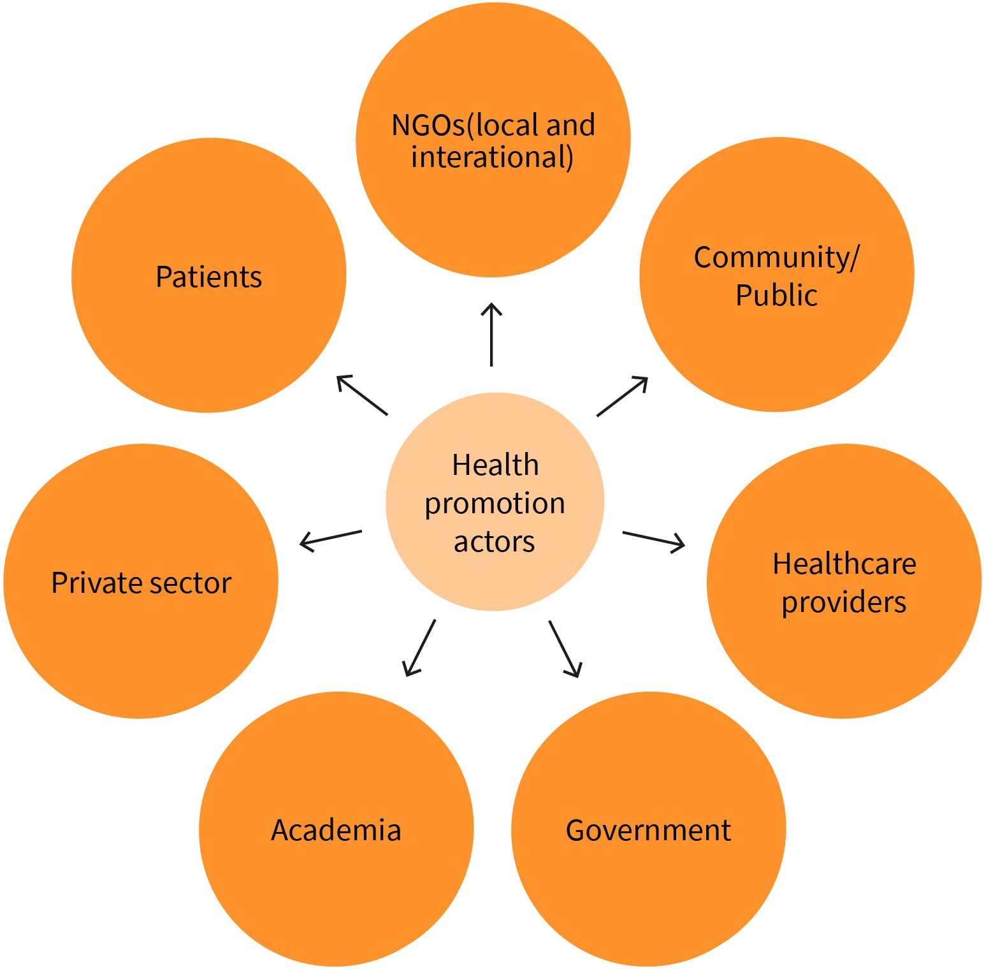

Source: Mirna Naccache (2023).

*Medecins Sans Frontières* (MSF), also known as Doctors Without Borders, is an example of a global humanitarian NGO that promotes health in and offers medical assistance to impov- erished or conflict-ridden countries (Mackintosh et al., 2016). MSF uses health promotion to address a variety of health challenges, from gender-based violence to preventing the spread of Ebola. Most notably, MSF has been essential since the late 1990s in the delivery of medical services and promoting ways to prevent and fight infectious diseases in Africa, specifically malaria (Mackintosh et al., 2016).

Similarly, the Cochrane Collaboration is a global, non-profit organization that aims to aid in the preparation, upkeep, and promotion of systematic evaluations of the impacts of healthcare interventions. Updated information on public health and health promotion ini- tiatives, programs, and the like is included in their publications (Levin, 2001). This allows people to make well-informed and evidence-based decisions about their healthcare.

A key agent at the international level is the WHO. It is the UN’s coordinating body responsi- ble for international public health. A declared goal of the WHO is to improve the health and well-being of all people. This is reflected, for example, in the WHO strategy “Health for All” (Egger, Low, et al., 2018, p. 601). The WHO’s main focus areas are helping countries establish nationwide healthcare systems, providing information on health risks and prob- lems, and coordinating activities to prevent communicable and non-communicable dis- eases, for instance, by launching vaccination programs. The WHO publishes the annual World Health Report on the state of global health and healthcare.

#### Disciplines of Public Health

Public health requires an interdisciplinary approach and draws on methods and findings from various scientific disciplines. A distinction can be drawn between the two branches of science: life sciences and the social and behavioral sciences (Hurrelmann & Laaser, 2003, p. 31). At the core of the traditional practice of the life sciences is epidemiology, which deals with the temporal and geographic characteristics of diseases and their risk factors. Another important field is biostatistics, which deals with statistical questions relat- ing to medical care. The insights of this field are supplemented by occupational medicine, which focuses on work-related illnesses and their prevention. Environmental medicine investigates environmental influences on the health of the population, such as air or water pollution, while preventive medicine focuses on avoiding disease through vaccinations to prevent infectious diseases or screening programs for the early detection of chronic dis- eases (Egger et al., 2018c, p. 49).

Medical sociology, demography, health psychology and pedagogy, health economics, health policy, organizational and management sciences, and ethics all fall within the social and behavioral sciences. Medical sociology deals with the social conditions, causes, and consequences of health. Demography considers population developments and deals with the social effects of a changed population structure. Human experience and behavior are at the heart of health psychology. It aims to understand health-related behaviors and attitudes. Health pedagogy, or health education, refers to the teaching and promotion of health-related knowledge, skills, and behavior, and is therefore closely related to health psychology. Health economics analyzes the economic impact of health and disease. Health policy deals with the institutions in the health system and the political framework for the provision of care. Organizational and management sciences focus on the processes and decisions within healthcare organizations. Ethics is concerned with questions of good and right actions: A key concern of ethicists is the fair distribution of scarce resources within the healthcare system (Egger et al., 2018c, p. 49).

#### Public Health Ethics

Public health ethics is a relatively new field of applied ethics that deals with ethical issues in public healthcare. The aim is to evaluate measures taken to monitor, control, and pre- vent diseases from a moral point of view to evaluate whether they are proper and to develop standards for good and correct action (Egger & Habermann-Horstmeier, 2018, p. 58).

An important basis for evaluating actions is consequentialist ethics, which considers them based on their consequences. An action is ethically justified if it leads to good consequen- ces. Utilitarianism plays an important role within consequentialist ethics. Under this framework, a measure is considered justifiable if the resulting overall benefit is positive. This includes the possibility that an action may have adverse consequences for some peo- ple. We will return to this aspect when considering screening measures. From a popula- tion-related perspective, screening measures have the advantage of allowing diseases to be detected early and premature deaths to be avoided. Since screenings are intended to detect as many cases of disease as possible, one will try to use a diagnostic test with as high a sensitivity as possible. This means a diagnostic test is set to be positive when in doubt. This also leads to false-positive test results (i.e., false alarms), which can entail a high amount of psychological stress for those affected until the results are further clarified on the basis of additional testing. This raises the question of whether screening programs are unethical. From a utilitarian point of view, the answer to the question would be “no,” since the overall benefit for the population outweighs the concern about the stress it pla- ces on the individual.

The principles outlined by Beauchamps and Childress (2001) play an important role in medical ethics, as they provide key guidance for the actions of those involved in health- care, nursing, and research. These are autonomy, beneficence/non-maleficence, and jus- tice. In the area of public health ethics, the principles of interdependence, participation, and scientific evidence are also relevant (Egger & Habermann-Horstmeier, 2018, p. 59).

Table 1: Principles of Medical and Public Health Ethics

**Medicine Public health**

|  |  |
| --- | --- |
| Respect for autonomy | Interdependence |
| Each person can make decisions freely. The patient must provide informed consent before receiving medical treatment or participating in a study. | A person’s actions affect not only themselves but also other people. Each person is also affected by the actions of others. |
| Beneficence and non-maleficence | Participation |
| Harmful or risky interventions and treatments should be avoided. The treatment/study should promote the well-being of the patients or study subjects. | Public health measures are planned and imple- mented with the participation and consent of the affected population. |
| Justice | Scientific evidence |

**Medicine Public health**

***anon***

*2024-06-13 08:57:51*

--------------------------------------------

try to break up such long paragraphs

***anon***

*2024-06-13 08:57:51*

--------------------------------------------

some kind of bullet-point list or use of heading 4 might be nice for breaking this up

|  |  |
| --- | --- |
| The principle of justice demands a fair distribution of health services, as well as the risks and benefits of clinical research. | Decisions about public health measures should be based on scientific data rather than assumptions and opinions. |

Source: Created by another author, based on Egger & Habermann-Horstmeier (2018).

The principle of autonomy states that the individual’s freedom of choice must be respected. Each individual must be able to decide freely whether to participate in a meas- ure or not. However, the principle of autonomy must be weighed against the principle of interdependence. This refers to the fact that the actions of the individual usually also have an impact on third parties. When considering this, a smoking ban in public places, for example, can be justified, since smoking not only has negative health effects on the indi- vidual smoker but also on others through secondhand smoking. The principle of benefi- cence/non-maleficence calls for promoting the well-being of people and preventing harm. This obligates the state to become active in the field of public health to ensure a healthy life for all people. The principle of participation states that when designing public health measures, the wishes of those affected must be considered and, if possible, no measures should be implemented against the will or without the consent of those affected. The prin- ciple of justice demands that all people should have equal access to health services. When designing public health measures, care must be taken to ensure that these are not only used by those with better socioeconomic and health statuses so socioeconomic differen- ces in health status are not further aggravated. Finally, the principle of scientific support requires that only scientifically grounded public health measures be carried out (Egger & Habermann-Horstmeier, 2018, p. 59).

#### Necessity of Health Services Research

Scientific findings are essential for establishing a needs-based orientation of healthcare. Health services research plays a special role here: It examines the structure and perform- ance of healthcare offerings and assesses them based on the criteria of availability, acces- sibility, and benefit (Egger et al., 2018c, p. 51). The focus here is on evaluating the effec- tiveness of healthcare structures and processes under everyday conditions. This type of research does not evaluate an intervention on the basis of an isolated criterion and under ideal conditions, as is the case of clinical studies. Rather, it assesses the effectiveness of the intervention when integrated into day-to-day healthcare processes and structures. Based on these findings, existing healthcare concepts can be further developed or new approaches for care can be designed; tested in everyday healthcare situations; and, if the evaluation is positive, permanently incorporated into everyday practice (Pfaff, 2003, p. 13).

Health services research uses the throughput model to provide a systematic analysis and description of the healthcare system.

Figure 2: Throughput Model of the Supply System

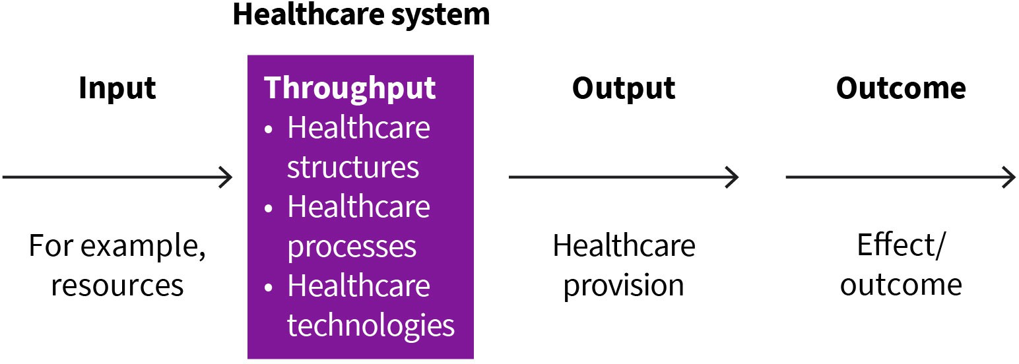

Source: Created by another author, based on Pfaff (2003).

Accordingly, health services research considers the following aspects of the healthcare system (Pfaff, 2003, p. 16; Schwartz & Busse, 2000, p. 409):

***anon***

*2024-06-13 08:57:51*

--------------------------------------------

The input identifies ...

***anon***

*2024-06-13 08:57:51*

--------------------------------------------

redundant. delete this.

**Output** This concept describes the outcomes of health- care that can be directly

observed.

* The term “input” identifies factors that influence the healthcare system. These include, for example, financial resources, human resources, and material equipment, but also the state of health of the population to be cared for or organizational and system struc- tures, such as the distribution of assignments between the professional groups involved in providing healthcare. If the goal is to measure the effectiveness of skin cancer screen- ing, one of the things that would be captured here is how many physicians have the necessary qualifications and how many people can be put through the program given the resources available.
* The term “throughput” summarizes organizational, diagnostic, therapeutic, and nurs- ing structures, processes, and technologies. The aim of the throughput analysis is to shed more light on the healthcare process. In order to do this, healthcare processes are examined, whereby the utilized healthcare technologies and the settings are reviewed to see if they are appropriate to meet current needs. In the example of skin cancer screening, one would look at how efficiently resources are used (is there idle time, long wait times, etc.?)
* The term **“output”** describes the short-term results of healthcare immediately after such services are used. For skin cancer screening, the outcome would be counted as how many people are screened, how many abnormal findings there are, and how many follow-ups and treatments the screening results in.
* The term “outcome” refers to medium- to long-term health results. These are the deci- sive evaluation criterion that can be used to answer many questions, but they can only be determined with a temporal delay. Medical-clinical parameters, such as survival rates, quality of life, and patient satisfaction, are used as indicators to measure the out- comes. Specifically for skin cancer screening, we would look at whether screening reduces skin cancer mortality.

**SUMMARY**



Public health focuses on the health situation of the population and aims to promote and maintain its health using appropriate measures.

The beginnings of public health can be traced back to the 19th century. Thanks to the introduction of public hygiene measures, such as the con- struction of sewers and water pipelines; the search for the underlying causes of disease; and the introduction of a range of health promotion programs and appropriate healthcare services, the population has bene- fited from continuous improvements to their health over the years.

Health promotion is an interdisciplinary task that requires the coopera- tion of a diverse range of agents from the healthcare, social services, and educational systems, as well as from the employment and leisure sec- tors at national and international levels.

The disciplines on which public health is based are just as diverse as the agents involved in health promotion. Best practices from the life scien- ces, as well as from social and behavioral sciences, are used to plan and evaluate public health strategies.

In addition, ethics play a crucial role in the moral evaluation of measures used to monitor and prevent diseases. It is important to consider the individual’s freedom of choice, the impact of individual actions on third parties, and the benefits and risks of measures from a scientific and social point of view and in light of a fair distribution of benefits. This process requires findings from health services research that consider the structure and performance of the range of available healthcare services, as well as their accessibility and use by the population in everyday con- ditions.

# UNIT 2

## PUBLIC HEALTH – DISCIPLINES AND

**METHODS**

###### STUDY GOALS

On completion of this unit, you will be able to ...

* explain which epidemiological parameters can be used to describe the health situation of the population and how health risks can be quantified.
* define age standardization and explain why it is necessary.
* understand what makes something statistically significant and what this concept means.
* differentiate between quantitative and qualitative data collection methods.
* define efficacy and community effectiveness.
* evaluate alternative courses of action.

### 2. PUBLIC HEALTH – DISCIPLINES AND

***anon***

*2024-06-13 08:57:51*

--------------------------------------------

WAY too short. align all case studies/introductions to ensure they have (1) similar lengths, (2) levels of detail, and (3) some manner of prompting the student to think deeply.

***anon***

*2024-06-13 08:57:51*

--------------------------------------------

this is way too simplistic for a university book. rewrite this completely using a relevant, recent example. force the student to THINK CRITICALLY.

***anon***

*2024-06-13 08:57:51*

--------------------------------------------

again, do not cite in this manner. improve source variety, as otherwise the book feels biased.

**METHODS**

#### Case Study

While conducting a literature review, Anja, a student, learned that public health actually consists of several disciplines and uses different methods. She finds the field quite intrigu- ing, and she wants to know more about its working methods. She is interested in how data on the population’s health situation can be collected and analyzed and how public health strategies can be evaluated. She also knows from other modules that healthcare resources are limited. Therefore, she would like to learn more about how an informed decision can be made for or against a public health measure, given that resources are scarce.

#### Epidemiology

Epidemiology forms the basis of all approaches to public health. Using epidemiological measures and parameters, it is possible to describe the health status of the population and to identify not only risk factors but also protective factors for the development of dis- eases, to design suitable public health programs, and to evaluate their effectiveness (Razum et al., 2018, p. 68).

Epidemiology focuses on types of exposure and their connection with health outcomes. Exposures include both risk and protective factors, which protect against disease. On the one hand, they represent the outcomes of people’s individual behaviors. For example, smoking or a lack of physical activity have been identified as risk factors, whereas a healthy, balanced diet with only moderate consumption of animal fats is said to have a protective effect against the development of many diseases. On the other hand, there are exposures resulting from the physical and occupational environment, for example, from increased particulate matter pollution or occupational exposure to carcinogenic substan- ces. The term “outcomes” refers to events relevant to health, such as the occurrence of an illness or death. Health-related events are always evaluated in relation to a particular pop- ulation. This can be a country’s entire population or just a subgroup, such as individual age groups, certain professions, or participants in a study (Razum et al., 2018, p. 68).

Epidemiologists use both descriptive and analytical methods. Descriptive epidemiology describes the population’s health situation and considers the temporal and spatial distri- bution of health problems, diseases, and deaths, the groups of people affected, and the number of cases that have occurred. During the next stage, analytical epidemiology inves- tigates the connection, referring to the association between a suspected risk factor and the observed outcome. It investigates the strength of the association and whether it is causative (i.e., really a cause of the outcome; Razum et al., 2018, p. 69).

Below we briefly consider the most important measures of descriptive epidemiology, as well as the central risk measures and study designs of analytical epidemiology. More detailed descriptions can be found in the references.

##### Absolute Case Numbers

Absolute case numbers indicate the number of people who are exposed to a health- endangering or a protective factor or who have experienced a specific outcome. They are a basic descriptive measure, but they are not suitable for making comparisons between regions or different points in time.

##### Rates

The (crude) rates of occurrence can be calculated in addition to the absolute case num- bers. For this purpose, the absolute number of cases is considered in relation to the underlying population (Razum et al., 2018, p. 72; Stark & Guggenmoos-Holzmann, 2003, p. 286). For example, given the same disease risk profile of the underlying population, more cancer cases can be expected in large federal states than in federal states with a smaller population simply due to the larger population. Due to the small numerical values, rates are usually given per 100, 1,000, or 100,000 people.

##### Incidence

**Incidence** refers to the number of new cases. It is common to specify the incidence rate. To calculate this rate, the newly occurring cases of illness (in the numerator) are consid- ered in relation to the average population at risk (in the denominator). The average popu- lation at risk is calculated as the average of the populations at risk at the beginning and end of the observation period (Razum et al., 2018, p. 74; Stark & Guggenmoos-Holzmann, 2003, p. 287).

**Incidence**

This measures how many new cases occur within a certain period of time.

New patients during a defined period Average population at risk during the same period

Incidence rate =

##### Prevalence

Prevalence is a measure of the “number of sick persons.” It indicates how many cases of disease are recorded in a defined population. A distinction is made here between point prevalence and period prevalence. Point prevalence indicates the number of cases at a certain point in time in relation to the population under consideration.

Point prevalence expressed as a percentage

Person with exposure or an outcome at a defined point in time Total population at the same point in time

=

· 100

***anon***

*2024-06-13 08:57:51*

--------------------------------------------

too vague. if you're going to direct the students, be specific with your citations.

***anon***

*2024-06-13 08:57:51*

--------------------------------------------

colon

Period prevalence is defined as the number of all people who have suffered from a partic- ular disease during a period of time (e.g., within a year). For this purpose, both the num- ber of sick people at the beginning of the period and the new cases arising during the

period are considered. This number is, in turn, considered in relation to the average popu- lation during the respective period (Razum et al., 2018, p. 72; Stark & Guggenmoos-Holz- mann, 2003, p. 286).

Period prevalence expressed as a percentage

=

Sick people at the start of a period+new cases during the period

Average population during the period

· 100

The two measures of mortality and lethality are used to investigate mortality. To calculate mortality, the number of deaths during a period of time is considered in relation to the average population during this period (Razum et al., 2018, p. 75).

Mortality rate per 100,000 persons

Number of deaths during a period Average population at risk during the same period

=

·100,000 

In addition, researchers are interested in how quickly a disease leads to death or, in other words, how deadly a disease is. For this purpose, the number of people who died from a disease within a specified period of time is compared to the number of people who con- tracted the illness in the same period (Razum et al., 2018, p. 75). For example, a 28-day mortality rate is calculated for strokes. This indicates the percentage of those who had a stroke and subsequently died within 28 days of the stroke.

Lethality percentage

Number of deaths from a disease during a period People who contracted a disease during the period

=

· 100

***anon***

*2024-06-13 08:57:51*

--------------------------------------------

different sized letters looks bad

Figure 3: Scheme of a Prospective Cohort Study

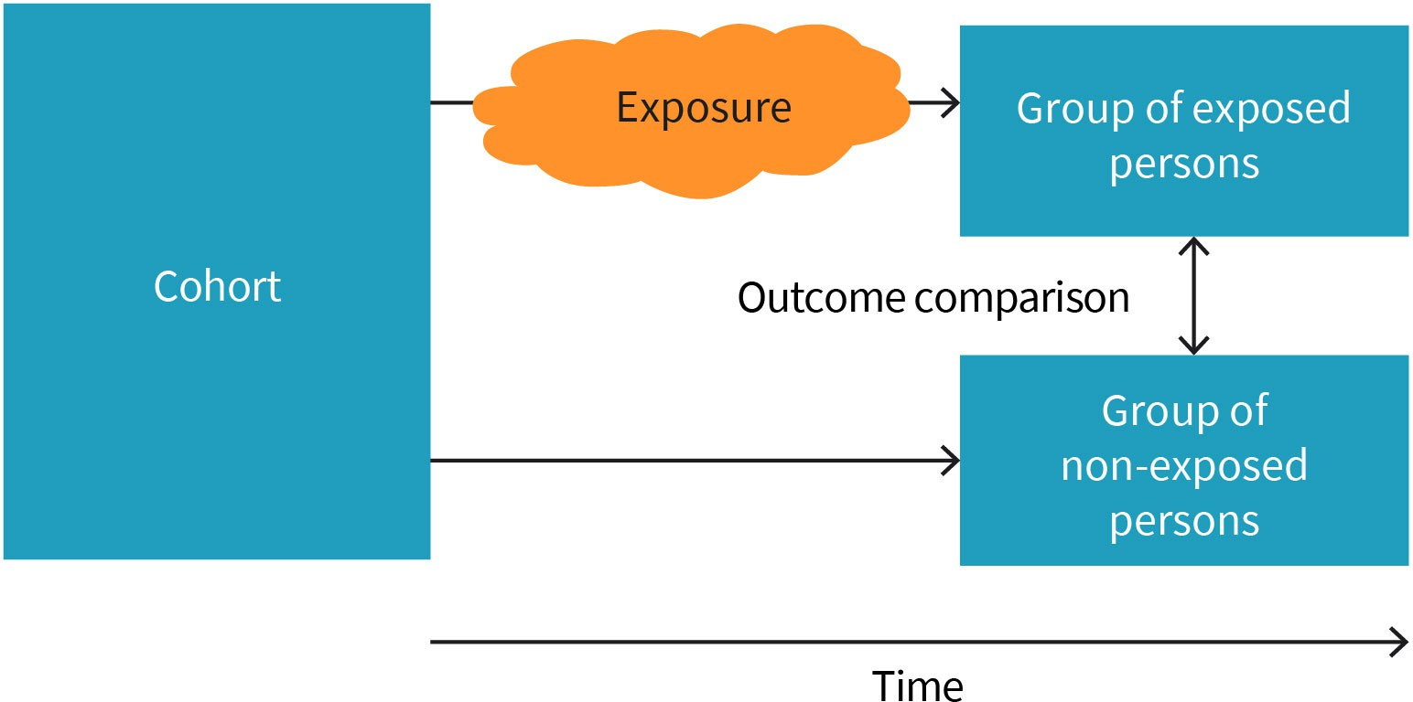

Source: Created by another author, based on Stark & Guggenmoos-Holzmann (2003).

Studies are used to analyze the connection between possible influencing factors and dis- ease development or prevention. Depending on the type of study, different risk measures can be determined.

##### Longitudinal Studies (Cohort Studies)

Longitudinal studies, which are also known as cohort studies, investigate a suspected rela- tionship between exposure and disease. They are prospective, meaning they observe an initially defined study population that is free of the disease of interest over a longer period of time. The study population is divided into a group of exposed individuals and a group of non-exposed people, as can be seen in the figure. In both groups, the focus is on docu- menting how many people have developed the disease.

In this type of study, the chronological sequence of exposure and disease development can be clearly observed. To quantify the strength of association of exposure for the devel- opment of the disease of interest, the **relative risk** (RR) can be determined (Stark & Gug- genmoos-Holzmann, 2003, p. 304). It is calculated as the quotient of the disease frequen- cies in the exposed group compared to the disease frequencies in the non-exposed group.

Number of new cases in the exposed group

Number of persons in the exposed group

Relative risk =

Number of new cases in the non‐exposed group Number of persons in the non‐exposed group

Therefore, it indicates by how much a specific exposure increases the risk of disease (Stark & Guggenmoos-Holzmann, 2003, p. 290).

##### Case-Control Studies

Case-control studies are retrospective, which means they study the relationship between exposure and disease development in the past. Here, the cases (i.e., sick persons) are compared with suitable control persons and examined for different exposures in the past (Stark & Guggenmoos-Holzmann, 2003, p. 305).

The odds ratio (OR) can be used as a measure of the risk between exposure and disease development. For this purpose, the chance (or odds) that a specific outcome (in this case, the disease under consideration) will occur is initially calculated for both the exposed and non-exposed groups. These odds are calculated as the ratio of the probability (p) of having the disease to the opposite probability (1–p) of not having the disease (Razum et al., 2018, p. 78; Stark & Guggenmoos-Holzmann, 2003, p. 290).

Odds = Probability of an outcome

1 *−* Probability of an outcome

**Relative risk**

This indicates whether a factor increases or decreases the risk of developing a disease.

The OR is then calculated as the ratio of the odds for the exposed group to the odds for the non-exposed group (Stark & Guggenmoos-Holzmann, 2003, p. 290).

Odds for the exposed Odds for the unexposed

Odds ratio =

Like the relative risk, the OR indicates by how much the risk of developing the disease increases or decreases, given the presence of an exposure or protective factor.

Figure 4: Schematic of a Retrospective Case-Control Study

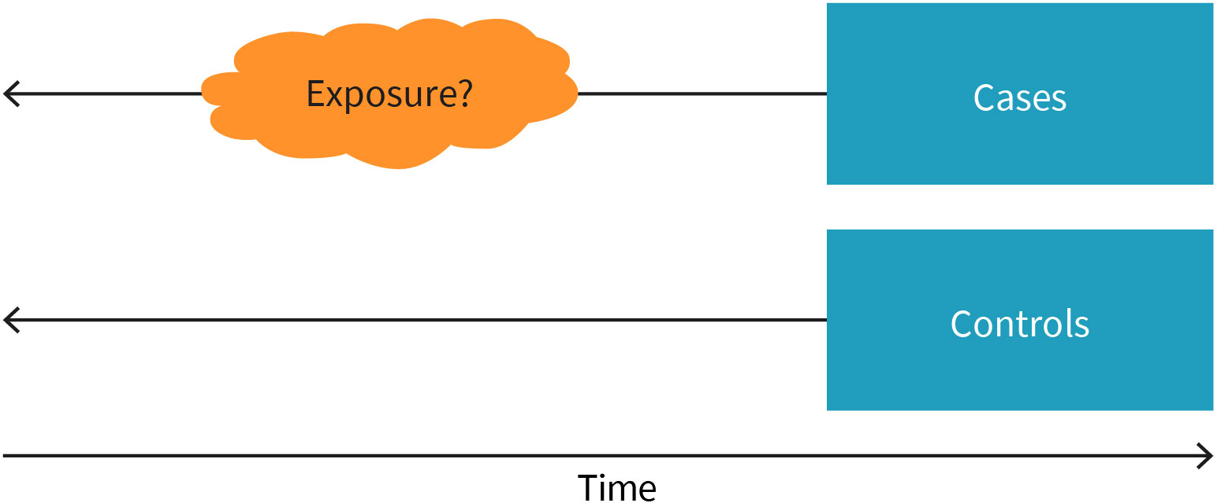

Source: Created by another author, based on Stark & Guggenmoos-Holzmann (2003).



**EXAMPLE**

Let us suppose that a case-control study aims to examine the connection between a diet rich in vitamins and the development of breast cancer. For this purpose, a group of breast cancer patients (cases) and a suitable control group (i.e., women who do not have breast cancer, but who are comparable to the cases across other characteristics, such as age) were asked about their past diet- ary habits. The study included a total of 100 women with breast cancer and 200 women without breast cancer. In the group of breast cancer patients, 18 women stated that they had valued a diet rich in vitamins A and E, whereas 71 women in the control group stated this. Accordingly, 82 breast cancer patients and 129 non-patients did not eat a diet that was particularly rich in vitamins. Of all those

who stated that they had consumed a diet rich in vitamins, the chance of

71

vitamin-rich diet, the chance of developing the illness is 63.57 percent.

becoming ill was 18 = 25.35%. Of those who did not attach any importance to a

The OR is calculated as the quotient of these two chances. This means that women who eat a diet rich in vitamins have a lower risk of developing breast

cancer by a factor of 0.4 (Stark & Guggenmoos-Holzmann, 2003, p. 303).

#### Demography

***anon***

*2024-06-13 08:57:51*

--------------------------------------------

update and be more specific

Demography deals with the description of the population. In addition to the total size of the population, it is interested in migration, the composition of the population, age, and gender, as well as social and environmental factors responsible for changes (Zwahlen et al., 2018a, p. 110).

##### Population Development, Demographic Transition, and Case Studies

To determine the population of a place or region, all persons who are permanent resi- dents or have a registered address in that place or region as of a specific date are counted. Population numbers are affected by both natural population changes (such as births and deaths) and migration flows. To determine the extent of this natural population change, a birth surplus or birth deficit is determined. In other words, it is determined whether there are more births or deaths in a given region. Mathematically, this measure results from the difference between the number of births and the number of deaths within a calendar year, which is determined in relation to the population. The measure is specified per 1,000 inhabitants (Zwahlen et al., 2018a, p. 111).

**EXAMPLE**

In a city of 250,000 inhabitants, there were 7,000 births and 11,000 deaths last year. The birth deficit is calculated as the difference between deaths and births

divided by the number of inhabitants:

11,000*−*7,000 = 0.016

250,000

This refers to 16 per 1,000 inhabitants. Therefore, a total of 16 fewer births per

1,000 inhabitants were recorded than deaths.

Population increases and decreases attributable to people moving in and out of a region are considered population migration flows. These migration flows can also be quantified, which is referred to as the migration balance. This is calculated using the difference between the number of people moving into and out of an area (e.g., across city or state borders). The migration balance can be specified as an absolute number, as well as in rela- tion to the respective population (per 1,000 inhabitants; Zwahlen et al., 2018a, p. 113).

For public health, not only the population size is important but also the composition by age and gender. The age structure of a population is defined as the percentage of individu- als in each age group at a certain point in time. It is a defining characteristic of a popula- tion in a nation or region. Age structure of a population is shaped by migration, birthrate, and mortality rate (Blue & Espenshade, 2011).

Demographic transition

***anon***

*2024-06-13 08:57:51*

--------------------------------------------

source? use something from 2020+...

***anon***

*2024-06-13 08:57:51*

--------------------------------------------

source?

The term “demographic transition” describes how the age structure of a society typically changes as the society develops economically. Before the demographic transition begins, societies have both high birth rates and high mortality rates. In this state, the population is stable or it grows only slightly and the age structure has the shape of a pyramid. When the demographic transition begins, mortality falls first, and fertility falls later (McCracken & Phillips, 2016). Initially, this leads to the population growing strongly and age structures tending to get younger, as more children survive with the beginning of the mortality decrease, but populations thereafter progressively age as fertility declines (United Nations, 2017). Age distribution may also be impacted by migration from abroad. Since

working populations are frequently older than average early in the transition, emigration can cause a decline in average ages when migrants are clustered in young working ages, as is usual with labor migration. Emigration eventually has less of an influence on a popu-

lation’s average age due to continued drops in mortality and fertility. Three variables – fer- tility, mortality, and international migration – are responsible for these alterations in the age structures of the national population, as well as potential changes in the sex composi- tion (United Nations, 2017).

In high-income countries, the demographic transition has already taken place, whereby the life expectancy is higher (Baker et al., 2022). In contrast, low- and middle-income countries are still going through this transition. In reality, the demographic transition may play out somewhat differently in each country, and a country’s regions may differ greatly; in particular, urban-rural differences may be large. This is more noticeable in low- and middle-income countries where the wealthier regions (such as urban areas or cities) of a country may display a radically different life expectancy compared to the less wealthy areas (such as rural areas). These less wealthy regions also have a high prevalence of infec- tious diseases, especially in children and older people (Baker et al., 2022).

The three age pyramids below show three countries that are in different stages of demo- graphic transition.

Case of Somalia

Somalia is a country at the beginning of demographic transition. It is considered one of the countries with the youngest age structure in the world with nearly 48 percent of its citizens being under the age of 15 (WHO Regional Office for the Eastern Mediterranean, 2022). Additionally, around 70 percent of Somalia’s population is under the age of 30. Over the past 40 years, Somalia’s age distribution has not altered significantly, and healthcare has not significantly improved. Contrary to dozens of other countries where fertility has sharply decreased in recent decades, Somali women currently give birth to almost as many children as they did in the 1970s. Only 12 percent of the total fertility rate, which is currently 6.4 children per woman, has decreased since 1970 (WHO Regional Office for the Eastern Mediterranean, 2022).

Figure 5: Somalia’s Population Age Pyramid

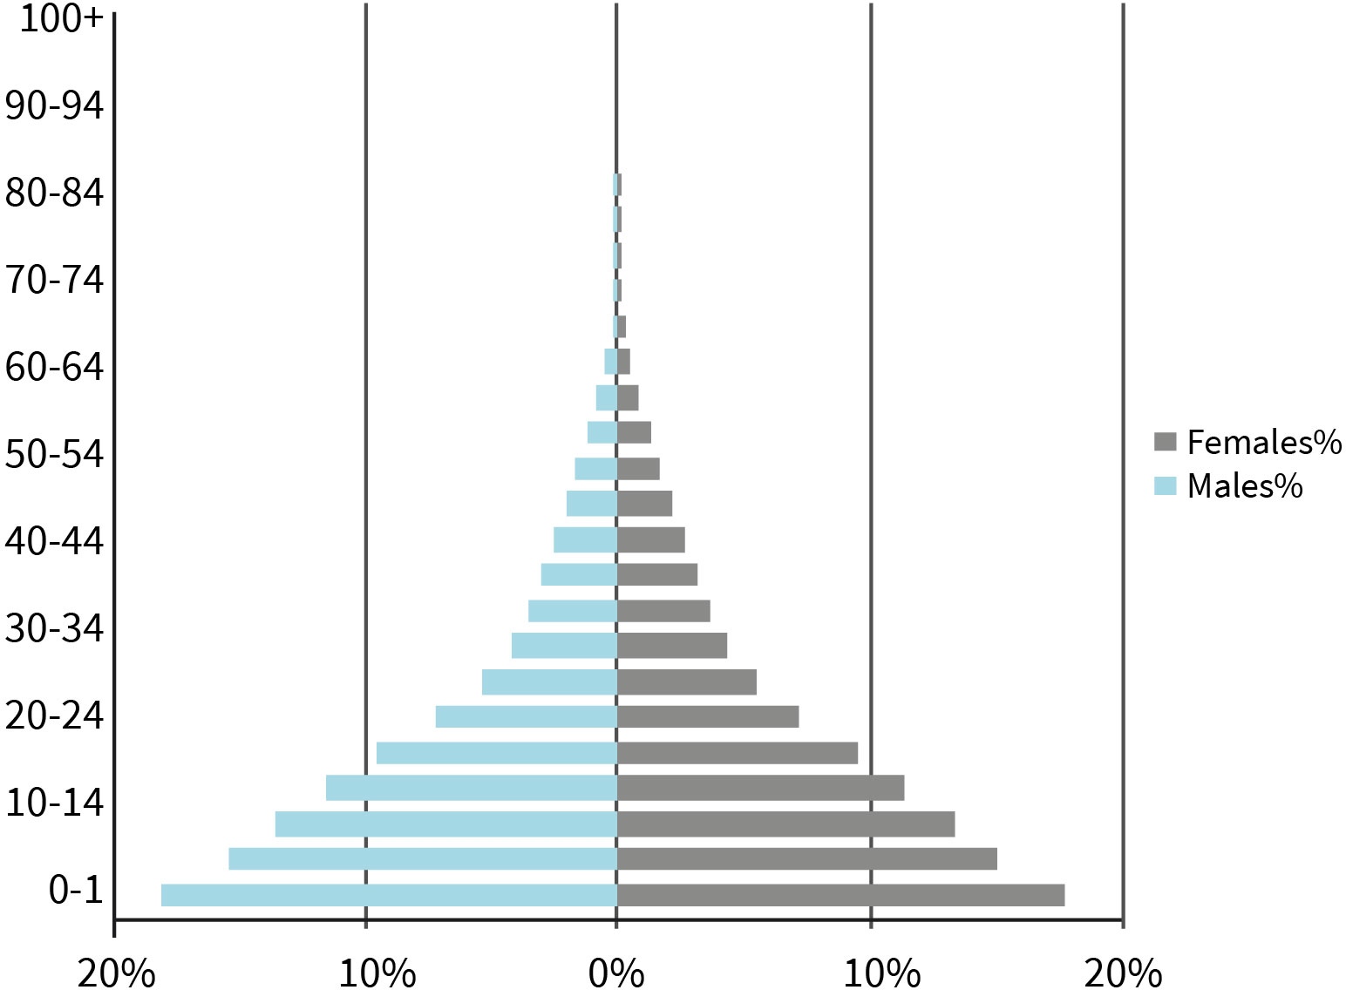

Source: Mirna Naccache (2023), based on Populationpyramid.net (2019).

Case of South Africa

***anon***

*2024-06-13 08:57:51*

--------------------------------------------

is this a reliable source?

South Africa is an example of a developing country with one of the highest **working age populations** in the world. There were over 20.2 million women of working age in the first quarter of 2022, compared to roughly 19.8 million men of working age (International Labour Organization, 2020). By 2050, employing Southern Africa’s growing working-age population could raise per capita incomes, decrease poverty, and boost growth (Lam et al., 2019). One of the attributes causing this age structure is fertility rate in South Africa, which is caused by a number of variables, including high desired family size, low rates of modern contraception usage, and high rates of adolescent pregnancy (Lam et al., 2019).

**Working age popula- tions**

This is the number of peo- ple within a population between the ages of 15 and 64 (Organisation for Economic Co-operation and Development, 2021).

Figure 6: South Africa’s Population Age Pyramid

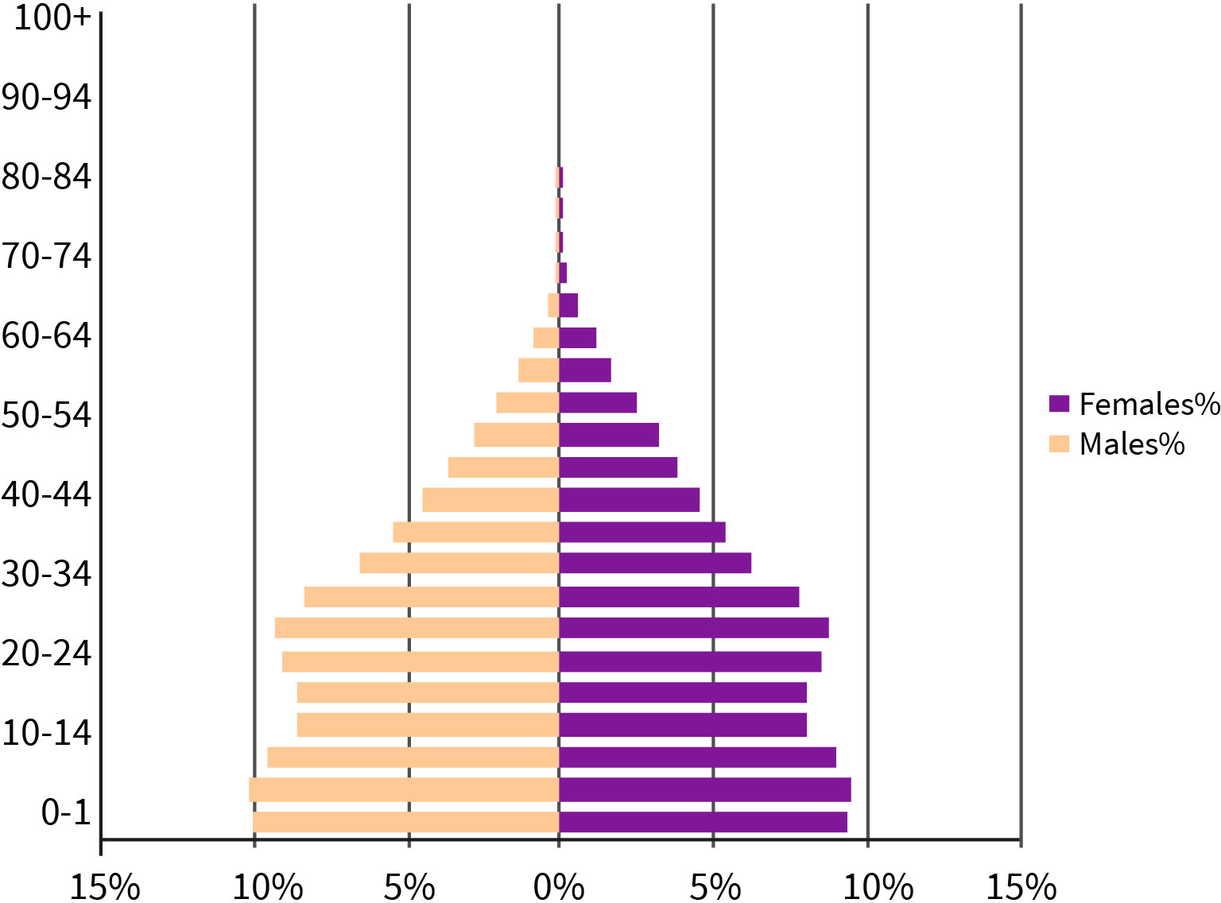

Source: Mirna Naccache (2023), based on Populationpyramid.net (2020b).

Case of Japan

Japan is an example of a country where the demographic transition is particularly advanced. The population of Japan is aging and declining quickly. The oldest population in the world is found in Japan, where the median age is 48.4 years. The Japanese govern- ment have projected that, for every person of working age, there will be almost one eld- erly person by 2060 (Nakatani, 2019).

The percentage of elderly people there is the highest in the world. It is advancing more towards a super-aged civilization as a result of a number of demographic factors, includ- ing exceedingly low fertility rates, a steady increase in life expectancy, and improved nutri- tion and living conditions (Nakatani, 2019).

Figure 7: Japan’s Population Age Pyramid

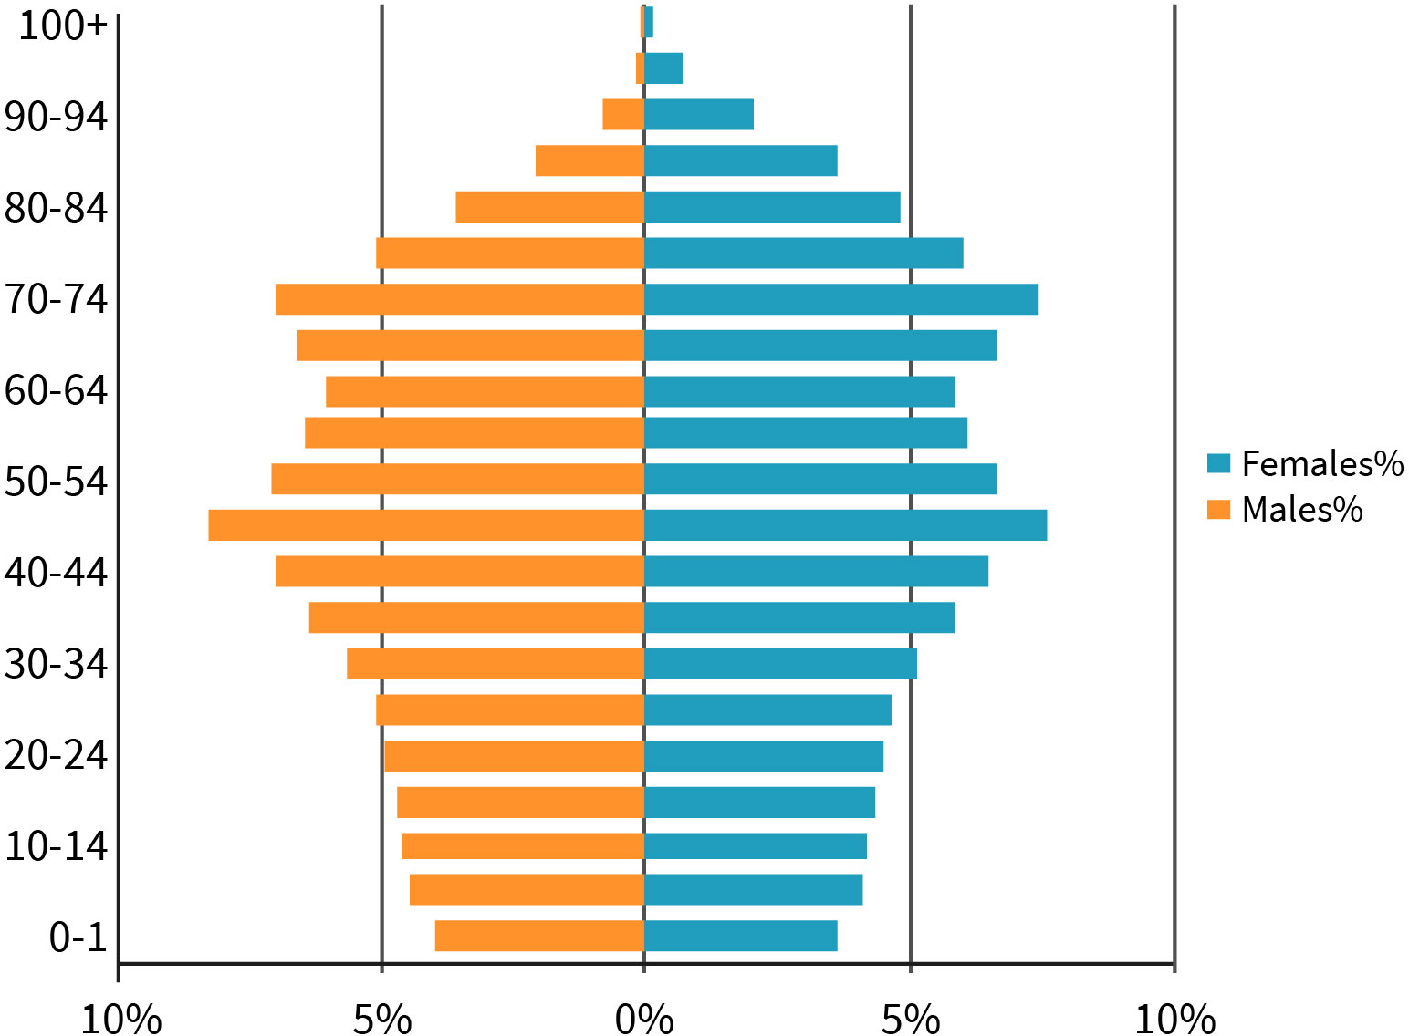

Source: Mirna Naccache (2023), based on Populationpyramid.net (2020a).

##### Age Standardization

Changes in age structure over time, in addition to age structures that differ across regions, pose a problem for the comparison of crude death rates or disease rates over time or regions. For example, we can expect more deaths in populations with a high proportion of older people than in populations with a very young age composition. Likewise, many dis- eases usually appear in old age. To control the distorting influence of different age struc- tures, the data are adjusted using **age standardization**. A distinction can be made between direct and indirect age standardization. Direct age standardization calculates how many deaths or new cases could be expected if the given age-specific mortality/inci- dence rates for a given population/region are compared to a standard population (Stark & Guggenmoos-Holzmann, 2003, p. 294). A standard population is an artificial population with a fictitious age structure. For example, the (old or new) European standard popula- tion or the world standard population can be used as the standard population.

Indirect age standardization is used in particular to make regional comparisons. It calcu- lates how many deaths or new cases could be expected if the actual mortality and inci- dence rates were not effective in the regions to be compared but rather the average rate of a superordinate unit. For example, if we wanted to compare new cancer cases in the states or provinces of a country, the average, age-specific national cancer incidence rates would be used and applied to the population of the respective state. If we wanted to compare measles cases within individual city districts, this could be done on the basis of the aver-

**Age standardization** This makes it possible to compare morbidity and mortality rates across populations with differ- ent age structures.

age disease rate for the entire city. The number of cases actually observed is then com- pared with the expected number of cases for each federal state or district. For this pur- pose, the quotient is calculated based on the observed and expected number of cases (Stark & Guggenmoos-Holzmann, 2003, p. 295). If this quotient is greater than one, this indicates higher morbidity in the respective state or district compared to the country or the city as a whole. A quotient of less than one, conversely, suggests lower morbidity. The wording “suggest” and “suspect” was deliberately chosen since further statistical analyses are required to determine whether the morbidity is actually elevated or depressed.

#### Biostatistics

Statistics is the science of collecting, summarizing, presenting, and interpreting data. Bio- statistics focuses specifically on issues from the fields of biomedicine and public health (Deutschmann & Guggenmoos-Holzmann, 2003, p. 199; Zwahlen, 2018, p. 122).

All biological processes are typically subject to fluctuations. In this context, we speak of variability. This leads to the question of how an increase in the number of new cancer cases in a community compared to the previous year should be interpreted, for example. Is it merely regular fluctuation or does it represent an actual increase in incidence? A com- parable question also arises in studies: Is there a real reduction in relative risk from a pub- lic health intervention, or is the lower relative risk the result of random fluctuations? To determine this, we must draw truthful conclusions about populations or patient groups from an observation or a study (Deutschmann & Guggenmoos-Holzmann, 2003, p. 201; Zwahlen, 2018, p. 122).

**Statistical significance**

**test** A statistical significance test checks whether the observed results can be attributed to random fluc- tuations or describe an

actual effect.

In this regard, you often read about a statistically significant increase in disease incidence or statistically significant study results. These claims are based on the **statistical signifi- cance test**. This test is based on the null hypothesis that the incidence has not increased or that the intervention has had no effect. Based on this assumption, the probability (p- value) that the observed difference came about purely by chance is then calculated. A p- value of less than 0.05 is said to be a statistically significant result, and p-values of less than 0.01 point to highly statistically significant results. Often, one will read that results are statistically significant at the five percent or one percent levels of significance. But what exactly does a statistically significant result mean? The starting point is the assump- tion that the incidence has not increased or that the intervention is not effective. A p-value of 0.05 means that the probability of observing so many cases of illness or such a large reduction in the relative risk purely by chance is five percent and, therefore, very unlikely. It is, thus, assumed that there is an actual increase in disease incidence or an actual reduc- tion in the relative risk as a result of the measure (Deutschmann & Guggenmoos-Holz- mann, 2003, p. 212; Zwahlen, 2018, p. 140).

#### Social Science Data Collection

***anon***

*2024-06-13 08:57:51*

--------------------------------------------

dropped citations. fix this throughout the book.

***anon***

*2024-06-13 08:57:51*

--------------------------------------------

you gotta cite some evidence when making claims like this.............

Data collection in the social sciences differs from biomedical research in that data are not collected by measuring biological or medical indicators but rather by conducting surveys, interviews, or individual case studies. In the public health sector, data collection methods from the social sciences are used to obtain information about the knowledge, attitudes, and needs of a target group. To critically assess the corresponding results and conduct your own surveys, it is essential to understand data collection in the social sciences (Geyer & Abel, 2018, p. 145).

First, we will briefly consider how surveys are structured. Clear and understandable ques- tions that leave no room for different interpretations are the most important criterion of a survey. However, this may pose the problem that the survey designers’ use of vocabulary and linguistic expression may differ from that of the survey participants. The developed survey instrument must, therefore, be tested before it can be used. This pretesting process reveals whether the used terms are clear and the survey is of an appropriate length. If the survey is too long, the participants’ motivation and concentration will decrease, thereby increasing the risk of errors in judgment. Closed questions with fixed answer options are particularly easy for participants to answer; however, they limit the range of possible responses. Alternatively, open-ended questions that allow the participants freedom to answer may be particularly suitable if little is known about the subject area in question. However, these questions require more time to answer, and participants are more likely not to answer them at all. In addition, participants may also be less likely to answer ques- tions that they consider too personal (e.g., questions about alcohol consumption, sexual orientation, or income; Geyer & Abel, 2018, p. 145).

Survey methodology can be divided into quantitative and qualitative approaches. Quanti- tative methods include in-person surveys, phone surveys, written surveys, and internet- based surveys. In-person surveys are conducted as face-to-face interviews. The inter- viewer reads out the questions and writes down the answers. In a phone survey, however, data are collected via phone interview. In contrast to an in-person survey, a phone survey can be carried out faster and more cost-effectively since the interviewer does not need to spend time and money traveling to meet with the participant. However, phone surveys have a relatively high refusal rate. In other words, many prospective participants are unwilling to take part in the survey. Especially when it comes to sensitive topics, such as domestic violence, phone surveys offer greater anonymity and are sometimes the only method by which the survey could be conducted in the first place. A written survey is sent in the mail or distributed to the participants in some other way (e.g., at an event). There is no direct contact between the researcher and the participant while answering the survey. With an internet survey, data are collected online. This offers the advantage that questions can be automatically filtered in real time depending on previous answers or hidden if they do not apply at all. In addition, various other media formats, such as images or films, can be integrated into the survey using this format. However, it should be noted that not all groups of people can be reached via the internet. Internet use is closely tied to age and familiarity with digital media (Geyer & Abel, 2018, p. 151; Geyer & Siegrist, 2003, p. 263).

In public health, qualitative methods are used before quantitative surveys to test the com- prehensibility of questions and their relevance, for example. They can supplement the findings of quantitative surveys and provide more detailed insights into selected subject areas. However, they require more time and human resources to execute. Qualitative sur- vey methods include narrative interviews, episodic interviews, focused interviews, focus group interviews, and individual case studies. During a narrative interview, a topic is pro- posed, which the interviewees can then report on in free form and in as much detail as they wish. This can be a participant’s own medical history or their experience of an illness, for instance. The interviewer should not direct or interrupt the narrative. In the episodic interview, the focus is on specific situations, such as critical life events. The basis for the interview is a guideline that summarizes the possible topics in an overview. It is up to the interviewee to choose the topic and focus. The goal of focused interviews, however, is to test hypotheses. To do this, the interviewer uses question stimuli in a targeted manner and steers the conversation to obtain precise statements. The interviewee’s reactions should be observed, and central aspects of a topic should be elaborated on. The focus group interview is conducted with a group of people (ideally consisting of eight to ten par- ticipants). Here, a topic is provided, which the participants subsequently discuss. One practical example would be asking residents about the health risks of their living environ- ment. Finally, individual case studies examine selected cases that are assumed to be rep- resentative of the subject under investigation. A case study can refer to persons, groups, institutions, or organizational structures. A case study is used to obtain as detailed a pic- ture as possible of a specific issue. For example, it is possible to analyze the impact of a public health measure on the healthcare situation and the daily processes in everyday healthcare on the basis of a small number of patients (Geyer & Abel, 2018, p. 157; Geyer & Siegrist, 2003, p. 260).

***anon***

*2024-06-13 08:57:51*

--------------------------------------------

this subsection is just one big paragraph! unacceptable!!!

**Efficacy** the effectiveness of a measure under artificial

study conditions

**Community effec-**

**tiveness** the efficacy of a measure under real world condi-

tions

#### Evaluation of Complex Interventions

Public health measures are complex interventions that typically consist of several individ- ual components. The individual components are mutually interdependent, and they include the healthcare setting, meaning that the context in which the measure is imple- mented can influence its effectiveness (Mühlhauser et al., 2011, p. 751). For example, a drug that has proven to be effective in clinical trials and inpatient care may be less effec- tive in everyday healthcare because the patient fails to follow the precise dosage instruc- tions at home. This problem is also described using the concept of **efficacy** or **community effectiveness**. Efficacy indicates the effectiveness of an active ingredient or a measure under ideal conditions. In order to determine efficacy, randomized and controlled studies are usually conducted in which confounding factors can be largely excluded and attention is paid to the exact intake of the drug under investigation or the exact performance of exercises in a physical therapy program. Community effectiveness, however, describes the efficacy under everyday conditions (i.e., when the drug or intervention is used in everyday healthcare; Schwartz & Busse, 2000, p. 401). This example also demonstrates that several components must work in tandem for the measure to be implemented. Besides medica- tion, adequate education of patients provided by motivated and knowledgeable service providers also plays a key role in ensuring the success of the measure, for example. Thus, evaluations of complex interventions have to consider that the poor success rate of a

measure could be due to implementation problems. In evaluating complex healthcare

programs, the central issue is not to assess the efficacy of individual components in theory but rather their effectiveness in real-world situations and, above all, in their interactions. For this purpose, it is insufficient to consider only one outcome indicator by itself. Rather, the point is to record and analyze all effects, including unintended ones, and to investigate the range of outcomes, including especially individual, spatial, and temporal variations.

***anon***

*2024-06-13 08:57:51*

--------------------------------------------

old sources used throughout this section....

These findings can be used to refine measures and programs (Craig et al., 2008, p. 7).

#### Decision-Oriented Management (Decision Theory)

Decisions are only possible and become necessary if the decision-maker is afforded some scope for action. A characteristic feature of decision-making problems is that there are more courses of action that can be implemented. In the healthcare sector, this problem arises particularly in light of limited financial, human, and time resources. Management is thus faced with the question of how to make the “right” decision. In principle, a good deci- sion helps to achieve a goal (Jeschke, 2017, p. 3). A clear definition and operationalization of goals, therefore, plays a key role in decision-making processes. Goal operationalization should consider three dimensions, namely the goal object, the degree of goal achieve- ment, and the time horizon. The goal should be described as completely and clearly as possible. If there are multiple goals, all goals should be consistent with each other (i.e., they should not contradict each other). When specifying the degree of goal achievement, it is important to determine the extent to which the goal must be achieved. This can be defined as “as far as possible” or as a limitation to minimum or maximum values. It is important that the degree of goal attainment is objectively measurable. Finally, the time horizon determines the timeframe or the final date for the achievement of the goal (Jeschke, 2017, p. 31).

Decision-making situations are characterized by the existence of several relevant decision alternatives for achieving the goal. These alternatives have to be evaluated based on deci- sion criteria that are consistent with the defined goals. Alternative courses of action and decision criteria can be compared using a two-dimensional matrix. The first column con- tains the decision criteria, which are listed in rows. The second column can be used as the weighting of the listed criteria where the sum of the components adds up to 1 or 100 per- cent. The decision alternatives are then entered in the following columns. The alternatives are evaluated based on the criteria, usually using school grades (one: the measure exactly satisfies the criterion; six: the measure does not fulfill the criterion at all) or a multi-level scale. Here, the scale is inverted. The highest degree of fulfilment is assigned to the high- est value, and the lowest degree of fulfilment is assigned to the lowest value (e.g., on a 10- point scale, one does not fulfill the criterion at all, while 10 completely fulfills the crite- rion). The result of the evaluation is entered in the respective matrix field, which provides information on how the alternative performs with regard to the respective criterion. The overall result is obtained by summing up all scores or points for each alternative and dividing it by the number of criteria. If the value has been weighted, the criterion value is first multiplied by the weighting factor, and the resulting values are then divided by the

number of criteria. The decision-making rule is as follows: When awarding points, the alternative with the highest point value is favored, and in the case of school grades, the alternative with the best overall grade is favored (Jeschke, 2017, p. 47, p. 68; Willnauer, 2016, p. 70).

Figure 8: Decision Matrix Using the Example of the Choice Between Two Public Health Measures

***anon***

*2024-06-13 08:57:51*

--------------------------------------------

these subsections lack (1) recent evidence of the success of these methods in the real world and (2) a critical lens regarding theory.

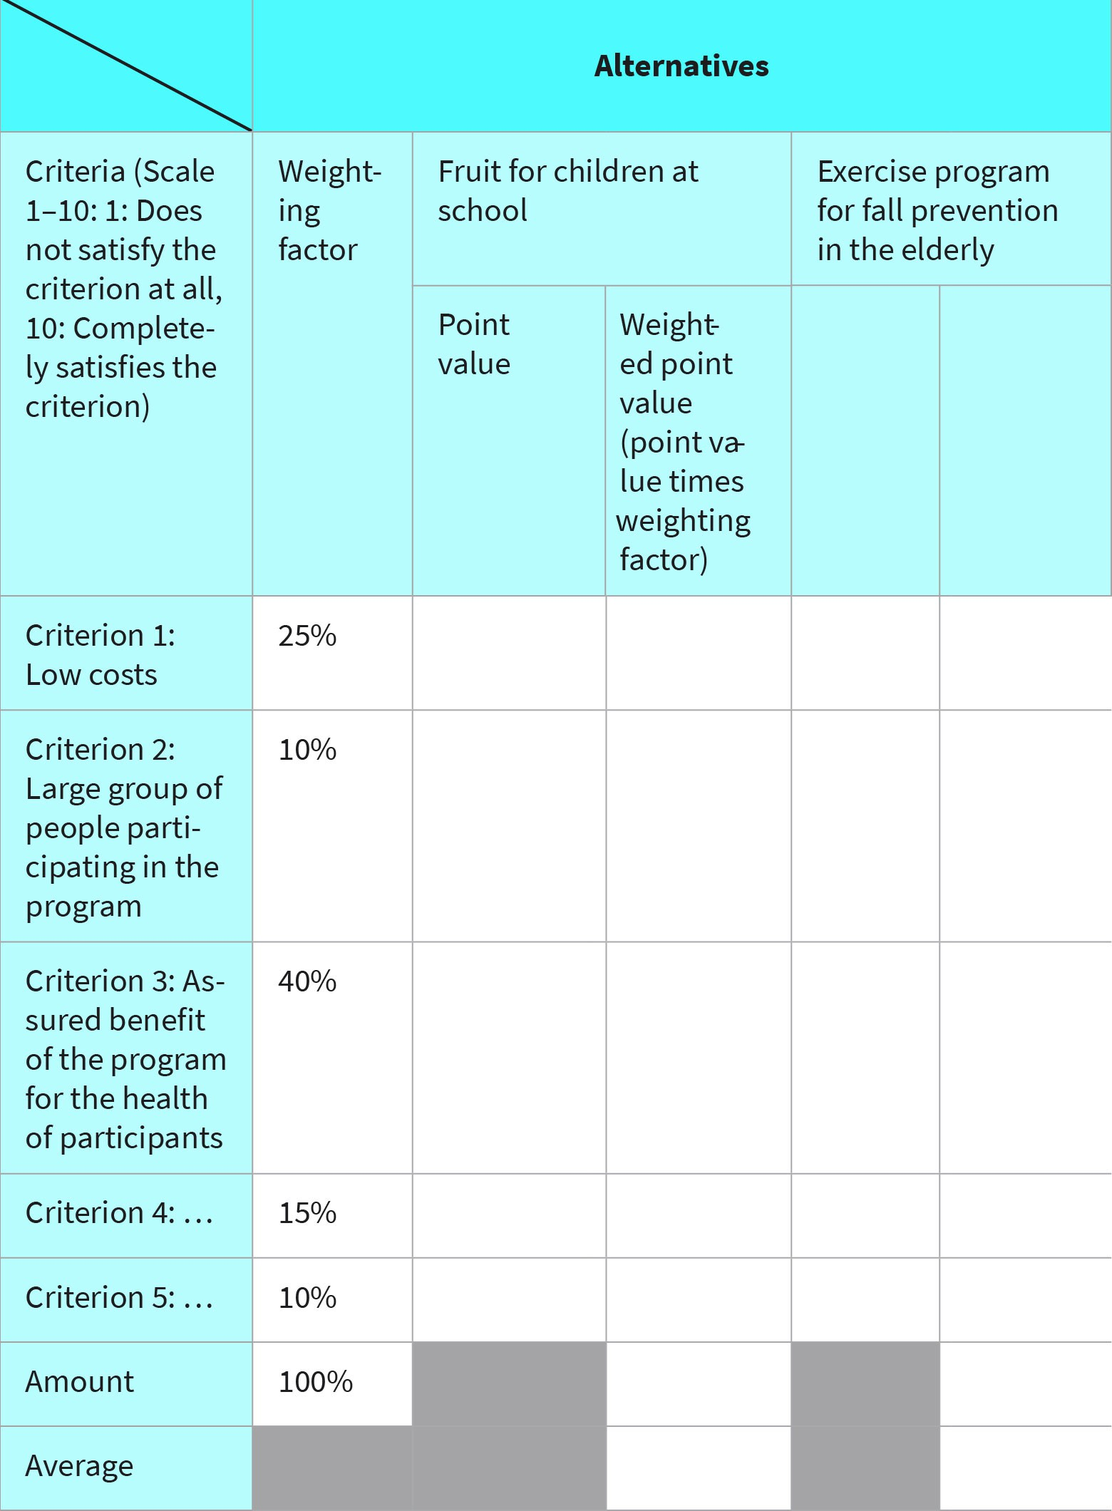

Source: Created by another author, based on Jeschke (2017); Willnauer (2016).

In addition to the decision matrix, there are a large number of methods and techniques to support decision-making problems, but they fall outside the scope of discussion here.

**SUMMARY**



The state of health of the population can be described using epidemio- logical indicators, such as incidence, prevalence, mortality, and lethality. Studies are conducted to investigate the influence of certain factors on the development or prevention of diseases. In longitudinal or cohort studies, the chronological sequence of exposure and disease develop- ment can be clearly observed. Case-control studies look at factors that may have contributed to the development of a disease retrospectively.

Demography is concerned with the size and composition of the popula- tion based on age and sex characteristics and the influencing factors. The population structure changes over time and may differ from region to region. As the risk of developing certain diseases and the risk of death usually depends on age, it is necessary to apply age standardization when comparing morbidity and mortality rates over time and between regions if the age structure has changed.

Biological processes are typically subject to fluctuations. Statistical sig- nificance tests are performed to determine whether the data represent an actual increase or decrease in disease cases or risks or just a normal fluctuation. A statistically significant test result indicates that there is indeed a change.

Information about the knowledge, attitudes, and needs of specific target groups is essential when planning public health strategies. For this pur- pose, researchers rely on data collection methods from the social scien- ces, such as surveys, interviews, and individual case studies.

The term efficacy describes the effectiveness of a measure under ideal conditions. However, to assess the effectiveness of complex healthcare programs and adapt the measures as required, we need findings on community effectiveness. This is the effectiveness of the individual pro- gram components working together in aggregate and under everyday conditions.

A wide range of options for maintaining and promoting the health of the population are available. However, it is not possible to pursue all options due to limited resources. Decision support methods help when choosing between alternative courses of action.

# UNIT 3

## POPULATION MEDICINE AND BIOMEDICAL

**PRINCIPLES**

###### STUDY GOALS

On completion of this unit, you will be able to ...

* name the models that can be used to explain health and disease.
* explain which social determinants beyond individual factors can influence health.
* understand which criteria can be used to subdivide society, and why an understanding of social structure is necessary for planning effective public health strategies.
* define the connection between social and health inequality.
* explain how public health strategies can be designed to reduce social inequalities in health.

### 3. POPULATION MEDICINE AND

**BIOMEDICAL PRINCIPLES**

#### Case Study

Anja, a student, is meeting up with her classmate Paul. He tells her about a study that he recently read about the connection between education and health. The results of the study suggest that people with a lower level of education tend to be sicker and die earlier than those with higher level (Mielck et al., 2012, p. 4). Anja is surprised by these findings. She previously assumed that only pathogens could lead to illness. Are there actually other factors that play a role? Anja and Paul decide to take a closer look at the models used to

explain health and illness.

***anon***

*2024-06-13 08:57:51*

--------------------------------------------

boring and short. unacceptable

***anon***

*2024-06-13 08:57:51*

--------------------------------------------

explicitly cite and discuss recent evidence in such cases

**Pathogenesis** Pathogenetic concepts describe processes that lead to the development of diseases. The central question is: “What makes

us sick?”

**Salutogenesis** Salutogenic concepts consider the protective factors and resources that help people stay healthy despite risks and stress. The central question is: “What keeps us healthy?”

#### Biomedical Model of Disease

There are different approaches to explaining health and disease. The biomedical model assumes that every disease has a biochemical, mechanical, or genetic cause. Social deter- minants that may predispose a person to become sick are not considered. The biomedical model thus assigns significant weight to **pathogenetic** causes. In this model, disease is seen as a deviation from a natural norm. Health and disease are not understood as a con- tinuum here, but only as the two dichotomous states of “healthy” and “sick.” The model assumes that there is a causal connection between a disease-causing factor and the mani- festation of the disease and that every disease follows a predetermined course. Accord- ingly, the disease can only be cured if the underlying cause is eliminated (Franke, 2012, p. 133; Egger et al., 2018b, p. 41).

The biomedical model has proven to be very successful, particularly in the search for causes, prevention, and treatment of infectious diseases. The reason for this is that infec- tious diseases can usually be attributed to individual pathogens and, therefore, have a sin- gle cause (Franke, 2012, p. 133). However, many diseases are caused by multiple factors, so we must consider other disease-causing or health-promoting factors. In particular, social determinants of health and disease and the influence of individual behaviors are not considered in the biomedical model. The biomedical model also fails to explain why some people become ill, while others remain healthy despite the fact that both groups are predisposed or exposed to the same risk factors. However, these aspects are considered in **salutogenesis**, a concept that Antonovsky influenced decisively. In contrast to the bio- medical model, health and disease are understood as the two poles of a continuum between which the individual can move. Whether a person is moving more in the direction of health or disease depends on various factors that reach beyond the presence of certain risk factors, namely personal and social protective factors and access to resources (Altgeld & Kolip, 2014, p. 45; Egger et al., 2018b, p. 42).

#### Social Determinants and Biopsychosocial Models of Health and Disease

***anon***

*2024-06-13 08:57:51*

--------------------------------------------

these shouldn't be so short.

**Social determinants**, such as poverty or education, can influence the health and illness of the population and aggravate health inequalities (Klemperer, 2015, p. 28).

Dahlgren and Whitehead (1991) developed a very comprehensive model that sheds light on the key factors influencing an individual’s health – the Determinants of Health model (also known as the rainbow model). In addition to individual factors, such as age, sex, bio- logical makeup, and individual health behavior, the model takes social determinants into account; for example, the presence of social support and the degree of community involvement can influence the development of diseases. As another example, let us con- sider the stress burden of single parents, which is influenced by the social support they receive from their environment, or the higher risk of depression due to loneliness. The socioeconomic, cultural, and physical conditions of the living environment are additional factors. Here, the impact of living and working conditions on health must be considered, such as stress at work, the influence of personally meaningful activities, unemployment, and precarious employment or living conditions. In addition, the focus is on the health- care system itself, the education system, environmental hygiene, and the food supply and its production. This model can serve as a basis for analyzing the role of biopsychosocial mechanisms in the development or prevention of diseases (Dahlgren & Whitehead, 1991, p. 11; Klemperer, 2015, p. 29).

**Social determinants** They describe the condi- tions in which people are born, grow up, and grow old.

Figure 9: Determinants of Health

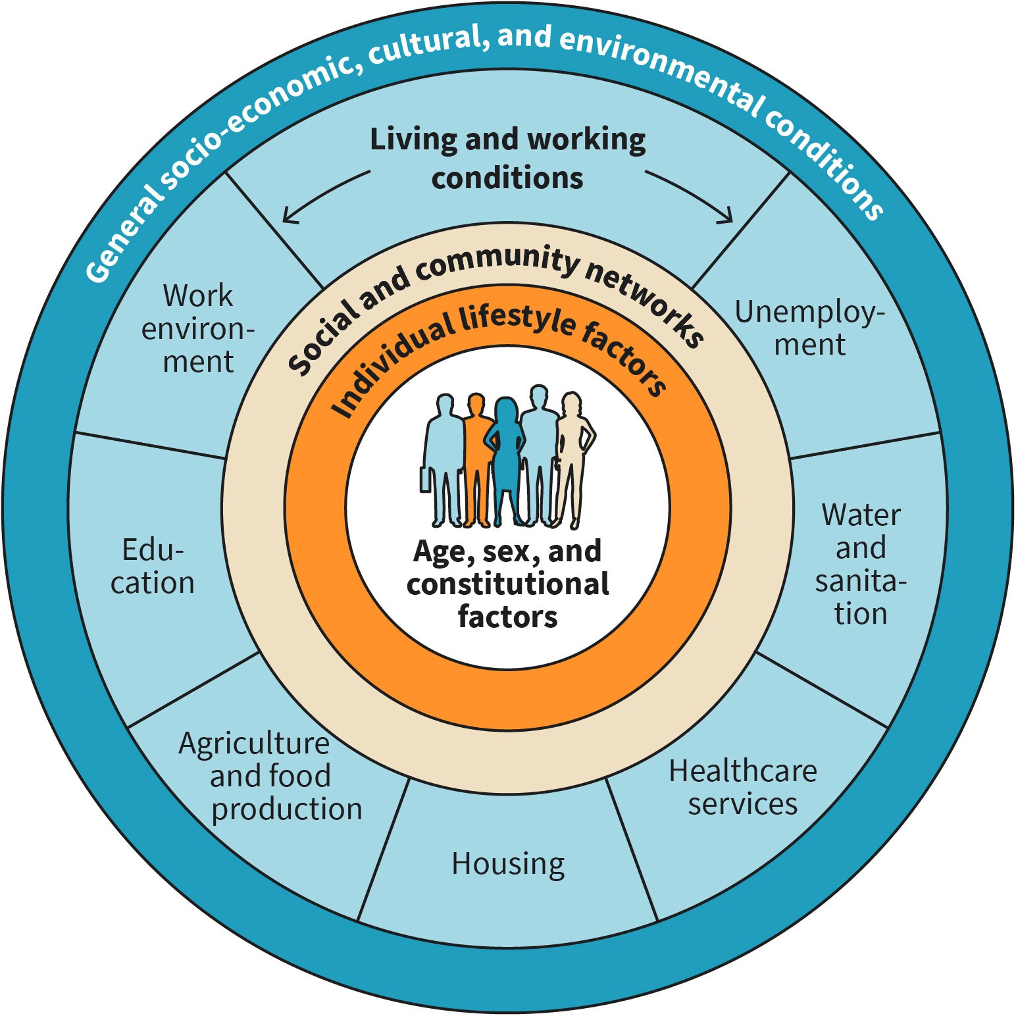

Source: Created by another author, based on Dahlgren & Whitehead (1991); Klemperer (2015).

The model assumes that people always move along a continuum between health and dis- ease. At each level, both risk factors (pathogenic factors) for the development of diseases and health-related resources (salutogenic factors) must be identified. The concept of resources refers to attitudes, emotional coping strategies, and material (e.g., financial resources to employ domestic help) and non-material means (e.g., social support) that allow people to successfully cope with health burdens and challenges (Abel & Kolip, 2018a, p. 225).

Figure 10: Continuum Between Health and Illness

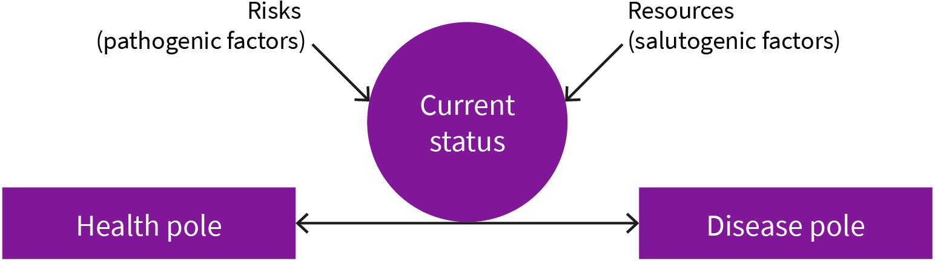

Source: Created by another author, based on Kolip & Abel (2018).

***anon***

*2024-06-13 08:57:51*

--------------------------------------------

short subunits.................

#### Social Structure

**Social structure analysis** investigates the different working and living conditions of the members of a society. Structural characteristics, such as social origin, gender, or migration background, are considered, and the causes of the development and stabilization of unequal living conditions are examined. These findings can then be used to pose further questions. One consideration relevant to public health is, for example, the health-related behavior of different social groups, which can serve as a basis for designing prevention programs (Weischer, 2011, p. 15).

There are different approaches to grouping members of a society in meaningful ways and analyzing their living conditions. A distinction can be made here between purely socioeco- nomic approaches and those that also weigh cultural considerations. The socioeconomic approaches use economic indicators such as income/assets, education/professional quali- fications, and professional position to determine the social structure of a society. Socioe- conomic-cultural approaches also consider aspects such as values, attitudes, and life- styles (Weischer, 2011, p. 340, 380).

When analyzing and evaluating **social structure**, we should remember that cross-sec- tional studies can only ever consider a snapshot of the population. However, the chance of social advancement or the risk of deterioration in the social situation is also of particular interest to social structure analysis. Thus, the question of social mobility over the course of one’s life or across generations arises. Social mobility describes a change in position in social space and must not be confused with spatial mobility (i.e., a change of position in geographical space; Weischer, 2011, p. 448). There are two forms of social mobility: verti- cal and horizontal. Vertical mobility describes an ascent or descent between hierarchically stratified positions, for example, when an employee is promoted to senior management. Horizontal mobility describes a change between hierarchically identical positions and, therefore, does not entail an improvement in status or income (Weischer, 2011, p. 449).

**Social structure analysis** This examines factors that shape different work- ing and living conditions.

**Social structure**

This describes the divi- sion and stratification of human societies based on social characteristics.

#### Social and Health Inequalities

As evidenced by a large amount of research, one’s health is significantly directly and indi- rectly impacted by socioeconomic factors such as race, gender, wealth, location, etc. (World Health Organization [WHO], 2018). The health status of different groups of people within a country varies noticeably depending on whether it is low-, middle-, or high- income. A person’s risk of bad health increases as their socioeconomic status drops.

Health inequalities are enduring variations in the state of health of various demographic groups (WHO, 2018). These inequalities have negative social and economic effects on both individuals and entire countries. As previously mentioned, these inequalities may be due to one’s socioeconomic circumstances or inequitable allocation of healthcare resources across various demographic groups (WHO, 2018).

Equity and health disparities are at odds with one another (Braveman, 2014). Access to high-quality healthcare products and services, regardless of one’s age, gender, ethnicity, race, degree of education, or financial status, is known as health equity (WHO, 2008). Health disparities are a sign of health inequity. There has been significant advancement in reducing health disparities and raising health equity over the last three decades. Improv- ing the health of those who are socially or economically disadvantaged, such as refugees and racial minorities, is necessary to move toward more fairness. This must be done with- out compromising the ability of those in privileged groups, such as those with higher soci- oeconomic status, university degrees, or other levels of education, to receive high-quality healthcare (Braveman, 2014).

***anon***

*2024-06-13 08:57:51*

--------------------------------------------

update

***anon***

*2024-06-13 08:57:51*

--------------------------------------------

NEED evidence for such statements. use varied sources from different organizations and include scholarly critiques.

***anon***

*2024-06-13 08:57:51*

--------------------------------------------

clunky. the study is also old. be more specific when discussing the data, where it comes from, and what it means in specific.

**Health policy** This entails the laws, reg- ulations, plans, and deci- sions that are made (typi- cally by the government) to promote wellness and ensure that health objec- tives and goals are ach- ieved for a particular community or society as a whole (Buse et al., 2012).

Thus, there is a need to address the factors that affect people’s health while recognizing how discrimination on the basis of religion, nationality, age, or sexuality is a factor contri- buting to health disparity. This could be done using **health policies**, public health pro- grams, etc. For instance, data indicate that segregation and discrimination between white and Black Americans in terms of where they reside has resulted in major health inequali- ties and worse health outcomes in the Black American population as a result of discrimi- natory housing regulations in the US (LaVeist, 2011).

#### Public Health Strategies to Mitigate Social Inequalities in Health

Measures to reduce health inequalities attributable to socioeconomic factors do not nec- essarily have to start within the health sector. In fact, health-promoting and preventive measures alone cannot be expected to deliver decisive changes. In particular, correspond- ing changes to educational, labor market, environmental, financial, and tax policies must be made to ensure that the conditions under which people are born, grow up, live, work, and age are conducive to health (Klemperer, 2015, p. 241; Rosenbrock, 2001, p. 757). Social and political input is needed to achieve social justice and reduce health inequalities (Klemperer, 2015, p. 241). The Swedish Public Health Strategy, which was passed by the Swedish Parliament in 2002, is one example of such a measure. The declared goal of this

strategy is to shape social living conditions in such a way that the entire population lives in good health. The central components of the strategy are poverty reduction, income redistribution measures, and improved ability to help vulnerable social groups through policy decisions. These political approaches can be combined with measures from the field of health promotion and prevention, such as tobacco and alcohol prevention and programs to increase physical activity. These measures are supported by the National Public Health Institute, and they are implemented down to the level of local administra- tive offices (Klemperer, 2015, p. 244).

This program makes it clear that public health strategies must be launched across macro, meso, and micro levels. At the macro level, politics determine the social framework condi- tions that directly impact living conditions. Government policies set the standards for the quality of air, food, or drinking water and specify what funding is made available to the individual; what protections members of society should enjoy from stressful working con- ditions; how highly tobacco should be taxed; how many people may be employed in pre- carious jobs; and how education and, thus, also knowledge about health, is imparted to the population. These specifications are implemented at the meso level, for example, in the education and training plans of schools and daycare centers, in the food supply chain, or in the organization of work processes within a company. Decisions made at the macro level and their implementation at the meso level ultimately affect health-related behavior and individuals’ exposure to health-promoting or harmful factors at the micro level. Therefore, monotonous work assignments and a lack of recognition in the workplace, for example, can lead to chronic stress that entails negative health impacts. Likewise, knowl- edge of health hazards encourages a healthy lifestyle (Klemperer, 2015, p. 30).

In 2015, 193 nations accepted the UN’s Millennium Development Goals (MDGs), later known as the Sustainable Development Goals (SDGs; United Nations, 2017). The Interna- tional Monetary Fund (IMF), the World Bank, high-income nations, and the **Organization for Economic Co-operation and Development** (OECD) have provided and continue to provide financial assistance to low- and middle-income countries in particular to help them achieve these objectives. The 17 SDGs offer metrics with precise goals to gauge progress, and all parties involved are held accountable for achieving these goals (Buse et al., 2012).

SDG 3 in particular is concerned with health and well-being. The broader SDG of “leaving no one behind” and the moral obligation of social justice are aligned with health equity. With a strong commitment to eradicating the epidemics of AIDS, tuberculosis, malaria, and other infectious diseases by 2030, SDG 3 seeks to safeguard the well-being of all peo- ple, regardless of their socioeconomic background (Costanza et al., 2014). To promote health equity and decrease health disparities, it is essential to achieve universal health coverage (UHC). UHC, which is one of the SDG health targets, is an effective way to ensure that everyone has equitable access to safe, efficacious, and effective healthcare services and health commodities (such as medication) that are of high quality (WHO, n.d.-d).

**Organization for Economic Co-operation and Development**

The best-performing economies from 37 nations make up this group. Its responsibility is to establish standards for policy guidelines that will encourage sustained eco- nomic growth (U.S. Department of State, n.d.).



**SUMMARY**

There are different models that can be used to explain health and dis- ease. The biomedical model assumes that every disease has a biochemi- cal, mechanical, or genetic cause. It is particularly useful for explaining infectious diseases.

The underlying assumption of the biopsychosocial model is that health and illness are determined by individual factors, such as age and gender, health behavior, social support, and socioeconomic, cultural, and envi- ronmental influences.

Social structure analysis investigates the different living and working conditions that exist in society. It divides society into groups based on criteria such as education, income, or even values and attitudes. The findings provide an important basis for planning public health meas- ures.

Social status entails different health risks. This is due to the unequal dis- tribution of knowledge, income, health burdens and resources, the vary- ing demands on the healthcare system, and divergent health-related lifestyles.

Public health strategies to reduce socially determined disparities in health must not be limited to disease prevention and health promotion programs. They must be linked to measures in the areas of education, labor market, environmental, financial, and tax policy.

# UNIT 4

## ENVIRONMENTAL MEDICINE

###### STUDY GOALS

On completion of this unit, you will be able to ...

* explain the direct and indirect consequences of climate change on health.
* understand the health risks associated with air pollution.
* comprehend the direct and indirect health impacts that high levels of noise can have.
* determine the health hazards of contaminated water.
* explain the consequences of excessive exposure to radiation on human health.

### 4. ENVIRONMENTAL MEDICINE

#### Case Study

After finishing their assignment on the social determinants of health in the library, stu- dents Anja and Paul decided to go to a nearby park and enjoy their afternoon. They sat in the shade of an old oak tree to escape the midsummer temperatures. They both agreed that temperatures in summers are getting higher. Then, they started to think about the environment around them, especially climate change and its effect on public health. Anja recalled reading about the relationship between climate change and human health on the World Health Organization’s (WHO) website. She also read that breathable air, a safe living environment, access to fresh water, and an abundance of nutrient-rich food are all at risk, which could reverse decades of progress in global health (WHO, n.d.-b). Anja also men- tioned that she had read that “as a result of starvation, malaria, diarrhea, and heat stress alone, climate change is predicted to result in an additional 250,000 deaths annually between 2030 and 2050” (WHO, n.d.-b, para. 2). Paul was fascinated by this information and suggested that they take a look at their Public Health course book, as it would cer- tainly contain a lot more information on how climate change and the environment in gen- eral affects health.

**Biogenic** The term biogenic means “of biological origin” (from Greek *bios* meaning “life” and *genesis* mean-

ing “origin”).

#### Climate

Climate change poses various public health challenges. Extreme events, such as heat waves, floods, storms, or forest fires, result in direct health impairments in the form of increased mortality and morbidity. For example, an increased number of deaths can be recorded during a heat wave, with long heat waves having a worse effect than shorter ones. Pathogens also multiply faster at higher ambient temperatures, which can lead to increased incidences of food poisoning. In addition, the higher ozone concentration resulting from global warming is associated with an increase in the number of **biogenic** airborne particles, such as pollen or fungal spores, which can lead to an increase in respi- ratory diseases. Additionally, there are indirect effects on health, which can be ecologi- cally or socially determined. The indirect effects of environmental changes can be illus- trated using the example of persistent drought, which can lead to food shortages. Persistent hunger, in turn, weakens the immune system and makes people more suscepti- ble to diseases. However, famine can also be a contributing factor to social instability, which results in wars or refugee movements. In turn, this increases the risk of death or injury (Kuehni et al., 2018, p. 347; Robert Koch Institut, 2010b, p. 80).

Table 2: Direct and Indirect Health Impacts of Climate Change on Health

***anon***

*2024-06-13 08:57:51*

--------------------------------------------

citations. ?

**Causes**

**Health consequences**

**Direct (primary) consequences**

**Causes Health consequences**

|  |  |
| --- | --- |
| More heat waves, fewer colder days | * Increased risk of heat-related mortality, particularly among the elderly, young children, the chronically ill, and the socially isolated * Decrease in cold-related mortality (which does not compen- sate for the increased number of heat-related deaths) |
| Increased frequency of extreme events (heavy rain, storms, and floods) | Increased risk of   * deaths and injury * waterborne and foodborne diseases * post-traumatic stress disorders * infectious, respiratory, and skin diseases |

**Indirect (secondary) consequences mediated by climate changes**

Spread of drought areas, reduction in agricultural productivity, changed dis- tribution area, and changed infectivity of pathogens and vectors

Increased risk of

* + - food and water shortages, malnutrition, and child develop- mental delays
    - diseases that are transmitted through water or food
    - Infectious diseases (including especially those that are pov- erty-related), such as diarrhea, malaria, and dengue fever

**Indirect (tertiary) consequences mediated by increased social instability**

|  |  |
| --- | --- |
| Increased number of wars, refugee flows and famines, and economic stag- nation in the affected areas | Increased risk of   * deaths and injury * all poverty-related diseases |
|  | * post-traumatic stress disorders |

Source: Created by another author, based on Kuehni et al. (2018).

#### Air

Air pollution manifests in a change in the natural composition of the air. **Particulate mat- ter** and nitrogen oxides pose the greatest risk to human health. The most important sour- ces of pollutants in outdoor air are combustion processes from industry, homes, and traf- fic (Künzli & Hoffmann, 2018, p. 372; Robert Koch Institut, 2015, p. 185). Tobacco smoke, however, is the most important source of indoor air pollution. In addition, indoor environ- ments also pose a risk of exposure to volatile organic compounds (from paints, varnishes, or furniture); particulate matter (e.g., from laser printers); and viruses, bacteria, and mold spores. In contrast to outdoor air pollution, people have a much greater degree of direct control over indoor air quality by being conscious consumers and practicing correct venti- lation (Künzli & Hoffmann, 2018, p. 373; Robert Koch Institut, 2015, p. 186).

The pollutants in the air can initially trigger pathophysiological processes in the body, which ultimately manifest in clinically relevant symptoms and can have long-term effects on health and the health system (Künzli & Hoffmann, 2018, p. 376). Depending on their size, particulate matter can, for example, penetrate the nasal cavity into the deeper areas of the bronchi or even to the alveoli and enter the bloodstream from there. Particulate matter can irritate the mucous membranes; cause inflammation of the throat, trachea,

**Particulate matter**

The term refers to invisi- ble particles that are smaller than a hundredth of a millimeter and, due to their small size, can penetrate deep into the bronchi and enter the bloodstream from there.

and bronchi; and damage the alveoli, thereby increasing the risk of lung cancer. It is also possible for particulate matter to accumulate in the blood vessels and cause thrombosis and heart attacks (Künzli & Hoffmann, 2018, p. 377; Umweltbundesamt, 2022). This, in turn, leads to a higher number of hospital admissions due to respiratory or cardiovascular diseases, and sometimes to increased mortality (Künzli & Hoffmann, 2018, p. 377).

The table below provides an overview of all health effects that cannot be attributed to any single air pollutant, but rather to a complex mixture of pollutants in the air.

Table 3: Proven and Suspected Health Effects of Urban Air Pollution on Health and the Health System

**Type of effect Effects of urban air pollution**

|  |  |
| --- | --- |
| Pathophysiological | * **Pulmonary receptors:** Activation of pulmonary receptors and influence on the autonomic nervous system, including predominantly the sympa- thetic nervous system * **Inflammation reactions:** Initiation of oxidative stress and local inflam- mation in the airways and lung tissue, “spill over” of inflammatory mediators into the systemic circulation, initiation of a subclinical inflammatory response throughout the body, influence on the regula- tion of blood coagulation and vessel size * **Transfer of pollutants into the bloodstream:** Triggering of a subclini- cal inflammatory reaction throughout the body, influence on the regu- lation of blood coagulation and vessel size * **Neuronal transfer to the brain:** Triggering of inflammatory foci in the central nervous system |
| Acute symptoms/effects | * **Mortality:** Increase in daily mortality (especially cardio-respiratory causes) * **Cardiovascular system:** Increase in daily heart attack and stroke rates, acute decompensation of heart failure, and acute deterioration in lung function * **Respiratory tract:** Increased respiratory symptoms in children and adults, decreased lung function, and triggering of asthma attacks * **Reproduction:** Medium-term reduced birth weight and increased peri- natal mortality |
| Long-term effects | * **Mortality:** Shortened life expectancy * **Cardiovascular system:** Increased incidence of cardiovascular and cer- ebrovascular events, indications of a contributory cause of arterioscle- rosis and its sequelae (in particular, coronary heart disease [CHD] and peripheral arterial occlusive disease [PAOD]) * **Respiratory tract:** Cause of bronchial asthma in children, deterioration in lung function, reduced lung growth in children, indications of con- tributory cause of chronic obstructive pulmonary disease (COPD) and of lung cancer * **Metabolism:** Indications of involvement in the development of diabe- tes mellitus * **Cognitive function:** Possible impairment suggested by studies |
| Health system | * **Acute:** Increased hospital admissions, emergency room visits, and doc- tor visits for cardiovascular and respiratory diseases * **Long-term:** Increased chronic morbidity of the population, probably due to its influence on cardiovascular and respiratory diseases |

Source: Created by another author, based on Künzli & Hoffmann (2018).

#### Noise

Significant sources of noise include traffic, industrial activity, and the surrounding neigh- borhood. The noise level is measured in **decibels** (dB). Noise levels starting at 40 dB, which is the volume of birds chirping, can cause learning and concentration disorders, and continuous exposure to noise of over 55 dB, or the noise level of normal conversation, is associated with an increased risk of cardiovascular disease. Noise levels above 85 dB, or the sound of a passing train, pose an acute danger to hearing in case of prolonged expo- sure, and above 120 dB, such as the noise of a passing jet plane, permanent damage to hearing is possible even with short exposure. Acute hearing damage sets in immediately, for example, in the form of sudden hearing loss or tinnitus. Chronic exposure to noise, however, leads to a slowly progressing deterioration in hearing that may not initially be noticeable. For this reason, the danger of long-term moderate noise exposure is often underestimated. This particular health hazard is also posed by the loud music in dance clubs or emitted by toys (Robert Koch Institut, 2015, p. 186; Röösli et al., 2018, p. 399).

As we already mentioned, noise not only has direct health effects in the form of hearing loss, but it also has indirect effects on the population’s health. Long-term exposure to noise, for example, can limit the cognitive performance of children. This can manifest in poorer school performance. Regular, undisturbed sleep is also essential for an individual’s physical and mental performance. Altered sleep stages, longer sleep onset times, reduced total sleep time, and changes in blood pressure and heart rate have been observed in peo- ple who have been exposed to noise while sleeping. This is associated with an increased risk of cardiovascular disease, such as a heart attack or stroke. Noise is considered a psy- chosocial stressor that affects the sympathetic nervous system, as well as the hormone system (Röösli et al., 2018, p. 401).

**Decibel**

This is a measure of rela- tive loudness. The volume level is given in relation to the limit of audible sound, which is 0 deci- bels.

Figure 11: Health Risks From Noise

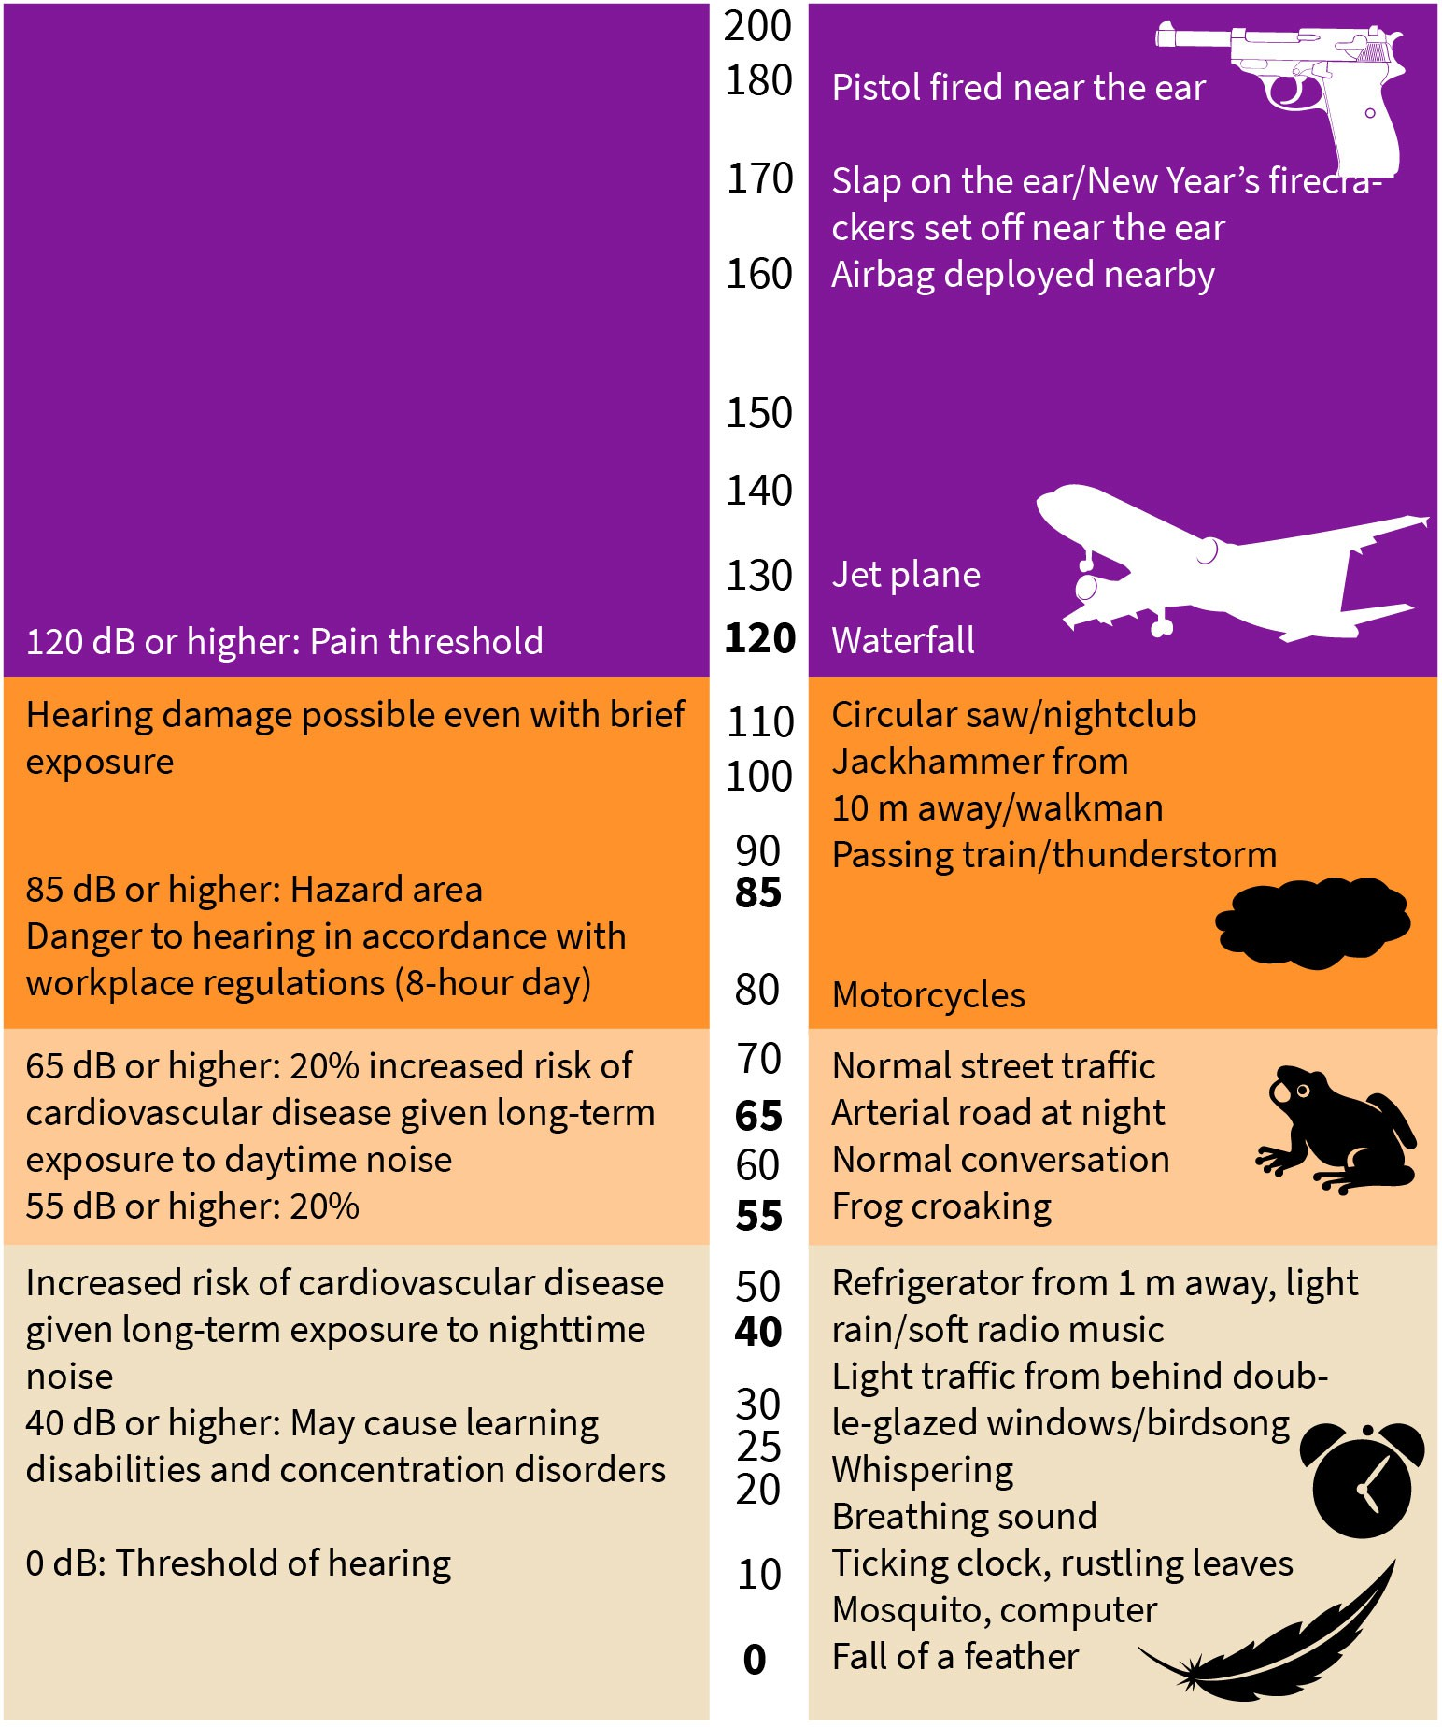

Source: Created by another author, based on Röösli et al. (2018).

#### Water

Access to clean water is a human right because clean drinking water and a functioning sewage system that reliably disposes of **feces** and wastewater make a decisive contribu- tion to people’s health. The biggest problem here is the contamination of the water supply by pathogens, such as cholera bacteria. In contrast, chemical impurities play a subordi- nate role (Egger, Kuehni, et al., 2018, p. 357).

Water can play a direct or indirect role in the transmission of germs. Some pathogens, such as typhus/cholera bacteria or norovirus, are transmitted directly through contami- nated water. This is not only a problem in lower-income countries, but it also persists in Western industrialized nations; for example, rotaviruses can also be transmitted in swim- ming pools. Water insecurity leads to poor hygiene and means that food cannot be cleaned adequately. As a result, infections, such as **shigellosis**, can spread. In addition, a large number of diseases are transmitted by vectors, that is, disease carriers that are either aquatic (e.g., aquatic snails for **schistosomiasis**) or require access to water (e.g., mosquitoes that transmit malaria), as shown in the following table (Egger, Kuehni, et al., 2018, p. 358).

Table 4: Infections Caused by Contaminated Water or Lack of Water

|  |  |  |
| --- | --- | --- |
| **Transmission** | **Description** | **Examples** |
| Contaminated water | Gastrointestinal infection resulting from fecal contamination of the drinking water | Typhoid, cholera, giardiasis, infections with campylobacter, norovirus, enterotoxic E. coli, and cryptosporidium |
| Poor hygiene | Infections that spread when there is insuf- ficient water available for personal hygiene and washing food | Shigellosis, trachoma, and sca- bies |
| Vectors that live in water | Infections transmitted by vectors that spend part of their life cycle in water | Schistosomiasis and dracuncu- losis |
| Vectors that require water | Infections transmitted by vectors that require access to water | Malaria, onchocerciasis, trypa- nosomiasis |

Source: Created by another author, based on Egger, Kuehni, et al. (2018).

Accordingly, preventive measures must be taken at several points. Sanitary facilities and sewage systems are designed to ensure that feces do not come into contact with drinking water. In addition, water is treated and disinfected so that clean drinking water is available in sufficient quantity. Personal hygiene, particularly regular hand washing, is also very important. Even if clean water is available, poor hygiene can mean that pathogens are spread via smear infections, such as with flu viruses, which can stick to the palm of the hand after you blow your nose and can be transmitted to third parties via doorknobs. In addition, food hygiene is also of great importance, since properly washing fruit and vege- tables can eliminate pathogens (Egger, Kuehni, et al., 2018, p. 360).

Chemical contamination is caused in particular by nitrates and nitrites, which are used as fertilizers in agriculture and gardening and can inhibit oxygen transport in the human body. However, contamination of water with arsenic is mostly of geological origin but can also be caused by commercial activities, such as fabric tanning. Arsenic is considered car- cinogenic. Another problem is excessive fluoride concentrations in water since they can lead to bone changes and stiffening of joints. Excessively high fluoride concentrations can be found in East Africa, India, or Mexico, for example. In other countries, such as the US, Australia, or Brazil, by contrast, fluoride concentration in groundwater is too low. Thus, flu- oride is deliberately added to drinking water since a fluoride deficit in the drinking water can lead to tooth decay. Drinking water containing lead poses a particular health hazard

**Shigellosis**

This is an infectious dis- ease that leads to inflam- mation of the colon and is accompanied by watery diarrhea.

**Schistosomiasis**

This is a worm disease caused by fluke parasite larvae. It is spread in warm water by snails, which act as intermediate hosts.

for unborn babies and small children, as it can impair blood formation and the develop- ment of the child’s nervous system. Lead contamination is mostly introduced by lead pipes and fittings, which are still used in older residential buildings (Egger, Kuehni, et al., 2018, p. 361).

***anon***

*2024-06-13 08:57:51*

--------------------------------------------

why do we have these german citations?

#### Radiation

Health is impacted by non-ionizing and ionizing radiation, as well as ultraviolet (UV) radia- tion, which exists in the boundary area between ionizing and non-ionizing radiation.

Non-ionizing radiation includes low-frequency electromagnetic fields generated by elec- trical devices, such as hair dryers or vacuum cleaners, as well as high-frequency electro- magnetic fields emitted by cell phones and cordless phones. It is known that high doses of low-frequency electromagnetic fields are harmful to health. It is disputed, however, whether these fields pose a health risk at low doses. In particular, the possible connection between low-frequency electromagnetic radiation and the development of various can- cers, such as leukemia, is currently being researched. However, since the research data are still contradictory, the International Agency for Research on Cancer (IARC, 2011) has classi- fied low-frequency electromagnetic radiation as possibly carcinogenic (Röösli & Berg- Beckhoff, 2018, p. 384).

High-frequency electromagnetic radiation initially has a thermal effect. Here, too, a possi- ble connection between exposure to high-frequency electromagnetic radiation and vari- ous types of cancer is being investigated. When using a cell or cordless phone, your head area in particular is exposed to radiation (Röösli & Berg-Beckhoff, 2018, p. 387). For this reason, the brain tumor risk from cell phone use has been examined in several studies. However, other studies looked at the risk of testicular cancer since cell phones are often carried in people’s pockets. Past studies suggest that there is no increased cancer risk for average users. At the same time, areas for further research were identified. The IARC, therefore, also classifies high-frequency electromagnetic radiation as possibly carcino- genic (Krebsinformationsdienst, 2019).

Ionizing radiation occurs when radioactive substances decay. Radiation is able to liberate electrons from atoms or molecules (ionization), thereby causing permanent DNA changes in humans (Kuehni & Blettner, 2018, p. 390; Robert Koch Institut, 2015, p. 186). Humans are at particular risk of natural exposure to the radioactive rays of noble gas radon, which occurs in many types of rock and soil. It can accumulate indoors if buildings are poorly sealed from the ground and there is insufficient ventilation. This is more likely to occur in the basement and ground floor of houses. In non-smokers, the majority of lung cancer cases can be traced back to radon exposure (Kuehni & Blettner, 2018, p. 392; Robert Koch Institut, 2015, p. 186).

UV radiation is necessary for humans because the body’s formation of vitamin D is only stimulated by sufficient exposure to sunlight. Too much UV radiation, on the other hand, is harmful to health. Exposing yourself to the sun or artificially generated UV radiation for too long can result in sunburn. The risk of skin cancer increases with the number and

severity of sunburns a person experiences. Sunburns have a highly harmful effect, espe- cially in infancy. The IARC has, therefore, classified UV and solar radiation as well as the use of sunbeds as carcinogenic. Excessive UV radiation can also lead to premature skin aging, eye damage, and weakening of the immune system (Röösli & Berg-Beckhoff, 2018, p. 389; Robert Koch Institut, 2015, p. 186).

***anon***

*2024-06-13 08:57:51*

--------------------------------------------

should be a table

Figure 12: Effect of UV Radiation on Health

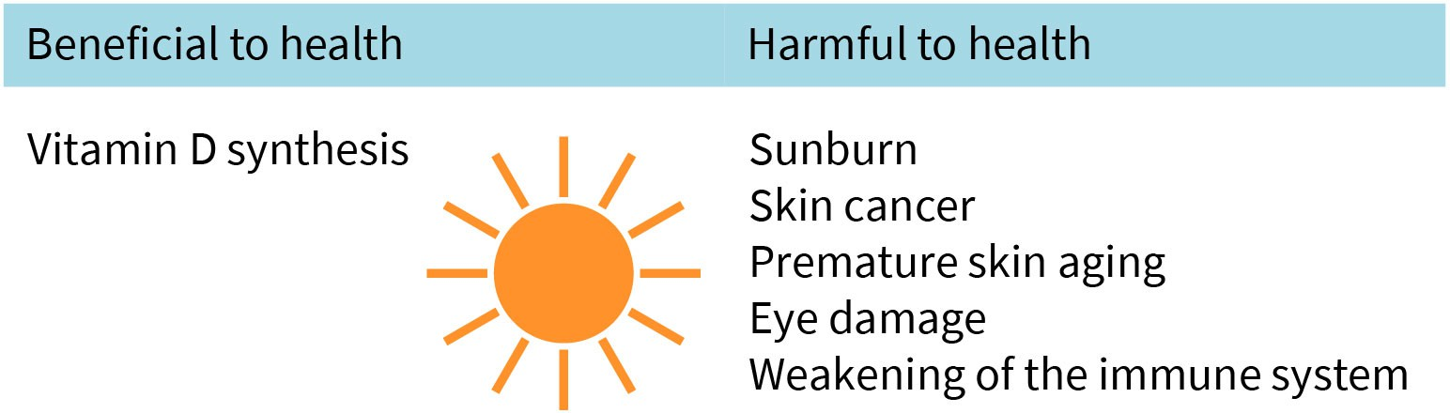

Source: Created by another author.



**SUMMARY**

Climate change is accompanied by extreme weather events that lead to increased morbidity and mortality. A distinction is made between direct consequences, such as increased heat-related deaths, and indirect con- sequences, such as injuries and deaths due to wars or refugee move- ments triggered by famine.

Air pollutants in outdoor and indoor air cause pathophysiological changes in the body and can cause cardiovascular and respiratory dis- eases. Combustion processes in industry, homes, and traffic are particu- larly responsible for the pollution of the outside air. Smoking, volatile compounds emitted by paint and varnish, and mold spores are signifi- cant sources of indoor air pollution.

Extreme exposure to noise often results in acute hearing damage, such as sudden hearing loss and tinnitus. Prolonged exposure to noise, even at moderate levels, can lead to hearing loss, impaired cognitive perform- ance, sleep disorders, and cardiovascular diseases.

Water contaminated by feces and dirt and lack of access to water are associated with an increased risk of infectious diseases. A further health hazard results from the contamination of drinking water with nitrates/ nitrites, arsenic, and excessively high fluoride content or lead.

Researchers have noted that excessive radiation exposure can lead to the development of certain types of cancer. A distinction is made between non-ionizing radiation emitted by electronic devices or cell phones and ionizing radiation resulting from radioactive decay and UV radiation.

# UNIT 5

## PREVENTION AND HEALTH PROMOTION

###### STUDY GOALS

On completion of this unit, you will be able to ...

* define the terms primary, secondary, and tertiary prevention, as well as behavioral and situational prevention.
* Differentiate between objectives of prevention and health promotion.
* apply the transtheoretical model of health change.
* understand the process of a screening program.
* explain which measures fall within the area of occupational safety and occupational health management.

### 5. PREVENTION AND HEALTH PROMOTION

#### Case Study

The students Anja and Paul take part in a company excursion. At a large automotive manu- facturer, they want to see how occupational safety measures can be successfully inte- grated into operational processes. The company’s strategy for health and safety at work is based on the International Labour Organization’s (ILO) Standards on Occupational Safety And Health. The ILO is an agency under the United Nations (UN). The aim of these stand- ards is the upkeep and promotion of employees’ health and working capacity; the improvement of workplace conditions and the workplace environment so it can be safe and healthful; and the development of work organizations and working cultures that should reflect the fundamental value systems adopted by the concerned undertaking, including effective short-term systems, selection and training, fundamentals for participa- tion, and voluntary performance management practices to improve workplace conditions (ILO, n.d.). Accordingly, the factory has strived to increase the availability of occupational health services and the needed measures for the prevention and control of workplace and employment diseases and injuries. This has significantly reduced the number of accidents. On the way back, those who were on the trip started discussing the issue of prevention and health promotion. Accordingly, terms such as primary, secondary, and tertiary pre- vention; health promotion screening; and occupational health management were men- tioned. These terms were new to Anja, so she decided to look them up once she got home.

#### Prevention

##### Primary, Secondary, and Tertiary Prevention

**Prevention** The term prevention describes all measures for the prevention, early detection, and slowing the worsening of disease.

The goal of **prevention** is to avert health hazards. Preventive measures are intended to prevent diseases, detect them at an early stage, or stop them from getting worse (Abel & Kolip, 2018b, p. 234). The idea of prevention is thus based on the concept of pathogenesis. Preventive measures can be divided into three sub-areas: primary, secondary, and tertiary prevention. The aim of primary prevention is to avoid impairment to health, illness, and death – or at least to reduce the probability of any of these events occurring. Vaccination programs or smoking bans in public buildings are just a few such measures. The object of secondary prevention is the early detection of diseases already present but still asympto- matic. Ideally, a cure, or at least a more favorable prognosis, should be able to be ach- ieved. This area includes screening programs for the early detection of diseases, such as breast cancer screening. Tertiary prevention aims to prevent or slow the progression of an already manifest disease. Corresponding measures fall within the field of rehabilitation (Egger et al., 2018d, p. 52).

##### The Paradox of Prevention: Mass Versus High-Risk Strategy

In the field of prevention, a distinction must be made between the population strategy (also called mass strategy) and the high-risk strategy. The mass strategy is directed at the entire population and tries to reduce the risk of disease occurrence in general. The benefit of this strategy is sometimes minor for the individual, but there is a great benefit for the population as a whole since the program is aimed at a large number of people. One exam- ple would be educational campaigns on the link between unprotected sex and HIV infec- tion. The high-risk strategy tries to identify people at the greatest risk of developing a dis- ease in order to reduce their risk through appropriate measures. Only people at a significantly increased risk of illness will benefit from the program. This includes, for example, screening for very high cholesterol levels and appropriate treatment of patients with high levels using cholesterol-lowering drugs to reduce the risk of coronary heart dis- ease (Egger et al., 2018d, p. 53).

The mass strategy is suitable for reducing the burden of disease and premature deaths in the population, even if the benefit for the individual is usually small. Individuals benefit greatly from the high-risk approach. However, this makes a smaller contribution to improving the population’s overall health situation. This already describes a problem of prevention, which is also known as the prevention paradox: Prevention interventions tar- geting large groups at low risk of disease (population strategy) may be more effective than programs targeting a small group of high-risk patients (high-risk strategy). Similarly, pre- ventive measures that bring great benefit to the population as a whole may provide little benefit to a particular individual. However, this does not mean that population and high- risk strategies are mutually exclusive. Rather, sensible combinations of both should be considered. In the area of HIV prevention, it is, therefore, possible to combine an educa- tional campaign on safer sex with the provision of clean syringes for drug addicts (Egger et al., 2018d, p. 56; Klemperer, 2015, p. 199).

Environmental prevention focuses on living, working, and environmental conditions and aims to prevent health risks to people. These include government regulations on con- sumer protection, infection control, and occupational safety, as well as environmental health protection and road safety. Examples include ensuring the quality of drinking water, establishing hygiene standards in hospitals, ergonomic workplace design, or man- dating the wearing of seatbelts in vehicles (Klemperer, 2015, p. 194; Richter & Rosenbrock, 2018, p. 237).

A comprehensive prevention strategy: Case study

As an illustration, the World Health Organization (WHO) Regional Office for the Eastern Mediterranean offers a program for disease prevention and promotion that uses **popula- tion-based interventions** to tackle social determinants of health (SDH) and health dispar- ities (WHO Regional Office for the Eastern Mediterranean, n.d.). This program includes two main activities: disease prevention and health promotion. When it comes to prevention, the program carries out the following (WHO Regional Office for the Eastern Mediterranean, n.d.):

* primary prevention, which includes

**Population-based inter-**

**vention** This is a strategy that con- siders interventions at all practicable levels. A com- munity’s overall popula- tion, institutions that influence health, and the people and households who are recognized as being at risk may all be the targets of interven- tions (Sanson-Fisher et

al., 2007).

**Malnutrition** This is characterized by an uneven intake of essential nutrients, an insufficient utilization of nutrients, or an insuffi- cient or excessive nutrient

intake.

**Health promotion** These measures seek to strengthen health resour- ces and potentials.

* immunization of children, adults, and older adults;
* spreading information on health hazards related to behavior and medicine;
* prevention programs at the primary and specialized levels of care, such as giving patients access to preventative treatments (e.g., counseling); and
* provision of oral hygiene services and educational assistance
* secondary prevention, which includes
  + screening programs;
  + providing maternal and child health initiatives, such as those aimed at identifying and avoiding congenital abnormalities; and
  + provision services aimed at preventing or reducing risk factors, such as diabetes and hypertension

When it comes to health promotion, this program

* offers nutrition and dietary intervention to address **malnutrition**;
* establishes strategies to improve sexual and reproductive health, such as providing family planning services, and enabling greater accessibility to sexual and reproductive healthcare; and
* develops policies and initiatives to target use of alcohol, nutrition, physical exercise, and smoking (WHO Regional Office for the Eastern Mediterranean, n.d.).

#### Health Promotion

The aim of **health promotion** is to create living conditions that promote health and to strengthen people’s health resources. The promotion of health literacy plays a decisive role here: People should be empowered and encouraged to adopt healthier behaviors and to work for healthy living conditions (Klemperer, 2015, p. 197; Kolip & Abel, 2018, pp. 228, 232). The focus is thus shifted from avoiding disease, which is the aim of prevention, to strengthening health (Kolip & Abel, 2018, p. 228). The area of health promotion can thus be classified under salutogenesis.

The Ottawa Charter, which was adopted by the WHO in 1986, is regarded as the most important document and a model for strategies in the field of health promotion. It describes three action strategies and names five priority areas of action. Basic require- ments for good health are taken into account, such as peace, adequate housing, educa- tion, nutrition, income, stable ecosystems, social justice, and equal opportunities. This framework emphasizes that the health sector is not solely responsible for health but that it must be addressed by all policy areas (“health in all policies”; Kolip & Abel, 2018, p. 228).

The action strategies of the Ottawa Charter can be described using the terms “advocacy,” “enable,” and “mediate” (WHO, 1986):

* + - **“Advocacy”**: This refers to advocacy for health with the aim of positively influencing political, economic, social, cultural, biological, environmental, and behavioral factors.
    - **“Enable”**: This refers to promoting health literacy and equal opportunities.
      * **“Mediate”**: This focuses on networking. The aim here is to work toward coordinated interaction between many actors at international, national, and local levels.

Accordingly, five priority fields of action emerge (WHO, 1986):

1. Build healthy public policy.
2. Create supportive environments.
3. Strengthen community action.
4. Develop personal skills.
5. Reorient health services.

The setting approach plays a central role in health promotion. The term setting describes living spaces that can be delimited and analyzed with regard to their health-relevant con- ditions and intervention options. These include daycare centers, schools, companies, and residential areas (Kolip & Abel, 2018, p. 231). In the school setting, for example, a school development process with a health-promoting design can be initiated and tailored to the needs of a school as a place of learning and work. This process involves all stakeholders, including teachers, students, and non-teaching staff. Health-promoting measures can include, for example, ergonomically designed workplaces, improved access to exercise areas, low-sugar and fat-reduced food offerings in the school cafeteria, and improved communications to avoid peaks in the workloads of children and adults (Kolip & Abel, 2018, p. 234).

The principles of the Public Health Action Cycle can be used to plan health promotion measures. Accordingly, the problem should be defined at the start of every planning initia- tive. Here, the basis is the determination of health needs and the definition of which health problem areas should be given priority. The next step is the formulation of goals and strategies. To this end, the general goal to be achieved by the health promotion pro- gram and the target group must first be determined. This goal is then broken down into several sub-goals, and the deadlines for these goals are incorporated into the planning. Depending on the defined goals and the target group, appropriate measures are selected or designed and implemented. This also includes the procurement of the required resour- ces. Tools should be selected according to evidence-based health promotion, meaning research should be conducted to determine which measures have been successful in simi- lar projects. Finally, the program is evaluated and, if necessary, adapted. In particular, the evaluation should consider the effectiveness of the program (i.e., the suitability of the applied measures); the degree of acceptance of the program by the target group, effi- ciency, or the ratio of the resources used to the benefits achieved; and how well it satisfies considerations of equity/equality. In terms of the latter criterion, particular attention must be paid to whether all persons with a corresponding health need have been offered and have taken advantage of the measures in the same way (Dorner, 2018, p. 270; Hartung & Rosenbrock, 2022; Rosenbrock, 1995, p. 140).

Figure 13: Public Health Action Cycle

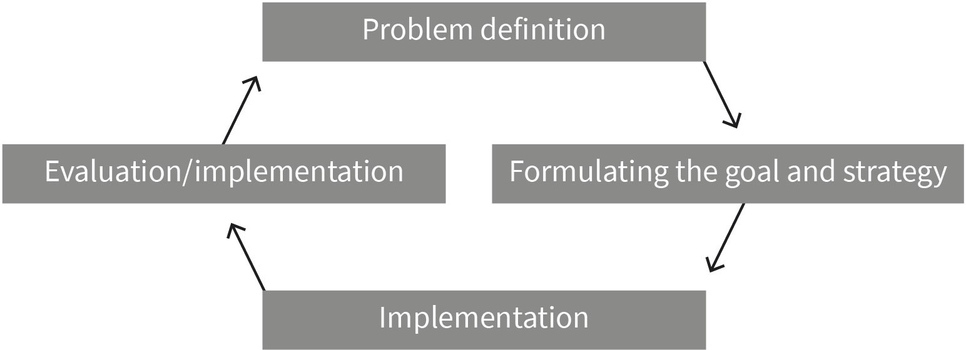

**Health behaviors** This describes all behav- iors that increase the chance of staying healthy or influence the develop-

ment of disease.

Source: Created by another author, based on Dorner (2018).

#### Health Behaviors and Lifestyles, Health Literacy

The concept of **health behaviors** includes all of an individual’s actions that serve to pre- vent diseases, promote health, and protect against injuries. There are five health behav- iors that are particularly important for a population’s morbidity and mortality. These are as follows (Fuchs, 2018, p. 244):

1. Physical activity
2. Eating habits
3. Tobacco consumption
4. Alcohol consumption
5. Sleeping patterns

Personal health behavior plays a decisive role in many chronic diseases, such as cardio- vascular diseases, diabetes mellitus, certain cancers, or back pain. The goal of public health measures in the field of prevention and health promotion is, therefore, to promote positive health behavior and reduce risky health behavior. In this context, various psycho- logical models have been developed that help explain health behavior. We will briefly present the transtheoretical model due to its practical relevance (Fuchs, 2018, p. 245).

The transtheoretical model of health behavior change distinguishes between five stages or levels of motivation. These stages are not run through in a linear fashion but rather in a spiral fashion. At each level, it is possible to regress to one of the previous levels, or to ascend to one of the next higher levels. The starting point is the stage of precontempla- tion. At this level, the individual has not yet considered changing health-related behavior. During the second stage (contemplation), intentions are formed. At this stage, the individ- ual begins to consider changing something about their health-related behavior at some point. However, they do not yet have any firm intention to change the behavior. The third stage involves preparation. At this stage, the person makes a firm commitment to change

the behavior and attempts a new behavior. The fourth stage (action) describes the imple- mentation process. The tested behavior is now adhered to over the longer term. The fifth and final stage is maintenance. At this stage, the new behavior has become habitual. Dif- ferent strategies help individuals to implement the changes. These include cognitive and behavioral strategies. The area of cognitive strategies includes increased awareness of the problem by reading brochures or perceiving beneficial environmental conditions (e.g., consciously recognizing nutrient-dense foods in the supermarket). Behavioral strategies include self-commitment, which can occur by informing those close to you about your planned behavior change, or by counterconditioning, in which unfavorable behaviors are replaced by favorable ones (e.g., eating fruit instead of junk food; Fuchs, 2018, p. 245; Pro- chaska & Velicer, 1997, p. 38).

Progressing from one level to the next depends on various factors. These include the indi- vidually perceived and weighted advantages and disadvantages of the change in behavior. The individual weighs the advantages and disadvantages for themselves and others, as well as whether the new behavior is appreciated or rejected, both from their own perspec- tive and by others. In addition, there is an individual’s self-efficacy expectation, that is, their level of confidence that they will be able to (permanently) adhere to the new behav- ior. Closely related to this is trust in one’s own ability to resist situational temptations and stick to the model behavior even in difficult situations (e.g., when there are invitations to eat junk food; Prochaska & Velicer, 1997, p. 40).

Figure 14: Transtheoretical Model of Health Behavior Change

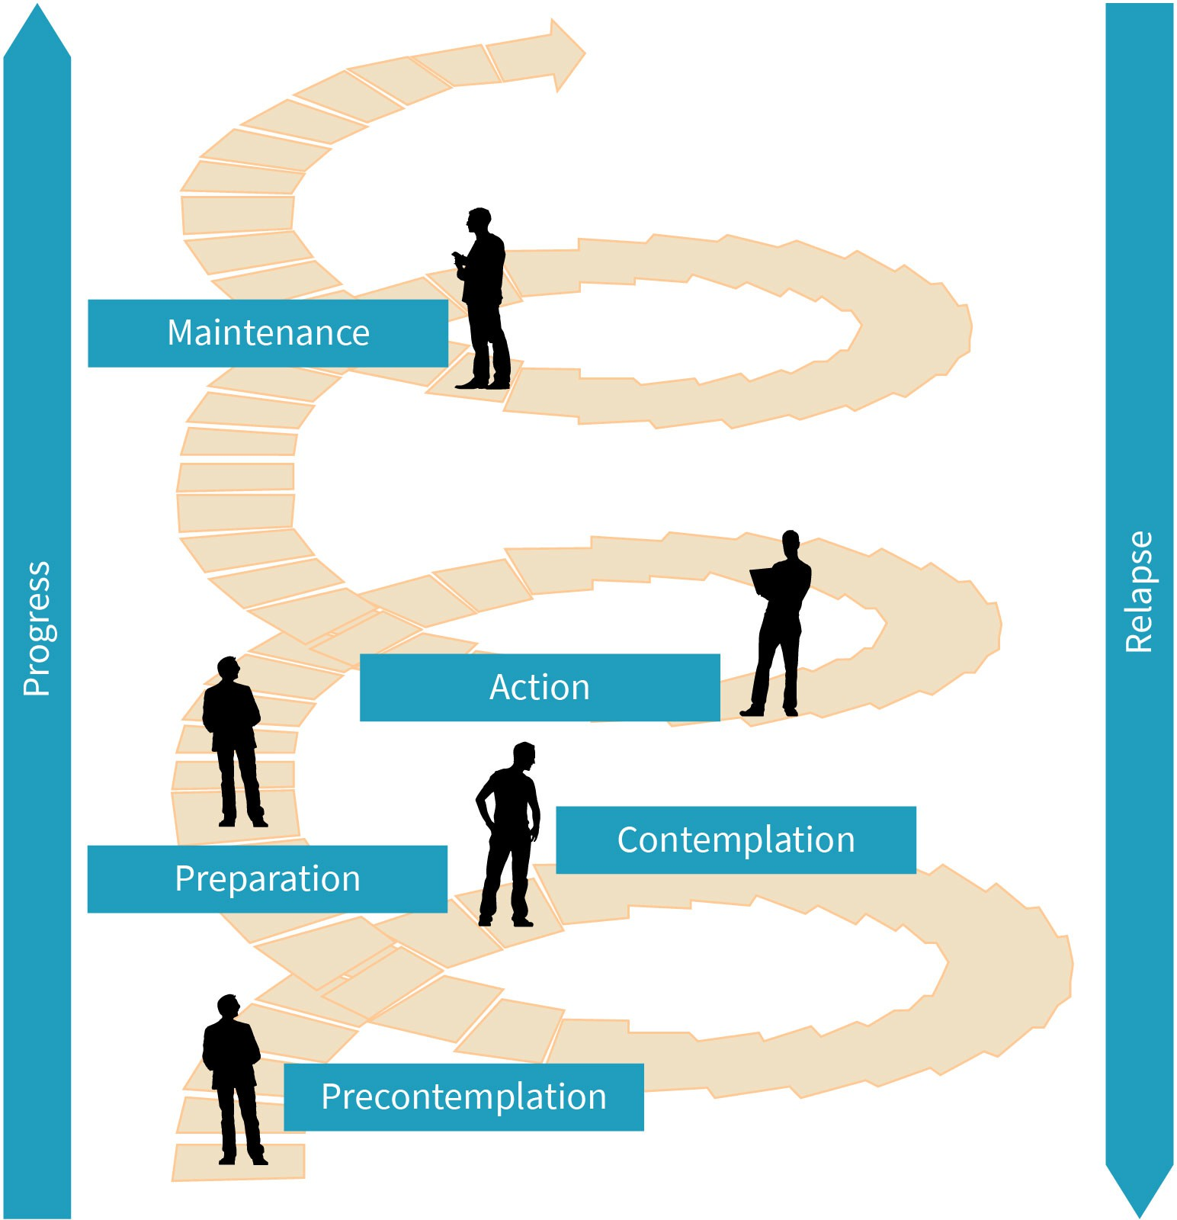

**Health-related lifestyles** This describes a consis- tently practiced health- related lifestyle that is maintained over a longer

period of time.

Source: Created by another author, based on Fuchs (2018).

An individual’s health-related behavior depends on the social context. The individual’s social situation and, thus, their available resources influence their way of life. The choice of lifestyle also depends on the norms and values of the specific reference group. In this regard, we speak of **health-related lifestyles**. These are defined as

* relatively stable patterns of health-related behavior (e.g., smoking, physical activity),
* intrapersonal (e.g., attitudes, health literacy [i.e., knowledge and skills about how to take care of one’s own body, maintain health, and cope with illness], and health-related living conditions; Abel, 2018b, p. 261), and
* social resources (e.g., community support and services available in the neighborhood)

that have evolved as a function of the social, cultural, and material living conditions of individuals and groups (Abel, 2018a, p. 258).

Lifestyles reinforce the individual’s identity and convey a sense of belonging to certain groups. The concept of health-related lifestyles is, therefore, crucial when it comes to understanding health-related behavior in its social context. For example, public health interventions will have little effect if they only appeal to behavioral change while ignoring socially shaped attitude patterns and available resources of the target groups (Abel, 2018a, p. 259).

The transtheoretical model provides important points of reference for the design of healthcare measures. This can be shown, for example, in the design of programs to pro- mote physical activity. Sufficient exercise is an important health resource. However, many people do not exercise enough for such physical activity to provide tangible health bene- fits (Robert Koch Institut, 2015, p. 190). Many only recognize that it would make sense to change a behavior after encountering health problems. The psychological strain often goes hand-in-hand with the development of intentions and the preparation to adopt and initially try a new health behavior. Studies have shown that a new behavior is more likely to become permanent if patients are asked during inpatient treatment to draw up detailed action plans for the time after discharge and coping plans for dealing with anticipated bar- riers (Fuchs, 2018, p. 248; Schwarzer et al., 2008,2011, p. 161).

Gamification is a relatively new approach to promoting healthy lifestyles (Sardi et al., 2017, p. 31). This approach uses digital offerings that convey knowledge in an entertaining way and aim to motivate people to adopt health-promoting behaviors over the long term by integrating playful elements. Activity trackers, which encourage people to move more in everyday life, are one example of gamification. The number of steps taken is measured by wearable sensors and transmitted to an app on the smartphone or computer. There, the achievement of set goals is immediately rewarded with points, badges, and awards. The use of ranking lists contributes an additional element of competition (Innungskran- kenkasse Brandenburg und Berlin, n.d.; Lupton, 2014, p. 174).

#### Screening

**Screening** is a systematic program that aims to reduce the risk of future health problems and detect diseases at an early stage. It is aimed at people who are at increased risk of developing a disease due to their age, gender, or genetic disposition but who have not yet shown any clinical symptoms of the disease or are not aware of them (Egger, Zwahlen, et al., 2018, p. 282). For a screening program to be meaningful, there must be a suitable marker that can be detected (for example, in a blood test), and that indicates a disease, or there must be clearly defined pathological changes that are considered to be precursors of the disease (e.g., colon polyps as a precursor to colon cancer; Egger, Zwahlen, et al., 2018, p. 283).

A screening program consists of four steps: First, the population group to be examined is defined, and all people who belong to this group are invited to take part in the screening (e.g., all women between the ages of 50 and 69 are invited to take part in a mammography screening for the early detection of breast cancer). The screening is then carried out. For

**Screening**

The term “preventive examination” is used syn- onymously with screen- ing. Certain defined popu- lation groups undergo this examination with the aim of early detection of diseases.

people with a positive screening test or with abnormal test results, further diagnostic clar- ification is conducted. If a suspected disease is confirmed, appropriate treatment will be initiated (Egger, Zwahlen, et al., 2018, p. 284).

Figure 15: Flow Diagram of the Screening Process

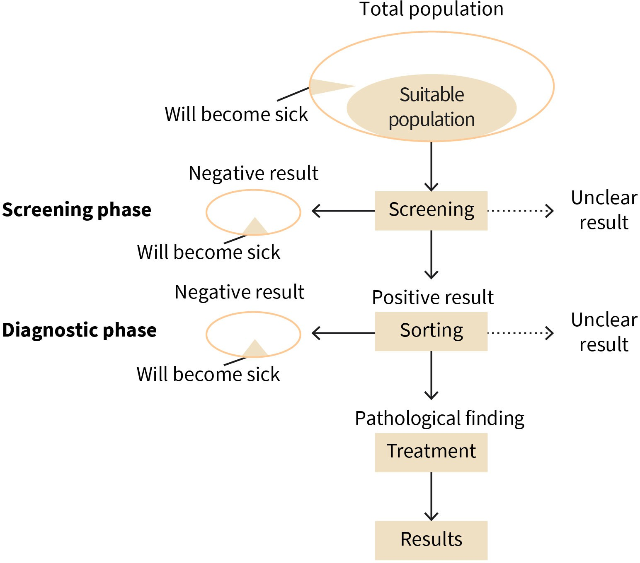

Source: Created by another author, based on Egger, Zwahlen et al. (2018).

From these statements, it should be clear that not all people who have positive test results are actually ill. To keep the number of false positive cases as low as possible while still identifying all people who have an early stage of the disease, screening programs should have the highest possible sensitivity and be highly specific. However, there is a trade-off between these two quality criteria (Egger, Zwahlen, et al., 2018, p. 288): The higher the sensitivity of a test, the lower the specificity, and vice versa.

These terms and the relationships between them can be illustrated by an example with 1000 people participating in a screening. If we assume that the prevalence of the disease is 10 percent, then 100 of the 1,000 people tested will have the disease (cell *A* + *C*). If the diagnostic test is able to detect 98 of the 100 having the disease, then its sensitivity is 98 percent. Sensitivity is, therefore, the ability of a diagnostic test to detect people who

actually have the disease. In the four-field table, this corresponds to the quotient *A* .

*A* + *C*

Accordingly, two out of 100 diseased persons test negative, thus, the false negative rate is

two percent ( *C* ). If the test is able to correctly detect 810 of the 900 individuals without the disease, then the specificity of the test is 90 percent, which is equivalent to the quo-

*A* + *C*

tient *D* . Specificity is, therefore, the ability to correctly detect healthy individuals. In

*B* + *D*

the example, a specificity of 90 percent means that 90 persons out of 900 healthy persons receive a positive test result. This corresponds to a false positive rate of 10 percent

*B B* + *D*

( ).

Specificity and sensitivity of a test are quality characteristics of a diagnostic test and, thus, important properties, especially from a manufacturer’s point of view. In the four-field table, they correspond to a vertical orientation along the columns: If a person actually has the disease, how likely is it that the test will detect it? If a person is actually healthy, how likely is it that the test will be negative? For tested persons, however, the horizontal per- spective is more important since they do not know the true result but only the test result. Therefore, they ask themselves: If the test is positive, what is the probability that I actually have the disease? In health sciences, this is called the positive predictive value (PPV). Anal- ogously, there is a negative predictive value (NPV), which indicates the probability that a negative test result is correct.

To determine the positive predictive value, we need two pieces of information: First, the number of persons with a positive test result who actually have the disease (equals cell A with 98 persons). Second, we need the total number of persons with a positive test result. In addition to 98 persons with the disease with a positive test, this is the 90 healthy per- sons with a positive test (i.e., 188 persons). The positive predictive value is therefore

98

98 + 90

= 0 . 521. In other words: If a person gets a positive test result, then the proba-

bility that they actually have the disease is only 52.1 percent. Given the high sensitivity (98 percent) and high specificity (90 percent), the low positive predictive value may be surpris- ing because the positive predictive value depends not only on the sensitivity and specific- ity, which are fixed as technical properties. In addition, the positive predictive value also depends on the prevalence of the disease: The lower the prevalence, the lower the posi- tive predictive value.

Similarly, the negative predictive value results from the quotient of persons who do not have the disease and tested negative (cell D with 810 persons) in relation to all persons who tested negative (cell C+D = 812). At 99.8 percent, the negative predictive value turns out to be very high. In other words: If the test is negative, then it is very likely true. Analo- gously, the negative predictive value would also be lower at a higher prevalence: At a prev- alence of 20 percent, it would be 99.4 percent.

Figure 16: The Links Between Sensitivity, Specificity, PPV, and NPV in the 2 by 2 Table

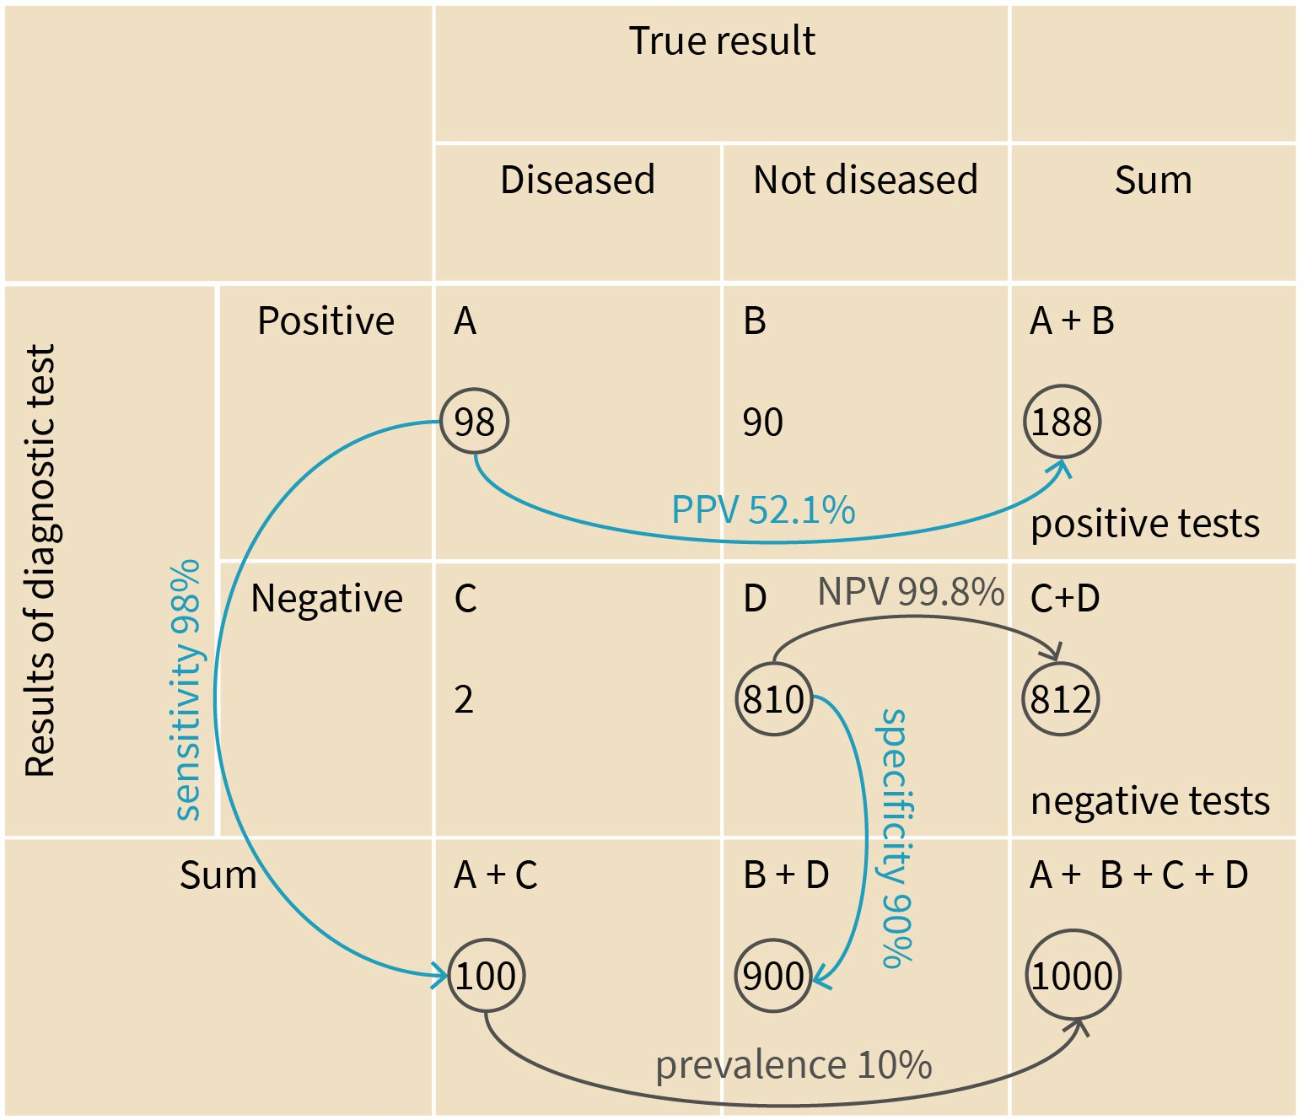

Source: Andreas Heinz (2023).

A characteristic of screening programs is that the majority of participants are not affected by the disease, though all bear the risk of the examination method. In principle, patients with a true positive screening result benefit from a screening program. However, this is only the case if early treatment of the disease leads to a longer lifespan and the treatment does not impair quality of life more than a treatment that is initiated later for an already advanced disease. Sometimes it is also possible that treatment intensity and lifespan are not at all dependent on the time when the disease was discovered. This is the case, for example, with slowly growing prostate tumors, for which the watchful waiting approach is definitely a valid treatment strategy. Many of these tumors grow so slowly that the tumor disease will remain asymptomatic throughout the patient’s lifetime and thus will not entail any serious health impairments for the patient. These patient groups would not benefit from prostate screening since it only prolongs the morbidity phase and, hence, the period in which the patient would experience psychological stress from knowing about the disease. Healthy people with negative screening results (i.e., true negatives) benefit from the screening result, since the medical confirmation of health is generally perceived as positive. However, people who have a false positive result must undergo further and sometimes stressful diagnostics and usually find the time from suspicion to clarification to be very stressful. The problem is that screening programs usually result in more false posi- tives than true positives. For example, the positive predictive value for mammography

screening in Germany is only 15 percent. This means that for 85 percent of the partici- pants, the initial suspicion provided by a positive result is not confirmed by a subsequent investigation. Before deciding to mandate screening measures, legislators must, there- fore, carefully weigh the benefits against the harms of the measure. Likewise, the people invited to participate must be informed and advised about the advantages and disadvan- tages of the particular screening (Spix & Blettner, 2012, p. 385).

#### Occupational Safety and Corporate Health Management

Occupational safety and health (OSH), often known as safety in the occupation (i.e., in a workplace), is a multidisciplinary field that focuses on the welfare, health, and safety of people at work (Alli, 2008). Since they also refer to the goals of the field, these terms were initially used as an abbreviation for OSH programs, departments, etc. An OSH program’s goal is to promote a safe and healthy work environment (Alli, 2008). OSH also safeguards all members of the public who might be affected by the workplace environment.

Work is a meaningful activity for many people, and it can have a positive effect on health. For example, completing a meaningful task exercises a protective effect against depres- sion. However, work can also entail health problems that need to be prevented. Typical work-related health hazards arise from stress at work (this can result from a high workload or psychological stress caused by interpersonal conflicts at work or a lack of recognition by managers); working with substances that are carcinogenic (cause cancer); toxic (poi- sonous), or teratogenic (harmful to embryos); physically demanding or repetitive activi- ties; unhealthy working attitudes, physically demanding working hours (e.g., alternating between early and late shifts); or exposure to high levels of radiation and noise (Haber- mann-Horstmeier et al., 2018, p. 407).

Figure 17: Health Hazards in the Worlplace

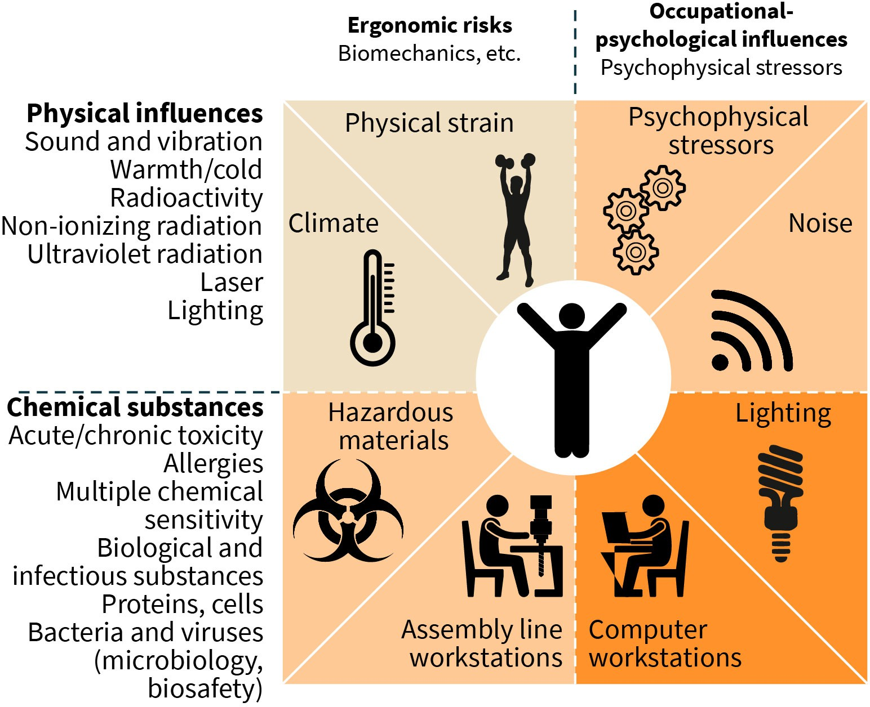

Source: Created by another author, based on Meyer et al. (2018).

The figure shows that there are numerous health risks affecting workers in the workplace, and these can contribute to the development of occupational diseases, work-related ill- nesses, and accidents.

In the workplace, too, a distinction can be made between primary, secondary, and tertiary prevention measures. Primary prevention measures aim to avoid or reduce hazards in the workplace. Secondary prevention measures are intended to identify work-related illnesses at an early stage. Finally, tertiary prevention measures serve to maintain the ability to work despite illness or disability (Habermann-Horstmeier et al., 2018, p. 408).

**Gross domestic product** This is a thorough evalua- tion of a country’s eco- nomic activity. GDP is the value of the finished goods and services pro- duced (O’Neill, 2014).

More than 2.78 million individuals worldwide lose their lives each year to workplace acci- dents or illnesses, or one every fifteen seconds. An additional 374 million nonfatal occupa- tional accidents occur each year. The annual financial impact of occupational disease, injury, and mortality is estimated to be close to four percent of the worldwide **gross domestic product** (GDP). High costs result from this misfortune (International Labour Organization, n.d.). In most legislations around the world, employers are bound by the legal system to take precautionary measures for the safety of their employees (Michaels & Barab, 2020). The specifics of this vary based on the jurisdiction, but primary legislation may also impose broader requirements, introduce new specific obligations, and create government bodies with the power to oversee occupational safety issues.

Additionally, with the spread of global awareness on the importance on mental health, OSH nowadays also encompasses “psychological safety” (Kelloway, 2018). The goal of psychological safety is preventing harm to employees’ mental health. A workplace that fosters good employee mental health and does not intentionally, negligently, or recklessly endanger that health is psychologically safe and healthy (Shain et al., 2012). This includes providing mental health sick leaves, offering mental health support programs, encourag- ing work–life balance, controlling workloads, and having procedures in place for resolving disputes (European Commission, 2014). Problems with occupational health may occur at work or as a result of the kind of work you do. Examples of these problems are as follows (Alli, 2008):

* fractures, fractured bones, sprains, and strains
* hearing problems brought on by loud noises
* vision problems
* disease brought on by exposure to radiation
* disease brought on by breathing, touching, or eating harmful substances
* exposure to microorganisms in medical settings

As a result, the primary goal of occupational health is to prevent illnesses and accidents at work through a variety of strategies, including the following (Alli, 2008):

* making work environments safer for employees
* ensuring that employees use ergonomically sound techniques
* looking for ways to improve workplace health
* helping employees who are sick or are absent from work because of illness
* providing ongoing mental health care to those who experience stress at work or at home

By carefully examining their current environment, with the help of occupational health, employers may minimize health dangers and maintain compliance with changing regula- tions.

##### Types of OHS Services

The goal of OHS is to assist employees in treating any present health issues and foresee any health-related difficulties at work. This field of medicine approaches workplace issues proactively and preventively and may provide a variety of therapies, such as the following (International Labour Organization, 2014):

* tools for workplace health screening: Services in areas including behavioral health, addiction, and pain may be offered. Services may include employee tele-behavioral health services and access to outreach behavioral health professionals. Additionally, it is possible to assess prospective employees for dangerous and demanding jobs.
* management of absences and disabilities: A behavioral health component may be included in fitness-for-duty evaluations.
* digital mental health: By promoting resilience and upholding employees’ mental health, digital technologies support prevention through self-guided cognitive behavioral pro- grams, coaching, and brief counseling. The general well-being of the workforce may be promoted with the help of tools and coaching.
* employee compensation: Personalized and supervised pain management programs may be provided for injured workers who use opioids. Centralized care management with medical professionals and psychologists is also possible.

##### Corporate Health Management

Corporate health management describes how health promotion initiatives for staff mem- bers can be planned, organized, and implemented within a business. Corporate health refers to initiatives implemented by corporations to advance the health and wellness of their workforce populations (Zink, 2005). The goal is to protect employee well-being, which will ultimately improve business performance. Because of this, this work is closely linked to both corporate governance and human resources management.

Companies, organizations, and institutions are becoming more aware of the fact that employee health affects not only the employees but also the company’s interests in a sig- nificant way (Zink, 2005). Whether a small- or medium-sized organization or a large corpo- ration, corporate health management is a strategically valuable component for all busi- nesses when it is effectively applied. The benefits of corporate health management are as follows (Aldana et al., 2005; Baxi & Ray, 2012; Goetzel et al., 2014):

* motivated and effective workforce
* decreased employee absences
* increase in performance across the organization as a whole
* advantageous positioning of the company, organization, or institution in the job market



**SUMMARY**

In the field of prevention, a distinction is made between primary, secon- dary, and tertiary prevention measures. These aim to (1) avoid diseases,

(2) detect them at an early stage, or (3) avoid worsening of existing con- ditions. Behavioral prevention tries to positively influence health-rele- vant behavior. Relationship prevention, however, begins with living, working, and environmental conditions.

The focus of health promotion is not on disease prevention, but on strengthening health and promoting health skills. In health promotion, the setting approach is often used. The aim here is to shape living envi- ronments, such as schools or workplaces, in a health-promoting way. All relevant actors are involved.

The transtheoretical model of health behavior change provides impor- tant foundations for the design of campaigns or programs aimed at changing health-related behavior. In addition to knowledge about the significance of changed behavior and the will to bring about this change, the permanent implementation of a new behavior also depends, among other things, on self-efficacy expectations, and social influences.

Screening programs are used for the early detection of diseases. All per- sons who are at an increased risk of developing a particular disease due to their age or gender are invited to take part in the screening. If the test result is positive, further diagnostic clarification is performed.

# UNIT 6

## CHRONIC DISEASES

###### STUDY GOALS

On completion of this unit, you will be able to ...

* explain why obesity is a significant public health problem.
* list factors that contribute to the development of cardiovascular diseases.
* name measures used for the early detection of cancer.
* differentiate between the two respiratory diseases, bronchial asthma and chronic obstructive pulmonary disease.
* explain why diseases of the musculoskeletal system usually entail a significant reduc- tion in quality of life.

### 6. CHRONIC DISEASES

#### Case Study

During his research, Paul comes across the Global Action Plan for the Prevention and Con- trol of Non-Communicable Diseases (NCDs). The goal of this plan was to lower the preva- lence of chronic NCDs and mortality rates by promoting prevention and management in all government sector initiatives. Additionally, the goal is to give NCDs more weight in national development plans; step up efforts to tackle the major NCD risk factors, such as smoking, eating poorly, and inactivity; fostering cooperation for NCD prevention and con- trol; research and monitor NCDs and the variables that affect them; and assess national progress (World Health Organization [WHO], 2013).

#### Obesity

The term obesity (ICD-10: E65 – E68) describes a pathological increase in body weight that is associated with an excessively high proportion of body fat. Excess weight and obesity are measured using the body mass index (BMI). This is calculated as the body weight (in kilograms) divided by the height squared (in meters):

BMI = body weight in kg

body height in m2

According to the WHO, a BMI of more than 25 kg/m2 is considered overweight and a BMI of 30 kg/m2 or more is considered obese. According to a study by the Robert Koch Institut on the health of adults in Germany (DEGS1), 67.1% of men and 53.0% of women in Germany are overweight (obese people are included in this percentage). For obesity, the percen- tages for both sexes are about 23%. The population becomes more overweight and obese with age (Robert Koch Institut, 2015, p. 202). There is a connection between the preva- lence of excess weight or obesity and social status. For example, people with a lower level of education and a lower occupational status, as well as the unemployed and people with an income below the poverty line, are more likely to be overweight and obese than a com- parison group of people with a higher socioeconomic status. Similar results can also be found in children and adolescents. Children and young people from socially disadvan- taged families are more likely to be overweight or obese than their peers from families with a higher social status (Robert Koch Institut, 2015, p. 206).

As per the WHO, the prevalence of obesity has risen dramatically worldwide since 1975. Over 1.9 billion adults over the age of 18 are overweight currently (39 percent of the world’s population), with over 650 million of these people being obese (13 percent of the world’s population; WHO, 2021e). Thus, most individuals on Earth live in countries where being overweight or obese is more likely to lead to death than being underweight, such as

high-income countries like the US. Similarly, about 39 million children under the age of five are considered to be overweight or obese. There are also over 340 million overweight or obese children (from age five) and teenagers (up to age 19; WHO, 2021e).

Measures to prevent excess weight and obesity must first address the main risk factors. These include lack of exercise and poor nutrition, especially excessive consumption of high-calorie foods with a high fat and sugar content. The foundations for healthy physical activity and a healthy diet are laid in childhood and adolescence. Accordingly, it is advisa- ble to start prevention programs to avoid excessive weight and obesity at a young age. Here, too, a combination of behavioral and relationship-related measures has proven to be effective. In the field of behavioral prevention, the aim is to point out the importance of an active lifestyle and a balanced diet and to encourage appropriate behavior, for exam- ple, through programs to promote physical activity in schools or by providing fruit in the school cafeteria. The area of situational prevention includes measures such as making access to unhealthy food more difficult (Robert Koch Institut, 2015, p. 206). Here, it is sometimes proposed that unhealthy foods be taxed at a higher rate (Ärzteblatt, 2018). However, studies highlight that that food taxes (on “unhealthy” foods, such as chocolate, candy, sugary drinks, and fast food) and subsidies (on “healthy” foods, such as fruits, veg- etables, and non-processed grains) should be at least 10 to 15 percent and preferably used in conjunction for maximum success and impact (Niebylski et al., 2015).

Obesity puts a lot of strain on the muscular and skeletal system, and it can lead to the development of lipid metabolism disorders and increased blood pressure, which, in turn, increases the risk of cardiovascular diseases, type 2 diabetes mellitus, and certain cancers, such as malignant cancers of the colon, pancreas, or kidneys. The higher morbidity of obese individuals is associated with higher mortality. Obesity is, therefore, associated with high direct and indirect costs (Robert Koch Institut, 2015, p. 202).

Excess weight and obesity are a significant health problem, particularly in children and adolescents, since this group of people is at increased risk of being overweight or obese as adults.

#### Cardiovascular Diseases

Cardiovascular diseases (CVDs; ICD-10: I00–I99) include all diseases of the heart and blood circulation. These include, for example, circulatory disorders of the coronary arteries (cor- onary heart disease), cerebral arteries (stroke), leg arteries (peripheral arterial disease), and high blood pressure or chronic heart failure (Haidinger et al., 2018, p. 462).

CVDs account for 17.9 million deaths annually and are the major cause of death globally (WHO, n.d.-a). One-third of these deaths occur before the age of 70, and about 80 percent of CVD deaths are caused by strokes or heart attacks (WHO, n.d.-a). Consequently, CVD is predicted to increase medical expenses and productivity losses globally from $555 billion in 2015 to $1.1 trillion in 2035, according to the American Heart Association (Dunbar et al.,

2018). In industrialized countries, CVDs are the most common cause of death for both women and men. They are responsible for a majority of premature deaths before the age of 65, and they are responsible for a significant loss of potential years of life.

The main risk factors for CVDs include smoking, obesity, a sedentary lifestyle, dyslipide- mia, high blood pressure, diabetes mellitus, and chronic inflammation (Haidinger et al., 2018, p. 466; Robert Koch Institut, 2015, p. 38). These risk factors can be positively influ- enced by behavioral changes and drug therapies (Robert Koch Institut, 2015, p. 38). In addition, researchers have investigated a connection between the development of cardio- vascular diseases and exposure to certain environmental factors, such as particulate mat- ter or noise pollution. It can also be observed that the risk of CVD is higher in men and women with a low socioeconomic status. This can be attributed to the class-specific distri- bution of the risk factors listed above, though social isolation and a lack of social support can also contribute to the development of the disease. Life without a partner, the loss of close relatives, or the lack of reliable social relationships are associated with an increased risk of CVD (Haidinger et al., 2018, p. 469).

In addition, psychosocial stress at work and in the family, especially chronic long-term stress, promotes the development of CVDs. Personality traits and corresponding behavio- ral patterns are also discussed as a cause for the development of CVDs. In particular, peo- ple who suppress anger and other negative emotional states seem to be at increased risk (Haidinger et al., 2018, p. 484).

Due to advances in the prevention and treatment of CVDs, mortality from CVDs has decreased significantly in recent decades. In terms of prevention, programs that aim to change health behavior have proven to be very effective (Robert Koch Institut, 2015, p. 49).

#### Malignant Neoplasms

In 2020, nearly 10 million people died from cancer worldwide, making it one of the leading causes of death (WHO, 2022b). In terms of new cases of cancer per year the following were most common (WHO, 2022b, p. 1):

* + - 2.26 million cases of breast cancer
    - 2.21 million cases of lung cancer
    - 1.93 million cases of colon and rectum cancer
    - 1.41 million cases of prostate cancer
    - 1.20 million cases of non-melanoma skin cancer
    - 1.03 million cases of stomach cancer

The most typical reasons for cancer deaths per year are as follows (WHO, 2022b):

* + - 1.80 million deaths from the lung cancer
    - 916,000 deaths from colon and rectum cancer
    - 830,000 deaths from liver cancer
* 769,000 deaths from stomach cancer
* 685,000 deaths from breast cancer

In addition, around 400,000 children are diagnosed with cancer every year (WHO, 2022b). The most prevalent cancers among children differ from one country to another.

For many types of cancer, little is known about the **etiology**(i.e., the mechanism by which the disease develops). In addition, there is no known way of influencing many well-known triggers, such as genetic factors. For this reason, prevention strategies are only available for a few types of tumors. Tobacco consumption is one of the avoidable risk factors. It is estimated that around 16 percent of all tumor diseases (including lung cancer and cancer of the oral cavity, larynx, esophagus, bladder, or kidneys) can be traced back to smoking. In addition, lack of exercise and obesity play a role. In addition to eating too much food, the type of food consumed is also important. A protective effect is attributed to the con- sumption of fruit, vegetables, and fiber, whereas excessive consumption of alcohol, red meat, and sausage promotes tumor development. For example, alcohol is considered a risk factor for cancer of the oral cavity, throat, and liver. High consumption of red meat and sausages is associated with the development of colon cancer. Overall, however, the World Cancer Research Fund (WCRF) report revealed that far fewer cancers are lifestyle- related than previously assumed (World Cancer Research Fund & American Institute for Cancer Research, 2018, p. 38). In addition to lifestyle factors, chronic infections can con- tribute to the development of cancer. Infection with hepatitis B viruses is considered a risk factor for liver cancer, while human papillomaviruses (HPV) are linked to the development of cervical cancer. Vaccinations can help reduce the risk of infection-related cancer. The avoidable risk factors also include exposure to ultraviolet radiation from the sun or in a tanning bed, which promotes the development of malignant skin cancer. Medical proce- dures can also lead to the development of a tumor disease or a second tumor, i.e., a renewed tumor disease after a previous cancer disease. Diagnostic and therapeutic proce- dures associated with radiation exposure, cytostatics in chemotherapy, and hormone replacement therapy for women during menopause are considered risky (Robert Koch Institut, 2017, p. 19).

***anon***

*2024-06-13 08:57:51*

--------------------------------------------

why is the book now german-focused?

The health insurance companies, such as the statutory health insurance funds in Germany, have proposed measures for the early detection of cancer caused by malignant tumors of the skin and intestines, as well as breast and cervical cancer in women and prostate can- cer in men (Robert Koch Institut, 2017, p. 20). In addition, depending on the country, there may be other early detection tests that a person can pay for out of pocket. Some of these **self-pay services** may offer a questionable benefit, however. This is the case, for example, with the prostate-specific antigen (PSA) test that is used to screen for prostate cancer. This is a blood test that measures the level of PSA. High levels can indicate a prostate tumor, inflammation of the prostate, or benign prostate enlargement. The benefit of this test pro- cedure is disputed, however, since this test is sometimes used to diagnose many tumors in older men that never otherwise become of clinical concern (Zwahlen et al., 2018b, p. 493).

**Etiology**

This deals with the causes and processes that con- tribute to the develop- ment of a disease.

**Self-pay services**

These are healthcare services that may not be covered by health insur- ance and must be paid for by the patient.

**Chronic obstructive pulmonary disease**

This describes a group of diseases that can obstruct airflow in the lungs and lead to issues with breathing (Barnes & Celli,

2009).

#### Respiratory Diseases

Respiratory diseases (ICD-10: J00-J99) – particularly acute respiratory diseases, such as bronchitis, the flu, and the common cold – are common causes of sick leave (Fisk et al., 2004). The burden of respiratory diseases on the world’s population continues to be among the greatest of all diseases and one of the leading causes of death. Lower respira- tory tract infections (LRTIs) and **chronic obstructive pulmonary disease** (COPD) are con- sidered to be leading causes of death (GBD Chronic Respiratory Disease Collaborators, 2020). Pneumococcal pneumonia is responsible for about 55 percent of LRTI-related deaths around the world. In high-income countries, lung cancer is the most common cause of respiratory disease-related death and pneumonia is the second-leading cause (Biscevic-Tokic et al., 2013). In low- and middle-income countries (LMICs), it is estimated that prevalence of respiratory diseases is 7.2 percent. Lower respiratory diseases are the second most common cause of death of children in LMICs after diarrheal diseases (Simen- Kapeu et al., 2021).

Respiratory diseases include acute infections of the upper respiratory tract (e.g., cold, sinusitis, pharyngitis, or tonsillitis); acute infections of the lower respiratory tract (e.g., inflammation of the bronchi, pneumonia); diseases of the lungs caused by exogenous sub- stances (e.g., asbestosis caused by the inhalation of asbestos); and chronic diseases, such as bronchial asthma or chronic obstructive pulmonary disease. Let us consider the latter two diseases in more detail here.

Bronchial asthma is a chronic inflammatory disease of the respiratory tract. Asthma attacks lead to a narrowing of the bronchial system and, as a result, they cause breathing problems, including acute shortness of breath. In the case of bronchial asthma, a distinc- tion is made between the allergic and non-allergic forms of the disease. In the case of allergic bronchial asthma, the body reacts to allergens such as pollen or the faecal pellets of household dust mites. Non-allergic asthma is caused by non-specific stimuli, such as cold air, or as a result of infections, and it leads to a pseudo-allergic reaction (Robert Koch Institut, 2015, p. 77).

Bronchial asthma is the most common chronic disease in childhood. About five percent of girls and about seven percent of boys between 0 and 17 years of age in Germany have been diagnosed with asthma. Among adults, almost 10 percent of women and almost seven percent of men suffer from asthma. Thanks to the good treatment options with inhaled steroids (to reduce the swelling of the bronchial mucosa as well as the hypersensi- tivity of the bronchi) and bronchodilators to expand the bronchi, mortality from asthma is low (Kuehni & Latzkin, 2018, p. 525; Robert Koch Institut, 2015, p. 79).

The development of bronchial asthma is due to a complex mechanism of action between genetic factors and environmental influences (Robert Koch Institut, 2015, p. 77). There- fore, researchers speak of multifactorial diseases, meaning those with many contributing factors (Kuehni & Latzkin, 2018, p. 525). A clear risk factor for bronchial asthma is pre- and postnatal exposure to tobacco smoke and air pollution. In addition, researchers have also observed that children who have been breastfed in the first months of life are less likely to

develop asthma than children who have not been breastfed. One protective effect that has been identified is early exposure to infections, for example, as communicated by siblings or early visits to daycare centers (Kuehni & Latzkin, 2018, p. 526).

COPD entails a high disease burden and is one of the most common causes of death in Germany after CVDs and malignant cancers. COPD is characterized by chronic inflamma- tion of the respiratory tract, which leads to narrowing of the respiratory tract and the destruction of lung tissue. COPD manifests as a persistent cough with sputum (phlegm) and a permanent expansion of the pulmonary vesicles. Affected people often complain about shortness of breath, which initially only occurs during exercise. As the disease pro- gresses, it also occurs at rest (Steppuhn et al., 2017, p. 46).

The occurrence of COPD is age-dependent, and the risk of developing it increases from middle age onwards. So far, little reliable data have been collected on the prevalence of COPD. It is estimated that almost six percent of people over 40 suffer from COPD, and the incidence differs significantly depending on educational status (Kuehni & Latzkin, 2018, p. 527; Steppuhn et al., 2017, p. 46).

Smoking is the main avoidable risk factor for the development of chronic obstructive pul- monary disease (Robert Koch Institut, 2015, p. 469). The risk of developing COPD is deter- mined by the pack years, which refers to the total number of packs of cigarettes smoked over a given number of years. A patient can slow the development of the disease by quit- ting smoking. Other important risk factors are exposure to dust in certain workplaces, such as in open-pit coal mines, for example. The development of COPD is also associated with growth and development disorders of the lungs. These are mostly due to genetic fac- tors and prenatal influences, such as maternal smoking, but they can also be caused by repeated respiratory infections in early childhood, or exposure to air pollutants or asthma in childhood (Kuehni & Latzkin, 2018, p. 527; Steppuhn et al., 2017, p. 46).

#### Diseases of the Musculoskeletal System

Diseases of the musculoskeletal system (ICD-10: M00–M99) include diseases of the joints, cartilage, and muscles. They are another one of the most common causes of health prob- lems. The disease spectrum varies from mild and temporary impairments to severe, chronic disabilities. Musculoskeletal disorders are usually not life-threatening. However, they are usually associated with (severe) pain and significantly limit the scope of action of those affected, which reduces quality of life and productivity. From a clinical and epide- miological point of view, the clinical pictures of back pain, osteoarthritis, osteoporosis, and rheumatoid arthritis are of great importance (Reichenbach, 2018, p. 498).

The term “back pain” describes all pain conditions in the area of the back, regardless of their cause. In most cases, it is not possible to explain the pain as part of a clear clinical picture. Here, clinicians often speak of non-specific back pain. These disease cases can be divided into acute (length of less than one month), subacute (length of less than three

months), and chronic pain states (Reichenbach, 2018, p. 513). Back pain tends to have a high lifetime prevalence. The global prevalence of back pain is between 7.5 and 8.2 per- cent. Moreover, about 577 million persons have had back pain at some point in their lives, with higher prevalence of back pain in females than males (Wu et al., 2020).

The risk factors for back pain include mechanical stress at work due to heavy lifting and carrying, awkward postures, and vibrations. In addition, psychosocial factors, such as stress, anxiety, or job dissatisfaction, and unfavorable lifestyle factors, such as obesity and lack of physical activity, also contribute to the development of back pain. Preventive measures should, therefore, start with both behavioral and situational prevention. Behav- ioral prevention measures include information about the origin and course of back pain, as well as physical activity that strengthens the muscles. When it comes to situational pre- vention, clinicians recommend ergonomic workplace design, training in how to lift and carry loads in a back-friendly way and avoiding monotonous work procedures and bad workplace environments (Reichenbach, 2018, p. 514; Robert Koch Institut, 2015, p. 70).

Osteoarthritis refers to progressive joint failure caused by slow but steady cartilage degra- dation. The progression of the disease can also affect the surrounding bones, ligaments, capsules, and muscles. Consequences include pain and loss of function in the affected joints, which can result in reduced mobility and impairments in everyday life, including disabilities (Robert Koch Institut, 2015, p. 71). Over the course of almost three decades, the number of common cases of osteoarthritis increased by 113.25 percent globally, which is more than double the 247.51 million new cases in 1990 to about 527.81 million new cases in 2019 (Long et al., 2022).

Regardless of sex, incidence increases with age. Knee, hip, shoulder, finger, and vertebral joints in particular are often affected. The causes of the development of osteoarthritis are diverse and not fully known. Osteoarthritis can, therefore, only be prevented to a limited extent. The risk factors that can be influenced include joint malpositions that can be cor- rected surgically, but also obesity and placing excessive loads on the joints as part of work-related tasks, such as in agriculture. Behavioral prevention measures include partici- pating in sporting activities that are gentle on joints, such as cycling, swimming, or hiking, and reducing body weight. In the area of environmental prevention, ergonomic training in the workplace is recommended (Reichenbach, 2018, p. 516; Robert Koch Institut, 2015, p. 71).

Osteoporosis is a term used to describe a skeletal disease characterized by loss of bone mass with a concomitant deterioration in bone structure. This increases the susceptibility of the bone to fracture, so that even minor external injuries can lead to fractures. Vertebral compression fractures, fractures of the femoral neck bone, and wrist fractures occur par- ticularly frequently.

According to estimates, one in three females and one in five males over the age of 50 glob- ally suffer from osteoporosis. Thus, osteoporosis is considered to be the most prevalent bone disease globally (Sözen et al., 2017). Women tend to be at much higher risk of osteo- porosis than men. In addition to having a genetic predisposition and experiencing early menopause, the risk factors for developing this disease also include being underweight, smoking, alcohol consumption, insufficient physical activity, and taking medication that

negatively affects bone metabolism (e.g., high-dose glucocorticoids; Reichenbach, 2018, p. 518; Robert Koch Institut, 2015, p. 72). The most important behavioral prevention meas- ures, therefore, include avoiding being underweight, abstaining from nicotine and alcohol, and improving bone stability. This can be increased through regular physical exercise, receiving sufficient vitamin D (through sun exposure and possibly taking medication), as well as calcium, folic acid, and vitamin B12 (possibly through dietary supplements). If frac- tures have already occurred, the patient should avoid long-term immobility as a form of tertiary prevention, and physiotherapeutic measures should be started at an early stage (Reichenbach, 2018, p. 518; Robert Koch Institut, 2015, p. 72).

Rheumatoid arthritis is a type of inflammatory joint disease that is caused by a disorder of the immune system. Rheumatoid arthritis is an autoimmune disease. The course is mostly relapsing, and it leads to progressive destruction of the joints, starting in the joints that are furthest from the body (finger and wrist joints, toe and ankle joints, and knee joints). This clinical picture is characterized by swelling of the affected joints (i.e., rheumatic nod- ules; Reichenbach, 2018, p. 518; Robert Koch Institut, 2015, p. 72).

Rheumatoid arthritis is thought to affect 0.24 to 1 percent of individuals worldwide, and it affects women twice as frequently as men (Almutairi et al., 2021). The prevalence of rheu- matoid arthritis increases with age. The development of rheumatoid arthritis is mainly dependent on genetic predisposition. Accordingly, there are no primary prevention approaches; however, smoking, lack of exercise, and obesity have a negative impact on the course of the disease. Therefore, forms of tertiary prevention include giving up nico- tine, increasing physical activity, and reducing weight, which are just as important as tak- ing medication that prevents damage to the structure of the joints (Reichenbach, 2018, p. 518; Robert Koch Institut, 2015, p. 72).

#### Costs Associated With the Selected Diseases

The burden of disease is the effect of a health issue as determined by monetary costs, fatalities, diseases, or other indicators associated with this issue (Bhutta et al., 2014). **Disa- bility-adjusted life years** (DALYs) or **quality-adjusted life years** (QALYs) are commonly used to quantify it. The total burden of disease can be used as a measure of the health gap when compared to the optimum health level (Bhutta et al., 2014).

According to the Pan American Health Organization, NCDs caused the loss of 121 million years of life due to premature mortality, 226 million years of life lost (226 million DALYs), and 105 million years of life lost (105 million QALYs) due to illness or impairment in the Americas in 2019 (PAHO, 2021). In terms of lost lives and livelihoods, healthcare expenses, and a negative effect on human capital and productivity, chronic diseases have a signifi- cant economic cost. The five most prevalent chronic diseases (cardiovascular, respiratory, cancer, diabetes, and kidney diseases) are expected to cost $47 trillion between 2010 and 2030, or more than $2 trillion annually on average (NCD Alliance, 2022).

**Disability-adjusted life years**

This reflects the loss from one year of healthy living, so one DALY can be com- pared to a year of healthy life lost when one lives to old age free from illness and disability (McDonald et al., 2020).

**Quality-adjusted life**

**years** These are often used in health economic analyses to evaluate the effects of medical interventions or prevention programs on health and eventually help with resource alloca- tion in the healthcare sys- tem (Sanghera & Coast,

2020).

**Out-of-pocket medical**

**expenses** These are medical costs that must be paid entirely out of pocket because they are not covered by any type of health insur- ance (Sirag & Mohamed

Nor, 2021).

**Universal health**

**coverage** This is when everyone in the country has access to healthcare. It aims to pro- vide everyone with access to healthcare, not only those who cannot afford it on their own (WHO,

2021f).

Costs incurred by chronic diseases, both direct and indirect, are draining economies (Bloom et al., 2012). They increase healthcare costs while lowering productivity and human capital due to serious illness, disability, and death. Chronic diseases also harm the economy of millions of households each year as both a cause and a repercussion of pov- erty. According to estimates, 100 million people worldwide experience extreme poverty each year as a result of paying for their own medical care (as **out-of-pocket medical expenses**) to treat chronic diseases (Bloom et al., 2012). In addition, chronic diseases can come with non-healthcare expenditures like lost productivity due to morbidity or mortal- ity and informal care costs. Therefore, it is anticipated that chronic diseases will continue to grow economically in the future, especially in low-, middle-, and high-income countries, but especially in less wealthy economies (Ebrahim et al., 2013). Death rates are reducing at all ages, increasing life expectancy, but if morbidity is increasing rather than decreasing, this will lead to more years of chronic illness (Marthias et al., 2021).

In high-income countries, when more than 150 million people encounter catastrophic costs each year and unexpected out-of-pocket expenses for expensive services, the house- hold financial burden of healthcare is much lower than in LMICs (Kazibwe et al., 2021). This is because LMICs have insufficient safety nets and vulnerable health systems, and they are coping with a number of concomitant health issues (such as the double burden of disease). Over two billion people residing in LMICs are unable to access a good, fair, and adequately funded healthcare system due to the lack of financial risk protection programs and **universal health coverage** (UHC; Kazibwe et al., 2021). For instance, research con- ducted in China found that 37 percent of patients and their households were living below the poverty line of $1 per day per person, and one stroke incident forced nearly two-thirds of those without insurance into poverty (Zhou et al., 2020). Another further illustration is the family of a diabetic child in Sudan, who spent nearly a fifth of their income on health- care (Elrayah et al., 2005). In Pakistan, it was found that while 63.5 percent of cancer patients turned to their personal funds, 27 percent of them took out loans to pay for their care (Mahmood & Ali, 2002).



**SUMMARY**

Chronic diseases are long-lasting illnesses that either cannot be cured or only with difficulty, and they require continuous monitoring.

Obesity is a pathological increase in body weight, and, in turn, it is a risk factor for the development of diseases of the muscular and skeletal sys- tem, the cardiovascular system, type 2 diabetes mellitus, and certain cancers.

Cardiovascular diseases are the most common cause of death in women and men in industrialized nations. In addition to obesity, the main risk factors for these maladies include smoking, lack of exercise, dyslipide- mia, high blood pressure, diabetes mellitus, and chronic inflammation.

Malignant cancers are the second most common cause of death after cardiovascular diseases. Risk factors include tobacco consumption; lack of exercise and obesity; excessive consumption of alcohol, red meat, and sausages; and chronic infections. There are early detection measures for tumors of the skin and intestines, breast and cervix, and prostate.

Respiratory diseases can be both acute and chronic in nature. The chronic forms include bronchial asthma and chronic obstructive pulmo- nary disease. Both diseases are accompanied by symptoms such as coughing and shortness of breath. While asthma is relatively easy to con- trol, COPD is a progressive disease that is associated with the deteriora- tion of lung tissue, and it is a common cause of death.

In contrast, diseases of the musculoskeletal system, such as back pain, osteoarthritis, osteoporosis, or rheumatoid arthritis, are not life-threat- ening. However, they are sometimes associated with severe pain and severely restrict the mobility and quality of life of those who suffer from them.

Illness typically comes with a cost. A distinction is drawn between direct and indirect costs. Direct costs include all costs that are directly related to the use of health services. The concept of indirect costs, however, encompasses the economic losses sustained in the form of early retire- ment due to illness or mortality.

# UNIT 7

## MENTAL ILLNESS AND ADDICTION

###### STUDY GOALS

On completion of this unit, you will be able to ...

* understand the importance of not neglecting the aspect of mental health in addition to physical health.
* explain which mental illnesses can occur in childhood and adolescence.
* list the diseases that can be classified as affective disorders.
* understand which addictions are particularly relevant from a public health perspective.

### 7. MENTAL ILLNESS AND ADDICTION

#### Case Study

At their next meeting, Paul enthusiastically tells Anja about a kindergarten program that focuses on physical movement. Anja listens with interest. She has another topic to share that was new to her since she has had no previous personal experience with chronic dis- eases. She read about a project whereby long-term unemployed workers are paired with a health coach. The reason for this is that job loss and unemployment often cause high mental stress, which can lead to a lack of drive, social isolation, and reduced self-esteem. This state of mind can, in turn, lead to mental illnesses, such as depression, or addiction problems. A health coach intends to counteract this by offering talks and psychosocial support. If necessary, additional services are arranged (Wabnitz et al., 2019, p. 93).

#### Mental Illness

In addition to physical health, mental health makes a decisive contribution to well-being and high quality of life, and it is an important requirement for an individual’s performance (Robert Koch Institut, 2015, p. 112). There is a wide range of mental disorders (ICD-10: F00–F99) that are detrimental to mental health. Mental illness is usually characterized by abnormal thoughts and emotions, behavioral problems, and problems in social relation- ships. The description of psychological problems goes back to antiquity. However, over

time, perceptions of what constitutes mental illness and what does not have changed in many ways. For example, in the first edition of the **Diagnostic and statistical manual of mental disorders**(DSM), which the American Psychiatric Association (APA) published in 1952, homosexuality was labeled as a mental disorder. It remained in the DSM until the

**The diagnostic and statistical manual of mental disorders**

***anon***

*2024-06-13 08:57:51*

--------------------------------------------

rephrase for sensitivity, please...

This is the manual that most doctors throughout the world regard as the key resource for identify- ing mental illnesses (Wakefield, 2013). The DSM contains classifica- tions, signs, and other diagnostic standards for mental disorders.

1970s when it was removed from the DSM III (Drescher, 2015). Other diagnoses, such as attention deficit disorder, were only included in the ICD catalog of mental and behavioral disorders at the end of the 1970s. The diagnostic criteria are also subject to change over time. Mental disorders are very stressful for those affected and their families because, in addition to reducing quality of life and performance, they often carry a social stigma and exclusion (Steck & Müller, 2018, p. 528). Mental illness not only makes a significant impact on the lives of those affected, but it also has a measurable economic impact. According to data from the World Health Organization (WHO), mental disorders are the most common causes of illness-related disabilities and early retirement (Robert Koch Institut, 2015, p. 112).

The five mental illnesses with the highest global burden of disease are bipolar disorder, major depressive disorder, anxiety disorders, schizophrenia, and **dysthymia** (Vigo et al., 2016). Additionally, a 30-year global systematic review discovered that the prevalence of mental illnesses has been rising and that they remain a significant global burden (Vigo et al., 2022). However, the impact is still underreported and understudied, particularly in LMICs and countries where stigma around mental illness persists. This speaks volumes about why public health is so interested in mental health.

Additionally, studies on mental health demonstrate that from 80.8 million in 1990 to 125.3 million in 2019, the number of disability-adjusted life years (DALYs) caused by mental dis- orders increased significantly, as did the percentage of those DALYs (3.1 percent in 1990 to 4.9 percent in 2019). The data show a 48.1 percent increase in cases of mental disorders from an estimated 654.8 million cases in 1990 to 970.1 million cases in 2019 (Vigo et al., 2022). However, particularly in nations where stigma around mental health still exists, the worldwide burden of disease related to mental health is underreported.

***anon***

*2024-06-13 08:57:51*

--------------------------------------------

update

***anon***

*2024-06-13 08:57:51*

--------------------------------------------

evidence?? be careful when discussing potentially triggering issues and conditions

#### Mental Health in Childhood and Adolescence

Children and adolescents can be affected by various mental and behavioral disorders. Despite these disorders typically remining undetected and untreated, it is estimated that one in seven (10 to 19-year-old) adolescents globally experience mental health concerns (WHO, 2021a). In addition to academic difficulties, hazardous behaviors, poor physical health, and human rights violations, children and adolescents with mental health issues are particularly vulnerable to social exclusion, discrimination, and stigma (which may also reduce their willingness to seek care; Mukolo et al., 2010). The most common mental health diseases among teenagers are anxiety, mood, concentration, and behavior disor- ders, such as Attention Deficit Hyperactivity Disorder (ADHD). Suicide is the second lead- ing cause of death for adolescents aged between 15 and 24 (WHO, 2021a).

##### Eating Disorders

Eating disorders are diseases such as anorexia nervosa; bulimia; and binge eating disor- der, which is characterized by periods of increased caloric intake without vomiting as a countermeasure. Although these diseases can vary quite widely in their symptoms, they all share the fact that eating habits, which are important for the body, have turned into a health problem, with sometimes considerable somatic, psychological, and social conse- quences. The development of eating disorders is multifactorial and dependent on both external and internal risk factors. External influencing factors include social (e.g., the pro-

motion of slimness as a societal beauty ideal), familial (e.g., overprotective parenting styles, emotional stress caused by family disputes), and **peer group**-related variables (e.g., the equation of slimness with attractiveness; over-adaption to Western norms and

values). However, there are also internal factors, such as certain personality traits (includ- ing a tendency toward anxiety and depressive behavior) and the onset of puberty. Eating disorders are misguided problem-solving behaviors in which the focus is on one’s own body and how it can be manipulated. Due to the severity of the diseases and the risk of them developing into a chronic disorder, it is necessary to develop effective prevention concepts. Appropriate measures must be used to detect eating disorders at an early stage. They should be based on increased efforts to educate young people, parents, pedagogical specialists, and teachers, as well as athletic coaches about them, their risk factors, and the damaging effects they have on health (Hölling & Schlack, 2007, p. 749).

**Dysthymia**

This is a less severe but chronic type of depres- sion. Another name for it is persistent depressive disorder. Those who have this condition can occa- sionally undergo major depressive episodes (Schramm et al., 2020).

**Peer group**

The term peer group describes a group of peo- ple of the same age and status. Young people tran- sitioning through puberty in particular identify very strongly with their peer group.

##### ADHD

About 3.1 percent of 10 to 14-year-olds and 2.4 percent of 15 to 19-year-olds have ADHD. Moreover, approximately 3.6 percent of 10 to 14-year-olds and 2.4 percent of 15 to 19-year- olds experience conduct disorder (characterized by signs of destructive or difficult behav- ior; WHO, 2021a).

**Hyperactivity**

This term describes the

sudden onset of increased and uncontrol-

led movements.

In Germany, ADHD has been diagnosed almost twice as often in children from families with low socioeconomic status than in children from families with higher socioeconomic status (Robert Koch Institut, 2015, p. 118). ADHD can manifest in symptoms such as inat- tention, **hyperactivity**, and increased impulsivity (Schlack et al., 2007, p. 827; Tischler et al., 2010, p. 25). ADHD affects multiple aspects of child development, as well as social, cog- nitive, and emotional functioning, and it is associated with an increased risk of accidents and injuries. Children with ADHD have trouble forming lasting friendships and relation- ships. Since they are easily distracted, their academic performance often falls short of their actual ability at school (Schlack et al., 2007, p. 827). ADHD is a chronic disease, with symptoms that change, attenuate, or shift as the person grows older (Schlack et al., 2007, p. 828; Tischler et al., 2010, p. 25). Inattentiveness in adulthood manifests, for example, in poor time management or a tendency to avoid tasks that require increased concentration. In childhood, however, an inability to pay attention or to listen are the primary symptoms. Hyperactivity in children manifests itself in restlessness and excessive running. In adults, however, these symptoms shift to non-stop work and a sense of inner restlessness. Increased impulsivity in adulthood no longer manifests in the tendency to burst out with answers, for example, but rather by low frustration tolerance and a tendency to make hasty decisions. Overall, the biggest problem in adulthood for those affected is that their everyday lives lack basic structure and organization. This makes it difficult to pursue and achieve personal and professional goals, and it can lead to a fundamental dissatisfaction with life. In many cases, ADHD in adulthood is accompanied by comorbidities, such as depressive symptoms (Tischler et al., 2010, pp. 24, 30).

Table 5: ADHD Symptoms in Childhood/Adolescence in Comparison with Adulthood

**Symptoms according to the DSM-IV**

**Symptoms in adulthood**

Inattentiveness

* Difficulty paying attention
* Inability to listen
* Difficulty completing tasks
* Lack of organizational abilities
* Loss of important items and documents
* Lack of focus and forgetfulness
* Poor time management skills
* Difficulty starting and completing tasks, switch- ing to other tasks, and concentrating on several things at once
* Procrastination
* Avoiding tasks that require concentration and increased attention
* Adaptive behavior (delegating to others, special- izing in a niche profession, etc.)

Hyperactivity

***anon***

*2024-06-13 08:57:51*

-------------------------------------------- NO!

**Symptoms according to the DSM-IV Symptoms in adulthood**

* + Restlessness, fidgeting
  + Inability to sit still
  + Excessive running and climbing
  + Inability to play and work quietly
  + Always “on the go,” as though driven
  + Excessive talking
  + Adaptive behavior (non-stop work, performance of many activities at work and during leisure hours)
  + Stress on family life due to constant restlessness
  + Avoidance of sedentary work and situations because they are perceived as boring
  + Symptoms tend to be more emotional than behavioral (restlessness)

Impulsivity

* + - Tendency to blurt out answers
    - Inability to wait for their turn
    - Tendency to disturb and interrupt others
* Low tolerance for frustration (over-willingness to quit, end relationships, lose temper, and drive too fast)
* Tendency to make hasty decisions
* Willingness to interrupt others and their activi- ties

Source: Created by another author, based on Tischler et al. (2010).

***anon***

*2024-06-13 08:57:51*

--------------------------------------------

old studies

The connections between risk factors that contribute to the development of ADHD have not yet been conclusively understood. However, a multifactorial genesis is assumed, whereby the genetic predisposition is by far the most important factor. There are also environmental factors, such as psychosocial and educational conditions. Genetically pre- disposed children can compensate for this disposition to a certain extent through targeted support. Yet, children with a low genetic risk who grow up under unfavorable living condi- tions (lack of health-promoting behavior, little social support, and few economic resour- ces) are also at risk of developing ADHD (Schlack et al., 2007, p. 827, 833). Due to the signif-

icance of genetic factors, the options for primary prevention are limited. Therefore, both secondary (early detection and early support) and tertiary prevention measures (multimo- dal therapy with psychosocial, educational, psychotherapeutic, and drug measures) are of great importance in order to minimize the consequences of ADHD for personal, social, and

educational development (Schlack et al., 2007, p. 834).

#### Affective Disorders

The term “affective disorders” classifies all pathological changes in mood. The most com- mon affective disorder is depression, which manifests in low mood, reduced self-esteem, listlessness, and loss of interest or pleasure in activities. Accompanying symptoms often include sleep disorders, tiredness, loss of appetite, and concentration problems. Mania is also an affective disorder. It is characterized by a highly euphoric mood, as well as severe irritability in some cases. Finally, those with bipolar mood disorder alternate between depressive and manic phases (Robert Koch Institut, 2015, p. 114; Steck & Müller, 2018, p. 527).

The clinical picture of depression will be discussed in more detail below. Due to its fre- quency, complications, and consequences, depression is the group of diseases that bur- dens society the most (Robert Koch Institut, 2010a, p. 7). Depending on the duration and

intensity of the symptoms, a distinction is made between a temporary depressive mood (that does not require therapy) and clinical depression. In most cases, sufferers experience several depressive episodes in the course of their lives with long symptom-free intervals between these episodes. Depression and depressive disorders are often the result of other mental or physical illnesses (such as ADHD, cancer, or addiction), chronic stress, or drastic life events.

According to estimates, five percent of adults worldwide experience depression, which usually affects more females than males (WHO, 2021b). A significant contributor to the global disease load and a leading cause of disability globally is depression. Depression is the most prevalent mental health disorder in the world, affecting approximately 300 mil- lion people, and has the greatest economic impact on civilizations globally (Herrman et al., 2019).

The etiology of the disease is multifactorial and results from the interaction of genetic, neurobiological, psychosocial, and personality factors. From a neurobiological point of view, the changed function of messenger substances in the brain and hormonal changes have been discussed as underlying causes of depression. Psychosocial stress in particular includes the loss of a partner or job, negative life experiences combined with a lack of con- trol, overburdening of roles (e.g., providing care as a mother), chronic stress, or poverty.

**Introversion** This is a personality trait wherein a person is said to prefer to concentrate on their own inner thoughts and ideas as opposed to what is hap- pening around them (Walker, 2020).

**Big Five personality**

**traits** This is a proposed classifi- cation, or grouping, for personality qualities. It was has been around since the 1980s in psycho- logical trait theory and includes five traits (Roc- cas et al., 2002): open- ness, conscientiousness, extraversion, agreeable- ness, and neurotiscism.

According to studies, people with high levels of neuroticism (who are extremely emotion- ally sensitive) as well as levels of **introversion** are the two personality types (based on the **Big Five personality traits** classification) who are more likely to have depression (Klein et al., 2011). This is attributed to the facts that self-reported memories of more traumatic life events are associated with introversion, while neuroticism predisposes one to experience unpleasant emotions, such as melancholy, self-consciousness, irritation, and rage (Klein et al., 2011).

Depression significantly impairs a person’s ability to perform in their professional and pri- vate lives, resulting in frequent absences from work and early retirement (Robert Koch Institut, 2010a, 2015). The focus of primary prevention of depression is on promoting and strengthening resilience. Resilience describes an individual’s ability to successfully cope with stressful life situations. In the area of secondary prevention, the focus is on recogniz- ing and treating depression at an early stage to avoid suicidal ideation. Public outreach plays a key role in this regard. The task is to lift the stigma surrounding depression and raise awareness that, while depression can affect everyone, it is treatable (Robert Koch Institut, 2010a, p. 32).

#### Addiction Disorders

Addiction disorders are characterized by a desire to consume a substance. These can be legal substances, such as alcohol or tobacco, or illegal substances, such as cannabis, amphetamines, cocaine, or opiates. An addiction disorder occurs when a reduction in the consumed dose leads to withdrawal symptoms. The factors that contribute to the devel-

opment of an addiction disorder have not yet been conclusively understood. In addition to access to the respective substance, genetic factors play a role, along with personality traits and people’s living conditions (Steck & Müller, 2018, p. 536).

From a public health perspective, alcohol and tobacco dependency are among the addic- tion disorders that must be addressed in particular. Around 1.4 percent of people world- wide are thought to suffer from alcohol dependence. Annually, alcohol dependence and addiction result in three million fatalities worldwide, or around 5.3 percent of all fatalities (WHO, 2022a). Alcohol contributes to 5.1 percent of global disease and harm burden when measured in DALYs. Males are twice as likely to die from alcohol-related causes than females. Around 6.2 liters of pure alcohol are consumed yearly by people over 15 around the world, but as only 38.3 percent of people really drink, this amount rises to roughly 17 liters for those who do (Park & Kim, 2020).

##### Alcohol Dependency

Alcohol has been consumed for centuries in a number of civilizations as a cognitive stimu- lant with addictive properties (WHO, 2022a). Abuse of alcohol is extremely harmful to soci- ety, the economy, and health. Alcohol consumption can be damaging to one’s friends, family, workplace, and strangers, in addition to one’s own health. Alcohol usage results in more than 200 diseases, accidents, and other health problems yearly (WHO, n.d.-a). The risk of developing major chronic diseases, including various malignancies, cardiovascular diseases, and behavioral and mental disorders like alcohol dependence, is increased while drinking alcohol.

Alcohol dependence is associated with a significantly reduced life expectancy; a greater likelihood of being incapacitated to work; and a higher risk of accidents, aggressiveness, and violence. Not only alcoholism but also excessive and frequent alcohol consumption poses a health risk. A large number of diseases are causally related to excessive alcohol consumption. These include inflammation of the pancreas and gastric mucosa; cirrhosis of the liver; damage to the brain; and various cancers, such as malignant tumors in the oral cavity and pharynx, esophagus, intestine, breast, or liver. Risky alcohol consumption is defined as an average daily consumption of pure alcohol in excess of 24 g for men and 12 g for women (Robert Koch Institut, 2015, p. 114, 223). Alcohol is a strong cell toxin that can cause irreparable cell damage, especially in adolescents (Robert Koch Institut, 2015, p. 225). To avoid alcohol consumption that damages health, various campaigns have been launched, which are aimed at young people in particular, but also at adults. Among other things, the state can enact rules to reduce alcohol consumption. In many states, there are age limits on when alcohol can be purchased and restrictions on sales, consumption (spa- tial or temporal), and advertising.

The 75th **World Health Assembly** approved the WHO’s Worldwide Alcohol Action Plan 2022–2030 in May 2022 to successfully carry out the global strategy to eliminate the harm- ful use of alcohol as a priority for public health (WHO, 2021c). Actions are suggested for each region to various stakeholder types. There are six action areas in the plan (WHO, 2021c):

**World Health Assembly** This is the WHO’s deci- sion-making body made up of 194 countries.

* + 1. Putting high-impact ideas and interventions into practice
    2. Advocacy, knowledge, and dedication
    3. Collaboration, communication, and partnership
    4. Technical assistance and capacity development
    5. Information and knowledge-based systems
    6. The sourcing of resources

Different types of stakeholders, such as international partners, civil society organizations, and academia, suggested actions for each of the action areas (WHO, 2021c). Some of the actions proposed in the plan are as follows (WHO, 2021c):

* + - * Support the creation of knowledge and monitoring initiatives related to alcohol and health at all levels, collaborate with the WHO on research on alcohol policy, and strengthen national monitoring capabilities.
      * Encourage and support financial policies and initiatives that will guarantee the availa- bility of sufficient resources for a faster implementation of the global strategy, while remaining independent from funding from alcoholic beverage manufacturers and dis- tributors.
      * Develop horizontal multistakeholder initiatives and partnerships and include activities for effectively reducing alcohol consumption and the implementation of the global strategy and action plan in their strategies and action plans.

##### Smoking

**Tobacco** The dried leaves of this plant are processed and smoked (in cigarettes for example) or chewed.

Smoking is a major health risk in industrialized nations and the leading cause of prema- ture death. Smoking is considered to be either the sole cause or at least one of the causes of many diseases, including cardiovascular and respiratory diseases and malignant tumors. Both active consumption of **tobacco** products and passive smoking pose a health hazard (Robert Koch Institut, 2015, p. 218).

Smoking kills well over eight million people annually. More than seven million of the fatal- ities are due to direct tobacco smoking, whereas around 1.2 million are due to non-smok- ers being exposed to secondhand smoke (He et al., 2022). More than 80 percent of the 1.3 billion tobacco smokers worldwide reside in LMICs. Additionally, smoking is responsible for 229.77 million DALYs globally (He et al., 2022).

The prevalence of smoking tends to decrease with age. This is because many people quit smoking or die from tobacco-related diseases. There is a clear connection between smok- ing behavior and socioeconomic status: Women and men with a lower socioeconomic sta- tus smoke about twice as often as members of higher social status groups (Robert Koch Institut, 2015, p. 218). Looking at smoking prevalence over time, there is a noticeable decline in the proportion of smokers in both adolescence and adulthood. Health policy measures aimed at smoking prevention have likely made a significant contribution to this. In recent years, certain countries have increased their taxes on tobacco, making smoking more expensive. Moreover, the age at which tobacco products can be purchased and con- sumed has been raised (Robert Koch Institut, 2015, p. 218).



**SUMMARY**

Mental health impairments affect individual quality of life and produc- tivity and are a major cause of workplace absenteeism and early retire- ment. Mental illnesses can occur as early as childhood and adolescence, and these affect people well into adulthood. From a public health per- spective, eating disorders, such as anorexia, bulimia, or binge eating, as well as behavioral problems, such as attention deficit hyperactivity dis- order (ADHD), are of particular relevance.

The term affective disorder is a classifier for all pathological changes in mood. The most common affective disorder is depression. It is charac- terized by a low mood, reduced self-esteem, listlessness, and loss of interest.

Addiction disorders include alcohol, tobacco, and drug addiction. Those who are addicted experience an irresistible desire to consume a particu- lar substance. From a public health point of view, alcohol and tobacco dependency are particularly pressing issues due to their high preva- lence.

# UNIT 8

## INFECTIOUS DISEASES

###### STUDY GOALS

On completion of this unit, you will be able to ...

* describe which factors facilitate and slow the spread of infectious diseases.
* explain why certain infectious diseases are subject to a legal reporting obligation.
* understand the importance of fighting the stigmatization of and discrimination against those infected with HIV.
* define the term nosocomial infections.
* comprehend the existing preventive measures against infectious diseases.

### 8. INFECTIOUS DISEASES

***anon***

*2024-06-13 08:57:51*

--------------------------------------------

so basic for a university book. redo all of these...

#### Case Study

After studying public health issues and prevention of diseases, Paul decided to go for a health checkup, which is offered by the university he is enrolled in as part of its health and wellbeing program. He made an appointment with the health office and went to see the General Practitioner (GP). During the appointment, the GP did a physical exam and asked Paul about his social history, such as if he smokes, if he is sexually active, and so on. After the checkup, the GP checked Paul’s health records, which include details about his medi- cal history, his vaccination calendar, and other relevant information. The GP told Paul that everything looks good but that he needed the meningococcal vaccine (which is a vaccine against meningitis), as he had not had a booster since he was 10 years old. Paul men- tioned that, since he was healthy, there was no reason to have it. The GP answered that first-year or returning students like Paul may be more susceptible to dangerous illnesses like meningitis because of their close contact with numerous other students coming from across the country, or even from abroad, in classrooms, university functions and dorm rooms (CDC, 2021b; Cohn et al., 2013). The GP also said that anyone who received the last dose of meningococcal vaccine before turning 16 should get a booster (CDC, 2021b). After the appointment was done, Paul went to the front desk of the health office and made an appointment to get the meningococcal vaccine because he remembered what the GP had said about how the vaccine will keep him and his classmates safe.

#### Infectious Diseases and Modes of Transmission

Infectious diseases (as defined in ICD-10: A00–B99: Specific infectious and parasitic dis- eases) represent a group of diseases caused by microorganisms that enter and multiply in the human body. Infectious diseases are most commonly caused by viruses and bacteria, and more rarely by protozoa, fungi, and worms that use humans as hosts. Children, the elderly, and people with weakened immune systems are at increased risk of contracting infectious diseases. As a result of improved living conditions, personal hygiene, vaccina- tions, and the availability of antibiotics, many infectious diseases have been suppressed in countries with access to these resources. The successful fight against infectious diseases has fueled hopes of eradicating these diseases completely. However, many pathogens reappear in a modified form, and an increasing number of these pathogens are becoming resistant to the antibiotics that could combat them in principle. In addition, there are new pathogens, such as human immunodeficiency virus (HIV), which first appeared in the 1980s, or Severe Acute Respiratory Syndrome (SARS) in 2003. In light of increasing global mobility (travel and migration flows) and the global food trade, a new infectious disease can spread worldwide within a very short time (Robert Koch Institut, 2015, p. 84; Wandeler et al., 2018, p. 571).

Figure 18: Factors Influencing the Increase and Decrease in Infectious Diseases

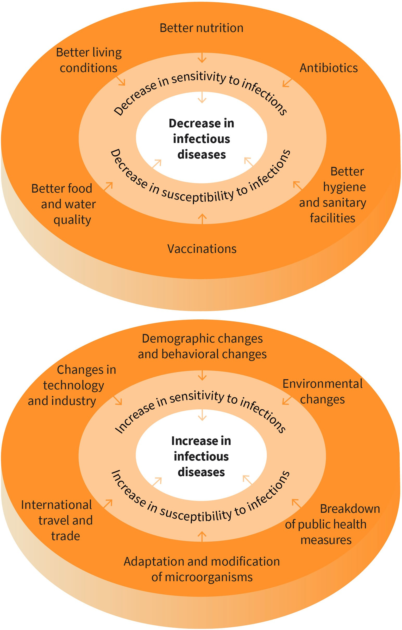

Source: Created by another author, based on Wandeler et al. (2018).

**Incubation period** The incubation period is the period of time between infection with a pathogen and the first signs or symptoms of dis-

ease.

A characteristic feature of infectious diseases is their transmissibility, whereby infection is only possible during the infectious period. To obtain a better understanding, we should discuss the different stages of an infectious disease in more detail: At the beginning of an infection, a person is infected by coming into contact with the pathogen. Once the patho- gen has entered the body, it multiplies there. However, it usually takes some time before the first symptoms of the disease appear. This time interval between infection and mani- festation of the disease is called the **incubation period**. The term “disease” is used to refer to the period during which symptoms are present (period of clinical illness). In most cases, the main infectious period overlaps partly with the disease phase. Depending on the pathogen, however, infection is still possible before the first symptoms of the disease manifest or after the symptoms have subsided. In addition, infectious diseases may also be asymptomatic, meaning the infected person does not display any symptoms of the dis- ease. The infected person is thus unaware of the infection, but they can still spread the pathogen. The disease period is usually followed by the pathogen elimination phase, in which the body’s immune system (possibly supported by therapy) renders the pathogen harmless (Wandeler et al., 2018, p. 550).

A distinction is made between the horizontal and vertical modes of pathogen transmis- sion. Horizontal transmission refers to transmission within a host population, while verti- cal transmission refers to transmission to the next generation (e.g., from a mother to an unborn child). A distinction can be made between direct and indirect transmission paths. Direct transmission includes, for example, transmission via physical contact (especially shaking hands) or droplets. Indirect paths of pathogen transmission occur via objects, such as doorknobs or toys, the soil, or insects, for example (Wandeler et al., 2018, p. 552).

#### Reporting Systems and Legal Basis for the Surveillance of Infectious Diseases

##### Diseases

The aim of healthcare monitoring systems is the continuous and systematic collection and analysis of data on a population’s health situation. This is intended to identify changes in the incidence rates and to plan, implement, evaluate, and adapt appropriate public health measures.

There are several national and international reporting and information systems for moni- toring infectious diseases. In the US, there is the Centers for Disease Control and Preven- tion (CDC), while in Africa, there is the Africa Centers for Disease Control and Prevention (Africa CDC; The World Bank, 2019).

At an international level, the World Health Organization (WHO) operates the Global Influ- enza Surveillance Network. This network monitors the circulating subtypes of the influ- enza virus. Informed predictions about the composition of next season’s influenza vaccine are based on the collected data. At a European level, the European Center for Disease Con- trol (ECDC) based in Stockholm should be mentioned (Wandeler et al., 2018, p. 558). There

is a legal obligation to report many infectious diseases. International Health Regulations set the guidelines for this reporting at an international level. These prescribe international reporting obligations for diseases, such as smallpox, poliomyelitis, or SARS, and they also allow the WHO to adopt additional specifications for the monitoring and control of situa- tions that pose a risk to public health. In Germany, for example, the Infection Protection

Act (IfSG) regulates which diseases (§ 6 IfSG) or pathogens (§ 7 IfSG) must be reported, who is obliged to report (§ 8 IfSG), and how the report should be filed (§ 11 IfSG; Wandeler

et al., 2018, p. 559).

An essential goal of the existing reporting and information systems for infectious diseases is the early detection of an **epidemic**. During such an epidemic, an increase in new cases occurs during a certain period of time and in a region beyond the defined expected value. If several continents are affected by an epidemic, it is called a “pandemic”. In particular, pathogens with a high level of **contagiousness** can lead to an epidemic. To stop the spread of an epidemic and its course, it is crucial to identify the pathogen, source, and mode of transmission as quickly as possible (Wandeler et al., 2018, p. 553). To this end, all notifiable diseases must be reported within a specified period using the prescribed form.

***anon***

*2024-06-13 08:57:51*

--------------------------------------------

pair with a TON of international examples..............

***anon***

*2024-06-13 08:57:51*

--------------------------------------------

are we going to talk about COVID-19 anytime soon...?

The International Health Regulations (IHR), a binding agreement involving over 196 coun- tries, were established in 2005 to increase the ability to recognize and report possible global public health emergencies (WHO, 2021d). According to the IHR, every country must be able to recognize, assess, communicate, and respond to public health emergencies. All countries are required under the IHRs to have the following instruments (WHO, 2021d):

* identification: ensuring that surveillance systems and labs are equipped to detect potential threats
* analysis: deciding what to do in the case of a public health emergency in cooperation with other countries
* reporting: informing local IHR representatives or the WHO if there is a possibility that an infectious outbreak might go global and result in a public health emergency
* reaction: what steps should be followed at the countries’ entry points in the case of a health emergency, as well as how to address unnecessary travel and trade limitations to nearby countries while managing public health emergencies

### HIV/AIDS

Human immunodeficiency virus (HIV) is transmitted through blood, semen, vaginal fluid, and breast milk. Acute HIV infection is usually accompanied by temporary flu-like symp- toms. This is followed by a latency period during which the virus multiplies in the body without causing any symptoms. The infection develops into Acquired Immune Deficiency Syndrome (AIDS) when the immune system becomes severely compromised. As a result of the weakened immune system, other pathogens can easily cause further diseases. Pneu- monia or inflammations in the brain are very common and can often lead to the death. Thanks to improved therapy options, the period between infection with HIV and the mani-

**Epidemic**

a disease that spreads rapidly in a certain area within a short period of time

**Contagiousness**

the transmissibility of a pathogen

festation of AIDS has lengthened considerably in recent years. Therefore, most people with HIV have an almost normal life expectancy. This shows in the fact that fewer people die from HIV infection and its consequences each year than become newly infected.

***anon***

*2024-06-13 08:57:51*

--------------------------------------------

homosexual and bisexual cisgender men, transgender women...

***anon***

*2024-06-13 08:57:51*

--------------------------------------------

side note

Approximately 38.4 million individuals globally have HIV/AIDS as of the end of 2021. Esti- mates place the prevalence of HIV/AIDS among those aged 15 to 49 at 0.7 percent world- wide, whereas the epidemic’s toll varies significantly by country and in regions within a country. Moreover, in 2021, 650,000 persons worldwide died from HIV/AIDS-related ill- nesses (WHO, 2022c). More than two-thirds of all HIV-positive people worldwide – or around one in every twenty-five people – live in Africa (3.4 percent; World Health Organiza- tion Regional Office for Africa, 2018). It should be noted that homosexual and bisexual males, transgender women, and minority communities continue to be disproportionately affected by the HIV/AIDS (Gamarel et al., 2018).

Public outreach efforts are of great importance for those with the disease since they are more likely to be affected by discrimination in everyday life than by the HIV infection itself. Many HIV-positive people are subject to slander, insults, or even physical assault. This can result in social withdrawal, reduced self-esteem, and psychological problems (Mrusek, 2018). The Global AIDS Strategy 2021–2026 is a new initiative that aims to address the gaps impeding the fight against HIV/AIDS by using an inequities perspective. The Global AIDS Strategy prioritizes those who have not yet accessed life-saving HIV/AIDS services to lessen the disparities that fuel the HIV/AIDS epidemic. The strategy outlines aggressive tar- gets and evidence-based priority activities to put every nation and community on track to eradicate HIV/AIDS as a public health hazard by 2030 (The Joint United Nations Pro- gramme on HIV/AIDS, 2022). The strategy utilizes the tried-and-true methods and strat- egies of the HIV/AIDS response, identifying where, why, and for whom it is not working. It does this by drawing on significant lessons acquired from the overlapping HIV/AIDS and COVID-19 pandemics (Mahy et al., 2021). The strategy defines the priorities and actions that must be carried out by international, regional, national, and local partners to move toward eradicating HIV/AIDS. It is based on forty years of experience responding to HIV/ AIDS, helping governments, organizations, and communities “build back better,” as well as strengthening health systems and emphasizing the importance of putting people first. The UNAIDS Joint Programme is also given a fresh, audacious call to action in this strategy to strengthen our leadership in the global fight against HIV/AIDS and carry out the plan (Mahy et al., 2021).

#### Nosocomial Infections

Nosocomial infections (from the Greek *nósos*, meaning disease and *komein*, meaning to care for) are a subset of infectious disorders acquired in a healthcare context. They are also referred to as hospital-acquired illnesses or infections connected to healthcare. They are defined as infections that were not yet manifest when the patient was admitted to or visited the particular facility, but are diagnosed more than 48 hours later. Nosocomial infections endanger patient safety and the success of treatment outcomes. As a result of

nosocomial infections, (extended) hospital stays can be necessary. This results in addi- tional treatment costs and other costs that impact society due to absence from work, disa- bility, and death (Wandeler et al., 2018, p. 577).

***anon***

*2024-06-13 08:57:51*

--------------------------------------------

according to WHAT?

***anon***

*2024-06-13 08:57:51*

--------------------------------------------

old

***anon***

*2024-06-13 08:57:51*

--------------------------------------------

old

Most nosocomial infections are caused by bacteria. Infections caused by **multi-resistant bacteria** that no longer respond to antibiotic treatment pose a particular problem. In industrialized nations, pathogens that lead to a nosocomial infection very often originate from the patient’s own bacterial flora. These bacteria enter the patient’s body during inva- sive procedures, such as ventilation or catheterization. In contrast, other sources, such as contaminated objects, surfaces, food, or water, are less likely to be a source of nosocomial infection. The risk of nosocomial infections depends on endogenous and exogenous fac- tors. Endogenous risk factors include pre-existing conditions, in particular diseases that are associated with a compromised immune system, obesity, and consumption of addic- tive substances. Exogenous risk factors are associated with treatment measures that can, for example, reduce the body’s own defenses against infections or when poor hygiene was used (Robert Koch Institut, 2015, p. 92; Wandeler et al., 2018, p. 579). It is assumed that around 20 to 30 percent of nosocomial infections could be avoidable. Important preven- tive measures include increased hand washing, education and training for all staff at healthcare and nursing facilities, and an adequate staffing ratio. Careful use of antibiotics can help ensure that the number of multi-resistant pathogens does not continue to increase.

Overuse of antibiotics can cause bacteria to increase their resistance. It is, therefore, important to determine the specific cases where antibiotics are absolutely necessary. For example, antibiotics do not help counter viral infections and should not be used indiscrim- inately in livestock fattening.

Seven patients in high-income countries and ten patients in middle- and low-income countries out of every 100 hospitalized patients can contract one of the infections related to healthcare (WHO, 2014). These infections, which occur while a patient is in the hospital, extend the stay, cause impairment, and increase the patient’s financial burden. Breathing machine pneumonia, urinary tract infections due to catheters, infections at surgery sites, and central line-associated bloodstream infections are some of the nosocomial infections that are usually prevalent (Khan et al., 2017). Nosocomial pathogens include bacteria, viruses, and fungal parasites. Fifteen percent of all hospitalized patients, according to esti- mates from the WHO, are affected by these infections (Khan et al., 2017).

For example, in the US, an increasing number of states are requiring hospitals to submit their nosocomial infections reports through the National Healthcare Safety Network (NHSN) of the CDC, which offers a standardized approach to surveillance techniques (Weiner-Lastinger et al., 2020). Other countries may have different policies and procedures on whether or not nosocomial infections should be reported, how they should be reported, and to whom.

***anon***

*2024-06-13 08:57:51*

-------------------------------------------- NO

**Immunization** the intentional induction of immunity, i.e., the process by which the body is made insuscepti- ble to certain pathogens

**Herd immunity** You often hear the term herd immunity in discus- sions about certain groups of people who cannot be vaccinated (e.g., babies). They depend on the people around them being vacci- nated to protect them

from infection.

#### Vaccinations and Preventive Measures

Vaccinations are the key measures used to eradicate, or at least contain, infectious dis- eases. A distinction is made between active and passive **immunization**. With active immu- nization, weakened live pathogens are administered, which produce an active immune response (i.e., the formation of antibodies). Due to the body’s own memory cells, the body can quickly start producing suitable antibodies in the event of an actual infection. In the case of passive immunization, however, ready-made antibodies are injected, which only have a short-term effect and are much more expensive to produce since they are derived from the blood serum of foreign organisms, such as horses (Wandeler et al., 2018, p. 588).

The goal of active vaccination at an individual level is to achieve protection against a pathogen that is as long-lasting as possible. At a population level, there is also the effect that with increasing vaccination coverage (i.e., an increasing proportion of vaccinated people in the population), the transmission dynamics of the pathogen weaken. Here, researchers use the term **herd immunity** (Wandeler et al., 2018, p. 591). Thus, one’s own vaccination protection also contributes to the protection of society.

In the case of active immunization, vaccination can use live or inactivated vaccines. Live vaccines, which are used, for example, against measles, mumps, rubella, or chickenpox, contain small amounts of the pathogen, which is capable of reproduction but so attenu- ated that it does not trigger the disease. Occasionally, however, the vaccination can lead to mild vaccine-associated illness, as is the case with vaccination-induced measles. These manifest as a mild, measles-like rash that may appear sometime after the vaccination but is not contagious. In the case of inactivated vaccines, dead pathogens that can no longer multiply in either the whole body or just parts of it are administered. The immune system recognizes these as foreign bodies and stimulates the formation of antibodies. Inactivated vaccines are used for vaccinations against diphtheria, hepatitis B, polio, whooping cough, or tetanus, for example (Bundeszentrale für gesundheitliche Aufklärung, 2019).

Unfortunately, suitable vaccines are not available for all infectious diseases. In addition, not all people think favorably of vaccinations, as they reject them due to the reported cases of vaccination complications, severe vaccination reactions, or lack of vaccination effectiveness. For these reasons, chemo- and exposure prophylaxis are also of great importance. In chemoprophylaxis, an antimicrobial substance is administered prophylac- tically to prevent infectious disease or the spread of disease. A typical example is taking tablets for malaria prophylaxis before traveling to an area at risk of malaria. Perioperative antibiotic prophylaxis (i.e., the administration of an antibiotic shortly before an operation to prevent surgical wound infections) is also common. The antibiotic is intended to reduce the bacterial load around the wound area and thus the risk of wound infection. In addi- tion, chemoprophylaxis is also used in patients with a weakened immune system (e.g., in people infected with HIV or those with transplanted organs) to avoid opportunistic infec- tions. These are infections with pathogens that do not normally cause any symptoms in healthy people.

The term exposure prophylaxis includes all non-drug preventive measures that reduce the probability of exposure to a pathogen and thus the risk of infection. The most important of these measures is washing hands before meals, after going to the bathroom, and after

contact with dirty and possibly contaminated objects and food. In healthcare facilities, hand disinfection is also of great importance along with the wearing of gloves, mouth and nose protection, and protective clothing. Another measure is patient isolation. This occurs in the case of epidemics that are dangerous to the public, such as smallpox, pneumonic plague, inhalational anthrax, or hemorrhagic fever. These patients are treated in special competence centers that have trained staff and utilize a system of airlocks and prepara- tion and decontamination rooms. If it is suspected that a patient is suffering from a partic- ular infectious disease or is a carrier of a pathogen, temporary and precautionary isolation can be considered. The duration of this temporary quarantine depends on the incubation period of the suspected illness. Another preventive measure is social distancing. This includes the cancellation of major events or temporary school closures to prevent the spread of an infectious disease (Wandeler et al., 2018, p. 593).

##### Recommended vaccinations

Each country tends to have its own vaccine requirements, recommendations, and sched- ules. These lists include what vaccines are required, how many doses, which vaccines are recommended for what age, the required types of vaccines, etc. (WHO, n.d.-e). Most coun- tries follow the WHO vaccination recommendations. It should be noted that the effective- ness, safety, and cost-effectiveness of a vaccination are requirements for a vaccine to be recommended by the WHO. Accordingly, there are two main categories of vaccines that the WHO recommends (WHO, n.d.-e):

* + 1. Standard or routine vaccines, which everyone should receive
    2. Travel-recommended vaccines for people traveling to certain areas where some dis- eases (like **tropical diseases** such as yellow fever) are prevalent

The following are the standard or routine vaccines the WHO recommends everyone receives (WHO, 2021g, pp. 1–2):

* + - * diphtheria
      * hepatitis B
      * haemophilus influenzae type b
      * human papillomavirus
      * seasonal influenza
      * meningococcal
      * measles
      * mumps
      * pertussis
      * rubella
      * pneumococcal disease
      * poliomyelitis (polio)
      * rotavirus
      * tetanus
      * tuberculosis (TB)
      * varicella

**Tropical diseases**

This is any infectious dis- ease that is native to or predominately affects tropical or subtropical regions of the world.

**Booster** This is given when the ini- tial vaccine’s levels of pro- tection have started to

wane.

**Zoster** Also called shingles, this is the same virus that causes chickenpox (vari- cella zoster virus). This virus remains latent (inac- tive) in the body after a person heals and, years later, it can reactivate and cause zoster (Arvin, 1996).



**SUMMARY**

The term infectious diseases covers diseases that spread through the transmission of pathogens. Improved hygiene measures, increased food and water quality, availability of vaccines and antibiotics, and better liv- ing conditions have led to the suppression of many infectious diseases. However, due to the adaptation and mutation of pathogens, changed risk behavior, and increased international mobility and global change, there has been a resurgence in certain infectious diseases.

Thanks to innovative forms of therapy, people who have become infected with HIV have an almost normal life expectancy and can enjoy a high quality of life. However, they encounter societal stigma and dis- crimination that can lead to psychological problems.

Additionally, the WHO recommends that all adults over 50 get a **booster** Td or Tdap vac- cine (tetanus, diphtheria, and pertussis), booster hepatitis B vaccines, pneumococcal vac- cine, and the annual seasonal flu vaccine (WHO, 2021g).

Below are the travel-specific vaccines the WHO recommends for travelers. These vaccina- tions are used to protect against diseases indigenous to the country of origin or the place of travel (WHO, n.d.-e):

* hepatitis A and E (e.g., recommended for people traveling to Egypt)
* cholera (e.g., recommended for people traveling to sub-Saharan Africa, South and Southeast Asia, and some countries in the Middle East)
* Japanese encephalitis (e.g., recommended for people traveling to South-East Asia and Western Pacific regions)
* typhoid fever (e.g., recommended for people traveling to Pakistan, India, and Bangla- desh)
* yellow fever (e.g., recommended for people traveling to Africa and South America’s tropical and subtropical regions)

The CDC may recommend additional vaccines which are indication-based. Indication- based vaccines are given to people who are at higher risk due to being exposed to infec- tious agents, such as healthcare providers, people with certain conditions like with chronic diseases, or people who have low immunity (CDC, 2021a). When it comes to indi- cation-based vaccines and subsequent routine boosters, adults with chronic conditions should get the following vaccines (CDC, 2021a):

* Tdap vaccine
* meningococcal
* pneumococcal vaccines
* **zoster** vaccine
* hepatitis B vaccine

The term nosocomial infections refers to infections that are contracted during a stay in a healthcare or nursing facility. Infections with multi- resistant bacteria that no longer respond to treatment with antibiotics are particularly problematic.

Vaccines, chemoprophylaxis, and exposure prophylaxis can also help protect against infectious diseases. Vaccinations are the most important available measure to eradicate or at least contain infectious diseases. Chemoprophylaxis offers event-related protection through the preven- tive administration of medication. Personal hygiene, isolation, quaran- tine measures, and the avoidance of large crowds of people in a con- fined space are all examples of exposure prophylaxis.