Chapter X

Othering construed and maintained in discourse

Jadranka Gvozdanović

1 Introduction: Othering, bias and procedures of exclusion

Identities of individuals and social groups are conceptualized in contrast to others, with perceived different properties. In this sense, otherness is a fundamental human thought (for the latter, see de Beauvoir 1949, 16). Construal of the Self vs. the Other is a culturally bound matter; depending on the culture, it may lead to procedures of segregation implemented and ensured by the social organization (see also Goffman 1977, 316). Construal of the Self or the in-group and the Other or the out-group occurs in an active, constitutive process (see Brons 2015, 70) conveyed through language (see Duszak 2002, 1). Coherent discourse procedures transmit ideas of othering construed by social groups.

In his inaugural lecture at the Collège de France, Michel Foucault convincingly showed in *The order of discourse* (1981)[1], that

in every society the order of discourse is at once controlled, selected, organized and redistributed by a certain number of procedures whose role is to ward off its powers and dangers, to get mastery over its chance events, to evade its ponderous, formidable materiality (Foucault 1981, 49).

Practices of control and restraint mark discourse at every point. Foucault illustrated these statements by procedures of exclusion such as constraints on sexuality and exclusion of madness. His analysis of discourse provides a setting for understanding how exclusion of the Others is maintained by the rules of discourse and social powers behind it. Importantly, according to Foucault, discourse consists of practices that systematically form the objects of which they speak. In this sense, discourse is more than a composition of semiotic signs, it actively construes the world spoken about. And Norman Fairclough (2003, 2004), who developed his critical discourse analysis fundamentally based on Foucault’s approach, conceived of discourse order as a social structuring of semiotic differences, a particular social ordering of relationships amongst different ways of making meaning. Fairclough distinguished text, discourse practices and (what he calls) social reality, consisting of social structure and social events.

Discourse traditions provide frames for reasoning and interpretations. Psychologically, we are more susceptible to recognizing what conforms to our previous experiences, and less open to recognizing new information. This is referred to as *priming* (a phenomenon known in cognitive psychology since Palmer 1975, discussed also in Kahneman 2011, 59-66). Priming is based not only on direct experiences, but also on knowledge of norms and values valid for our surroundings, our habitat (in the sense of Bourdieu 1979) in the sociocultural sense. As most people tend to avoid risks involved in shifting their attitudes (this has been known as *the Bernoulli effect* for almost three centuries, see also Kahneman 2011, 313), the existing norms and values tend to be maintained, even when in many cases they have been shaped to serve the interests in some domain of power. In other words, those in power shape discourse properties to safeguard their sphere of power.

In the actual practice of societies, this results in various types of attitudes towards Others, justifying their segregation and mostly disadvantageous treatment. This is clearly visible in spatial segregation of race and social class in urban centers. Goffman (1977, 307) distinguished segregated disadvantaged people, who usually live within specific neighborhoods such as the Black in the US, and nonsegregated disadvantaged people (e.g., blind, obese, etc.) who live rather scattered in societies. Women belong in principle to the nonsegregated group, but – instead of being scattered – they constitute half of the humanity. Historically assumed to pertain to the domain of home and family, women are culturally construed as fragile and valuable at the same time, not imbued with the qualities attributed to men, and therefore not capable of performing the same functions (see Goffman 1977, 308).[2]

The present contribution has two disadvantaged groups in focus:

(a) women, who are non-segregated horizontally, but – as we shall see below – are vertically segregated, and

(b) migrants, whose numbers have risen significantly over the past decades and especially since 2015 in the EU, resulting in a change from initial segregated inhabitation in city neighborhoods to non-segregated inhabitation and entrance into spheres formerly reserved to nationals; their newcomers status often intersects with racial differences.

For both these groups, their status has changed over the past decades. Women have moved out of domestic sphere to become competitors to men in professional contexts. And migrants, alongside with racial minorities, have moved out of their spatial segregation to become spread all over the majority spaces. It is my hypothesis that both phenomena of shifting boundaries of segregation instigated discourse negotiation leading to othering and stigmatization. I assume (following up on Bourdieu 1979, 1982) that stigmatization is reflected in all the areas of capital – economic, social and symbolic-cultural, and that it is construed by means of language.

This contribution starts with a presentation of economic indicators showing that othering, manifesting itself as exclusion, is in place on a large scale. At the next step, the rise of discourse negotiation will be documented by the rise of frequencies of the key expressions referring to the investigated groups. Finally, grammatical means of representing these groups will be investigated as further indicators of the same discourse negotiation.

For each group, its status as disadvantaged will be firstly demonstrated by the EU economic indicators (Eurostat, etc.). Secondly, linguistic means contributing to the disadvantaged status will be examined in discourses over time. For the linguistic data, German has been chosen as primary language. The linguistic data stems from the Digital Dictionary of the German Language 1600 until now (*Digitales Wörterbuch der deutschen Sprache*, *DWDS*[3]) with 67,293,943,366 tokens, coupled with the German 2020 corpus on SketchEngine[4] with 20,999,598,683 tokens (including the newspaper *Die Zeit*).

The German data concerning recent discourse on migrants have been briefly contrasted with Croatian linguistic data, to see how language-specific the discourse on this issue is. Croatian is similar to German insofar as both languages have morphological markers of gender and number. Also, despite geographical distance, the two countries share a relatively similar Central European heritage, as from the Middle Ages to the end of WWI Croatia has belonged to the Western sphere of cultural, religious and political influence: first as a part of Charlemagne’s empire, and on later dates up until WWI as a part of the Habsburg empire. Croatian linguistic data come from the Croatian web corpus on SketchEngine, hrWaC 2.2 with 1,405,794,913 tokens (with 85,878,109 tokens from the newspaper *Slobodna Dalmacija* and 49,521,530 from *Večernji list*[5]). Since the Croatian corpus contains only contemporary texts (from 1990 onwards), it was not possible to compare historical data. It was also impossible to compare data concerning gender: the gender sensitive language is a relatively recent issue for Croatian (Kuna and Nujić 2015).

2 The disadvantaged status of women and migrants

As mentioned above, the disadvantaged status of women and migrants is not a biological, but a sociocultural matter, a matter of perception of Others from an in-group perspective. From the in-group perspective, these Others do not conform to the in-group norms – they form an out-group breaking these norms. Othering treats them indiscriminately as a group, and ascribes (usually negative) properties to the entire group. This leads to skewed perception and also evaluation of individuals pertaining to this group, psychologically corresponding with what is called *bias*. In this sense, bias is a psychological correlate of othering, whereas othering itself is a matter of evaluation relative to the in-group sociocultural norms. Othering is construed and maintained by means of language in discourse, but its effects are noticeable in all the areas of capital – economic, social and symbolic-cultural.

2.1 Othering of women

As already understood by Simone de Beauvoir in her book *Le deuxième sexe* ‘The second sex’ (1949), since the rise of the patriarchal society women were forced into the secondary position and this was enforced by the education and social contracts. This treatment, similar to the treatment of minorities, was in part supported by women themselves as part of the social contract. De Beauvoir’s analysis (based on existential ethics, but with a strong empirical grounding) preempted the work of later philosophers and gender activists until the present times. Much is owed to Goffman’s lucid work on the arrangement of sexes (1977), who also showed that gender is construed in interaction with institutions and in concrete discourse framed by contexts; construal of gender is at the core of sociocultural construal of order and power.

In 1948, the United Nations (UN) proclaimed the *Universal Declaration of Human Rights*, and in 1979, the UN General Assembly adopted the *Convention on the Elimination of All Forms of Discrimination against Women (CEDAW)*[6], often described as an “International Bill of Rights for Women”. In the 1980s, much activity developed on the institutional level based on the understanding that not women, but institutions should be changed to pave the way for greater equality. In spite of these efforts, Virginia Valian published her well-known book *Why so slow*? almost two decades later (in 1999) showing – from interdisciplinary perspectives – that gender schemas, entrenched from the early youth, create cumulative gender differences in characteristics, behaviors, perceptions, and evaluations of men and women (e.g., by construing males as more agentic and females as more communal). These originally small differences accumulate in creating gender schemas that overrate men in professional life and underrate women.

Even with this knowledge, twenty years later at European universities, the underrepresentation of women rises with each higher career step, as calculated by the European Institute for Gender Equality, as instantiated by data from a report published in 2021 and covering the years 2015–2018 (see Figure 1 below). At the same time, statistics show that young female researchers finish their PhD on the average with slightly better grades than their male colleagues. It is apparently not a matter of quality that underlies the underrating of women on the way towards higher professional positions. If it is neither biology nor empirical quality that withholds women, then it must be a cultural phenomenon, i.e., cultural capital combined with economic and social capital.

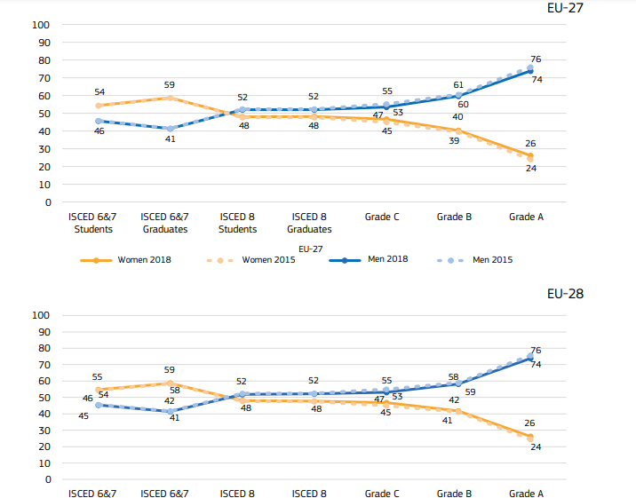

Figure 1 Leaky pipeline at European universities, closing at about only half a percent point per year; 2015-2018, EU 27 and EU 28 (European Commission 2021, 161)

From the first postdoctoral position (i.e., C, in 2018 at 46.6%) to assistant/associate professors (i.e., grade B, in 2018 at 40.3%) to full professor (i.e. grade A, in 2018 at 26.2 %), the participation of women apparently declined to around one-quarter.

The leaky pipelines of Figure (1) are indicative for the essence of Othering involved in the Academia. Here, othering cannot be explained as radical alienness and discrimination (as assumed by Brons 2015): it is neither general nor radical (because there are no traces of these phenomena against female students before PhD in Europe). Othering within the Academia is clearly socially situated; it emerges when a construed social norm (of assistant, associate and full professors being prototypically male) gets challenged and shifted (by women entering these positions). Therefore, *othering of this kind is a situated sociocultural judgement of deviation from a group-internally accepted sociocultural norm*.

When discrimination is involved, it affects all kinds of (an individual’s or group’s) capital, including the economic capital as shown in Figure 2 below in terms of pay gap[7]. It clearly demonstrates that at the same position and with the same education and the same years of service across all EU countries women consistently earn less.

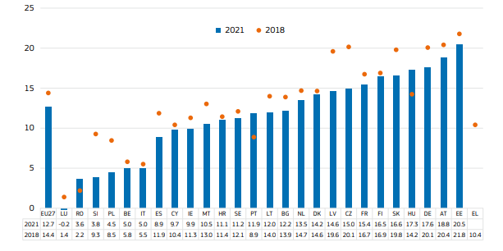

Figure 2 Female pay gap in % (European Commission 2023, 22)

Diminished access to higher positions in Academia, and more generally on the labor market, as well as gender pay gap across Europe show that women belong to a disadvantaged group. The changing values of these phenomena depend on the political situation (i.e. awareness and action against unequal treatment) and illustrate situated othering.

2.2 Othering of migrants

Migrants are similarly subjected to substantial pay gaps, even exceeding over 40% and rising in some countries lately (see Figure 3 below). In a recent report, Silas Amo-Agyei (2020) has shown that in spite of migrant workers’ education levels being similar to or higher than that of nationals for the same occupation, migrant workers earn less than non-migrant workers within the same occupation in several countries (Amo-Agyei 2020, 112). What is more, “women migrant workers are doubly discriminated against, especially with regard to pay” – both as migrants and as women (Amo-Agyei 2020, iii).

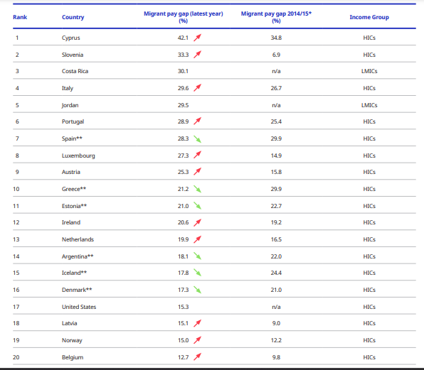

Figure 3 The 20 countries with the widest migrant pay gap (source: Amo-Agyei 2020, xvii)

Strikingly, as an effect of the migration wave that started in 2015, the migrant pay gap within higher incomes (HICs) became larger in 11 countries, and smaller in 6 countries. As a corollary of the pay gap, migrants are at a risk of poverty, and female migrants even more so than male migrants, as illustrated by Figure 4 below[8].

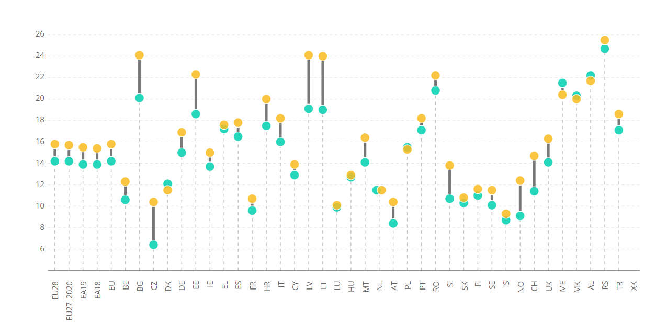

Figure 4 At-risk-of poverty rate (%) by sex and migrant background (18+ population)

Women and migrants are apparently clearly disadvantaged on the labor market. Moreover, since the opening of Europe to migrants in 2015, the pay gap between migrants and nationals rose significantly, pointing to treatment of migrants as the Others in a disqualifying way. In addition, the data of Figure 4 show that female migrants suffer double disadvantages, as women and as migrants.

3 Negotiation of the Other: women and migrants in discourse

Linguistically, construal of othering can be either explicit or implicit. It is explicit when referring to those significant Others by newly coined names or descriptions suggesting that they are different – in some respects less advantageously so – compared to Us, the inner group. In the current legal situation in Germany, where discrimination is legally forbidden, it is the implicit othering which is the core strategy of signaling doubt or lesser value of those Others. Doubt about capacities of those Others gets implicitly communicated without being indictable; it is construed and maintained communicatively as a powerful means of priming. The Others tend to be treated indiscriminately as a group on the basis of the feature that others them. This holds for first-, second- and even third-generation immigrants, and racial differences enhance othering. Indeed, by the current data published by the German Federal Office against Discrimination, discrimination is on the rise and of the 10,772 reported cases in 2023, 41% concerned racial discrimination.[9]

3.1 Gender

Research on women in application procedures (e.g., by Trix and Psenka 2003) shows that discourse practices are in place to raise doubt about the capacities of female applicants. These include faint praise (e.g., *She has the potential to grow*, an assessment that is theoretically positive, but rather negative in the context of a leading position) or hedges (e.g., *She is actually good*) to express doubt, which is understood as signaling weakness, and this often suffices for a rejection. At universities, this is especially relevant for the position of a professor, where leadership qualities are expected.

Linguistically, both male and female professors were historically referred to by the generic masculine. However, psycholinguistic research showed that the generic masculine was usually understood as a referential masculine (see e.g., Stahlberg et al. 2007). It was the political discussion about gender and discrimination that paved the way to gender-sensitive language in Germany. In addition, the decision of the German Research Council (DFG) to include gender policy as one of the criteria for quality had its impact on gender-sensitive usage. Currently, it is a declared policy of DFG to use gender-sensitive language (e.g., *Professor*\**in* ‘male or female professor’ in non-referential contexts).

The Digital Dictionary of the German language (DWDS) gives almost the same frequency curves for *Professor* and *Professorin,* which is surprising, given that the masculine in its generic reading can denote both. For *Professorin* (see Figure 5), the following frequencies hold: in 1985, 9,059 tokens; 1989: 10,662 tokens; and 1991: 5,510 tokens, and for *Professor* (see Figure 6)*,* the following very similar ones: in 1985: 9,003 tokens; 1989: 10,435 tokens; and 1991: 5,296 tokens.

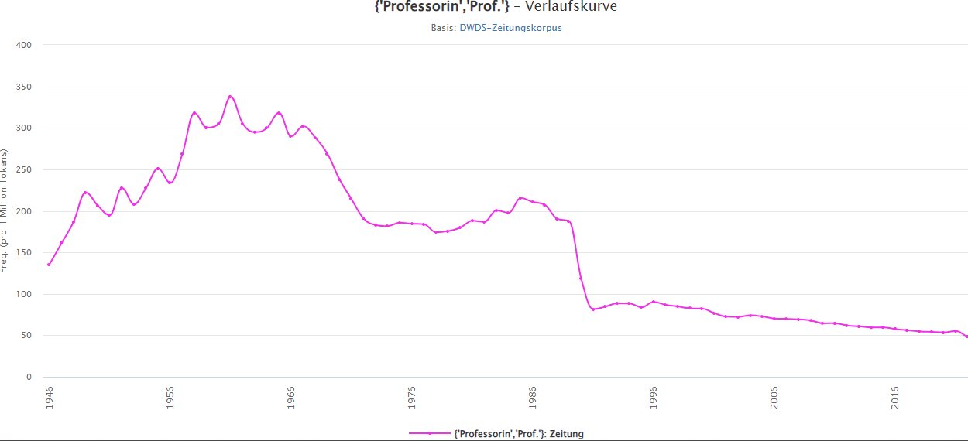

Figure 5 Frequency of *Professorin* (‘professor-N.F’) in DWDS

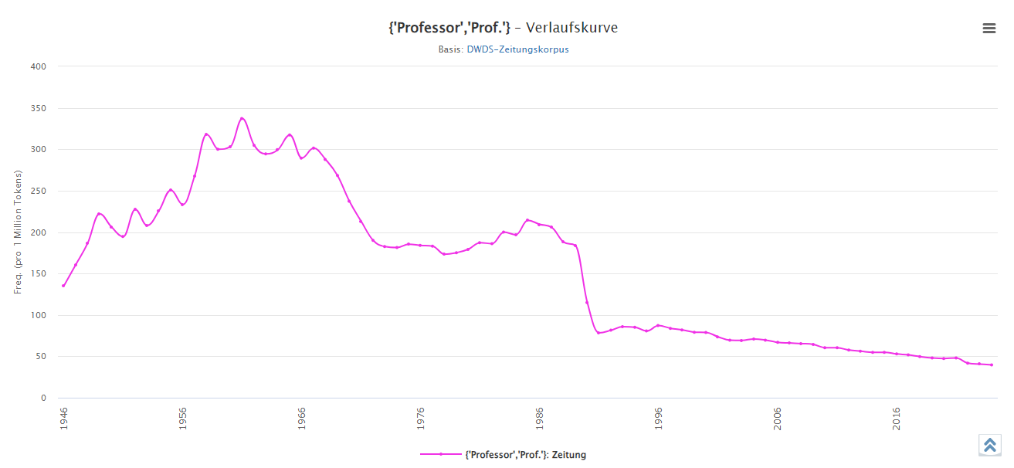

Figure 6 Frequency of *Professor* (‘professor-N.M’) in DWDS

We can see that both frequency curves start rising around 1948, the year when the UN proclaimed the Universal Declaration of Human Rights, including equal rights of women. This apparently provoked lots of discussion in the public media. This discussion continued into the 1980s, after the UN General Assembly adopted the Convention on the Elimination of all Forms of Discrimination against Women (1979). The parallel decline in frequencies for both *Professor* and *Professorin* in the mid-1980s reflects diminishing interest in the debate surrounding the use of gender-sensitive language. While similar frequencies for both masculine and feminine forms might suggest that the problem of discrimination has been resolved, it is not the case. Qualitative linguistic data prove that 40 years after the debate implicit forms of discrimination linger on, progress is still slow and not justifiable by any objective measure of competence. The following example originates from DWDS:

1. *Es gibt schließlich kein schöneres Leben als das einer* ***Professorin****!* [Die Zeit, 01.05.2007, Nr. 19]

‘There is actually no nicer life than that of a female professor’

In contrast to *Professorin* vs. *Professor*, where the non-significantly different data point to insufficient differentiation of female and male professors, an everyday expression such as *Steuerzahler/Steuerzahlerin* ‘tax-payer-N.M/N-F; resp. male/ female’ appears to be indicative of the increased use of gender-sensitive language. The history of the latter female form in newspaper language (based on data in DWDS) reflects the development of gender discussions. The female form is first attested with 2 examples in 1952. The attestations remain extremely low until 1986; in 1990 there are 15 attestations in newspapers. The number of occurrences rises in 1995 to 49 examples, in 2019 it reaches 79 examples, and in the first half of 2024 (up to June 18, 2024, the date of writing this text) 156 examples were attested.

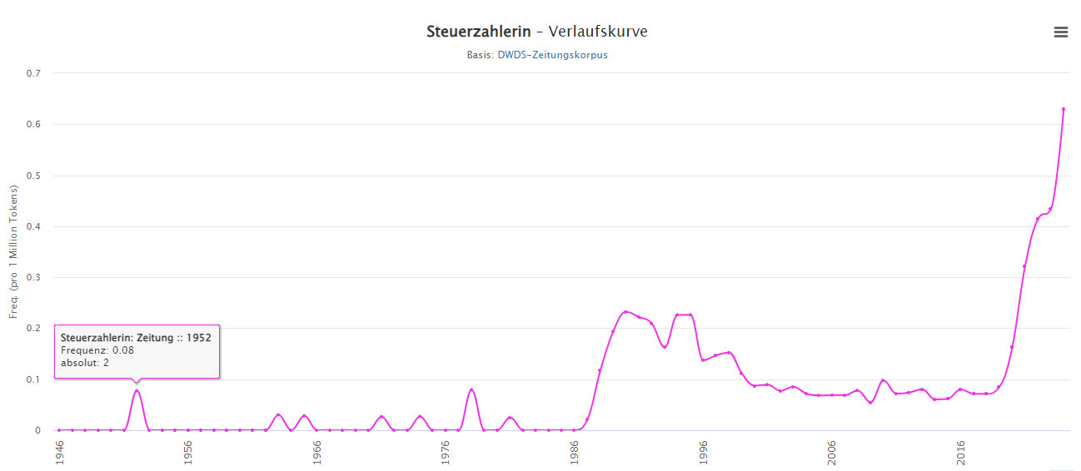

Figure 7 Frequency of *Steuerzahlerin* (‘tax-payer-N.F’) in DWDS

Example:

1. *Sie … hält es mit ihrem Gewissen »für unvereinbar«, als****Steuerzahlerin*** *zum Wehretat der Bundesrepublik beizutragen*. [Der Spiegel, 19.09.1988]

‘She…considers it „irreconcilable“ with her conscience to contribute as tax payer-N.F to the military budget of the (German) Federal Republic.’

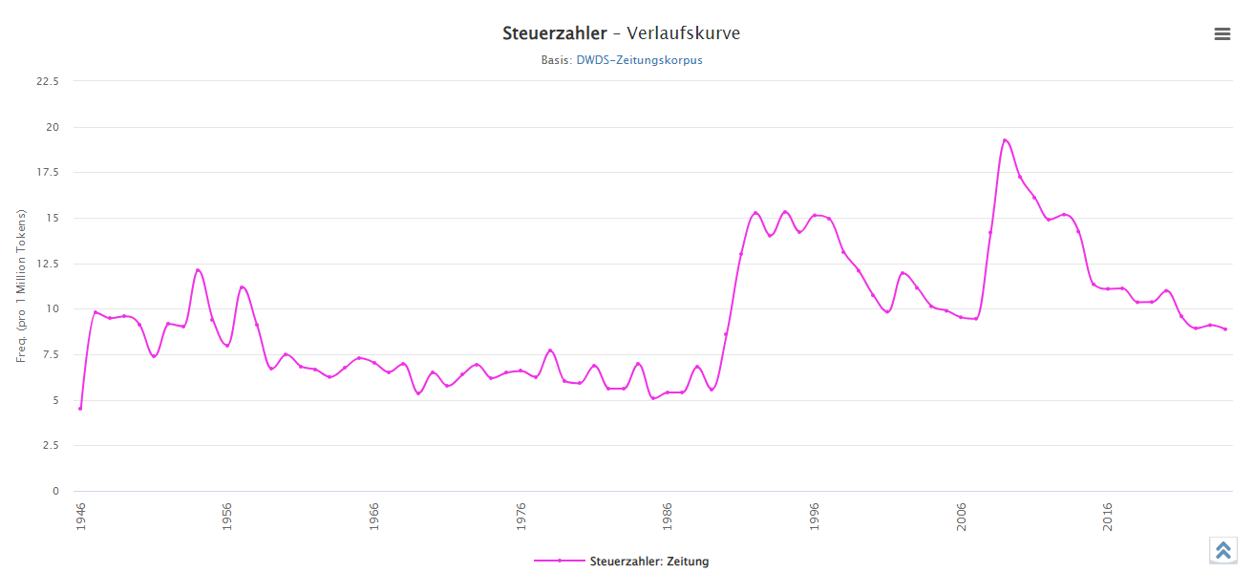

Figure 8 Frequency of *Steuerzahler*(‘tax-payer-N.M’) in DWDS

These figures show that the masculine form (used for both genders or for the function as such, e.g., *Firmen und andere Steuerzahler* ‘firms and other tax-payers-N.M.PL’) has been recessive since 2009 (when there were 17,998 attestations) up to 2024 (so far only 2,458 attestations). While the generic masculine is still an option for both genders, it is by now less used and restricted to plural forms.

Gender-sensitive language is by now the predominant norm in Germany. Mikołajczyk and Aptacy (2023) showed that, in political tweets, there is predominant usage of gendered forms by five out of six political parties in Germany (only the extreme right-wing AfD does not do so), whereas in Poland only two of the eight political parties use gender-sensitive language in political tweets.[10] Such national contexts additionally frame gendered forms.

3.2 Migrants

Discourse frequencies of different names for migrants also tell the story behind them. First of all, *Gastarbeiter* ‘guest worker’ and the feminine form *Gastarbeiterin* ‘guest worker-N.F’ become frequent when Germany concluded contracts with a number of South European countries in the late 1950s and 1960s to allow immigrant workers with a work permit. There is a peak in the early 1970s (440 occurrences, 11.71 per million tokens); it diminishes after 1973, when the oil crisis constrained this practice. For *Gastarbeiterin*, there are 6 occurrences in 1964 (0.18 per million tokens) and 9 occurrences in 1970 (0.24 per million tokens).

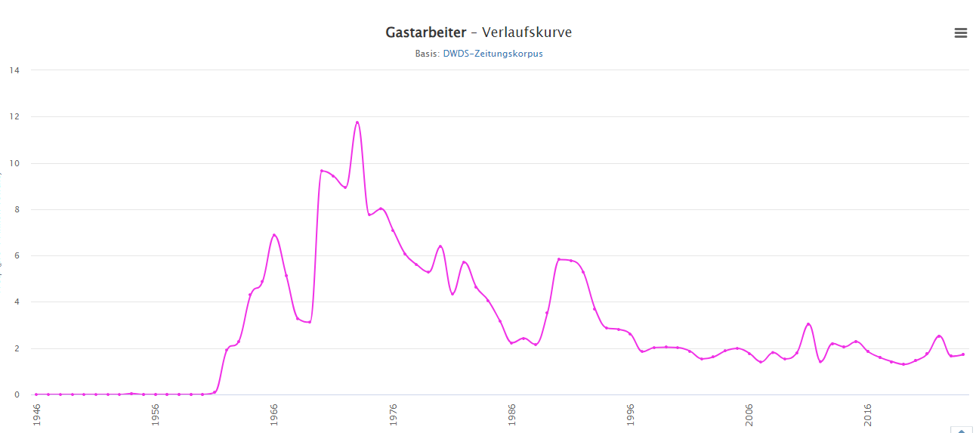

Figure 9 Frequency of *Gastarbeiter (*‘guest worker-N.M’) in DWDS

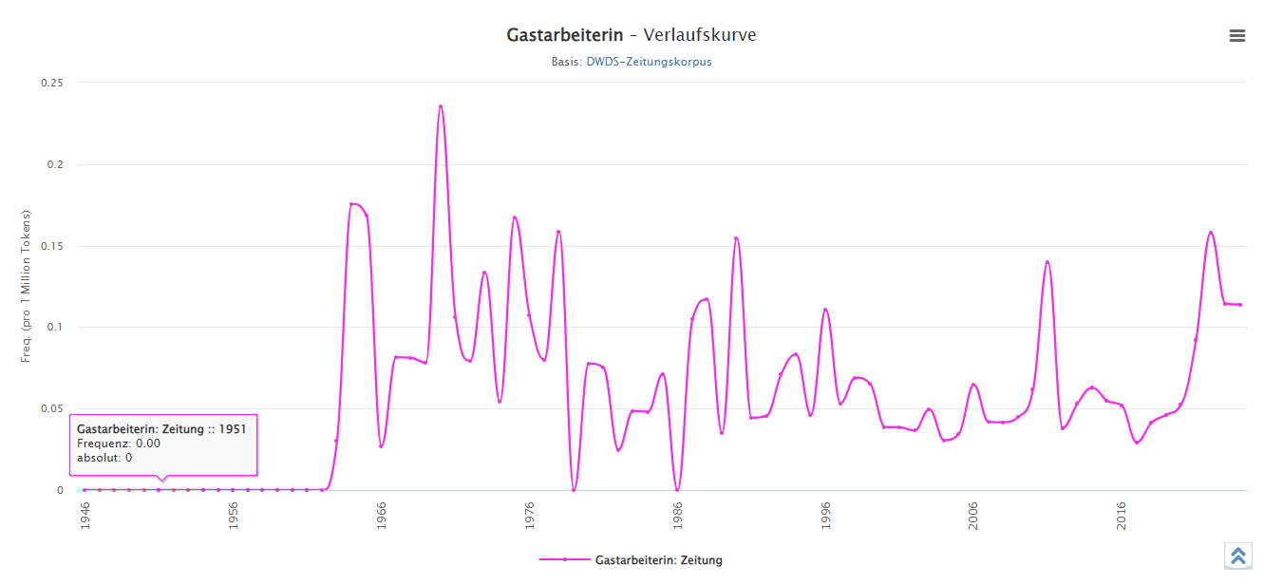

Figure 10 Frequency of *Gastarbeiterin* (‘guest worker-N.F’) in DWDS

Examples:

1. *Seit dem ersten deutsch‑italienischen Anwerbeabkommen im Jahr 1955 bis zum Anwerbestopp während der Ölkrise 1973 kamen Millionen sogenannte Gastarbeiter**in die Bundesrepublik*. [Die Zeit, 22.04.2017 (online)]

‘Since the first German-Italian recruitment agreement in the year 1955 until the recruitment stop during the oil crisis of 1973 millions of so-called guest workers-N.M.PL came to Germany.’

1. *In den Sechzigerjahren sind ihre Eltern nach Deutschland gekommen, der Vater zum Studieren, die Mutter als Gastarbeiterin*. [Süddeutsche Zeitung, 07.11.2023]

‘Her parents came to Germany in the 1960s, her father to study, her mother as a guest-worker-N.F.’

These nouns occur in texts in singular and in plural (mostly generic). The work these guest workers are doing usually remains unspecified, as in the example (4), where the juxtaposition of academic pursuits of the father against the mother’s guest worker status implies the latter represents a group that has been relegated to perform unqualified work.

When the need for guest workers subsided after the oil crisis of 1973, there was an expectation that these guest workers, the biggest group of which were Turks, would leave Germany. However, they did not. As a reaction, an old loanword *Kanake* (from *kanaka* ‘human;’ see Figure (11) below for frequencies rising in the 19th century) was revived. It used to denote inhabitants of Polynesia and South Islands, in the 18th century transferred to inhabitants of other colonial states (Unified Germany had colonies between 1884 and 1919, but individual states had them already in the 17th century). However, the first attestation of *Canace* was different. It occurred in a poetic text based on Ovid’s *Metamorphoses* (see example 5 below) mentioning Canace, a woman who fell in love with her brother Macareus, bore him a child, and was forced into suicide by her father Aeolus. This story (construed of a non-Western woman and shameful by the Western morals) continued to be retold in texts until the 19th century.

1. /*Die Thisbe/ Canace/ vnd Dido führn das Schwerdt/* [Opitz, Martin. 1624. Teutsche Pöemata und Aristachvs Wieder die verachtung Teutscher Sprach. Straßburg]

‘Thisbe, Canace and Dido wield the sword’

In the 18th century, travelers and sailors attributed this name to inhabitants of Polynesia and Southern Islands and subsequently also to other colonial territories and languages, as illustrated by example 6 below (first attested in a Swedish original, published in German in 1974).

1. *Den gelben Turmalin, welcher ebenfalls Matureſe Diamant, malabariſch und cingaliſch Kaneke Turemali heißt*… [Thunberg, Carl Peter: Reisen durch einen Theil von Europa, Afrika und Asien [...] in den Jahren 1770 bis 1779. Bd. 2. Übers. v. Christian Heinrich Groskurd, 1794, 220. Berlin. https://www.deutschestextarchiv.de/book/view/thunberg_reisen02_1794?p=516**]**

‘The yellow turmaline, which like matara diamond, is in Malayalam and Cingalese Canac (language) called *Turemali*.’

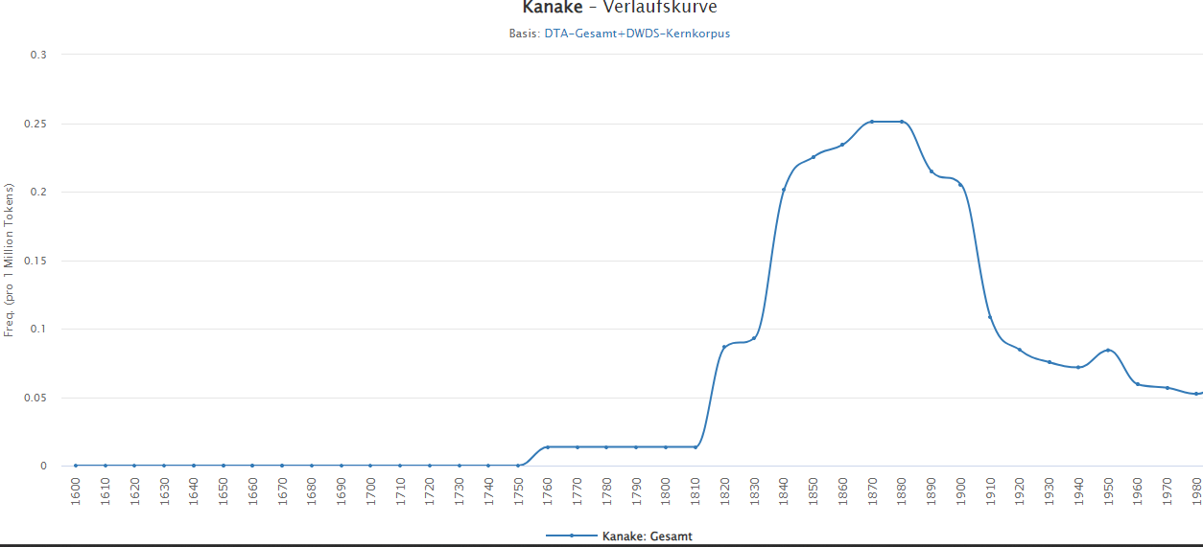

Figure 11 Frequency of *Kanake* since 1600 in DWDS

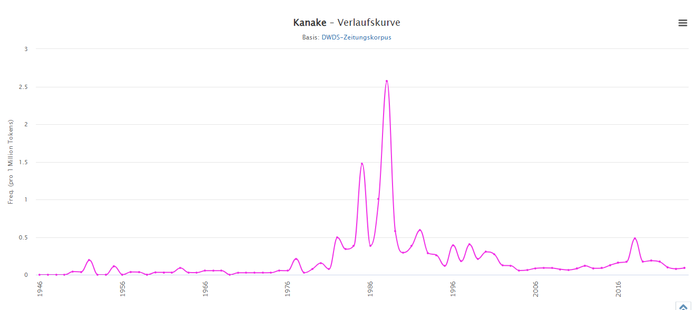

Figure 12 Frequency of *Kanake* since 1946 in DWDS

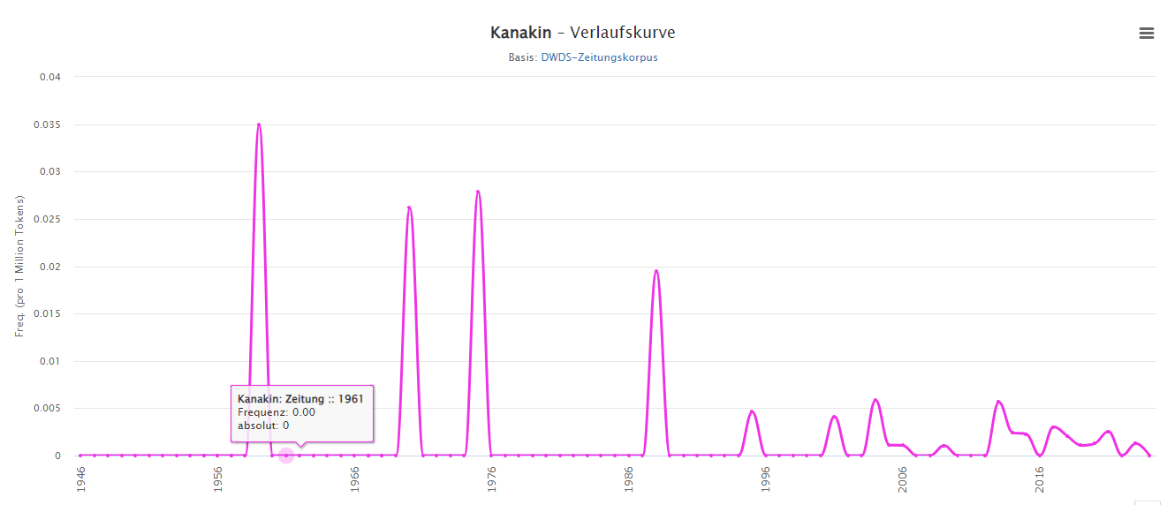

Figure 13 Frequency of *Kanakin* since 1946 in DWDS

As already stated, in the 20th century, *Kanake* resurfaces in discourse after the oil crisis of the 1970s and in reference to the fact that immigrants, most numerously Turks, did not leave Germany in the 1980s: in 1985, the noun *Kanake* was attested 62 times (1.40 per million tokens) and only three years later, in 1988, had as many as 132 attestations (2.57 per million tokens). For the feminine noun *Kanakin* there is one attestation in 1959, one in 1970, one in 1975, one in 1988, 5 in 2004 and 5 in 2013.

DWDS gives the following three meanings for *Kanake*: 1. ‘inhabitant of Polynesia and South-Sea islands;’ 2. ‘foreigner, foreign worker, especially Turkish;’ 3. ‘a stupid, uneducated person.’

In view of the analysis presented here, the sequence of the semantic shift should be as follows: 1. ‘inhabitant of Polynesia and South-Sea Islands;’ 2. ‘inhabitant of western colonies (underdeveloped);’ 3. ‘foreigner, foreign worker, especially from non-European areas.’ Stage 2 developed in the context of foreign travels and colonies already by the end of the 18th century, and led to clear stigmatization during the official colonial period in the late 19th and early 20th century. Stage 3 developed after the oil crisis of the 1970s. All the attestations, including the ones pertaining to a female hero transgressing Western moral boundaries (and even the one showing that the Canac languages do not properly distinguish precious stones), contain othering and stigmatization based on a comparison to the Western cultural values. This persists until the present time.

Example:

1. *Man hat uns als Kanaken beschimpft, gedroht, unser Haus anzuzünden*. [Der Tagesspiegel, 13.03.2002]

‘We were scolded as Canacs ‘Kanake-N.M.PL.PEJ’, they threatened to set our house on fire’ (report by a migrant)

Besides *Gastarbaiter/Gastarbaiterin* and *Kanaka/Kanakin* over the past decades, several new expressions for migrants came into use and were partly abolished for reasons of suggesting discrimination. Among them is perhaps most clearly *Asylant* ‘asylum seeker,’ which underwent a development from neutral to stigmatized. In 1991, there were 582 attestations (8.61 per million tokens) of *Asylant*; for *Asylantin*, there were only 8 attestations in 1986 (0.18 per million attestations). The stigmatized status is also explicitly mentioned in texts.

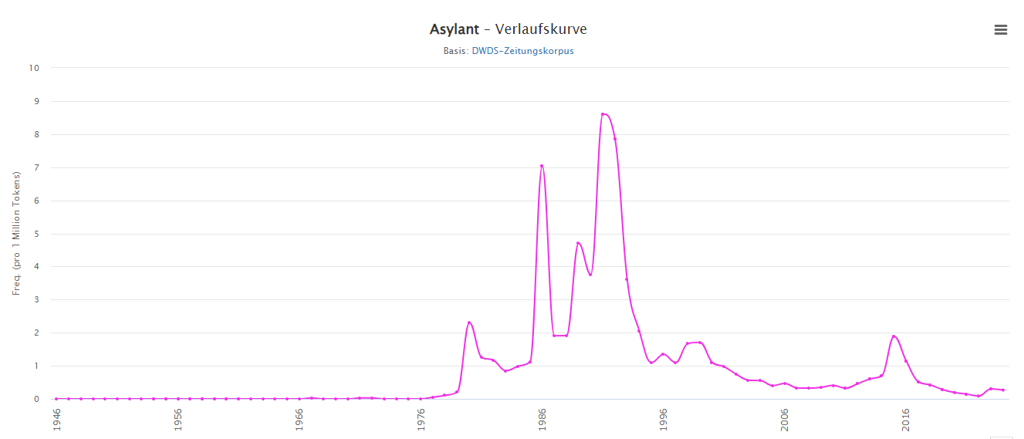

Figure 14 Frequency of *Asylant* (‘asylum seeker-N.M’) in DWDS

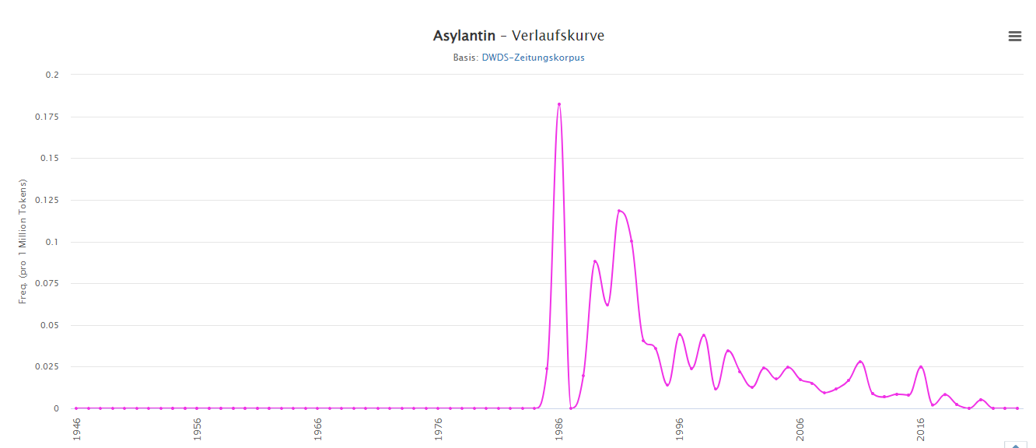

Figure 15 Frequency of *Asylantin* (‘asylum seeker-N.F’)in DWDS

Example:

1. *In den 1990er‑Jahren hat sich das Wort Flüchtling gegen das abwertend klingende Wort »Asylant« durchgesetzt, indem Flüchtlingsinitiativen es aufgriffen, neben dem ebenfalls korrekten Wort »Asylbewerber«. Ja, »Asylant«, das klang wirklich negativ. Das Wort »Flüchtlinge« war also ein Fortschritt: Flüchtlinge sind Menschen, die willkommen sind, weil sie auf der Flucht waren und Schutz brauchen*. [Süddeutsche Zeitung, 02.09.2017]

‘In the 1990s the word *Flüchtling* (‘refugee’), along with the correct form *Asylbewerber* succeeded the derogatory word *Asylant* (‘asylum seeker’), because organizations of refugees protested against it. Indeed, *Asylant* sounded really negative. The word *Flüchtlinge* ‘refugee-N.PL’ was thus an improvement: refugees are people who are welcome, because they have to flee and need protection.’

1. *Heute betreibt die Anwältin, die 1989 als politische Asylantin**nach Deutschland kam, in Kiel die Flüchtlingshilfsorganisation* «Refugio*».* [Die Zeit, 16.03.2006]

‘The female lawyer, who came to Germany in 1989 as a political *Asylantin***(‘**asylum seeker-N.F’), is currently in charge of the refugee help center *Refugio* in Kiel.

Example (8) also shows that semantic struggles were going on in the public discourse for several decades.

*Asylbewerber* (‘asylum seeker-N.M)*,* mentioned as neutral in example (7), peaks almost immediately after *Asylant* (in 1992 with 8,046 attestations; 73.27 per million tokens), and *Asylbewerberin* in 1989 with 118 attestations (2.08 per million tokens).

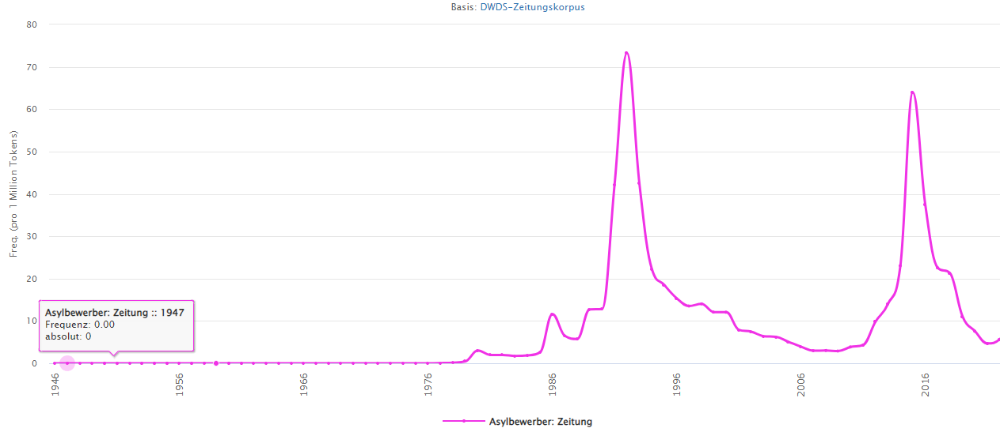

Figure 16 Frequency of *Asylbewerber* (‘asylum seeker-N.M’) in DWDS

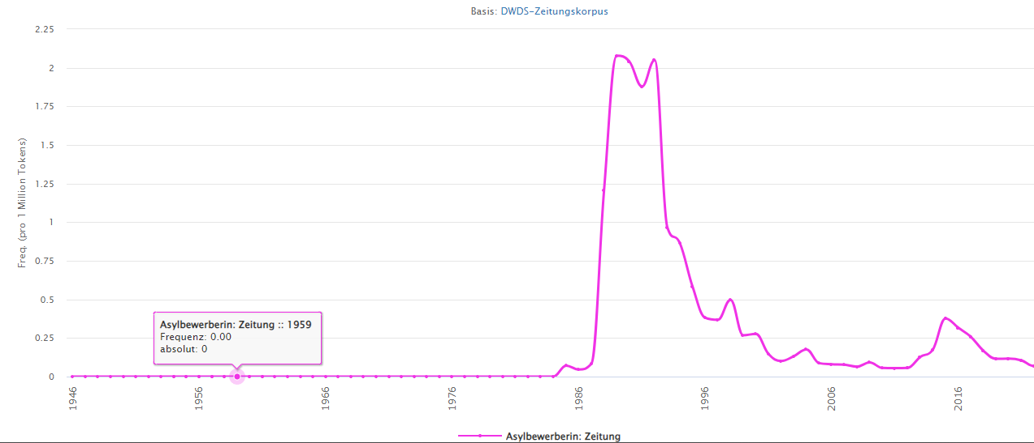

Figure 17 Frequency of *Asylbewerberin* (‘asylum seeker-N.F’) in DWDS

*Asylbewerber* and *Asylbewerberin* are legal terms; they were particularly used directly before and during the Yugoslavian war, with many refugees in Germany seeking a legal status after the war instead of returning to the country of origin, and again in 2015 and 2016, with the new migration wave.

Example:

1. *Im Jahr 2017 hatten Asylbewerber**durchschnittlich 10,7 Monate auf eine Entscheidung warten müssen*. [Die Welt, 12.02.2019]

‘In the year 2017, asylum seekers had to wait for 10,7 months on average to obtain a decision.’

In addition to these terms, *Migrant/Migrantin* (‘migrant-N.M/N.F’) came into use as a relatively neutral expression with the wave of migrants from former Yugoslavia.

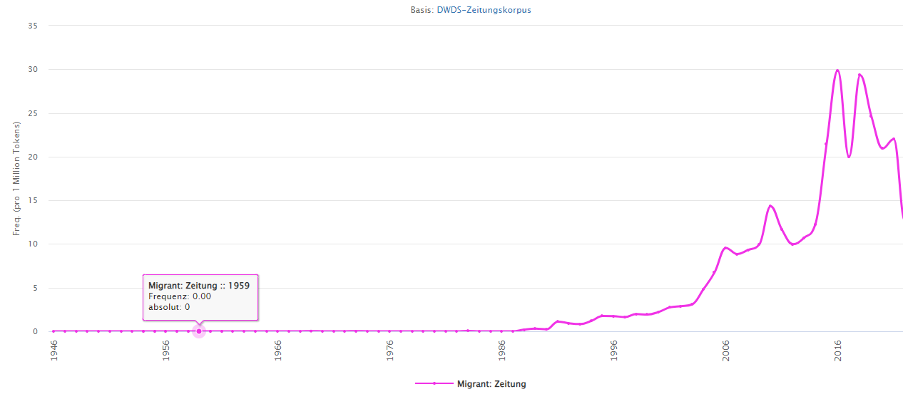

Figure 18 Frequency of *Migrant* (‘migrant-N.M’)in DWDS

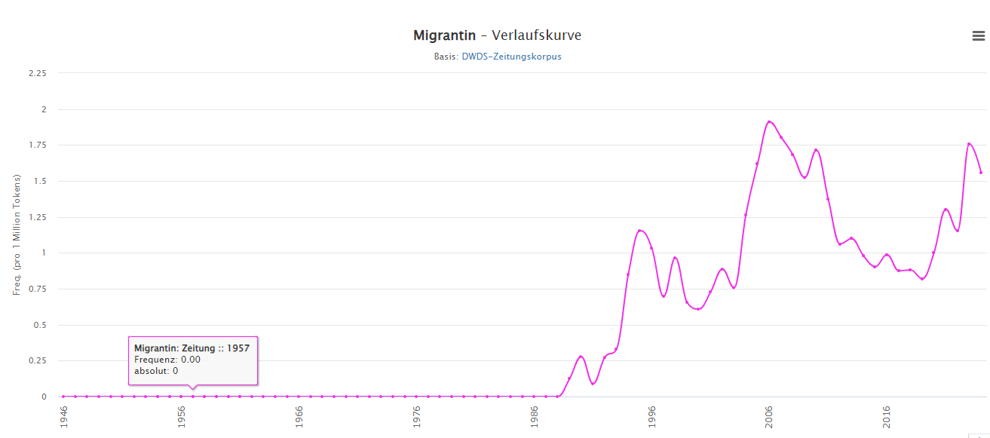

Figure 19 Frequency of *Migrantin* (‘migrant-N.F’) in DWDS

Despite the fact that the internationalism *Migrant* appeared in the context of the Yugoslavian war, its frequency peaks in 2016 with 27,703 attestations (29.89 per million tokens). Interestingly, *Migrantin* becomes noticeable in discourse already in 1995 with 250 attestations (1.15 per million tokens), and peaks in 2006 (1,775 attestations; 1.91 per million tokens), long before *Migrant* gains frequency in the public media due to the recent migrant wave. This expression is predominantly used in the plural, with characteristics illustrated by example (10) ascribed to the entire group, and varies between neutral and negatively connotated.

Example:

1. *Die schwarz‑gelbe Bundesregierung will im Ausländer‑ und Zuwanderungsrecht den Druck auf integrationsunwillige Migranten**erhöhen*. [Die Zeit, 21.10.2010 (online)]

‘The black-yellow government [i.e., Christian-Democrat and Free-Democrat governement] want to raise the pressure on integration-ready migrants in the Law on Foreigners and Migration.’

1. *Sie ist gleichzeitig Migrantin und Nachkomme von Ausgewanderten, eine Frau mit multiplen Identitäten*. [Die Zeit, 14.07.2011]

‘She is at the same time a migrant and descendant of emigrants, a woman with multiple identities.’

*Flüchtling* ‘refugee-N.M’ also reflects past migration waves and strongly peaks in 2015 with 307,172 attestations (350.55 per million tokens).[11]

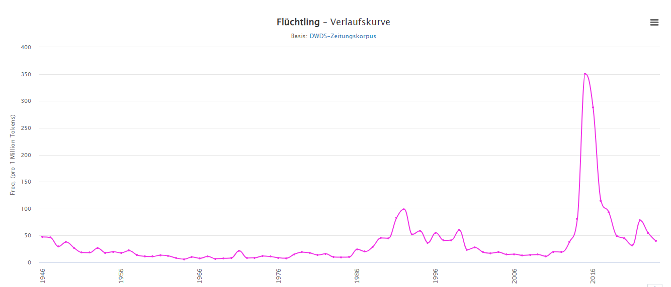

Figure 20 Frequency of *Flüchtling* (‘refugee-N.M’) in DWDS

Example:

1. *Im Dezember 2015 wählte die Gesellschaft für deutsche Sprache (GfdS) Flüchtlinge**zu ihrem Wort des Jahres 2015*.

‘In December 2015 the Society for the German language chose *Flüchtlinge*-N.M.PL as the word of the year 2015.’

*Geflüchtete* (past participle of the verb *fluchten* ‘to flee,’ i.e. ‘lit. people who have fled’) peaks in 2022 with 39,905 attestations (50.06 per million attestations).

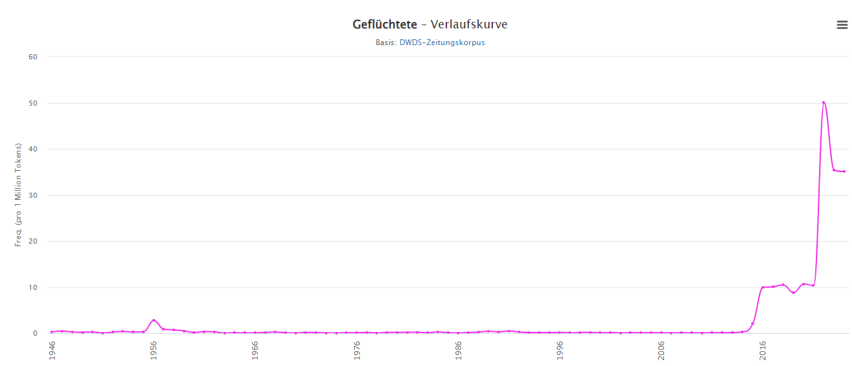

Figure 21 Frequency of *Geflüchtete* (‘people who have fled-N.PL’) in DWDS

This form can be used for both genders and in singular and plural with appropriate articles; the plural use being predominant, but the singular possible, as in the following example.

Example:

1. *Der Geflüchtete wurde von der inzwischen alarmierten Volkspolizei in der Finowstraße entdeckt und ergriff wiederum die Flucht*. [Berliner Zeitung, 11.05.1958]

‘The refugee-N.M.SG was discovered by the police alarmed in the meantime and started to flee again.’

*Schutzsuchende* (‘lit. those seeking shelter; shelter-seeking people’; present participle of the expression *Schutz suchen* ‘to seek shelter’) peaks in 2016 with 2,684 attestations (2.90 per million tokens) and then again in 2022 with 2,814 attestations (3.53 per million tokens).

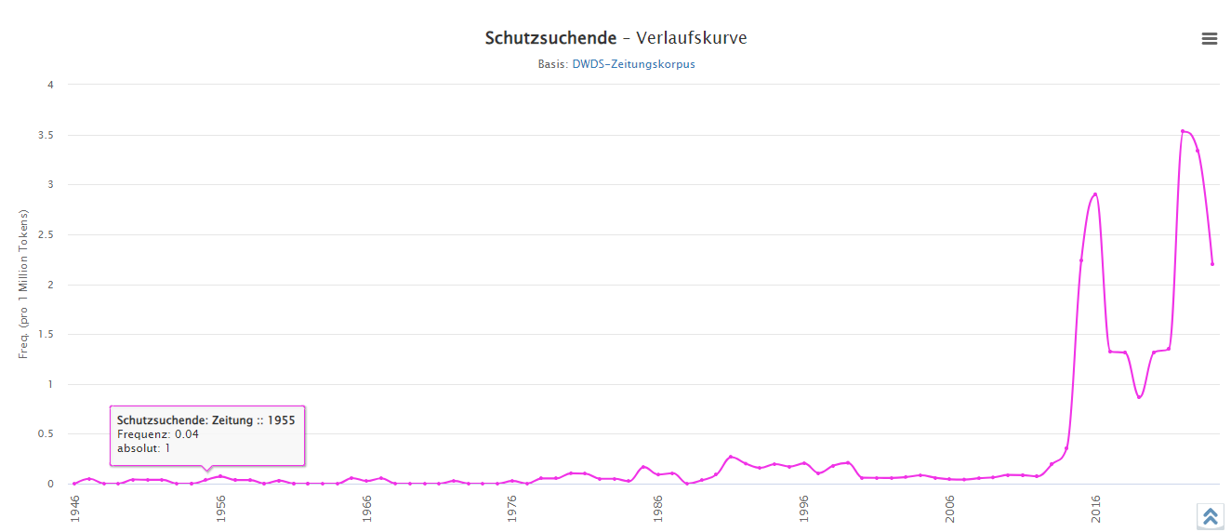

Figure 22 Frequency of *Schutzsuchende* (‘shelter-seeking people-N.PL’) in DWDS

Example:

1. *Er beschreibt konkrete Probleme die für die Schutzsuchenden**daraus entstehen*. [Die Zeit, 30.08.2013, Nr. 36]

‘He describes concrete problems that emerge for the refuge seeking.’

*Arbeitsmigrant* ‘lit. work migrant; economic migrant-N.M’ peaks in 2022 with 1,222 attestations (1.53 per million tokens). *Arbeitsmigrantin* (‘economic migrant-N.F) also peaks in 2022, with 63 attestations (0.08 per million tokens). Both are used predominantly (> 95%) in plural.

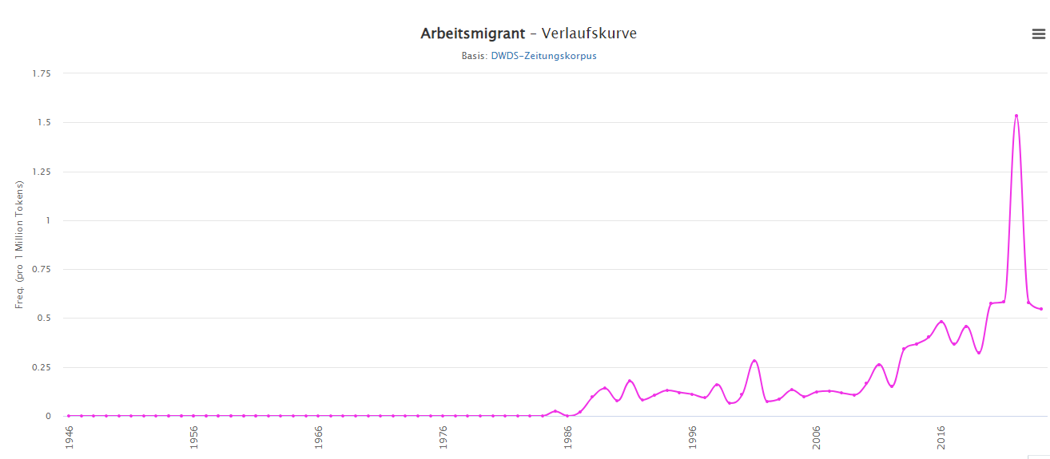

Figure 23 Frequency of *Arbeitsmigrant* (‘economic migrant-N.M’) in DWDS

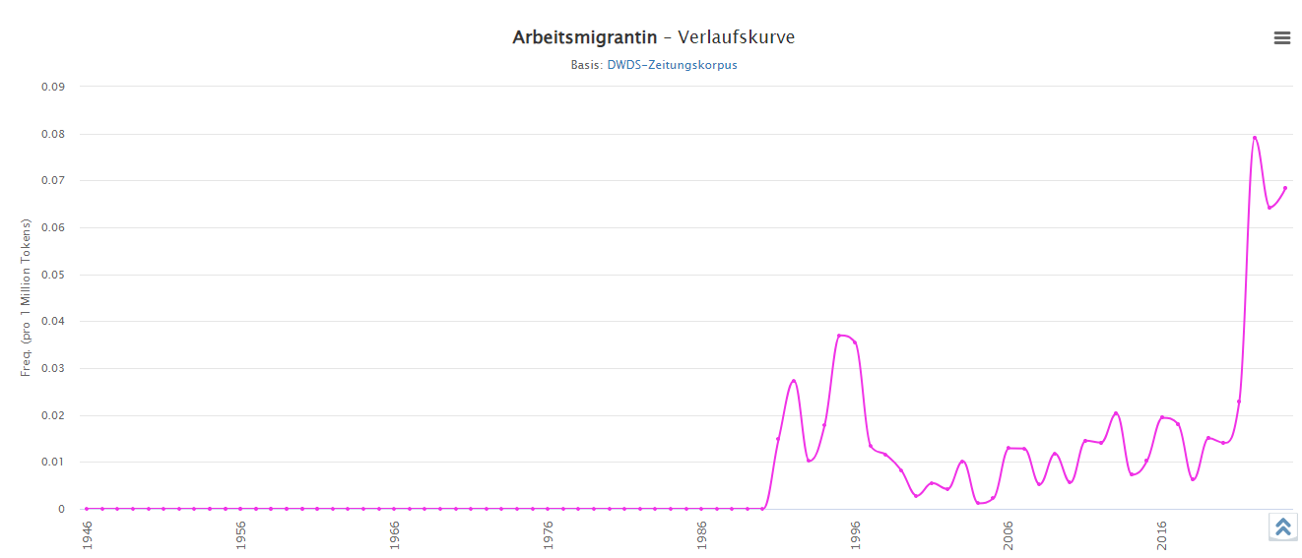

Figure 24 Frequency of *Arbeitsmigrantin* (‘economic migrant-N.F’)in DWDS

Example:

1. *Die Restauration der kapitalistischen Nachkriegsökonomie wäre ohne die massenhafte Anwerbung von Arbeitsmigrantinnen und ‑migranten nicht möglich gewesen*. [konkret, 2000 [1991]]

‘The renewal of the capitalist postwar economy would have been impossible without massive recruitment of female and male economic migrants.’

3.3 Grammatical number of these attestations

There is a systematicity in the distribution of grammatical number, as shown by the SketchEngine data offered for German:

* *Kanakin* and *Asylantin* occur (at least in modern texts) only in singular;
* *Kanake* and *Asylant* occur significantly predominantly (<95%) in plural;
* *Gastarbeiterin* occurs in about 20% of the cases in singular, 80% in plural, *Gastarbeiter* predomantly (<95%) in plural;
* *Migrantin* occurs nowadays predominantly (in 1-2%) in singular, otherwise in plural (under *Migrantin*, SketchEngine calculated also *MigrantInnen*, used for both genders), *Migrant* (including also *Migrant*innen* and *Migrant/-innen*) only in plural;
* *Migrant, Flüchtling, Geflüchtete, Schutzsuchende* occur predominantly (< 95%) in plural.

This survey, based on the modern language attested in SketchEngine, shows that the established stigmatized expression *Kanake/Kanakin* occurs in singular, whereas male and generic forms occur (at least in the modern language) significantly more often (> 95%) in plural forms (this finding corroborates Niehr’s (2020) general statement about the use of plural forms in the designation of migrants). This holds even for politically correct expressions such as *Geflüchtete* and *Schutzsuchende*. This systematic use of plural forms is a linguistic means of construing migrants not as individuals, but as a group with shared properties (as corroborated also by the analysis by Saicová Římalová, Kopřivová, and Rejzek in the present volume). And these properties are as a rule negative, as shown by collocating words (e.g., *geflohen* ‘flee-V.PP,’ *abgeschoben* ‘expel-V.PP,’ *parasitär* ‘parasitic-ADJ;’ one attestation states: *sie ist eine würdige Asylantin* ‘she is an honorable asylum seeker-N.F,’ implicating that this would not generally be the case). Indiscriminate assignment of properties to a group is the prototypical procedure of stigmatization, applied even to originally positive expressions (such as *Schutzsuchende* ‘shelter-seeking people). The rise of frequency and plural use are indicators of othering, attested whenever a group starts to be observed as threatening. This again attests to the situated character of othering.

The terms, and specifically changes in their frequency over time, tell a following story. As long as migrants are construed as necessary to the economy, they are welcome guest-workers. The moment they outstay their welcome and are no longer needed they become otherized through a historical, colonial term (*Kanake*). Interestingly, refugees from the Yugoslavian war are not initially strongly othered (see the frequency data on *Migrant*); by contrast, since the refugee crisis in 2015, they become othered again as economic migrants compared to refugees. The story also reflects the migrants’ and their allies’ attempts to prevent othering (the case of *Asylant* vs. *Asylbewerber*). These changing attitudes entrenched in linguistic expressions confirm the situated character of othering.

4 A brief comparison with Croatian

In order to see whether treating migrants as a single undifferentiated group is language-specific for German or culturally specific for Germany, a comparison with Croatian can be illustrative. Croatia is a EU country socioculturally embedded in the same Central European heritage as Germany (see above), and Croatian is linguistically similar by distinguishing gender and number grammatically. I compared the recently adopted internationalism *migrant* in Croatian (with a feminine counterpart, *migrantkinja*) with the corresponding Croatian word *izbjeglica* ‘refugee’ (with no possibility to distinguish gender; this is one of the Croatian morphologically feminine derivatives used generically). Based on hrWaC 2.2 on SketchEngine *izbjeglica* is used for both genders, and the feminine form *migrantkinja* occurs only in 11 examples (compared to 2,176 for *migrant*), all in the plural.

In hrWaC 2.2, *migrant* (2,176 attestations) is predominantly (> 95%) used in plural (even *ilegalni migrant* ‘illegal migrant’ occurs in 188 instances in plural and only once, *ako si ilegalni migrant* ‘if you are an illegal migrant’, non-referentially, in singular. *Izbjeglica* ‘refugee, of both genders’ (‘from’–‘flee’–APP–desinence; i.e. prefix – verb root – suffix for active past participle – desinence for a bearer of a property) follows the same formation pattern as e.g., *pridošlica* ‘newcomer, of both genders’. However, *pridošlica* (2,109 attestations) has a rather even distribution between singular and plural, whereas *izbjeglica* (17,882 attestations on May 30, 2024) exhibits a strong preference (> 95%) for plural forms (singular forms are used with *ako* ‘if’ or *kao* ‘as’). This points to the same discourse strategy in Croatian as in German.

5 Conclusion

We have seen two different instances of construal of othering in discourse, demonstrating that discourse is indeed more than the involved semiotic elements (be they politically correct expressions such as *Geflüchtete* in German, or politically incorrect such as *Asylant*). As shown by the quantitative data, grammatical categories such as number are employed in the construal of migrants as an indiscriminate group with the same, predominantly negative, properties. The discourse strategy of employing plural designations is valid both in Germany and in Croatia.

By contrast, in the case of women it is not the frequencies of masculine and feminine forms that are revealing, but the rhetorically fixed expressions that are employed in the construal of women as not equally qualified for a position as a man would be. In this case, the qualitative data have been much more revealing.

While it is mainly grammatical means that underlie the construal of migrants as Others pertaining to an indiscriminate group, women are construed individually as weak by discourse strategies including hedges (e.g., *so to say*) and faint praise (e.g., *she has the capacity to grow and develop*). We may ask how these results relate to Brons’s definition of *othering* as “the attribution of relative inferiority and/or radical alienness to some other/out-group” (2015, 83). Both investigated cases point to contextualization of othering as a matter of situated sociocultural judgement; in this sense, alienness is relative and contextually embedded, as is also relative inferiority (construed with reference to adopted sociocultural norms with the aim to maintain the established order). Concerning Brons’s distinction between *crude* and *sophisticated othering*, the data show that (apart from scolding by means of the word *Kanake*, against which a legal complaint can be filed), in countries where discrimination is legally forbidden, indirect othering (e.g., by means of indiscriminate group treatment) is basically the norm in public discourse; this may be called *sophisticated othering*.

In all the investigated instances, clear language cues could be established, leading discourse participants to the underlying othering and potentially lesser achievement of the entire undifferentiated group. In this sense language plays an even greater role than assumed by Foucault, and both grammar and lexicon contribute to construal of underlying meanings in discourse in addition to fixed rhetoric means. Othering is indeed a situated judgement of deviation from a sociocultural norm. Once triggered in resistance to a social group transgressing real or imagined boundaries, othering becomes embedded in the system of sociocultural values by means of language, and relatively resistant to dynamism and change.

References

Amo-Agyei, Silas. 2020. *The migrant pay gap: Understanding wage differences between migrants and nationals*. Geneva: International Labour Organization. https://migrant-integration.ec.europa.eu/sites/default/files/2020-12/Themigrantpaygap_ILOReport.pdf

Bourdieu, Pierre. 1979. *La distinction: Critique sociale du jugement*. Paris: Éditions du Minuit.

Bourdieu, Pierre. 1982. *Ce que parler veut dire: l’économie des échanges linguistique*. Paris: Fayard.

Brons, Lajos L. 2015. “Othering, an analysis.” *Transcience* 6 (1): 69–90.

de Beauvoir, Simone. 1949. *Le deuxième sexe*. Paris: Gallimard.

Duszak, Anna. 2002. “Us and others: An introduction.” In *Us and Others. Social identities across languages, discourses and cultures*, edited by Anna Duszak, 1–28. Amsterdam: John Benjamins Publishing Company.

European Commission. 2021. *She figures 2021: Gender in research and innovation: Statistics and indicators*. Luxembourg: Publications Office of the European Union. https://data.europa.eu/doi/10.2777/06090

European Commision. 2023. *2023 report on gender equality in the EU*. Luxembourg: Publications Office of the European Union. https://commission.europa.eu/system/files/2023-04/annual_report_GE_2023_web_EN.pdf

Fairclough, Norman. 1995. *Critical Discourse Analysis*. *The critical study of Language*. London: Longman.

Fairclough, Norman. 2003. *Analysing Discourse and Text. Textual Analysis for Social Research*. London: Routledge.

Foucault, Michel. 1970. *The order of discourse*, Inaugural lecture at the College de France, published in *Untying the Text: A Post-Structural Reader*, edited by Robert Young, 48–78. Boston, Mass & London: Routledge & Kegan.

Goffman, Erving. 1977. “The Arrangement between the Sexes.” *Theory and Society* 4.3: 301–331.

Gumperz, John J. 1992. “Contextualization and understanding.” In *Rethinking Context: Language as an interactive phenomenon*, edited by Alessandro Duranti, and Charles Goodwin, 229–252. Cambridge: Cambridge University Press.

Gvozdanović, Jadranka, Katrien Maes et al. 2018. *Implicit bias in academia: A challenge to the meritocratic principle and to women’s careers – And what to do about it. LERU advice paper*. https://www.leru.org/files/Publications/Implicit-bias-in-academia-Full-Paper.pdf

Kahneman, Daniel. 2011. *Thinking fast and slow*. New York: Farrar, Straus & Giroux.

Kuna, Branko, Damira Nujić. 2015. “O rodno osjetljivom jeziku (On Gender-Sensitive Language).” *Poznańskie Studia Slawistyczne* 9, 303–318.

Łaziński, Marek. 2006. *O panach i paniach. Polskie rzeczowniki tytularne i ich asymetria rodzajowo-płciowa*. Warszawa: Wydawnictwo Naukowe PWN.

Mikołajczyk, Beata, and Jarosław Aptacy. 2023. “Gendern in der Politik. Weibliche Personenbezeichnungen in deutschen und polnischen Partei-Tweets.” *Convivium*. *Germanistisches Jahrbuch Polen*: 51–83. <https://doi.org/10.18778/2196-8403.2022.04https://doi.org/10.18778/2196-8403.2022.04>

Niehr, Thomas. 2020. “Migrationsdiskurs.” In *Handbuch Sprachkritik*, edited by Thomas Niehr, Jörg Killian, and Jürgen Schieve, 225–232. Berlin: J.B. Metzler Verlag.

Palmer, Stephen. 1975. “The effects of contextual scenes on the identification of objects.” Memory and Cognition (3): 519–526.

Stahlberg, Dagmar, Friederike Braun, Lisa Irmen, and Sabine Sczesny. 2007. “Representation of the Sexes in Language.” In *Social communication*, edited by Klaus Fiedler, 163–187. New York: Psychology Press.

Trix, Frances, and Carolyn Psenka. 2003. “Exploring the color of glass: letters of recommendation for female and male medical faculty.” *Discourse & Society* 14(2): 191–220.

van den Brink, Mareike, and Yvonne Benschop. 2011. “Gender practices in the construction of academic excellence: Sheep with five legs.” *Organization*, 19(4), 507–524.

1. The lecture was first delivered in French in 1970. I am quoting the English translation from 1981.
2. The valuable thing of studying such disadvantaged categories, as remarked by Goffman (1977, 307), is the bearing of the social structure on their generation and stability.
3. Available from dwds.de (last access: July 22, 2024).
4. <https://app.sketchengine.eu/#dashboard?corpname=preloaded%2Fdetenten20_rft3> (last access: July 22, 2024).
5. <https://www.sketchengine.eu/hrwac-croatian-corpus/> (last access: July 22, 2024).
6. <https://www.ohchr.org/en/instruments-mechanisms/instruments/convention-elimination-all-forms-discrimination-against-women> (last access: July 22, 2024).
7. Figure 2 comes from The European Commision *2023 report on gender equality in the EU* (European Commision 2023, 22); https://commission.europa.eu/system/files/2023-04/annual_report_GE_2023_web_EN.pdf (last access: July 22, 2024). It features gender pay gap expressed in percentages in 2018 and 2021 across EU countries (abbreviations: LU = Luxemburg, RO = Romania, SI = Slovenia, PL = Poland, BE = Belgium, IT = Italy, ES = Spain, CY = Cyprus, IE = Ireland, MT = Montenegro, HR = Croatia, SE = Sweden, PT = Portugal, LT = Lithuania, BG = Bulgaria, NL = The Netherlands, DK = Denmark, LV = Latvia, CZ = The Czeck Republic, FR = France, FI = Finland, SK = Slovakia, HU = Hungary, DE = Germany, AT = Austria, EE = Estland, EL = Greece).
8. Source: <https://eige.europa.eu/gender-statistics/dgs/indicator/bpfa_a_offic_a4__ilc_li32> (last access: July 22, 2024)
9. <https://www.antidiskriminierungsstelle.de/SharedDocs/aktuelles/DE/2024/20240625_Jahresbericht_2023.html> (last access: July 22, 2024).
10. This corresponds with general remarks about gender asymmetry in Polish by Łaziński (2006).
11. *Flüchtlinge* is both the feminine form and the plural male/generic form; the attestations are not separately encoded in the corpus.