**Mobile Witnessing Paradise that Turns Into Hell: The Documentary *#Nova***

**Abstract**

*#Nova* (2023)is a documentary film that presents 212 videos, recorded phone-calls and recorded messages taken at real time from the “Nova” music festival before and during the Hamas terror attack. This article observes *#Nova* as a mosaic of ‘mobile witnessing’: the practice of digital recording and memorializing by first-hand witnesses using mobile devices and its unique manifestation in the context of an immediate danger and terror attack. Our premise is that witnessing is as a practice of communication, and focuses on ‘mobile witnessing’ – using the camera phone to document newsworthy events. The article also relates to a sub-genre of mobile witnessing: selfie witnessing. We will particularly address the phenomenon of "dark selfies" taken at trauma sites, which function as acts of witness, engagement, and memorialization and ‘death selfie’ – selfies and videos taken in times of danger, sometimes a few moments before death.

By analyzing the film’s characteristics and the cinematic tools, we discuss the broader implications of mobile witnessing for contemporary communication and memory practices, using Immanuel Levinas’ concept of *the trace* arguing that the age of new media leads the way to *mobile traces* – traces of life captured on the mobile phone camera, signifying the infinite beyond being. Finally, the article analyzes *#Nova* using Jean-François Lyotard's concept of the *differend*, which stands for injustice that cannot be expressed with words. We argue that *#Nova* fulfills Lyotard’s call to create new idioms to convey horror and injustice.

**Theoretical Background**

***Witnessing and Mobile-Witnessing***

Communication theorists often discuss the vast changes that occur onto the perception of witnessing as a personal experience and a social structure at the age of new media. The underlying perception of the new theories is the view of witnessing as a phenomenon that relates directly to the essence of communication. In the words of Peters (2001):

“Witnessing is an intricately tangled practice. It raises questions of truths and experience, presence and absence, death and pain, seeing and saying … fundamental questions of communication … the term involve all three points of the basic communication triangle: (1) the agent who bears witness (2) the utterance or text itself, (3) the audience who witnesses … a witness is the paradigm case of a *medium:* the means by which experience is supplied to others who lack the original” (p.707-709, emphasis in the original)

Observing witnessing as a form of communication can shed a new light on the well discussed practice of witnessing and testifying. Following that, the rapid development of new media and digital environment requires new thinking about the formulation and nature of witnessing in the era of digital communication and social networks. In this spirit Frosh and Pinchevski (2014) connect between nowadays technologies and the concept of ‘participatory culture’. They argue that the extensive mediation of everyday life, in the context of participatory culture destabilizes and redistributes the possibilities for testimonial agency – for performing witnessing – not only through the blurring of boundaries between testimony production and consumption but also through the dynamic realignment of lines of influence and connection between technologies, persons, texts and social forms. As such, they distinguish ‘media witnessing’ from eye and flesh witnessing that originate from the human body, defining it as ‘world witnessing’. They relate this concept to media witnessing of significant media events such as the attack on the world trade center in 9/11, the 2004 tsunami or the shooting of Neda Soltan, an Iranian protester who was shot by the Iranian regime. According to Frosh and Pinchevski

“Thus technologies of media witnessing, through their referential excess, render all incidents as significant and immanently singular, all instants as pregnant instances. This is a reversal of the conventional relations of dependence between event and mediation, between singularity and representation, between being there and not being there…the singularity of an event is not external or prior to its repetition; rather, its singularity *emerges from* its repeatability” (2014, p.599, emphasis in the original).

While Frosh and Pinchevski focus on the broad implications of media witnessing in the digital age, another conceptual shift highlights a specific technology: the mobile phone. The constant presence of the mobile phone in every aspect and moment of our private and public lives (Abeele et al., 2018) and its close proximity to the human body (Rosenberg et al., 2022), creates a new discussion about the term ‘mobile witnessing’ (Reading, 2009). Reading uses this concept to describe the practice of digital recording and memorializing by first-hand witnesses using mobile devices. In McLuhan's term, mobile phones are a part of our extended memory system; we store personal knowledge and reminders within and use apps to support and prompt aspects of our personal and working lives each day (Ling, 2004). As a result, “the camera phone, as a wearable digital mobile prosthetic, enables a new kind of public record or a globally shareable and immediate form of mobile witnessing” (Reading, 2009, p.65).

Alike Frosh and Pinchevski, Reading relates to the new concept of mediated witnessing during a terror attack. Reading examines the 7 July 2005 London Bombings, when some of the first images of the attacks were taken using camera phones by non-journalists, who were both witnesses and survivors of the event. These personal images taken by survivors later, in what Reading defines as ‘mobile witnessing’, became part of the public archive via various news organizations, with the BBC receiving around 30 video clips and around 1,000 images on the day of the attacks taken by mobile camera phones. In particular, Reading focuses on a photo that later became the most well-known image from the attack: the capture photo of Adam Stacey, a 24-years-old man who asked his friend to use his camera phone to take a photo to show to colleagues later at work (Dear, 2006). Short while after, Stacey sent this photo to his friend, Alfie Dennen, who posted it in his moblog as ‘London Underground Bombing, Trapped’ (Dennen, 2005) Adam Stacey’s picture was chosen to go on the front of the BBC’s website and featured worldwide. Reading characterizes Adam Stacey’s photo as a new form of speech act:

“This particular mobile witness image is also both a speech act and yet incorporates speechlessness … I would contend that as a captured image communicated via phone the image of Adam Stacey is a speech act of a moment of atrocity, while capturing a moment of speechlessness in relation to the atrocity through the self-image of a man gagging with a hand over his mouth “

(2009, p.70).

Moreover, Reading points out that Alfie Dennen, who was the first to post Stacey’s photo in his blog, confirmed via his blog, that Adam Stacey is his neighbor, and that he is alive and well (Ibid, p.71). Reading finds that “this emergent concern for a neighbor generated by the atrocity and articulated in relation to a speech act related to the mobile witness image then leads back to the living person of the survivor/witness … [Hence] mobile witnessing has the potential for … an *ethical witnessing* that enables a sense of mutuality and engagement beyond spectatorship” (Ibid, p.72, emphasis added).

Ethical witnessing occurs when the circle is complete – when the attitude towards Adam Stacey is not just an image of a terror attack, but as a human being. This specific mobile witnessing is also ethical witnessing since it relates to the person photographed. Within this act of ethical witnessing, the speechless speech act of mobile witnessing becomes eventually a full sign. Adam Stacey’s image (the signifier), that became the image of the 2005 terror attack via social media, returned to the identity Adam Stacey the person by social media.

Those images, taken from the bombing by non-journalists witnesses, were considered "citizen journalism" taken by "citizen reporters" (Day, 2005). This new form of "citizen journalism" corresponds with the writing of Jürgen Habermas, who constructs his concept of public sphere in which “the press remained an institution of the public itself, effective in the manner of a mediator and intensifier of public discussion” (1974, p.53). “Citizen Journalism” is hence the epiphany of a press that is an institution of the public itself, when citizens participate in creating the news broadcast. However, while Habermas’ model is built upon a sharp differentiation between the private and public sphere, it is rather the lack of boundaries between private and public that creates a new form of civil engaged journalism.

The intersection between this content creation and its distribution as a practice of mobile witnessing, and the public context in which these contents are consumed, allows us to view it as part of the emerging genre of citizen journalism. Andén-Papadopoulos (2014) defines the concept of ‘citizen camera-witness’ relates to the murder of Neda Agha-Soltan, a young woman who was shot during a demonstration in Tehran on 20 June, 2009. Neda’s last moments were captured by at least three bystanders with mobile camera who swiftly spread their videos and images across global media. As a result, Neda became known worldwide, hailed as an ‘Angel of Freedom’ or the ‘Iranian Joan of Arc’. Andén-Papadopoulos argues accordingly that “(t)he camera phone permits entirely new performative rituals …Drawing on the unique testimonial force and galvanizing potential of stark visual imagery, citizen camera-witnessing has enabled the formation of new political publics whose significance we have yet to seriously study and assess” (Ibid, p.766).

The mobile phone and the opportunity of wide and fast distribution of images and information create a new form of citizen journalism – journalism of active citizens. With that, the mobile phone has a significant role not only for concern citizens, but also for soldiers, especially in the times of war. For example, in the context of the Russo-Ukrainian war, Horbyk (2022) describes how smartphones are taking on a new role as a "non-human actor" (Latour, 2005) in the conflict, blurring the boundaries between the state (the military), the private, and the intimate. Additionally, Horbyk finds that the use of mobile phones supports soldiers' mental well-being and strengthens both the military as an institution and the social networks of individual soldiers. In this sense, the mobile phone as a medium blurs the lines between the federal, the private, and the intimate, helping soldiers balance their roles with their private identities, and examines 'the participation culture' (Jenkins 2006; Carpentier 2016) and role it plays among its users.

***Selfie Witnessing: 'dark selfie' and 'death selfie'***

The selfie, often defined as a self-generated digital photographic portrait primarily shared through social media, has become a widespread and popular phenomenon (Senft and Baym, 2015). It is accessible to a large portion of the population and is considered a democratizing tool that does not exclude participants based on class, race, gender, religion, or age. It has also been referred to as the "folk art" of the digital age (du Preez, 2018). Kate Douglas (2017) identifies a sub-genre of selfies: ‘the dark selfie’ – selfies taken in memorial sites and funerals. As an example, she discusses the selfie-scandal of Breanna Mitchell, an American teenager who took a smiling selfie outside Auschwitz and posted it on Twitter. The image quickly went viral, leading to widespread criticism and public shaming across international media. In response, Mitchell explained that the photograph was a tribute to her late father, with whom she had always wanted to visit Auschwitz, but he passed away before they had the chance. Douglas argues that, despite the selfie being perceived as inappropriate and insensitive, Mitchell's defense suggests that when taken at trauma sites, selfies can serve as proof of pilgrimage, as well as acts of witness and emotional expression. According to Douglas, selfies do more than just depict the self: "Such self-portraits are not just of the self; they locate and historicize the self.” (Douglas, 2017, p.2-3). Douglas claims accordingly that

“The self(ie) offers a context for reflecting on the past in light of one’s position in the present (as young, as privileged, etc.). It is not uniform in its intentions and outcomes: selfies are a diverse cultural practice with wide meanings and potentials. When staged and taken at trauma memorial sites, selfies have the ability to be acts of witness: as engaged responses, as demonstrations of affect and as admissions of complicity and/or communion … Simplistic interpretations and judgments deny the potential diversity and complexity of the trauma selfie as a cultural practice and what this act might reveal about new modes of witnessing stemming from new technologies: the mobile phone camera and new subject positions: contemporary youth … The second person’s critical engagement with traumatic representation should be empowered rather than limited (Douglas, 2017, p.12-13)

As opposed to common opinion, which condemns the “dark selfie”, Douglas calls to encourage it. For Douglas “dark selfie” is a new form of interactive witnessing that engages contemporary youth with memorial sites, past events and historic memory.

Like Douglas, Maria Zalewska (2017) seeks to map theoretical and practical preoccupations in the contemporary relationship between places of commemoration and more abstract spaces of Holocaust memory, with a particular focus on the phenomenon of "dark selfies" in commemorative sites. However, unlike Douglas, Zalewska critically examines the phenomenon, raising concerns about its implications. Zalewska focuses on the ways in which the Auschwitz-Birkenau Memorial and Museum engages with Holocaust-related visual content on Instagram. She declares that “Selfies from Auschwitz are one of the many examples in which contemporary public visual discourse counters the one previously established by Holocaust related educational institutions” (Ibid, p.100). She relates to selfies taken in Auschwitz that ”feature smiling people in front of the barracks, the gate, the barbwire, or the piles of suitcases … images of people marking their presence as if the surroundings were irrelevant” (Ibid, p.109). The ‘Auschwitz selfie’ led to the creation of the Facebook page ‘*With My Besties in Auschwitz’* by an anonymous woman. This Facebook page captioned online photos of Israeli teenagers smiling and posing in front of crematoria and the *Arbeit Macht Frei* gate during educational trips to concentration camps. It mocks and criticizes the new phenomenon of ‘Auschwitz selfie’.

Zalewska analyzes the highly criticized ‘Auschwitz selfies’, arguing that selfie highlights the person photographed and not his/her surroundings:

“If we consider these selfies at their face value … seem to privilege ‘the self’ over the surroundings and context within which they are taken. For authors of these images, Auschwitz becomes one of the landscapes or backdrops for their self-portraits. It is their presence that fills and defines these images. Authors become their own subjects. The place of commemoration matters only as much as it provides a background for authors’ perspective and subjective history. The space and memory become objectified” (ibid, p.109).

As oppose to Douglas, who calls to encourage dark selfies, including selfies in concentration camps, since it engages youngsters with commemoration of past events, Zalewska criticizes the phenomenon of the Auschwitz selfie arguing that it trivializes the memory of the Holocaust. According to Zalewska Auschwitz selfies turn the memory of the Holocaust to empty scenery and do not contribute to the commemoration of the Holocaust.

As such, Zalewska observes the ways the Auschwitz-Birkenau museum deals with the Auschwitz selfies in particular and with Holocaust commemoration in the age of new media and social networks. The Auschwitz-Birkenau museum was the first Holocaust educational institution to launch a Facebook page (on October 2009). The popularity of the Facebook page led to the establishment of an Instagram page, a page on Twitter and a Youtube channel.

With that, Zalewska points out that the museum’s Facebook page is a supervised and limited platform for Holocaust commemoration: the Facebook page is not a platform for debate but rather a place for learning about the Holocaust and the museum. As such, users are not allowed to write post on the museum’s page nor post images, only to comment on the content uploaded by the page’s admins (ibid, p.110).

Not only that, Zalewska finds that new media can create new forms of engagements with the history and memory of the Holocaust. She argues that

“The digital device serves as a catalyst for experiences. Through this process of digital self-inscription, the visitors establish new relations with the history of the Holocaust, which can be shared and thereby become part of social media biographies, circulated across wide networks

(Ibid, p.231).

From a different angle, the connection between death and selfie is also examined by Amanda Du Preez (2018), who examines the phenomenon of ‘death selfie’. ‘Death selfie’ are divided into three categories: “selfies unknowingly taken *before* death, selfies *of* death where the taker’s death is almost witnessed and selfies *with* death where the taker stands by while someone else dies” (2018, p.744, emphasis in the original).

Du Preez connects between slefie and Marshel McLuhan’s interpretation to the myth of Narcissus, who fell in love with his water reflection. According to McLuhan (1994) the youth Narcissus mistook his own reflection in the water for another person. This extension of himself by mirror numbed his perceptions until he became the servo mechanism of his own extended or repeated image… He had adapted to his extension of himself and had become a closed system. Following that, du Preez finds that McLuhan’s interpretation is a suitable metaphor to the selfie phenomenon, arguing that the selfie both extends and amputates its taker (du Preez, 2014).

Du Preez connects the myth of Narcissus with the death selfie of Xenia Ignatyeva, a Russian teenager who in April 2014 climbed on a high bridge and took a selfie photo to impress her friends, but then slipped and fell and was executed by electric fences. “Just as Narcissus…sees in the moment of self-discovery, his own blindness … Narcissus gives life to the image; Narcissus gives his life to the image’ (Lippit, 2015, p. 107), sadly Xenia Ignatyeva also gave her life to the image” (du Preez, 2014, p. 754). Du Preez concludes by emphasizing the danger of death selfie, when the selfie itself can resolve in death, like in above discussed case. The thrill-seeking combined with the ambition to create a remarkable image are exceeding the boundaries of the healthy distance needed to experience the sublime over the limits and can result in death and injuries.

Another example of ‘death selfie’ – selfie and selfie videos taken in times of danger and in many cases – a few moments prior to death is discussed by Hjorth and Cumiskey (2018), which observes the videos and images taken in mobile phones during the Sewol ferry sinking on 16th April 2014 in which 246 school children drowned, and the mass shooting in Las Vegas, United States of America, on the 1 October 2017. They argue that selfies are not just about representing the self but also about extending the self to include viewers of the media and define these images as “‘affective witnessing’ entailed by mobile visuality—whereby graphic images of events are shared in publicly and intimate ways—often originate from a persistent and dominant mobile media trope: the ‘selfie’ and in the most tragic cases often the selfies of the soon-to-be deceased” (Ibid, 167)

Hjorth and Cumiskey relate to videos and images – mostly selfies and slefie videos – found in mobile phones of children who drowned on the Seoul ferry sinking, arguing that

“These selfie movies were not about narcissism as obsessive self-love or pathology but about the numbness and misrecognition that trauma can bring with it … Some left eulogies of themselves for their family and friends. Others, who believed they would survive, mocked the severity of the situation with mundane selfies gestures like the peace fingers while others cried uncontrollably”

(Ibid, p.169)

Hjorth and Cumiskey also describe the fast online distribution of the selfie-eulogies that “quickly moved from familial grief of the *personal* to a form of *intimate public politics*” (Ibid, ibid, emphasis in the original), and argue that “(t)he Sewol disaster and its hundreds of selfies-as-eulogies signified a relational bond—a *cultural intimacy* and *digital intimate public*” (Ibid, p.170, emphasis in the original). In other words, the personal parting from life via mobile phone created a community. The personal selfies, which were taken during a national disaster, were later charged with political critique. The personal selfies videos, and the national context in which they were taken, created a parallel between the intimate and the national.

In this sense, Hjorth and Cumiskey echo du Preez’s article, when they view the slefie and videos as an extension of the self. According to Hjorth and Cumiskey “the mobile device itself becomes an extension of the self and a mechanism through which it can at once serve as a lifeline and as a portal for the extension of one’s presence and influence beyond death” (Ibid, p.175). While du Preez relates to the selfie as an extension of one’s image, Hjorth and Cumiskey relate to the selfie as an extension of a bygone life.

***#Nova***

On 7 October 2023, the Palestinian Islamist militant group Hamas initiated a surprise invasion of Israel from the Gaza Strip. As part of the attack, 364 civilians were killed, many more wounded and 40 civilians were taken hostages by Hamas at “Nova”, an open-air music festival, approximately 5 km (3.1 miles) from the Gaza–Israel barrier. After the October massacre the Israeli director Dan Pe’er volunteered in a missing persons’ emergency room. He spent most of his time in an intensive internet search trying to match the names of the missing people from the Nova music festival with profiles form social networks (Facebook, Instegram and Tik-Tok), using the search word ‘#Nova’.

In an interview to the Meni Aviram’s podcast ‘speaking about Nova’ Pe’er describes his work process:

“I received an excel file with names of missing people from the festival and tried to locate them. I logged on to social networks and wrote the missing person’s name in all kinds of variations. If you see that he writes on Facebook that he is going to a party you understand that this is the person you are looking for. Afterward I crossed the Facebook profile with Instegram profile. I was exposed to hundreds of videos of family members looking for their loved ones, videos uploaded from the party and videos that Hamas terrorists uploaded on Telegram. I checked if I can identify in these videos the people I see on social networks” (2023, Hebrew, our translation).

In other words, Pe’er tried to track ‘digital footprints’ in order to track down the missing people from the music festival. Digital footprints, as discussed by Golder and Macy (2014), are a concept that describes the traces that users leave in online interactions with social media. These online ‘life pieces’ create a mosaic of personal and collective conduct. Digital footprints are mostly used by companies and organizations that wish to create a profile for work candidates (Hinds & Joinson, 2018). In this case, digital footprints were used to find out if the person in question is dead, alive or abducted.

The exposure to these videos led Pe’er to create *#Nova* – a documentary film that does not include narration or testimonies, but rather videos (mostly mobile phone videos), voice messages and recorded phone calls. *#Nova* is set chronologically – from11 pm October 6th to 2pm October 7th. The film opens with a recorded phone call between Yuval Raphael, a young Israeli girl with her father:

Yuval: Daddy there are a lot of dead people here, send the police.

Father: Dead people?!

Yuval: Daddy, please, send police here. It’s urgent.

Father: I am sending them now sweetie, stay calm, stays online, don’t hang up, ok? Stay silence.

Yuval: Daddy they are crashing me, they are crashing me!

Father: Be quiet sweetie, be crashed. Be crashed Yuvali. Yuvali, breath deep, hide, pretend to be dead. Are there injured people outside? Explain what’s going on.

Yuval: There are dead people on me.

Father: Wait, are there still terrorists there?

Yuval: They walk around. Daddy, send police cars.

Father: Yuval be dead, be dead. Hang up the phone, be dead.

Yuval: Bye

(Hebrew, our translation)

After this phone call, *#Nova* regresses 36 hours in time, to the publications in the “The Tribe of Nova” Facebook page, 24 hours prior to the festival, presenting the preparations for the festival. *#Nova* progresses chronologically – it starts with videos from the festival: on 11 p.m. and later on 2:30 a.m. The change occurs on 5:30 a.m; *#Nova* presents the festival at its prime, at sunrise. Parallel to the festival, we see for the first time Hamas terrorists, driving from Gaza to Israel on their motor-cycles. The festival comes to an end on 6:29 a.m. when Hamas fires rockets into Israel. *#Nova* then presents a video taken by Hamas terrorists crossing the Israeli border. *#Nova* progresses in time, showing videos of party participants running for their lives and saying goodbye to their loved ones while presenting parallel videos of Hamas terrorists shooting and abducting party goers. The last video shown at the film was taken at October 7th 2 p.m. by Eran Masas, an Israeli policeman, who came to the festival arena looking for survivors. The film ends with an update on some of the people seen on the film that were murdered or abducted. Its final scenes present videos from the festival prior to the attack, with a promise to return to dance and celebrate.

In an interview to the Israeli journalist Gadi Sukenick in the youtube channel ‘DemkratTV’, Dan Pe’er explains his choice to open *#Nova* with a recorded phone call and not with a visual video:

“A father tells his daughter ‘be dead, be dead’. I’m a father, I have a son, and it moved me immediately. Everyone can identify with this conversation. Atrocities are so graphical and very hard to process. One cannot contain evil. This conversation is something that we can identify with. I heard this conversation when I just started to volunteer, and it made my heart tremble, it wounded my soul. This is a very tough conversation. There is something very intense in the black screen and in the father’s voice when he tells his daughter to be dead. There are no graphic images of blood and bodies” (2023, Hebrew, our translation).

**Analysis and Discussion**

***Mobile Witnessing as 'Seeing’, 'Saying’ and 'Showing'***

In the first level, we argue that the format and the content of the film *#Nova* offer viewers a participation in mobile witnessing that documents a new form of active seeing and experience of real-time event snippets, without retrospective framing. We aim to present this argument in the context of Bill Nichols' (2001) classification of six main modes of documentary representations, including 'the participatory mode’. The participatory mode is an encounter in which the filmmakers actively engages with the situation they are documenting, asking questions of their subjects, sharing experiences with them, and stressing the actual lived encounter between the filmmaker and the subject or the environment.

The participatory mode can be viewed as part of ‘the participatory culture’ (Jenkins, 2006) which “contrasts with older notions of passive media spectatorship… rather than talking about media producers and consumers as occupying separate roles, we might now see them as participants who interact with each other according to a new set of rules that none of us fully understand” (2006, p.3). As such, social media and mobile communication are often considered within the framework of participatory culture, whereby users are simultaneously content producers who collaborate on creating and improving the content (Bruns and Schmidt 2011).

Naturally, documentary films of the participatory mode often use the web to gather video footages from users on a specific topic. These footages are then edited by the editor and the director to create a linear form. *#Nova* is a classic example of this technique; however, it is not the only one or the first. An example to a participatory mode documentary is the Israeli documentary *#Uploading Holocaust* (2016)*,* composed entirely of Youtube clips, mostly recorded by mobile phones, uploaded by pupils and teachers who participated in school-journeys to Poland, an annual journey in which the teenagers visit concentration camps memorials, the Warsaw Ghetto and places of destroyed Jewish communities and learn about the holocaust. The technique of those films, demonstrate the active engagement with the historical sites of atrocities through digital mnemonic devices such as mobile phone cameras and closely related to it, the medium of selfie videos (Ebbrecht-Hartmann and Henig ,2021). Indeed, while “witnessing became a key paradigm of Holocaust memory during the last decades of the twentieth century, with global events such as the Eichmann Trial in Jerusalem (1961), and acclaimed film projects such as Lanzmann’s *Shoah* (1985)” (Ibid, p.217), however, due to new media, we are moving from ‘the era of witnessing’ to what Hogervorst (2020) defines as ‘the era of the user’. In this context, ‘The era of the user’, they claim “recognizes users (and publics more broadly) as co-creating actors of the constitution of Holocaust-related memories” (Ebbrecht-Hartmann and Henig ,2021, p.218).

Ebbrecht-Hartmann and Henig expand this argument and apply it to selfie videos taken at Holocaust memorial sites, viewing them as active witnessing and collaborative content creation. They argue that the self(ie)-mobile phone witnessing as a medium that help those visitors process their own feelings and their own experience:

Selfie videos enable modes of self-witnessing that adopt elements and strategies from established commemorative practices and re-appropriate them in experimental arrangements produced for and through mobile devices … The digital device serves as a catalyst for experiences. Through this process of digital self-inscription, the visitors establish new relations with the history of the Holocaust, which can be shared and thereby become part of social media biographies, circulated across wide networks.

(Ibid, p.231).

Following that, mobile witnessing, bridges between ‘the era of witnessing’ and ‘the era of the user’: the medium of the mobile phone allows its users to bear digital and mobile witness while actively creating their own content.

Another example to a participatory mode documentary film is *Life in a Day* (2010). In this movie the filmmakers, Ridley Scott and Kevin Macdonald, asked YouTubers to record glimpses of their day on the 24th of July 2010 and to post them onto a dedicated YouTube channel. Scott and Macdonald selected videos that were uploaded to the assigned YouTube channel and created a mosaic of videos from different countries.

But unlike *Life in a Day,* and *#Uploading Holocaust*, the images, conversations and videos that constructs *#Nova* were not filmed in order to be part of a documentary, but rather videos originated for personal use that were gathered afterwards. Also, as opposed to *Life in a Day,* which collects videos from different places, portraying different cultures in the same point in time, *#Nova* uses different videos from the same event through time. It is a mosaic of videos that tells a story of a singular local event, offering the audience to be a witness. In this sense, corresponding Peters' definition of witnessing in which there are two ‘faces’ to witnessing, “the passive one of *seeing* and the active one of *saying*… an active witness first must have been a passive one” (2001, p.707, emphasis in the original), it appears that *#Nova* presents a new form of witnessing. Peters describes a classic process in which the witness who witnessed an event framing what s/he saw with words for those who were not present in the event, and in the *#Nova* contextit is not verbal witnessing divided into seeing and saying, passive and active. The mobile technology creates the opportunity for a new form of witnessing: mobile witnessing of *showing,* that gives us fractions on a real time event without retrospect framing.

Moreover, *#Nova,* does not present retrospect witnessing, but rather witnessing in real time. While Peters describes a primary stage of being a passive witness, the witnesses on *#Nova* are not limited to passive seeing. They present a new form of active seeing, active witnessing by choosing to document themselves in real-time. They choose to actively document moments of immediate danger; while running for their lives or hiding from terrorists.

Furthermore, Peters formulates another aspect of witnessing when he connects between witnessing and morality. According to Peters

There is a strange ethical claim in the voice of the victim. Witnessing in this sense suggests a morally justified individual who speaks out against unjust power. Imagine a Nazi who published his memoirs of the war as a ‘witness’ – it might be accepted as an account of experience, but never as a ‘witness’ in the moral sense: to witness means to be on the right side” (2001, 714).

Following Peters, it seems that the documentary *#Nova* offers a new perspective on the connection between witnessing and morality. In *#Nova* the victims’ videos, voice messages and phone calls are combined with videos taken by the terrorists’ web cams. Mobile witnessing in this sense, detached witnessing from its ethical root. In an interview to the Israeli reporter Gadi Sukenik (2023), Dan Pe’er, *#Nova*’s directorexplains his choice to combine images of terrorists with images of their victims. Pe’er argues that his intention is to contras between those who celebrate life and love to those who celebrate death. With that, as stated earlier, *#Nova* does not provide narration, it does not point out who are morally right and who are morally wrong, but rather leaves the ethical judgment to the viewers.

This notion corresponds with Peters describes witnessing in “a strange but intelligible sentence … the witness (speech-act) of the witness (person) was witnessed (by an audience)" (Peters, 2001, p.709). Peters’ model of witnessing assumes an active speaking witness and a passive listening audience. Pe’er, however, paints a different picture. The audience is passive in its action (watching the film), but active morally – differing between the victims and the attackers, deciding what is right and what is wrong. Hence, *#Nova,* whichpresents a new form of active witnesses, offers also a new form of an active audience.

***Mobile Witnessing as Mobile Traces***

*The trace* is a key concept in the philosophy of Immanuel Levinas. The trace, according to Levinas, is an opposite concept to ‘the sign’. It is a non-intendant presence of past occurrences, which “passes without being able to enter” (Levinas, 1981, p.93), it signifies something or someone that is not presence in the current world, signifying the infinite beyond being.

Amit Pinchevski connects between the Levinasian trace to the act of communication. Pinchevski finds that

“The saying [the relational part of the language] “imprints its traces on the thematization itself” (Levinas, 1981, p. 46) … Further, “the trace of saying, which has never been present, obliges me” (Ibid, p.168). … These temporal metaphors evoke a past always anterior to the present, but one that still haunts the present. They operate textually by intimating a beyond the said as written and a before the written as said … Levinas’s medium of communication … stores the very traces of storing, the inscription of the very act of inscription, the traces left by attempting to capture the uncapturable” (Pinchevski, 2014, p.58-59)

Following Pinchevski, we seek to further implements Levinas’ philosophy in the field of communication and introduce a new concept – *the mobile trace*. This new notion of the mobile trace corresponds with the concept ‘digital footprints’, a concept that describes the traces that users leave in online interactions with social media. These online ‘life pieces’ create a collage of personal and collective conduct (Golder& Macy, 2014).

An example of mobile traces is provided in Larissa Hjorth and Kathleen M. Cumiskey’s article, which observes videos and images taken in mobile phones during the Sewol ferry sinking on 16th April 2014 in which 246 school children drowned, and the mass shooting in Las Vegas, United States of America, on the 1 October 2017. Hjorth and Cumiskey relate to the story of Park Ye-seul, a high-school girl who documented the disaster as it happened through selfie videos. After Ye-seul’s death, her father recovered the camera-phone and restored the images and videos taken before her death. As such, the recovered mobile and the images it stores can be viewed as mobile traces. Moreover, Hjorth and Cumiskey find that

“the selfies left by Ye-seul operate as residues—capturing moments immediately prior to death in ways that allow them to live on for the loved ones left behind … These selfie residuals suggest new liminal spaces between how images inhabit lives, deaths and after-lives that exceed Barthes’s punctum in ways we are only beginning to map”.

(2018, p.171)

Immanuel Levinas defines the trace as signifying the infinite beyond being. The mobile trace, via the mobile phone, creates a new liminal sphere between life and death when it preserves fraction of life that ceased to exist.

Another example of a 'mobile trace'—intentionally left in this case—can be identified in an interview with Yarden Waknin, published in an Israeli newspaper. Waknin, a survivor of the Nova music festival whose mobile phone videos appear in the documentary #Nova, recalls her experience:

I hid under a tree for 8 hours. It was dissociating. There are many things I don’t remember. I’m looking now at the videos and say to myself: wow, that actually happened … I filmed myself because I realized that if I don’t document what happen I will not believe it afterwards … At a certain point I sent photos to my family, I wrote: I love you. I wanted to say goodbye. There was a moment when they [the terrorists] tried to abduct us … I wrote to my family: ‘this is probably over; they found us’ and *hid my phone so that the photos and the stories will be found later*

(Isaac, 2024, p.10, Hebrew, our translation, emphasis added).

In this short passage Waknin describes three uses of the mobile phone – to part from her loved ones, to document a surrealist situation for future reference and to leave a trace, or rather, a mobile trace.

Waknin notions echo the writings of Anna Cubilie who regards testimony of atrocities as “a performative act between the mute witnesses … the dead, the survivor witness, and the witness to the survivor … [which] exists in a performative relationship of language and action” (2005, p.3). And with Anna Reading who defines mobile witnessing as a performative speechless speech act (2009, p.70). Waknin sees her life on the threshold. She chooses to leave a mobile trace that will tell her story after her demise. In this sense, mobile trace can be viewed as a performative speechless speech act. It is a new “formulation of voice from within this ‘grey zone’ between human and nonhuman, life and death” (Cubilie, 2005, p.3), a media memory of a bygone human life. From this perspective, *#Nova* is a mosaic of mobile traces, which are a new form of performative speechless speech act. This documentary does not try to speak about the unspeakable or tries to translate atrocities into words, but rather show fractions from a chaotic event.

Another connection between the Levinasian trace to nowadays media is offered by Amit Pinchevski, who argues that current media can provide a new approach to Levinas’ concept of the trace:

Modern media do not simply store and transmit deliberate content but also the traces of the physical conditions by which content is stored and transmitted. A whole new dimension is introduced, not only of static and interferences but also of timbre and tone, of filterization and enhancement, of zoom and focus, of freeze and replay—in short, the materialities of communication… Levinas’s metaphors of trace and echo, which are employed metaphorically in the explication of the saying, may acquire a new level of literality and referentiality with audiovisual media

(Pinchevski, 2014, p.62-63).

Pinchevski’s reflections on modern media and its unique traces seem extremely valid when viewing *#Nova.* In a way, it seems that *#Nova* fulfills Levinas vision of a communication medium that stores and openly presents its own traces. The cinema, the seventh art, is a medium of continuity that tells a coherent story. However, this continuity is built upon separate shots that are edited together to create this illusion. *#Nova* tells a coherent story – it moves chronologically in time, but its format is more of a quilt or a mosaic – constructed from videos and conversations that do not create coherent continuity.

Furthermore, *#Nova* reveals somewhat of the way it was created; *#Nova* opens with a declaration that the movie is a collection of videos and conversation from the Nova music festival. Also, the name of the film, “#Nova”, was Pe’er search word during his search for missing people on social media. Not only that, *#Nova* is a film that contains videos taken by a different medium: the mobile phone. As such, many of the videos that Pe’er collected were filmed vertically, as opposed to the cinematic screen which is horizontal (see image 1). *#Nova* does not change the setting of these videos, but rather fuse the horizontal cinematic screen to show three videos at the same time, thus emphasizes the original medium of these videos.

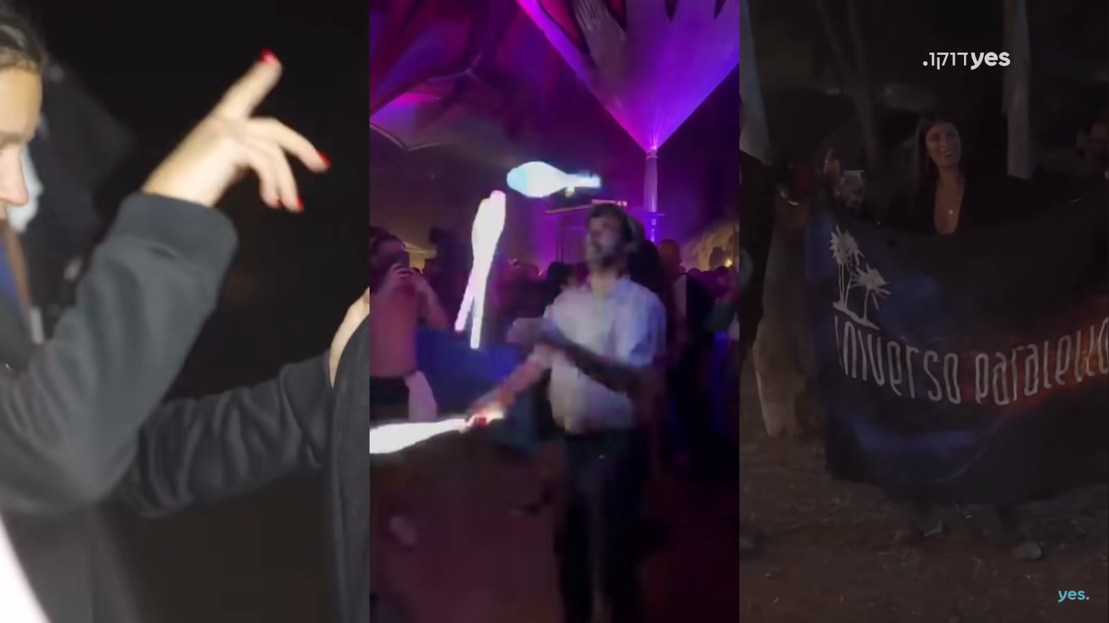

**Image 1:** *#Nova:* 3 different videos on screen, taken from the festival participants mobile phones.

Furthermore, some of the scenes on screen collaborate between videos from the festival to videos of Hamas terrorists on their way to the Israeli border (see image 2). These photos are at the same point in time, but not at the same place. It is the film editing that creates this parallel, telling the audience about the upcoming catastrophe.

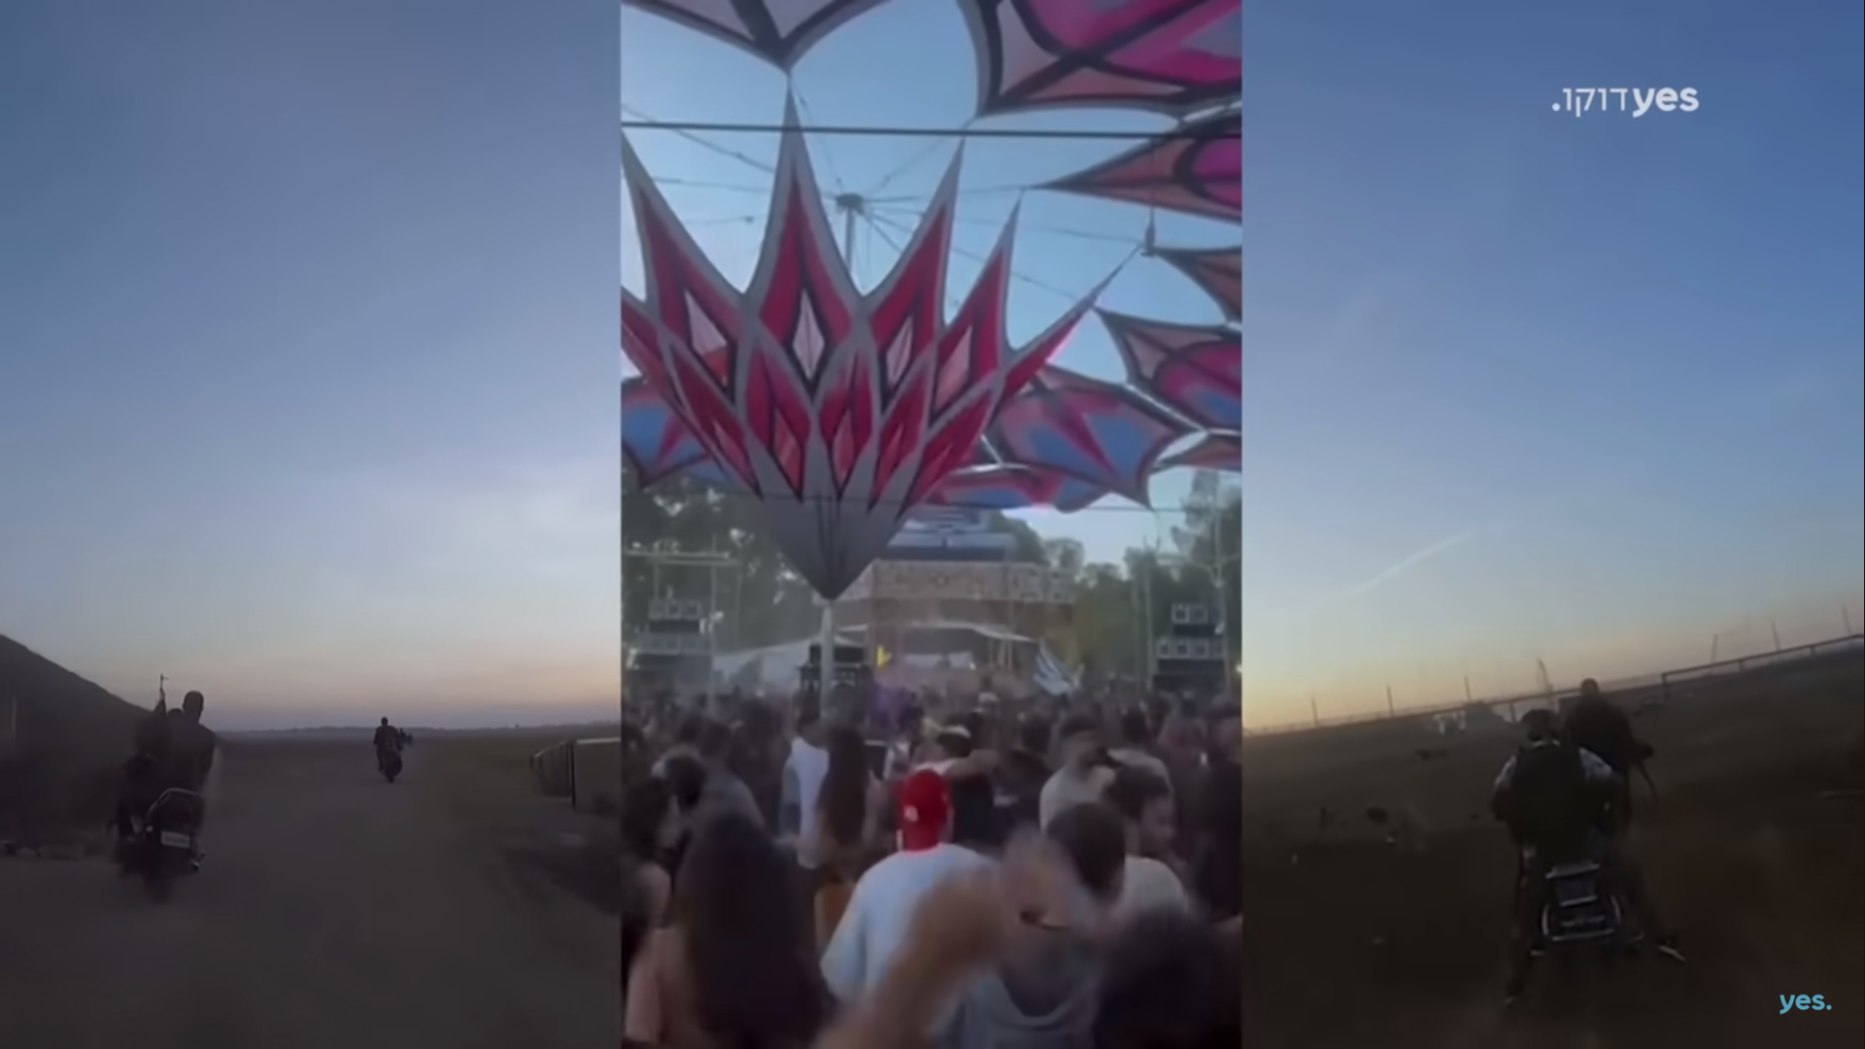

**Image 2:** *#Nova*: videos from Hamas terorists webcams and from a festival participant mobile phone. The videos were taken at the same time, in different locations.

In the interview to the youtube channel ‘democrat t.v’ Pe’er’s interviewer, Gadi Suckenik, relates to the parallel editing, that shows the terorists and their future victims on the same screen, arguing that Pe’er turns the viewers into the choir in the Greek tragedies, who tells the audience what the heros of the play do not know yet – that in a minute their paradise will become hell. Pe’er confirms this observation, stating that he intended to create an intensive feeling that those who celebrate love are about to be killed or abducted by those who celebrate death.

Another example of mobile traces is videos that include narrations. In this case the voice of the witness is heard and his/her face is seen on screen with his/her name attached (see image 3). The mobile phone is a very personal device. When someone takes a selfie or a video via his/her mobile phone, s/he does not need name mentioning – his/her phone stands for their own signature (Rosenberg & Blondheim, 2024). *# Nova,* however, detaches the personal video from the private digital sphere of the private mobile phone, to the public sphere of a documentary film. In this sense, adding one’s name and picture restores its personal aspect.

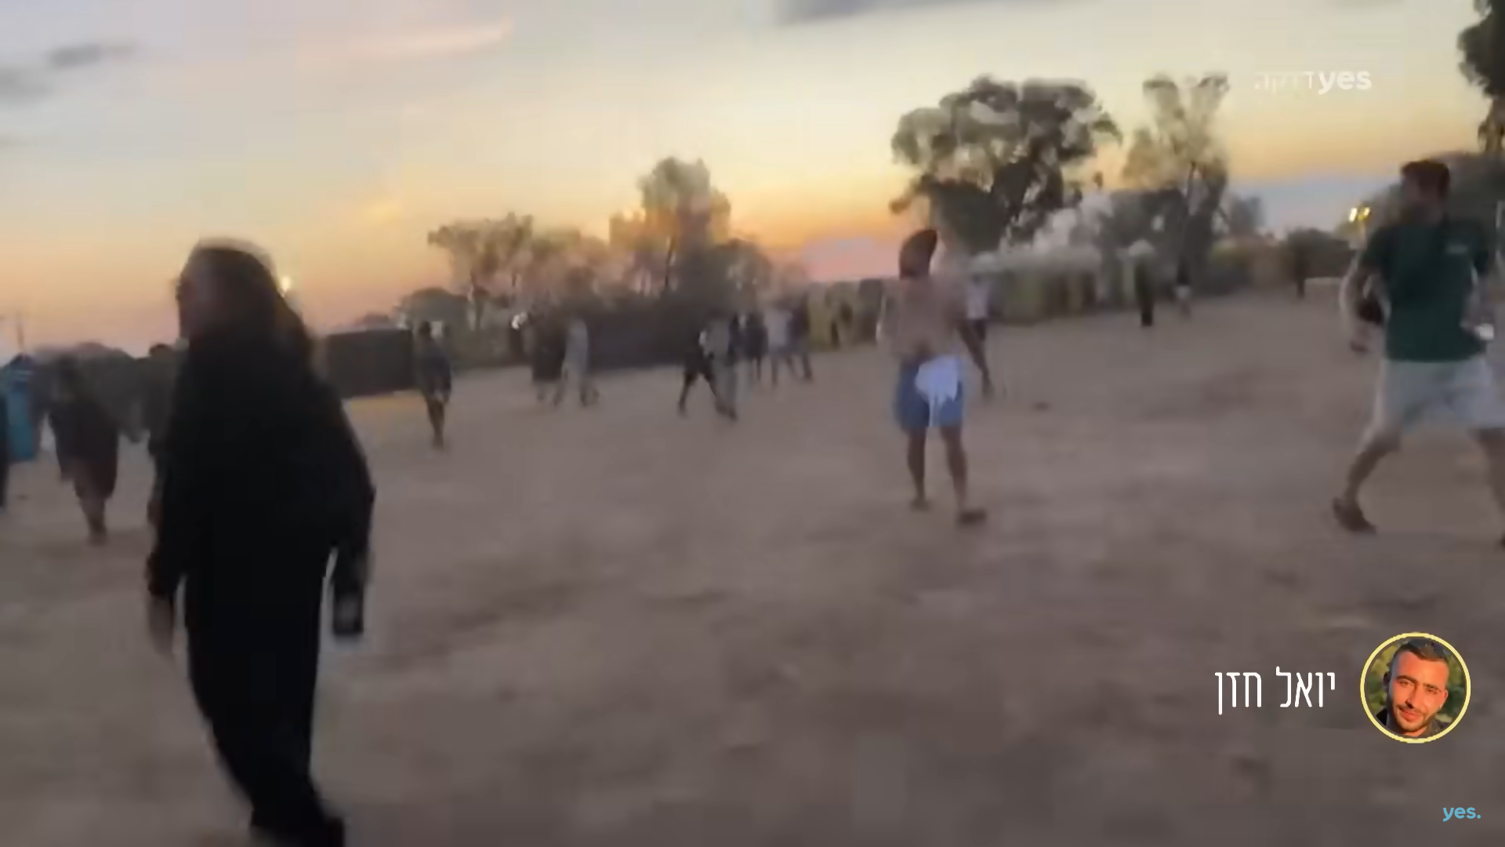

. **Image 3:** a video taken by Yoel Hazan, a festival participant. His face and name appear on screen.

***Mobile Witnessing as a Différend***

As previously stated, *# Nova* is a mosaic of mobile witnessing. As such, *#Nova* can be viewed as a new form of mobile witnessing: mobile witnessing constructed by mobile traces that gather into a narrative film. This new notion echoes the concept of *the* *differend. The* *differend* is a key concept in the writings of the philosopher Jean-François Lyotard. It stands in contrast to the term *referent,* according to which meaning of words and phrases can be determined only by what they refer to. In the words of Lyotard:

“The differend is the unstable state and instant of language wherein something which must be able to be put into phrases cannot yet be. This state includes silence, which is a negative phrase, but it also calls upon phrases which are in principle possible. This state is signaled by what one ordinarily calls a feeling: “One cannot find words,” etc. A lot of searching must be done to find new rules for forming and linking phrases that are able to express the differenddisclosed by the feeling, unless one wants this differend to be smothered right away in a litigation and for the alarm sounded by the feeling to have been useless. What is at stake in a literature, in a philosophy, in a politics perhaps, is to bear witness to differends by finding idioms for them”. (Lyotard 1988, p.13)

Following Lyotard, Anna Cubilie suggests that “perhaps it is the differend that survivors [of the holocaust] testimony repeatedly addresses” (2005, p.4). The concept of the differned connects between witnessing on the one hand and communication on the other hand, as it calls to bear witness by finding new idioms.

This notion corresponds with Hjorth and Cumiskey. As stated, Hjorth and Cumiskey examine the videos and images form the Sewol ferry sinking and from the mass shooting in Las Vegas. They find the videos and images taken in real time of chaotic events have unique qualities

“The rawness of coming face-to-face with death is captured in these selfies. The unflinching nature of the video itself makes it all the more raw and real. As mobile media become an integral part of everyday human rituals, so too do they reflect different ethical dimensions opened up the passages of life and death and digital after-life … In these chaotic moments, it is evidenced that the mobile media users are not thinking about the ethical aspects of what they are doing. In essence, they are attempting to bring more people into their experience, a decision not readily understood beyond the human need for connection, reassurance and recognition of an event that is difficult to comprehend” (2018, p.176)

The rawness of real-time mobile witnessing, taken during a terror attack in the Nova music festival, conveys the chaos of this terror attack in a new and authentic way. *#Nova* offers glimpses and fractions of the unspeakable horrors, using real-time mobile witnessing from moments of horror and danger. As such, these videos and images – mobile witnessing taken at real time, provide a new idiom to express the inexpressible horror. In this sense, mobile witnessing in chaotic times of terror and disasters can be regarded as a differend.

Not only that, another aspect of the differend is that it originates in wrong and injustice. Lyotard finds “that a differend is born from a wrong and is signaled by a silence, that the silence indicates that phrases are in abeyance of their becoming event, that the feeling is the suffering of this abeyance” (Lyotard 1988, p.57). The differend stems from injustice, injustice that cannot be described in words. The very attempt to find words and phrases to articulate this injustice reaches a dead-end. The solution to this situation is “to give the differend its due … to institute new addressees, new addressors, new significations and new referents in order for the wrong to find an expression … This requires new rules for the formation and linking of phrases” (Ibid, p.13).

Amit Pinchevski relates to Lyotard, arguing that “Lyotard locates a crucial political obligation: to bear witness to the silence of differends and to develop alternative ways to express wrongs that are presently inexpressible” (2005, p.233). As such, we can see the documentary *#Nova* as a differend. *#Nova* presents new ways to express the inexpressible chaos that stems from injustice. It is not merely a collection of videos; it deconstructs and reassembles them in a way that seeks to present the chaos in its raw form, potentially offering a new idiom that encourages viewers to engage with the horrors without relying on traditional framing. The use of real-time mobile witnessing, combined with editing that highlights the contrast between life and death, aims to create a cinematic experience that may bring forth the injustice and atrocities in ways that differ from what has been seen before. In this way, *#Nova* can be seen as an attempt to create a new language that tries to express what often feels beyond words. Mobile witnessing which serves as a new idiom.

**Conspectus**

This article views witnessing as a communication practice, focusing on the unique concept of ‘mobile witnessing’: when the mobile phone camera functions as a non-human witness. It observes of mobile witnessing during times of terror and great danger discussing its implications and meanings with the analysis of the documentary *#Nova.*

In an interview to an Israeli newspaper Geut Gil, a survivor of the Nova festival terror attack, who appeared in the documentary *#Nova* states that she photographs herself all time, uploading stories to social networks platforms, so naturally that what she did during the terror attack (Isaac, 2024, p.10). The mobile phone becomes part of our everyday life, an extension of man figuratively and literally.

However, mobile witnessing during times of terror creates a unique situation when the images and videos taken via a personal medium (the mobile phone) for personal use have a great significant in the public sphere. This notion challenges Habermas’ model of an ideal public sphere, a public sphere that is completely separate from the personal and the domestic sphere. Mobile witnessing of personal images taken by one’s personal phone, presented in the public sphere of documentary cinema and news broadcasts, challenges Habermas’ dichotomist differentiation between the private and public sphere. Mobile witnessing blurs the boundaries between the private and the public sphere while creating its own digital sphere, a sphere that combines between the ‘era of witnessing’ and the new ‘era of the user’.

Furthermore, not only that mobile witnessing blurs the boundaries between personal and the public sphere, it can also create a new liminal sphere: a digital sphere between life and death. By formulating the new concept of ‘mobile trace’ – digital fractions which preserves and presents pieces of lives that ceased to exists, signifying the infinite beyond being.

*#Nova,* a mosaic of digital traces, is a documentary film that uses a personal medium – the mobile phone – weaving personal videos of different people to tell the story of the music festival that turned into a blood bath. Going back to Lyotard, *#Nova* is a *differend* since it creates a new idiom that provides a raw and unmediated glimpse into the chaos and horror of the terror attack at the music festival.

These observations provide us new perspectives regarding the dynamic realignment of influence and connection between technologies, individuals, and social forms. As such, *#Nova* not only enriches our understanding of mobile witnessing but also highlights the necessity for new idioms and approaches to capture and communicate the complexities of human experiences in the digital era.

**References**

Abeele, M. V., De Wolf, R., & Ling, R. (2018). Mobile media and social space: How anytime, anyplace connectivity structures everyday life. *Media and Communication*, *6*(2), 5-14

Andén-Papadopoulos, Kari (2014) “Citizen camera-witnessing: Embodied political dissent in the age of ‘mediated mass self-communication’”, *New Media and Society,* Vol. 16(5) 753–769

Aviram, Meni (Host). (2023, December 17). Speaking about ‘Nova’. Kastina Communication.

Available at: <https://www.youtube.com/watch?v=zryicLdvCI8>

Carpentier, N. (2016) “Beyond the ladder of participation: an analytical toolkit for the critical analysis of participatory media processes”. *Javn Public* 23 (1): 70–88. https:// doi.org/ 10. 1080/ 13183 222.2016. 11497 60.

Cubilie, Anne (2005) *Women Witnessing Terror: Testimony and the Cultural Politics of Human Rights* (New York: Fordham University Press).

Day, Julia (2005) “We had fifty images an hour” <http://www.guardian.co.uk/technology/2005/jul/11/mondaymediasection.attackonlond>.

Dennen, Alfie (2005) ‘London Underground Bombing: Trapped’, Alfies Moblog, http://moblog.co.uk/view.php?id¼77571

Dennen, Alfie (2008) Profile/Home page, <http://moblog.net/view/77571>

Douglas, Kate (2017) “Youth, trauma and memorialisation: The selfie as witnessing”, *Memory Studies*

Du Preez, Amanda (2018) “Sublime selfies: To witness death”, *European Journal of Cultural Studies* vol. 21(6), 744–760

Ebbrecht-Hartmann, Tobias & Henig, Lital (2021), “ i-Memory: Selfies and Self-Witnessing

in *#Uploading_Holocaust* (2016)“, *Digital Holocaust Memory, Education and Research,* pp.213-235

Frosh, Paul & Pinchevski, Amit (2014) “Media witnessing and the ripeness of time”, *Cultural Studies, 28:4*, 594-610, DOI: 10.1080/09502386.2014.891304

Golder, S. A., & Macy, M. W. (2014). „Digital footprints: Opportunities and challenges for online social research”, *Annual review of sociology*, *40*, 129-152.‏

Habermas, Jürgan (1974) “The Public Sphere: An Encyclopedia Article”, *New German Critique*, No. 3

Hinds, J., & Joinson, A. N. (2018) “What demographic attributes do our digital footprints reveal? A systematic review”. *PloS one*, *13*(11)

Hogervorst, S. (2020) “The Era of the User: Testimonies in the Digital Age”, *Rethinking History*. Available at: https://doi.org/10.1080/13642529.2020.1757333

Horbyk, Roman (2022) “The war phone: mobile communication on the frontline in Eastern Ukraine”, *Digital War.*

Available at: <https://doi.org/10.1057/s42984-022-00049-2>

Isaac, Rotem, (2024, January 5(“Nightmare Scene”, *Current News (weekend magazine)* pp.10-11

Jenkins, Henry (2006) *Convergence Culture: Where Old and New Media Collide*. New York: NYU Press

Ling Rich (2004). *The mobile connection: The cell phone's impact on society*. Elsevier.‏

Lippit AM (2015) “Plus surplus love: Jacques Derrida’s echopoiesis and narcissism adrift”,

*Discourse 37(1–2)*: 87–116.

McLuhan, Marshal (1994) *Understanding Media: The Extension of Man*. Cambridge, MA: The MIT Press.

Nichols, Bill (2001) *Introduction to Documentary*. Bloomington and Indianapolis: Indiana University Press.

Pinchevski, Amit (2014) “Levinas as a Media Theorist: Toward an Ethics of Mediation”, *Philosophy and Rhetoric,* Vol. 47, No. 1*,* 48-72

Pinchevski, Amit (2005) *By Way of Interruption: Levinas and the Ethics of Communication*. Pittsburgh: Duquesne University Press.

Reading, Anna (2009) “Mobile Witnessing: Ethics and the Camera Phone in the 'War on Terror’”, *Globalizations, 6: 1*, 61 — 76 DOI: 10.1080/14747730802692435

Rosenberg, H., Blondheim, M., & Sabag-Ben Porat, C. (2022). Mobile phones and the experience of time: New perspectives from a deprivation study of teenagers. *Time & Society,* *31*(3), 366–391

Suckenick, Gadi (2023 December 10). DemokraT.V

Available at: https://www.youtube.com/watch?v=Tn7P-76uPGc

Zalewska, Maria (2017) “Selfies from Auschwitz: Rethinking the Relationship between Spaces of Memory and Places of Commemoration in the Digital Age”, *Studies in Russian, Eurasian and Central European New Media.* No. 18, 95–116.

**Filmography**

*#Nova.*2023.Directed by Dan Pe’er. Israel: Kastina Communications & Yes Doco