**Historical Ethical Judgments in Times of War:**

**Israeli Students Engaging with the Nakba Before and Following the War in Gaza**

# **1. Rationale**

This study aims to contribute to the international theoretical understanding of ethical judgments in history education by utilizing a unique dataset I collected from Israeli adolescents just before and during the recent War in Gaza. It constitutes the second phase of a multi-year project focused on the ethical dimension of the most controversial historical event in Israel’s history—the Nakba. The Nakba, meaning “the catastrophe” in Arabic, refers to the forced displacement of approximately 750,000 Palestinians during the 1948 Arab-Israeli War.

The project's first phase examined ethical judgments regarding the Nakba within Jewish educational systems, including a textual analysis of diverse educational materials (Weintraub & Gibson, 2024). In the current phase, I seek to understand the ethical judgments and justifications of graduates from these educational systems. To this end, in September 2023, I administered a comprehensive questionnaire to approximately 450 adolescents, assessing their historical thinking abilities and ethical judgments concerning the 1948 War. This data collection was completed just three weeks before October 7th, when the latest War in Gaza erupted. In February 2024, I revisited the same participants and successfully created a dataset of 254 matched pre- and post- The Gaza War questionnaires.

Preliminary findings indicate significant potential for theoretical contributions to the field of history education, as well as for advancing our understanding of teaching the Israeli-Palestinian conflict in Israel (see appendix). Consequently, I am conducting two additional rounds of data collection during the 2024-2025 academic year to deepen this investigation.

I intend to utilize the NAEd/Spencer Fellowship to conduct this research at the University of British Columbia (UBC) in Vancouver, Canada. Primarily, this move will allow me to work closely with Lindsay Gibson, with whom I co-authored the article published on the project’s first phase. Currently, Gibson and I are aiming to collaboratively develop a new analytical framework to examine the students’ ethical responses and write several articles based on the second phase’s findings. Additionally, I see a need to distance myself from Israel to conduct the research in a more emotionally detached manner, all while remaining mindful of the inevitable subjective circumstances.

# **2. Importance and research questions**

Historical thinking has become a standard in both the theory and practice of history education across many European and developed countries worldwide (Monte-Sano & Reisman, 2016; Seixas, 2017; Van Boxtel & Van Drie, 2018; Wineburg, 2018). Recently, research has shifted toward the ethical dimension as a field capable of advancing the historical thinking model. Miles and Gibson (2022) maintain that “in history education, the ethical dimension has been defined in terms of the ability to make reasoned ethical judgments about whether past actions and decisions were justifiable, [...] draw ethical lessons from the past to inform the present” (p. 523).

Especially in light of the increasing social polarization in recent years, research has suggested that the ethical dimension can introduce important educational aspects that may promote values such as democracy, human rights, ethical relationships, and social justice among students (Conrad et al., 2023; Popa, 2020; Wilke et al., 2023; Yoon, 2022) . However, despite its great potential, these studies also highlight that the ethical dimension is still underresearched and remains only marginally integrated into the educational process (Edling, 2020; Gibson et al., 2022; Milligan et al., 2018).

Despite the weight of the ethical dimension and the increasing attention it has won, no research study has examined thus far the unique challenges of historical ethical judgments within the context of an ongoing violent conflict. Previous studies have predominantly focused on countries or societies in post-conflict situations, such as New Zealand (Gibson et al., 2022), Finland (Löfström & Myyry, 2017), Canada (Gibson, 2014, 2018), and Sweden (Ammert et al., 2020). Although these studies refer to difficult histories whose consequences may still resonate today, they do not explore the challenge of teaching ethics derived from historical events that are part of an ongoing conflict directly impacting students presently. Thus, the studies have yet to examine how these conflictual circumstances influence students’ ability to utilize their historical thinking skills to make reasoned historical ethical judgements.

Two main characteristics make the investigation of Jewish Israeli adolescents' ethical historical judgments regarding the Nakba a fertile ground for international theoretical research:

1. The Nakba serves as a prime example of “difficult history” (Garrett 2017; Stoddard, 2022; Gross & Terra, 2019; Epstein & Peck, 2018) at the heart of a violent and ongoing conflict. As difficult history, it involves widespread violence, undermines declared national values, and challenges historical understandings central to the Zionist narrative. Simultaneously, the Nakba is one of the most formative events in the Israeli-Palestinian conflict, which is an "intractable conflict"—a conflict that is long-lasting, violent, existential and perceived as zero-sum (Bar-Tal, 2013).
2. The research participants are characterized by significant religious, social, and political diversity. Previous studies have emphasized the ways in which students' identities and cultural surroundings influence their historical thinking (An, 2009; Barton & McCully, 2012; Epstein, 2009; Goldberg, Schwarz, & Porat, 2011; Peck, 2010). However, to date, no systematic research has been conducted to examine how these factors affect adolescents’ ethical historical judgment.

The current war in Gaza adds another dimension to the two characteristics described above. Three weeks after the completion of the first round of data collection, Israeli society experienced the deadliest attack since the establishment of the state. This event triggered the ongoing war in Gaza, which has claimed the lives of more than 40,000 Palestinians and caused unprecedented destruction in the Gaza Strip. The war has led to a severe crisis in Israel’s international standing, with the country facing trial in the International Court of Justice for alleged genocide against Palestinians.

Given the theoretical potential of investigating adolescents’ ethical engagement with the Nakba, as well as the ongoing, intensified war of the past year, I will structure the inquiry around the following research questions:

1. In what ways do students assess the ethics of historical events that directly impact their lives compared to those with minimal contemporary relevance?
   1. How do adolescents’ identity and social backgrounds shape their ethical historical judgments?
   2. What is the relationship between the level of adolescents' historical thinking and their capacity for ethical historical judgment?
   3. To what extent do adolescents’ ethical historical judgments and justifications align with the educational materials of their respective educational systems?
2. How have Israeli adolescents’ ethical stances toward the Nakba shifted following the outbreak of the war in Gaza?
   1. In what ways have adolescents’ identity, social characteristics, and historical thinking abilities influenced these changes?

# ***3*. Literature review and scientific contribution**

## *3.1. Historical thinking and difficult histories*

Empirical studies in various circumstances and contexts prove the role of historical thinking in enhancing historical understanding, promoting critical thinking, and developing a range of learning skills. While research emphases may differ globally, they consistently aim to foster disciplinary principles such as engaging with primary sources, contextualization, corroboration, and establishing historical significance (Gibson & Peck, 2020; Lévesque & Clark, 2018; Monte-Sano & Reisman, 2016; Seixas & Morton, 2013; VanSledright, 2014; Wineburg, 2018).

Teaching difficult histories is an important aspect of the research on the potential benefits of historical thinking (Foster, 2013; Goldberg & Savenije, 2018; Psaltis et al., 2017). The concept of “difficult histories” evolves from the notion of “difficult knowledge” (Stoddard, 2022). First conceptualized by Deborah Britzman (1998) and later expanded in social studies education by James Garrett (2017), difficult histories refer to educational encounters with traumatic and challenging subjects such as war, genocide, large-scale death, forced destruction, confinement, and dislocation. These topics require individuals to confront uncomfortable existential truths, often resulting in emotional and cognitive discomfort (Garrett, 2017; Goldberg, 2017; Gross & Terra, 2019; Epstein & Peck, 2018; Pitt & Britzman, 2003; Segall & Garrett, 2013; Stoddard, 2022; Zembylas, 2014).

Researchers found that teaching strategies grounded in critical disciplinary principles encourage individuals to transcend their initial historical perceptions, develop the ability to consider multiple perspectives, and empathize with opposing viewpoints (Goldberg, 2017b; McCully, 2012). At the same time research has emphasized the important role of emotions when coping with difficult histories, warning against a purely cognitive approach (McCully, 2018; Miles, 2019; Garrett, 2017).

Despite extensive research on teaching difficult histories and acknowledging that ethical historical judgment is a core principle of historical thinking (Seixas & Morton, 2013; Barton & Levstik, 2004), the ethical implications of learning such issues have been under-researched. A further significance my study is that it can examine the ethical implications with a population with diverse social, religious, and demographic characteristics––elements that researchers found to have a significant impact on one’s historical thinking abilities (An, 2009; Epstein, 2009; Peck, 2010; Gottlieb & Weinberg 2012).

## *3.2. Ethical Judgments in History Education*

Researchers have recently been giving more attention to the ethical aspects of the historical thinking model. This growing attention arises from acknowledging that the ethical dimensions of historical thinking have remained under-researched and under-theorized despite their recognized potential to cultivate essential values and fill students’ lives with meaning (Gibson et al., 2022; Barton and Litvak, 2004; Seixas & Morton, 2013).

Theoretical studies emphasize that ethical stances are intrinsic to the construction of history education, requiring systematic and methodological consideration (Edling et al., 2020, 2022; Milligan et al., 2018). Debates focus on whether ethics-based pedagogy should emphasize historical distance or current moral relevance when addressing controversial events (Edling, 2020; Miles & Gibson, 2022). From a curricular analysis perspective, studies have found that only recently have a few countries begun to address explicitly the ethical dimension (Löfström et al., 2020; Gibson et al., 2022; Miligan et al., 2018). At the same time, despite the lack of explicit references to the ethical dimension, several studies haive shown that teaching materials actually contain numerous implicit ethical references (Gibson, 2018). In my article with Gibson on the ethical dimension of the Nakba in Israel's history education, we demonstrated that the implicit ethical references provide a crucial lens for understanding the differences between the education systems in Israel and the ways in which these materials seek to develop students’ understanding (Weintraub & Gibson, 2024).

Empirical studies have highlighted the educational potential of historical ethical judgments, though the field remains limited. Research from Sweden and Finland shows that students view the integration of ethics in history education positively, with personal reflection enhancing learning (Löfström et al., 2020). These studies indicate that students using ethical arguments do not overlook historical context but instead base their judgments on factual knowledge (Löfström & Myyry, 2017). Examining the expulsion of Japanese Canadians during WWII, Gibson (2014, 2018) found that the explicit focus on ethical judgments in history classrooms affects their quality. Despite the diverse contexts and aims of the above studies, a comprehensive study exploring the various aspects of student’s historical ethical judgment within the context of ongoing, violent conflict is lacking.

## *3.3. The Teaching of the Israeli-Palestinian Conflict in Israel*

In Israel, history education is a complex and multidimensional field. Numerous studies have illustrated the profound transformation the field has undergone—from a monolithic, mobilizing ideological approach around the state establishment period to a fragmented landscape rife with cultural, political, and social struggles (Ben-Amos, 2002; Hofman, 2007; Tal & Naveh, 2023; Weintraub et al., 2022). Over the years, the teaching of the Israeli-Palestinian conflict has been a focal point of intense disputes, including heated parliamentary debates, media polemics, and academic protests. Furthermore, controversies on this subject have even led to the dismissal of teachers and the removal of several textbooks (Naveh, 2010, 2023).

The study of the 1948 war is at the heart of the controversies surrounding the conflict. Since the 1980s, the acknowledgment of injustices and brutal acts committed by the Israeli side has challenged foundational Zionist myths about the moral standards of Jewish security forces and exposed manipulations and distortions in the construction of national heritage (Silberstein, 2013). Accordingly, Israeli teachers point to these issues as the most sensitive topics in history education, and they pose a challenge to establishing meaningful teaching (Goldberg, 2017a; Podeh, 2002, 2010; Teff-Seker, 2020).

Over the past decade, there has been a significant change in the representation of the 1948 War in Israel’s education system, with the concept of the Nakba now explicitly included in 40% of official educational materials. As part of this shift, these materials have begun to give more attention to the injustices committed by the Israeli side and the violent actions taken during the displacement of the Palestinian population. Gibson and I identified three types of ethical justifications embodied in the educational content: denial; acknowledgment of suffering with limited responsibility; and complex engagement (Weintraub & Gibson, 2024).

At the same time, as the Nakba becomes more prominent in Israel’s history education, the differences between the educational systems are becoming increasingly pronounced. The : State Education (SE), which serves the non-religious Jews in Israel, adopts a more complex approach, acknowledging Israel’s responsibility for Palestinian suffering. In contrast, the State-Religious Education (SRE), which serves the Religious Zionist public, tends to downplay Israeli responsibility and often teaches about the Nakba specifically to mitigate criticism of Zionism (Weintraub & Gibson, 2024).

In the current study, I seek to examine whether and how the significant differences in the objectives and characteristics of the representation of the Nakba in these educational systems are reflected in the ethical positions of their graduates. Moreover, my study aims to address the substantial gap in understanding Israeli adolescents’ attitudes toward the Israeli-Palestinian conflict, last comprehensively studied in the 1990s (XXX), with findings that are now outdated.

# **4. Methods**

## *4.1. Context*

In Israel’s history education there are four main education systems: State Education (SE), the State-Religious Education (SRE), the Ultra-Orthodox (UO), and the State-Arab (SA). Each system operates independently and has its own inspectorate, curricula, teaching materials, and assessments (Weintraub 2020; Weintraub & Naveh 2020). My analysis will focus on Israel's two Jewish public education systems: the SE, which serves the non-religious Jewish population and the SRE that serves the Religious Zionist community. Together, these systems account for more than 60 percent of the country’s total enrollment (Central Bureau of Statistics, 2023). I do not explore the Ultra-Orthodox (UO) system, which is semi-private and unsupervised. The fourth system, the SA, servs the Arab-Palestinian citizens of Israel and thus requires a completely different analytical framework.

The research is conducted across 11 Pre-Military Leadership Academies (PMLAs), selected for their ideological-social diversity. The diversity of the institutions also manifests in their locations: some reside within 1948 borders and others in 1967 occupied territories; some operate in rural areas while others in mixed Jewish-Arab cities. PMLAs are voluntary pre-military educational programs for high school graduates. The activities in PMLAs focus on developing leadership, social values, community involvement, and preparing for meaningful military service, with an emphasis on social, Zionist, and ethical issues. Therefore, this study does not represent a sample of the entire Israeli population. However, it does represent a diverse group that aspires to establish itself as the elite of Israeli society.

## *4.2. Participants*

The research involves four rounds of data collection. The first two rounds were conducted last year, consisting solely of an anonymous questionnaire distributed in person in PMLA classrooms. This year’s rounds, one of which has already been completed, are more limited in scope but include both the questionnaire and follow-up semi-structured interviews.

The initial data collection took place in late August and early September 2023, during the first two weeks of students' studies, to capture their twelve years of education within the governmental systems. This timing minimized any influence from the PMLAs activities and occurred before the outbreak of the Gaza War, ensuring that those events did not affect students’ responses. The second collection was conducted in the same PMLAs in late February and early March 2024, five months into the war. Despite the anonymity of the questionnaires, we successfully matched 242 fully completed pre- and post-war questionnaires: 161 from State Education (SE) and 82 from State-Religious Education (SRE). The gender distribution was predominantly female, with 152 women and 91 men, and no participants identified as non-binary or gender fluid, with a relatively balanced gender split between the two educational systems.

This academic year's data collection focuses on four large PMLAs with approximately 160 new students who completed 12 years of study in the summer of 2024. Two-thirds are SE graduates, and one-third are SRE graduates, with an evenly balanced gender distribution. As in the previous year, the first round was conducted in September 2024, and the second is planned for March 2025.

## *4.3. Instruments*

The questionnaires anonymous consist of three sections: (a) questions concerning the students’ identity attributes and epistemological stances; (b) questions designed to examine their ethical judgments of different events; and (c) questions to test their historical thinking abilities.

The fisr section of the questionnaire examines their historical ethical views regarding the 1948 War as well as events that are ideologically distant from the students’ lives, such as the conditions of child labor in 19th-century Britain and the dropping of atomic bombs on Japan. Unlike the Nakba, these questions will address issues that are not central to the political, security, and social aspects of their lives, providing an alternative perspective on their ethical judgment abilities. Thus, they will serve as control questions for assessing students’ historical ethical judgment in non-conflictual circumstances.

Aligned with Gibson’s findings (2014, 2018), the questions in this section will feature explicit ethical references. That is, they will explicitly prompt students to directly reason about whether the actions were justified or unjustified, wrong or correct. Accordingly, in my pilot, I posed the students the following question: “Some claim that the Israeli security forces’ policies and actions towards the Palestinian population during the War of Independence were justified, while others claim they were not. What is your stance on the matter? Please explain.” Gibson demonstrated that such questions encouraged more extensive and in-depth elaboration on ethical positions than questions where the ethical stances are implied or assumed.

The second section on students’ historical thinking capabilities will utilize the Stanford History Education Group’s (SHEG) Historical Assessment Tasks (HATs) that evaluate adolescents’ historical thinking skills (Breakstone, 2014; Smith, 2018; Smith et al., 2019). The questionnaire will incorporate these validated tasks, with some HATs translated into Hebrew with no adaptation, while others will be culturally adapted. These HATs will assess various historical thinking principles such as historical significance, sourcing, and contextualization.

The third section gather information on students’ identity characteristics. This will include religious identity, educational background, ethnic origin, place of upbringing, and other sociodemographic factors. Following preliminary results from last year data collection, in this year data collection I added two more aspects to measure in the questionnaires: 1) Intellectual humility and 2) epistemological beliefs about history. I measure both aspects via a 6-point Likert scale questions. For the first aspect I use Leary and colleagues’ (2017) Intellectual Humility Scale. Epistemological beliefs were measured through the scale of Wiley and colleagues (2020).

In the current academic year, after obtaining the results, I will conduct semi-structured interviews with a sample of participants to delve deeper into the students’ responses and how they apply their historical ethical judgment and thinking skills to specific events. The interviews will pose questions regarding the Nakba, the more distant historical dilemmas, and the students understanding of ethical justifications (see Appendix B). In the September 2024 round, I completed 21 semi-structured interviews, each lasting an average of 15 minutes, out of approximately 150 fully completed questionnaires.

## *4.4. Data analysis*

A key objective of this research is to develop an analytical framework for assessing students’ ethical historical judgments. This framework will build on principles developed by Gibson in his previous studies (2014, 2018), where he identifies complex student responses as those that integrate multiple perspectives, consider the historical context of events, and acknowledge the temporal distance between past and present. Such responses avoid unwarranted comparisons with other historical events, presentist statements, and broad generalizations about human nature based on trans-historical principles. In contrast, basic responses typically focus on a single perspective and often rely on presentist views or oversimplified interpretations of events.

In this study, Gibson and I will use these principles to create detailed rubrics for measuring the quality of students' historical ethical judgments. With these rubrics, we will conduct an inductive analysis of student responses, assigning each a rating. Additionally, we will utilize the typology we developed regarding the justifications in official educational materials within Israel's education system concerning the Nakba to examine if and how graduates employ these justifications.

Students’ historical thinking will be analyzed using the rubrics provided by the Stanford History Education Group (SHEG) for each type of Historical Assessment of Thinking (HAT). These rubrics categorize responses into three levels—basic, emergent, and proficient—based on elements that indicate the level of historical thinking demonstrated. Each student will receive a score for each type of HAT, reflecting specific historical thinking skills. Ultimately, a composite score will be provided for each student, indicating their overall historical thinking proficiency.

Through statistical analysis, we will explore the complex relationships between students’ identity characteristics, their level of historical thinking, intellectual humility, and epistemological beliefs in relation to their historical ethical judgment abilities. Additionally, I will investigate how these factors influenced the dynamics of students’ historical ethical judgments following the outbreak of the war.

# **5. Preliminary results**

Please see Appendix A for a very preliminary analysis about the students’ ethical judgments about the 1948 War and how it chagned following October 7th and the outbreak of the War in Gaza.

# **Selected references**

# **Appendix A - Preliminary results**

The following analysis is very preliminary and includes only the most basic coding of the historical ethical questions into four categories: “Justified,” “Complex,” “Unjustified,” and “Don't Know.” The data presented here pertains solely to the first two rounds of data collection, conducted in August-September 2023 and February-March 2024.

## *A.1.. Ethical judgments about the Nakba*

The analysis of the Pre-War questionnaires revealed significant differences between SRE and SE graduates regarding ethical justifications for the 1948 War and the Nakba (ꭓ2=13.57 p=.0088). Graduates of religious education were far more likely to justify the actions of the Israeli forces, while graduates of secular education presented a more nuanced picture. Still only 4% of secular education graduates believed the actions were unjustified, and none of the religious education graduates held this stance. Nevertheless, there was a significant portion of graduates in both systems who stated they “Don’t Know” to answer this ethical question (Figure 1).

Moreover, it became evident that more than the education system, the strongest explanatory variable for the ethical stances was gender (ꭓ2=23.63 p=.00009). Despite the differences between education systems, women graduates from both systems were more likely to state they don’t know to answer this question. In contrast to the question regarding the 1948 War and the Nakba, there were no significant gender differences in responses to the question about child labor in 19th-century Britain. Furthermore, in stark contradiction to the sensitive ethical question, only a negligible percentage of women took the “Don’t Know” stance on this issue (Figure 2).

**Figure 1. Historical ethical judgments about the 1948 War pre-October 7 and the Gaza War**

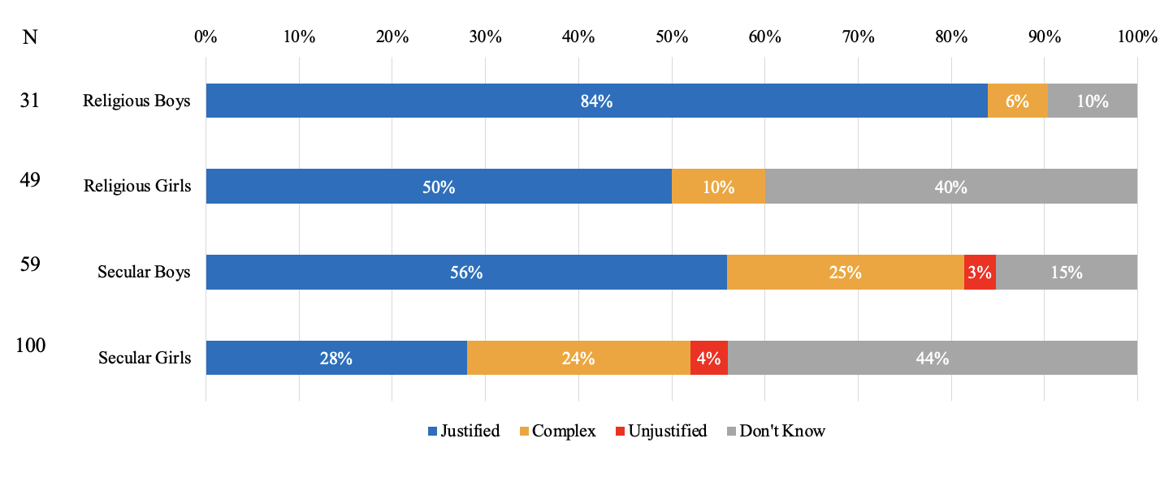

**Figure 2. Historical ethical judgments about the child labor in 19th century Britan**

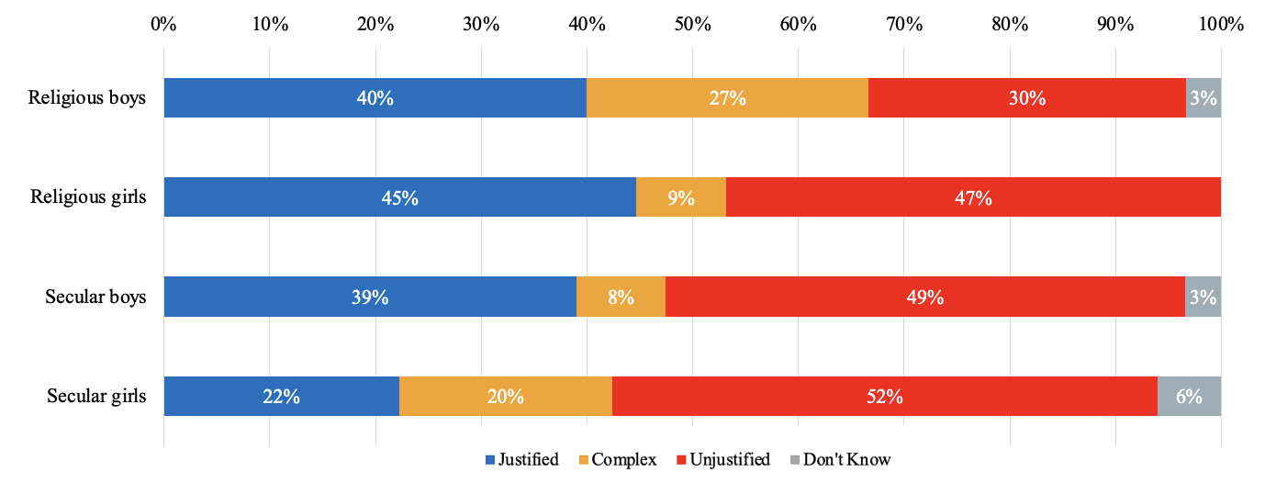

## *A.2. Chagnes following October 7 and the Israel-Gaza War*

The analysis of the Post-war questionnaires indicates significant and diverse changes in student responses (Figure 4). Graduates of religious education became even more assertive about the justifications for the Israeli side. The percentage of religious men who held the “justified” position increased from 84% to 97%. Similarly, among religious women, the increase in the justifying position was also significant, rising from 50% to 65%, making this shift the dominant trend (Figure 5). An illustration of the shift from a “Don’t Know” position to a “Justified” one can be seen in the words of Rivka, an 18-year-old religious education graduate. In September 2023, she responded: “I didn’t learn about the War of Independence and I don’t know what was there.” By February 2024, her response to the same question had changed to:

I don’t think I know enough, but I think they were justified. [...] If we didn’t show our power and kill them and get them out of here, they would take over the country, and then all our deaths would be in vain. [...] Therefore, we had to keep the Palestinian population away from the land.

In contrast to the trend among religious education graduates, the picture among secular education graduates was more ambiguous, with no significant increase in the “Justifying” stance. Moreover, among secular women, the most notable increase was in the “Complex” stance, and they exhibited significant shifts in their views overall (Figure 6). An example of a shift from a “Justified” to a “complex” can be seen in the words of Dana. In September 2023, she answered:

It was justified, first the Palestinians started the war. At first, Israel didn’t even attack. [...] The state had to protect itself and its residents. [...] In addition, after the partition agreement, Israel was happy and celebrated (satisfied with the partition) and the Palestinians were not satisfied and immediately attacked.

By February 2024, her response to the same question had evolved to:

I think some actions are justified and some are not. For example, some of the expulsions are justified and some are extreme. As a Jew, it is easy to justify what was done. But it is important to hear the narratives of both sides – Nakba and the like. Overall, my opinion is divided.

**Figure 4. Historical ethical judgments about the 1948 War Post-October 7 and the Gaza War**

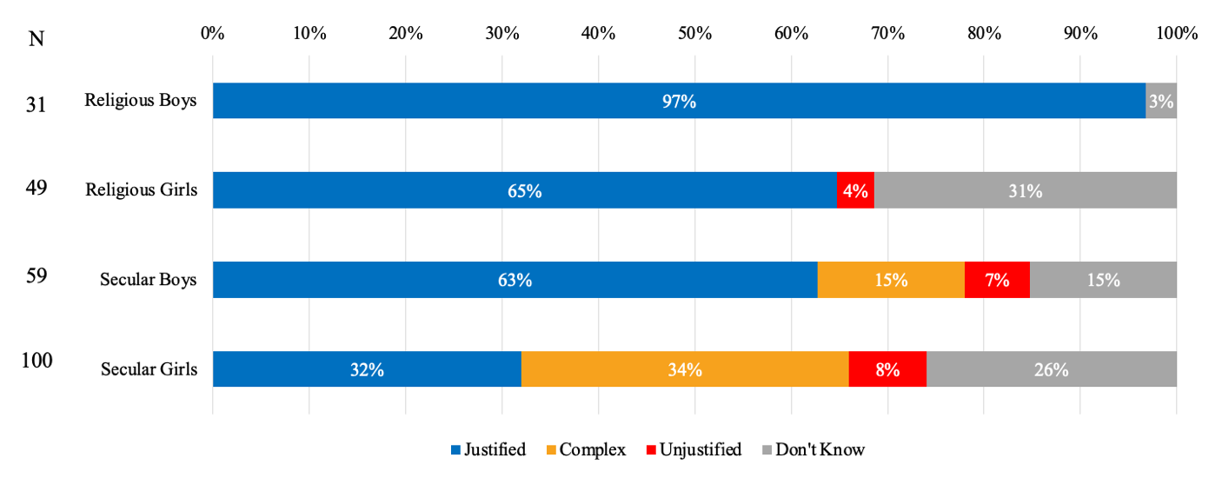

**Figure 5. Changes among religious women in historical ethical judgments about the 1948**

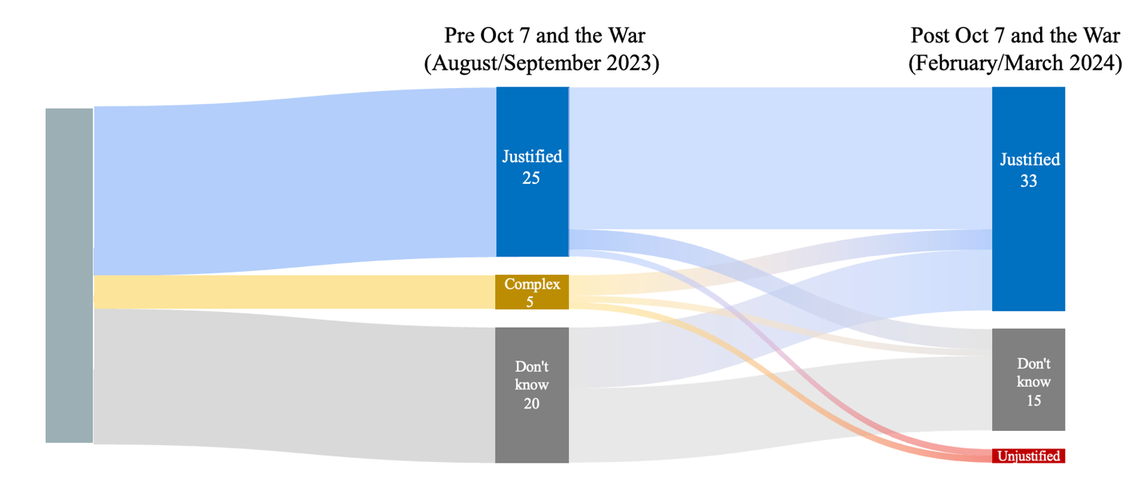

**Figure 6. Changes among secular women in historical ethical judgments about the 1948**

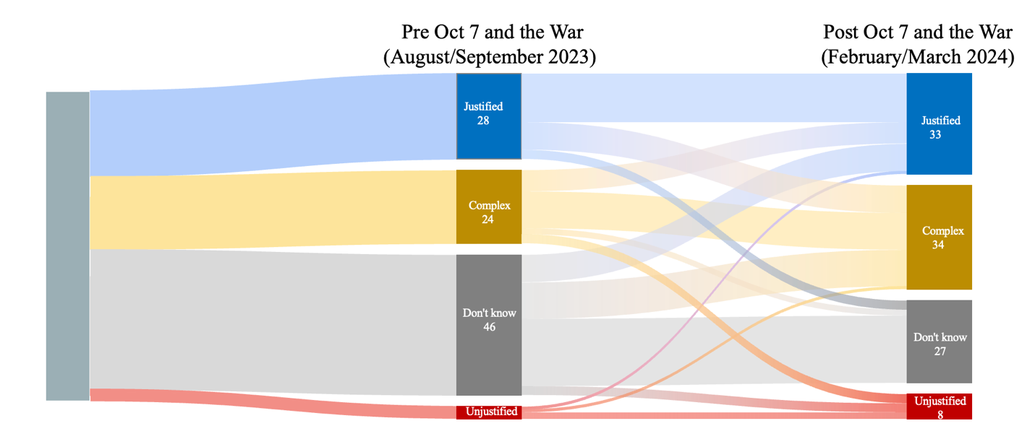

# **Appendix B – Semi-structed interviews protocol**

Population: Personal interview with a sample of approximately 15% of the students who completed the questionnaire.

Timing: Interviews begin about half an hour after the questionnaire is completed.

Location: One of the classrooms in the PMLA.

Interviewer: Roy Weintraub.

Language: Hebrew (the interviewees' native language).

Duration: Approximately 20 minutes.

**Questions**:

1. In your opinion, how should one determine whether a decision or actions in the past were ethical or not?

Regarding the question about the 1948 War:

1. Could you explain why you wrote these things [referring to the student’s response]?
2. Could you please tell me what you know about the 1948 War? Where did you learn about it?
3. What do you know about the Israeli side's treatment of the Palestinian population?
4. Are you familiar with the term Nakba? Where did you learn about it?
5. Can you explain the perspective of those who chose a different ethical stance from yours?

Regarding the question about the dropping of the atomic bombs on Japan:

1. Could you explain why you wrote these things [referring to the student’s response]?
2. Could you please tell me what you know about the motives behind the U.S. dropping the atomic bombs? Where did you learn about it?
3. What do you know about the consequences of dropping the atomic bombs?
4. Can you explain the perspective of those who chose a different ethical stance from yours?