A. Scientific background
Tissue development and homeostasis is driven by resident stem cell populations, whose self-renewal activity and their differentiation dynamics is orchestrated by highly specific transcriptional regulatory programs [1-3]. This regulation is achieved by the coordinated activity of transcription factors (TFs), epigenetic and chromatin modifiers, and spatial chromosomal organization [4,5]. One example of such a process is the development and maintenance of the skin epidermis, which entails the transition from a single layer of embryonic cells at the surface ectoderm to a stratified and highly specialized tissue that self-renews and provides essential protective barrier functions [6,7].
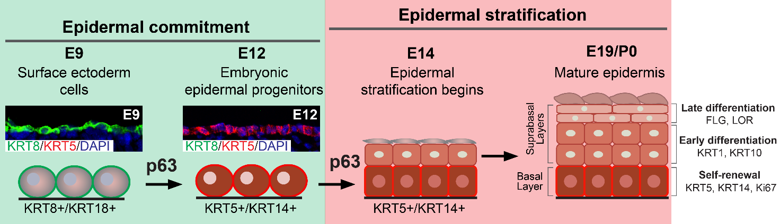
In mice, the program of epidermal development begins around embryonic day 9 (E9) and terminates with the formation of a functional epidermal barrier shortly before birth around E18.5 [6,8,9]. Initially, a monolayer of surface ectoderm cells that starts expressing TF p63, as well as keratin 8 (K8) and K18 from E9, will acquire an epidermal fate by E12 and switch into the K5+/K14+ embryonic epidermal progenitors that form the basal layer of the epidermis. Next, as epidermal differentiation and stratification begin around E14, basal-layer epidermal progenitors move outward in a columnar fashion, forming the first suprabasal layers, and begin to express the early differentiation markers K1 and K10. Additional suprabasal layers that express late differentiation markers, such as loricrin (LOR) and filaggrin (FLG), are subsequently formed around E16–E17. In the final step of stratification, epidermal cells are terminally differentiated into enucleated cornified cells and form a mature epidermis with protective barrier functions [6,10] (Figure 1). Throughout life, cornified cells are constantly shed off the epidermis surface and renewed by progenies of the mitotically active epidermal progenitors of the basal layer. The balance between self-renewal and differentiation is essential for maintaining epidermal homeostasis [3,11,12], and impaired epidermal differentiation characterizes common skin diseases such as atopic dermatitis, psoriasis, and squamous cell carcinoma [13-16]. Thus, elucidating the regulatory mechanisms controlling epidermal differentiation during tissue development and homeostasis is essential for our understanding of the development of common skin diseases.
Figure 1. Epidermal morphogenesis. In mice, epidermal morphogenesis and stratification are established in ~10 days, from embryonic day 9 (E9) to postnatal day 0 (P0). At the first stage of epidermal commitment, a single-layered surface ectoderm cells, which express keratins (K) 8 and 18, acquire an epidermal fate and turn into embryonic epidermal progenitors, which express K5 and K14. At the second stage of epidermal development, the epidermal progenitors are withdrawn from the cell cycle and undergo a step-wise epidermal differentiation program, resulting in the formation of a stratified and mature epidermis with protective barrier functions.
The initiation and progression of the epidermal differentiation program is regulated in a stepwise manner by a specific transcriptional regulatory network. Thus far, several key TFs involved in this process have been identified, including IRF6 [17,18], GRHL3 [12,19,20], KLF4 [21,22], KLF5 [23], ZNF750 [24-27], and the epidermal master regulator p63 [28-34]. Developmentally, p63 seems to play a role in both epidermal commitment and epidermal stratification stages (Figure 1), as its activity is required for the transition of surface ectoderm into K5/14-expressing epidermal progenitors [33-35]. Once epidermal commitment has established, p63 regulates key chromatin regulators, such as SATB1 and BRG1, and epidermal TFs, such as KLF4 and ZNF750, which drive together with additional key TFs the epidermal differentiation programs and epidermal stratification [25,29,35-38]. However, the transcriptional regulatory network governing epidermal differentiation is yet to be fully uncovered.
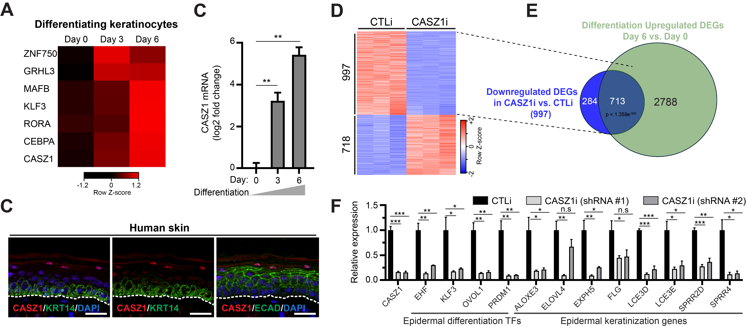
In search for regulators of epidermal differentiation, we recently identified Castor zinc finger 1 (CASZ1) as a new regulator of the epidermal differentiation program in vitro (Oss-Ronen et al., 2024; [39]). CASZ1, also known as ZNF693, is a C2H2-type zinc finger TF previously characterized in several non-epithelial cells and is known to be involved in vast developmental processes, including neural and cardiovascular tissue development and disease [40-46]. Our analysis uncovered that in human epidermal keratinocytes (KCs), CASZ1 expression is induced during epidermal differentiation alongside with other TFs known to regulate epidermal differentiation (Figure 2A-B). In line, immunofluorescence staining of normal human skin further demonstrated a predominant CASZ1 expression in the upper suprabasal layers of the epidermis (Figure 2C). To elucidate the role of CASZ1 in KC differentiation, we used short hairpin RNA (shRNA) sequences to silence the expression of CASZ1 (CASZ1i) in primary normal human epidermal KCs and determined the effect of CASZ1 silencing on epidermal differentiation gene expression. We observed a total of 1,715 differentially expressed genes (DEGs) in CASZ1i versus CTLi differentiated KCs, from which 997 genes showed decreased expression, and 718 genes showed increased expression (Figure 1D). Of the 997 DEGs that demonstrated decreased expression in CASZ1i, 72% overlapped with DEGs upregulated during KC differentiation (Figure 2E). To further understand the regulatory role played by CASZ1 in epidermal differentiation, we next mapped the genome-wide binding of CASZ1 in differentiated KCs using cleavage under targets & release using nuclease (CUT&RUN) analysis [47,48], followed by high-throughput sequencing. CASZ1 binding was mostly enriched at gene bodies and promoter regions of active epidermal differentiation genes (Oss-Ronen et al., 2024 [39]; Figure 5A, Figure 6B and data not shown). Importantly, motif analysis for CASZ1-bound peaks uncovered motif enrichment of key epidermal TFs known to be involved in epidermal differentiation and barrier function, including KLF3 [49], KLF4 [21,22], KLF5 [23], EHF [50,51], C/EBPα and C/EBPβ [52,53], AP2α, and AP2γ [30,54-57] (Figure 5B). Next, using RT-qPCR analysis we confirmed the significant reduction of several CASZ1-targets in CASZ1i differentiated KCs (Figure 2F). Interestingly, among CASZ1-dependent targets we identified epidermal keratinization genes such as late cornified envelope (LCE) family members LCE3D and LCE3E, small proline rich (SPRR) family members SPRR2D and SPRR4 [58], as well as several well-known differentiation TFs including KLF3, KLF5, OVOL1, and PRDM1 [23,49,59,60]. Notably, a parallel study in differentiating KCs by the group of Xiaomin Bao have identified CASZ1 as a p63/p300-dependent factor that regulates epidermal differentiation genes [61]. Together, these data suggest a central role played by CASZ1 in regulating epidermal differentiation and barrier functions. Supporting this notion, sequence variant frequencies in the CASZ1 gene were recently reported to differ significantly between subgroups of psoriasis patients with different medical history [62], and the expression of CASZ1 was shown to be significantly reduced in several diseased skin conditions with impaired barrier function, including atopic dermatitis, psoriasis and cutaneous squamous cell carcinoma [61]. However, the role of CASZ1 in regulating epidermal development and the maintenance of skin tissue homeostasis is yet to be determined.
Figure 2. CASZ1 regulates epidermal differentiation. (A) Heatmap showing TPM normalized RNA-seq data for CASZ1 and previously identified epidermal differentiation TFs during in vitro human KC differentiation. (B) RT-qPCR analysis of CASZ1 expression during KC differentiation. Data are mean ± SEM, n=4, ** p < 0.01 (unpaired two-tailed t-test). (C) Immunofluorescence (IF) staining for CASZ1 (red) in normal human skin. K14 (left panel, green) marks the basal layer, and E-CADHERIN (right panel, green) marks spinous and lower granular layers. Bar=25 µm. (D) Heatmap showing differentially expressed genes (DEGs) in CASZ1i versus CTLi differentiated human KCs. (E) Venn diagram showing the number of DEGs downregulated in CASZ1i that overlapped with DEGs upregulated in KC differentiation. (F) RT-qPCR analysis of a panel of epidermal differentiation genes in CASZ1i and CTLi differentiated KCs. Data are mean ± SEM, n=3, * p < 0.05, ** p < 0.01, *** p < 0.001, n.s, not significant (unpaired two-tailed t-test).
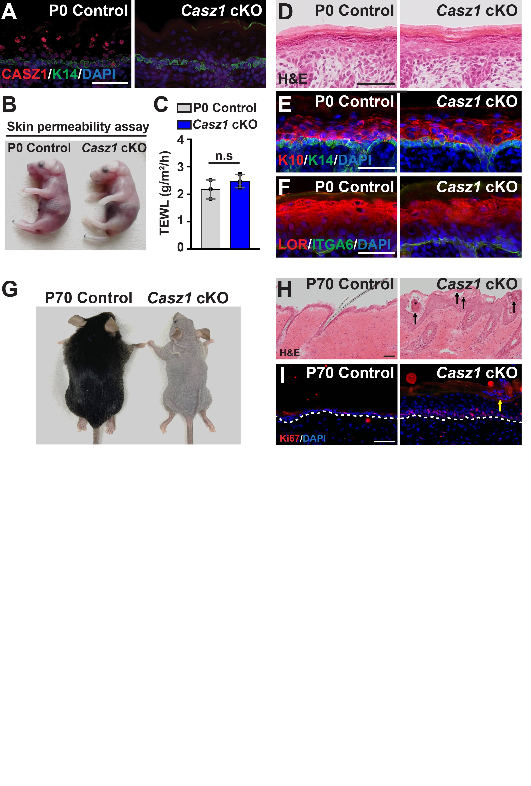
To determine the role of CASZ1 in epidermal development and tissue homeostasis, we next established a genetic mouse model for the deletion of murine Casz1. Since germline deletion of Casz1 is embryonic lethal [63], we conditionally deleted Casz1 in embryonic epidermal progenitors by crossing Casz1 floxed mice [42] with K14-Cre mice [64], in which Cre-recombinase is expressed under keratin 14 promoter in embryonic epidermal progenitors starting at E12 (K14-Cre; Casz1^{flox/flox} = Casz1 cKO). The specific deletion of Casz1 was confirmed by immunofluorescence (Figure 3A), however no gross abnormalities in epidermal barrier functions were observed at postnatal day 0 (P0), as analyzed by trans-epidermal water loss (TEWL) and toluidine blue dye exclusion assays (Figure 3B-C). In line, we observed apparently normal induction of the early differentiation marker, keratin 10, the late epidermal differentiation marker, loricrin, as well as epidermal stratification (Figure 3D-F). Taken together, these data suggest that the loss of epidermal CASZ1 during skin development is potentially compensated for by other epidermal TF(s). However, later throughout life, adult Casz1 cKO mice lose their hair and display dry and scaly skin (Figure 3G). Histological analysis further confirmed a diseased skin characteristics in the adult Casz1 cKO mice, and showed a hyperproliferative and hyperkeratotic epidermis, with signs of parakeratosis in the epidermal cornified layers, as well as deformed hair follicles (Figure 3H-I). These data strongly suggest that CASZ1 activity in the adult skin is required to preserve epidermal tissue homeostasis.
Figure 3. Loss of CASZ1 is dispensable for epidermal development, but required for tissue homeostasis. (A) IF staining for CASZ1 (red) in P0 control and Casz1 cKO mice. K14 (green) marks the epidermal basal layer. (B) Toluidine blue dye exclusion assay of Casz1 cKO and control mice at P0. (C) TEWL measurements from dorsal skin of Casz1 cKO and control mice at P0. Data are mean ±SD. n=3. n.s, not significant (unpaired two-tailed t-test). (D) Hematoxylin and Eosin (H&E) staining of P0 control and Casz1 cKO skins. (E) IF staining of P0 skins for K14 (green) and early differentiation
suprabasal marker K10 (red). (F) IF staining of P0 skins for the late differentiation marker LOR (red). The basement membrane is labeled by ITGA6 (green). (G) Appearance of Casz1 cKO and control mice at P70. (H) H&E staining of P70 control and Casz1 cKO skins. (I) IF analysis of the proliferation marker Ki-67 (red) in P0 control and Casz1 cKO epidermis. Bar in A, D-F, H, I = 50µm.

B. Working hypothesis, Research objectives & expected significance
We propose to test our specific hypothesis that CASZ1 orchestrates transcriptional regulatory pathways to control epidermal development and skin tissue homeostasis. To this end, we will pursue three specific aims:
Aim 1: Determine the role of CASZ1 in skin tissue homeostasis
Our preliminary studies strongly suggest that CASZ1 activity in the epidermis is required for the maintenance of skin tissue homeostasis. The conditional deletion of Casz1 in the epidermis results in a hyperproliferative and hyperkeratotic epidermis (Figure 3G-I) – a hallmark of common skin diseases such as atopic dermatitis and psoriasis. In Aim 1, we will perform histological analyses together with RNA-seq and CUT&RUN to elucidate the CASZ1 molecular pathways controlling tissue homeostasis. Specifically, we will use epidermal-inducible Casz1 deletion to fully characterize the histopathological alterations upon CASZ1 loss and pinpoint the time course for their development. Next, we will perform an RNA-seq analysis both prior to and when phenotypic alterations first emerge and determine the initial transcriptional changes associated with diseased skin conditions. Finally, we will combine these data with CUT&RUN data of CASZ1 genomic targets to elucidate the downstream genes and molecular pathways that play a role in skin homeostasis.
Aim 2: Characterize the CASZ1 transcriptional regulatory circuitry controlling epidermal differentiation
Our preliminary data show that CASZ1 binding loci are enriched for DNA binding motifs of several key epidermal differentiation TFs, strongly suggesting that CASZ1 interacts with other TFs in order to regulate the epidermal differentiation program. In Aim 2, we will use biochemical and cellular approaches to define the cooperation between CASZ1 and the transcriptional machinery that drives epidermal differentiation. Specifically, we will use CASZ1 immunoprecipitation experiments coupled with mass spectrometry to determine the CASZ1 isoform-specific interactomes. In addition, we will perform isoform-specific loss-of-function studies, coupled with CUT&RUN genomic mapping, to determine the impact of each CASZ1 isoform on epidermal tissue homeostasis and on the transcriptional machinery activity.
Aim 3: Elucidate compensatory TFs regulatory pathways preserving epidermal differentiation
Our studies strongly indicate that while CASZ1 activity is essential for the epidermal differentiation program in vitro, its loss in vivo does not lead to apparent impairment of epidermal differentiation in the developing mouse skin. Thus, we hypothesize that, in vivo, CASZ1 loss is being compensated for by other epidermal TF(s). Our preliminary studies have identified several candidate epidermal TFs, including ZNF750 [27], that significantly overlap in binding to CASZ1-dependent genes (Figure 8A-B). In Aim 3, we will utilize genetic mouse models to co-ablate Casz1 and Znf750 in the developing epidermis to elucidate the extent of their compensatory functions in preserving epidermal differentiation programs. Specifically, this will be determined by combining in-depth histological analyses with RNA-seq experiments of both singles and the double conditional KO mice.
Expected Significance and Innovation
The proposed study will elucidate the roles of CASZ1 and its cooperation with the epidermal transcriptional machinery in epidermal cell differentiation and the maintenance of adult tissue homeostasis. There are a number of major innovative aspects and approaches in this proposal: (1) Transcription factors and chromatin modifiers play a central role in the regulation of gene expression. Here, we will identify a novel regulatory interplay between CASZ1 and the epidermal transcriptional machinery in driving epidermal differentiation and the maintenance of proper tissue homeostasis. (2) CASZ1 activity is provided by two isoforms, whose specific contribution in regulating transcriptional programs and tissue homeostasis are poorly characterized. Here, we will demonstrate, for the first time in vivo, the isoform-specific roles in somatic tissue development and homeostasis. (3) Functional genomics is widely used in many experimental systems, but the use of such methodologies in tissue developmental and homeostasis is less common. In the proposed study, we will combine in vivo cutting-edge chromatin and transcriptional profiling with genetic mouse models to elucidate the CASZ1 transcriptional network in epidermal development and homeostasis. As such, our findings will significantly impact our understanding of different aspects of gene regulation, tissue development, and skin disorders, as detailed below.
Gene regulation: During tissue development and throughout the lifetime of an organism, cells differentiate into multiple or specialized cell types using the same genetic blueprint. This process is orchestrated by changes in chromatin architecture, enhancer activity, transcription factors, and chromatin modifiers. The identification of CASZ1 cooperation with lineage transcription factors and how their interactions orchestrate transcriptional networks can therefore deepen our understanding of how generic and tissue-specific transcription factors, together with chromatin modifiers, are integrated to drive a precise transcriptional program. Moreover, the characterization of the isoform-specific functions of CASZ1 may provide insights into how gene expression programs are fine-tuned throughout different stages such as tissue development and homeostasis.
Skin disorders: The epidermis provides protective barrier functions against insults and dehydration. Disruptions in epidermal differentiation and barrier function are characteristic of various common skin diseases, including ichthyosis, atopic dermatitis, psoriasis, and skin cancer, which affect up to one in five people worldwide [13]. Our preliminary data strongly indicate that CASZ1 plays a central role in this process. Therefore, the findings of the proposed study will provide insights into the regulation of the epidermal differentiation and the maintenance of proper tissue homeostasis, ultimately improving our understanding of common skin diseases with impaired epidermal differentiation and barrier functions.
Epidermal tissue development: mammalian gene expression programs can be regulated in a cell type dependent context, developmental stage specific manner, or in response to various stimuli. In the developing epidermis, basal-layer epidermal progenitors must undergo a precise transcriptional program to differentiate and form a stratified tissue with protective barrier functions. The findings of the proposed study are expected to shed light on distinct transcriptional layers that are acting redundantly to provide a protective safety net, thereby preserving the proper development of the skin epidermis – a tissue essential for our survival.

C. Detailed description of the proposed research & preliminary results
Aim 1: Determine the role of CASZ1 in skin tissue homeostasis
1a. Characterize the phenotypic changes in Casz1 iKO epidermis
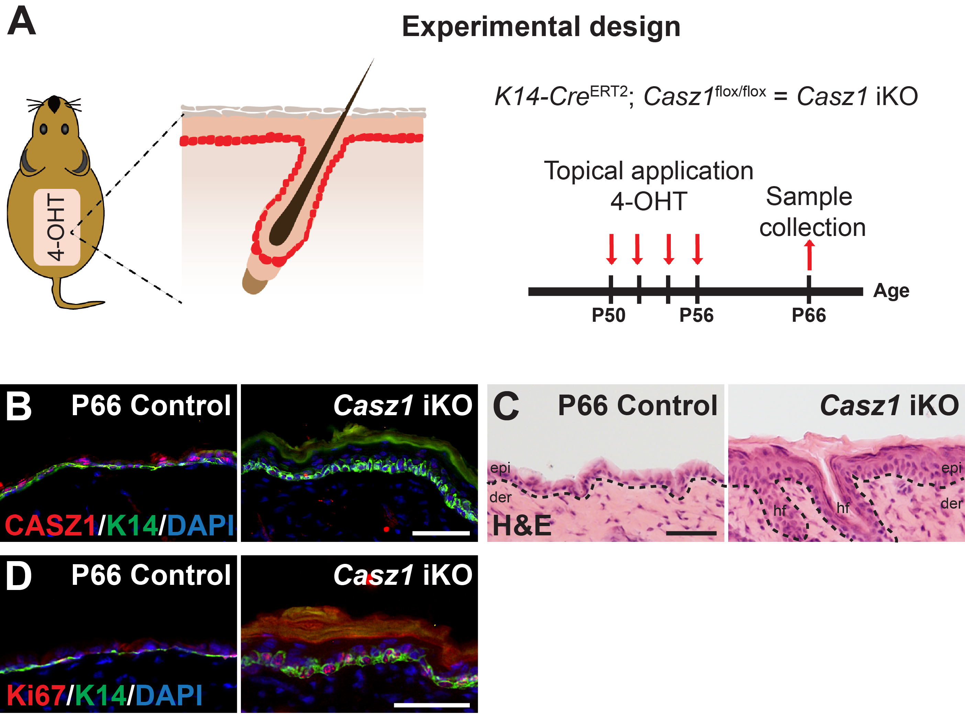
Our preliminary analysis of mice with epidermal-specific deletion of Casz1 in the developing epidermis, using the K14-Cre driver (Casz1 cKO), revealed strong alterations in epidermal tissue homeostasis, as reflected by the impaired epidermal differentiation alterations that reminiscent of atopic dermatitis and psoriasis (Figure 3G-I). We hypothesize that CASZ1 activity in the adult epidermis is required to maintain proper tissue homeostasis. In Aim 1a, we will topically induce Casz1 deletion in the adult epidermis, and characterize the onset and the exact phenotypic and transcriptional alterations that occur upon the loss of CASZ1 activity. To this end, we will cross Casz1 floxed mice with K14-Cre^{ERT2} mice, in which the expression of Cre recombinase is controlled by the keratin 14 promoter and its nuclear localization and activation depend on tamoxifen [65], a system that we routinely use in the lab (K14-Cre^{ERT2}; Casz1^{flox/flox} = Casz1 iKO). As a preliminary proof of concept, we provide preliminary supporting evidence showing that shortly after the induction of Casz1 deletion in the adult skin (Figure 4A-B), Casz1 iKO mice demonstrate a thick and hyperproliferative epidermis, along with the induction of K6 that is known to be induced upon barrier breach [66] (Figure 4C-E).
Figure 4. Loss of CASZ1 impairs epidermal tissue homeostasis. (A) Illustration of treatment strategy for inducing topical Casz1 deletion in the skin epithelium. (B) IF staining for CASZ1 (red) in P66 control and Casz1 iKO mice. K14 (green) marks the epidermal basal layer. (C) H&E staining of P66 control and Casz1 iKO skins. (D) IF analysis of the proliferation marker Ki-67 (red) in P0 control and Casz1 cKO epidermis (E) IF staining for K6 (green). Basement membrane is labeled by ITGB4 (red). Bar in B-E = 50µm.

Using histological analysis of Hematoxylin and Eosin (H&E) and immunofluorescence staining for several markers, including epidermal proliferation and differentiation markers, we will next pinpoint the time point when the initial phenotypic alterations first emerge following the deletion of epidermal Casz1. The effect of CASZ1 loss on skin barrier function will be assessed by TEWL measurements, and by transmission electron microscopy analysis with the support of our long-time collaborator Dr. Gopinathan Menon from the California Academy of Sciences (see letter of support). In addition, since our data suggests that Casz1 cKO epidermis presents signs of diseased skin (Figure 3G-I), we will stain for markers of monocyte and lymphocyte immune cells to determine the effect of CASZ1 loss on skin inflammation, and identify the specific subpopulations of immune cells that may be involved.
1b. Elucidate the CASZ1-dependent molecular pathways in epidermal tissue homeostasis
We will complete our characterization of the Casz1 iKO epidermis by using RNA-seq and a differential gene expression analysis of FACS-isolated epidermal cells as previously described [67,68]. Briefly, adult mice skin will be shaved, placed in trypsin for 1 hour in 37°C, and epidermis will be peeled from the underlying dermis using scalpel, and passed through a cell strainer to generate a single cell suspension. Live interfollicular epidermal cells will be sorted as DAPI(-), EPCAM(+), SCA1(+), and ITGA6(+). We will specifically focus in our analysis on the critical time points identified in Aim 1a. Next, to elucidate the CASZ1-dependent molecular pathways misregulated, we will combine the differential gene expression analysis from RNA-seq data with CUT&RUN data of CASZ1 genomic binding in the adult epidermis. The computational and statistical analyses of these genomic data will be performed by my longtime collaborator Dr. Liron Levin from the Bioinformatics Core Facility at Ben-Gurion University of the Negev (a letter of support is attached). Following the bioinformatics, we will subject the CASZ1 targets that are differentially expressed in Casz1 iKO epidermis to pathway enrichment analysis using DAVID [69,70], and further validate candidate genes by quantitative RT-qPCR analysis. These experimental approaches will help us to establish a foundation for understanding the role of CASZ1 regulation in epidermal tissue homeostasis.
Expected outcomes, potential pitfalls, and alternative strategies for Aim 1
We have already demonstrated severe phenotypic alterations upon the deletion of Casz1 in the adult murine epidermis, with features reminiscent of common skin disorders, such as atopic dermatitis and psoriasis. In Aim 1, we expect to elucidate the prominent transcriptional programs and molecular pathways by which CASZ1 regulates epidermal homeostasis. We expect that the ablation of CASZ1 function will impair the epidermal differentiation program, resulting in impaired barrier function and potentially skin inflammation. Since all the methodologies employed in this aim are relatively straightforward and are well-established in my laboratory (as indicated by the preliminary data and our recent publications), I do not predict any difficulties in completing this aim. However, it is possible that pinpointing the exact initial stages in which Casz1 iKO epidermis displays abnormalities in epidermal differentiation and/or tissue homeostasis will not be obvious. In such a case, we will examine by RNA-seq additional timepoint between the end of tamoxifen-mediated deletion and the emergence of a clear phenotype. Another possibility is that the histopathological features of the Casz1 iKO epidermis will not be as severe as we envision based on our preliminary analysis. If that would be the case, we will combine in our studies imiquimod (IMQ)-induced psoriasis-like inflammation [71] and calcipotriol (MC903)-induced atopic dermatitis-like inflammation [72], and determine the effect of CASZ1 loss on their pathogenesis.
Aim 2: Characterize the CASZ1 transcriptional regulatory circuitry controlling epidermal differentiation
2a. Characterize CASZ1-TF protein–protein interactions in epidermal cells
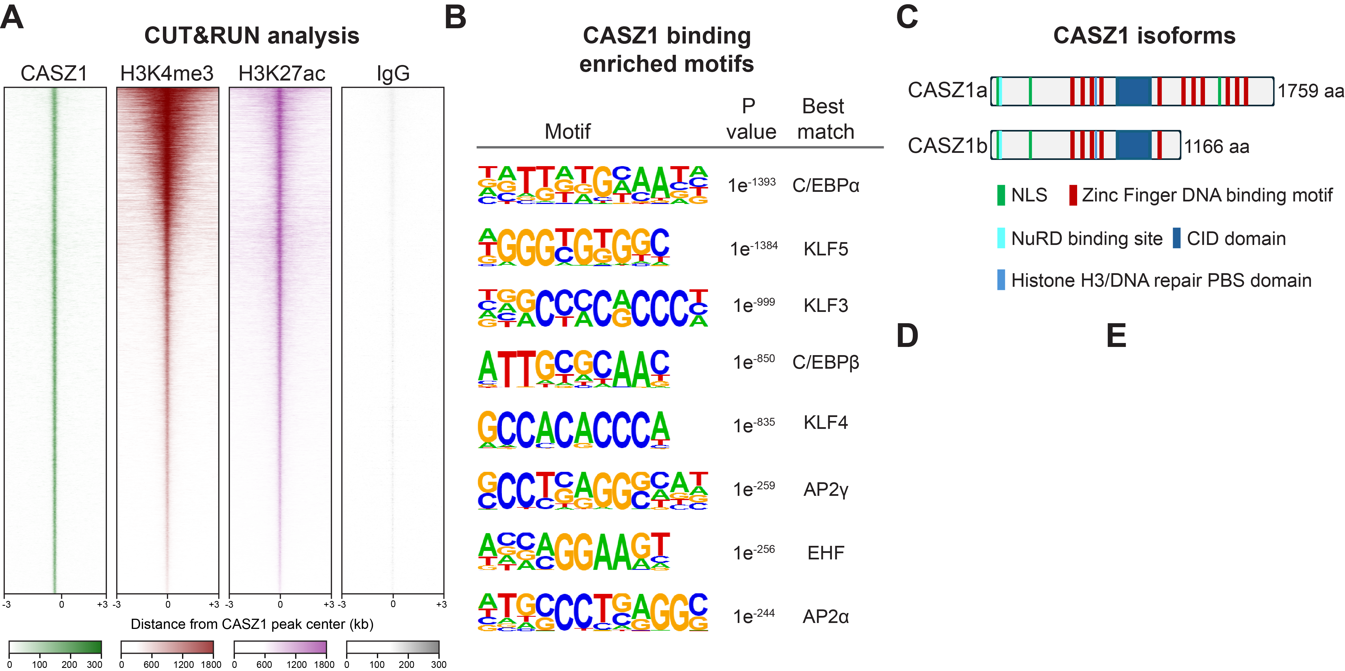
Our preliminary CASZ1 CUT&RUN analysis demonstrated that the genomic binding of CASZ1 in differentiated keratinocytes is enriched at gene bodies and promoter regions of genes that were co-marked by the active histone marks H3K4me4 and H3K27ac (Figure 5A), suggesting that CASZ1 drives the expression of epidermal differentiation genes. In line, HOMER motif discovery scan of the CASZ1 binding sites identified an enrichment for several key epidermal differentiation TFs (Figure 5B), suggesting that CASZ1 may interact and coordinate the activity of these TFs during epidermal differentiation. This notion is also supported by the fact that the CASZ1 isoforms, which we conformed both are expressed in the mouse epidermis (Figure 5C-D), are rather large, with multiple zinc-finger DNA bindings motifs, and several motifs that have been shown to interact with chromatin remodelers in other cell types [42,44,73-75].
Figure 5. CASZ1 genomic binding loci are enriched for epidermal differentiation TF motifs. (A) Heatmaps showing CUT&RUN read densities for CASZ1, H3K4me3, H3K27ac, and IgG across CASZ1 genomic peaks in differentiated epidermal keratinocytes. (B) Homer de novo motif scan of CASZ1 binding sites shows the enrichment of epidermal differentiation TFs. (C) Schematic illustration of CASZ1 protein isoforms. NLS, nuclear localization signal; CID, CHD5-interacting domain. (D) Western blotting analysis for CASZ1 in control and Casz1 cKO epidermis. (E) The nuclear fraction of epidermal keratinocytes was immunoprecipitated by using an anti-FLAG antibody, followed by western blot analysis.
In Aim 2a, we will perform immunoprecipitation experiments following mass-spectrometry analysis to characterize the CASZ1 isoform-specific interactome. To this end, we already established a FLAG-tagged CASZ1a and CASZ1b recombinants and confirmed their proper expression in primary epidermal keratinocytes, as well as our ability to immunoprecipitate them (Figure 5E). We will also use an anti-CASZ1 antibody for the immunoprecipitation of the endogenous proteins (both isoforms together) with their interacting partners. The chromatin fraction of Flag-tagged and endogenous proteins will each be separated by SDS-PAGE stain with Coomassie blue, and then gel will be sliced into 1 mm squares and subjected to mass spectrometry, as previously described [76]. We will validate these interactions using co-immunoprecipitation experiments in nuclear extracts from epidermal cells, and in vivo by using proximity ligation assays (PLA) – a method that detect protein-protein interactions at a single molecule resolution [77]. This set of biochemical and molecular experiments will be accomplished with the support of Prof. Dan Levy (Ben-Gurion University of the Negev), who is an expert in such biochemical approaches (see letter of support).
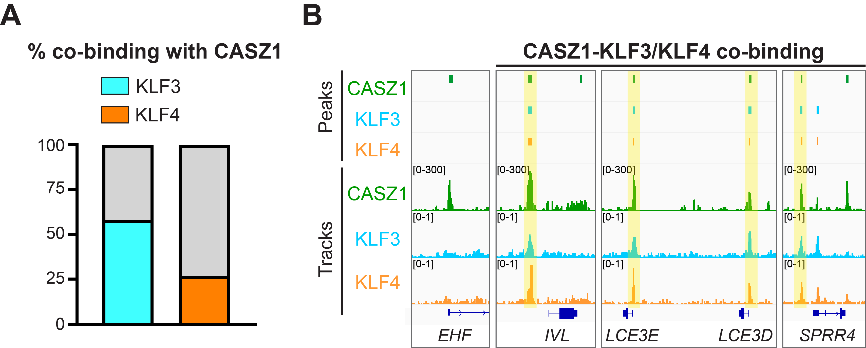
To prioritize between the various CASZ1-interacting factors, special attention will be given to chromatin regulators or TFs enriched in our motif analysis, which will appear in both the recombinant and endogenous datasets. In case of available genomic mapping data in epidermal keratinocytes for a candidate interacting factor, we will also use this data to check for the extent of overlap with CASZ1 binding. For example, we have obtained and analyzed publicly available ChIP-seq data of KLF3 [49] and KLF4 [78] in differentiated epidermal keratinocytes. Our analysis uncovered co-binding of KLF3 to more than 50% of the binding regions of CASZ1, and a similar trend for KLF4 in about 25% of the binding regions of CASZ1 in differentiated epidermal keratinocyte (Figure 6A-B). Following our proteomics analysis, we will perform such an analysis for each promising candidate interacting factor with publicly available ChIP-seq/CUT&RUN data. Finally, for a selected group of CASZ1-interacting factors that lack publicly available genomic mapping in differentiated epidermal keratinocytes, we will perform CUT&RUN to elucidate their genome-wide functional cooperation with CASZ1 in driving epidermal differentiation pathways.

Figure 6. CASZ1-bound loci are enriched for KLF3 and KLF4 binding. (A) Bar graphs showing the percentage of TF co-binding with CASZ1 peaks in differentiated epidermal keratinocytes. (B) IGV browser views showing CUT&RUN tracks of CASZ1, and ChIP-seq tracks of KLF3 and KLF4, for indicated epidermal differentiation genes.
2b. Analyze the CASZ1 isoform-specific effect on interacting TFs genomic recruitment
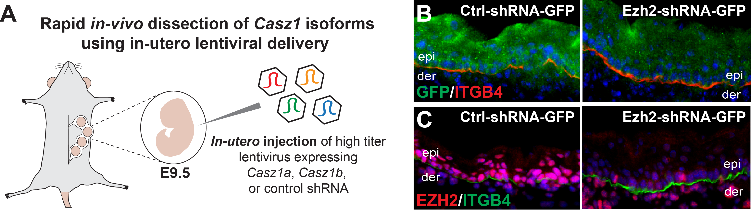
Based on our genomic mapping analysis and functional studies of CASZ1 in epidermal differentiation (Figure 5A-B; Oss-Ronen et al., 2024 [39]), further supported by its roles in orchestrating transcriptional programs in other cell types [42-45,74], we hypothesize that CASZ1 coordinates transcriptional programs in epidermal differentiation. In Aim 2b, we will perform isoform-specific loss-of-function studies to determine the roles of CASZ1 in orchestrating transcriptional programs in the epidermis. To distinguish between the specific functions of each CASZ1a/b isoforms, we will perform in vivo studies using in utero injections of viral supernatants expressing short hairpin RNA (shRNA) sequences against murine Casz1a, Casz1b, or a control shRNA sequence. In this method, high-titer lentiviral supernatants are injected into the amniotic space of E9 embryos (Figure 7A). The lentiviruses then transduce the first cell layer encountered, which at E9 is the single layer of the surface ectoderm [79]. Importantly, the virus does not travel past the surface ectoderm layer; thus, this method can be considered as an alternative to the conventional conditional epidermal transgenic/knockout system. This part of the analysis will be done with the support of Dr. Elena Ezhkova for the Icahn School of Medicine at Mount Sinai, NY, USA (see support letter attached). As a proof of concept, we provide data done by the Ezhkova lab, showing the successful silencing of Ezh2 using in utero injections of viral supernatants expressing shRNA against Ezh2 (Figure 7B).
Figure 7. Rapid in vivo dissection system using in-utero lentiviral delivery. (A) Schematic illustration of in-utero lentiviral delivery technique. (B, C) In-utero injection of Ezh2-shRNA-GFP and Ctrl-shRNA-GFP lentiviruses, showing high infection efficiency as judged by GFP expression (B), and high Ezh2 knockdown efficiency as judged by EZH2 protein staining (C).
Efficient infection, stable integration, and sustained expression of the viral construct permits the analysis of each Casz1 isoform’s effect on the epidermal differentiation program. Following efficient infection and the silencing of Casz1 isoforms, we will perform CUT&RUN analysis in epidermal cells for the CASZ1-interacting partners identified in Aim 2a and determine changes in their genomic occupancy due to the silencing of Casz1a/b. In addition, we will also perform CUT&RUN analysis in the isoform-silenced epidermis using antibodies against the endogenous CASZ1 protein, to determine whether the CASZ1 isoforms can act redundantly to each other despite some structural differences between the isoforms.
2c. Determine the CASZ1 isoform-specific role in maintaining tissue homeostasis
While our preliminary data indicates that the loss of CASZ1 in the adult skin epidermis impaires tissue homeostasis, it is unknown whether this function is regulated by a specific isoform of CASZ1. In Aim 2c, we will further take advantage of the in-utero system and determine whether skin tissue homeostasis is maintained by a specific CASZ1 isoform, or by both isoforms joint activity. Following successful in-utero injection and viral integration, we will allow transgenic mice to mature until the time point when adult Casz1 cKO mice display impaired epidermal homeostasis. Full histological analysis will then be conducted as outlined in Aim 1a.
Expected outcomes, potential pitfalls, and alternative strategies for Aim 2
Determining the interplay and physical interactions between CASZ1 and the epidermal differentiation TF network is critical to deepening our understanding of the molecular mechanisms by which these essential regulators cooperate in epidermal differentiation. Our preliminary analysis already indicates several promising TFs, the experimental approaches are relatively straightforward, and our preliminary data already established critical milestones for the completion of Aim 2a studies. In case our CASZ1 proteomics will uncover a relatively large number of candidates interacting TFs, we will perform in silico analysis of publicly available TF binding data to prioritize a specific TFs that significantly overlap in their genomic binding to CASZ1 peaks, as shown in Figure 6 data, although a much-higher priority will be given to TFs with significant interaction enrichment whose role in epidermal differentiation is not known.
For Aim 2b and 2c studies, while we are well set for the in-utero injections, this technique can be quite challenging as its successful application requires the production of high titer viruses and technical expertise in the injection procedure. As an alternative strategy, in case of complications or delays with the in-utero experiments, we will perform cellular loss-of-function studies using primary keratinocyte cultures – a model commonly used for the study of epidermal differentiation process. We will specifically use shRNA constructs that contain a selection marker such as puromycin instead of the GFP reporter used for the in-utero experiments. Following infection and selection, epidermal keratinocytes will then be induced for differentiation using high-calcium media, and the effect of each CASZ1 isoform will be evaluated using RNA-seq and CUT&RUN experiments.
Aim 3: Elucidate compensatory TF regulatory pathways preserving epidermal differentiation
Our recent studies have demonstrated that CASZ1 activity is essential for the epidermal differentiation program in vitro (Figure 2D-F; Oss-Ronen et al., 2024 [39]). However, analysis of Casz1 cKO newborn epidermis demonstrated apparently intact epidermal differentiation with a functional skin barrier activity (Figure 3A-F). It is possible that this discrepancy is due to inherent differences in the regulatory axis between murine and human epidermis, or it could have resulted from the different environment and molecular feedback mechanisms that exist in vivo and can compensate for the absence of CASZ1 in the developing skin.
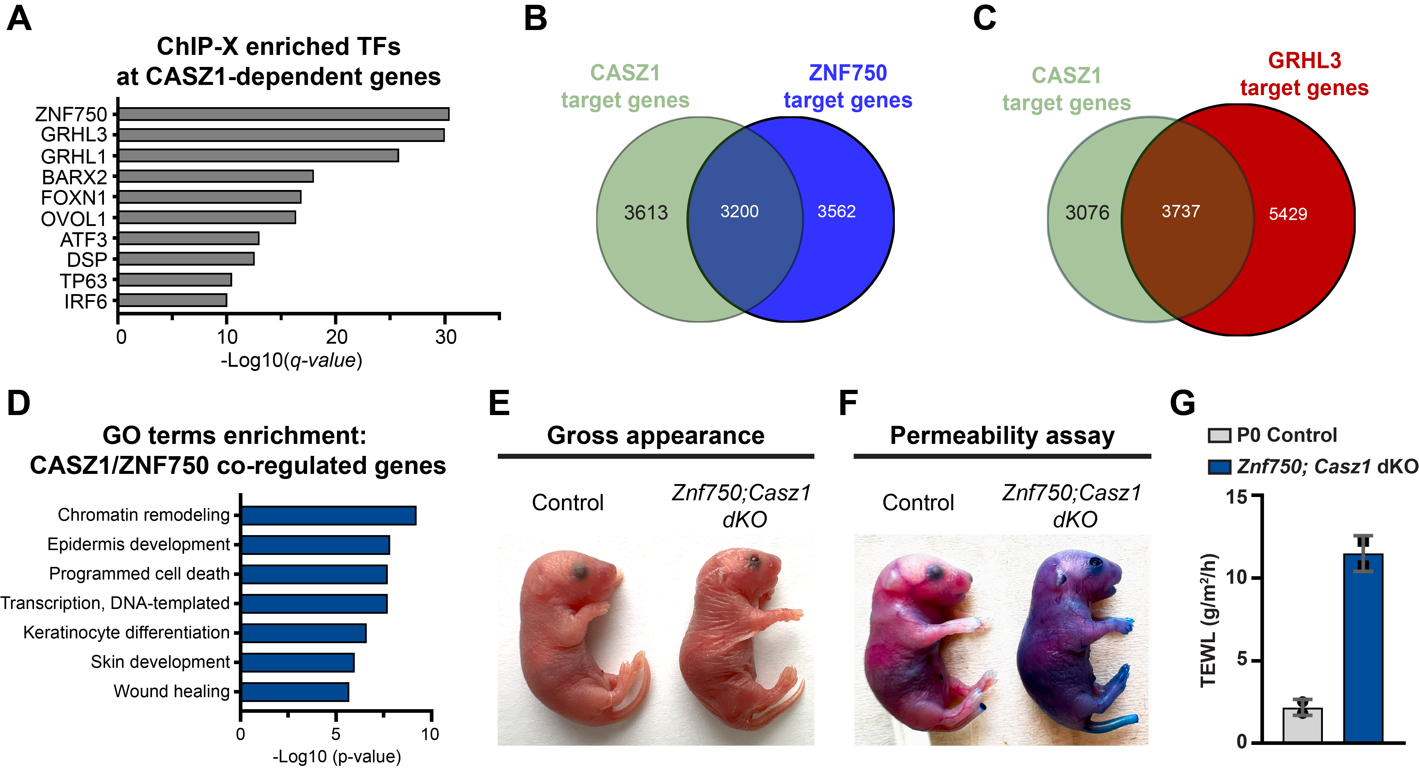
To examine the possibility that the loss of CASZ1 could be compensated for by other epidermal TF(s), we used the gene list of CASZ1-dependent genes from our in vitro studies and performed ChIP-X TF enrichment analysis using the ChEA3 tool, which identifies putative binding of TFs to a given set of target genes based on publicly available data from chromatin immunoprecipitation sequencing experiments [80]. Our analysis revealed a significant enrichment of several TFs, including ZNF750 and grainy head-like family members GRHL1 and GRHL3 that were ranked at the top, as well as additional TFs such as OVOL1, p63, and IRF6 (Figure 8A), all of which are known to play important roles in epidermal development and differentiation. Analysis of publicly available ChIP-seq data of the top enriched TFs, ZNF750 [78] and GRHL3 [81], demonstrated a significant overlap in the target genes also bound by CASZ1 (same target genes, but binding site and interacting partners may by different) in differentiated epidermal keratinocytes (Figure 8A-C). Notably, previous studies have shown that the conditional deletion of Znf750 or Grhl3 in the developing epidermis perturbs the epidermal differentiation process, but results in a relatively mild epidermal phenotype [27,82], suggesting that their loss may be compensated for by other TFs. Indeed, our recent published studies have shown that the loss of ZNF750 activity in the developing epidermis initially leads to a delay in epidermal differentiation, as evident by the lack of late differentiation markers and barrier function at E17.5, but later through development Znf750 cKO epidermis induces the expression of late differentiation markers and acquires barrier function [27], suggesting its function may be compensated for by other TF(s). Here, focusing on ZNF750 and more specifically on its shared target genes with CASZ1, a Gene Ontology analysis further demonstrated an enrichment for terms related to epidermis development, keratinocyte differentiation, and programmed cell death (Figure 8D), indicating that ZNF750 is a strong candidate TF which may compensate for the loss of CASZ1 during epidermal development. In Aim 3, we will test our specific hypothesis that CASZ1 and ZNF750 act redundantly to safeguard epidermal differentiation programs and skin development.
Figure 8. Epidermal loss of CASZ1 may be compensated for by ZNF750 during skin development. (A) ChIP-X enrichment analysis of CASZ1-dependent genes in human epidermal keratinocytes, showing the top enriched TFs at CASZ1-dependent genes. (B) Venn diagram showing the overlap in shared target genes in differentiated epidermal keratinocytes between CASZ1 and ZNF750. (C) Venn diagram showing the overlap in shared target genes in differentiated epidermal keratinocytes between CASZ1 and GRHL3. (D) Gene Ontology enrichment analysis shared target genes between CASZ1 and ZNF750. (E) Gross appearance Znf750;Casz1 dKO and control mice at P0. (F) Toluidine blue dye exclusion assay of Znf750;Casz1 dKO and control mice at P0. (C) TEWL measurements from dorsal skin of Znf750;Casz1 dKO and control mice at P0. Data are mean ±SD. n=2.

Aim 3a. Elucidate potential redundancy between CASZ1 and ZNF750 in epidermal development
Our preliminary data strongly suggests that the loss of CASZ1 during epidermal development is compensated for by other epidermal TF(s), with strong indications for the involvement of ZNF750 in this process (Figure 2D-F, Figure 3B-F, Figure 8A-C). In Aim 3a, we will utilize genetic mouse models to co-ablate Casz1 and Znf750 in the developing epidermis to elucidate the extent of their compensatory functions in preserving epidermal development and the establishment of skin barrier functions. To conditionally double knockout (dKO) both TFs in the developing epidermis, we will cross Casz1 floxed mice [42] with Znf750 floxed mice [27] and K14-Cre mice [64] (K14-Cre;Znf750^{flox/flox}; Casz1^{flox/flox} = Znf750;Casz1 dKO). The resulting Znf750;Casz1 dKO mice will be compared to Znf750 cKO, Casz1 cKO, and control mice. Notably, our preliminary analysis already uncovered that the Znf750;Casz1 dKO mice are lacking inward and outward barrier functions (Figure 8E-F), strongly supporting our hypothesis. We will repeat these functional barrier permeability assays few additional times to confirm our initial observations, and perform in-depth histological studies to determine and fully characterize the phenotype which emerges due to the concomitant deletion of both Casz1 and Znf750 in the developing epidermis. We will specifically focus on E17.5 when late differentiated layers are formed, and the P0 timepoint when the impaired barrier function of Znf750;Casz1 dKO mice is evident (Figure 8E-F). Using known markers of the early (K1 and K10) and late differentiating layers (Loricrin and Filaggrin), we will determine whether differentiation markers are not induced in the first place or being compensated for as seen in the Znf750 cKO epidermis. We will also determine the effect on the terminal differentiation of granular layer keratinocytes using a TUNEL assay, which labels fragmented DNA and cell death typically occurring in the epidermis when transitional granular cells become anucleate [83]. Finaly, we will characterize the ultrastructural alterations of the epidermal barrier structure using transmission electron microscopy, following the experimental procedures and methodologies described in our recent analysis of the Znf750 cKO epidermis [27]. We will compare in our analyzes the Znf750;Casz1 dKO epidermis to Znf750 cKO, Casz1 cKO and controls epidermis. Together, these studies will uncover the significance of the redundant functional layers provided by CASZ1 and ZNF750.
Aim 3b. Define the molecular pathways redundantly regulated be the CASZ1/ZNF750 axis
We hypothesize that the phenotype observed in the Znf750;Casz1 dKO epidermis, but not in the single KO’s, is due to a loss of the transcriptional regulatory layers provided by CASZ1 and ZNF750 activities, otherwise being compensated for (at least to some extent) by the remaining counterpart in the single KO’s epidermis. In the course of Aim 3b, we will conduct functional genomics studies (RNA-seq, CUT&RUN) to define the specific genes and molecular pathways that are redundantly regulated by CASZ1 and ZNF750. Specifically, we will perform RNA-seq on FACS-purified epidermal cells obtained from newborn Casz1 cKO, Znf750 cKO, Znf750;Casz1 dKO, and control skins. Special attention will be given to direct ZNF750/CASZ1-target genes that are differentially expressed (fold change ≥2; adjusted p-value < 0.05) only in the Znf750;Casz1 dKO epidermis, but not in the single KO’s. Next, although the binding region at target genes, as well as the molecular mechanisms and interacting partners may vary between ZNF750 and CASZ1, we will
expand our analysis to determine whether any changes occur in ZNF750’s genomic occupancy upon the deletion of Casz1, and vice versus. Together, these genetic and genomic approaches will enable us to determine whether CASZ1 and ZNF750 – two major drivers of the in vitro epidermal differentiation program, act redundantly to preserve epidermal development and skin barrier functions.
Expected outcomes, potential pitfalls, and alternative strategies for Aim 3
Our preliminary data strongly suggests that CASZ1 and ZNF750 act redundantly during epidermal development, since the combatant loss of both factors markedly aggravates the impairment in skin barrier functions. The approaches proposed in Aims 3a and 3b are well established in my laboratory and we do not expect any technical difficulties to complete them. However, while we routinely use RNA-seq, we may experience difficulties in identifying the redundantly regulated genes sets due to our genetic mating scheme. To obtain high ratios of Znf750;Casz1 dKO, we will cross K14-Cre; Znf750^{wt/flox}; Casz1^{wt/flox} males with Znf750^{flox/flox}; Casz1^{flox/flox} females, and the resulting single KO’s will each contain only single functional copy of the counterpart factor (K14-Cre; Znf750^{flox/flox}; Casz1^{wt/flox} = Znf750 cKO, and K14-Cre; Znf750^{wt/flox}; Casz1^{flox/flox} = Casz1 cKO). In case that our initial RNA-seq analysis will indicate that a single copy does not suffice to fully rescue gene expression programs, and the transcriptional changes are therefore too subtle in the transition between single KO’s to the Znf750;Casz1 dKO, we will use true single KO’s with their matching control littermates and use the ComBat empirical Bayes models [84,85] to remove batch effects between samples as we previously described [86].
D. Available resources
The proposed research will be conducted in the Department of Microbiology, Immunology and Genetics at Ben-Gurion University of the Negev (BGU). My laboratory includes a PhD-level laboratory manager, one PhD student, and four MSc students currently employed at the laboratory. My group works in a renovated 65 m² main laboratory space with additional designated tissue culture and fluorescent microscopy rooms. The laboratory is equipped for all the histological, genomic, and molecular studies described in this proposal; cryostat, microtome, gel electrophoresis, immunoblotting, PCR cyclers, several centrifuges, deep freezers, two biological hoods, two CO₂ incubators, and an upright fluorescent microscope. Additional shared resources are available on our floor, including real-time PCR cyclers, cryostats, ultracentrifuges, autoclaves, and cold rooms. BGU has a state-of-the-art SPF mouse facility, which provides superb conditions for the mice that will be used in this study. BGU also houses several service units—Genomics, Proteomics, Microscopy, and Bioinformatics—each headed by a skilled scientist. These units possess state-of-the-art equipment, such as MALDI-TOF, LC/MS, transmission electron microscopy, and a FACS cytometer. Additional resources include DNA and peptide synthesis facilities and DNA sequencing and microarray units.
Bibliography
1. Reik, W. (2007). Stability and flexibility of epigenetic gene regulation in mammalian development. Nature 447, 425-32.
2. Rue, P. & Martinez Arias, A. (2015). Cell dynamics and gene expression control in tissue homeostasis and development. Mol Syst Biol 11, 792.
3. Cockburn, K., Annusver, K., Gonzalez, D.G., Ganesan, S., May, D.P., Mesa, K.R., Kawaguchi, K., Kasper, M. & Greco, V. (2022). Gradual differentiation uncoupled from cell cycle exit generates heterogeneity in the epidermal stem cell layer. Nat Cell Biol 24, 1692-1700.
4. Klemm, S.L., Shipony, Z. & Greenleaf, W.J. (2019). Chromatin accessibility and the regulatory epigenome. Nat Rev Genet 20, 207-220.
5. Botchkarev, V.A., Fessing, M.Y. & Sharov, A.A. (2023). Deciphering a Message from the Nucleus: How Transcription Factors and Spatial Chromatin Interactions Orchestrate Epidermal Differentiation. J Invest Dermatol 143, 1117-1120.
6. Koster, M.I. & Roop, D.R. (2007). Mechanisms regulating epithelial stratification. Annu Rev Cell Dev Biol 23, 93-113.
7. Blanpain, C. & Fuchs, E. (2009). Epidermal homeostasis: a balancing act of stem cells in the skin. Nat Rev Mol Cell Biol 10, 207-17.
8. Sotiropoulou, P.A. & Blanpain, C. (2012). Development and homeostasis of the skin epidermis. Cold Spring Harb Perspect Biol 4, a008383.
9. Blanpain, C. & Fuchs, E. (2006). Epidermal stem cells of the skin. Annu Rev Cell Dev Biol 22, 339-73.
10. Moreci, R.S. & Lechler, T. (2020). Epidermal structure and differentiation. Curr Biol 30, R144-R149.
11. Mesa, K.R., Kawaguchi, K., Cockburn, K., Gonzalez, D., Boucher, J., Xin, T., Klein, A.M. & Greco, V. (2018). Homeostatic Epidermal Stem Cell Self-Renewal Is Driven by Local Differentiation. Cell Stem Cell 23, 677-686 e4.
12. Lin, Z., Jin, S., Chen, J., Li, Z., Lin, Z., Tang, L., Nie, Q. & Andersen, B. (2020). Murine interfollicular epidermal differentiation is gradualistic with GRHL3 controlling progression from stem to transition cell states. Nat Commun 11, 5434.
13. Lopez-Pajares, V., Yan, K., Zarnegar, B.J., Jameson, K.L. & Khavari, P.A. (2013). Genetic pathways in disorders of epidermal differentiation. Trends Genet 29, 31-40.
14. Schmuth, M., Eckmann, S., Moosbrugger-Martinz, V., Ortner-Tobider, D., Blunder, S., Trafoier, T., Gruber, R. & Elias, P.M. (2024). Skin Barrier in Atopic Dermatitis. J Invest Dermatol 144, 989-1000 e1.
15. Zhou, X., Chen, Y., Cui, L., Shi, Y. & Guo, C. (2022). Advances in the pathogenesis of psoriasis: from keratinocyte perspective. Cell Death Dis 13, 81.
16. Pacella, G. & Capell, B.C. (2021). Epigenetic and metabolic interplay in cutaneous squamous cell carcinoma. Exp Dermatol 30, 1115-1125.
17. Kousa, Y.A., Fuller, E. & Schutte, B.C. (2018). IRF6 and AP2A Interaction Regulates Epidermal Development. J Invest Dermatol 138, 2578-2588.
18. Richardson, R.J., Dixon, J., Malhotra, S., Hardman, M.J., Knowles, L., Boot-Handford, R.P., Shore, P., Whitmarsh, A. & Dixon, M.J. (2006). Irf6 is a key determinant of the keratinocyte proliferation-differentiation switch. Nat Genet 38, 1329-34.
19. Klein, R.H., Lin, Z., Hopkin, A.S., Gordon, W., Tsoi, L.C., Liang, Y., Gudjonsson, J.E. & Andersen, B. (2017). GRHL3 binding and enhancers rearrange as epidermal keratinocytes transition between functional states. PLoS Genet 13, e1006745.
20. Yu, Z., Lin, K.K., Bhandari, A., Spencer, J.A., Xu, X., Wang, N., Lu, Z., Gill, G.N., Roop, D.R., Wertz, P. & Andersen, B. (2006). The Grainyhead-like epithelial transactivator Get-1/Grhl3 regulates epidermal terminal differentiation and interacts functionally with LMO4. Dev Biol 299, 122-36.
21. Segre, J.A., Bauer, C. & Fuchs, E. (1999). Klf4 is a transcription factor required for establishing the barrier function of the skin. Nat Genet 22, 356-60.
22. Patel, S., Xi, Z.F., Seo, E.Y., McGaughey, D. & Segre, J.A. (2006). Klf4 and corticosteroids activate an overlapping set of transcriptional targets to accelerate in utero epidermal barrier acquisition. Proc Natl Acad Sci U S A 103, 18668-73.
23. Lyu, Y., Guan, Y., Deliu, L., Humphrey, E., Frontera, J.K., Yang, Y.J., Zamler, D., Kim, K.H., Mohanty, V., Jin, K., Mohanty, V., Liu, V., Dou, J., Veillon, L.J., Kumar, S.V., Lorenzi, P.L., Chen, Y., McAndrews, K.M., Grivennikov, S., Song, X., Zhang, J., Xi, Y., Wang, J., Chen, K., Nagarajan, P. & Ge, Y. (2022). KLF5 governs sphingolipid metabolism and barrier function of the skin. Genes Dev 36, 822-42.
24. Cohen, I., Birnbaum, R.Y., Leibson, K., Taube, R., Sivan, S. & Birk, O.S. (2012). ZNF750 is expressed in differentiated keratinocytes and regulates epidermal late differentiation genes. PLoS One 7, e42628.
25. Sen, G.L., Boxer, L.D., Webster, D.E., Bussat, R.T., Qu, K., Zarnegar, B.J., Johnston, D., Siprashvili, Z. & Khavari, P.A. (2012). ZNF750 is a p63 target gene that induces KLF4 to drive terminal epidermal differentiation. Dev Cell 22, 669-77.
26. Butera, A., Agostini, M., Cassandri, M., De Nicola, F., Fanciulli, M., D'Ambrosio, L., Falasca, L., Nardacci, R., Wang, L., Piacentini, M., Knight, R.A., Jia, W., Sun, Q., Shi, Y., Wang, Y., Candi, E. & Melino, G. (2023). ZFP750 affects the cutaneous barrier through regulating lipid metabolism. Sci Adv 9, eadg5423.
27. Schwartz, B., Levi, H., Menon, G., Maria, R., Upcher, A., Kotlovski, Y., Oss-Ronen, L. & Cohen, I. (2024). ZNF750 Regulates Skin Barrier Function by Driving Cornified Envelope and Lipid Processing Pathways. J Invest Dermatol 144, 296-306 e3.
28. Shalom-Feuerstein, R., Lena, A.M., Zhou, H., De La Forest Divonne, S., Van Bokhoven, H., Candi, E., Melino, G. & Aberdam, D. (2011). DeltaNp63 is an ectodermal gatekeeper of epidermal morphogenesis. Cell Death Differ 18, 887-96.
29. Kouwenhoven, E.N., Oti, M., Niehues, H., van Heeringen, S.J., Schalkwijk, J., Stunnenberg, H.G., van Bokhoven, H. & Zhou, H. (2015). Transcription factor p63 bookmarks and regulates dynamic enhancers during epidermal differentiation. EMBO Rep 16, 863-78.
30. Fan, X., Wang, D., Burgmaier, J.E., Teng, Y., Romano, R.A., Sinha, S. & Yi, R. (2018). Single Cell and Open Chromatin Analysis Reveals Molecular Origin of Epidermal Cells of the Skin. Dev Cell 47, 21-37 e5.
31. Yang, A., Schweitzer, R., Sun, D., Kaghad, M., Walker, N., Bronson, R.T., Tabin, C., Sharpe, A., Caput, D., Crum, C. & McKeon, F. (1999). p63 is essential for regenerative proliferation in limb, craniofacial and epithelial development. Nature 398, 714-8.
32. Mills, A.A., Zheng, B., Wang, X.J., Vogel, H., Roop, D.R. & Bradley, A. (1999). p63 is a p53 homologue required for limb and epidermal morphogenesis. Nature 398, 708-13.
33. Koster, M.I., Kim, S., Mills, A.A., DeMayo, F.J. & Roop, D.R. (2004). p63 is the molecular switch for initiation of an epithelial stratification program. Genes Dev 18, 126-31.
34. Romano, R.A., Smalley, K., Magraw, C., Serna, V.A., Kurita, T., Raghavan, S. & Sinha, S. (2012). DeltaNp63 knockout mice reveal its indispensable role as a master regulator of epithelial development and differentiation. Development 139, 772-82.
35. Di Girolamo, D., Di Iorio, E. & Missero, C. (2024). Molecular and Cellular Function of p63 in Skin Development and Genetic Diseases. J Invest Dermatol
36. Fessing, M.Y., Mardaryev, A.N., Gdula, M.R., Sharov, A.A., Sharova, T.Y., Rapisarda, V., Gordon, K.B., Smorodchenko, A.D., Poterlowicz, K., Ferone, G., Kohwi, Y., Missero, C., Kohwi-Shigematsu, T. & Botchkarev, V.A. (2011). p63 regulates Satb1 to control tissue-specific chromatin remodeling during development of the epidermis. J Cell Biol 194, 825-39.
37. Mardaryev, A.N., Gdula, M.R., Yarker, J.L., Emelianov, V.U., Poterlowicz, K., Sharov, A.A., Sharova, T.Y., Scarpa, J.A., Joffe, B., Solovei, I., Chambon, P., Botchkarev, V.A. & Fessing, M.Y. (2014). p63 and Brg1 control developmentally regulated higher-order chromatin remodelling at the epidermal differentiation complex locus in epidermal progenitor cells. Development 141, 101-11.
38. Lin-Shiao, E., Lan, Y., Coradin, M., Anderson, A., Donahue, G., Simpson, C.L., Sen, P., Saffie, R., Busino, L., Garcia, B.A., Berger, S.L. & Capell, B.C. (2018). KMT2D regulates p63 target enhancers to coordinate epithelial homeostasis. Genes Dev 32, 181-193.
39. Oss-Ronen, L., Tickotsky Moskovitz, N., Levi, H., Levin, L. & Cohen, I. (2024). CASZ1 Regulates Late Epidermal Differentiation. J Invest Dermatol
40. Charpentier, M.S., Christine, K.S., Amin, N.M., Dorr, K.M., Kushner, E.J., Bautch, V.L., Taylor, J.M. & Conlon, F.L. (2013). CASZ1 promotes vascular assembly and morphogenesis through the direct regulation of an EGFL7/RhoA-mediated pathway. Dev Cell 25, 132-43.
41. Liu, Z., Lam, N., Wang, E., Virden, R.A., Pawel, B., Attiyeh, E.F., Maris, J.M. & Thiele, C.J. (2017). Identification of CASZ1 NES reveals potential mechanisms for loss of CASZ1 tumor suppressor activity in neuroblastoma. Oncogene 36, 97-109.
42. Mattar, P., Stevanovic, M., Nad, I. & Cayouette, M. (2018). Casz1 controls higher-order nuclear organization in rod photoreceptors. Proc Natl Acad Sci U S A 115, E7987-E7996.
43. Liu, Z., Zhang, X., Lei, H., Lam, N., Carter, S., Yockey, O., Xu, M., Mendoza, A., Hernandez, E.R., Wei, J.S., Khan, J., Yohe, M.E., Shern, J.F. & Thiele, C.J. (2020). CASZ1 induces skeletal muscle and rhabdomyosarcoma differentiation through a feed-forward loop with MYOD and MYOG. Nat Commun 11, 911.
44. Mattar, P., Jolicoeur, C., Dang, T., Shah, S., Clark, B.S. & Cayouette, M. (2021). A Casz1-NuRD complex regulates temporal identity transitions in neural progenitors. Sci Rep 11, 3858.
45. Liu, Z., Zhang, X., Xu, M., Lei, H., Shern, J.F. & Thiele, C.J. (2022). Loss of CASZ1 tumor suppressor linked to oncogenic subversion of neuroblastoma core regulatory circuitry. Cell Death Dis 13, 871.
46. Taheri Baghmisheh, S., Wu, Y.Y., Wu, J.E., Hsu, K.F., Chen, Y.L. & Hong, T.M. (2023). CASZ1 promotes migration, invasion, and metastasis of lung cancer cells by controlling expression of ITGAV. Am J Cancer Res 13, 176-189.
47. Meers, M.P., Bryson, T.D., Henikoff, J.G. & Henikoff, S. (2019). Improved CUT&RUN chromatin profiling tools. Elife 8
48. Skene, P.J. & Henikoff, S. (2017). An efficient targeted nuclease strategy for high-resolution mapping of DNA binding sites. Elife 6
49. Jones, J., Chen, Y., Tiwari, M., Li, J., Ling, J. & Sen, G.L. (2020). KLF3 Mediates Epidermal Differentiation through the Epigenomic Writer CBP. iScience 23, 101320.
50. Rubin, A.J., Barajas, B.C., Furlan-Magaril, M., Lopez-Pajares, V., Mumbach, M.R., Howard, I., Kim, D.S., Boxer, L.D., Cairns, J., Spivakov, M., Wingett, S.W., Shi, M., Zhao, Z., Greenleaf, W.J., Kundaje, A., Snyder, M., Chang, H.Y., Fraser, P. & Khavari, P.A. (2017). Lineage-specific dynamic and pre-established enhancer-promoter contacts cooperate in terminal differentiation. Nat Genet 49, 1522-1528.
51. Reehorst, C.M., Nightingale, R., Luk, I.Y., Jenkins, L., Koentgen, F., Williams, D.S., Darido, C., Tan, F., Anderton, H., Chopin, M., Schoffer, K., Eissmann, M.F., Buchert, M., Mouradov, D., Sieber, O.M., Ernst, M., Dhillon, A.S. & Mariadason, J.M. (2021). EHF is essential for epidermal and colonic epithelial homeostasis, and suppresses Apc-initiated colonic tumorigenesis. Development 148
52. Antonini, D., Sirico, A., Aberdam, E., Ambrosio, R., Campanile, C., Fagoonee, S., Altruda, F., Aberdam, D., Brissette, J.L. & Missero, C. (2015). A composite enhancer regulates p63 gene expression in epidermal morphogenesis and in keratinocyte differentiation by multiple mechanisms. Nucleic Acids Res 43, 862-74.
53. Lopez, R.G., Garcia-Silva, S., Moore, S.J., Bereshchenko, O., Martinez-Cruz, A.B., Ermakova, O., Kurz, E., Paramio, J.M. & Nerlov, C. (2009). C/EBPalpha and beta couple interfollicular keratinocyte proliferation arrest to commitment and terminal differentiation. Nat Cell Biol 11, 1181-90.
54. Zhang, H., Raymundo, J.R., Daly, K.E., Zhu, W., Senapati, B., Zhong, H., Ahilan, A.R. & Marneros, A.G. (2024). AP-2alpha/AP-2beta Transcription Factors Are Key Regulators of Epidermal Homeostasis. J Invest Dermatol 144, 1505-1521 e12.
55. Wang, X., Pasolli, H.A., Williams, T. & Fuchs, E. (2008). AP-2 factors act in concert with Notch to orchestrate terminal differentiation in skin epidermis. J Cell Biol 183, 37-48.
56. Li, L., Wang, Y., Torkelson, J.L., Shankar, G., Pattison, J.M., Zhen, H.H., Fang, F., Duren, Z., Xin, J., Gaddam, S., Melo, S.P., Piekos, S.N., Li, J., Liaw, E.J., Chen, L., Li, R., Wernig, M., Wong, W.H., Chang, H.Y. & Oro, A.E. (2019). TFAP2C- and p63-Dependent Networks Sequentially Rearrange Chromatin Landscapes to Drive Human Epidermal Lineage Commitment. Cell Stem Cell 24, 271-284 e8.
57. Collier, A.E., Piekos, S.N., Liu, A., Pattison, J.M., Felix, F., Bailetti, A.A., Sedov, E., Gaddam, S., Zhen, H. & Oro, A.E. (2023). GRHL2 and AP2a coordinate early surface ectoderm lineage commitment during development. iScience 26, 106125.
58. Jonca, N. & Simon, M. (2023). The Cornified Envelope: A Versatile Contributor to the Epidermal Barrier. J Invest Dermatol 143, 1335-1337.
59. Nair, M., Teng, A., Bilanchone, V., Agrawal, A., Li, B. & Dai, X. (2006). Ovol1 regulates the growth arrest of embryonic epidermal progenitor cells and represses c-myc transcription. J Cell Biol 173, 253-64.
60. Magnusdottir, E., Kalachikov, S., Mizukoshi, K., Savitsky, D., Ishida-Yamamoto, A., Panteleyev, A.A. & Calame, K. (2007). Epidermal terminal differentiation depends on B lymphocyte-induced maturation protein-1. Proc Natl Acad Sci U S A 104, 14988-93.
61. Droll, S.H., Zhang, B.J., Levine, M.C., Xue, C., Ho, P.J. & Bao, X. (2024). CASZ1 Is Essential for Skin Epidermal Terminal Differentiation. J Invest Dermatol
62. Xing, J., Zhao, X., Li, X., Wang, Y., Li, J., Hou, R., Niu, X., Yin, G., Li, X. & Zhang, K. (2020). Variation at ACOT12 and CT62 locus represents susceptibility to psoriasis in Han population. Mol Genet Genomic Med 8, e1098.
63. Liu, Z., Li, W., Ma, X., Ding, N., Spallotta, F., Southon, E., Tessarollo, L., Gaetano, C., Mukouyama, Y.S. & Thiele, C.J. (2014). Essential role of the zinc finger transcription factor Casz1 for mammalian cardiac morphogenesis and development. J Biol Chem 289, 29801-16.
64. Dassule, H.R., Lewis, P., Bei, M., Maas, R. & McMahon, A.P. (2000). Sonic hedgehog regulates growth and morphogenesis of the tooth. Development 127, 4775-85.
65. Zhang, Y.V., White, B.S., Shalloway, D.I. & Tumbar, T. (2010). Stem cell dynamics in mouse hair follicles: a story from cell division counting and single cell lineage tracing. Cell Cycle 9, 1504-10.
66. Wang, F., Chen, S., Liu, H.B., Parent, C.A. & Coulombe, P.A. (2018). Keratin 6 regulates collective keratinocyte migration by altering cell-cell and cell-matrix adhesion. J Cell Biol 217, 4314-4330.
67. Cohen, I., Zhao, D., Menon, G., Nakayama, M., Koseki, H., Zheng, D. & Ezhkova, E. (2019). PRC1 preserves epidermal tissue integrity independently of PRC2. Genes Dev 33, 55-60.
68. Li, M.Y., Flora, P., Pu, H., Bar, C., Silva, J., Cohen, I., Galbo, P.M., Jr., Liu, H., Yu, X., Jin, J., Koseki, H., D'Orazio, J.A., Zheng, D. & Ezhkova, E. (2021). UV-induced reduction in Polycomb repression promotes epidermal pigmentation. Dev Cell 56, 2547-2561 e8.
69. Huang da, W., Sherman, B.T. & Lempicki, R.A. (2009). Systematic and integrative analysis of large gene lists using DAVID bioinformatics resources. Nat Protoc 4, 44-57.
70. Sherman, B.T., Hao, M., Qiu, J., Jiao, X., Baseler, M.W., Lane, H.C., Imamichi, T. & Chang, W. (2022). DAVID: a web server for functional enrichment analysis and functional annotation of gene lists (2021 update). Nucleic Acids Res 50, W216-W221.
71. van der Fits, L., Mourits, S., Voerman, J.S., Kant, M., Boon, L., Laman, J.D., Cornelissen, F., Mus, A.M., Florencia, E., Prens, E.P. & Lubberts, E. (2009). Imiquimod-induced psoriasis-like skin inflammation in mice is mediated via the IL-23/IL-17 axis. J Immunol 182, 5836-45.
72. Li, C., Maillet, I., Mackowiak, C., Viala, C., Di Padova, F., Li, M., Togbe, D., Quesniaux, V., Lai, Y. & Ryffel, B. (2017). Experimental atopic dermatitis depends on IL-33R signaling via MyD88 in dendritic cells. Cell Death Dis 8, e2735.
73. Sojka, S., Amin, N.M., Gibbs, D., Christine, K.S., Charpentier, M.S. & Conlon, F.L. (2014). Congenital heart disease protein 5 associates with CASZ1 to maintain myocardial tissue integrity. Development 141, 3040-9.
74. Liu, Z., Lam, N. & Thiele, C.J. (2015). Zinc finger transcription factor CASZ1 interacts with histones, DNA repair proteins and recruits NuRD complex to regulate gene transcription. Oncotarget 6, 27628-40.
75. Liu, Z., Kruhlak, M.J. & Thiele, C.J. (2023). Zinc finger transcription factor CASZ1b is involved in the DNA damage response in live cells. Biochem Biophys Res Commun 663, 171-178.
76. Cohn, O., Chen, A., Feldman, M. & Levy, D. (2016). Proteomic analysis of SETD6 interacting proteins. Data Brief 6, 799-802.
77. Soderberg, O., Gullberg, M., Jarvius, M., Ridderstrale, K., Leuchowius, K.J., Jarvius, J., Wester, K., Hydbring, P., Bahram, F., Larsson, L.G. & Landegren, U. (2006). Direct observation of individual endogenous protein complexes in situ by proximity ligation. Nat Methods 3, 995-1000.
78. Boxer, L.D., Barajas, B., Tao, S., Zhang, J. & Khavari, P.A. (2014). ZNF750 interacts with KLF4 and RCOR1, KDM1A, and CTBP1/2 chromatin regulators to repress epidermal progenitor genes and induce differentiation genes. Genes Dev 28, 2013-26.
79. Beronja, S., Livshits, G., Williams, S. & Fuchs, E. (2010). Rapid functional dissection of genetic networks via tissue-specific transduction and RNAi in mouse embryos. Nat Med 16, 821-7.
80. Keenan, A.B., Torre, D., Lachmann, A., Leong, A.K., Wojciechowicz, M.L., Utti, V., Jagodnik, K.M., Kropiwnicki, E., Wang, Z. & Ma'ayan, A. (2019). ChEA3: transcription factor enrichment analysis by orthogonal omics integration. Nucleic Acids Res 47, W212-W224.
81. Hopkin, A.S., Gordon, W., Klein, R.H., Espitia, F., Daily, K., Zeller, M., Baldi, P. & Andersen, B. (2012). GRHL3/GET1 and trithorax group members collaborate to activate the epidermal progenitor differentiation program. PLoS Genet 8, e1002829.
82. Gordon, W.M., Zeller, M.D., Klein, R.H., Swindell, W.R., Ho, H., Espetia, F., Gudjonsson, J.E., Baldi, P.F. & Andersen, B. (2014). A GRHL3-regulated repair pathway suppresses immune-mediated epidermal hyperplasia. J Clin Invest 124, 5205-18.
83. Eckhart, L., Lippens, S., Tschachler, E. & Declercq, W. (2013). Cell death by cornification. Biochim Biophys Acta 1833, 3471-3480.
84. Johnson, W.E., Li, C. & Rabinovic, A. (2007). Adjusting batch effects in microarray expression data using empirical Bayes methods. Biostatistics 8, 118-27.
85. Zhang, Y., Jenkins, D.F., Manimaran, S. & Johnson, W.E. (2018). Alternative empirical Bayes models for adjusting for batch effects in genomic studies. BMC Bioinformatics 19, 262.
86. Cohen, I., Bar, C., Liu, H., Valdes, V.J., Zhao, D., Galbo, P.M., Jr., Silva, J.M., Koseki, H., Zheng, D. & Ezhkova, E. (2021). Polycomb complexes redundantly maintain epidermal stem cell identity during development. Genes Dev 35, 354-366.

