The end of World War II brought a sense of possibility —a chance to redefine civilization. But for Jews displaced throughout Europe, more doors closed than opened.

As Allied forces liberated concentration camps in 1945, they witnessed scenes of immense death and devastation, with mass graves of countless Holocaust victims. Amid this horror, they found survivors grappling with the aftermath of trauma, starvation, and illness.

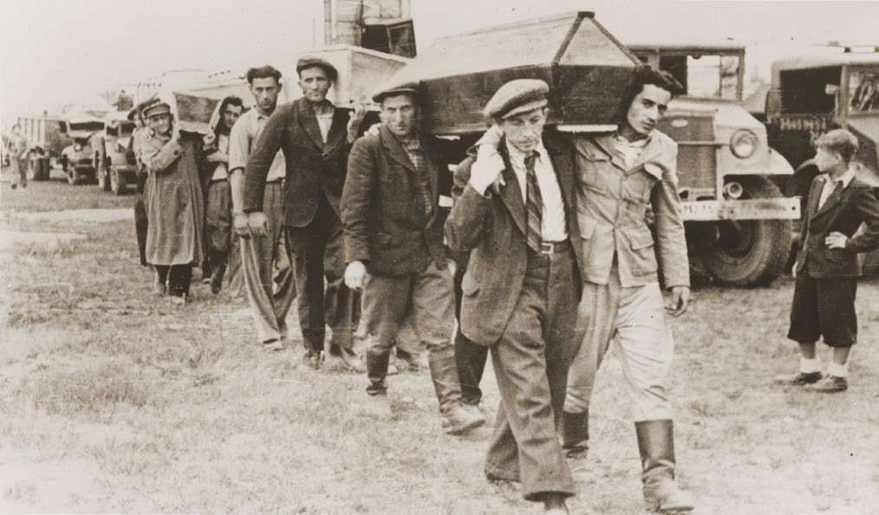The challenge of piecing their lives back together loomed large for these survivors. The Allies had prepared to repatriate the millions of displaced people in Europe to their home countries, but they quickly realized that this plan would not work for the Jewish refugees. Throughout Europe, many Jewish survivors tried to return home after liberation in order to search for missing relatives or to retrieve property. Instead, they found strangers living in their houses, ruins of their communities, and reminders of families and friends they had lost. They also encountered virulent

antisemitism, which remained a strong force throughout Europe. Survivors continued to experience hatred,

Pallbearers carrying the victims of the Kielce pogrom,

USHMM, Photograph Number 14380.

harassment, and abuse even after the horrors they had endured, adding to the feeling of tragedy.



JEWISH MIGRATION AND ANTISEMITISM AFTER THE HOLOCAUST

In postwar Poland, for instance, anti-Jewish violence included pogroms like the tragic one in Kielce in 1946 where 42 Jews were murdered. Incidents like this, accounting for at least 1,000 additional Jewish deaths in the year after liberation, instilled further fear.

The fear of pogroms and the tragedy of going home to find only ruins led many Holocaust survivors to travel west to territories liberated by the Allies, finding shelter in displaced persons (DP) camps across Europe. These camps were managed by the United Nations Relief and Rehabilitation Administration (UNRRA) and the military forces of the United States, Great Britain, and France.

Various Jewish organizations stepped in to assist these displaced people. The American Jewish Joint Distribution Committee provided essential food and clothing, while the Organization for Rehabilitation through Training (ORT) offered vocational training.

Survivors themselves formed various mutual assistance groups. Many advocated for a Jewish state in Mandatory Palestine. Restrictive immigration quotas were still in place in the United States, Canada and other Western countries while British authorities restricted entry into Mandatory Palestine. Holocaust survivors led the push for expanded emigration rights with Mandatory Palestine becoming the preferred destination for the displaced Jews. Homeless refugees, the Jewish DPs became an influential force in the Zionist cause,

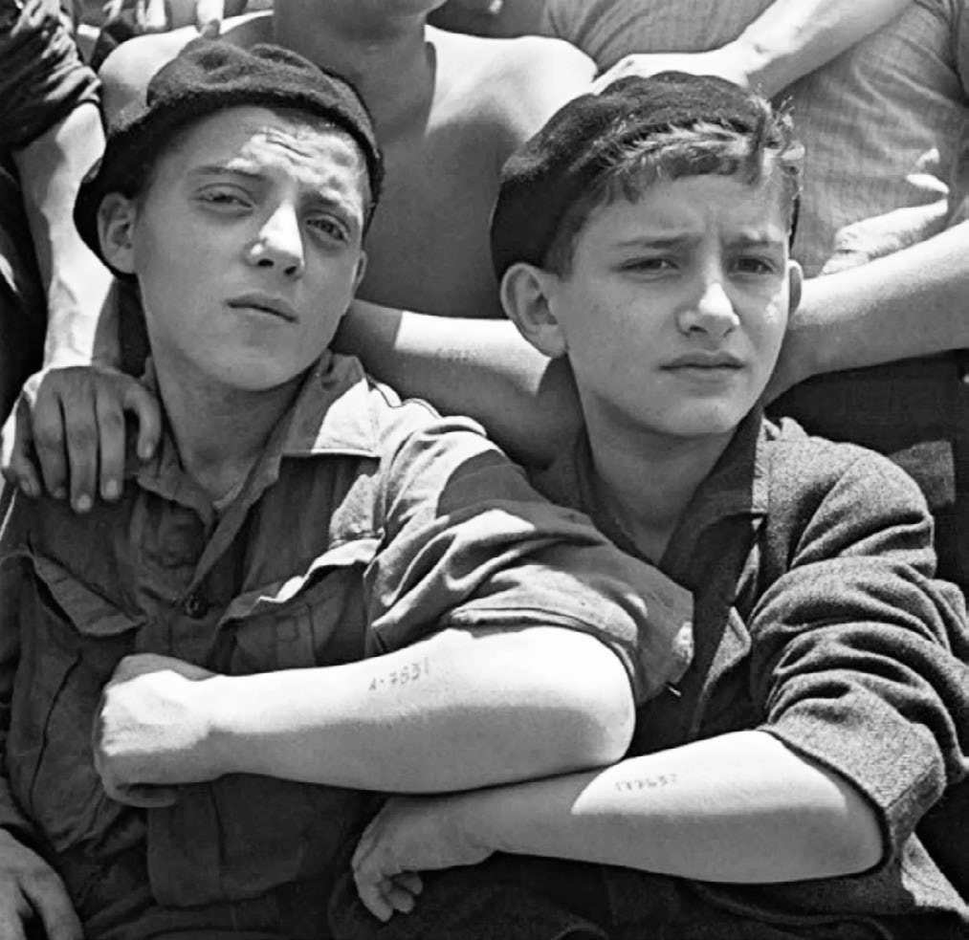

Jewish refugees, rescued from Auschwitz, arriving in Haifa,

Israel in July, 1945. AKG Images.

protesting British policy that limited open immigration to Palestine.

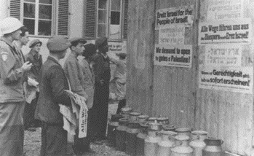In December 1945, President Truman issued a directive that loosened quota restrictions on persons displaced by the Nazi regime, giving preference to DPs, especially widows and orphans. Under this directive, more than 41,000 displaced persons immigrated to the United States from Europe; approximately 28,000 of these were Jews. Still, opportunities for legal immigration to the United States remained extremely limited.

Great Britain continued to strictly limit the number of Jews allowed in Mandatory Palestine. Jews already living there organized “illegal” immigration by ship (also known as Aliyah Bet), though the British intercepted many ships

Jewish survivors in a displaced persons camp post signs calling for Great Britain to open the gates of Palestine to the Jews, Germany, after May 1945. YIVO Institute for

Jewish Research, New York.

bound for Palestine and imprisoned their passengers, who were Holocaust survivors, in detention camps on the island of Cyprus, where they were once again behind barbed wire and deprived of autonomy and freedom. In 1947, the British faced a great public outcry after they forced the passengers of the ship, *Exodus 1947*, which was carrying 4,500 Holocaust survivors headed for Palestine, to return to France, where they had boarded.

The passengers, including many orphaned children, carried out a 24-day hunger strike in protest, but the

British forced them into DP camps in Germany. The forcible relocation and imprisonment of Jewish Holocaust survivors in Germany caused an international uproar. The *Exodus 1947* attracted worldwide publicity and strengthened support for the DPs’ struggle to emigrate from war-devastated Europe. The plight of the *Exodus* passengers became a symbol of the struggle for immigration into Palestine.

After the *Exodus* incident, the United Nations Special Committee on Palestine (“UNSCOP”) recommended Great Britain’s relinquishment of control of Mandatory Palestine and the partition of this area into two states: one Arab and one Jewish. On November 29, 1947, the UN voted in favor of this “Partition Plan”. The Jewish community accepted this arrangement; however, the Arabs did not.

On May 14, 1948, following the British departure, Israel declared its independence, and five Arab countries, Egypt, Iraq, Transjordan, Lebanon, and Syria, immediately attacked the fledgling State. The majority (about 2/3) of the 250,000 survivors remaining in DP camps in Europe chose to immigrate to Israel, despite the fact that Israel was engaged in a war in which some ten thousand served in the armed forces.

One-third of the remaining survivors chose to reconstruct their lives in Western Europe, North or South America, Australia and South Africa. Via the Displaced Persons Act of 1948, the U.S. further opened the door for nearly 400,000 displaced persons to immigrate to the U.S. between 1949 and 1952, with about 68,000 of them being Jews.

The Holocaust left its scars on the survivors, but within a few years most were successfully integrated into the countries in which they settled. The story of liberation was only the beginning of a much longer struggle.

Sources

Sorkin, A. D. (2020, November 2). *Searching for Refuge after the Second World War.* The New Yorker. [https://www.newyork-](https://www.newyorker.com/magazine/2020/11/09/searching-for-refuge-after-the-second-world-war) [er.com/magazine/2020/11/09/searching-for-refuge-after-the-second-world-war](https://www.newyorker.com/magazine/2020/11/09/searching-for-refuge-after-the-second-world-war)

United States Holocaust Memorial Museum. *Holocaust Survivors and the Establishment of the State of Israel (May 14, 1948).* Holocaust Encyclopedia. [https://encyclopedia.ushmm.org/content/en/article/postwar-refugee-crisis-and-the-estab-](https://encyclopedia.ushmm.org/content/en/article/postwar-refugee-crisis-and-the-establishment-of-the-state-of-israel) [lishment-of-the-state-of-israel](https://encyclopedia.ushmm.org/content/en/article/postwar-refugee-crisis-and-the-establishment-of-the-state-of-israel)