Jewish presence in Poland spans over 1000 years, marking a history rich with cultural vibrancy. Traditionally, Poland served as a relatively safe haven of religious tolerance and was a central hub for the Ashkenazi Jewish community from the 1500s to the 1700s, which thrived under a relatively autonomous structure. This golden age of Jewish life in Poland was markedly altered following the country’s partitions beginning in the late 18th century, during which the Russian Empire, the Kingdom of Prussia, and the Austro-Hungarian Empire each seized and annexed territory belonging to Poland. Poland as a country did not exist for 123 years until it was reestablished as an independent country following WWI in 1918. Wars, pogroms, and anti-Jewish laws in neighboring countries, including Russia and Ukraine, sparked the most dramatic change in Poland – a huge influx of Jewish immigration into Poland, which by 1938, included more than 3 million Jews, about 10% of the total population.

About 90% of the once-thriving Jewish community of Poland was murdered during the Holocaust. In the immediate aftermath of the war, the Jewish

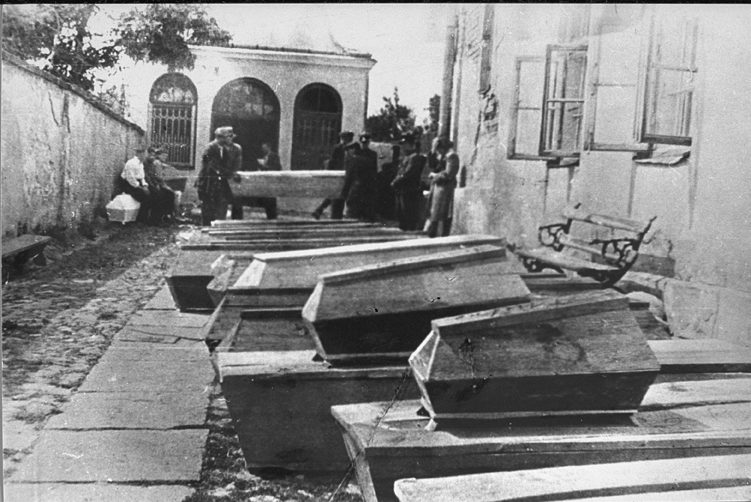

survivors who returned to Poland faced a barrage of antisemitic discrimination in education and employment. They also faced physical violence and persecution, including the infamous Kielce pogrom in July 1946, which resulted in the death of at least 42 Jews.

The mass violence of the Kielce pogrom was the result of entrenched antisemitism in Poland at the time, motivated in large measure by the false accusation that Jews kill Christian children in order to use their blood for ritual purposes. This accusation is called a “blood libel” and has been used against Jews for at least 800 years.

Coffins containing bodies of Jews killed in the Kielce Pogrom,

USHMM, Photograph Number 08407.



**RECLAMATION OF JEWISH LIFE IN POLAND AFTER NEAR ANNIHILATION**

On July 1, 1946, a nine-year-old Polish boy, Henryk Blaszczyk, left his home in Kielce without informing his parents. When he returned on July 3rd, the boy told his parents and the police that he had been kidnapped and hidden in the basement of the local Jewish Committee building, presumably so that the Jews could use his blood for ritual purposes. About 180 Jews who had survived the Holocaust and were attempting to return to their homes were living in the building at the time. Although Blaszyczyk’s story quickly unraveled, since the building did not

have a basement, on July 4, 1946, the police and local Poles numbering upwards of 1,000 people descended on the building in a violent pogrom.

The pogrom, in which 42 Jews were brutally murdered and many were wounded, was a turning point for survivors; it was the ultimate proof that no hope remained to rebuild Jewish life in Poland. During the months that followed it, survivors fled, with approximately 62,000 Jews fleeing Poland by the end of September, 1946.

Antisemitism continued in Poland under Communist rule. After the 1967 Six Day War between Israel and its Arab neighbors, Jews who still remained in Poland were accused of being a potential “fifth column,” a coded word for internal spies. These charges were imbued with antisemitism. The Communist government began an aggressive antisemitic campaign that forced between 13,000-20,000 Jews to emigrate from Poland, leaving behind a small remnant of Jews, no more than 10,000 in a country of 32 million people.

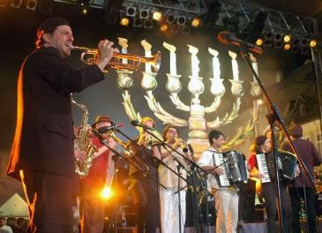The Jewish population in Poland remains small, especially compared to pre-Holocaust levels. Since the fall of Communism in the early 1990s, there has been a significant revival of interest in Jewish culture and heritage in Poland, evident in cultural events like the annual Jewish Culture Festivals and educational efforts such as the establishment of the Museum of the History of Polish Jews in Warsaw. These initiatives are part of a broader movement to reclaim and celebrate the Jewish cultural identity that suffered near annihilation during the Holocaust.

A performance at the Jewish Culture Festival, with the Menorah image in the background, Jewish Culture Festival.

Sources

Shupac, J. (2019, February 12). *Next Year in Krakow*. Maisonneuve. [https://maisonneuve.org/article/2019/02/12/next-year-kra-](https://maisonneuve.org/article/2019/02/12/next-year-krakow/) [kow/](https://maisonneuve.org/article/2019/02/12/next-year-krakow/)

United States Holocaust Memorial Museum. *The Kielce Pogrom: A Blood Libel Massacre of Holocaust Survivors*. Holocaust Encyclopedia. [https://encyclopedia.ushmm.org/content/en/article/the-kielce-pogrom-a-blood-libel-massacre-of-holocaust-](https://encyclopedia.ushmm.org/content/en/article/the-kielce-pogrom-a-blood-libel-massacre-of-holocaust-survivors) [survivors](https://encyclopedia.ushmm.org/content/en/article/the-kielce-pogrom-a-blood-libel-massacre-of-holocaust-survivors)

Yad Vashem. The World Holocaust Remembrance Center. *Anti-Jewish Violence in Poland after Liberation*. [https://www.](https://www.yadvashem.org/articles/general/anti-jewish-violence-in-poland-after-liberation.html) [yadvashem.org/articles/general/anti-jewish-violence-in-poland-after-liberation.html](https://www.yadvashem.org/articles/general/anti-jewish-violence-in-poland-after-liberation.html)