My name is Haim Raanan, and I am a survivor of both the Holocaust and the October 7 massacre. I was born in Budapest, Hungary, in 1935. During the Nazi occupation, my family and I faced severe antisemitism. We were forced to wear yellow badges and our home was marked with the Star of David, a tactic used to isolate and dehumanize us. Despite the pervasive fear and persecution, our survival was miraculously aided by the intervention of Swedish diplomats who provided us with diplomatic papers. This allowed us to move to what

was known as the ‘international ghetto’ in Budapest, a relatively safer area reserved for Jews holding protection certificates from neutral countries.

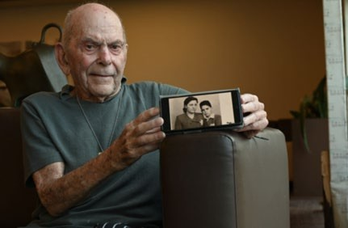Decades later, I found myself facing terror again, this time much closer to my current home in Kibbutz Be’eri. On October 7, as sirens wailed, I initially thought it was just another barrage of rockets from Gaza, which we had grown accustomed to. However, the reality was far more devastating.

We began receiving text messages that Hamas terrorists were infiltrating the kibbutz, attempting to break into safe rooms and setting fire to homes to force people out. By sheer luck, the terrorists did not reach my house, and all my family members who

live around the kibbutz survived. The massacre

Haim, with a photo of himself with his mother, Erin.

claimed the lives of about 10% of our kibbutz’s residents, either through murder or abduction. For me, it felt like a second Holocaust. During the Holocaust, I didn’t personally know the 6,000,000 who perished, but in the Kibbutz Be’eri massacre, I knew almost every single person who was affected.



A SURVIVOR OF THE HOLOCAUST AND OCTOBER 7, 2023

Now, at 88, I reside in a retirement home in Tel Aviv, having been evacuated from towns along the Gaza border. The trauma from my youth and the events of October 7 remain a subtle, ever-present shadow in my life.

Source

Adapted from: Haim Raanan. Humans of Tel Aviv. (2024, January 8). <https://www.humansoftelaviv.co.il/4930-2/>

ANTISEMITISM AFTER THE HOLOCAUST © Echoes & Reflections Partnership