**SCIENTIFIC BACKGROUND AND STATE OF THE ART**

The overall activity of the immune system has long been known to decline with age such that this progressive immunosenescence is a key hallmark of aging, affected by and impacting almost all pillars of aging (1-3). Older adults are much more prone to chronic inflammatory disorders, reduced vaccine efficacy, and infection-related morbidity and mortality (4-7). The mechanisms underlying this age-related deterioration of the immune system are not fully understood, and their elucidation may aid efforts to improve longevity and quality of life in the elderly (8-12). Of the many dysregulated inflammatory processes involved in aging, neuroinflammation characterized by glial activation (primarily microglia and astrocytes) and senescence (12-14), blood-brain barrier dysregulation (15-19), and leukocyte infiltration (20-22) has drawn increasing attention due to its strong impact on neurodegenerative diseases, psychiatric disorders, and dementia (23-33). Age-related inflammation may thus play a key role in tissue pathogenesis (14, 34-37) and degeneration (36, 38, 39).

One of the most remarkable changes that characterizes immunological aging relates to the maintenance and function of CD4 T cells, which are key orchestrators of the immune system (40-43). At younger age, CD4 T cells comprise a large repertoire of naïve cells, reflecting the plasticity of the immune system to encounter new antigens, respond to them effectively, and generate memory T cells (44). With age, however, central and effector memory cells accumulate and both the naïve and effector populations show dysregulated properties (3, 42, 43, 45-47). The complexity of the immune system and particularly the large variety of cells composing it has complicated investigatory efforts. To address changes in CD4 T cells over the course of aging and to better understand their functional properties, we applied single-cell RNA sequencing (scRNA-seq) to analyze CD4 T cell populations isolated from young and old mice (48). As expected, we found that the proportion and absolute number of naïve CD4 T cells shrink with age, whereas effector memory (EM) cells and exhausted cells accumulate (Scheme 1, Fig. 1). However, we also identified two intriguing subsets that accumulate in mice with age: A subset that exhibits an activated regulatory T cell phenotype (aTregs) and a subset with a cytotoxic and pro-inflammatory expression profile (CD4 cytotoxic T lymphocytes, CTLs). In addition, we found that the most prominent accumulation of EM, exhausted, and CD81+ Tregs occurred between the ages of 6 and 12 months, whereas CD4 CTLs accumulated primarily after the age of 16 months [Scheme 1, (48, 49)]. Furthermore, the transcription factors (TFs) required for the CD8 CTL lineage are active in these CD4 CTLs, and that the *in vitro* stimulation of these cells results in significantly higher levels of pro-inflammatory and cytotoxic protein expression as compared with EM and exhausted T cells [Fig. 1/Scheme 2, (48-50)]. These CD4 CTLs were previously observed and therapeutically implicated in mouse models of colitis (51, 52), cancer (53), neuroinflammation (54, 55), and infectious diseases, and in human samples in the context of viral infection (56-60), secondary progressive multiple sclerosis (27), and cellular senescence (61) (Scheme 2). *Strikingly, a recent study of a Japanese cohort of supercentenarian individuals also demonstrated high frequencies of CD4 CTLs (up to about 50% of all T cell compartments) (62), similar to those we observed in old mice [Fig. 1 and (48)]*. Further unveiling the role and properties of CD4 CTLs, our preliminary results show that transferring splenocytes or CD4 T cells from young to old mice resulted in accumulation of CD4 CTLs to similar frequencies of the endogenous cells [Fig. 5, and manuscript under revision (50)]. Intriguingly, using a Cre-Lox mouse model which allows for the depletion of EOMES—one of the key TF allowing the differentiation of effector cells to CD4 CTLs—we demonstrate that mice lacking the TF exhibit enhanced increased SC load, liver fibrosis, accelerated aging, and a shorter lifespan [Fig. 4, (50)]. Furthermore, by using senolyitc treatments we observed a causal relationship between SC load and EOMES+CCL5+ CD4 CTLs (Fig. XX). These results suggest that EOMES+ CD4 T cells may attenuate the aging process, at least in part, via differentiation to CTLs and the targeting of senescent cells (Fig. xx). Our preliminary study in human subjects revealed lifespan changes in the CD4 T cell landscape along with the accumulation of CD4 CTLs primarily among EM cells and EM cells reexpressing CD45RA (TEMRA) (Fig. 2). Notably, a small cohort of individuals with mild cognitive impairment (MCI) appeared to exhibit more robust changes in the age-related CD4 T cell landscape (Fig. 2-3). This was further demonstrated using ML approaches which could yield 80% accuracy in identifying MCI individuals (Fig. xx). scRNA-seq analysis of human CD4 T cells further demonstrated the accumulation of CD4 CTLs with age exhibiting several clusters which appear to differ in molecular properties between young, healthy older, and MCI individuals (Fig. xx). Taken together, although cytotoxicity was generally thought to be irreversibly blocked in the CD4 lineage, it is clear that the fate of CD4 T helper (Th) cells can change in a manner that contributes to the post-thymic differentiation of MHCII-restricted cytotoxic CD4 T cells with killing functions, similar to the CD8 CTL lineage. *Overall, changes in the CD4 T cell landscape with age along with the accumulation of CD4 CTLs appear to be critical to the biology of aging, age-related diseases, and longevity. Critical questions related to the differentiation and accumulation of the cells and their mode of action remain open. Particularly intriguing is the fact that while CD4 CTLs mark a stage in the timeline of aging, they also appear to represent a biology of immune aging adjusted to confer protection and healthy aging in certain individuals.*



**Scheme 1:** Illustration of the major changes that occur in the population of CD4 T cells during aging, demonstrating the shift from naïve dominancy in young mice to diverse and extreme effector and regulatory phenotypes in old mice.

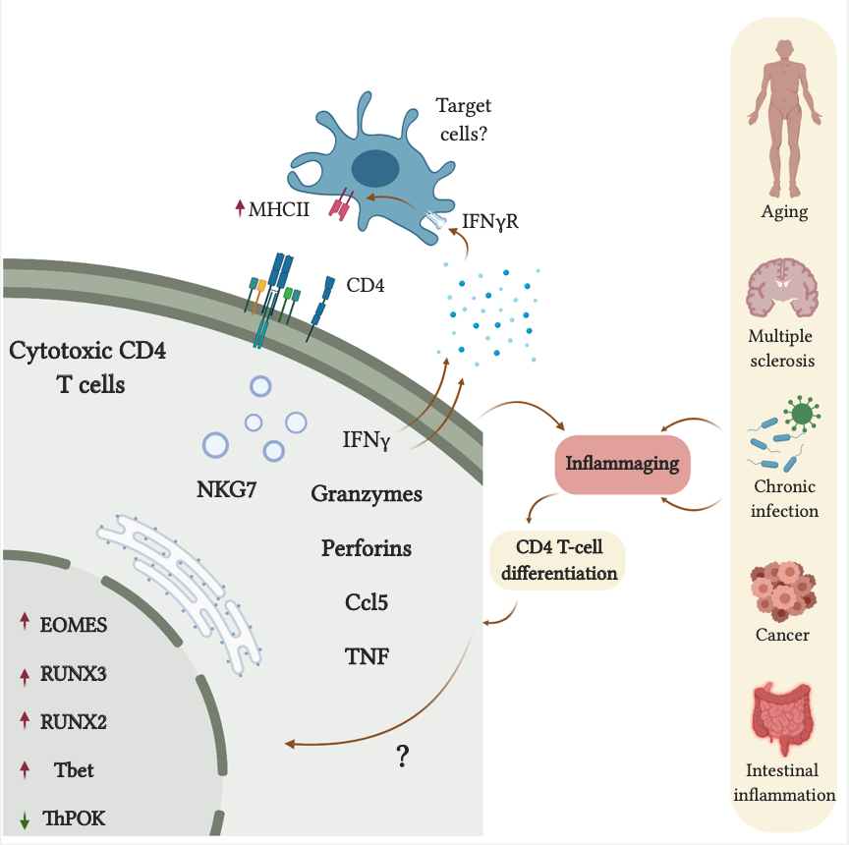

**Scheme 2:** Chronic inflammation promotes the accumulation of cytotoxic CD4 T cells.

**RESEARCH OBJECTIVES AND SIGNIFICANCE**

Our recent studies have aimed to comprehensively describe how aging reshapes the CD4 T cell compartment (48, 63). The scRNA-seq data and the functional assays we performed enabled the identification and characterization of CD4 T cell subsets, along with their specific transcriptional and functional regulation, in aging mice and human. Given their key roles in chronic inflammation, tissue repair, and age-related diseases (56, 64, 65), ***we hypothesize that age-related CD4 T-cell subsets can provide a platform to unveil immunological aging and cellular trajectories associated with chronic inflammation, cellular senescence, immunity, and tissue repair***. Our goal in the proposed study is to characterize age-related changes in the landscape of CD4 T cells in humans, which may enable efforts to predict the pace of aging, immune competence, and cognitive impairment. As CD4 CTLs appear both as a landmark in the aging process and as a population that may directly impact longevity, we plan to focus on the molecular characterization and functional roles of these cells in both mice and older individuals.

Objectives

***Aim 1: Characterize the molecular and functional properties of CD4 CTLs in mouse models of liver cirrhosis and aging.*** Based on our previous studies, we will characterize the differentiation and dynamic accumulation of CD4 CTLs and assess their molecular and functional properties. A Cre-Lox mouse model that enables the depletion of the TF *EOMES*, as a master regulator of the cytotoxic lineage, in CD4 T cells and EOMES reporter mice will be used to dissect the role of CD4 CTLs in aged mice and in mice subjected to CCl4-induced liver cirrhosis.

***Aim 2: Assess the capacity of CD4 CTL frequency and molecular properties to predict aging-related chronic inflammation, cognitive decline, and frailty.*** We will study primarily samples from healthy males and females older than ≥70 years including healthy individuals, patients with MCI, and patients with AD. We will use advanced cellular, molecular, multivariate statistical analyses, and machine learning (ML) approaches to explore aging-related changes in the population structure of CD4 T cells, and more specifically in CD4 CTLs, that coincide with biomarkers of aging and cognitive decline.

Expected outcomes & Significance:

Our goal in this proposal is to conduct a detailed characterization of lymphocyte aging and its impacts on immune system functionality, cellular senescence, and cognitive decline. The direct outcomes of the successful completion of this work will include the identification of immune-related biomarkers and mechanisms that should help facilitate the development of immune screening strategies that predict age-related cellular trajectories linked to systemic inflammation, tissue senescence, and cognitive decline. *Perhaps the most intriguing implication of these studies is the possibility that lymphocyte aging is tightly linked to the biology of aging by virtue of changes in lymphocyte functional properties and hence their capacity to orchestrate tissue repair.* Such dynamics in lymphocyte aging can serve as a viable target not only to predict and understand other hallmarks of aging such as metabolic disorders, stem cell exhaustion and cellular senescence (2, 3), but also to treat age-related diseases such as cancer, cardiovascular diseases, and type II diabetes.

**DETAILED RESEARCH PLAN:**

**Aim 1: Characterize the molecular and functional properties of CD4 CTLs in mouse models of liver cirrhosis and aging.**

Rationale: Our findings in mice and human suggest that while the CD4 CTL population can serve as a measure of the aging timeline, at least in part, they exhibit beneficial properties through their ability to modulate tissue senescence, chronic inflammation, and antiviral and antitumor immunity (27, 54-56, 62). These intriguing results open critical questions related to the overall biology of CD4 CTLs and their role in aging including 1) the signaling cues that promote their terminal differentiation in tissues subjected to chronic inflammation and increased senescent cell load, 2) their molecular properties and mode of action leading to clearance of senescent cells, and 3) their overall impact on aging processes such as systemic inflammation, frailty, neuroinflammation, and cognitive decline. Addressing these questions may not only unveil individual’s aging trajectories culminating in healthy or enhanced aging, but also uncover novel diagnostic and therapeutic implications in aging.

Specific tasks & experimental systems:

1.1. *Generate Eomes reporter mice to follow the dynamic accumulation and function of CD4 CTLs.* A more detailed functional characterization of CD4 CTLs is currently limited due to the lack of sufficient extracellular markers that allow their isolation. In addition, the frequency of CD4 CTLs is very low except their more abundant accumulation at advanced ages [above 18 months, (48, 50)]. We thus used a mouse model of CCl4-induced liver cirrhosis and demonstrate that similar to their accumulation in tissues during aging, CD4 CTLs accumulate locally in the liver and that using senolytics treatment abolished this accumulation [Fig. xx, (50)]. Furthermore, depletion of EOMES in CD4 T cells using the CD4CreEREomeslox/lox mice resulted in increased frequencies of SCs and enhanced tissue pathology [Fig. 4, (50)]. We thus find this mouse model as an elegant and robust system to further interrogate the dynamic accumulation and molecular properties of EOMES+CD4+ cells. Notably, it was recently demonstrated that CD4 T cells expressing EOMES exhibit enhanced metabolic fitness that allow them to survive and facilitate effector functions in tissues subjected to chronic inflammation (66). Thus, EOMES+ CD4 T cells may not only represent CTLs but also a population with enhanced effector functions that facilitate the clearance of SCs. To determine the dynamic accumulation of EOMES+ CD4 T cells and the portion of which that differentiate to CD4 CTLs, we will cross the CreERT2 Eomes (Strain #:036301)with the tdTomatolox/lox reporter mice (Strain #:007914). Mice aged 3 months (n=xx) will be administered with TMX and CCl4 or TMX and vehicle as described in Methods [Fig. xx, (50)], and 3, 7, 14, and 28 days later livers and spleens will be excised and EOMES-expressing CD4+ tdTomato+ cells will be analyzed with flow cytometry panels including CD3, CD4, CD44, CD62L, the cytotoxic markers GzmB, GzmK, Eomes, CCL5, CD107, and perforin to define the dynamic accumulation of EOMES-expressing CD4 T cell landscape in the liver (Fig. xx, Methods). In addition, liver sections will be immunolabeled with CD4, GzmB, GzmK, CD11c, CD11b, b-Gal, P16, and/or P21, caspase 3, and Ki67 and analyzed via confocal imaging to assess the tissue distribution EOMES+CD4+ T cells, their cellular interactions with SCs or APCs, and cell-mediated cytotoxicity (Fig. xx, ref). Overall, we anticipate to follow an early differentiation of EOMES-expressing CD4 T cells which proliferate and gradually transition to EOMES-expressing CD4 CTLs. As our scRNA-seq analysis in older human individuals demonstrate distinct populations of GzmK+ and GzmB+ CD4 T cells, both populations will be analyzed as a possible transition from more proliferating GzmK+EOMES+ to more cytotoxic GzmB+EOMES+ CD4 T cells, as was recently shown for CD8 T cells (ref).

*1.2. Characterize the differentiation, molecular and cellular properties of CD4 CTLs in a mouse model of liver cirrhosis.* To further determine the population structure of CD4 T cells in the liver following cirrhosis and the impact of EOMES depletion on the CD4 T cell landscape, we will apply scRNA-seq analysis of liver-derived CD45+ cells. CreERT2+/-CD4CreEREomeslox/lox mice and littermate control mice (3 months old; n=xx) will be administered with TMX and CCl4 (Fig. xx, Methods). As a negative control group, littermate controls will be administered with TMX and vehicle. Depending on results in Task 1, livers will be dissected after 7, 14, or 28 days and analyzed for 1) CD4 T cell subsets (exhausted, regulatory, EOMES+ effectors, and EOMES+ CTLs; Fig.xx, Methods) with flow cytometry; 2) molecular and metabolic properties of CD4 T cell subsets and their TCR repertoire using scRNA-seq of CD45+ leukocytes/CD4 T cells (Methods). Combining the flow cytometry and scRNA-seq results, we anticipate to uncover the EOMES+ CD4 T cell subsets exhibiting effector and cytotoxic properties that accumulate in the liver following CCl4 administration and how the effective depletion of EMOES in CD4+ T cells impact the phenotype and repertoire of the CD4 T cell subsets in the liver. Cellular trajectory analysis using the xx package to infer transitioning from effector CD4 T cells to EOMES+ cells, and EOMES+ CTLs expressing GzmK+, GzmB+ or both. TCR analysis using the xx software will allow to dissect clonal expansion of CD4 CTLs in the presence or absence of EOMES and ultimately certain CTL TCRs which can be further analyzed for antigen specificity, beyond the scope of the current proposal.

1.3. *Characterize the accumulation and function of CD4 CTLs in old mice.* Transferring splenocytes or CD4 T cells from young to old, but not from young to young, mice resulted in differentiation and proliferation of EOMES+ CD4 T cells and subsequently their accumulation as CD4 CTLs in frequencies similar to the endogenous cells [Fig. 5, (50)]. In this task we will thus leverage this cell transfer system to follow the migration of EOMES+ CD4 T cells to various tissues in old CD4CreER+/-Eomeslox/lox and littermate control mice and determine the dynamic accumulation of GzmK+ and GzmB+ CD4 CTLs and their impact on the immune compartment, SC load, and frailty. CD4CreER+/-Eomeslox/lox and littermate control mice aged 16 months (n=xx) will be administered with TMX (Fig. xx, Methods) and 4 weeks later injected IV with 10 x106 CD4 T cells sorted from young CreERT2 Eomes- tdTomatolox/lox reporter mice or with vehicle. Mice will remain on weekly alternating TMX/normal chow diet [ensuring the effective and continuous depletion of endogenous EOMES+ CD4 T cells (Fig. xx) and the expression of EOMES in the transferred CD4 T cells] and sacrificed at 1, 2, 4, and 6 weeks after cell transfer. The mice will be analyzed for 1) the frequency of tdTomato (EOMES+) CD4 T cells expressing GzmK, GzmB, CCL5, and perforin along with frequencies of CD4 T cell subsets (exhausted, regulatory, effector, Fig. xx) in the spleen, blood, bone marrow, gut, adipose tissue, liver, lungs, and brain via flow cytometry, and 2) immunological synapse formation between tdTomato+CD4+ CTLs (GzmB+) and senescent cells (p16Ink4a+ and/or P21+) and/or antigen-presenting cells (APCs; CD11b+ and/or CD11c+) in the liver via confocal imaging. The groups analyzed at 4 and 6 weeks will be monitored for weight, food and water intake, and frailty using the hanging and wheel tests and frequencies of GzmK+ and GzmB+ CD4 CTLs in blood before the initial TMX administration and at the end of the experiment (Fig. 4, Methods). SC load will be assessed in livers and lungs via flow cytometry and confocal imaging (Fig. 4, Methods). We anticipate that this experiment will reveal the dynamic accumulation of CD4 CTLs in various tissues of old mice, the fraction of the GzmK+ and GzmB+ cells within CD4+tdTomato+ cells relative to the endogenous CD4 CTL populations, and their impact on aging processes and cellular senescence.

*1.4. Determine the cytotoxic properties of CD4 CTLs.* Activation of CD4 CTLs with anti-CD3/CD28 Dynabeads resulted in increased expression of IFN-g, GzmB, and perforin suggesting that the cells can exert cytotoxic functions following to MHCII-TCR interactions (48, 61). Yet, it is critical to establish an in vitro system to determine whether the CD4 CTLs are directly involved in the elimination of SCs via direct MHCII-TCR interactions or via their local stimulation by APCs and secretion of cytotoxic granules (ref). As the main limitation towards achieving this goal is the isolation of CD4 CTLs and maintain their cytotoxic properties, our preliminary results show that senescent primary fibroblasts cocultured with spleen-derived CD4 T cells promoted increased frequencies of CTLs [Fig. 6, (50)]. To obtain cytotoxic and potentially SC antigen-specific CD4 T cells, CD4+ tdTomato+ cells observed in Task 1 will be sorted from livers of mice subjected to CCl4 treatment at the timepoint where most of EOMES+CD4+ cells exhibit cytotoxic properties. The cells will be activated in vitro for 24 hours as using anti-CD3CD28 Dynabeads, and cocultured with primary fibroblasts or senescent primary fibroblasts for 3 and 7 days (Fig. 6, Methods). T cells will be then purified and subjected to flow cytometry analysis to determine the impact of cellular senescence on the cytotoxic profile of the cells (EOMES+CCL5+GzmB+perforin+CD107+) and SCs undergoing cell death (AnnexinV). In addition, cells will be fixed and immunolabeled with antibodies to CD4, GzmB, ICAM1, MHCII, CD90, b-Gal, and caspase3 and analyzed with confocal microscopy for CD4 CTL-SC interactions and cell-mediated cytotoxicity. ICAM1 and MHCII blocking ab’s will be used to determine whether the differentiation and/or function of CD4 CTLs is contact dependent. Cytokines associated with senescence (primarily IL-6, IL-1, and TNF-a) and other targets revealed by RNA-seq will be neutralized in the coculture system with blocking antibodies followed by analyses of the frequency and function of CD4 CTLs. Whether cytotoxicity is induced by secreted molecules and/or vesicles in a cell contact-independent manner the liver-derived CD4+ tdTomato+ cells will be cultured for 24, 48, and 72 hours and CM will be collected. Primary senescent and non-senescent fibroblasts will be then cultured with CM and evaluated for apoptosis at 24 and 48 hours post treatment with flow cytometry. Overall, we find this system highly useful to explore the signaling pathways that promote the differentiation of CD4 CTLs and their cytotoxic mode of action.

**Aim 2: Assess the capacity of CD4 CTL frequency and molecular properties to predict aging-related chronic inflammation, cognitive decline, and frailty.**

Rationale: Longitudinal brain imaging studies indicate that brain inflammation is one of the earliest signs of dementia developing 10-20 years later (14), and more attention is now focused on systemic inflammation as a key driver of brain inflammation (21, 67-72). Based on our earlier findings (48, 49) and preliminary results (Figs. 2-3), we hypothesize that immunological aging (as reflected by age-related CD4 T cells) and circulating inflammatory molecules can not only enhance aging but also disrupt the brain-immune ecosystem, a process that exacerbates neuroinflammation and neural damage. The accumulation of CD4 CTLs with age and their association with SC load, frailty, and longevity [Fig. xx, (48-50, 61)], suggest a newly-emerging concept of protective T cell-mediated cytotoxicity. Namely, rather than rejuvenation, healthy aging may be achieved by adjusted immunity such as the accumulation of CD4 CTLs over, for example, the naïve T cells. Our preliminary results in human cohorts not only show that the frequency of CD4 CTL subset is increased with age (Fig. 2), but that additional clusters of CD4 CTLs develop in older individuals and may differ between healthy individuals and patients with MCI (Fig. xx). Furthermore, ML approaches demonstrate that from all CD4 T cell subsets the cytotoxic markers markedly distinguished patients with MCI from healthy age- and sex-matched controls (Fig. xx). *Together, our preliminary results suggest that while CD4 CTLs can support healthy aging, both the frequency and functional properties of the cells may play a role in this process.* To further characterize the accumulation of CD4 CTLs, their differential molecular properties and functional roles in healthy individuals and patients with cognitive decline, we will analyze the changes of CD4 T cell subsets, and particularly the cytotoxic clusters, among male and female healthy adult individuals, older healthy individuals, older individuals with MCI, and older individuals with AD and assess their association with circulating biomarkers of inflammation and neurodegeneration. (42, 43, 73). ML toolbox will be used to determine whether age-related changes in the CD4 T cell landscape, and particularly among CD4 CTLs, can differentiate between healthy older individuals and MCI patients with improved accuracy (collaboration with Dr. Dan Vilenchick; see letter of support).

Specific tasks and experimental approaches:

*2.1. Determine the changes in CD4 CTLs during aging and the progression of cognitive decline and their association with systemic inflammation and neuroinflammation.* To further reveal the role of CD4 CTLs in aging and their different phenotype in patients with cognitive decline, we will recruit individuals aged 70 and older with or without MCI or dementia. We will thus not only strengthen the differences we observed between older individuals and patients with MCI but will also determine the pattern of the CD4 CTLs among other CD4 subsets at older ages (90-100 years). In addition, since only a portion of MCI patients will progress to dementia (about 40% in 4-5 years), we will recruit patients with already established AD which may exhibit a more extreme phenotype of the CD4 CTL clusters observed in the MCI cohort. The subject recruitment procedure, inclusion/exclusion criteria, and clinical assessments (cognitive decline and frailty) will be conducted in collaboration with Prof. Yan Press and Dr. Boris Punchik (*Clalit Health Services, Beer Sheva, Israel), Dr. xx (Psychiatry medical center),* Prof. Gil Atzmon (Ichilov xx), and the Siaal center (see letters of support), as detailed in the Methods section below. To that end, blood samples from healthy male and female individuals 70-100 years of age (n = 60, 20 individuals for each decade) and age-and sex-matched individuals with MCI (n = 60) (120 total individuals, as predicted by the ML-model RMSE [Root Mean Square Error] analysis – see Aim 2.2.). We also recruit patients with already established AD with MoCA scores <15 (n=50). PBMCs will be analyzed for the relative frequencies of CD4 T cell subsets, as shown in Figure 2. Based on the scRNA-seq analysis (Fig. xx), CD4 CTLs will be analyzed at a higher resolution with flow cytometry panels including EOMES, GzmK, GzmB, CCL5, perforin, CD81, and klrd1. A range of cytokines and chemokines including C-reactive protein (CRP), CX3CL1, CXCL9-10, IFN-g, interleukin 2 (IL-2), IL-6, TNF-a, and TNF receptor superfamily 1A (TNFRSF1A), and biomarkers of neuronal damage including glial fibrillary acidic protein (GFAP), neurofilament-light (NF-light), phosphorylated tau (pTau-181), and amyloid-beta peptides (Ab40 and Ab42), will be measured in serum samples using Luminex and Simoa (Methods). These data will allow us to determine the frequency and phenotypes of CD4 CTLs and their association with 1) other CD4 (naïve, regulatory, exhausted, effector) and CD8 (naïve, exhausted, effector) T cell subsets in each of the study groups, serum biomarkers of chronic inflammation and neuronal damage, and cognitive decline. To validate risk factors for developing frailty and/or cognitive decline among the healthy control and MCI groups, the recruited individuals in these 2 groups will be reevaluated, as described above, in 2 additional visits (once in years 2-3 and again in years 4-5). We anticipate that around 17% of healthy older individuals and around 40% of MCI patients will progress with cognitive decline over the 4-5 years study period (74-76).

*2.2. Use ML approaches to predict age and cognitive decline.* Our preliminary PCA analysis, in collaboration with Dr. Dan Vilenchick, revealed that the features of cytotoxic CD4 T cells among 46 healthy individuals (21-89 years old) and 6 elderly individuals with MCI (73-89 years old) roughly predict chronological age and MCI with no sex discrimination (Fig. 3). Our goal in this Aim is to increase our sample size and add additional markers of CD4 T-cell subsets obtained in the scRNA-seq and flow cytometry analyses performed in Task 2.1., such that our predictions of MCI and frailty, as a more advanced stage of biological aging, from this data set are more accurate. Using the various algorithms (Fig. xx, ref Dan), we will explore the top 5-10 features among the CD4 T-cell subsets underlying the discrimination between healthy controls and patients with MCI. To estimate the number of data points needed to train a model to predict the occurrence of MCI more accurately, we trained a Random Forest regressor on the entire dataset (Fig. 3). We then evaluated the RMSE (Root Mean Square Error) of this Random Forest regressor. As shown in Figure XX, an estimated 200 participants should be sufficient to predict MCI with 90% accuracy, and these subjects will be recruited in Aim 2.1. Throughout the recruitment process, we will continue to re-train the model based on further analyses of age-related CD4 T cell subsets and additional inflammatory markers identified in Aims 1 & 2 such that the testing of new samples will allow us to better infer cognitive decline and the underlining biological features.

*2.3. Does T cell subset functionality differ among older individuals at risk for cognitive decline?* The scRNA-seq analysis revealed CD4 CTL subsets that differ in older individuals and/or in patients with MCI and thus should be examined for functional properties. Intriguingly, in contrast to the homogeneous population of CD4 CTLs in young individuals, older individuals exhibited several clusters, which among other markers, differed in expression of GzmK and GzmB (Fig. xx). Furthermore, patients with MCI had decreased frequencies of GzmK- vs GzmB-expressing cells, which also showed reduced metabolic fitness (Fig. xx). These results suggest that patients with MCI may exhibit a defect in the differentiation and/or function of CD4 CTLs which may reflect a more advanced stage of aging. We will thus gain functional characterization of the GzmB- and GzmK-expressing CD4 CTL subsets to assess the functional properties of these subsets in healthy young and older individuals and patients with MCI. To this end, PBMCs from the healthy young (20-30 years), healthy older (≥70 years), and MCI (≥70 years) groups (n=10-15 in each group) will be thawed and cultured in the absence or presence of the cell activation cocktail containing optimized concentration of PMA (phorbol 12-myristate-13-acetate), ionomycin, and protein transport inhibitor (Brefeldin A) for 4 hours, and then harvested and analyzed via flow cytometry to assess the inflammatory, cytotoxic, and metabolic properties of GzmK+ and GzmB+ CD4 cells expressing EOMES, IL-2, IFN-g, perforin, CD69, and CD107. Mitochondrial mass and membrane potential will be assessed with xx. We will also determine functional differences associated with exhaustion [PD1, Lag3, and TIGIT (T cell immunoreceptor with Ig and ITIM domains)] and cytokine expression (e.g., IL-17, IL-10, and TNF-a) profiles among the effector subsets. To measure the proliferation capacity of the T cell subsets, the cells will be incubated with 5 mM CFSE (carboxyfluorescein succinimidyl ester), washed, and activated with anti-CD28/anti-CD3 for 5 days after which they will be harvested and analyzed via flow cytometry (48). Overall, these effector and cytotoxic properties will ultimately allow to determine key functional differences, beyond the frequency of cells, that distinguish healthy older individuals from patients with MCI and/or frailty.

**Potential pitfalls and alternative approaches:**

1. CD4+ tdTomato+ T cells do not maintain their phenotype following in vitro activation. Using spleen-derived CD4 cells from reporter mice.

2. Liver model instead aging model aim 1.3 to follow the accumulation, role, and efficacy of CD4 CTLs.

3. Over expression of EOMES-GFP in CD4 T cells instead of CD4+ tdTomato+ cells.

4. Human cohort sample size

5. Other cell subsets correlate with biomarkers of aging or cognitive decline except CD4 CTLs (ML, scRNA-seq).

**METHODS**

A. Human samples and clinical assessments. All recruitment will be performed in collaboration with Prof. Yan Press (Soroka Medical Center), Dr. Boris Punchik (*Clalit Health Services, Beer Sheva, Israel), Dr. Svetlana xx (Psychiatry medical unit),* and the Siaal Research Center at The Faculty of Health Sciences, Ben-Gurion University (support letters attached). Blood samples and questionnaires will be collected in community healthcare clinics in the south of Israel. Only subjects that signed consent forms will be included. *Exclusion criteria:* We will not recruit patients with known immunodeficiencies. This includes patients that received immunosuppressive treatments and/or over 5 days of steroid treatment within the three months preceding recruitment; oncology patients (not including squamous cell carcinoma and basal cell carcinoma); patients treated with chemotherapy or biological agents that might affect the immune system; patients with autoimmune diseases; immunosuppressed patients; patients with severe leukopenia (< 3000 leukocytes/µl) and/or neutropenia (< 1,500 neutrophils/µl); patients who suffered from a fever of 38.5°C or above in the two weeks preceding recruitment. Blood samples (50-70 ml) will be collected while taking a routine blood test, using 10 ml EDTA test tubes and one 5 ml serum tube. We will collect the following information from each participant: age; sex; gender; background diseases (including diabetes, chronic renal failure, ischemic heart disease, heart failure, liver dysfunction, hypertension, dementia, depression, and Parkinson's disease); vaccination status; marital status, and with whom they live; height and weight; and changes in weight during the past year. For these patients, we will calculate two comorbidity indexes: Charlson's Comorbidity Index and CIRS. All participants will undergo the following tests:

*Cognitive evaluation*:We will use a computerized-based platform (NeuroTrax) and the Montreal Cognitive Assessment test (MoCA) to determine MCI and dementia status. *NeuroTrax:* The Mindstreams computerized cognitive assessment battery has been well-validated for the assessment of cognitive function and MCI in older populations (77). The test lasts for 45–50 min and evaluates several cognitive components, including verbal memory, non-verbal memory, the Go-No Go test, the Stroop index, visuospatial perception, concentration, and reaction time. In the final report, these components are incorporated into categories with indices for memory, attention, visual-spatial perception, and executive function, together with a global score comprising all indices. The scores are based on a performance index in each cognitive domain that weighs the number of correct answers and response times, calculated as correct answers divided by the response time and multiplied by 100. Normative data are provided corrected for age and education level. There is no need for previous computer experience, as the program provides training before the initiation of the actual testing procedures. The data are automatically uploaded to a central server where the final score is calculated. *MoCA:* This instrument is a paper-based screening instrument that takes about 10 minutes to complete. The test iscomposed of 8 parts and has a maximum possible score of 30 points. A score of 26 or more is considered normal in the English version of the test (78). The tasks evaluate visuospatial perception, organizational skills, recognition and naming, short-term memory, attention, verbal ability, abstraction, and orientation. The Hebrew version of the MoCA was found to distinguish between cognitively asymptomatic older individuals and those with MCI with a sensitivity of 94.6% and a specificity of 76.3%, using a cutoff of 26/30 points (79, 80).

*Functional assessment*: For functional assessments, we will use the Barthel Index (Basic Activities of Daily Living) (81) and the OARS _IADL (Instrumental Activity of Daily Living) (82). For frailty measurements, we will use two indexes: Fried's frailty phenotype (FFP) (83) and the Study of Osteoporotic Fractures (SOF) index (84). According to the FFP index, "frailty" is defined by the presence of 3 or more of the following 5 components: (1) unintentional weight loss (4.5 kg in the past year), (2) self-reported exhaustion, (3) weakness (grip strength), (4) slow walking speed, and (5) low physical activity. According to the SOF index, “frailty” is defined by the presence of 2 or more of the following 3 components: (1) weight loss (irrespective of intent to lose weight) of 5% or more; (2) the subject’s inability to rise from a chair 5 times without using their arms; and (3) reduced energy levels, as identified by an answer of “no” to the question “Do you feel full of energy?”. Patients exhibiting none of these components will be considered to be robust, while those exhibiting one component will be considered to be in an intermediate or prefrail state. To evaluate muscle weakness participants, will undergo hand grip strength testing with a hand dynamometer. Individuals will be considered frail if they meet one of the frailty criteria (FFP and/or SOF).

B. Lymphocyte analyses. *Cell isolation:*We used standard operating procedures for Ficoll density gradient centrifugation for PBMC isolation, cryopreservation, storage, and thawing (85). Human CD4 T cells will be isolated from total PBMCs with a negative selection kit (StemCell Technologies, Canada) followed by the EasySep human CD4 T-cell positive enrichment kit, thus allowing us to achieve >95% purity. Spleens will be harvested from mice and mashed through a 70-μm cell strainer (48). Red blood cell lysis will be performed using 300 μl of Ammonium-Chloride-Potassium (ACK) buffer for 1.5 minutes (Lonza, Basel Switzerland).

*Flow cytometry:*We will use a multicolor labeling technique to detect cell-surface and intracellular molecules in PBMC, splenocyte, or mouse tissue samples, as we have recently described (48). Briefly, viable cells will be washed with FACS staining buffer and incubated with the Fc receptor blocker (TrueStain fcX; BioLegend) for 5 minutes at 4℃. To differentiate between live and dead cells, the eFluor780-Fixable Viability Dye (eBioscience) will be used according to the manufacturer’s instructions. Cells will be incubated with primary antibodies for 25 minutes at 4℃ and then washed twice with FACS staining buffer. After staining for surface markers, cells will be fixed and permeabilized using the FOXP3/Transcription Factor Staining Kit (eBioscience), blocked with rat serum (1 μl per 50 μl of staining buffer), and stained. For Sbeta-gal staining, we will use the CellEvent™ Senescence Green Flow Cytometry Assay Kit (eBioscience) according to the manufacturer's instructions. Flow cytometry experiments will be conducted using the CytoFLEX instrument (Beckman Coulter). Data analysis will be performed with the FlowJo (v10.5.3) software. Gating strategies will rely on fluorescence-minus-one controls, unstained samples, and unstimulated samples (when applicable).

C. Serum cytokine measurements. Red-topped tubes will be used to isolate serum from 5 ml blood samples. Blood tubes will be incubated at room temperature for coagulation (30 minutes) and then centrifuged at 450 xg. Serum will be then isolated and kept frozen. For measurements of circulating inflammatory mediators (described in Aim 1.2), we will use a Luminex human inflammation panel in accordance with the provided instructions. Data will be acquired on the Luminex instrument and analyzed by American Medical Laboratories (AML, Israel). The Simoa technology will be used for ultra-sensitive detection of serum biomarkers of neurodegeneration including GFAP, NF-light, pTau, and Ab (Quanterix; Merkel Technologies Ltd., Israel).

D. scRNA-seq and computational data analyses.Leukocytes collected from each blood sample will be barcoded by using the Chromium single-cell reagent kit of 10x Genomics, at the Weizmann Institute core facility. We will sequence each library by using Illumina's NextSeq 550 sequencing platform. The output Illumina base call files (BCLs) will be converted to FASTQ files and count files. Quality control, dimensionality reduction, clustering, and further analysis will be performed with Seurat v2.0.1 or similar packages as we recently described (48, 86). To annotate clusters, each cluster will be analyzed for expression of known biomarkers, or similarity to annotated cell types via CellTypist. We will identify genes with differential expression among subsets and among age groups. Downstream functional analysis of differentially expressed genes will include gene set enrichment analyses using clusterProfiler34 with KEGG or gene ontology (GO) as reference gene sets, assessing regulatory programs (87) and the differential activity of biological processes (88).

E. Confocal microscopy. Tissues will be immersed in a 4% paraformaldehyde solution at 4℃ overnight, then transferred to a 30% sucrose solution at 4℃ for 2 days and fixed in O.C.T Compound (Tissue-Tek). Sections (20-30 µm) will be produced with a cryostat and kept at -20℃. Sections will be rinsed in a washing solution (0.05% Tween 20 in PBS) and then permeabilized for 30 minutes in 0.5% Triton X-100 in PBS. Prior to staining, the sections will be incubated for 1 hour with a blocking solution containing 0.5% Triton X-100 and 10% Donkey serum in Antibody Diluting Buffer (Biomeda). Sections will be then incubated for 48 hours with primary antibodies in blocking solution at a 1:100 dilution. Following the incubation, the sections will be rinsed 3 times in a washing solution and then incubated for 1 hour with secondary antibodies conjugated to Alexa Fluor 488, 546, or 633 (Invitrogen) diluted 1:250 - 1:500 in PBS. Sections will be then rinsed in a washing solution twice more before nuclear staining and then mounted on slides for confocal imaging using an Olympus FV1000 laser-scanning 4-channel confocal microscope, as we recently described (89, 90).

F. Hanging test.Mice use their forelimbs to suspend their body weight on a wire stretched between two posts 50 cm above the ground, and a pillow is used to prevent fall injuries. We will evaluate grip strength and endurance in each mouse with the wire-hanging test before and after the tamoxifen feeding regime. Mice will be allowed to hang on a wire three times, and the average hanging time will be normalized to body weight as hanging duration (sec) × body weight (g).

G. Metabolic cages. For metabolic data acquisition, we will use the 8-cage Promethion High-Definition Behavioral Phenotyping System (Sable Instruments, Inc., Las Vegas, NV, USA). Before experiments, mice will be housed in a metabolic cage facility for 7 days. Data will be collected at 30-minute intervals for 84 hours of recording. Mice will be maintained under a 12/12 h light/dark cycle (07:00–19:00) at an ambient temperature of ≈ 23°C. The following parameters will be analyzed: temperature, body mass, water and food consumption, ped meter, ped speed, and x and y breaks. Overall activity will be the sum of all distances traveled within the beam break system (x and y). This includes fine movement (such as grooming and scratching) as well as direct locomotion. For analyses, we will record each mouse before and after 45 days of tamoxifen treatment and calculate the "performance ratio" = post-treatment parameter / pre-treatment parameter.

I. Senescence of primary fibroblasts and co-culture with CD4 T cells: To establish primary cultures of lung fibroblasts, lung tissue from young C57BL/6 mice (3 months old) will be chopped by gentleMACS and incubated at 37ºC with Liberase™ for 1 hour, then the tissue will be washed and transferred into T175 flasks. Tissue samples will be then incubated in Dulbecco’s Modified Eagle’s Medium (DMEM) (Gibco), supplemented with 10% (v/v) fetal bovine serum (Invitrogen) and 1% Penicillin-Streptomycin at 37°C in air containing 5% CO2. Cells will allowed to migrate out from the tissue and to grow to full confluence. Adherent cells will be passaged by digestion with 0.025% Trypsin-EDTA solution when ~90% confluent. Experiments will be performed with fibroblasts from individual cryovials of cells that were rapidly thawed in a 37°C water bath (1–2 min of agitation) and resuspended in culture media. Cells (105) will be seeded into wells (48-well plate) for a 48-hour incubation at 37°C. Senescence will be induced by treatment with Etoposide (Santa Cruz Biotechnology) dissolved in DMSO (3 mg/ml) and added to cell medium (final concentration: 30 μM) for 48 hours, after which cells will be washed with fresh medium and incubated for another six days. *CD4 isolation*: CD4 T cells will be isolated from the spleens of young (2-3 months) mice using the EasySep Mouse CD4 T Cell Isolation Kit (STEMCELL Technologies) according to the manufacturer's instructions. CD4 T cells will be activated with anti-CD3/anti-CD28 beads (Dynabeads, Gibco) in 96-well (U-shaped) plates (50 × 104 cells per well) and transferred to a 48-well plate with senescent or control fibroblasts. After 3 or 7 days, cells will be collected and analyzed by flow cytometry. Cell supernatants will be collected for cytokine measurements via ELISA.

J. Statistics. Statistical analyses will be carried out in collaboration with Dr. Vered Chalifa-Caspi, from the bioinformatics core facility at Ben-Gurion University (BGU, letter of support attached). ML tools will be used in collaboration with Dr. Dan Vilenchick; see letter of support). For routine statistical analysis, Student’s t-test or ANOVA will be used. We will identify and remove confounding sources of variation including batch effects, gender, background diseases, time of hospitalization, and additional parameters that will be collected from patients. We will use multivariable regression analysis to assess an association between clinical parameters and immunological states, adjusting for any confounding factors. Since clinical parameters may not be distributed normally, we will apply transformations or use non-linear regression approaches using Poisson or other distributions.

**Available resources:**

The laboratory employs a lab manager, research associate, 2 technicians, 2 postdoctoral researchers, 5 trainees, 4 MSc students, and 7 PhD students. The lab possesses the space and equipment required to perform the proposed study, including two tissue culture hoods, refrigerators and -20˚C freezers, -70˚C freezers, CO2 incubators, regular PCR instruments, an ELISA plate reader, an ELISA plate washer, a confocal microscopy station, and a 21-channel FACS analyzer. Available institutional services include a specific pathogen-free (SPF) animal facility with MRI, surgery, and behavioral stations and metabolic cages, Imagestream FACS instruments, cell sorters, cryostats, Taq-Man Real-time PCR instruments, ultracentrifuges, and a bioinformatics unit.

**PRELIMINARY RESULTS**

**Figure 1. CD4 T cells undergo extensive diversification with age, resulting in a new population structure:** Splenocytes were harvested from young (2–3 m, n = 4) and old (22–24 m, n = 4) mice and purified to isolate highly pure (99.2% ± 0.4%) CD4 T cells which were subjected to scRNA-seq, as we have recently published [Methods, (48, 91)]. We obtained expression profiles for 13,186 and 10,821 CD4 T cells from young and old mice, respectively. **A**. CD4 T cell subset and CD4 CTL trajectory analyses were performed using the scRNA-seq data from our recent publication (48). To create a pseudo-time trajectory, we first generated a uniform manifold-approximation and projection (UMAP)-based clustering projection using the reduce_dimension function. Seven robust clusters were identified, including (i) naïve T cells, (ii) naïve_Isg15; (iii) resting regulatory T cells (rTregs), and (iv) effector-memory T cells (TEM). The three other subsets have not been previously identified in the context of aging, and include (i) regulatory T cells (denoted aTregs) overexpressing the *Cd81, Cd74,* and *Cst7* genes, together with Tregs-associated genes, such as *Foxp3, Tnfrsf4, Tnfrsf9, Tnfrsf18,* and *Ikzf2;* (ii) cells overexpressing the *Lag3, Tbc1d4, Sostdc1,* and *Tnfsf8* genes, typical of exhausted phenotypes (denoted exhausted); and (iii) cells overexpressing genes such as *Eomes, Gzmk,* and *Ctla2a*, which are commonly associated with CD8+ T cells (denoted cytotoxic) and were previously described as cytotoxic CD4 T cells (CD4 CTLs). The learn_graph function was then used to reconstruct the developmental trajectories of these cells, suggesting that the CD4 CTL subset differentiates from the TEM subset.

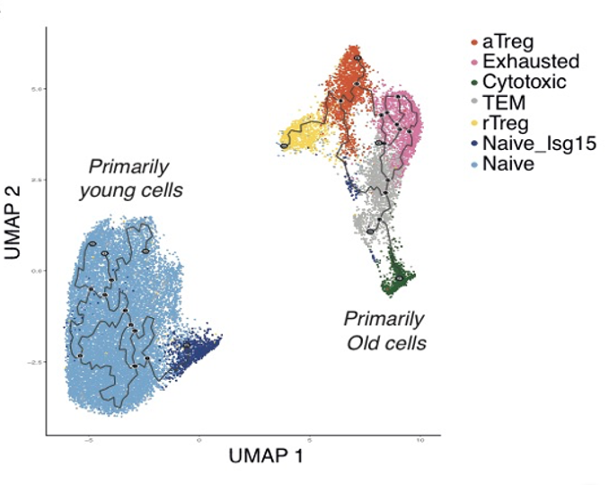

**Figure 2. Flow cytometry analyses of CD+ T cell subsets across the lifespan.** PBMCs were purified from the whole blood of healthy individuals of various ages and elderly individuals with mild cognitive impairment (MCI) and analyzed via flow cytometry (Methods). **A.** An overview of the selected flow cytometry gating strategy with different subpopulations identified by distinct colors (based on CD45RA/CCR7 labeling for effector memory [EM], central memory [CM], naïve, and TEMRA cells, and CD25/CD127 labeling for Tregs). **B.** Flow cytometry analysis showing alterations in CD4 subpopulations observed in healthy individuals across a range of ages (20-30, n=12; 61-70, n=8; and 71-90, n=19) and in elderly individuals with MCI (age 71-90, n=8). **C.** Flow cytometry results showing alterations in exhausted (PD1+, LAG3+) and cytotoxic (Granzyme B+, EOMES+) CD4 T cells across age groups (20 to 71+ years old) and in individuals with MCI. **D.** Percentages of EOMES+ cells within TEMRA, EM, CM, and naïve CD4 T cell populations in elderly individuals. **E.** Distributions of GzmB+ (left), EOMES+ (middle), and perforin+ (right) cells within TEMRA, EM, CM, and naïve CD4 T cell populations in elderly individuals. *p<0.05, **p<0.01, ****p<0.0001, one way ANOVA with Tukey correction.

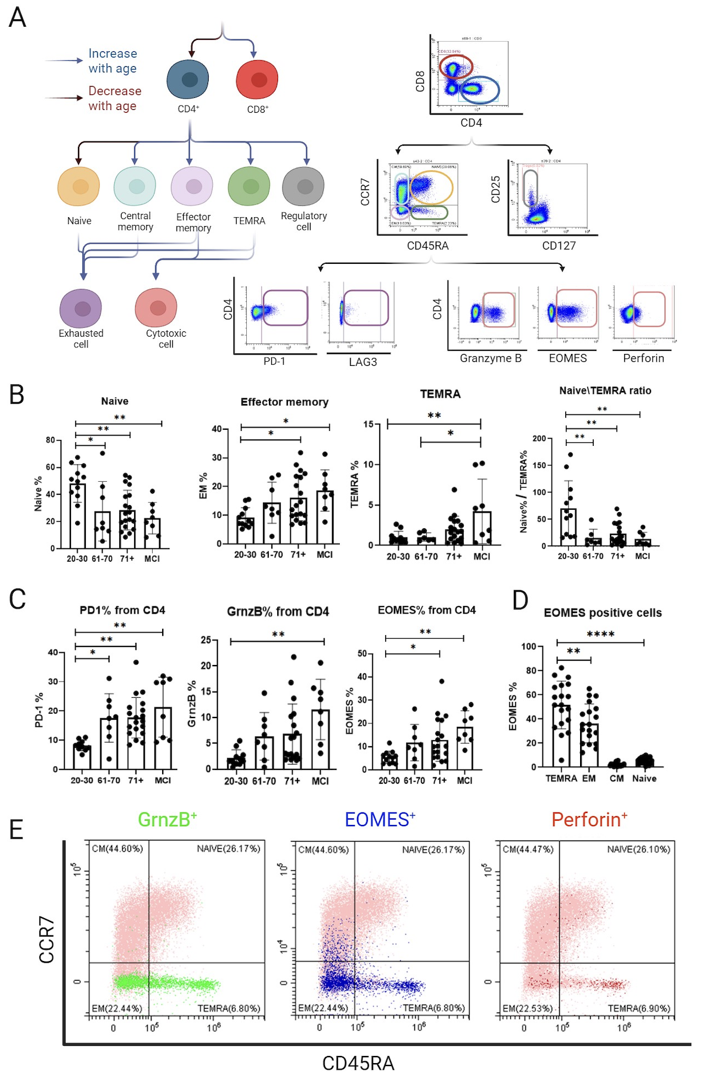

**Figure 3: The use of age-related immunological markers to explain age and cognitive decline.** PCA projections of flow cytometry data from 46 healthy individuals (21-89 years old) and 6 elderly individuals with MCI (73-89 years old) were generated (after standardization) for CD4 T cell subset features (excluding age, sex, or health status). PC1 and PC2 respectively explain 28% and 14% of the observed variance. The left panel shows a similar distribution of parameters among men and women. In the middle panel, points were color-coded by age, revealing that PC1 roughly represents the age axis (the larger the PC1 value the higher the age). In the right panel, to the left of the x=0 axis we see only healthy participants, while to the right we see a mix, with the majority of healthy individuals being to the left of x=0. PC1 values may thus be an indicator of cognitive decline. These analyses suggested that immune system parameters with top important features related to cytotoxic functions of CD4 T cells can predict aging and cognitive decline (data not shown). We then trained a Random Forest regressor on the entire dataset and checked its RMSE (Root Mean Square Error), which was 6.88 years, much smaller than the STD of 22 years. As these data are very scarce, we checked the RMSE on the training set itself (no train-test separation). Notably, the top features in a feature importance map for the Random Forest model that was trained on the entire dataset were also related to the cytotoxic properties of CD4 T-cells (data not shown).

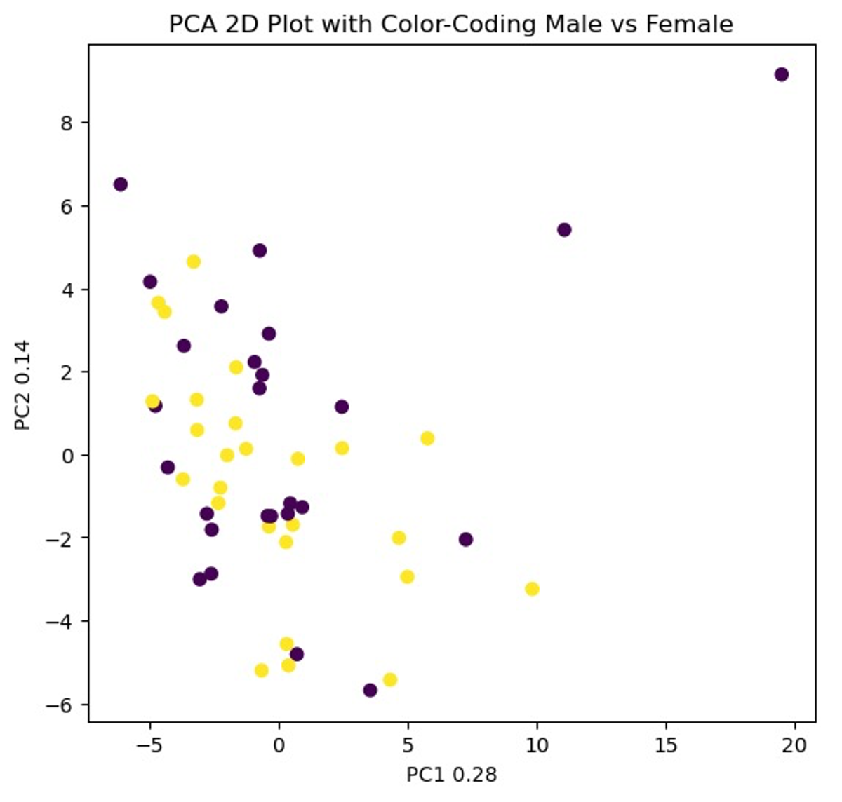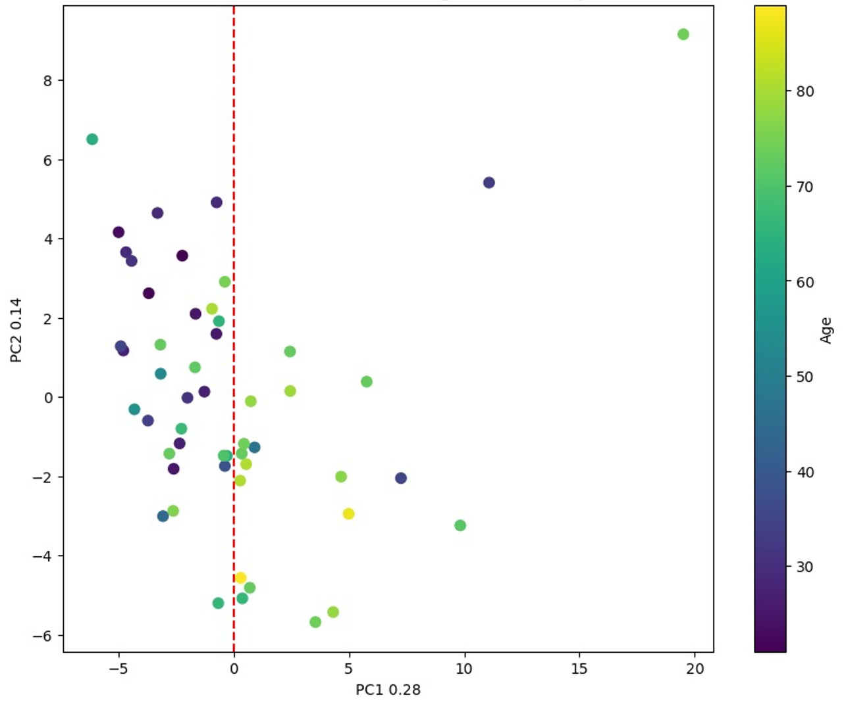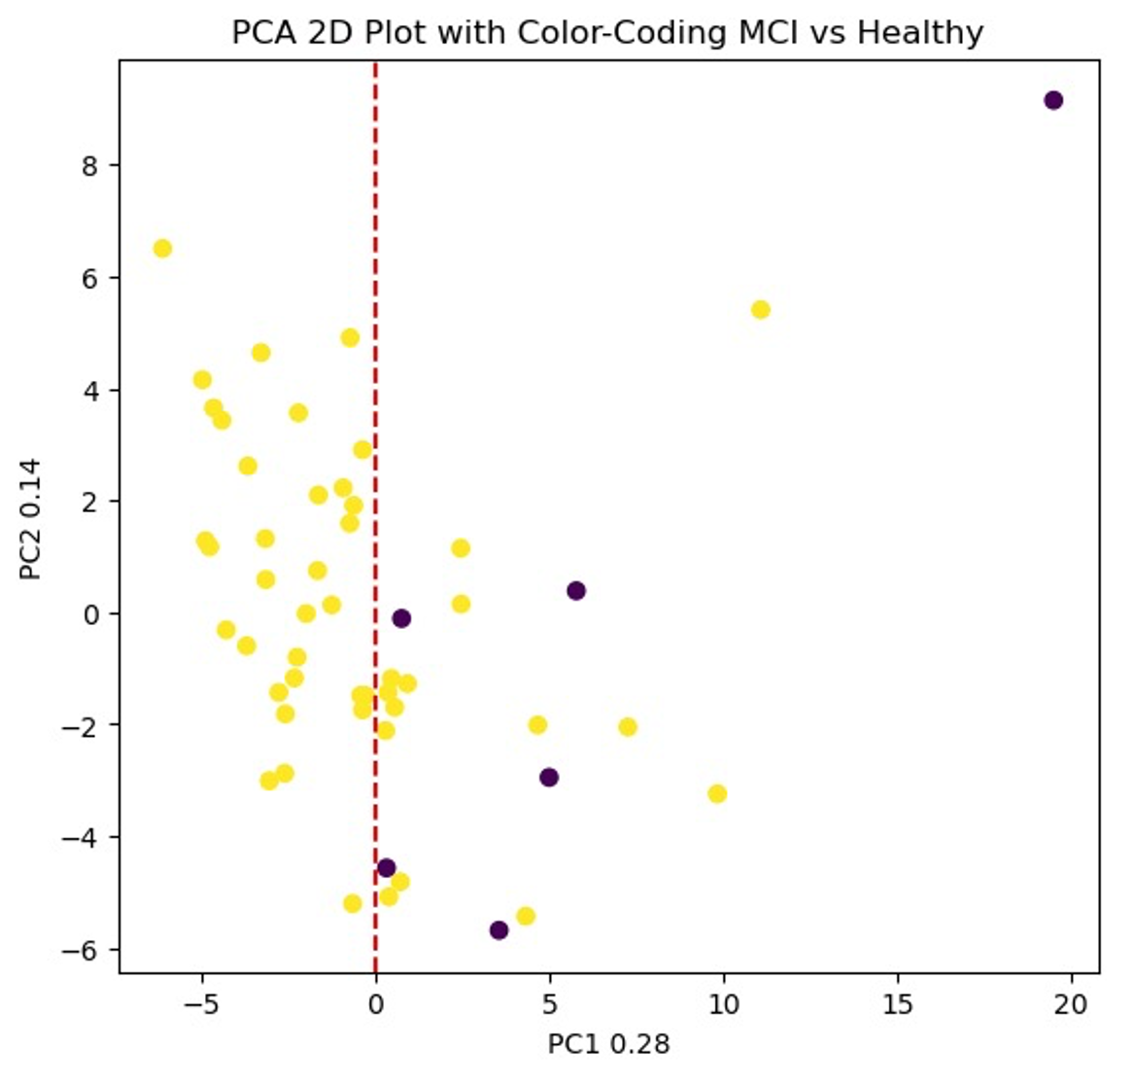

**Figure 4. Decreased physical performance and survival in aging are associated with lower frequencies of CD4 CTLs. A.** Experimental setup: physical performance of aged (20 months) control (CreERT2-/-Eomesfl/fl) and CD4 CTL KO mice (CreERT2+/-Eomesfl/fl) was evaluated using the hanging test and metabolic cages. Additionally, 100-200 µl of blood was collected from the tail vein of each mouse for flow cytometry analysis. Subsequently, the mice were subjected to a TMX regimen, which included intraperitoneal injections of 100 µl of TMX for 3 days, followed by an alternating dietary regimen of two weeks on TMX chow and two weeks on regular chow, lasting for a total of 6 weeks. After the TMX exposure period, each mouse was reevaluated for physical performance. Finally, the mice were sacrificed, and blood, spleen, and liver samples were collected for further analysis. **B.** CD4 CTL (CD3+CD4+EOMES+CCL5+) frequencies in the blood before and after TMX treatment in the control group (left, n=6) and in the CD4 CTL-depleted group (right, n=7). **C.** Representative flow cytometry plots showing CD4 CTLs in the blood of control mice (left) or CD4 CTL-depleted mice (right) before (upper plots) and after (lower plots) TMX treatment. The X-axis represents EOMES expression, and the Y-axis represents CCL5 expression. **D.** Hanging test results are shown as a ratio between the score after TMX and the score before TMX for each control (n=13) and CD4 CTL-depleted (n=15) mouse. Each dot represents one mouse. Scores were normalized to weight for each mouse. **E-F.** The ratio between post-treatment and pre-treatment performance in metabolic cages for each mouse in control (n=12) and CD4 CTL-depleted (n=14) groups. Each dot represents the ratio for one mouse. **E.** Activity ratio, which represents the sum of fine motor movement and intentional movements, in the control and CD4 CTL-depleted groups. **F.** Food consumption ratio (left) and water consumption ratio (right) in the control and CD4 CTL-depleted groups. **G.** Percentages of CD4 CTLs in the liver of control (n=12) and CD4 CTL-depleted (n=14) mice. **H.** Flow cytometry analysis of the percentage of Granzyme B+ cells among CD45+CD3+CD4+ cells in livers. **I.** Percentage of senescence β-Galactosidase+ (S-β-Gal+) cells among liver cells (CD45-) from control (n=12) and CD4 CTL-depleted (n=14) mice.  **J.** Percentage of p16Ink4a+ and P21+ cells among liver cells (CD45-) from control (n=6) and CD4 CTL-depleted (n=7) mice. **K.** Kaplan-Mayer survival curve for control (n=9) and CD4 CTL-depleted (n=9) mice. Censoring is indicated by the black line (|) mark.Bars indicate mean ± SEM from two (**D-J**) or one (**J**) independent experiments. Data were analyzed using a two-tailed Student’s t-test, paired (**B**), unpaired (**D-J**), or log-rank (Mental-Cox) (**K**). Exact P-values are presented in the graphs.

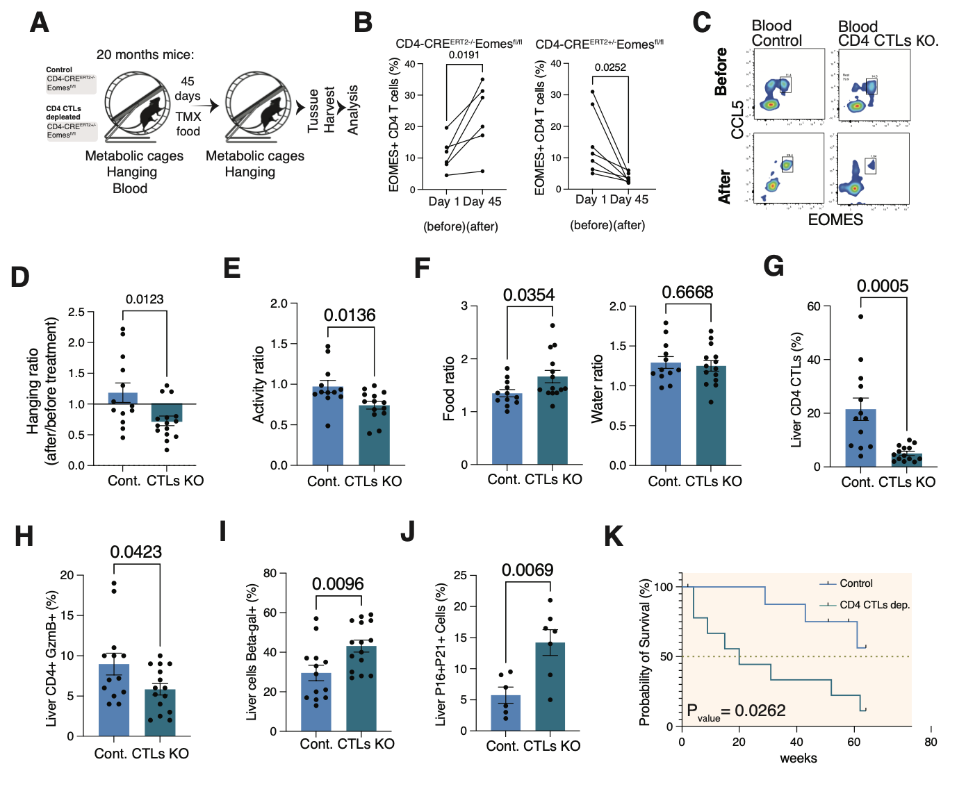

**Figure 5. CD4 T cells differentiate into CD4 CTLs in an aged environment. A**. Experimental setup: splenocytes were harvested from CD45.1+ C57BL/6 mice and then 20 million cells were injected into either young (2-3 months) or old (24-26 months) CD45.2+ C57BL/6 mice. After 30 days, spleens were harvested for analysis. **B**. Left: representative flow cytometry plots showing CD4 CTL (EOMES+CCL5+) frequencies out of transferred CD45.1+ CD4 T cells (CD3+CD4+CD8-) in young or old CD45.2+ mice. Right: quantitative analysis of CD4 CTL frequencies out of the transferred cells in young (n=6) or old (n=4) WT mice (CD45.2+). **C-D.** Quantitative analysis of exhausted (CD3+CD4+CD62L-CD44+PD1+LAG3+) **(C)**, effector (CD3+CD4+CD62L-CD44+PD1-LAG3-), and regulatory T cells (Tregs, CD3+CD4+FOXP3+) **(D)** out of transferred CD45.1+ CD4 T cells in young (n=6) or old (n=4) WT mice (CD45.2+). **E.** Percentages of CD4 CTLs (left) and exhausted (right) out of CD4 T cells comparing CD45.1+ (young-transferred cells) and CD45.2+ (old-endogenous cells) in the old group. Bars indicate mean ± SEM from two (**B-E**) independent experiments. Data were analyzed using a two-tailed Student’s t-test (**B-E**).

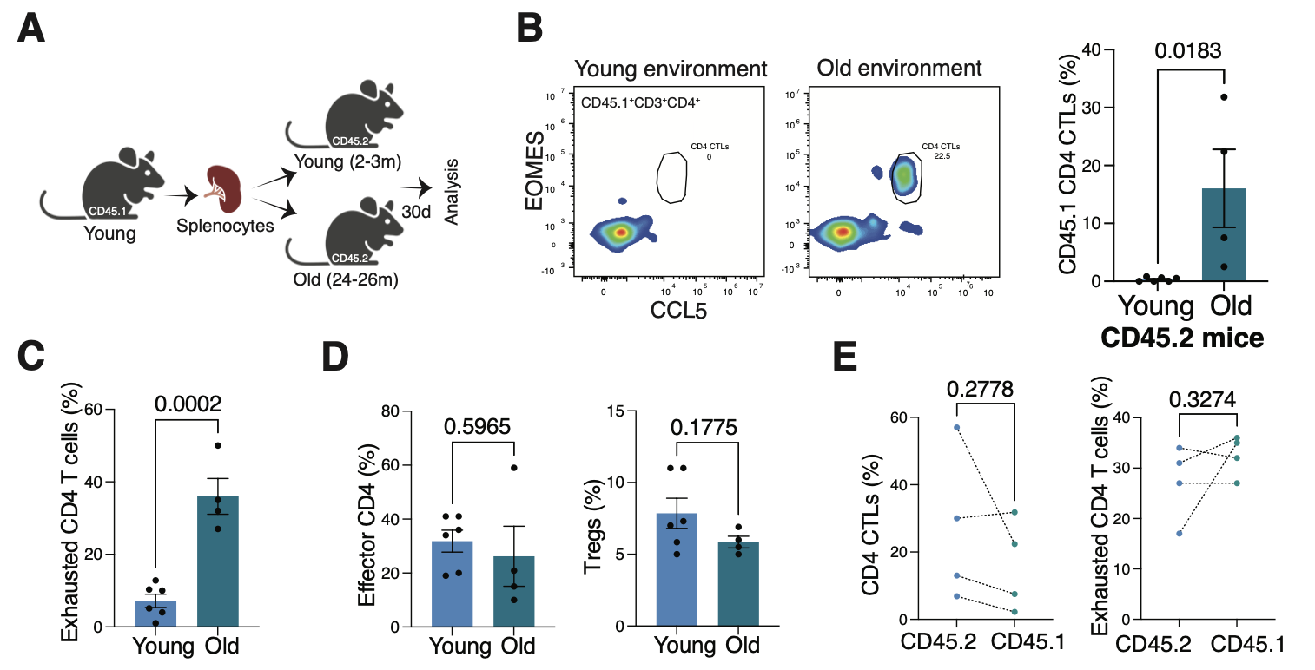

**Figure 6. CD4 CTL differentiation is induced by senescent fibroblasts *in vitro*. A.** Experimental setup: primary lung-derived fibroblasts underwent senescence induction with Etoposide (Methods). Next, CD4 T cells were purified, activated with anti-CD3/anti-CD28 beads, and co-cultured with either control or senescent fibroblasts for 7 days. Data were then analyzed via flow cytometry. **B.** A representative image displaying β-gal staining of cultured lung fibroblasts for control (upper panel) and etoposide-treated (lower panel) conditions. **C.** Percentages of CD4 CTLs (CD3+CD4+CCL5+EOMES+) (left) and median fluorescence intensity for EOMES (right) among CD4 T cells co-cultured with either control or etoposide-treated fibroblasts. **D.** Percentage of granzyme B positivity in CD4 T cells co-cultured with either control or etoposide-treated fibroblasts.Data are from one representative experiment analyzed using two-tailed Student’s t-tests (**C-D**). Exact P-values are presented in the graphs.

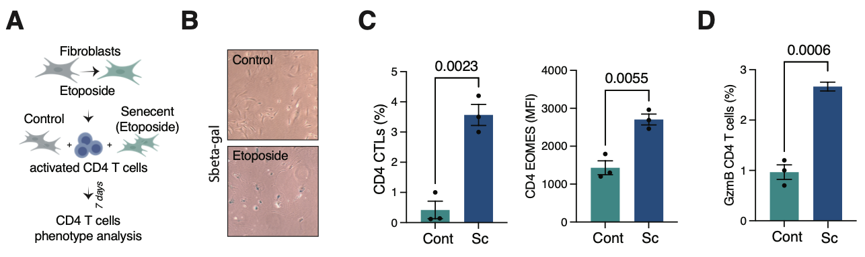

**REFERENCES:**

1. Lopez-Otin, C., M. A. Blasco, L. Partridge, M. Serrano, and G. Kroemer. 2013. The hallmarks of aging. *Cell* 153: 1194-1217.

2. Franceschi, C., P. Garagnani, P. Parini, C. Giuliani, and A. Santoro. 2018. Inflammaging: a new immune-metabolic viewpoint for age-related diseases. *Nat Rev Endocrinol* 14: 576-590.

3. Mittelbrunn, M., and G. Kroemer. 2021. Hallmarks of T cell aging. *Nat Immunol* 22: 687-698.

4. Lal, H., A. L. Cunningham, O. Godeaux, R. Chlibek, J. Diez-Domingo, S. J. Hwang, M. J. Levin, J. E. McElhaney, A. Poder, J. Puig-Barbera, T. Vesikari, D. Watanabe, L. Weckx, T. Zahaf, T. C. Heineman, and Z. O. E. S. Group. 2015. Efficacy of an adjuvanted herpes zoster subunit vaccine in older adults. *N Engl J Med* 372: 2087-2096.

5. Thompson, W. W., D. K. Shay, E. Weintraub, L. Brammer, N. Cox, L. J. Anderson, and K. Fukuda. 2003. Mortality associated with influenza and respiratory syncytial virus in the United States. *JAMA* 289: 179-186.

6. Furman, D., V. Jojic, B. Kidd, S. Shen-Orr, J. Price, J. Jarrell, T. Tse, H. Huang, P. Lund, H. T. Maecker, P. J. Utz, C. L. Dekker, D. Koller, and M. M. Davis. 2013. Apoptosis and other immune biomarkers predict influenza vaccine responsiveness. *Mol Syst Biol* 9: 659.

7. Shen-Orr, S. S., D. Furman, B. A. Kidd, F. Hadad, P. Lovelace, Y. W. Huang, Y. Rosenberg-Hasson, S. Mackey, F. A. Grisar, Y. Pickman, H. T. Maecker, Y. H. Chien, C. L. Dekker, J. C. Wu, A. J. Butte, and M. M. Davis. 2016. Defective Signaling in the JAK-STAT Pathway Tracks with Chronic Inflammation and Cardiovascular Risk in Aging Humans. *Cell Syst* 3: 374-384 e374.

8. Goronzy, J. J., and C. M. Weyand. 2013. Understanding immunosenescence to improve responses to vaccines. *Nat Immunol* 14: 428-436.

9. Montecino-Rodriguez, E., B. Berent-Maoz, and K. Dorshkind. 2013. Causes, consequences, and reversal of immune system aging. *J Clin Invest* 123: 958-965.

10. Pinti, M., V. Appay, J. Campisi, D. Frasca, T. Fulop, D. Sauce, A. Larbi, B. Weinberger, and A. Cossarizza. 2016. Aging of the immune system: Focus on inflammation and vaccination. *Eur J Immunol* 46: 2286-2301.

11. Alpert, A., Y. Pickman, M. Leipold, Y. Rosenberg-Hasson, X. Ji, R. Gaujoux, H. Rabani, E. Starosvetsky, K. Kveler, S. Schaffert, D. Furman, O. Caspi, U. Rosenschein, P. Khatri, C. L. Dekker, H. T. Maecker, M. M. Davis, and S. S. Shen-Orr. 2019. A clinically meaningful metric of immune age derived from high-dimensional longitudinal monitoring. *Nat Med* 25: 487-495.

12. Xu, W., J. Rustenhoven, C. A. Nelson, T. Dykstra, A. Ferreiro, Z. Papadopoulos, C. D. Burnham, G. Dantas, D. H. Fremont, and J. Kipnis. 2023. A novel immune modulator IM33 mediates a glia-gut-neuronal axis that controls lifespan. *Neuron* 111: 3244-3254 e3248.

13. Muraleedharan, A., N. Rotem-Dai, I. Strominger, N. P. Anto, N. Isakov, A. Monsonego, and E. Livneh. 2021. Protein kinase C eta is activated in reactive astrocytes of an Alzheimer's disease mouse model: Evidence for its immunoregulatory function in primary astrocytes. *Glia* 69: 697-714.

14. Leng, F., and P. Edison. 2021. Neuroinflammation and microglial activation in Alzheimer disease: where do we go from here? *Nat Rev Neurol* 17: 157-172.

15. Chen, M. B., A. C. Yang, H. Yousef, D. Lee, W. Chen, N. Schaum, B. Lehallier, S. R. Quake, and T. Wyss-Coray. 2020. Brain Endothelial Cells Are Exquisite Sensors of Age-Related Circulatory Cues. *Cell Rep* 30: 4418-4432 e4414.

16. Yang, A. C., R. T. Vest, F. Kern, D. P. Lee, M. Agam, C. A. Maat, P. M. Losada, M. B. Chen, N. Schaum, N. Khoury, A. Toland, K. Calcuttawala, H. Shin, R. Palovics, A. Shin, E. Y. Wang, J. Luo, D. Gate, W. J. Schulz-Schaeffer, P. Chu, J. A. Siegenthaler, M. W. McNerney, A. Keller, and T. Wyss-Coray. 2022. A human brain vascular atlas reveals diverse mediators of Alzheimer's risk. *Nature* 603: 885-892.

17. Senatorov, V. V., Jr., A. R. Friedman, D. Z. Milikovsky, J. Ofer, R. Saar-Ashkenazy, A. Charbash, N. Jahan, G. Chin, E. Mihaly, J. M. Lin, H. J. Ramsay, A. Moghbel, M. K. Preininger, C. R. Eddings, H. V. Harrison, R. Patel, Y. Shen, H. Ghanim, H. Sheng, R. Veksler, P. H. Sudmant, A. Becker, B. Hart, M. A. Rogawski, A. Dillin, A. Friedman, and D. Kaufer. 2019. Blood-brain barrier dysfunction in aging induces hyperactivation of TGFbeta signaling and chronic yet reversible neural dysfunction. *Sci Transl Med* 11.

18. Loscher, W., and A. Friedman. 2020. Structural, Molecular, and Functional Alterations of the Blood-Brain Barrier during Epileptogenesis and Epilepsy: A Cause, Consequence, or Both? *Int J Mol Sci* 21.

19. Delaney, C., M. Farrell, C. P. Doherty, K. Brennan, E. O'Keeffe, C. Greene, K. Byrne, E. Kelly, N. Birmingham, P. Hickey, S. Cronin, S. N. Savvides, S. L. Doyle, and M. Campbell. 2021. Attenuated CSF-1R signalling drives cerebrovascular pathology. *EMBO Mol Med* 13: e12889.

20. Gate, D., N. Saligrama, O. Leventhal, A. C. Yang, M. S. Unger, J. Middeldorp, K. Chen, B. Lehallier, D. Channappa, M. B. De Los Santos, A. McBride, J. Pluvinage, F. Elahi, G. K. Tam, Y. Kim, M. Greicius, A. D. Wagner, L. Aigner, D. R. Galasko, M. M. Davis, and T. Wyss-Coray. 2020. Clonally expanded CD8 T cells patrol the cerebrospinal fluid in Alzheimer's disease. *Nature* 577: 399-404.

21. Bettcher, B. M., M. G. Tansey, G. Dorothee, and M. T. Heneka. 2021. Peripheral and central immune system crosstalk in Alzheimer disease - a research prospectus. *Nat Rev Neurol* 17: 689-701.

22. Stym-Popper, G., K. Matta, T. Chaigneau, R. Rupra, A. Demetriou, S. Fouquet, C. Dansokho, C. Toly-Ndour, and G. Dorothee. 2023. Regulatory T cells decrease C3-positive reactive astrocytes in Alzheimer-like pathology. *J Neuroinflammation* 20: 64.

23. Ardura-Fabregat, A., E. Boddeke, A. Boza-Serrano, S. Brioschi, S. Castro-Gomez, K. Ceyzeriat, C. Dansokho, T. Dierkes, G. Gelders, M. T. Heneka, L. Hoeijmakers, A. Hoffmann, L. Iaccarino, S. Jahnert, K. Kuhbandner, G. Landreth, N. Lonnemann, P. A. Loschmann, R. M. McManus, A. Paulus, K. Reemst, J. M. Sanchez-Caro, A. Tiberi, A. Van der Perren, A. Vautheny, C. Venegas, A. Webers, P. Weydt, T. S. Wijasa, X. Xiang, and Y. Yang. 2017. Targeting Neuroinflammation to Treat Alzheimer's Disease. *CNS Drugs* 31: 1057-1082.

24. Pascoal, T. A., A. L. Benedet, N. J. Ashton, M. S. Kang, J. Therriault, M. Chamoun, M. Savard, F. Z. Lussier, C. Tissot, T. K. Karikari, J. Ottoy, S. Mathotaarachchi, J. Stevenson, G. Massarweh, M. Scholl, M. J. de Leon, J. P. Soucy, P. Edison, K. Blennow, H. Zetterberg, S. Gauthier, and P. Rosa-Neto. 2021. Microglial activation and tau propagate jointly across Braak stages. *Nat Med* 27: 1592-1599.

25. Ising, C., C. Venegas, S. Zhang, H. Scheiblich, S. V. Schmidt, A. Vieira-Saecker, S. Schwartz, S. Albasset, R. M. McManus, D. Tejera, A. Griep, F. Santarelli, F. Brosseron, S. Opitz, J. Stunden, M. Merten, R. Kayed, D. T. Golenbock, D. Blum, E. Latz, L. Buee, and M. T. Heneka. 2019. NLRP3 inflammasome activation drives tau pathology. *Nature* 575: 669-673.

26. Puntener, U., S. G. Booth, V. H. Perry, and J. L. Teeling. 2012. Long-term impact of systemic bacterial infection on the cerebral vasculature and microglia. *J Neuroinflammation* 9: 146.

27. Oki, S. 2019. Eomes-expressing T-helper cells as potential target of therapy in chronic neuroinflammation. *Neurochem Int* 130: 104348.

28. Heneka, M. T., M. J. Carson, J. El Khoury, G. E. Landreth, F. Brosseron, D. L. Feinstein, A. H. Jacobs, T. Wyss-Coray, J. Vitorica, R. M. Ransohoff, K. Herrup, S. A. Frautschy, B. Finsen, G. C. Brown, A. Verkhratsky, K. Yamanaka, J. Koistinaho, E. Latz, A. Halle, G. C. Petzold, T. Town, D. Morgan, M. L. Shinohara, V. H. Perry, C. Holmes, N. G. Bazan, D. J. Brooks, S. Hunot, B. Joseph, N. Deigendesch, O. Garaschuk, E. Boddeke, C. A. Dinarello, J. C. Breitner, G. M. Cole, D. T. Golenbock, and M. P. Kummer. 2015. Neuroinflammation in Alzheimer's disease. *Lancet Neurol* 14: 388-405.

29. Perry, V. H., and C. Holmes. 2014. Microglial priming in neurodegenerative disease. *Nat Rev Neurol* 10: 217-224.

30. Wohleb, E. S., T. Franklin, M. Iwata, and R. S. Duman. 2016. Integrating neuroimmune systems in the neurobiology of depression. *Nat Rev Neurosci* 17: 497-511.

31. Croese, T., G. Castellani, and M. Schwartz. 2021. Immune cell compartmentalization for brain surveillance and protection. *Nat Immunol* 22: 1083-1092.

32. Keren-Shaul, H., A. Spinrad, A. Weiner, O. Matcovitch-Natan, R. Dvir-Szternfeld, T. K. Ulland, E. David, K. Baruch, D. Lara-Astaiso, B. Toth, S. Itzkovitz, M. Colonna, M. Schwartz, and I. Amit. 2017. A Unique Microglia Type Associated with Restricting Development of Alzheimer's Disease. *Cell* 169: 1276-1290 e1217.

33. Bussian, T. J., A. Aziz, C. F. Meyer, B. L. Swenson, J. M. van Deursen, and D. J. Baker. 2018. Clearance of senescent glial cells prevents tau-dependent pathology and cognitive decline. *Nature* 562: 578-582.

34. Franceschi, C., M. Bonafe, S. Valensin, F. Olivieri, M. De Luca, E. Ottaviani, and G. De Benedictis. 2000. Inflamm-aging. An evolutionary perspective on immunosenescence. *Ann N Y Acad Sci* 908: 244-254.

35. Pawelec, G., D. Goldeck, and E. Derhovanessian. 2014. Inflammation, ageing and chronic disease. *Curr Opin Immunol* 29: 23-28.

36. Sarkar, D., and P. B. Fisher. 2006. Molecular mechanisms of aging-associated inflammation. *Cancer Lett* 236: 13-23.

37. Biran, A., L. Zada, P. Abou Karam, E. Vadai, L. Roitman, Y. Ovadya, Z. Porat, and V. Krizhanovsky. 2017. Quantitative identification of senescent cells in aging and disease. *Aging Cell* 16: 661-671.

38. Straub, R. H., and C. Schradin. 2016. Chronic inflammatory systemic diseases: An evolutionary trade-off between acutely beneficial but chronically harmful programs. *Evol Med Public Health* 2016: 37-51.

39. de Souza, R. G., C. S. de Paiva, and M. R. Alves. 2019. Age-related Autoimmune Changes in Lacrimal Glands. *Immune Netw* 19: e3.

40. Moro-Garcia, M. A., R. Alonso-Arias, and C. Lopez-Larrea. 2013. When Aging Reaches CD4+ T-Cells: Phenotypic and Functional Changes. *Front Immunol* 4: 107.

41. Linton, P. J., and K. Dorshkind. 2004. Age-related changes in lymphocyte development and function. *Nat Immunol* 5: 133-139.

42. Terekhova, M., A. Swain, P. Bohacova, E. Aladyeva, L. Arthur, A. Laha, D. A. Mogilenko, S. Burdess, V. Sukhov, D. Kleverov, B. Echalar, P. Tsurinov, R. Chernyatchik, K. Husarcikova, and M. N. Artyomov. 2023. Single-cell atlas of healthy human blood unveils age-related loss of NKG2C(+)GZMB(-)CD8(+) memory T cells and accumulation of type 2 memory T cells. *Immunity*.

43. Thomson, Z., Z. He, E. Swanson, K. Henderson, C. Phalen, S. R. Zaim, M. P. Pebworth, L. Y. Okada, A. T. Heubeck, C. R. Roll, V. Hernandez, M. Weiss, P. C. Genge, J. Reading, J. R. Giles, S. Manne, J. Dougherty, C. J. Jasen, A. R. Greenplate, L. A. Becker, L. T. Graybuck, S. V. Vasaikar, G. L. Szeto, A. K. Savage, C. Speake, J. H. Buckner, X. J. Li, T. F. Bumol, E. J. Wherry, T. R. Torgerson, L. A. Vella, S. E. Henrickson, P. J. Skene, and C. E. Gustafson. 2023. Trimodal single-cell profiling reveals a novel pediatric CD8alphaalpha(+) T cell subset and broad age-related molecular reprogramming across the T cell compartment. *Nat Immunol* 24: 1947-1959.

44. Nikolich-Zugich, J. 2018. The twilight of immunity: emerging concepts in aging of the immune system. *Nat Immunol* 19: 10-19.

45. Rodier, F., J. P. Coppe, C. K. Patil, W. A. Hoeijmakers, D. P. Munoz, S. R. Raza, A. Freund, E. Campeau, A. R. Davalos, and J. Campisi. 2009. Persistent DNA damage signalling triggers senescence-associated inflammatory cytokine secretion. *Nat Cell Biol* 11: 973-979.

46. Sage, P. T., C. L. Tan, G. J. Freeman, M. Haigis, and A. H. Sharpe. 2015. Defective TFH Cell Function and Increased TFR Cells Contribute to Defective Antibody Production in Aging. *Cell Rep* 12: 163-171.

47. Desdin-Mico, G., G. Soto-Heredero, J. F. Aranda, J. Oller, E. Carrasco, E. Gabande-Rodriguez, E. M. Blanco, A. Alfranca, L. Cusso, M. Desco, B. Ibanez, A. R. Gortazar, P. Fernandez-Marcos, M. N. Navarro, B. Hernaez, A. Alcami, F. Baixauli, and M. Mittelbrunn. 2020. T cells with dysfunctional mitochondria induce multimorbidity and premature senescence. *Science* 368: 1371-1376.

48. Elyahu, Y., I. Hekselman, I. Eizenberg-Magar, O. Berner, I. Strominger, M. Schiller, K. Mittal, A. Nemirovsky, E. Eremenko, A. Vital, E. Simonovsky, V. Chalifa-Caspi, N. Friedman, E. Yeger-Lotem, and A. Monsonego. 2019. Aging promotes reorganization of the CD4 T cell landscape toward extreme regulatory and effector phenotypes. *Sci Adv* 5: eaaw8330.

49. Elyahu, Y., and A. Monsonego. 2021. Thymus involution sets the clock of the aging T-cell landscape: Implications for declined immunity and tissue repair. *Ageing Res Rev* 65: 101231.

50. Elyahu Y. et al., a. A. M. 2024. CD4 T Cells Acquire Cytotoxic Properties to Modulate Cellular Senescence and Aging. *BioRxiv*.

51. Mucida, D., M. M. Husain, S. Muroi, F. van Wijk, R. Shinnakasu, Y. Naoe, B. S. Reis, Y. Huang, F. Lambolez, M. Docherty, A. Attinger, J. W. Shui, G. Kim, C. J. Lena, S. Sakaguchi, C. Miyamoto, P. Wang, K. Atarashi, Y. Park, T. Nakayama, K. Honda, W. Ellmeier, M. Kronenberg, I. Taniuchi, and H. Cheroutre. 2013. Transcriptional reprogramming of mature CD4(+) helper T cells generates distinct MHC class II-restricted cytotoxic T lymphocytes. *Nat Immunol* 14: 281-289.

52. Reis, B. S., A. Rogoz, F. A. Costa-Pinto, I. Taniuchi, and D. Mucida. 2013. Mutual expression of the transcription factors Runx3 and ThPOK regulates intestinal CD4(+) T cell immunity. *Nat Immunol* 14: 271-280.

53. Quezada, S. A., T. R. Simpson, K. S. Peggs, T. Merghoub, J. Vider, X. Fan, R. Blasberg, H. Yagita, P. Muranski, P. A. Antony, N. P. Restifo, and J. P. Allison. 2010. Tumor-reactive CD4(+) T cells develop cytotoxic activity and eradicate large established melanoma after transfer into lymphopenic hosts. *J Exp Med* 207: 637-650.

54. Raveney, B. J., S. Oki, H. Hohjoh, M. Nakamura, W. Sato, M. Murata, and T. Yamamura. 2015. Eomesodermin-expressing T-helper cells are essential for chronic neuroinflammation. *Nat Commun* 6: 8437.

55. Zhang, C., B. J. E. Raveney, H. Hohjoh, C. Tomi, S. Oki, and T. Yamamura. 2019. Extrapituitary prolactin promotes generation of Eomes-positive helper T cells mediating neuroinflammation. *Proc Natl Acad Sci U S A* 116: 21131-21139.

56. Patil, V. S., A. Madrigal, B. J. Schmiedel, J. Clarke, P. O'Rourke, A. D. de Silva, E. Harris, B. Peters, G. Seumois, D. Weiskopf, A. Sette, and P. Vijayanand. 2018. Precursors of human CD4(+) cytotoxic T lymphocytes identified by single-cell transcriptome analysis. *Sci Immunol* 3.

57. Juno, J. A., D. van Bockel, S. J. Kent, A. D. Kelleher, J. J. Zaunders, and C. M. Munier. 2017. Cytotoxic CD4 T Cells-Friend or Foe during Viral Infection? *Front Immunol* 8: 19.

58. Takeuchi, A., S. Badr Mel, K. Miyauchi, C. Ishihara, R. Onishi, Z. Guo, Y. Sasaki, H. Ike, A. Takumi, N. M. Tsuji, Y. Murakami, T. Katakai, M. Kubo, and T. Saito. 2016. CRTAM determines the CD4+ cytotoxic T lymphocyte lineage. *J Exp Med* 213: 123-138.

59. Levin, M. J. 2012. Immune senescence and vaccines to prevent herpes zoster in older persons. *Curr Opin Immunol* 24: 494-500.

60. Kaneko, N., J. Boucau, H. H. Kuo, C. Perugino, V. S. Mahajan, J. R. Farmer, H. Liu, T. J. Diefenbach, A. Piechocka-Trocha, K. Lefteri, M. T. Waring, K. R. Premo, B. D. Walker, J. Z. Li, G. Gaiha, X. G. Yu, M. Lichterfeld, R. F. Padera, Jr., and S. Pillai. 2022. Temporal changes in T cell subsets and expansion of cytotoxic CD4+ T cells in the lungs in severe COVID-19. *Clin Immunol* 237: 108991.

61. Hasegawa, T., T. Oka, H. G. Son, V. S. Oliver-Garcia, M. Azin, T. M. Eisenhaure, D. J. Lieb, N. Hacohen, and S. Demehri. 2023. Cytotoxic CD4(+) T cells eliminate senescent cells by targeting cytomegalovirus antigen. *Cell* 186: 1417-1431 e1420.

62. Hashimoto, K., T. Kouno, T. Ikawa, N. Hayatsu, Y. Miyajima, H. Yabukami, T. Terooatea, T. Sasaki, T. Suzuki, M. Valentine, G. Pascarella, Y. Okazaki, H. Suzuki, J. W. Shin, A. Minoda, I. Taniuchi, H. Okano, Y. Arai, N. Hirose, and P. Carninci. 2019. Single-cell transcriptomics reveals expansion of cytotoxic CD4 T cells in supercentenarians. *Proc Natl Acad Sci U S A*.

63. Harpaz, I., U. Bhattacharya, Y. Elyahu, I. Strominger, and A. Monsonego. 2017. Old Mice Accumulate Activated Effector CD4 T Cells Refractory to Regulatory T Cell-Induced Immunosuppression. *Front Immunol* 8: 283.

64. Zheng, C., L. Zheng, J. K. Yoo, H. Guo, Y. Zhang, X. Guo, B. Kang, R. Hu, J. Y. Huang, Q. Zhang, Z. Liu, M. Dong, X. Hu, W. Ouyang, J. Peng, and Z. Zhang. 2017. Landscape of Infiltrating T Cells in Liver Cancer Revealed by Single-Cell Sequencing. *Cell* 169: 1342-1356 e1316.

65. Carrasco, E., M. M. Gomez de Las Heras, E. Gabande-Rodriguez, G. Desdin-Mico, J. F. Aranda, and M. Mittelbrunn. 2022. The role of T cells in age-related diseases. *Nat Rev Immunol* 22: 97-111.

66. Joulia, E., M. F. Michieletto, A. Agesta, C. Peillex, V. Girault, A. L. Le Dorze, R. Peroceschi, F. Bucciarelli, M. Szelechowski, A. Chaubet, N. Hakim, R. Marrocco, E. Lhuillier, M. Lebeurrier, R. J. Arguello, A. Saoudi, H. El Costa, V. Adoue, T. Walzer, J. E. Sarry, and A. S. Dejean. 2024. Eomes-dependent mitochondrial regulation promotes survival of pathogenic CD4+ T cells during inflammation. *J Exp Med* 221.

67. Baruch, K., A. Deczkowska, N. Rosenzweig, A. Tsitsou-Kampeli, A. M. Sharif, O. Matcovitch-Natan, A. Kertser, E. David, I. Amit, and M. Schwartz. 2016. PD-1 immune checkpoint blockade reduces pathology and improves memory in mouse models of Alzheimer's disease. *Nat Med* 22: 135-137.

68. Goldeck, D., J. M. Witkowski, T. Fulop, and G. Pawelec. 2016. Peripheral Immune Signatures in Alzheimer Disease. *Curr Alzheimer Res* 13: 739-749.

69. Chen, X., M. Firulyova, M. Manis, J. Herz, I. Smirnov, E. Aladyeva, C. Wang, X. Bao, M. B. Finn, H. Hu, I. Shchukina, M. W. Kim, C. M. Yuede, J. Kipnis, M. N. Artyomov, J. D. Ulrich, and D. M. Holtzman. 2023. Microglia-mediated T cell infiltration drives neurodegeneration in tauopathy. *Nature* 615: 668-677.

70. Grabrucker, S., M. Marizzoni, E. Silajdzic, N. Lopizzo, E. Mombelli, S. Nicolas, S. Dohm-Hansen, C. Scassellati, D. V. Moretti, M. Rosa, K. Hoffmann, J. F. Cryan, O. F. O'Leary, J. A. English, A. Lavelle, C. O'Neill, S. Thuret, A. Cattaneo, and Y. M. Nolan. 2023. Microbiota from Alzheimer's patients induce deficits in cognition and hippocampal neurogenesis. *Brain*.

71. Piehl, N., L. van Olst, A. Ramakrishnan, V. Teregulova, B. Simonton, Z. Zhang, E. Tapp, D. Channappa, H. Oh, P. M. Losada, J. Rutledge, A. N. Trelle, E. C. Mormino, F. Elahi, D. R. Galasko, V. W. Henderson, A. D. Wagner, T. Wyss-Coray, and D. Gate. 2022. Cerebrospinal fluid immune dysregulation during healthy brain aging and cognitive impairment. *Cell* 185: 5028-5039 e5013.

72. Su, W., J. Saravia, I. Risch, S. Rankin, C. Guy, N. M. Chapman, H. Shi, Y. Sun, A. Kc, W. Li, H. Huang, S. A. Lim, H. Hu, Y. Wang, D. Liu, Y. Jiao, P. C. Chen, H. Soliman, K. K. Yan, J. Zhang, P. Vogel, X. Liu, G. E. Serrano, T. G. Beach, J. Yu, J. Peng, and H. Chi. 2023. CXCR6 orchestrates brain CD8(+) T cell residency and limits mouse Alzheimer's disease pathology. *Nat Immunol* 24: 1735-1747.

73. Zhang, H., R. R. Jadhav, W. Cao, I. N. Goronzy, T. V. Zhao, J. Jin, S. Ohtsuki, Z. Hu, J. Morales, W. J. Greenleaf, C. M. Weyand, and J. J. Goronzy. 2023. Aging-associated HELIOS deficiency in naive CD4(+) T cells alters chromatin remodeling and promotes effector cell responses. *Nat Immunol* 24: 96-109.

74. Bai, W., P. Chen, H. Cai, Q. Zhang, Z. Su, T. Cheung, T. Jackson, S. Sha, and Y. T. Xiang. 2022. Worldwide prevalence of mild cognitive impairment among community dwellers aged 50 years and older: a meta-analysis and systematic review of epidemiology studies. *Age Ageing* 51.

75. Mitchell, A. J., and M. Shiri-Feshki. 2009. Rate of progression of mild cognitive impairment to dementia--meta-analysis of 41 robust inception cohort studies. *Acta Psychiatr Scand* 119: 252-265.

76. Lin, S. Y., P. C. Lin, Y. C. Lin, Y. J. Lee, C. Y. Wang, S. W. Peng, and P. N. Wang. 2022. The Clinical Course of Early and Late Mild Cognitive Impairment. *Front Neurol* 13: 685636.

77. Dwolatzky, T., V. Whitehead, G. M. Doniger, E. S. Simon, A. Schweiger, D. Jaffe, and H. Chertkow. 2003. Validity of a novel computerized cognitive battery for mild cognitive impairment. *BMC Geriatr* 3: 4.

78. Nasreddine, Z. S., N. A. Phillips, V. Bedirian, S. Charbonneau, V. Whitehead, I. Collin, J. L. Cummings, and H. Chertkow. 2005. The Montreal Cognitive Assessment, MoCA: a brief screening tool for mild cognitive impairment. *J Am Geriatr Soc* 53: 695-699.

79. Lifshitz, M., T. Dwolatzky, and Y. Press. 2012. Validation of the Hebrew version of the MoCA test as a screening instrument for the early detection of mild cognitive impairment in elderly individuals. *J Geriatr Psychiatry Neurol* 25: 155-161.

80. Freud, T., A. Vostrikov, T. Dwolatzky, B. Punchik, and Y. Press. 2020. Validation of the Russian Version of the MoCA Test as a Cognitive Screening Instrument in Cognitively Asymptomatic Older Individuals and Those With Mild Cognitive Impairment. *Front Med (Lausanne)* 7: 447.

81. Mahoney, F. I., and D. W. Barthel. 1965. Functional Evaluation: The Barthel Index. *Md State Med J* 14: 61-65.

82. Doble, P., M. Macka, and P. R. Haddad. 1998. Factors influencing the choice of buffer in background electrolytes for indirect detection of fast anions by capillary electrophoresis. *Electrophoresis* 19: 2257-2261.

83. Fried, L. P., C. M. Tangen, J. Walston, A. B. Newman, C. Hirsch, J. Gottdiener, T. Seeman, R. Tracy, W. J. Kop, G. Burke, M. A. McBurnie, and G. Cardiovascular Health Study Collaborative Research. 2001. Frailty in older adults: evidence for a phenotype. *J Gerontol A Biol Sci Med Sci* 56: M146-156.

84. Ensrud, K. E., S. K. Ewing, B. C. Taylor, H. A. Fink, P. M. Cawthon, K. L. Stone, T. A. Hillier, J. A. Cauley, M. C. Hochberg, N. Rodondi, J. K. Tracy, and S. R. Cummings. 2008. Comparison of 2 frailty indexes for prediction of falls, disability, fractures, and death in older women. *Arch Intern Med* 168: 382-389.

85. Mexhitaj, I., M. H. Nyirenda, R. Li, J. O'Mahony, A. Rezk, A. Rozenberg, C. S. Moore, T. Johnson, D. Sadovnick, D. L. Collins, D. L. Arnold, B. Gran, E. A. Yeh, R. A. Marrie, B. Banwell, and A. Bar-Or. 2019. Abnormal effector and regulatory T cell subsets in paediatric-onset multiple sclerosis. *Brain* 142: 617-632.

86. Or Lazarescu, M. Z.-A., Yulia Haim, Idan Hekselman, Juman Jubran, Ariel Shneyour, Danny Kitsberg, Liron Levin, Idit F Liberty, Uri Yoel, Oleg Dukhno, Miriam Adam, Antje Körner, Rinki Murphy, Matthias Blüher, Naomi Habib, Assaf Rudich, Esti Yeger-Lotem. 2023. Human subcutaneous and visceral adipocyte atlases uncover classical and specialized adipocytes and depot-specific patterns. *BioRxiv*.

87. Bravo Gonzalez-Blas, C., S. De Winter, G. Hulselmans, N. Hecker, I. Matetovici, V. Christiaens, S. Poovathingal, J. Wouters, S. Aibar, and S. Aerts. 2023. SCENIC+: single-cell multiomic inference of enhancers and gene regulatory networks. *Nat Methods* 20: 1355-1367.

88. Sharon, M., G. Gruber, C. M. Argov, M. Volozhinsky, and E. Yeger-Lotem. 2023. ProAct: quantifying the differential activity of biological processes in tissues, cells, and user-defined contexts. *Nucleic Acids Res* 51: W478-W483.

89. Eremenko, E., K. Mittal, O. Berner, N. Kamenetsky, A. Nemirovsky, Y. Elyahu, and A. Monsonego. 2019. BDNF-producing, amyloid beta-specific CD4 T cells as targeted drug-delivery vehicles in Alzheimer's disease. *EBioMedicine* 43: 424-434.

90. Mittal, K., E. Eremenko, O. Berner, Y. Elyahu, I. Strominger, D. Apelblat, A. Nemirovsky, I. Spiegel, and A. Monsonego. 2019. CD4 T Cells Induce A Subset of MHCII-Expressing Microglia that Attenuates Alzheimer Pathology. *iScience* 16: 298-311.

91. Strominger, I., Y. Elyahu, O. Berner, J. Reckhow, K. Mittal, A. Nemirovsky, and A. Monsonego. 2018. The Choroid Plexus Functions as a Niche for T-Cell Stimulation Within the Central Nervous System. *Front Immunol* 9: 1066.