Baby Naming: Biblical Rites and Mother’s Rights

Who gets to name the child? Priestly and non-Priestly texts give two different answers.

[Dr. Hacham](https://www.thetorah.com/author/isaac-s-d-sassoon)

[Isaac S. D. Sassoon](https://www.thetorah.com/author/isaac-s-d-sassoon)

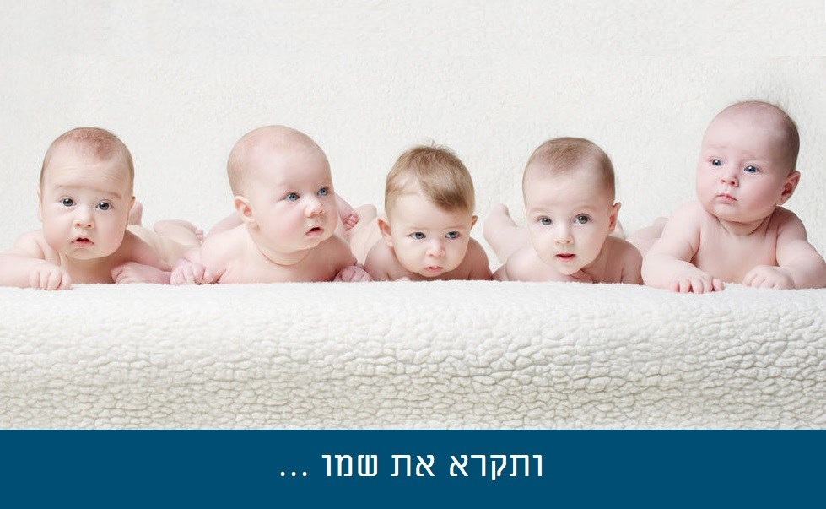

Who Names the Child at the Brit?

אלהינו ואלהי אבותינו קיים את הילד הזה לאביו ולאמו. ויקרא שמו בישראל פלוני בר’ פלוני. ישמח האב ביוצא חלציו ותגל האשה בפרי בטנה. כאומר ישמח אביך ואמך ותגל יולדתך.

“Preserve this child to his father and his mother and his name shall be called in Israel ….. son of … May the father rejoice in the issue of his loins and the woman in the fruit of her womb…”.[1]

These words come from the naming formula that has been recited at every circumcision, at least since the middle ages.[2] The fact that it refers to the infant’s parents in the third person shows that its framers intended someone other than the child’s father or mother to name him. The only biblical precedent for a child being named by anyone other than a parent – whether biological or adoptive – is King David’s grandfather Obed who was given his name by women who are described as Naomi’s neighbors:

רות ד:יז וַתִּקְרֶאנָה֩ ל֨וֹ הַשְּׁכֵנ֥וֹת שֵׁם֙ לֵאמֹ֔ר יֻלַּד־בֵּ֖ן לְנָעֳמִ֑י וַתִּקְרֶ֤אנָֽה שְׁמוֹ֙ עוֹבֵ֔ד

Ruth 4:17 And the women neighbors gave him a name, saying ‘A son is born to Naomi’. So they named him Obed…

It is not clear why the authors of “Preserve this child” ceded the privilege of naming to someone other than the parents; nor do we know why their formula became standard. In any event, the overwhelming majority of namings reported in the Bible are done by a parent, more often the mother (see n. 11 infra).

Contradictory Naming Accounts

Many of us consider themselves familiar with the Torah, which we presumably hear – if not study – year in year out. Yet there remain aspects that escape our notice. Speaking for myself, it was only tardily that certain anomalies with regard to the naming of children drew my attention.

Ishmael

Ishmael is a good example. An angel instructs Hagar to give the name Ishmael to the son she is being promised (Gen 16:11). Now the command to name is addressed directly to Hagar in second person feminine *’ve-qarat*’. Four verses later it says that “Abraham named his son that Hagar bore Ishmael.”[3] Is it pedantic to ask why Hagar neglected to carry out a specific directive imparted to her by the angel? Maybe yea maybe nay.

Seth

What about the double naming of Seth? Were it simply that the event was repeated, one would hardly bat an eyelid in view of the ubiquity of repetitions within the torah corpus. Contradictions are another matter. Gen 4:25 in the Masoretic Text (hereafter MT)[4] reads, “She bore a son and she called his name Seth ‘for God has granted me other offspring in place of Hebel whom Cain killed.’”[5] However, according to Gen 5:3 the name Seth was bestowed by Adam.

Commenting on 5:3 Nahum Sarna writes: “In 4:25 it was the woman who named Seth. The masculine [*va-yiqra*] is used here [at 5:3] because only the fathers are featured in the genealogies”.[6] But that begs the question as to why fathers alone are active protagonists in genealogies.

Naming Rights in the Priestly Source: Only Fathers

My eureka moment was when it dawned on me that the bulk of Torah genealogies[7] were possessed of characteristics peculiar to the Priestly strand of the Torah (hereafter P). And it is in P that mothers do not name. On the other hand, in Non-Priestly scriptures (hereafter NP) a father will occasionally name his son. Thus the criterion for distinguishing P namings from their NP counterparts is not which parent does it – since sometimes in NP the father does it – but rather the rationales (or more accurately: etiologies) that are the infallible hallmarks of NP naming – whether of children, of cities or of locations.

This etiological criterion applies not only in the Pentateuch but throughout the Bible down to the Book of Chronicles. Scholars have long recognized ancient material embedded in the early chapters of 1 Chronicles, including the story of Jabez whose mother “named him Jabez saying ‘I bore him in travail”’ (*be-otseb –*1 Chr 4:9).[8]

Who Named Levi?

The densest concentration of etiological rationales occurs in this week’s *parasha*. Leah names Zilpah’s sons in her role as their ‘surrogate’ mother and, of course, her biological children – or at least most of them.[9] In the MT, her third son, Levi, is named by a man (Gen 29:34).[10]However, where the MT has *qara shemo levi*, in both the Samaritan (that has *qar’ah*) as well as LXX, Levi is named by his mother.

On the strength of these two witnesses, many modern scholars presume the feminine inflexion to be ancient if not ‘original’.[11] Others conjecture that on account of Levi’s importance to the priesthood,[12] his naming was too consequential to be left to a woman. Hence masculine *qara*may have come to prevail in MT, albeit still retaining Levi’s etiology spoken by his mother Leah. Accordingly, a split procedure is created: the mother supplies the *de rigueur* etiology while leaving the actual naming to her husband. Such a partnership might help promote domestic harmony, but that makes it no less extraordinary. Extraordinary, not unique in view of Isaac’s naming.

The Split Naming of Isaac

Genesis 21’s style, vocabulary and, above all, its implicit theology are classic NP throughout, with the exception of verses 3-5 that sit uneasily in the context. The birth is reported in v. 2, and one expects a standard etiological naming to follow. Instead, we have to wait until v. 6 for Sarah to enunciate her יצחק etiology. But then, her etiology remains dangling, unattached to a naming because Abraham has preempted her in v. 3.

Abraham named his newborn son whom Sarah had borne him, Isaac. When his son Isaac was eight days old, Abraham circumcised him, as God had commanded him. Now Abraham was a hundred years old when his son Isaac was born to him. Sarah said ‘God has brought me laughter; everyone who hears will laugh with me.’[13]

So Abraham had no use for Sarah’s etiology, thank you very much, having long since bestowed the name יצחק upon his son.

Priestly versus Non-Priestly Naming of Isaac

All these seeming oddities are swept away if we accept the standard scholarly assumption that verses 3-5 have been spliced into the ancient narrative. Moreover, the three interposed verses are readily identifiable as P’s contribution. Among the clearest P indicators are Abraham’s age and Isaac’s eighth day circumcision. NP shows nugatory interest in dates or in people’s ages in contradistinction to P that consistently makes a point of registering them.

To be sure NP describes Abraham and Sarah as “old, advancing in years” (Gen 18:11) but not necessarily centenarian and nonagenarian respectively. In fact, when it goes on to say that Sarah “had ceased to have the way of women” it sounds as if she had but recently ceased rather than decades earlier. The only other place where the patriarch’s age is given as 100 is Gen 17, the same chapter that ordains the quintessentially P rite of eighth day circumcision.

It is tempting to speculate that prior to P, Sarah had been the parent to name Isaac in Genesis 21, between the report of his birth (v.2) and the name’s elucidation (v.6). But perhaps Isaac, who was destined to become one of the founding fathers of Israel and to assume quasi mythical status, needed a name conferred by a male according to P’s value system.

If some such scruples impelled Abraham’s supplanting Sarah as Isaac’s namer, then Levi’s fate in MT would be comparable. For as already noted, Jacob snatching the actual naming from Leah mid-sentence (Gen 29:34), was very likely another manifestation of a trend, beginning with P, to bar women from key solemnities. Hence, P might well have been the inspiration for these changes away from women.[14]

From Etiological Naming to Paponymy

As rewarding as it might be, this is hardly the place to pursue a comparative study of the versions. Such a study would have to take in the Dead Sea Scrolls insofar as they yield biblical texts, or fragments of text, for comparison. Jubilees too is instructive inasmuch as it represents a further stage along the continuum of restrictions on name-giving. Written around 150 BCE, Jubilees is one of the earliest Jewish texts to explicitly endorse paponymy, i.e. the naming of a boy after his grandfather (Jub. 11:15).

The adoption of paponymy by Jews was arguably responsible, at least to some extent, for the further erosion of the old Israelite custom of devising ad hoc names whose meanings were of immediate relevance to the parents. Jubilees offers no clue as to why naming after an ancestor gained favor. It is instructive to see the Rabbis’ attempt to explain the phenomenon.

ר’ יוסי א’ הראשונים על ידי שהיו מכירים יחסיהם היו מוציאים לשם המאורע, אבל אנו שאין אנו יודעין את יחסינו אנו מוציאין לשם אבותינו,

“R. Yose says: The ancients who knew their genealogies would produce names[15] befitting the occasion. We who do not know our genealogies produce names after our ancestors…” (Gen. Rab 37, v. 25).

R. Yose’s insight seems to be that as long as people are confident about their origins they feel no urge to harp on them.

[View Footnotes](https://www.thetorah.com/article/baby-naming-biblical-rites-and-mothers-rights)

Published

November 27, 2014

|

Last Updated

September 28, 2024

1. Machzor Vitri 506, p.626; Alternatively: ישמח האיש ביוצאי חלציו ותגל האשה בפרי בטנה (Shibbolei ha-Leqet p. 373). Others: ישמח האב ביוצאי חלציו ותגל אמו בפרי בטנה (e.g. Baer’s Avodat Yisrael, 1868 p. 583).
2. Widely attested by the 12th-13th centuries though not found in the prayer books of the geonim Amram and Sa’adia that have different formulae.
3. וַיִּקְרָ֨א אַבְרָ֧ם שֶׁם־בְּנ֛וֹ אֲשֶׁר־יָלְדָ֥ה הָגָ֖ר יִשְׁמָעֵֽאל
4. The Samaritan has ויקרא.
5. וַיֵּ֨דַע אָדָ֥ם עוֹד֙ אֶת־אִשְׁתּ֔וֹ וַתֵּ֣לֶד בֵּ֔ן וַתִּקְרָ֥א אֶת־שְׁמ֖וֹ שֵׁ֑ת כִּ֣י שָֽׁת־לִ֤י אֱ-לֹהִים֙ זֶ֣רַע אַחֵ֔ר תַּ֣חַת הֶ֔בֶל כִּ֥י הֲרָג֖וֹ קָֽיִן
6. The JPS Torah Commentary by Nahum M. Sarna, 1989 p. 42.
7. Not all. The Edom-Seir genealogies plus the king list (Gen 36) do not fit the P mould. Moreover, some P genealogies appear to incorporate older material  e.g. the naming of Noah (Gen 5:29) that uses the tetragrammaton (a divine name studiously avoided by P prior to the name’s disclosure at Ex 6:3). Also, Gen 5:29  plainly  alludes to a curse pronounced on Adam in Gen 3:17 – a demonstrably NP text.
8. וַיְהִ֣י יַעְבֵּ֔ץ נִכְבָּ֖ד מֵאֶחָ֑יו וְאִמּ֗וֹ קָרְאָ֨ה שְׁמ֤וֹ יַעְבֵּץ֙ לֵאמֹ֔ר כִּ֥י יָלַ֖דְתִּי בְּעֹֽצֶב
9. Gen 29:32,33,35; 30:11,13,18, 20—21.
10. The man is anonymous, but Rashi, on midrashic authority, identifies the man as the angel Gabriel (see n.7 below).
11. Typical is Karla G. Bohmbach who must take it for granted that Leah named all her children including Levi in order to obtain her otherwise useful statistic: “In the Hebrew Bible women outnumber men as name-givers. Of the approximately forty-seven instances in which a name-giver is specified, twenty-nine involve women”. If that were not clear enough: “Leah names individually all of the nine children that she claims as her own”.(“Names and Naming in the Biblical World” in *Women in Scripture* edited by Meyers, Craven and Kraemer Houghton Mifflin 2000 p.37).
12. Having identified Levi’s namer as Gabriel (n. 5 above), Rashi’s midrashic source continues: “and he [Gabriel] bestowed upon him [Levi] the 24 priestly entitlements [mostly listed in Num 18]”.

ג וַיִּקְרָ֨א אַבְרָהָם֜ אֶֽת־שֶׁם־בְּנ֧וֹ הַנּֽוֹלַד־ל֛וֹ אֲשֶׁר־יָלְדָה־לּ֥וֹ שָׂרָ֖ה יִצְחָֽק: ד וַיָּ֤מָל אַבְרָהָם֙ אֶת־יִצְחָ֣ק בְּנ֔וֹ בֶּן־שְׁמֹנַ֖ת יָמִ֑ים כַּאֲשֶׁ֛ר צִוָּ֥ה אֹת֖וֹ אֱ-לֹהִֽים: ה וְאַבְרָהָ֖ם בֶּן־מְאַ֣ת שָׁנָ֑ה בְּהִוָּ֣לֶד ל֔וֹ אֵ֖ת יִצְחָ֥ק בְּנֽוֹ: ו וַתֹּ֣אמֶר שָׂרָ֔ה צְחֹ֕ק עָ֥שָׂה לִ֖י אֱ-לֹהִ֑ים כָּל־הַשֹּׁמֵ֖עַ יִֽצְחַק־לִֽי:

1. This might also be relevant to the naming of Jacob. (Gen 25:26). Unlike Esau who is named by both parents jointly in MT (Gen 25:25), Jacob is named by his father alone (v.26). Again the Samaritan diverges, reading *va-yiqre’u* for Jacob too. Out on a limb is LXX that has the mother singlehandedly etiologizing and naming both sons.
2. The Hebrew original:  *motsi’een*which literally means to bring out, and is the semantic equivalent of the bavli’s derivatives of the verb  *nasaq.*