Chapter 1: Mechanisms: From Dominance over Nature to Dominance over People

How did states end up controlling the earth’s vast, once-untamed nature? And how did this process of taking control, in turn, affect local communities? Resources like forests and pastures are inherently local. Nonetheless, state actions affect local populations: trade, taxes, ownership rights, nearby development projects, and so on. In this chapter, I look at examples from Asia and the rest of the world to examine how the state has exerted its dominance over nature, with collateral effects on local populations. I investigate the methods used by governments and the sequence in which policies are implemented. By examining typical patterns of these mechanisms, I explain how the emerging new policy areas are in dire need of a justice-centered analysis.

# 1.1 Color-coding the domains of governance

## The project of “legibility”

In many developing countries, the state uses nature to extend its power without engaging in consultation with civil society. Such countries are racing through a development process that took well over a century for many advanced countries to complete. The process has become compressed into mere decades. Caught in this rapid cycle, many up-and-coming countries are ill-prepared to deal with any crises that might result from dealing with such resource development at breakneck speed. Civil societies, regardless of the level of development in which they are placed, are also relatively ignorant of which “environment” needs protecting and why.

The late-growing economies in Southeast Asian nations, such as Laos, Cambodia, and Myanmar, are good examples. Highly reliant on outside assistance, these countries turn to foreign companies for help with large-scale development projects. They also look to other countries or international organizations for institutional and technological solutions to environmental problems. Many of these “imported” policies generate unexpected effects, underscoring the difficulties with external solutions being applied in new local contexts. For example, the REDD+ projects moderated by the United Nations have been criticized as having failed in multiple cases across three continents (Jones and Lewis, 2023).

The process described above sets out a pathway for the typical transformation of developmental states into environmental states. The concept of environmental states elucidates one aspect of the governmental attempts to expand its authority in the environmental field until it encompasses interactions between people, reshaping relationships and the fabric of society—a process that can cause inversion. When seeking to justify its intentions, an environmental state may use a variety of rhetorical techniques to define what it deems to be “problems.” It selectively emphasizes particular aspects of environmental issues while also downplaying their complexity. We need to understand the forces at work during this framing process. We also need to remember that a state will not take action on issues such as depleted resources or pollution, or implement particular solutions, simply because these problems exist. The state does not cause inversion just because its interventions are too imposing, but rather because it constructs social mechanisms to nudge local communities toward accepting such impositions.

As outlined in the preface, the environmental state does not simply materialize once a state finds itself at some identifiable point of no return. The state’s systematic involvement with nature begins with the development of sectors like forestry and irrigation. The state then expands activities into other spheres, such as sustainability and environmental protection, and through this process, becomes an “environmental state.” There are many signs indicative of the emergence of an environmental state. A country may establish government ministries responsible for implementing comprehensive environmental policies or craft laws to legitimize this new activity. It may also institutionalize regulations and systems of redistribution. Finally, a state may cultivate environmental experts encouraged to educate the public (Duit et al. 2016). Figure 1.1 shows the number of environmental agencies and volume of legislation passed in Latin America, with a dramatic increase in the number of governmental bodies after the Rio Summit of 1992. A steep and consistent growth of environmental engagement in Latin America demonstrates that the rise of the environmental state is not limited to Asian regions but is rather a global trend.

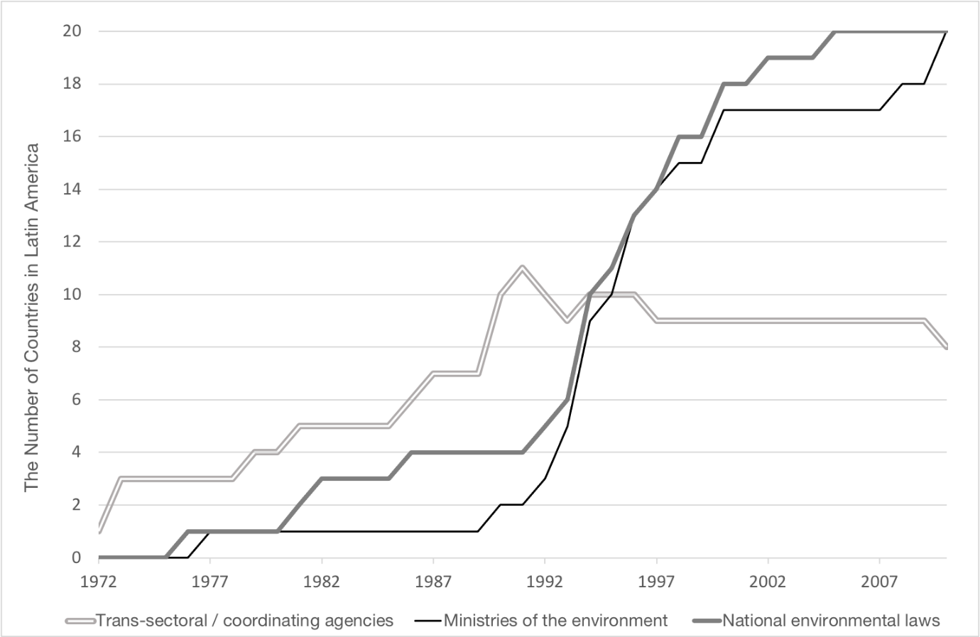

Figure 1.1 The diffusion of trans-sectoral agencies, ministries of the environment, and national environmental laws in Latin America, 1972–2012

Source: Orihuela (2014)

To fully understand how an environmental state functions, we need to look beyond its administrative systems. We also need to consider how the state’s environment-focused interventions reverberate throughout society.

When modern nations first sought to identify “legible” targets of government policy, they classified people according to race, occupation, and religion. Similarly, a state wanting to intervene in nature must embark on a similar process of establishing legibility to ensure that policy targets can be monitored and manipulated (Scott 1998: 2). Why is this necessary? The “environment” that surrounds human societies is perceived through our senses (heat, smell, and so on), making it a poorly defined target for coherent policies. An additional hurdle toward making the environment a subject for policy debate is that developmental states usually have a history of doing the exact opposite. Government officials often spend decades asserting that pollution is a necessary evil that comes with economic development, dismissing contamination incidents as merely local issues, and thus, they lie outside the purview of the state. After a state has clung to this narrative for a long time, it begins to argue that environmental policy is, quite suddenly, an issue that requires intervention at the national level. This is where the question of legibility comes in.

Governments use a range of technologies and systems to label problems as issues that need intervention. “Intellectual infrastructure,” such as statistics and maps or area photos, can be used to demonstrate where and how the environment has changed. Governments can foster citizen organizations to engage with specific issues, their causes and potential solutions, and they can craft laws to regulate these organizations. One key tool for conceptualizing global warming, for example, is to put a price on CO2 emissions. Carbon pricing in practice, however, has proven to be a tremendously difficult undertaking. Countries have difficulties in pinpointing the source of CO2 emissions. Creating a system of reporting and trading them is even more complex. Policy-makers struggle to understand and address the social and political impacts of carbon pricing. It's hard to identify where carbon pricing can be effective and where targeted policies may be needed (Stoll and Micharl 2021).

Governments can also make problems identifiable by resorting to images. Color-coding areas under their jurisdictions—for example, green for forests and brown for polluted land—is a common practice along this line. When otherwise undefined sections of nature are color-coded, they are transformed into something that is tangible enough to be targeted by government policy. As an example, let’s look at the use of green. This color evokes thoughts of forests, biodiversity, and conservation. It is synonymous with environmentalism, as evidenced by its use in the names of political parties that fight for “green” causes. Notably, this symbolic association did not emerge through public consensus but was first used by policymaking bodies, including the United Nations. This suggests that the political identification of policy targets through color-coding is part of the preparation for the state to penetrate into the political periphery.

## When politicians manipulate nature

The root causes of environmental problems, like those discussed in the Introduction, are not easily identified. This makes it hard to recognize the burdens that conservation imposes on people. It also leaves environment-related policy initiatives open to political manipulation. When these policies become inverted, those who suffer the most are usually the ones with the least political power. Nature is an easy target for power games.

We observe here that the global network of commodities influences the way environmental states behave in each location. Two processes illustrate this. Between 1970 and 1982, Japan imported so much wood that it was denounced as an “environmental terrorist.” During this period, tax collected from timber in the Philippines (logs, planks, and plywood), as reported by the forestry companies, accounted for only 14.8% of the total value of its timber exports (Kuroda 1989). This suggests that a large proportion of logging profits bypassed the Philippine Treasury (Repetto and Gillis, eds. 1988). Such over-exploitation is unsustainable, but it persists for economic development that may not be equitable. In an ideal scenario, profits from resource exploitation and the natural environment accrue to the government in the form of tax money. Then—and again, only in an ideal world—they are used to improve the lives of the people. More commonly, instead of filling the government coffers, the wealth often ends up lining the pockets of elites, as exemplified by Japan’s timber imports from Southeast Asia.

Profits may still contribute to the state’s power in ways other than taxes. During Suharto’s rule as president of Indonesia (1968–1998), for example, government officials commonly used forest and oil reserve concessions as political currency. Although logging concessions had great commercial value, this alone does not explain their importance to Indonesian politicians. Valuable concessions covered businesses in remote regions, meaning that the exploitation of forests could continue without much oversight. To ensure profitability, the Indonesian government applied low logging levies on the businesses, and some of these profits were earmarked for development projects endorsed by Suharto (Ascher 1999). It was this sort of developmental state arrangement that became the foundation of the subsequent emergence of environmental states.

This setup allowed the Indonesian government to secretly finance projects that would not have withstood public scrutiny in parliament. Kickbacks from logging companies enabled politicians to consolidate their power base with no legislative oversight. Suharto, for example, diverted the enormous wealth generated by exploiting the nation’s forests to the aircraft industry. The Indonesian government’s decision to set logging levies below market value also had consequences beyond immediate economic concerns, leading, for example, to accelerated deforestation because companies were granted concessions that were far larger than what they needed.

Massive revenues from oil extraction played a similar role in Indonesia’s corrupt system. To secure his power base, the President needed to keep the army in check. Oil revenue, like the logging profits, bypassed the treasury to disappear into the pockets of the military, thus allowing Suharto to maintain control over the armed forces.

In Japan, companies anxious to avoid government oversight manipulated information with the deliberate intent of misleading the public. In 2006, the Japanese media reported that the steel manufacturer Kobe Steel (Kobelco) had been falsifying emissions data in a similar manner to the case of Showa Denko, a chemical engineering firm. The deception had been going on for decades, and both companies claimed that they had under-reported their pollutant emissions because of concerns over government intervention. In addition to evading regulation, fabricated public records also have the effect of greenwashing, when companies falsely paint themselves as environmentally friendly and hoodwink conservation-minded investors. European and American companies also commonly engage in greenwashing (Lyon and Maxwell 2011). Greenwashing can take a variety of forms, from product-level claims with environmental labeling to firm-level nature-evoked execution elements in sustainability reports, which makes it difficult for consumers to identify the manifestations of the phenomenon (De Freitas et al. 2020).

Developmental states in the past limited their interventions to natural resources and infrastructure. Today, their domains extend to aspects of nature essential to human life: air, climate, and water. In the environmental state, regulations ostensibly imposed to limit pollution and prevent overexploitation often become opportunities for pork-barrel politics. Government incursions into new domains—and the reactions these elicit from companies and individuals—can become the seeds for inversion. Preventing inversion, however, is hampered by the existing relationships built during previous interventions, which under the developmental state phase, emphasized resource exploitation rather than conservation. Neither the vested interests of these partners nor the processes developed in state institutions have necessarily changed into the environmental state phase.

# 1.2 How states expand their domains

## When the management of resources becomes the management of the environment

Natural resources were once controlled by local governments. How did the environment end up under the jurisdiction of the state instead? While we will leave a detailed discussion of this topic until Chapter 2, a quick sketch of the history of Japan and other Asian countries provides an indication.

When countries in Asia first began their transformation into modern nations in the late nineteenth century, their governments perceived resources like woodlands and mineral deposits as commodities to be exported to secure funds for modernizing key equipment, such as those for industrialization and empowering the military. Chapter 2, for example, describes how Japan’s cash-strapped Meiji government had no hesitation in auctioning off government-owned forests. Minerals got the same treatment. The Meiji government sought to commodify precious metals, ranging from gold and silver to iron and copper, to fuel the modernization of Japan. Management of land and fishery resources by the state came later, but Japan advanced to this stage relatively quickly. After all, land surveys had been organized since the Sengoku period (mid-fifteenth to late-sixteenth centuries) to govern its limited amount of arable terrain.

When the Meiji government in the nineteenth century wanted to strengthen its management of the nation’s land, it already had access to a great deal of information. All land registered with the state was included in a cadastral map, which the government used as the basis for levying land tax. Over time, the state’s environmental interventions surpassed its systems for economic gain, and broader management of the environment came under its purview. This expansion of state involvement is obvious in the development of recent climate policies that override earlier regulations on water and air pollution. While net-zero policies to tackle climate change will accelerate current progress towards clean air, not all interventions have reinforcing or universal co-benefits for air quality and climate (The Royal Society 2021).

Today, the growth of state interests has reached beyond the sphere of the planet, and national governments and international forums deliberate resources and responsibility of cleaning up the debris in outer space, which may give birth to a new type of environmental state without any “local residents.” In short, as the example of Japan shows, state control over the natural environment does not evolve by itself. As governments expand their interests, they impose controls.

Moves toward the environmental state have proliferated since the 1972 United Nations Conference on the Human Environment. The Stockholm conference became the catalyst for developed and developing countries worldwide to set up systems for implementing environmental policies. The Southeast Asian nations were no exception. In 1974, Malaysia enacted the Environmental Quality Act, which introduced comprehensive environmental regulations. Thailand followed suit in 1975. The Philippines established full-fledged legal and administrative structures to manage environment-related risks in the late 1970s, with Indonesia doing the same in the early 1980s. Vietnam, a relative latecomer, did not take similar steps until the 1990s. Cambodia did not have an environmental policy until the final years of that decade. Both Vietnam and Cambodia experienced difficulties enforcing the policies enacted by their newly created institutions. They only jumped on the conservation bandwagon thanks to support from Organisation for Economic Co-operation and Development (OECD) countries and the World Bank, which sent expert advisors and significant financial help.

In terms of governance, the management of natural resources has implications that go far beyond what we would consider the “environment.” It affects the development of infrastructure, taxes levied on particular products, the collection of data on resource distribution, and more. Let us look at another example. Table 1.1, charting the chronological development of environment-related administrative bodies in Thailand, shows how its environmental state emerged. This table helps us to understand a key mechanism of the environmental state: how it converts dominance over nature into dominance over people.

At this point, it should be noted that countries seeking to control nature are not always planning to increase their control over people. Phenomena such as the loss of biodiversity, pollution, and deforestation have become increasingly prominent policy issues in and of themselves since the 1990s. Government agencies tasked with providing solutions for these crises have, however, mostly approached the issues from a conservation perspective. Dominance over people is more often an unintended byproduct. However, intentions and results are inevitably different. The effects of intervention can reverberate far beyond the government’s intended objectives. For example, a conservation project that increases the acreage of a forest may necessitate the displacement of indigenous people living in the area. When these people relocate, they will fall trees in the new location in support of their livelihood. Ultimately, this “successful” afforestation project may well end up making overall deforestation worse. The lesson here is the value of focusing on the effects of intervention, not the motives behind them.

The right-hand column in Table 1.1 shows the social effects of various interventions. When the state attempts to manage a particular resource, it enforces a system based on a logic of inclusion and exclusion. It is often convenient for a government to single out a particular group of people as the “cause” of a problem while others are identified as those who provide the “solution.” More to the point, these stakeholders do not start out as equals. Government interventions tend to adversely affect people who are already disadvantaged in terms of economic power, ethnicity, gender, residence, or language.

Table 1.1 Sequence of state interventions in the environment

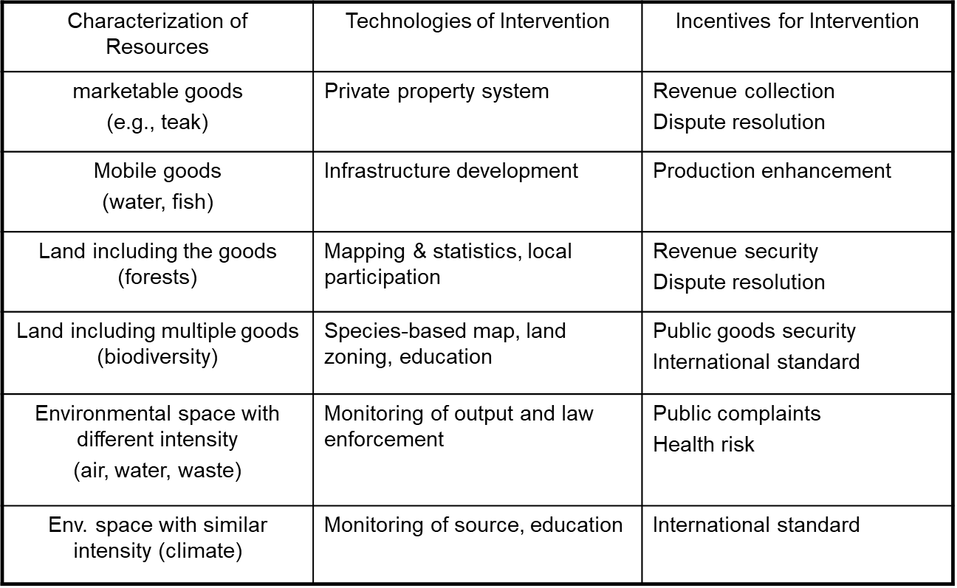Source: Created by author

Concerns over adverse effects are particularly relevant when discussions move from tangible, visible resources like the “soil” to abstract concepts for which the state has to establish standards that may seem arbitrary. Radioactive contamination and declining biodiversity are good examples. Here, the outcome of an intervention depends on the level of education and awareness of the people involved. Even when an initiative is nominally successful, it may lead to the widening of existing disparities between those who set the standard and those who have to take the standards as given.

Not every country will expand the scope of its environmental interventions in the order shown in Table 1.1. Interventions come at different points in time and have varying levels of success, depending on local circumstances. In the Philippines, for example, water regulations introduced during Spanish colonial rule were the earliest environmental intervention by the state (Magtolis and Indab 2008). Many Southeast Asian countries have a high ratio of land to population, and thus, these tend to prioritize securing a labor force. They may also postpone establishing private ownership for every plot of land in their territory because the necessary cadaster production would be incredibly complex. Japan demonstrates the mirror case: arable land is scarce, and the central government became involved in land registration at an early stage (see Chapter 2).

Some scholars note that environmental states in developed countries are already showing signs of decline. Environmental sociologist Arthur Mol, for example, found that in many developed nations the number of people employed by environment-related ministries and government agencies was stagnant or falling (Mol 2016). However, in less developed countries that depend on large flows of aid, the environmental state is still expanding.

In trying to adjust to the changes wrought by environment-oriented policies, people often find themselves reeling at the speed at which policymakers target more and more aspects of nature. Take Laos and Cambodia, two of the least developed countries in Asia. Compared to Thailand or Japan, which began their modernization process at the end of the nineteenth century, Laos and Cambodia are racing through the steps outlined in Table 1.1. An important factor here is the resource-hungry Chinese economy, whose constant expansion has fueled a steep increase in the value of mining and development concessions.

In Cambodia, in particular, it is reportedly not uncommon for power-seeking politicians to grant concessions on forests and the like to senior bureaucrats (Global Witness 2009). When companies from China, Thailand, and Vietnam offer direct investments to the rural areas of Laos and Cambodia, there is more at stake than funding mining operations and other resource extraction-related activities. The situation also encourages a shift in land use from small-time farming to large-scale cultivation of cash crops like rubber and sugar cane. This transition can take place very quickly. According to a 2012 study by the University of Bern in Switzerland, foreign direct investment in land rose fifty-fold over the preceding ten years alone, with about 5% of the country’s territory commodified in this manner (Schönweger et al. 2012). Governments of developing countries are selling large tracts of land through a concession system, using licenses and contracts to give businesses the exclusive right to exploit specific areas and develop them economically.

As we have seen, governments at present have expanded their influence on people through the environmental more gradually. However, this may change once they start implementing significant measures to mitigate the looming effects of climate change. Extreme weather patterns are already driving up food prices in the Middle East. As the Arctic icecap melts, Canada, the USA, and Russia are becoming locked in a struggle for submarine resources. Competition in technological development is also mounting, spurred by regulations on CO2 emissions. This is increasing confrontations over energy. For example, when the Chinese government poured massive subsidies into the solar industry, the USA imposed retaliatory tariffs (Busby 2018). Countries are also facing disasters more frequently. Japan, for instance, is building towering seawalls along its northeastern coast to weaken the effects of possible tsunamis. This is a drastic measure even for the Japanese, who are accustomed to natural disasters. Updating infrastructure to adapt to climate change is tremendously costly and will permanently alter the coastlines and fishing ports.

## When the state clashes with local people

Not all states follow the same procedure in converting nature into resources. However, it is possible to make some generalizations about the process. Figure 1.1 is a conceptual illustration of how the state expands its domains of governance; the space within the dotted lines represents the shrinking domain of the people. Note that while Figure 1.1 shows that the amount of control held by the people is steadily declining, this is not a reduction in a quantitative sense. As Chapters 4 indicates, citizens under the dominance of the state still maintain a measure of autonomy within the official system. They may, for example, be able to establish communal lands.

Frequent clashes and confrontations occur along the border where the spheres of control of the people collide with those controlled by the state. The fiercest conflicts often revolve around access to the land and resources that local people have long relied on for their livelihood. When the Japanese mining industry intensified during the Meiji era, for example, there were near-constant clashes between companies, authorities, and local residents over issues like forest access, water usage, and pollution.

Other similar incidents have been well-documented in Japan. One famous example is the so-called Ashio Copper Mine Incident in the late nineteenth century, one of the earliest cases of reported environmental damage. Pollution and deforestation related to mining operations caused tremendous environmental devastation in Japan’s central Tochigi prefecture. Around the same time as Ashio, the livelihoods of the residents in the town of Kamaishi (in Iwate Prefecture on the eastern coast of the country) came under threat. Fishing in the Owatari River, a vital aspect of the local economy, was jeopardized when a nearby foundry siphoned off large volumes of water for its smelting operations. Angry fisherfolk shut off the factory’s waterway, and the company responded by appealing to the courts for damages (Hayasaka 2013). The core issue at hand was whether the foundry, in the course of its steelmaking operations, had an obligation to ensure that the traditional fishing activities of the locals could proceed unimpeded. The court ruled against the fishing community. This conflict exemplifies the regularity of clashes over resource use between residents and state-backed industrial development policy in Meiji-period Japan. It also illustrates the state’s perception of its right to suppress locals who objected to its policies, often mobilizing police interventions.

Figure 1.2 Expansion of the environmental state as the domain controlled by citizens shrinks

Land

1990

1890

1910

1950

1970

Fisheries

Forests and Mineral

Water and Ecosystem

Climate, Air,

Energy

1930

2000

Spheres of State Influence

Domain of the People

Source: Created by author

When a nation-state modernizes, the government often colludes with private companies. When the government intervenes to protect natural resources, the result is not always a violation or suspension of citizens’ rights. For instance, when a government tries to regulate air pollution, it may restrict emissions by private companies to protect people’s right to clean air. In such cases, government intervention in environment-related conflicts or pollution incidents regularly does benefit the general population. However, considering this from a more sinister perspective, a state that imposes restrictions on emissions is indirectly expanding its influence. It is chipping away at the rights of citizens to public space and shifting more authority to the central government. Again, we should keep in mind that such measures may not constitute a deliberate attempt on the part of the government to extend its sphere of influence.

In some developing countries with vast wealth gaps, the government has convenient scapegoats in the form of ethnic minorities and impoverished citizens. By blaming environmental destruction on individuals who refuse to comply with the rules or have “strange” customs, a government can increase its control over resources under the guise of conservation.

When states establish national parks and wildlife sanctuaries, for example, they are effectively bringing extensive tracts of land under state control. According to a worldwide survey of national parks conducted by Masaaki Yui and Katsunori Furuya (1997), parks were first established in North America and Australia in the nineteenth century, with countries in Europe and South America following suit in the early twentieth century. After World War II, African countries began establishing national parks at a rapid rate (see Figure 1.2).

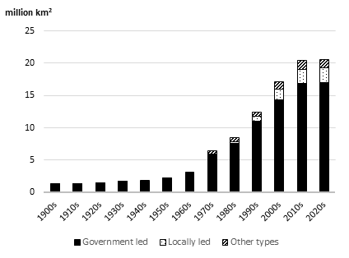

Figure 1.3  The increasing terrestrial and inland water protected areas worldwide and its governance type

Source: based on data from The World Database on Protected Areas (www.protectedplanet.net)

Note: “Government led” includes: Federal or national ministry or agency in charge, Sub-national ministry or agency in charge, and Government delegated the management to another organization. “Locally led” means under the governance of local communities or indigenous people. “Other types” include: Transboundary governance, Collaborative governance, Joint governance, Individual landowners, Non-profit organizations, For-profit organizations

Since their inception, national parks have been sites of conflict. Reports of persecution of ethnic minorities, illegal logging, and displacement of local people from reserve areas are common all over the world (Brockington and Igoe 2006)[1]. A global study covered 225 Protected Areas worldwide by Zafra-Calvo et al. (2019) reveals that more strictly managed PAs performed worse in terms of local people's ability to access mechanisms to address conflicts and attain justice. In places of heavy population growth, people evicted from the sites of newly established national parks often clash with the original inhabitants in the relocation areas.

Over time, governments have turned their attention away from location-specific resources, such as forests and land, to transferable elements of the environment, including water. They also perfected the techniques used to intervene in nature. Striving to address problems, like shrinking biodiversity and climate change, that are indirectly impacting on the daily lives of many people, they have also shifted their focus to educating the public. This includes projects to raise awareness about global warming and CO2 emissions among the rural population, often under the label of “environmental education.” One result of this science-based teaching is that it refutes the indigenous knowledges of the local people regarding the forests, rivers, and other resources they depend on. Much indigenous knowledge is indeed sustainable and worthy of the title of science (Hendry 2014). Step by step, people are made dependent on a government-approved system of formal science-based knowledge (Sasaoka 2019). For example, when citizens negotiate with the government to confirm the boundaries of shared woodland resources, they often discover that their indigenous knowledge about the extent of their lands is considered invalid. They must know how to demarcate their territory on a map with technology such as GPS (Sugimoto 2013). To safeguard their space, people are being forced to learn to use technology instigated by the government.

The body of literature discussing land grabbing in Southeast Asia has significantly increased (see special issue edited by Schoenberger, 2017). In the early 2000s, the concept of the “land grab” acquired a new dimension: the “green grab,” which is when land previously used to produce food and fuel is appropriated for conservational purposes (Fairhead et al. 2012). The build-up of palm oil plantations, for example, is frequently touted as an essential step toward the increased use of carbon-neutral fuels, but companies rarely acknowledge that these biofuels also have great commercial value.

The causes, conditions, and consequences of land grabs and climate change politics are inherently intertwined. Effective climate change mitigation and adaptation require addressing global land grabs, and vice versa (Franco and Borras 2019). A case study on Cambodia by Scheidel and Work (2018) demonstrates how discussions and beliefs around climate change and forestry policies can further displace local communities from their land and forest resources. The evidence of green grabs highlights the need to pay attention to how global environmental agendas and conversations can result in land use outcomes that disadvantage customary land users.

States or companies that “greenwash” interventions always use science as their justification. At this point, there appear to be no policies that are not motivated by or reliant on science (see a detailed discussion on science in Chapter 5).

# 1.3 Mechanisms of domination

## Wittfogel and total power

When a government and people clash over resources or the environment, we tend to assume that the conflict concerns only the specific problem at hand. However, this is rarely the case. When state power is concentrated around decisions on the use of natural resources in specific sectors such as fisheries and forestry, the impact of government interventions often spills outside the boundaries of these sectors.

German sinologist Karl Wittfogel (1896-1988) was the first to argue that a country’s system for managing resources forms the basis of how it organizes society. Wittfogel published his argument in the 1957 book *Oriental Despotism*, which he subtitled *A Comparative Study of Total Power*. He analyzed flood control systems in Asian countries, outlining how cooperation between the state and citizens on water management projects can end with the state wielding unfettered and ruthless power (Wittfogel 1957). His analysis was the first clear articulation of how a mechanism for controlling resources can lead to dominance over people by the state.

Let us take a closer look at this pioneering work. Wittfogel began by pointing out that a country’s social order relates to how it handles the division of labor, building on Adam Smith’s analysis of this topic in *The Wealth of Nations*. Smith (1976 [1904]) argued that agriculture tends to develop at a slower pace than industry because agricultural work is less suited to the division of labor than that of the industry.

Was Smith right to characterize agriculture as an activity that is ill-suited to the division of labor? Wittfogel says no. In his articulation, Wittfogel did not focus on agriculture as such but instead on the systems of water management that are key to successful agricultural irrigation. He noted that these systems require a significant division of labor, both to implement irrigation systems and prevent flooding. So-called “hydraulic societies,” according to Wittfogel, require a great deal of civil engineering work that is easily subdivided into separate tasks.

Large-scale projects like irrigation works are based on advanced knowledge. Managers of hydraulic economies must have an understanding of astronomy sophisticated enough to create calendars, as well as complex mathematical skills in order to calculate the numbers of workers needed and maintain records. In Wittfogel’s words, “A large quantity of water can be channeled and kept within bounds only by the use of mass labor; and this mass labor must be coordinated, disciplined, and led. […] The masters of hydraulic society were great builders because they were great organizers; and they were great organizers because they were great record keepers” (Wittfogel 1957: 18).

The intrinsic nature of large-scale irrigation clearly touched societies in ways that extend beyond their water management practices. Resource management necessitates the management of the people who are managing the resource. Those conscripted by the state as labor for massive engineering projects can also be mobilized in times of war, another example of a significant nationwide effort. In short, hydraulic societies rely on an integrated power base that originates with flood control projects.

Wittfogel was harshly criticized for preaching an environmental determinism that discounted human agency, i.e., the possibility that humans could control nature. Still, his insights offer one of the earliest systematic explanations of how state dominance over nature can become dominance over people.

Scholars still commonly explain the political and social circumstances of a country based on its management of resources. Historian Judd Kinzley, for example, studied the history of the Xinjiang Uygur Autonomous Region, an area of worsening ethnic strife since the 1990s. Tracing the conflict back to resource development that started in the early twentieth century, Kinzley (2018) argued that parts of the region experienced wave after wave of exploration and infrastructure-building, from mining facilities to railroads and other transportation. The result was a wide and still-widening gap between resource-rich and resource-poor areas. In Kinzley’s analysis, the unmistakable ethnic violence in Xinjiang is a symptom of the inequality created by resource development. Once in place, economic foundations create favorable conditions for attracting even more investment, increasing opportunities for profit, and eventually becoming a locus of political power.

As Wittfogel observed, state interventions in resources spread throughout a country by mobilizing labor from each region, with the level of penetration increasing over time in conjunction with investment accumulation.

## Popular resistance

If resource development brings economic opportunities to people who live only in specific regions of a country, others will miss out. These disadvantaged groups find it very difficult to change their circumstances once they have been excluded. Even in these situations, some options remain. When state benefits accrue wealth and power from resource networks and people, it is possible to resist that power by interrupting the flow of such networks in targeted ways.

How does this happen in practice? Political scientist Timothy Mitchell studied the history of energy procurement in Western countries, focusing on how democratic societies are influenced by their dependence on fossil fuels (Mitchell 2011). In the past, people mainly used firewood for energy. Forests were everywhere, providing both scattered and ubiquitous sources of fuel. As coal rose in prominence, people became more concentrated around the specific geographic areas where this new source of energy could be efficiently extracted, which also necessitated the spatial concentration of labor.

Why did such population centers provide the fertile soil for democracy? The answer, according to Mitchell, is that the Industrial Revolution relied entirely on coal for energy. This gave coal workers powerful political tools, from strikes to acts of sabotage, for expressing their grievances. The new industrial structure enabled workers to make their voices heard, and whenever capitalists and the ruling class saw their income threatened by worker action, they were forced to listen. Modern industry is, in fact, still an interconnected web where one malfunctioning node can paralyze an entire production process. As one member of the French railwaymen’s union said to Mitchell, “With two pennies-worth of a certain substance, used in the right way, we can make a locomotive unable to work” (Mitchell 2011: 23).

This power structure between workers and capitalists had far-reaching consequences. For one, the industry’s shift from coal to oil was not just an energy transition. It also meant that workers lost much of their earlier leverage. Why? Oil is much easier and cheaper to transport than coal. Once energy could be transported efficiently to wherever production costs were lowest, manufacturers were no longer physically bound to specific energy-producing areas. Management was no longer reliant on a particular group of workers. Furthermore, while coal mining takes place deep underground, tasks associated with extracting oil happen above ground and are more automated, which means significantly fewer workers. These workers are also much easier to oversee than those who spend their days hidden in dark mine tunnels.

In a comparison of the different working environments required to produce and use wood, coal, and oil, Mitchell concluded that coal was the most likely energy source to generate conditions for effective resistance by resource workers. Coal miners were so successful at industrial action simply because their opponents were economic elites utterly dependent on the input of their workers.

## Can administrative agencies dampen development?

Labor movements use strikes and other forms of industrial action to resist developmental states from the bottom up. But they are not the only stakeholders capable of mounting opposition. Some groups *within* the government itself can hinder development.

As pointed out earlier, countries around the world have been establishing government agencies for environmental conservation since the 1970s. These agencies can curb rampant overdevelopment and are expected to provide oversight—for example, through an environmental assessment system—to ensure that the government does not launch politically motivated development projects at will.

However, these agencies suffer from profound handicaps. For one, conservation does not produce wealth in the short term. Development, on the other hand, promises immediate riches. It is therefore not surprising that government agencies advocating environmental protection find themselves disadvantaged against those who champion economic growth. This is particularly true in developing nations eager to catch up and uplift their economies to raise the standard of living.

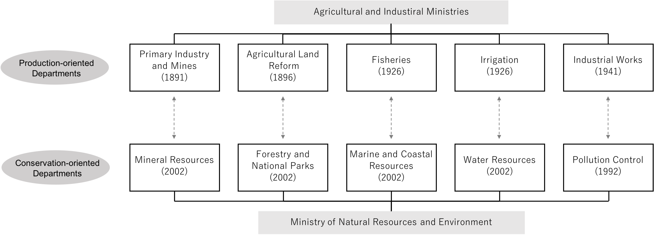

Figure 1.3 Environmental protection in Thailand: Comparison of production- and conservation-oriented government departments

Source: Created by author.

An added difficulty arises when environmental protection systems are superimposed on administrative and legal structures geared toward production and development. Environmental protection systems, no matter how well intended they may be, will often fall short of the initial expectations. Consider Figure 1.3, which shows an overview of all ministries and government offices in Thailand that are involved with environmental protection.

The top row shows departments dedicated to production, including agriculture, forestry, and industry. Established around the end of the nineteenth and beginning of the twentieth centuries, these departments have had over a century to generate webs of vested interests. The departments within the Ministry of Natural Resources and Environment—dedicated to conservation and shown on the bottom row—were all established as recently as the 1990s. They were also structured to ensure that they would function in line with existing laws, without impinging on the jurisdictions of other administrative agencies, with the result that the authority of these latecomers was curtailed from the beginning. Consider the Pollution Control Department, which was established in 1992 and is authorized to monitor pollutant emissions, but only externally, from outside the factories. Its production-oriented counterpart, the Department of Industrial Works, set up in 1941, has wide-ranging authority to access factories and grant operating permits (Sato 2013).

Today, a state seeking to expand its power in most countries rarely resorts to overt violations of private property rights or forcible requisitions. Rather, a state privileges knowledge that supports specific policies and disseminates it throughout society to consolidate a system of rights that reflects those policies.

As we shall discuss in Chapter 5, complex, large-scale issues like the degradation of biodiversity and climate change cannot be conceptualized as “problems” without scientific knowledge. Thus, people need to have an understanding of science, without which they have no place at the negotiating table. It is useful here to consider precisely how an environmental state tilts that negotiating table to its advantage.

## “Mechanisms of security”

Many present-day environmental states use similar measures to extend their influence throughout society. Comparable to what French philosopher Michel Foucault called “mechanisms of security,” these mechanisms operate when a government attempts to eliminate socially harmful incidents like crime or illness. They involve actions to “normalize” whatever conditions are deemed necessary from the government’s efforts to eliminate undesirable elements. The subsequent circumstances are then labeled as standard and acceptable. Here, the role of the government is “to establish an average considered as optimal on the one hand, and, on the other, a bandwidth of the acceptable that must not be exceeded. In this way a completely different distribution of things and mechanisms takes shape” (Foucault 2007: xx).

Consider, for a moment, how a government attempts to control the use of resources that are limited within a region. It may impose regulations on logging, the extraction of minerals, and so on. In these cases, it is not difficult to recognize the intent of the government. But the situation becomes more complicated when the state endeavors to influence complex phenomena like biodiversity or the atmosphere. Here, it cannot implement policy by promoting a simple logic of exclusion through slogans like “Don’t steal, don’t cut down trees.”

Politicians, however dedicated they may be to maintaining public order, will never be able to eliminate all ills in society. Similarly, no amount of management can ensure that people’s actions cause zero harm to the air or the woodlands. Thus, a government must determine the level of environmental damage it is willing to allow as a result of human exploitation of natural resources. Though the level can never be zero, neither should it be too extreme. Crime prevention works according to similar principles. Statistically, a certain number of people will always violate the law, and this reality has to be taken into account by the state in determining the overall level of dangerous behavior it is willing to tolerate. In deciding what level of unlawfulness is acceptable, a government not only considers the inconvenience generated by particular levels of lawless behavior but also the cost of maintaining crime at a “normal” level. In other words, a government shifts its focus from managing individuals to stabilizing the overall system, and the system is calibrated to ensure that resource use falls within the boundaries of what it considers as tolerable, setting “tolerance” levels that society is encouraged to accept as well.

Consider how this works with natural resource management. When a government establishes a national park in an area already populated by settlements, it acknowledges that some local residents will ignore the newly barred zone because their livelihoods depend on it. The government will then accommodate these people, at least to some extent, resulting in a system that functions much like a “mechanism of security.” Pollution problems often play out in the same way. It may not always be practical to eliminate or reduce harmful emissions entirely. Keeping in mind available technology and the incentives motivating all stakeholders, the issue then is finding the level of pollution that is tolerable for both those responsible for the emissions and those suffering the effects.

Foucault recognized an earlier version of a mechanism of security at work when vaccination was used to eradicate smallpox in Europe in the nineteenth century. Earlier smallpox vaccinations inoculated an individual with a small quantity of pathogens from a similar poxvirus, producing antibodies that can then protect them from the more deadly smallpox variants. Artificially triggering a less-severe form of an illness to prevent a more serious affliction was a radical departure from the accepted medical thinking of the day. The vaccination worked through the skillful manipulation of what constituted an “acceptable” level of illness, and this, for Foucault, constituted a typical example of a mechanism of security (Foucault 2007: 74).

Once a disease is controlled at the level of the individual, a government can estimate infection and mortality rates based on specific demographic factors, allowing the state to consider risk management as a matter of applying science and statistics. At that point, the task of determining “acceptable” levels becomes the purview of bureaucrats and state-backed scientists.[2]

The environmental state is a phenomenon that reflects how the state’s environmental interventions alter the relationships between people. Over time, the environmental state also becomes the “norm,” reflecting the particular interests of those in power. Governments and scientists work to normalize a particular relationship between humanity and nature, then encourage citizens to embrace that norm. How much of a country’s territory should be forested? What about national parks? What degree of energy independence should a country strive for? How much pollution should it tolerate? Such goals may sound neutral, but the effects they have in practice are anything but.

On the surface, the security mechanisms applied by an environmental state often appear moderate and adapted to the circumstances of the people in that natural environment. But it needs to be remembered that governments have exclusive authority in determining the standard of what levels of inconvenience are tolerable and what happens to those who exceed these levels. For example, successive forest conservation policies throughout Southeast Asia have normalized the idea that national parks must be protected. If stringent protection is the standard, then locals practicing slash-and-burn agriculture in or near national parks must surely be either antisocial or incompetent. Now governments and the international community are faced with an obvious problem: how to discipline or educate these “uncivilized” people so that they comply with the norm. The environmental state then proceeds to win hearts and minds through “environmental education,” a kind of government intervention that sounds kind and benevolent.

We may conclude that what shapes the character of a particular environmental state is how citizens react to the level and range of tolerances set by government policy. Yet, at times, people may oppose government policy, and at other times, they fall in line with little grumbling. The people who experienced the 2011 Great East Japan Earthquake are still struggling with government-determined tolerances. After the Fukushima Daiichi nuclear plant accident, many concerned individuals began voluntarily measuring the levels of radiation in their neighborhoods. This produced a tremendous amount of data on contamination levels throughout the country. However, it is the government that ultimately sets standards at which levels of pollution are deemed harmful to human health, and the state must draw the lines. Although citizens with Geiger counters can measure radiation levels, this ability does not empower them to correctly define the level of acceptability.

# 1.4 Nature as a channel for control

Discussions about inequality and justice tend to concentrate on how societies distribute financial resources and political power. Today, the environment is the new domain where the state can set the rules and expand its powers. Government policy on nature is inextricably intertwined with the livelihoods of rural populations, while the quality of air and water is a primary concern for urban citizens. At the national level, the state controls many key sectors, from disaster response to energy supply. In short, an environmental state directly affects the very foundation of human life, which makes the distribution of natural bounties and the burden of protecting the environment a matter of justice as well.

It took a long time for public discourse on environmental policies to turn to the topic of justice. For decades, developmental states treated nature as little more than the source of raw materials and a site for waste disposal. By the time the environment became a target for state intervention, it was barely noticed by the public. At that point, technological development had already alienated urban residents from the blue and green, making it difficult for them to feel the changes in nature. Undoubtedly, many individuals also struggled to understand why environmental justice should matter to them. It is easier to discuss government policies when people can see how these might give them a share in the outcome—whether it is income, rights, burdens, or something else. However, environmental policies are rarely so straightforward.

Today, justice and fairness are finally at the core of debates on how people relate to each other and the environment. The water, air, soil, and forests that governments try to regulate are shared resources for all. But the associated rights and burdens are not distributed equally. Some use—or pollute—more than others, and not everyone is forced to make sacrifices for a cleaner environment. As long as land and water remain plentiful and accessible to all, one individual’s larger share is not a problem of justice. The reality, however, is that certain resources––arable land and clean water––are not infinite. This scarcity is what sparks conflict between people, profit-seeking by businesses, interventions by the state, and attempts at problem-solving by international organizations.

In his 1983 book *Spheres of Justice*, political theorist Michael Walzer argued that structures of control operate through so-called “social goods,” which are goods that can be distributed and managed between people. Unlike a person’s inner capacity, which cannot be divided and shared with others, a social good is not internalized by any particular individual. The distribution of social goods also requires cooperation. In Walzer’s own words,

(…) the means of domination are differently constituted in different societies. Birth and blood, landed wealth, capital, education, divine grace, state power—all these have served at one time or another to enable some people to dominate others. Domination is always mediated by some set of social goods (Walzer 1983, xiii).

What if we consider how the natural environment can constitute a social good, as Walzer suggests? The problem with the governance of the natural environment is that it can give individuals rights, or social goods, that are dangerously easy to convert into other benefits. This means that an individual who obtains some level of governance in this sphere will have the tools to expand control further. A person who dominates because they are a substantial landowner, for example, will find it relatively easy to convert power into other forms of dominance, such as political and economic power. Likewise, a highly capable politician or bureaucrat will naturally succeed at becoming influential in politics. However, this politician may choose to extend their influence beyond politics through questionable means, perhaps ending up as an unstoppable tyrant.

The consequences of particular distribution choices are hard to predict when it comes to the environment. This is precisely why we need to scrutinize these choices and investigate their biases which can create significant distributional impact.

Over the years, different societies have had varying ideas about what constitutes “justice.” Even so, a consensus has existed across time and geography as to what constitutes extreme *in*justice (Sen 2010). Genocide, human rights abuses, structural violence, and other extreme injustices do not occur simply because some central authority desires these atrocities. Persecution does not happen without the support of the masses who make up the state’s power base. When we criticize the environmental state, we are also criticizing our own thinking and actions, which after all, allow the environmental state to emerge and operate.

Developmental states sought modernization and economic growth at all costs, ignoring the environmental destruction caused in the process by their large-scale consumption of resources. The riches promised by development were so tempting that they overrode any thought of negative externalities. It is tempting to think that countries become environmental states after careful reflection on their reckless economic expansion, but the reality is that environmental states seldom pause to consider how their conservationist zeal can impact on human societies.

It is no surprise that these impacts go unnoticed. The increasing regulation of people is an overlooked side-effect of state-led conservation, even when it becomes far-reaching. A contributing factor to this invisibility is that those disadvantaged by new policies are already politically marginal to begin with.

Today, state intervention in the natural environment and the accompanying injustices have become so momentous that they can no longer be ignored. When states push for economic development while tolerating poverty and inequality, they risk revolution and social unrest. The same principle applies to environmental policies. If these policies are not based on justice, they cannot sustain ecosystems and could consequently risk damaging human life.

Anyone analyzing interpersonal relations in the context of the environment needs to keep in mind that the state always has a crucial role, overtly or otherwise. State-led development that converts nature into a resource has consequences on the environment. Next, development is followed by state-led policies aiming to protect this same environment, which in turn, support the process that turns nature into a resource. Along the way, the state is able to consolidate its power a little more. The appropriation of common resources that were once representative of particular areas—like shared forests or irrigation works—are suddenly justified by official, feel-good designations such as “community forests” or “community irrigation infrastructure.” State intervention and approval are required for any action that affects the environment, whether it is resource development, conservation, or deciding which of those two will get priority.

Today, environmental states have moved beyond their original objective of managing the natural environment. They touch all aspects of human society, and we need to consider the implications of this change. Once, it was sufficient to launch targeted environmental policies to protect the forests, water, or some other specific elements of nature. That age is past. In the face of global climate change, we need policies that work to support the environment as a whole. Amid all this turmoil, the environmental state is becoming a force that works to change nature in ways that bolster its power, fostering conflict or cooperation between people as it sees fit.

1. But see also Naidoo et al. (2019) who claims that negative relation between protected areas and human well-being is unfounded.
2. Similar logic should apply to the state response to COVID-19, such as when to declare a state of emergency or impose lockdown policies.