(Article)

Enhanced Detection of Heavy Metals Pb2+, Hg2+, Cu2+, Cd2+ Using Combined Spectroscopy and Au-TiO2 coated PCF SPR Refractive Index Sensor

Ayushman Ramola1, Amit Kumar Shakya2*, Anurag Vidyarthi3, Surinder Singh4, Eliran Talker1, and Arik Bergman1*

|  |
| --- |
| **Citation:** To be added by editorial staff during production.  Received: date  Revised: date  Accepted: date  Published: date    **Copyright:** © 2024 by the authors. Submitted for possible open access publication under the terms and conditions of the Creative Commons Attribution (CC BY) license (https://creativecommons.org/licenses/by/4.0/). |

1 Dept. of Electrical and Electronics Engineering, Ariel University, Ariel, Israel

2 The Iby and Aladar, Fleischman Faculty of Engineering, School of Electrical Engineering, Tel Aviv University, Tel Aviv‑Yafo, Israel; email: [xlamitshakya.gate2014@ieee.org](mailto:xlamitshakya.gate2014@ieee.org)

3 Dept. of Electronics and Communication Engineering, Graphic Era (Deemed to be University), Dehradun, Uttarakhand, India

4 Dept. of Electronics and Communication Engineering, Sant Longowal Institute of Engineering and Technology, Sangrur, Punjab, India

**\***Correspondence: arikb@ariel.ac.il; xlamitshakya.gate2014@ieee.org

**Abstract:** This research introduces an innovative approach that combines spectroscopy with refractive index (RI) sensing. Photonic crystal fiber (PCF) based surface plasmon resonance (SPR) sensor is designed and presented, specifically for detecting heavy metals (HM) in water samples used in agricultural activities. A spectroscopy-based sensing setup is engineered for real-time analysis, providing detailed insights into transmission (%) and absorbance (AU) caused by HMs in water samples. The study present spectroscopy analyzes of water samples contaminated with HM such as lead (Pb2+), cadmium (Cd2+), copper (Cu2+), and mercury (Hg2+), exhibiting RI variations between 1.3317 and 1.3473 RIU. The RI sensor featuring a tetra core configuration with an external coating of plasmonic material operating in both transverse magnetic (TM) and transverse electric (TE) polarizations is proposed. It functions effectively within the HM RI range, seamlessly integrating spectroscopy and RI sensing technologies. Consequently, this plasmonic sensor demonstrates significant potential in detecting the RI of HMs dissolved in water samples, making it a highly effective tool for assessing water quality in diverse agricultural settings.

**Keywords:** Heavy metals, refractive index, spectroscopy, surface plasmon resonance, TE pol., TM pol.

1. Introduction

Heavy Metals (HM) ions are charged particles of metals with higher atomic weights and densities as compared to water. They are generated as a byproduct of industrial processes and cause significant pollution [1]. Some frequently encountered HM include nickel (Ni2+), lead (Pb2+), mercury (Hg2+), cadmium (Cd2+), arsenic (As3+), chromium (Cr3+), and copper (Cu2+) [2]. HMs enters agricultural water, plants, and crops through various pathways. Pesticides and fertilizers contain HMs either as active ingredients or impurities, *e.g.,* phosphate fertilizers can contain Cd2+ [3]. Cow dung used as fertilizer can also function as a source of HMs, specifically if the feed given to animals contains HM [4]. Water bodies contaminated by industrial, municipal, or mining activities when used for irrigation, directly introduces HMs into agricultural soil, crops, and plants. Soil contaminated with HMs from past industrial or agricultural practices can continue to impact current agricultural use, as plants absorb HMs from the soil. HMs in plants and crops can lead to reduced crop growth, impaired photosynthesis, and toxicity, which affect both yield and crop quality [5]. Crops contaminated with HMs pose several health risks to humans and animals consuming them directly or indirectly. Like Pb2+ causes anemia, kidney damage [6], Hg2+ causes tremors, insomnia, memory loss, neuromuscular effects [7], Cd2+ causes weakening of the bone, proteinuria [8], Cr2+ causes lung cancer, skin ulcers, dermatitis, allergic skin reactions [9], Ni2+ causes chronic bronchitis, reduced lung function, lung, and nasal cancers and many more [10]. Thus, HMs detection from agricultural water is quite important for maintaining healthy human and animal life. Figure (1) represents the pictorial view of the consequences of presence of HM in water bodies and agricultural lands.



**Figure 1.** Visual representation of agricultural land with and without HM contamination

Spectroscopy includes techniques like atomic absorption spectroscopy (AAS) [11], inductively coupled plasma optical emission spectroscopy (ICP-OES) [12], inductively coupled plasma mass spectrometry (ICP-MS) [13] *etc*. It is a crucial technique for analyzing HMs contaminated water due to its precision, accuracy, and capacity to detect even a low concentration of HMs. This technique allows for quantitative multi-element analysis with minimal sample preparation, making them ideal for agricultural purposes. While offering the advantage of standardized and reproducible results, the techniques require high skills. Thus, spectroscopy remains a preferred method due to its efficiency and reliability in detecting a wide range of HMs. In this context HM detection through photonic crystal fiber (PCF) based surface plasmon resonance (SPR) sensors can present significant advancement in the agriculture sector. [14]. SPR sensors are now used for several applications like chemical sensing, industrial and household oil sensing, food quality inspection, *etc.* [15], [16]. PCF can transmit light over long distances, allowing for the detection of HMs in locations that are difficult to access or hazardous. SPR technologies have precision in measuring refractive index (RI) thus can be used to detect RI changes associated with different HMs embedded water samples resulting in the identification of specific HMs, contributing to timely and effective implementation of water treatment strategies [17]. The design architectures of PCF SPR sensors traditionally fall into three primary models, *i.e.,* external metal deposition (EMD), internal metal deposition (IMD), and the D-shaped framework [18]. The geometrical models of the PCF often involve specific lattice structures that define the distribution and arrangement of air holes surrounding the fiber core. Some common air holes’ lattice structures used in the PCF designing are pentagonal, hexagonal, octagonal, *etc*. This geometric arrangement of air hole structures plays an important role in enhancing optical properties and the functionality of the PCF. Another aspect of PCF is the use of plasmonic materials. Gold (Au), aluminum (Al), copper (Cu), silver (Ag), and graphene which have been favored in several studies [19]. However, modern research efforts are venturing into the use of innovative materials including MXenes, transition metal dichalcogenides (TMDCs), transparent conductive oxides (TCOs), magnesium fluoride (MgF2), perovskites, silicone, and phosphorene [20], as well as material combinations like Au-Ag, Au-Cu, Au-TiO2 alloys, *etc.* [21]. Therefore, exploring novel combinations of materials is also a key area of research in the development of PCF SPR sensors. This pursuit involves examining various sensing dynamics, employing the foundational concepts of coupled-mode theory for light propagation in transverse magnetic (TM) and transverse electric (TE) orientations.

Detailed discussions on sensing capabilities and parameters are provided in further sections. The design and analysis of the plasmonic sensor utilizes the finite element method (FEM), which aids in examining mode behaviors, sensitivity, geometric optimization, and interactions between materials. Additionally, it facilitates the exploration of birefringence, dispersion, loss metrics, overall durability, and efficacy of the sensor. Techniques like wavelength and amplitude interrogation are employed to observe resonance wavelength (RW) shifts among different HMs. Thus, by integrating spectroscopy with PCF SPR sensing, this innovative approach enables rapid detection of HMs contaminants, offering a promising solution for improving the quality of agricultural and food products.

2. Technical overview of spectroscopy arrangement and sensor geometry

This section presents the working of the developed spectroscopy setup and a design of PCF based RI sensor to detect various HMs based on RI variations. Figure 2(a) explains the basic prototype and principle of the spectroscopy-based setup which operate in the range of 780 nm to 1320 nm. The system consists of a light source connected to a single-core jacketed optical fiber, which transmits light into the investigating sample via Port 1. The combination of water and HMs samples are stored in quartz cuvettes placed within a sample mount. The sample is covered with sample cover during its processing. As the light interacts with the HM sample, it exits from Port 2. It is crucial to note that the light entering Port 1 experiences no loss, maintaining strong intensity as presented by high light intensity image. However, after interacting with the HM sample, the light's intensity is reduced which is represented by low light intensity image. This loss in intensity occurs because a portion of light gets lost while interacting with the sample. This intensity loss varies differently for distinct HM samples. The light exiting Port 2 is transferred to the optical spectrum analyzer (OSA) where the transmission (Tx) (%) and absorbance (Ab) (AU) of the HM embedded water sample is determined. The behavior of Tx and Ab varies depending on the physical property of the HM fused sample solution, which is determined by their RI values. The data from the OSA is then transferred to a computing system via a USB data transfer cable for storage and further processing. Figure 2 (b) shows the filtered extracts of HM ions solution Pb2+, Hg2+, Cu2+, and Cd2+. The solutions containing HM ions are prepared by dissolving HM ion powders into distilled water in equal proportions. For each solution, ten grams of HM ion powder is weighed and mixed with 20 ml of distilled water. Later incubator shaker is used to mix the prepared sample for approx. ten minutes. It is crucial to perform the mixing in distilled water to prevent further addition of impurities in the solution. Finally, the prepared sample is filtered using filter paper and is collected in plastic cuvette for later analysis. Figure 2 (c-f) represents a quartz cuvette containing a processed Pb2+, Hg2+, Cu2+, and Cd2+ HM solution. As expressed before HM ion solution can be distinguished through their RI values. Thus, Table (1) presents the RI of the HM embedded water samples, expressed in parts per million (ppm).

**Table 1.** Refractive index of water and heavy metal ion solution

|  |  |  |  |
| --- | --- | --- | --- |
| **HM** | **Sample concentration** | **RI value** | **Ref.** |
| Pb2+ | 0.5 ppm - 1000 ppm | 1.3317-1.3392 | [22] |
| Hg2+ | 0.5 ppm - 1000 ppm | 1.3318-1.3381 | [22] |
| Cd2+ | 0.5 ppm - 1000 ppm | 1.3317-1.3388 | [22] |
| Cu2+ | 0.5 ppm - 1000 ppm | 1.3390-1.3473 | [22] |

Here it can be observed that the RI of the HM Pb2+ and Cd2+ is 1.3317 RIU which is the minimum RI value among the four HM ion solution. Similarly, the maximum value of RI of Cu2+ is 1.3473 RIU. Thus, this is the RI range of HM embedded water samples that can be detected using the proposed PCF SPR sensor. Therefore, using the RI sensor for HM detection makes it a swift process to identify the presence of HM in water.

Figure 3 (a) illustrates a two-dimensional (2D) model of the prospective PCF SPR RI sensor for distinguishing various HMs. Figure 3 (b) presents the three-dimensional (3D) view of the designed sensor fiber. The sensor operates in the near-infrared (NIR) wavelength of 780 nm to 2500 nm. This wavelength range is commonly used in spectroscopy, due to its ability to penetrate deeper into materials and metal tissues than visible light, with less scattering and absorption. Fused silica (Si) is used as a backdrop material for improving electron excitation and coupling incident light for generating surface plasmon wave (SPW). Sufficient interaction between the surface plasmon polaritons (SPP) and core mode is required to generate the SPR.

The geometrical parameters of the sensor consist of three dimensions of air holes having diameter d1=3.75 µm, d2=5.90 µm, and d3=8.95µm, respectively. The distance between two air holes is called pitch (Ʌ)=7.25 µm. The diameter of the background material Si surface is 20.57 µm. This arrangement assists in making the core-guided modes more lossy and generation of a tetra core in the sensor body. The number of cores increases sensitivity, multiplexing capability, redundancy, reliability, enhanced spatial resolution, *etc.* A coat of Au and TiO2 are used as plasmonic materials in the sensor model. Au is widely regarded as one of the most excellent plasmonic materials due to its exceptional stability and resistance to chemical reactions. It possesses strong SPR, enabling high sensitivity to RI changes. Its biocompatibility makes it ideal for HM sensing.

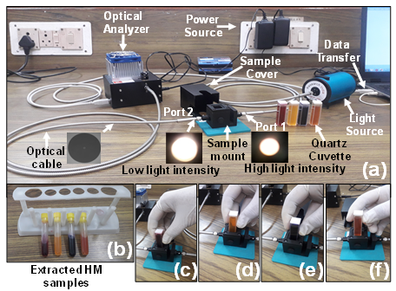

Figure 2. (a) Spectroscopy setup [27] (b) HM extracts (c) Pb2+ (d) Hg2+ (e) Cu2+ (f) Cd2+

Furthermore, Au surfaces can be easily functionalized for specific HM detection, enhancing the sensor's selectivity. TiO2 is biocompatible and chemically stable for sensing applications, ensuring durability. The optimized thickness of the Au layer is selected as 45 nm. A thin layer of TiO2 is installed over the Au layer as it offers unique advantages due to its high RI, enhancing phase-matching for improved sensitivity, and its photocatalytic properties. This keeps the sensor's surface clean and functional over extended periods. The optimized thickness of the TiO2 layer is selected as 85 nm. The third layer serves as the analyte sensing medium, designed specifically for the detection of various HM. The thickness of this layer is chosen as 1.50 µm. In this layer HMs fused water will be inserted using the capillary process for the HM detection. A perfectly matched layer (PML) is applied to the computational boundaries to eliminate unwanted reflections and ensure accurate simulation results. Thus, a PML layer of 2.0 µm is installed over the external surface of the PCF. Therefore, making the total dimension of the sensor to 24.2 µm.

The RI of the fused Si used as background material is expressed by the “Sellmeier equation” [18].

$n^{2}\left(λ\right)=1+\sum_{ 1≤j≤3}{\frac{B_{j}λ^{2}}{λ^{2}-C_{j}}}$

Where $n(λ)$ is RI corresponding to wavelength $λ,$ $B_{j}$ and $C_{j}$ which represents Sellmeier coefficients. Si coefficents values for these constants can be obtained from [23]. The RI of the Au is expressed by the "Drude Lorentz model" [18].

$$ϵ\left(ω\right)=ϵ_{∞}-\frac{ω_{p}^{2}}{ω\left(ω+iγ_{D}\right)}+\sum_{j}{\frac{S_{j}ω_{0j}^{2}}{ω_{0j}^{2}-ω^{2}-iωγ_{j}}}$$

Where $ϵ\left(ω\right)$ is the permittivity dependent on frequency, $ϵ_{∞}$ denotes permittivity at absolute frequency, $ω$ refers to the angular frequency, $ω_{p}^{2}$ is the plasma frequency, $γ_{D}$ represents the damping coefficient. The terms $S_{j}$, $ω_{0j}^{2}$ and $γ_{j}$ correspond to the damping constant for $j^{th}$"Lorentz" oscillator.

The values of Drude Lorentz model constants for Au can be obtained from [18]. The RI expression of TiO2 can be obtained from [24]. The RI of the air is 1.000293 RIU and can be evaluated using the Ciddor equation [25]. The analytical computational is performed using the FEM based COMSOL Multiphysics software [26]. Default physics-controlled mesh using free triangular meshing elements are used to mesh the sensor components. Extremely fine mesh conditions is used to mesh air holes, Au, and TiO2 layers. Extra fine mesh is used to mesh fused Si, analyte layer, and PML. Statistically 82534 triangles, 8589 edge elements, and 489 vertex elements are meshed. Minimal grid integrity is 0.4295 considering domain element statistics. The element aspect ratio is 0.002174, and the total meshed region is 459.72 ${μm}^{2}$. Different mesh conditions are chosen for optimal balance between computational efficiency, accuracy and computational time. Scattering boundary condition (SBC) is applied to the sensor structure to have minimum reflections from outgoing waves [26].

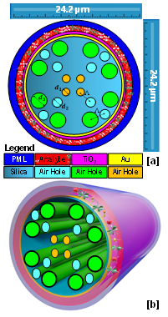

**Figure 3.** (a) 2D model of the sensor (b) 3D model of the sensor fiber

*2.1 Production methodologies of the proposed sensor*

Several methods are proposed for fabricating the sensor models, with prominent ones being the sol-gel method, injection molding, and notably the "stack and draw" method. Stack and draw methodology are preferred in PCF fabrication due to its cost-effectiveness and adaptability. This method involves aligning capillaries (air holes) of specific dimensions into a pre-determined 2D layout by stacking them together. These capillaries are then heated to merge, followed by drawing them into fiber within a fiber drawing tower. Subsequently, the fiber is cooled and encased in a protective layer. For depositing materials like Au and TiO2 alternative methods such as electro less plating, sputtering, thermal evaporation, end-face polishing, and chemical vapor deposition (CVD) are widely used [18]. Among these, CVD is particularly acknowledged for its straightforwardness in sensor model production.

1. **Result analysis**

*3.1 Spectroscopy of the HM fused water samples*

Light intensity can be expressed by the number of photons reaching a specific point at a particular time. Generally, “bright” light represents high intensity whereas “dimmer" light represents light with low intensity. Suppose the intensity of the light beam entering a sample is denoted as ( $I_{E})$ and the light intensity exiting the sample is ($I_{o})$. Then the ratio of exit to entering light intensity for the solution is "transmission" which is expressed in (%) form and is a dimensionless quantity [18].

$$Transmission (\%) = ({I_{O}}/{I_{E})}×100$$

The light lost during the interaction with the sample is assumed to be absorbed by the sample. This lost light is referred to as the "absorbance" of the solution. Absorbance is measured in (AU), which refers to arbitrary units [18].

$Absorbance (AU)=-\log_{10}\frac{I_{O}}{I_{E}}$

The detection method entails directing a light beam of a specific wavelength (nm) through the HM solution. In dilute solution, fewer photons are absorbed, leading to higher transmission and lower absorbance. Conversely, when the light ray passes through a concentrated solution, it is observed that more photons get absorbed, leading to lower transmission and higher absorbance. This approach is motivated by the "Beer-Lambert Law” [27].

Figure 4 (a) and Figure 4 (b) represent the spectral behaviour of the transmission (%) and absorbance (AU) caused by HMs in water sample. Table (2) presents the statistical quantification of the transmission (Tx) and absorbance (AU) obtained from the HM solution.

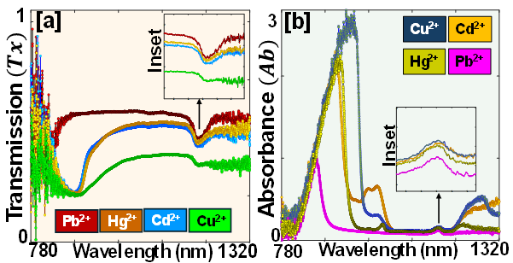

**Figure 4.** Spectroscopy analysis of HM solution (a) Transmission (%) (b) Absorbance (AU)

**Table 2.** Transmission and Absorbance of heavy metal water solution

|  |  |  |  |  |
| --- | --- | --- | --- | --- |
| **HM** | **Wavelength (nm)** | **Tx (%)** | **Wavelength (nm)** | **Ab (AU)** |
| Pb2+ | 1012.29 | 42.89 | 1005.45 | 0.172 |
| Hg2+ | 1089.84 | 38.69 | 1068.91 | 0.198 |
| Cd2+ | 1162.51 | 34.26 | 1154.32 | 0.214 |
| Cu2+ | 1208.49 | 27.84 | 1201.84 | 0.234 |

Thus, it can be concluded that the Tx (%) and Ab (AU) both are inversely related to each other. Now SPR sensing of the HM ions is performed to explore the relation between spectroscopy and sensing parameters.

* 1. *Methodology for refractive index sensing*

In the PCF SPR sensor light localizes in two critical zones, the "core region" and the "metal-dielectric interface". The light trapped in the core region facilitates the creation of the core mode, while that at the interface gives rise to the SPP mode. These two modes interact at a key interaction point, *i.e.,* RW. The coupled-mode light propagation in optical fibers follows two principal directions horizontal and vertical, commonly referred to as TM pol. (longitudinal) and TE pol. (radial), respectively. It is noted that the interaction between the core and SPP mode may be more pronounced in one of these orientations. However, in this study investigation of both TM pol. and TE pol. is expressed in detail.

Figure 5 (a-b) presents the 2D and 3D, TM pol. and TE pol. field distributions profiles for HM Pb2+ at RW of 756 nm and 777 nm, respectively. Figure 5 (c-d) reveal the SPP mode profiles for HM Pb2+ corresponding to TM pol. and TE pol. respectively. Similar field distributions profiles for other HM ions are possible and can be obtained. Electric field distribution and mode coupling of two or more wave modes interact as they propagate are expressed using the coupled mode light theory [24].

$$\frac{dA_{1}}{dz}=iβ_{1}A_{1}+ikA_{2}$$

$$\frac{dA_{2}}{dz}=iβ_{2}A_{2}+ikA_{1}$$

Here, $A_{1}$, $A_{2}$ represent the amplitudes of the interacting modes, with z indicating the spatial coordinates along the direction of propagation. The propagation constants for these modes are denoted by $β_{1}$, $β_{2}$, and the coupling coefficients, symbolized by $k$, enable their interaction. When the real parts of $β_{1}$, $β_{2}$ match, phase-matching occurs, which is valuable for energy transfer between the modes, triggering SPR. SPR occurs when light waves interact with plasmons at a metal-dielectric interface. The interaction between core and SPP modes results in coupled mode propagation which is calculated using as [24].

$$β_{±}=β_{avg}±\sqrt[2]{δ^{2}+k^{2}}$$

Here $β_{±}$ represents the propagation constant of the core and SPP modes coupling, $β_{avg}$ is the average of $β_{1}$ and $β_{2}$, $k$ is expressed as the coupling strength between the modes, $δ$ is given by $δ=\frac{β_{1}-β_{2}}{2}$ having imaginary part denoted by $δ_{r}$ and $δ_{i}$ respectively.

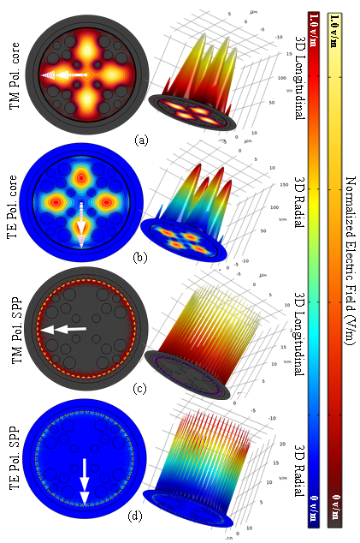

**Figure 5.** Intensity profiles (2D-left) and (3D-right) for RW corresponding to HM Pb2+,core configuration (a) TM pol. (b) TE pol.; SPP configuration (c) TM pol. (d) TE pol.

1. **Determining the sensor parameters**

The RI range of HM for which the sensor parameters are investigated is 1.3317 RIU to 1.3473 RIU which covers RI range of HM Pb2+, Hg2+, Cd2+ and Cu2+. In SPR sensors, the confinement loss ($α_{CL}$) represents the extent of light intensity attenuation occurring as light propagates through PCF core. This loss significantly influences the sensor's sensitivity, detection capabilities, and overall operational efficacy. It is represented as [18].

$$α_{CL}({dB}/{cm)=8.686×({2π}/λ)×Im(n_{eff})×{10}^{4}}$$

Where $Im(n_{eff})$ represents the imaginary part of the effective mode index, and $λ$ depicts the wavelength in $nm$. SPP and core mode coupling occurs at the RW, achieving its peak value. The distinction between HM can be discerned by examining their specific wavelengths at TM pol. and TE pol. respectively.

Figure 6 (a-d) illustrate the $α_{CL}$ behavior of HM for TM pol., respectively. It is apparent that HM components demonstrate unique $α_{CL}$ peaks at different RWs. Consequently, an individual HM component can be precisely represented by its characteristic RW and $α_{CL}$ spectrum. Table (3) provides a consolidated overview of the key insights, which corresponds to the TM pol.

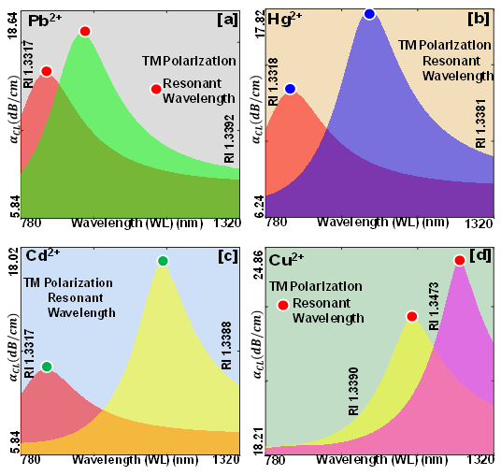

**Figure 6. $α_{CL}$** behavior of the HM sample for TM pol. (a) Pb2+ (b) Hg2+ (c) Cd2+ (d) Cu2+

**Table 3**. Analysis of primary outcomes from confinement loss spectrum

|  |  |  |  |  |
| --- | --- | --- | --- | --- |
| **HM** | **RI** | $$∆RI$$ | **TM Pol.** | |
| $α_{CL}$**(dB/cm)** | **RW (nm)** |
| Pb2+ | 1.3317-1.3392 | 0.0075 | 5.84-18.64 | 756 &1121 |
| Hg2+ | 1.3318-1.3381 | 0.0063 | 6.24-17.82 | 776 & 825 |
| Cd2+ | 1.3317-1.3388 | 0.0071 | 5.84-18.02 | 756 & 897 |
| Cu2+ | 1.3390-1.3473 | 0.0083 | 18.21-24.86 | 989 & 1282 |

Figure 7(a-d) illustrate the $α_{CL}$ behavior for TE pol., respectively. Here also it can be identified that HM components demonstrate unique $α_{CL}$ peaks at different RWs. An individual HM component can be identified accurately by its characteristic RW and $α_{CL}$ spectrum. Table (4) provides a detailed overview of the key insights, corresponding to the TE pol., respectively.

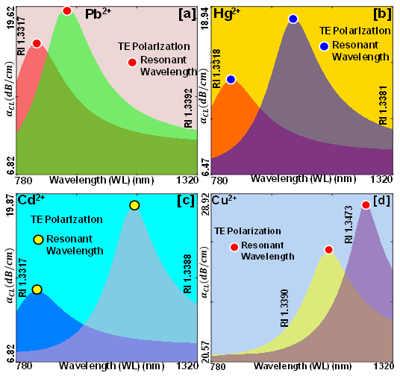

**Figure 7. $α_{CL}$** behavior of the HM sample for TE pol. (a) Pb2+ (b) Hg2+ (c) Cd2+ (d) Cu2+

**Table 4.** Analysis of primary outcomes from confinement loss spectrum

|  |  |  |  |  |
| --- | --- | --- | --- | --- |
| **HM** | **RI** | $$∆RI$$ | **TE Pol.** | |
| $α_{CL}$**(dB/cm)** | **RW (nm)** |
| Pb2+ | 1.3317-1.3392 | 0.0075 | 6.82-19.62 | 777 & 1142 |
| Hg2+ | 1.3318-1.3381 | 0.0063 | 6.47-18.94 | 815 & 856 |
| Cd2+ | 1.3317-1.3388 | 0.0071 | 6.82-19.87 | 777 & 927 |
| Cu2+ | 1.3390-1.3473 | 0.0083 | 20.57-28.92 | 1014 & 1294 |

It can be observed from Table (3) and Table (4) that with an increase in the $α_{CL}$ RW is reported to be increased for different RI of HM. The change in RW concerning RI is expressed using wavelength sensitivity ($S_{W}$) which is represented as [18].

$$S_{W}({nm}/{RIU)={∆λ_{P}}/{∆RI}}$$

Where the shifts between two individual RI are measured by $∆RI$ and change in their RW is represented by $∆λ_{P}$.

Thus, the obtained results of $S_{W}$ for TM pol. analogous to Pb2+, Hg2+, Cd2+ and Cu2+ are 12800, 12800, 14400, and 54400 nm RIU-1 respectively. Similarly, the $S_{W}$ for TE pol. analogous to Pb2+, Hg2+, Cd2+ and Cu2+ are 11200, 13200, 14600, and 54000 nm RIU-1 respectively. The average values of $S_{W}$ for TM pol. and TE pol. are 18800 nm RIU-1 and 18600 nm RIU-1 respectively.

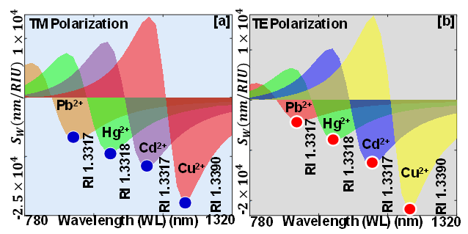

**Figure 8.** Variation in $S_{A}$ for HM components (a) TM pol. (b) TE pol.

Additionally, the amplitude interrogation method is employed to evaluate the change in the amplitude sensitivity ( $S_{A})$ of the sensor model. This approach provides insights into change in the amplitude of light due to SPR effects. It is computed as [18].

$$S_{A}\left({RIU}^{-1}\right)=-(1/{α_{CL}})×{∆α_{CL}}/{∆RI}$$

Where $∆α_{CL}$ represents the change in the confinement loss. Figure 8 (a-b) represents the $S_{A}$ for TM pol. and TE pol. respectively. $S_{A}$ for TM pol. analogous to Pb2+, Hg2+, Cd2+ and Cu2+ are 12230, 15412, 18311 and 22142 RIU-1, respectively. Similarly, for TE pol. analogous to Pb2+, Hg2+, Cd2+ and Cu2+ are 11420, 15231, 17428 and 19428 RIU-1 respectively. It can be observed that the highest $S_{A}$ is obtained for the HM component Cu2+ for both pol. High $S_{A}$ further enhances the resolution of the sensor.

Sensor resolution ( $S_{R})$ represents the ability of the sensor to discern extremely minor variations in the RI of HM components. It is determined as [18].

$$S_{R}(RIU)={∆RI×{∆λ}_{min}}/{∆λ_{p}}$$

Where minimum spectral resolution is represented by ${∆λ}_{min}$ and is equivalent to 0.1 nm. The relationship between alteration in RW and the change in RI is important for sensor optimization which is crucial for improving and assessing the sensor’s performance.

The calculated for Pb2+, Hg2+, Cd2+ and Cu2+ for TM pol. are 2.05×10-6 RIU, 1.28×10-5 RIU, 5.03×10-6 RIU and 2.83×10-6 RIU respectively.

Similarly, the for Pb2+, Hg2+, Cd2+ and Cu2+ for TE pol. are 2.05×10-6 RIU, 1.53×10-6 RIU, 4.73×10-6 RIU and 2.96×10-6 RIU respectively. Thus, it can be observed that the highest SR is obtained for the HM component Pb2+ for both TM pol. and TE pol. respectively. Meanwhile high $S_{R}$ in the order of 10-6 is reported by the proposed sensor model for both pol. modes.

Finally, the polynomial fitting between RW and RI of the HM components Pb2+, Hg2+, Cd2+ and Cu2+ analogous to TM pol. and TE pol. is presented in Figure 9 (a) and Figure 9 (b) respectively with 90% confidence bound. Fitting parameters R2, SSE, and RMSE obtained a value of 0.9846, 3796.2, and 30.807, analogous to TM pol.

Similarly concerning TE pol. fitting parameters R2, SSE, and RMSE have obtained a fitting value of 0.9989, 217.67, and 7.3768, respectively. Thus, the proposed sensor shows a good fitting towards the RI of HM and their RW.

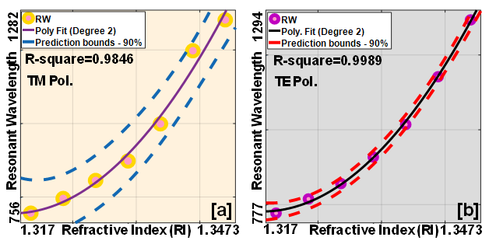

**Figure 9.** Fitting of RW with RI for various HM components (a) TM pol. (b) TE pol.

Therefore, for TM pol. and TE pol., the value of R² approaches unity, demonstrating a high degree of correlation between the RW and RI. Thus, it can be concluded that the presented RI sensor can effectively detect HM fused water samples with 90% confidence.

**4. Impact of varying material thickness on sensor efficacy and refractive index spectroscopy correlation**

* 1. *Evaluating sensor parameters*

In PCF SPR sensors it is expected that with optimized parameters, the sensor will produce the most efficient sensing results. However, when the thickness of plasmonic material is increased beyond the optimum thickness, sensing parameters are expected to degrade. Considering this scenario in this section we present result of the sensor parameters when the optimized thickness of plasmonic materials Au and TiO2 is increased from 45 nm and 85 nm to 50 nm and 90 nm respectively.

Table (5) provides detail of the sensing parameters derived from Figure 10 (a) and Figure 10 (b), which correspond to the TM pol. and TE pol., respectively. Here, it can be clearly observed that increasing the thickness of the plasmonic materials results in a significant increase in the $α_{CL}$ for both polarizations, which means that now less light with penetrate inside the PCF as compared with the amount of light propagating inside the fiber at the optimum thickness.

**Table 5.** Analysis of primary outcomes from confinement loss

|  |  |  |  |  |  |  |  |
| --- | --- | --- | --- | --- | --- | --- | --- |
| **RI of HM** | $$∆RI$$ | **TM Pol.** | | **TE Pol.** | | **Shift** | |
| $$α_{CL}$$ | **RW** | $$α_{CL}$$ | **RW** |  |  |
| 1.3317 | 0.0001 | 8.64 | 819 | 8.31 | 814 | 0.33 | 05 |
| 1.3318 | 0.0063 | 10.12 | 862 | 10.21 | 854 | 0.09 | 08 |
| 1.3381 | 0.0007 | 24.18 | 1026 | 25.42 | 1008 | 1.24 | 18 |
| 1.3388 | 0.0002 | 29.52 | 1097 | 31.22 | 1081 | 1.70 | 16 |
| 1.3390 | 0.0002 | 42.84 | 1266 | 46.41 | 1207 | 3.57 | 59 |
| 1.3392 | 0.0081 | 58.72 | 1331 | 57.71 | 1317 | 1.01 | 14 |
| 1.3473 | NA | 73.82 | 1425 | 73.11 | 1418 | 0.71 | 07 |

A shift in the RW of 43 nm, 164 nm, 71 nm, 169 nm, 65 nm, and 94 nm is obtained for RI 1.3317, 1.3318, 1.3381, 1.3388, 1.3390, 1.3392 and 1.3473 corresponding to TM pol. Similarly, a shift in RW of 40 nm, 154 nm, 73 nm, 126 nm, 110 nm, and 101 nm is obtained for RI 1.3317, 1.3318, 1.3381, 1.3388, 1.3390, 1.3392 and 1.3473 corresponding to TE pol. These shifts in RW are less as compared to the shift obtained at the optimum layer thickness. The $α_{CL}$ is also increased significantly when compared with the $α_{CL}$ obtained at the optimum thickness.

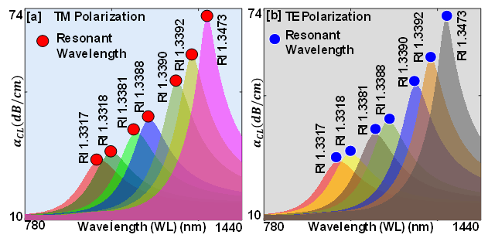

**Figure 10. $α_{CL}$** of the HM components with increased thickness (a) TM pol. (b) TE pol.

Figure 11 (a-b) illustrate the $S_{A}$ of the presented sensor with enhanced width of the plasmonic materials. It can be noticed that as the width of the plasmonic material is slightly increases, there is a decline in the $S_{A}$ compared to the $S_{A}$ obtained at the optimum thickness. The reason for this decline is that when thickness of the plasmonic material is increased it become difficult for the evanescent field to penetrate the material coating for the efficient generation of the SPR effect, thus more loss occurs at the interface of the metal and dielectric surface resulting in the reduction of $S_{A}$.

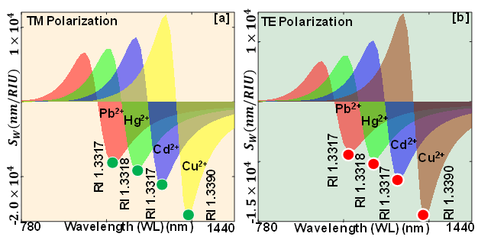

Figure 11. Variation in amplitude sensitivity of the HM components with increased thickness (a) TM pol. (b) TE pol.

Figure 11 (a) represents the $S_{A}$ for TM pol. corresponding to HM Pb2+, Hg2+, Cd2+ and Cu2+ which is numerically quantified to 11134, 14329, 17812 and 19522 RIU-1 respectively. Similarly, for TE pol. analogous to HM Pb2+, Hg2+, Cd2+ and Cu2 are 10540, 14236, 16423 and 17244 RIU-1 respectively as presented in the Figure 11(b). Therefore, it can be noted that due to increase in the thickness of the plasmonic materials a decrease in the $S_{A}$ of the sensor for both polarizations is obtained. Consequently, several other sensing parameters also decline when the thickness of the plasmonic materials exceeds the optimum thickness.

*4.2* *Evaluating relation between sensing and spectroscopy parameters*

This section presents a new outcome obtained from the performed experiment and simulation. Firstly, it can be observed that when spectroscopy of the water embedded with HM is performed, Tx (%) and Ab (AU) can be correlated, as shown in Figure (12), which establishes an inverse relationship between Tx (%) and Ab (AU) as presented by the expression.

$$Transmission∝\frac{1}{Absorbance }$$

Secondly the HM ions Pb2+, Hg2+, Cd2+ and Cu2+ merged with water samples can be distinguished from each other on the basic of RI variations, light confinement, sensitivity towards plasmonic materials, wavelength shift, *etc*. It is further observed that the transmission is directly proportional to the RI of the HM. It means that when the RI of the HM is low Tx (%) is high and Ab (AU) is low and vice versa. Thus, the modified expression of the relation between Tx (%), Ab (AU) and RI are expressed as follow.

$$Transmission∝\frac{1}{Absorbance }∝Refractive Index$$

Thus, this research work represents that the HM detection from PCF SPR sensor is possible. Further, in the presented research work two different schemes are fused together to present a novel solution for quick detection of the HM ions. It is evident that SPR sensing technique can be used effectively for the HM detection and can further effectively used in water quality monitoring for agricultural applications. Consequently, this study undertakes a dual-mode exploration, encompassing both TM pol. and TE pol. In this investigation the proposed sensor has successfully attained high values of $S_{w}$ and $S_{A}$ displaying its proficiency in detecting minute variations in the RI of the HM. The $S_{R}$ in the order of 10-6, further indicates an elevated level of sensitivity.

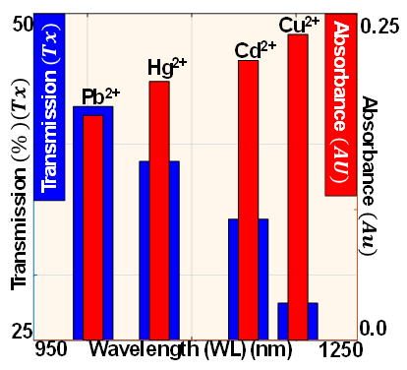

**Figure 12.** Established relation between Tx (%) and Ab (AU) of the HM sample

Finally to evaluate the real-world applicability of our sensor, a detailed comparison of the sensing parameters of our designed sensor with previously reported sensors is presented in Table (6).

**Table 6.** Comparing sensing parameters of proposed sensor with previously reported sensors

|  |  |  |  |  |  |
| --- | --- | --- | --- | --- | --- |
| **RI Range** | **Pol.** | $$S_{W}$$ | $$S_{A}$$ | $$S_{R}$$ | **Ref/Year** |
| 1.33-1.41 | TM | 16000 | 4596 | 2.18×10-6 | [28], 2020 |
| TE | 17000 | 4557 | 2.19×10-6 |
| 1.42-1.46 | TM | 15000 | 230 | 6.67×10-6 | [29], 2020 |
| 1.42-1.46 | TM | 15000 | 560 | -------- | [30], 2021 |
| 1.360-1.401 | TM | 12857.14 | 13240 | 7.77×10-6 | [31], 2021 |
| TE | 14285.71 | 15010 | 7.00×10-6 |
| 1.355-1.385 | TM  TE | 5200 | ------- | -------- | [32], 2022 |
| 3340 | ------- | -------- |
| 1.340-1.380 | TM | 20000 | 2158 | 5.0×10-6 | [18], 2022 |
| TE | 18000 | 3167 | 5.55×10-6 |
| 1.40-1.45 | TM | 18800 | 3152 | -------- | [33], 2023 |
| 1.37-1.42 | TM | 19600 | 2300 | -------- | [34], 2023 |
| 1.32-1.37 | TM | 14100 | ------- | 9.17×10-6 | [35], 2024 |
| 1.3317-1.3473 | TM | 54400 | 22142 | 2.05×10-6 | PRIS |
| TE | 54000 | 19428 | 2.05×10-6 |

Unit: (nm/RIU), (RIU-1), (RIU), PRIS: proposed RI sensor

**5. Conclusion**

This study introduces an innovative method that merges spectroscopy with RI sensing, creating a new methodology and providing additional parameters to PCF SPR optoelectronic sensor tailored for detecting HM in agricultural water sources. The sensor employs a tetra core structure coated with a plasmonic material Au and TiO2. A spectroscopy-driven setup facilitates real-time analysis, offering precise measurements of Tx (%) and Ab (AU) for various HM in the water samples. HM ions Pb2+, Cd2+, Cu2+, and Hg2+ which present RI change between 1.3317 and 1.3473 RIU is used to craft a RI sensor for HM detection, seamlessly integrating spectroscopy and RI sensing techniques. Dual mode investigation is performed, and high sensing parameters are obtained from the presented plasmonic sensor. Consequently, the presented sensor shows significant potential in bridging spectroscopy and RI sensing parameters together. Thus, the proposed sensor proves to be a valuable instrument for monitoring water quality across various agricultural activities.

**Author Contributions:** A.R. and A.K.S performed the experiments and the analytical simulation. A.V., S.S., and E.T. supervised the work. A.B. supervised all aspects of the work.

**Funding:** This research received financial support from Ariel University, Israel.

**Data Availability Statement:** The raw data supporting the conclusions of this article will be made available by the authors on request.

**Acknowledgments:** The author AKS wish to thanks All India Council of Technical Education (AICTE), New Delhi, India for providing the equipment support used in this research work.

**Conflicts of Interest**. The authors declare no conflicts of interest.

References

1. S. A. Razzak et al., “A comprehensive review on conventional and biological-driven heavy metals removal from industrial wastewater,” Environmental Advances, vol. 7, p. 100168, Apr. 2022, doi: 10.1016/j.envadv.2022.100168.
2. Md. H. Zahir, K. Irshad, M. M. Rahman, M. N. Shaikh, and M. M. Rahman, “Efficient Capture of Heavy Metal Ions and Arsenic with a CaY–Carbonate Layered Double-Hydroxide Nanosheet,” ACS Omega, vol. 6, no. 35, pp. 22909–22921, Sep. 2021, doi: 10.1021/acsomega.1c03294.
3. M. Jokar, N. Mirghaffari, M. Soleimani, and M. Jabbari, “Preparation and characterization of novel bio ion exchanger from medicinal herb waste (chicory) for the removal of Pb2+ and Cd2+ from aqueous solutions,” Journal of Water Process Engineering, vol. 28, pp. 88–99, Apr. 2019, doi: 10.1016/j.jwpe.2019.01.007.
4. A. T. Ojedokun and O. S. Bello, “Sequestering heavy metals from wastewater using cow dung,” Water Resources and Industry, vol. 13, pp. 7–13, Mar. 2016, doi: 10.1016/j.wri.2016.02.002.
5. M. Zhang et al., “Identification of the heavy metal pollution sources in the rhizosphere soil of farmland irrigated by the Yellow River using PMF analysis combined with multiple analysis methods—using Zhongwei city, Ningxia, as an example,” Environ Sci Pollut Res, vol. 27, no. 14, pp. 16203–16214, May 2020, doi: 10.1007/s11356-020-07986-z.
6. Moussa Abbas, “Mass Transfer Processes in the Adsorption of Lead (Pb2+) by Apricot Stone Activated Carbon (ASAC): Isotherms Modeling and Thermodynamic Study,” Prot Met Phys Chem Surf, vol. 57, no. 4, pp. 687–698, Jul. 2021, doi: 10.1134/S207020512104002X.
7. A. M. Fallatah et al., “Rational synthesis and characterization of highly water stable MOF@GO composite for efficient removal of mercury (Hg2+) from water,” Heliyon, vol. 8, no. 10, p. e10936, Oct. 2022, doi: 10.1016/j.heliyon. 2022.e10936.
8. Q. Guo, H. Tang, L. Jiang, M. Chen, N. Zhu, and P. Wu, “Sorption of Cd2+ on Bone Chars with or without Hydrogen Peroxide Treatment under Various Pyrolysis Temperatures: Comparison of Mechanisms and Performance,” Processes, vol. 10, no. 4, Art. no. 4, Apr. 2022, doi: 10.3390/pr10040618.
9. N. Dhariwal, M. Chahar, V. Kumar, and O. P. Thakur, “Ethanol sensing materials and device using Co2+, Zn2+, Cr2+ doped α-Fe2O3 nano-particles with room temperature response/ recovery,” Sensors and Actuators B: Chemical, vol. 390, p. 134037, Sep. 2023, doi: 10.1016/j.snb.2023.134037.
10. Md. Mahmudur Rahman et al., “Simultaneous abatement of Ni2+ and Cu2+ effectually from industrial wastewater by a low-cost natural clay-chitosan nanocomposite filter: Synthesis, characterization and fixed bed column adsorption study,” Environmental Nanotechnology, Monitoring & Management, vol. 20, p. 100797, Dec. 2023, doi: 10.1016/j.enmm.2023.100797.
11. K. O. Omeje et al., “Quantification of Heavy Metals and Pesticide Residues in Widely Consumed Nigerian Food Crops Using Atomic Absorption Spectroscopy (AAS) and Gas Chromatography (GC),” Toxins, vol. 13, no. 12, Art. no. 12, Dec. 2021, doi: 10.3390/toxins13120870.
12. S. R. Khan, B. Sharma, P. A. Chawla, and R. Bhatia, “Inductively Coupled Plasma Optical Emission Spectrometry (ICP-OES): a Powerful Analytical Technique for Elemental Analysis,” Food Anal. Methods, vol. 15, no. 3, pp. 666–688, Mar. 2022, doi: 10.1007/s12161-021-02148-4.
13. H. Liu, Q. Meng, X. Zhao, Y. Ye, and H. Tong, “Inductively coupled plasma mass spectrometry (ICP-MS) and inductively coupled plasma optical emission spectrometer (ICP-OES)-based discrimination for the authentication of tea,” Food Control, vol. 123, p. 107735, May 2021, doi: 10.1016/j.foodcont.2020.107735.
14. S. K. Panigrahy, P. Das, and S. K. Tripathy, “Agricultural soil health monitoring using photonic crystal fiber based on combined principles of surface plasmon resonance and interferometry for lead ion detection,” JNP, vol. 17, no. 3, p. 036013, Sep. 2023, doi: 10.1117/1.JNP.17.036013.
15. A.K. Shakya and S. Singh, “Novel Merger of spectroscopy and refractive index sensing for modelling hyper sensitive hexa-slotted plasmonic sensor for transformer oil monitoring in near-infrared region,” Opt Quant Electron, vol. 55, no. 9, p. 764, Jun. 2023, doi: 10.1007/s11082-023-05016-z.
16. A.K. Shakya and S. Singh, “State of the Art Alliance of Refractive Index Sensing and Spectroscopy Techniques for Household Oils Analysis,” Plasmonics, vol. 18, no. 6, pp. 2347–2364, Dec. 2023, doi: 10.1007/s11468-023-01940-8.
17. Amit Kumar Shakya and S. Singh, “State of the art in fiber optics sensors for heavy metals detection,” Optics & Laser Technology, vol. 153, p. 108246, Sep. 2022, doi: 10.1016/j.optlastec.2022.108246.
18. A.K. Shakya, A. Ramola, S. Singh, and V. Van, “Design of an ultra-sensitive bimetallic anisotropic PCF SPR biosensor for liquid analytes sensing,” Opt. Express, OE, vol. 30, no. 6, pp. 9233–9255, Mar. 2022, doi: 10.1364/OE.432263.
19. Y. Zhou et al., “Biochemical sensor based on functional material assisted optical fiber surface plasmon resonance: A review,” Measurement, vol. 207, p. 112353, Feb. 2023, doi: 10.1016/j.measurement.2022.112353.
20. Y. Yuan et al., “Two-dimensional nanomaterials as enhanced surface plasmon resonance sensing platforms: Design perspectives and illustrative applications,” Biosensors and Bioelectronics, vol. 241, p. 115672, Dec. 2023, doi: 10.1016/j.bios.2023.115672.
21. Y. Tiandho, N. L. W. Septiani, G. Gumilar, R. Jonuarti, Suprijadi, and B. Yuliarto, “High-Performance Refractive Index-Based Sensor Using Ellipsoid Ag–Au Nanoparticles,” IEEE Sensors Journal, vol. 23, no. 9, pp. 9390–9401, May 2023, doi: 10.1109/JSEN.2022.3233905.
22. Y. W. Fen and W. M. M. Yunus, “Characterization of the Optical Properties of Heavy Metal Ions Using Surface Plasmon Resonance Technique,” Optics and Photonics Journal, vol. 1, no. 3, Art. no. 3, Sep. 2011, doi: 10.4236/opj.2011.13020.
23. Sarita, R. Jha, and R. K. Singh, “Mie scattering of tightly focused beams by a core-shell nanoparticle,” Optics Communications, vol. 557, p. 130306, Apr. 2024, doi: 10.1016/j.optcom.2024.130306.
24. V. S. Chaudhary, D. Kumar, and S. Kumar, “Au-TiO2 Coated Photonic Crystal Fiber Based SPR Refractometric Sensor for Detection of Cancerous Cells,” IEEE Transactions on NanoBioscience, vol. 22, no. 3, pp. 562–569, Jul. 2023, doi: 10.1109/TNB.2022.3219104.
25. S. Masuda, S. Kadoya, M. Michihata, and S. Takahashi, “Novel absolute length measurement method for etalon sensor using optical comb pulsed interference and harmonic etalon reflections,” Meas. Sci. Technol., vol. 34, no. 5, p. 055205, Feb. 2023, doi: 10.1088/1361-6501/acb072.
26. “COMSOL: Multiphysics Software for Optimizing Designs,” COMSOL. Accessed: Oct. 02, 2023. [Online]. Available: <https://www.comsol.com/>
27. A. K. Shakya and S. Singh, “Performance Analysis of a Developed Optical Sensing Setup Based on the Beer-Lambert Law,” Plasmonics, vol. 19, no. 1, pp. 447–455, Feb. 2024, doi: 10.1007/s11468-023-01979-7.
28. M. R. Islam et al., “Design and analysis of birefringent SPR based PCF biosensor with ultra-high sensitivity and low loss,” Optik, vol. 221, p. 165311, Nov. 2020, doi: 10.1016/j.ijleo.2020.165311.
29. Md. Biplob Hossain et al., “Numerical development of high-performance quasi-D-shape PCF-SPR biosensor: An external sensing approach employing gold,” Results in Physics, vol. 18, p. 103281, Sep. 2020, doi: 10.1016/j.rinp.2020.103281.
30. Md. B. Hossain, T. V. Mahendiran, L. F. Abdulrazak, I. M. Mehedi, Md. A. Hossain, and Md. M. Rana, “Numerical analysis of gold coating based quasi-D-shape dual core PCF SPR sensor,” Opt Quant Electron, vol. 52, no. 10, p. 446, Sep. 2020, doi: 10.1007/s11082-020-02555-7.
31. A. Ramola, A. Marwaha, and S. Singh, “Design and investigation of a dedicated PCF SPR biosensor for CANCER exposure employing external sensing,” Appl. Phys. A, vol. 127, no. 9, p. 643, Aug. 2021, doi: 10.1007/s00339-021-04785-2.
32. N. A. Elmahdy, M. F. O. Hameed, and S. S. A. Obayya, “Refractive index sensor based on plasmonic D-shaped photonic crystal fiber with pyramid grating,” Opt Quant Electron, vol. 54, no. 11, p. 763, Sep. 2022, doi: 10.1007/s11082-022-04102-y.
33. A. Zuhayer, M. Abd-Elnaby, S. H. Ahammad, M. M. A. Eid, V. Sorathiya, and A. N. Z. Rashed, “A Gold-Plated Twin Core D-Formed Photonic Crystal Fiber (PCF) for Ultrahigh Sensitive Applications Based on Surface Plasmon Resonance (SPR) Approach,” Plasmonics, vol. 17, no. 5, pp. 2089–2101, Oct. 2022, doi: 10.1007/s11468-022-01700-0.
34. W. Li, Y. Chen, J. Xu, M. Jiang, and H. Zou, “A D-Shaped SPR-Based PCF Sensor with an Extremely High-Amplitude Sensitivity for Measuring the Refractive Index,” Micromachines, vol. 14, no. 7, Art. no. 7, Jul. 2023, doi: 10.3390/mi14071295.
35. G. Melwin and K. Senthilnathan, “Modelling a simple arc shaped gold coated PCF-based SPR sensor,” J Opt, vol. 53, no. 1, pp. 117–126, Feb. 2024, doi: 10.1007/s12596-023-01110-3.