**The Bologna Fragments of *Halakhot Gedolot* and their Relation to the Italian Textual Tradition of the Book**

Roni Shweka, University of Haifa

**The two versions of *Halakhot Gedolot***

The book *Halakhot Gedolot* by R. Simeon Qayyara (hereafter: *HG*) is one of the most important halakhic books composed in the Geonic period. It enjoyed vast popularity already during the Geonic period, and it is the most quoted Geonic book in medieval rabbinic literature[1]. The book was known in Europe in different versions, and medieval rabbinic authorities in France and Germany refer occasionally to ‘*HG of Aspamia*’ (Spain) in contra to ‘*Our HG*’ or ‘*HG of Babylonia*’. Until the end of the 19th century *HG* was known only by the version of the editio princeps, Venice 1548. During 1888-1892 J. Hildesheimer published a totally different version of *HG* found in ms. Vatican ebr. 142, a presumably North-African manuscript from the 11th century[2]. Besides many variants in the text, the order of the chapters is quite different, as is the setting of some of the chapters, mostly at the beginning and end of the book. Another remarkable difference is that the Berlin edition contains numerous geonic responsa, together with late interpretations and marginal notes that entered into the text.

A. Epstein, who dedicated a comprehensive study to these versions, argued that the editio princeps represents the more original version of *Halakhot Gedolot*, which was composed in the academy of Sura at the beginning of the ninth century, while the Berlin edition represents an augmented recension compiled in Qayrawan around 900. He also identified the version of the Berlin edition with the ‘Spanish’ *Halakhot Gedolot*.[3] Epstein’s theory was challenged by some scholars in light of more manuscripts and many Genizah fragments of *Halakhot Gedolot* thathave been discovered since his study.[4] During 1972-1987 E. Hildesheimer, The grandson of the above-mentioned and his namesake, published a variorum edition of *HG*. As the base text of his edition, he choose an Italian manuscript found at the Ambrosiana library in Milan, which is dated around year 1400. The version in this manuscript is very similar to the version of the Berlin edition. Hildesheimer argued, contra to Epstein, that excluding the late additions that accompany this version (mainly in the Berlin edition), this edition presents more faithfully the original version of *HG*. Besides the Venice edition (V), Berlin edition (B) and Milan manuscript (M), Hildesheimer recorded in his edition variants from two additional manuscripts: another an almost complete manuscript in the Vatican library (R) written in ashkenazic script of mid-thirteen century, and a partial manuscript in Bibliothèque nationale de France, Paris (P).[5] This is an early eastern manuscript, not later than the 11th century.

In my study of *HG* I reexamined all the textual witnesses of the book, including additional two partial ashkenazic manuscripts in the Firkovich collections, and no less than four-hundred Genizah fragments.[6] Besides constructing the stemma of the main manuscripts, I dedicated a large part of the work to identify and point out the special characteristics of the B-M version. As Epstein already suggested concisely, I concluded that this version reflects a complex and sophisticated project which took place in the last part of the ninth century, i.e. compiling and revising a new recension of *HG*, not too long after it was published. The two more noticeable features of this recension are allegedly the different order of chapters and the addition of geonic responsa to the book. However, the order of chapters in the B-M recension is no less original than the one in V or R. In fact it is closer to the original setting of the book as reflected in P and other sources. The addition of geonic responsa too should not be considered as the primary feature of this recension. These additions are common mostly in B, and less in the other textual witnesses of this recension. Instead, the main feature of this recension is the rearranging of small units within a given chapter or in-between chapters, and the massive editing of the running text, which in some sections can be traced in almost every sentence. This characteristic of the B-M recension, although it is not always very evident by first sight, defines it as a well-planned and comprehensive project that took place at a definite place and time with the scope of rewriting the book of HG from start to end. By this characteristic the B-M recension is also distinguished from all other versions of HG that are found in different manuscripts, which can be explained as sporadic adaptations and modifications made by local scribes and scholars, but do not present a systematic effort to rewrite the book completely.

**The Italian tradition of HG**

As I mentioned above, Epstein suggested based on the responsa that have been included in the B-M recension that this recension was compiled in Qayrawan around 900. This is a very reasonable speculation, and it is certainly fit the evaluation of Bet-Arie who identified the script of B as North African (and the provenance?)[7]. However, the purchase statement at the end of the manuscript apparently states that the manuscript was produced in Fustat and Cairo. In any case, the manuscript was purchased in Cairo by Isaac b. Saul from Ferrara, who presumably brought the manuscript to Italy[8]. The presence of B in Italy could have explain the close relationship between B and the later Italian manuscript M, but in fact there is no need to assume a direct relationship between these manuscripts. The recension reflected in B-M is presented in many Genizah fragments. Most of these fragments are written in oriental script and some of them assumed to be as early as the tenth century. However, among these fragments there are also fragments written in Italian script, which emerged from two different manuscripts. One of them is dated by Edna Engel around 1100, and the other around 1200. Altogether, they compose about thirty-five fragments.[9] These early Italian manuscripts found in the Cairo Genizah present the same recension presented by B-M, and thus confirm that this recension reached Italy not after the eleventh century, and certainly before manuscript B arrived to Italy by Isaac b. Saul. Moreover, in another place I proved that these Genizah manuscripts share some unique textual variants with manuscript M only, against all other manuscripts including B![10] It can be concluded therefore that the textual tradition found in the relatively late manuscript M is not based solely on B, which was brought to Italy from Cairo, but present an original Italian tradition of *HG* which can be traced to the beginning of the second millennium by early Italian manuscripts found in the Cairo Genizah. This textual tradition reflects the reworked recension found in B-M, and it may well be that this recension arrived to Italy directly from Qayrawan, where it has been created. The connections between the Jewish communities in Italy - especially those of south and Sicily in particular - and North Africa are well attested, either by merchants traveling from North Africa to Italy or with Italian scholars and students immigrating to North Africa, particularly to the academy of Qayrawan.[11] The immigration of R. Hushiel and his son R. Elhanan from Bari and their settlement in Qayrawan at the beginning of the eleventh century is one famous example, which found its way to the legendary story of the four captives by Ibn Daud.[12] Be that as it may, the textual evidence is clear enough: in Italy the common version of *HG* was the recension presented in B-M. This is also the conclusion reached by Epstein based on quotations from the book by Italian scholars.

On the contrary, in German and French the common version of *HG* was the more original one instead of the reworked recension. This is evident primarily from the textual findings. All of the three Ashkenazic manuscripts (R and two partial manuscripts in the Firkovich collections) present the original version of the book. Obviously none of the manuscripts should be considered identical with it, but all of them are reflecting instead various adaptions and modifications which occur through its transmission. Nevertheless, they do not present the reworked recension presented by B-M. Again, this textual evidence agrees with the conclusion of Epstein based on quotations from *HG* by German and French rabbinic authorities.

**The Bologna fragment**

The Bologna fragment of *HG* consist of two not-continuous folios. One side of every folio is totally erased, and do not contains any legible characters. The other side is beautifully clear and easy to read. The inner margins of every folio are cut, and therefore a few letters at the end of lines and at the beginning of lines of the first folio and the second folio respectively are missing[13]. One page contains *Hilkhot Yibum we-Halitza* p. 97 l. 75 to p. 99 l. 17 on Hildesheimer (Jerusalem) edition. The other contains *Hilkhot Me’un* p. 118 l. 44 to p. 120 l. 83. In all versions of *HG* *Hilkhot Yibum we-Halitza* precedes *Hilkhot Me’un*, so we can assume that this is the case also in this manuscript. I mark therefore the first page as p. 1 and the second as p. 2. The two folios are most probably not parts of one bifolio. As the text of every page occupies approximately 40 lines in Hildesheimer edition, and the gap between the pages occupies there 400 lines, there are ten missing pages gap between the two surviving pages, which make an odd number of five folios exactly, that do not correlate to a certain number of bifolios. Hence unless the manuscript had in these chapters a significant and unique lacuna or addenda, we should conclude that the two pages survived from two different bifolios.

The overall quality of the text in the Bologna fragment is not of the best. Besides variant readings and typographical errors which are common in most manuscripts, the short text in the fragment presents also some obvious scribal mistakes which are not typographical errors and do not occur in other manuscripts. In two places, the scribe wrote ‘מים שאין להן סוף’ while it is clear from the context that the text should read ‘מים שיש להן סוף’[14]. In the first instance the error led also to another one, in which the scribe changed the wording ‘אבל ודאי מים שאין להן סוף’ in the next line, which contrasts the previous case, with ‘מאי טע' אמרינן מים שאין להן סוף’, so that it will follow the erroneous wording at the beginning of the sentence. In another case *HG* is quoting *Mishnah Niddah* 6, 12 ‘שתי שערות האמורות בפרה ובנגעים’, while the fragment reads: ‘שתי שערות האמורות בפעוטות ובנגעים’, an erroneous reading that is not found elsewhere[15]. At the same time, the fragment preserves also some original readings which in other manuscripts are replaced with more common forms, as the idiom ‘קטן פרח’ in the fragment instead of ‘קטן פורח’ found in other manuscripts[16].

In any case, the more interesting question is the position of this fragment in the stemma of *HG* textual witnesses. In another opportunity, I showed that the early Italian fragments in the Genizah share a common textual tradition with the much later Milan manuscript, by pointing out some unique variants which occur only in these manuscripts.[17] Unfortunately, I cannot repeat the same argument here and present a variant which is shared by M and the Bologna fragment only, as the short text in concern does not present an example in which M has a significant and distinct reading from all other witnesses, including B. Still, the fragment can be attributed to the B-M recension by one clear evidence.

The dictum “תנו רבנן פדחת בלא פרצוף פנים ופרצוף פנים בלא פדחת אין מעידין עליו עד שיהו שניהן עם החוטם. אמר אביי ואיתימא רב כהנא מאי קראה הכרת פניהם ענתה בם” (Hild. ed. p. 98 l. 83-86) appears in the fragment (p. 1 l. 6-8) in the same place it appears on the B-M recension,[18] while in V and R it appears later, after “שנים אומרים מת ואחד אומר לא מת אף על פי שלא נישאת תינשא” (Hild. ed. p. 98 l. 99). The different setting of the dictum in the text is caused by the fact that this dictum was not in the original text of *HG* here, and has been transferred to this chapter from an early addenda section originally placed in the last part of *HG*, very far from this chapter.[19] Most probably, the short dictum was copied from its original place in the addenda at the end of the book to the margins of this chapter in one of the earliest manuscripts of the book. The different place of the dictum in this chapter as presented in the two versions of *HG*, reflects different interpretations as to the exact place where this unit should be inserted. The agreement of the fragment with B-M here against V and R clearly sets the fragment in the textual tradition of the B-M recension.

The phenomenon of small textual units which are transferred from early addenda sections to different parts of the book, is one of the most distinctive and significant characteristics of the various versions of *HG*, and in particular, the B-M recension.[20] J.N. Epstein already draw attention to the fact that in the end of some chapters of *HG* one can find series of paragraphs, mainly Talmudic quotations, which are not connected to one another and do not even relate to the chapter topic at all.[21] These sections are titled in some testimonies as *‘Tosefta’*, i.e. Addenda, additional textual units that were not part of the original book (not to be confused with the Tannaitic compilation with the same name). These *Tosefta* sections were preserved in their original format mainly in P and R, while in the B-M recension they were decomposed and all these paragraphs were removed from their original addenda sections and integrated into different chapters, according to their content. In some cases, the editors of B-M did not find the appropriate places to move the paragraphs to, and they created such new secondary *tosefta* sections in the end of other chapters, collecting all the additional units of the same topic in one place. This process of reediting the *tosefta* sections and transferring paragraphs from the end of the book to its beginning and vice versa, convincingly proves the posteriority of the B-M edition. In addition, it shows that this edition is a result of an intended and well-planned process, and this observation is proved from other evidences as well.

The agreement of the Bologna fragment with the B-M recension is by no means surprise, and approves what we presuppose for an Italian manuscript, as I argued above. Still, this agreement introduce before us a great riddle that I do not know yet how to solve it.

**The Leipzig fragments**

As Perani has demonstrated convincingly, the Bologna fragment is part of a manuscript which other pages from it are found in Leipzig[22]. The Leipzig fragments preserved a much larger portion of the manuscript, and altogether they present no less than nine bifolios, that is eighteen folios. These folios come from many different chapters of *HG*: *Hilkhot Me’un, Ketubot, Nedarim, Gittin, Kiddushin, Bava Kama, Niduy, Halva’ah,* and *Bava Batra*. In some cases, we can determine the order of these chapters in the manuscript. To my big surprise, the order presented in the Leipzig fragments is identical with this of R, and diverge from the order of chapters in all other testimonies, in particular that of B-M. Thus, the Leipzig fragments present the order of *Me’un, Ketubot* as in R and V, whereas in B, M, and P *Ketubot* is in the end of *Seder Nashim* and placed after *Kiddushin*.[23] The same with *Nedarim, Gittin*. It was long observed that B and M does not include the chapter of *Nedarim*, and it was also argued that this chapter is not original in *HG*. In another place I argued differently, and noted also that there is no positive evidence for the omission of *Nedarim* in B, as the last pages of *Seder Nashim* are missing from this manuscript.[24] In any case, all of the other testimonies place *Nedarim* at the end of *Seder Nashim*, and the order of *Nedarim* before *Gittin* is found only in V and R![25] This is the case also with the three chapters *Niduy, Halva’ah,* and *Bava Batra* – so is the order in the Leipzig fragments, and this is the order in R. Although the chapters of *Niduy* and *Halva’ah* are missing in P, it is most probably that in this case R and P share the same tradition. However, in B-M and V the order is *Bava Batra, Niduy, Nahalot* and *Halva’ah*.[26] In conclusion, in all three cases for which there is evidence in the Leipzig fragments, these fragments agree precisely with R against other manuscripts. In particular, against B-M in all of the three cases!

**Conclusion**

So here is the problem we are facing: If the Bologna fragment is an Italian manuscript, it would be expected that it will be associate with the B-M recension. Indeed, despite the short text of the fragment, this association has been successfully attested by one clear and satisfying example. On the other hand, if the Bologna fragment and the Leipzig fragments are parts of the same manuscript, which I do not doubt, then how shall we explain the fact that the order of chapters in the Leipzig fragments is identical with the ashkenazic manuscript R precisely and diverge completely from B-M? Perani identified the script of the manuscript that is presented in both fragments as a ‘typical Italian script of the 12th c.’, and revealed most amazingly the journey of the folios from Bologna to Leipzig. The Italian origin and provenance of the manuscript is therefore asserted beyond any doubt. However, the precise textual tradition of the manuscript as a whole is still dubious and should be determined only after a further comprehensive study of the Leipzig fragments, a study which I hope to fulfill in the future.

**The text of the Bologna fragment**

**הלכות גדולות הלכות יבום וחליצה, עמ' 97-99**

1. [יבמה] יבא עליה ביאה גומרת בה ואין כסף ושטר גומרין בה. וקונה את עצמה בחליצה
2. [מנ]א לן [ד]כת' ונקרא שמו ביש' בית חלוץ הנעל כיון שחלצה נעל הותרה לכל יש'. נפל
3. [במים] שאין להן סוף ודאי בשני עדים ודיי מימת מיית ולגבי ממון יורשין יורדין[27] לנכסיו ולגבי
4. [אש]ה אחמ[י]רו בה רבנן עד דאמרין עדים סימנין שלו פדחתו וחוטמו ושאר סימנים שלו
5. [אם] כן ניסת בעד אחד תצא אקילו בה רבנן כל היכא דאיכא עד אחד וודאי איכא עד
6. [אח]ר בהדיה אלא איתרמויי דלא מתרמי בהדדי הדדי. תנו רבנ'[28] פדחת בלא פרצוף
7. [פנים] ופרצוף פנים בלא פדחת אין מעידין עליו עד שיהו שניהן עם החוטם. אמ' אביי
8. [ואית]ימא רב כהנא מהאי קרא הכרת פניהם ענתה בם. בעי מיניה מרב ששת עד אחד
9. [ביבמ]ה לשוק מהוא אמ' להו תניתוה אמרו לה מת בעליך ואחר כך מת בנה וניסית וקא מוקים
10. [לה ר]ב ששת בעד אחד ואפעלגב דקא מדחי ליה רבנן למתניתין רב ששת בעד אחד מוקים
11. [לה ו]להיתירא קא פשיט דקאמ[רינ]ן והכא[29] נמי להיתירא קא פשיט דקאמרינן רבא אמ'
12. [קל ו]חומר א'ס'ו'ר' לאיסור כרת היתרתה לאיסור לאו לא כל שכן ואפעלגב דאמ' ליה ההוא
13. [מרב]נן לרבא[30] הא קאמ' להיתירא וקמו להו רב ששת ורבא בחדא שיטתא להיתירא וקמ'
14. [...]רב' ששת שמע מינה עד אחד ביבמה לשוק כשר והשתא דאמרת עד אחד כשר
15. [דשו]יוה רבנן כאשה שהולך בעלה למדינת הים כאשה לכולה מילתא וקתני גבי אשה
16. [הוחז]קו להיות משיאין עד מפי עד עד מפי אשה אשה מפי עבד ומפי שפחה והדא יבמה
17. [...] שריא לאינסובי. הכל נאמין להעידה חוץ מחמותה ובת חמותה צרתה ויבמתה
18. [ובת ב]עלה ומה בין גט למיתה כתב מוכיח עד אחד אומ' מת וניסית ובא אחר ואמ' לא מת
19. [הרי זו] לא תצא עד אחד אומ' מת ושנים אומ' לא מת אפעלפי שניסית תצא שנים אומ' מת
20. [ועד] אומ' לא מת אפעלפי שלא ניסית תינשא. והיכא דאתו בתרי סהדי או אפי[לו]
21. [חד ס]הדא ואמ' חזיתיה לגברא פלו' דטבע במים שאין[31] להן סוף ושהאי כשיעור מיפ[ק]
22. [נשמת]יה ולא סליק לאלתר שרינן לה לאיתתיה מאי טע' אמרינן[32] מים שאין להם סוף אפיל[ו]
23. [...] משהיי לי טובא ולא סליק לא שרינן ליה לאיתתיה מאי טע' גנדרוה מיא מיא
24. [וסליק] בדוכתא אחריתי הני מילי לכתחילה אבל עבר ואינסיב לא מפקינן לה ולא שנ[א]
25. [גברא] קמא חשוב הוה ולא שנא שאינו חשוב היכא דעבר ונסיב לא מפקינן לה ולכתח[ילה]
26. [לא ש]רינן לה. תנו רבנ' נפל למים בין שיש להן סוף ובין שאין להם סוף אשתו אסורה
27. [דברי ר'] מאיר וחכמ' אומ' מים שאין להן סוף אשתו אסורה ושיש להן סוף אשתו מותרת
28. [היכי ד]אמי מים שאין[33] להן סוף אמ' אביי כל שעומד ורואה אותו מארבע רוחותיו. תנו [רבנן]
29. [יש חול]ץ לאמו מיספק יש חולץ לבתו מספק יש חולץ לאחותו מספק. אמו מספק כיצ[ד]
30. [אמו וא]שה אחרת ילדו שני זכרים במחבא ובא בנה שלזה ונשא אמו שלזה ובא בנה של[זה]
31. [ונשא א]מו שלזה ומתו בלא בנים זה חולץ לאמו וזה חולץ לאמו מספק. בתו מספק כיצד
32. [...] אשתו ואשה אחרת ילדו שתי נקבות במחבא ובאו אחי אביהן ונשאום ומתו בלא
33. [בנים ז]ה חולץ לבתו מספק וזה חולץ לבתו מספק. אחותו מספק כיצד אחותו[34] ואשה
34. [אחרת] ילדו שתי נקבות במחבא ובאו אחיהן ונשאום ומתו בלא בנים זה חולץ אחותו
35. [מספק] וזה חולץ אחותו מספק. מי שמת והניח אשתו מעוברת ומת וולד בן יום

**הלכות גדולות הלכות מיאון, עמ' 118-120**

1. זבינה זביני במקרקעי הויא עדותו עדות במקרקעי [אל]א אינו נבדק ולמטל[טלי לא]
2. [ה]ויא עדותו עדות בעידנא דהוו זביניה זביני במטלטלי דאילו זביני דמטלטלי פ[עוטות]
3. כבר שית כבר שבע כבר תמני כבר תשע כבר עשר כל חד וחד[35] לפי[36] חורפיה ואילו [לענין]
4. עדות אפילו מטלטלי עד שיהא בן שלש עשרה שנה ויום אחד משום דכת' ו[עמדו שני]
5. האנשים. ולהשלם לתפילה ולברכת המזון קטן פרח[37] מצטרף היכא דאתחיל ל[יה לאתויי]
6. שתי שערות ואכתי לא אייתי ההוא קטן פרח ודווקא ליה דעייל ליה בתליסרי וד[וקא]
7. דידע למי מברכין. והיל' קטן שקידש אין קידושיו קידושין ואם נשא אשה [והוליד]
8. בנים ועדיין לא הגיע לשלש עשרה שנה ויום אחד[38] אין קידושיו קידושין [ואין כתובתו]
9. כתובה אבל בניו כשרין [ה]ם ונקראין על שמו ואם בא לה[וצי]א אין צריך ליתן גט [ולכשיגיע]
10. לשלוש עשרה שנה ויום אחד [יחזו]ר ויקדיש ויכת[ו]ב כתובה אחרת ואסור לשה[ות את]
11. אשתו בלא כתובה וקידושין לאחר שלוש עשרה שנה ויום אחד מפני שכתובה [ראשונה]
12. אין משתעבדין בה נכסיו ואם בא עליה לאחר שלש[39] עשרה שנה ויום אחד אפע[לפי שלא]
13. קידש ושלא כתב כתובה אחרת ומבקש לגרשה צריכה הימנו גט שאין אדם עוש[ה בעילתו]
14. בעילת זנות. בא סימן התחתון עד שלא יבא סימן העליון או חולצת או מ[תייבמת]
15. דכולי עלמא מיהא אתחתון סמכינן מנהני מילי אמ' רב יהודה אמ' רב כדתנא[40] ד[בי ר']
16. ישמעא' אמ' קרא איש או אשה כי יעשו מכל חטאות האדם הישוה הכת' אשה [לאיש]
17. לכל ענשין שבתורה מה איש [בס]ימן אחד [א]ף אשה בסימן אחד אימא כי האי[41] [..כאיש]
18. מה איש תחתון ולא עליון אף אשה תחתון ולא עליון. תניא נמי הכי אמ' ר' אלע[זר בר']
19. יצחק[42] כך היו מפרשין ביבנה כיון שבא תחתון שוב אין משגיחין על העליון. תניא [רבן]
20. ש[מ]עון בן גמל' אומ' בנות כרכין תחתון ממהר לבוא מפני שרגילות במרחצאות בנו[ת כפרים]
21. עליון ממהר לבוא מפני שטוחנות בריחים. ר' שמעון בן אלעזר אומ' בנות עשירים [צד]
22. ימין ממהר לבוא מפני שנישוף באפיקרסותן בנות עניים צד שמאול ממהר לבוא [מפני]
23. ששואבות עליו כדי מים. דב' אח' מפני שנושאות אחיהן על גיססיהן. תנו [רבנן כל]
24. הנבדקות נבדקות על פי שנים[43] וכן היה ר' אליעזר מוסר לאשתו ור' ישמעאל[44] מוסר לא[מו ר']
25. יהודה אומ' לפני הפרק ולאחר הפרק נשים בודקות אותן תוך הפרק אין הנשים בודק[ות]
26. אותן שאין משיאין ספיקות על פי נשים ר' שמעון אומ' אף תוך הפרק הנשים בודקות [אותן]
27. ונאמנת אשה להחמיר אבל לא להקל כאי זה צד גדולה היא שלא תמאן קטנה ה[יא שלא]
28. תחלוץ אבל אין נאמנת לומר קטנה היא שתמאן גדולה היא שתחלוץ. שתי ש[ערות]
29. האמורות בפעוטות[45] ובנגעים והאמורות בכל מקום כמה שיעורן כדי לכוף ראשן [לעיקרן]
30. דברי ר' ישמעאל ר' אליעזר אומ' [כד]י לקרוץ בציפורן ר' עקיבה אומ' כדי שיהו ניטלי[ן בזוג]
31. אמ' רב חסדא אמ' מר עוקבא הלכ' כדברי כולן להחמיר. תינוקת שהביאה שת[י]
32. שערות חייבת בכל מצוות האמורות[46] או חולצת או מתיבמ'. תינוקת שהביאה שתי [שערות]
33. אינה יכולה למאן. אמ' ר' חלבו אמ' רב הונא שתי שערות שאמרו צריך שיהא בעי[קרן ..]
34. גומות. אמ' רב מילכיו אמ' רב אדה בר אהבה גומות אפעלפי שאין שערות ואפעל[פי]
35. שתי שערות בגומא אחת. והיכא דאיכא גומות אי איפשר לגומות בלא שערות

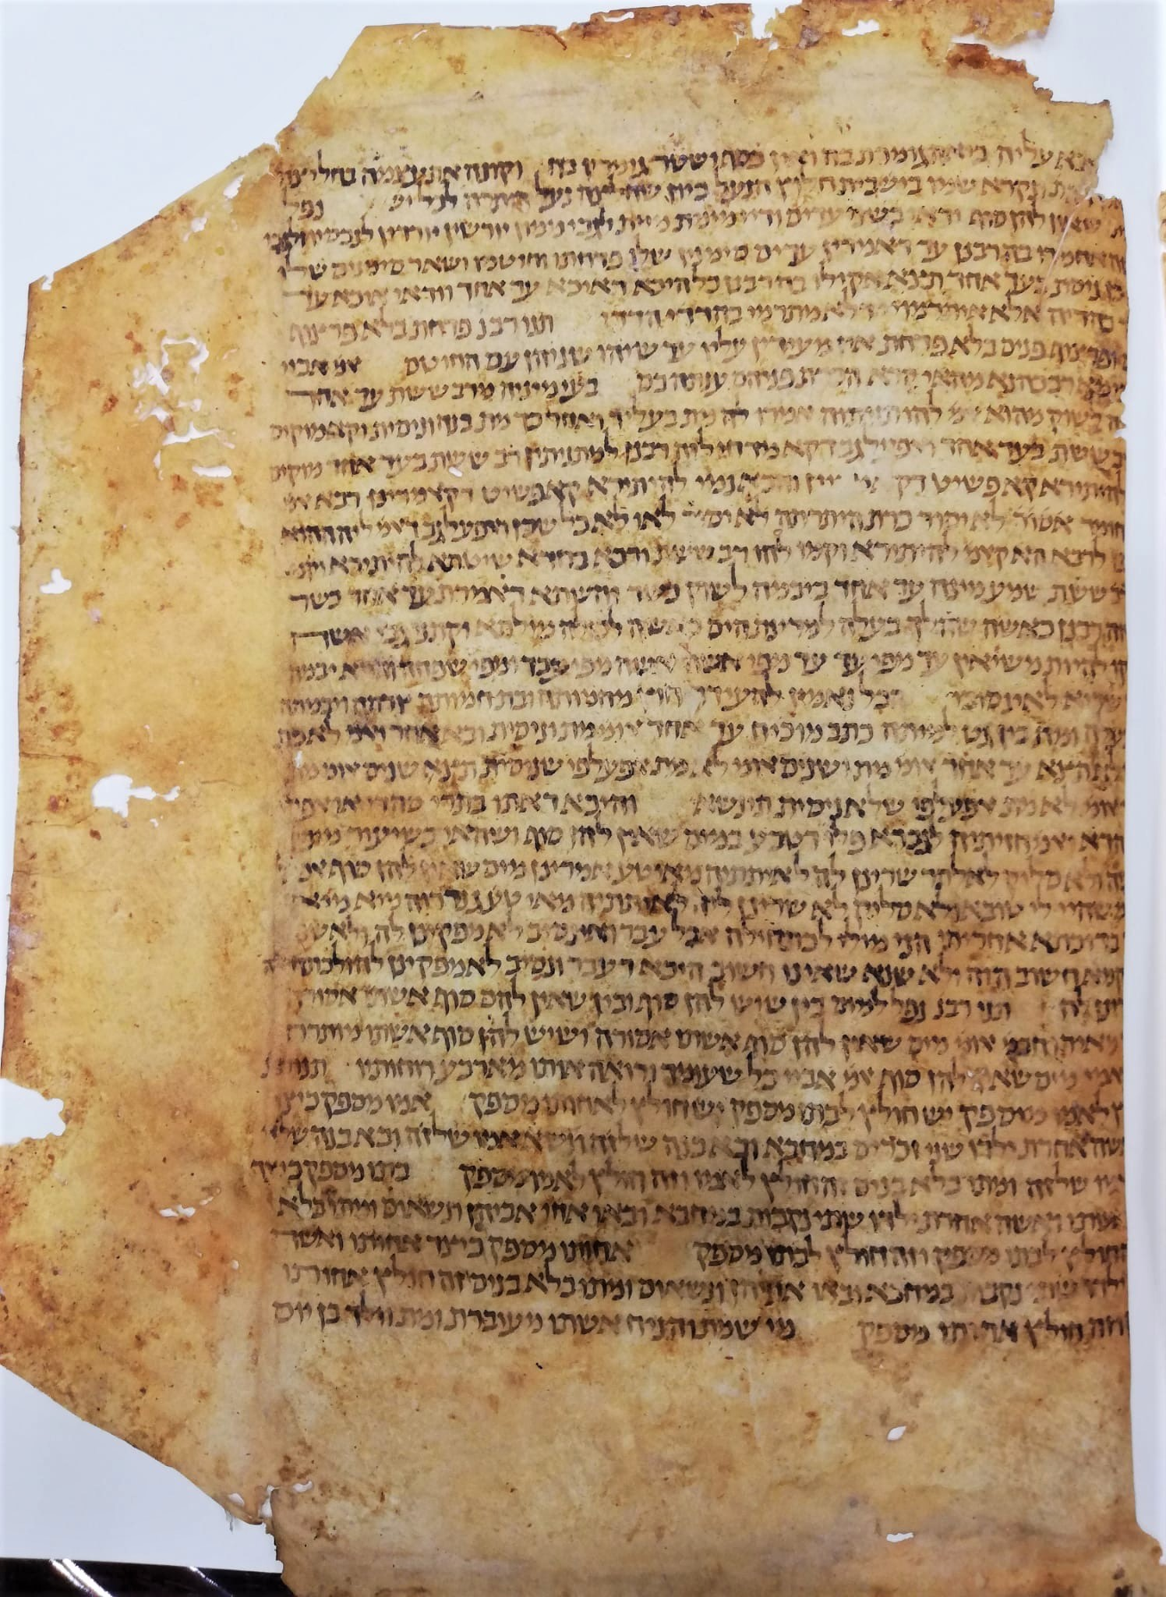

Fig. 1 – Bologna, Archivio di Stato, folio 1 containing *Halakhot gedolot*, *Hilkhot Me’un*.

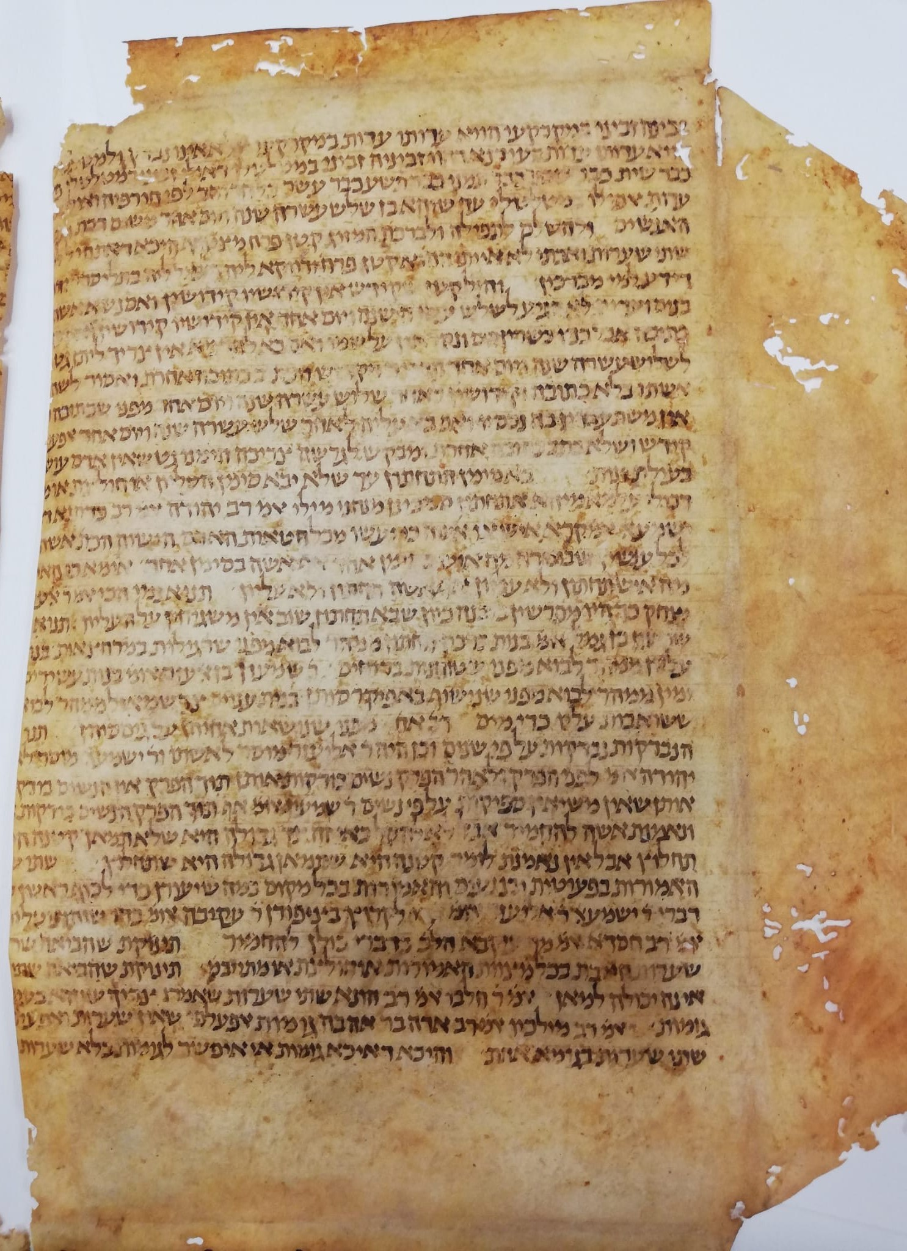

Fig. 2 – Bologna, Archivio di Stato, folio 1 containing *Halakhot gedolot*,

*Hilkhot Yibum we-Halitza*.

1. For general information on *HG* see R. Brody, *The Geonim of Bablyonia and the Shaping of Medieval Jewish Culture*, New Haven and London 1998, pp. 223-230;Id., *Zion Between the Tigris and the Euphrates: The World of the Babylonian Geonim*, Jerusalem 2015, pp. 379-386 (Hebrew).
2. J. Hildesheimer, Halachot Gedolot, Berlin 1888-1892.
3. A. Epstein, *Mi-Qadmoniyyot ha-Yehudim: Mehqarim u-Reshimot*, Edited by A. M. Hebermann = The Literary Works of Abraham Epstein, vol. 2, Jerusalem 1957, pp. 378-409.
4. See in particular N. Danzig, “Teshuvot haGeonim beQeta min haGenizah veYahasan leHalakhot Gedolot”, *Proceedings of the American Academy for Jewish Research*, vol. 54, 1987, pp. 13–57;id., *Introduction to Halakhot Pesuqot* (Hebrew), 2nd ed., New York and Jerusalem 1999, pp. 186-191.
5. The sigla of the manuscripts is in accordance with the sigla used in Hildesheimer variorum edition.
6. R. Shweka, *Studies in Halakhot Gedolot: Text and Recension* (Hebrew), Dissertation, The Hebrew University 2009.
7. B. Richler (ed., Palaeographical and Codicological Descriptions by M. Beit-Arie in collaboration with N. Pasternak), *Hebrew manuscripts in the Vatican Library*, Città del Vaticano 2008, p. 99-100.
8. Another note in Latin records the purchase of the manuscript on 12 November 1542 for four and a half ducats (f. 1r).
9. Shweka, Halakhot Gedolot, pp. 35-36 (manuscripts G4 and G5 there).
10. An unpublished paper given at Oxford, February 2011. See for now R. Shweka, “Genizah Fragments of Geonic Halakhic Codes”, *Report of the Oxford Centre for Hebrew and Jewish Studies*, 2010-2011, pp. 95-96.
11. M. Ben Sasson, “Italy and Ifriqia from the Ninth to the Eleventh Century”, in: J. L. Miege (ed.),*Les relations intercommunautaires juives en méditerranée occidentale. XIIIe-XXe siècles.*Paris 1984, pp. 34-50.
12. G. D. Cohen, “The Story of the Four Captives”, *Proceedings of the American Academy for Jewish Research*, vol. 29 (1960), pp. 55-131. On R. Hushiel and his son in Qayrawan see M. Ben Sasson, *The Emergence of the Local Jewish Community in the Muslim World: Qayrawan, 800-1057*, Jerusalem 1996, pp. 221-229.
13. For full codicological description see M. Perani, “Juridical Books bound in 16th c. Bologna with folios from a 12th c. manuscript of *Halakhot Gedolot*, and donated, in the 19th c., to the Leipzig University Library”, in this volume pp. 00-00.
14. p. 1 l. 21, l. 28
15. p. 2 l. 29.
16. The meaning of ‘קטן פרח’ is probably related to the meaning of ‘a young boy who is not a child, an apprentice’; as in ‘פרחי כהונה’ (*Mishnah Yoma* 1, 7). This reading is found in two genizah fragments of *Bavli Berakhot* 47a, Cambridge T-S F1(1).106 and T-S F1(1).113, instead of the form ‘קטן פורח’found in all other manuscripts. This is also the form in some geonic authorities, among them *Halakhot Pesukot*, p. 154 and *Sefer ha-bagrut le-Rav Shmuel ben Hofni Gaon*, ed. by T. Meacham, Jerusalem 1999, p. 164.
17. See n. 10.
18. The same also in Genizah fragment Cambridge University Library, T-S AS 77.139, which belongs to a manuscript that present the B-M recension (Shweka, Halakhot Gedolot, p. 50 [G40] and p. 138).
19. Shweka, Halakhot Gedolot, p. 161.
20. Shweka, Halakhot Gedolot, pp. 143-146.
21. J. N. Epstein, *Studies in Talmudic Literature and Semitic Languages* (edited by E. Z. Melamed), vol 1, Jerusalem 1983, pp. 270-273 (=*MGWJ* 61 (1917), pp. 127-132).
22. Perani (above, n. 13).
23. Shweka, Halakhot Gedolot, pp. 113-114.
24. R. Shweka, “Concerning The Chapters Nedarim and Nazir in Halakhot Gedolot”, *Tarbiz* 74 (2005), pp. 305-312 (Hebrew).
25. Shweka, Halakhot Gedolot, pp. 117-119.
26. Shweka, Halakhot Gedolot, pp. 124-125.
27. [ יורשין יורדין B, M, V, R: נחתין יורשין (Aramaic)
28. תנו רבנ'... ענתה בם ] so also in B, M and T-S AS 77.139; in VR missing here and found after אעלפי שלא ניסית תינשא (l. 20)
29. והכא] read ורבא, so R and T-S AS 77.139; B, M, V missing דקאמרינן ורבא נמי להיתירא קא פשיט (homeoteleuton)
30. B, M, V and T-S AS 77.139 correctly: לרבא רבא
31. B, M, V, R correctly: שיש
32. מאי טע' אמרינן ] B, M, V, R correctly:אבל ודאי
33. B, M, V, R correctly: שיש
34. אחותו ] so also B, M, R and this is an ancient mistake; V: אמו
35. חד וחד ] so B, M, V; R missing וחד
36. לפי ] so B; M (contra Hild. ed.!), R, V: לפום
37. קטן פרח ] other mss.: קטן פורח; the same for the second occurrence on the next line.
38. ויום אחד ] R missing in all occurrences (l. 8, 10, 11,12)
39. So in all mss. including M, but in Hild. ed. שתים!
40. כדתנא ] B, M, V, R: וכן תנא
41. כי האי ] so R; B, M, V: אי האי אי האי
42. יצחק ] B, M, V, R correctly: צדוק
43. שנים ] read נשים
44. ישמעאל ] so M (contra Hild. ed.!), R, V; B: יהושע
45. בפעוטות ] B, M, R, V and T-S F10.65: בפרה
46. האמורות ] B, M, R, V: האמורות בתורה