The Adelis Foundation
2017-2018

Table of Contents
Prof. Ehud Gazit
Dr. Johann Elbaz
Dr. Oded Rechavi
Dr. Noam Shomron


Prof. Ehud Gazit Ph.D. FRSC OSSI
Department of Molecular Microbiology and Biotechnology
Department of Materials Science and Engineering
Tel Aviv University,

Nano-Chemistry Meets Medicine: Study and Manipulation
of Metabolite Assembly

Scientific Background
Following the eras of genomics and proteomics, we enter that of metabolomics with emerging appreciation of metabolite role in different pathological states such as cancer, neurodegenerative disorders and inborn error of metabolism (IEM) disorders. The majority of IEM disorders are due to mutations in single genes, encoding for enzymes that facilitate the conversion of various substances into processed products. This results in metabolite accumulation that could be toxic or interfere with normal functions of the cell. Yet, little is known about the pathological mechanisms in IEM disorders whose symptoms include mental retardation and other developmental problems. More than 50 IEM disorders have been reported and described, but as most of them are rare, occurring in less than 1 per 250,000 in most populations, results in limited amount of research is available. However, collectively they constitute a very significant portion of paediatric genetic diseases.

Our group has recently demonstrated that phenylalanine, as a single essential amino acid, can self-assemble to form amyloid-like fibrils. A plethora of degenerative disorders, including Alzheimer’s disease (AD), Parkinson’s diseases (PD), and type II diabetes, are associated with the self-assembly of well-ordered proteinaceous amyloid fibrils. All amyloid fibrils share a unique set of similar biophysical and structural properties, despite being formed by a diverse and structurally unrelated group of proteins and peptides. These fibrillary assemblies have a diameter of 5–20 nm, are predominantly rich in β-sheet secondary structure, and specifically bind dyes, such as thioflavin-T (ThT) and Congo red. Moreover, the toxicity of amyloid assemblies appeared to be a generic property of the formed structures, rather than as a disease-specific pathology, thus implying a common mechanism for the toxic effect.

While the formation of cytotoxic supramolecular entities has previously been linked to proteins and peptides, it was first demonstrated by our group and later reinforced by others that phenylalanine fibrils possess typical ultrastructural and biochemical properties similar to those of protein and polypeptide amyloids. Moreover, we revealed the connection between these assemblies and the accumulation of phenylalanine in phenylketonuria (PKU) - the most prevalent IEM disorder. We demonstrated that phenylalanine assemblies are cytotoxic and that antibodies raised towards these species reduce fibril toxicity. The generation of antibodies in a PKU mice model and the identification of aggregate deposits in patients’ brains post-mortem suggested a pathological role of these assemblies.

To study whether these observations represent a general amyloid-like mechanism common to other metabolic disorders, we have screened metabolites that accumulate in other IEM disorders. We demonstrated that several other metabolites can self-assemble to form ordered amyloid-like ultrastructures in solution with molecular dimensions and dye-binding specificity similar to canonical amyloid fibrils. In addition, we have shown that these fibrillar self-assemblies are cytotoxic via induction of apoptotic programmed cell death, as observed for many amyloid disorders.
Here, we present the ability of two generic polyphenolic inhibitors of protein and peptide amyloid self-assembly to also restrict the formation of metabolite fibrils and reduce the cytotoxicity triggered by metabolite assemblies. To strengthen the clinical relevance of the metabolite assemblies, linking them to the IEM disorders pathology, we demonstrated the discrete immunological entities of these metabolite amyloid-like assemblies, which can activate the immune system and allow the formation of specific antibodies against them. Furthermore, for the first time we detected in ex vivo serum samples from IEM patients the presence of specific antibodies against the metabolite assemblies. Moreover, in vivo yeast model system was established and allowed monitoring the clinical disease ethology of the IEM disorders as well as the mechanism of action of the polyphenols. Finally, we suggest and discuss a possible mechanistic insight into metabolite accumulation in conditions such as neurodegenerative diseases and cancer. Our hypothesis is based on the ability of metabolite amyloids to promote protein aggregation, which will be presented here. This notion can provide a new paradigm for neurodegeneration and cancer, as both conditions are linked to protein loss of function due to protein aggregation.

Altogether, exploring the formation of structures by IEM disorders-associated metabolites may decipher the pathological mechanism in these poorly investigated maladies and can attribute to the discovery of new routes for future therapy. Moreover, the potential link between metabolite accumulation to other maladies such as neurodegenerative diseases and cancer, and their effect on disease pathology may redirect the efforts towards new therapeutic developments.

Summary of Results & Achievements

Inhibition of metabolite amyloid formation by generic polyphenols

Polyphenols are composed of one or more small aromatic phenolic rings that specifically and efficiently inhibit amyloid aggregation. High concentrations of natural polyphenols can be found in a wide variety of plants. This family of materials, which represent the first generation of amyloid-based potential therapeutic agents, cause a dramatic reduction in amyloidogenic-related cell death, as well as efficient inhibition of amyloid self-assembly in vitro. Here, we explore the inhibitory effect exerted on metabolite amyloid formation by two polyphenolic compounds, (-)-Epigallocatechin gallate (EGCG) and tannic acid (TA). Both inhibitors were previously shown to efficiently inhibit the formation of various protein amyloids in vitro and in vivo. We show that these two polyphenols successfully inhibit the self-assembly of adenine, phenylalanine and tyrosine into amyloid-like fibrils, which accumulate in adenine phosphoribosyltransferase deficiency, PKU and tyrosinemia IEM disorders, respectively. Furthermore, both inhibitors effectively deplete the neuronal cell model cytotoxic effect, which caused by the metabolite amyloid.

The effect of increasing concentrations of the inhibitors on the kinetics of metabolite amyloid fibril formation was first studied by monitoring the time-dependent ThT fluorescence intensity curve. Both EGCG and TA were found to inhibit adenine fibrils in a dose-dependent manner, as demonstrated by the ThT fluorescence assay, presenting near complete inhibition of adenine aggregate formation at their higher concentrations (Figs. 1A & B). Similarly, in the case of phenylalanine aggregates, both EGCG and TA inhibited the formation of the assemblies in a dose dependent manner (Figs. 1C & D). EGCG presented a near complete inhibition at all concentrations (Fig. 1C), while TA presented a complete inhibition only at its highest concentration (Fig. 1D). Lastly, both inhibitors presented near complete inhibition of tyrosine aggregates formation at their highest concentration and a significant reduction at the lower concentrations (Figs. 1E & F).

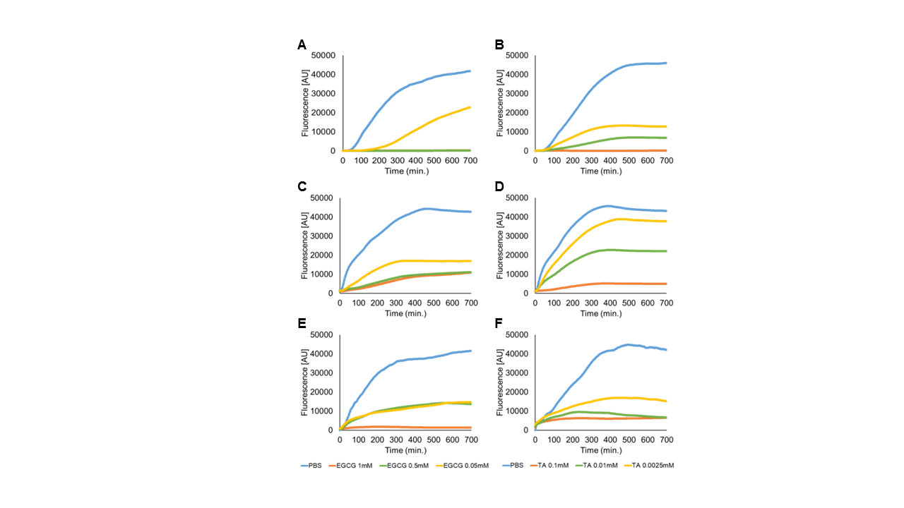
Figure 1: The inhibition of adenine, phenylalanine and tyrosine fibril self-assembly, as demonstrated by ThT fluorescence kinetics assay. All metabolites were dissolved at 90 °C in PBS and mixed with inhibitors, EGCG or TA, or with PBS as a control. Next, ThT in PBS was added and its emission data at 480 nm (excitation at 450 nm) was measured over time. Samples of metabolites without inhibitors and ThT were used as a control (No ThT). (A) Adenine 8 mg/ml + EGCG. (B) Adenine 8 mg/ml + TA. (C) Phenylalanine 40 mg/ml + EGCG. (D) Phenylalanine 40 mg/ml + TA. (E) Tyrosine 2 mg/ml + EGCG. (F) Tyrosine 2 mg/ml + TA

Next, we examined the correlation between the inhibition of metabolite assemblies’ formation by the polyphenol inhibitors and the resulting cytotoxicity. SH-SY5Y cells were incubated with metabolite amyloid fibrils for 24 h. In the case of adenine, the inhibitors significantly increased cell viability in a dose-dependent manner (Figs. 2A & B), showing a threefold and twofold viability increase in the presence of the highest concentration of EGCG (Fig. 2A) and TA (Fig. 2B), respectively. In the case of phenylalanine, cell viability was almost completely restored in the presence of both inhibitors at their highest concentration, while presenting a dose-dependent inhibition (Figs. 2C & D). Finally, in the case of tyrosine, for all the tested concentrations of both inhibitors, cell viability was significantly increased to about 70%
(Figs. 2E & F).

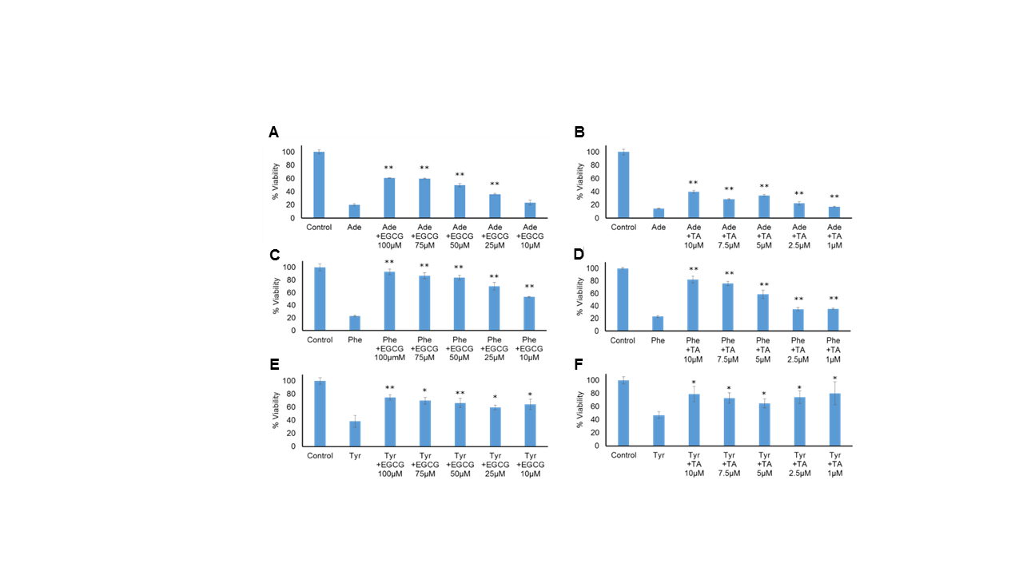
Figure 2: Inhibition of metabolite assemblies cytotoxicity by EGCG and TA, as determined by MTT assay. Adenine, phenylalanine and tyrosine were dissolved at 90 °C in cell medium to a final concentration of 2 mg/ml, 4 mg/ml, and 2 mg/ml, respectively, and mixed with or without the inhibitors. The control reflects medium with no metabolites. The results represent three biological repeats ($⋆$p < 0.05 $⋆⋆$p < 0.01) (A-B) Adenine (Ade) with or without (A) EGCG. (B) TA. (C-D) Phenylalanine (Phe) with or without (C) EGCG. (D) TA. (E-F) Tyrosine (Tyr) with or without (E) EGCG. (F) TA.

Identifying the immunological properties of metabolite assemblies
Here, we assess the immunological effect of phenylalanine, adenine, tyrosine and tryptophan and assemblies. Through cycles of immunization, antibodies against those assemblies were raised and then purified. To examine the reactivity of the purified antibodies, we preformed Dot-blot immunoassay. Metabolite assemblies were loaded on to a membrane and reacted with the antibodies. The specific detection of metabolites assemblies by antibodies was demonstrated (Fig. 3). This specific detection demonstrated the immunological properties of metabolite amyloid-like assemblies, which can activate the humoral immune system and allow for the formation of specific antibodies.

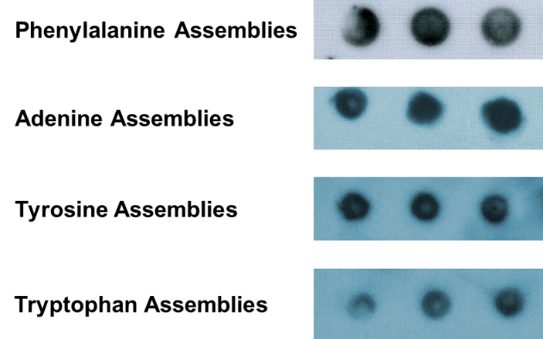

Figure 3: Dot-Blot reactivity assay of metabolites assemblies. The metabolite blotting (triplicate) and their recognition by specific antibodies

Recognition of Phenylalanine assemblies by antibodies purified from ex vivo PKU patients’ serum

Whole blood samples were received from diagnosed PKU subjects and from a healthy normal subject. The serum was separated from the whole blood sample and antibodies were purified from the serum. Each subject’s purified antibodies, both PKU patients and healthy subject, were used as a primary antibody in a dot-blot immunoassay to test the reactivity against phenylalanine assemblies. Phenylalanine fibrillary assemblies were loaded in triplicates onto a membrane and then were reacted with the antibodies purified from the human subjects. Here we demonstrated the identification of in-vitro phenylalanine assemblies by antibodies purified from PKU patients (Figs. 4A & B). Thus, the recognition of assemblies implies on the existence of antibodies against phenylalanine fibrils in PKU patient’s serum. Furthermore, the antibodies purified from the healthy subject did not react with the phenylalanine assemblies, while did react against Tetanus toxin, which used as a positive control (Fig. 4C).
Figure 4: Immunodetection of phenylalanine assemblies by antibodies purified from PKU patients. Dot-blot immunoassay. (A-B) Phe assemblies' recognition by antibodies purified from different PKU patients. (C) Phe assemblies were not recognized by antibodies purified from samples from healthy human subjects. A strong recognition of tetanus toxin by the antibodies served as a positive control and validated the integrity of the negative signal.
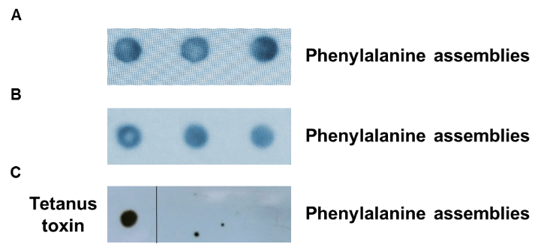

In vivo characterization of metabolite assemblies and development of therapeutic leads
In order to understand the biological relevance and the consequences of metabolite molecular self-assembly, the establishment of a model organism is needed. We used the budding yeast (Saccharomyces cerevisiae) to investigate metabolite self-assembly in vivo. Accumulation of metabolites was achieved by manipulating the endogenous metabolic pathways of the yeast, most closely mimicking the metabolic state in inborn error of metabolism disorders. Using salvage mutants that block biosynthesis downstream to adenine, phenylalanine and tyrosine, we revealed inhibition of growth upon the addition of increasing amount of the respective exogenous metabolites (Fig. 5A). Thus, the presence of the metabolite at the normal concentration used for wild-type yeast growth leads to a significant cell growth decrease in a strain that is defective in the biosynthesis downstream to the respective metabolite.

The yeast model for adenine accumulation was further examined. The effect shows sigmoidal dependence on the concentration of adenine suggesting a cooperative assembly process. This is consistent with a mechanism of nucleation-growth as was already reported for amyloid formation. Interestingly, the growth inhibition could be rescued by the treatment with polyphenols that are known to inhibit protein amyloids (Fig. 5B). By using an amyloid-specific dye we confirmed the presence of amyloid-like structures only in the metabolite accumulating mutant (data not shown). Furthermore, the formation of the metabolite amyloid-like structures disassembled by reducing adenine levels or by addition of amyloid inhibitors. Interestingly, while the addition of the inhibitor drastically improved cell growth (Fig. 5B), the intracellular levels of adenine remained constant. Thus, the change in cell growth appears to occur specifically due to the inhibition of adenine aggregate formation, and not as a result of a decrease in adenine levels.

We intend to extend our studies and establish additional yeast models that reflect the error of metabolism in human patients. These models will be further utilized to examine drugs with potential therapeutic effect and can lead to mechanistic understanding of the self-assembly process of metabolites in a living system and can pave the way into disease-modifying therapeutic avenues in the future.

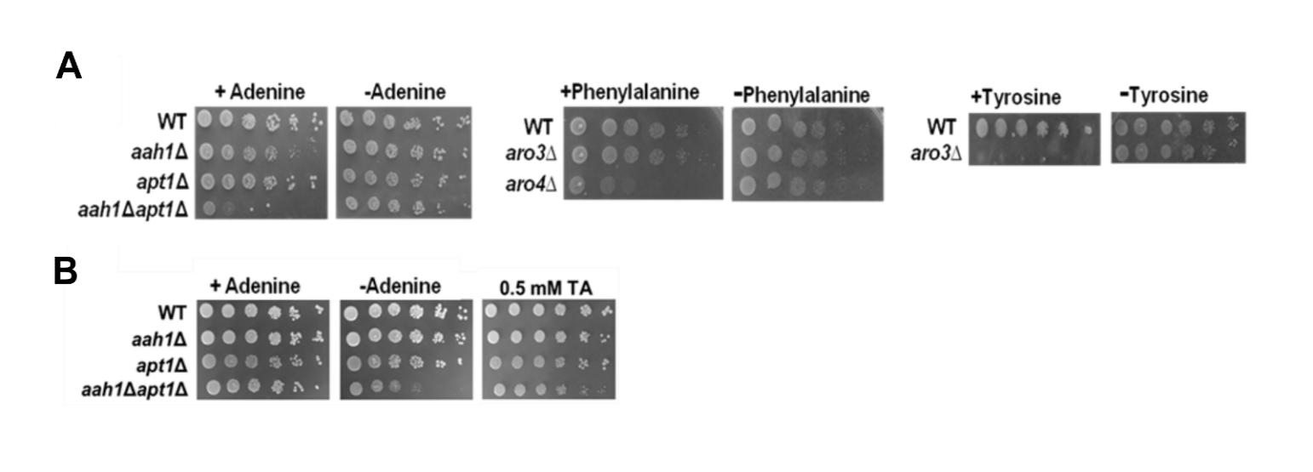
Figure 5: Sensitivity of salvage mutants models to adenine, phenylalanine and tyrosine feeding. Wild-type (WT), Δaah1, Δapt1, Δaah1Δapt1, Δaro3 and Δaro4 strains were serially diluted and spotted on SD medium with and without adenine, phenylalanine or tyrosine (A) or with adenine and 0.5mM tannic acid (TA) (B).

Neurometabolites self-assembly and cross-seeding of protein amyloids

Several metabolites were found to be associated with neurodegenerative diseases, such as Homocysteine (Hcy), a non-coded amino acid, which levels are elevated in the plasma of AD, PD and ALS patients. Moreover, Hcy was also found to accelerate dopaminergic cell death, a hallmark characteristic of PD, and act as a risk factor in case of AD. Neuronal cell death induced by Hcy is mediated by NMDA receptor activation. However, it is still unknown whether the elevated levels of Hcy are a cause or an effect in the etiology of neurodegenerative pathologies. Another example is Quinolinic acid (QA), which is associated with the pathology of several neurodegenerative diseases, including AD, PD, ALS and Huntington’s disease. QA co-localizes with tau fibrillary structures known to be associated with AD pathology, and its levels are increased in the CSF of ALS patients. Secreted by activated microglia, QA is an NMDA receptor agonist, thereby conferring neurotoxicity. Though its mode of action has not been fully elucidated, QA can induce several cellular processes, including cytoskeleton destabilization, inflammation, oxidative stress, autophagy and apoptosis. While the association of metabolites with neurodegenerative diseases is well-established, no common underlying mechanisms are known. In many cases, whether metabolites accumulation is a cause or side-effect in these ailments is also unclear. So far, no comprehensive theory has been suggested to explain the high occurrence of metabolites in neurodegenerative diseases.

We aimed to explore a novel concept suggesting protein cross-seeding as a mechanism underlying the role of metabolites accumulation in the initial stages of neurodegenerative diseases. We postulate that high levels of neurometabolites cause their self-assembly into small metabolite seeds, which, in turn, serve as template for the assembly of protein amyloids. Thus, the cross-seeding of protein amyloids by neurometabolites is expected to accelerate, and possibly initiate, the amyloidogenic process. Though protein cross-seeding by phenylalanine has been demonstrated in vitro, this mechanism has never been explored as a common initiator of the neurodegenerative process.

We first demonstrated the ability of Hcy and QA to self-assemble in vitro (Figs. 6A, 7A). For that purpose, we dissolved each neurometabolite at 90°C in a physiological buffer to obtain a homogenous monomeric solution, followed by gradual cooling, resulting in the formation of supramolecular-structures. We assayed various concentrations of each neurometabolite to determine the conditions under which it forms ordered supramolecular structures. To visualize the neurometabolite structures, we performed TEM analysis. This analysis showed that Hcy formed amyloid-like fibrils (Figs. 6B & C), while QA self-organized to form short fibrillar assemblies (Fig. 7B). To examine the amyloid-like nature of the metabolite assemblies, we stained the structures with ThT. The neurometabolite assemblies were stained with ThT and viewed using confocal microscopy. We found Hcy to bind ThT and form well-ordered amyloid-like structures (Fig. 6D). Additionally, a kinetic analysis of the Hcy fibrillization process using ThT binding assay demonstrated its dose-dependent nature (Fig. 6E). However, ThT did not stain or bind QA, possibly indicating that QA is not amyloidogenic (data not shown).

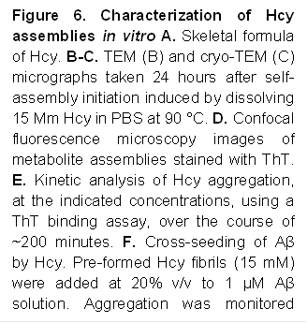
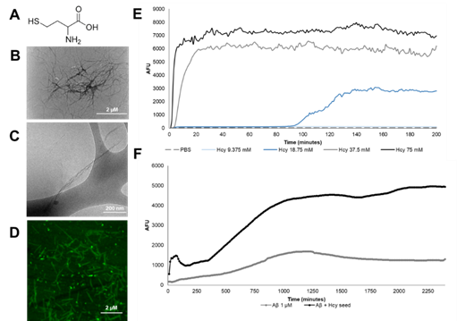

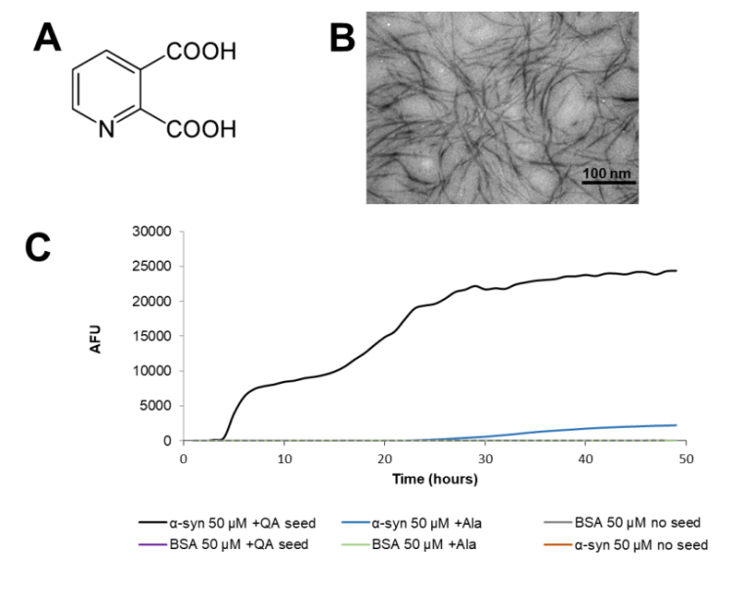
Next, we conducted a preliminary experiment to examine the cross-seeding of amyloidogenic proteins by both neurometabolites. Amyloid-β (Aβ) and α-synuclein, amyloidogenic proteins related to AD and PD, respectively, were co-incubated with pre-formed fibrils of Hcy and QA, correspondingly, expected to serve as a nucleation seed. Protein aggregation was monitored using a ThT binding assay. Both neurometabolites induced cross-seeding of the corresponding proteins (Figs. 6F, 7C). In contrast, incubation of Hcy and QA with bovine serum albumin (BSA) as a control did not affect the aggregation propensity of this protein (Fig. 7C and data not shown). Moreover, using alanine as a negative control did not affect Aβ or α-synuclein aggregation (Fig. 7C and data not shown).
Figure 7: Characterization of QA assemblies in vitro (A) Skeletal formula of QA. (B) TEM micrograph taken 24 hours after self-assembly initiation induced by dissolving 12 mM QA in PBS at 90 °C. (C) Cross-seeding of α-synuclein by QA. Pre-formed QA fibrils (12 mM) were added at 20% v/v to 50 µM α-synuclein solution. Aggregation was monitored using ThT binding assay, over the course of ~50 minutes. Alanine and BSA under the same conditions were used as a negative control.

Publications Resulting from the Research
Submitted and under revision: 2
In preparation: 3


Dr. Johann Elbaz
Assistant Professor, Department of Molecular Microbiology and Biotechnology, The George S. Wise Faculty of Life Sciences,
Tel Aviv University

Genetically Engineering Bacteria as Smart Genomic Recorder for the Sensing of Complex Gut Disease and as novel Virus-Liked Nanoreactors.

Introduction

Cells are the most sophisticated machinery, producing hundreds of thousands of complex molecules selectively and simultaneously. The ability to engineer biological organisms has been a long-envisioned goal dating back more than half-century. With the genomics revolution, came the development of a new field “synthetic biology”; to create, control and program cellular behaviors. Synthetic biology combines different scientific disciplines, including engineering, biology, chemistry and computer sciences, to program cells that can perform tasks or create chemicals and materials, mimicking the complexity in nature. Recently, we have developed a genetic synthetic pathway for the expression of artificial ssDNA and their self-assembly into dictated nanostructure in E. coli. This technology builds a fundamental bridge for the successful incorporation of DNA nanotechnology to the cellular world using synthetic biology tools. In this context, our research group is divided into three joint projects to resolve fundamental challenges associated with the development of smart genomic recorder based biosensor for biomedical applications, the production of smart virus-like bioreactor for energy application and smart drug delivery system on demand:

- Development of Smart Genomic Recorder-based Biosensor.

While dynamics underlie many biological processes, our ability to robustly and accurately profile timevarying biological signals and regulatory programs remains limited. Our ability to sense information across cell populations in difficult-to-study habitats such as the mammalian gut or in open settings such as soil or marine environments remain extremely challenging.
Our goal in this project is to create new applications in biological recording. A smart intracellular recorder system could be utilized to record metabolite fluctuations, gene expression changes, and lineage-associated disease disorders. In this project, we are developing a framework to store temporal biological information directly into the genomes of a cell population. A “biological tape recorder” is developed in which biological signals trigger intracellular ssDNA production that is then recorded into a precise location within the E. coli genome using the β recombinase from the λ-red system.

- Living Synthetic Virus-like Nanoreactors.
Viruses are well known to cause devastating diseases. However, scientists have now found a positive way to make use of their incredibly sophisticated natural self-assembly in order to engineer materials at the nanoscale for a wide range of applications from solar cells and batteries to medical diagnostics, regenerative medicine, and gene therapy platforms.

The promise of genetically encoding nucleic-acid nanotechnology in living cells underlies the ability to exploit straightforward Watson–Crick-based rules to program nanosystems with defined structures and functions. This approach has already been used in vitro for the formation of intriguing precisely designed nanoscaffolds that mediate the enhancement of enzymatic reactions. However, problems of cellular degradation and difficulties with export and delivery to other organisms and the extracellular matrix, remain challenging. During the physiological process of self-assembly, viruses encapsulate their genome, and thereby protect the genome from degradation while creating a very sophisticated delivery system. Learning from nature, and using the ability of my system to genetically encode pre-programmed, artificial self-assembling ssDNA nanostructures in bacteria, we envisagion the production of artificial virus nano-assemblies, and the encapsulation of DNA-protein or RNA-protein nanoscaffolds, designed for the enhancement of metabolic and chemical productions within the artificial virus particles. We hypothesize that the encapsulation of DNA based nanoscaffolds within an artificial virus, will lead to the production of ultra-stable biological nanoreactors (undegradable DNA scaffolding), with the ability to sense and respond to their surroundings (e.g. light-inducible promotor).

Specific Goals of this Research

Aim 1: Genetically Engineer Bacteria to Produce Multiple ssdnas.
  - New synthetic biological tools based on the functionality of catalytic nucleic acids (DNAzymes) that can produce multiple ssDNAs in vivo.

  - Engineering new synthetic biological tools based on RNA/DNA for the production of multiple DNA.

Aim 2: Dynamic Genomic Recording of Cellular Events for Robust, Fast and Cheap Diagnostic of Complex Gut Diseases.

2.1 Engineering the artificial genetic recorder pathway based on the production of ssDNA via non-coding RNA, natural mRNA and Reverse transcriptase.

2.2 Implementing the artificial genetic recorder pathway to RNA sensing and production of multiple different ssDNAs..

2.3 Developing an evolutionary platform to increase the efficiency of the DNA recorder system and the discovery of new genetic sensor parts (e.g. promotor) for specific gut cancer, such as pH or adenomatous polyps.

Aim 3: Engineer Bacteria to Produce Adjustable Living Artificial Nanoscaffolds that can be Encapsulated into Artificial MS2 Bacteriophage Virus Based Particles.

3.1 Engineering the encapsulation of chemically synthesis DNA/RNA nanoscaffolds within artificial virus-based particles using purified coat protein subunits from MS2 prokaryotic phages.

3.2 Engineering the encapsulation of in vivo-produced DNA/RNA nanoscaffolds within artificial virus-based particles using coat protein subunits from MS2 prokaryotic phages.

3.3 Evaluate the potential of DNA nanostructures encapsulated within viruses as nanoreactors that can enhance chemical reactions within cells or in the extracellular media.

Results
Aim 1: Genetically Engineer Bacteria to Produce Multiple ssDNAs.

1.1 Engineering new synthetic biological tools based on the functionality of catalytic nucleic acids (DNAzymes) that can produce multiple ssDNAs in vivo.

We have recently resolved the challenge to encode and express artificial short ssDNA in living bacteria. This was done using a well-known biological system from a eukaryotic retrovirus (HIV reverse transcription, HIVRT) that was artificially incorporated into the host organism (E. coli) using synthetic biology genetic tools. The HIVRT enzymatically converts RNA to dsDNA, but was not found active in prokaryotes. To synthetically activate the HIVRT in prokaryotes, two main innovations have been developed. First, each ssDNA is encoded by a gene that is transcribed into non-coding RNA containing a 3’-hairpin (HTBS). This hairpin includes the eukaryote t-RNA^{LYS} sequence, known as the HIV binding site, and also serves as the transcriptional terminator. Second, the expression of the HIVRT had been found insufficient to produce ssDNA; thus, only by co-expressing the murine leukemia reverse transcriptase, the ssDNA production is amplified. By incorporating this synthetic pathway into a genetic circuit, we demonstrated the in vivo production of ssDNA for in vitro applications, such as forming 1D and 2D wires and sheets.

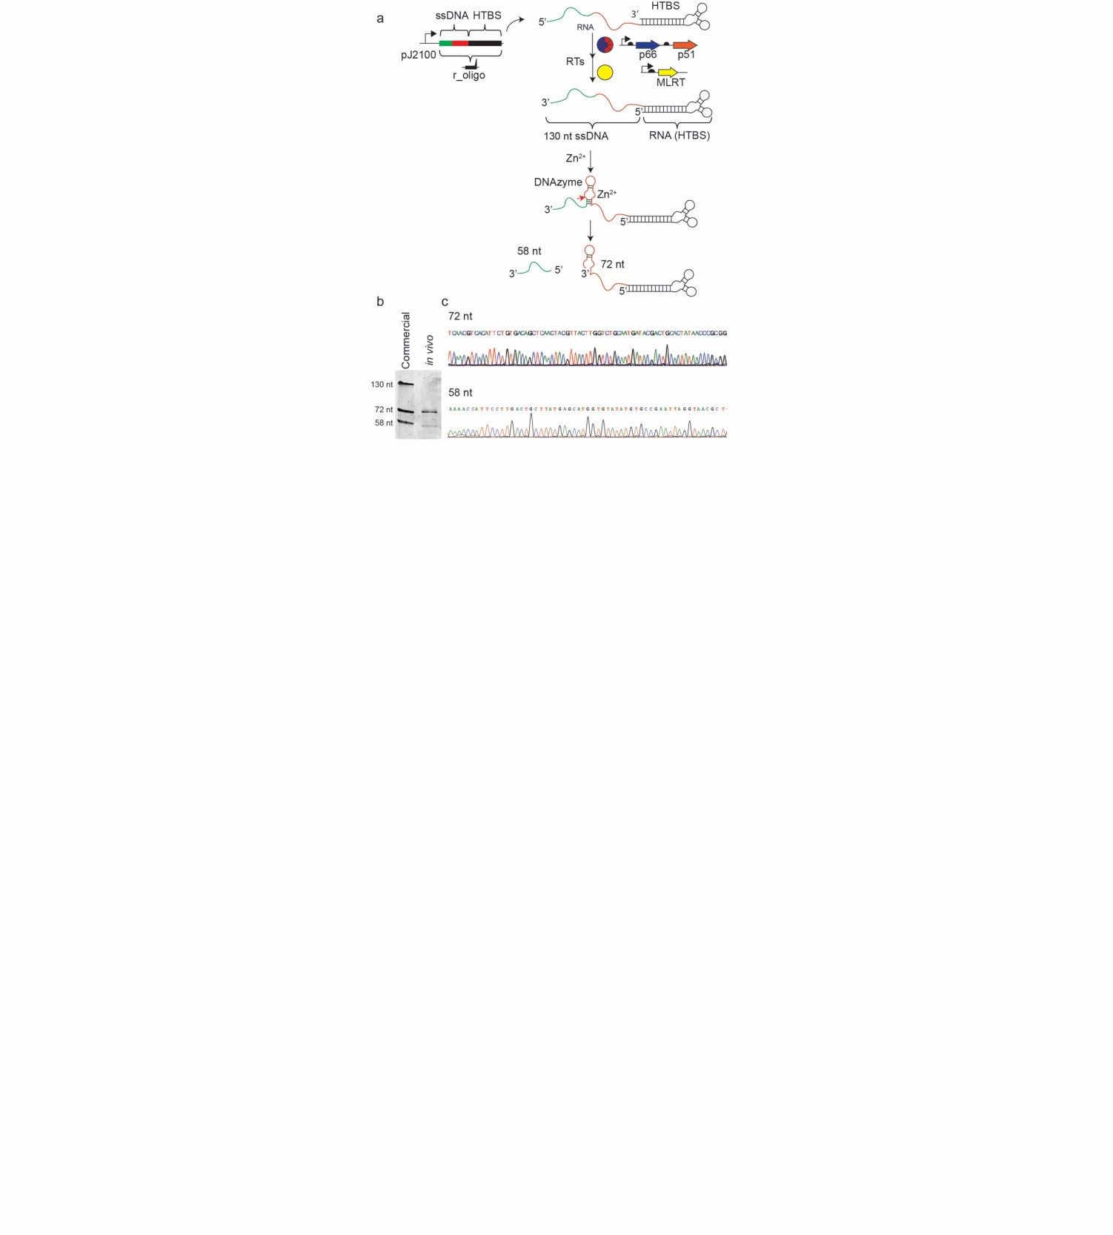
Figure 1: (a) A schematic for the conversion of the r_oligo gene to ssDNA followed by its self-cleavage. The r_oligo gene contains the desired ssDNA sequence (green), the catalytic nucleic acid (DNAzyme, red) and the HTBS part (black), which serves as the transcription terminator. The red arrow shows the DNAzyme cutting site. (b) Comparison of an in vivo produced 130 nt ssDNA that self-cleaved itself using the DNAzyme into two ssDNAs (72-nt and 58-nt) with commercial chemically synthesized ssDNAs. (c) Sequencing analysis of the in vivo produced 72-mer and 58-mer.
Another important goal is not only to establish a system to produce ssDNA but the ability to produce multiple copies of the different ssDNA molecules in vivo, while also removing the conjugated RNA (HTBS) (Figure 1) after formation. For this purpose, we fused a specific catalytic nucleic sequence (R3-DNAzyme) to the oligo gene. During the first year of the grant, we designed our system (unpublished data) to express a 130-nt ssDNA that includes the DNAzyme sequence such that when the active DNAzyme structure is formed, the 130-nt ssDNA is cleaved into two fragments (72-nt and 58-nt) (Figure 1a). These could be detected after purification of the total ssDNA (Figure 1b). We further analyzed the specific sequence of the two bands by conjugating DNA adapters to the purified ssDNAs (Figure 1c). This procedure enables the sequencing with short oligos and prevents the possibility of plasmid contamination (the DNA adapters can be ligated only to ssDNA and not to circular DNA). We identified the precise cutting site of the DNAzyme and found it to be identical to the site previously described in vitro. This result not only prepares the way for the production of stable and more efficient DNA nanostructures, but also builds a bridge between components of chemical DNA science, such as aptamers and DNAzymes, and their efficient integration to the intracellular world that can be useful for medical and bioengineering applications.

1.2 Engineering new synthetic biological tools based on RNA/DNA for the production of multiple DNA.

The system is under construction and will be checked during the second year of the grant.

Aim 2: Dynamic Genomic Recording of Cellular Events for Robust, Fast and Cheap Diagnostic of Complex Gut Diseases.

2.1 Engineering the artificial genetic recorder pathway based on the production of ssDNA via non-coding RNA, natural mRNA and Reverse transcriptase.

To record biological signals via in vivo ssDNA production, an engineered strain was first designed. The engineered strain is based on DNA repair of defective kanamycin resistance gene. First, a kanamycin resistant strain was cloned by inserting kanR gene, which encodes neomycin phosphotransferase II and confers resistance to kanamycin, into the galK locus. Next, two stop codons were introduced by changing 5 bases in the genomic kanR to make a kanamycin-sensitive reporter strain, named kanR_{OFF}. These premature stop codons could be reverted back to the WT sequence (KanR_{ON}) via recombination with the ssDNA.

Figure 2: Cell density of the sensor strains. The absorbance at 600nm of the different strains was measured after 6h in the presence (red) or absence (blue) of kanamycin.

As shown by growth detection in the presence of kanamycin, both the resistant and the sensitive strains were successfully engineered (Figure 2), and the incorporation of 5 bases in order to form the premature stop codons was enough to establish a kanamycin based sensor.

Next, the desired genetic program, which produces ssDNA and integrates it into the specific mutated locus in E. coli, was designed and constructed. The engineered genetic system effectively expresses HIVRT, MLRT and β recombinase proteins. HIVRT and MLRT are the enzymes necessary to express ssDNA, while β recombinase integrates the ssDNA into the genome. HIVRT, MLRT and β recombinase production are controlled by the pTac inducible promoter. A cassette under a constitutive promoter expresses a synthetic HIVRT binding site (HTBS) and a non-coding RNA that produces the ssDNA with the KanR_{ON} sequence. This sequence is designed to be homologous to the KanR_{OFF} part. Thus, by integrating the KANon sequence to the replication fork, the KAN gene will be repaired via recombination and restore kanamycin resistance (Figure 3).

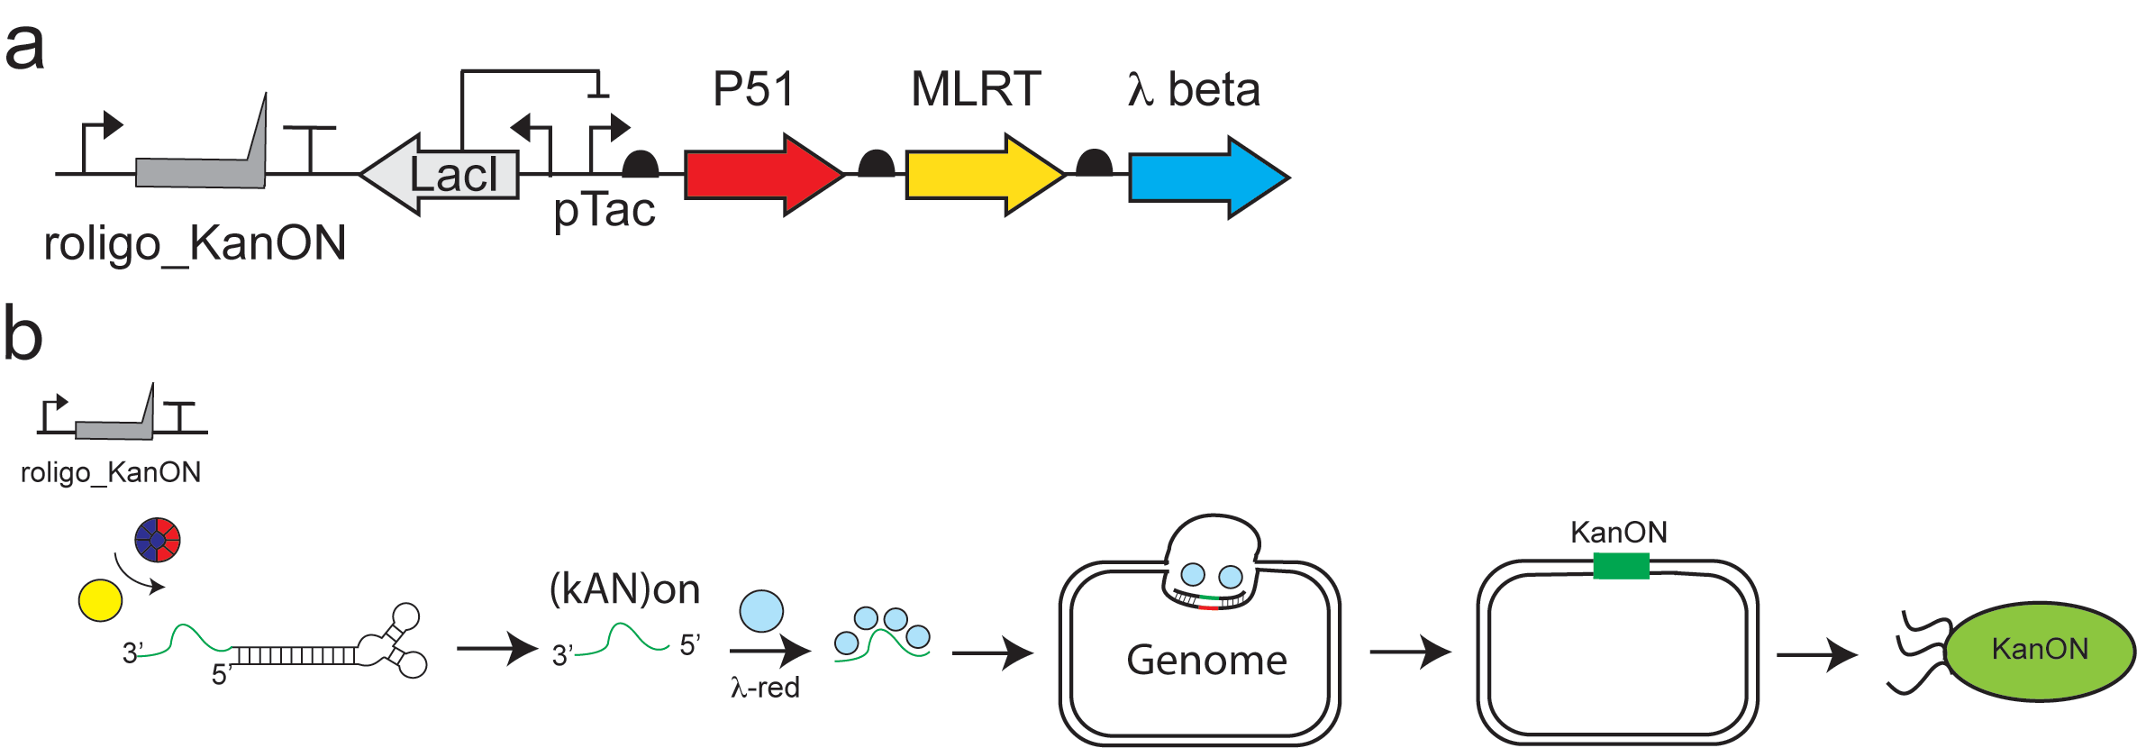
Figure 3: The general recorder paradigm. (a) The genetic program includes three genes (P51, MLRT and beta) on a similar operon and controlled under pLacI, and the co-expression of the oligo gene under a constitutive promotor J23100. (b) A schematic presentation of the system is described: the ssDNA production by the RT system and its integration into a precise genomic location, resulting in the activation of the kanamycin resistance gene.

After successfully constructing the sensor strain and the genetic circuit used for the production under demand of the ssDNA in the presence of β recombinase, the incorporation of the ssDNA within the precise location was tested. A plasmid containing the genetic circuit was transformed into the KanR_{OFF} strain. Following an induction of the pTac promoter by IPTG, bacteria were plated on LB-agar with or without kanamycin and the recombination frequency was calculated by the ratio between the colony-forming-units (CFU) grown on the selective medium and the total count on the non-selective medium. It was shown that following IPTG induction bacteria grew on the kanamycin plates. The mutation correction was further verified by sequencing, indicating a successful correction of the defected resistance gene.
To further study our system and to verify the significance of its components, different versions of the system lacking each of the enzymes were designed. In addition, a random sequence instead of the KanR_{ON} sequence was tested. It was shown that without the β recombinase and also with a random ssDNA sequence, no correction of the gene has occurred (Figure 4). A construct lacking both HIVRT and MLRT did not acquire the kanamycin resistance, indicating the vital role of the reverse transcription. Surprisingly, either the HIVRT or the MLRT were sufficient for the correction of the mutated gene (Figure 4).

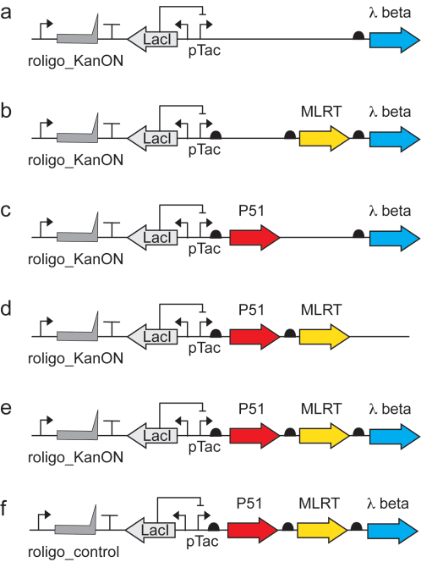

Figure 4: The recombinant frequency of the different genetic programs. The design of the different systems is shown in the left panel. The corresponding recombinant frequencies are described on the right panel.

Since recombination events occurred also in the absence of IPTG (figure 5), we are currently constructing different genetic programs which may rigidly control the system. It is possible that improving regulation on the expression of the non-coding RNA, which serves as template for ssDNA production, will enable a tighter control over the recording event.
We aim to improve the ability of the system to sense the cell environment and record events of exposure to chemical and biological signals by tightening the regulation on the components of the system and lowering the recombination events occurrence in non-induced state.

Figure 5: The ability to record the IPTG presence into the genome. The genetic program includes an IPTG-dependent inducible promotor controlling the expression the three enzymes (P51, MLRT and beta) while co-expressing a precise oligo KanON (upper panel). The recombination frequency was 6 time higher in the presence of 1mM IPTG than without it (bottom panel).

2.2 Implementing the artificial genetic recorder pathway to RNA sensing and production of multiple different ssDNAs.

We aim to develop a more versatile version of the system in which the ssDNA produced will be used as a primer enabling the reverse transcription of an RNA template. This will allow the use of a single ssDNA for the production of multiple different ssDNAs to be incorporated into different locations in the genome, and may also serve as a system requiring more input signals for functionality of the genomic recording process, and enable the capability to sense RNA naturally present in the cell.

This part is under construct and will be checked in the next months.

2.3 Developing an evolutionary platform to increase the efficiency of the DNA recorder system and the discovery of new genetic sensor parts (e.g. promotor) for specific gut cancer, such as pH or adenomatous polyps.
This part will be started by the end of the second year.

Aim 3: Engineer Bacteria to Produce Adjustable Living Artificial Nanoscaffolds that can be Encapsulated into Artificial MS2 Bacteriophage Virus Based Particles.

Preliminary Results (first 3 months)

3.1 Engineering the encapsulation of synthetic DNA/RNA nanostructure in MS2 in vitro.

Wild-type bacteriophage MS2 capsids were first generated and purified at bulk through their natural infection pathway. TEM images show the purified natural MS2 virus with 27 nm dimensions (Figure 6a). The purified MS2 were then disassembled and their natural nucleic acids (RNA) were removed to prevent their self-reassembly in the absence of the synthetic RNA/DNA (Figure 6b). The viral coat proteins of MS2 were then exposed to synthetic ssRNA to enable their reassembly and the encapsulation of the artificial ssRNA instead of the natural viral genomic element in vitro. The MS2 particles were successfully characterized via TEM (Figure 6c), thus demonstrating the ability to assemble MS2 viruses in vitro and the potential encapsulation of artificial ssRNA. While the wild-type natural MS2 prevented degradation of their RNA genome upon treatment with Rnase, the recomposed MS2 (encapsulated ssRNA in the viral proteins) was unable to prevent the degradation of the RNA upon treatment with Rnase as it arises from the control "naked" ssRNA molecules (Figure 7). ssDNA degradation in the viral proteins was in similar to the degradation in the control ssDNA, suggesting that these virus-like particles did not protect from Dnase. However, DNA and RNA encapsulation was not validated yet.

Our next work will include finding the optimized conditions for MS2 capsid decomposition and re-assembly in vitro, replacing the viral natural genomic element with DNA nanoscaffolds, catalytic nucleic acids (DNAzymes), and functional RNA-based machines. The DNA/RNA affinity to the coat proteins of MS2 will be compared with the natural viral RNA affinity in the extracellular media and the structural and functional stability of the encapsulated nucleic acids in the virus-like particles will be evaluated.

3.2 Genetically engineering the encapsulation of synthetic DNA/RNA nanostructure in MS2 in living cells.

The vectors (plasmids) for expressing the DNA/RNA nanostructures together with the coat proteins of MS2 in bacteria are now designed and under construction for the in vivo experiments. These nanostructures will be characterized and engineered to enhance chemical reactions within cells. Further work will combine an artificial secretion system for the developed RNA/DNA-protein functional elements in order to design and produce extracellular multi-scale patterning materials like biofilms.
a | b | c
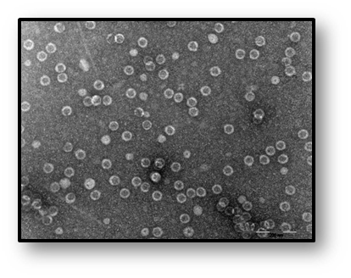 | 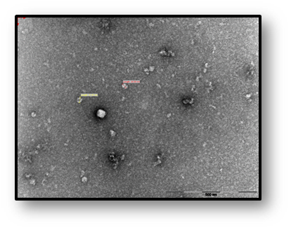 | 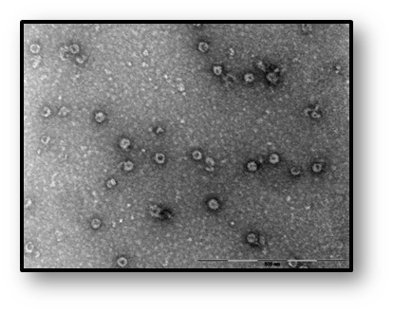
Figure 6: MS2 decomposition and re-assembly in vitro. TEM images showing (a) wild-type bacteriophage MS2 (b) wild-type bacteriophage MS2 after de-composition with glacial acetic acid (c) re-assembly of the viral proteins with artificial ssRNA. Scale bar = 500 nm.

Figure 7: DNA and RNA degradation in MS2 and the recomposed MS2-like particles. MS2 and MS2-like particles were treated with Dnase (upper gel) or Rnase (lower gel) and the nucleic acid degradation was followed in gel agarose. Treated samples with Dnase and Rnase are marked with '+'. A and E: natural MS2; B and F: Viral proteins without nucleic acids; C: Viral proteins with ssDNA; D: 'naked' ssDNA; G: Viral proteins with ssRNA. H: 'naked' ssRNA. | 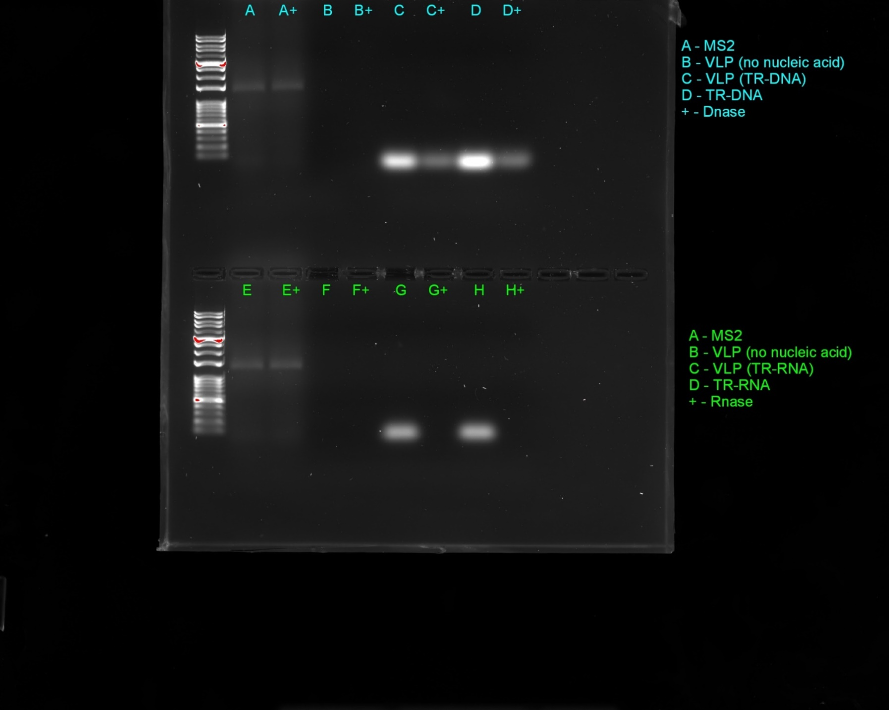

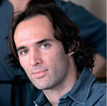
Oded Rechavi, PhD
The George S.Wise Faculty of Life Sciences,
Department of Neurobiology, Tel Aviv University

Reading and Writing Epigenetic Memories

Immediate Goal
The immediate goal of the Rechavi lab is to expose novel mechanisms that encode biological memories. In the last year, we have progressed towards that goal, and achieved significant accomplishments.

Special Award Given:
Among other achievements, Oded Rechavi was awarded the Blavatnik Award for Young Scientists.

Information regarding the Blavatnik Awards (from the Blavatnik award site):
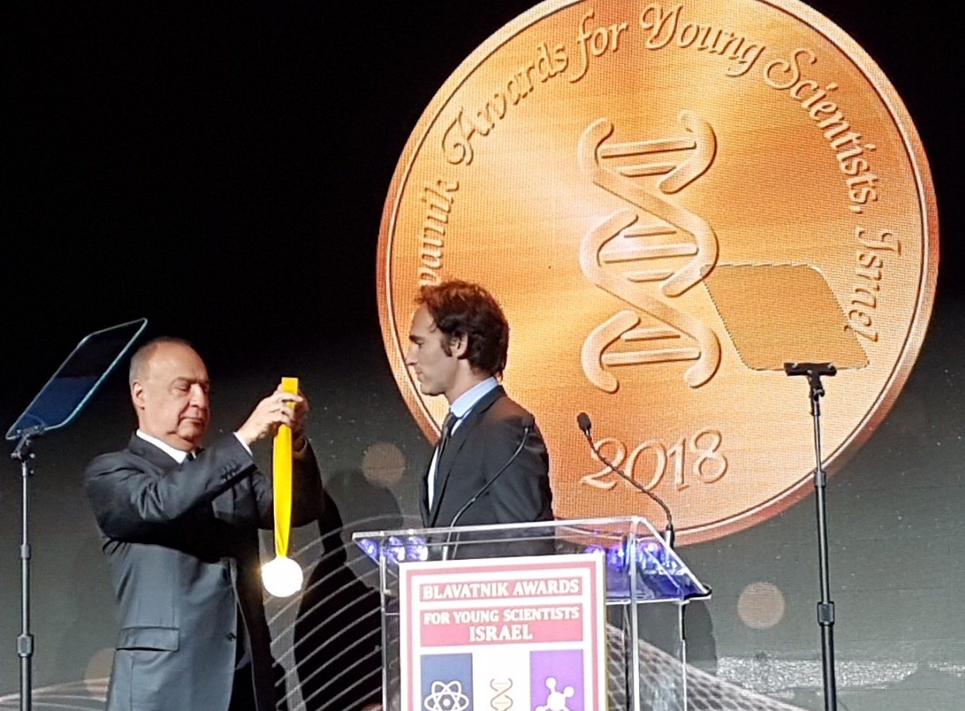
“The Blavatnik awards honor exceptional young scientists and engineers by highlighting their extraordinary achievements, recognizing remarkable promise for future discoveries, and accelerating innovation in their research. Established in the United States in 2007, the Blavatnik Awards are a signature program of the Blavatnik Family Foundation that are administered by the New York Academy of Sciences. Awarded in Israel for the first time – in collaboration with the Israel Academy of Sciences and Humanities - three of the country’s most outstanding young scientists and engineers will receive US$100,000 each, one of the largest unrestricted prizes ever created for early-career researchers in Israel.”

Brief Summary of The Achievements Obtained During the Last Year:
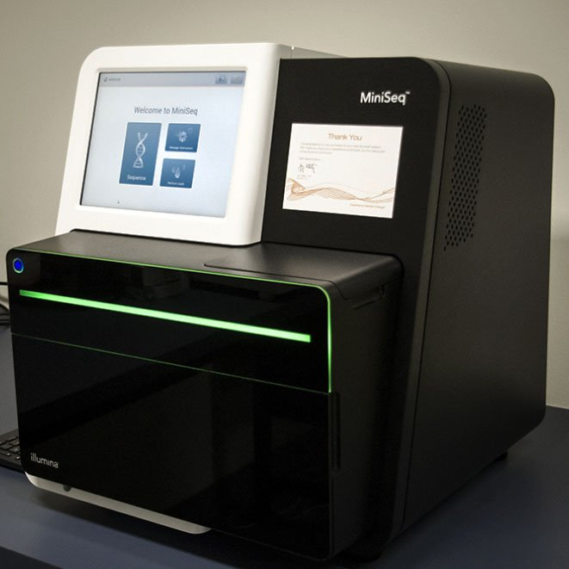
The funds from The Adelis Foundation were extremely helpful, and pushed our research forward. We allocated the funds according to the original budget plan. No major changes to the original budget were made. We bought a MiniSeq Illumina deep sequencer which revolutionized RNA and DNA sequencing in my lab.

Until this purchase, we had to outsource our sequencing projects and it took us months until we received results from our deep sequencing experiments. Now, with our own machine, (purchased with the generous donation of the Adelis Foundation), we obtain our results over-night! We also used funds, to purchase sequencing and molecular biology reagents, and advanced our computational analyses.

Publications
We progressed very nicely and followed the aims of the grant very successfully. Already this year, we published a few high impact papers, and obtained new data that will allow further insights and publications soon. The Adelis Foundation is already acknowledged in 3 papers that we published over the course of the year:

- D.Cohen, M.Volovich, Y.Zeevi, K.Louie, D.J.Levy, O.Rechavi*. Asymmetric Overlap in Neuronal Sensation Constraints Rational Choice in C. elegans. Biorxiv.

Article Abstract

Rational choice theory in economics assumes optimality indecision-making. One of the basic axioms of economic rationality is “Independence of Irrelevant Alternatives” (IIA), according to which a preference ratio between two options should be unaffected by introducing additional alternatives to the choice set. Violations of IIA have been demonstrated in both humans and in various animals, and could therefore stem from common neuronal constraints. We used the nematode Caenorhabditis elegans, an animal with only 302 neurons and a fully mapped connectome, to examine when and why economic rationality and violations of rationality occur. We developed tests for IIA
violations by characterizing the choices that C. elegans make in olfactory chemotaxis assays. In each assay, we exposed the worm to different odors that activate only specific neurons, thus involving in the choice process only defined neuronal networks, and tested whether particular neuronal architectures are prone to producing irrational choices. We found that C. elegans are capable of maintaining robust binary olfactory preferences irrespectively of the presence of a third attractive odor. However, in very
specific olfactory contexts, which we term asymmetric overlaps, the preference ratio between the two odors was altered due to the addition of a third inferior odor, in a manner that violates IIA, and in certain cases can be considered “irrational” based on the economic definition of rationality. Our results suggest that different network configurations vary in their propensity to give rise to inconsistent decision making. Thus, non-optimal choices, assumed to be an outcome of high-order cognitive and mental processes, could result from much more basic attributes of neuronal activity and constrained computational mechanisms.

- A.Hakim, Y.Mor, I.A.Toker, A. Levine, Y.Markovitz, O.Rechavi*. WorMachine: Machine Learning-Based Phenotypic Analysis Tool for Worms. BMC Biology, 16:8, 2018.

Article Abstract

Background: Caenorhabditis elegans nematodes are powerful model organisms, yet quantification of visible phenotypes is still often labor-intensive, biased, and error-prone. We developed WorMachine, a three-step MATLAB-based image analysis software that allows (1) automated identification of C. elegans worms, (2) extraction of morphological features and quantification of fluorescent signals, and (3) machine learning techniques for high-level analysis.

Results: We examined the power of WorMachine using five separate representative assays: supervised classification of binary-sex phenotype, scoring continuous-sexual phenotypes, quantifying the effects of two
different RNA interference treatments, and measuring intracellular protein aggregation.

Conclusions: WorMachine is suitable for analysis of a variety of biological questions and provides an accurate and reproducible analysis tool for measuring diverse phenotypes. It serves as a “quick and easy,” convenient,
high-throughput, and automated solution for nematode research.

- O.Rechavi*, I.Lev. Principles of Transgenerational Small RNA Inheritance in C. elegans. Current Biology, Vol.27, Issue 14, 2017 (pp.R720-R730).

Article Abstract

Examples of transgenerational inheritance of environmental responses are rapidly accumulating. In Caenorhabditis elegans nematodes, such heritable information transmits across generations in the form of RNAdependent
RNA polymerase-amplified small RNAs. Regulatory small RNAs enable sequence-specific gene regulation, and unlike chromatin modifications, can move between tissues, and escape from immediate germline reprogramming. In this review, we discuss the path that small RNAs take from the soma to the germline, and elaborate on the mechanisms that maintain or erase parental small RNA responses after a specific number of generations. We focus on the intricate interactions between heritable small RNAs and histone modifications, deposited on specific loci. A trace of heritable chromatin marks, in particular trimethylation of histone H3 lysine 9, is deposited on RNAi-targeted loci. However, how these modifications regulate RNAi or small RNA inheritance was until recently unclear. Integrating the very latest literature, we suggest that changes to histone marks may instigate transgenerational gene regulation indirectly, by affecting the biogenesis of heritable small RNAs. Inheritance of small RNAs could spread adaptive ancestral responses.

In the next year I expect to publish many more papers (related to the Adelis foundation grant). These include hopefully a very high impact publication about the genome of Dead Sea Scrolls (will be submitted to Nature).

Lab Team

I am very happy with the lab’s current team which includes our senior bioinformatician, Dr. Hila Gingold (supported by The Adelis Foundation) and especially the outstanding students that work with me. Most of the students in my lab are part of prestigious university Ph.D. and M.Sc. programs (which are highly selective), and many were awarded scholarships, (parts of the students’ scholarships are paid by the university).

Current Team Members
Lab | Dr. Oded Rechavi
Lab Manager | Dr. Sarit Anava
Senior Bioinformatician | Dr. Hila Gingold
Research Associate | Dr. Dror Sagi
Lab Technician | Olga Antonova
PhD Students | Idit Aviram  Amit Alon  Shahar Bracha  Dror Cohen  Leah Houri  Dorit Hizi  Dana Landschaft  Itamar Lev,  Yael Mor,  Moran Neuhof  Rachel Posner  Itai Toker
Msc Students | Or Sagy  Meshi Volovich

Prof. Oded Rechavi is currently an associated Professor, at The George S.Wise Faculty of Life Sciences, Department of Neurobiology, Tel Aviv University. Oded received his BSc and PhD in Interdisciplinary Neuroscience for excellent students from Tel Aviv University. He held a Post-doctoral Research Fellow at The Howard Hughes Medical Institute Columbia University Medical Center. In addition to receiving the 2018 Blavatnik Award for Young Scientists, The Blavatnik Family Foundation. He received many other awards including; in 2016, “Outstanding Lecturer” award for teaching, Faculty of Life Sciences, Tel-Aviv University, Israel, 2015, The Krill Prize for Excellence in Scientific Research, Krill Prize of the Wolf Foundation, Israel and in 2013: “40 Most Promising People in Israel Under 40”, Globes Magazine, Israel. In addition to speaking at international and local conferences and publications, Oded has patented; (Ramot Reference: 2015045), “Engineered parasites for delivering protein to the CNS” *Rechavi Oded, Bracha Shahar, Sheiner Lilach. US Provisional Patent Application 62/355,898, filed June 29, 2016, where he is the main inventor on the patent.

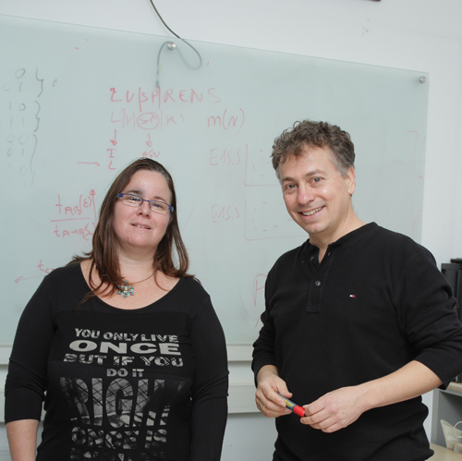
Dr. Hila Gingold is currently the senior bioinformatician at Department of Neurobiology, Wise Faculty of Life Sciences and Sagol School of Neuroscience, Tel Aviv University, Israel under, Prof. Oded Rechavi. She received her BSc, MBA, and MSc (Cum Laude), from Bar Ilan University. Hila received her PhD from the Department of Molecular Genetics from the Weizmann Institute of Science. Her doctoral research was on the Dynamic interplay between codon usage and the tRNA pool affects translation efficiency and may play a role in shaping the cell fate. Her advisor was Prof. Yitzhak Pilpel. In 2013, she held a post-doctoral fellowship at Weizmann. Since 2011, Hila has been first author on several articles. Along with her research partner, Hila patented: the "Method for detecting line width defects in electrical circuit inspection (United States Patent Application 20020038510)".

I will summarize briefly our important advances this year, based on the research plan to the Adelis Foundation:

- We published a paper (in Current Biology) which summarizes the state of the art in transgenerational small RNA inheritance. We progressed significantly in understanding the highly elaborate genetic program that evolved to control the duration of transgenerational small RNA responses. We are currently summarizing a very important paper, on a mechanism that re-sets small RNA inheritance in response to stress.
- We have a paper which is currently under revision in Cell (the paper has been submitted in June, and we are close to finishing the revisions), about a heritable neuronal response. This paper will be a complete game-changer in the field, as it would be the first proof that neuronal activity can affect behavior.

- We are currently summarizing three additional high impact papers, on important transgenerational phenotypes that we hope to publish in the next year or year and a half.

- We published a paper (in BMC biology), in which described a deep-learning based phenotypic analysis software that we wrote (that’s free and open access) that allows analyzing C.elegans high throughput phenotype with precision and ease. We also published a pre-print (that will be submitted to the prestigious journal eLife soon), about decision-making in C.elegans.

- We’ve been invited to (already submitted), a follow-up study on transgenerational and developmental effects that could influence decision-making in adulthood to Philosophical Transactions B (the prestigious journal of the English Royal society), due out in August.

- Our paper on the Genome of the Dead Sea Scrolls is almost complete. We hope to submit it to Nature in the next few months.

Impact
The importance of our previous discoveries is appreciated by the community and follow-up papers from other groups that have corroborated the generality of the principles we first discovered. For example, we showed before, viral infections of the worm with an artificial transgene-induced virus, generate a transgenerational response. Very recently Craig Mello’s lab (the Nobel laureate which discovered RNAi) has published that another “real” virus generates, (similarly to what we have shown), a transgenerational small RNA-mediated, adaptive immune response (Gammon et al. Current Biology 2017). Thus, the inheritance of small RNAs, a field in which we are leaders, is becoming an established and important field. In summary, we have progressed very nicely, according to the plan of the grant, and did not encounter any setbacks.

Specific Aims for the Next Year:
- We will publish the paper that is currently under revision, and continue elucidating the mechanisms that enable transgenerational inheritance of small RNAs from the C.elegans nervous system to the next generations. We will identify genes that orchestrate the process, and learn how to manipulate them to control epigenetic inheritance.

- We will publish a paper that has been in the works for the last couple of years in the lab, about a new mechanism that we developed for delivery of proteins into the brain. We invented an innovative genetically engineered parasite that breaches the blood brain barrier and delivers proteins to the brain. We patented our approach as well. A number of VCs are interested in commercializing our invention. We are still developing the product at Tel Aviv University, in collaboration with Ramot.

- We will publish our pre-printed paper about decision making in C.elegans, and move on to establish a new system in the lab for monitoring calcium influxes and high resolution behavioral changes in the nematode. This will allow us to understand basic nervous system architectures that limit “economic” decision making, the building blocks of rational thoughts (the boundaries of neurons that limit our ability to optimize decisions).

- We designed molecular tools to modulate, erase, and potentiate epigenetic inheritance. This is already working nicely in the lab in C.elegans, and we will set up next, a human cell line system to expand the generality of our approach also to humans. This could have immense therapeutic potential.

- After we will publish our paper on the genome of the Dead Sea scrolls, we will collect and analyze more samples. We reached an agreement with the Israeli Antiquity Authority. So far we analyzed ±50 samples (scrolls and other artefacts). We wish to eventually sequence the DNA of hundreds or even thousands of pieces, to allow “piecing together” and classification of the scrolls.



Adelis Foundation ANNUAL REPORT 2018

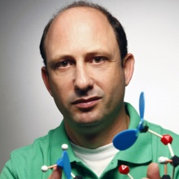
Dr Noam Shomron

Sackler Faculty of Medicine, Tel Aviv University

OVERVIEW OF OUR WORK

Suppressing Metastatic Cancer
Metastasis is a complex biological process, which requires cells to acquire motility abilities. However, while metastasis is the primary cause for mortality in many cancer types, such as in breast cancer, cancer therapy lacks effective anti-metastatic strategies. Being master regulators of gene expression, small RNAs termed ‘microRNAs’ (or ‘miRNAs’ in short), constitute an attractive candidate to control metastasis progression via regulating cell motility. Nonetheless, the therapeutic promise of miRNAs in preventing breast cancer metastasis is underexplored. We set to decipher regulation of metastasis via a unique perspective. Our hypothesis is that understanding cancer metastasis could be reached by combining large datasets of human polymorphisms; miRNA binding sites; and, cancer associated genes. In our preliminary experiments, we tested one such interaction, of many, which proved successful in breast cancer: metastasis was suppressed by treatment with two carefully selected miRNAs (numbered miR-96 or miR-182). In this particular case, we found that these miRNAs down- regulate a cytoskeletal related gene/protein (Palladin) and thereby reduce migration and invasion abilities of breast cancer cells. Further supporting our hypothesis, an identified single nucleotide polymorphism (SNP) at the miR-96/miR-182 binding site within Palladin 3' untranslated region (PALLD 3’UTR) abolishes miRNA:mRNA binding and consequently diminishes Palladin regulation by these miRNAs. This disruption was successfully restored by applying complimentary engineered miRNAs. To begin translating these findings into functional treatments, we are currently developing an in vivo delivery vehicle which will allow to easily test, multiple sets of candidate miRNAs, and their effect on potential targets and subsequently, clinical outcome/metastasis progression. Taken together, our bioinformatics analysis, in addition to one successful confirmation, emphasizes the potential role of miRNAs in metastasis regulation. It also demonstrates that combining polymorphism information, miRNA:mRNA binding sites, and cancer related genes, might lead to better understanding of the metastatic process and would eventually permit a more effective individualized anti-metastatic therapy.

"better understanding of the metastatic process would permit a more effective individualized cancer therapy"


RESEARCH OBJECTIVES
- Modeling genomic polymorphism, linking them to miRNA binding sites and clinical information.
- Testing the candidate sets of genes, with/without mutations in the presence/absence of miRNAs, for cancer properties in vitro (cell lines).
- Testing successful candidate target genes in vivo (in mice) xenograft model.
- Evaluating several delivery methods to administer the miRNAs in order to reduce cancer metastasis in vivo (in mice).
- Constructing a comprehensive online map of polymorphism involved in breast cancer associated with miRNA binding sites used as a risk calculator for breast cancer predisposition and personalized treatment.
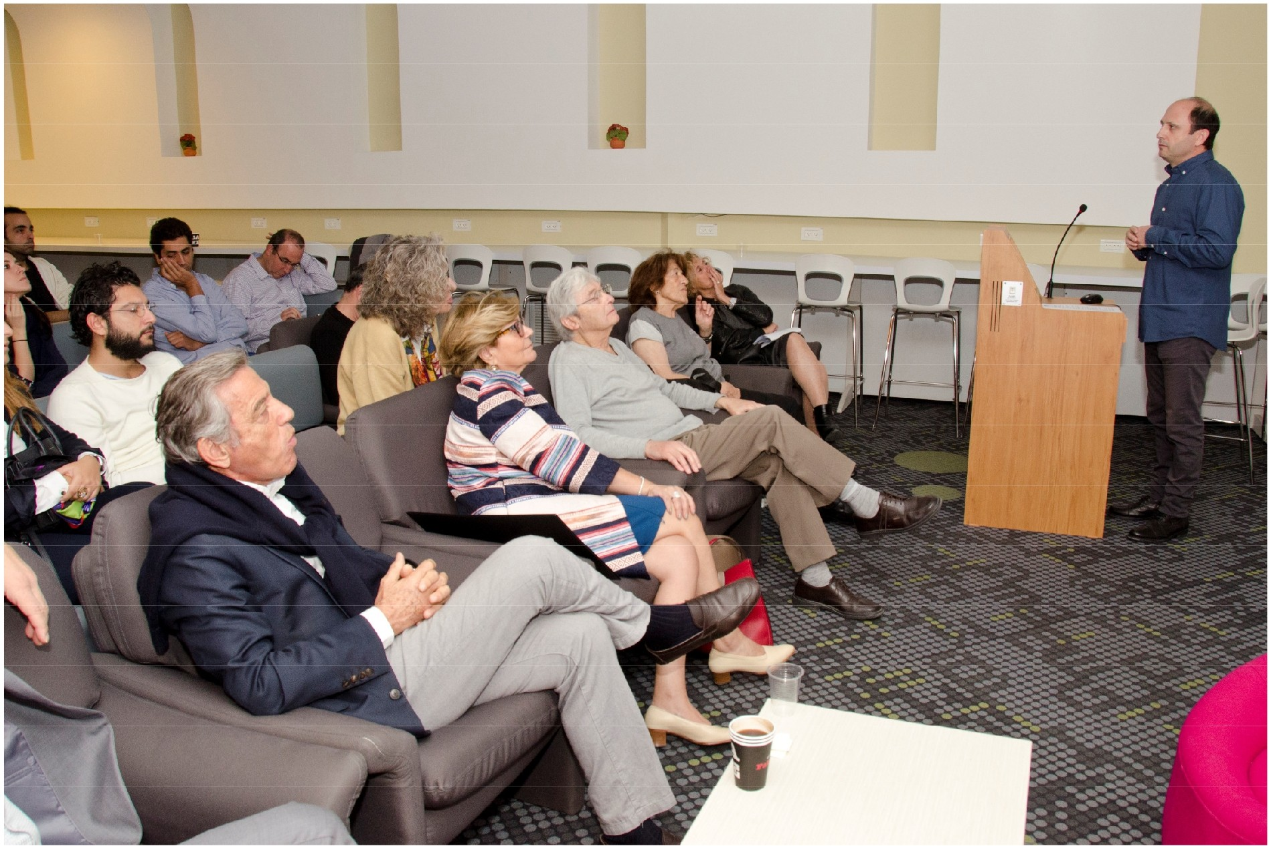

EXPECTED SIGNIFICANCE

Taken together, our study should lead to potentially new therapeutic strategies to prevent development of metastases. Our work will: (i) decipher the mechanism by which miRNAs regulate genes involved in metastatic cancer; (ii) present the therapeutic potential of miRNAs in preventing cancer metastasis; (iii) identify a delivery vehicle enabling efficient miRNA release for reducing metastasis; (iv) serve as a model approach that integrates multiple datasets in order to reveal novel regulatory mechanisms in cancer. Importantly, understanding the profound effect of a common germline sequence variant (specific change in miRNA binding-site) on cancerous phenotype, will permit a more effective individualized anti- metastatic therapy.

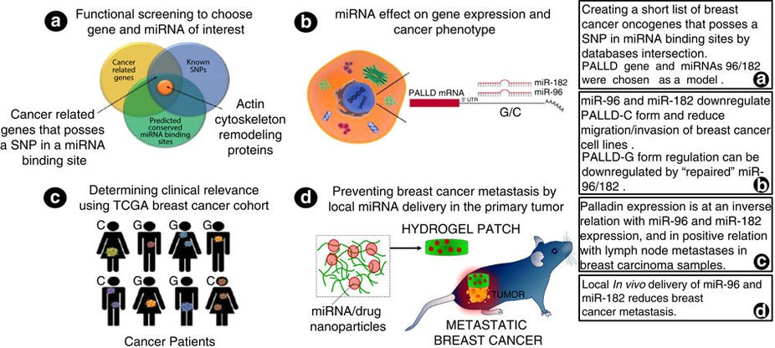

"our well established cancer models allow an effective screening for cancer genes"

FINDINGS FROM YEAR 1 – A

By comparing two breast cancer mice models, where cancer cells where either injected into the mammary fat-pad or straight to the tail-vain, we have identified small RNA molecules that control the mechanistic formation of breast derived lung metastasis. We are currently comparing these differences in order to narrow down the changes in metastatic levels to a few target genes and microRNAs which we will control in order to stop the movement of the cells from the breast to the lungs and other organs.
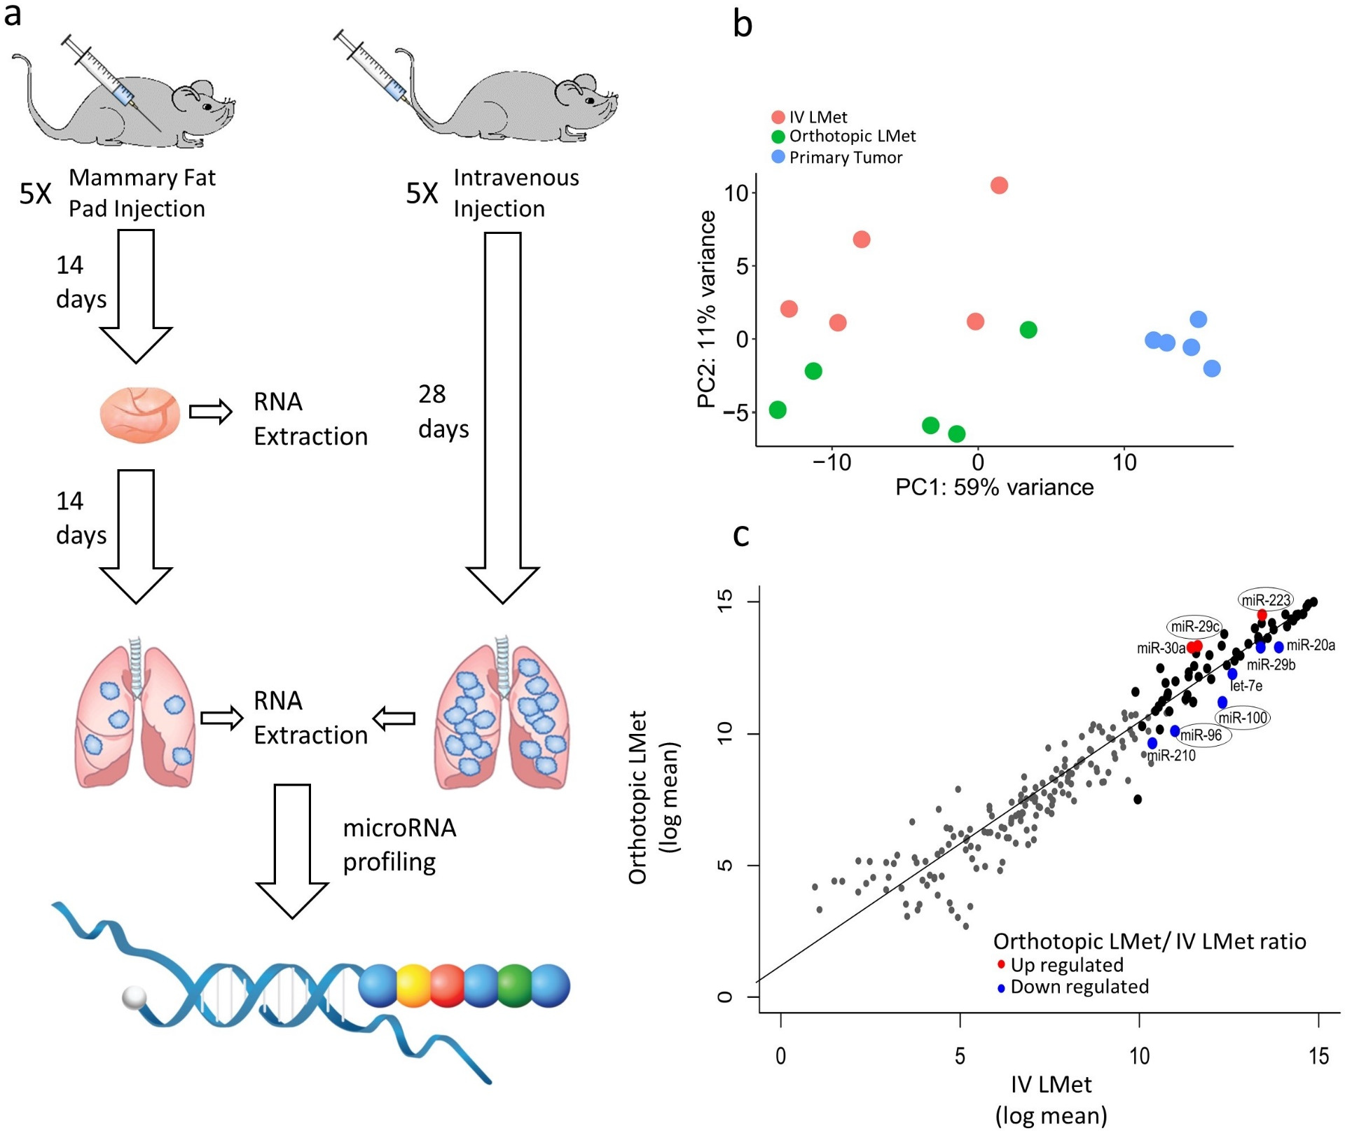

"we have identified molecules that control the mechanistic formation"

FINDINGS FROM YEAR 1 – B
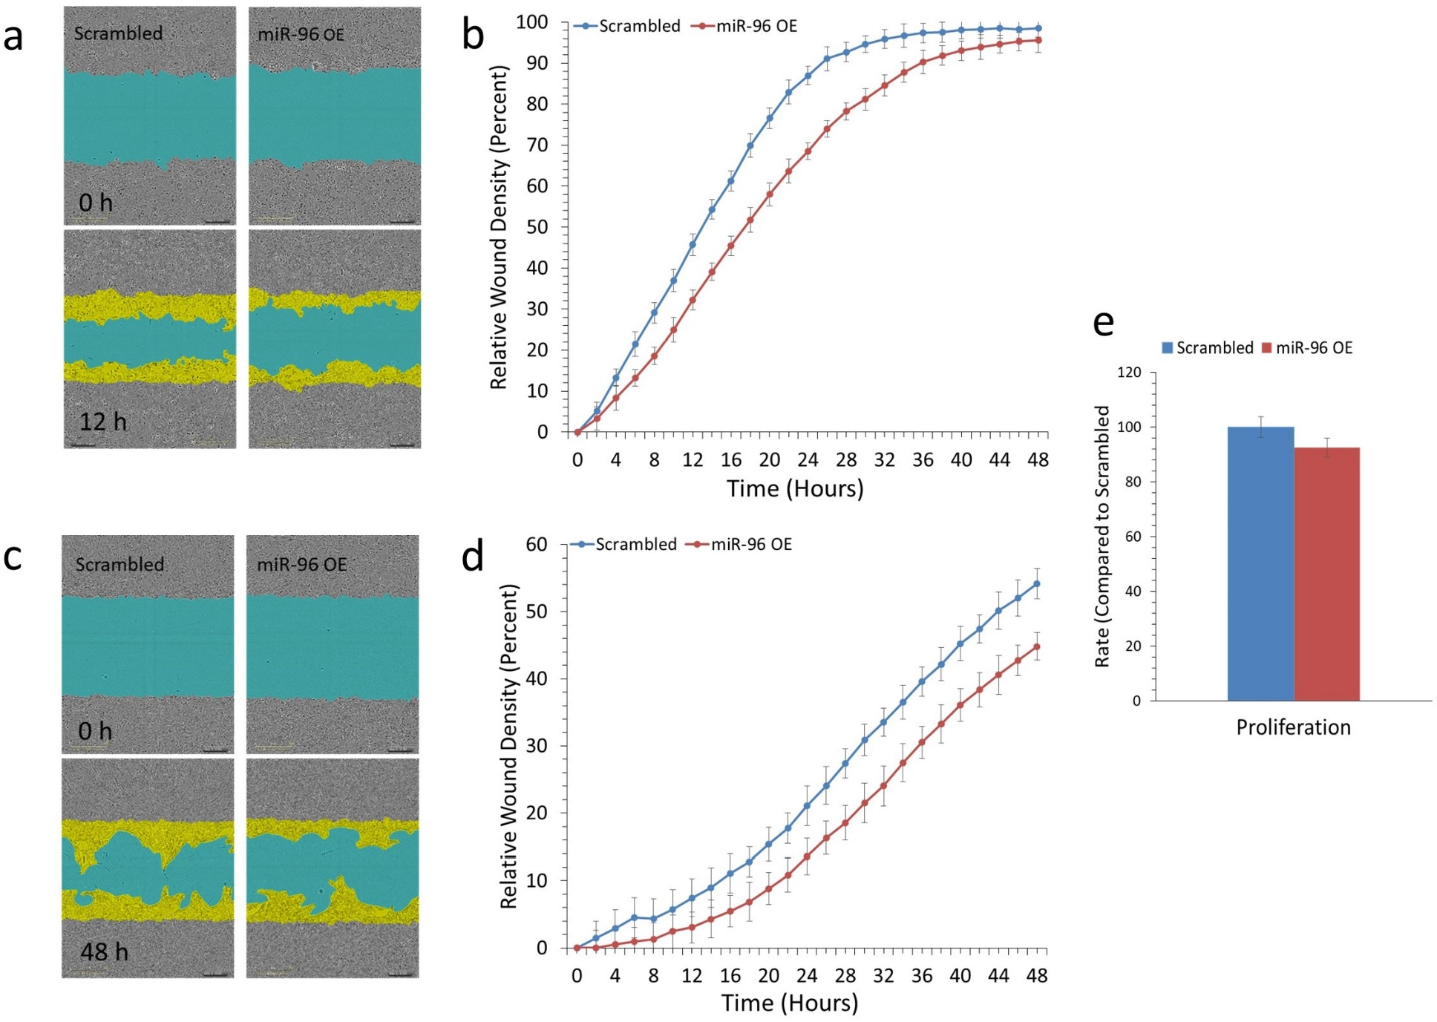
We can change the level of one of the small molecules we identified (microRNA 96) and show that by its increase in expression we can reduce the invasion and the migration of breast cancer cells monitored on an automatic cell analysis system.

"we can drastically reduce the levels of invasion and migration of breast cancer cells"

FINDINGS FROM YEAR 1 – C
We identified that by changing the microRNA molecule (number 96) we were not only able to reduce the movement of the cells but also damage the mitochondrial activity of the cancer cells. This means that a multiple hit was generated in the cancer cells with a more effective outcome than targeting only one pathway.

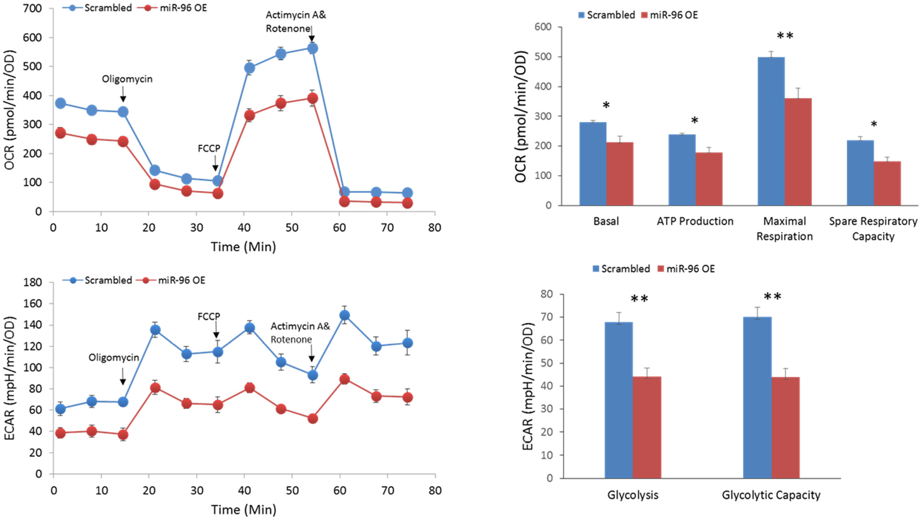

"a hit on multiple cell pathway would be more effective in stopping cancer cells"

PUBLICATIONS FROM YEAR 1
- Pillar N, Bairey O, Goldschmidt N, Fellig Y, Rosenblat Y, Shehtman I, Haguel D, Raanani P, Shomron N*, Siegal T*. MicroRNAs as predictors for CNS relapse of systemic diffuse large B-cell lymphoma. Oncotarget. 2017 Sep 15; 8(49):86020-86030. doi: 10.18632/oncotarget.20902. eCollection 2017 Oct 17. PubMed PMID: 29156774; PubMed Central PMCID: PMC5689664.
*Equal last authors

- Oved K, Farberov L, Gilam A, Israel I, Haguel D, Gurwitz D, Shomron N. MicroRNA-Mediated Regulation of ITGB3 and CHL1 Is Implicated in SSRI Action. Front Mol Neurosci. 2017 Nov 2;10:355. doi: 10.3389/fnmol.2017.00355. eCollection 2017. PubMed PMID: 29163031; PubMed Central PMCID: PMC5682014.

- Pillar N, Pleniceanu O, Fang M, Ziv L, Lahav E, Botchan S, Cheng L, Dekel B, Shomron N. A rare variant in the FHL1 gene associated with X-linked recessive hypoparathyroidism. Hum Genet. 2017 Jul;136(7):835-845. doi: 10.1007/s00439-017-1804-9. Epub 2017 Apr 25. PubMed PMID: 28444561; PubMed Central PMCID: PMC5487855.

"Adelis Foundation's support led to three peer-reviewed publications from our lab in the first budget year"

BUDGET OF YEAR 1

We used the budget allocated to our first year project to boost our facility and to establish a working model where we can run tests on cancer, in particular breast cancer, and to follow metastatic developments. We have purchased apparatuses for high-throughput screening of small RNA molecules, gene expression and automatic analysis of cell movement. Expenditures also included many consumables needed for the tracking of the cells and the molecules. Additionally, we used NGS analysis of cancer cells in order to pinpoint changes to specific genes and microRNAs. We used the funding to support students who ran the experiments, in the lab. Some of the funding went to support the publication of papers in international journals, as well as support travel to relevant conferences in the field.

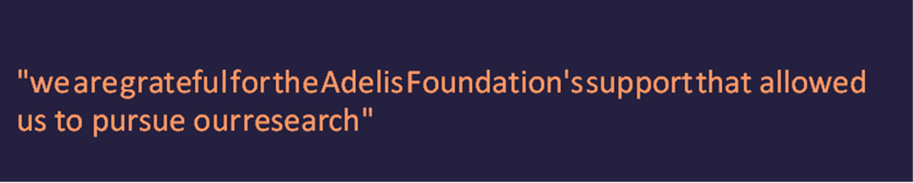

Appendix

