GENERAL:

Please type the translation in the second column of the tables provided. (See note, first graph, regarding title translations)

Please use Duden for headline style capitalization for titles, Duden sentence style capitalization for everything else

If there is an uncertainty about a translation, please put “See comment” in the table and then list the suggested translations in a comment box.

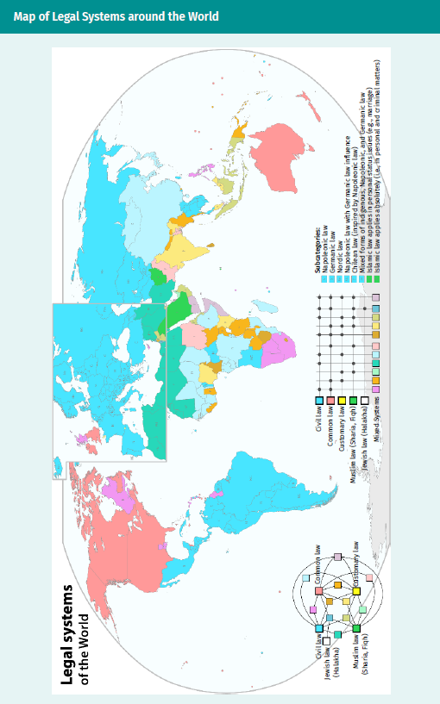

|  |  |
| --- | --- |
| Map of Legal Systems around the World  TRANSLATION HERE | |
| Legal systems of the world |  |
| Civil law |  |
| Jewish law (Halakha) |  |
| Muslim law (Sharia, Fiqh) |  |
| Customary law |  |
| Common law |  |
| Mixed systems |  |
| Napoleonic law |  |
| Germanic law |  |
| Nordic law |  |
| Subcategories |  |
| Napoleonic law with Germanic law influence |  |
| Chilean law (inspired by Napoleonic law) |  |
| Mixed forms of indigenous, Napoleonic, and Germanic law |  |
| Islamic law applies in personal status issues (e.g., marriage) |  |
| Islamic law applies absolutely (i.e., in personal and criminal matters) |  |

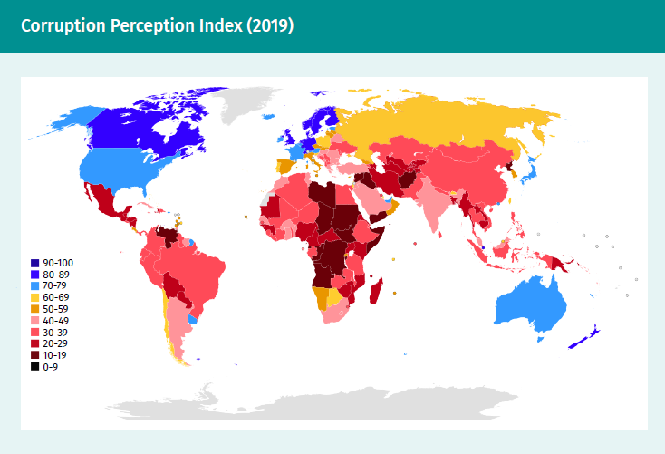

|  |
| --- |
| Corruption Perception Index (2019) |

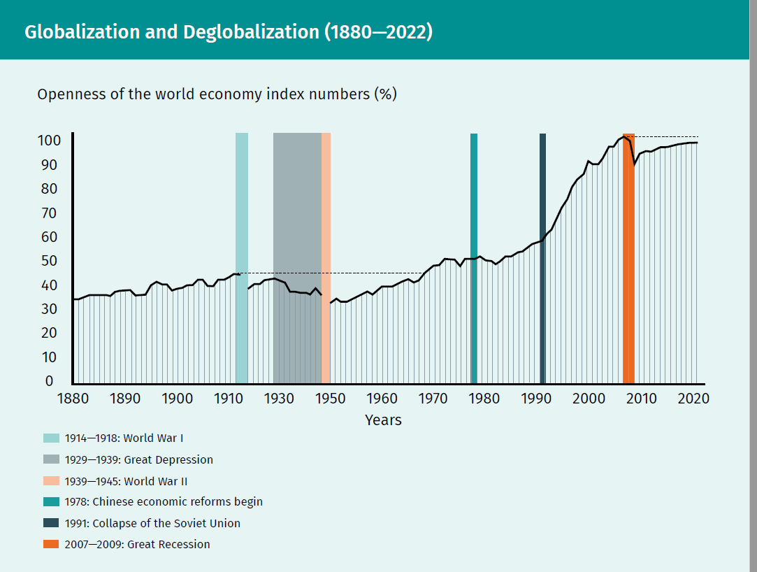

|  |  |
| --- | --- |
| Globalization and Deglobalization (1880—2022) | |
| 1914—1918: World War I |  |
| 1929—1939: Great Depression |  |
| 1939—1945: World War II |  |
| 1978: Chinese economic reforms begin |  |
| 1991: Collapse of the Soviet Union |  |
| 2007—2009: Great Recession |  |
| Openness of the world economy index (%) |  |

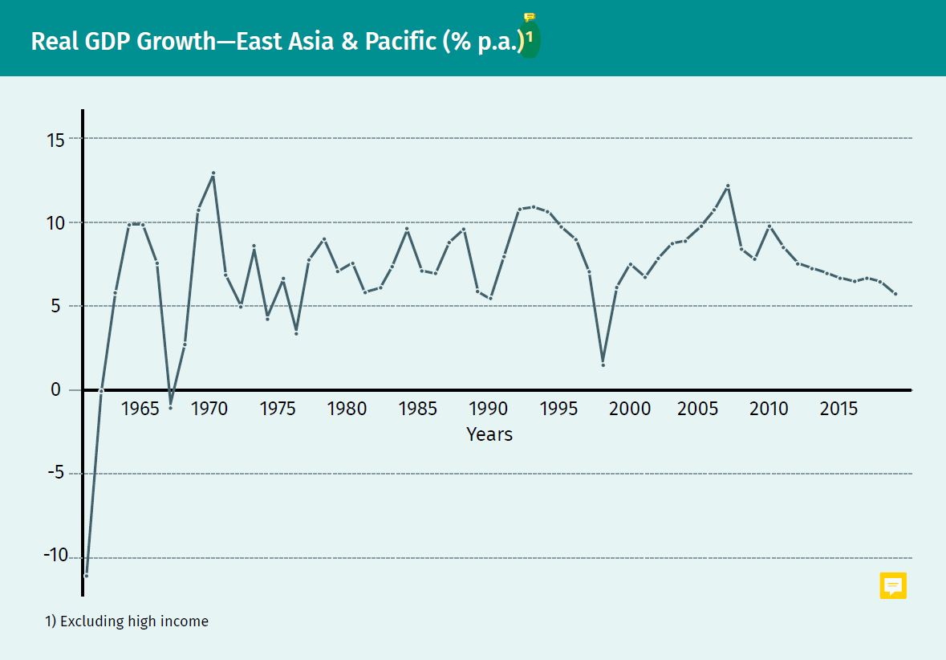

|  |  |
| --- | --- |
| Real GDP Growth—East Asia & Pacific (% p.a.) | |
| Excluding high income |  |
| Years |  |

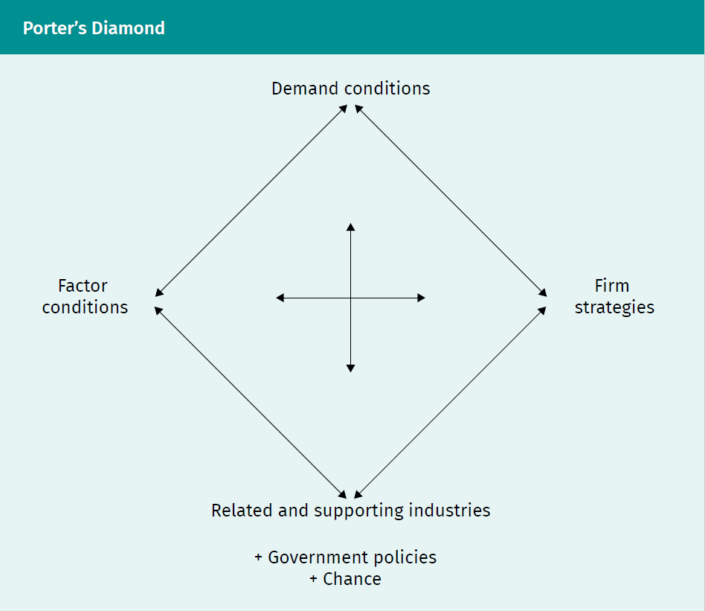

|  |  |
| --- | --- |
| Porter’s Diamond | |
| Demand conditions |  |
| Factory conditions |  |
| Firm strategies |  |
| Related and supporting industries |  |
| Government policies |  |
| Chance |  |

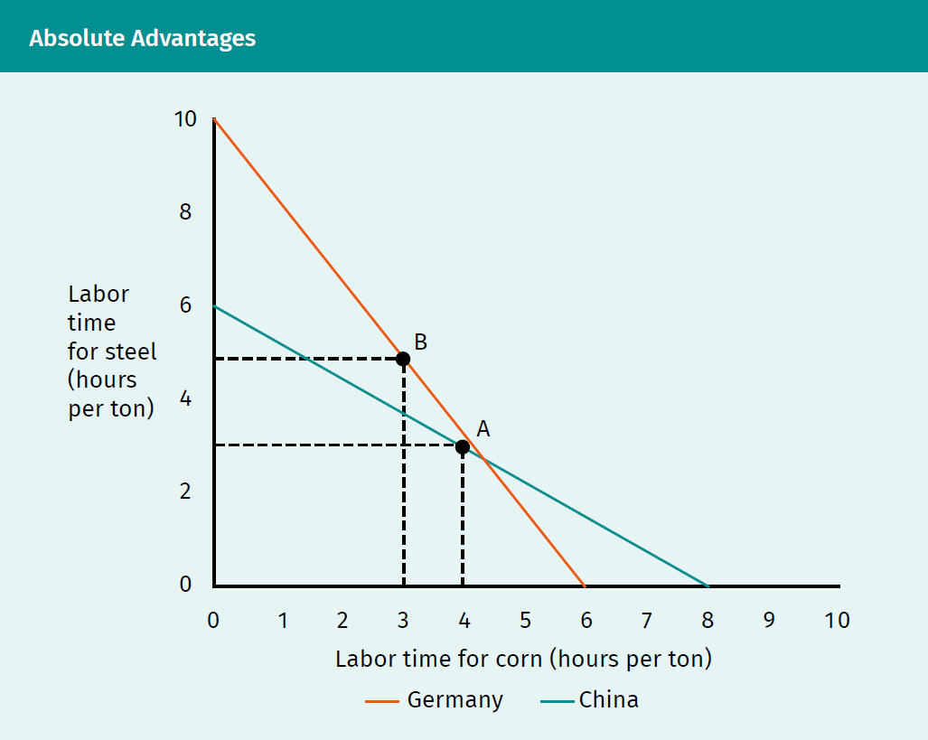

|  |  |
| --- | --- |
| Absolute Advantages | |
| Labor time for steel (hours per ton) |  |
| Labor time for corn (hours per ton) |  |
| Germany |  |
| China |  |

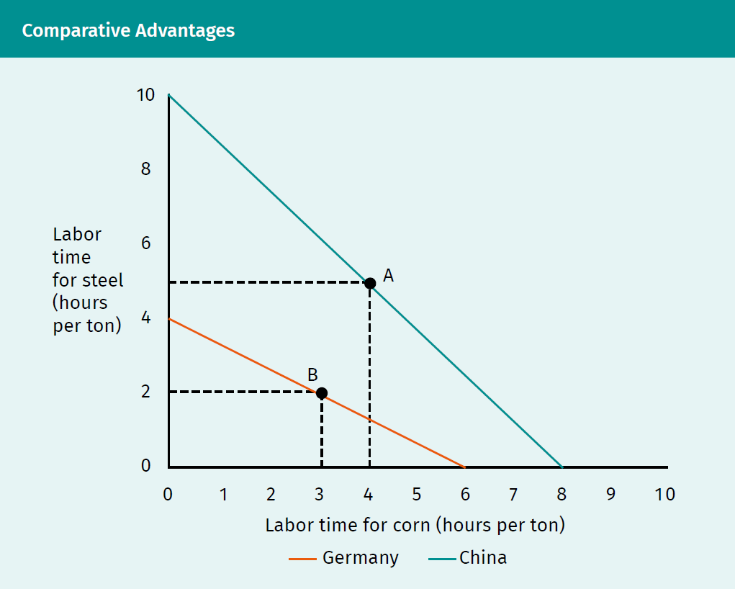

|  |  |
| --- | --- |
| Comparative Advantages | |
| Labor time for steel (hours per ton) |  |
| Labor time for corn (hours per ton) |  |
| Germany |  |
| China |  |

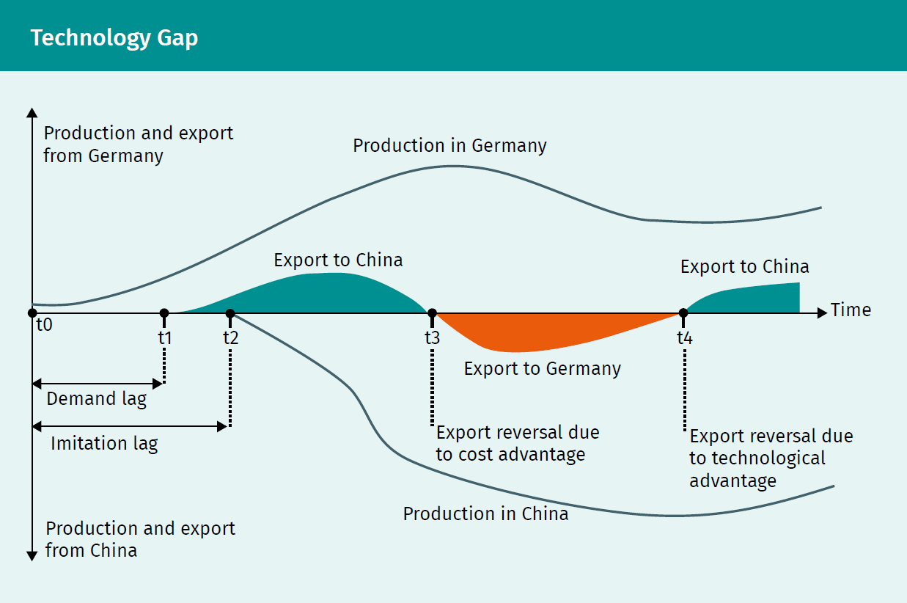

|  |  |
| --- | --- |
| Technology Gap | |
| Production and export from Germany |  |
| Production in Germany |  |
| Export to China |  |
| Demand lag |  |
| Imitation lag |  |
| Export reversal due to cost advantage |  |
| Export reversal due to technological advantage |  |
| Production and export from China |  |
| Production in China |  |

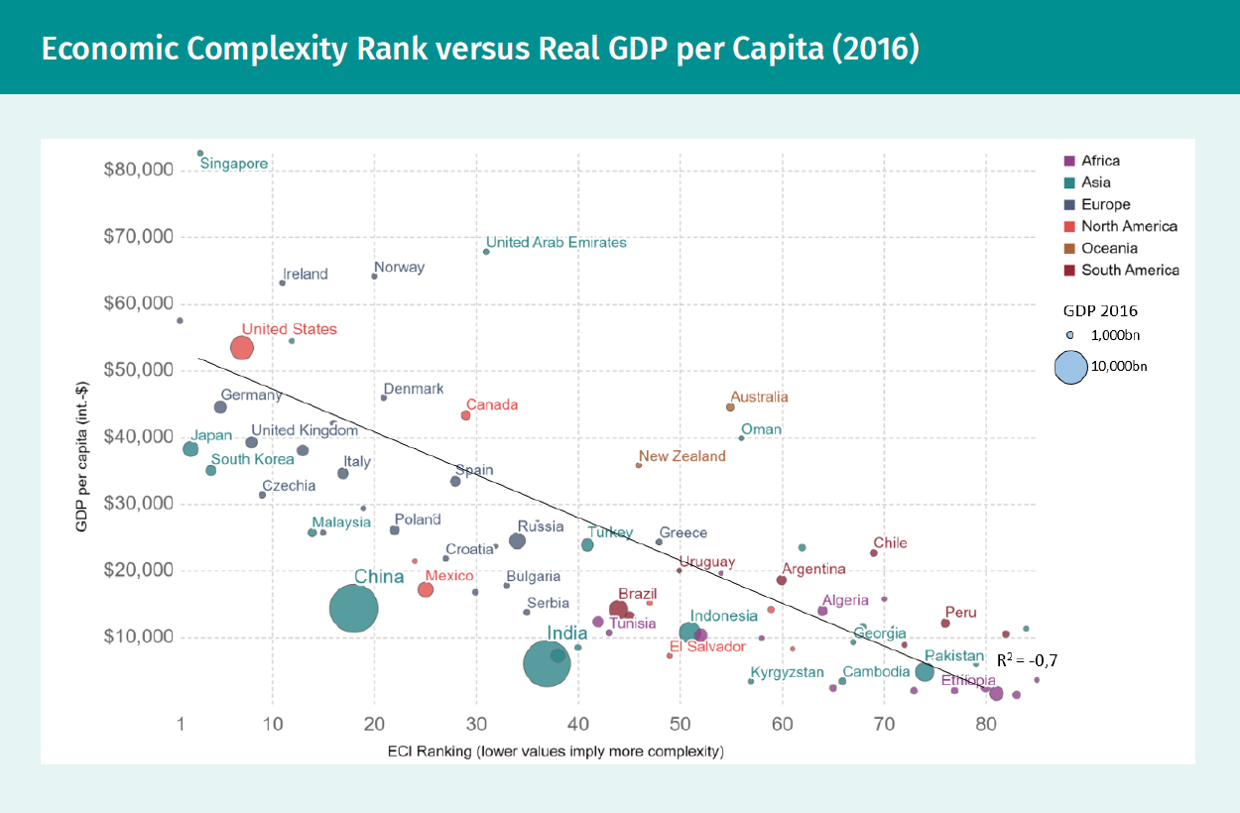

|  |  |
| --- | --- |
| Economic Complexity Rank versus Real GDP per Capita (2016) | |
| GDP per capita (int. $) |  |
| ECI ranking (lower values imply more complexity) |  |
| Africa |  |
| Asia |  |
| Europe |  |
| North America |  |
| Oceania |  |
| South America |  |
| GDP 2016 |  |
| Singapore |  |
| United Arab Emirates |  |
| Norway |  |
| Ireland |  |
| United States |  |
| Germany |  |
| Denmark |  |
| Canada |  |
| Australia |  |
| Japan |  |
| United Kingdom |  |
| South Korea |  |
| Italy |  |
| Oman |  |
| New Zealand |  |
| Czechia |  |
| Spain |  |
| Malaysia |  |
| Poland |  |
| Russia |  |
| Croatia |  |
| Turkey |  |
| Greece |  |
| Chile |  |
| China |  |
| Mexico |  |
| Bulgaria |  |
| Uruguay |  |
| Argentina |  |
| Serbia |  |
| Brazil |  |
| Algeria |  |
| India |  |
| Tunisia |  |
| Indonesia |  |
| Peru |  |
| El Salvador |  |
| Georgia |  |
| Pakistan |  |
| Kyrgyzstan |  |
| Cambodia |  |
| Ethiopia |  |

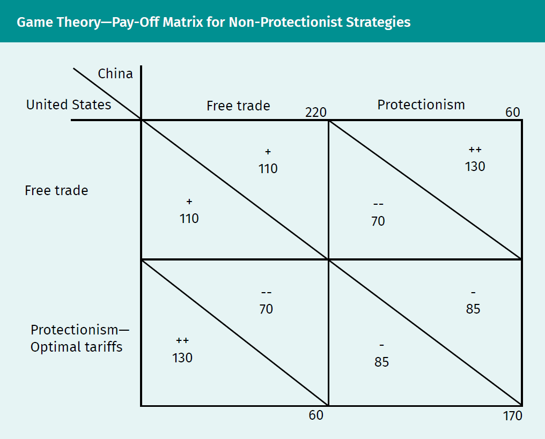

|  |  |
| --- | --- |
| Game Theory—Pay-off Matrix for Non-Protectionist Strategies | |
| United States |  |
| China |  |
| Free trade |  |
| Protectionism |  |
| Protectionism—optimal tariffs |  |

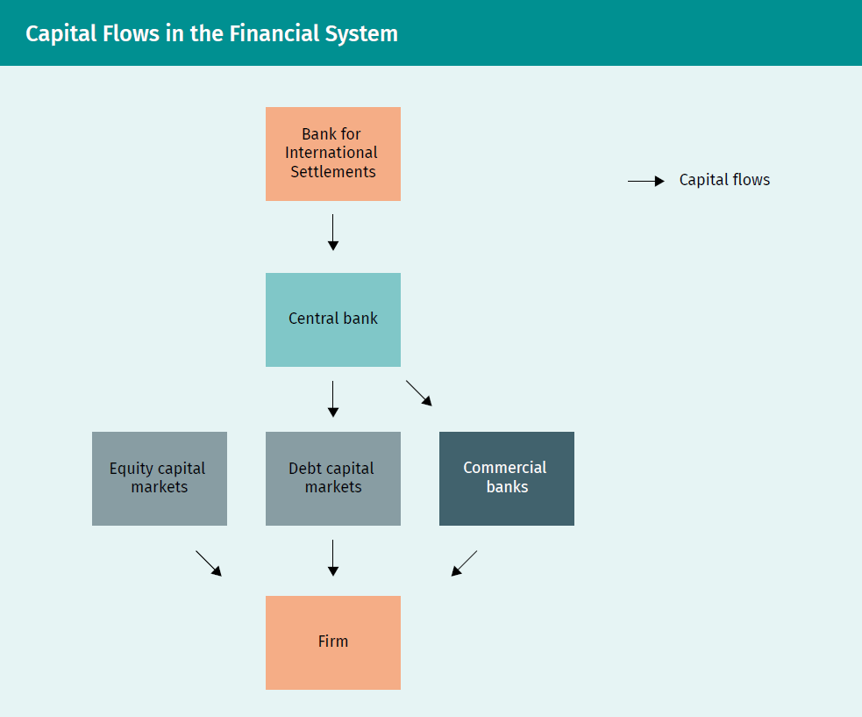

|  |  |
| --- | --- |
| Capital Flows in the Financial System | |
| Capital flows |  |
| Bank for International Settlements |  |
| Central bank |  |
| Equity capital markets |  |
| Debt capital markets |  |
| Commercial banks |  |
| Firm |  |

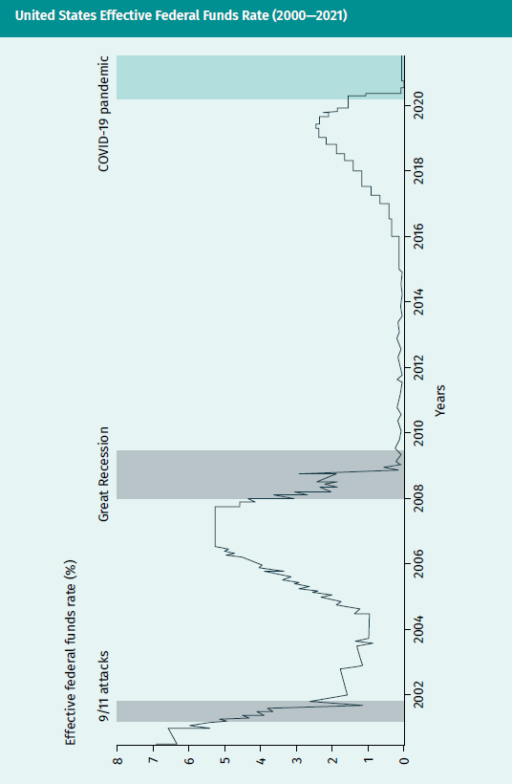

|  |  |
| --- | --- |
| United States Effective Federal Funds Rate (2000—2021) | |
| Effective federal funds rate (%) |  |
| 9/11 attacks |  |
| Great Recession |  |
| COVID-19 pandemic |  |
| Years |  |

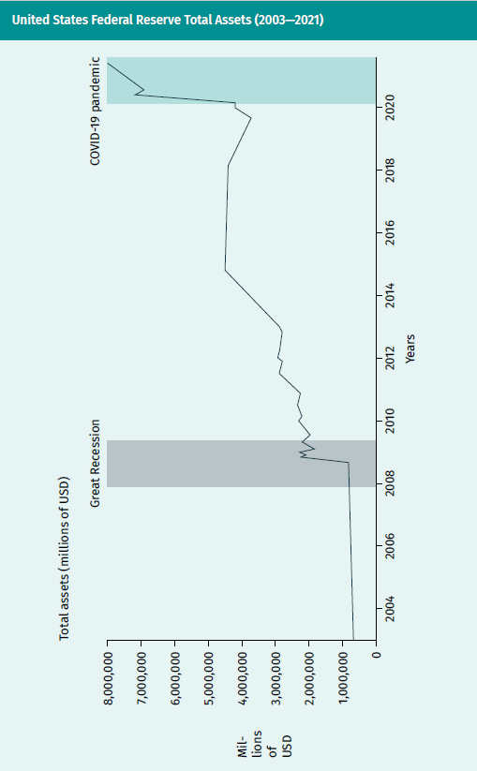

|  |  |
| --- | --- |
| United States Federal Reserve Total Assets (2003—2021) | |
| Total assets (millions of USD) |  |
| Millions of USD |  |
| Great Recession |  |
| COVID-19 pandemic |  |
| Years |  |

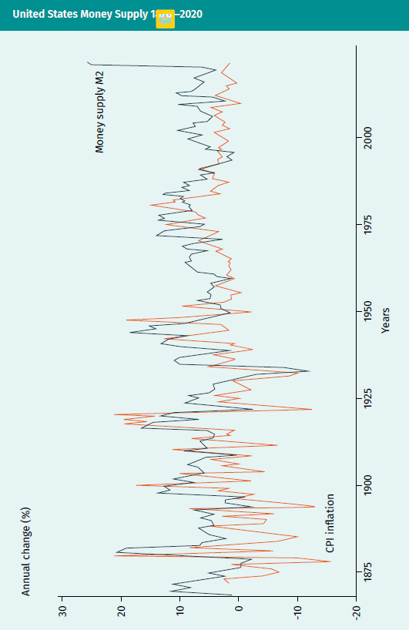

|  |  |
| --- | --- |
| United States Money Supply (1870—2020) | |
| Annual change (%) |  |
| CPI inflation |  |
| Money supply M2 |  |
| Years |  |

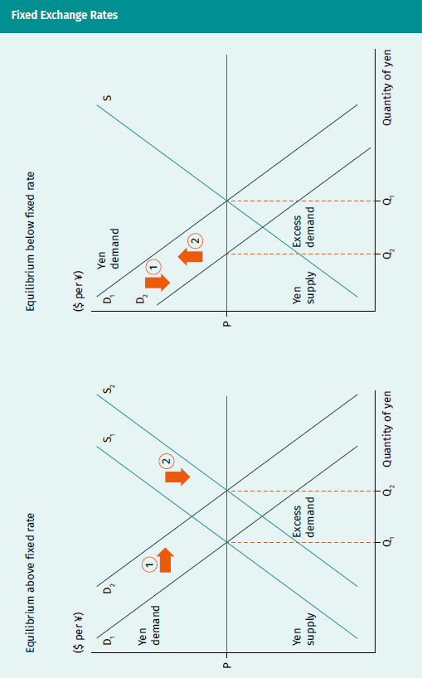

|  |  |
| --- | --- |
| Fixed Exchange Rates | |
| Equilibrium above fixed rate |  |
| Equilibrium below fixed rate |  |
| ($ per ¥) |  |
| Yen demand |  |
| Yen supply |  |
| Excess demand |  |
| Quantity of yen |  |

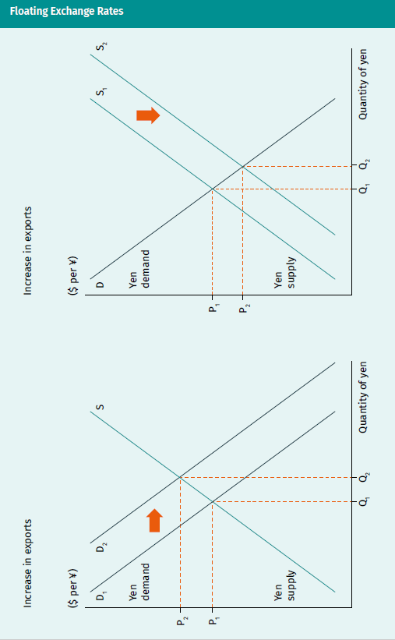

|  |  |
| --- | --- |
| Floating Exchange Rates | |
| Increase in exports |  |
| Increase in imports |  |
| Yen demand |  |
| Yen supply |  |
| Quantity of yen |  |

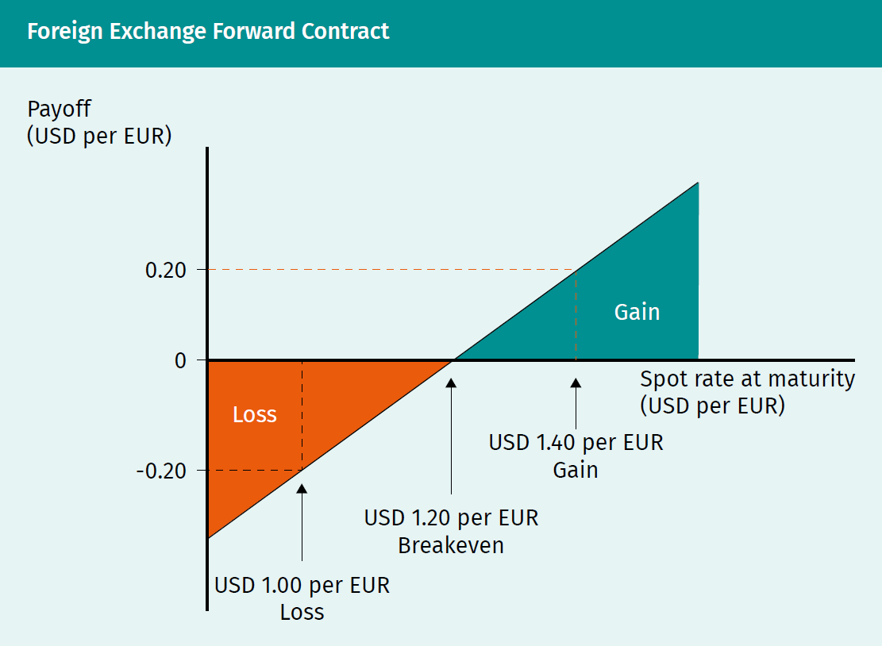

|  |  |
| --- | --- |
| Foreign Exchange Forward Contract | |
| Payoff (USD per EUR) |  |
| Loss |  |
| Gain |  |
| Spot rate at maturity (USD per EUR) |  |
| USD 1.40 per EUR |  |
| USD 1.20 per EUR |  |
| Breakeven |  |
| USD 1.00 per EUR |  |

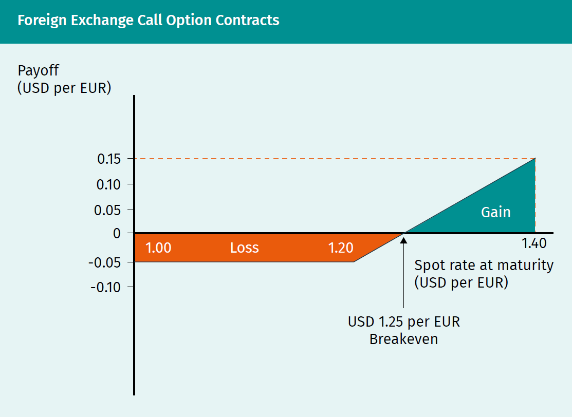

|  |  |
| --- | --- |
| Foreign Exchange Call Option Contracts | |
| Payoff (USD per EUR) |  |
| Loss |  |
| Gain |  |
| Spot rate at maturity (USD per EUR) |  |
| USD 1.25 per EUR |  |
| Breakeven |  |

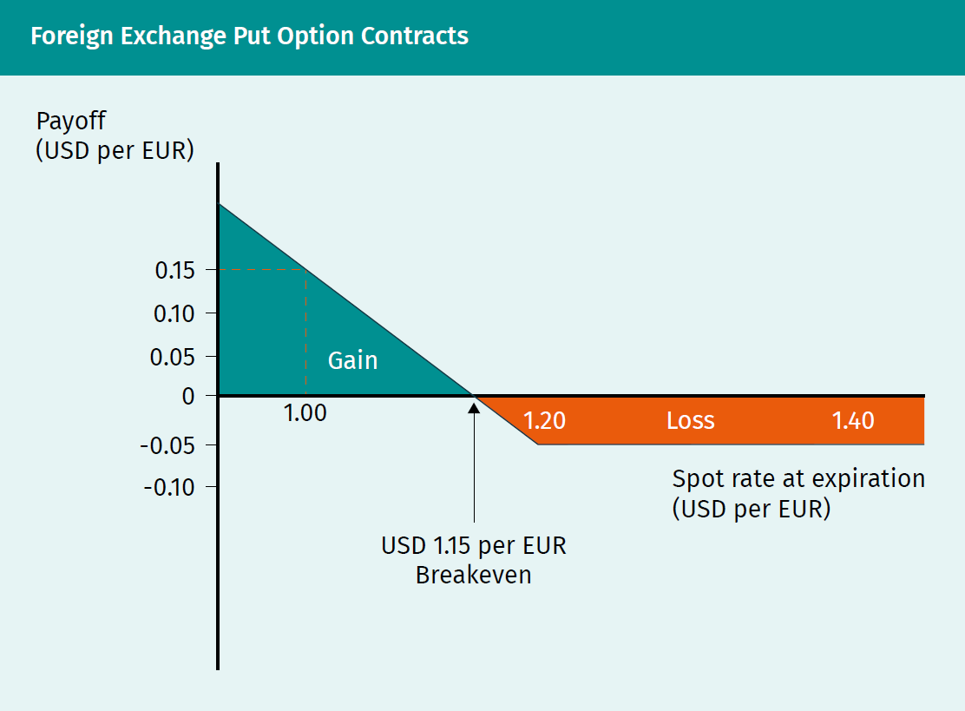

|  |  |
| --- | --- |
| Foreign Exchange Put Option Contracts | |
| Payoff (USD per EUR) |  |
| Gain |  |
| Loss |  |
| Spot rate at expiration (USD per EUR) |  |
| USD 1.15 per EUR |  |
| Breakeven |  |

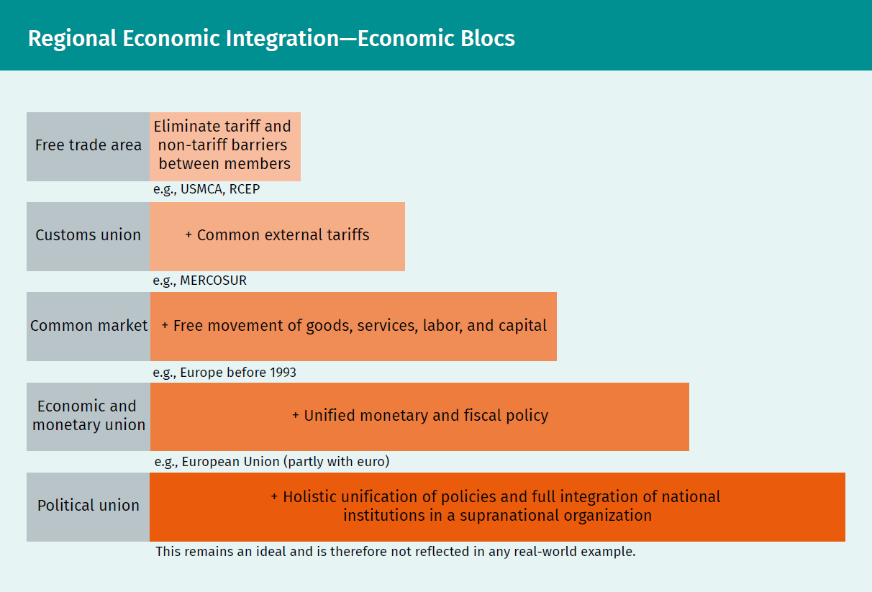

|  |  |
| --- | --- |
| Regional Economic Integration—Economic Blocs | |
| Free trade area |  |
| Eliminate tariff and non-tariff barriers between members |  |
| e.g., USMCA, RCEP |  |
| Customs union |  |
| e.g., MERCOSUR |  |
| Common external tariffs |  |
| Common market |  |
| Free movement of goods, services, labor, and capital |  |
| e.g., Europe before 1993 |  |
| Economic and monetary union |  |
| Unified monetary and fiscal policy |  |
| e.g., European Union (partly with euro) |  |
| Political union |  |
| Holistic unification of policies and full integration of national institutions in a supranational organization |  |
| This remains an ideal and is therefore not reflected in any real-world example. |  |

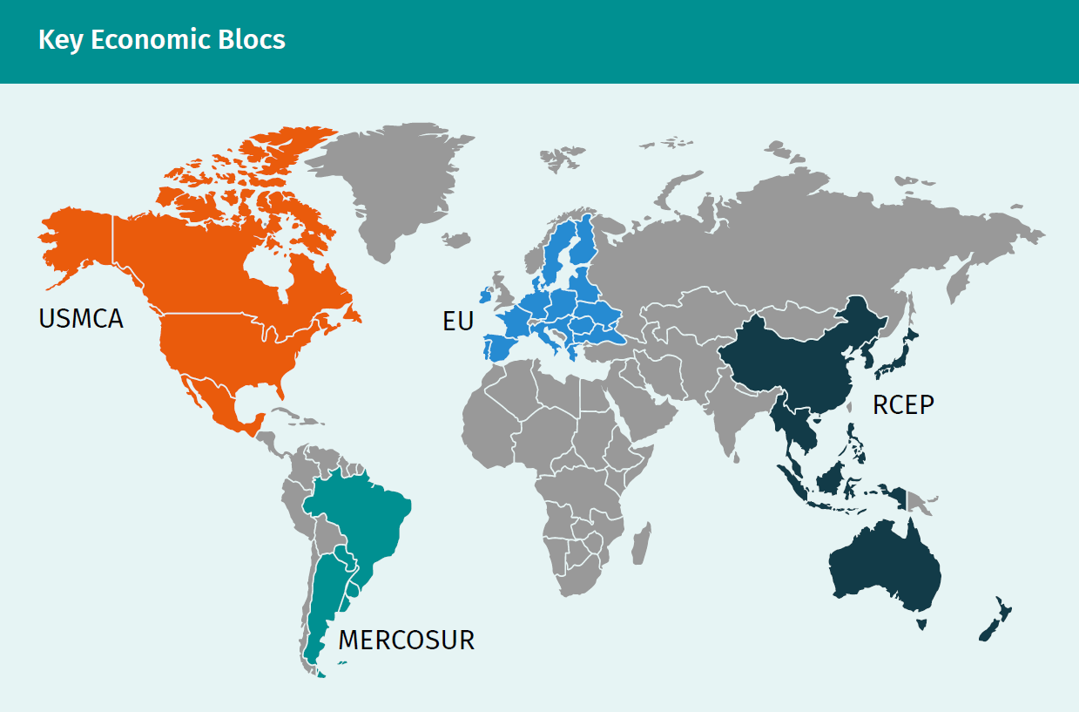

|  |  |
| --- | --- |
| Key Economic Blocs | |
| USMCA |  |
| MERCOSUR |  |
| EU |  |
| RCEP |  |

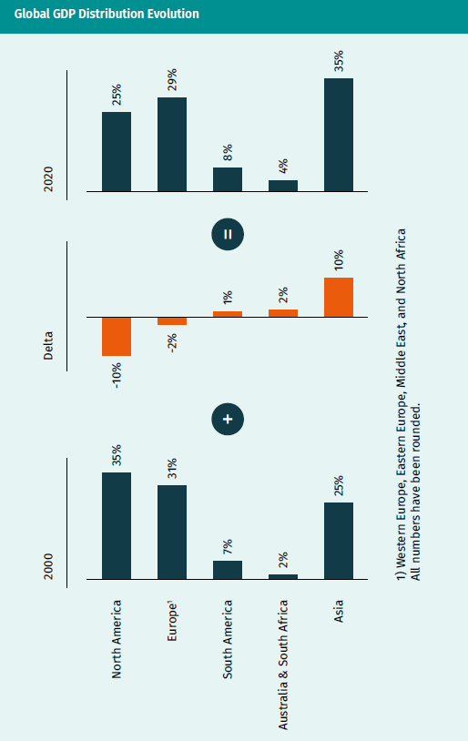

|  |  |
| --- | --- |
| Global GDP Distribution Evolution | |
| Delta |  |
| North America |  |
| Europe |  |
| South America |  |
| Australia & South Africa |  |
| Asia |  |
| Western Europe, Eastern Europe, Middle East, and North Africa |  |
| All numbers have been rounded. |  |

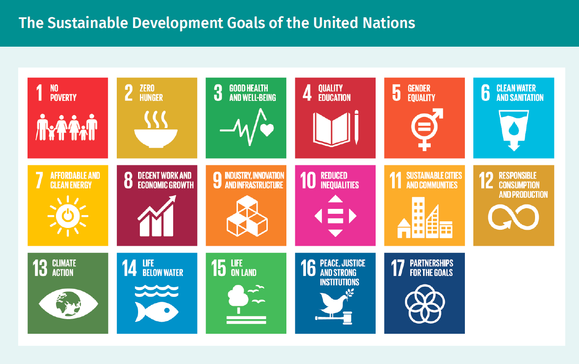

[HINWEIS: This graphic already exists with an official German translation from the United Nations. I have provided the text in the table below, but I would recommend using the official version to avoid any confusion. I do not know if the German version is 100% public domain (I believe it is, but I would double check before usage).]

|  |  |
| --- | --- |
| The Sustainable Development Goals of the United Nations | |
| No poverty |  |
| Zero hunger |  |
| Good health and well-being |  |
| Quality education |  |
| Gender equality |  |
| Clean water and sanitation |  |
| Affordable and clean energy |  |
| Decent work and economic growth |  |
| Industry, innovation, and infrastructure |  |
| Reduced inequalities |  |
| Sustainable cities and communities |  |
| Responsible consumption and production |  |
| Climate action |  |
| Life below water |  |
| Life on land |  |
| Peace, justice, and strong institutions |  |
| Partnerships for the goals |  |