COURSE BOOK

Managing Across Borders
DLMINTMAB01_E



Course Book
Managing Across Borders
DLMINTMAB01_E



2 Masthead

Masthead

Publisher:
IU Internationale Hochschule GmbH
IU International University of Applied Sciences Juri-Gagarin-Ring 152
D-99084 Erfurt

Mailing address:
Albert-Proeller-Straße 15-19 D-86675 Buchdorf

media@iu.org www.iu.de

DLMINTMAB01_E
Version No.: 001-2021-0929

© 2021 IU Internationale Hochschule GmbH
This course book is protected by copyright. All rights reserved.
This course book may not be reproduced and/or electronically edited, duplicated, or distributed in any kind of form without written permission by the IU Internationale Hochschule GmbH.

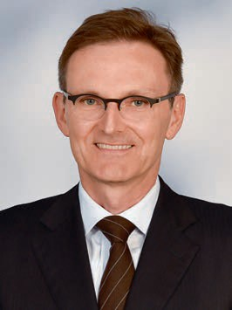
Prof. Dr. Andreas Herrmann

Module Director

Mr. Herrmann is Professor of Business Administration at IU Interna- tional University of Applied Sciences since 2020. His major research interests lie in growth strategy and corporate finance.

Mr. Herrmann holds a PhD in Biochemistry from the University of Cambridge (UK) and an MBA from INSEAD (France). He worked as a management consultant for the Boston Consulting Group and Moni- tor Deloitte. As managing director of Healthways Inc. (USA), he was responsible for all business in the DACH (German speaking) region and was one of the co-founders of an innovative software company.

As part of his practical projects, Mr. Herrmann offers consulting advice to companies on general management and digital innovation issues.

- Contents

Table of Contents
Managing Across Borders
Module Director 3
Introduction
Managing Across Borders 7
Signposts Throughout the Course Book 8
Learning Objectives 9
Unit 1
International Economic and Business Environment 12
  - Economic Environment 12
  - Political Environment 16
  - Technological Environment 22
Unit 2
Globalization and International Competitiveness 28
  - Definition and Development of Globalization 28
  - Opportunities and Threats of Globalization 32
  - International Competitiveness 35
Unit 3
International Trade 42
  - Classical Theories and Models of International Trade 42
  - Importance of International Trade for an Economy 50
  - Protectionism as a Threat to International Business 53

Unit 4
International Financial and Capital Markets 60
  - Importance of International Financial and Capital Markets for Glob-
ally Active Companies 60
  - International Exchange Rate Regimes 73
  - Hedging of Exchange Rate Risks 79
Unit 5
International Organizations and Economic Integration 86
  - International Organizations as the Basis of the World Economy (WTO, IMF, and World Bank) 86
  - Regional Economic Integration as a Driver for International Business
(EU, USMCA, RCEP, MERCOSUR) 93
Unit 6
Current Hot Spots in the International Economic and Business Environment 104
  - USA and China: Struggle for Political and Economic Supremacy 104
  - Emerging Markets: New Players in the Global Economy 111
  - Agenda 2030: Sustainable Development Goals (SDG) 118
Appendix 1
List of References 130
Appendix 2
List of Tables and Figures 156

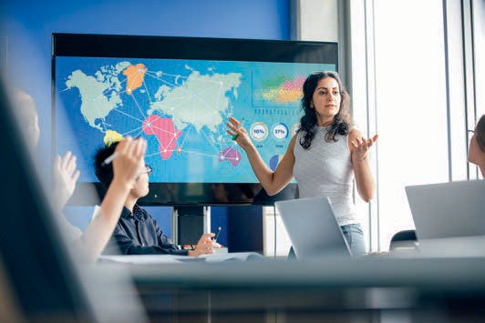

Introduction
Managing Across Borders





8 Introduction

Signposts Throughout the Course Book

Welcome

This course book contains the core content for this course. Additional learning materials can be found on the learning platform, but this course book should form the basis for your learning.

The content of this course book is divided into units, which are divided further into sections. Each section contains only one new key concept to allow you to quickly and efficiently add new learning material to your existing knowledge.

At the end of each section of the digital course book, you will find self-check questions. These questions are designed to help you check whether you have understood the concepts in each section.

For all modules with a final exam, you must complete the knowledge tests on the learning platform. You will pass the knowledge test for each unit when you answer at least 80% of the questions correctly.

When you have passed the knowledge tests for all the units, the course is considered fin- ished and you will be able to register for the final assessment. Please ensure that you com- plete the evaluation prior to registering for the assessment.

Good luck!

Learning Objectives
Introduction 9



At the end of World War II, the world went through an extended period of increased globali- zation and international trade. Today, most companies are, in one way or another, exposed to the international environment. For this reason, managers of companies need to be increas- ingly aware of how the international environment affects their business.

In Managing Across Borders, we will take a managerial view to understand how cross-border elements affect companies. You will first examine which factors constitute the international business environment. You will learn what globalization is, how it developed over the course of history, and what opportunities and threats it yields for both industry and society. By investigating international trade theories, we will aim to understand why countries trade with each other and how they can obtain a national, competitive advantage. We will also examine recent protectionist tendencies, which form a threat to international business.

As part of the recent trend toward globalization, financial markets have become more inter- twined. You will learn the basic functions of financial markets and how companies can access capital markets to raise funds for expansion plans. This course will also teach you how exchange rates affect companies’ profits and which financial instruments companies can use to manage risks associated with foreign exchange. We will also discuss how the interna- tional economic system is governed by international organizations and how these have driven global economic integration. The limits of global economic integration will become clear when we discuss regional economic integration as a driver for international business. Finally, we will investigate recent topics in the international business environment, including the struggle for political and economic supremacy between the United States and China, the role of emerging markets in the global economy, and the Sustainable Development Goals of the United Nations.

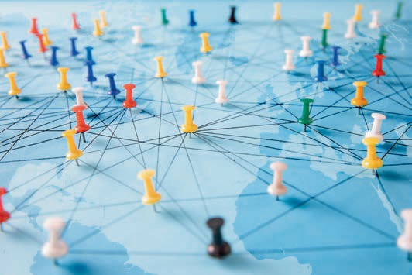

Unit 1
International Economic and Business Environment

STUDY GOALS

On completion of this unit, you will be able to …

… understand the various dimensions of the economic environment.
… recognize the main distinctions between various political and legal systems.
… describe how technology developed over the past few centuries.
… explain how innovations affect economic growth.

DL-E-DLMINTMAB01_E-U01

- International Economic and Business Envi- ronment

Case Study

The CEO of Globex, a consulting company specializing in macro-economic analysis, answers an incoming call from an investment manager from BlueRock. BlueRock is a pension fund seeking to invest part of their funds, around $3B dollars, in emerging market over the next 24 months. They have turned to Globex for advice after hearing that Central Asia may become a promising location over the course of the next decade. The new client expects a report that provides macro-level details on the countries in the region, including the most promising industries.

The Globex CEO is delighted about the call for two reasons. First, this new client could potentially become a long-term, returning client; second, this assignment speaks exactly to Globex’s core expertise. The CEO requests one of the company’s internal ana- lysts, Jamie, to prepare a report for BlueRock. The analyst will have full liberty to pre- pare a draft the way they see fit. The CEO further explains the situation.

Jamie, who is a first-year analyst at the firm, is both excited and nervous. It is the first time that they need to prepare a report independently. Central Asia is definitely not Jamie’s area of expertise. They know little more than the fact that Kazakhstan and Uzbekistan are two countries located there. Jamie thinks out loud about the factors that should be considered: a short paragraph on the history of the countries in Central Asia, key factors of the national economies, the characteristics of the political systems, corruption. But what else should Jamie include in the report that will inform BlueRock’s investment decision? Jamie clearly needs to think this through. If the CEO and the cli- ent are satisfied with the report, Jamie could be up for a promotion soon.

  - Economic Environment
International business is inherently more complex than domestic business, particularly because each country differs in its economic, political, and legal systems. They can also be in varying states of economic and technological development. These differences affect the opportunities and risks associated with conducting international business (Hill, 2015). In this unit, we will discuss the relevance of the economic, political, and technological environments for individual countries and for international business.

The economic environment refers to the external economic factors that affect the busi- ness directly (and thereby their corporate performance), as well as a consumer’s pur- chasing behavior. These factors typically reach beyond a company’s control (Business Development Bank of Canada, n.d.-a). The following four factor groups define the eco- nomic environment (Joy, 2014):

International Economic and Business Environment

- Economic systems, i.e., systems by which societies or governments produce goods, allocate resources, and eventually distribute both across a geographic area (e.g., a region or country) (Corporate Finance Institute, n.d.-d)
- Economic conditions, i.e., the current state of a given economy (Corporate Finance Institute, n.d.-b)
- Economic policies, e.g., fiscal policy, foreign exchange policy, trade policy drafted by the government, and monetary policy drafted by the central bank
- Global linkage, i.e., how well a country is integrated into the global trade network, the volume and nature of its cross-border trade flows (imports and exports), and its membership to trade blocs and international organizations (e.g., the World Trade Organization)

These four groups are mutually exclusive (i.e., they do not overlap) and collectively exhaustive (i.e., they cover all factors defining the economic environment). Neverthe- less, they remain interrelated. For example, the current state of an economy (point 2) is partly the result of the other three points: the way said economy currently allocates resources (point 1); what the fiscal and monetary policies active in this economy are (point 3); and how the economy interacts with other economies in a cross-border fash- ion (point 4).

Economic Systems

Essentially, an economic system answers questions concerning goods. For example, what kinds of goods should be produced (and how many)? When and how should they be produced? And how should income be distributed (Samuelson, 1980)? There are three types of economic systems, namely command economies, market economies, and mixed economies. We will now define and take a closer look at each of these.

Command economies
In a command economy, the government plays a dominant role in the production of goods and services. It decides what goods are produced (or services rendered) and in which quantity. Central planners determine how resources should be allocated. Fur- thermore, in pure command economies, the state is in possession of all businesses and sets all the prices. In such economies, the bureaucracy tends to play a very large role. One employs a command economy with the goal of managing resources for the public good. However, in practice, command economies often fail in matching supply and demand. In contrast to privately owned businesses, state-owned enterprises have few incentives to be efficient. Due to the lack of competition from private companies, there is no push for innovation and growth. Command economies, therefore, tend to stagnate. The now defunct Soviet Union, once operating with a collectivist communist ideology, serves as an apt historical example. At that time, goods shortages were com- mon and lead to long queues in which people had to wait for hours. Although some Western countries (e.g., France) have experimented with centralized planning and state- owned business practices, command economies are slowly dying out in favor of market economies (Hill, 2015; Cavusgil et al., 2014).

Fiscal policy
The use of govern- ment revenues (through taxes) and expenditure to influ- ence economic con- ditions is known as fiscal policy.

Monetary policy This is the policy adopted by the monetary authority
of a nation (typically, a central bank) to manage money sup- ply.

Market economies
In a market economy, prices are set in such a way that the market clears, i.e., supply matches demand. In a command economy, by contrast, prices will remain stable and cause long waiting times for the consumer should demand surpass supply. In a market economy, the means of production are privately owned and no central planning of resources takes place. Private companies (or individuals) make their own economic decisions free of any government intervention. Private ownership promotes innovation and entrepreneurship, as any entrepreneurs active in this economy are entitled to the profits they have generated. Some scholars argue that these incentives have a strong positive effect on economic growth and development (Romer, 1994). The role of the government in market economies is restricted to ensuring free and fair competition between private producers, primarily by establishing a legal system that guarantees private property rights and contractual agreements (Hill, 2015; Cavusgil et al., 2014). According to the 2021 Index of Economic Freedom, the “freest” economies in the world are Singapore and New Zealand (The Heritage Foundation, 2021).

Mixed economies
Mixed economies have features of both command and market economies. In mixed economies, certain sectors are privately owned and enjoy a free market mechanism. By contrast, the state may have majority ownership in some key sectors (e.g., transporta- tion, energy, or telecommunications) and maintain control in certain economic policy areas, such as social welfare (i.e., pensions and minimum wage). Despite there being no single model for a mixed economy, the number of them active across the globe sharply increased throughout the twentieth century.

Welfare state A welfare state is a governance system in which the state protects the social and economic well- being of its citizens through welfare pro- grams and regula-
tion.
China offers us one such example: a market-oriented economy with economic planning, also known as a socialist market economy (Ding, 2009). Another type of market-orien- ted economy is the welfare state, a concept typical in Western-European societies, par- ticularly in the Nordics (Fritzell et al., 2005). In a welfare state, a key objective of the government is to provide a comprehensive public welfare system. Welfare expenditures, i.e., public spending on social welfare programs, include public pensions, disability and health benefits, family expenditures (e.g., maternity and paternity leave), unemploy- ment benefits, active labor market programs, and housing benefits (OECD, 2020). That year, government expenditures in the United States were around 35 percent of gross domestic product (GDP) (O’Neill, 2021b) and over 50 percent in select European coun- tries (e.g., France) (Eurostat, 2021a). In 2019, these expenditures amounted to 31% of GDP in France, thus forming the largest share of total government expenditures there (OECD, 2020).

In times of economic or financial crises, welfare states tend to support financially ailing corporations and individuals. For example, during the 2008 global financial crisis, Amer- ican and European governments acquired stakes in numerous companies in order to prevent them from going bankrupt. Had they gone bankrupt, there would have been more dire economic consequences (Hill, 2015). Welfare states also needed to pivot dur- ing the COVID-19 crisis over a decade later. As a result, they developed different finan- cial support programs to support both firms and individuals.

International Economic and Business Environment

Economic Conditions

Countries differ tremendously in their individual levels of economic development. Eco- nomic development refers to the process where low-income economies transform into modern industrial ones. A common measure for a country’s economic development is the gross national income (GNI), i.e., the total income per annum for all residents of a nation. This includes the income that a nation’s residents have earned abroad. By con- trast, the gross domestic product (GDP) measures the total annual value added of all final goods and services produced in a nation. Although GDP tends to be the more common economic indicator, GNI is a more appropriate measure to use for countries that have large foreign receivables from residents abroad or large outflows from foreign workers domestically (Maverick, n.d.). A change in GNI or GDP reflects a rise or fall in national income conditions, thereby indicating the level of a nation’s level of advance- ment over time.

Comparing GNI and GDP figures across countries might be misleading, as they alone do not account for the cost of living. A purchasing power parity (PPP) adjustment, which adjusts GNI and GDP by purchasing power, allows for more direct comparisons of living standards between countries. The adjustment is based on the cost of living in the Uni- ted States (Hill, 2015). Assume, for example, that the GNI per capita for 2020 is USD 3,000 in Bangladesh and the PPP-adjusted GNI per capita is USD 7,000. This suggests that the cost of living in the United States was higher than in Bangladesh and that USD 3,000 in Bangladesh would have the same purchasing power as USD 7,000 in the United States (Hill, 2015).

These cross-country comparisons give us an idea of their levels of development—but only as it relates to one specific point in time. These figures are static and do not show how economic development levels change. To analyze the dynamics of economic devel- opment levels, scholars typically examine GDP growth rates. The previous example tells us that Bangladesh is a poorer country than the United States, and higher growth rates would imply that the country is catching up. Because nominal GDP growth rates do not account for changes in the overall price level in a country, economists typically use real GDP growth rate figures, i.e., the nominal GDP growth rates adjusted for inflation (a gen- eral increase in price levels). To illustrate this further, let us look at an example: if one country’s GDP rises 2 percent in one year and goods become 3 percent more expensive, then residents in that country are worse off. Real GDP growth in this case is —1 percent.

International trade has provided great opportunities for countries to profit from both exports and imports. Some countries, such as Germany, have achieved sustained eco- nomic growth primarily based on exports, which constitutes a large part of their GDP. As one of the largest exporters globally, Germany had an export ratio (i.e., exports / GDP) of over 47 percent in 2018 (World Integrated Trade Solution, n.d.). The balance of trade shows a country’s net exports (i.e., exports – imports). By macro-economic definition, a positive trade balance increases GDP; a negative trade balance reduces GDP.

Productivity The efficiency of producing goods or services, typically defined as a ratio of output per unit of
input.
To take these points further, let us now consider companies currently deciding whether they want to build a factory abroad. For them, production costs are an important factor. Labor costs are particularly relevant when purchasing labor-intensive goods. That being said, one cannot compare labor costs without considering productivity. For example, factory workers in Romania may earn EUR 30 an hour, and workers from the Nether- lands may earn EUR 60. Although it may appear more cost-effective, at least on the sur- face, to build the factory in Romania, one must first consider their level of productivity: let us say that the Dutch produce six machines an hour; the Romanians produce only two. If the Dutch workers produce, on average, four more machines an hour than the Romanians, then they are indeed the more cost-effective workforce on a cost-per-unit basis. In this scenario, the productivity of the Dutch is three times higher and each worker only costs twice as much per hour. The corresponding unit cost is EUR 10 (60 / 6) with the Dutch workforce versus EUR 15 (30 / 2) with the Romanian workforce. Nota- bly, because technology leads to an increase in productivity, it is also seen as the main driver of economic growth. This has been reflected in various studies (Greenwood & Seshadri, 2005). Therefore, a country’s technological innovations are key for sustained economic growth.

  - Political Environment
Companies that are only operational domestically will likely be familiar with the busi- ness environment in their area. By comparison, those seeking to pursue opportunities in foreign markets must contend with varying political and legal systems, which we will discuss in this section. We will also outline specific political risks that companies might be confronted with when conducting business abroad.

Political Systems

A political system is “a set of formal institutions that constitute a government” (Cavus- gil et al., 2014, p. 168). Such a system comprises various political parties, legislative and governing bodies, trade unions, and lobbying groups. Broadly defined, political systems are responsible for all decision-making processes regarding the allocation, production, and distribution of resources in a society (Scott & Mcloughlin, 2014). The two polar ends of the political spectrum are totalitarianism and democracy, and some scholars claim that socialism can be viewed as a third political system (Cavusgil et al., 2014).

Totalitarianism
Totalitarianism is defined by the state having unlimited authority over society. In fact, the state strives to regulate all aspects of both public and private behavior. A totalitar- ian government thus controls all economic and political matters, as well as the values and beliefs of its citizens (Casvusgil, 2014). Totalitarian regimes attempt to maintain power by using various methods. For example, they disseminate propaganda through state-controlled mass media while simultaneously restricting and highly regulating free speech and criticism. The use of terror tactics is widespread, and a system of mass sur- veillance, including the use of secret police, is maintained. These states have a single

International Economic and Business Environment

party, often with a personal cult revolving around its dictatorial leader, e.g., the Workers’ Party of Korea and Kim Jong-un in North Korea (Cavusgil et al., 2014). Totalitarian states can be either theocratic (i.e., religion-based) or secular (i.e., non-religion-based). An example of a country with theocratic elements is Iran, where the Supreme Leader (a religious leader) has more power than the governing president (Abrahamian, 1989). An example of a secular totalitarian state is the former Soviet Union, which attempted to remove all religious elements from society (Ramet, 2005). Well-known past and current totalitarian states include Nazi Germany (1933—1945), the Soviet Union (1918—1991), Spain (1939—1975), China (1949—1980s), and North Korea (1948—).

Totalitarianism is usually associated with collectivism, and democracy is linked to indi- vidualism. Nevertheless, mixed political systems also exist. Collectivist societies, such as those in China and Japan, prioritize societal cohesion over the well-being of any one person. This is deeply engrained in such societies on a cultural level and further reflec- ted in the political system. By comparison, Western societies are often rather individu- alistic. Individualism prioritizes personal freedom of action over collective or state con- trol. (Hofstede & Bond, 1984).

Socialism
Socialism is a political, economic, and social philosophy based on collectivist ideology: the collective welfare of society is believed to outweigh the welfare of the individual (Cavusgil et al., 2014). Socialists argue that, in a capitalist society, workers do not receive an adequate part of society’s wealth for their labor compared to the return on capital. Therefore, they believe that the means of production, distribution, and com- merce should be owned (or controlled) by the workers or, alternatively, by the govern- ment.

Socialism has emerged primarily in Western countries, as well as in India and Brazil, in the form of social democracy. This occurred because pure democratic (typically capital- ist) systems insufficiently compensated for inequalities between citizens, such as income and wealth inequalities. Social democratic states, such as the Nordics, are typi- cally welfare states, with frequent government intervention (e.g., through regulation) in the private sector (Cavusgil et al, 2014). Corporate and individual income taxes are typi- cally high in those countries in order to finance welfare programs.

Democracy
Democracy refers to a form a government “of the people, by the people, for the people” (Lincoln, n.d., para 6.) typically through elected representation. This meaning that the people have the authority to choose their governing legislators. The three key features of a democracy are as follows:

- There must be a separation of powers. This refers to a governmental system based on the trias politica of Charles-Louis de Secondat, Baron of Montesquieu (1748), which implies a distribution of power among the three political branches: legislative

(responsible for drafting law), executive (responsible for exercising authority), and the judicial (responsible for upholding the law). This separation of powers prevents a concentration of power and provides checks and balances.
- A protection of basic liberties by the government, such as human rights, freedom of speech, and freedom of the press, must also be ensured. These basic liberties are usually defined in a written constitution.
- Finally, there must be a protection of minority rights. This avoids a majority from becoming tyrannical, as was the case in Germany during their period of national socialism. At that time, a “people’s court” (Volksgerichthof), which operated outside of the boundaries of the constitution, was set up to prevent opposition of the national socialist regime. One of the principles it used to make judicial decisions was “Recht ist, was dem Volke nützt” [right is what serves the people] (Prinz, 2015, para. 3).

For the international business environment, two further features of a democratic state, building on the separation of powers and the protection of basic liberties, are particu- larly important: the protection of private property rights and a limited government (Cavusgil et al, 2014). Private property rights ensure that individuals or firms can freely own, buy, and sell assets and are entitled to the profits derived from them. Property rights can affect both tangibles (e.g., real estate) and intangibles (e.g., intellectual prop- erty rights and patents). Properly establishing property rights is crucial for incentivizing entrepreneurship and innovation.

In a democracy, a limited government performs only essential functions for the public good as determined by society, e.g., upholding law and order, developing infrastructure, and maintaining national defense (Cavusgil et al., 2014). What constitutes an essential function is defined by public discourse and differs between democratic societies. Therefore, resource allocation is largely determined by market forces and not by gov- ernmental central planning. Various scholars suggest a correlation between democracy, economic freedom, and higher living standards (Sen, 2001).

Legal Systems

A legal system is “a system for interpreting and enforcing laws” (Cavusgil et al., 2014, p. 168). There are two major types of legal system: the civil law system and the common law system. The civil law system is primarily used across Europe, Latin America, Central Asia, and certain territories of Africa (Dörrbecker, 2018). The common law system is pri- marily used in Anglo-Saxon countries. Civil and common law differ in several key ways, most notably the degree of codification. Whereas civil law is primarily based on written law (i.e., “code” law), common law is chiefly based on court cases (i.e., “case” law). Under common law, legislators have the power to change current policy. Once this hap- pens, the courts must change their rulings going forward. That being said, the courts also have the power to declare a law unconstitutional and, therefore, not binding.

Civil law systems have an exhaustive law code, while common law systems have a brief law code. For this reason, courts in common law systems typically have more flexibility in interpreting legislation. One can see the effects of this when reviewing contracts.

International Economic and Business Environment

Because the law code is a common law system and not as comprehensive, contracts tend to be noticeably more detailed, as they outline any possible contingencies. This also means that contract drafting is usually more costly in countries employing a com- mon law system.

Two further types of legal systems that are somewhat less ubiquitous are religious law systems and customary law systems. As the name suggests, religious law systems base their laws on a set of religious ethical and moral codes. Saudi Arabia and Israel are two prime examples of states employing a religious law system. In Saudi Arabia, the legisla- ture in rooted in Sharia law (Hiro, 2019); in Israel, it is based on Halakha law (Ravitzky, 2005). The legislature in a customary law system is based on a certain set of customs understood as a set of conduct rules. Customary law is typically seen in mixed law sys- tems, i.e., those comprising different forms of law. For example, India employs a mix of common, religious, civil, and common law, the latter of which being its primary point of reference. (Bhan & Rohatgi, 2021). The following map shows the different legal systems of the world. Apart from the four main legal systems (i.e., civil law, common law, cus- tomary law, and religious law), the map depicts the various mixed legal systems around the world.

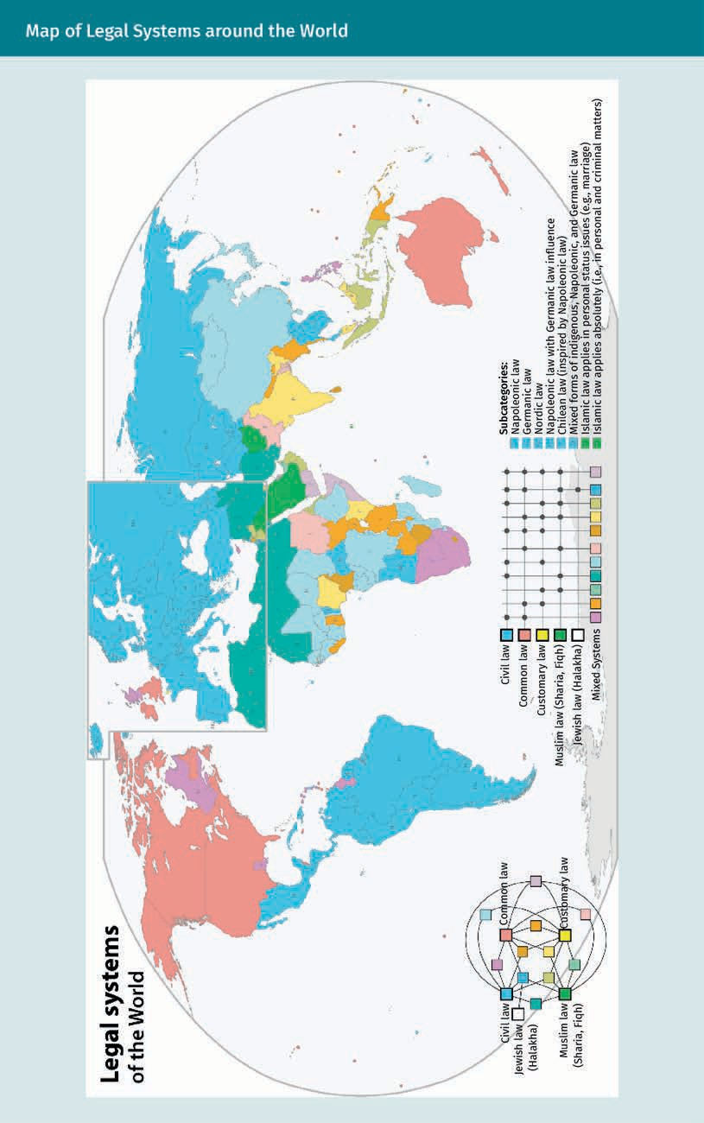

International Economic and Business Environment

Political Risk

When companies intend to conduct their business in a foreign country, they must first assess the associated political risk of the country in question. Briefly, this is the risk that the return of an investment could deteriorate due to political decisions, events, or conditions (Matthee, 2011). There are various types of political risk that originate from the political and legal environment. The following list is not exhaustive and only includes the most common examples.

The first political risk that a company operating in foreign markets could be faced with is the government imposing trade barriers. A foreign government could, for example, implement tariffs on imports with the intent of protecting the domestic job market from imports and to have more value adding activities domestically. This would hurt a company that wants to export its goods to that foreign market, as the import taxes make these goods more expensive. The second risk, typical in developing countries, are uncertain property rights. A government takeover of assets as result of uncertain prop- erty rights can take various forms:

- Confiscation is the seizure of corporate or personal assets without compensation. For example, in the 1980s, Robert Mugabe, prime minister of Zimbabwe at the time, confiscated over 5,000 farms owned by farmers of European descent and redistrib- uted the land to native Zimbabweans (Cavusgil et al., 2014). Today, confiscation is still a risk for the mining industry in developing countries.
- Expropriation is the seizure of corporate or personal assets with compensation. In 2008, a Russian subsidiary of British Petroleum known as TNK-BP was strong-armed into selling a large stake in its oil business to Rosneft, the national energy company in Russia. This was due to political pressure from the Russian government (The Economist, 2008; Cavusgil et al., 2014).
- Nationalization is the seizure of a complete sector. While compensation may be offered in some cases, this is not guaranteed. For example, large parts of the Boli- vian extractive industries were nationalized by the state without an offer of com- pensation (The Economist, 2008; Cavusgil et al., 2014).

A third relevant risk is a sudden change in taxation. The governments of nations rich with resources may implement a “supertax” on revenues from, e.g., mining activities, in times of soaring commodity prices. In 2012, for example, Australia introduced the Min- erals Resource Rent Tax, which levied 30 percent on any annual profits larger than AUD 75 million made by the local mining companies (The Australian, 2010). This tax was to be paid in addition to standard corporate income taxes.

A fourth risk stems from foreign investment laws. Many countries impose restrictions on inward foreign direct investments. For example, foreigners can only own up to 49 percent of a company in Thailand (Siam Legal, n.d.). This can lead to major issues in case of conflict with the joint owner(s).

A fifth risk is political instability caused by terrorism, wars, insurrection, or violence. In parts of Mexico, for example, firms are limiting investments due to drug-related vio- lence and instability. For this reason, Swedish appliance manufacturer Electrolux opted to build their new facilities in Memphis (for USD 190 million) rather than in Mexico (Hsu, 2013).

The sixth risk and final example of political risk discussed here is corruption (e.g., in the form of bribery). This is when a person of authority, often employed by the state or at least active in the local bureaucracy, abuses their power to obtain illicit benefits. For example, a government employee could approve plans for a company to build its premises in exchange for cash bribes or other favors. Corruption is said to cause dam- ages to the world economy totaling USD 2.6 trillion per annum, i.e., 5 percent of global GDP (Wathne & Stephenson, 2021).

Companies can refer to the Worldwide Governance Indicators from the World Bank, the Political Risk Map from Marsh, and the Political Risk Index from Willis Towers Watson for a more comprehensive look at political risk around the globe. Transparency Interna- tional (n.d.) provides an index focusing specifically on corruption. The map below shows how countries scored on the Corruption Perception Index in 2019.
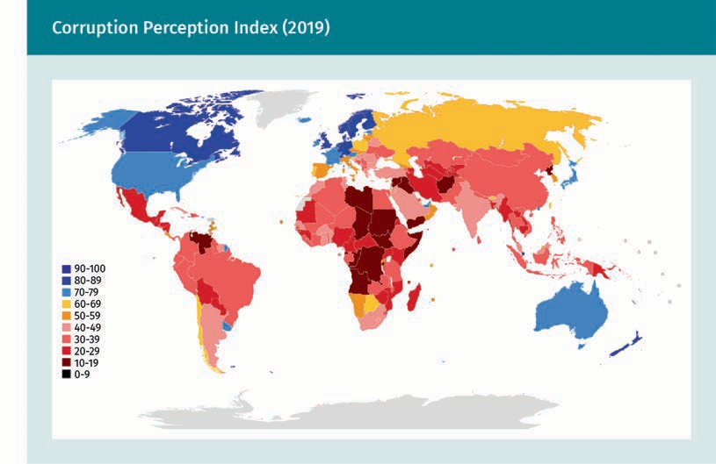

  - Technological Environment
Technological innovation, new products, and increased production efficiency are key factors for successful economic growth (Steenhuis & De Bruijn, 2012). In fact, strong productivity growth during the second half of the 1990s was primarily attributable to

International Economic and Business Environment

technological change (Basu et al., 2001). The field of economics uses a broad definition of technology, i.e., the process of transforming inputs into outputs (Corporate Finance Institute, n.d.-b). Technological progress is anything that makes an economy produce more efficiently, including anything considered cheaper, better, or faster. Therefore, economists consider both physical items (e.g., cell phones or computers) and processes (e.g., assembly line production or the creation of a television series) technologies. Even abstract social or political constructs (e.g., democracy or money) are considered tech- nologies (Mankiw, 2014; Our Economy, n.d.).

Technological Revolutions

A technological revolution is a period in which innovations replace existing technolo- gies in a relatively short amount of time, which increases productivity and efficiency and typically causes abrupt economic and societal changes (Corrado & Hulten, 2010). Although it is debatable what exactly counts as a technological revolution, scholars typically define four industrial revolutions caused by technological change (Schwab, 2017).

The First Industrial Revolution began in Great Britain and took place from about 1760 to sometime between 1820 and 1840. It refers to the transition of manual manufacturing processes to more efficient, mechanized manufacturing ones across Europe and the United States (Horn et al., 2010). Key innovations in this era included mechanized cot- ton spinning in the textile industry, the industrial use of steam power, increased effi- ciency in iron production, and the invention of the first modern machines (Bond et al., 2003). The First Industrial Revolution marked a turning point in history and had major impacts on everyday life. Some economists, including Lucas (2002), argue that, for the first time in history, the average standard of living and the population in the western world began to improve sustainably.

The Second Industrial Revolution, also known as the Technological Revolution, took place between 1870 and 1914 (at the beginning of World War I). During this period, sev- eral new technologies were invented, including methods of harnessing electricity. This period of time is thus characterized by electrification and standardization. Innovations in manufacturing and production technology led to the adoption railroad and telegraph networks, which in turn led to a surge in movement—of both people and their ideas. For example, at the turn of the twentieth century, Henry Ford’s automobile industry pio- neered the assembly line, thus introducing the concept of mass production to the world. (Hounshell, 1985). Other public fixtures, such as sewage systems and gas and water supplies, were also greatly modernized at this time (Atkeson & Kehoe, 2001).

The ongoing Third Industrial Revolution, also known as the Digital Revolution, signifies the transition from mechanic and analog electronic technology to digital electronics (Brynjolfsson & McAfee, 2012). The Digital Revolution found its origins in the period immediately after World War II with the invention of the first computer systems. By the 1970s, the first home computers, video games consoles, and microprocessors (invented by Intel) had been introduced (Shirriff, 2016); by the 1980s, they achieved widespread adoption in developed economics (Kominski, 1988). The World Wide Web was invented

and made accessible to government and academic bodies in 1989 and then to the gen- eral public a few years later (McPherson, 2009). Cell phones were also widely adopted around this time, becoming increasingly advanced as the years progressed. Today, around 60 percent of the global population is connected to the internet (Johnson, 2021).

Internet of Things The Internet of Things (IoT) is a sys- tem of physical objects (e.g., digital devices, machines, people, animals) with embedded sen- sors, software, and other technologies to collect and trans-
fer data.

Income inequality The measure of how unevenly GDP is dis- tributed between citizens throughout a country is called income equality.
The Fourth Industrial Revolution (Industry 4.0) leverages the ongoing digitization of tra- ditional manufacturing and industrial processes (Moore, 2019). It is essentially a transi- tion toward automation and data exchange in manufacturing processes. Key compo- nents of Industry 4.0 include the Internet of Things, on-demand availability of computer system resources (i.e., cloud computing), and artificial intelligence (Hermann et al., 2016). These components use a wide range of technological tools, such as smart sensors, big analytics, augmented reality, and advanced human-machine interfaces. The connectedness of things leads to higher productivity: For example, electric cars could be charged at times when ample electricity from renewable sources is available rather than when they are plugged in. This would result in reducing fossil fuel con- sumption. This example can be applied to other devices (e.g., deep freezers).

Ongoing digitization will lead to further connectedness between individuals, increased consumer empowerment, and a convergence between the physical and digital world. Convergence means that physical objects are enhanced through digital insights and graphics based on aspects of the physical world (Meige & Schmitt, 2015). For example, maintenance engineers can use an augmented reality app on Google Glass when inspecting a jet engine. This app brings up information on the go, which saves time to go through a 1000-page manual on a laptop (The Atlantic, n.d.). These technological innovations have also transformed traditional business models and value chains. Com- panies today leverage digital technologies to adapt to changing customer needs in real-time in order to create customer value (Geissbauer et al., 2016). They expand their product portfolio by offering new digitized products and services. Finally, they can increase their transparency and efficiency by integrating these digitized corporate pro- cesses across their entire network.

The economic and societal effects of Industry 4.0 remain unclear. The current lack of regulation leads to privacy and data security concerns (Birkel & Hartmann, 2019). Although Industry 4.0 will undoubtedly lead to improved production efficiency, increased automation may lead to the redundancy of many jobs and to an increasing level of income inequality.

Measuring Technological Innovation

Innovation indicators are used to measure technological progress between countries or firms. Examples of such indicators are the International Innovation Index, created jointly by the Boston Consulting Group and the United States National Association of Manufacturers, and the Global Innovation Index, the latter of which is jointly published by Cornell University, Institut européen d'administration des affaires (INSEAD), and the World Intellectual Property Organization. In order to rank countries on technological

International Economic and Business Environment

innovation, these indicators make use of different variables, e.g., the number of patents filed in a certain period or the annual amount spent on research and development (R&D) as a percentage of GDP (Matthews & Brueggemann, 2015).

Overall, scholars agree that a country needs a market economy, along with strong prop- erty rights, in order to foster entrepreneurial activity and innovation. In fact, innovation itself is the engine of economic growth (Hill, 2015). With regards to the kind of political system that is most favorable for economic growth, the evidence is more ambiguous. Although most people in Western countries would argue that democracy is good for growth, it must be stated that regimes with certain totalitarian traits in Asia have also developed a market economy with well-protected property rights, leading to rapid eco- nomic growth (e.g., in China and Singapore). However, totalitarian regimes only seem successful when they embrace market economies and strong property rights protec- tion, as numerous African countries have shown (e.g., the failed economies of Equato- rial Guinea and the Central African Republic) (Hill, 2015; BBC, 2021).

Summary
International business is affected by the economic, political, and technological environment. The economic environment is defined by economic systems, eco- nomic conditions, economic policies, and global linkage. The three types of eco- nomic systems are command economies, market economies, and mixed economies. In a command economy, the government plays a dominant role in the production of goods and services. In a market economy, supply and demand determine prices so that market clearance is achieved. Mixed economies include features of both command economies and market economies. Welfare states are market-oriented economies where a key function of the government is to provide an extensive pub- lic welfare system. Economic conditions vary from country to country, often reflec- ted in changes in national income, purchasing power, balance of trade, labor costs, and production efficiency.

The three key political systems are totalitarianism, democracy, and socialism. Under totalitarianism, the state has unlimited authority. Socialism is based on collectivist ideology. The two key features of a democratic state are the protection of private property rights and limited government. The two key legal systems are the civil law and common law systems. Civil law is mainly based on written codes and common law on past cases. Political risk includes, e.g., trade barriers, foreign investment pol- icies, and uncertain property rights.

Technological innovations are a key success factor for economic growth because they improve production efficiency. Major technological innovations led to four dis- tinct industrial revolutions. Scholars agree that a country needs a market economy, along with strong property rights, in order to foster entrepreneurial activity and innovation. That being said, the best political system suited to economic growth remains undetermined.

Knowledge Check
Did you understand this unit?

You can check your understanding by completing the questions for this unit on the learning platform.

Good luck!


Unit 2
Globalization and International Competitiveness

STUDY GOALS

On completion of this unit, you will be able to …

… define globalization and explain how it developed historically.
… understand the opportunities and threats of globalization.
… describe how nations can obtain a national competitive advantage.

DL-E-DLMINTMAB01_E-U02

- Globalization and International Competi- tiveness

Case Study

Alex Madding is the Head of Strategy at Dango, a European producer of remote water meter readers. Dango, a market leader in its home country, is a family-owned business that has existed for more than 60 years. Its sales chiefly originate from the domestic market, and the production is handled from local factories.

However, due to declining costs of international trade, the economic rise in Asia, and increased transparency (due to the internet), the domestic market has started to shift. Particularly, Dango is witnessing increased competition from new water meter produc- ers based out of Asia. Although Alex believes that Dango manufactures a technologi- cally superior product, the foreign competitors are rapidly eating domestic market share by offering lower cost products.

Dango has little experience abroad, but Alex is nevertheless thinking about different ways in which the company could benefit from internationalization. They start brain- storming, thinking of how to compete with low-cost, foreign competitors in their mar- ket. They toy with the idea of sourcing product parts from lower-cost countries or even building a production facility abroad. Alex also imagines adopting a more aggressive strategy: entering and competing in some of the Asian sales and other foreign markets. Alex needs to decide fast to ensure Dango maintains its position in the market.

  - Definition and Development of Globalization
Globalization is a loosely defined term frequently used in both academic and popular discourse. Although definitions vary according to each academic field, scholars gener- ally agree that globalization describes the worldwide movement toward economic and societal interconnectedness. This overarching definition captures the following key ele- ments of globalization (Wall et al., 2010):

- Economic globalization is the increasing of economic integration and interdepend- ence of nations through free transfer of capital, goods, services, technology, infor- mation transfer, and communication across national frontiers.
- Political globalization is the shrinking of national governments’ political influence.
- Cultural globalization is the increasing of societal homogeneity worldwide, which has considerable impact on local cultures. For example, one can see this reflected in the uniformity of consumer preference.

The main driver for globalization is the idea of the division of labor. Each country can specialize in the production of a certain good or service and maximize productivity through economies of scale. Globalization thus takes this idea of organizing work to increase productivity to countries. There are two main enablers for this global division

Globalization and International Competitiveness

of labor: the first is the lowering of both inter-country trade barriers (e.g., tariffs, quo- tas, and other trade barriers) and investment barriers (i.e., obstacles for foreign direct investment); the second is technological progress, including advances in transporta- tion, manufacturing, and information technology (IT).

Early Globalization

Because globalization has not been uniformly defined, its exact beginnings are some- what ambiguous. Based on its key elements, we can identify different waves of globali- zation. The first globalization wave started sometime between the 1500s and 1600s. During the Age of Discovery, beginning in the fifteenth century, European nations star- ted to explore regions across the globe, which led to the rise of maritime European empires by the 1600s (Mancall, 1998). This was the first period in which the African and Eurasian regions traded with the Americas (Stearns, 2019). This period also witnessed the birth of private companies. The Dutch East India Company, active in Asia and South Africa, was founded in 1602 and became the first private company. It adopted a corpo- rate model with a vertically integrated supply chain, a model rather comparable to today’s conglomerates (Grenville, 2017). In the 1600s, our world view and our under- standing of the universe changed with the birth of modern science, thanks in part to scientists like polymath Nicolaus Copernicus (1473—1543) and astronomer Galileo Galilei (1564—1641). Galilei used innovative scientific methods to advance knowledge in the fields of astronomy, engineering, and physics (Weidhorn, 2005). With Europe colonizing other regions of the world, propelled by the various novel scientific insights of the time (e.g., the technological advancements in ship design and navigation), the world took its first steps toward global integration.

Modern Globalization

The second wave of globalization immediately follows the first Industrial Revolution (ca. 1760—1840), which marked a transition from manual to large-scale, more efficient manufacturing schemes using machines, steam power, and chemical manufacturing (Horn et al., 2010). GDP per capita remained flat before the Industrial Revolution, and an era of economic growth in developed, capitalist countries began shortly after (Lucas, 2002). Standardized production of common appliances (up to and including the auto- mobile), combined with rapid population growth, created increased demand for raw materials and inputs for production. Because these input factors were not all available in the countries of production, they had to be imported.

Several factors facilitated globalization in the period from 1815—1870. Importantly, tech- nological innovations in transportation, i.e., shipping and railway infrastructure, signifi- cantly reduced trade costs. With the end of the Napoleonic wars came a period of rela- tive stability in Europe, and those territories, along with the United States, increased their world power by developing new industrial military technologies. This helped them force open markets on a global scale (O’Rourke et al., 2010).

Foreign direct invest- ment
An investor who invests in a control- ling share of a for- eign business entity is making a foreign direct investment.

After World War II

Economic national-
ism This ideology advo- cates government intervention, includ- ing adopting trade barriers, over market
mechanisms.

Liberalization This economic phi- losophy implies less government involve- ment and regulation, typically leading to
privatization.
Globalization came to a halt during World War I. Only after World War II did globaliza- tion make a strong resurgence, the result of explicit planning by the world’s then-lead- ing politicians. Their diplomatic efforts led to the Bretton Woods conference, an agree- ment between the 44 Allied nations detailing a framework to regulate the international monetary and financial order after the war. The core agenda behind the conference was the intended establishment of open markets and the eradication of economic nation- alism by lowering trade barriers between participating nations.

There was a consensus between the Allied nations that there was need for an entity that monitored and promoted the stability of global exchange rates and prevented competitive devaluations of national currencies (with the intent of boosting any one nation’s own exports) (Markwell, 2006). This entity became the International Monetary Fund (IMF). Apart from the IMF, the International Bank for Reconstruction and Develop- ment (IBRD, better known as the World Bank) was established. At the time, the World Bank’s goal was to expedite reconstruction of Europe after World War II and foster eco- nomic development.

A concrete and direct result from the conference was the General Agreement on Tariffs and Trade (GATT), the predecessor of the World Trade Organization (WTO). The GATT resulted in significant tariff reductions between GATT participants in the post-war period. Exports, as a percentage of total gross world product, rose from 8.5 percent in 1970 to 16.2 percent in 2001 (Global Policy Forum, n.d.).

Technological advances helped to push globalization during the second half of the twentieth century: in the 1970s, aviation services became more affordable for the mid- dle class; in the 1980s, society witnessed advances in information and communication technology with the rise of personal computers, cell phones, and the advent of the internet. However, the tensions of the Cold War (1947—1989) between the Western and Eastern blocs severely limited the effects of globalization.

After the Cold War ended, global interconnectedness surged with the economic liberali- zation in various parts of the world. After the collapse of the Soviet Union, the United States, a free market proponent, became the world’s only superpower, i.e., a country that can exert extensive power on a global scale through a combination of militant, cul- tural, economic, technological, and diplomatic strength (Kennedy, 1987). The global expansion of multinational corporations based in the United States was a major driver of economic globalization. This includes the globalization of markets and competition (Hill, 2015). The influence of American multinationals also promoted cultural globaliza- tion, i.e., the transmission of values and ideas around the world, and the homogeneity of consumer preferences worldwide (Hunt, 2003). Restrictions on a person’s freedom of movement were also greatly relaxed, leading to a surge in migration. In particular, work- ers and jobseekers from less-developed countries sought opportunities in more devel- oped territories (Kolb, 2018). Furthermore, broader access to computers and the inter- net allowed people from these underdeveloped areas of the world to find work in new industries, e.g., software development and customer services (Schifferes, 2007). As a

Globalization and International Competitiveness

result of these changes, firms in developed countries started moving parts of their business activities offshore. Meanwhile, the economic reforms in China started under Deng Xiaoping in 1978 were leading the country to a market-oriented economy, making it possible for them to export lower-cost goods to Europe and the Americas (Galvez, 2012). This resulted in stable inflation rates, affordable mass products for the lower- middle class in developed countries, and a rise of the middle class in developing coun- tries (e.g., China) (Rubin, 2018).

The third dimension of globalization is the political. Political globalization refers to the growth of a global political system, which affects national governments, intergovern- mental organizations, and non-governmental institutions. A key element of political globalization is the declining role of nation-states in favor of other political actors, notably intergovernmental and supranational organizations (e.g., the European Union) (Cogan et al., 2016).

Current State of Globalization

According to data from DHL (2019), an international logistics company, both the global transfer of goods, services, and capital as well as the movement of people have risen about 30 percent from 2001 to 2007. Unfortunately, the impending financial crisis in 2007, which lead to the Great Recession at the tail end of the decade, led to a drop in these global transfers. In contrast, the cross-border movement of information (i.e., data) showed no decrease. In fact, between 2001 and 2017, it surged approximately 170 percent. This increase reflects the elemental role that the internet and international communication are playing today in global society.

The figure below shows the development of the openness of the world economy, defined by (imports + exports) / GDP. The recent halt in the increased cross-border movement of goods, services, and capital (as shown) made some analysts believe that the world is deglobalizing (Gjelten, 2009). The COVID-19 pandemic has exacerbated the pullback in globalization, as firms have regionalized or even nationalized their supply chains to reduce supply risk (Shih, 2020). It remains to be seen whether we have already witnessed the peak in globalization or whether we are merely temporarily pla- teauing.
Multinational corpo- ration
A business organiza- tion that is incorpo- rated in one country and produces, man- ufactures, or sells goods in various other countries is a called a multina- tional corporation.

Supranational organization This is a political
entity to which cer- tain powers are delegated by govern- ments of member states.

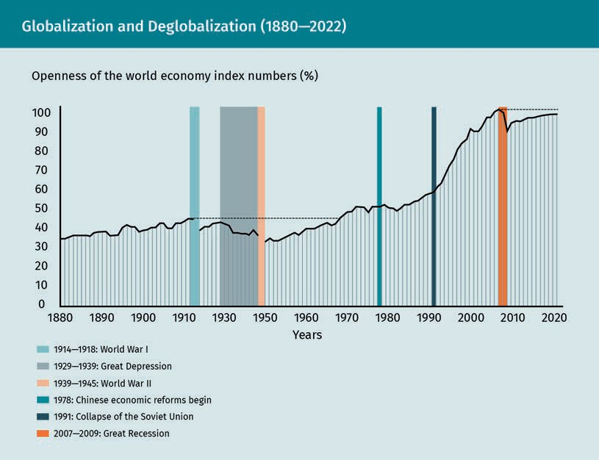

  - Opportunities and Threats of Globalization
For most countries that opened their economies for international trade, globalization led to an improvement in living standards (Cavusgil et al., 2014). That being said, global- ization may also have negative consequences for societies. This section provides an overview of key opportunities and threats of globalization.

Opportunities

First and foremost, globalization’s greatest achievement has been the reduction in pov- erty levels across developing countries. For example, most countries in East Asia liber- alized their economies in the early 1980s and opened their markets for international trade (Young, 1996). As a result, the manufacturing and services sectors grew signifi- cantly. Services exports alone surged from USD 114 billion in 2005 to USD 292 billion in 2013 (Mukhopadhyay, n.d.). This growth was highly correlated to increases in real GDP per capita, as shown in the following figure. Scientists have argued that trade explains at least parts of the growth (Cavusgil et al., 2014). It should be noted that the dip toward the end of the 1990s reflects the effects of the Asian financial crisis (International Mon- etary Fund, 1998). Overall, Asia’s poverty rate, defined by the United Nations poverty

Globalization and International Competitiveness

line (USD 3.20 per day), dropped from 74 percent in 1965 to under 10 percent in 2014 (United Nations, 2020b). Scholars believe globalization may offer similar opportunities for real GDP growth and poverty reduction in Africa (Cavusgil et al., 2014).
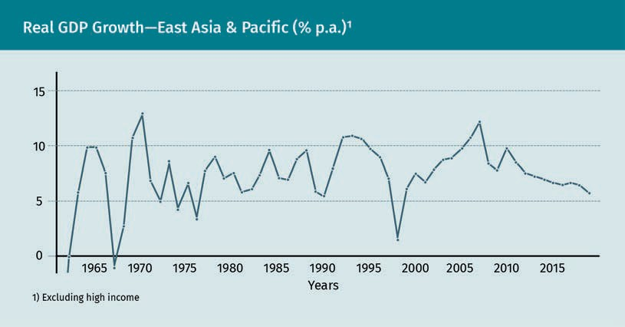

A further advantage of globalization is that it offers access to a broader variety of goods and services, which are now more available to consumers at a lower cost. Firms can source their inputs from low-cost countries and subsequently reduce the cost of manufacturing their end-product. Individual customers can then purchase such end- products directly online from abroad. Furthermore, firms obtain access to global sales markets. The liberalization of the Asian economies, for example, has benefited Western firms in a multitude of sectors, e.g., the automobile industry and microchip production (Bandyopadhyay et al., 2018). As a result of increased international trade, national economies have become more interconnected and interdependent. Arguably, this inter- dependence has led to more international political stability, as unresolved political conflict between nations jeopardizes the economic development of all.

Technology, now easier and cheaper to access, has led to improved corporate produc- tivity and made information more globally available. This has even made it easier for the average person to discover new ideas, learn about different cultures, and commu- nicate with people living in other countries. One could argue that globalization has increased cross-cultural awareness and understanding. Advances in transportation and information technology have “reduced the distance” between countries across eco- nomic, political, and cultural dimensions.

Threats

The clear advantages and opportunities notwithstanding, there are several problems that globalization can cause. One key threat of interdependent financial markets is the risk of contagion should there be a monetary or financial crisis, e.g., the global financial crisis of 2008. That year, the housing bubble in the United States burst, causing housing prices to plummet and house-owners to default on their mortgages (Holt, 2009). Thou-

Mortgage-backed
security This is a financial instrument that is secured by a mort- gage or a collection
of mortgages.

Liquidity crisis This is a sudden shortage of liquidity, i.e., cash or credit.

National sovereignty The authority of a state to govern itself is called national
sovereignty.
sands of these mortgages were combined by banks in mortgage-backed securities and sold to various financial institutions throughout the world. When the value of these securities fell, banks holding these assets experienced a liquidity crisis, as any poten- tial buyers had already disappeared by then. The crisis resulted in the banks going bankrupt themselves, most prominently and importantly Lehman Brothers, one of the largest in the United States at the time (Williams, 2010). Because international financial markets are highly interconnected, the result was a global recession, leading to an increased unemployment rate (CBPP, 2014) and a reduction in international trade (IMF, 2009).

As discussed, globalization has led to the creation of new jobs in low-cost countries. Unfortunately, there is a downside to this positive development: increased competition from outside the local network has cost many people resident in developed economies their jobs. Large manufacturing companies, e.g., Ford and Volkswagen (two car manu- facturers), have moved parts of their production to factories in Eastern Europe (Cavusgil et al., 2014). Many service-sector jobs in software development, customer services, and accounting have moved to Southeast Asia (Cavusgil et al., 2014). Nevertheless, one could argue that increased foreign competition also serves as an impetus for innova- tion.

Increased power of multinationals has led to the loss of national sovereignty. As the size of multinationals has increased, the revenue of certain multinationals has become larger than the GDP of some smaller countries. Because these firms have considerable financial resources, they are able to assert influence on national legislature through lobbying efforts. For example, they could lobby for a devaluation of the local currency, which would make their exports more competitive internationally (Cavusgil et al., 2014).

Another drawback of the growing power of and competition between multinationals is the pressure to produce at the lowest possible cost. This may lead to adverse effects on the impoverished in developing markets, such as the use of child labor, unsafe working environments, and worker exploitation. It may result in further negative consequences, i.e., jobs moving to the informal sector or families losing their income, thereby adversely affecting their living standards (Bachman, 2000). Over time, working condi- tions in developing countries have improved with a rising GDP (Cavusgil, 2014). Unfortu- nately, income inequality has also risen. For example, the Gini index, which measures income inequality, witnessed a 10 percent increase in Asia between 1965 and 2006 (Uni- ted Nations, 2020b).

The increase in manufacturing spurred on globalization has a positive effect on the economic growth; it also considerably impacts the natural environment in a negative way. Environmental pollution, which leads to climate change, is the primary source of concern. Developing markets in particular attract foreign direct investments, which pro- motes the construction of factories. Studies suggest that a citizen’s environmental awareness increases and, in the long term, pollution decreases as economies develop (Galeotti, 2007).

Globalization and International Competitiveness

Although globalization opens the door to other cultures, it has also put pressure on national identity and led to increased cultural homogeneity. This trend has been exa- cerbated by the dissemination of information through communications technology. In short, consumers from across the globe (generally) have access to the same websites, can watch the same movies, and listen to the same music. With the help of expanding multinationals, particularly influential countries (notably the United States), have been able to assert their soft power throughout the world.

  - International Competitiveness
As a result of globalization, nations are facing increased international competition. Contemporary trade theories try to explain how nations can enhance their competitive advantage and become leaders in a given industry. According to Michael Porter (1990), a prominent scholar in the field of business strategy, national competitive advantage is derived from the combination of national comparative advantages and firm-specific competitive advantages.

According to Porter, comparative advantages, also known as location-specific advan- tages, refer to “superior features of a country that provide it with unique benefits in global competition” (Cavusgil et al., 2014, p. 146). Such advantages can be derived from a country-wide abundance of one or more of the following factors:

- natural resources, e.g., oil, gas, or minerals
- a favorable climate, e.g., for harvesting fruit
- arable land, e.g., for harvesting certain crops
- buildable land, e.g., for constructing large commercial projects or skyscrapers
- low-cost labor, e.g., textile production in developing countries
- skilled labor, e.g., engineers and doctors
- access to cheap capital, e.g., due to low credit default risk.

Competitive advantages in Porter’s theory refer to “distinctive assets or competencies of a firm that are difficult for competitors to imitate” (Cavusgil et al., 2014, p. 146). Such firm-specific advantages can be derived from an abundance of

- specific resources, e.g., a unique patent or brand.
- specific knowledge, e.g., concerning how to develop a certain medication or vaccine.
- specific capabilities, e.g., superior supply chain management in the online fashion industry.
- appropriate networks, i.e., strong relationships with other actors (e.g., suppliers) in the value chain or ecosystem.
- winning strategies, e.g., those based on cost-leadership or on differentiation.

Soft power
This political scien- ces concept refers to the use of attraction and persuasion to attain foreign policy goals (hard power, conversely, is coer- cive) (Nye, 1990).

Differentiation strat-
egy This corporate strat- egy aims to obtain a competitive advant- age by offering a product or service distinguishable from others on the mar-
ket.

National industrial
policy A national industrial policy is an interven- tionist measure by a government aimed at encouraging the development of a particular sector or the entire economy (Graham, 1994).
A country has a national competitive advantage in an industry when it can combine its comparative industrial advantages and the competitive advantages of its domestic firms (Cavusgil et al., 2014). A national government can support its domestic firms in obtaining competitive advantages by implementing a national industrial policy. Among others, this can take the form of

- tax incentives, e.g., a value-added tax exemption in a particular sector.
- export subsidies, e.g., direct payments or low-cost loans for the export of a com- modity.
- monetary and fiscal policies, e.g., devaluating the national currency to promote exports.
- investments in national infrastructure, e.g., in transportation and telecommunica- tions.
- educational systems, e.g., subsidized access to public universities.

For an example of a national industrial policy, we can look at the aviation industry. In the early 1970s, the United States had a monopoly in the commercial aircraft sector (excluding the Soviet Union). Around the same time, the governments of Germany, France, Great Britain, and Spain offered federal support for Airbus, a European aircraft manufacturer, in the form of subsidies to create jobs and obtain advanced technologi- cal knowledge. Today, Airbus and its US rival Boeing form a global duopoly for aircraft manufacturing (Francis & Pevzner, 2006).

Porter (1990) developed a framework to capture the various determinants of national competitive advantage, which became known as “Porter’s Diamond.” As Porter (1990) states, “these determinants create the national environment in which companies are born and learn how to compete” (p. 77). He outlines six factors that determine national competitive advantage, as shown in the figure below. The four key factors that are inter- connected are as follows:

- Demand conditions, i.e., how large is the domestic demand—and what is the quality of said demand? Sophisticated and demanding local customers are important for development because they put pressure on society to innovate. Strong growth of the domestic market creates learning effects for expansion abroad. Demand in special- ized segments (e.g., Hollywood movies) can be served nationally and internationally.
- Factor conditions, i.e., does a country have high quality, specialized inputs available to firms? This can include natural resources, qualified labor forces, capital, and superior infrastructure (i.e., physical, administrative, information, and scientific infrastructure). A country may indirectly benefit from a lack of certain resources (e.g., natural resources), as this creates pressure for them to innovate.
- Firm strategies, i.e., what kind of managerial systems and strategies does the nation promote? Is the private sector marked by internationally successful, well-managed organizations? Is there open and vigorous local competition?
- Related and supporting industries. Does the nation provide access to capable, locally based suppliers and firms in related fields? Suppliers are relevant for a com- pany’s own products because they can have specialized technical knowledge. Also,

Globalization and International Competitiveness

is there a presence of clusters instead of isolated industries? Clusters offer a key advantage in that they can lead to knowledge spill-over effects and lower transpor- tation costs. Furthermore, competition leads to innovation pressure.

In Porter’s framework, two further factors that influence national competitive advant- age are as follows:

  - Government policies, i.e., does the nation provide a local context and regulation, e.g., incentives for capital investments and intellectual property protection, that both encourage productivity in the private sector?
  - Chance, i.e., can a country recognize and seize opportunities from unexpected favor- able events (e.g., business opportunities in the former communist countries of the Soviet bloc after the Cold War)? How resilient is a country vis-à-vis any unfavorable random events (e.g., a pandemic)?

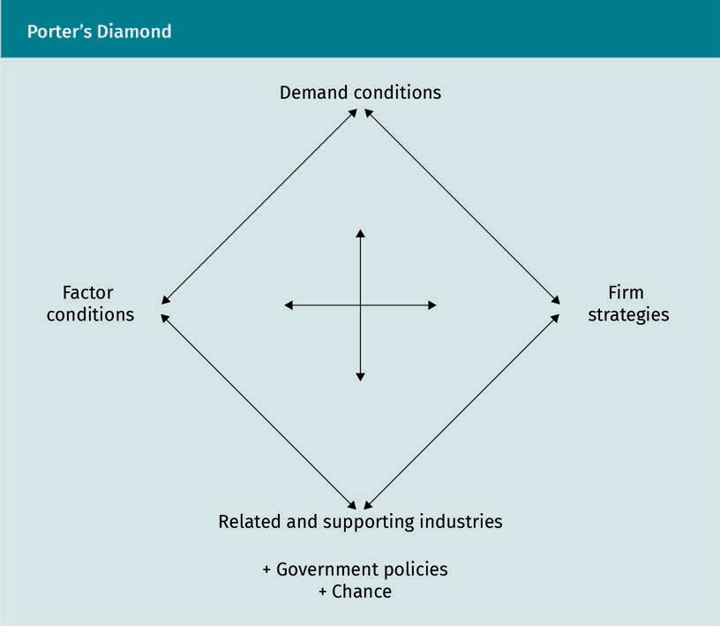
One way to compare the competitiveness of different countries is to use a competitive- ness index. There are various indices that often provide a yearly ranking of the country competitiveness worldwide based on a defined set of dimensions. Perhaps the most well-known competitiveness index is the Global Competitiveness Index (GCI) created by the World Economic Forum. The GCI is based on more than 100 variables, that are grou- ped into the GCI eleven pillars (Schwab & Zahidi, 2020):
Cluster
A cluster is a geo- graphic concentra- tion of related and supporting indus- tries (e.g., suppliers, customers, competi- tors) that are physi- cally close.

- Institutions
- Infrastructure
- Supportive macroeconomic framework
- Modernized education and training
- Social protection and stronger labor laws
- Expanded accessibility of care services
- Development of long-term orientation of financial markets and financial inclusion
- Redesign competition and international anti-trust frameworks
- Enabling of new markets that promote sustainability through public-private partner- ships
- Investments in technological research
- Improvements in diversity, equity, and inclusion

In 2020, the World Economic Forum prepared a special report that analyzed a country’s level of preparation for transforming their economies and societies in response to the COVID-19 pandemic (Schwab & Zahidi, 2020). The table below shows the ranking for the top ten countries, including their score on a scale from 1—100 (100 being the highest score). This overall score reflects categories of the “transformation readiness” score, i.e., having strong public institutions, infrastructure, and a supportive macroeconomic framework. The GCI can be used by firms for strategic decision-making, such as interna- tional expansion decisions.

Global Competitiveness Index 2020—World Economic Forum
Rank | Strong public institutions | Infrastructure | Supportive macroeconomic framework
1 | Finland (78.5) | Estonia (99.7) | South Africa (65.2)
2 | Switzerland (76.8) | Denmark (91.5) | Japan (64.5)
3 | New Zealand (73.0) | The Netherlands (91.4) | South Korea (63.4)
4 | Denmark (72.0) | Finland (88.9) | Australia (62.1)
5 | The Netherlands (72.0) | Sweden (88.0) | Ireland (59.2)
6 | Sweden (70.3) | Portugal (87.8) | China (58.1)
7 | Austria (69.9) | Spain (86.9) | Canada (56.7)

Globalization and International Competitiveness

Rank | Strong public institutions | Infrastructure | Supportive macroeconomic framework
8 | The United States (67.5) | Ireland (86.8) | India (55.8)
9 | Canada (67.0) | Hungary (86.4) | France (55.6)
10 | Australia (66.7) | Slovak Republic (84.9) | Germany (54.2)

Summary
Globalization is the worldwide movement toward economic and societal intercon- nectedness; its dimensions include economic, political, and cultural globalization. Globalization has advanced in different waves over the last few centuries, and its main driver has been the division of labor. Technological advancement and a reduction of inter-country trade barriers have greatly helped to enable this phe- nomenon. The recession of the late 2000s and the COVID-19 pandemic both put a pause on further its progress. It is unclear whether society has already witnessed the peak of globalization.

Globalization offers different opportunities and comes with many risks (i.e., threats). Major opportunities include a reduction in poverty, consumer access to a broader variety of cheaper products, and improved productivity through technology and easier access to information. Among others, threats include monetary and financial crises, adverse consequences for the natural environment and impover- ished communities, a loss of national sovereignty, and the loss of jobs in developed economies.

Contemporary international trade theories attempt to answer one rather complex question: how can a nation can enhance its competitive advantage? National com- petitive advantage is derived from the combination of national comparative and firm-specific competitive advantages. Competitive advantages are promoted by a national industrial policy. Porter’s diamond model identifies six factors that deter- mine national competitive advantage: the four key, interconnected factors are demand conditions, factor conditions, firm strategies, and related and supporting industries; the two secondary factors are government policies and chance.

Knowledge Check
Did you understand this unit?

You can check your understanding by completing the questions for this unit on the learning platform.

Good luck!


Unit 3
International Trade

STUDY GOALS

On completion of this unit, you will be able to …

… understand different theories for why countries engage in trade.
… explain why international trade is important for an economy.
… define protectionism and explain why it is a threat to international business.

DL-E-DLMINTMAB01_E-U03

- International Trade

Case Study

The newly elected president of the Highlands, a large Western nation, was busy drafting policies for their first few months as president. While developing an action plan to fight the COVID-19 pandemic was the highest priority, there were several other issues that required immediate attention. Under the administration of the previous president, the Highlands adopted a rather defensive stance towards Palinga, an emerging economy, leading to increased political tensions and protectionist trade measures. The previous president established tariffs on various products imported from Palinga, including corn and sugar. As a response, Palinga adopted protectionist countermeasures, resulting in lower total imports and exports between the two countries. Palinga and the Highlands have a complex relationship, as they are each other’s largest political and economic rivals and trade partners.

Soon after the new president was installed, various lobbyists knocked on the door. Those working in sugar production requested the president maintain the existing tariffs to protect the domestic industry from the threat of cheap Palinganese sugar exports. By contrast, executives from the manufacturing sector, such as automobile and aircraft producers, were urging the president to improve relationships with Palinga—their sales depend highly on Palinga.

During a walk in the presidential garden, the president of the Highlands was pondering: Should the predecessor’s protectionist policies against Palinga be maintained, or should the government adopt a more accommodative stance and aim for a free trade relationship between the Highlands and Palinga?

  - Classical Theories and Models of International Trade
Classical trade theories seek to answer the basic question of why nations trade. Over the last few centuries, we have borne witness to the continuous change in the theories concerning open economic practice for international trade. This section provides an historical evolution of these international trade theories.

Mercantilism (1500—1700)

After the Middle Ages, European nations (notably France and England) adopted the eco- nomic policy of mercantilism, which aims to reach a current account surplus by maxi- mizing exports and minimizing imports. Tariffs on imported manufactured goods were a key tool to achieve this goal, as well as forbidding colonies from trading with other nations. Today, non-tariff barriers, such as local content requirements, play a larger role as mercantilist policy elements.

International Trade

Absolute Advantage (1776)

In his book An Inquiry into the Nature and Causes of the Wealth of Nations, published in 1776, Scottish economist and philosopher Adam Smith opposed mercantilist policies by introducing his theory of absolute advantage. Absolute advantage refers to a nation’s ability to produce a certain good or service more efficiently than another nation (Encyclopedia Britannica, n.d.-a). According to Smith (1776), by trying to minimize imports, a country uses too much national resources to produce those goods it cannot produce efficiently. Because he used only one input in this theory (i.e., labor), absolute advantage is determined by labor productiveness. Limiting the discussion to labor time was due to the context of the piece’s time, i.e., just before the First Industrial Revolu- tion, when labor was the most important proxy for cost. He suggested that each coun- try, while importing other goods, should specialize in producing and exports those goods that it can most efficiently (Smith, 1776). In this scenario, each country increases its welfare by specializing in the production of certain products and engaging in free trade. It allows each nation to consume more than it otherwise could and at a lower cost (Cavusgil et al., 2014).
Current account sur- plus
The value of a coun- try’s exports exceeds the value of its imports.

Local content requirements Firms are required by local law to use
goods manufactured domestically.

Absolute Advantage—Production Possibilites (Tons per Labor Hour)
 | Steel | Corn
Germany | 10 | 6
China | 6 | 8

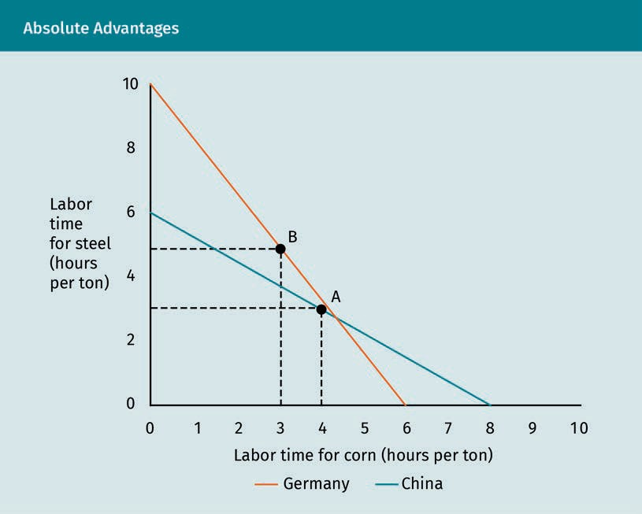

Factor of production
This is a firm resource (e.g., labor, capital, technology, entrepreneurship) used to produce goods and services.

Production possibili-
ties frontiers This is a graphical representation of different combina- tions of goods that a country can produce when the production depends on the same finite resour-
ces.
The example above illustrates how absolute advantage would work in real-world situa- tions. Imagine that Germany and China are trading goods. Following the approach used in Smith (1776), we assume labor is the only factor of production used in making or procuring both goods (i.e., steel and corn). Adam Smith originally limited the discussion to labor time because he was writing his work just before the beginning of the First Industrial Revolution when labor was the most important proxy for cost. The orange and blue lines in the figure represent the production possibilities frontiers.

In the example, an average worker in China can produce a maximum of either six tons of steel or eight tons of corn in an hour. An average worker in Germany can produce a maximum of either ten tons of steel or six tons of corn in an hour. Because Germany can produce four tons of steel more in an hour, they have an absolute advantage in steel production. China, by contrast, has an absolute advantage in corn production, as they can produce two tons more in an hour. The principle of absolute advantage sug- gests that, if both of these countries specialized in the production of a single good (in which it is more efficient) and then exchanged these goods (i.e., steel and corn) at a ratio of 1:1, China could import one ton of steel in exchange for one ton of corn. If China produces the steel itself, it will need ten minutes for one ton (60/6). It only needs 7.5 minutes to produce one ton of corn (60/8). Therefore, by engaging in trade with Ger- many, the cost of one ton of steel is now only 7.5 minutes, i.e., it gains back 2.5 minutes’ labor time. This scenario is as equally beneficial to Germany as it is to China.

International Trade

The example also exhibits why producing at point A and B on the chart is a losing prop- osition for both countries. If Germany and China decide not to trade, instead opting to spend half of their available labor time (say, one hour) on producing both products, then China will produce three tons of steel in 30 minutes and four tons of corn in 30 minutes (point A). Germany will produce five tons of steel in 30 minutes and three tons of corn in 30 minutes (point B). If the countries do not trade, they produce a combined total of eight tons of steel and seven tons of corn in an hour. If both countries special- ize in a single good and engage in trade, they can produce a combined total of ten tons of steel and eight tons of corn in an hour. Thus, the countries obtain a combined gain of two tons of steel and one ton of corn, or an average of one ton of steel and 0.5 ton of corn for each country.

The theory that Adam Smith proposed was, in fact, a 180-degree shift from the previ- ously dominating mercantilist theory, i.e., from having trade barriers to free interna- tional trade with few trade barriers as possible. It thus had a huge impact on economic thinking and public discourse.

Comparative Advantage (1817)

In his book On the Principles of Political Economy and Taxation, British political econo- mist David Ricardo (1817) explained how two countries could benefit from trade even if one of them has absolute advantage in the production of all products. The theory of comparative advantage suggests that two countries can benefit from trade if one coun- try is relatively more efficient at producing goods or services needed by the other (Cav- usgil et al., 2014). Let us return to the example of China and Germany and slightly mod- ify it. We will assume that China now has an absolute advantage in both steel and corn production, meaning that they can produce more of these goods than Germany in the same amount of time. Correspondingly, the production possibility frontiers of Germany and China do not intersect. Following Smith’s absolute advantage principle, one would conclude that China should produce its own steel and corn and not engage in trade with Germany. However, Ricardo (1817) demonstrates that, even though China can pro- duce both items more efficiently than Germany, they can still benefit from a trade agreement.

Comparative Advantage—Production Possible (Tons per Labor Hour)
 | Steel | Corn
Germany | 4 | 6
China | 10 | 8

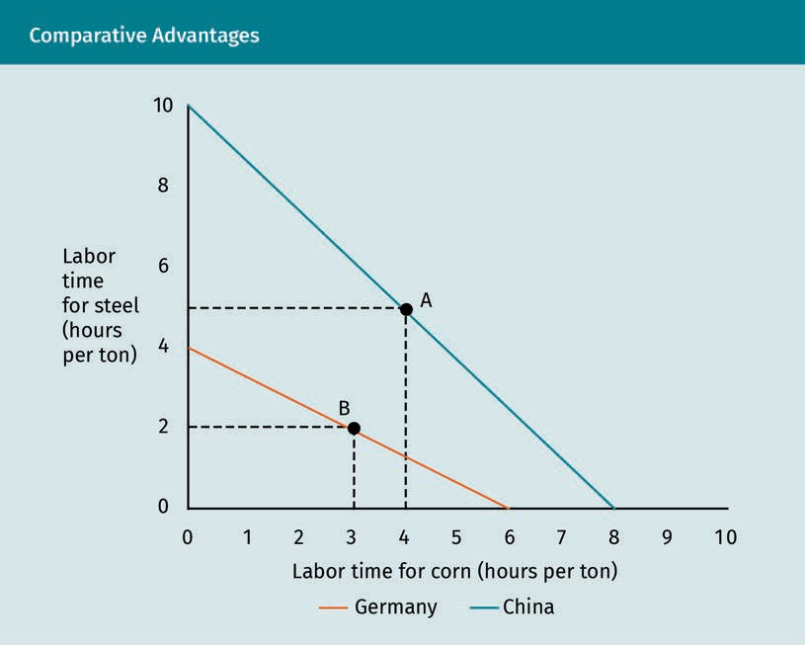

Ricardo (1817) showed that it is the relative cost of production at which the two coun- tries can produce that is the deciding factor (and not the absolute production effi- ciency). What does this mean? In our example, China is comparatively more efficient at producing steel than corn: it can produce 2.5 times as much steel as Germany (i.e., 10/4) and only 1.3 as much corn (i.e., 8/6). Therefore, China should only produce its own steel and opt to import corn from Germany; Germany should specialize in producing corn and opt to import its steel from China. Both countries gain from trade because, for a given level of labor cost, they can each consume and produce relatively more of the goods they want (Cavusgil et al., 2014). Note that, in the example, China should import corn from Germany, even though it is more efficient at it than Germany. While this may sound counterintuitive at first, the reason is obvious: corn trade allows China to con- centrate its resources in the production of steel in which it has comparative advantage.

For points A and B, similar thinking applies, as detailed when we discussed absolute advantage. The countries will agree to terms of trade (i.e., the “price” at which the coun- tries trade goods) between the respective opportunity costs of a good for both coun- tries. We can illustrate this further: The opportunity cost for Germany to produce one ton of steel is 1.5 ton of corn (6/4). The opportunity cost for China to produce one ton of steel is 0.8 ton of corn (8/10). The countries could, therefore, trade one ton of steel (where China has a comparative advantage) for any price between 0.8—1.5 ton of corn (where Germany has a comparative advantage).

International Trade

The ideas of absolute and particularly comparative advantage constitute the basis for international trade. Nevertheless, they are also based on simplified assumptions and thus have several limitations (Cavusgil et al., 2014):

- The theories fail to account for transportation costs, which can constitute a signifi- cant part of the total product cost.
- Whereas some services are freely tradeable online (e.g., banking services), others are not (e.g., getting a haircut).
- Government intervention distorts free trade by implementing protectionist meas- ures (e.g., subsidies or tariffs).
- On a firm level, advantages (e.g., efficiencies) can be achieved through economies of scale and more competitive business strategies. Absolute and comparative advant- age trade theories do not consider underlying causes for possible advantages.
- Not all traded products are commodities like steel and corn. The theories do not account for branding and any differentiating features of the goods in question.

Factor Proportions Theory (1930s)

Expanding on Ricardo’s theory of comparative advantage, Swedish economists Heckscher and Ohlin (1991) developed the factor proportions theory (also known as the factor endowment theory and the Heckscher-Ohlin model) in the early 1930s. Their theory investigates root causes for comparative advantages (Heckscher & Ohlin, 1991). Countries possess different types of production factors (i.e., labor, natural resources, and capital), as well as absolute quantities. Factor proportions theory suggests that those nations that manufacture products using relatively abundant factors of produc- tion should export such goods and import goods that use factors of production rela- tively scarce for them. For example, a capital-abundant country (e.g., the United States) exports capital-intensive products (e.g., commercial aircrafts) to a labor-abundant country (e.g., Bangladesh), which exports labor-intensive products (e.g., textiles) (Cavus- gil et al., 2014; Economist Intelligence Unit, 2016).

The original Heckscher-Ohlin model differs from comparative advantage theory by including capital as a factor of production. In the early 1950s, Russian econometrist Leontief (1953) tested the Heckschler-Ohlin model with empirical data and found that, contrary to what the model claimed, American exports were primarily labor-intensive and not capital-intensive. One explanation for these findings is that the United States has a comparative advantage in highly skilled, productive labor (i.e., technology-driven labor) rather than in capital. This problem became known as Leontief’s paradox. These findings led many economists to favor the Ricardian model, where technological differ- ences determine comparative advantage, over the Heckscher-Ohlin model, where fac- tors of production (i.e., labor and capital) determine comparative advantage.

For a present-day example, we can look to Chile, which is by far the most prominent copper producing nation in the world (Garside, 2021). South Korea manufactures elec- tronics (Suarez-Villa & Han, 1990) and has relatively few natural resources compared to

Chile (Encyclopedia Britannica, n.d.-c). It thus makes sense for each country to special- ize in one product and then trade with each other (rather than producing both prod- ucts domestically).

Technology Gap Theory (1960s)

American economist Michael Posner (1961) introduced the technology gap theory, which suggests that a country can obtain significant advantages by introducing new products. In stark contrast to factor proportions theory, which assumes no differences in technol- ogy between countries, technology gap theory claims that it is the technology itself that determines trade currents. This view assumes that technology and knowledge determine the development of new products, services, and production processes. Tech- nologies and technology-related processes developed by one country cannot immedi- ately be adapted by foreign companies—in fact, this may take a considerable amount of time. In introducing new products, a country can obtain comparative advantage and a temporary monopoly by realizing “pioneer advantages,” at least until other countries are able to imitate the new good. The following figure summarizes technology gap theory, assuming a scenario in which a new product is developed in Germany and exported to China.
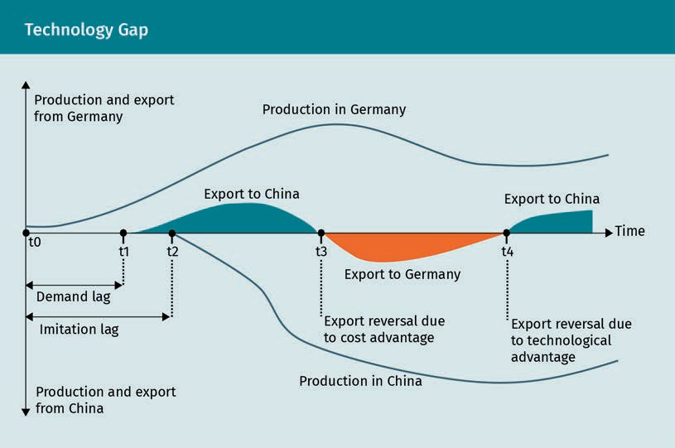

This example shows the following developments across time. At t0, Germany has devel- oped a new product (e.g., an industrial machine), started production, and is now selling it domestically. The demand lag refers to the time taken between product creation and its domestic acceptance. At this point, exports are equal to zero and the product is being tested in the domestic market. This lag remains until the point where foreign

International Trade

countries begin to slowly accept this newly developed product. At t1, customers in China have gained knowledge of the new industrial machine and start importing it from Germany.

At t2, after the product has been fully accepted by the importing country (i.e., China), local producers will start imitating the new product. The imitation lag is the time taken between the initial creation of a product in the innovating country and the start of pro- duction in the importing country. The length of the process depends on the innovative- ness and the amount of research and development (R&D) resources the importing country spends on developing the product. Between t2 and t3, the innovating country exports the product due to its technological advantage. In the example, Germany enjoys technological superiority and, therefore, will have a monopoly until China learns to produce the industrial machine for itself. At t3, a reversal of export flows takes place due to a cost advantage of the imitating country. China now exports the product to Ger- many, and German exports to China fall, resulting in net exports from China.

At t4, exports from the imitating country (China) to the innovating country (Germany) end due to improved technologies in the innovating country or higher costs in the imi- tating country (or a combination of both factors). This marks the end of the low-wage trade and may lead to another reversal of exports, i.e., where the innovating country starts exporting an improved machine to the imitating country again. According to Pos- ner (1961) and Juneja (1994), the technology gap, i.e., the difference in the development and use of a technology between two countries, is determined by several factors, including

- foreign reaction lag. This is the time from the new product’s adoption by companies in the innovating country to the moment when the new product is regarded by com- panies in the importing country as a potential competitive product to those pro- duced domestically.
- domestic reaction lag. This is the time needed for all companies in the importing country to realize that the new product forms a competitive threat.
- learning period. This is the time needed for the companies in the importing country to learn how to manufacture the new product and sell it on its domestic market. The foreign reaction lag, domestic reaction lag, and learning period together constitute the imitation lag.
- demand lag. This is the time needed between the product’s creation and its even- tual acceptance in the domestic market.

New Trade Theory (1970s)

In the late 1970s, a group of economists led by Paul Krugman (1981) developed the new trade theory. These economists observed that, contrary to previous trade theories, trade growth was strongest among industrialized countries with similar factors of pro- duction (Cavusgil et al., 2014). Whereas previous trade theories assume constant econo- mies of scale, the new trade theory essentially argues that increasing economies of scale in industries with high fixed costs (e.g., shipping, aircraft, or automobile manufac- turing) explain trade patterns. Countries can increase productivity and lower unit costs

Constant economies
of scale The output increases proportionally to the change in inputs.

Increasing econo- mies of scale
The change in out- put is greater than the change in inputs.
by specializing in such industries. Exports are a good way to increase economies of scale when national markets are small. They also allow a nation to develop a speciali- zation in a few industries in which it does not have comparative advantages or the rel- evant factor abundance advantages (Cavusgil et al., 2014). Thus, according to the new trade theory, increasing economies of scale provide the basis for international trade (and not the comparative advantage).

To summarize, comparative advantage explains inter-industry trade between countries with different factors of production. For example, Germany buys pineapples from Costa Rica, and Costa Rica buys industrial machines from Germany. Each country specializes in a good because it has a relative cost advantage in producing this good. Rather than explaining inter-industry trade, the new trade theory explains intra-industry trade between countries with the same factors of production, based on increasing economies of scale. Each country specializes in a product, which is typically capital-intensive (e.g., airplanes or automobile), and then exports this product to achieve economies of scale. Therefore, under the new trade theory, increasing economies of scale rather than rela- tive cost advantage forms the basis of trade.

The new trade theory often serves as a theoretical justification for protectionist meas- ures, particularly for the development of industries still in their infancy. Some econo- mists argue that such measures may help to build a large industrial base and obtain an international competitive advantage in certain industries. Japan, for example, upheld protectionist measures from 1945 to the 1970s to stimulate the development of the automobile industry. However, empirical studies are still inconclusive as to whether such policies directly helped to achieve increased economies of scale (Beason & Wein- stein, 1996). In the early 1990s, international trade theories shifted from focusing on comparative advantages to national competitive advantages to explain trade currents.

  - Importance of International Trade for an Economy
International trade benefits both importing and exporting nations. It allows consumers in importing countries to buy goods (that domestic companies cannot produce effi- ciently) at lower prices. Moreover, countries can import products that are not available domestically, leading to a greater variety of goods for consumers. International trade scholars regard this as a key benefit of free trade. After all, as English poet William Cowper (1817) once wrote, “variety is the spice of life.”

Based on the principle of comparative advantage, countries will produce goods for which they have a relative cost advantage. This implies that resources are allocated more efficiently, leading to an overall reduction in wasted resources. Access to interna- tional sales markets provides an incentive for a country to produce more efficiently, thus beating out competition from foreign producers. Fostering export-oriented indus- tries has proven to be a great opportunity for both developed countries (e.g., Germany) to obtain comparative advantage in innovative products and for developing countries

International Trade

to become leaders in low-cost, labor-intensive goods (e.g., South-East Asian countries). Furthermore, one could argue that nations becoming economically more interdepend- ent through international trade fosters political stability.

International Trade and Economic Growth

A great number of academic studies has shown a positive correlation between interna- tional trade and economic growth in developed and developing countries (e.g., Frankel & Romer, 1999; Sachs et al., 1995). Thus, to stimulate growth, many countries strive to open their economies for imports and exports. Free trade is advanced by signing inter- national and bilateral trade agreements to lower trade barriers.

The Economic Complexity Index (ECI), developed by Hidalgo and Hausmann (2009), is a tool for measuring productive capabilities of an economic system, e.g., a nation or a city. Productive capabilities include land, infrastructure, human resources, knowledge, machines, and much more. The ECI is a proxy that attempts to measure productive capabilities indirectly by analyzing the product mix that an economic system (e.g., a country) exports (Ortiz-Ospina & Beltekian, 2018). The idea of economic complexity assumes that “productive capabilities determine the number and quality of products that this country can export” (Ortiz-Ospina & Beltekian, 2018, para. 5). Therefore, analyz- ing a country’s exports helps us to understand its underlying productive capabilities. Let us use an analogy: If an economy is like a fashion retailer, then productive capabili- ties would be all the things needed to produce the clothes. The ECI ranks different fashion retailers by comparing their catalogs rather than their production facilities, human resources, and textiles (Ortiz-Ospina & Beltekian, 2018).

The ECI reflects two dimensions: the diversity and ubiquity of exports. Diversity refers to “the number of products that a country can export competitively,” while ubiquity is “the number of countries that can export a product competitively” (Ortiz-Ospina & Belte- kian, 2018, para. 8). The ECI compares these dimensions between countries. The lowest ranking countries in the ECI (i.e., those with lowest complexity) are those that export few distinct products (i.e., low diversity)—products that are also produced in many other countries (i.e., they are ubiquitous). Returning to the analogy, fashion retailers with a more diverse and sophisticated catalog rank higher, and fashion retailers with similar catalogs have, naturally, similar rankings.

The chart below shows the ECI ranking on its horizontal axis (the lower the numerical value, the better) and real GDP per capita on its vertical axis. A strong correlation between the two dimensions is observable. In other words, the chart suggests that eco- nomic complexity has a positive effect on income. Longitudinal studies over a longer period of time, which analyze change in ECI and real GDP per capita growth, equally suggest a strong positive correlation.

Productive capabili- ties
These are the inputs, technologies, and ideas that together determine the boun- daries of what an economy can pro- duce.

Proxy
A proxy is a variable that is used in lieu of another, highly correlated variable, one which is unob- servable and immeasurable.

Longitudinal study This is an analysis during which input and output variables are measured at dif- ferent points in time.

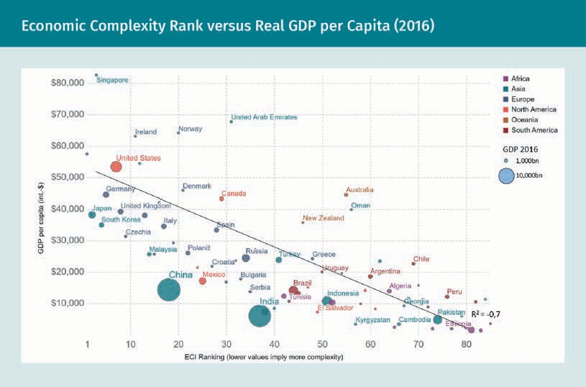

The ECI implies that a high-ranked country, such as Germany, produces a great variety of sophisticated products that are not produced by many other countries. Importantly, the ECI does not care about the quantity of exports, and economies driven by export are not guaranteed real GDP growth. For example, certain African countries (shown above in pale green) primarily export resources that have low diversity, meaning they will not witness strong, real GDP growth according to the idea of economic complexity. One study suggests that the ECI predicts both income growth and income inequality (Hartmann et al., 2017).

Offshore outsourcing When a business activity is transferred to a foreign country, this is called off- shore outsourcing.

Captive sourcing When a company’s production activities are moved to a for- eign subsidiary or affiliate, this is called captive sourc-
ing.
There are also disadvantages to international trade. Reducing barriers for international trade implies that domestic firms need to compete on a global scale. If they cannot (e.g., because the price of a product imported from one country is lower than that of a similar product produced elsewhere), this leads to job cuts, offshore outsourcing, or captive sourcing. However, the consensus among economists is that free trade leads to economic growth and a net gain for all countries involved (Whaples, 2006). It is then up to the national governments to distribute the gains of global trade within their coun- tries and ensure that those who are losing because of global trade are appropriately compensated. For example, this could be through welfare benefits for the poorer social classes or by making higher education affordable for all.

International Trade

  - Protectionism as a Threat to International Business
Despite the benefits of free trade, national governments may choose to intervene in international trade. Protectionism refers to the economic policy of restricting a nation’s imports through governmental intervention. We will now look at some of the economic, political, and social reasons for protectionist measures in more detail.

One economic reason to implement protectionist measures is to shield the domestic industry through import substitution and/or export-led development while increasing government revenue. In 2018, for example, the United States, under the stewardship of President Trump, imposed various tariffs, most notably a 25 percent tariff on steel imports and a 10 percent tariff on aluminum imports (Long, 2018). The government may also wish to defend and develop infant industries. For example, in the 1980s, Brazil capped the import of computers with the purpose of developing its own computer industry (Dedrick et al., 2001). The results were negative: The technological gap between Brazil and the innovating countries only widened, and the Brazilian computer industry only managed to produce low-quality copies of foreign computers. Finally, a govern- ment could want to deter unfair competition and dumping. For example, during the 1997 Asian financial crisis, the United States implemented measures against cheap steel imports from various Asian countries, which were witnessing a sudden oversupply (Goldstein, 1998).

Political reasons involve national security. One clear example is the decision made by several Western countries (e.g., the United States and a growing number of European countries) to block Chinese companies (e.g., Huawei) from building 5G wireless net- works on their land. This was done in order to prevent any potential data theft (Tho- mas, 2021).

Lastly, there are social reasons for such protection measures. Some governments may wish to protect domestic jobs and curb the unemployment rate. For example, the afore- mentioned American steel tariffs helped limit lay-offs in their domestic steel industry. However, the resulting increased steel prices did put downstream American manufac- turing industries at a competitive disadvantage, leading to job cuts (Cox & Russ, 2020). Another reason can be to protect the national culture and identity. In France, for exam- ple, television groups need to meet an investment quota, i.e., they need to invest a cer- tain percentage of their annual revenues in French-language series and films (Statt, 2020).

Protectionist Instruments

Governments can use the following instruments to intervene in international trade: tar- iffs, quotas, and non-tariff barriers. A tariff is a tax levied on imported goods. One example is the aforementioned steel tariff; another is the 30 percent tariff that former President Trump imposed in 2018 on solar panels imported from China (Eckhouse et al., 2018). An import quota sets a fixed limit on the quantity of a given good that can be imported during a certain period of time. One way this quota can be allocated is by

Dumping
When an exporting country sells goods abroad for less than the “normal” value, e.g., below produc- tion cost, this is known as dumping.

distributing the total of the quota among specified supplying countries. Another way is having a tariff quota. Here, a specified quantity is allowed to be imported tariff-free, but after having reached this hurdle rate imports are subject to a tariff. Quotas are common in both developed and developing countries. Vietnam, for example, had an import quota for various goods (e.g., cars and cement) in the late 1990s (World Bank, 2000).

Finally, there are non-tariff barriers, which come in several different forms:

  - Import licenses are documents issued by a government authorizing the import of certain goods into its territory.
  - Local content requirements are governmental policies that require firms to use products manufactured in the home country. In India, for example, single-brand retail stores have to source at least 30 percent of their goods from Indian-based firms (Cimino-Isaacs & Zilinsky, 2016).
  - Administrative rules reflect bureaucratic procedures (e.g., documentation, customs clearance, and inspection of small shipments), which are often made so difficult that potential importers simply decide to cancel their plans.
  - Subsidies are payments from the government made out to domestic firms that struggle to compete with imports. These payments are given to protect local jobs and are common in the agricultural sector. For example, American and European farmers receive subsidies for certain products (e.g., milk and sugar). They can either be paid out in the form of direct subsidies (e.g., the firm receives payments based on its production) or export subsidies (i.e., based on the value exported).
  - Exchange rate controls reflect the power a government has over its local currency. A government can devaluate its currency by selling it on the open market, which makes imports more expensive and exports more attractive for foreign nations.
  - Finally, there may be restrictions on foreign direct investments, such as regulations on acquisitions of domestic companies by foreign investors. While this is primarily an investment barrier and not a trade barrier, foreign direct investments and trade complement each other. For example, American subsidiaries abroad buy almost 25 percent of all American exports. Thus, removing foreign barriers to American invest- ment is a key element in stimulating American exports and fostering competition (Wessner, 1997).

Although tariffs are the most well-known trade barriers, non-tariff barriers are the most frequently used protectionist measures today. With non-tariff barriers, it is more diffi- cult for World Trade Organization (WTO) member to prove that the country applying the measures has breached the rules of the WTO trade agreement.

Consequences of Protectionism

Economists agree that protectionism has negative consequences on economic growth (Mankiw, 2015). Other consequences for intervening countries, i.e., those imposing pro- tectionist measures, include

International Trade

- reduced competitiveness on the global markets due to fewer incentives for produc- tivity gains, quality improvements, or research and development (R&D).
- foreign governments potentially retaliating by also adopting protectionist measures, which leads to higher input prices for domestic importers.
- higher input prices and a potential scarcity due to lower imports, which may lead to inflation.

Agricultural subsidies in developed countries can help to lower prices for consumers. Nevertheless, it can also lead to negative consequences for farmers in developing countries. When crops (e.g., sugar and cotton) that also grow in developing markets (e.g., in African countries) are subsidized, the farmers in developing countries (i.e., those growing unsubsidized crops) may find it difficult to directly compete (La Vina et al., 2007). Such subsidies hamper economic growth in the developing world. Some economists, contrarily, argue that protectionist policies can help to develop infant industries. In certain cases, protectionist measures could even, they argue, maximize trade gains.

Game theory offers a theoretical framework for analyzing the effects of (non-)protec- tionist policies. The pay-off matrix below shows the outcomes in economic gains of dif- ferent trade strategies of two countries (here, the United States and China). The com- bined trade gains are largest when both countries engage in free trade (i.e., 110 + 110
= 220). However, the United States can obtain higher individual trade gains (130) if it implements protectionist policies and China does not retaliate; the combined trade gains in this situation are 200 (130 + 70). If China does retaliate and both countries use protectionist measures, the combined trade gains are at their lowest (85 + 85 = 170). This is the worst combined outcome for both countries. However, if we look at each country separately, this is still a better outcome for China, i.e, compared to the outcome when not retaliating after the United States engages in protectionism. In this case, trade gains for China would only be 70. In conclusion, protectionist strategies can help when no retaliation of the counterparty is expected; or in retaliating against protection- ist measures from the counterparty.

Note that this example is a simplified game-theoretical model based on a single “game” (decision-making round). In reality, this is much more complex.
Game theory
This term refers to a mathematical frame- work to analyze stra- tegic interaction of rational parties.

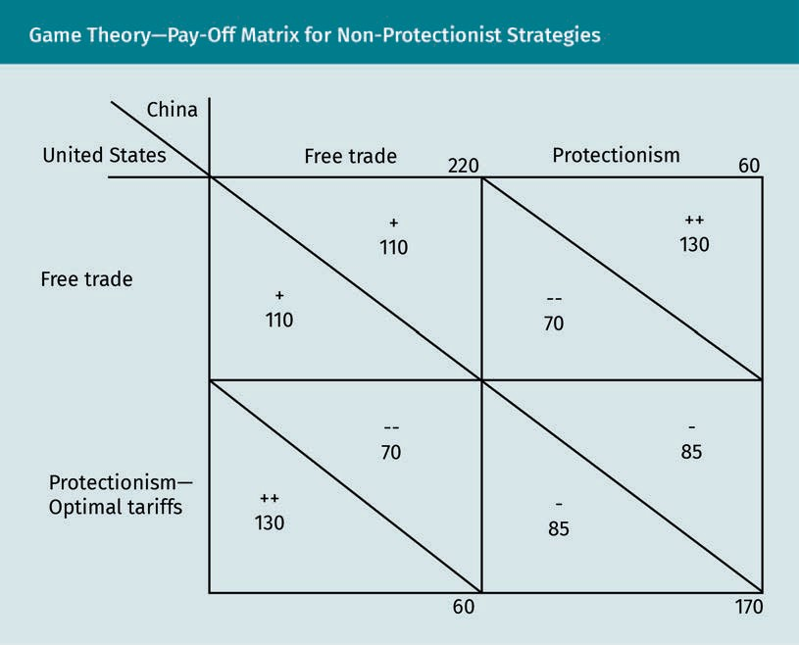

Summary
Classical international trade theories attempt to offer reasons as to why nations trade with each other. Thought on this subject has changed significantly from cen- tury to century. Mercantilism aimed to achieve current account surpluses by maxi- mizing exports while minimizing imports. The principle of absolute advantage sug- gests that each nation should specialize in the production of goods that it can produce most efficiently and then trade with other nations. The principle of compa- rative advantage states that the relative cost (and not the absolute cost) of produc- tion at which countries can produce goods forms the basis for international trade. Factor proportions theory (the Heckscher-Ohlin model) proposes that nations ought to export goods requiring production factors already in abundance. In other words, they should import those goods requiring production factors that they may be lacking. Technology gap theory claims that differences in technological develop- ment between countries determine trade currents. Finally, new trade theory posits that, rather than comparative advantage, increasing economies of scale provide the basis for international trade.

International Trade

Empirical data suggests that international trade has a positive impact on economic growth. Protectionist measures hamper this growth. Such measures include tariffs, quotas, non-tariff barriers, and subsidies. Protectionist policies are typically inten- ded to protect the domestic economy, e.g., to protect jobs. However, generally speaking, these measures have negative consequences for all countries involved. Game theory suggests that it only makes sense to adapt protectionist policies when it is either expected that the counterparty does not retaliate or when such meas- ures themselves are used as retaliation.

Knowledge Check
Did you understand this unit?

You can check your understanding by completing the questions for this unit on the learning platform.

Good luck!

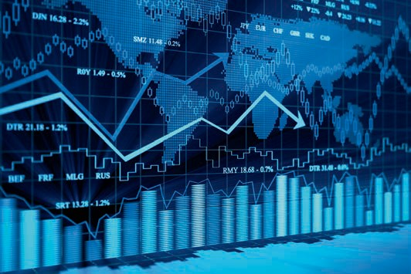

Unit 4
International Financial and Capital Markets

STUDY GOALS

On completion of this unit, you will be able to …

… understand financial markets and how companies can use them to their advantage.
… distinguish different exchange rate regimes.
… explain how companies operating internationally can manage exchange rate risk.

DL-E-DLMINTMAB01_E-U04

- International Financial and Capital Markets

Case Study

The chief executive officer (CEO) of Zibbit, a newly founded European online retailer selling eco-friendly furniture, joins the web conference with the company’s chief finan- cial officer (CFO) for their weekly update. This week, the CFO had a couple of important points to discuss. First, the company has achieved a monthly double digit growth rate. This is mainly thanks to its marketing efforts. However, because of high marketing costs, it is still operating at a monthly loss. If Zibbit wishes to continue its upward tra- jectory, it will soon need to raise additional capital to fund ongoing operations.

Second, the local currency of Maldonia, the country from which Zibbit imports most of its sustainable wood, has appreciated with around 15 percent against the euro. Essen- tially, the company’s imports have become significantly more expensive, which puts additional pressure on its earnings. The CEO realizes that these indeed are two highly relevant and urgent topics. Over the next hour, the two executives will discuss different options for Zibbit to find capital. They will also plan for having to contend with surging imports costs caused by fluctuating exchange rates.

  - Importance of International Financial and Capital Markets for Globally Active Companies
With the increased globalization in the twentieth century, financial markets have become more integrated. This unit will discuss what financial markets are, how they benefit companies operating internationally, and how they have recently developed.

Functions and Types of Financial and Capital Markets

A financial market is one where financial assets (e.g., stocks, bonds, currencies, and commodities) can be traded (Corporate Finance Institute, n.d.-c). Financial markets serve as an intermediary to facilitate the transfer of funds between buyers and sellers of these assets. Their key functions are outlined in the following list:

- They provide a mechanism for price determination, based on supply and demand for a financial asset. Transparent price information and high liquidity save resources needed to find buyers or sellers. They also reduce transaction costs.
- Financial markets provide access to capital for individuals, companies, and govern- ments. Whenever companies need cash, they can raise money from the stock mar- ket or bond market. The size of financial markets, as well as the high volume of activity, implies high liquidity, i.e., that sellers can dispose of their financial assets rather easily to convert them into cash.

International Financial and Capital Markets

- They provide businesses with possible ways to offset risk, in particular through derivatives. By using derivatives, companies can hedge financial risks (e.g., those rel- evant to commodity prices and foreign exchange rates).
- Financial markets offer a way to purchase alternative financial assets with higher potential returns than savings deposits. This is especially relevant in the current environment, with interest rates on retail savings deposits in the United States and Europe around or even below zero percent (Kowsmann, 2021).

Financial markets encompass different types of markets. The most relevant ones for companies are discussed below.

Equity capital markets
To raise cash, companies are active in capital markets, the most ubiquitous example being stock markets. These enable companies to raise funds, e.g., for expansion by sell- ing their shares to the public. Shareholders invest with the expectation of seeing higher share prices in the future. A share offering can take place through an initial pub- lic offering (IPO). In an IPO process, a private company sells part of its shares to the public through a listing on a stock exchange. IPOs are time-consuming and expensive for a company because they require a prospectus.

There are two principal ways for management to allow shareholders to participate in a company’s profits: dividends and share buybacks. Management could decide to pay out (part of) a company’s net earnings in dividends. In this scenario, each shareholder would be entitled to receive dividends relative to the numbers of shares held. A com- pany could also decide to use cash reserves for share buybacks. This means that a company buys back shares on the stock market, which are then cancelled or held as treasury shares. These can then be re-issued at a later date. Share buybacks can help boost a company’s share price to improve its financial ratios.

Financial ratios “measure the relationship between two or more components of finan- cial statements” (Business Development Bank of Canada, n.d.-b, para. 1) and are used to analyze a company’s financial health. Examples include liquidity ratios, such as the working capital ratio (i.e., current assets / current liabilities); and profitability ratios, such as the return on equity (i.e., net income / equity). Share buybacks reduce the number of outstanding shares, increase shareholder ownership, and, in turn, increase an investor’s earnings per share. Management may decide to buy back shares when it is believed the stock is undervalued by the market (Banton, n.d.).

The largest stock market exchanges by market capitalization of listed companies are the New York Stock Exchange (NYSE) and Nasdaq on Wall Street; the Japan Exchange Group; the Shanghai, Hong Kong, and Shenzhen stock exchanges in China; Euronext, which operates in several European cities (e.g., Amsterdam, London, Paris, and Milan); and the London Stock Exchange (Ali, 2020). The NYSE and Nasdaq exchanges represent almost half of the global stock market value—approximately USD 90 trillion (Ali, 2020).

Private company
A company is private when its shares are privately held, meaning it is not lis- ted on a public stock exchange.

Prospectus
A prospectus is a document for poten- tial investors that discloses material information on the company and the securities offered, including key risks.

Maturity date The maturity date is the specific date by which a debt must be fully repaid.

Credit rating A credit rating is a score representing a company’s credit worthiness based on any potential risk of
default.

Derivative This is a financial security that derives its value from an underlying asset or basket of assets.
Debt capital markets
Besides raising equity on the stock market, organizations can also raise debt capital in the debt capital market (i.e., bond market). Notably, organizations can raise debt capital on both. A bond is tradable financial asset under which the issuer (i.e., the debtor or borrower) owes a debt to the holder (i.e., the creditor or lender). Usually, the issuer is obliged to pay the bond holder periodic interest (the “coupon”) and to repay the “prin- cipal” (i.e., the nominal loan amount) by the maturity date. The coupon payment is a fixed percentage of the principal (O’Sullivan & Sheffrin, 2003). For example, a bond with a principal value of USD 100 has a 5 percent annual coupon rate, meaning that the bond holder will receive annual interest payments of USD 5.

Market prices of bonds fluctuate based on supply and demand. Let us assume there is high demand for bonds, leading to a bond price above principal value of, say, USD 110. If the coupon payment is USD 5, the bond’s current yield, i.e., the annual coupon pay- ments divided by the market value of the bond, has fallen to 4.55 percent (5 / 110). This compares to the coupon rate of the bond of 5 percent (5 / 100). In bond markets, there- fore, bond prices and yields are inversely related. Bond market prices are highly sensi- tive to inflation, which erodes the purchasing power of a bond’s future coupon pay- ments. To compensate for this, bond investors will demand a higher yield, which leads to lower bond prices (Nielsen, n.d.).

Bonds can be treasury bonds (issued by the government), municipal bonds, or corpo- rate bonds. Companies can raise debt financing by issuing corporate bonds, which can come with different maturities and investment grades. A corporate bond is a long-term debt security with a maturity of at least one year. Corporate debt securities with a short maturity are called commercial papers (Coyle, 2002). According to their credit rating, corporate bonds can be divided into investment grade (“high grade”) and non-invest- ment grade (“high yield”). In contrast to stocks, where investors have equity in the com- pany, bond holders are creditors to the company (i.e., they are lenders). Therefore, when a company goes bankrupt, its creditors (including bond holders) have priority over its owners. For this reason, bonds are perceived as less risky investments than stocks (Morah, n.d.). This risk further decreases when corporate bonds are secured, meaning that the bond issuer pledges certain assets (acting as collateral) for the loan. Corporate bonds can be either senior or subordinated, meaning they rank higher or lower, respectively, than other debt securities in the event of corporate bankruptcy.

Derivatives markets
These markets offer derivatives, which companies can use to manage financial risk. Common underlying assets include stocks, bonds, commodities, currencies, interest rates, and market indexes; common derivatives include forwards, futures, options, and swaps (Chen, n.d.-a).

Commodity markets
Commodity markets include physical and derivatives trading of natural resources, such as oils, metals, sugar, cocoa, livestock, dairy, and grains. Most commodities are traded on the futures market, on which companies buy derivatives to hedge price risks of commodities. In essence, by using future contracts, companies can lock in a price for a future delivery of a commodity. This enabled farmers, who started using this type of

International Financial and Capital Markets

derivative in the 1840s in Chicago, to protect their revenue from falling any market pri- ces (Cronon, 1991). Buyers, in contrast, were protected against potential market price surges. The largest commodity exchange today is the Chicago Mercantile Exchange in the United States.

Foreign exchange markets
Foreign exchange markets provide the possibility to buy and sell currencies of different countries. The daily trading volume of currencies converts to roughly USD 7 trillion (of which nearly 90 percent reflects the U.S. dollar alone) (Bank for International Settle- ments, n.d.-b). Three days of trade correspond to the United States gross domestic product (GDP) of USD 21 trillion (International Monetary Fund, 2021). A large part of trade is conducted by commercial banks on behalf of their corporate customers. By using foreign exchange derivatives, companies operating internationally can manage the volatility of foreign currency exposure. Hedge funds, which trade currencies both to hedge their investment positions and to speculate, constitute another important player on the foreign exchange markets (Bank for International Settlements, n.d.-a).

Cryptocurrency market
A cryptocurrency is a digital asset for which all ownership and transactional records are stored in an encrypted, decentralized ledger (Greenberg, 2011). The size of the global cryptocurrency market (around USD 1—2 trillion) is still relatively small compared to the world’s broad money supply (around USD 100 trillion), which includes all coins, bank- notes, and deposits (Desjardins, 2020). Nevertheless, cryptocurrency has already exhibi- ted high growth rates, both in its adoption as a payment method and its market size (Kharpal, 2021). Companies are increasingly accepting cryptocurrencies as an online payment method (Wadhwahni & Loomba, 2021). Some companies, such as Tesla, are even starting to hold cryptocurrencies on their balance sheet in a move away from fiat currencies (Bursztynsky, 2021). Although originally designed as an alternative currency and payment method, cryptocurrency currently seems to serve mainly speculative pur- poses (S&P Global, 2021).

Participants in Financial and Capital Markets

The financial and capital markets house a multitude of participants. This section briefly discusses a few key players, namely international firms, commercial banks, and central banks. It also highlights the various capital flows between these participants.

International firms
Firms operating internationally participate in the financial and capital markets in two major ways: First, they obtain foreign exchange, which typically is converted to local currency, by engaging in international trade and selling products abroad. Second, firms raise financing from equity and bond markets or commercial banks to finance organic expansion plans, acquisitions, or working capital. They may also use the derivatives or commodities market to access other financial products (e.g., financial hedges) (Cavusgil et al., 2014).

Fiat currency
A fiat currency is one issued by the gov- ernment without intrinsic value that derives its value from supply and demand and the sta- bility of the issuing government (e.g., the dollar).

IOU
An IOU is a docu- ment acknowledging debt; the term is an abbreviation of (and play on) the phrase
“I Owe You.”

Interbank market An interbank market is one in which banks provide short- term loans to each other, typically with a maturity of less than a week.
Commercial banks
From a corporate perspective, the key functions of commercial banks are providing loans and facilitating the exchange of foreign currencies (Cavusgil et al., 2014). Notably, aside from acting as an intermediary lender, banks “create” money. This happens every time a bank provides a loan to a customer by making an accounting entry. The loan amount is booked as a customer liability or IOU in the form of an electronic bank deposit, which effectively increases the total money supply circulating in an economy (Bundesbank, 2017). Today, electronic bank deposits make up over 95 percent of the money supply, while less than five percent is physical cash (Desjardins, 2020). Banks obtain funding by raising saving deposits from individual customers, by borrowing in the interbank market, and by issuing securities in the capital markets. When a com- mercial bank experiences financial difficulty, or is nearing bankruptcy, it can borrow loans from the country’s central bank. After the global financial crisis of 2007—2008, banks faced increased national and international regulation (Calmes, 2008). National laws, such as the United States Dodd-Frank Act (Baily et al., 2017) and the global Basel III regulatory framework (Basel Committee, 2010) were intended to strengthen the financial sector. Key focus points of these regulations include higher minimum capital requirements and lower leverage, which, in essence, means that banks need to increase their ratio of equity versus debt (Mackenzie, 2012).

Commercial banks can be owned privately or by the state. Germany, for example, has a banking system based on three pillars: the first consists of around 200 private banks (including Deutsche Bank); the second comprises around 400 public savings banks (including local Sparkassen); the third pillar consists of around 1,100 cooperative credit unions (e.g., Raiffeisenbanken and DZ-Bank). These credit unions were formed in the nineteenth century when Wilhelm Raiffeisen founded cooperatives to help farmers that were facing bad harvests and poverty. Instead of focusing on profit for third-party shareholders, the credit unions are owned by the customers (i.e., members). The goal here is to maximize value for this stakeholder group. One way of ensuring this is to employ a cross-guarantee system that protects savers when one of the members goes bankrupt (Cermak, 2017). Today, the largest banking centers include New York, London, Shanghai, Hong Kong, Singapore, Tokyo, and Frankfurt (Long Finance, 2016).

Central banks
A central bank is a country’s monetary authority that oversees the national financial and banking system. It acts as a “lender of last resort” to national commercial banks when they face severe financial problems (Cavusgil et al., 2014). The Bank for Interna- tional Settlements (BIS) is an international financial institution that fosters cooperation between central banks and acts a “bank for central banks” (BIS, n.d.-a). Major central banks include the United States Federal Reserve (known as “the Fed”) and the Euro- pean Central Bank (ECB).

The main objectives of a central bank include maintaining price stability, promoting high employment, and fostering economic growth. It aims to achieve these objectives by regulating the money supply and managing exchange rates (Cavusgil et al., 2014). In most developed countries, central banks are kept independent from the government to prevent political interference. Research shows that central bank independence leads to lower inflation rates (Dall’Orto Mas et al., 2020). The Phillips curve, named after the

International Financial and Capital Markets

economist from New Zealand, suggests that the short-run relationship between infla- tion and unemployment is inverse (Phillips, 1958). This means that unemployment decreases when inflation increases (and vice-versa). Central banks, therefore, face a trade-off in their short-term monetary policies. Nevertheless, inflation and unemploy- ment are unrelated in the long run (Modigliani & Papademos, 1975). The Fed and the ECB have a current inflation target of around 2 percent (Martínez-García et al., 2021).

To achieve its goals, a central bank can employ several monetary policy instruments. The key instrument to regulate the money supply is to buy and sell government bonds (i.e., open market operations) (Federal Reserve, 2021). A central bank purchases a gov- ernment bond from a commercial bank by digitally crediting their account. The pur- chase of this bond injects new money into the financial system, which increases the money supply in an economy. In turn, the commercial banks loan out these balances to the broader economy. Because interest rates essentially reflect the price of money, they fall when central banks increase money supply through bond purchases.

A second instrument is to increase or decrease the interest rate that a central bank charges for loans to commercial banks. With lower interest rates, the demand for cen- tral bank loans from commercial banks will increase. This liquidity will lead to more credit being made available to the broader economy, thus increasing the money supply. A third policy tool is to change the reserve requirements for banks. When the central bank lowers reserve requirements, commercial banks have additional leeway to increase loans to customers, thus creating credit. Part of the commercial bank reserves must be deposited at an account of the central bank. Some central banks pay interest on these bank deposits. In the current negative interest environment, commercial banks need to pay for their deposits at the central bank. As a result, some banks are now charging negative rates for their retail customers (Kowsmann, 2021).

Monetary intervention refers to the central bank’s manipulation of a country’s currency rate vis-à-vis other currencies (Cavusgil et al., 2014). By buying and selling currencies in the foreign exchange market, central banks can support their national currency. For example, when the Fed buys dollars on the foreign exchange market using euros, it takes dollars out of circulation. This decrease in the supply of dollar leads an apprecia- tion in its value.

In addition to the three principal players mentioned in this unit, national governments also raise debt financing to cover their budgetary expenses by issuing government bonds on the market. Furthermore, institutional investors, such as pension funds and insurance companies, play a key role in both the equity and bond markets (Cavusgil et al., 2014).

Reserve require- ments
A reserve require- ment is a threshold set by the central bank that requires commercial banks to hold a minimum amount of cash as a percentage of deposits.

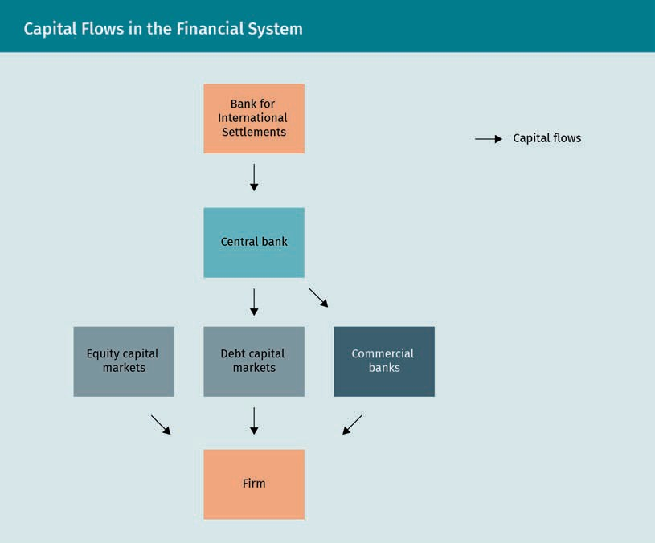

Recent Developments in Financial and Capital Markets

The 2008 global financial crisis led to the Great Recession, the worst of its kind since the Great Depression in the 1930s (Pendery, 2009). It led to increases in unemployment (Center on Budget and Policy Priorities, 2019) and ultimately to a debt crisis of certain European governments, such as Greece and Portugal (Feaster et al., 2011). In response, governments and central banks, including the Fed and the ECB, encouraged lending through lower interest rates to prevent deflation and expanded fiscal and monetary policies to bail out struggling banks (Sakelaris, 2014). In other words, central banks attempted to stop a further collapse and to stabilize financial markets and the global economy by increasing the money supply.

Federal funds rate This term defines the overnight inter- bank lending rate.
In 2008, the Fed lowered the federal funds rate very quickly to almost zero, as shown in the following figure (New York Fed, n.d.). With little leverage to further lower the interest rates, the Fed started using more unconventional methods to fight the recession. From November of that same year to November 2014, the Fed engaged in three rounds of quantitative easing, which increased the money supply and kept interest rates near zero (Appelbaum, 2014). Apart from buying government bonds, the Fed bought various

International Financial and Capital Markets

asset classes through open market operations at a large scale, such as corporate bonds and mortgage-backed securities (Federal Reserve, 2008). Central banks around the world, including the ECB, implemented similar programs (Duncan, 2009).
Quantitative easing This is a “monetary policy whereby a central bank purcha- ses government bonds or other financial assets at large scale […] to inject money into the economy to expand economic activity” (Cermáková & Filho, 2021, p. 3—4).

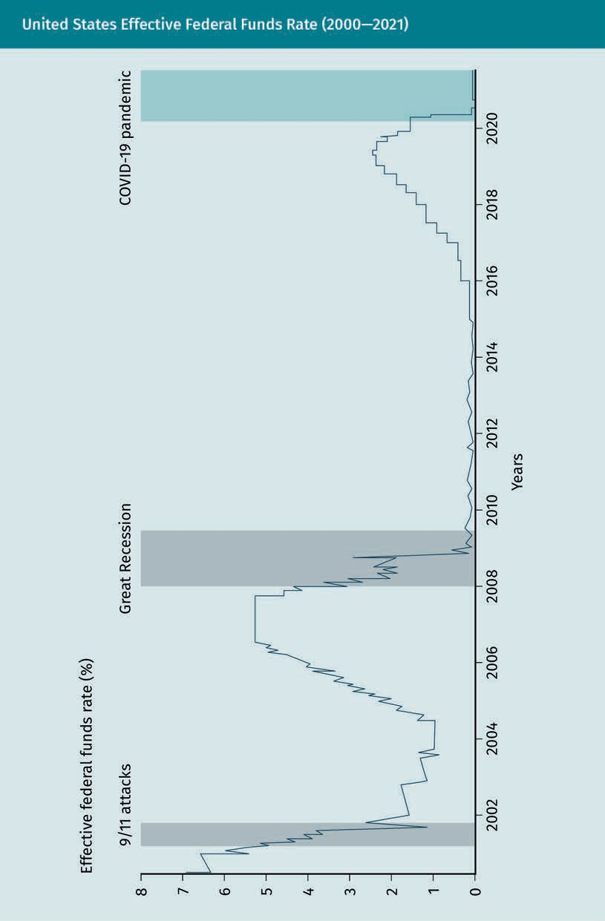

International Financial and Capital Markets

In response to the COVID-19 crisis, the Fed and the ECB cut interest rates to zero and implemented even more robust quantitative easing programs (Liesman, 2020; European Central Bank, n.d.). Throughout 2020 and 2021, these central banks have spent trillions of dollars to buy assets, as shown in the following figure.

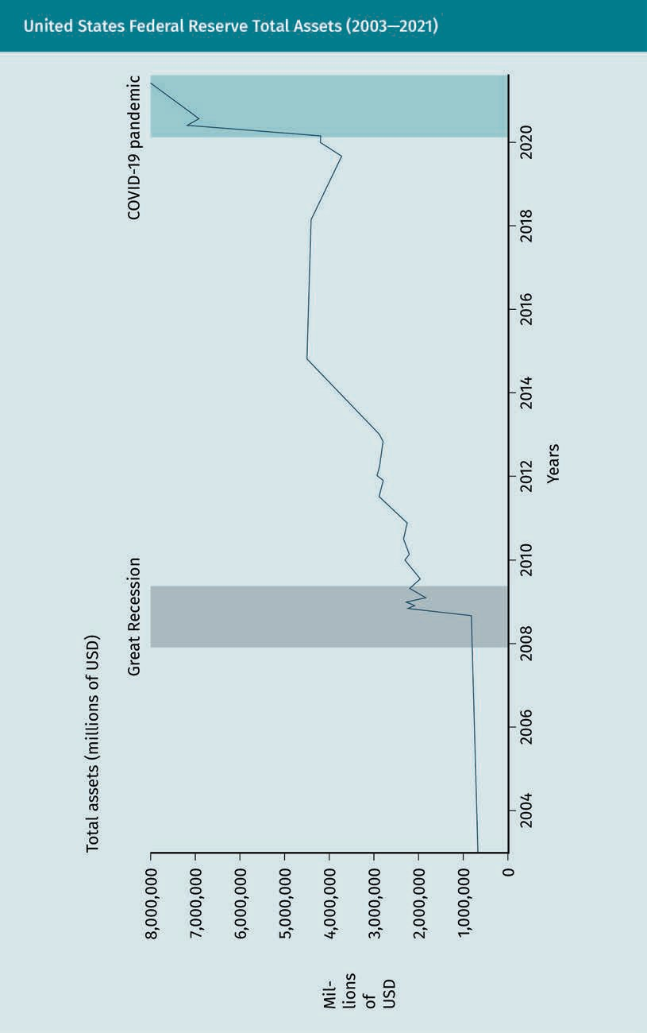

International Financial and Capital Markets

The increase in money supply created by the central banks over the last few years has reached historic proportions. This surge in money supply, coupled with extensive fiscal stimulus planned by the Biden administration, led various economists to warn of potential inflationary pressures (Cox, 2021). Inflation, according to monetarist theory, is determined by the money supply and money velocity (Kenton, n.d.).

The Consumer Price Index (CPI) measures “the average change in prices over time that consumers pay for a basket of goods and services” (Fernando & Westfall, n.d., para. 3). The basket includes, e.g., food, medical care, and transportation. Because the CPI tries to reflect changes in the cost of living, it is the most common measure of inflation (Fer- nando & Westfall, n.d.).

By the end of 2020, inflation had been limited due to a sharp decrease in money veloc- ity caused by the COVID-19 lockdowns (Demertzis & Dominguez-Jimenez, 2020). Never- theless, with the American economy slowly reopening and money velocity rising some economists expect increased inflation throughout 2021 (Cox, 2021). In the first half of the year, certain commodities, such as lumber, copper, and sugar, have already wit- nessed significant price increases. Lumber, for example, increased around 260 percent between June 1, 2020 and June 1, 2021 (Nasdaq, 2021), leading to further upward pres- sure on housing prices in the United States (Egan, 2021). Furthermore, the increased money supply has weakened the U.S. dollar. The DXY, a measure of the U.S. dollar rela- tive to a basket of foreign currencies, has fallen around 7 percent between June 1, 2020 and June 1, 2021 (MarketWatch, n.d.). The figure below shows the development of the money supply in the United States, measured as M2, relative to inflation, measured by the CPI.

Money velocity This is a measure- ment of the rate at which money changes hands in a
given period of time. It is calculated as nominal GDP over money supply.

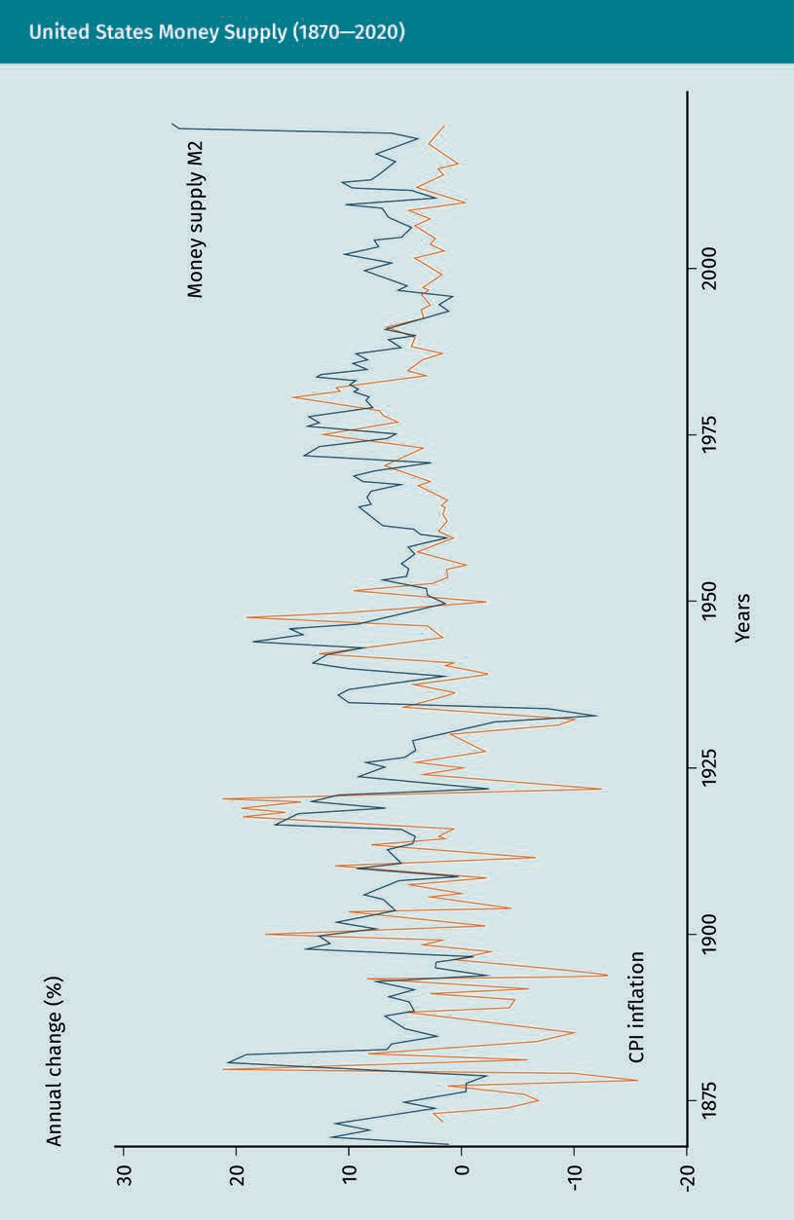

International Financial and Capital Markets

Central banks typically measure the money supply using different tiers, the definitions of which may vary. The Fed uses threetiers, namely M0 to M2. M0 includes the most liq- uids assets. The further along the tiers we go, the less liquid the assets are (i.e., M2 includes the least liquid assets). The table below shows how the Fed defines each tier. M2 is the money supply indicator most widely used by observers for analysis and by the Fed for monetary policy (Investopedia, n.d.-b).

Definition of Money Supply by the Fed—M0 to M2
Tier | Definition | Value (in USD trillions) as of May 2021
M0 | Physical currencies: bills and coins | USD 6.0 trillion
M1 | M0 + demand deposits, traveler’s checks, and other checkable deposits | USD 19.2 trillion
M2 | M1 + savings deposits, money market securities, mutual funds, and other time deposits | USD 20.4 trillion

  - International Exchange Rate Regimes
Companies operating internationally can face different foreign exchange rate regimes. Countries can have a fixed exchange rate, a floating exchange rate, or a managed float. The institutional arrangements that nations adopt to govern exchange rates are refer- red to as the international monetary system (Hill, 2015).

Fixed Exchange Rate Regimes

Under a fixed exchange rate regime, a country’s central bank pegs the value of its cur- rency to the value of another currency, to a basket of currencies, or to another value such as gold (Cavusgil et al., 2014).

Let us assume that the United States pegs the dollar (USD) to the Japanese yen (JPY). The figures seen below show the equilibrium at a fixed exchange rate of USD per JPY (P), where the demand of yen (D₁) meets the supply of yen (S₁) at Q₁. If, for some rea- son, the demand for yens significantly rises, the demand curve will shift to D₂, as shown in the diagram on the left. Because demand for yen is now Q₂ and supply is Q₁,

a situation of excess yen demand has been created. In order to keep the fixed exchange rate and meet the excess demand, the Fed now needs to supply additional yen. The Fed does so by selling yen (which diminishes its foreign currency reserves) and buying dollars. This leads to a shift in the supply curve from S₁ to S₂. The demand and supply curves (D₂ and S₂) again meet at the fixed exchange rate P, now at Q₂.

If, by comparison, the demand for yen significantly falls, the demand curve moves down from D₁ to D₂, as shown in the diagram on the right. Because demand for yen is now Q₂ and supply is Q₁, a situation of excess yen supply is created. In order to keep the fixed exchange rate and to counter the excess supply, the Fed now buys yens by selling dollars. This leads to a shift of D₂ back to the original D₁ curve with the fixed exchange rate P at Q₁.

Many developing countries, and some emerging markets, use a fixed exchange rate regime (Cavusgil et al., 2014). Aruba and Bermuda, for example, have pegged their cur- rencies to the U.S. dollar because most of their income comes from tourism paid in dollars. This essentially means that the exchange rate risk is shifted from domestic companies to the central bank, which uses its foreign currency reserves. This allows a smoother running of the economy. Many African countries peg their currencies to the euro (Zucchi, n.d.).

International Financial and Capital Markets

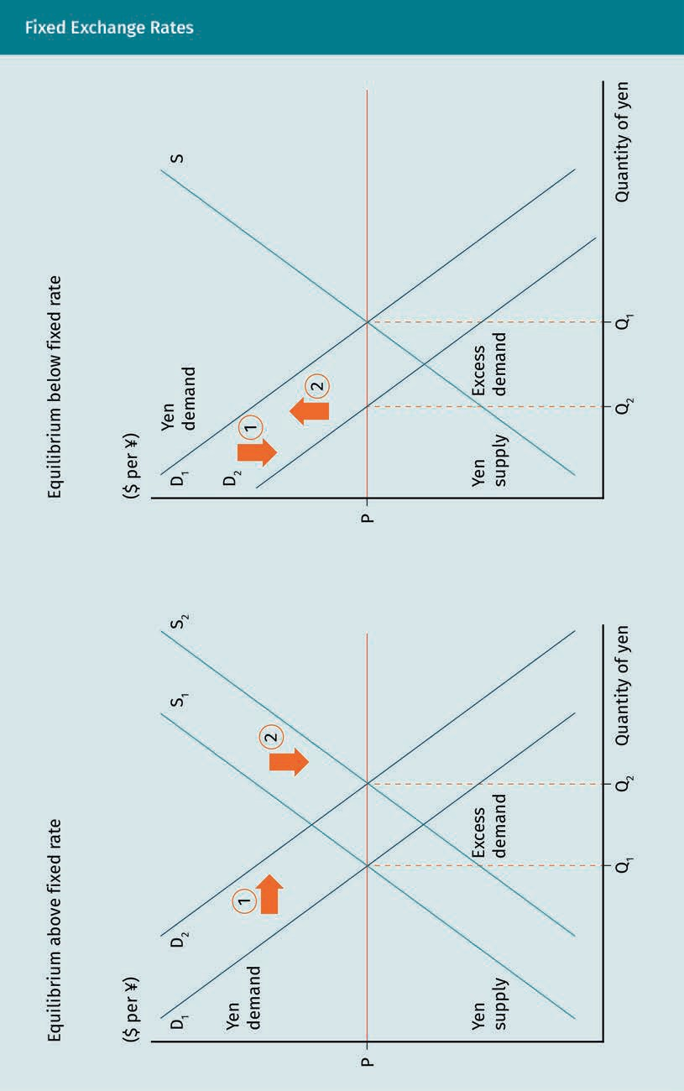

Floating Exchange Rate Regimes

Under a floating exchange rate regime, employed by most developed nations, a coun- try’s currency floats freely against the value of other currencies based on market forces of supply and demand (Cavusgil et al., 2014). The following figure provides an example, again using USD and JPY as a currency pair. The demand for yens depends on three main factor. First, it depends on the level of exports from Japan. Foreign companies buying goods and services from Japan need to pay in JPY, which they obtain by selling their own currency. Second, the demand for JPY depends on foreign direct investments. For example, companies investing in Japan, e.g., to build a factory, will need JPY. Third, investors may buy JPY purely for speculative purposes. The supply of JPY, conversely, depends on the level of Japanese imports, the investment outflows from Japan, and speculation.

We now assume both countries have free currency floats. Supply and demand of JPY find an equilibrium price at P₁ (e.g., $0.01 per 1¥) and Q₁. We further assume that Japa- nese exports to the United States have risen significantly. This leads to an increase in demand for JPY, as American importers need to pay for their imports in that currency. This will shift the demand curve from D₁ to D₂, as shown in the diagram on the left. The result is an appreciation of the yen to P₂ (say, $0.02 per ¥) at Q₂. Conversely, a rise in Japanese imports from the United States would lead to an increase in the supply of JPY. Importers would sell JPY in order to pay for the American imports in dollars. This would shift the supply curve from S₁ to S₂, as shown in the diagram on the right, leading to a depreciation of JPY to P₂ (say, $0.005 per ¥) at Q₂.

International Financial and Capital Markets

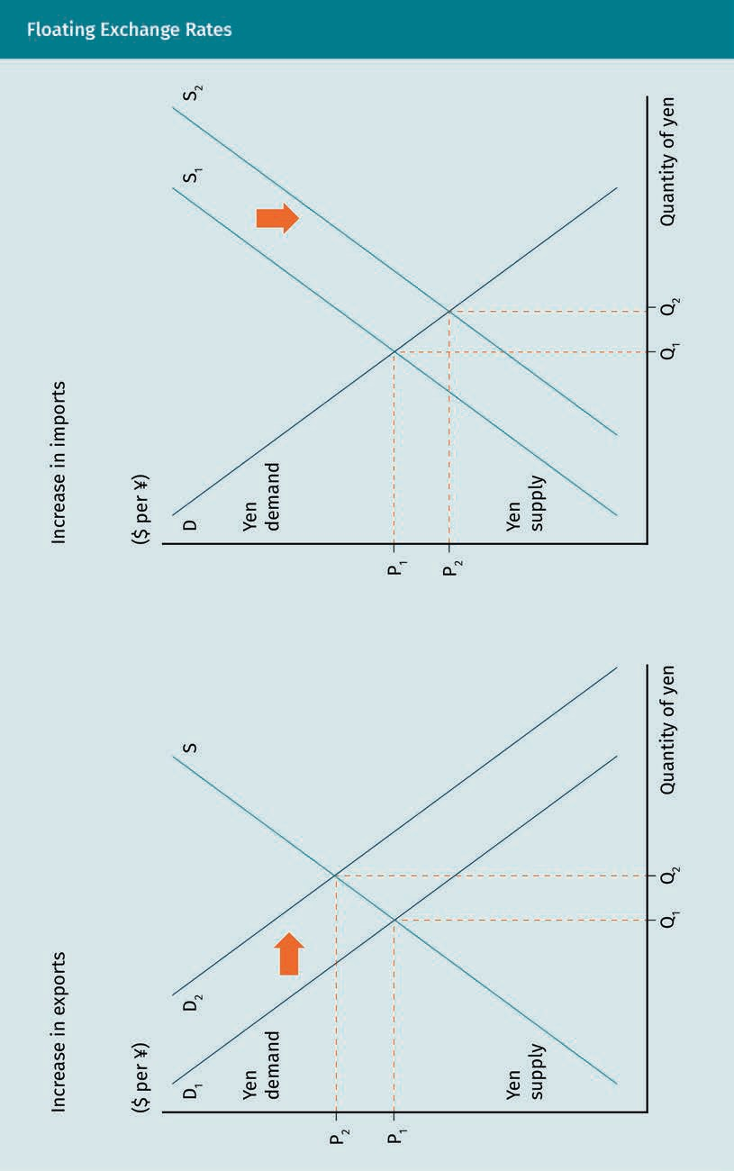

Advantages and disadvantages of fixed and floating exchange rate regimes
According to Cavusgil et al. (2014), most economists prefer floating exchange rates. Nev- ertheless, a fixed exchange rate regime also has advantages. First, a fixed exchange rate increases economic certainty and eliminates exchange rate risk. For example, because Germany is the largest trading partner of The Netherlands, the Dutch central bank had pegged the Dutch guilder to the German Deutsche Mark (the two national currencies before the introduction of the Euro in the 2000s) (Watson et al., 1999). A second advant- age is the absence of foreign exchange speculation, which could have destabilizing effects. Furthermore, a fixed exchange rate sets limits on irresponsible monetary or fis- cal policy by the central bank and government. In order to maintain the peg, it is not possible to unlimitedly increase the money supply. This prevents high inflation.

Trade deficit A trade deficit is a negative balance of trade. In other words, imports are larger than exports.

Currency band A currency band is a range with both an upper and lower limit in which the value of a currency is allowed to move against another cur-
rency, often expressed as a per- centage of a target exchange rate.
However, this knife cuts both ways. With fixed exchange rates, governments have little flexibility when drafting their monetary and fiscal policies. Neither stimulating inflation in deflationary times nor promoting exports through currency depreciation is possible. Another main criticism of fixed exchange rates is the lack of automatic rebalancing when a trade deficit occurs (Suranovic, 2010). Under floating exchange rates, a trade deficit implies increased demand for the foreign currency, leading to a depreciation of the domestic currency against it. As a result, importing foreign products becomes less attractive and reduces the trade deficit. Fixed exchange rates do not support this auto- matic rebalancing. Furthermore, fixed exchange rates can lead to currency crises. In order to maintain a peg, a country needs considerable amounts of foreign reserves. There is a possibility that these foreign reserves run out when their demand exceeds supply. When a country runs out of foreign reserves (and thus, cannot further sell any), it needs to devalue its currency to maintain the peg. This one-off, forced devaluation will be more extreme than the daily fluctuations of flexible exchange rates.

Managed Float Regimes

Under a managed float regime, a country has flexible exchange rates and the country’s central bank tries to stay within a certain range (currency band). Under this regime, exchange rates are primarily determined by market forces. By buying and selling cur- rencies, the central bank intervenes and manipulates exchange rates to prevent extreme fluctuation. China uses a managed float of the renminbi to prevent its currency from appreciating too strongly against the dollar (Mitchell & Liu, 2019). A strong domes- tic currency would have negative impacts for Chinese exports. China links the value of the renminbi to a basket of currencies, which includes the dollar and the euro. It allows the renminbi to trade within a narrow currency band of two percent, i.e., it is allowed to move two percent in either direction against this basket on a daily basis (Reuters, 2021). In practice, many countries’ central banks engage in exchange rate manipulation to var- ious extents (Nikkei Asia, 2014).

International Financial and Capital Markets

  - Hedging of Exchange Rate Risks

Companies with international activities (e.g., importing, exporting, production abroad, and international franchising) are exposed to exchange rate risks. We can illustrate cor- porate exchange rate risk with an example: An American importer orders 100 pairs of sport shoes from Germany. According to the sales contract, the importer has to pay EUR 2,000. At the time the importer placed the order, the exchange rate is USD 1.20 per EUR, i.e., the shoes cost USD 2,400 (EUR 2,000 · USD 1.20 per EUR). Upon the shipment’s arrival in the United States two month later, the payment is due. The exchange rate is now at USD 1.40 per euro, i.e., the euro has appreciated, and the dollar has depreciated. The American importer now has to pay USD 2,800 (EUR 2,000 · USD 1.40 per EUR).

Imagine the importer has long-term contracts with local retailers that purchase the shoes for USD 26.40 per pair. Rather than making an expected profit of USD 240 on the order, the importer now incurs a loss of USD 160 (USD 1.60 per pair) due to the appreci- ation of the euro. This example highlights the currency risk inherent to international activities. Fortunately, companies have several possibilities to insure against currency risks.

Hedges against Exchange Rate Risks

Derivatives markets offer companies different ways to hedge, i.e., insure against exchange rate risks. Although hedges take away currency risk, they still come at a cost (Investopedia, n.d.-a). This section focuses on the effect of hedging and not the calcula- tion of the hedging price. We will discuss the two most common hedges for exchange rate risks: forwards and options.

Forward contracts
A foreign exchange forward contract is “a contractual agreement between two parties to exchange a pair of currencies at a specific time in the future” (Chen, n.d.-b, para. 2) and “at a price agreed on now, known as the forward rate” (Clear Currency, n.d., para. 1). In other words, two parties can advancedly set the price for an exchange rate transaction in the future. For most currency pairs, forward exchange rates can be obtained for up to a maximum of 12 months (Chen, n.d.-b). Forward contracts are the most prevalent deriv- ative used in corporate foreign exchange risk management. They are widely available and typically do not require an upfront premium payment to the facilitating party for entrance (FX Initiative, 2017). Usually, a forward contract is provided by a bank to a com- pany to hedge a foreign exchange rate risk.

The figure below illustrates how forward contracts work. Let us return to the example of the American shoe importer, who wants to hedge the risk of dollar depreciation for the two months between order placement and payment. Before ordering the shoes, the importer closes a forward contract with a bank, for which the importer has to pay a small fee. In this forward contract, it is agreed that the current exchange rate, namely USD 1.20 per EUR, will be the forward exchange rate between the two parties in two months’ time. The importer agreed to buy EUR 2,000 at a price of USD 2,400 at the time

Franchising
In this model, the owner of a business (i.e., franchisor) licenses the busi- ness infrastructure (e.g., the brand, busi- ness model, and processes) to a fran- chisee for a fee.

Hedging
To hedge is to use financial instru- ments to offset the risk of a potential adverse price move- ment.

of payment. If the spot price of USD per EUR at the time of payment (i.e., two months later) is exactly 1.20 (the same as the forward exchange rate), the forward contract leads to neither a financial gain nor loss for the importer.

Now let us imagine that the spot price of USD per EUR at the time of payment is USD
1.40 per EUR. Without a forward contract in place, the importer would have incurred a loss due to the depreciation of the dollar. Instead, the importer now pays the USD 1.20 per EUR. This means the financial gain of the forward contract is USD 0.20 per EUR, or
16.7 percent (0.20/1.20). Now imagine that the spot price at the time of payment is USD
1.00 per EUR. Although the importer could have bought euros at only 1 USD per EUR on the spot market, the importer is now obliged to pay 1.20 USD. The loss resulting from the forward contract is, therefore, —0.20 USD per EUR, or —16.7 percent (—0.20/1.20). Any gains or losses from a forward contract are settled financially with the provider by the maturity date. The importer in this example never physically received the EUR 2,000; these were paid by the bank to the German exporter.
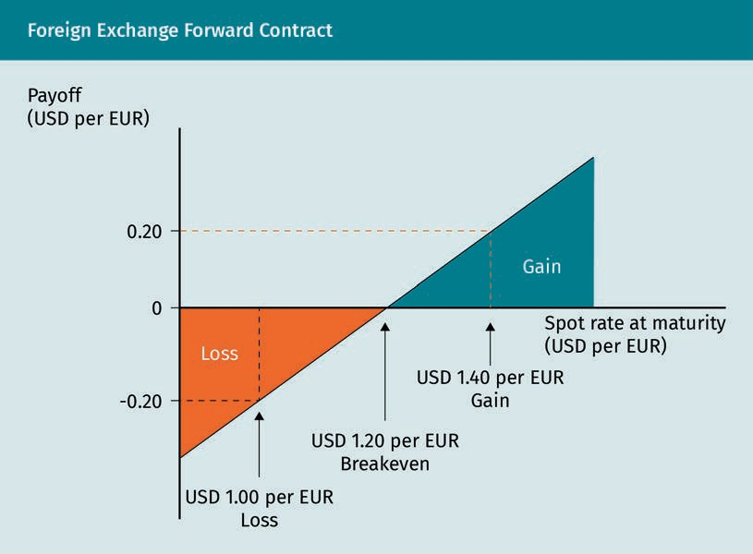

A future contract has the same functionality as a forward contract and differs only in a few formal aspects. A forward contract is a private and customized agreement that set- tles at the maturity of the contract. A future contract, by comparison, is standardized and traded on a futures exchange. Prices settle daily until the contract matures (Phung, n.d.).

International Financial and Capital Markets

Option contracts
An alternative hedging tool is offered by option contracts. An option is the right to buy or sell an underlying security for a specified period at a specified price. A call option is the right to buy an underlying security; a put option is the right to sell. These options may be European style (i.e., the option can only be exercised at exercise date) or Ameri- can style (i.e., the option can be exercised at any date until maturity) (Corporate Finance Institute, n.d.-a).

The figure below illustrates how call and put option contracts work. Again, we can return to the example of the American shoe importer who wants to hedge the risk of dollar depreciation for the two-month period. Instead of closing a forward contract, the importer closes a call option contract with a bank before ordering the shoes. The option price depends on the exercise price of the underlying security, its volatility, and the expiration (i.e., maturity) period. We assume the importer wants to buy a call option for two months with an exercise price of USD 1.20 per EUR (i.e., equal to the current spot price). This means the importer has the right to buy euros at a price of USD 1.20 per EUR on the expiration date (European option) or before the expiration date (Ameri- can option), irrespective of the spot price. We further assume that the bank charges USD 0.05 per EUR for the call option. This is an upfront premium that the importer needs to pay. Therefore, the USD per EUR price needs to fall at least to USD 1.25 per EUR for the importer to break even with the call option, as shown in the following figure. When the dollar depreciates further, the option contract starts paying off: The advant- age of this contract is that the maximum loss is USD 0.05 per EUR (the premium cost) while the gain is theoretically unlimited. Buying a put option with the right to sell USD would result in the same figure and payoff profile as buying a call option with the right to buy EUR.

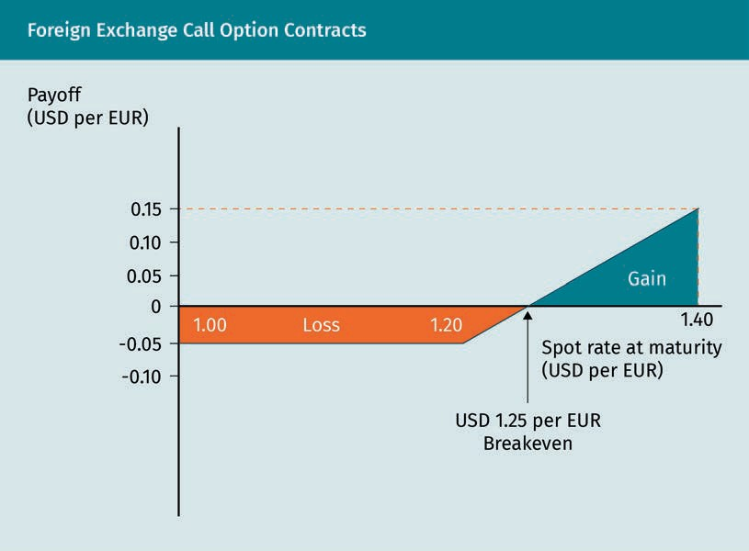

In the example so far, we have assumed that the importer had the exchange rate risk because the importer had to pay in EUR. Let us now reverse this assumption by saying the German shoe exporter carries the exchange rate risk (i.e., the payment is due in USD instead of EUR). At the order date, the transaction value is EUR 2,000 · 1.20 USD per EUR = USD 2,400. If the EUR depreciates during the two-month period between the order and the payment, the exporter will receive fewer USD. For example, if the exchange rate changes to USD 1.10 per EUR, the exporter now receives EUR 2,000 · 1.10 USD per EUR = USD 2,200. The exporter loses USD 200, or 8.3 percent (200/2,400) purely due to the fluctuation in exchange rate. Therefore, the exporter closes a put option contract with a commercial bank and buys a put option with the right to sell EUR for a rate at USD 1.20 per EUR on the expiration date (European option) or before the expiration date (American option). Let us assume that the put option costs the Ger- man exporter USD 0.05 per EUR. The put option starts paying off financially if there is an appreciation above USD 1.15 per EUR. For example, if the USD per EUR exchange rate is 1.00 at the time of payment, the German exporter gains 0.15 USD per EUR with the put option. In case the EUR appreciates (and the USD depreciates), the maximum loss for the exporter resulting from the put option contract is the option premium of USD 0.05 per EUR.

International Financial and Capital Markets

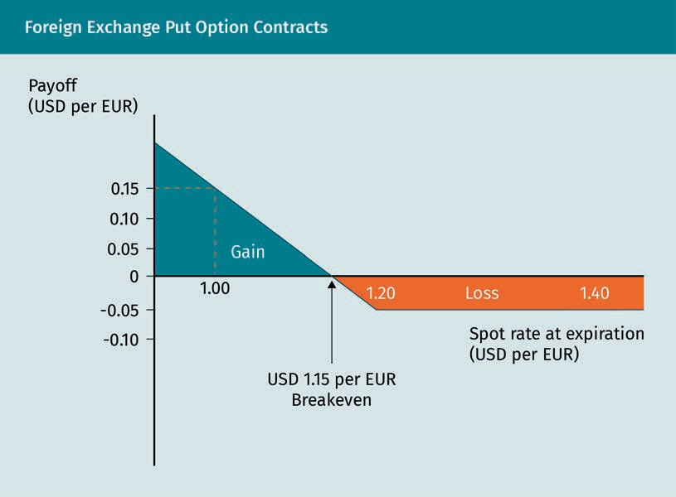

Summary
Companies with international activities are exposed to foreign exchange rate risks. These companies can use financial derivatives to hedge currency risks. The two most common hedges for currency risks are forward and option contracts. A foreign exchange forward contract is an agreement between two parties for the dual exchange of currencies for a period of time in the future. The price is agreed upon in advance (the forward rate). No upfront premium is paid for a forward contract. A foreign exchange option is the right to buy or sell a currency for a specified period at a specified price. The right to buy a currency is a call option; the right to sell a currency is called a put option. Although a premium is paid for entering into an option contract, the resultant loss from the option contract is maximized to this premium. The option holder profits once the exchange rate moves passed the breakeven threshold. In practice, importers and exporters frequently use forwards and options to hedge currency risks.

Knowledge Check
Did you understand this unit?

You can check your understanding by completing the questions for this unit on the learning platform.

Good luck!
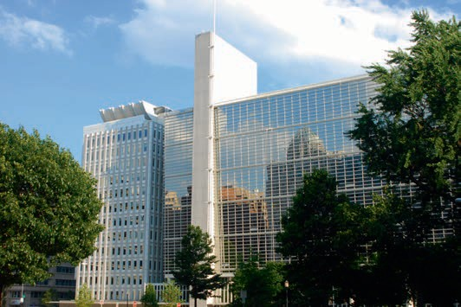

Unit 5
International Organizations and Economic Integration

STUDY GOALS

On completion of this unit, you will be able to …

… explain the roles of international organizations in the global economy.
… detail how regional economic integration can promote economic growth.
… describe the different stages of regional economic integration and the key characteristics of the largest trade blocs.

DL-E-DLMINTMAB01_E-U05

- International Organizations and Economic Integration

Case Study

The chief strategy officer (CSO) and the chief executive officer (CEO) of LiOn sit together in a café in Buenos Aires, Argentina. LiOn is a small, quickly growing producer of the rechargeable lithium-ion batteries used in electric vehicles and personal electronics. As part of its growth trajectory, LiOn is planning to internationalize. The inputs for its final product are already sourced globally. Nevertheless, the CEO would like to access international sales markets and is also contemplating using production facilities abroad.

The pair discusses which countries LiOn could enter for their sales and production. They first need to agree on a list of criteria that are most relevant for making this deci- sion. The CSO recommends that they start with international sales and believes LiOn should focus on potential market size, competitive position, the regulatory framework, political risk, and prior experience in foreign markets. Taking into account these factors, the CSO mentions that LiOn would likely find the best opportunities in China, India, and Brazil. The countries for a second wave would then include Germany, which, although stable and well developed, has a medium-sized market and low growth rates.

In general, the CEO agrees with one caveat. When considering market sizes, the CEO believes they should look at both single countries and whole economic blocs. Germany, for example, is part of the European Union (EU), which has free movement of goods and capital. In other words, entering Germany would mean entering Europe. The CSO and the CEO both agree to compare the potential market size of economic blocs.

  - International Organizations as the Basis of the World Economy (WTO, IMF, and World Bank)
In 1944, the leaders of the allied nations came together to create a new framework for regulating the international monetary and financial order after their victory in World War II. The ideal behind the Bretton Woods conference was free trade between nations and global economic integration. A key element in achieving this ideal was to establish international organizations that would govern the international economic system. This section discusses the most relevant international organizations.

World Trade Organization

During the Great Depression of the 1930s, countries around the world implemented trade barriers (mainly import tariffs) to protect their own industries and fight unem- ployment. This resulted in a deeper economic depression before World War II. With the Great Depression fresh in its memory, the United States, as victor of the war and an

International Organizations and Economic Integration

economically dominant nation, set the agenda for free trade. The General Agreement on Tariff and Trade (GATT) was created in 1947 under American leadership and was signed by 19 allied nations. The goal of the GATT was to liberalize international trade by eliminating trade barriers, including tariffs, quotas, and subsidies. Because this goal required extensive negotiation and mutual trust, its direct achievement would have been impossible. Therefore, trade barriers were eliminated gradually over different “rounds” of negotiation. The GATT was highly successful in its early years: between the Geneva Round of 1947 and the Tokyo Round taking place in the 1970s, the average tariff fell by almost 92 percent (Hill, 2015).

According to Hill (2015), during the 1980s and early 1990s, protectionist tendencies increased for three reasons. First, the rise of Japan, which had become the second larg- est economy by the 1980s, put pressure on the global trading system. This was espe- cially the case in the automobile and semiconductors industries, in which Japan was leading. Second, the structural U.S. trade deficit, which implied high unemployment fig- ures, led to popular demand in the United States for protectionist measures against imports. Third, countries had found a loophole to circumvent the GATT-rules by using voluntary export restraint (VERs). Under a VER, neither the exporting nor the importing country would file an official complaint with the GATT. Without a complaint, the GATT could not take any action. Japanese automobile producers, for example, voluntarily limited their exports to the United States under a VER agreement to prevent any deteri- oration of their trade relationship (Richardson et al., 1994).

A key principle under the GATT includes the most-favored nation (MFN) principle. This can be best illustrated with a basic example. If a member country A provides a trade advantage (e.g., lower tariffs) to another member country B bilaterally, then other mem- ber countries trading with member country A (e.g., member country C) are entitled to the same lower tariff according to GATT rules. However, an exception to this rule is made for preferential treatment under regional trade agreements.

Although the GATT successfully advanced free trade, its rules only applied to manufac- tured products and commodities (Hill, 2015). In 1986, when protectionism was on the rise, the GATT members started a new round of negotiations to extend the rules to international trade in services. At the end of the Uruguay Round in 1993, an agreement was reached that created the World Trade Organization (WTO), the successor to the GATT. The following is a list of key outcomes of this agreement (Hill, 2015):

- The GATT rules were extended to include the services sector and intellectual prop- erty rights. Due to the variation between the nations concerning the protection of intellectual property rights, the implementation of unilateral rules was a priority.
- Tariffs were reduced. For manufactured goods, tariffs were reduced by 35 percent; about 40 percent of all tariffs were removed. Developed nations had to reduce their tariffs to four percent on average.

Voluntary export restraint (VERs)
A VER is a bilateral agreement between two nations in which the exporting nation voluntarily agrees to restrict the quantity of its exports to the importing nation.

  - Non-tariff trade barriers were reduced. It was agreed that trade barriers on textiles had to be significantly reduced over the next 10 years. Importantly, the GATT mem- bers also agreed that agricultural subsidies had to be significantly reduced.
  - The agreement strengthened the monitoring and enforcement mechanisms. If one member state believes another has violated WTO rules, it can lodge an official com- plaint, which is then reviewed by an independent, ad-hoc panel of experts. The arbi- tration decisions are automatically adopted by the WTO members, unless there is a consensus to reject the decision. Under the old GATT, member states were able to block the acceptance of arbitration reports (Hill, 2015).

Limitations of the WTO
In 2001, the WTO started the Doha round for further negotiations. Key topics in this negotiation round included further tariff cuts, reducing barriers for international investment, clearly defining antidumping laws, and reducing subsidies for agricultural products (Hill, 2015). Ultimately, the negotiations have, thus far, not been successful. In a 2003 meeting, the European Union, the United States, and India clashed with emerg- ing market members, such as Brazil and several West African nations, on the issue of eliminating subsidies in the agricultural sector (Hopewell, 2021). While the developed nations were unwilling to significantly reduce these subsidies, the members from emerging markets wanted to see trade barriers removed as soon as possible. These issues remain unresolved and negotiations have not yet been resumed.

Antidumping actions are another heavily debated topic. Instead of regulating the actions of companies that are dumping, the WTO rules stipulate how governments are allowed to react to them. In other words, they regulate antidumping actions (World Trade Organization, n.d.). The problem is that the definition of what constitutes dump- ing is rather vague. As a result, a number of member countries (notably India, the Euro- pean Union, and the United States) have exploited these rules by frequently employing antidumping tactics as protectionist measures (Hill, 2015).

The Doha round has been further complicated by the trade war between its two largest members: the United States and China. The WTO has been unable to resolve this trade dispute. In case of a dispute between member countries, the WTO Dispute Settlement Body, comprising all WTO members, is responsible for settling disputes. This body ini- tially tries to settle the dispute by means of consultation between the member coun- tries. If that fails, the complaining country can ask for an ad-hoc panel appointed, which helps the Dispute Settlement Body make rulings. Because the Dispute Settle- ment Body can only reject the panel’s report by consensus, its recommendations are difficult to invalidate. Either member country in the dispute can appeal the panel’s rul- ing. Each appeal is heard by three members of a permanent seven-member Appellate Body. An appeal can uphold, modify, or reverse the panel’s legal findings and conclu- sions. The Dispute Settlement Body has to accept or reject the appeals report. Rejec- tion is only possible by consensus.

If the country that is the target of the complaint loses, it must follow the recommenda- tions of the panel report or the appeals report. If it does not, and no satisfactory com- pensation is agreed with the complaining country, the complaining side may ask the Dispute Settlement Body for permission to retaliate (World Trade Organization, n.d.). In

International Organizations and Economic Integration

case retaliation is authorized, a WTO decision does not necessarily lead to an end of the dispute. Such an authorization of retaliation is the worst trade sanction the WTO can implement. In other words, it cannot sanction a member country that does not abide by the rules by, e.g., imposing fines. This demonstrates the limits of the WTOs enforcement system to end international trade disputes (Politico, 2016).

Because the WTO has been less effective in dealing with groups of countries and in lib- eralizing trade in agricultural products, many countries, particularly developing coun- tries, have sought alternatives to the trading system favored by the WTO. The most suc- cessful alternative has been regional economic integration.

International Monetary Fund (IMF)

The International Monetary Fund (IMF) can be best understood with a sound knowledge of the international monetary system and its history. Gold and silver have been the pri- mary medium of exchange, store of value, and unit of account for thousands of years. When international trade was less developed, payments for imports were typically made in gold or silver (Hill, 2015). With the rise of international trade after the First Industrial Revolution, it became impractical to transport boats full of these metals to pay for imported goods. For this reason, a paper currency payment system was intro- duced.

The United Kingdom, for example, began issuing sterling bank notes with an exact sum printed on its faces. This number indicates the government’s promise to pay the bearer that exact sum in pounds sterling, an alloy consisting mainly of silver (e.g., five pounds). This reflects the transition from a currency with intrinsic value to fiat money. The largest trading nations in the world agreed on the gold standard, a system under which paper currency was pegged to the gold price (with a fixed exchange rate) and could be converted into gold on demand (Hill, 2015). A key advantage of the gold stand- ard is that all countries can achieve balance of trade equilibrium.

Let us assume we have two countries, Germany and China, that have agreed on the gold standard. We further assume that Germany’s exports to China are larger than its imports from China. Germany thus has a balance of trade surplus. German exporters receive Chinese renminbi, which they exchange at a German bank for euros. The Ger- man bank then goes to the Chinese government and asks to convert the renminbi into gold. The gold flow from China to Germany decreases the money supply in China and increases the money supply in Germany. This increase in money supply leads to infla- tion in Germany and a decrease in the number of exports; the decrease in money sup- ply in China leads to lower prices, which promotes exports. This process continues until a balance of trade equilibrium is reached (Hill, 2015).

The gold standard functioned quite well from its implementation in the 1870s until World War I. During the inter-war period, foreign holders of pounds and dollars began converting their holdings due to the inflation in Great Britain and the United States during the Great Depression. Because they did not want to deplete their gold reserves, both countries withdrew from the gold standard in 1931 and 1933 respectively. The Uni-

ted States returned to the gold standard in 1934 but increased the dollar price of gold by almost 80 percent. In other words, it effectively devaluated the U.S. dollar toward other currencies. Its goal was to promote American exports and increase employment. Other countries soon followed with similar manipulations of their currencies through devaluations, leading to a severe loss of confidence in the gold standard system. By the start of World War II, the gold standard had been abandoned (Hill, 2015).

Gold par value The gold par value is
the amount of national currency needed to buy one ounce of gold.
At the Bretton Woods conference in 1944, the major trading nations came together to develop a new international monetary system (Hill, 2015). The goal was to create a sys- tem that would lead to stable economic growth in the post-war era. After the failure of the gold standard system, the nations needed to find an alternative solution. They agreed to set up a fixed exchange rate system that would be monitored by a new multi- national institution: the International Monetary Fund. This system also fixed each cur- rency to gold—but the countries involved no longer had to convert these currencies. In the end, the only currency that remained convertible into gold was the U.S. dollar (Hill, 2015). Each country pegged its exchange rate to the U.S. dollar and then calculated the gold par value of the currency based on the dollar exchange rate (Hill, 2015).

All countries agreed to keep the value of their currencies within one percent of the gold par value, which they did by buying or selling currencies or gold. Devaluations up to a maximum of 10 percent were allowed under the system. For large devaluations, the approval of the IMF was needed. Although the fixed exchange rate regime imposed monetary discipline for the participating countries, there was still room for flexibility. Apart from adjusting exchange rates through devaluations, the IMF also introduced lending facilities to countries that had a deficit in foreign currency reserves. Such loans would reduce pressures for devaluations. Larger loans came with conditions from the IMF, implying that countries had to tighten their fiscal and monetary policies.

The Bretton Woods system of fixed exchange rates worked well for about 20 years before its collapse in the early 1970s. The key flaw of the Bretton Woods fixed exchange rate system was its dependency on a stable dollar (i.e., the only currency convertible to gold). At the end of the 1960s, the United States was financing the Vietnam War and its welfare programs. Instead of raising taxes to do so, the United States increased its money supply. Combined with increased government spending, this led to substantial inflation, with the inflation rate at around nine percent by 1968 (Hill, 2015). Increased government spending led to a surge in imports and a U.S. trade balance deterioration.

In 1971, for the first time since the end of World War II, U.S. imports surpassed U.S exports. This led speculators to believe that the German Deutsche Mark would have to be revalued upward against the U.S. dollar. Ultimately, this led to the German Bundes- bank allowing its currency to float freely against it. Although a logical step would have been to devalue the U.S. dollar against all other currencies, this would have only been possible if all other nations had agreed. Ultimately, many did not, as it would have had a detrimental effect on their exports. In August 1971, President Nixon declared that the dollar was no longer convertible into gold. Soon after that, developed nations started floating their currencies freely against the U.S. dollar. Developing nations, however, still pegged their currency against it. Today, this is still the case, and the IMF continues to monitor international exchange rates and national macroeconomic policies.

International Organizations and Economic Integration

In order to peg currencies against the U.S. dollar or euro, or to stay within a certain bandwidth, countries’ national central banks need foreign currency reserves. For those countries that do not have sufficient foreign currency reserves to manage a financial crisis, the IMF provides lending facilities. Apart from monitoring the international eco- nomic system, the IMF strongly engages in crisis management. This role came to the forefront when exchange rates became more volatile after the breakdown of the Bret- ton Woods system (Hill, 2015).

A financial crisis can be a currency crisis, a banking crisis, or a foreign debt crisis— often, it is a combination of the three. A currency crisis, also called a balance of pay- ments crisis, is a situation in which a country with a pegged exchange rate has insuffi- cient foreign currency reserves to maintain the peg. This leads to a devaluation of the national currency. One example of this is the 1997 Asian financial crisis, in which sev- eral Asian countries pegging their national currencies to the U.S. dollar were affected. The trouble started in Thailand, where there was heavy reliance on foreign debt while the country was running a large current account deficit. When the United States started raising domestic interest rates, the dollar appreciated. Thailand had insufficient foreign reserves to maintain the peg of the Thai baht to the U.S. dollar and, therefore, devalu- ated its currency. Financial contagion spread to other Asian countries, including Indo- nesia and South Korea (Goldstein, 1998). The IMF stepped in with a USD 40 billion bail- out package for these three countries (International Monetary Fund, 1998).

A banking crisis refers to the situation in which banks are headed for bankruptcy. This starves consumers of capital, which results in an economic recession. This happened during the 2008 global financial crisis. When the housing bubble in the United States burst, it led to home buyers defaulting and write-downs by the banks who bought mortgage-backed securities. Consumers started to worry, which led to a bank run for cash, and financial institutions stopped lending to one another. This resulted in a liq- uidity crisis, followed by bank defaults. Notably, financial systems in other countries suffered the same fate, and the IMF had to intervene. For example, the IMF provided loan support programs of USD 2.1 billion to Iceland to prevent the country from a break- down of the financial sector and economic collapse (International Monetary Fund, n.d.- b).

A foreign debt crisis means that a government cannot fulfill its foreign debt obligations. This happened, for example, during the Greek debt crisis in 2010 (Hill, 2015). After the 2008 global financial crisis (Pendery, 2009), GDP in Greece fell as the Greek economy was facing a high debt burden. This led to a loss of confidence in the economy, reflec- ted by the higher bond yields. In the 2010s, Greece required several bailout loans from the IMF, the European Union, and the European Central Bank (Floros & Chatziantoniou, 2017).

Limitations of the IMF
IMF loan support packages during crisis times do not come for free. The IMF sets spe- cific conditions, which imply that the recipient countries will have to drastically change their macroeconomic policies. This typically includes a tight monetary policy (i.e.,

increasing interest rates to reduce borrowing in the economy) and cuts in public expen- ditures, with the goal of reducing inflation and government debt (Hill, 2015). These pol- icy prescriptions have led to strong criticism (Masters & Chatzky, n.d.).

First, the IMF has been accused of using policies inappropriate for many countries based on a “one size fits all” approach (Hill, 2015). During the Asian financial crisis, for example, the IMF imposed the same tight policies on multiple countries with different macroeconomic conditions (Goldstein, 1998). As a result of this intervention, South Korea, which was in a relatively good economic shape with low inflation, was forced to tighten its monetary policies as part of the IMF arrangement. The resultant higher inter- est rates led to less corporate borrowing and increased corporate defaults there (Hill, 2015).

The second criticism concerns the problem of moral hazard. Moral hazard means that people will act irresponsibly if they know they will be bailed out when things go wrong (Hill, 2015). This criticism is often targeted at banks, who have been accused of approv- ing loans too easily because they know they will be saved. This was the case, for exam- ple, in the 1997 Asian financial crisis (Goldstein, 1998) and the 2008 global financial cri- sis (Pendery, 2009). The third criticism is the lack of external control. While the IMF has become a very powerful international organization, it employs a relatively small staff with few economic experts. According to critics, it would be better to engage more external experts (Sachs, 1997).

World Bank

The World Bank (officially called the International Bank for Reconstruction and Devel- opment) was also established at the Bretton Woods conference in 1944 (World Bank, n.d.-b). The initial mission of the bank was to finance the reconstruction of war-torn Europe with cheap loans. However, when the U.S. Marshall Plan overtook this mission in 1948, the World Bank shifted its focus to the economic development of third world countries (Hogan, 1987). In the 1950s, it provided these countries with low-cost loans to develop transportation and energy infrastructure projects (e.g., railroads and power plants). One decade later, the bank also started focusing on other sectors, such as agri- culture and education (Hill, 2015).

The most common way for developing countries to borrow funds from the World Bank is through IBRD Flexible Loans (IFLs). These loans have long maturities (up to 35 years) and tailored repayment terms. The loans include mechanisms to manage currency and interest rate risk. Borrowers pay market-based interest rates reflecting the World Bank’s AAA credit rating (i.e., the highest rating). The borrowing country thus pays a rate that is lower than what commercial banks charge (World Bank, n.d.-e). Frontier countries, meaning only the most impoverished countries, can borrow money for an interest rate below one percent. They may also receive interest-free loans or grants.

The International Finance Corporation (IFC) (n.d.), as part of the World Bank Group, is the commercial sister organization. It provides loans at commercial rates to developing and emerging markets and takes ownership stakes in companies by investing equity.

International Organizations and Economic Integration

Thus, it aims to develop the private sector in emerging markets. Apart from the afore- mentioned global international organizations, there are various regional international institutions focused on economic development. The largest ones include the Inter- American Development Bank (IADB), focusing on Central- and South America; the Asian Development Bank (ADB), focusing on Asia and the Pacific; the African Development Bank (AfDB), focusing on Africa; and the European Bank for Reconstruction and Devel- opment (EBRD), focusing mainly on Eastern Europe and Central Asia.

  - Regional Economic Integration as a Driver for International Business (EU, USMCA, RCEP, MERCOSUR)
The Bretton Woods institutions (i.e., the IMF and World Bank) and the WTO try to ach- ieve global economic growth and secure an improved standard of living across nations through global economic integration. Regional economic integration, by comparison, seeks to strengthen the economy on a regional level through the degradation of barrier between nations (in one region) and by creating trade blocs (i.e., regional alliances) (Das, 2004). A trade or economic bloc is a geographic area comprising at least two countries that agree to pursue economic integration by reducing tariffs and other restrictions to the cross-border flow of goods, services, capital, and (in more advanced stages) labor (Cavusgil et al., 2014).

The more nations are alike in their geography, history, culture, language, economics, and politics, the easier their goals will be to pursue through regional economic integra- tion. The advantages of regional economic integration include the following (Cavusgil et al., 2014):

- The size of the market is expanded. If trade barriers between nations are eliminated and (in case of more advanced regional integration) technical standards and regula- tions are harmonized, previously separate, national markets will be combined into one. This allows companies from the cooperating nations to pursue business oppor- tunities across national borders within the region.
- Due to lower exports costs within a bloc, foreign investors will be more willing to invest. In other words, trading in this region becomes more attractive.
- A reduction of trade barriers between nations leads to increased specialization. Nations will produce those goods and services in which they have a comparative advantage, leading to economies of scale and increased competitiveness.
- Increased specialization and trade within the region lead to higher standards of liv- ing due to lower prices and greater choices of goods.
- Cooperating nations enjoy a stronger political position and are poised for negotia- tion. Acting as an alliance, these nations can arrange contracts and conclude deals with third countries or other trade blocs. In doing so, they can leverage their size and obtain lower prices or other beneficial conditions.

The WTO has succeeded in promoting global economic integration since its foundation in the 1940s. That being said, it has also faced various issues. The clash between devel- oped and developing nations concerning agricultural subsidies in particular has put a

strain on further global economic integration. In practice, regional economic integration has proven to be, in many ways, more encompassing than global integration as gov- erned by the WTO. For example, most member states of the European Union (EU) had a share of intra-EU exports between 50 and 75 percent in 2020 (Eurostat, 2021b).

Stages of Regional Economic Integration

As is the case for global economic integration, regional economic integration does not come overnight. In fact, it takes place in different stages. This is shown in the figure below.
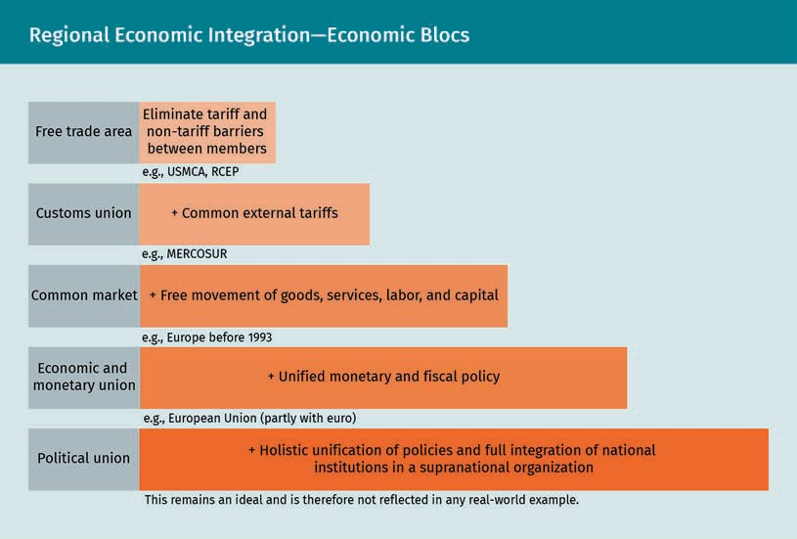

Free trade area
The first stage of regional economic integration is the free trade area, in which member countries agree to gradually eliminate tariffs and other barriers to facilitate trade among each other. A key goal of a free trade area is for member countries to focus on their respective comparative advantages. Member countries in a free trade area can still have their own trade policy toward non-member countries (i.e., they can set their own tariffs). Within the trade bloc, members can set local content requirements that force firms to use products manufactured in the home country. Products that fail to meet these local requirements would be subject to the same tariffs that non-member countries would pay (Cavusgil et al., 2014). Examples of free trade areas include the Uni- ted States-Mexico-Canada Agreement (USMCA) (Lobosco, 2020) and the Regional Com- prehensive Economic Partnership (RCEP) in Asia-Pacific (Channel News Asia, 2020), which were both concluded in 2020. Signing a preferential trade agreement, narrow in

International Organizations and Economic Integration

its nature, is often the first step toward creating a free trade area. Specifically, it may only cover a specific set of products or services, be valid for a fixed number of years, and offer lower tariffs (instead of completely abolishing them) (Das, 2004).

Customs union
The second stage of regional integration is the customs union. A customs union is simi- lar to a free trade area, but with a common tariff and non-tariff barriers towards non- member countries. This means that non-members encounter the same tariff and non- tariff barriers when they trade with any of the members of the bloc (Cavusgil et al., 2014). The difficulty in progressing from a free trade agreement to a customs union lies in agreeing on the level of tariffs and, importantly, on how the revenues of the tariffs are divided between the members of the bloc. An example of a customs union is MER- COSUR (a portmanteau of Mercado Común del Sur), the largest economic bloc in South America (Cavusgil et al., 2014).

Common market
The third stage of regional economic development is the common market, in which member countries aim to completely remove trade barriers within the bloc. They estab- lish a “single” market among each other to facilitate free movement of goods, services, capital, and (ultimately) labor (Cavusgil et al., 2014). Just as with a customs union, com- mon external barriers are established. The difficulty in creating a common market lies in the amount of coordination and cooperation needed to enact suitable economic policies. Typically, investment capital flows to those member countries where returns are greater; labor moves to where wages are higher. This increase in immigration may lead to social tensions. One example of a common market is the EU (Jones et al., 2012).

Economic and monetary union
The fourth stage of regional economic development is the economic and monetary union. In an economic union, the member countries have a common market and aim to have common fiscal policies and, in due time, identical tax rates (Cavusgil et al., 2014). Furthermore, they strive to have a harmonized monetary policy with fixed exchange rates and free convertibility of national currencies or, in more advanced stages, a mon- etary union. A monetary union eliminates exchange rate risks and foreign exchange conversion costs, thereby facilitating a firm’s ability to trade and invest within the union. In addition, member countries in an economic union seek to harmonize techni- cal product standards and regulations regarding a broad variety of issues affecting cor- porations (e.g., taxation and competition). With some of its members having a common currency (the euro), the EU has elements of an economic and monetary union (Jones et al., 2012).

Political union
The final stage of regional economic development is the political union. A political union refers to a perfect, holistic unification of economic policies and the full integra- tion of national institutions into supranational ones. One example from European his- tory can be seen in the German unification of 1871, when individual states became the German Empire (Breuilly, 1996). That same year, various states on the Italian peninsula unified into the Kingdom of Italy (Collier, 2003). In both situations, each state had its own government, currency, internal and external trade tariffs, and standards. Today,

Monetary union
A monetary union is an agreement under which member countries adopt a single currency.

certain member countries have delegated some of their national powers to the EU, a supranational organization. Nevertheless, the EU is still far from being a full political union (Cavusgil et al., 2014).

Key Economic Blocs

The following section discusses some of the largest economic blocs, namely the EU, USMCA, RCEP, and MERCOSUR. The following figure depicts these, and the corresponding table offers key data on each (i.e., gross domestic product [GDP], GDP per capita, and population).
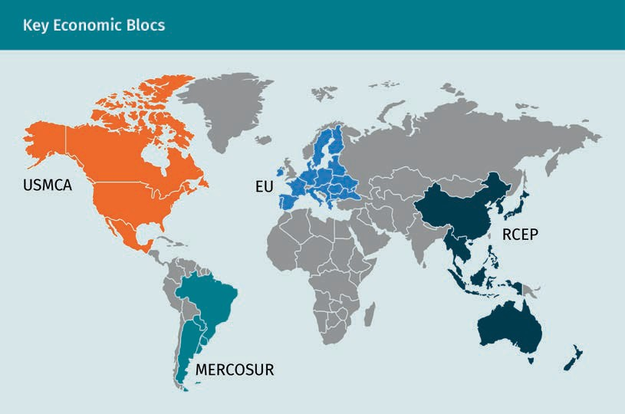

Key Economic Blocs (2019)
Block | GDP (USD trillion) | GDP per capita (USD) | Population (million)
EU | USD 19,557 trillion | USD 36,993 | 529 million
USMCA | USD 24,368 tril-  lion | USD 49,390 | 493 million

International Organizations and Economic Integration

Block | GDP (USD trillion) | GDP per capita (USD) | Population (million)
RCEP | USD 25,840 tril-  lion | USD 11,400 | 2,267 million
MERCOSUR | USD 2,384 trillion | USD 10,564 | 267 million

European Union
The European integration project started after World War II. In 1951, six countries (Bel- gium, The Netherlands, Luxembourg, France, West Germany, and Italy) created the Euro- pean Community for Coal and Steel (ECCS). According to two of the founding fathers of the ECCS, Jean Monnet and Robert Schuman, coal and steel were necessary materials for waging war and, in order to prevent future wars, the corresponding national indus- tries should be connected. The establishment of the ECCS was the first formal step toward creating a European federation. That same year, these countries also created the European Economic Community (EEC) through the Treaty of Rome (Jones et al., 2012).

The EEC established a customs union between its members with a common external tariff. Over the years, this customs union has developed into a common market with common policies (e.g., for agriculture) and unified technical standards for goods. Con- siderable steps were taken toward creating a single market, which was formally estab- lished with the Treaty of Maastricht in 1993. This treaty, which came into effect in 1993, established the EU (Jones et al., 2012).

The EU is based on three pillars: The European Community (EC, formerly the EEC), the Police and Judicial Cooperation in Criminal Matters (PJCC), and the Common Foreign and Security Policy (CFSC). While the EC is mainly supranational (i.e., national member countries delegated part of their sovereignty to the EU), the second and third pillar are intergovernmental (i.e., national member countries maintain sovereignty on these top- ics and try to coordinate policies). The EC established a common market with free movement of goods, services, capital, and labor within the EU. Tariffs and most nontar- iff barriers were eliminated for trade in goods and services, and rules of origin favor manufacturing that makes use of inputs smithed in the EU. The member countries largely eliminated customs procedures and regulations, which streamlined transporta- tion and logistics within the union. The EC harmonized certain technical standards, reg- ulations, and enforcement procedures relevant to goods and services. It continues this work to this day.

Before the 1990s, the focus of the European integration project was chiefly on Western European states. In 1985, the Schengen Agreement laid the foundation for open bor- ders, meaning that travel between most member states no longer required passport controls. After the fall of the Berlin Wall, the focus turned toward Eastern Europe. East Germany became a member of the European communities in 1990 as part of a reunified

Germany. In 2002, the EU introduced a common currency, the euro, for twelve member countries. In 2009, the Lisbon Treaty came into force, opening up membership for a large number of countries, mainly from Eastern Europe (e.g., Czech Republic, Slovakia, Slovenia, Poland, and the Baltic states) (Jones et al., 2012).

Today, the EU comprises 27 member states, 19 of which having a monetary union with the euro as a single currency. The EU can thus be characterized as a common market with elements of an economic, monetary, and political union. The monetary union sim- plifies the process of cross-border trade within the EU and eliminates exchange rate risks. Furthermore, it forces member countries to improve their fiscal and monetary policies. That being said, it also forced national governments to relinquish monetary power to the European Central Bank in Frankfurt, which oversees the monetary func- tions of the EU. Importantly, it makes it impossible for member countries to manipulate their local currencies through devaluations in order to stimulate exports.

With certain traits of a political union, the EU is the most developed economic bloc in terms of regional economic integration. Several institutions of the EU, such as the Court of Justice, have a supranational character. In other words, their decisions have effect in all member states. Likewise, European regulations drafted by the European Commission (the executive branch) and accepted by the Council of Ministers (comprising ministers from each member state) and the European Parliament have a direct effect in the member states.

As of today, the EU does not have full common fiscal, taxation, and social welfare poli- cies. Previous plans to create the European Defence Community (with a single army) and a European Political Community have all failed (Jones et al., 2012). It remains to be seen whether this will happen in the future. Since 2008, the EU has faced several severe pressures. For example, during the European debt crisis, several indebted eurozone countries such as Greece and Portugal had to be bailed out by other eurozone coun- tries, the European Central Bank, and the IMF. The required tightening of fiscal and monetary policies as part of the bail-out package led to popular displeasure and politi- cal polarization in both the indebted countries and those financing the program (Guiso et al., 2019). Additionally, increasing migration rates have led to an increase in euro- scepticism, which was the basis for the United Kingdom’s withdrawal from the EU (“Brexit”) (Tilford, 2015). These and possibly further issues will test the cohesion of the European Union in the years to come.

USMCA
The North American Free Trade Agreement (NAFTA) between the United States, Canada, and Mexico came into force in 1994, superseding the bilateral Canada-United States Free Trade Agreement from 1988. NAFTA eliminated tariffs and most non-tariff barriers between the three North American countries and established uniform customs proce- dures. Furthermore, it prohibited technical standards from being used as trade barriers and instituted rules for cross-border investment and intellectual property rights. Rules regarding bidding processes for government contracts by firms in member countries were also enacted. Finally, NAFTA helped settle disputes concerning cross-border investment, unfair pricing, labor issues, and environmental issues (Gantz, 2020).

International Organizations and Economic Integration

Under pressure from the Trump administration, a new trade agreement was negotiated between the three countries. Quoted in Time (2016), the then-president referred to NAFTA as “the worst trade deal ever made” (para. 31). He later managed to get a new United States-Mexico-Canada Agreement (USMCA) into force in July 2020 (Office of the United States Trade Representative, n.d.). All products that previously had zero tariffs under NAFTA remain as such under USMCA. The following elements constitute the main aspects of USMCA, as well as key deviations from NAFTA (Lobosco, 2020):

- USMCA promotes automotive and truck production in North America. 75 percent of a vehicle’s parts are required to be produced in one of the member countries (previ- ously 62.5 percent) to avoid tariffs when crossing borders in the trade bloc. Impor- tantly, it requires workers who produce vehicle parts to earn a minimum wage of USD 16 per hour. This thus leads to higher wages in Mexico, which usually competes with low wages. In turn, this leads to increased competitiveness in the automotive industry in the United States. The agreement is expected to add between 28,000 and 76,000 jobs in the United States over the following five years.
- USMCA strengthens the enforcement of labor laws in Mexico, e.g., through the crea- tion of a committee that monitors the implementation of labor reforms there.
- USMCA further opens up the Canadian market for poultry, eggs, and dairy from the United States. In exchange, Canadian peanut products, dairy, and sugar will be allowed on the American market.
- USMCA updates NAFTA for trade in the digital era. For example, Canada and Mexico cannot hold American companies liable for the content on their platforms. Further- more, American companies cannot be forced to store their data on in-country serv- ers.
- USMCA provides a fixed sum (USD 600 million) to cope with environmental issues in the trade bloc, e.g., sewage spillovers from Tijuana (Mexico) into San Diego (United States). It also makes it easier to enforce environmental regulations.

The Regional Comprehensive Economic Partnership (RCEP)
The Regional Comprehensive Economic Partnership (RCEP) is a free trade agreement recently signed in November 2020 by 15 countries in Asia and the Pacific. Five of these countries (China, Australia, Indonesia, Japan, and South Korea) are members of the G20, the international forum for global economic cooperation between the world’s 20 larg- est economies. The RCEP is the largest free trade area in the world measured by mem- ber countries’ GDP, with a total GDP of approximately USD 39 trillion (i.e., 30 percent of global GDP). The RCEP is expected to eliminate around 90 percent of cross-border tar- iffs between its member countries within the next two decades. Furthermore, it will set harmonized rules for intellectual property and e-commerce. Standardized rules of ori- gin will support international supply chains within the bloc (Mukherjee, 2019).

El Mercado Común del Sur (MERCOSUR)
Established in 1991, El Mercado Común del Sur (MERCOSUR) is the largest economic bloc in South America. It started as a free trade agreement between Brazil and Argentina in 1988, with Paraguay, Uruguay, and Venezuela joining later. These five members account for more than 80 percent of South America’s GDP (Coffey, 1998). Today, MERCOSUR is a customs union with a common external tariff and trade policy. With free movement of

goods and services within the bloc and coordinated fiscal and monetary policies, MER- COSUR has elements of a common market. The aim of MERCOSUR is to ultimately become an economic union (Cavusgil et al., 2014).

The worldwide financial crisis of 2008 exposed the fragilities and risks associated with national economies having global integrated economies and financial markets. Further- more, the WTO discussions between developed and developing countries have come to a standstill due to disagreements on various issues, most notably on agricultural subsi- dies. Because of this fragmentation, the world has seen a strong push toward regional- izing (i.e., not globalizing) the economy over the last 15 years. This trend has been exa- cerbated due to the COVID-19 pandemic, which had disastrous effects on global supply chains. COVID-related policies, including lockdowns and the closure of airports and shipping ports, led to severe logistical issues and, in turn, delayed or cancelled export shipments across the world (Dempsey & Hale, 2021). As a result, many companies star- ted regionalizing their supply chains. Western European firms, for example, started importing more from Eastern Europe instead of Asia to lower their supply chain risks (Lund et al., 2019). Some observers (e.g., Wang & Sun, 2021) go as far as to claim that, in the wake of COVID-19, we have reached the apex of globalization and will now bear wit- ness to a prolonged move toward economic regionalization at its expense.

Summary
Nations aim to achieve regional economic integration through the degradation of regional barriers and the creation of trade blocs. A trade bloc (or economic bloc) is a geographic area consisting of at least two countries that agree to pursue eco- nomic integration through the reduction of tariffs and other restrictions. This facili- tates a cross-border flow of products, services, capital, and (in more advanced stages) labor. The more nations are alike in their geography, history, culture, lan- guage, economics, and politics, the easier it will be to pursue their goals through regional economic integration.

Regional economic integration offers member states a number of advantages, including an expanded market size, increased attractiveness for foreign direct investment (from outside the bloc), increased specialization and competitiveness, higher standards of living, and a stronger political and negotiation position.
Regional economic integration develops in stages. First, in a free trade area, mem- ber countries reduce tariff and non-tariff barriers. In a customs union, member countries adopt common trade policies aimed at non-members. In a common or single market, member countries have free movement of goods, services, capital, and labor. This is followed by an economic and monetary union in which member countries have common fiscal and monetary policies. The final stage of regional economic integration is the political union, in which all national institutions are integrated in a supranational organization and all policies are unified. The largest trade blocs are RCEP and USMCA (both free trade areas); the European Union (a common market with elements of an economic, monetary, and political union); and MERCOSUR (a customs union).

International Organizations and Economic Integration

Knowledge Check
Did you understand this unit?

You can check your understanding by completing the questions for this unit on the learning platform.

Good luck!

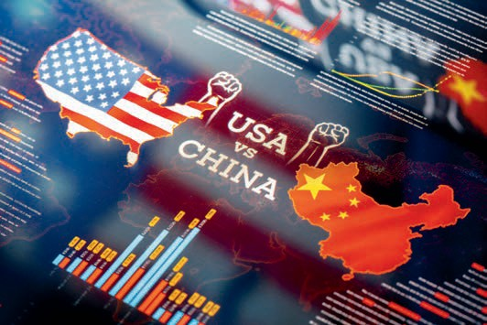

Unit 6
Current Hot Spots in the International Economic and Business Environment

STUDY GOALS

On completion of this unit, you will be able to …

… explicate the struggle for political and economic supremacy between the United States and China, reflected in their ongoing trade war.
… explain what emerging markets are and why they are increasingly important.
… understand how the Sustainable Development Goals aim to make the world a better place.

DL-E-DLMINTMAB01_E-U06

- Current Hot Spots in the International Eco- nomic and Business Environment

Case Study

Solarna, based in a large western country called the Highlands, is a renewable energy company that sells solar panels. Over the last year, Solarna has invested time and money into marketing their products and increasing sales in Palinga, the Highlands’ largest political and economic rival. Notably, Palinga, a developing nation, is also the Highlands’ largest trading partner. Palinga has witnessed tremendous economic growth rates over the last decade, during which it became one of the largest economies in the world. Because Palinga’s current president believes that power must be wielded responsibly, they are aiming for a more sustainable economy to protect the environ- ment for future generations. For this reason, Palinga subsidizes the use of renewable energy, including solar panels.

To date, Solarna’s investment has paid off, with sales increasing 150 percent on an annual basis. Unfortunately, the relationship between the countries has deteriorated in the recent months. The chief executive officer (CEO) of Solarna feels very nervous read- ing that the Highlands is enacting import tariffs for solar panels from Palinga. Such protectionist measures are often followed by similar countermeasures from the other party. How will this conflict develop? Is this the start of a trade war between the coun- tries? How will this affect Solarna?

  - USA and China: Struggle for Political and Economic Supremacy
There is a consensus among scholars that the United States became the world’s only true superpower after the annexation of Hawaii and acquisition of the Philippines, Puerto Rico, and certain islands in the Pacific at the start of the twentieth century (Her- ring, 2008; Digital History, n.d.). The United States supported Panama in securing its independence from Colombia in order to build the Panama Canal. It also occupied Nicaragua, Haiti, and the Dominican Republic for 20, 19, and eight years respectively (Digital History, n.d.). In the early 1900s, the United States also saw the Second Indus- trial Revolution, with technological advancements (e.g., electrification) and economic growth. During this period, the United States became the largest economy in the world measured by gross domestic product (GDP) (Kuepper & Boyle, 2021). Later, after declar- ing war against Germany in 1917 during World War I, it further developed its military forces (Garamone, 2017). Together with the Allied powers, the United States was victori- ous in both World Wars (Encyclopedia Britannica, n.d.-d; n.d.-e).

After World War II, the United States took the lead in creating a new economic world through the Bretton Woods agreements (Hill, 2015), and the U.S. dollar became a global reserve currency (Best & Kelly, n.d.). Although the Soviet Union was considered a superpower during the Cold War, it lost its status after its collapse in the late 1980s and

Current Hot Spots in the International Economic and Business Environment

early 1990s (Rosefielde, 2005). The capitalist ideology triumphed over communism, and the United States was the sole superpower left. Throughout the 1980s and 1990s, the United States exerted soft power globally and extended its technological strength through Silicon Valley (Li, 2018).

Over the last few decades, China has become the largest competitor of the United States as a potential superpower (Tisdall, 2014). Some observers believe it is too early to bestow the country this title because it does not show strengths in all five afore- mentioned elements, with particular regards to the culture and diplomacy (Pei, 2009). Nevertheless, in a relatively short time span of two decades, China has become remark- ably powerful on the economic, military, and technological fronts. Over the last ten years, China’s share of global GDP has strongly increased (from 8.7 percent in 2011 to
18.3 percent in 2020) at the expense of the United States, whose share fell from its top at 21.5 percent in 2016 to 15.9 percent in 2020 (The Global Economy, n.d.; O’Neill, 2021c). This implies that China had the largest share of GDP in the world in 2020 (measured by purchasing power parity) and surpassed the United States (O’Neill, 2021c).

In terms of international trade, China has been the largest exporter in the world since 2009, with exports worth USD 2.64 trillion in 2019 (Jahn, n.d.). China’s main export prod- ucts include electronics (e.g., mobile phones and computers), solar power diodes, semi-conductors, and automotive parts (Workman, n.d.). In 2019, it also became the sec- ond largest importing country after the United States with USD 2.08 trillion in imports (O’Neill, 2021a). In fact, in 2013, China became the largest player in international trade in terms of combined exports and imports (Monaghan, 2014). Furthermore, China has massively invested in overseas companies and infrastructure in both developed and developing countries, gaining a strong economic foothold globally (Silver et al., 2019). China has also rapidly developed its technological base through state funding and vari- ous reforms (Cordesman, 2019). On the military front, China has been heavily investing since the 1990s to expand and modernize its military. With around 2.8 million soldiers, China has the largest army in the world with twice the number of active American sol- diers. Thanks to its advancements in civil technology and manufacturing, China may have an edge in irregular warfare, such as cyber conflict, in the decades to come (Cor- desman, 2021).

The United States–China Trade War

The relationship between the United States and China had been largely hostile in the years since Mao Zedong founded the communist People’s Republic of China in 1949. The end of the 1960s witnessed a period of rapprochement (i.e., closer contact between the two nations), mainly because China needed American support to balance the politi- cal threat of the Soviet Union. Their relationship normalized in 1979 when Deng Xiao- ping implemented economic reforms in China. The bilateral economic ties grew rapidly during the 1980s (Council on Foreign Relations, n.d.). While U.S. exports stayed relatively stable between USD 3—6 billion during the 1980s, imports increased—from USD 4 bil- lion in 1985 to USD 12 billion in 1989 (United States Census Bureau, n.d.).
Reserve currency This is a foreign cur- rency held by central banks in large quan- tities as part of their foreign exchange reserves.

Ultimately, the relationship turned sour again after the 1989 Tiananmen Square Mass- acre, during which Chinese military troops killed a large number of civilians with tanks during student-led protests for (among other things) democracy and free speech (Council on Foreign Relations, n.d.). Despite the civil unrest, U.S. imports from China surged to USD 100 billion by 2000, while exports remained relatively low at USD 16 bil- lion (United States Census Bureau, n.d.). It was only after the 9/11 terrorist attacks in 2001 in the United States that formal relations between the two countries started to improve again (Lampton, 2003). China, no longer considered by the Bush administration as the primary security threat to the United States, strongly supported the War on Ter- ror. Between 2000 and 2008, U.S. exports to China increased to USD 69 billion, while imports surged to USD 296 billion.

Under the Obama administration, starting in 2009, the relationship developed quickly, leading to an increase in bilateral trade. U.S. exports to China witnessed a strong inc- rease to USD 116 billion, and imports surged to USD 462 billion in 2016 (United States Census Bureau, n.d.). The resulting U.S. trade deficit of almost USD 350 billion was financed by China, who bought U.S. debt (in the form of government bonds) with its trade surplus. A key factor in achieving this trade surplus throughout the last 30 years has been the devaluation of China’s currency vis-à-vis the U.S. dollar, made possible with China’s large foreign exchange reserves (Scott, 2017). In 1994, for example, China devalued its currency overnight with 33 percent against the dollar, making their exports suddenly more attractive. With the equivalent of USD 3.4 trillion, China became the country with the largest foreign exchanges reserves in the world by 2020 (Central Bank of the Republic of China [Taiwan], 2020).

The Trump presidency, starting in 2017, led to a rapid deterioration in bilateral relations between the two countries (Council on Foreign Relations, n.d.). The United States took the initiative to subdue China by implementing an initial set of tariffs in January 2018 (Erken et al., 2019). The struggle for political and economic hegemony resulted in a (still ongoing) trade war. The figure below provides a timeline and details the (retaliatory) actions, tariffs level, and the types and value of goods affected by these tariffs (Erken et al., 2019; Giesbergen et al., 2020).

Timeline of the Trade War between the United States and China
Date | Actions taken; goods affected | Tariff (%) | Value of imports (USD bn)
January 2018 | The United States imposes tariffs on washing machines and solar panels for all countries. | 15%—50%1) | Unknown
March 2018 | The United States imposes tariffs on steel and aluminum for most count- ries. | Steel: 25%, Aluminum: 10% | USD 2.9  bn

Current Hot Spots in the International Economic and Business Environment

Date | Actions taken; goods affected | Tariff (%) | Value of imports (USD bn)
April 2018 | China imposes tariffs on aluminum, meat, fruit, and wine from the United States. | 15%—25% | USD 2.4  bn
July— August 2018 | The United States imposes tariffs on Chinese imports (mainly electrotech- nical goods) in two tranches. | 25% | USD 50  bn
July— August 2018 | China immediately retaliates with tariffs on various American imports. | 25% | USD 50  bn
August 2018 | The United States imposes new on Chinese imports (mainly electrotech- nical goods, rice, and textiles). | 10% | USD 200  bn
August 2018 | China immediately retaliates with tariffs on American soybeans, SUVs, and aircraft parts. | 5—10% | USD 60  bn
May 2019 | The tariffs previously imposed by the United States on USD 200 bn of goods are raised to 25 percent. | 25% | USD 200  bn
May—Sep- tember 2019 | China responds with higher tariffs to each new American protectionist mea- sure. | 5%—25% | USD 60  bn
August— October 2019 | Negotiations to ease the trade conflict fail (August); The United States imple- ments new tariffs (August—Septem- ber); China implements limited tariff exclusions on American imports (star- ting September). | 15% | USD 120  bn
January 2020 | “Phase 1” deal is reached: tariffs from previous round reduced from 15 to 7.5 percent;  China pledges to buy USD 200 bn worth of American goods over next two years; tariffs remain in place. | 7.5% | USD 120  bn

Date | Actions taken; goods affected | Tariff (%) | Value of imports (USD bn)
2020— | China falling 40 percent short of its pledge (BBC, 2021); No “Phase 2” trade deal has been reached; the tariffs are still in place and the trade war ongo- ing under the Biden administration.

Note
1) Washing machines

Year 1: 20% for the first 1.2 million unit, 50% thereafter. Year 3: Tariffs decline to 16%
and 40% respectively. Solar panels
Year 1: Up to 2.5 gigawatts of unassembled solar cells tariff-free, thereafter 30%. Year 4: Tariff declines to 15%.

The trade war started in January 2018, when President Trump imposed tariffs for all countries on the import of solar panels and washing machines (Erken et al., 2019). The American government had already previously imposed tariffs on those particular goods, specifically Chinese and Taiwanese solar panels and South Korean, Mexican, and Chinese washing machines. In other words, these first tariffs were not explicitly aimed solely at Chinese imports; they were part of the “America first” economic policy, which aimed to reduce the American trade deficit by shifting from multilateral free trade agreements to bilateral trade deals (Shapiro, 2017).

Because these tariffs simply led to trade diversions (e.g., solar panels now came from Malaysia and South Korea), they failed in effectively supporting the American solar industry (Bown, 2018). In March of 2018, the United States imposed tariffs on steel and aluminum from most countries, which cover more than four percent of American imp- orts (Chance, 2018). In the same month, Trump already drafted a list of goods from China upon which he wanted to impose tariffs (Diamond, 2018). China reacted swiftly with retaliatory tariffs. A second round of U.S. import tariffs was implemented in July of that year, which were immediately followed by further Chinese countermeasures. The following 12 months saw further implementations of new or higher tariffs from both countries, intensifying the trade war.

Current Hot Spots in the International Economic and Business Environment

In August of 2019, the United States labeled China a currency manipulator after its cur- rency devaluated strongly against the U.S. dollar. New tariffs were subsequently imple- mented against USD 120 billions’ worth of Chinese imports. After signing the Phase 1 deal, the currency manipulation allegations were dropped. In the Phase 1 deal, the latest tariffs were reduced from 15 to 7.5 percent, and China pledged to buy USD 200 billion in American goods over the following two years. Ultimately, however, the Phase 1 deal turned out to be rather weak. It failed to address some of the key issues between the two countries, such as credible protection in China of American intellectual pro- perty rights (Giesbergen et al., 2020). In July of 2020, President Trump stated that a Phase 2 trade deal was not a priority, as relations had already been severely damaged by the COVID-19 pandemic (Breuninger, 2020). Under the Biden administration, which came into effect in January of 2021 (The New York Times, n.d.), the tariffs are still in place and the trade war is ongoing.

China (since 2001) and the United States are both members of the WTO (Bundesver- band der Deutschen Industrie, 2019). After the implementation of the August 2018 U.S. tariffs, China filed an official complaint with the WTO. Specifically, China claimed that the United States did not offer equal tariff rates among the WTO trading partners. In 2020, the WTO ruled that the United States had violated its rules by imposing these tariffs on China. President Trump’s response to this ruling was that the United States should be able to defend itself against unfair trade practices, including intellectual property theft in China. In other words, he ignored the WTO ruling and did not repeal the tariffs, thereby underpinning the limits of the WTO’s ability to influence its two lar- gest members in a trade war (Swanson, 2020).

The economic effects of this trade war are expected to result in negative consequences for both countries. In 2020, U.S. exports to China remained stable at USD 125 billion; imports from China, by comparison, dropped to USD 435 billion. In other words, the trade war has impacted China harder than it has the United States (at least, to date). According to Erken et al. (2019), the United States could lose 0.9 percent of cumulative GDP growth up to 2030 should the trade war linger on with the existing tariffs. In the scenario of a full escalation of the trade, in which both countries implement tariffs on all bilateral imports, the United States could lose 1.6 percent of cumulative GDP growth by 2025. It should be stated that China has much more at stake in this trade war. Under the current protectionist measures, the country is expected to lose 1.5 percent cumula- tive GDP growth until 2027; in case of a full escalation, the loss in GDP could end up being almost 6 percent by then. How the trade war will develop remains to be seen, and some observers fear it could devolve into an armed conflict (Erken et al., 2019).

The trade war also indirectly affects third countries. Other countries may enjoy positive export substitution effects due to improved price competitiveness. For example, Ameri- can companies, which normally import from China, may opt to import from other countries (e.g., Vietnam or Mexico) (Schacht, 2020; Erken et al., 2020). Lower global trade activity and economic growth caused by the trade war dominates these positive export substitution effects. Notably, a company may face price increases if their intermediary goods (intended for export to China) are caught in the United States-China supply chain. One example could be a supplier from the semiconductor industry that sells its intermediate goods to China. Consumers in third countries may equally be affected. For

example, electronic products (e.g., laptops) requiring expensive Chinese intermediates and shipped from the United States to Europe will become more expensive for Euro- pean consumers (Erken et al., 2020).

The Future Balance of Power

Although one cannot accurately determine how the balance of power between the Uni- ted States and China will develop in the future, there are different signs pointing toward a gradual shift of economic power in favor of China, at least in the short term. First, China’s increasing share of global GDP has been bolstered by the COVID-19 pan- demic. While the United States has been grappling with the pandemic, resulting in a 2.3 percent decline in GDP growth in 2020, China’s GDP rose by 2.3 percent (Cheng & Lee, 2021). After having contained the virus, China swiftly reopened its economy, which grew a record 18.3 percent in the first quarter of 2021 compared to the same quarter of the previous year (Harrabin, 2021a). By comparison, the U.S. GDP grew only 6.4 percent over the same period (United States Bureau of Economic Analysis, 2021). China’s share of the world’s GDP is projected to rise from 18.3 percent to 20.1 percent by 2026 (Textor, 2021).

Second, the status of the U.S. dollar as a reserve currency, which is typically seen as a safe-haven currency, is gradually weakening. In 2000, it accounted for over 71 percent of global currency reserves held by central banks; by 2020, this figure had dropped to 59 percent (International Monetary Fund, n.d.-a). Meanwhile, emerging markets, including Russia and China, are increasingly moving away from using the U.S. dollar when con- ducting international business, such as when closing oil contracts (Meredith, 2021).

Third, in addition to its dominance in international trade, China also became one of the largest players in global investment flows. From 2015 to 2017, China was both the sec- ond-largest, outbound foreign direct investment and the second-largest recipient of inbound investment in the world (Lee, 2019). Finally, in 2013, China adopted a new development strategy designed to build physical and digital infrastructure across 70 different countries, thereby connecting Eastern Asia to the Middle East, Africa, and Europe (Kuo & Kommenda, 2018). This strategy is called the Belt and Road Initiative, known colloquially as the “New Silk Road” (Laudien, 2019), and is expected to expand China’s global influence. These factors suggest that, for the foreseeable future, China’s economic power will increase relative to that of the United States.

With regards to the military balance of power, the number of China’s ground, air, and naval forces deployed in Asia is expected to increase significantly and exceed that of the United States. In fact, by 2025, China is expected to have eight times as many fighter jets and nine times as many warships than the United States (Akita, 2021). This may lead to increased tensions in territorial disputes in the South China Sea region and Tai- wan. The United States Department of Defense warns that China may attempt to force Taiwan to unify with China by 2027, the result of nationalistic inclinations of the Chinese Communist Party (Akita, 2021). Nevertheless, the United States possesses almost eight times more deployed nuclear warheads than China (Axe, 2021).

Current Hot Spots in the International Economic and Business Environment

Finally, China is expected to become more powerful in irregular warfare, including cyberwar (Cordesman, 2021). On the technological front, large state investments and favorable regulations are expected to result in Chinese domination in various fields, including artificial intelligence (HDI, 2021). Both countries are expected to compete in different technology-related sectors, including electric car production, civic airplanes construction, and the “space race” (e.g., anti-satellite weapons) (Broad, 2021). That said, China also faces several long-term challenges, such as an ageing and shrinking work- force (Beardson, 2013), fragile internal political and social stability, inequality, corrup- tion (Shirk, 2008), a lack of allies (Pei, 2009), and difficulties in attracting skilled labor from abroad (Chua, 2007).

  - Emerging Markets: New Players in the Global Economy
Before the 1850s, China and India were the largest economies in the world. At that time, economic output was mainly a function of population size. Starting with the First Indus- trial Revolution, mechanization became the driving force for economic prosperity, help- ing Great Britain (and later the United States) to become the world’s largest economy (Kuepper & Boyle, 2021). Technological innovations, among other factors, helped main- tain this status throughout the twentieth century and until recently.

The last two decades have witnessed a remarkable shift of economic power from developed markets to “emerging markets,” a term which lacks a uniform definition. Generally speaking, emerging markets are economies that are in the process of becom- ing a developed economy and, therefore, share some (but not all) characteristics of a developed market. They transition from a typically pre-industrial, lower income econ- omy to an industrial one with an improved standard of living (Investopedia, n.d.-b.). The figure below shows that North America’s share of global GDP dropped considerably from 35 percent in 2000 to 25 percent in 2020. Since 2000, Asia’s economy overtook Europe’s and North America’s, thus becoming the strongest economy worldwide (Inter- national Monetary Fund, 2021b).

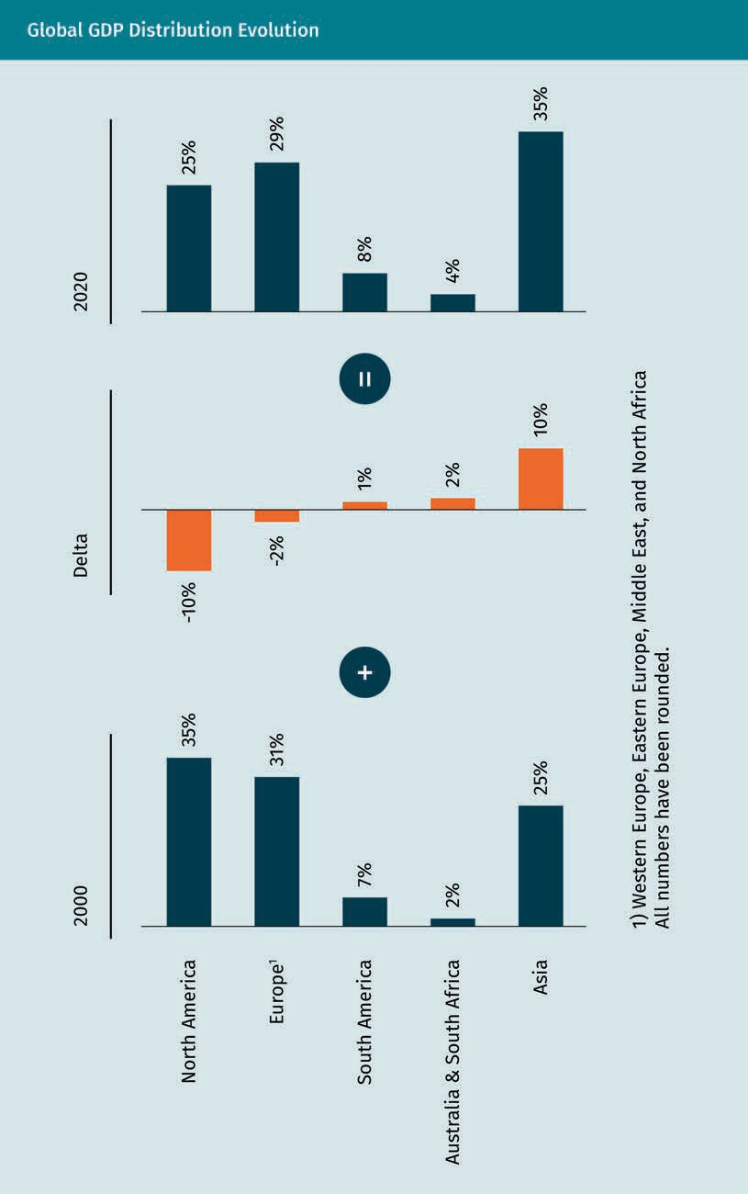

Current Hot Spots in the International Economic and Business Environment

This change primarily reflects growth in the largest Asian countries, i.e., China and India. Key drivers of this economic growth include population growth, improved pro- ductivity, and increased international trade. This economic growth trend is expected to continue in the future (Textor, 2021). Several analysts have predicted that the regional trade agreement RCEP, signed in 2020, will offer significant economic gains for the sig- natory nations in Asia and the Pacific. It could shift the global economic center further toward Asia, with China taking a leading role in dictating trade rules for the region and weakening the role of the United States (Gunia, 2020). As mentioned, analysts claim that China and India are the two emerging markets most poised to become superpow- ers in the future (Meredith, 2007). For this reason, we will explore these two countries further before discussing other emerging markets.

China

China, with over 1.4 billion people, has the largest population in the world and one of the most remarkable economic growth stories (United Nations Department of Economic and Social Affairs, 2019a). From 1949 to 1976, China was a communist country under the leadership of Mao Zedong, and its economy was characterized by state ownership and central planning (Encyclopedia Britannica, n.d.-b). From 1950 to 1973, real GDP in China grew on average 2.9 percent per annum, which was in line with neighboring countries such as South Korea and Japan (Brandt & Rawski, 2008). In the 1970s, the Chinese econ- omy entered into a period of stagnation (Brandt & Rawski, 2008). Two years after Mao’s death in 1976, Deng Xiaoping, the new leader of the communist party, initiated eco- nomic reforms. Initially, the goals of these reforms were to decollectivize agriculture, open the country up to foreign investment, and give permissions to entrepreneurs looking to start a business. The core object at the time was to have a more market-ori- ented economy. In the 1980s and 1990s, further reforms followed, including privatiza- tion, the lifting of price controls (leading to free market prices), and the removal of pro- tectionist policies.

The economic reforms were highly successful. From 1978 to 2013, China witnessed unprecedented growth, with the economy growing by 9.5 percent on average per annum (World Bank, n.d.-c). This economic growth over the last decades has also led to signifi- cant changes in Chinese society. In particular, the country transitioned from being a largely rural country to becoming “the workshop of the world,” with almost unlimited masses of cheap labor now active in an export-driven economy. Poverty levels greatly decreased from 41 percent in 1978 to 5 percent in 2001, and a new middle class emerged (Brandt & Rawski, 2008).

Today, China has the largest economy in the world (measured by purchasing power par- ity) (O’Neill, 2021c). The country is a socialist republic still run by a single party: the Chi- nese Communist Party, currently led by President Xi Jinping (Mai, 2021). The country’s economy has elements of both communist and capitalist systems and is usually descri- bed as a socialist market economy (Sigley, 2006). The state is heavily involved through economic planning, which includes industrial policies and five-year plans. While the economy is dominated by state-owned enterprises, it also has a large private sector and is open for foreign businesses. State-owned enterprises accounted for 40 percent

Stagnation
This term refers to a prolonged period of slow economic growth, typically accompanied by high unemployment.

of China’s GDP in 2020, with domestic and foreign private businesses and investment generating the remaining 60 percent (Guluzade, 2020). Although China was still the world’s largest exporter in 2020, the economic model has been changing to focusing on domestic consumption. Also that year, China was the second-largest importing country in the world after the United States (O’Neill, 2021c).

The government has tried to promote technological innovation through favorable regu- lation, the creation of technology clusters, and funding. This has led to China becoming a leader in certain fields (e.g., artificial intelligence and high-tech manufacturing). Chi- na’s share of global research and development expenditure rose from 5 percent in 2000 to 26.3 percent in 2018. Shenzhen is a large Chinese city and technology hub near Hong Kong, known as the “Silicon Valley of the East” (HDI, 2021). It hosts tech giants including Huawei and Tencent.

Regardless of how unclear China’s ambitions to achieve international, political, and economic hegemony may have been in the early 2000s, the country’s long-terms goals have become evident over the last decade (Godement, 2017). China has significantly invested in building railways, skyscrapers, and even whole new cities within its borders. It also has an ambitious global infrastructure plan. The Belt and Road Initiative is the largest infrastructure project in the history of humankind, with an estimated total cost of several trillion U.S. dollars and a target completion date of 2049 (Vontobel, 2019). Infrastructure investments under this project (to date) include ports, railroads, roads, airports, dams, tunnels, and skyscrapers. Some critics, among them the United States, consider the Belt and Road Initiative a way for President Xi Jingping to establish a China-centric international trade network and expand the country’s global influence.

India

India became an independent country in 1947 after 150 years of British colonization (Rudolph & Rudolph, 2008). This extended colonial period, unsurprisingly, strongly influenced its economic policy upon regaining independence. Indian economic policy had a highly protectionist character and was focused on government intervention, financial planning, extensive business regulation, and maintaining a state that owned certain key industries (e.g., telecommunications, steel, and insurance) (Aiyar, 2016). With five-year economic plans, India’s economy had traits in common with that of the Soviet Union, the country’s largest trading partner.

With the fall the Soviet Union, as well as the disruption caused by the Gulf War (which caused a spike in oil prices), India had to contend with a crisis concerning the balance of payments (Gargan, 1992). In order to fight against the resultant recession, known as the 1991 Indian economic crisis, the IMF gave India a bailout loan worth USD 1.8 billion (Meredith, 2007). To meet the stipulations of the bailout, India had to implement eco- nomic reforms, which led to a broad economic liberalization there. The reforms, enac- ted in 1991, were designed to reduce import tariffs, deregulate markets, end public monopolies, and facilitate foreign direct investment. The economic reforms had similar

Current Hot Spots in the International Economic and Business Environment

effects to those in China, leading to high growth rates. From 2000 to 2020, the average annual GDP growth rate was around 6.5 percent (Macrotrends, n.d.); from 2013 to 2018, India was the fastest growing economy in the world, even surpassing China (BBC, 2019).

In contrast to China, India today is a parliamentary democratic republic, i.e., the country is not governed by a single (communist) party (Rudolph & Rudolph, 2008). Their current economy largely follows free market principles and has become the third largest in the world by purchasing power parity (Silver, n.d.). Nearly 60 percent of India’s GDP is driven by domestic private consumption, followed by government spending and exports (World Bank, n.d.-d). With 500 million workers, India had the world’s second largest labor force in 2017 (after China) (The World Factbook, 2021). India is also well positioned for international trade for two reasons: many Indian citizens speak English, a side effect of the colonial period; and Indian culture shares more in common with countries in the West than it does with China. These two points, combined with low labor costs, has encouraged Western companies to outsource many (mainly tech-rela- ted) processes to India.

In recent years, the service sector, which makes up 50 percent of the GDP, and computer and telecom industries remained leading sectors for foreign direct investment inflows (Bhargava, 2016; Department for Promotion of Industry and Internal Trade, 2020). In 2019, India was the world’s ninth-largest importer and the twelfth-largest exporter (World Trade Organization, 2020). India is also the world’s sixth-largest manufacturer, representing three percent of global manufacturing output and 14 percent of national GDP (World Trade Organization, 2020; World Bank, n.d.-d). Nevertheless, the industrial sector (25 percent of GDP) and the agricultural sector (16 percent of GDP) still employ a majority of the labor force, and around 65 percent of India’s population still lives in rural areas (World Bank, n.d.-e.; World Bank, n.d.-d). Major industries in India include the pharmaceutical sector (India being world’s largest manufacturer of generic drugs), the IT sector, the chemical industry, the tourism industry (accounting for 9.2 percent of GDP in 2017), the textiles industry, and the telecommunication industry (The World Fact- book, n.d.).

The long-term growth outlook of the Indian economy remains positive due to its young population, savings and investment rates, and increasing integration into the global economy (The World Factbook, n.d.). India’s GDP at purchasing power parity is expected to overtake that of the United States by 2050 (PricewaterhouseCoopers, 2017). That being said, the COVID-19 pandemic had an immense, negative effect on the Indian economy. The middle class shrank by 32 million people in 2020, and more than 200 mil- lion have returned to earning below the minimum wage (i.e., USD 5 a day). In all likeli- hood, it will take some time for India to return to its pre-pandemic growth levels (Beniwal et al., 2021).

Further Emerging Markets

China and India, though the largest of the emerging markets (by GDP), are certainly not alone. Each emerging market has its unique context and faces different challenges and opportunities. Observers have tried to group these countries based on different sets of criteria. This section will discuss what are believed to be the main classifications.

Goldman Sachs, one of the world’s most renowned investment banks, introduced the “BRIC” countries (i.e., Brazil, Russia, India, and China) in 2001 (O’Neill, 2001). These emerging markets were grouped together due to the large size of their economies (measured in GDP), growth rates, and significance in their respective regions (O’Neill, 2001). The BRIC countries have held regular formal summits to discuss internal cooper- ation efforts. In 2010, South Africa was invited to join, and the group became known as the “BRICS” countries (Smith, 2011).

The BRICS countries’ composition was identical to the original Group of Five countries (also known as the “Outreach Countries”). These are countries that are not members of the G8 group but whose economies are influential on today’s global challenges (e.g., climate protection). As it would be impossible to solve these challenges without their participation, these countries collaborate with the G8 group at a series of conferences. Together, these act as the G8+5 group. In 2014, Russia was expelled from the group due to its role in the Ukrainian crisis over Crimea. Ultimately, Russia was replaced with Mex- ico in the Group of Five (Smale & Shear, 2014).

Goldman Sachs also coined the term “Next Eleven” (N-11) in 2005, referring to a group of eleven countries that could become some of the world’s largest economies. These countries are Bangladesh, Egypt, Indonesia, Iran, Mexico, Nigeria, Pakistan, the Philip- pines, South Korea, Turkey, and Vietnam (O’Neill et al., 2005). The Next Eleven group is characterized by large populations and potentially high growth rates. To determine this cluster, Goldman Sachs focused on the following criteria: macroeconomic factors (e.g., inflation, public debt, and openness of an economy); technical infrastructure (e.g., access to phone and Internet); human capital (e.g., education and life expectancy); and political factors (e.g., political stability, rule of law, and degree of corruption). The con- clusion of the Goldman Sachs report was that, of these current emerging markets, only Mexico has the capacity to become as globally relevant as the BRIC countries (O’Neill et al., 2005).

Financial indices group emerging markets together to track their performance. An example of an index doing so is the MSCI Emerging Markets Index. This international stock index was developed by Morgan Stanley, a large investment bank, and reflects the market value of over 1,400 companies across 27 emerging markets: Argentina, Brazil, Chile, China, Colombia, Czech Republic, Egypt, Greece, Hungary, India, Indonesia, South Korea, Kuwait, Malaysia, Mexico, Pakistan, Peru, Philippines, Poland, Qatar, Russia, Saudi Arabia, South Africa, Taiwan, Thailand, Turkey, and the United Arab Emirates. Between 2000 and 2019, this index showed an annual growth rate of nine percent, compared to the 5 percent in the MSCI World Index. Simultaneously, the volatility of the MSCI Emerg- ing Markets Index was considerably higher than the MSCI World Index, reflecting

Current Hot Spots in the International Economic and Business Environment

increased risk (MSCI, 2021). The groupings of emerging markets above are only a few of many. Taking into account different classifications used, the number of total emerging markets currently lies somewhere around 40 countries (BBVA Research, 2014).

Opportunities and Risks in Emerging Markets

Emerging markets can be attractive to international companies because they provide low-cost sourcing opportunities. Foreign companies can access goods and services that are either cheaper than in their home market, thereby lowering the company’s produc- tion cost, or are not available domestically. Furthermore, emerging markets can be a potential sales market. From a revenue perspective, foreign companies can benefit from the high growth rates that emerging markets exhibit by increasing their sales. Foreign companies pioneering into a new market as early entrants (i.e., before their competi- tors do) may enjoy first mover advantages (Suarez & Lanzolla, 2005). Examples of first mover advantages include beating rivals in the long-term by establishing a strong brand name, developing a cost advantage by building up a sales volume early, and increasing switching costs (i.e., costs incurred by customers changing brands) by creat- ing a lock-in effect. One example of a switching cost would be the high cancellation fees for a cell phone contract.

To illustrate first mover advantages and how influential they can be, let us now turn to the late 1980s, when fast food chains KFC and McDonald’s first entered the Chinese market. KFC opened its first store in China in 1987, with McDonald’s following suit shortly after in 1990. Having entered the country three years before its competition, KFC had the chance to learn more about the local market and solidify their brand’s pres- ence. Ultimately, the company opted to adapt its menu to Chinese consumer preferen- ces. When McDonald’s entered China in 1990 and opened restaurants in the four largest cities, KFC decided to expand rapidly in second-tier cities and build outlets all over China. This offered economies of scale and allowed KFC, the first to arrive in these cit- ies, to pick the best locations (Bell & Shelman, 2011). In 2016, KFC had the largest fast- food market share in China with 11.6 percent, which was more than double the market share of McDonald’s (Jacobs, 2019).

International companies operating in emerging markets also face political, cultural, and foreign exchange risk. Among others, political risk can include government intervention in the form of trade barriers and uncertain property rights. Foreign exchange rate risk in emerging markets is largely a function of the specific economic environment. Cul- tural risk refers to “the potential for a company’s operations in a country to struggle because of differences in language, customs, norms, and customer preferences” (Ketchen & Short, 2016, p. 175).

Uber provides a recent example of a Western company failing in China because it did not fully understand how to navigate the local business environment. When Uber entered the Chinese market in 2014, it soon realized that it had to adapt many ele- ments of its core product to the local context. For example, the standard process at Uber was that customers had to authenticate credit card information before opening an account. This became a stumbling block for the company, as an increasing number

of Chinese citizens use apps (e.g., WeChatPay and Alipay) instead of credit cards for electronic purchases (Buchwald, 2019). As a result, the company had to add the option of paying with Alipay. Furthermore, Uber used Google Maps to locate customers and match them with drivers. Unfortunately, Google Maps was often inaccurate in China, so Uber decided to partner with Baidu, a large Chinese technology company. Uber contin- uously had to adapt its product and processes in order to compete, which was costly. In the end, what really spelled the end for Uber in China, was the national regulation of the ride-hailing services industry. Uber needed provincial and national regulatory approval for all of its activities in China. Its online and offline services were regulated separately. Importantly, the Chinese government subjected foreign companies to more regulation than their local competitors. In other words, Uber grossly underestimated the risk of government intervention by the Chinese state to protect domestic compa- nies. As a result, the company ended its operations in China (Kirby, 2016).

  - Agenda 2030: Sustainable Development Goals (SDG)
While globalization and regional economic integration have led to economic growth throughout the second half of the twentieth century, the world still faces a number of critical challenges. The Sustainable Development Goals (SDGs), developed by the Uni- ted Nations (UN) in 2015, attempt to address these global challenges (United Nations General Assembly, 2015). This section discusses what the SDGs are and how they are implemented.

What are the Sustainable Development Goals?

In 2015, the United Nations developed the SDGs as a sort of blueprint for establishing a more sustainable future for every person across the globe (United Nations General Assembly, 2015). The SDGs, which are intended to be achieved by 2030, refer to 17 inter- linked projects that address global issues such as poverty, hunger, peace, income inequality, and climate change. The figure below provides a full overview of the 17 SDGs.

Current Hot Spots in the International Economic and Business Environment

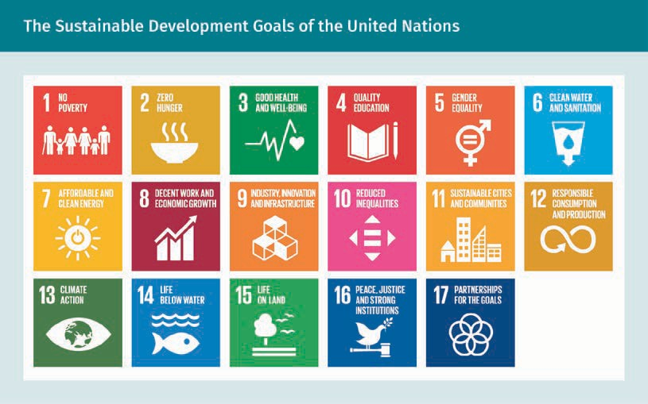

The SDGs are included in a UN resolution colloquially known as Agenda 2030. In 2017, the UN made the SGDs more actionable by defining specific targets for each goal (Uni- ted Nations General Assembly, 2015). The progress made toward these targets can be measured by using indicators. Different tools were developed to track and visualize the progress toward each goal. The SGD-Tracker, available online, is a free, open-access publication providing data across all indicators (Our World in Data, n.d.). Each goal typi- cally comprises 8—12 targets, and each target has up to four indicators. The targets are either outcome targets (specific circumstances to be achieved) or means of implemen- tation targets, the latter of which were introduced after some member states raised concerns over how to best achieve the SDGs.

Goal 1: No poverty
The UN’s goal of ending poverty comprises five outcome targets (United Nations Gen- eral Assembly, 2015). First, extreme poverty (i.e., an income lower than USD 1.90 per day) must be eradicated (World Bank, 2016). Second, all poverty must be reduced by half. Third, social protection systems must be implemented. Fourth, equal ownership rights, basic services and technology and economic resources must be ensured. Finally, resil- ience to environmental, economic, and social disasters must be strengthened.

The highest priority is to eradicate extreme poverty, which is especially prevalent in low-income countries with political conflicts. The poverty rate in rural areas in 2016 was at 17.2 percent compared to 5.3 percent in urban areas (United Nations Department of Economic and Social Affairs, 2019b). Notably, nearly half of all people in extreme pov- erty are children. In 2015, more than half of the world’s 736 million people living in extreme poverty lived in Sub-Saharan Africa (United Nations Department of Economic and Social Affairs, 2016). Between 1990 and 2015, the world saw a steady decline in the
UN resolution
This is a formal text adopted by a UN organization (usually the Security Council or the General Assembly), which provides a recom- mendation. It is not legally binding.

number of people living in extreme poverty, i.e., from 36 percent to 10 percent (United Nations, n.d.). This is largely thanks to globalization in general and, more specifically, the economic successes in Asia (e.g., China and India).

Nevertheless, extreme poverty is expected to increase dramatically by 2030 due to the COVID-19 pandemic should clear shifts in social policy not occur. A study published in September 2020 found that the pandemic had caused poverty to increase by 7 percent in just a few months’ time. The economic fallout from the pandemic could increase global poverty by as much as half a billion people—eight percent of the total human population (Sumner et al., 2020). This would be the first time that poverty has increased globally in 30 years since 1990 (United Nations, n.d.).

Goal 2: No hunger
This goal has five outcome targets, of which ending world hunger and making food more accessible (as well as ending malnutrition) are the most salient. Globally, one in nine people are considered undernourished, the overwhelming majority of which resid- ing in developing countries (UNICEF, 2018). Almost half (45 percent) of all deaths in chil- dren under the age of five are caused by malnutrition. This roughly translates to 3.1 mil- lion children every year (Black et al., 2013).

Goal 3: Good health and well-being
The goal of SDG 3 is to “ensure healthy lives and promote well-being for all at all ages” (United Nations General Assembly, 2015, p. 20). This broad definition encompasses vari- ous dimensions defined in nine outcome targets. These include the reduction of mater- nal mortality, an end to all avoidable deaths of children younger than five, promotion of mental health, and a decrease in road-related injuries. The focus so far has been on the first two targets. Between 2000 and 2016, the world saw the mortality rate of chil- dren under five decrease by 47 percent (i.e., a ratio of 78 deaths per 1,000 children down to 41 deaths). Nevertheless, with 5.6 million child deaths in 2016 alone, the relevant sta- tistics are still remarkably high (UNICEF, 2018).

Goal 4: Quality education
For this goal, the main objectives are to make high-quality primary and secondary edu- cation freely accessible to all, eliminate discrimination in academia, and achieve uni- versal literacy and numeracy. Efforts made in this area have yielded powerful results, with improved access to education for primary school students (for all children). By 2014, the number of children not attending school had decreased from 112 million in 1997 to 60 million (UNESCO Institute for Statistics, n.d.).

Goal 5: Gender equality
SDG 5 seeks to advocate for the rights of women and girls everywhere, including the right to live and work without threat of discrimination or violence. Today, women have better access to decision-making positions at both the local and national level. They hold 36 percent of elected seats in local deliberative bodies. In fact, representation by women globally in national parliaments was 25 percent in 2020, up from 22 percent in 2015 (United Nations Economic and Social Council, 2020). Nevertheless, women around the world are still at considerable risk of unspeakable abuse.

Current Hot Spots in the International Economic and Business Environment

Goal 6: Clean water and sanitation
SDG 6 focuses on providing access to affordable, potable drinking water and improved sanitation measures. It has been determined that only 71 percent of the world’s popu- lation had access to potable water, which translates to roughly 2.2 billion people going without it. That same year, Northern Africa, Central Asia, and Southern Asia had to con- tend with water stress levels, defined as the quantity of fresh water used over total renewable freshwater resources, of over 70 percent. Around the world, 4.2 billion people also had no access to safely managed sanitation systems. In 2020, 673 million people routinely discarded solid waste in open or public spaces (United Nations, 2020a).

Goal 7: Affordable and clean energy
The key outcome targets for this goal are focused equally on people and the environ- ment. Efforts made in this arena strive toward ensuring universal access to electricity, increasing the usage of renewable energy, and doubling energy efficiency. To date, there have been noticeable results in certain countries (e.g., India, Bangladesh, and Kenya) where access to electricity has significantly expanded. The world has borne wit- ness to a decrease in the number of people living without electricity: 1.2 billion in 2010 to 840 million in 2017. As it stands today, Sub-Saharan Africa is currently the region with the weakest access to electricity (World Bank, 2019). It is estimated that, between 2018 and 2030, expanding global energy access will come at a cost of an annual average of USD 55 billion; increasing the use of renewable energy will cost USD 700 billion; and improving efficiency will cost USD 600 billion. By 2016, only 17.5 percent of the world’s total energy consumption was renewable (World Bank, 2019).

Goal 8: Decent work and economic growth
SDG 8 comprises several targets, including attempts to end modern slavery, trafficking, and child labor and to ensure sustained economic growth, equal labor rights, and safe working conditions. In the world’s least developed nations, growth rates hovered around 4.5 percent between 2018 and 2019—less than the UN’s seven percent target (United Nations Department of Economic and Social Affairs, 2020). In fact, as of 2019, 22 percent of the world’s youth was unemployed and not enrolled in any education pro- grams. This figure is noticeably similar to that in 2005. It is predicted that the fallout from the COVID-19 pandemic will have negative effects on the growth rates in 2021 (Uni- ted Nations, 2020b).

Goal 9: Industry, innovation, and infrastructure
The key outcome target of SDG 9 is to develop sustainable, resilient, and inclusive infrastructure. In 2019, 14 percent of workers globally were employed in the manufactur- ing sector, which was similar to the numbers seen in 2000. Eastern and South-Eastern Asia have the highest share of manufacturing employment (18%), while sub-Saharan Africa has the lowest (6%) (United Nations Economic and Social Council, 2020). Global carbon dioxide emissions have declined by almost 25 percent since 2000, while GDP growth has continued rising (United Nations Economic and Social Council, 2020). SGD 9 also aims to ensure internet access for the entire world population. Today, only just over half of the population has internet access (International Telecommunication Union, 2019).

Goal 10: Reduce inequality
SDG 10 has one clear goal, that being to reduce income inequality. Between 2012 and 2017, around 70 different countries saw income growth among the lower 40 percent of their population. That being stated, those workers earned less than 25 percent of over- all income (United Nations, 2020a). Governing bodies and central banks in developed countries often enact loose fiscal policies, which can have negative income distribution effects, i.e., increases in income inequality (Weinstock, 2021).

Goal 11: Sustainable cities and communities
SDG 11 focuses efforts on ensuring safe and affordable housing and transport systems and promoting inclusive and sustainable urbanization measures. In 2018, some 24 per- cent of the world’s urban population (a little over one billion people) resided in slums, a problem that plagues Central, Southern, and South-Eastern Asia and Sub-Saharan Africa in particular. As of 2019, only half of the world’s urban population enjoyed easy access to public transport. The United Nations Economic and Social Council (2020) defines a person with easy access to public transport as one who resides in a home within 500 m walking distance of a low-capacity system (e.g., a bus network) or 1 km of a high-capacity system (e.g., a commuter rail).

Goal 12: Responsible consumption and production
This SDG centers around efforts made to establish more sustainable consumption and production patterns and efficient management of natural sources. Additionally, those active in this area seek to promote recycling and reduce global food waste by at least 50 percent. In 2018, subsidies for fossil fuel added up to USD 400 billion, twice the esti- mated amount for renewables. This complicates achieving the reduction of global car- bon dioxide emissions. That following year, the EU, alongside 79 other countries, imple- mented national policy instruments to help advance improved consumption and production patterns (United Nations Economic and Social Council, 2020).

Goal 13: Climate action
SDG 13 calls for “urgent action to combat climate change and its impacts by regulating emissions and promoting developments in renewable energy” (United Nations General Assembly, 2015, p. 27). This SDG is clearly interrelated with some of the others, notably SDG 7. In order to realize SDG 13, there is a focus on improving global resilience to natu- ral disasters, incorporating climate change measures into policy making, and increasing awareness. Climate change negatively affects all nations and citizens across the world, especially given today’s vulnerable conditions. In recent times, climate change has led to a higher frequency of natural disasters (e.g., droughts, hurricanes, floods, and wild- fires) (United Nations, 2020a). The world saw a 6.5 percent decrease in greenhouse emissions stemming from developed nations between 2000 and 2018; by comparison, there was an increase of 43 percent of these emissions in developing nations between 2000 and 2013. In 2019, 120 out of 153 developing countries began partaking in different activities designed to draft and implement climate action plans on a national level (United Nations Statistics Division, 2020).

Current Hot Spots in the International Economic and Business Environment

Goal 14: Life below water
For SDG 14, we shift attention to the projects designed to “conserve and sustainably use the oceans, seas, and marine resources for sustainable development” (United Nations General Assembly, 2015, p. 28). Because clean oceans represent a key compo- nent in maintaining a hospitable planet, there is a strong focus on protecting ecosys- tems by reducing pollution and acidification, as well as bringing an end to subsidies that contribute to overfishing. Ocean currents are responsible for the global climate, including the flow of rainwater and potable water. Increased ocean temperatures and oxygen loss contribute to acidification, which are major pressures on the marine envi- ronment (International Union for Conservation of Nature, 2017).

Goal 15: Life on land
SDG 15 focuses on preserving both terrestrial and freshwater ecosystems, putting an end to deforestation, and restoration efforts made for the benefit of forests and land already degraded. There is additional focus on preventing desertification and promot- ing the health of particular ecosystems. Forests are important sources for clean air and water and play a crucial role in the fight against climate change. As a percentage of total land area, forests dropped from 31.9 percent in 2000 to 31.2 percent in 2020. Deser- tification impacts around one-sixth of the global population and leads to increased poverty (United Nations Economic and Social Council, 2020).

Goal 16: Peace, justice, and strong institutions
SDG 16 seeks to reduce violence, promote law and justice, and prevent the exploitation, trafficking, and abuse of children. Those active in this area also focus on reducing cor- ruption, the presence and power of organized crime outfits, and illegal flows of money and arms. To combat these problems, SDG 16 works toward developing and maintaining trustworthy, transparent, and efficient institutions. In the last decade, high-income countries saw lower levels of bribery (an average of 3.7%); lower-income countries revealed higher levels of bribery in the public sector (22.3%) (United Nations Economic and Social Council, 2020).

Goal 17: Partnerships for the goals
The final GDP of Agenda 2030 is designed to “strengthen the means of implementation and revitalize the global partnership for sustainable development” (United Nations General Assembly, 2015, p. 30). In other words, efforts made in this area focus on ensur- ing cooperation (and not competition) among all participating parties. One important way of stimulating cooperation is to develop multi-stakeholder partnerships through which knowledge, expertise, and technology can be shared. This goal also seeks to facilitate “north-south” cooperation (i.e., between developed and developing nations) and “south-south” cooperation) (i.e., among developing nations). Financial support is equally as important to the success of all SDGs. To achieve them, USD 5—7 trillion in annual investment is required. In 2017, official development assistance totaled USD 147 billion, i.e., well below targets. In 2016, only six countries met the international target of having official development assistance at a minimum of 0.7 percent of gross national income (United Nations Development Programme, n.d.).

Implementation

Implementation of the SGDs started in 2016. National governments have to pursue the SGDs through national legislation, action plans, and defined budgets. An example of national legislation that advances the SDGs is the German Lieferkettengesetz (i.e., “law on supply chains”), which was enacted by the federal government in June of 2021. This law provides a framework to protect the environment, human rights, and children rights along global supply chains. Starting in 2023, German companies with more than 3,000 employees need to monitor their supply chains and report on their activities (Lieferket- tengesetz, n.d.).

Recently, national judges have been forcing companies to adhere to environmental reg- ulations. For the first time in history, the Dutch court in The Hague ordered Royal Dutch Shell, a private oil company, to curb the greenhouse gas emissions (i.e., CO₂ emissions) resulting from all its business operations by 45 percent by 2030. According to the court, Shell has to align its policies with the Paris Agreement on climate change. With this treaty, nearly 200 nations agree to keep global temperatures at a maximum of two degrees celsius above pre-industrial levels (Harrabin, 2021b). This court decision could create a precedent and have far-reaching consequences for other companies both domestically and internationally.

UN Secretary General This is the chief administrative offi- cer of the UN and head of the UN Sec- retariat, one of their six key organizations.
The SDGs are monitored by the UN High-Level Political Forum on Sustainable Develop- ment, which organizes an annual meeting to discuss progress made to date. The UN Secretary General publishes regular high-level progress reports for all SDGs. These reports only disclose progress data on a global and regional level (i.e., typically by con- tinent). The online SDG-Tracker, available since 2018, provides data on all indicators.

On a firm level, there is no uniform template or process that companies can follow to start work on these SDGs. For this reason, some companies have developed their own processes. For example, the Kreditanstalt für Wiederaufbau (KfW), a German state bank that provides loans to developing countries, implements the SDGs through what it calls “SDG mapping.” KfW takes into account around 1,500 indicators (e.g., purpose of loans) to map its yearly financial commitments with regards to each of the SDGs. In doing so, KfW aims to be transparent about how its financings contribute to each of the SDGs. This largely automated approach makes KfW a model for how to remain transparent when contributing to the SDGs in the financial sector (KfW, 2021).

The SDGs have been criticized by observers for a broad variety of reasons. Some argue that they can conflict and compete with one another. Notably, seeking high economic growth makes achieving sustainability goals more difficult. Furthermore, with 17 over- arching goals comprising 169 targets in total, the SDGs are rather broad and lack focus (The Economist, 2015). Critics also argue that environmental sustainability is underre- presented in the SDGs (Hickel, 2019). Although climate change is perceived as a major threat to global society by many observers, it is lost in a sea of Agenda 2030’s many goals. Finally, observers have identified a need for improved technology and internet connectivity within these SDGs. With the COVID-19 pandemic having created a “new nor- mal,” digitalization should be higher on the list of priorities.

Current Hot Spots in the International Economic and Business Environment

Summary
Current topics in the international economic and business environment include the struggle for political and economic supremacy between the United States and China, emerging markets as important new players in the global economy, and the Sustainable Development Goals developed by the United Nations. For a long period, the United States has been the world’s only true superpower. During the last two decades, China has become its largest competitor in two ways and is now challenging its status. First, China has become the world’s largest economy. Second, it has significantly strengthened its military and technology fronts. The battle for political and economic hegemony is clearly illustrated through the ongoing trade war between both countries.

Emerging markets are gaining relevance in the global economy. Over the course of the previous two decades, a significant shift has taken place in economic power from the West to the East. The share of global GDP in Asia has increased during this period with 10 percent, while that of the United States has fallen. The largest emerging markets in Asia, and those that are most likely to pose a threat to Ameri- can economic and political dominance, are China and India. Further emerging mar- kets include Brazil, Russia, and Mexico. For companies, emerging markets offer opportunities for low-cost sourcing and increasing revenue. They also imply increased risk.

The Sustainable Development Goals (SDGs), developed by the United Nations in 2015, strive to address the key global challenges caused by the economic growth seen throughout the second half of the twentieth century (e.g., poverty, hunger, and climate change). The SDGs are intended to be achieved by 2030. The United Nations made the SGDs actionable by defining specific targets for each one. The progress made toward these targets can be measured by using indicators.

Knowledge Check
Did you understand this unit?

You can check your understanding by completing the questions for this unit on the learning platform.

Good luck!

Evaluation
127

Congratulations!

You have now completed the course. After you have completed the knowledge tests on the learning platform, please carry out the evaluation for this course. You will then be eligible to complete your final assessment. Good luck!



Appendix 1
List of References

List of References

Abrahamian, E. (1989). The Iranian Mojahedin. Yale University Press.

Aiyar, S. A. A. (2016, October 26). Twenty-five years of Indian economic reform (Policy Analysis No. 803). Cato Institute. https://www.cato.org/policy-analysis/twenty-five- years-indian-economic-reform

Akita, H. (2021, March 16). Future balance of power haunts US as China bulks up. Nikkei Asia. https://asia.nikkei.com/Spotlight/Comment/Future-balance-of-power-haunts-US- as-China-bulks-up

Ali, A. (2020, October 29). The world’s 10 largest stock markets. Visual Capitalist. https:// www.visualcapitalist.com/the-worlds-10-largest-stock-markets/

Appelbaum, B. (2014, October 29). Federal reserve caps its bond purchases: Focus turns to interest rates. The New York Times. https://www.nytimes.com/2014/10/30/business/ federal-reserve-janet-yellen-qe-announcement.html

Atkeson, A., & Kehoe, P. J. (2001). The transition to a new economy after the second industrial revolution. National Bureau of Economic Research.

The Atlantic (n.d.). Augmented reality goes to work. https://www.theatlantic.com/spon- sored/vmware-2017/augmented-reality/1584/

The Australian. (2010, July 2). Full statement and detail of new mining tax. https:// web.archive.org/web/20101108165759/http://www.theaustralian.com.au/politics/full- statement-and-detail-of-new-mining-tax/story-e6frgczf-1225887000521

Axe, D. (2021, March 10). There’s no chance China will out-nuke the United States. For- bes. https://www.forbes.com/sites/davidaxe/2021/03/10/theres-no-chance-china-will- out-nuke-the-united-states/

Bachman, S. L. (2000). The political economy of child labor and its impacts on interna- tional business. Business Economics, 35(3), 30—41. https://link.gale.com/apps/doc/ A64396571/AONE?u=anon~963c1017&sid=googleScholar&xid=8c4e421d

Baily, M. N., Klein, A., & Schardin, J. (2017). The impact of the Dodd-Frank Act on financial stability and economic growth. RSF: The Russell Sage Foundation Journal of the Social Sciences, 3(1), 20—47. https://doi.org/10.7758/rsf.2017.3.1.02

Bandyopadhyay, S., Bharadwaj, A., & Roy, S. (2018). Taking a closer look at US exports to China. The Regional Economist, 26(3). https://www.stlouisfed.org/publications/regional- economist/third-quarter-2018/closer-look-exports-china

Bank for International Settlements (BIS). (n.d.-a) About BIS—Overview. https:// www.bis.org/about/index.htm

List of References

Bank for International Settlements (BIS). (n.d.-b). Turnover of OTC foreign exchange instruments [Data set]. https://stats.bis.org/statx/srs/table/d11.1?p=2019&c=

Banton, C. (n.d.). Share repurchase. Investopedia. https://www.investopedia.com/ terms/s/sharerepurchase.asp

Basel Committee. (2010). Group of Governors and Heads of Supervision announces higher global minimum capital standards. Basel Committee on Banking Supervision.

Basu, S., Fernald, J. G., & Shapiro, M. D. (2001). Productivity growth in the 1990s: Technol- ogy, utilization, or adjustment? Carnegie-Rochester Conference Series on Public Policy, 55(1), 117—165. https://doi.org/10.1016/S0167-2231(01)00054-9

BBC. (2019, May 31). India loses place as world’s fastest-growing economy. https:// www.bbc.com/news/business-48478028

BBC. (2021, April 29). Chad country profile. https://www.bbc.com/news/world- africa-13164686

BBVA Research. (2014). EAGLEs economic outlook (Annual Report No. 14). https:// www.bbvaresearch.com/wp-content/uploads/mult/2014_EAGLEs_Economic_Outllok- Annual_tcm348-437158.pdf

Beardson, T. (2013, June 28). I don’t see China becoming a superpower in this century. Times of India. https://articles.economictimes.indiatimes.com/2013-06-28/news/ 40234296_1_challenges-facing-china-foreign-companies-china-20-years

Beason, R., & Weinstein, D. E. (1996). Growth, economies of scale, and targeting in Japan (1955—1990). Review of Economics and Statistics, 78(2), 286—295. https://doi.org/ 10.2307/2109930

Bell, D., & Shelman, M. L. (2011, November 11). KFC’s radical approach to China. Harvard Business Review. https://hbr.org/2011/11/kfcs-radical-approach-to-china

Beniwal, V., Martin, E., Pandya, D., & Srivastava, S. (2021, July 8). India supercharged its economy 30 years ago, Covid unraveled it in a matter of months. The Economic Times. https://economictimes.indiatimes.com/news/economy/indicators/india-supercharged- its-economy-30-years-ago-covid-unraveled-it-in-months/articleshow/84223449.cms

Best, R., & Kelly, R. C. (n.d.). How the U.S. dollar became the world’s reserve currency. Investopedia. https://www.investopedia.com/articles/forex-currencies/092316/how-us- dollar-became-worlds-reserve-currency.asp

Bhan, A., & Rohatgi, M. (2021, March 1). Legal systems in India: Overview. Thomson Reu- ters Practical Law. https://content.next.westlaw.com/Document/ I23fdf5f3e67811e8a5b3e3d9e23d7429/View/FullText.html?contextData=(sc.Default)&tran- sitionType=Default&firstPage=true

Bhargava, Y. (2016, August 5). India has second fastest growing services sector. The Hindu. https://www.thehindu.com/business/budget/india-has-second-fastest-growing- services-sector/article6193500.ece

Birkel, H. S., & Hartmann, E. (2019). Impact of IoT challenges and risks for SCM. Supply Chain Management: An International Journal, 24(1), 39—61. https://dx.doi.org/10.1108/ SCM-03-2018-0142

Black, R. E., Victora, C. G., Walker, S. P., Bhutta, Z. A., Christian, P., de Onis, M., Ezzati, M., Grantham-McGregor, S., Katz, J., Martorell, R., & Uauy, R. (2013). Maternal and child undernutrition and overweight in low-income and middle-income countries. Lancet 382(9890), 427—451. https://doi.org/10.1016/S0140-6736(13)60937-X

Bond, E., Gingerich, S., Archer-Antonsen, O., Purcell, L., & Macklem, E. (2003, February 17).
The Industrial Revolution. http://www.industrialrevolution.sea.ca

Bown, C. P. (2018, January 23). Donald Trump’s solar and washer tariffs may have now opened the floodgates of protectionism. The Washington Post. https://www.washing- tonpost.com/news/monkey-cage/wp/2017/10/09/donald-trump-now-has-the-excuse- he-needs-to-open-the-floodgates-of-protectionism/?variant=116ae929826d1fd3

Brandt, L., & Rawski, T. G. (2008). China's great economic transformation. Cambridge University Press.

Breuilly, J. (1996). The formation of the first German nation-state, 1800—1871. Macmillan International Higher Education.

Breuninger, K. (2020, July 10). Trump says U.S.-China relationship is ‘severely damaged’, phase 2 trade deal not a priority. CNBC. https://www.cnbc.com/2020/07/10/trump-says- us-china-relationship-damaged-phase-2-trade-deal-not-a-priority.html

Broad, W. J. (2021, January 24). How space became the next ‘Great Power’ contest between the U.S. and China. The New York Times. https://www.nytimes.com/ 2021/01/24/us/politics/trump-biden-pentagon-space-missiles-satellite.html

Brynjolfsson, E., & McAfee, A. (2012). Race against the machine: How the digital revolu- tion is accelerating innovation, driving productivity, and irreversibly transforming employment and the economy. Digital Frontier Press.

Buchwald, E. (2019, November 3). Credit cards have gone out of style in China—Will the
U.S. be far behind? MarketWatch. https://www.marketwatch.com/story/credit-cards- have-gone-out-of-style-in-china---will-the-us-be-far-behind-2019-11-01

Bundesverband der Deutschen Industrie. (2019, August 13). China in the World Trade Organisation. https://english.bdi.eu/article/news/china-in-the-world-trade-organisa- tion/

List of References

Bursztynsky, J. (2021, May 16). Elon Musk clarifies that ‘Tesla has not sold any Bitcoin’. CNBC. https://www.cnbc.com/2021/05/16/elon-musk-suggests-tesla-is-dumping-bit- coin.html

Business Development Bank of Canada. (n.d.-a). Economic environment. https:// www.bdc.ca/en/articles-tools/entrepreneur-toolkit/templates-business-guides/glos- sary/economic-environment

Business Development Bank of Canada (n.d.-b). How to use financial ratios to improve your business. https://www.bdc.ca/en/articles-tools/money-finance/manage-finances/ financial-ratios-what-are-how-use

Calmes, J. (2008, October 14). Both sides of the aisle see more regulation, and not just of banks. The New York Times. https://archive.nytimes.com/query.nytimes.com/gst/full- page-9405E1D71F3AF937A25753C1A96E9C8B63.html

Cavusgil, S. T., Knight, G., & Riesenberger, J. R. (2014). International business: The new realities (3rd ed.). Pearson.

Center on Budget and Policy Priorities. (2019). Chart book: The legacy of the great reces- sion. https://www.cbpp.org/research/economy/the-legacy-of-the-great-recession

Central Bank of the Republic of China (Taiwain). (2020). Foreign exchange reserves as of the end of January 2020. https://www.cbc.gov.tw/en/cp-448-106177-f26ff-2.html

Cermak, C. (2017, September 6). How Germany’s three-tiered banking system works. Han- delsblatt. https://www.handelsblatt.com/english/handelsblatt-explains-how-germa- nys-three-tiered-banking-system-works/23570344.html

Cermáková, K., & Filho, E. A. H. (2021). Effects of expansionary monetary policy on agri- cultural commodities market. Sustainability, 13(9317), 1—21. https://doi.org/10.3390/ su13169317

Chance, D. (2018, March 5). Trump’s trade tariffs: Long on rhetoric, short on impact? Reu- ters. https://www.reuters.com/article/us-usa-trade-trump-rhetoric-analysis/trumps- trade-tariffs-long-on-rhetoric-short-on-impact-idUSKBN1GH37N

Channel News Asia. (2020, November 15). Asia-Pacific nations sign world’s largest trade pact RCEP. Channel News Asia. https://www.channelnewsasia.com/news/business/ rcep-trade-pact-asean-summit-singapore-china-13534960

Chen, J. (n.d.-a). Derivative. Investopedia. https://www.investopedia.com/ask/ answers/12/derivative.asp

Chen, J. (n.d.-b). Forward Exchange Contract (FEC). Investopedia. https://www.investope- dia.com/terms/f/forward-exchange-contract.asp

Cheng, E., & Lee, Y. N. (2021, January 31). New chart shows China could overtake the U.S. as the world’s largest economy earlier than expected. CNBC. https://www.cnbc.com/ 2021/02/01/new-chart-shows-china-gdp-could-overtake-us-sooner-as-covid-took-its- toll.html

China Merchants Bank (CMB) Wing Lun Bank. (n.d.). FX forward contract. https:// www.cmbwinglungbank.com/wlb_corporate/en/personal/investments/foreign- exchange-services/fx-forward-contract.html

Chua, A. (2007). Day of empire: How hyperpowers rise to global dominance—and why they fall. Random House.

Cimino-Isaacs, C., & Zilinsky, J. (2016, July 22). Local content requirements: Backdoor pro- tectionism spreading under the radar. Pearson Institute for International Economics. https://www.piie.com/blogs/trade-investment-policy-watch/local-content-require- ments-backdoor-protectionism-spreading

Clear Currency. (n.d.). What is a forward contract? https://www.clearcurrency.co.uk/ stories/what-is-a-forward-contract

Coffey, P. (Ed.). (1998). Latin America: MERCOSUR (Vol. 1). Springer. https://doi.org/ 10.1007/978-94-011-4870-2

Cogan, J. K., Hurd, I., & Johnstone, I. (Eds.). (2016). The Oxford handbook of international organizations. Oxford University Press.

Collier, M. (2003). Italian unification, 1820—71. Heinemann.

Cordesman, A. H. (2019, October 1). China and the United States: Cooperation, competi- tion, and/or conflict. Center for Strategic & International Studies. https://www.csis.org/ analysis/china-and-united-states-cooperation-competition-andor-conflict

Cordesman, A. H. (2021, August 3). Chinese strategy and military forces in 2021. Center for Strategic & International Studies. https://www.csis.org/analysis/chinese-strategy-and- military-forces-2021

Corporate Finance Institute. (n.d.-a). American vs European vs Bermudan options. https://corporatefinanceinstitute.com/resources/knowledge/trading-investing/ameri- can-vs-european-vs-bermudan-options/

Corporate Finance Institute. (n.d.-b). What are economic conditions?https://corporatefi- nanceinstitute.com/resources/knowledge/economics/economic-conditions/

Corporate Finance Institute. (n.d.-c). What are financial markets? https://corporatefi- nanceinstitute.com/resources/knowledge/trading-investing/financial-markets/

Corporate Finance Institute. (n.d.-d). What is an economic system?https://corporatefi- nanceinstitute.com/resources/knowledge/economics/economic-system/

List of References

Corrado, C. A., & Hulten, C. R. (2010). How do you measure a “technological revolution”?
American Economic Review, 100(2), 99—104. http://dx.doi.org/10.1257/aer.100.2.99

Council on Foreign Relations. (n.d.). U.S. relations with China. https://www.cfr.org/time- line/us-relations-china

Cowper, W. (1817). The task. John Sharpe.

Cox, J. (2021, June 7). Deutsche Bank warns of global ‘time bomb’ coming due to rising inflation. CNBC. https://www.cnbc.com/2021/06/07/deutsche-bank-warns-of-global- time-bomb-coming-due-to-rising-inflation.html

Cox, L., & Russ, K. (2020, February 6). Steel tariffs and US jobs revisited. EconoFact. https://econofact.org/steel-tariffs-and-u-s-jobs-revisited

Coyle, B. (2002). Corporate bonds and commercial paper. Financial World Publishing. Cronon, W. (1991). Nature’s metropolis: Chicago and the Great West. W. W. Norton.
Dall’Orto Mas, R., Vonessen, B., Fehler, C., & Arnold, K. (2020). The case for central bank independence (Occasional paper no. 248). European Central Bank. https:// www.ecb.europa.eu/pub/pdf/scpops/ecb.op248~28bebb193a.en.pdf

Das, D. K. (2004). Regionalism in global trade. Edward Elgar Publishing.

Dedrick, J., Kraemer, K. L., Palacios, J. J., Tigre, P. B., & Botelho, A. J. J. (2001). Economic lib- eralization and the computer industry: Comparing outcomes in Brazil and Mexico. World Development, 29(7), 1199—1214. http://dx.doi.org/10.1016/S0305-750X(01)00038-9

Demertzis, M., & Dominguez-Jimenez, M. (2020). Monetary policy in the time of COVID-19, or how uncertainty is here to stay. European Parliament. https://www.bruegel.org/wp- content/uploads/2020/11/02.BRUEGEL_final.pdf

Dempsey, H., & Hale, T. (2021, June 22). Covid outbreak at Chinese port exacerbates global supply chain delays. The Financial Times. https://www.ft.com/content/ c3c55dca-2ee7-488a-ad68-9286822b881c

Desjardins, J. (2020, May 27). All of the world’s money and markets in one visualization. Visual Capitalist. https://www.visualcapitalist.com/all-of-the-worlds-money-and-mar- kets-in-one-visualization-2020/

Department for Promotion of Industry and Internal Trade (2020). Fact sheet on foreign direct investment (FDI) from April, 2000 to September 2020. https://dipp.gov.in/sites/ default/files/FDI_Fact_sheet_September_20.pdf

Deutsche Bundesbank (2017, April 24). How money is created. https://www.bundes- bank.de/en/tasks/topics/how-money-is-created-667392

DHL International GmbH (DHL). (2019). DHL global connectedness index 2018. The state of globalization in a fragile world. https://www.dhl.com/content/dam/dhl/global/core/ documents/pdf/glo-core-gci-2018-full-study.pdf

Diamond, J. (2018, March 23). Trump hits China with tariffs, heightening concerns of global trade war. CNN. https://edition.cnn.com/2018/03/22/politics/donald-trump- china-tariffs-trade-war/index.html

Digital History. (n.d.). The United States becomes a world power. https://www.digitalhis- tory.uh.edu/disp_textbook.cfm?smtid=2&psid=3158

Ding, X. (2009). The socialist market economy: China and the world. Science & Society, 73(2), 235—241.

Dörrbecker, M. (2018, September 26). Map of the legal systems of the world (en).png [Illustration]. Wikimedia Commons. https://en.wikipedia.org/wiki/ List_of_national_legal_systems#/media/ File:Map_of_the_Legal_systems_of_the_world_(en).png

Duncan, G. (2009, May 8). European Central Bank opts for quantitative easing to lift the eurozone. The Times. https://www.thetimes.co.uk/article/european-central-bank-opts- for-quantitative-easing-to-lift-the-eurozone-nt9072vq9q0

Eckhouse, B., Natter, E., & Martin, C. (2018, January 22). President Trump slaps tariffs on solar panels in major blow to renewable energy. Time. https://time.com/5113472/ donald-trump-solar-panel-tariff/

The Economist. (2008, April 12). Strategic move. https://www.economist.com/the-ameri- cas/2008/04/10/strategic-move

The Economist. (2015, March 28). The 169 commandments. https://www.economist.com/ leaders/2015/03/26/the-169-commandments

Economist Intelligence Unit. (2016, September 8). Bangladesh: Labour-intensive exports exhibit strong gains. http://country.eiu.com/article.aspx?articleid=1674590151&Coun- try=Bangladesh&topic=Economy&subtopi_1

Egan, M. (2021, May 6). New homes cost $36,000 more because of an epic shortage of lumber. CNN Business. https://edition.cnn.com/2021/05/05/business/lumber-prices- home-building-costs/index.html

Encyclopedia Britannica. (n.d.-a). Absolute advantage. https://www.britannica.com/ topic/absolute-advantage

Encyclopedia Britannica. (n.d.-b). Mao Zedong. https://www.britannica.com/biography/ Mao-Zedong

List of References

Encyclopedia Britannica. (n.d.-c). South Korea. https://www.britannica.com/place/ South-Korea

Encyclopedia Britannica. (n.d.-d). World War I: 1914—1918. https://www.britannica.com/ event/World-War-I

Encyclopedia Britannica. (n.d.-e). World War II: 1939—1945. https://www.britannica.com/ event/World-War-II

European Central Bank. (n.d.). Our response to the coronavirus pandemic. https:// www.ecb.europa.eu/home/search/coronavirus/html/index.en.html

Erken, H., Every, M., Giesbergen, B., & De Groot, E. (2019, May 10). The US-China trade war in the rerun. Rabobank. https://economics.rabobank.com/publications/2019/may/the- us-china-trade-war-in-the-rerun/

Eurostat. (2021a, March 3). Government expenditure by function—COFOG. https:// ec.europa.eu/eurostat/statistics-explained/index.php?title=Government_expendi- ture_by_function_%E2%80%93_COFOG

Eurostat. (2021b, April 29). Exports of goods: Intra EU and extra EU, 2020. https:// ec.europa.eu/eurostat/statistics-explained/index.php? title=File:Exports_of_goods_intra_EU_and_extra_EU,_2020.png

Feaster, S. W., Schwartz, N. D., & Kuntz, T. (2011, October 22). It’s all connected: A specta- tor’s guide to the euro crisis. The New York Times. https://archive.nytimes.com/ query.nytimes.com/gst/fullpage-9C02E7DA153AF930A15753C1A9679D8B63.html

Federal Reserve. (n.d.). Credit and liquidity programs and the balance sheet: Open mar- ket operations. https://www.federalreserve.gov/monetarypolicy/bst_openmarke- tops.htm

Federal Reserve. (2008, November 25). Federal Reserve announces it will initiate a pro- gram to purchase the direct obligations of housing-related government-sponsored enterprises and mortgage-backed securities backed by Fannie Mae, Freddie Mac, and Ginnie Mae. https://www.federalreserve.gov/newsevents/pressreleases/mone- tary20081125b.htm

Federal Reserve Bank of St. Louis. (n.d.-a). Assets: Total assets: Total assets: Wednesday level: (RESPANNWW) [Data set]. https://fred.stlouisfed.org/series/RESPPANWW

Federal Reserve Bank of St. Louis. (n.d.-b). Effective federal funds rate [Data set]. https://fred.stlouis.org/series/FEDFUNDS

Fernando, J., & Westfall, P. (n.d.). Consumer price index (CPI). Investopedia. https:// www.investopedia.com/terms/c/consumerpriceindex.asp

Floros, C., & Chatziantoniou, I. (Eds.). (2017). The Greek debt crisis: In quest of growth in times of austerity. Springer.

Francis, J. G., & Pevzner, A. F. (2006). Airbus and Boeing: Strengths and limitations of strong states. Political Science Quarterly, 121(4), 629—651. https://www.researchgate.net/ publication/233577923_Airbus_and_Boeing_Strengths_and_Limita- tions_of_Strong_States

Frankel, J. A., & Romer, D. H. (1999). Does trade cause growth? American Economic Review, 89(3), 379—399. https://doi.org/10.1257/aer.89.3.379

Fritzell, J., Hvinden, B., Kautto, M., Kvist, J., & Uusitalo, H. (2005). Nordic welfare states in the European context. Routledge.

FX Initiative (2017, February 6). FX Forward contract fundamentals. https://fxcpe.com/ Company/Blog/fx-forward-contract-fundamentals#sthash.4WRhme2E.dpbs

Galeotti, M. (2007). Economic growth and the quality of the environment: Taking stock. Environment, Development and Sustainability, 9(4), 427—454. http://dx.doi.org/10.1007/ s10668-006-9030-y

Galvez, D. (2012, December 6). The changing of the guard: China's new leadership. Knowledge INSED. https://knowledge.insead.edu/economics-politics/the-changing-of- the-guard-chinas-new-leadership-2359

Gantz, D. A. (2020). An introduction to the United States-Mexico-Canada Agreement: Understanding the new NAFTA. Edward Elgar Publishing.

Garamone, J. (2017, April 3). World War I: Building the American military. U.S. Army. https://www.army.mil/article/185229/world_war_i_building_the_american_military

Gargan, E. A. (1992, August 15). India stumbles in rush to a free market economy. The New York Times. https://www.nytimes.com/1992/08/15/world/india-stumbles-in-rush- to-a-free-market-economy.html

Garside, M. (2021, February 16). Copper production in leading countries 2010—2020. Sta- tista. https://www.statista.com/statistics/264626/copper-production-by-country/ #:~:text=Chile%2C%20e%20world's%20leading%20copper,producer%20from%20mines
%20is%20China

Geissbauer, R., Vedso, J., & Schrauf, S. (2016). Industry 4.0: Building the digital enterprise.
PricewaterhouseCoopers.

Giesbergen, B., De Groot, E., Erken, H., Marey, P., & Mevissen, T. (2020, January 17). Trade deal China-US: Phase One, Phase None. Rabobank. https://economics.rabobank.com/ publications/2020/january/trade-deal-china-us-phase-one-phase-none/

List of References

Gjelten, T. (2009, February 18). Economic crisis poses threat to global stability. National Public Radio. https://www.npr.org/templates/story/story.php?storyId=100781975

Glenfarclas. (2019). Corruption index 2019.png [Illustration]. Wikimedia Commons. https://commons.wikimedia.org/wiki/File:Corruption_Index_2019.png

The Global Economy. (n.d.). China: Percent of world GDP; USA: Percent of world GDP.
https://www.theglobaleconomy.com/

Global Policy Forum. (n.d.). World exports as a percentage of gross world product. https://web.archive.org/web/20080712023541/http://www.globalpolicy.org/socecon/ trade/tables/exports2.htm

Godement, F. (2017, March 9). Expanded ambitions, shrinking achievements: How China sees the global order. European Council on Foreign Relations. https://ecfr.eu/publica- tion/expanded_ambitions_shrinking_achieve- ments_how_china_sees_the_global_order/

Goldstein, M. (1998). The Asian financial crisis. Institute for International Economics. Graham, O. L. (1994). Losing time: The industrial policy debate. Harvard University Press.
Greenberg, A. (2011, April 20). Crypto currency. Forbes. https://www.forbes.com/forbes/ 2011/0509/technology-psilocybin-bitcoins-gavin-andresen-crypto-currency.html

Greenwood, J., & Seshadri, A. (2005). Technological progress and economic transforma- tion. In P. Aghion, & S. Durlauf (Eds.), Handbook of economic growth, Volume 1 (pp. 1225
—1273). Elsevier.

Grenville, S. (2017, November 3). The first global supply chain. The Interpreter. https:// www.lowyinstitute.org/the-interpreter/starting-point-first-global-supply-chain

Guiso, L., Herrera, H., Morelli, M., & Sonno, T. (2019). Global crises and populism: The role of Eurozone institutions. Economic Policy, 34(97), 95—139. https://doi.org/10.1093/epolic/ eiy018

Guluzade, A. (2020, May 21). How reform has made China’s state-owned enterprises stronger. World Economic Forum. https://www.weforum.org/agenda/2020/05/how- reform-has-made-chinas-state-owned-enterprises-stronger/

Gunia, A. (2020, November 17). Why the U.S. could be the big loser in the huge RCEP trade deal between China and 14 other countries. Time. https://time.com/5912325/rcep- china-trade-deal-us/

Harrabin, R. (2021a, April 16). China’s economy grows 18.3% in post-Covid comeback. BBC. https://www.bbc.com/news/business-56768663

Harrabin, R. (2021b, May 26). Shell: Netherlands court orders oil giant to cut emissions. BBC. https://www.bbc.com/news/world-europe-57257982

Hartmann, D., Guevara, M. R., Jara-Figueroa, C., Aristarán, M., & Hidalgo, C. A. (2017). Link- ing economic complexity, institutions, and income inequality. World Development, 93, 75
—93. http://dx.doi.org/10.1016/j.worlddev.2016.12.020

Harvard Atlas of Economic Complexity. (n.d.). Country & product complexity rankings
[Data set]. https://atlas.cid.harvard.edu/rankings

Haftpflichtverband der Deutschen Industrie (HDI). (2021, March 18). China ready to become a technological superpower. https://www.hdi.global/infocenter/insights/2021/ china-technological-superpower/

Heckscher, E. F., & Ohlin, B. (1991). Heckscher-Ohlin trade theory. MIT Press.

The Heritage Foundation. (2021). 2021 Index of Economic Freedom. https://www.herit- age.org/index/

Hermann, M., Pentek, T., & Otto, B. (2016). Design principles for Industrie 4.0 scenarios (Working paper no. 01/2015). Hawaii international conference on system sciences (pp. 3928—3937). https://doi.org/10.1109/HICSS.2016.488

Herring, G. C. (2008). From colony to superpower: U.S. foreign relations since 1776. Oxford University Press.

Hickel, J. (2019). The contradiction of the sustainable development goals: Growth versus ecology on a finite planet. Sustainable Development, 27(5), 873—884. https://doi.org/ 10.1002/sd.1947

Hidalgo, C. A., & Hausmann, R. (2009). The building blocks of economic complexity. Pro- ceedings of the National Academy of Sciences, 106(26), 10570—10575. http://dx.doi.org/ 10.1073/pnas.0900943106

Hill, C. W. L. (2015). International business: Competing in the global marketplace (10th ed.). McGraw-Hill.

Hiro, D. (2019). Cold war in the Islamic world: Saudi Arabia, Iran and the struggle for supremacy. Oxford University Press.

Hofstede, G., & Bond, M. H. (1984). Hofstede’s culture dimensions: An independent vali- dation using Rokeach’s value survey. Journal of Cross-Cultural Psychology, 15(4), 417— 433. https://doi.org/10.1177%2F0022002184015004003

Hogan, M. J. (1987). The Marshall Plan: America, Britain and the reconstruction of West- ern Europe, 1947—1952. Cambridge University Press.

List of References

Holt, J. (2009). A summary of the primary causes of the housing bubble and the result- ing credit crisis: A non-technical paper. The Journal of Business Inquiry, 8(1), 120—129. https://citeseerx.ist.psu.edu/viewdoc/download?doi=10.1.1.367.6248&rep=rep1&type=pdf

Hopewell, K. (2021). Heroes of the developing world? Emerging powers in WTO agricul- ture negotiations and dispute settlement. The Journal of Peasant Studies, 1—24. doi.org/ 10.1080/03066150.2021.1873292

Horn, J., Rosenband, L. N., & Smith, M. R. (Eds.). (2010). Reconceptualizing the industrial revolution. MIT Press.

Hounshell, D. (1985). From the American system to mass production, 1800—1932: The development of manufacturing technology in the United States. JHU Press.

Hsu, A. (2013, April 8). One manufacturing giant creates winners and losers. tNational Public Radio. https://www.npr.org/2013/04/08/176347792/one-manufacturing-giant-cre- ates-winners-and-losers

Hunt, M. H. (2003). The world transformed: 1945 to the present. Macmillan.

International Finance Corporation (IMF). (n.d.). About IFC. https:// www.ifc.org/wps/wcm/connect/corp_ext_content/ifc_external_corporate_site/about
+ifc_new

International Monetary Fund (IMF). (n.d.-a). Currency composition of official foreign exchange reserves (COFER) [Data set]. https://data.imf.org/regular.aspx?key=41175

International Monetary Fund (IMF). (n.d.-b). Iceland: Spectacular turnaround from finan- cial meltdown. https://www.imf.org/en/Countries/ISL/iceland-lending-case-study

International Monetary Fund (IMF). (1998). The Asian crisis. Finance and Development, 35(2), 18—21. https://www.imf.org/external/pubs/ft/fandd/1998/06/imfstaff.htm

International Monetary Fund (IMF). (2009). World economic outlook—Crisis and recovery.

International Monetary Fund. (2021). World economic outlook—Managing divergent recoveries. https://www.imf.org/-/media/Files/Publications/WEO/2021/April/English/ text.ashx

International Telecommunication Union. (2019, November 5). New ITU data reveal grow- ing Internet uptake but a widening digital gender divide. https://www.itu.int/en/media- centre/Pages/2019-PR19.aspx

International Union for Conservation of Nature. (2017). Issues brief: Acidification.
https://www.iucn.org/sites/dev/files/ocean_acidification_issues_brief.pdf

Investopedia. (n.d.-a). A beginner’s guide to hedging. https://www.investopedia.com/ trading/hedging-beginners-guide/

Investopedia. (n.d.-b). Emerging market economy. https://www.investopedia.com/ terms/e/emergingmarketeconomy.asp

Jacobs, H. (2019, March 8). KFC is by far the most popular fast food chain in China and it’s nothing like the US brand—Here’s what it’s like. Insider. https://www.businessin- sider.com/most-popular-fast-food-chain-in-china-kfc-photos-2018-4

Jahn, M. (n.d.). Which country is the largest exporter of goods in the world? Investope- dia. https://www.investopedia.com/ask/answers/011915/what-country-worlds-largest- exporter-goods.asp

Juneja, H. (1994). Business environment. Kalyani Publishers.

Johnson, J. (2021). Worldwide digital population as of January 2021. Statista. https:// www.statista.com/statistics/617136/digital-population-worldwide/

Jones, E., Menon, A., & Weatherill, S. (2012). The Oxford handbook of the European Union.
Oxford University Press.

Joy, M. M. (2014). Economic environment. Slideshare. https://www.slideshare.net/manu- melwin/economic-environment-international-business

Kennedy, P. (1987). The rise and fall of the great powers: Economic change and military conflict from 1500 to 2000. Vintage.

Kenton, W. (n.d.). Monetarist theory. Investopedia. https://www.investopedia.com/ terms/m/monetaristtheory.asp

Ketchen, D., & Short, D. (2016). Mastering strategic management. The Open University of Hong Kong.

Kharpal, A. (2021, April 6). Cryptocurrency market value tops $2 trillion for the first time as ethereum hits record high. CNBC. https://www.cnbc.com/2021/04/06/cryptocur- rency-market-cap-tops-2-trillion-for-the-first-time.html

Kirby, W. C. (2016, August 2). The real reason Uber is giving up in China. Harvard Business Review. https://hbr.org/2016/08/the-real-reason-uber-is-giving-up-in-china

Kolb, M. (2018, 19 October). What is immigration?https://www.piie.com/microsites/glob- alization/what-is-globalization

Kominski, R. (1988). Computer use in the United States: 1984. U.S. Department of Com- merce.

Kowsmann, P. (2021, March 1). Banks in Germany tell customers to take deposits else- where. The Wall Street Journal. https://www.wsj.com/articles/banks-in-germany-tell- customers-to-take-deposits-elsewhere-11614594601

List of References

Kreditanstalt für Wiederaufbau (KfW). (2021, February 9). KfW maintains focus on climate protection even in times of crisis. https://www.kfw.de/KfW-Group/Newsroom/Latest- News/Pressemitteilungen-Details_632384.html

Krugman, P. R. (1981). Intraindustry specialization and the gains from trade. Journal of Political Economy, 89(5), 995—973. https://www.jstor.org/stable/1830815

Kuepper, J., & Boyle, M J. (2021, June 10). What will be the world’s largest economies by 2050? The Balance. https://www.thebalance.com/largest-world-economies- in-2050-4153858

Kuo, L., & Kommenda, N. (2018, July 30). What is China’s Belt and Road Initiative? The Guardian. https://www.theguardian.com/cities/ng-interactive/2018/jul/30/what-china- belt-road-initiative-silk-road-explainer

La Vina, A., Fransen, L., Faeth, P., & Kurauchi, Y. (2007). Agricultural subsidies, poverty and the environment: Supporting a domestic reform agenda in developing countries [Policy note]. World Resources Institute. http://pdf.wri.org/aspe_domestic_reform.pdf

Lampton, D. M. (2003, September 1). The stealth normalization of US-China relations. The National Interest. https://nationalinterest.org/article/the-stealth-normalization-of- us-china-relations-1117

Laudien, A. S. (2019, September 2). The West has long had its own “Silk Road.” Bertels- mann Stiftung. https://www.bertelsmann-stiftung.de/en/topics/latest-news/2019/ september/the-west-has-long-had-its-own-silk-road

Lee, Y. N. (2019, September 23). Here are 4 charts that show China’s rise as a global eco- nomic superpower. CNBC. https://www.cnbc.com/2019/09/24/how-much-chinas-econ- omy-has-grown-over-the-last-70-years.html

Leontief, W. (1953). Domestic production and foreign trade: The American capital posi- tion re-examined. Proceedings of the American Philosophical Society, 97(4), 332—349. https://www.jstor.org/stable/3149288

Li, E. (2018, August 20). The rise and fall of soft power. Foreign Policy. https://foreignpo- licy.com/2018/08/20/the-rise-and-fall-of-soft-power/

Lieferkettengesetz. (n.d.). Initiative Lieferkettengesetz [Initiative law of supply chains]. https://lieferkettengesetz.de/

Liesman, S. (2020, March 15). Federal Reserve cuts rates to zero and launches massive
$700 billion quantitative easing program. CNBC. https://www.cnbc.com/2020/03/15/ federal-reserve-cuts-rates-to-zero-and-launches-massive-700-billion-quantitative-eas- ing-program.html

Lincoln, A. (n.d.). The Gettysburg address [Transcript]. Abraham Lincoln Online. http:// www.abrahamlincolnonline.org/lincoln/speeches/gettysburg.htm

Lobosco, K. (2020, July 1). NAFTA is officially gone. Here’s what has and hasn’t changed. CNN. https://edition.cnn.com/2020/07/01/politics/usmca-nafta-replacement-trump/ index.html

Long, H. (2018, May 31). Trump has officially put more tariffs on US allies than on China. The Washington Post. https://www.washingtonpost.com/news/wonk/wp/2018/05/31/ trump-has-officially-put-more-tariffs-on-u-s-allies-than-on-china/

Long Finance. (2016). The global financial centres index 20. https://www.longfi- nance.net/media/documents/GFCI20_26Sep2016.pdf

Longtermtrends. (n.d.). M2 money supply growth vs. inflation. https://www.longterm- trends.net/m2-money-supply-vs-inflation/

Lucas, R. E. (2002). The industrial revolution: Past and future. Lectures on economic growth, 109—188.

Lund, S., Manyika, J., Woetzel, J., Bughin, J., Krishnan, M., Seong, J., & Muir, M. (2019, Janu- ary 16). Globalization in transition: The future of trade and value chains. McKinsey & Company. https://www.mckinsey.com/featured-insights/innovation-and-growth/glob- alization-in-transition-the-future-of-trade-and-value-chains

Mackenzie, K. (2012, October 24). European bank deleveraging: Basel III edition. The Financial Times. https://www.ft.com/content/e5f944d8-401e-3947-b2ca-fa59bc4587c9

Macrotrends. (n.d.). India GDP growth rate 1961—2021. https://www.macrotrends.net/ countries/IND/india/gdp-growth-rate

Mai, J. (2021, May 8). Leadership in China’s Communist Party: How general secretary became the country’s top job. South China Morning Post. https://www.scmp.com/news/ china/politics/article/3132631/chinas-communist-party-how-general-secretary- became-countrys

Mancall, P. C. (1998). The age of discovery. Reviews in American History, 26(1), 26—53. https://www.jstor.org/stable/30030873

Mankiw, N. G. (2014). Principles of economics (7th ed.). Cengage Learning.

Mankiw, N. G. (2015, April 24). Economists actually agree on this: The wisdom of free trade. The New York Times. https://www.nytimes.com/2015/04/26/upshot/economists- actually-agree-on-this-point-the-wisdom-of-free-trade.html

MarketWatch. (n.d.). U.S. dollar index (DXY). https://www.marketwatch.com/investing/ index/dxy

Markwell, D. (2006). John Maynard Keynes and international relations: Economic paths to war and peace. Oxford University Press.

List of References

Martínez-García, E., Coulter, J., & Grossman, V. (2021, April 6). Fed’s new inflation target- ing policy seeks to maintain well-anchored expectations. Federal Reserve Bank of Dal- las. https://www.dallasfed.org/research/economics/2021/0406

Masters, J., & Chatzky, A. (n.d.). The IMF: The world’s controversial financial firefighter. Council on Foreign Relations. https://www.cfr.org/backgrounder/imf-worlds-controver- sial-financial-firefighter

Matthee, H. (2011). Political risk analysis. In B. Badie, D. Berg-Schlosser, & L. Morlino (Eds.), International Encyclopedia of Political Science (pp. 2011—2013). Sage.

Matthews, C. H., & Brueggemann, R. F. (2015). Innovation and entrepreneurship: A com- petency framework. Routledge.

Maverick, J. B. (n.d.). Measuring economic conditions: GNI or GDP? Investopedia. https:// www.investopedia.com/ask/answers/062315/gross-national-income-gni-or-gross- domestic-product-gdp-better-measure-economic-condition-country.asp

McPherson, S. S. (2009). Tim Berners-Lee: Inventor of the World Wide Web. Twenty-First Century Books.

Meige, A. & Schmitt, J. P. M. (2015). Innovation intelligence. Commoditization. Digitaliza- tion. Acceleration. Major pressure on innovation drivers. Absans Publishing.

Meredith, S. (2021, June 3). Russia to consider ditching dollar-denominated oil contracts if faced with more U.S. sanctions. CNBC. https://www.cnbc.com/2021/06/03/us-sanc- tions-may-see-russia-ditch-dollar-denominated-oil-contracts-novak-says.html

Meredith, R. (2007). The elephant and the dragon: The rise of India and China and what it means for all of us. W. W. Norton.

Mitchell, T., & Liu, X. (2019, August 6). Why Beijing’s ‘managed float’ of renminbi has drawn U.S. ire. The Financial Times. https://www.ft.com/content/3dcb4f0c- b807-11e9-8a88-aa6628ac896c

Modigliani, F., & Papademos, L. (1975). Targets for monetary policy in the coming year. Brookings Papers on Economic Activity, 1975(1), 141—165. https://www.brookings.edu/wp- content/uploads/1975/01/1975a_bpea_modigliani_papdemos.pdf

Monaghan, A. (2014, January 10). China surpasses US as world’s largest trading nation. The Guardian. https://www.theguardian.com/business/2014/jan/10/china-surpasses- us-world-largest-trading-nation

de Secondat, C.-L. (1748). De l'esprit des lois [The spirit of the laws]. http://dx.doi.org/ doi:10.1522/cla.moc.del8

Morah, C. (n.d.). Bond market vs. stock market: What’s the difference? Investopedia. https://www.investopedia.com/ask/answers/09/difference-between-bond-stock-mar- ket.asp

Moore South Africa. (2019, November 26). Market outlook: The fourth industrial revolu- tion. https://www.moore-southafrica.com/news-views/november-2019/market-outlook- the-fourth-industrial-revolution

MSCI. (2021). MSCI emerging markets index (USD). https://www.msci.com/documents/ 10199/c0db0a48-01f2-4ba9-ad01-226fd5678111

Mukherjee, D. (Ed.). (2019). Economic integration in Asia: Key prospects and challenges with the Regional Comprehensive Economic Partnership. Routledge.

Mukhopadhyay, K. (n.d.). At your service: Trade liberalization could bring huge benefits to Southeast Asia. Asian Development Bank. https://blogs.adb.org/print/node/5381

Nasdaq. (n.d.). Commodities. https://www.nasdaq.com/market-activity/commodities

New York Fed. (n.d.). Federal funds data. Federal Reserve Bank of New York. https:// www.newyorkfed.org/markets/reference-rates/effr

The New York Times (n.d.). President Joe Biden. https://www.nytimes.com/spotlight/ joe-biden

Nielsen, B. (n.d.). Understanding interest rates, inflation, and bonds. Investopedia. https://www.investopedia.com/articles/bonds/09/bond-market-interest-rates.asp

Nikkei Asia. (2014, August 19). IMF finds more countries adopting managed floating exchange rate system. https://asia.nikkei.com/Business/Markets/Forex/IMF-finds- more-countries-adopting-managed-floating-exchange-rate-system

Nye, J. S. (1990). Soft power. Foreign Policy, 80, 153—171. https://doi.org/10.2307/1148580

Organisation for Economic Co-operation and Development (OECD). (2020). Social expen- diture database (SOCX). www.oecd.org/social/expenditure.htm

Office of the United States Trade Representative. (n.d.). USMCA: United States-Mexico- Canada Agreement. https://ustr.gov/usmca

O’Neill, A. (2021a, August 25). Leading import countries worldwide 2019. Statista. https:// www.statista.com/statistics/268184/leading-import-countries-worldwide/

O’Neill, A. (2021b, June 1). Ratio of government expenditure to gross domestic product (GDP) in the United States. Statista. https://www.statista.com/statistics/268356/ratio- of-government-expenditure-to-gross-domestic-product-gdp-in-the-united-states/

List of References

O’Neill, A. (2021c, June ). Countries with the largest proportion of global gross domestic product (GDP) 2020. Statista. https://www.statista.com/statistics/270183/countries-with- the-largest-proportion-of-global-gross-domestic-product-gdp/#statisticContainer

O’Neill, J. (2001). Building better economic BRICs. (Global Economics paper no. 66). Gold- man Sachs. https://www.goldmansachs.com/insights/archive/archive-pdfs/build-bet- ter-brics.pdf

O’Neill, J., Wilson, D., Purushothaman, R., & Stupnytska, A. (2005). How solid are the BRICs? (Global Economics paper no. 134). Goldman Sachs. https://www.goldman- sachs.com/insights/archive/archive-pdfs/how-solid.pdf

O’Rourke, K. H., de la Escosura, L. P., & Daudin, G. (2010). Trade and empire. In S. Broad- berry & K. O’Rourke (Eds.), The Cambridge Economic History of Modern Europe, Volume 1: 1700—1870 (pp. 96—120). Cambridge University Press.

Ortiz-Ospina, E., & Beltekian, D. (2018, March 19). How and why should we study ‘eco- nomic complexity’? Our World in Data. https://ourworldindata.org/how-and-why-econ- complexity

O’Sullivan, A., & Sheffrin, S. M. (2003). Economics: Principles in action (2nd ed.). Pear- son/Prentice Hall.

Our Economy. (n.d.). What is technology? https://www.ecnmy.org/learn/your-future/ technology-innovation/what-is-technology/

Our World in Data. (n.d.). Measuring progress towards the Sustainable Development Goals. https://sdg-tracker.org/

Pei, M. (2009, December 29). China’s not a superpower. The Diplomat. https://carne- gieendowment.org/2009/12/29/china-s-not-superpower-pub-24404

Pendery, D. (2009, February 27). Three top economists agree 2009 worst financial crisis since Great Depression; Risks increase if right steps are not taken. Business Wire. http://icsidfiles.worldbank.org/icsid/ICSIDBLOBS/OnlineAwards/C3004/C-164_Eng.pdf

Phillips, A. W. (1958). The relation between unemployment and the rate of change of money wage rates in the United Kingdom, 1861—1957. Economica, 25(100), 283—299. https://doi.org/10.2307/2550759

Phung, A. (n.d.). Forward contracts vs. futures contracts: What’s the difference? Investo- pedia. https://www.investopedia.com/ask/answers/06/forwardsandfutures.asp

Politico. (2016, July 10). Is free trade dead? https://www.politico.eu/article/is-free-trade- dead-ttip-uk-eu-ceta-ttip/

Porter, M. E. (1990). The competitive advantage of nations. Harvard Business Review, March-April 1990(1), 73—93. https://hbr.org/1990/03/the-competitive-advantage-of- nations

Posner, M. V. (1961). International trade and technical change. Oxford Economic Papers, 13(3), 323—341. https://doi.org/10.1093/oxfordjournals.oep.a040877

PricewaterhouseCoopers. (2017). The long view: How will the global economic order change by 2050? [White paper]. https://www.pwc.com/gx/en/world-2050/assets/pwc- the-world-in-2050-full-report-feb-2017.pdf

Prinz, C. (2015). Der Volksgerichthof [The people's court]. Deutsches Historisches Museum. https://www.dhm.de/lemo/kapitel/ns-regime/innenpolitik/volksgericht- shof.html

Ramet, S. P. (Ed.). (2005). Religious policy in the Soviet Union. Cambridge University Press.

Ravitzky, A. (2005). Is a halakhic state possible? The paradox of Jewish theocracy. Israel Affairs, 11(1), 137—164. https://doi.org/10.1080/1353712042000324490

Reuters. (2021, January 4). China’s tweaks to CFETS index basket could drive yuan higher
—analysts. https://www.reuters.com/article/china-yuan-basket-idUSL4N2JF100 Ricardo, D. (1817). On the principles of political economy and taxation. John Murray.
Richardson, J. D., Olmer, L., & Stern, P. (1994). Trade policy. In M. Feldstein (Ed.), American Economic Policy in the 1980s (pp. 627—690). University of Chicago Press.

Romer, P. M. (1994). The origins of endogenous growth. Journal of Economic Perspec- tives, 8(1), 3—22. https://doi.org/10.1257/jep.8.1.3

Rosefielde, S. (2005). Russia in the 21st century: The prodigal superpower. Cambridge University Press.

Rubin, T. (2018, November 16). 400 million strong and growing: China’s massive middle class is its secret weapon. The Seattle Times. https://www.seattletimes.com/opinion/ 400-million-strong-and-growing-chinas-massive-middle-class-is-its-secret-weapon/

Rudolph, L. I., & Rudolph, S. H. (2008). Explaining Indian democracy: A fifty-year perspec- tive, 1956—2006. Volume 1: The realm of ideas, inquiry, and theory. Oxford University Press.

S&P Global. (2021, March 8). The future of banking: Cryptocurrencies are still mostly about speculation, not payment. https://www.spglobal.com/ratings/en/research/arti- cles/210308-the-future-of-banking-cryptocurrencies-are-still-mostly-about-specula- tion-not-payment-11860149

List of References

Sachs, J. (1997, December 11). IMF is a power unto itself. The Financial Times. https:// www.earth.columbia.edu/sitefiles/file/Sachs%20Writing/1997/Financial- Times_1997_IMFIsaPowerUntoItself_12_11_97.pdf

Sachs, J. D. W., A., Åslund, A., & Fischer, S. (1995). Economic reform and the process of global integration. Brookings Papers on Economic Activity, 1995(1), 1—118. https:// doi.org/10.2307/2534573

Sakelaris, N. (2014, February 5). Paulson: Why I bailed out the banks and what would have happened if I hadn’t. Dallas Business Journal. https://www.bizjournals.com/ dallas/blog/2014/02/paulson-why-i-bailed-out-the-banks-and-what-would.html

Samuelson, P. A. (1980). Economics: An introductory analysis (11th ed.). McGraw-Hill.

Schacht, K. (2020, October 29). The real winners of the US-China trade dispute. Deutsche Welle. https://www.dw.com/en/the-real-winners-of-the-us-china-trade-dispute/ a-55420269

Schifferes, S. (2007, 21 January). Globalisation shakes the world. BBC. http:// news.bbc.co.uk/2/hi/business/6279679.stm

Schwab, K. (2017). The fourth industrial revolution. World Economic Forum.

Schwab, K., & Zahidi, S. (2020). The global competitiveness report: How countries are performing on the road to recovery, Special Edition 2020. World Economic Forum. http://www3.weforum.org/docs/WEF_TheGlobalCompetitivenessReport2020.pdf

Scott, R. E. (2017, January 31). Growth in U.S.-China trade deficit between 2001 and 2015 cost 3.4 million jobs. Economic Policy Institute. https://www.epi.org/publication/ growth-in-u-s-china-trade-deficit-between-2001-and-2015-cost-3-4-million-jobs-heres- how-to-rebalance-trade-and-rebuild-american-manufacturing/

Scott, Z., & Mcloughlin, C., (2014). Political systems: Topic guide. University of Birming- ham. https://gsdrc.org/wp-content/uploads/2015/07/PoliticalSystems.pdf

Sen, A. (2001). Development as freedom. Oxford University Press.

Shapiro, A. (2017, January 23). As Trump adopts ‘America first’policy, China’s global role could change. [Radio broadcast]. NPR. https://www.npr.org/2017/01/23/511267259/as- trump-adopts-america-first-policy-chinas-global-role-could-change

Shih, W. (2020, March 19). Is it time to rethink globalized supply chains? MIT Sloan Man- agement Review, 61(4), 1—3. https://sloanreview.mit.edu/article/is-it-time-to-rethink- globalized-supply-chains/

Shirk, S. (2008). China: Fragile superpower. Oxford University Press.

Shirriff, K. (2016). The surprising story of the first microprocessors. IEEE Spectrum, 53(9), 48—54. https://doi.org/10.1109/MSPEC.2016.7551353

Siam Legal. (n.d.). What is required to open a company in Thailand? https://www.siam- legal.com/thailand-law/what-is-required-to-open-a-company-in-thailand/

Sigley, G. (2006). Chinese governmentalities: Government, governance and the socialist market economy. Economy and Society, 35(4), 487—508. https://doi.org/ 10.1080/03085140600960773

Silver, C. (n.d.). The top 25 economies in the world. https://www.investopedia.com/ insights/worlds-top-economies/

Silver, L., Devlin, K., & Huang, C. (2019, December 5). China’s economic growth mostly welcomed in emerging markets, but neighbors wary of its influence: US still seen as world’s leading economic power. Pew Research Center. https://www.pewresearch.org/ global/2019/12/05/chinas-economic-growth-mostly-welcomed-in-emerging-markets- but-neighbors-wary-of-its-influence/

Smale, A., & Shear, M. D. (2014, March 24). Russia is ousted from Group of 8 by U.S. and allies. The New York Times. https://www.nytimes.com/2014/03/25/world/europe/ obama-russia-crimea.html

Smith, J. A. (2011, January 21). BRIC Becomes BRICS: Changes on the geopolitical chess- board. Foreign Policy Journal. https://www.foreignpolicyjournal.com/2011/01/21/bric- becomes-brics-changes-on-the-geopolitical-chessboard/2/

Smith, A. (1776). An inquiry into the nature and causes of the wealth of nations. W. Stra- han and T. Cadell.

Statt, N. (2020, January 17). Netflix will nearly double the number of French language originals. The Verge. https://www.theverge.com/2020/1/17/21070762/netflix-french-lan- guage-originals-paris-office-expansion-europe

Stearns, P. N. (2019). Globalization in world history (3rd ed.). Routledge.

Steenhuis, H. J., & De Bruijn, E. J. (2012). Technology and economic development: A liter- ature review. International Journal of Innovation and Technology Management, 9(5), 1250033-1—1250033-10. https://doi.org/10.1142/S0219877012500332

Suarez, F. F., & Lanzolla, G. (2005). The half-truth of first-mover advantage. Harvard Busi- ness Review. https://hbr.org/2005/04/the-half-truth-of-first-mover-advantage

Suarez-Villa, L., & Han, P. H. (1990). The rise of Korea’s electronics industry: Technologi- cal change, growth, and territorial distribution. Economic Geography, 66(3), 273—292. https://www.tandfonline.com/doi/citedby/10.2307/143401?scroll=top&needAccess=true

List of References

Sumner, A., Hoy, C., & Ortiz-Juarez, E. (2020). Estimates of the impact of COVID-19 on global poverty (WIDER working paper 2020/43). United Nations University. https:// www.wider.unu.edu/sites/default/files/Publications/Working-paper/PDF/wp2020-43.pdf

Suranovic, S. (2010). International finance: Theory and policy. Palgrave Macmillan.

Swanson, A. (2020, November 15). W.T.O. says American tariffs on China broke global trade rules. The New York Times. https://www.nytimes.com/2020/09/15/business/econ- omy/wto-trade-china-trump.html

Textor, C. (2021, April 7). China’s share of global gross domestic product (GDP) adjusted for purchasing-power-parity (PPP) from 2010 to 2020 with forecasts until 2026. Statista. https://www.statista.com/statistics/270439/chinas-share-of-global-gross-domestic- product-gdp/

Thomas, B. (2021, February 5). What Germany’s new cyber security law means for Hua- wei, Europe, and NATO. European Council on Foreign Relations. https://ecfr.eu/article/ what-germanys-new-cyber-security-law-means-for-huawei-europe-and-nato/

Tisdall, S. (2014, January 1). China’s military presence is growing. Does a superpower col- lision loom? The Guardian. https://www.theguardian.com/world/2014/jan/01/china- military-presence-superpower-collision-japan

Tilford, S. (2015). Britain, immigration and Brexit. CER Bulletin, 105, 2—3. https:// www.cer.eu/sites/default/files/bulletin_105_st_article1.pdf

Time. (2016, June 28). Read Donald Trump’s speech on trade. https://time.com/4386335/ donald-trump-trade-speech-transcript/

Transparency International (n.d.). 2019 Corrumptions perception index [Data set].

United Nations. (n.d.). Sustainable Development Goals—Goal 1: End poverty in all its form, everywhere. https://www.un.org/sustainabledevelopment/poverty/

United Nations. (2019, July 13). Climate action: Why it matters. https://www.un.org/ sustainabledevelopment/wp-content/uploads/2019/07/13_Why-It-Matters-2020.pdf

United Nations. (2020a). Progress towards the Sustainable Development Goals: Report of the Secretary-General (Report no. E/2020/57). https://digitallibrary.un.org/record/ 3865828?ln=en

United Nations. (2020b). United Nations world economic situation and prospects. https://www.un.org/development/desa/dpad/wp-content/uploads/sites/45/ WESP2020_FullReport.pdf

United Nations Children’s Fund (UNICEF). (2018). Progress for every child in the SDG era.
https://data.unicef.org/wp-content/uploads/2018/03/Progress_for_Every_Child_V4.pdf

United Nations Department of Economic and Social Affairs. (2016). The Sustainable Development Goals report 2016. https://unstats.un.org/sdgs/report/2016/The%20Sus- tainable%20Development%20Goals%20Report%202016.pdf

United Nations Department of Economic and Social Affairs. (2019a). The Sustainable Development Goals report 2019. https://unstats.un.org/sdgs/report/2019/The-Sustaina- ble-Development-Goals-Report-2019.pdf

United Nations Department of Economic and Social Affairs. (2019b). 2019 revision of world population prospects. https://population.un.org/wpp/

United Nations Department of Economic and Social Affairs. (2020). UN stats open SDGs data hub. https://unstats-undesa.opendata.arcgis.com/

United Nations Development Programme. (n.d.). Goal 17: Partnerships for the goals.
https://www.undp.org/sustainable-development-goals#partnerships-for-the-goals

United Nations Development Programme. (2016, October 31). Sustainable_develop- ment_goals.jpg [Illustration]. Wikimedia Commons. https://commons.wikimedia.org/ wiki/File:Sustainable_Development_Goals.jpg

United Nations Educational, Scientific and Cultural Organization (UNESCO) Institute for Statistics. (n.d.). Education—National monitoring: Number of out-of-school children of primary school age [Data set]. http://data.uis.unesco.org/

United Nations General Assembly. (2015). Transforming our world: The 2030 agenda for sustainable development (Report no. A/RES/70/1). https://stg-wedocs.unep.org/ bitstream/handle/20.500.11822/11125/unepswiosm1inf7sdg.pdf?sequence=1

United Nations Statistics Division. (2020). SDG report 2020—SDG 13: Take urgent action to combat climate change and its impacts. https://unstats.un.org/sdgs/report/2020/ goal-13/

United States Bureau of Economic Analysis. (2021, May 27). Gross domestic product, 1st quarter 2021 (second estimate); corporate profits, 1st Quarter 2021 (preliminary esti- mate). Bureau of Economic Analysis. https://www.bea.gov/news/2021/gross-domestic- product-1st-quarter-2021-second-estimate-corporate-profits-1st-quarter

United States Census Bureau. (n.d.). Trade in goods with China [Data set]. https:// www.census.gov/foreign-trade/balance/c5700.html

Van Bergejik, P. (2018). Globalization and deglobalization 1880—2020 (index numbers 2008=100).jpg [Illustration]. Wikimedia Commons. https://en.wikipedia.org/wiki/Deglob- alization#/media/File:Openness_of_the_world_econ-
omy_1880-2020_(index_numbers_2008=100).jpg

List of References

Vontobel. (2019, July 2). The Belt and Road Initiative—The most ambitious infrastructure and investment plan in history. https://investerest.vontobel.com/en-ch/articles/9571/ the-belt-and-road-initiative--the-most-ambitious-infrastructure-and-investment-plan- in-history/

Wadhwani, P., & Loomba, S. (2021, May 4). Cryptocurrency market size worth over $1.8 bn by 2027. Global Market Insights. https://www.gminsights.com/pressrelease/cryptocur- rency-market

Wall, S., Minocha, S., & Rees, B. (2010). International business (3rd ed.). Pearson.

Wang, Z., & Sun, Z. (2021). From globalization to regionalization: The United States, China, and the post-Covid-19 world economic order. Journal of Chinese Political Sci- ence, 26(1), 69—87. https://doi.org/10.1007/s11366-020-09706-3

Watson, C. M., Bakker, B. B., Martijn, J. K., & Halikias, I. (1999). The Netherlands: Trans- forming a market economy. International Monetary Fund.

Weidhorn, M. (2005). The person of the millennium: The unique impact of Galileo on world history. Iuniverse.

Weinstock, L. R. (2021). Fiscal policy: Economic effects. Congressional Research Service Report (pp. 1—11). https://fas.org/sgp/crs/misc/R45723.pdf

Wathne, C., & Stephenson, M. C. (2021). The credibility of corruption statistics. A critical review of ten global estimates [White paper]. U4 Anti-Corruption Resource Centre.

Whaples, R. (2006). Do economists agree on anything? Yes! The Economists’ Voice, 3(9), 1
—6. https://doi.org/10.2202/1553-3832.1156

Wessner, C. W. (1997). International friction and cooperation in high technology develop- ment and trade: Papers and proceedings. National Research Council.

Williams, M. (2010). Uncontrolled risk: Lessons of Lehman Brothers and how systemic risk can still bring down the world financial system. McGraw-Hill.

World Bank. (n.d.-a). GDP growth (annual %)—East Asia & Pacific (excluding high income) [Illustration]. https://data.worldbank.org/indicator/NY.GDP.MKTP.KD.ZG? end=2019&locations=4E&start=1961&view=chart&year=1961

World Bank. (n.d.-b). History. https://www.worldbank.org/en/about/history

World Bank. (n.d.-c). Households and NPISHs final consumption expenditure (current US
$): India 2020. https://data.worldbank.org/indicator/NE.CON.PRVT.CD

World Bank. (n.d.-d). Rural population (% of total population): India 2020. https:// data.worldbank.org/indicator/SP.RUR.TOTL.ZS?name_desc=false

World Bank. (n.d.-e). The World Bank in China. https://www.worldbank.org/en/country/ china/overview

World Bank. (2000). Vietnam: Export performance in 1999 and beyond. https://open- knowledge.worldbank.org/handle/10986/15272

World Bank. (2016, January 13). Principles and practice in measuring global poverty. https://www.worldbank.org/en/news/feature/2016/01/13/principles-and-practice-in- measuring-global-poverty

World Bank. (2019). Tracking SDG 7: The energy progress report. https://track- ingsdg7.esmap.org/data/files/download-documents/2019-Tracking%20SDG7-Full
%20Report.pdf

The World Factbook. (n.d.). Country comparisons—Labor force. https://www.cia.gov/the- world-factbook/field/labor-force/country-comparison

World Integrated Trade Solution. (n.d.). Germany trade statistics: Exports, imports, prod- ucts, tariffs, GDP, and related development indicator [Data set]. https://wits.world- bank.org/CountryProfile/en/DEU

World Trade Organization. (n.d.). Anti-dumping. https://www.wto.org/english/tratop_e/ adp_e/adp_e.htm

World Trade Organization. (2020). World trade statistical review 2020. https:// www.wto.org/english/res_e/statis_e/wts2020_e/wts2020_e.pdf

Workman, D. (n.d.). China’s top 10 exports. https://www.worldstopexports.com/chinas- top-10-exports/

Young, S. (1996). Political economy of trade liberalization in East Asia. In J. J. Schott (Ed.), The world trading system: Challenges ahead (pp. 141—149). Institute for International Economics.

Zucchi, K. (n.d.). Top exchange rates pegged to the U.S. dollar. Investopedia. https:// www.investopedia.com/articles/forex/061015/top-exchange-rates-pegged-us-dollar.asp

Appendix 2
List of Tables and Figures

List of Tables and Figures

Map of Legal Systems around the World
Source: Dörrbecker (2018), CC BY-SA 2.5.

Corruption Perception Index (2019)
Source: Glenfarlcas (2019), CC BY-SA 4.0.

Globalization and Deglobalization (1800—2022)
Source: Müller & Herrmann (2021), based on Van Bergejik (2018), CC BY-SA 4.0.

Real GDP Growth—East Asia & Pacific (% p.a.)
Source: World Bank (n.d.-a).

Porter’s Diamond
Source: Wall et al. (2010).

Economic Complexity Rank versus Real GDP per Capita (2016)
Source: Timmer (2021), based on Harvard Atlas of Economic Complexity (n.d.); MIT Observatory of Economic Complexity (n.d.); Our World in Data (2017); World Bank (2017).

Regional Economic Integration—Economic Blocs
Source: Timmer (2021), based on Cavusgil et al. (2014).

Capital Flows in the Financial System
Source: Timmer (2021), based on Cavusgil et al. (2014).

United States Effective Federal Funds Rate (2000—2021)
Source: Federal Reserve Bank of St. Louis (n.d.-b).

United States Federal Reserve Total Assets (2003—2021)
Source: Federal Reserve Bank of St. Louis (n.d.-a).

United States Money Supply (1870—2020)
Source: Longtermtrends (n.d.), used with permission.

Appendix 2
157

List of Tables and Figures

Foreign Exchange Forward Contract
Source: Timmer (2021), based on CMB Wing Lun Bank (n.d.).

Global GDP Distribution Evolution
Source: Timmer & Herrmann (2021).

Sustainable Development Goals
Source: United Nations Development Programme (2016), CC.

All other tables and figures
Source: Timmer (2021).

IU Internationale Hochschule GmbH
IU International University of Applied Sciences
Juri-Gagarin-Ring 152 D-99084 Erfurt
Mailing address:
Albert-Proeller-Straße 15-19 D-86675 Buchdorf
Phone: +49 30 311 988 55
X

