**Jana Vytrhlik #8721**

**Extract from UNEDITED Dissertation** submitted for context only.

Chapter 4 Synagogue of Jewish conformity

# 

# The Journey of the Dutch Silver *Rimmonim*

**to The Great Synagogue in Sydney:**

# The Search for Australian Jewish Visual Legacy, 1838–1878

A thesis submitted by Jana Vytrhlik

to fulfil requirements for the degree of Doctor of Philosophy PhD

UNIVERSITY OF SYDNEY

Faculty of Arts and Social Sciences Art History Department

2020

# The Journey of the Dutch Silver *Rimmonim* to The Great Synagogue in Sydney: The Search for Australian Jewish Visual Legacy, 1838–1878

# Contents

Abstract **i**

Acknowledgements **ii**

Publication disclosure **iii**

Contents **iv**

List of illustrations **v**

Glossary viii

Preface xv

Introduction 1

Chapter 1 The Sydney rimmonim 48

Chapter 2 The search for Jewish identity 100

Chapter 3 Building an architecture of visual identity 141

Chapter 4 Synagogue of Jewish conformity 196

Chapter 5 Australian Judaica 234

Chapter 6 Conclusion: Australian Jewish visual legacy, 1838–1878 281

**Bibliography** **289**

# Chapter 4: The synagogue of Jewish conformity

The Town Hall is another magnificent building … worthy of mention … the Museum, the Anglican and Roman Catholic cathedrals, the Jewish Synagogue, and the University.

*The Sydney Morning Herald*, January 18881

## Introduction

In January 1888, the non-Indigenous Australian population celebrated the colony’s centenary of the ‘ever-memorable proclamation of British supremacy over Australia’,2 with *The Sydney Morning Herald* being one of its main voices. Leaving aside the arrogance of this statement, the newspaper enumerated the successes in all spheres of colonial endeavour. Sydney, the first of ‘the Australasian capitals’,3 was described in glowing terms, and among the ‘splendid and magnificent’ architecture of Pyrmont stone, the *Jewish* Synagogue on Elizabeth Street was named alongside Christian cathedrals and the University. Seemingly, the newspaper editor did not doubt that The Great Synagogue’s architecture, physically and figuratively, belonged among the ranks of cathedrals, the highest religious establishments and the most venerated examples of architecture.4

In Chapter 3, I outlined the development of the new Jewish visual identity, epitomised by the Egyptian architectural style of the first synagogue in Australia in the 1840s. In this chapter, I explore the motivation and visual inspirations for the significant changes in the architectural style of the new synagogue in Sydney in the 1870s. In Europe, similar changes were the result of ‘profound attempts at acculturation in Jewish worship and religious

1 ‘The Australasian capitals’, *The Sydney Morning Herald*, 24 January (1888), The Centennial Supplement, 2.

2 ‘The Australasian capitals’, 2.

3 Other capitals were Melbourne, Adelaide, Brisbane, Perth, Hobart and Wellington. Initially, New Zealand was part of New South Wales colony, and became a separate Crown colony in 1841 (until 1907). Total population of NSW in 1888 was reported as 346,758. For statistics on the Jewish population, see Charles Price, ‘Jewish Settlers in Australia 1788–1961’, *AJHS Journal*, 5 (8) (1964), Appendix 1. In 1881, 3,266 Jews lived in NSW, three-quarter of them in Sydney; 4,330 Jews in Victoria and a total of 9,125 in Australia. For the next twenty years, Victoria’s Jewish population will surpass NSW.

4 In 1954, Jewish architectural historian Edward Jamilly coined the term and concept ‘cathedral synagogues’; see Sharman Kadish, ‘The “Cathedral Synagogues” of England’, *Jewish Historical Studies*, 39 (2004), 45–77.

architecture’.5 It will be suggested that Thomas Rowe, the architect of The Great Synagogue, presented a groundbreaking design that would once again transform the Sydney congregation’s visual identity. While the building of The Great Synagogue signalled the consolidation of previous disagreements within the congregation, it also heralded the social progress of a modern Jewish congregation. The grand architecture, now in a more prestigious city location, made the Jewish community visible in the context of its new self- determination. It also placed Sydney on par with the Jewish communities of major European capitals, where more synagogues were built in the second half of the nineteenth century than ever before. Moving on from the distinct and independent Egyptian style of the first synagogue, in 1878, the second synagogue in Sydney, was a new statement. The Sydney Jewish congregation was striving for a new phase of social acceptance and conformity.

The most recent recognition of The Great Synagogue in Sydney as a uniquely preserved example of Victorian architecture was a milestone in the building’s history. For the Synagogue to be also studied by students of Australian architecture adds a significant dimension to its role of providing the traditional focus for the study of Judaism. In the words of Orwell & Peter Phillips Architects:

Architecturally, the Great Synagogue represents … the most elaborately decorated Victorian building in Sydney. … The form and construction of the building exemplify the traditional 19th century pattern of Orthodox Anglo-Jewish worship.6

During this phase of my study, the art historical analysis and comparison remained the key approach. Inclusion of some objects from the Synagogue’s museum collection to authenticate historical information added a primary-resource dimension to the research. Moreover, a greater application of visual semiotics method was possible with more pictorial records being now available, although the documentation of entries to The Great Synagogue design competition of 1872–73 is still fragmented. As a result, the ultimate visual source of the architectural style and decorative elements of The Great Synagogue has been the surviving edifice itself (**Figs. 16, 76**).

5 Benjamin J. Elton, ‘The alterations to the interior of The Great Synagogue, Sydney, 1906–1911: Architecture and ideology’, *AJHS Journal*, 23 (2) (2017), 243–259.

6 Orwell & Peter Phillips Architects, ‘Assessment of significance: The Great Synagogue, DP 52572 (2008), <https://www.environment.nsw.gov.au/heritageapp/ViewHeritageItemDetails.aspx?ID=5051584>

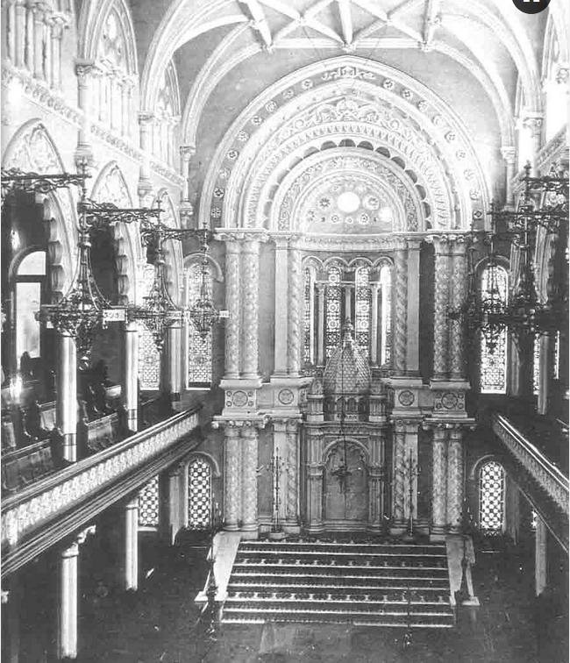

**Fig. 76** Interior, The Great Synagogue, Sydney, designed by architect Thomas Rowe (1829–1899). Photograph c.1890 by Charles Bayliss (1850–1897). View towards the Ark, located in a niche enveloped by a set of tall ornate moulded arches. The Ark, where Torah scrolls are safeguarded, is positioned against the western wall to direct the prayers to Jerusalem. This is a rare pre-1900 photograph before the *bimah* (reader’s platform) was moved closer to the Ark. As required in an Orthodox synagogue, ladies’ galleries are separate, here shown on the balconies behind the wide-open multi-foil arches.

## The Great Synagogue in Sydney

Historians of Jewish art call the decade from the 1870s to the 1880s the ‘Golden Age’ of synagogue architecture in High Victorian Britain.7 Perhaps not surprisingly, this time frame coincides with a ‘Golden Age’ of Jewish participation in Australian public life.8 Jewish life in the colonies was modelled on the Anglo-Jewish tradition, and the chief rabbi of Britain was also the Chief Rabbi of the Australian Jews; thus, The Great Synagogue Sydney represents the art and historical legacy of both continents. It is the largest and most complex example of Jewish architecture in Australia. It was designed and built between 1874 and 1878 by Thomas Rowe, originally of Penzance, one of the leading and most prolific architects in the colony. At the request of the local Jewish leaders, Rowe used the style and design of the 1870 Central Synagogue in London as a model, redesigning several of its stylistic features. The result is an eclectic style, with predominantly Romanesque and Gothic arches balanced with a few subtle decorative elements of Moorish design.9 Owing to the Rowe’s original design features, The Great Synagogue Sydney does not necessarily exemplify the common architectural style typical of synagogues in Europe and America in the second half of the nineteenth century. Surviving largely in its original form, the Synagogue has been recognised as a major architectural landmark of the late Victorian period in central historical Sydney, representing one of the most elaborately decorated Victorian sandstone buildings, both internally and externally. Since 2004, the Synagogue has been included in the State Heritage Register.10

As the oldest standing synagogue still in use in New South Wales, The Great Synagogue in Sydney has been a centre of interest for over a century. Past and present scholars focused on its religious and historic significance, and its architecture attracted also artists and tourists in Victorian times just as it does today. Since 1878, The Great Synagogue has represented the home of the mother congregation of Australian Jewry and been the base for some of Australia’s highest-profile rabbis, presidents, ministers and choirmasters. Its

7 Sharman Kadish, ‘The ‘Cathedral Synagogues’ of England’, *Jewish historical Studies*, Vol. 39 (2004), 10.

8 Suzanne D. Rutland, *Edge of the Diaspora: Two Centuries of Jewish Settlement in Australia*, Sydney: Collins Australia (1988), 107.

9 For the latest research on The Great Synagogue Sydney styles, see Benjamin J. Elton, *The Architecture of The Great Synagogue*, Sydney: The Great Synagogue, March (2019), 23–29.

10 State Heritage Register (2004), DP Folio No. 52572, [www.environment.nsw.gov.au/heritageapp/ViewHeritageItemDetails.aspx?ID=5051584](http://www.environment.nsw.gov.au/heritageapp/ViewHeritageItemDetails.aspx?ID=5051584)

liturgy has evolved over more than a century, often led by a Rabbi arriving from Britain. The services are based on a Modern Orthodox Ashkenazi rite in the Anglo-Jewish liturgical tradition, and are attracting younger generations of worshippers as well as retaining dedicated older members.11 The central location makes The Great Synagogue the first choice of worship for travelling Jews and the destination of cultural tourists.

## Scholarship on synagogue architecture of the nineteenth century

As discussed in Chapter 3, the international historiography of synagogue architecture has advanced significantly in the past decade, and the works of architecture historians such as Kadish, Snyder, Olson and Fine are relevant to this study, with Saskia Snyder’s research and the visual semiotics methodology applied in her latest work, *Building a Public Judaism*,12 remaining the most applicable. Snyder examined synagogues in London, Amsterdam, Paris and Berlin. Her analysis and visual reading of synagogue buildings essentially validate my methodology in interpreting the Jewish architecture of colonial Sydney.13 The final point to make about the international scholarship on Australian synagogue architecture is one of disappointment. I have noted earlier that the Egyptian style of Australian synagogues has only recently been noticed by international scholars. Similarly, The Great Synagogue still remains to be discovered, despite the fact that in the future it could be one of the few surviving original ‘cathedral’ synagogues left in the world, as discussed in the concluding section of this chapter.

Australian research on The Great Synagogue falls into two groups. One includes studies

published in the Australian Jewish Historical Society Journal,14 focusing on a particular

11 In 2019, the membership of The Great Synagogue Sydney was 850 families, with approximately 450 seats renewed each year. [https://www.greatsynagogue.org.au/](http://www.greatsynagogue.org.au/)

12 Saskia Coenen Snyder, *Building a Public Judaism*, 5–20.

13 Saskia Coenen Snyder, *Building a Public Judaism*, 87–149.

14 A journal dedicated to Jewish art history does not exist in Australia. *The Australian Journal of Jewish Studies*, as the key scholarly annual periodical, accepts contributions on all aspects and periods of Jewish culture but

studies on Jewish visual art and architecture appear rarely. The prime platform for the history of Australian Jews, the bi-annual *AJHS Journal* (1939–) also accepts, to a degree, art historical studies. Historic studies broadly corresponding with the topic and timeframe of my thesis include: Sydney B. Glass, ‘The foundations of The Great Synagogue’, *AJHS Journal*, Vol. 4 (1956), 157–171; O. P. Phillips, ‘The building of The Great Synagogue’, *AJHS Journal*, Vol. 9 (1984), 582–594; M. Z. Forbes, ‘The Great Synagogue and Zionism’, *AJHS*

aspect of the Synagogue’s history. They draw on the local community archives and have provided additional information to this present study. However, most of these studies do not interpret their findings in a broader international context. One exception is a recent article by Benjamin Elton who, while drawing on existing research, analysed a single aspect of the Synagogue’s interior architecture and positioned it in a theological as well as a European context.15 Elton’s is also the most recent study focused on the architectural style of The Great Synagogue,16 and therefore directly relevant to this thesis. The next body of literature is conspicuously smaller. Only two monographic history works are available, of which only one was published (R. Apple), drawing on the research of the unpublished one (O. P. Phillips).17

In 2008, Raymond Apple, one of the longest-serving former Senior Rabbis of The Great Synagogue, compiled a richly illustrated monograph on Synagogue’s history to mark its 130th anniversary (1878–2008).18 It comprised Apple’s earlier research19 and contributions from community historians. Apple is a prolific writer and skilful raconteur and shares many insightful remarks. As a result, the most comprehensive monographic analysis of The Great Synagogue’s building and architecture to date is the report prepared by the architect

*Journal*, Vol. 10 (1988), 57–67; Miriam Solomon, ‘Music and musicians of The Great Synagogue, Sydney’, *AJHS Journal*, Vol. 11 (1993), 896–921; and Benjamin J. Elton, ‘The alterations to the interior of The Great Synagogue’, 243–259. Publications outside the *AJHS Journal* include Israel Porush, *The House of Israel. A Study of Sydney Jewry from its Foundation (1788) and a History of the Great Synagogue of Sydney, the Mother Congregation of Australian Jewry, Compiled on the Occasion of its Centenary (1878–1978)*, Melbourne: The Hawthorn Press (1977), 20, 35–44. Art historical studies relevant to this thesis include ‘Some treasures of the Great Synagogue’, *AJHS Journal*, 3 (6) (1951), 257–275; and Jana Vytrhlik, ‘Symbol of Jewish continuity: the Torah finials from The Great Synagogue in Sydney’, *AJHS Journal*, Vol. 23 (2018), 619–639. Publications outside the *AJHS Journal* include Marcelle Jacobs, ‘Judaica at the Great Synagogue’, *World of Antiques and Art*, 64 (Feb-July) (2003), 112–117; Marcelle Jacobs, ‘Treasures of The Great Synagogue’, in Raymond Apple, *The Great Synagogue, A History of Sydney’s Big Shule*, Sydney: UNSW Press (2008), 20–24; Brittany Freelander and Susan Bures, *Treasures of The Great Synagogue*, *AM Rosenblum Jewish Museum*, exhibition catalogue, Sydney: The Great Synagogue, (2011).

15 Benjamin J. Elton, ‘The alternations to the interior of The Great Synagogue’, 243–259.

16 Benjamin J. Elton, *The Architecture of The Great Synagogue Sydney*.

17 Orwell & Peter Phillips Architects, *‘*Conservation Management Plan [for] The Great Synagogue Sydney’,

unpublished report for the Board of Management of The Great Synagogue, revised edn, July (2007); and

Raymond Apple, *The Great Synagogue, A History of Sydney’s Big Shule.*

18 Raymond Apple, *The Great Synagogue, A History of Sydney’s Big Shule.*

19 See Rabbi Apple’s website, a fount of detailed information on many topics concerning Australian Jewish history, [https://www.oztorah.com/; ‘](https://www.oztorah.com/)The musical history of The Great Synagogue, Sydney’; ‘125th anniversary

of The Great Synagogue, Sydney’, ‘ ‘120th anniversary of The Great Synagogue, Sydney’, ‘Great Synagogue Rabbis and the British Chief Rabbinate’.

O. P. Phillips (2007).20 It is not surprising to find the name Phillips associated with research on this topic. The family’s patriarch, Louis Phillips (1838–1913), arrived in Sydney from England in the 1850s and was involved in the design and budget of The Great Synagogue in the 1870s.21 His son, Orwell Phillips (1877–1957), a merchant, was a member of the Board of Management of The Great Synagogue for more than forty years.22 The O. P. Phillips study draws on Louis Phillips’s family papers, both pictorial and text records,23 and as such, it significantly contributes to our knowledge of the Synagogue design process and the envisioned structure. As architects themselves, Orwell and Peter Phillips’ technical and visual insights resulted in a comprehensive report from which this chapter drew to advance the corresponding arguments.

## Historical perspective

As discussed in Chapter 3, the Jews in Sydney formed their new visual identity, mostly condoned by the community at large, around their first synagogue in York Street. The colony was rapidly changing, and Sydney was becoming a modern city. In 1851, new social rules were established when gold was discovered in Australia, first in rural New South Wales and soon after in Victoria.24 Attracted by the prospect of more business and profit, Sydney’s population grew from just under 40,000 in 1851 to around 150,000 by 1871.25 The Jewish community in the city increased by a similar proportion, and it was clear that the

20 Orwell & Peter Phillips Architects, ‘Conservation Management Plan’, (2007). The report draws on earlier study, O. P. Phillips, ‘The building of The Great Synagogue’, *AJHS Journal*, Vol. 9 (1984), 582–593. The study was re-published (without the footnotes) in *Yismach Yisrael: Historical Essays to Honour Rabbi Sr. Israel Porush, O.*

*B. E. on his Eightieth Birthday* (a special publication of the Australian Jewish Historical Society, Sydney (1988), 47–56. The identity of the author O. P. Phillips is somewhat confusing. The University of Sydney holds a copy of a study by one Orwell Peter Phillips, *Some Aspects of Building Site Operation in Sydney, 1870–1890*, MA Thesis, University of Sydney (1978). Later, one Peter Phillips published a conference paper (online), *Singing the Lord’s song in a strange land: The Great Synagogue, Sydney*, in 16th ICOMOS General Assembly and International Symposium: ‘Finding the spirit of place – between the tangible and intangible’, Quebec, Canada, 29 September– 4 October (2008), 1–9. This paper draws substantially on the original article from 1984. Peter Phillips, an architect, is presently heading the company Orwell & Peter Phillips in Sydney which was founded by his father Orwell Phillips in 1947. [www.opp.net.au/](http://www.opp.net.au/)

21 ‘Late Mr. Louis Phillips: A Philanthropic Citizen’, *The Sydney Morning Herald*, 8 November (1913), 19.

22 ‘Orwell Phillips Obituary’, *AJHS Journal*, 4 (1957), 320–322, citing *The Great Synagogue Journal*, September (1957) no page given. His son Orwell Phillips was an Honorary architect to the Synagogue and Peter Phillips (of Orwell & Peter Phillips) led several major restoration projects at The Great Synagogue, [www.opp.net.au/](http://www.opp.net.au/)

23 O. P. Phillips, ‘The building of The Great Synagogue’, *AJHS Journal*, 9 (1984), 582–593.

24 ‘Discovery of an extensive gold field (From the Bathurst Free Press)’, *The Sydney Morning Herald*, 15 May (1851), 3. Also cited in Suzanne D. Rutland, *Edge of the Diaspora,* 50.

25 Garry Wotherspoon, *Economy*, Dictionary of Sydney (2008), [dictionaryofsydney.org/entry/economy](http://dictionaryofsydney.org/entry/economy))

colony’s Jewish minority had entered a new era.26 According to the 1851 census, 979 Jews lived in New South Wales, 364 in Victoria and 435 in Van Diemen’s Land.27 Within three decades, by 1881, the Jewish population had more than tripled in New South Wales, but the most dramatic increase was recorded in Victoria, making it – at the time – the most important Jewish centre in Australia and bringing the overall number of Jews in the Australian colonies to more than 9,000.28 The gold rush also attracted Jewish immigration from outside of Britain. During the 1850s, large numbers of Jews from continental Europe were drawn to the goldfields, among them almost 900 from Germany.29 In addition, with the arrival of Jews from Eastern Europe, the community’s diversity increased and the demographic widened. More Jews were now settling in rural areas and, by 1861, 40 per cent of Australian Jews lived outside of the main cities.30

As concluded in Chapter 3, the missionaries’ earlier efforts may have resulted in a sense of urgency and focus. During the 1860s and 1870s, the missions to the Jews, while still active, changed tactic, and the pressures were no longer a threat to the survival of Judaism. The preaching and missionary visits to the Synagogue were replaced by an open debate on the pages of the daily newspapers, which favoured the Jews’ right to maintain their faith:

To talk about converting the Jews to Christianity or any other religion is, to my mind, simply nonsensical. They have gone through a fiery ordeal in past ages to maintain the tenets of their faith, and shall they yield now, when civilisation and education have removed in English-speaking countries every barrier to their social advancement?31

In 1868, an erudite editorial praised the Jews of Australia for their energy and industry in contributing ‘largely to raise our commerce to its present high position. Their [Jewish] prosperity has imparted itself, in no small degree to the whole community’.32

26 Suzanne D. Rutland, *Edge of the Diaspora,* 50.

27 Israel Porush, *The House of Israel,* 19, 334.

28 In 1881, 3,266 Jews lived in NSW, three-quarters of them in Sydney; 4,330 Jews in Victoria and a total of 9,125 in Australia. Over the next twenty years, Victoria’s Jewish population would surpass that of NSW; see Israel Porush, *The House of Israel*, 334.

29 Israel Porush, *The House of Israel*, 18, 19.

30 Suzanne D. Rutland, ‘Jews’, in James Jupp (ed.), *The Australian People: an encyclopedia of the nation, its people and their origins*, Cambridge, New York: Cambridge University Press (2nd edn) (2001), 527.

31 ‘Conversion of the Jews’, *The Argus*, 23 November (1876), 6.

32 ‘The Jews’ Synagogue’, *Empire*, 4 July (1868), 5.

The Jewish population was enjoying growth in numbers and prosperity, and the strengthening of their religious life would naturally follow. Yet, within the seemingly prospering Jewish congregation, an internal theological matter divided the community.

## The Macquarie Street synagogue

The breaking away of about twenty Jews to form a new ‘synagogue’ in the late 1850s was an important chapter in the history of the Sydney Jewish congregation and its visual identity. The stated cause of the dispute was at the heart of Jewish religion. It concerned the circumcision – the ultimate sign of covenant with God – of a son born to a non-Jewish mother and Jewish father.33 The decision made by the Synagogue Board and carried out by the *mohel* (a Jew trained to circumcise) was evidently unacceptable to the more traditional and affluent members of the congregation. As discussed shortly, it seems that other concerns were also at play.34

It is not known exactly where on Macquarie Street the breakaway group adapted a building to a synagogue, which would be named the Tabernacle of David.35 Two newspaper references from 1859 indicate that it was ‘a small Jewish Synagogue’, ‘opposite the Council Chambers’ (today NSW Parliament on Macquarie Street), ‘reached by a narrow passage’.36 In any case, the central location in the vicinity of government buildings would have been possibly regarded as a touch more prestigious than the York Street location near a few taverns and the Old Police Court. A drawing of the frontage of a one-story house, presumed to be the Macquarie Street ‘synagogue’, appeared in the 1970s,37 showing a building of simple Georgian brick architecture, c.1835, with a central two-pilaster entrance flanked by two large round-arch windows and a low-angle roof. Inside, according to the *Sydney*

33 In intermarriage, the child of a Jewish woman is universally recognized as Jewish. However, a child born to a Jewish father and gentile mother, is not – by the Orthodox rite – Jewish and would need to be converted.

34 Israel Porush, *The House of Israel*, 20; also Israel Porush, ‘The reason for the Macquarie Street secession: Part 2 – the case from the York Street records’, *AJHS Journal* 3 (1) (1949), 14–28; and David J. Benjamin, ‘The Macquarie Street Synagogue, 1859–1877’, *AJHS Journal* 3 (9) (1953), 379–432, and correction in *AJHS Journal* 3

(10) (1953), 489.

35 It was also called the New Sydney Synagogue, or New Synagogue as this title shows, ‘Religious Memoranda. Opening of the New Synagogue, Macquarie Street’, *The Sydney Morning Herald*, 13 October (1859), 11. There is a discrepancy in the date of consecration: in this article the newspaper states 26 September, but Porush states 9 September [without further reference], see Israel Porush, *The House of Israel*, 21.

36 (Advertising), ‘New Synagogue’, *The Sydney Morning Herald*, 5 September (1859), 1; ‘Old Macquarie Street’,

*The Sydney Morning Herald*, 13 June (1914), 7.

37 Reproduced in Israel Porush, *The House of Israel*, 106 ff., Pl. 1, ‘New Synagogue, Macquarie St. (1859–77)’

[without further reference].

*Morning Herald*, the room was ‘fitted up in a very neat and unique style, and much pains appear to have been taken with its fittings’.38 It appears therefore that efforts for the visual expression of piety were channelled to the adornment of the sanctuary and Torah. Furthermore, it was reported that the new congregation conducted its services in Hebrew, according to orthodox principles, and with the choir singing the opening hymn to musical accompaniment.39 During the consecration ceremony, the procession of Torah scrolls, ‘adorned in rich white mantles and with silver “bells”, under the white silk canopy’,40 was the highlight of the celebrations.

On the surface, for a period of almost twenty years, both synagogues would have appeared to coexist side by side, conducting services and solemnising marriages.41 The York Street Synagogue, embodied in the Egyptian style architecture, was recognised as the principal congregation, while the Macquarie Street house of worship functioned as an independent entity.42 Its members provided the necessary means to maintain the synagogue and religious services. A set of ceremonial textiles was donated for the inauguration in 1859,43 and it is possible that some of the silver ornaments, now in the Museum collection at The Great Synagogue, also originated with the break-away congregation. It is tempting to imagine that the Sydney *rimmonim*, explored in-depth in Chapter 2, could be among the silver bells embellishing one of the mentioned Torah scrolls. Interestingly, comments about Jewish ceremonial objects in the Australian colonial press were rare, and I will discuss the possible explanation in the next chapter.

38 ‘Opening of the New Synagogue, Macquarie Street’, *The Sydney Morning Herald*, 13 October (1859), 11.

39 Israel Porush, *The House of Israel,* 21.

40 ‘Opening of the New Synagogue, Macquarie Street’, *The Sydney Morning Herald*, 13 October (1859), 11. The white colour of the Torah mantles and other fabrics indicates the approaching festival of Yom Kippur, Hebrew year 5619.

41 ‘Family Notices, Marriages’, *Evening News (Sydney)*, 30 April (1870), 2; and ‘Family Notices, Marriages’,

*Evening News (Sydney)*, 18 February (1871), 2.

42 ‘New Synagogue, Macquarie Street, Notice’, *The Sydney Morning Herald*, 5 September (1859), 1; and ‘Notice. The Dedication’, *The Sydney Morning Herald*, 24 September (1859), 1.

43 ‘Opening of the New Synagogue, Macquarie Street’, *The Sydney Morning Herald*, 13 October (1859), 11.

## The changing image of Australian Judaism

The Australian historian who consolidated research into the early socio-religious divides in the Jewish community in Sydney was Garry Luke whose findings were introduced in previous chapters. Perhaps not surprisingly, Luke dates the initial signs of friction within the Jewish community to the 1820s, coinciding with the first arrivals of free and wealthier Jewish settlers from Britain. In general, the colonial society saw these new Jewish settlers as more respectable citizens and devout worshippers than the settled class of Jewish convicts and emancipists. There was also contrast in the newcomers' self-perception and attitudes.44 The turning point came in 1859 when disagreement of the growing community of the emancipists over the mentioned religious matter triggered the departure of the free settlers. Israel Porush, historian and former Rabbi of The Great Synagogue, assessed the break-up of the congregation as ‘ the unnecessary split’ fuelled by personal motivations and ‘the vexed discord between the emancipist and the free settler’.45 Nevertheless, I believe that the conflict was critical for the clarification of the future congregational identity and its visual development. It seems that the disagreement over the right to a ritual circumcision highlighted the core challenge that commenced to appear already in 1833 when the first synagogue’s *Laws and Rules* were issued. Then, the Sydney congregation was to follow the Ashkenazi rules of the Jews in England, but it was also willing to compromise and ‘curtail, modify, and abridge [the form of prayers and consequently the laws] as may be deemed necessary by the Committee’.46 This laxity itself towards the strict observance may not have been the essence of the issue, rather, it was how far, in effect, such leniency would extend. In 1861, the Macquarie Street Synagogue's Rules confirmed the congregation to be guided by ‘strict orthodox principles’ but simultaneously asserted ‘the right to decide upon all affairs … without reference to any clerical authority’.47

44 Gary Luke, ‘Forging the first Australian *kehillah*: 1820 to 1832’, *AJHS Journal* 23(2) (2017), 222–230.

45 Israel Porush, *The House of Israel,* 20–21. Israel Porush (1907–1991), Rabbi at The Great Synagogue from 1940 to 1973.

46 *Laws and Rules for the Management and Regulations of the Sydney Synagogue: Beth Hakanassas Kahl Koudesh Beth Tephillah: Instituted A.M. 5591 and Established A.M. 5592* (1833), 4.

47 Israel Porush, *The House of Israel,* 21.

As noted, the rift between the two Jewish groups seems to have run deeper and possibly even at an individual level than what most people in the colony were accustomed. At first glance, the cause was the objectionable religious decision made by the York Street Synagogue Board. But it is possible that the more prosperous and conservative Jewish merchants were also distancing themselves from their socially less acceptable and respectable coreligionists, whose convicts' pasts could taint the desired public image and acceptance. This disparaging attitude would have had a contemporary European parallel. The emancipation movement freed the Jews from their unsanitary ghettos, and the emerging wealthier Jewish middle-class would not always welcome the modern exodus that could pose a threat to their social progress.48 Australia had never had Jewish ghettos, but in the mid-nineteenth century, it still had its ubiquitous Jewish convicts' past.

Since the foundation of the York Street Synagogue in 1844, several new major sandstone constructions had been built nearby, visually dwarfing the Synagogue. By the late 1870s, the streetscape of the immediate surroundings of the Synagogue had changed dramatically. Across the street, under construction, stood the massive florid Romanesque Queen Victoria Market and the tall tower of the neo-Renaissance Town Hall complex. A few metres away was the large St Andrew’s Cathedral, modelled after the fashionable Gothic style. Sydney had advanced into an active urban entity, and the Jewish community would need to negotiate for a new identity that reflected new aspirations. What made the York Street Synagogue’s architecture distinct in 1844 would now look archaic and overshadowed by the monumentality and civic importance of the nearby Sydney Town Hall.49 It appears that the Jewish community in Sydney was outgrowing its early colonial synagogue, and not only by its size. A building ‘creditable to the position [the Jewish community] had been called upon to occupy in Sydney and New South Wales’50 was now desired. Strong signals of change were also coming from London, where the establishment of a union of major Ashkenazi synagogues, called the United Synagogue (1870), resulted in a ‘well-organised, acculturated’ body, which played a dominant role in deciding on the new appearance of

48 On Jews leaving ghetto in Berlin, see Saskia Coenen Snyder, *Building a Public Judaism*, 199–200.

49 The construction of Sydney Town Hall commenced in 1869, and it was designed to be a symbol of the wealth and status of the city. The building was constructed in the ‘Second Empire style’ in two stages, 1868 – 1878 and 1885 - 1890.

50 Cited in Orwell & Peter Phillips Architects, ‘Conservation Management Plan’, 10.

synagogue buildings.51 Australian newspapers published extensive reports of the inauguration of the Central Synagogue in London in April 1870, describing in detail the ‘striking interior, and the loftiness of its proportions [that] at once arrests attention’.52 With this awareness, the vision of the future Great Synagogue in Sydney may have been born, as the events highlighted in the following section indicate.

## A vision of a cohesive Jewish identity

Goldrush immigration was followed by a growing prosperity and rapid social and economic changes. The schism in Sydney’s Jewish congregation may have eased, and by the

mid-1870s, the community seemed to agree to unite, with the Macquarie Street Synagogue closing in 1877.53 Due to the efforts of the religious leader Rev. A. B. Davis54 (**Fig. 17**), Sydney Jewry ultimately progressed to the unified vision of changing identity. Reverend Alexander Bernard Davis (1828–1913) was appointed as minister of the York Street Synagogue in 1862. From 1871, Davis was instrumental in inspiring the building of the new synagogue to ultimately become the new visual expression of the community’s identity. His efforts were encouraged by the desire to strengthen the Sydney Jewish community’s visibility and prominence, which in turn, was another significant factor in the process of unification.55

A Jewish community meeting was held on 13 March 1871, where Davis presented the 'unification' speech and discussed the proposal of building a new synagogue in the city.56 More than three decades had passed since the first public meeting in 1839 when the purpose of building the first dedicated synagogue in the colony was discussed (Chapter 2).

51 Saskia Coenen Snyder, *Building a Public Judaism*, 88–89.

52 ‘Consecration of the Central Synagogue’, *Evening News*, 17 June (1870), 3; and ‘Consecration of the Central Synagogue’ *Empire,* 18 June (1870), 4.

53 Israel Porush, *The House of Israel,* 22.

54 Suzanne D. Rutland, *Edge of the Diaspora,* 60–63. According to others, both congregations had to work together to receive the desired assistance from the government, and ‘this enforced collaboration probably helped to reunite the two’. This comment is not to diminish Davis’ efforts but to acknowledge other forces. See *Minutes of the Board of the Sydney Synagogue*, 3 July (1870), cited in Orwell & Peter Phillips Architects, ‘Conservation Management Plan’, 9.

55 The colonial government’s decision to contribute funds to a single synagogue was also a decisive aspect of the congregation unification.

56 Meeting held at Masonic Hall in York Street and reported next day in ‘Latest telegrams. The Meeting in the Masonic Hall’, *Evening News*, 14 March (1871), 3; and over the week in other newspapers across the colonies; see ‘The New Synagogue’, *The Sydney Mail and NSW Advertiser*, 18 March (1871), 82;

The community now met again to nominate the building committee and consider what proved to be the most significant decision in respect of the visual identity and, ultimately, of the Jewish visual legacy of the colonial era of Australian history. The proposal was accepted, and with it, as will be explored, the congregational factions not only settled their differences, they also advanced to a break-up with the convict chapter of their past.

Nowhere was it more evident than in the image that the new synagogue was to convey, and

in the prestigious city location it was to occupy.

Some of the older members of the congregation attending the meeting in 1871 may have remembered the beginnings of the York Street Synagogue. In 1839, the Synagogue Board distributed a circular,57 and similarly, in 1871, a document was distributed to the community.58 In comparing them, some interesting features can be highlighted. Firstly, at the 1871 meeting, the Committee provided vital details about the envisioned construction. The location in Elizabeth Street was determined, the architectural style was outlined and a vision shared of ‘a handsome building filled with all the appliances of modern Synagogues as now prevailing in Europe and America’.59 Moreover, a photograph was attached, introducing the interior of the recently opened Central Synagogue in [Great] Portland Street in London, designed by Jewish architect Nathaniel S. Joseph, which was to become a design model for the new Sydney synagogue (**Fig. 77**).60 Finally, comparing the semantics, it is of interest to note that in 1839, community members referred to themselves as ‘Israelitish’, ‘Israelites’ and ‘Children of Israel’, and *The Circular* had the character of a religious text.61

In contrast, in 1871, the matter-of-fact tone replaced the sanctity of the text's style. The words ‘Jews’ and ‘Jewish’ returned to the congregational vocabulary.62 This self- identification would be maintained a little later, when newspapers in Australia reported on 'The Opening of the New *Jewish* Synagogue' and associated events of the *Jewish*

57 Circular to the Members of the Faith of Israel, 1839, State Library of NSW collection, JA Pam 261/1, 1-4. 58 Circular, ‘New Synagogue, Elizabeth Street, Hyde Park, 3 April, 1871, in Orwell & Peter Phillips Architects, ‘Conservation Management Plan’, 10, 11.

59 Orwell & Peter Phillips Architects, ‘Conservation Management Plan’, 10.

60 Orwell & Peter Phillips Architects, ‘Conservation Management Plan’; Minutes of Sydney Synagogue Board Meeting (1841–1877), 8, 9, 13, 14, 16ff.

61 This is in reference to Chapter 3, *The Circular* (1839), where the text was reviewed and the semantic implications considered.

62 The 1871 Circular is reproduced in Orwell & Peter Phillips Architects, ‘Conservation Management Plan’, 10.

community.63 It seems therefore that the period of using an alternative self- representation was framed by the years 1839 and 1870, which roughly corresponded with the peak of the missionary campaigns to the Jews in Australia (Chapter 2).

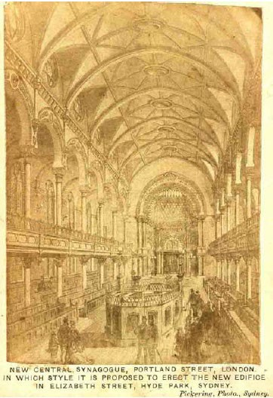

**Fig. 77** 'New Central Synagogue', Portland Street, London. [Inscribed] ‘In which style it is proposed to erect the new edifice in Elizabeth Street, Hyde Park, Sydney’. Pickering Photo, Sydney.64 (**Fig. 84).**

63 For example, ‘Grand Jewish Wedding in Sydney’, *Town and Country Journal*, 9 and 16 March (1878), 9 and

440. The name Great Synagogue appeared a few days after the opening, on page 9; Phillips claims that it in fact was already used in Herald, in 1875. See Orwell & Peter Phillips Architects, ‘Conservation Management Plan’, 27.

64 A photograph of an engraving of the Central Synagogue in London, consecrated in 1870. The image was distributed at the Sydney Jewish community meeting in Sydney on 13 March 1871. Reproduced in Orwell & Peter Phillips Architects, ‘Conservation Management Plan’, 11, Fig. 2.2.

## Model synagogue in 1871

The **Fig. 77** shows the image distributed at the Jewish community meeting in Sydney in 1871. It is a photograph (from a Sydney studio) of an engraving depicting the interior of the Central Synagogue in [Great] Portland Street in London that was inaugurated in June 1870. It was one of the first of the new style of synagogues in England, spatially immense and elegant, and signifying the style that art historians would later term the ‘cathedral synagogue’. The newspaper reports from the opening that reached Sydney65 would

provide an important boost to the Committee, enabling them to present their proposal to the congregation with a reasonably accurate vision of the synagogue. This vision – the interior photograph together with building plans – would be later conveyed also to the architect Thomas Rowe.66 It is possible that the Building Committee members may have understood the symbolism of the grand architecture of London’s Central Synagogue. They would have been aware of the momentous changes that were underway in the socio- political and cultural status of Jews in Britain, France and Germany.67 In view of the growing interconnection between the Anglophone Jewish Diaspora and the existence of transnational Jewish networks (Chapter 2), it is possible that the Jewish leaders in Sydney, themselves representatives of a rising community, who enjoyed relatively more administrative freedom than their coreligionists in London or Berlin,68 aspired to construct a such synagogue that would symbolise and herald the changing times in Sydney.

### Certificate of Title

The oldest known record pertinent to the history of The Great Synagogue in Sydney is the

*Certificate of Title*,69 a handwritten document on a large folio of parchment paper. Dated

65 ‘Consecration of the Central Synagogue’, *Empire*, 18 June (1870), 4.

66 For records of aspects of the Sydney Synagogue’s planning stages, see Orwell & Peter Phillips Architects, ‘Conservation Management Plan’, 12ff.

67 Colonial press of the early 1870s reported regularly on social and legal standing of Jews in France, Britain and Germany; see for example Prussian chancellor Bismarck’s views concerning the Jews in France, ‘The Policy

of Humiliating France’, *The Sydney Morning Herald*, 9 December (1870), 6; or on legal position of Jews in France, ‘Family Litigation’, *Sydney Mail*, 17 December (1870), 6; and ‘The Jews as Politicians’, *The Herald* (Melbourne), 16 August (1872), 4.

68 Snyder describes some of the restrictions in Berlin and London when building a new synagogue and deciding on it location, style and level of decoration; see Saskia Coenen Snyder, *Building a Public Judaism*, 89, 103, 117,

118, 121.

69 *Certificate of Title*, 1871, ink on paper parchment.

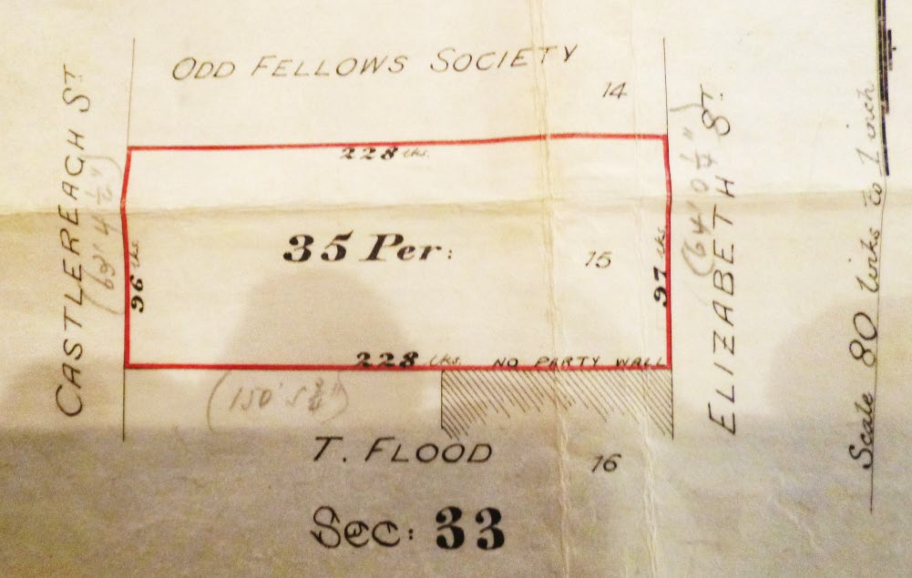

**Fig. 78** Detail, *Certificate of Title*. Black and red pen sketch of the Land Lot 15 of 35 perches, marking the future position of The Great Synagogue in Sydney. Drawn on reverse of the *Certificate of Title,* 1871. Later additions of measurement figures are made in pencil. ‘Sec. 33’ refers to ‘Section 33’ map register of the 1833 City Survey Plans (City of Sydney Archives), redrawn in 1880.

21 March 1871, only a week after the community meeting, it reveals some new and useful information. Most importantly, it records the legal registry and transfer of the land lot situated opposite Hyde Park, between Elizabeth and Castlereagh Streets.70 On its reverse side is a sketch of a simple plan (**Fig. 78**) showing the lot’s position in relation to its four boundaries, with Elizabeth Street to the east, Castlereagh Street to the west and two adjacent buildings to the north and south. The lot was purchased for £2,004.12.9, and by the end of 1873, all previous structures on the site had been demolished to commence preparations for the construction of the new synagogue.71 The perimeter was recorded as being 64 feet (19.5 m) wide and 150 feet (45.7 m) long,72 making its footprint

70 *Certificate of Title*, 1871, ink on paper parchment.

71 Orwell & Peter Phillips Architects, ‘Conservation Management Plan’, 5.

72 On the plan, the exact figures read W 64’ 0 ¼”‘ (the east side, or Elizabeth Street, and 63’4’ ¼’’ on the west, Castlereagh Street). There is a discrepancy with the building’s depth figures: the press reported 140 feet while

approximately twice the size of the former York Street Synagogue (Chapter 3). It was also obvious that the rectangular-shaped site was closely bordered on the north and south sides by the walls of the adjacent buildings. These factors could have either limited the architect’s options or alleviated the challenges in terms of the key proportions and floor plan of the new edifice. While the York Street Synagogue was built as (and always remained) a free-standing structure with six tall unobstructed windows on the south side, with three front and three back windows,73options for The Great Synagogue were clearly limited.74 Synagogue’s windows are not just a source of daylight; by Jewish laws, they are seen as conduits to expedite prayers towards the heavens.75 Thus, understandably, historians of The Great Synagogue asked in the past 'why were there no windows along the side walls, even though there are 12 arches [recessed]...?76 A possible explanation is that to achieve sufficient clearance from adjacent walls for a safe laneway and adequate light, a substantial decreasing in the Synagogue’s dimensions would be required. A reduction of the width of the Synagogue by minimum 3 metres on each side would achieved the desired effect but it would reduce the seating capacity, and alter the well- proportioned rectangular shape into an uncomfortably long and narrow configuration.

Moreover, projecting this situation into the future, if either neighbour wished to build higher, the benefits for the Synagogue would be lost, indeed, its security would be compromised if either side windows or laneways were introduced. Fast forward, and in 1925, such considerations became obsolete when the Manchester Unity Building had risen to new heights, wholly overshadowing the Synagogue (**Fig. 79**).

the plan reads 150’ 5 2/4”‘. Refer to *Certificate of title,* 1871; and ‘Consecration of the New Synagogue’, *The Sydney Morning Herald*, 5 March (1878), 3.

73 Refer to Chapter 2, **Fig. 52** and Chapter 3, **Fig. 61**.

74 These walls are on the plan referred to as ‘party walls’, a term that carries a statutory definition in respect of the maintenance of and alterations to the adjoining walls – the Odd Fellows building walls on the north and T.

Flood in the south. Later, in the 1920s, a serious fault with the required thickness of the north wall was uncovered, prior to the expansion of the Odd Fellows building, see Gordon Samuel Keesing (1888–1972) letter to the Synagogue Board, 1 May 1922, TGS File 1922. This could have been another reason for the lack of full- length windows.

75 Ena G. Heller, ‘Western Ashkenazi synagogues in medieval and early modern Europe’, in Steven Fine (ed.),

*Jewish Religious Architecture: From Biblical Israel to Modern Judaism*, Boston, MA: Brill (2019), 169, 174.

76 For example, Raymond Apple (ed.), *The Great Synagogue: A History of Sydney’s Big Shule*, 6. Note 74 above.

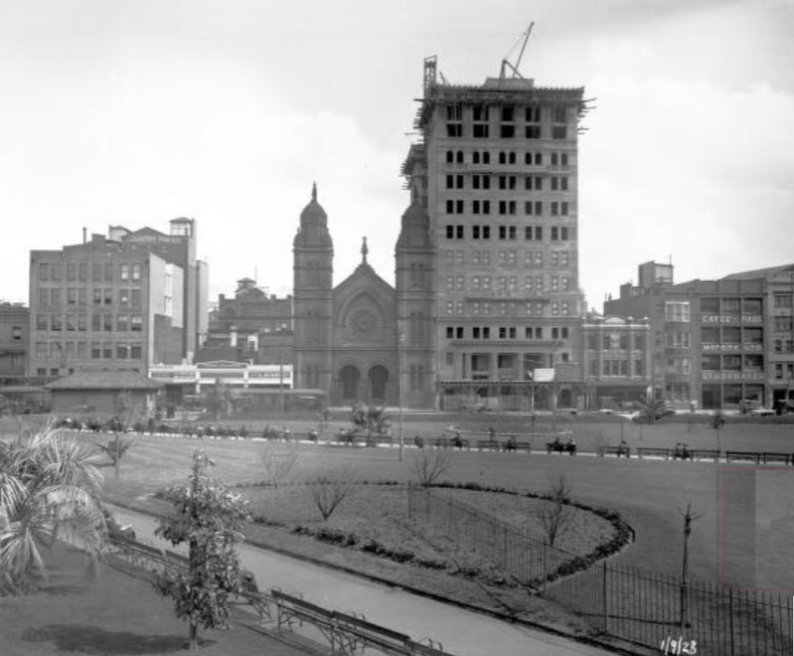

**Fig. 79** The Great Synagogue, Sydney, in 1923, viewed from Hyde Park. The construction of the adjacent Manchester Unity Building commenced in 1922, rapidly dwarfing the synagogue. By 1925, the massive urban structure was heralding another changing image of modern Australian Judaism. National Library of Australia.

## Architect Thomas Rowe

### Design competition

After purchasing the land and securing the Jewish community’s enthusiasm for the new synagogue, a design competition was held in 1872–1873. Three architects – Thomas Rowe, G. Allen Mansfield and Benjamin Backhouse – were invited to submit one or more designs.77 The process was protracted, and the architects were asked several times to submit design variations. Eventually, in 1874, Rowe was selected as the architect and construction manager of the new project. While Rowe’s winning design survived (**Fig. 80**), regrettably, no artworks nor design records submitted by the other two architects are known.78

77 Orwell & Peter Phillips Architects, ‘Conservation Management Plan’*,* 13, 76.

78 Rowe’s winning design was reproduced in 1874 in newspapers, ‘New Jewish Synagogue, Sydney’, *Illustrated Australian News for Home Readers*, 10 August (1874), 131, Illustration on 133; other newspaper reporting on the design competition ‘The Great Synagogue’, *The Sydney Mail and New South Wales Advertiser*, 9 March

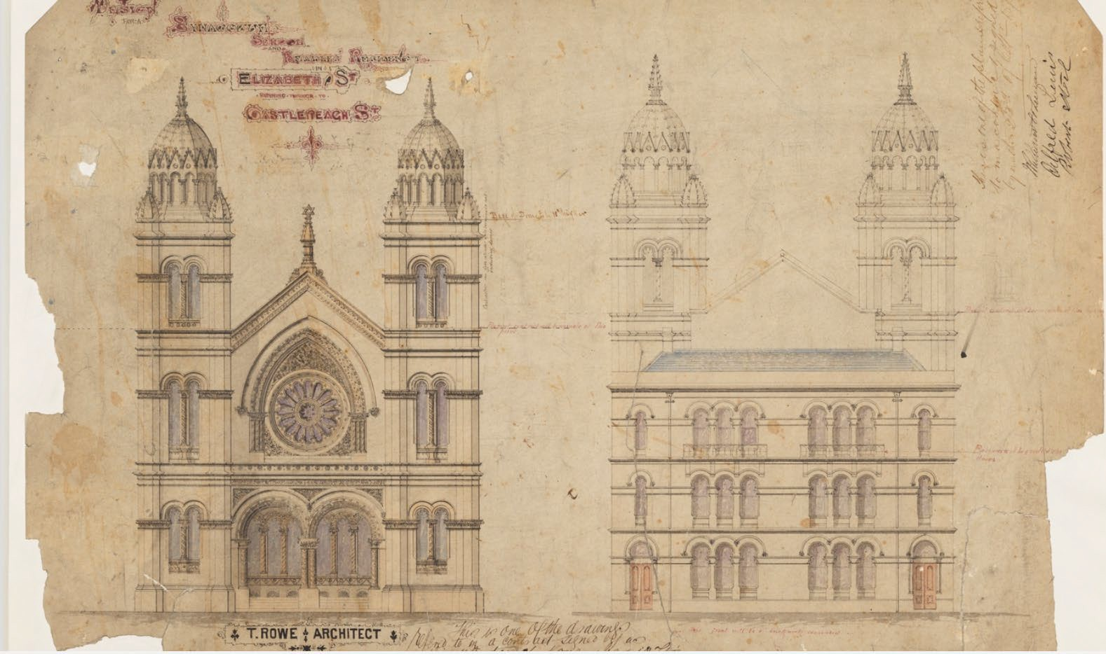

**Fig. 80** Winning design for The Great Synagogue in Sydney (with school and beadle’s residence), drawing by Thomas Rowe, 1874. State Library of New South Wales.

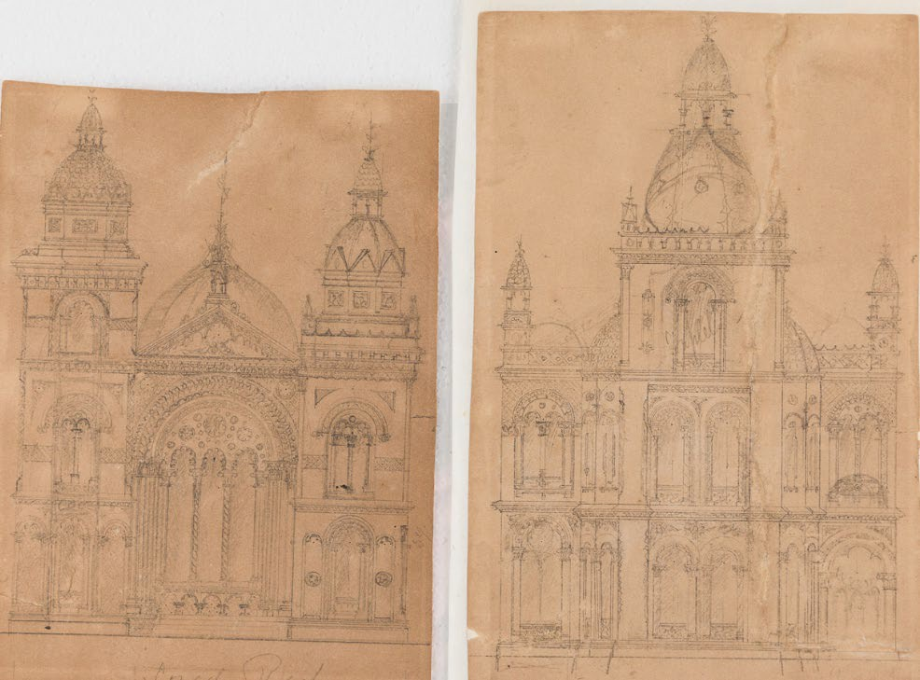

**Fig. 81** Two architectural drawings of [presumed] synagogue facade by Thomas Rowe, c.1874. Thought to be preliminary sketches of The Great Synagogue in Sydney. Some of the design ideas will be further developed in the final construction, including the two-tower structure with a triangular roofline (instead of a full pediment), and double-arched windows featuring a multi-foil decoration (left) or the tall cupolas embellished with crockets decorating the outer corners (right). (**Fig. 89 d**).

(1878), 302–303. See also Orwell & Peter Phillips Architects, ‘Conservation Management Plan’, 76. Foundation stone for The Great Synagogue was laid 16 January 1875; the consecration was on 4 March, 1878. The reported cost was just over £23,000.

Interestingly, Rowe had worked for the Jewish community prior to the design competition. In March 1863, he placed in the press a call for tenders for repairs jobs at the York Street Synagogue.79 The original architect of the Synagogue, James Hume, was still practising in Sydney,80 but the Board engaged Thomas Rowe (1829–1899) who was to become an accomplished colonial architect. Within a decade of his arrival (1848),81 Rowe’s career was advancing.82 Meanwhile, the composition of the Synagogue Board had changed, and new ideas were sparked by the arrival of Rev. A. B. Davis in Sydney in 1862.83 By the time the Synagogue Board decided to build a new synagogue in 1871, Rowe had gained experience in designing a range of ecclesiastical and secular buildings. Besides, as an alderman for the City Council, he would be familiar with the administrative aspects of a large construction.84

### Rowe’s inspiration

It is known that the Synagogue Committee presented Rowe with an image (**Fig. 77**) as well as own ideas for the new synagogue’s style. Whereas Phillips concluded that Rowe had markedly adhered to the interior plans of the London synagogue,85 my analysis of architectural elements and the building composition contests such a conclusion. In the next section, I investigate some of the building details, as well as the overall approach and inspirational sources. The customary stone-carvings and decorative details can be traced to Rowe’s earlier church buildings in Sydney,86 and at times, the architectural influences of his native Cornwall may also be suggested. In Penzance, as a young draftsman in his father’s building firm, Rowe would be surrounded by church architecture of various styles; indeed, many design elements that would later become his hallmarks, including square towers

79 ‘Advertisements: To Builders – Tenders’, *Empire*, 4 March (1863), 1.

80 After working on St Andrew’s Cathedral and building the synagogue in the 1840s, James Hume did not expand his practice. Last evidence of him working as an architect was in 1851. See Nicholas Bucciarelli, *James Hume: His Life and Work,* BA thesis, University of New South Wales (1993), iv, 126 and 159.

81 There is a discrepancy in Rowe’s arrival from England. The obituary – ‘Death of Colonel Rowe’, *The Sydney Morning Herald*, 16 January (1899), 5 – states (erroneously, it seems) Rowe’s arrival as 1857; another source says 1850 – Raymond Apple (ed.), *The Great Synagogue*, 10; Phillips does not provide any information on Rowe’s arrival; and Rowe’s family papers show that Rowe ‘left for Sydney at the close of the year 1848’ – ‘A biography’, Rowe Family Papers, State Library of NSW, PX*D 138.

82 Orwell & Peter Phillips Architects, ‘Conservation Management Plan’*,* 14.

83 Orwell & Peter Phillips Architects, ‘Conservation Management Plan’*,* 7.

84 Rowe was an alderman for Bourke Ward, Sydney City Council, which included the construction site for The Great Synagogue from 1872 to 1876; <http://adb.anu.edu.au/biography/rowe-thomas-4517>

85 Orwell & Peter Phillips Architects, ‘Conservation Management Plan’*,* 15.

86 For example the Romanesque windows with round arches on Wesleyan Church in Goulburn, 1870, and St Paul’s Presbyterian Church in Hill End, 1872; or the triangular embellishments on the spire of the Presbyterian Church in Glebe, 1876.

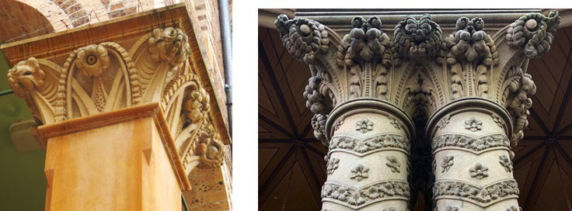

1. Sydney Hospital, Nightingale Wing, 1869. Rowe’s early commissions in Sydney heralded his sculptural approach to a

stone that was to embody the city’s beauty and historical achievements.

1. The Great Synagogue, Sydney, 1878. Exterior portico columns decorated with Hibiscus tree flowers, vine leaves and grape garlands.87 Two stylised flowery capitals are artfully carved into Corinthian capitals refashioned in the Victorian taste.

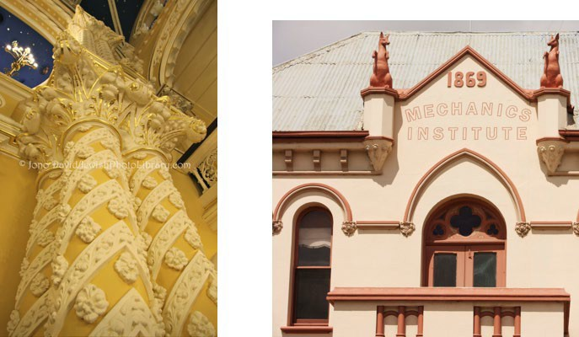

1. The Great Synagogue, Sydney, 1878. (d) Mechanics’ Institute in Yass, NSW, 1869.

Gilt moulding. An interior version of the A pair of kangaroo sculptures flank the pediment portico columns (b). of an early public education colonial building.

**Fig. 82 a-d** Details, sandstone ornaments and modelled sculptures on some of the Thomas Rowe’s (1829– 1899) early career buildings, and The Great Synagogue in Sydney, point to his Australian inspiration sources.

87 Vine and grapes are ancient Jewish symbols. See Chapter 3, Note 73. Hibiscus, also known as ‘rose of Sharon’ may have biblical origins, referring to the beauty in Song of Solomon 2:1, biblehub.com/kjv/songs/2.htm

with octagonal turrets, ornamental archivolts of recessed portals and semicircular Romanesque arches, can be found in the early nineteenth-century church architecture in his Cornish home town.88 Apparently, Rowe would have been readily inspired by Australia’s fauna and flora as well as the natural materials. **Figs. 82 a-c** show several examples of such an inspiration and exemplify Rowe’s skills in designing sandstone flowers and foliage. Rowe’s attempt to capture an Australian native animal may not have been as successful. A pair of kangaroos, cast in cement, were to crown his winning and ‘elegant design’ of the Mechanics’ Institute in Yass (1869).89 **Fig. 82 d** displays two large male upright kangaroos with somewhat less stylish result. Nevertheless, other designs on the Yass building indicate Rowe’s future use of trefoil and quatrefoil ornaments as well as the pointed arch over a large rounded Romanesque curve. Furthermore, The Great Synagogue’s design alludes to Rowe’s particular penchant for regimented crockets and finials, originally Gothic ornaments that were reintroduced into the architectural repertory with the arrival of historicism. Crocketed domes and spires were abundantly represented in Sydney’s architectural landscape of the 1850s through to the 1870s (**Figs. 83 a-e**).

However, it was Rowe’s reinterpretation of some of the main features of the contemporary European synagogues, and new ideas introduced in Sydney, that resulted in designing of an original exterior and interior, *superseding* traditional Jewish architecture. It is not known whether Rowe visited any of the synagogues built after 1869 in Berlin or London. Apart from being guided by the interior photograph, and possibly building plans of the London’s Central Synagogue, Rowe may have been familiar with *The Building News* or *The Builder*, the weekly London editions available in the colony and popular among builders and architects. These and other periodicals featured engravings of the new style of synagogues in Britain and Europe.90 Some of their building design features are examined next (**Figs. 84-90**).

88 In Penzance, for example, the tower and finials of St Mary’s Church (1832–1835); or the ornamental archivolts and twin semicircular Romanesque arches enveloped by a larger decorated round arch of the Baptist Church (1802).

89 ‘Yass Mechanic’s Institute’, *The Goulburn Herald and Chronicle*, 21 October (1868), 4.

90 For example, ‘Opening of the New Jewish Synagogue, Berlin’ [featuring colour engraving of the interior], *The Illustrated London News*, 22 September (1866), 277; or ‘Interior of the London Central Synagogue’, *The Builder*, 6 November (1869). This appears to be the reproduction of an engraving which was later photographed and distributed in Sydney at the meeting in 1871 to serve as a model for designing the style of the new Sydney synagogue; and ‘The New West London Synagogue’, *The Building News*, 7 April (1871), 258.

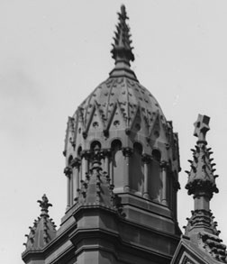

(a)

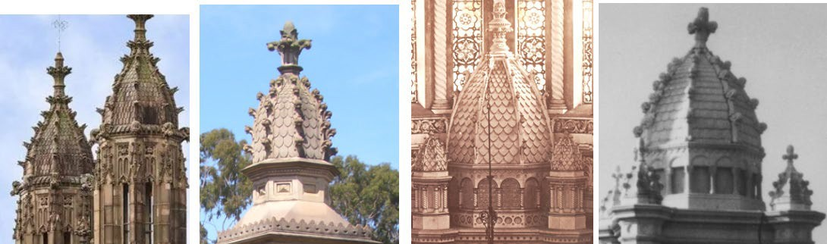

(b) (c) (d)

**Fig. 83 a-e** Details of Sydney structures (c.1857–1913) featuring ornate domes with crocketed ribs.

(e)

1. The Great Synagogue, Sydney, 1878. One of the twin domes with crocketed cupolas spiring the tower. The central finial carries the Star of David, a familiar symbol of Judaism **(Fig. 31 a).**
2. Sydney University, architect Edmund Blacket (1817–1883). Crocketed domes on top of the square tower overlooking the university’s central quadrangle, built c.1857.
3. Rookwood Cemetery, Sydney, 1874, tomb of Maurice Alexander (1820–1874). A singular dome with rounded slate-like roofing, crockets and an open-bud finial became a feature of The Great Synagogue sanctuary (d) in 1878. Further research may determine the designer.
4. Interior of The Great Synagogue, 1878. A dome with two smaller cupolas crowning the ark, echoing the design of the exterior towers, Thomas Rowe (1829–1899) (compare with (e)).
5. Rookwood Cemetery, Sydney, 1913. Detail of the tomb of Rev A. B. Davis (1828–1913). While the designer is not readily identifiable, the inspiration source (d) is apparent.

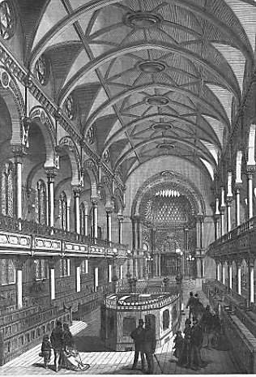 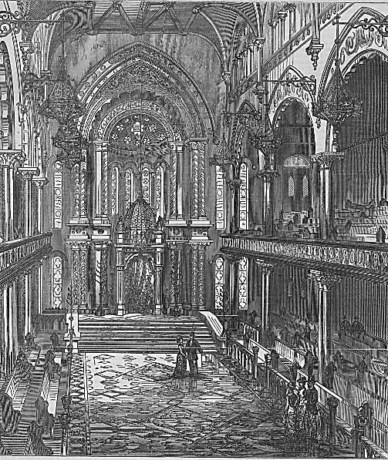

**Fig. 84** Interior of Central Synagogue, London, 1870. Jewish architect N. S. Joseph (1832– 1909).91 This image was used as prototype for The Great Synagogue Sydney (**Fig. 77)**. Note the Tablets of the Law above the Ark.

**Fig. 85** Interior of The Great Synagogue, Sydney, 1878.92 Architect Thomas Rowe (1829–1899). View from the front of the *bimah*. Note the domed Ark structure.

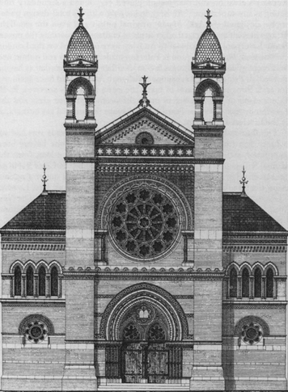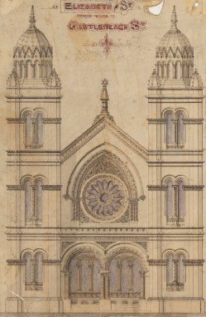**Fig. 86** Front elevation plans. Synagogues introducing the two-tower design and eclectic historicism style in Jewish architecture in the 1870s.

* 1. New West End Synagogue, Bayswater, London. Front facade plan, 1877. Architects George Audsley and N.

S. Joseph.93 Consecrated 1879.

* 1. The Great Synagogue, Sydney, front elevation plan, 1874. Architect Thomas Rowe. Consecrated 1878.

(a) (b)

91 ‘Interior of the Central Synagogue’, *The Builder*, 6 November (1869).

92 ‘Opening of the Great Synagogue, Sydney’, *Town and Country Journal*, 16 March (1878), 440, supplement.

93 Sharman Kadish, ‘The ‘Cathedral Synagogues’ of England’, 60; from *The Building News*, 13 July (1877).

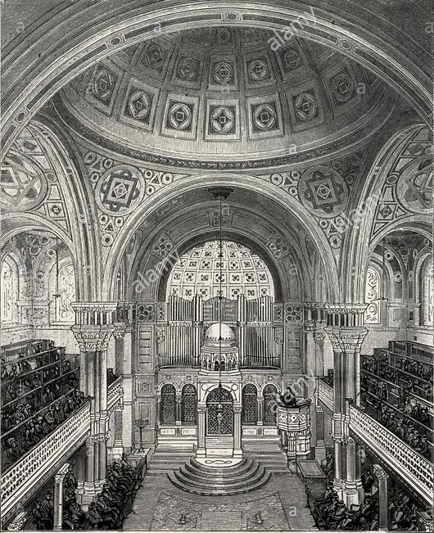

**Fig. 87** Interior, West End Synagogue, Upper Berkeley Street, London, 1870. Jewish architects Davis & Emanuel. The neo-Byzantine style coincided with the Moorish style in Europe, featuring wide domed ceilings, rounded vaults and geometrical patterns. Note the domed Ark structure.94

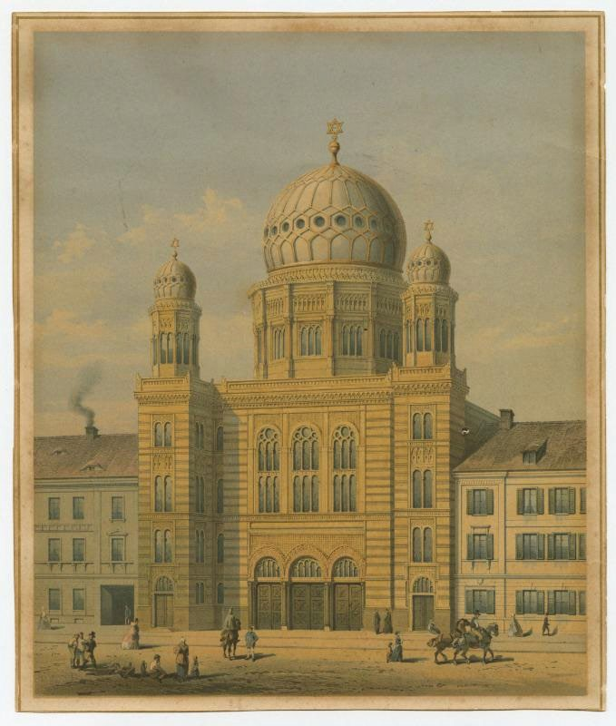

**Fig. 88** Oranienburger Strasse Synagogue, Berlin, 1866. Architect Eduard Knoblauch (1801–1865). Early example of the Moorish style typified by two-window turrets and a large ‘onion’ dome.95 Rare image of new style of synagogue exterior prior to 1870. Lithograph, Berlin, 1865. Leo Baeck Institute.

94 ‘The West London Synagogue’, *The Building News*, 7 April (1871), 258. Architects Messrs Davis (1838–1915) and Emanuel (1841–1904). (Not to confuse with the *New* West London Synagogue, 1879, Audsley & Joseph). 95 Saskia Coenen Snyder, *Building a Public Judaism*, 24–27, 64.

### Rowe’s originality

When the Sydney’s Jewish leaders conveyed their particular request to the architect Rowe and presented him with the photograph of their ideal synagogue (**Figs. 77, 84**), he may have thought of a few Christian churches in Sydney. Soaring vaulted naves under the neo- Gothic ribbed lunette ceilings, tall arches curving over semicircular apses and large stained- glass rose windows with tracery had become a familiar sight in the colony since the middle of the nineteenth century.96 But this time, the client was the burgeoning Sydney Jewish congregation, not the parish of St Mary’s Cathedral. Clearly, the significance of the requested style and its symbolism were announcing far-reaching social changes that may not have been fully grasped by the architect at the time.

Comparing the Sydney’s synagogue with the London model (**Figs. 84**, **85**) reveals those particular features of Rowe’s design that were not part of the prescribed interior plan, namely the domical form above the Ark and the tall pointed neo-Gothic arch enveloping the entire Ark compound. Surprisingly, little documentation exists in respect of the development of the London building’s outer appearance. Consequently, it is essential to investigate how the Sydney architect resolved The Great Synagogue’s facade design within the constraints of predetermined perimeter measures (**Fig. 78**) and what inspired the striking external sandstone domes atop the two towers, which over the years have become one of the most recognisable images of Australian colonial Judaism.

Only a few other synagogues of the time are known to feature a domed ark – examples include Berlin’s Oranienburger Strasse Synagogue, consecrated in 186897 and the West London Synagogue, 1870 (**Fig. 87**).98 A domical structure crowning an altar in a church (also called canopy or baldachin) has been a known feature from the early Christian edifices to the European Baroque, but it is beyond the scope of this chapter to establish the

96 See for example ‘The original interior St Mary’s Cathedral’, Sydney, 1841-1844, lithograph by John Skinner Prout (1805–1876), dictionaryofsydney.org/entry/st_marys_cathedral; Gothic Revival, one of the early

historicizing architectural movement that began in England in late eighteenth century.

97 ‘Opening of the New Jewish Synagogue, Berlin’ [featuring colour engraving of the interior], *The Illustrated London News*, 22 September (1866), 277.

98 West London Synagogue Interior, 1869–1870 engraving, from *Illustrated London News*, January (1872), in Sharman Kadish, *The Synagogues of Britain and Ireland*, 117. This image shows a domed ark compound,

unlike the second engraving from 1871.

inspirational path leading to the Jewish architecture of the late nineteenth century. What seems, however, to be Rowe’s original idea can be seen on **Figs. 83 a**, **d**: clearly, the ark’s dome shape replicates the external domical cluster surmounting both towers, the popular crocket decorations inclusive. As a result, Rowe achieved a spatial and spiritual continuity of the reference to the biblical Tabernacle symbolism flowing outside-in in perpetuity.

A large pointed Gothicising arch was another of Rowe’s signature features. We have encountered this, in a simplified form, on the facade of one of his early buildings in Yass (1869) (**Fig. 82 d**); and he used a similar idea, this time a more ornamented vault, in a double-arch motif in the Synagogue design. One is rising high above the ark’s dome inside, and one envelops the large stained glass rose wheel window that dominates the Elizabeth Street entrance outside. These soaring arches are positioned on an outside–in and East– West axis. The architect achieved a similar effect of visual and spiritual link, connecting the outside world again with the inner sanctuary. It is not immediately apparent whether Rowe sought inspiration or adapted his previous design. What is apparent though, that there were other interior images in circulation,99 and that none of the London architects implemented this neo-Gothic trait in their synagogue designs. Rowe applied it to the advantage of his balanced vertical composition. Sydney Jewish leaders apparently also approved the large neo-Gothic rose wheel window that to the present days marks the front facade in a prominent Gothicising style. Sensibly, and as expected, Rowe adopted the Central Synagogue’s tall ceiling displaying Gothicising lunettes above the top-floor windows with only some design adjustments. Aesthetically, Rowe’s introduction of a pointed arch over a heavier semicircle adds elegance and lightness and gives the interior style a harmonious configuration.

As noted, it seems that when designing the new synagogue in London in the 1870s, more

attention was given to the interior style than to the building’s outside appearance. Architecture historians point out that certain ‘aesthetic pragmatism’ of Jewish leaders in London demanded the new synagogue's exterior ‘be of the plainest ... unpretentious

99 See reproduction of 1869 in Sharman Kadish, *The Synagogues of Britain and Ireland*, 99. This earlier photograph of the Central Synagogue in London featured a pointed arch over the Ark.

but serviceable character’.100 In practice, this resulted in synagogue facades having less style and little decorative ornamentation. This was not to be the case in Sydney. Rowe, mindful of the wishes of his committee, designed a richly ornate building inside-out. The interior three-aisle configuration with a soaring vaulted ceiling manifests itself also externally through a tripartite composition and application of eclectic historicism to both structure and decorative detail.

Rowe translated the Synagogue’s interior decorative mouldings to the fine sandstone carvings on the Elizabeth Street frontage (**Figs. 82 b, c**). His design of two prominent towers flanking a vertically divided facade bears some similarities with a later synagogue in London, the New West End Synagogue, consecrated in 1879 (**Fig. 86 a**), one year after Sydney and two years after the planning image appeared in the press. Comparatively (**Figs. 86 a, b**) and conceptually, these two concurrent places of Jewish worship, although oceans apart, share a desire to express congregational identities and seek own appropriate and unique design style to achieve it. Leaving aside the building material – red brick in London and golden sandstone in Sydney – there are interesting design parallels, as well as style variances. Both synagogues feature a tripartite facade with domed twin-towers over a triangular pediment, a large wheel window above the main double-arched entrance and prominent roof pinnacles, all being unmissable traits of some Christian churches.

A notable difference appears in the use of the neo-Gothic and Romanesque arches, for example, as already indicated in the examination of the interior’s features. The form of Rowe’s frontage is based on the verticality and perfect proportions of the two octagonal towers while the London’s New West End Synagogue architects had to balance much wider front facade with the horizontal lines of the side wings. In his Sydney design, three years ahead of Audsley and Joseph’s in London, Rowe had little to guide him in terms of the appearance of the synagogue’s frontage but there was also little to restrict him. Since the inclusion of the Jews under the *Church Act 1836* (Chapter 2), the management of sacred sites in Australia had been handed over to the clerics, and it was up to the Synagogue Committee to determine the size, location, architectural style and interior design of the new house of worship in Sydney. This was in contrast to the limits and regulations the

100 Saskia Coenen Snyder, *Building a Public Judaism*, 118.

Jewish congregations had to consider in Britain and elsewhere in Europe.101 In Sydney, Rowe could draw on his earlier experience in designing Christian churches and apply the popular Romanesque decorative elements next to the subtle hints of Moorish décor inside the synagogue.102

It is probably owing to the Rowe’s more traditional architectural and builder training under his father’s firm, that he decided to apply the ancient Golden Ratio calculation103 to the Synagogue’s frontage design and proportions. As I discovered, the width of the central section spanning between the two towers and marked by the double-arched entrance, the wheel window diameter, the pointed arch span and the triangular roof-line with a tall pinnacle, are all proportional in the Golden Ratio balance with the width of each tower. The length of the front wall104 is also harmoniously balanced in the Golden Ratio proportion with the overall height of the building, inclusive its pinnacles.

Rowe applied the traditional and measured approach in the context of the eclectic historicising architectural styles and emphasised decorative details, whether executed in moulding or artful stone carvings. The distinct ingenuity and consistency of the style and design point beyond the architecture. As mentioned, the 1870s was an era when the emancipated Jews across Europe begun to consider in earnest the appearance of their synagogues, and when the concept of the 'cathedral synagogue' was born. At the same time, Sydney’s Jewry shared the confidence and aspirations to be seen and accepted as equally British and Australian as Jewish. The building of The Great Synagogue was central to their determination for a new congregational identity. Australian Jewish identity of the late 1870s bears the imprints of the sense of freedom and conformity as well as desire for acceptance. These were also the defining features with which the architect Rowe created the new place for the Australian colonial Judaism to move into the next stage of its religious identity and shape new social and cultural affiliations. Eventually, the latter will

101 Saskia Coenen Snyder, *Building a Public Judaism*, 256.

102 According to Elton, Moorish elements include inner scalloping of the arches, columns of the ladies’ gallery and other minor ornamentation, in Benjamin J. Elton, *The Architecture of The Great Synagogue*, 24. I am

rather reserved in identifying these features as Moorish in the context of, for example, the decoration of the Oranienburger Strasse in Berlin.

103 a.k.a Golden Section, first thought to be applied in design of the Greek Parthenon sculptures (447 BC). It is defined by a special mathematical ratio of 1:1.618 to compose the most harmonious proportion of a rectangle.

104 I used the measurements of the *Certificate of Title*, see Note 69; and architectural drawings in Orwell & Peter Phillips Architects, ‘Conservation Management Plan’, 72, Fig. 3.5.

also lead to the changing demographics, as was common in most Victorian cities, and bring new challenges to the Sydney Jewish community.105

Last on the list of the architect’s ambitions for original style, is a motif, for which the inspiration comes from a surprising source. As noted earlier, Benjamin Elton, historian and present Rabbi of The Great Synagogue in Sydney, has advanced the knowledge on the architectural styles of The Great Synagogue. One of his finds, for which he shares credit with the art historian Michael Young (University of Connecticut), is an innovative idea that the Pisa Baptistery, a well-known Roman Catholic architecture in Italy, was Rowe’s inspiration for the two large domes towering over the east side of The Great Synagogue.106 Grand dome structures that typified the Byzantine architecture and churches with two- tower facades crowned with domes have been known since the Romanesque period; they were also the common feature during the continental Baroque era, and a few buildings showing similar form can be found in Victorian Sydney. However, it is the concept of a ribbed dome with triangular shapes over rounded arches topping the miniature Corinthian columns that makes Rowe’s synagogue design visually, if not symbolically, linked to the widely recognisable liturgical edifice of Christianity (**Figs. 89 a-d**). Rowe’s preliminary sketches (**Fig. 89 d**) provide an insight into his early ideas, which he further developed for the winning design (**Fig. 89 b**). The drawing shows that he reduced the number of roof segments to twelve and applied some of his preferred decorations such as quatrefoils, lobed arches and a tall crocketed pinnacle. Each dome is surrounded by four smaller domical forms that I have examined earlier in the context of their inspiration and influence (**Figs. 83 a-e**).

Elton’s conclusion regarding the inspirational role played by the Baptistery in the design of The Great Synagogue’s domes is both plausible and astonishing. Future research may determine when and how would the architect Rowe either visited Pisa or viewed images of the Baptistery in time to submit his ideas to the design competition in 1872–1873.

105 From the 1840s through to the 1870s, many Jews lived in the city near Wynyard Square, within walking distance of both synagogues, first at York Street and later Elizabeth Street. See Sydney B. Glass, ‘The foundation of the Great Synagogue’, *AJHS Journal*, 4 (4) (1956), 162.

106 Benjamin J. Elton, *The Architecture of The Great Synagogue*, 31–35.

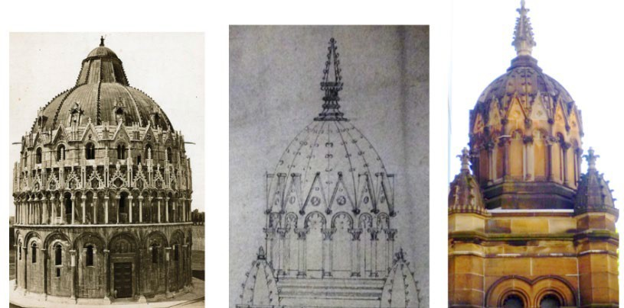

(a) Pisa Baptistery, Italy. Designed (b) Detail, tower dome, The Great by Diotisalvi, 1153. Completed Synagogue. Drawing by Thomas 1363. Roman Catholic monument. Rowe, 1874. Winning design. Photo by Enrico Van Lint, 1869.

1. Detail, tower dome, The Great Synagogue. Carved sandstone. Thomas Rowe, 1878.

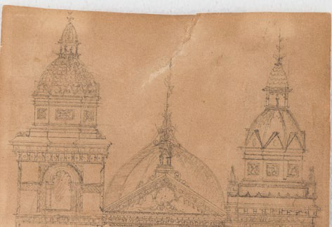**Fig. 89 a-d** Dome architecture design and inspiration for The Great Synagogue in Sydney. The large dome structure of the Pisa Baptistery (a), with a segmented roof and varied finial-decorations, shows a remarkable similarity with the two ribbed domes crowning the east-front towers of the Synagogue in Sydney. Recent research established that the Synagogue’s architect, Thomas Rowe, may have been inspired by the form, composition and ornamentation of the Pisa's Christian Baptistery (Note 105 above).

1. Detail, sketch by Thomas Rowe, c.1874. Possibly a few preliminary ideas for the Synagogue roof composition. The segmentation and triangular design (right) were refined, with the final execution (c) closely resembling the Pisa Baptistery (a).

A rare photograph of the Pisa monument was published in 1869,107 and also an eighteenth- century engraving most probably existed. Whether these or similar images served as models for Rowe is a matter of speculation at the present.

### The symbolism of Rowe’s Great Synagogue in Sydney

After winning the Synagogue design competition in 1873, architect Rowe was requested to build not only a ‘handsome building’ similar to contemporary synagogues in Europe and America, modelled on the Central Synagogue in London. The project also demanded a ‘temple for true devotion … worthy of us [Jews] as a religious body’,108 commendable to the new status the Jewish community aspired to occupy in Sydney and beyond.

Furthermore, with respect to the former congregational divide, the new ‘place of worship may be the means of uniting us [Jews] as one family, burying in oblivion any differences of the past’.109 Not a simple task, indeed. By virtue of these stipulations, Sydney’s Jewish leaders equipped us with an insight into their efforts to manage their public image and define new identity at the time when Jews in London, Paris and Berlin faced similar challenges. Most importantly, in Sydney, as in other parts of the world, the Jewish community embraced the power of the symbolism their new synagogue may acquire, and the prestige it may achieve. The expression of Jewish visual identity was again as important as it was in 1844, when the Egyptian style synagogue in Sydney manifested the Jews’ independence and biblical distinctiveness (Chapters 2, 3). This time, they aspired for acceptance and conformity. In other words, they desired a perhaps Utopian approval of their social status and contribution to the society, while preserving the distinctiveness of Jewish faith. To what extent did the architect meet these visions and expectations?

As stated in Chapter 3, Jewish architecture historian Jess Olson identified the period between 1830 and 1930 as an era of an explosion of synagogue construction activity that coincided with the Jewish pursuit for an expression of their particular identity.110

107 ‘Baptistery in Pisa’, *Christian Reflector and Christian Watchman,* 31 August (1848), 29, 35; and 1869 photo, getty.edu/art/collection/objects/82206/enrico-van-lint-the-baptistery-pisa-italy-italian-about-1869/

108 ‘Laying the Foundation Stone of The Great Synagogue in Hyde Park’, *The Sydney Morning Herald*, 27 January (1875), 5.

109 ‘Laying the Foundation Stone of The Great Synagogue in Hyde Park’, 5.

110 Jess Olson, ‘Reimagining the synagogue in the nineteenth and twentieth centuries,’ in Steven Fine (ed.),

*Jewish Religious Architecture: From Biblical Israel to Modern Judaism*, Boston, MA: Brill (2019), 288–289.

Although examples of Australian synagogues were absent from Olson’s research, I have highlighted the significance of both Sydney’s oldest synagogues in the context of his analysis of Jewish architectural styles. In Sydney, the 'Egyptian' York Street Synagogue coincided with the start of the style in the 1830s while the eclectic historicism of The Great Synagogue matched with the huge popularity of eclectic historicism style in Europe and North America a few decades later. Constructing of Jewish identity in reliance on the acceptance by the

non-Jewish society was a common sensitivity of the emancipation times. Measured by the reaction of the Australian press in 1878, Rowe’s synagogue was a huge success. Branded ‘an ornament to the city in which we live’ and having a ‘magnificent internal effect’, the consecration of The Great Synagogue in Sydney on 4 March 1878 was a memorable social event for the Jews as for the rest of colonial society in Australia.111

Moreover, on account of two newspaper illustrations depicting a public visit soon after the respective consecrations in 1870 and 1878 (**Figs. 84**, **85**), it is possible to compare the two events in the London and Sydney synagogue. Both images show a relaxed ambiance of a rather Sunday afternoon stroll to a museum than religious services. Well-dressed Londoners and Sydneysiders, who may or may not have been Jewish, are there to admire the architecture and ornaments. The visuality and theatricality of the moment cannot be underestimated: a visit to a synagogue was becoming a visual and social experience.112 Within their sanctuaries, Jews were presenting themselves to the world at their best – emancipated and liberated from the ghetto or their convict pasts. They too had rising arches, gilded ceilings and carved ornaments. Still, not everything had become, as phrased by Snyder, ‘public Judaism’.113 Out of sight, behind the heavy velvet curtains, were the sacred Torah scrolls. Safeguarded in the Ark until an evening prayer when the reading from the central platform, *bimah* (obscured in the Sydney image), will become the focus of the congregation, and the ornate sanctuary will transform into the divine space commanding piety. This was the spatial and conceptual complexity of public Judaism that required

111 ‘Consecration of the New Synagogue’, *The Sydney Morning Herald*, 5 March (1878), 3; [‘The opening of the](https://trove.nla.gov.au/newspaper/article/63334879?searchTerm=York%20Synagogue%20%20%20%20%20%20%20%20%20%20%20%20&searchLimits=l-title%3D803) [new Jewish Synagogue’, *Illustrated Sydney News and New South Wales Agriculturalist and Grazier*,](https://trove.nla.gov.au/newspaper/article/63334879?searchTerm=York%20Synagogue%20%20%20%20%20%20%20%20%20%20%20%20&searchLimits=l-title%3D803) 20 April (1878), 4–6.

112 Souvenir items from the opening of The Great Synagogue in Sydney include an embellished postcard and a small box with the Synagogue miniature front entrance image, currently on display in the A. M. Rosenblum Jewish Museum exhibition.

113 Saskia Coenen Snyder, *Building a Public Judaism,* 6, 22.

Rowe’s architectural vision and realisation. The architect was not keen, it seems, on the idea of designing an exact copy of the London synagogue space. Instead, Rowe conceived a novel conception which, in its entirety, references the model space but which at the same time manifests his distinctive approach and symbolism that has not been fully appreciated to date.

It can be argued that by building a synagogue in a remote colonial outpost that would visibly connect with those already admired in London, Paris, Berlin, Prague or Budapest, made this faraway Jewish community part of the larger movement in Europe of the 1870s. It can be further argued that it was this symbolism and new visual identity that was the leading conceptual drive guiding the Sydney architect charged with designing and constructing the new synagogue. The result – admired by the Jewish community in Australia then and now – confirms the architect’s masterwork. The history has also confirmed the broader significance of the synagogue’s architecture for the Australian art history, and its central location which, to a degree, can be seen as symbolic of the changes as the building style itself.

## Conclusion

One of the outcomes of the Jewish social and political emancipation in Europe in the first half of the nineteenth century was a bustling synagogue building activity. Jews commenced a search for a suitable architectural style, and a few even entered the architect profession. Unlike in Europe, Jews in Australia were generally free of discriminatory restrictions on the place, size and appearance of their house of worship. Consequently, while in 1844 the community built the first synagogue in a distinct Egyptian style to emphasise their otherness (Chapter 3), in the 1870s, the freedom of choice saw the Jews of Sydney following the style of the acculturated Jewish Europe. In Sydney, the Jewish community wished to leave their convict past behind and to present a changing and acceptable cultured identity. Visually, this meant that the synagogue building design displayed forms and styles conforming to the architecture of Christian churches while maintaining a representation of and devotion to the Jewish faith and way of life. In the context of Jewish visual identity, and seen from an aesthetic, architectural and iconographical point of view, The Great Synagogue in Sydney became an antithesis of its early colonial predecessor, the York Street Synagogue.

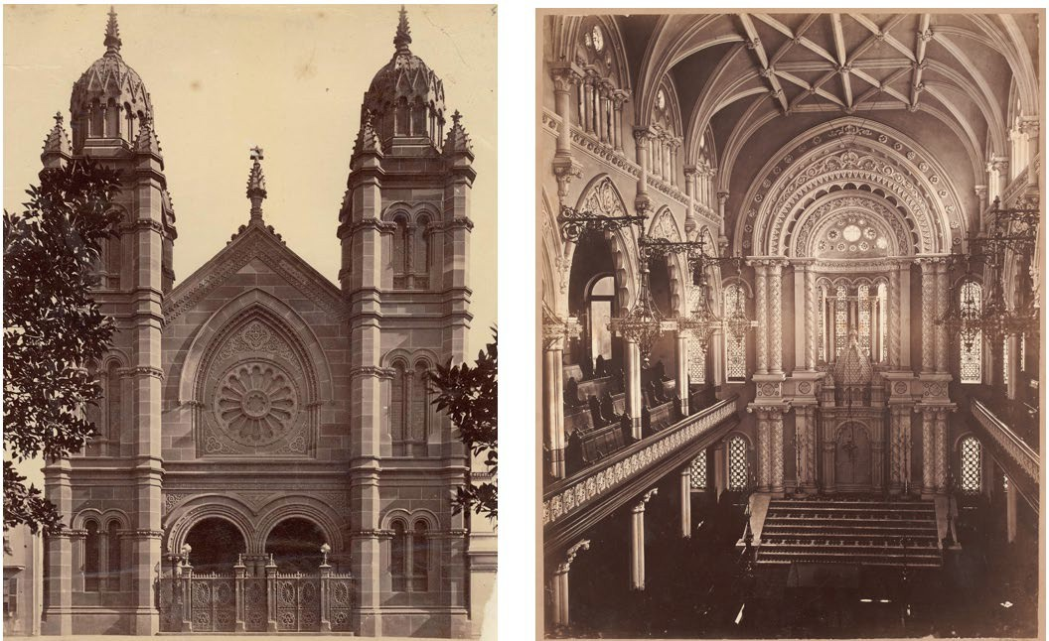

1. Exterior–interior, The Great Synagogue, Sydney, 1878, architect Thomas Rowe, photo c.1880.

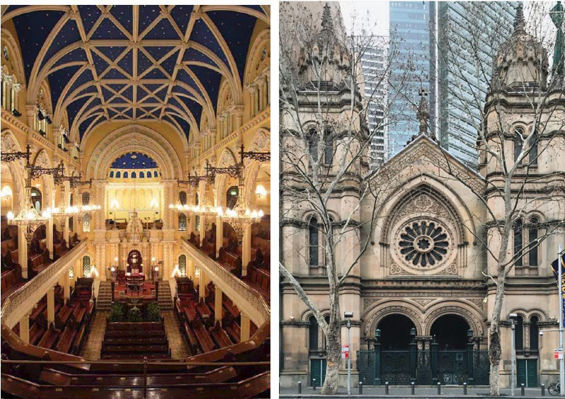

1. Interior–Exterior, The Great Synagogue, Sydney, 1878, architect Thomas Rowe, photo c.2014.

**Fig. 90 a-b** The Great Synagogue occupies the lot between Elizabeth and Castlereagh Streets. The style of the principal front (incorrectly described as ‘Byzantine with Gothic forms’ in 1878)114 is an example of eclectic historicism introducing Romanesque semi-circular double arches, rising to a dominant Gothic vault over the central rose window. Two flanking square towers with octagonal turrets are crowned with a pair of transitional historicism-style pinnacled domes. The visual consonance of the portico segment with its interior focal point, the Ark, is achieved by echoing architectural elements such as the soaring archways over the domed Ark and the Corinthian columns decorated with fine Victorian stone carvings and moulding.

114 ‘Consecration of the New Synagogue’, *The Sydney Morning Herald*, 5 March (1878), 3. For comments that clarify the term Byzantine, see Benjamin J. Elton, *The Architecture of The Great Synagogue*, 12.

In March 1878, the Ark in the newly erected The Great Synagogue in Sydney became the repository for the Sydney *rimmonim* (Chapter 1) and other ornaments of the sacred Torah scrolls. The newspaper illustration in **Fig. 29** depicts the celebration of the Synagogue consecration. Six male congregants dressed in traditional attire carry the scrolls of the Law to the Ark, which at that moment was still concealed behind the crimson *parochet* (Torah curtain, held in the Synagogue collection). They would have concluded the procession carrying the scrolls seven times round the *bimah* (placed in the centre) before depositing them in the Ark. Hundreds of guests attended the ceremony, and for many among the non- Jewish audiences, the event may have been the first glimpse of a Jewish synagogue and into the rituals of Judaism. Others could read about the opening and admire the decorated interior in the press in the following days and weeks. This may be first time in the history of Australian colonial Judaism that the Jews were publicly represented as a religious community, and their traditions and visual legacy appreciated as part of the visual culture of Australia.

Over the past century, while remaining the most important place of the active Jewish worship in Australia, The Great Synagogue in Sydney has also become a symbol of the Jewish community’s history, continuity and architectural tradition. Remarkably, the front facade retained its original design and only minor layout changes were carried inside (**Figs. 90 a, b**). Rowe’s design, style and forms drew on the ideas and concepts of both the local colonial and world architectural legacy. Viewing this iconic building in the broader context of the Australian architecture history, Thomas Rowe could merit a revision of his contribution and be regarded an innovator of Australian architecture of Jewish faith.

It is not known whether Rowe attended the consecration of *his* Synagogue on the afternoon of 4 March 1878 or read the lengthy reports and commendations in the press the following day. Reportedly, his next large projects, Newington College in Stanmore and the new Sydney Hospital on Macquarie Street, were already underway. After being appointed the first mayor of Manly in 1877, Rowe turned his attention to more profane ventures and did not build another synagogue.

### Epilogue to Chapter 4

On 10 May 1941, amid one of the many London Blitz attacks during World War II, the Central Synagogue was bombed and destroyed. The architecture that in the 1870s motivated the Sydney Jewish community and inspired the architect Thomas Rowe disappeared forever. Although today The Great Synagogue in Sydney is obscured by surrounding structures, busy roads and growing trees, it remains a memorial to the London model, and witness to a significant Australian architectural legacy and its colonial origins and connections.