**A war of words: Virtualizing the Israeli –Palestinian Conflict on Facebook in times of crisis**

**Iman Garra-Alloush and Wissam Magadley**

**Abstract**

The current study examines expressions of political opinions on Facebook following politically charged events in the Israeli-Palestinian context. Using content analysis we compared 539 (296 by Jewish Israelis and 243 by Palestinian Israelis) randomly selected Facebook comments written by both Jews and Palestinians living in Israel in response to three political incidents that sparked heated discussions and exchange of ethno-political insults between the two sides on social networks. For each incident, we categorized comments into two major categories, offensive and friendly, then analyzed and compared the percentage of comments posted by Jewish Israelis and Palestinian Israelis under each category. The findings show that 66% of the total number of comments were categorized as offensive, of which 44% were posted by Israeli Jews and 25% were posted by Palestinian Israelis. The findings reflect the tense and fragile relationship between Jewish and Palestinian citizens of Israel, and highlights the role of social network platforms such as Facebook in unleashing extreme political opinions, which may not surface otherwise.

Keywords: Israeli-Palestinian conflict, politically charged events, political expression, Facebook, Palestinian-Israelis.

**Introduction**

The increasing popularity of social media sites, such as Facebook as platforms for expressing political content and opinions has been gathering increased research attention in recent years (e.g. Jang et al., 2014; Vraga et al., 2015). The easy and affordable access to Facebook, and the heterogeneous and largely unknowable audience associated with it, provides rich grounds for political disagreement, and the exchange of heated and fiery online posts between users with differing political views (Coe, Kenski, & Rains, 2014). The rising expression of political disagreement on social media sites is attributed to their structures that weaken social boundaries and allow easier contact between users with conflicting political views (Brundidge, 2010).This is particularly pertinent in conflict-ridden countries such as, Israel who’s citizens, Jewish and Palestinian, have been embroiled in the ongoing, long-lasting, an irresolvable Israeli–Palestinian conflict (Halperin & Bar-Tal, 2011).

In the Israeli context of heightened political conflict, discussing highly divisive political issues or events on social media platforms such as Facebook will most certainly cause confrontations and personal repercussions (John & Dvir-Gvirsman, 2015). These consequences are likely to be even more acute when the political issue under discussion is situated along the ethno-political demarcation line of Arabs and Jews. However, the willingness to express ones’ candid political opinion on Facebook, particularly in highly charged political times, may depend on whether the person belongs to the majority Jewish population, or to the minority Arab population in Israel. Because parties to conflict in interethnic conflicts, such as the Israeli-Palestinian conflict are more often not equal in their power and do not show the same sense of threat or security (Rouhana & Fiske, 1995). As such, individuals are more likely to express their true opinions when they are part of a majority, whereas individuals in the minority may be less likely to express their political opinions to avoid potential repercussions.

This study aims to explore and compare Jewish and Palestinian Israelis willingness to express political opinions on Facebook in the context of the Israeli-Palestinian conflict, particularly following highly charged political events. The comparison is based on content analysis of 539 randomly selected Facebook comments written by both Jews and Palestinian Israelis in response to three news items about politically motivated incidents that sparked heated discussions and exchange of ethno-political insults between Jewish and Palestinian Israelis on social media.. The incidents under investigation include the killing of *'Nash'at Milhim'*, the shooting of *'Israa 'Abed'*, both Palestinian Israelis, and the Jewish Home MK *Bezalel Smotrich's* statement in support of segregated Jewish-Arab maternity wards in Israeli hospitals. These incidents will be discussed further in a later section, however, it is necessary first to provide some historical and political background on the Palestinian minority in Israel for a better understanding of the study's context.

*Palestinian Israelis*

After the Arab–Israeli war of 1948, only 156,000 Palestinians remained in that part of Palestine, which had now become the State of Israel. Cut off from the rest of the Palestinian people, and physically, socially and culturally isolated from the rest of the Arab world, the remaining Palestinians formed a socially and politically weakened group in Israel (Al- Haj & Rosenfeld, 1990; Boymel, 2007). Although they were granted Israeli citizenship and were offered full rights, as a minority they have chronically suffered from limited political representation and a debilitated social, economic and educational infrastructure (Bekerman & Maoz, 2005). David Grossman (1992), the Israeli novelist, used the oxymoron *'Present Absentees*' to describe Palestinians in Israel in reference to their political and social marginalization.

Israel’s formal policy towards its own Palestinian citizens has been determined by three main factors: the democratic character of the state, the Jewish-Zionist nature of the state, and security considerations. When the three principles come into conflict, the latter two gain the upper hand (Al-Haj & Yaniv, 1983; Smooha, 1990; Al-Haj, 2004). The democratic character of Israel has given the Palestinians in Israel room for political organization and activity, through which they have sought to improve their status and bargain for the advancement of the Palestinian case (Al-Haj, 2004).

However, the status and conditions of the Palestinians in Israel have been linked and deeply affected by the Israeli-Palestinian conflict and the wider Arab-Israeli conflicts. These conflicts have profoundly influenced relations between Jews and Palestinians in Israel and shaped the political identities of both groups. Their contrasting and competing narratives *vis-à-vis* the conflict continues to feed the perpetual tensions, animosity, suspicion and distrust between the two groups (Amara, 2017). Furthermore, Jewish Israelis tend to perceive Palestinian Israelis as constituting a “hostile minority” and “security risk” because of their links with the Palestinians in the West Bank and the Gaza Strip as well as Arabs in neighboring Arab countries. These perceptions deepen further the schism between Jews and Palestinians in Israel, and have had a major influence on the Israel's policy of surveillance and control of its Palestinian citizens (Smooha, 1989; Al-Haj, 1996; Al-Haj, 2004). The status of Palestinians in Israel has become even more vulnerable following the al-Aqsa intifada, which erupted in 2000 against the background of a deep crisis in the peace process (Al-Haj, 2004).

*Palestinian Israelis and political expression in the public sphere*

Despite the democratic character of Israel, Palestinian Israelis were for long reluctant to display symbols of their Palestinian identity and express their political views towards the state of Israel in public for fear of security related repercussions. This fear may stem from the fact that for years following its creation, Israel has effectively employed strategies of political control and surveillance on the Palestinian minority that remained within its borders, despite the latter being granted Israeli citizenship (Sa'di, 2013). Cohen (2006) shows that the Israeli state was able to exercise tight surveillance due to the many collaborators and informers that it recruited to spy and pass on information to the authorities about their colleagues, neighbors and friends. However, with the advancement of social media the display of ones' identity and political views, which have traditionally taken place in private, have become mediatized through social networks sites such as Facebook (Enli & Thumim, 2012). Indeed, much work has investigated social media, and Facebook in particular, as an avenue for political expression and talk (e.g. Jang et al., 2014; Bond et al., 2012). Furthermore, scholars have stressed the importance of investigating the nature of the unique Facebook context for expressing political content and conducting political discussion (Jang et al., 2014; Vraga et al., 2015).

*Facebook as a platform for political discussion*

The characteristics of Facebook make it a distinct place for political expression. The affordances of the platform, and the interaction with hundreds of people simultaneously, allow users to convey information to a vast audience (Kuo et al., 2013), including those whose opinions differ from each other - a rarity in most face-to-face social circles (Mutz, 2006). Hence, incendiary political posts on Facebook can result in heated debates, offended audiences, and even damaged relationships (Dvir-Gvirsman, Tzfati, & Menchen-Trevino, 2014; John & Dvir-Gvirsman, 2015). The controversy and disagreement on Facebook can escalate to an extreme level during times of political crisis, while at the same time tolerance and acceptance decline (Huckfeldt, Johnson, & Sprague, 2004). This is particularly true in in Israel, home of the heaviest Facebook users in the world (Mor, KliglerVilenchik, & Maoz, 2015; Karniel & Lavie-Dinur, 2012).

John and Dvir-Gvirsman (2015) found that in the Israeli context of heightened conflict, discussing politics on Facebook could be a risky endeavor, causing confrontation and repercussions. For instance, during the 2014 Gaza war John and Dvir-Gvirsman reported that Jewish-Israelis judged others harshly over political statements and sometimes blocked their contents or unfriended them. Similarly, Mor, Kliger-Vilenchik & Maoz (2015) found that Jewish-Israeli Facebook users were aware that posting political content, both in times of heightened political conflict and in calmer times, holds risks such as disappointing family members, ending friendships and even damaging future career opportunities. However, despite the attached risks, they found that the majority of Facebook users were highly motivated to express their opinions on sensitive political issues. Mor, Kliger-Vilenchik & Maoz contend that they do so because they value open discussion and hence are willing to pay the price.

For Palestinian Israelis, however, discussing politically sensitive issues on Facebook during times of heightened political tension can hold higher political risks. The consequences can be dire and go beyond heated exchanges of racial slurs with fellow Jewish Facebook users. Posting an inappropriate comment may lead to being fired from a job or even facing arrest. For instance, during the 2014 Gaza war, an Arab female educational psychologist was sacked from her job at the Lud Municipality after posting on Facebook that she was pleased about the death of Israeli soldiers. The mayor of Lud Municipality, Ya'ir Rivivo, took to Facebook to announce her dismissal from her job and to launch into an angry tirade against her [1]:

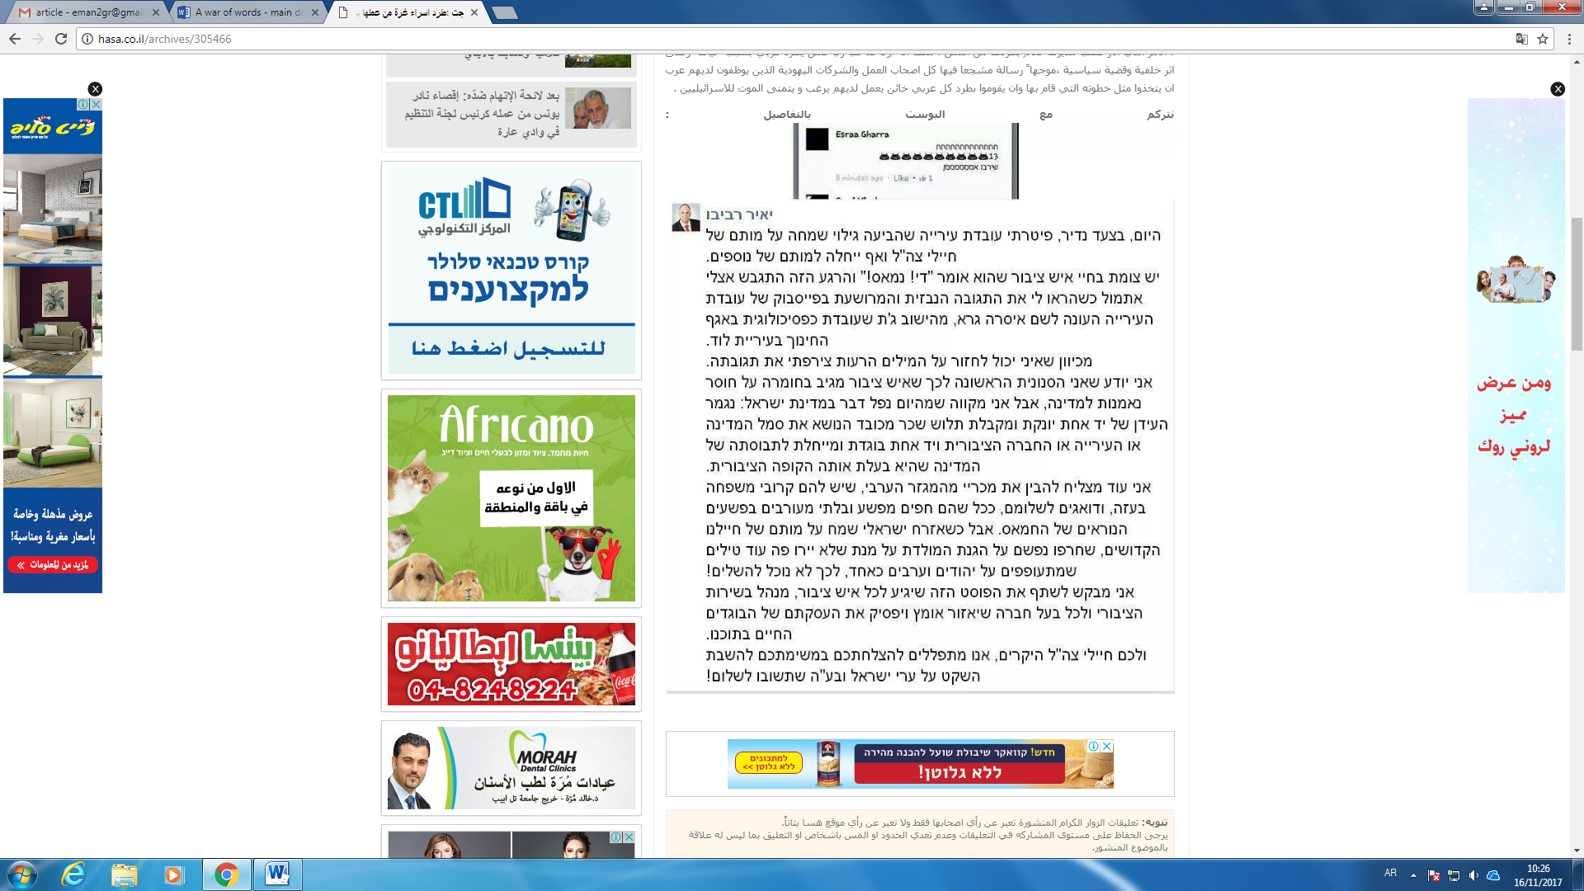

Another incident that was widely shared on Facebook and received a wide coverage on major Israeli and International News Channels was the arrest of Anas Abu Daabis, a well-known Arab-Israeli blogger and social activist. Abu Daabis posted on Facebook a comment satirizing Palestinians who expressed their delight on social media about the wildfires that blazed through Israel in November 2016. However, the Police misinterpreted his comment in Arabic, after relying on automatic translation software to translate the post he wrote and accused him of inciting Palestinian Israelis to commit further arson attacks. Incidents like these can make Palestinian Israelis reluctant to express their political opinions, particularly at times of heightened political tension. Furthermore, such incidents send a clear message to Palestinian Israelis that their Facebook posts are taken more seriously by the Israeli security apparatuses than their Jewish counterparts. To prove this, after the arrest of *Abu Daabis*, many Palestinian Facebook users posted screenshots of similar comments made by Jewish Facebook users that contained direct incitement to arson in Arab areas.

*The news items under investigation*

The first incident studied was that of Israa Abed, 29, who was shot multiple times in the bus station of the city of Afula in October 2015. A video of the shooting shows Abed, a Nazareth resident, standing alone surrounded by heavily armed Israeli police before she was shot and badly wounded. She was suspected of planning to carry out a stabbing attack. The Israeli press reported that she had been holding a knife, a claim that was refuted by her father who insisted that the police mistook her sunglasses for a knife.[2]

The second incident is that of Nashat Milhim the gunman who killed three Israelis in a shooting rampage in Tel Aviv in January 2016. Nashat a Palestinian Israeli from the village of Arara escaped the shooting scene and remained at large for a week before he was tracked down in his hometown by Israeli security forces and killed in an ensuing gunfight.[3]

The third incident examined was the controversy surrounding a proposal made in April 2016 by Betzalel Smotrich, a 36-year-old member of Knesset (MK) from the ultra-nationalist Bayit Yehudi (Jewish Home) party, which is part of Prime Minister Netanyahu's coalition, calling for a segregation between Jewish and Arab mothers in maternity wards in Israeli hospitals. His statement sparked an outrage from both left and right wing politicians and the news set social media ablaze in reaction to his statement.[4]

**Methodology**

Krippendorff (2013) defines content analysis as a research technique that allows making contextual inferences out of the text for the purpose of having replicable and valid results. Using this technique, researchers can address the consequences of communication which allows locating the cause and effect communication throughout its explicit content (Drikson & Maschi, 2015). "It provides new insights, increases a researchers' understanding of particular phenomena, or informs practical actions" (Krippendorff, 2013, p.24).

Holsti (1969) offers a broad definition of content analysis as, "any technique for making inferences by objectively and systematically identifying specified characteristics of messages" (p. 14). Under Holsti’s definition, the technique of content analysis is not restricted to the domain of textual analysis, but may be applied to other areas such as coding student drawings (Wheelock, Haney, & Bebell, 2000), or coding of actions observed in videotaped studies (Stigler, Gonzales, Kawanaka, Knoll, & Serrano, 1999). In order to allow for replication, however, the technique can only be applied to data that are durable in nature. Content analysis enables researchers to sift through large volumes of data with relative ease in a systematic fashion (GAO, 1996). It can be a useful technique for allowing us to discover and describe the focus of individual, group, institutional, or social attention (Weber, 1990). It also allows inferences to be made which can then be corroborated using other methods of data collection. Krippendorff (1980) notes that "[m]uch content analysis research is motivated by the search for techniques to infer from symbolic data what would be either too costly, no longer possible, or too obtrusive by the use of other techniques" (p. 51). 12/2/2014 An overview of content analysis. Stem

Facebook has become a global documenting arena wherein anybody can express and chronicle whatever they wish through posts, comments, links, and even screenshots. Before the advent of Facebook and other social media outlets, it was extremely difficult for individuals to document their attitudes and real-time reactions and discourse about current events. Today, the task of reporting and chronicling public attitudes is now much easier given the pervasive use of social media.

In order to understand public reactions to politically charged events in the context of the Israeli-Palestinian conflict, the study applied content analysis on 539 randomly selected Facebook comments. Content analysis is a technique that allows making contextual inferences out of text for the purposes of having replicable and valid results (Krippendorff, 2013). The comments were screenshotted randomly from different Israeli Facebook pages and included comments of both Jews and Palestinians living in Israel that were made in response to controversial news items about the conflict between Jews and Palestinians living in Israel which were posted on Facebook.

In total, 296 comments by Jewish Israelis and 243 comments by Palestinians living in Israel were collected. Then, the nature of the comments was categorized. Comments including obscene, anti-social, or inflammatory language were categorized as comments with “offensive reactions.” Comments with clearly positive language or reactions were categorized as “friendly comments/reactions.”

**Findings**

As stated previously, reactions of Israeli Jews and Palestinians towards controversial events as expressed on Facebook were gathered for the purpose of this study. The reactions were divided into two groups of offensive and friendly comments. This section presents a sample of the comments posted in response to the three incidents under study together with their translations. A table summarizing the findings for each incident is also provided.

**Incident I: The shooting of *Israa' Abed***

The following are samples of the comments posted by different Jewish Israeli Facebook users following this incident.

**Comment 1** 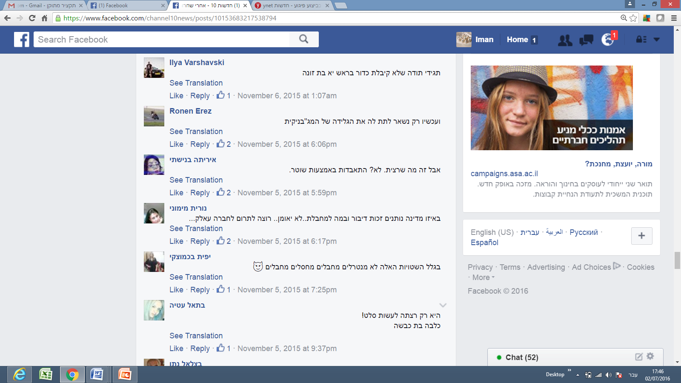

**Translation**: *“Just be grateful that you didn’t get a bullet in the head, you bitch.”*

**Comment 2**

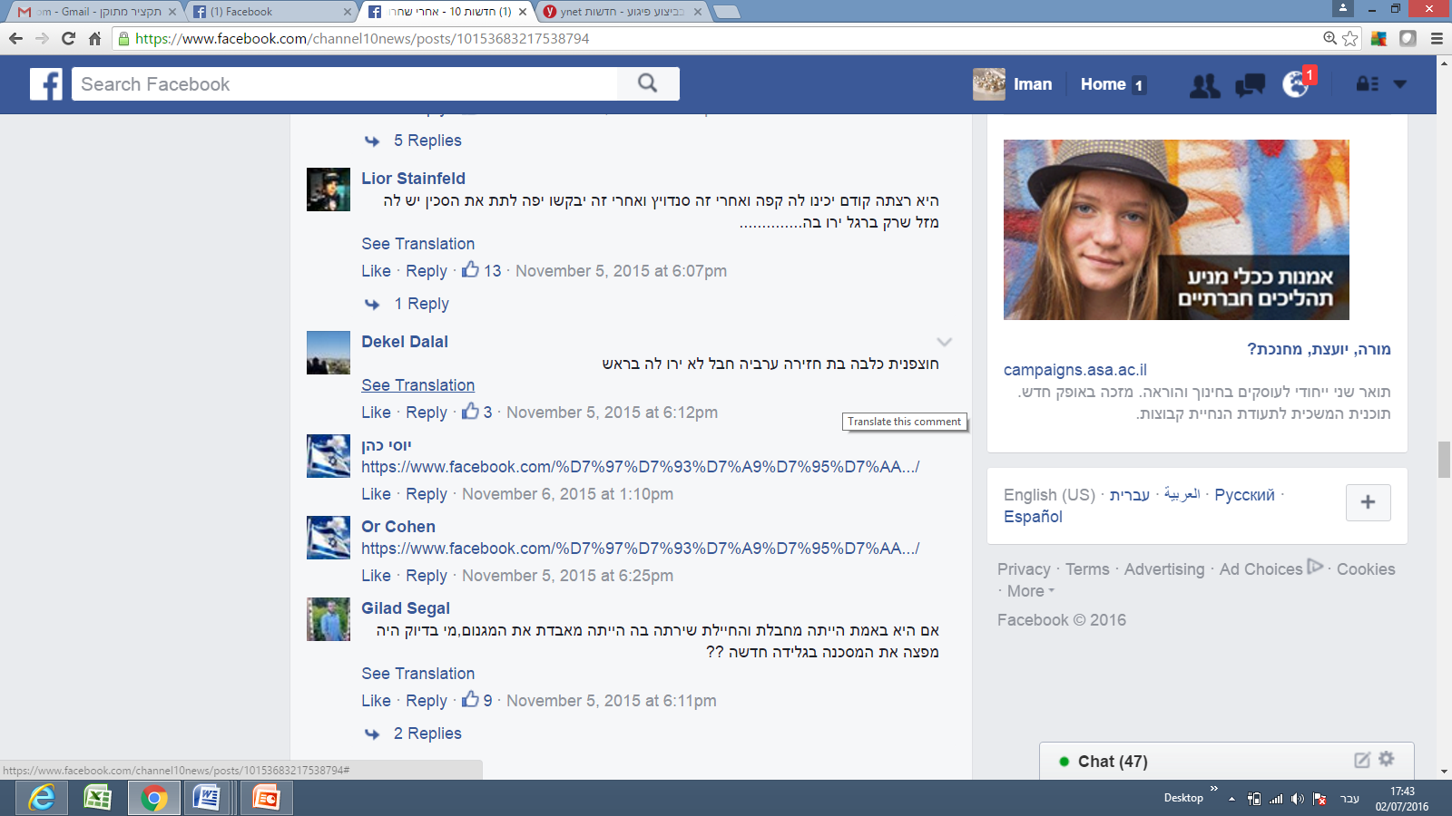

**Translation:** “*You’re an Arab pig; it’s too bad you weren’t shot in the head*.”

**Comment 3**

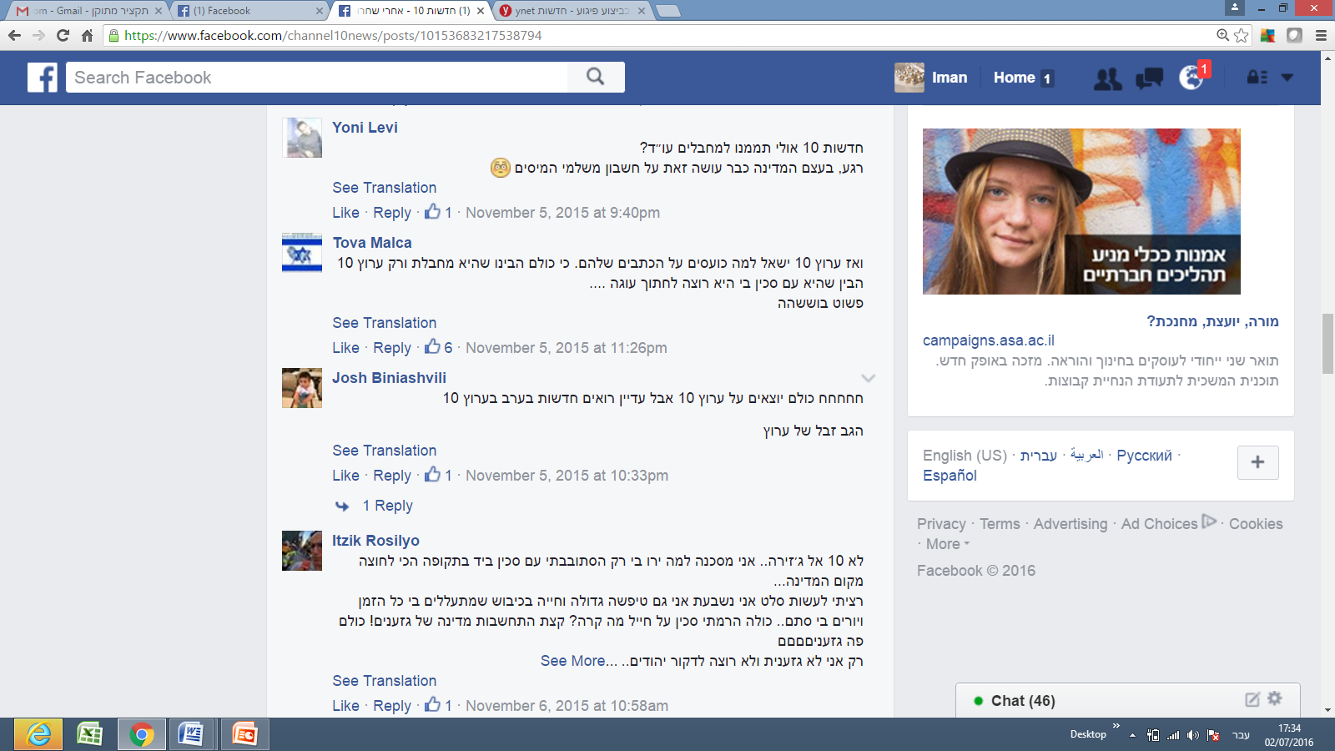

Translation: “*Not Channel 10, but Al Jazeera*. [the following was written sarcastically, but as if quoting Israa' Abed]: ‘*I’m an unfortunate victim. Why did they shoot me? I was only wandering in the street with a knife in my hand during one of the most stressful times since the establishment of the state.’*

“[Continuing sarcastically]: ‘*I only wanted to prepare salad. I swear. I am a big idiot living under occupation. They abuse me all the time, and shoot at me for no reason... All I did was raise a knife towards a soldier! So, what?! Just show a bit of consideration, you country of racists! You are all racists! I am the only one who is not racist, and I don’t want to stab Jews....*’”

Table 1: Attitudes Expressed on Facebook Following the *Israa' Abed* shooting

|  |  |  |  |
| --- | --- | --- | --- |
|  | **Jewish Israelis** | **Palestinian Israelis** | **Total** |
| Offensive Comments | 45:48  **94%** | 26:50  **52%** | 56:98  **73%** |
| Friendly Comments | 3:48  **6%** | 24:50  **48%** | 42:98  **28%** |

**Incident II: The shooting of *Nashat Milhim***

The following are samples of the comments posted by Jewish Israeli Facebook users following this incident.

**Comment 1**

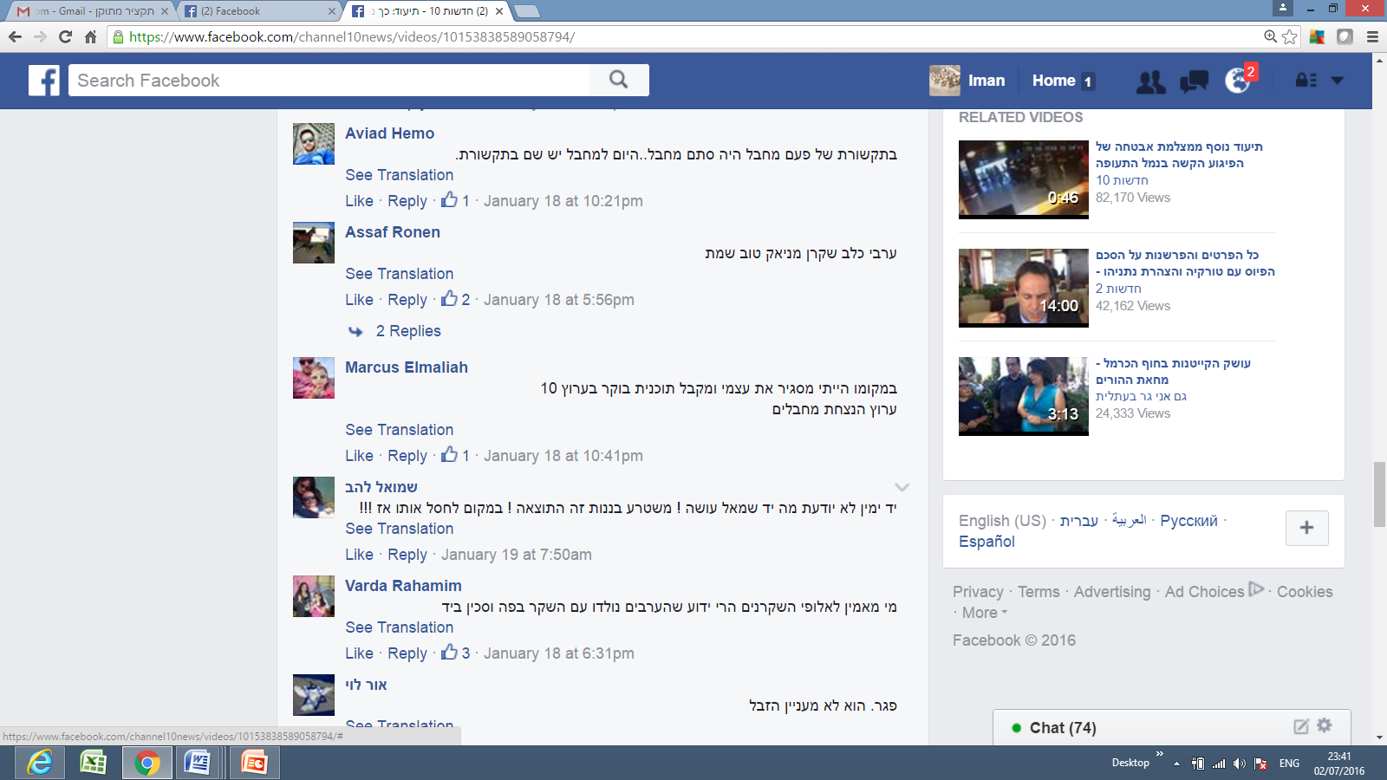

**Translation**: *“An Arab dog, liar, maniac; good that he’s dead.”*

**Comment 2**

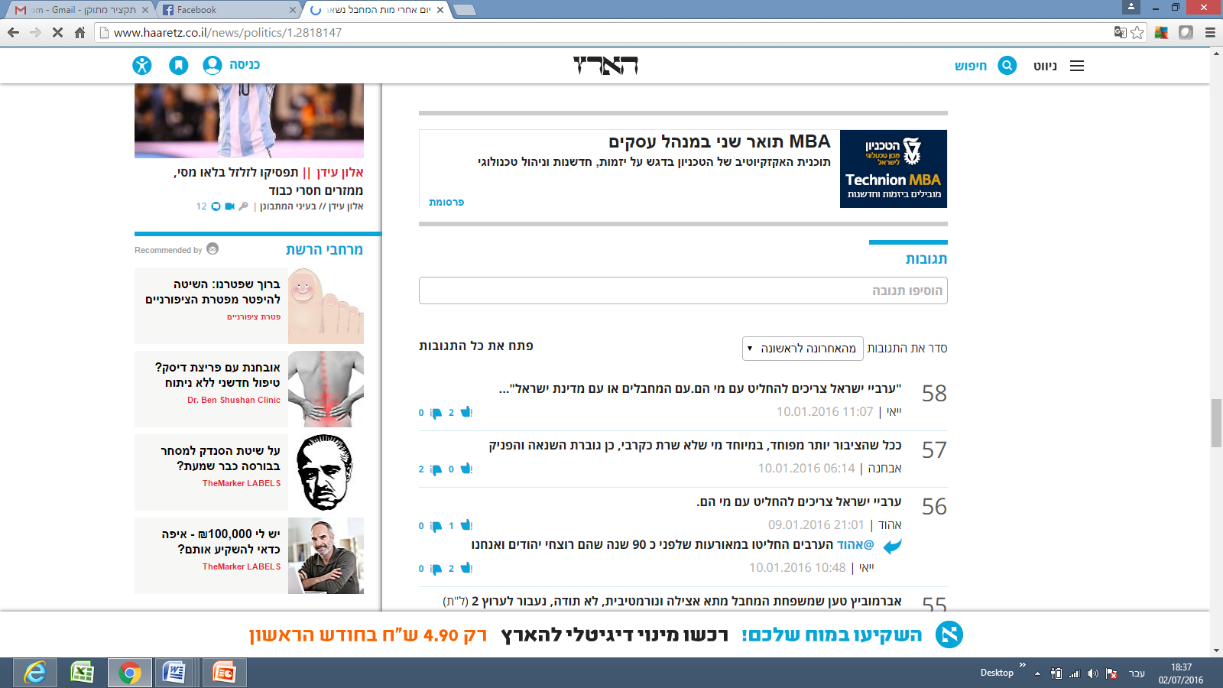

**Translation**: “*Israeli Arabs should decide who they stand with: with the terrorists or the State of Israel?”*

**Comment 3**



**Translation**: “*Who would believe the lying champions* [meaning Arabs]*? Everyone knows that Arabs are born with a lie in their mouths and a knife in their hands.”*

Table 2: Attitudes Expressed on Facebook Following the Killing of *Nashat Milhem*

|  |  |  |  |
| --- | --- | --- | --- |
|  | **Jewish Israelis** | **Palestinian**  **Israelis** | **Total** |
| Offensive  Comments | 128:150  **85%** | 19:93  **20%** | 147:243  **60%** |
| Friendly  Comments | 22:150  **15%** | 74:93  **80%** | 96:243  **40%** |

**Incident III: MK Bezalel Smotrich’s call for the segregation of Arab and Jewish mothers in maternity wards in Israeli hospitals**

The following are samples of the comments posted by Jewish Israeli Facebook users following this incident.

**Comment 1**

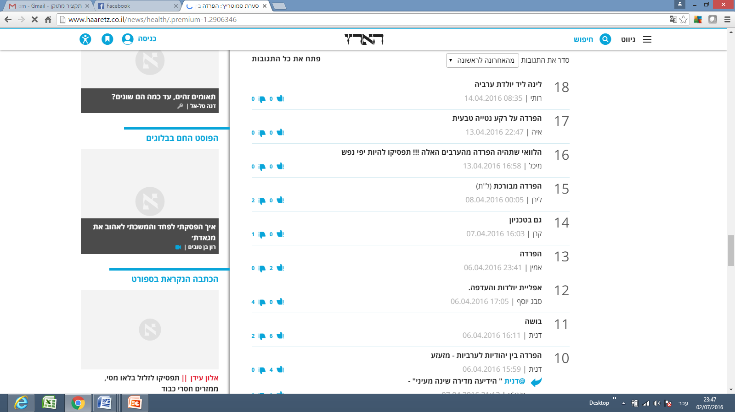

**Translation**: *“I wish there would be segregation from those Arabs!!! Stop being kind hearted!”*

**Comment 2**

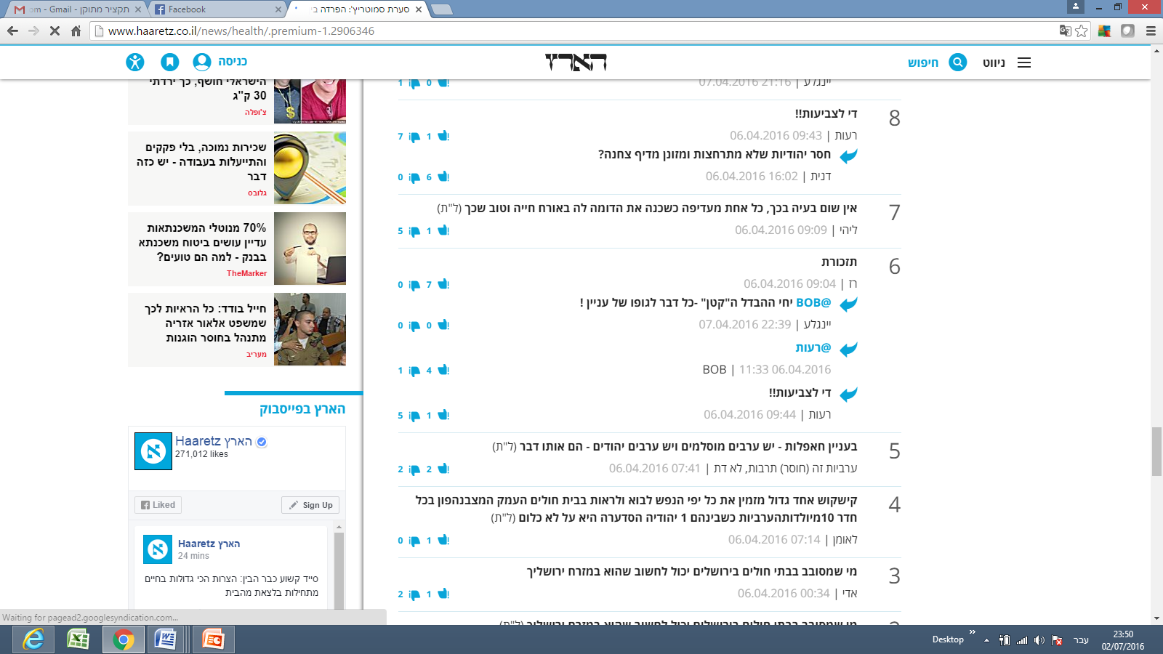

**Translation:** *“Regarding get-togethers: there are Arab Muslims, and Arab Jews* [referring to the Jews who oppose the segregation] *- they are both the same."*

*“Arabness is a (lack) of culture; not a religion.”*

comment 3

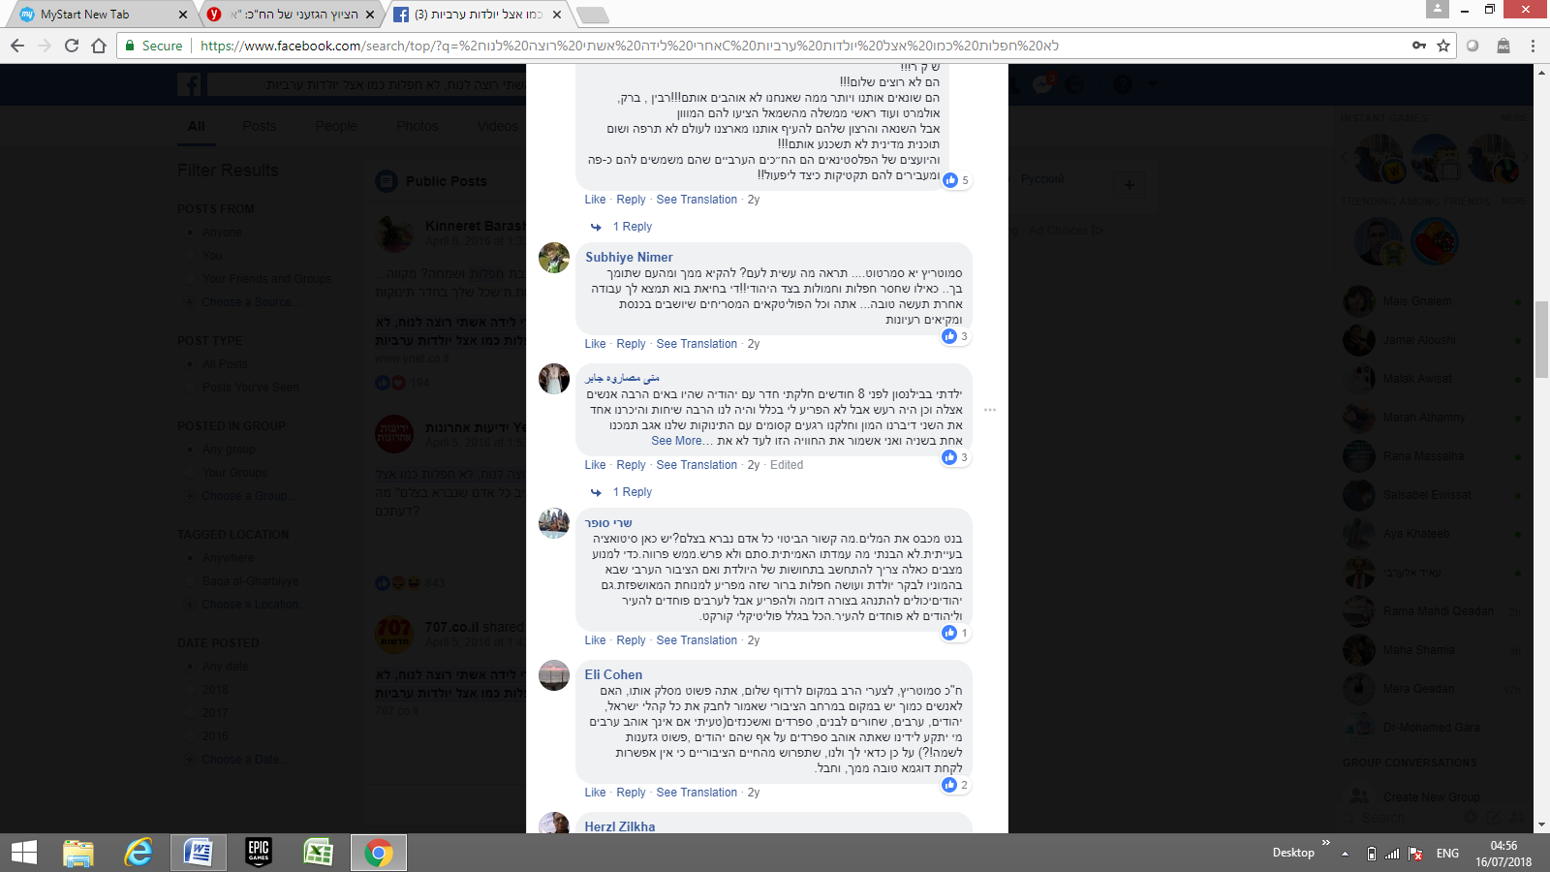

Translation: Smotrich.. what have you done to the people? we will vomit from you and from people supporting you. As if we lack parties from the Jewish side! Stop it dor God's sake. Do us a favor and go find yourself some other job.. you and all the disgusting Knesset Members who sit in the Knesset and only vomit their ideas.

comment 4 (written by a jewish Israeli citizen):

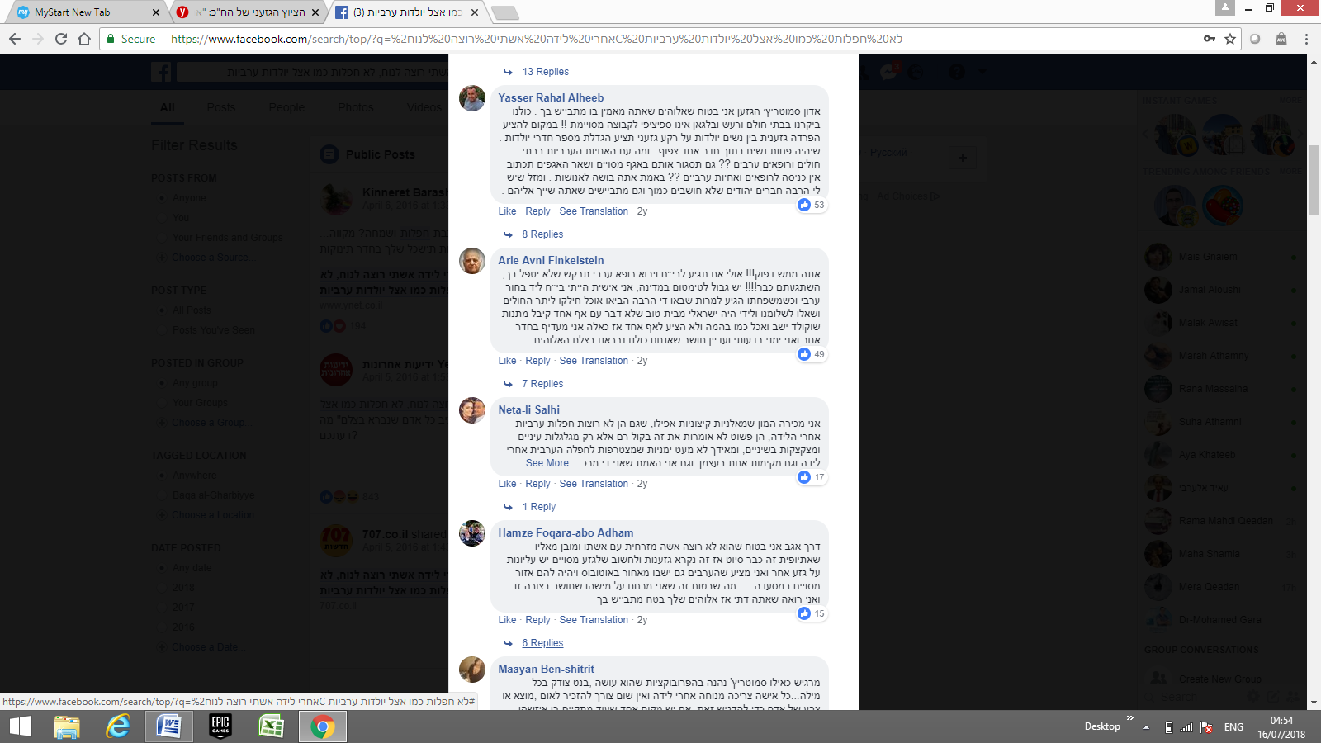

translation:

You [addressing Smotrich] must be crazy! Maybe if you go to a hospital and an Arab doctor comes to treat you, you will ask him not to take care of you! Are you all crazy! ... Even though I am a right wing in my political view of points, but I still believe that we are all humans.

Table 3. Reactions to the statement calling for the segregation of Arab and Jewish mothers in maternity wards

|  |  |  |  |
| --- | --- | --- | --- |
|  | **Jewish Israelis** | **Arabs** | **Total** |
| Offensive  Comments | 47:98  **47%** | 92:100  **92%** | 139:198  **70%** |
| Anti-segregation  Comments | 51:98  **52%** | 8:100  **8%** | 59:198  30% |

These findings point to a high percentage of negative reactions expressed following controversial incidents by both parties under study. Of the 296 comments made by Jewish Israelis, 220 (74%), were categorized as negative reactions, and 137 of the 243 comments made by Palestinian Israelis (56%), expressed negative reactions toward Jews. The total negative comments from both parties amounted to 66% of the total number of comments gathered for the study, with 357 of the 539 comments displaying negative attitudes.

**Discussion**

The frequency with which both Jewish Israelis and Arab/Palestinian Israelis used offensive language about the other group, as well as their strong negative attitudes toward the other regarding the incidents under examination, reveal a fragmented and polarized political and social landscape vulnerable to significant inflammation or incitement. These findings also support the proposition that peaceful channels of communication between Jewish Israelis and Arab/Palestinians Israelis are rare. In addition, it is clear from the findings presented that Jewish Israelis commenting on Facebook are far more likely to use offensive language than are their Arab/Palestinian Israeli counterparts. One possible explanation for this finding is that Jewish Israelis feel more secure about expressing their true opinions; regardless of how offensive they are, believing that they are less likely to face legal or security-related consequences. In contrast, Arab/Palestinian Israeli commentators are more reluctant to express their views freely, as they feel more vulnerable to being pressured or even arrested by Israel’s security apparatuses than do their Jewish counterparts.

A further examination of these findings also raises the question of the relative absence of left-wing views expressed. Mass communication theories, specifically Noelle-Neumann’s (1979) spiral of silence theory, which posits that some people are not willing to state their real opinions due to fear of isolation from the overwhelming majority opinion, may help understand this phenomenon. According to Noelle-Neumann, public opinion amounts to “pressure to conform.” In essence, public opinion is a general social climate, a prevailing moral and aesthetic trend in society that monitors human activity much like a “public eye” from which nobody can remain unseen (Noelle-Neumann, 1985, p. 84). Furthermore, she argues that the essential meaning of the term lies in “the interaction between the inclinations, abilities, and convictions of the individual and the agreement of the many, to which the individual has to subordinate himself if he does not want to place himself in isolation outside society” (Noelle-Neumann, 1979, p. 151). According to Noelle-Neumann, it is through the media of mass communication that people in modern societies come to learn about public opinion. This is certainly the case in the context of social media networks and can help explain why the overwhelming majority the posts by Jewish Israelis examined expressed anti-Arab sentiments,

In addition, in many cases in the past where Arab/Palestinian Israelis revealed negative attitudes towards the Jewish community, the Arab/Palestinians Israelis experienced troublesome consequences. For example, an Arab/Palestinian Israeli woman was fired from her job at a Jewish Israeli municipality after writing on her Facebook wall that she wished more Israeli soldiers had been killed following the death of some Israeli soldiers.[5]

Another well-known incident, which was frequently discussed and shared on Facebook pages and other media platforms, including Al Jazeera and all Israeli mainstream media, such as Channels 2 and 10, was that of the popular Arab journalist Anas Abu Daabes, who had written a satirical Facebook post during a time when wildfires were raging in Israel. The post, after having been translated using Google Translate, lost its satirical meaning and was interpreted as an incitement for Arab/Palestinian Israelis to commit arson, leading to Abu Daabes’ arrest.[6] These incidents likely dissuaded Arab/Palestinians Israelis from revealing their true attitudes towards Jewish citizens, especially during times of crisis or regarding controversial issues. Many Arab/Palestinian Israelis using Facebook are certain that their Facebook posts are scrutinized more closely by Israel’s security apparatuses than are those of their Jewish counterparts. In the case of Abu Daabis, for example, many Arab Facebook users shared screenshots on their walls of other comments by Jewish Facebook users which clearly called for arson.[7]

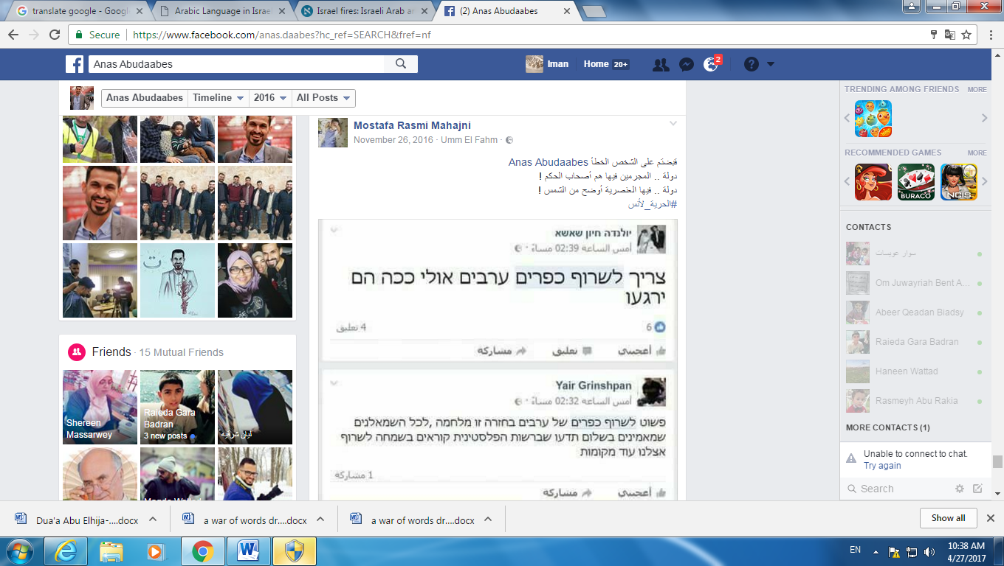

**Translation of the Arabic text**: “You’ve arrested the wrong person, Anas Abudaabes. In this country the criminals are the governors! In this country racism is as clear as the light of the sun!

#Freedom to Anas!”

**Translation of the Hebrew texts:**

**Comment 1:** “We have to burn all Arab villages; maybe this way they’ll calm down.

**Comment 2:** “We simply need to burn Arab villages in return. This is a war, and all the leftists who believe in peace should know that in the Palestinian Authority, they are happily calling for more fires in our country.”

The findings also demonstrate a difference between Jewish Israelis’ reactions to controversies involving physical threats or confrontations and to controversies involving ideological or ethical issues, such as that of segregating Arab and Jewish women in maternity wards. The latter case evoked far fewer offensive comments from Jewish Israelis. However, even these comments revealed a sub-category of attitudes, with Jewish Israelis criticizing Jews who sympathized or affiliated with Arab/Palestinian Israelis. Arab/Palestinian Israelis were also much more confident about expressing their opinions about the segregation controversy, as the issue clearly involved racism rather than a threat of physical harm.

**Bibliography**

Al-Haj, M. (1996). *Education among the Arabs in Israel: Control and social change*. Jerusalem: Magnus.

Al‐Haj, M. (2004). The political culture of the 1990s immigrants from the former Soviet Union in Israel and their views toward the indigenous Arab minority: A case of ethnocratic multiculturalism. *Journal of Ethnic and Migration Studies*, 30(4), 681-696.

Al-Haj, M., & Rosenfeld, H. (1990). *Arab local government in Israel*. Westview Press.

Amara, M. (2002). The place of Arabic in Israel. *International journal of the Sociology of Language,* 53-68.

Amara, M. (2003). The Collective Identity of Arabs in Israel in an Era of Peace. *Israel Affairs.* 9(1-2), 249-262.

Amara, M. (2017). *Arabic in Israel: Language, Identity and Conflict.* Routledge.

Avgerinakou, A. (2003). Flaming in computer-mediated interactions. *Pragmatics and Beyond New Series,* 273-294.

Bekerman, Z., & Maoz, I. (2005). Troubles with identity: Obstacles to coexistence education in conflict ridden societies. *Identity*, 5(4), 341-357.

Ben-Rafael, E., Shohamy, E., Hasan Amara, M., & Trumper-Hecht, N. (2006). Linguistic landscape as symbolic construction of the public space: The case of Israel. *International Journal of Multilingualism*, 3(1), 7-30.

Bligh, A. (2003). *The Israeli Palestinians: an Arab minority in the Jewish state* (No. 27). Psychology Press.

Bond, R. M., Fariss, C. J., Jones, J. J., Kramer, A. D., Marlow, C., Settle, J. E., & Fowler, J. H. (2012). A 61-million-person experiment in social influence and political mobilization. *Nature*, 489(7415), 295.

Boymel, Y. (2007). Blue and white shadow–the policy of the Israeli establishment and its activities among the Arab citizens: the formative years: 1958–1968. Haifa [Hebrew].

Brundidge, J. (2010). Political discussion and news use in the contemporary public sphere: The “accessibility” and “traversability” of the Internet. *Javnost-The Public,* 17(2), 63-81.

Coe, K., Kenski, K., & Rains, S. A. (2014). Online and uncivil? Patterns and determinants of incivility in newspaper website comments. *Journal of Communication*, 64(4), 658-679.

Cohen, H (2006). *Good Arabs*. Jerusalem: Keter (Hebrew)

Dvir-Gvirsman, S., Tzfati, Y., & Menchen-Trevino, E. (2014). The extent and nature of ideological selective exposure online: Combining survey responses with actual web log data from the 2013 Israeli Elections. *New Media & Society*, 18, 857-877.

Enli, G. S., & Thumim, N. (2012). Socializing and self-representation online: exploring Facebook. *Observatorio* (OBS*), 6(1).

Grossman, D. (1992). *Present absentees*. New Library-Hakkibutz Hameuhad Publishers, Tel Aviv.

Halperin, E., & Bar-Tal, D. (2011). Socio-psychological barriers to peace making: An empirical examination within the Israeli Jewish society. *Journal of Peace Research,*48(5), 637-651.

Holsti, O. R. (1969). Content analysis for the social sciences and humanities. Reading. MA: Addison-Wesley (content analysis).

<http://www.aljazeera.com/news/2015/10/terrorist-state-151011084548356.html>

<http://www.haaretz.com/israel-news/1.682928>

[http://www.haaretz.com/israel-news/1.696321 Last access 17.04.2016](http://www.haaretz.com/israel-news/1.696321%20Last%20access%2017.04.2016)

<http://www.jpost.com/Israel-News/Report-Various-Israeli-hospitals-separate-pregnant-Jewish-Arab-on-request-450271> Last access 17.04.2016

Huckfeldt, R., Johnson, P. E., & Sprague, J. (2004). *Political disagreement: The survival of diverse opinions within communication networks*. Cambridge University Press.

Jang, S. M., Lee, H., & Park, Y. J. (2014). The more friends, the less political talk? Predictors of Facebook discussions among college students. *Cyberpsychology, Behavior, and Social Networking,* 17(5), 271-275.

John, N. A., & Dvir-Gvirsman, S. (2015). “I Don't Like You Any More”: Facebook Unfriending by Israelis During the Israel–Gaza Conflict of 2014. *Journal of Communication,* 65(6), 953-974.

Karniel, Y., & Lavie-Dinur, A. (2012). Privacy in new media in Israel: How social networks are helping to shape the perception of privacy in Israeli society. *Journal of Information, Communication and Ethics in Society*, 10(4), 288-304.

Krippendorff, K. (1980). *Content analysis*. Beverly Hills. California: Sage Publications, 7, l-84.

Krippendorff, K. (2013). *Content Analysis. An Introduction to Its Methodology*. Sage, London.

Kuo, F. Y., Tseng, C. Y., Tseng, F. C., & Lin, C. S. (2013). A study of social information control affordances and gender difference in Facebook self-presentation. *Cyberpsychology, Behavior, and Social Networking*, 16(9), 635-644.

Mor, Y., Kligler-Vilenchik, N., & Maoz, I. (2015). Political expression on Facebook in a context of conflict: Dilemmas and coping strategies of Jewish-Israeli youth. *Social Media+ Society*, 1(2), 2056305115606750.

Mutz, D. C. (2006). How the mass media divide us. Red and blue nation? Characteristics and causes of America’s polarized politics, 1.

Noelle-Neumann, E. (1979). Public Opinionand the Classical Tradition: A Re-evaluation. *Public Opinion Quarterly*, 43(2), 143-156.

Ramon, S., Campbell, J., Lindsay, J., McCrystal, P., & Baidoun, N. (2006). The impact of political conflict on social work: Experiences from Northern Ireland, Israel and Palestine. *British Journal of Social Work*, 36(3), 435-450.

Rouhana, N. N., & Fiske, S. T. (1995). Perception of power, threat, and conflict intensity in asymmetric intergroup conflict: Arab and Jewish citizens of Israel. *Journal of Conflict Resolution*, 39(1), 49-81.

Sa'di, A. (2013). *Thorough surveillance: The genesis of Israeli policies of population management, surveillance and political control towards the Palestinian minority*. Manchester University Press: Manchester, UK.

Smooha, S. (1989). *Arabs and Jews in Israel* (Vol. 1, pp. 2-3). Boulder: Westview Press.

Smooha, S. (1990). Minority status in an ethnic democracy: The status of the Arab minority in Israel. *Ethnic and Racial Studies*, 13(3), 389-413.

Smooha, S. (1992). *Arabs and Jews in Israel* (Vol. 2, pp. 1-22). Boulder: Westview Press.

Smooha, S., (1984). *The orientation and politicization of the Arab minority in Israel*(No. 2). University of Haifa, Jewish-Arab Center, Institute of Middle Eastern Studies.

Vraga, E. K., Thorson, K., Kligler-Vilenchik, N., & Gee, E. (2015). How individual sensitivities to disagreement shape youth political expression on Facebook. *Computers in Human Behavior*, 45, 281-289.

Wheelock, A., Haney, W., & Bebell, D. (2000). What can student drawings tell us about high-stakes testing in Massachusetts? TCRecord. org.

Yiftachel, O. (1992). The Arab minority in Israel and its relations with the Jewish majority: A review essay. *Studies in Comparative International Development,* 27(2), 57-83.

1. [https:// Workplaces Discipline Israeli Arabs for Facebook Posts Against Gaza Incursion](https://www.haaretz.com/israel-news/1.606681)

   [read more: https://www.haaretz.com/israel-news/1.606681](https://www.haaretz.com/israel-news/1.606681)
2. Author (if available). Title of article. (full date of article). Retrieved from: <http://www.haaretz.com/israel-news/1.682928> vs. Author (if available). Title of article. (full date of article). Retrieved from <http://www.aljazeera.com/news/2015/10/terrorist-state-151011084548356.html>
3. Author (if available). Title of article. (full date of article). Retrieved from <http://www.haaretz.com/israel-news/1.696321>
4. [Author (if available). Title of article. (full date of article). Retrieved from http://www.jpost.com/Israel-News/Report-Various-Israeli-hospitals-separate-pregnant-Jewish-Arab-on-request-450271](http://www.jpost.com/Israel-News/Report-Various-Israeli-hospitals-separate-pregnant-Jewish-Arab-on-request-450271)
5. Author (if available). Title of article. (full date) Retrieved from <http://hasa.co.il/?p=305466>
6. The Facebook post in question ended with the tag:[#satire_not_serious](https://www.facebook.com/hashtag/satire_not_serious?source=feed_text&story_id=10210042404830148) and  [#the_smoke_is_blinding_the_eyes_and_heart](https://www.facebook.com/hashtag/the_smoke_is_blinding_the_eyes_and_heart?source=feed_text&story_id=10210042404830148). See the link to the original post which was mistranslated: Author (if available). Title of article. (full date of article). Retrieved from <https://www.facebook.com/anas.daabes/posts/10209996280477068>

   See also the comment on the story in *Haaretz*: Author (if available). Title of article. (full date of article). Retrieved from <http://www.haaretz.com/israel-news/.premium-1.755367>
7. See: <https://www.facebook.com/permalink.php?story_fbid=1248838305139564&id=100000402186492>