Incorporating Sustainability into Chemistry Education by Teaching through Project-Based Learning

Muhamad Hugerat

The Academic Arab College for Education in Israel - Haifa

22 Hahashmal St., Haifa 33145; P.O. Box 8349, Israel

[muha4@arabcol.ac.il](mailto:muha4@arabcol.ac.il)

Abstract

In modern life, there is a "coarse" interference of man in his environment, and this can have a direct and indirect impact on our quality of life. As a result, today we make great efforts to explain the damage that human beings cause to the environment and the ways in which the damage can be reduced. Also, green behavior educators, such as recycling, reducing consumption and transitioning to renewable energy.

In this section, we present three projects: *"Green scientific stories", "Solar village"* and *"Microscale"* to incorporate sustainability using the Project Base Learning. We train that performing these projects in and out school will increase student awareness of sustainability. Executing the projects pushed students to work for the environment and for the protection of our planet in the future.

Introduction

Sustainability is the totality of aspects that affect the chances of survival of the human race, its continuity and quality of life (Bonder, 2014; Burmeister & Eilks, 2013).

The first discussion of "sustainability" took place around 1960, due to human activities that caused great damage in the environment after World War II (Anastas & Eghbali, 2010). Sustainability or sustainable status is a condition where resources can be replenished at a rate that is faster than or equal to their degradation rate, and thus these resources can be sustained for a long time (Burmeister & Eilks, 2013), a term that deals with a multitude of aspects that affect the chances of human survival. , For his continuity and quality of life.

Sustainability has become an important issue that needs to be addressed in modern societies. Sustainability deals with our responsibility to make sensible and economical use of the earth’s resources that will allow future generations to live on a live able and resourceful planet. For successfully achieving long-term technological, environmental and societal sustainability all members and groups of our societies will have to contribute by making minimum use of irreplaceable natural sources and by providing and developing new technologies (Eliks & Rauch, 2012).

According to Eissen (Eissen, 2012), sustainability is an approach that promotes ideas and actions designed to prevent the collapse of ecosystems and social systems. According to Tal (2009), ecologically sustainability is the ability of an ecosystem to continue to exist with the same diversity and function and to satisfy the needs of the present without endangering future generations' ability to use a variety of resources.

According to the concept of sustainability, the challenge today is how to produce what is in short supply and what the audience wants without having a negative impact on the environment (Benstein, 2011).

It is of great importance to integrate sustainability and green chemistry into the curricula of all students and especially the *in* and *pre* service teachers. Providing pre- and in-service teachers with experiences related to sustainability relevant to their current and future students is an important component of their training to become effective chemistry instructors (Burmeister et al. 2013). Teachers should be aware of the applications of chemistry to industry, health, and technology (Braun et al. 2006).

Universities and colleges must be at the forefront of a sustainability projects to increase public awareness of the environment and strengthen knowledge of sustainability and the environment, technology relevant to these issues and the desire to create a sustainable future (Pike et al., 2003). Education plays an important role in the development of behaviors, but not every education method can lead to change in behavior. It is only through educational projects focused on a particular behavior that one can create a change in behavior. To advance the topic of education for sustainable behaviors, knowledge must be imparted that reflects the internal connections between humans and natural systems (Karpudewan, Seng & Ismail, 2014).

Project Base Learning (PBL) is one of the best methods for developing broad learning capabilities among students (Barak, 2012; Terasawa, 2016). It promotes student interest in science and improves their understanding of science content (Langbeheim, 2015). In this method, the inquiry process is organized around a project, an output that motivates student activity. Learning involves accomplishing complex tasks whose output is usually an "artifact", a concrete product such as a model, a picture, or a presentation. Students present their product before an audience (presentation), explain it, and reflect on the learning process. In this method, the teacher constructs tasks, asks challenging questions, as well as directs and encourages the development of information and social skills. Finally, the teacher evaluates the learning and the knowledge that the students obtained from the experience (Ministry of Education, 2014).

PBL creates a link between practical and intellectual activity (Solomon, 2003), promotes significant learning, associates new learning with previous experience and knowledge, and enables students to experience a variety of communication and knowledge-presentation situations (Westwood, 2006). In addition, it constitutes a more efficient method than traditional learning does, because it helps students adapt to different learning styles (Kaldi et al., 2011), and provides a broad variety of learning possibilities, so that each student can participate and can choose an appropriate learning level. The element of choice is an important component of student success (Bell, 2010). The PBL method enables students to acquire knowledge and abilities by inquiry and involvement in complex problems and challenges (Coyne, Hollas & Potter, 2016; Hugerat, 2016).

According to Hugerat (2016), PBL induces students to develop self-learning skills, which are very important in the new age of information technology. Using a project-based learning approach induces a creative classroom atmosphere; students generally perceive project work as enjoyable and entertaining.

One of the major aims of modern education is to support pupils in developing a sense of responsibility for the environment. Hence, schools and other places of education have a significant role to play in the promotion of sustainable development and environmental conservation through teaching and learning using PBL. It is possible by educational means to encourage the formation of positive environmental values and to teach the skills and cognitive basis required for active participation as individuals and members of the community. According to Zoller (2004), sustainable development requires a radical change in the environmental “behavior” and “thinking environment”.

In this chapter, we describe three projects to make chemistry more relevant to everyday life and to teach sustainability.

*Sustainability Learning Objectives of the projects:*

Through the implementation of the educational projects, all partners should be able to:

* Define and apply sustainability principles.
* Explain how natural, economic, and environmental factors influence the educational projects to foster or prevent sustainability.
* Consider sustainability principles while developing personal and professional values through the implementation of the educational projects.
* Recognize and assess how sustainability affects their lives and how their actions influences sustainability.
* Think critically about sustainability across a diversity of cultural values and across multiple scales of relevance from local to global.
* Know more about the importance of sustainability in our daily life.
* Take personal actions to maintain a sustainable environment

These learning objectives were applied to three educational projects:

*1. Incorporating Sustainability by Teaching "Green scientific stories" Project:* These stories are a creative and imaginative learning tool can influence kids to pursue sustainable lifestyles. Early education through chemistry stories for sustainability can help “green” decisions be the default mode for the generation to come.

*2. Incorporating Sustainability by Teaching "Solar village" Project:* Teaching children to value solar energy through educational project, such as, solar village in the schoolyard, encourage students to think of the school backyard as a sustainability laboratory. Bringing solar energy as an educational project to schools increases the use of solar energy as alternative green energy in the community at large. In addition, Increases public awareness of the environment and strengthens knowledge of sustainability and environmental issues, the technology relevant to these issues and the desire to create a sustainable future.

*3. Incorporating Sustainability by teaching the "Microscale" Project:* Miniaturizing laboratories for sustainability. Miniaturized environmental laboratory in order to protect the near and far environments. The microchemistry system is a solution to the problem of environmental pollution for the reasons that the equipment is disposable, less costly and easy to use. This increases awareness of sustainability and the prevention of environmental pollution.

1. *Incorporating Sustainability by Teaching "Green scientific stories" Project*

Albert Einstein said, “*Imagination is more important than knowledge.”* This is important for the problem-solving aspects of science. The Storyline Approach is an inquiry-based teaching method based upon a strategy first introduced by Kieran Egan (1986). The story structure can provide students with a framework for concept formation and for the retention of the concept. Storytelling is a gentle and effective way to pass on lessons and values (Trostle & Donato, 2001; Grugeon & Gardner 2000).

Storytelling is an effective way to teach lessons. Human brains seem to retain material put in story form much better than a list of unrelated facts (Haven, 2000; Weaver, 1994). In the classroom, you can use stories to introduce a topic, hook listeners and demonstrate abstract ideas. In addition to being an effective teaching tool, you will also discover that telling stories is fun for both the listeners and the teller (Trostle & Donato, 2001; Grugeon & Gardner 2000).

Storytelling is fun and helps to build bridges between people and the natural world. Stories can help listeners develop empathy for the animals and plants that share our world (Strauss, 2006; Taylor, 2010).

The story is a good way to teach children different subject and explain phenomena in the kindergarten (Grugeon, 2000; Hewlett, 2008; Turner & Bage 2006). Before we chose a story to introduce it in front of the children, we must to ask several questions, such as: If the subject of the story will be found in the cycle of the children attention? If the subject introduces in the way that it will give a new expert, which the children, will achieve easily? Which solution the story will give?

To answer these questions we must be careful to choose a story for the children and we must take in account several point such as (Grugeon, 2000; Hewlett, 2008; Turner & Bage 2006):

* Adjustment the story to the children in several age stages.
* The subject well takes about life expert similar to that from the close environment of the children.
* The actors of the story will be well known from the close environment of the children, such as, the family word, the neighbors or the animals word, the plants words which react as the human being in their relations and emotional, speak, cry, play, be happy and be sad.
* The way that the story introduces the general idea.
* The solutions that the story gives will be acceptable and effective.

***The story influence in extending child's imagination:***

The story uses the entire intelligence element, such as, imagination, intelligent, remembrance, conclusion, and understanding and acceptable; all of these elements are connecting to the imagination (Trostle & Donato, 2001; Haven, 2000, Weaver, 1994; Feasey, 2006):

* The story exposes the child to different excitement and different cultures.
* The story satisfies many aspects in the child, such as amazing, strange and expected the non-normal.
* The story opens in front of the child new domains of creativity and methods to adopt new ways of behavior. This thing supports the capability to behave in a positive way.
* The story gives the child a lot of information that the scientific subject cannot give them, and this information does not need a big effort to know and understand.

Writing “green” scientific stories for sustainability to make chemistry more relevant to everyday life (Hugerat, 2007). Early education through chemistry stories for sustainability can help “green” decisions be the default mode for the generation to come. These projects for sustainability to make chemistry more relevant to everyday life. These stories are a creative and imaginative learning tool can influence kids to pursue sustainable lifestyles.

The project is based on covert processes in teaching science according to problem solving method, asking questions, and raising arguments.

*Working Program*

*The First Step:*

Writing a simple science story to convey an environmental science topic (sustainability). Teacher or expert will write the story.

*The Second Step:*

The teacher divides the story into several parts, using an open-ended inquiry method. In addition, after each chapter, he asks a number of questions to the students and expects the students to come up with arguments that will solve the problem presented and provide an opening for the next chapter. The teacher opens a class discussion to hear different arguments from the students.

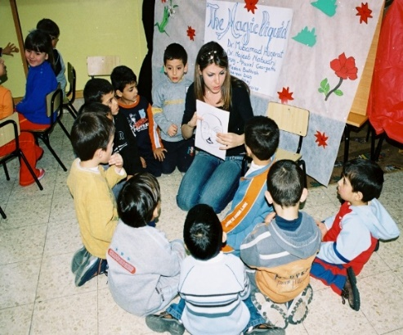 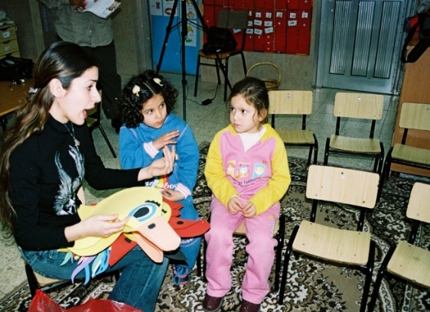

*The Third Step:*

At the end of each chapter, the teacher ask the students: What do you expect the chapter to be after. Until the end of the story.

*The Forth Step:*

Work with the students on the story summary and its implications on three aspects: scientific-environmental, social and educational, with the main topic of discussion being on sustainability.

Example1: "Rose in the Dark"

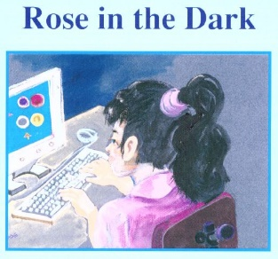

1. "Rose" is a computer-loving girl who sits for hours in front of the screen in a dark room without caring for food or playing with her friends. She looks pale on her face and on her body. Therefore, her mother decided to took her to the clinic to meet with her family doctor.

*Q1: why "Rose" look pale?*

*Q2: why her mother took her to meet the family doctor?*

*Q3: suggest to "Rose"; how to be healthier!*

1. Her family doctor gives her some medications, warns her against sitting too long in front of the computer, advises her to eat fresh meals and go out to play with her friends. In the corner of the clinic was to similar pot that contain the same plat with green Leaves. The Family doctor asked to "Rose" to watch carefully what he is doing. He took the first pot, poured a little water, and placed it next to the window where the light and air, and the second pot placed in the closet where dark without water and without light, and the doctor asked "Rose" return to the clinic after a week.

*Q1: can you explain! Why the doctor do this activity in front of "Rose"?*

*Q2: What do you expect to happen to the plant in the first pot?*

*Q3: What do you expect to happen to the plant in the second pot?*

*Q4: why the family doctor asked "Rose" to return the clinic after a week?*

1. After one week, "Rose" came to the clinic accompanied by her mother. When she entered the clinic, she looked to the window where the first pot; the pot was in excellent condition. The flowers grew, and the scent of the waffle opened everywhere. The second pot, which was in the closet inside the darkness, did not bloom and the green leaves became yellow. The smell of them stinking.

*Q1: Did your expectations match the results of the activity? Are your expectations better than the results given?*

*Q2: According to the results can you explain why the doctor did this activity!*

1. "Rose" looked at the doctor and said: "thank you indeed doctor for your message; now I understand what you aim from this activity."

*Q1: what the docors' message to "Rose"?*

*Q2: How "Rose" will behave after she will come back to her house.*

*Q3: what you think will happened to our life if it will be darkness forever?*

*Q4: Is there a situation in nature that would be total eternal darkness?*

*Q5:* *How do we act to prevent this situation and preserve the plant in which we live?*

***Summary:*** Performing the project "*Rose in the dark"* raises awareness of sustainability. It also strengthens three aspects: the *environmental-science aspect, the social aspect,* and *the educational aspect* in students:

*The scientific content* appears in the adaptation of the organism and the need of the plant for water, light and oxygen to complete its growth process. The plant, like any other organism, needs care to grow, and humans need living conditions so that they can live properly.

*The social content* emerged through the fear of the mother to her daughter; the mother was watching her young daughter pale face with tearful eyes. When the father returned in the evening and saw the mother in an abnormal state, after consultation, they decided to present a Rose to the family doctor.

*The educational content* appears in the treatment of the doctor, it was soft, not only his task to give her medicine and advice, but he did scientific activity in front of "Rose". The doctor did not give the result of the experience to "Rose" and did not tell her why he did this particular experience but left it until she thinks and draw the result alone.

Example 2: "The Polluted Lake"

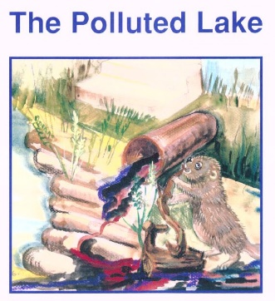

1. "The story speaks of an animal named beaver who lives on the bank of the lake next to a waterfall. Two days passed and he did not see the duck family. He decided to visit them, on the way, he asked the rabbit-doctor to join him.

*Q1: why the beaver decided to visit the duck family?*

*Q2: why he asked the rabbit-doctor to join him?*

1. When they arrived at the duck family's house, everyone was amazed. The little duck was lying on the ground and coming out of his mouth a white liquid ………

*Q1: what you think happened to the little duck?*

*Q2: how you can help him?*

1. … that later turned out to be drinking from the polluted nearby lake water. The rabbit said: I will go to my house and bring medicine. The beaver, in cooperation with his animal friends, decided to bring the tree branches to close the nozzle of the pipe…

*Q1: what the reason that the lake was polluted?*

*Q2: what you think about the decision of beaver? Do you think you should act like him?*

*Q3: what you think about the result of the beaver act?*

1. … which brings the dirt from the village into the lake and pollutes it. Thus, the friends succeed in cooperating with each other to return the water and dirt to the houses of the village so that the lake water is safe to drink and swim in it. The rabbit said, "I heard the people of the village talking about the mistake they did"…

*Q1: why the beaver act like that?*

*Q2: what the beavers' message to the people of the village that make the pollution?*

*Q3: do you think you will behave like the beaver?*

*Q4: what you think will happened to our life if we through all the dirt and sewage to the lakes and sea?*

*Q5: Is there a situation in nature that would be total eternal polluted?*

*Q6: how you will act to prevent water pollution in the future?*

*Q5:* *How do we act to prevent this situation and preserve the plant in which we live?*

***Summary:*** Performing the project "*The Polluted Lake"* raises awareness of sustainability. It also strengthens three aspects: *the environmental-science aspect, the social aspect,* and *the educational* aspect in students:

*The environmental science content*: Here, the story addresses the issue of environmental pollution in general, and the individual must take responsibility towards the environment and should contribute to the rescue of the environment from pollutants. He should help to get rid of all that can be detrimental to the environment and not to dump waste in the estuaries because it causes diseases for those they live in this environment.

*The social content*: In the story of the "polluted lake," mention and repeat the word "family", for example: "The beaver worried about the duck family", "Two days ago, I don’t see any member of the duck family", "The beaver decided to visit the duck family", "I come asking you to accompany me to visit Duck family.

"yes, we can" if we working together we can solve our problems; "The beaver, together with his animal friends, decided to bring in the branches of the trees to close the nozzle of the pipe, which would bring dirt from the village, pour into the lake, and pollute it."

*The educational content*: The collective work of the animal friends and cooperation among them contributed to the return of water and dirt to the homes of the village. Everyone realized that throwing dirt leads to pollution, which causes diseases.

1. *Incorporating Sustainability by Teaching "Solar village" Project*

A teacher who motivates his students and stirs their curiosity and their ability to research and explore will create a worthy student who can contribute to local social and economic development. Thus, a generation can arise which is capable of planning and inventing the appliances needed by the community and of becoming good citizens in their society (……).

From a historical perspective, the use of projects in science instruction dates back to 1908, when Rufus Stimson, a teacher at Smith Agricultural School in Northampton, Massachusetts, coined the term "home projects" (Stevenson, 1928). The purpose of these projects was to provide students with the opportunity to apply the school’s teachings in their farm work at home. “Child-centered learning,” “learning by doing” and “applying school teachings in the home” are the core values of project-based science instruction. This method was further strengthened by the work of constructivists such as Piaget (1969, 1970) and Vygotsky et al. (1978). Both focused their work on child-centered learning and knowledge construction through practice and reflection. The work of progressive and constructivist science educators laid the foundation for project-based science instruction in the United States and elsewhere.

One of the major aims of modern education is to support pupils in developing a sense of responsibility for the environment. Hence, schools and other places of education have a significant role to play in the promotion of sustainable development and environmental conservation (Eilks & Rauch 2012)

Teaching children to value solar energy through educational projects(e.g., Solar village in the schoolyard) and to encourage students to think of the school backyard as a sustainability laboratory were effective approaches (Hugerat et al. 2003).

Hugerat (2016) found that teaching science by the project-based teaching method significantly improved student-teacher relationships, and enhanced students' enjoyment. These variables led to the creation of a good educational climate that enabled the teacher to achieve the lesson's objectives and the students to benefit.

The school are an ideal place to use solar energy. Changes and improvement at schools are highly visible and closely followed. Bringing solar energy to school increases the use of solar energy in the community at large. School make a good showcase for the benefits of solar photovoltaic electricity and pupils will educate their parents that solar energy is clean, limitless and using the sun for lighting, heating and cooling. This using emphasizes the importance of energy for technological society and especially alternative energy sources, are quite, do not create pollution, do not require much land and water to operate and can be used to generate both electricity and fuels (Hugerat et al. 20024; Hugerat et al., 2011).

The youth of today feel disenfranchised by their elders. All they hear about is how dire their environmental future is and how little effort previous generations are putting into change. By encouraging the installation of solar power in their schools, students will see firsthand the benefits of natural energy and grow up interested in its uses and production. With so many future careers in the green energy sector, this will provide them with the drive and enthusiasm they will need to succeed in it (Hugerat et al. 20024; Hugerat et al., 2011).

In a project that we designed the students built a real model of solar village inside the school (Hugerat et al. 2003), which uses only solar energy. The project emphasize the importance of energy for a technological society and the advantage of alternative energy sources. In this project, the pupils in three elementary schools in Israel were active participants in building systems that use solar energy to work (Hugerat et al. 2004; Hugerat et al., 2011). Teaching through projects methods were effective approaches to introduce principles of various types of renewable energy to students. Through working on the projects, students not only got a better understanding of the basic concepts of various types of renewable energy, but also were able to apply the concepts to the design of hardware and systems.

*Working Program*

*The First Step:*

Preparing a studying school program, this will contain the following (Hugerat et al. 2011):

* Teaching the entire teacher in the school about sun energy, their uses and the need of this energy in enhancing advanced technology. In this step, it is very important that the teacher has an experience in different technology methods and prepares a studying material for the pupils about the solar energy subject for the solar village project.
* The teacher tours the place that uses solar energy in daily life or the place that investigates the solar energy.

*The Second Step:*

The second Step is to expose the subject of the educational project to the students. Here, we exposed the advanced technology instrument on the subject of solar energy before the pupils (see Figure 1).

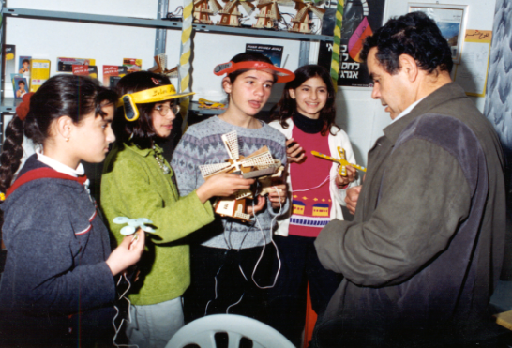

*Figure 1.* The teachers introduce the solar energy instruments for the students.

*The Third Step:*

In activities with investigation group, the students deal with the scientific, technological and social aspects of solar energy. It will introduce the students to an investigation and activities on the subject of solar energy are the teacher instructions. The students will work as a team, as they construct the solar kits that operate through solar energy.

*The Fourth Step:*

The students will built a big model of solar village inside the school; everything, which needs energy use the solar energy, such as lighting, TV, computer, communications and transport. The students built a small car that moves in the school courtyard and water pump that operate with solar energy (see Figure ...).

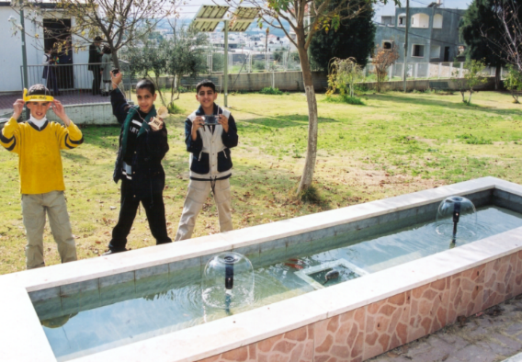 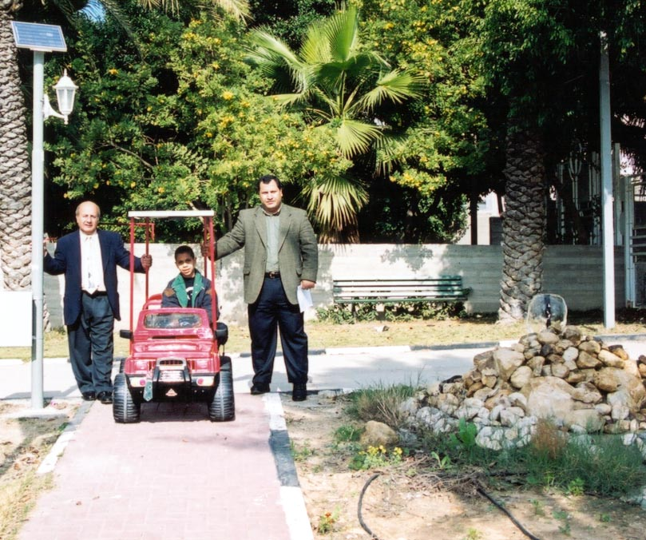

*Figure 3.* The students testing the water pump that operate with solar energy (right); and the solar energy car in the school yard (left).

*The fifth Step:*

In activities with investigation group, the students conducting experiments, using photocell instead of conventional battery. During the year the laboratory need so much battery to operate different apparatuses and it will be so expensive comparing to use one photocell that you can use it for a long time and if you keep it in good situation, you can use it forever and using photocell decrease pollution (Cantrell, 1978; Carless, 1993).

The sustainable nature of solar electricity along with its associated large resource potential and falling costs have motivated a rapid increase in the deployment of utility-scale solar electricity generation plants in recent years (Davis, 1983). As the installed capacity of photovoltaics (PVs) continues to grow, cost-effective technologies for solar energy storage will be critical to mitigate the intermittency of the solar resource and to maintain stability of the electrical grid (Tomas, 1996; White, 1979; Carless, 1993).

Electrolysis is a process that produces chemical change, especially decomposition, when an electrical current flow through an electrolyte. Starting from the last century, electrolysis of solution has been widely demonstrated to students in order to illustrate oxidation-reduction reactions as well as to demonstrate the potential use of an external source of energy to drive non-spontaneous chemical reactions (Hugerat et al. 2003; Cantrell, 1978). Among various technologies for producing hydrogen, water electrolysis using electricity from renewable power sources instead of conventional battery shows great promise. Hydrogen generation via solar water splitting represents a promising solution to these challenges, as H2 can be stored, transported and consumed without generating harmful (Hugerat et al. 2003, Davis, 1983)

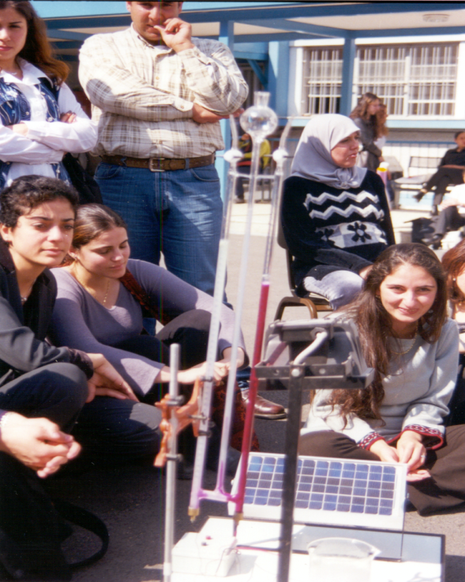

Fig. 2: Students use solar electric panels to produce hydrogen and oxygen gases from the electrolysis of water.

After producing hydrogen and oxygen gases through the electrolysis of water and studying the process, students realize that hydrogen can act as an energy carrier and that as an energy carrier it has many properties that are useful to humankind. Students complete a short reading on hydrogen as an energy carrier, and use solar electric panels to produce hydrogen and oxygen gases from the electrolysis of water. They then test for the presence of flammable gases and propose and balance the chemical reaction for the process of the electrolysis of water.

*The Educational Project Effect*

* Students learn how to deal with environmental phenomena, analyze causes and outcome of things they observe and examine the relations between such things. This process helps students to develop different thinking styles and develop a comprehensive perception for the different phenomena. The implementation of such projects gives students greater and closer feelings of their environment and invites them to protect it. The implementation of such projects leads to change in the students’ way of thinking and improvement of their skills and creativity. A great majority (80.5%) of the students showed support to the conversion of the solar village project to reality in their hometowns (Hugerat et al. 2011).
* The project gave the parents the opportunity to know the activities that their children carryout at school, because they were requested to help the children in getting some data for the project. Parents will be more involved in sustainability and the environment and use of non-polluting alternative energy, thus preserving our planet. The majority of parents (95.3%) are supportive of projects that give their children the opportunity to participate, because they think that such projects like the solar energy village are very important to their children; and gives their children environmental education and the opportunity to work for the environment (Hugerat et al. 2011)..
* The execution of the project led to great cooperation, improved relations between teachers and students and made the teaching process more interesting, which led to improving the learning skills among students, such as planning and execution of research, doing other assignments and the development of the ability to “search and discover” among students in order to understand and become more aware of the environmental phenomena. The teamwork of the participating teachers affected the other faculty members and created a more positive and vital work environment. This led all teachers to adopt new and more effective thoughts and teaching methods. The execution of the project increased the community appreciation of the school and its values in the eyes of parents and Ministry of Education. The results show that almost all the teachers (95.4%) are willing to participate in environmental educational projects inside the school. This indicates the positive impact of the solar village project on the schools that carry out this and similar projects (Hugerat et al. 2011).

***Summary***: Performing solar village project raises awareness of sustainability and clean energy, as well as increases students' social engagement. The results of implementation the project assert that the solar village project was widely accepted by students, parents and teachers. These groups support such project because of great educational impact and its effect in increasing the students’ moral and in promoting their thinking and creativity. Socially, the project offers everyone the opportunity to participate in the activity, become acquainted with issues relevant to our environment, and have a positive effect on our daily life. From a learning aspect, it increases the students’ knowledge about our surrounding, especially the dependence on the sun as a source of clean energy in future.

1. *Incorporating Sustainability by Teaching the "Microscale Chemistry Home Experimentation" Project*

Environmental protection is an important issue in chemical education. Maintaining a pollution free environment and handing chemical wastes are subjects of increasing concern to educators, universities and school systems. The best way to alleviate this concern is to eliminate chemical wastes at the source by using pollution prevention in schools teach environmental responsibility, encourage safety in the laboratory, save money and also help ensure schools meet legal requirements (Skinner, 1988; Zhou et al., 2005; Ibanez et al. 2008).

With increased concern about the problems of environmental pollution as well as rising laboratory costs, the strategy in teaching/learning chemistry through laboratory work requires certain modifications. One possible solution is to change from the traditional, large-scale and metal ware to the non-traditional microscale plastic or glass equipment (Singh, Szafran & Pike, 1999; Zhou et al., 2005).

The micro science system is a solution to this problem for the reasons that the equipment is less costly and easy to use. An important consequence, especially for chemistry, is that chemicals are used in much smaller quantities, thereby saving consumables costs and greatly reducing hazards and environmental impact (Bradley, 2000; Kalogirou & Nicas, 2010).

Microscale Chemistry Experiments (MCE) is an approach to conducting chemistry practical that can help overcome increased concerns about environmental pollution problems as well as rising laboratory costs. It is accomplished by using miniature lab ware and significantly reduced amounts of chemicals. Microchemistry is an innovative approach and effective teaching tool. Microscale experiments can contribute by providing quality chemical education with an environmentally safe approach (Singh, Szafran & Pike, 1999; Zhou et al., 2005; Hugerat & Schwarz, 2008).

At school level, MCE means practical working with substances in the volume range between 5 and 0.05 mL (1 drop). It offers a safer way to perform chemical experiments by using smaller quantities of chemicals. These have the advantages of reducing costs, reducing safety hazards and allowing many experiments to be done quickly in and outside of the laboratory (Singh, Szafran & Pike, 1999; Zhou et al., 2005; Hugerat & Schwarz, 2008).

.

Microscale experiments are supposed to diffuse problems of pollution disposal. Similar to the replacement of traditional laboratory equipment, the used substances can also be replaced. Experiments with food, detergents, household chemicals or solids taken from the kitchen and garage complete the techniques mentioned above. These substances cannot only be purchased in supermarkets, home improvement stores or pharmacies for a lower cost, but also dealing with and transporting them is less regimented. In addition, the handling of these resources is more motivating, since the students are working with substances that already play a role in their lives (Jorge et al. 2008).

Building miniaturized research microscale laboratory at the school gives an active learning environment for all students during the year and attracts the community. This encourages the teachers to actually build a miniature laboratory in the school in the future (Bradly, 2000).

Advantages of incorporate microscale chemistry in the experimental hands-on teaching laboratories with students in the classroom:

* The microchemistry system is a solution to the problem of environmental pollution for the reasons that the equipment is disposable, less costly and easy to use.
* Students are encouraged to experiment and develop their own electrolysis experience. Laboratory activities can be done quickly, even at home.
* Micro-scale: Saves time and Save money.
  1. Saves time: Leaves more opportunities for conversation, reflection and evaluation when protecting the environment using small amount of chemical: fewer chemicals, less waste (less is more!).
  2. Saves money: disposable ones used in the daily life replace special laboratory materials

Many methods for the volumetric water analysis have been developed since the German chemist A. W. von Hofmann (1803 – 1892) constructed his apparatus for the electrolysis of water. End of the nineties MCE appliances for electrolysis of brine were introduced by Hugerat (2008, 2009, 2010, 2013) into in and pre-service teachers used disposable plastic pipettes, needles, pencil leads and neutral electrolytes to design different types of microscale Hofmann Apparatus. Hugerat et al. (2010) made Galvanic and Electrolytic Cells from pieces of disposable materials such as, a Cola can, pencil leads, 1-mL blisters and 2-mL injection bottles. Hugerat et al. (2013) introduced into schools, a small and cheap plastic container with a 2-mL plastic pipette pierced by two hypodermic needles and a 9 Volt battery enough oxyhydrogen gas can be made and transferred into a well for a safe explosion every minute.

*Working Program*

*The First Step:*

The teacher asked the students to collect the materials: Syringe, smallest hypodermic needle, Soft drink cans, blisters, Tetra Paks, dropper bottles, drinking straws (spatula) can be found in households. Sterile syringes are obtained in pharmacies; a nurse may collect empty vials, 5ml injections bottles (Liquemin Roche) and 1-2 plastic pipets (Fig..) may collect by the students with help from the parents or the teachers. Many of the chemicals you may find in the household, such as, packing soda, sodium sulfate, table salt, red cabbage.

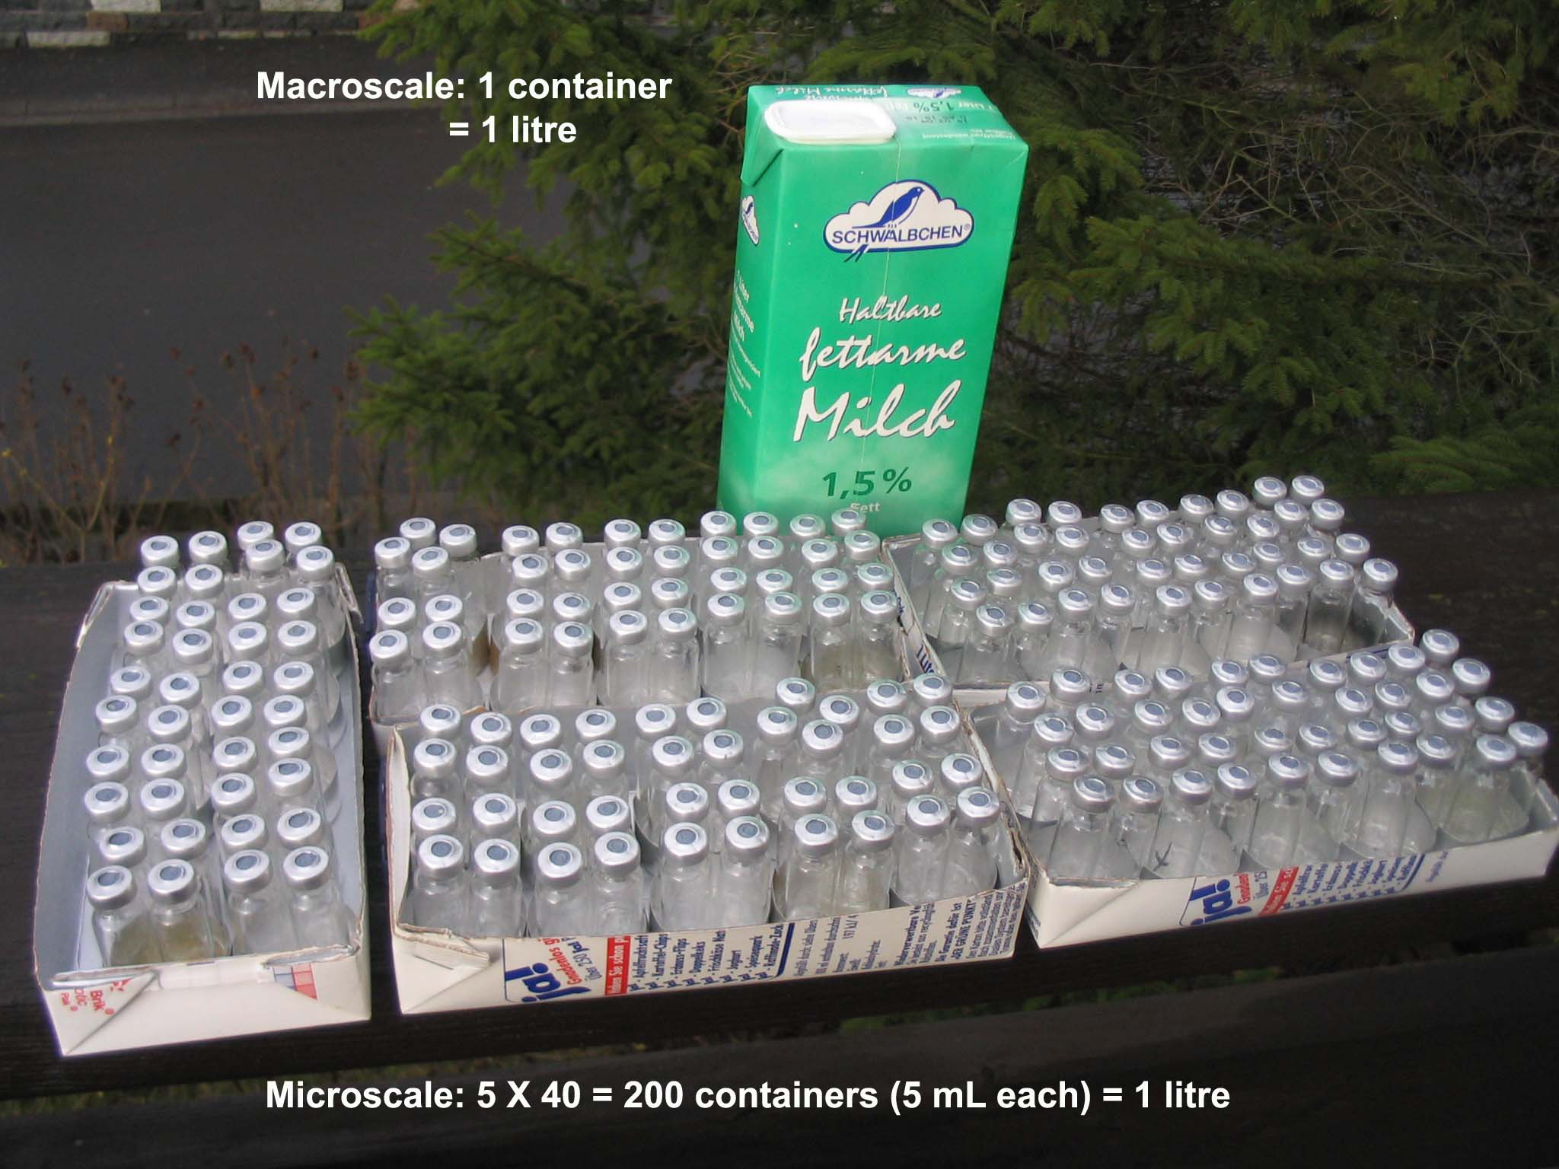

These materials can be collected from home, clinics, doctor family, and hospital.

*The Second Step:*

The teacher asks the students to cleanse the materials to keep away the dangers of infectious or any risk and it is important that the materials be sterilized. Under the supervision of these teachers, these materials are put into boiling water for a few minutes to undergo a perfect sterilization process. The teacher explains to students that materials should not be used without cleaning and sterilization. Once everything is ready, the teacher will tell the students that these tools will be used with us as a tool for performing various labs.

*The Third Step:*

The teacher bring worksheets about disposable materials, sustainability, and the dangers of pollution of the plastic to the earth and the water cycle if we threw it. The students should work in groups and discuss these issues and how this related to their life.

With the guide of the teacher, the students will suggest to build their laboratory from these disposable materials. The teacher will ask the students to suggest any experiments where they can use these disposable materials.

*The Forth Step:*

The students with the guide of the teacher will build the conventional "Hofmann apparatus" (macroscale) and the alternative "Hofmann apparatus" (microscale) using disposable materials as follow:

* The “Hofmann Apparatus for Decomposition of Water” – introduced by the German chemist A. W. von Hofmann (1813 – 1892) – is still worldwide present in schools and universities: Two tubes (connected with a third one) are supplied with platinum electrodes and powered by DC. Water mixed with sulfuric acid as electrolyte is decomposed leaving hydrogen and oxygen in a volume ratio of two to one.
* A first step to modify the "Hofmann" was done by replacing the electrodes by paper clips and the electrolyte by sodium sulfate solution mixed with red cabbage juice.
* A "Hofmann" for Microscale Home Experimentation consists of a small honey package pierced by two hypodermic needles. They were extracted from an Insulin syringe. The electrolyte is again sodium sulfate solution mixed with red cabbage juice. The electrodes (paper clips) are connected with a 9-Volt rechargeable battery. Two 5-ml injections bottles (Liquemin Roche) full of electrolyte are placed on the electrodes upwards down.
* In working groups the students will discuss and concluding the results.

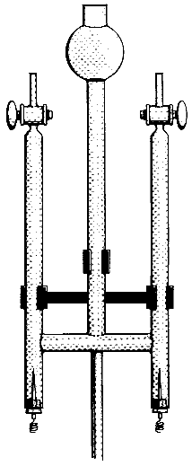 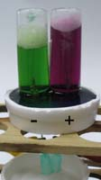 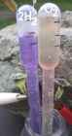

Fig….: in the right traditional glass Hofman apparatus (200ml), in the middle micro scale Hofman apparatus (10 ml) from disposable materials design by Hugerat et al. (2010, 2013).

*The Fourth Step:*

The teacher will ask the students to be more creative and think about different household materials than they use in this experiment, to build their own "Hofmann Apparatus". Alternatively, how they use this materials that the collect in another chemical process.

*The Fifth Step:*

***Conclusion:*** Microscale Chemistry Experimentation can supplement and sometimes replace demonstration experiments in schools, colleges and universities or even at home. Methodological and didactic ones supplement these economic and ecological advantages of MCE with packages:

* Experimenting is no longer restricted to the limited time in the school.
* Each student can do his/her own experiment, as materials are simple and cheap.
* Home experimentation with small quantities can even be done outdoor:
* Students can acquire basic skills and sustainable understanding already (assisted and supervised by teachers).

The presented simple and familiar apparatus should make these experiments safely available at all levels in chemistry classes. Students that have conducted the aforementioned described experiments with alternative Hoffman apparatus have shown excitement and fun especially when observing visually occurring electrolysis. We believe that; on one hand, this motivate the students to be more creative in designing new apparatuses in teaching and learning chemistry, and encouraging the students to be learning that is more active and creative in their classes and on the other hand, raises awareness of sustainability and prevents contamination from using non-polluting household and disposable materials.

*Micro scale solvated electron using disposable materials*

The existence of solvated electrons was speculated long ago. The earliest known example of an established electron excess in a liquid is alkali metals that produce stable blue solutions owing to solvated electrons in liquid NH3 (i.e., ammoniated electrons).



Here, we present a simple experiment to produce solvated electrons using materials commonly available in undergraduate laboratories, such as, lithium metal from small battery and computer-cleaning fluid) without the dangers associated with the use of solid Na or K metals (i.e., vigorous reactions or explosions) in a reasonably safe manner. The production of liquid ammonia and the use of a simple and inexpensive source for a metal alkali are also interesting from an educational standpoint (Ibanez et al. 2011).

***Summary:***  Microscale experiments are supposed to diffuse problems of pollution disposal. Furthermore, they are also supposed to reduce the potential risks in handling substances because much smaller amounts of chemicals are used in these experiments. Microscale chemistry is a laboratory-based, environmentally safe, pollution-prevention approach accomplished by using miniature glassware and significantly reduced amounts of chemicals.

***Conclusion:***

Performing the projects; *"Green scientific stories", "Solar village"* and *"Microscale"* to incorporate sustainability using the PBL, raises awareness of sustainability, clean energy and increase students' engagement. It also strengthens three aspects: the environmental-science aspect, the social aspect, and the educational aspect in students.

***References:***

Anastas, P., & Eghbali, N. (2010). Green chemistry: principles and practice. *Chemical Society Reviews, 39*(1), 301-312.

Barak, M. (2012). From 'doing' to ' doing with learning': Reflection on an effort to promote self-regulated in technological projects in high school. *European Journal of Engineering Education, 37*(1), 105-116.

Bell, S. (2010). Project-based learning for the 21st century: Skills for the future. *The Clearing House, 83*(2), 39-43.

Bodner, G. (2014). Green chemistry and sustainability education in the U.S. *Education for Sustainable Development and Chemistry Education*, 113-122.

Bradley, J. D. (2000). The micro-science project and its impact on pre-service teacher education. Washington, D. C.: The World Bank.

Braun, B., Charney, R., Clarens, A., Farrugia, J., Kitchens, C., Lisowski, C. ...& O’Neil, A. (2006). Completing our education: Green chemistry in the curriculum. *Journal of chemical education, 83*(8), 1126-1129.

Burmeister, M., & Eilks, I. (2013). An understanding of sustainability and education for sustainable development among German student teachers and trainee teachers of Chemistry. *Science Education International, 24*(2), 167-194.

Burmeister, M., Schmidt-Jacob, S., & Eilks, I. (2013). German chemistry teachers’ understanding of sustainability and education for sustainable development — An interview case study. *Chemistry Education Research and Practice, 14*(2), 169-176.

Cantrell, J. S. (1978). Solar energy concepts in the teaching of chemistry. *J. Chem. Educ.,* *55,* 41.

Carless, J. (1993). *Renewable energy: A concise guide to green alternatives.* Walker & Co.

Coyne, J., Hollas, T., & Potter, J. P. (2016). Jumping in: Redefining teaching and learning in physical education through project-based learning. *A Journal for Physical and Sport Educators, 29*(1), 43-46.

Davis, C. E. (1983). Solar energy experiment for beginning chemistry. *J. Chem. Educ.,* *60,* 158.

Egan, K. (1986). Teaching as storytelling. London, Ontario: Althouse Press; London: Routledge, 1988; Chicago: University of Chicago Press, 1988.

Eissen, M. (2012). Sustainable production of chemicals–an educational perspective. *Chemistry Education: Research and Practice, 13*(2), 103-111.

Eilks, I., & Rauch, F. (2012). Sustainable development and green chemistry in chemistry education. *Chemistry Education Research and Practice, 13*(2), 57-58.

Feasey, R. (2006). Using stories and poems in science. Primary Science Review, 8-10.

Grugeon, E., & Gardner, P. (2000). The art of storytelling for teachers and pupils. London: David Fulton.

Haven, K. (2000). *Super Simple Storytelling*. Englewood, CO: Teacher Idea Press.

Hewlett, C. (2008). Science from Stories. In H. e. Ward, *Teaching Science in the Primary Classroom* (pp. 94-104). Paul Chapman Publishing.

Hugerat, M. (2016). How teaching science using project-based learning strategies affects the classroom-learning environment. *Learning Environments Research*, *19*(3), 383-395.

Hugerat, M., Ilaiyan, S., Abu-Rayya, M., & Basheer, S. (2003). Acid-Base Demonstration through Electrolysis of Water Solution Using a Solar Panel. *Journal of Science Education, 2*(4), 96-97.

Hugerat, M., Ilaiyan, S., Zadik, R., Zidani, S., Zidan, R., & Toren, Z. (2004). The Impact of Implementing an Educational Project, The Solar Village, on Pupils, Teachers, and Parents. *Journal of Science Education and Technology, 13*(2), 277-284.

Hugerat, M., Mamlok-Naaman, R., Eilks, I., Hofstein, A. (2015). Professional development of chemistry teachers for relevant chemistry education. In I. Eilks, & A. Hofstein (Eds.), A. Relevant Chemistry Education - From Theory to Practice (pp. 369-386). Rotterdam: Sense Publishers.

Hugerat, M., Najami, N., Abu-Much, R., Khatib, W., & Hofstein, A. (2018). Making the Learning of Acid-Base Concepts More Relevant - A Research Study*. Journal of Laboratory Chemical Education*, 6(2), 36-45. DOI: 10.5923/j.jlce.20180602.04

Hugerat, M., Saker, S., Odeh, S. & Agbaria, A. (2011). Teaching Children to Value Solar Energy. *US-China Education Review, 1*(6), 804-818.

Hugerat, M. (2008). New Inexpensive Apparatus for Electrolysis. *Chemical Education Journal (CEJ), 10*(2).

Retrieved from: URL=<http://www.juen.ac.jp/scien/cssj/cejrnlE.html>;

Hugerat, M. (2009). Electrolysis of water using accessible materials: a case study of its implementation with middle and high school teachers*. Journal of Science Education, 2*(10), 115-118.

Hugerat, M., & Schwarz, P. (2008). Microscale Electrolysis Using Disposable Materials. *The Chemical Educator, 13*, 1-4.

Hugerat, M., Basheer, A. & Kortam, N. (2013). Usefulness of Plastic Hoffman Apparatus in Chemistry Classes: A Case Study of Its Implementation with High School Teachers. *Creative Education*, *4*, 446-451.

Hugerat, M., Basheer, A., Abu-Much, R., & Basheer, S. (2010). Using inexpensive to free materials to do chemistry experiments with all school ages. *Chemical Education Journal (CEJ), 13*(2).

Ibanez, J. G.; Hernandez-Esparza, M.; Doria-Serrano, C.; Fregoso-Infante, A. & Singh, M. M. (2008). *Environmental Chemistry: Microscale Laboratory Experiments.* Publisher: Springer

Ibanez, G. J., Guerra-Milan, F. J., Hugerat, M., Vazquez-Olavarrieta, J. L., Basheer, A., & Abu-Much, R. (2011). Readily Made Solvated Electrons*. Journal of Chemical Education, 88*, 670-672.

Kaldi, S., Filippatou, D., & Govaris, C. (2011). Project-based learning in primary schools: Effects on pupils' learning and attitudes. *Education 3–13, 39*(1), 35- 47.

Kalogirou, E. & Nicas, E. (2010). Microscale chemistry: experiments for schools. *Science in School. Issue 16, 27-32.*

Karpudewan, M., Seng, C., & Ismail, Z. (2014). Route to sustainability using green chemistry in the pre-service teachers' curriculum. *Science Education Research and Education for Sustainable Development*. 123-132.

Langbeheim, E. (2015). A project-based course on Newton’s laws for talented junior high-school students. *Physics Education, 50*(4), 410-415.

Mat Said, A., Ahmadun, F. L. R., Paim, L. H. J, & Masud, J. (2003). Environmental concerns, knowledge and practices gap among Malaysian teachers. *International Journal of Sustainability in Higher Education, 4*(4), 305-313.

Mintz, K., & Tal, T. (2013). Education for sustainability in higher education: a multiple-case study of three courses. *Journal of Biological Education*, *47*(3), 140-149.‏

Mintz, K., & Tal, T. (2014). Sustainability in higher education courses: Multiple learning outcomes. *Studies in Educational Evaluation*, *41*, 113-123.‏

Ministry of Education (2014). Project based learning. Education for thinking. Jerusalem: Pedagogic Secretariat, Department of Pedagogic Development (In Hebrew).

Piaget, J. (1970). *Science of education and the psychology of the child*. New York: Orion Press.

Pike, L., Shannon, T., Lawrimore, K., McGee, A., Taylor, M., & Lamoreaux, G. (2003). Science education and sustainability initiatives: A campus-recycling case study shows the importance of opportunity. *International Journal of Sustainability in Higher Education, 4*(3), 218-229.

Singh, M., Szafran, Z., & Pike, R. M. (1999). Microscale chemistry and green chemistry: Complementary pedagogies. *Journal of Chemical Education. 76,* 1684.

Skinner, J. (1998) *Microscale Chemistry: Experiments in Miniature*. Cambridge, UK: Royal Society of Chemistry.

Solomon, G. (2003). Project-based learning: A primer. *Technology and Learning-Dayton‚ 23*(6), 20-30.

Stevenson, J. A. (1928). *The project method of teaching*. New York: Macmillan.

Strauss, K. (2006). *Tales with Tails: Storytelling the Wonders of the Natural World*. Westport, Connecticut: Libraries Unlimited.

Taylor, N. (2010). *Using Stories to Support Science at KS1*. Science Assessment.

Terasawa, I. (2016). Challenge study: A project-based learning on a wireless communication system at technical high school. *Higher Education Studies, 6*(1), 110-115.

Tomas, M. (Ed.). (1996). *Solar electricity*. New York: John Wiley and Sons.

Trostle, B. S. & Donato, J. M. (2001). *Storytelling in Emergent Literacy:* *Fostering Multiple Intelligences*. Albany, NY: Delmar, 2001.

Turner, J., & Bage, G. (2006). Real Stories, Real Science. Primary Science Review, 4-6.

Vygotsky, L. S., Cole, M., John-Steiner, V., Scribner, S., & Souberman, E. (Eds.). (1978). *Mind in society: The development of higher psychological processes*. Cambridge, MA: Harvard University Press.

Weaver, M., ed. (1994). *Tales as Tools.* Jonesborough, TN: National Storytelling Press.

Westwood, P. (2006). *Teaching and learning difficulties: Cross-curricular perspectives.* Camberwell, Vic.: ACER Press.

White, J. C. (1979). *Solar energy potential*. *J. Chem. Educ.,* *56,* 337.

Zhou, N., Habelitz-Tkotz, W., Giesler, D., El-Marsafy, M. K., Schwarz, P., Hugerat, M., & Najdoski, M. (2005). Quantitative microscale chemistry experimentation. *Journal of Science Education, 6(2),* 84.