The Adelis Foundation
2018-2019

Table of Contents
Prof. Ehud Gazit
Dr. Johann Elbaz
Dr. Oded Rechavi
Dr. Noam Shomron


Prof. Ehud Gazit Ph.D. FRSC OSSI
Department of Molecular Microbiology and Biotechnology
Department of Materials Science and Engineering
Tel Aviv University,

Nano-Chemistry Meets Medicine: Study and Manipulation
of Metabolite Assembly

Progress
Hundreds of metabolic disorders have been reported and described thus far. Most disorders are due to the malfunction of single genes that interfere with critical metabolic pathways necessary to maintain normal organ function. A new paradigm for the pathophysiology of metabolic diseases has significantly extended the central dogma regarding amyloid formation that was previously attributed exclusively to proteins. Biophysical characterizations of several amino acids and nucleobases, including adenine, revealed the formation of amyloid-like nanofibrillar structures with typical binding of amyloid-specific fluorescent dyes and electron diffraction pattern. The extension of the amyloid hypothesis offers new opportunities for both diagnostics as well as therapy of these disorders. However, studies regarding the formation of amyloid-like assemblies by metabolites were so far performed mostly in vitro.
Following the successful utilization of yeast for studying amyloid formation in living cells and the development of therapeutic leads, we set out to establish in vivo yeast models inborn error of metabolism (IEM) disorders in order to understand the biological relevance and consequences of metabolites self- assembly. These models can most reliably mimic the metabolic state in IEM disorders, as the native metabolic pathways are manipulated with no artificial introduction of genes. Recently, we start also to establish in vivo models for several metabolic disorders in a more advanced multicellular system - the nematode worm Caenorhabditis elegans (C. elegans).
The implementations of our studies provide a powerful and straightforward tool to gain insights regarding the pathophysiology of IEM disorders in a living system for the first time. Based on these yeast models, potential therapeutic compounds could be found which in turn could be used to provide a cure for these metabolite disorders.
Adenine Accumulation Yeast Model
Purine biosynthesis pathways are crucial for the normal function of cells and are conserved between yeast and humans. Both the adenine phosphoribosyltransferase (APRT) and adenosine deaminase (ADA) enzymes take part in adenine salvage in humans and mutations in their encoding genes can lead to the accumulation of adenine and its derivatives. Mutation in APRT leads to the adenine phosphoribosyl transferase deficiency and mutation in ADA leads to adenosine deaminase deficiency. In budding yeast, the APRT and ADA orthologs (APT1 and AAH1, respectively) are similarly involved in adenine salvage. Apt1 catalyzes the formation of AMP from adenine and Aah1 converts adenine to hypoxanthine. To reveal the importance of these two enzymes for cell growth, we generated an adenine salvage mutant by disruption of both APT1 and AAH1 genes. Using the indicated adenine salvage model, we observed sensitivity to adenine supplied in the growth medium (Figure 1a), as reflected by a non-linear dose-dependent growth inhibition above a critical feeding concentration of the metabolite. To examine whether the observed non-linear behavior of the dose- dependent toxicity is indeed associated with self-organization of the metabolites into amyloid-like assemblies in vivo, the cells were stained with ProteoStat, an amyloid-specific fluorescent dye (Figure 1b) as well as with anti-adenine assemblies antibodies (Figure 1c). These results suggest that the observed cellular toxicity is directly linked to self-assembled amyloid-like adenine structures. The amyloid-like structures were disassembled by lowering adenine levels. In addition, treatment with a polyphenol inhibitor reduced the occurrence of amyloid-like structures while not affecting the dramatic increase in intracellular adenine concentration, implying that the assemblies, rather than free metabolite molecules, mediate the cell toxicity.

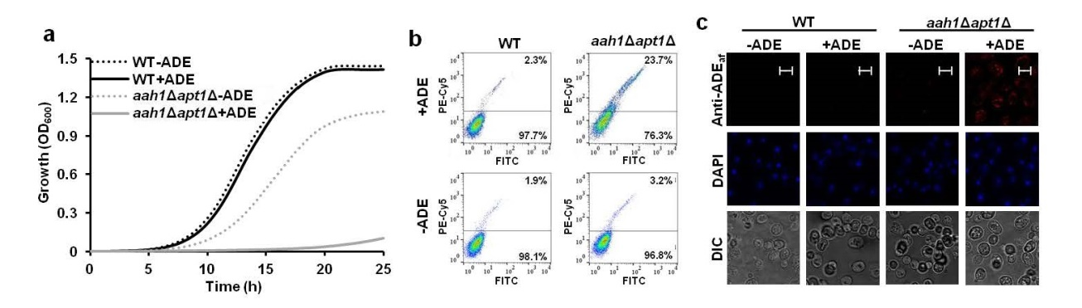

Fig. 1. Sensitivity of the salvage mutant to adenine feeding and staining with an amyloid-specific fluorescent dye and with anti-adenine assemblies antibodies. a, Wild-type (WT), aah1Δ, apt1Δ and aah1Δapt1Δ strains were serially diluted and spotted on SD complete medium containing 20 mg/L adenine (SD-com) or on SD medium without adenine (-ADE). b, Growth curves of WT and aah1Δapt1Δ cells in SD media with or without adenine (ADE). c, Representative confocal and differential interference contrast (DIC) images of WT and aah1Δapt1Δ cells under the indicated conditions. Cells were fixed and subjected to indirect immunofluorescence using a polyclonal antibody raised against adenine amyloid-like assemblies, designated as Anti-ADE_{af} (=amyloid fibrils). Scale bar is 5 µm.

Understanding the Biological Relevance and Consequences of Adenine Self-Assembly
Despite of the well-established relation between amyloid-like structures and cytotoxicity, the details of the biochemical pathway by which such damage is caused are yet to be elucidated. Screening for genes involved in the pathogenetic mechanism requires a reliable, yet simple, in vivo model. Indeed, yeast provides a powerful platform for high throughput genome-wide genetic screens of this kind. Basing on the adenine yeast model described above, we currently seek to find the genes involved in the pathological mechanism of this IEM. Such genes might either suppress or enhance the lethal phenotype and are identified by systemically inserting or deleting genes from the model strain. As yeast contains more than 5,000 genes, much automatization is desperately needed. Using the sophisticated, cutting-edge robotic systems provided by our collaborators at the Weizmann Institute of Science and at Bar-Ilan University, we have already identified more than 100 potential hits. In figure 2, five hits from our study are shown to suppress the toxicity caused by the addition of adenine to our adenine salvage model. The results of these screens can lead to the establishment of a metabolic network of interactions that stands behind the IEM disorders related to adenine accumulation. Because of the common amyloid character of the pathology-causing moiety in many other IEMs, the conclusions of this study might apply to them as well. Unrevealing the detailed cellular-biochemical pathway leading to the pathology might pave the way for developing efficient remedies to these severe, life threatening disorders.

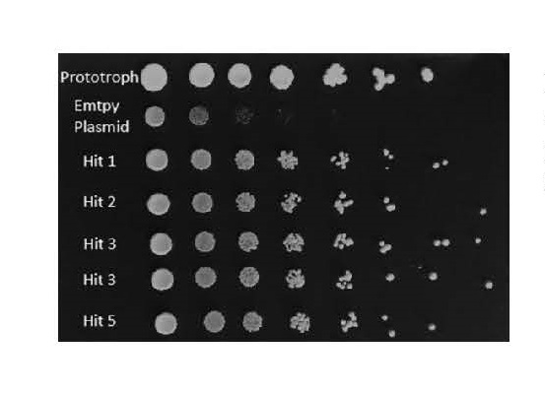
Fig. 2 Five potential candidates from our genetic screen. Strains were serially diluted and spotted on SD medium containing 20 mg/L adenine. The mutant strain presents a significantly reduced growth rate compared to strains expressing the suppressor genes identified in this study.

A Novel Yeast Model for Tyrosine Accumulation
Tyrosinemia, an autosomal recessive metabolic disorder, is characterized by elevated levels of tyrosine in the blood. Symptoms include liver and kidney disturbances and intellectual disability and when untreated, can be fatal. In vivo model for the formation of amyloid-like structures by tyrosine self-assembly was recently established. Using a strain blocked in the enzymatic salvage pathway upstream to tyrosine, a toxicity that can be observed by the addition of tyrosine to the media (Figure 3a, b). In addition, growth was affected by tyrosine levels in a non-linear dose-dependent manner, with no effect at lower concentrations and a sharp increase in the inhibitory effect upon reaching a critical concentration. The toxicity was later proven to be indeed associated with self-organization of the metabolites into amyloid-like assemblies by staining with amyloid-specific florescent dye. Additionally, we showed that the common anti-amyloid polyphenol molecule, Epigallocatechin gallate (EGCG), ameliorates the cytotoxic affect due to the inhibition of the formation of tyrosine assemblies. Taken together, we suggest that the toxicity results from the amyloid-like structures of tyrosine.
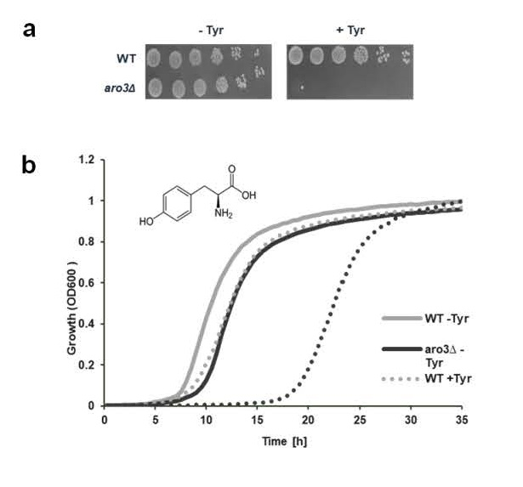
Fig. 3 Sensitivity of aro3Δ to tyrosine feeding. a, Wild-type (WT) and aro3Δ strains were serially diluted and spotted on SD medium containing 7.2 mg/L tyrosine (+Tyr) or on SD medium without tyrosine (-Tyr). b, Growth curves of WT and aro3Δ cells in SD media with or without tyrosine.

A Model for Glycine Self-Assembly in Yeast
The IEM Non Ketotic Hyperglycinemia (NKH) affects mainly newborns and infants and is lethal in many of the cases or otherwise can cause severe damage to the nervous system, impeding normal motor and intellectual development. In this study, we established an in vivo yeast model system for the study of NKH whereby addition of glycine to the growth medium resulted in dose-dependent growth inhibition (Figure 4a). In addition, upon glycine feeding we have detected a fluorescent signal using the amyloid dye ProteoStat, which is known to effectively detect the presence of intracellular amyloid-like deposits (Figure 4b). This model opens up exciting prospects for understanding the mechanism of the disease and for drug screening in order to identify potential treatment for NKH.

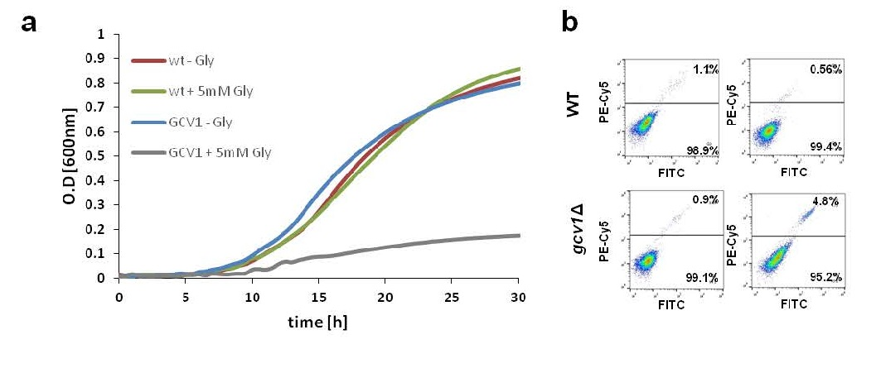
Fig. 4 a, Sensitivity of gcv1∆ to glycine feeding and amyloid-like staining. Growth curves of WT and gcv1∆ cells in SD media with or without 5mM glycine (Gly). b, Flow cytometry analysis of WT and gcv1∆ cells under the indicated conditions using ProteoStat staining.

Slightly Elevated Levels of Aromatic Amino Acids Hinder Growth in Wild-Type S. Cerevisiae Laboratory Strains
A wild-type yeast cell that has the ability to synthesize its own nutritional requirement is called a prototroph strain while its mutant counterpart that loses the ability to synthesize an essential nutrient due to a DNA mutation somewhere in the biosynthetic pathway is called an auxotroph strain. An auxotrophic marker is then defined as a wild-type allele of a gene that encodes a key enzyme for the production of an essential monomer used in biosynthesis. Those auxotrophic markers are necessary for genetic manipulations in yeast. By utilizing yeast as an in vivo model to study aggregation phenomena we have found that the commonly used WT laboratory auxotrophic strain, 'BY4741 WT', exhibits a non-linear, dose-dependent sensitivity, upon feeding, to increasing amounts of the aromatic amino acids phenylalanine, tyrosine and tryptophan (Figure 5a), compared to the prototrophic strain 'BY4741 KI' (Figure 5b). We suspect that this is due to the accumulation of metabolites and the consequential formation of metabolite-based amyloid-like structures in the cell. These results support the notion that auxotrophic markers may present an inherent bias when studying yeast metabolism, embedding the yeast with a metabolic "disease-like" state.
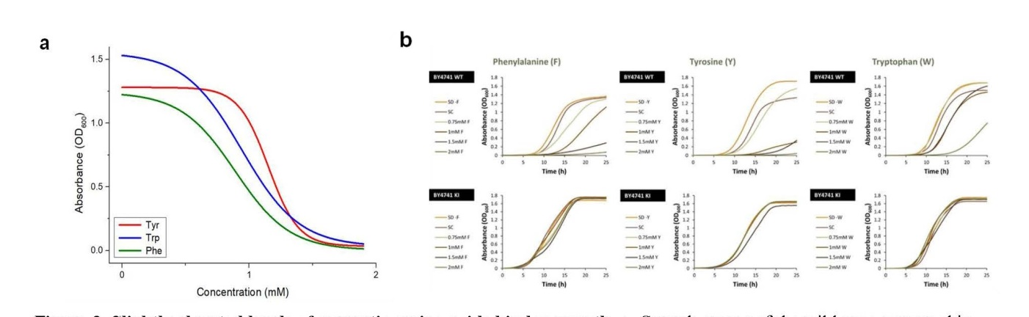

Figure 5. Slightly elevated levels of aromatic amino acids hinder growth. a. Growth curves of the wild-type auxotrophic strain BY4741 (BY1) and the knock-in prototrophic strain (KI) (Mülleder, et al., 2012) cells in SD media with increasing concentrations of phenylalanine (F), tyrosine (Y) and tryptophan (W). b. For the dose-response curve the WT laboratory auxotrophic strain (BY4741 WT) and the prototrophic strain (BY4741 KI) were grown in the presence of different concentrations of the aromatic amino acids- tyrosine (Tyr), tryptophan (Trp) and phenylalanine (Phe)- and alanine (control), ranging from 0mM to 1.9mM in SD medium. The absorbance at 600nm was measured 30h post-inoculation. The results were fitted using the Boltzmann model, R²>0.99.

Using the Nematode Worm Caenorhabditis Elegans as a Model Organism for IEM Disorders
In order to establish models of inborn metabolic disorders in C.elegans, we first asked whether it is possible to stain aggregates of peptides in vivo using the well-established model for Alzheimer's disease in C.elegans using a transgenic C. elegans strain expressing Aβ1-42, which is the main component of amyloid plaques found in the brains of patients with Alzheimer's disease. Interestingly, we managed to stain amyloid-beta (Aβ) aggregates for the first time with the amyloid dye ProteoStat in transgenic C. elegans strain expressing Aβ1-42 in the muscles compared to a wild type strain (Figure 6a). In addition, we asked whether treating adult worms with Resveratrol (a type of natural phenol found in grapes, blueberries and more) will reduce Aβ aggregates in the mutant strain as was previously reported using nematode lysates. The results below show, for the first time in C. elegans, reduced Aβ aggregates upon Resveratrol addition (Figure 6c). Furthermore, in order to establish a model for Tyrosinemia in C. elegans, the Fumarylacetoacetate Hydrolase homolog (fah-1) enzyme was inhibited via RNAi and a dramatic effect on C. elegans development was observed as well as destruction of their intestine (Figure 7). We intend now to move forward and try to track tyrosine amyloid-like structures due to tyrosine accumulation using the amyloid dye ProteoStat in the C.elegans Tyrosinemia model.

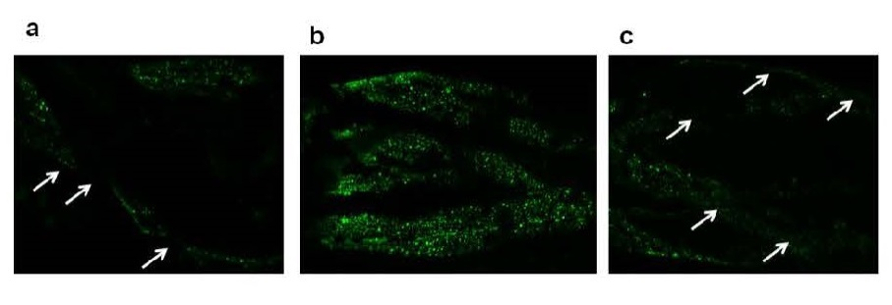
Fig. 6. Amyloid staining of amyloid-beta (Aβ) in transgenic C. elegans strain model for Alzheimer's disease. ProteoStat staining in transgenic C. elegans strain expressing Aβ1-42. Staining of WT strain (1), Alzheimer model of C. elegans (2) and Alzheimer model of C. elegans treated with Resveratrol.

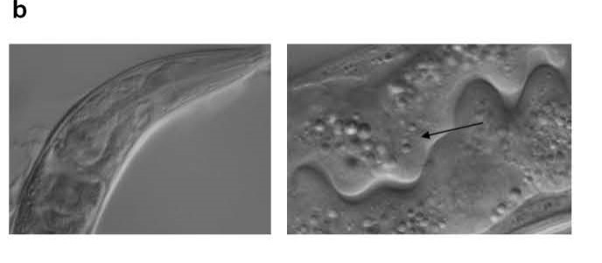
Fig. 7. Studying the phenotype observed in a C. elegans Tyrosinemia model. Inhibition of C. elegans enzyme fah results in a dramatic effect on the development and destruction of the intestine. Arrow show damage to the intestine of the RNAi treated worms.

Publications
Published:
- Laor, D., Sade, D., Shaham-Niv, S., Zaguri, D., Gartner, M., Basavalingappa, V., Raveh, A., Pichinuk, E., Engel, H., Iwasaki, K., Yamamoto, T, Noothalapati, H and Gazit, E. (2019). Fibril formation and therapeutic targeting of amyloid-like structures in a yeast model of adenine accumulation. Nat. Commun. 10, 62.
"This work was supported by the Adelis Forever Foundation"
- Zaguri, D., Kreiser, T., Shaham-Niv, S and Gazit, E. (2018). Antibodies towards tyrosine amyloid- like fibrils allow toxicity modulation and cellular imaging of the assemblies". Molecules 23
"This work was supported by the Adelis Forever Foundation"
- Tavassoly, O*. Sade, D*., Bera, S., Vocadlo, D., and Gazit, E. (2018). Quinolinic acid amyloid-like fibrillar assemblies seed α-synuclein aggregation. J.Mol. Biol. 430: 3847–3862.
"This work was supported by the Adelis Forever Foundation"
Submitted and under revision:
- Rencus-Lazar, S., DeRowe, Y., Adsi, H., Gazit, E and Laor, D. (2019). Yeast models for the study of amyloid-associated disorders and development of future therapy. Frontiers.
"This work was supported by the Adelis Forever Foundation"

Posters-
- Kreiser, T.; Shaham-Niv, S.; Zaguri, D. and Gazit, E. Metabolite Amyloids in Pathological Conditions. Current Challenges in Amyloid Diseases: From Molecular Mechanisms to the Cell and Clinics. Dead sea, Israel.2018.
- Zaguri, D.; Kreiser, T.; Shaham-Niv, S.; Gazit, E. Antibodies towards tyrosine amyloid-like fibrils allow toxicity modulation and cellular imaging of the assemblies. Current Challenges in Amyloid Diseases: From Molecular Mechanisms to the Cell and Clinics. Dead sea, Israel, 2018
- Zaguri, D., Shaham-Niv S., Adler-Abramovich L. and Gazit E. Immunodetection of metabolite fibrillary assemblies suggests a common amyloid-like mechanism in metabolic disorders. Nanoscience and Nanotechnology at Interfaces (NaNaInt). Jerusalem, Israel, 2017.
- Adsi, H., Gazit, E and Laor, D. A Novel Yeast Model for Tyrosine Accumulation. The School of Molecular Cell Biology and Biotechnology 2018 Retreat, Maalot, Israel,
- DeRowe, Y., Gazit, E and Laor, D. Slightly elevated levels of aromatic amino acids hinder growth in wild-type S. cerevisiae laboratory strains. The School of Molecular Cell Biology and Biotechnology 2018 Retreat, Maalot, Israel.


Dr. Johann Elbaz
Assistant Professor, Department of Molecular Microbiology and Biotechnology, The George S. Wise Faculty of Life Sciences,
Tel Aviv University

Genetically Engineering Bacteria as Smart Genomic Recorder for the Sensing of Complex Gut Disease and as novel Virus-Liked Nanoreactors.

Introduction
Cells are the most sophisticated machinery producing hundreds of thousands of complex molecules selectively and simultaneously. The ability to engineer biological organisms has been a long-envisioned goal dating back more than half-century. With the genomics revolution, came the development of a new field “synthetic biology”; to create, control and program cellular behaviors. Synthetic biology combines different scientific disciplines, including engineering, biology, chemistry and computer sciences, to program cells that can perform tasks or create chemicals and materials, mimicking the complexity in nature. Recently, we have developed a genetic synthetic pathway for the expression of artificial ssDNA and their self-assembly into dictated nanostructure in E. coli. This technology builds a fundamental bridge for the successful incorporation of DNA nanotechnology to the cellular world using synthetic biology tools. In this context, our research group is divided into three joint projects to resolve fundamental challenges associated with (a) the development of smart genomic recorder based biosensor for biomedical applications, (b) the production of smart virus-like bioreactor for energy application and (c) smart artificial cell, which allows the execution of hierarchical processes in specific post-translational modifications and mimics protein secretion.

Development of Smart Genomic Recorder-based Biosensor.
While dynamics underlie many biological processes, our ability to robustly and accurately profile time varying biological signals and regulatory programs remains limited. Our ability to sense information across cell populations in difficult-to-study habitats such as the mammalian gut or in open settings such as soil or marine environments remains extremely challenging.

Our goal in this project is to create new applications in biological recording. Smart intracellular recorder system could be utilized to record metabolite fluctuations, gene expression changes, and lineage-associated disease disorders. In this project, we are developing a framework to store temporal biological information directly into the genomes of a cell population. In a “biological tape recorder” biological signals trigger intracellular ssDNA production that is recorded in a precise location within the E. coli genome using the β recombinase from the λ-red system.

Living Synthetic Virus-like Nanoreactors.
Viruses are well known to cause devastating diseases; however, scientists have now found a positive way to make use of their incredibly sophisticated natural self-assembly in order to engineer materials at the nanoscale for a wide range of applications from solar cells and batteries to medical diagnostics, regenerative medicine, and gene therapy platforms.

The promise of genetically encoding nucleic-acid nanotechnology in living cells underlies the ability to exploit straightforward Watson–Crick-based rules to program nano-systems with defined structures and functions. This approach has already been used in vitro for the formation of intriguing precisely designed nano-scaffolds that mediate the enhancement of enzymatic reactions. However, problems of cellular degradation and difficulties with export and delivery to other organisms and the extracellular matrix remain challenging. During the physiological process of self-assembly, viruses encapsulate their genome, and thereby protect the genome from degradation while creating a very sophisticated delivery system. Learning from nature, and using the ability of my system to genetically encode pre-programmed, artificial self-assembling ssDNA nanostructures in bacteria, we envisage the production of artificial virus nano-assemblies, and the encapsulation of DNA-protein or RNA-protein nanoscaffolds designed for the enhancement of metabolic and chemical productions within the artificial virus particles. We hypothesize that the encapsulation of DNA based nanoscaffolds within an artificial virus will lead to the production of ultra-stable biological nanoreactors (undegradable DNA scaffolding) with the ability to sense and respond to their surroundings (e.g. light-inducible promotor).

Cell- Free Based Artificial Cells
Proteins in living cells function together as the basic machinery of life. The production of functional proteins can be partitioned to specific hierarchical steps known as central dogma activities, comprising transcription, translation and post-translational modifications (PTMs). These highly coordinated biochemical processes rely on the subdivision of the reactions into different cellular compartments, allowing precise control over the final products. In particular, site-specific PTMs, such as phosphorylation, glycosylation and ubiquitination, allow to further extend the functionality of proteins by yielding a wide range of protein variants consisting of the same amino acid sequences. While this set of discrete reactions has naturally evolved over millions of years, synthetic approaches aimed to allow such control have been recently developed to generate cell-free artificial cell platforms. Cell-free-based artificial cells are simplified synthetic living cell, which may address fundamental queries in cell biology, molecular biology, biotechnology, and biomaterials science. Utilizing artificial cells as a compartmentalized and controlled synthetic milieu, to drive novel biochemical pathways for biotechnology and biomedical applications in response to a predetermined stimulus, have been a long-time unmet goal. Spatial and temporal segregation of biological pathways derived mainly from compartmentalization is a desired property for artificial cell system. Thus far, the lack of efficient confinement of sequential processes has prevented the emergence of an artificial cell system with highly controlled transcription, translation, and PTMs processes.

The greatest advantage of cell-free systems (CFSs) is the reduction of the intricate cellular environment into its individual components. Ever since their tremendous impact on the elucidation of the genetic code, CFSs have been proven as an effective method to address fundamental questions in biology. Moreover, CFSs have been used as a powerful synthetic biology tool allowing the production of complex molecules beyond those produced by purely synthetic chemistry, leading to the development of unprecedented diagnostic applications. Yet, the ability to post translationally modify peptides and proteins in a controlled and selective manner using CFSs, is currently unavailable.

Microfluidics
Microfluidics is both the science which studies the behavior of fluids through micro-channels, and the technology of manufacturing highly controlled synthetic micro-compartments comprising unique engineered features such as chambers, tunnels and valves through which fluids flow or are confined. Microfluidics technology holds a number of advantages for wide range of research fields and biotechnology applications; (i) reduced reagents usage due to small reaction volumes (sub-microliters) (ii) production of a large number of independent compartments (droplets), (iii) control over spatial and temporal separation, and (iv) control over the reaction conditions.

Specific Goals of this Research

Aim 1. Genetically Engineer Bacteria to Produce Multiple ssDNAs.
  - Engineering new synthetic biological tools based on the functionality of catalytic nucleic acids (DNAzymes) that can produce multiple ssDNAs in vivo.

  - Engineering new synthetic biological tools based on RNA/DNA for the production of multiple DNA.

Aim 2. Dynamic Genomic Recording of Cellular Events for Robust, Fast and Cheap Diagnostic of Complex Gut Diseases.

2.1 Engineering the artificial genetic recorder pathway based on the production of ssDNA via non-coding RNA, natural mRNA and Reverse transcriptase.

2.2 Implementing the artificial genetic recorder pathway to RNA sensing and production of multiple different ssDNAs.

2.3 Engineering a unique in vivo error prone “RT-PCR” editing tool for automated fast and affordable genomic library synthesis.

Aim 3. Engineer Bacteria to Produce Adjustable Living Artificial Nanoscaffolds that can be encapsulated into Artificial MS2 Bacteriophage Virus Based Particles.

3.1 Engineering the encapsulation of chemically synthesis DNA/RNA nanoscaffolds within artificial virus-based particles using purified coat protein subunits from MS2 prokaryotic phages.

3.2 Engineering the encapsulation of in vivo-produced DNA/RNA nanoscaffolds within artificial virus-based particles using coat protein subunits from MS2 prokaryotic phages.

3.3 Evaluate the potential of DNA nanostructures encapsulated within viruses as nanoreactors that can enhance chemical reactions within cells or in the extracellular media.

Aim 4. Developing a Compartmentalized and Programmable Artificial Cell Granting High Degree of Control over Hierarchical Processes.

Results

Aim 1. Genetically Engineer Bacteria to Produce Multiple ssDNAs.

1.1 Engineering new synthetic biological tools based on the functionality of catalytic nucleic acids (DNAzymes) that can produce multiple ssDNAs in vivo.

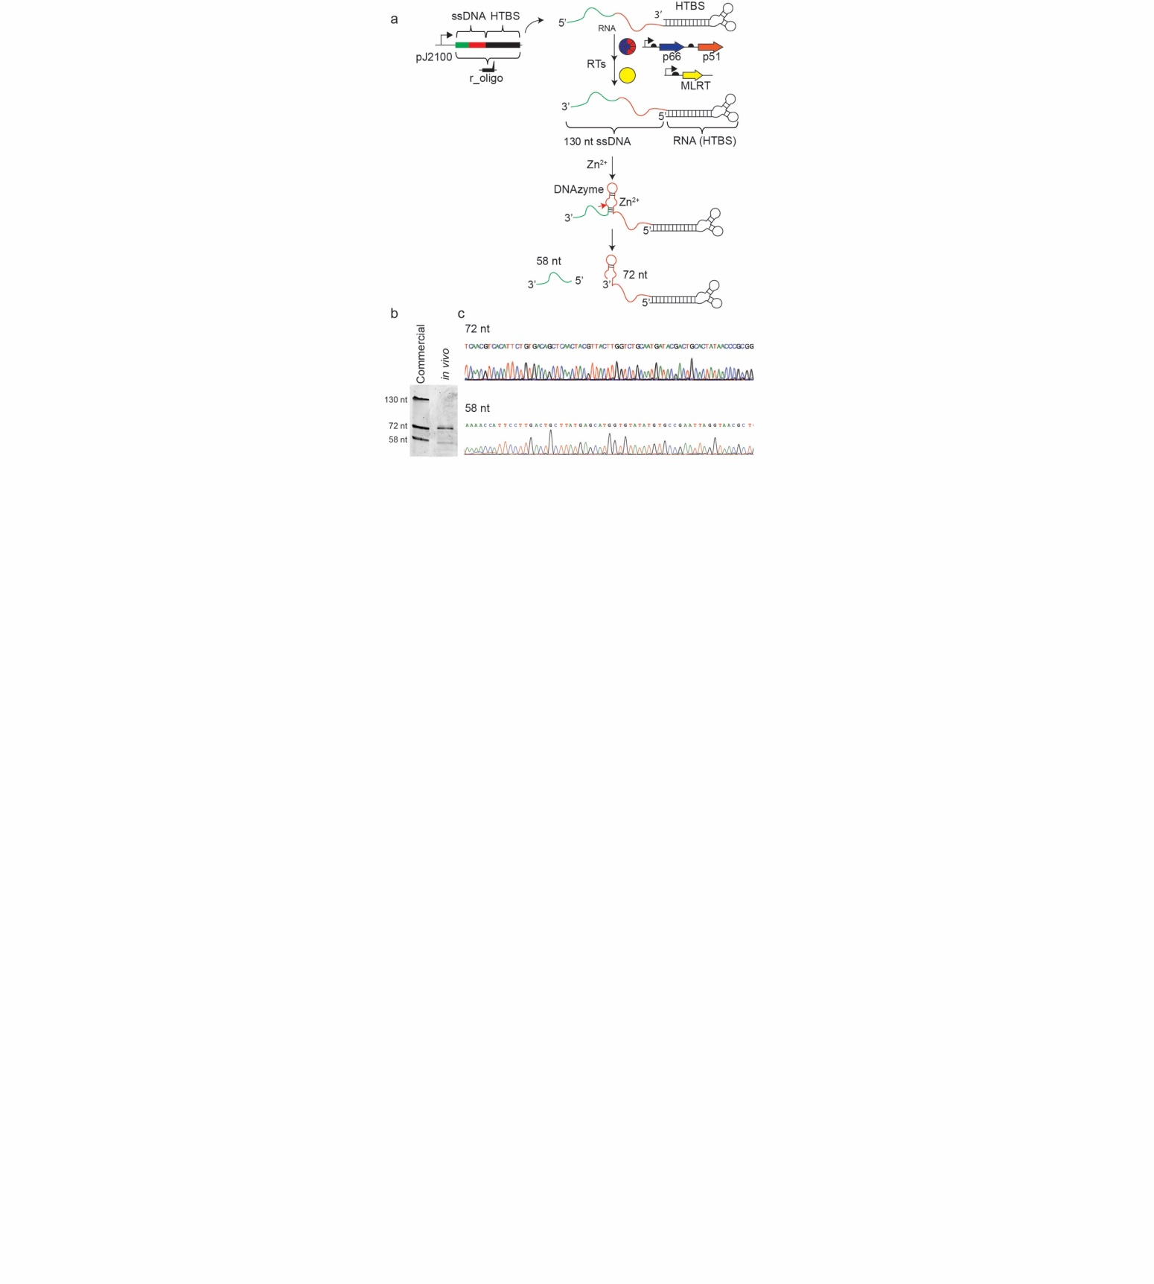
We have recently resolved the challenge to encode and express artificial short ssDNA in living bacteria. This was done using a well-known biological system from a eukaryotic retrovirus (HIV reverse transcription, HIVRT) that was artificially incorporated into the host organism (E. coli) using synthetic biology genetic tools. The HIVRT enzymatically converts RNA to dsDNA, but was not found active in prokaryotes. To synthetically activate the HIVRT in prokaryotes, two main innovations have been developed. First, each ssDNA is encoded by a gene that is transcribed into non-coding RNA containing a 3’-hairpin (HTBS). This hairpin includes the eukaryote t-RNA^{LYS} sequence, known as the HIV binding site, and also serves as the transcriptional terminator. Second, the expression of the HIVRT had been found insufficient to produce ssDNA; thus, only by co-expressing the murine leukemia reverse transcriptase (MLRT), the ssDNA production is amplified. By incorporating this synthetic pathway into a genetic circuit, we demonstrated the in vivo production of ssDNA for in vitro applications, such as forming 1D and 2D wires and sheets.
Figure 1: (a) A schematic for the conversion of the r_oligo gene to ssDNA followed by its self-cleavage. The r_oligo gene contains the desired ssDNA sequence (green), the catalytic nucleic acid (DNAzyme, red) and the HTBS part (black), which serves as the transcription terminator. The red arrow shows the DNAzyme cutting site. (b) Comparison of an in vivo produced 130 nt ssDNA that self-cleaved itself using the DNAzyme into two ssDNAs (72-nt and 58-nt) with commercial chemically synthesized ssDNAs. (c) Sequencing analysis of the in vivo produced 72-mer and 58-mer.

Another important goal is not only to establish a system to produce ssDNA but the ability to produce multiple copies of the different ssDNA molecules in vivo, while also removing the conjugated RNA (HTBS) (Figure 1) after formation. For this purpose, we fused a specific catalytic nucleic sequence (R3-DNAzyme) to the oligo gene. During the first year of the grant, we designed our system (unpublished data) to express a 130-nt ssDNA that includes the DNAzyme sequence such that when the active DNAzyme structure is formed, the 130-nt ssDNA is cleaved into two fragments (72-nt and 58-nt) (Figure 1a). These could be detected after purification of the total ssDNA (Figure 1b). We further analyzed the specific sequence of the two bands by conjugating DNA adapters to the purified ssDNAs (Figure 1c). This procedure enables the sequencing with short oligos and prevents the possibility of plasmid contamination (the DNA adapters can be ligated only to ssDNA and not to circular DNA). We identified the precise cutting site of the DNAzyme and found it to be identical to the site previously described in vitro. This result not only prepares the way for the production of stable and more efficient DNA nanostructures, but also builds a bridge between components of chemical DNA science, such as aptamers and DNAzymes, and their efficient integration to the intracellular world that can be useful for medical and bioengineering applications.

1.2 Engineering new synthetic biological tools based on RNA/DNA for the production of multiple DNA.

The system is under construction and will be checked during the third year of the grant.

Aim 2. Dynamic Genomic Recording of Cellular Events for Robust, Fast and Cheap Diagnostic of Complex Gut Diseases.

2.1 Engineering the artificial genetic recorder pathway based on the production of ssDNA via non-coding RNA, natural mRNA and Reverse transcriptase.

To record biological signals via in vivo ssDNA production, an engineered strain was first designed. The engineered strain is based on DNA repair of defective kanamycin resistance gene. First, a kanamycin resistant strain was cloned by inserting kanR gene, which encodes neomycin phosphotransferase II and confers resistance to kanamycin, into the galK locus. Next, two stop codons were introduced by changing 5 bases in the genomic kanR to make a kanamycin-sensitive reporter strain, named kanR_{OFF}. These premature stop codons would be reverted back to the WT sequence (KanR_{ON}) via recombination with the ssDNA.

As shown by growth detection in presence of kanamycin, both the resistant and the sensitive strains were successfully engineered (Figure 2), and the incorporation of 5 bases in order to form the premature stop codons was enough to establish a kanamycin based sensor.

Figure 2: Cell density of the sensor strains. The absorbance at 600nm of the different strains was measured after 6h in the presence (red) or absence (blue) of kanamycin.

Next, the desired genetic program, which produces ssDNA and integrates it into the specific mutated locus in E. coli, was designed and constructed. The engineered genetic system effectively expressed HIVRT, MLRT and β recombinase proteins. HIVRT and MLRT are the enzymes necessary to express ssDNA, while β recombinase integrates the ssDNA into the genome. HIVRT (also called P51), MLRT and β recombinase production were controlled by the pTac inducible promoter. A cassette under a constitutive promoter expressed a synthetic HIVRT binding site (HTBS) and a non-coding RNA that produced the ssDNA with the KanR_{ON} sequence. This sequence was designed to be homologous to the KanR_{OFF} part. Thus, by integrating the KANon sequence to the replication fork, the kan gene would be repaired via recombination, restoring the kanamycin resistance (Figure 3).

After successfully constructing the sensor strain and the genetic circuit used for the production under demand of the ssDNA in the presence of β recombinase, the incorporation of the ssDNA within the precise location was tested. A plasmid containing the genetic circuit was transformed into the KanR_{OFF} strain. Following an induction of the pTac promoter by IPTG, bacteria were plated on LB-agar with or without kanamycin and the recombination frequency was calculated by the ratio between the colony-forming-units (CFU) grown on the selective medium and the total count on the non-selective medium. It was shown that following IPTG induction bacteria grew on the kanamycin plates. The mutation correction was further verified by sequencing, indicating a successful correction of the defected resistance gene.

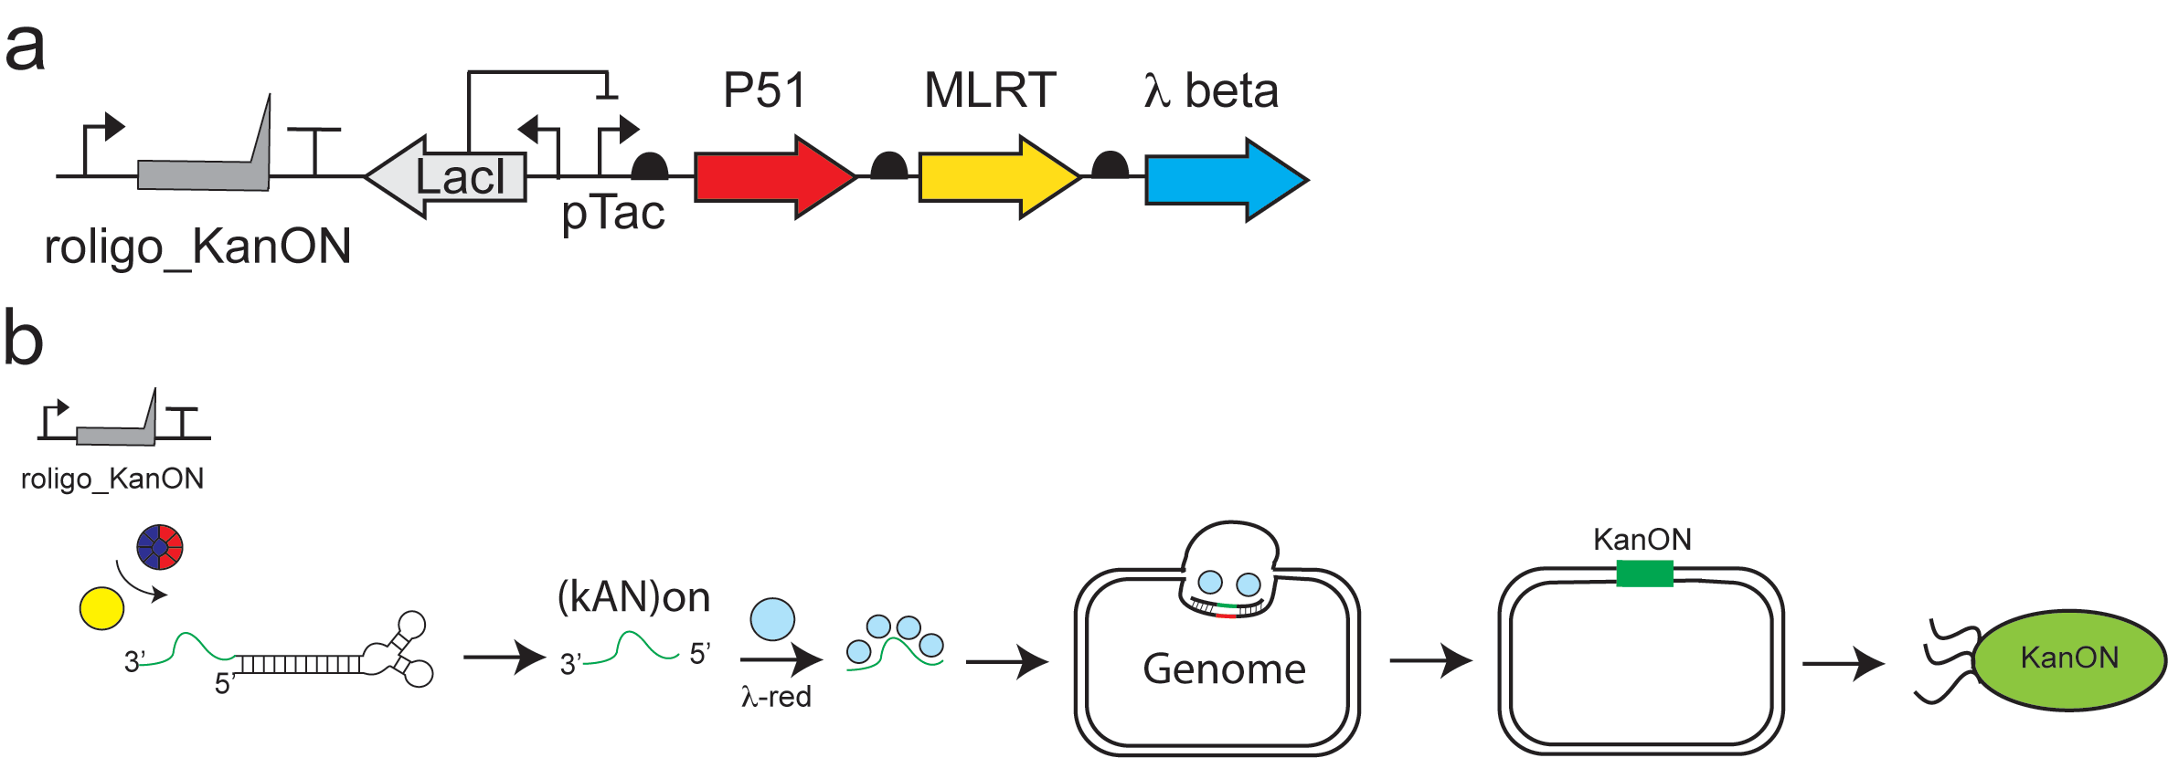
Figure 3: The general recorder paradigm. (a) The genetic program includes three genes (P51, MLRT and beta) on a similar operon and controlled under pLacI, and the co-expression of the oligo gene under a constitutive promotor J23100. (b) A schematic presentation of the system is described: the ssDNA production by the RT system and its integration into a precise genomic location, resulting in the activation of the kanamycin resistance gene.

To further study our system and to verify the significance of its components, different versions of the system lacking each of the enzymes were designed. In addition, a random sequence instead of the KanR_{ON} sequence was tested. It was shown that without the β recombinase and also with a random ssDNA sequence, no correction of the gene has occurred (Figure 4). A construct lacking both HIVRT and MLRT did not acquire the kanamycin resistance, indicating the vital role of the reverse transcription. Surprisingly, either the HIVRT or the MLRT were sufficient for the correction of the mutated gene (Figure 4).

To improve the ability of the system to sense the cell environment and record events of exposure to chemical and biological signals, it was important to tighten the regulation on the components of the system. It was hypothesized that improving regulation on the expression of the non-coding RNA, which serves as template for ssDNA production, would enable a tighter control over the recording event.

Since recombination events occurred also in the absence of IPTG (figure 5), we constructed different genetic programs which may rigidly control the system and lower the recombination occurrence in a non-induced state.

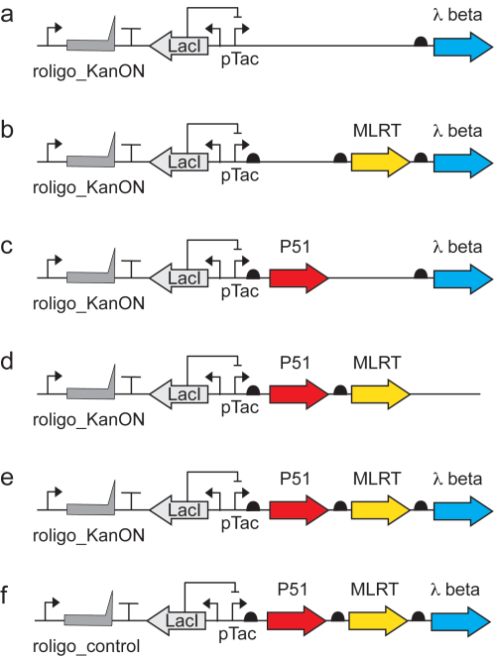
Figure 4: The recombinant frequency of the different genetic programs. The design of the different systems is shown in the left panel. The corresponding recombinant frequencies are described on the right panel.

Figure 5: The ability to record the IPTG presence into the genome. The genetic program includes an IPTG-dependent inducible promotor controlling the expression the three enzymes (P51, MLRT and beta) while co-expressing a precise oligo KanON (upper panel). The recombination frequency was 6 time higher in the presence of 1mM IPTG than without it (bottom panel).

The initial proof of concept was built on a high copy number vector. To investigate the effect of the plasmid copy number on recombination frequency and correlation to inducer levels, new designs were built on moderate copy number vectors (ColE1- copy number of 15-20 and p15A- copy number of ~10). These vectors indeed showed a decrease in recombination frequency, both non-induced and induced, with p15A showing a significantly low recombination frequency. Though, recording activity in the induced state was insignificant in comparison to the non-induced state (Figure 6).
Figure 6: Recombinant frequency for the genetic circuit under different vectors.
The effect of plasmid copy number on recording activity led to the design of the recording system on two plasmids. The first plasmid contained only the cassette transcribing the ssDNA template RNA on the high copy ColE1 derivative. The second plasmid contained the enzymes under the pTac inducible promoter on the moderate copy p15A. The recombination frequency assay was performed on KanOFF reporter cells containing both plasmids. Results showed very low recording activity in non-induced state and significantly higher recording activity under IPTG induction (1mM), indicating that the two plasmid design can serve as an indication for the presence of IPTG in the bacteria’s environment, having a recording with clear digital off and on signal.
Figure 7: Recombinant frequency of the two-plasmid recorder compared to the original one-plasmid recorder.
Next, we examined the recording activity of the two plasmid design under different concentrations of IPTG. The recombination frequency assay was performed on this design under IPTG concentrations of 0, 0.01, 0.1 and 1mM. The results showed a linear correlation between inducer concentration on a logarithmic scale and recombination frequency, demonstrating that the two plasmid design had analog memory capabilities.

Figure 8: Frequency of recombination for the two plasmids recorder showing the linear correlation fit for IPTG concentration on a log scale.
A similar design was constructed with the araC inducible promoter instead of the pTac inducible promoter. Under different concentrations of arabinose, the results resembled a more digital, on\off recording, with a very low recording activity in none induced conditions, and subsequent increase with induction, not correlating linearly to the recombination levels.
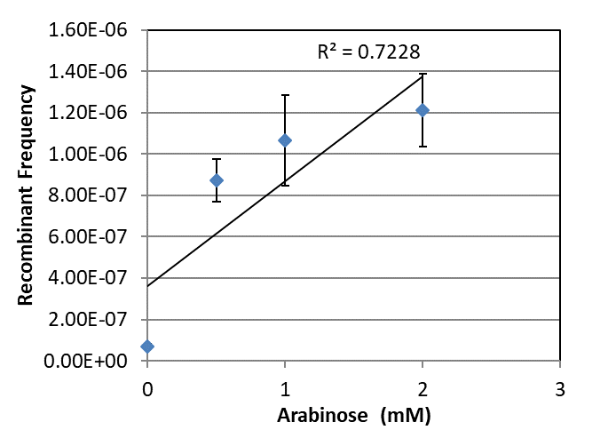
Figure 9: frequency of recombination for the two-plasmid recorder showing the linear correlation fit for arabinose concentration.

2.2 Implementing the artificial genetic recorder pathway to RNA sensing and production of multiple different ssDNAs.
We aim to develop a more versatile version of the system in which the ssDNA produced will be used as a primer enabling the reverse transcription of an RNA template. This will allow the use of a single ssDNA for the production of multiple different ssDNAs to be incorporated into different locations in the genome, and may also serve as a system requiring more input signals for functionality of the genomic recording process, and enable the capability to sense RNA naturally present in the cell.

The proof of the RNA-based tape recorder’s capability was also based on the ability to fix a mutated KanR gene in the genome of E.coli. Plasmid OA_JE_5.3 was designed similarly to the random ssDNA plasmid (Figure 4, scheme f, GG16) with the addition of the KanON ncRNA (Figure 10). In addition to the fixing sequence, the ncRNA has a complementary sequence to the ssDNA primer, r_oligo, at his 3’ end. The ssDNA primer that HIVRT and MLRT produce anneals to the 3’ end of the ncRNA, which generates a DNA-RNA complex. The hybrid complex is recognized by MLRT and reverse transcribed to KanON ssDNA. Finally the β recombinase integrates the fixing ssDNA to the E.coli locus, resulting in kanamycin resistant bacteria. The efficiency of recombination is measured the same way as for the genomic memory recorder system.

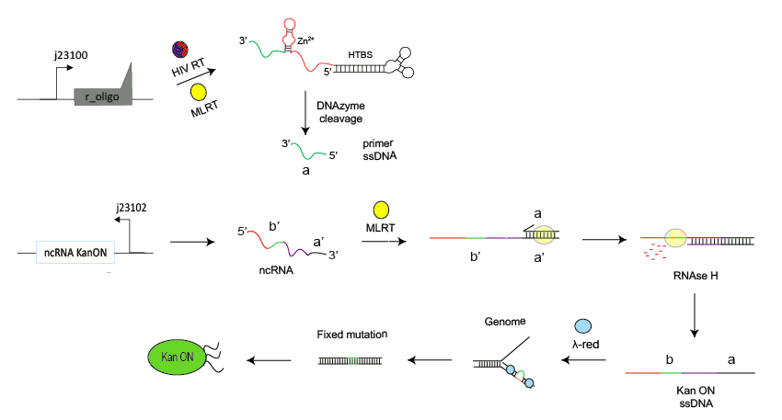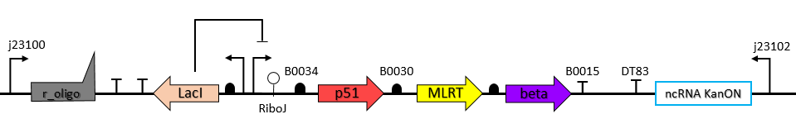
a
b
Figure 10: RNA-based genomic memory recorder. (a) OA_JE_5.3 plasmid scheme. (b) The mechanism of the RNA-based genomic recording. The primer RNA (r_oligo) is reverse transcribed by HIVRT and MLRT, followed by DNAzyme activity that generates the primer ssDNA. Primer ssDNA binds to its complementary sequence on the ncRNA KanON and this DNA-RNA complex is reverse transcribed to Kan On ssDNA. Beta recombinase integrate the ssDNA into genomic KanR gene and the resistance to kanamycin is retrieved (Kan ON).
The OA_JE_5.3 system was induced with 0-1 mM IPTG, along with negative controls, for 24 hr at 30°C (Figure 11). OA_JE_5.4 and GG16 were the negative controls, while OA_JE_5.4 lacks the ssDNA primer cassette, GG16 lacks the ncRNA cassette. As anticipated, the negative control systems did not result in kanamycin resistant colonies, while OA_JE_5.3 had an increasing recombination frequency as the IPTG concentration augmented. The scale of 10⁻⁶-fold recombination frequency remained the same as for the genomic memory recorder system, so as the leakage when the system was not induced.

Further characterization and tuning work have been planned for this system, such as detecting different amount of expressed ncRNA by putting it under different promoters or separating the ncRNa cassete and expressing it on another plasmid with different copy numbers. Another aspect that would be examined is the effect of DNAzyme in the ssDNA primer and the minimal primer length that is possible. These systems were designed and some of them already built, and they are planned to be tested.
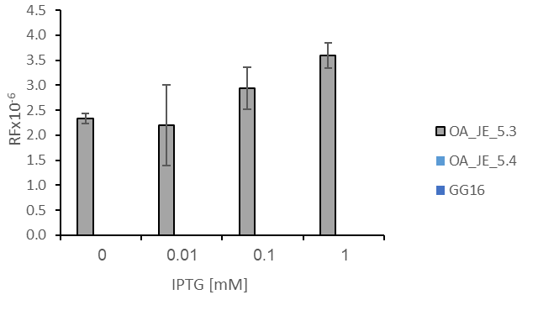
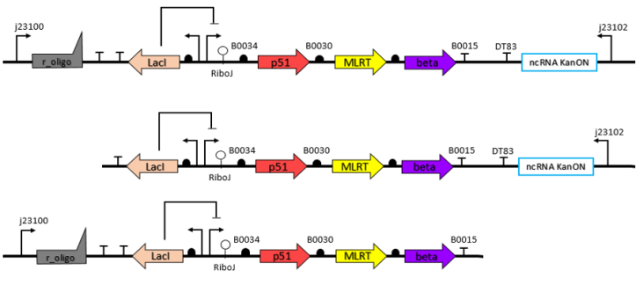
2.3 Developing an evolutionary platform to increase the efficiency of the DNA recorder system and the discovery of new genetic sensor parts (e.g. promotor) for specific gut cancer, such as pH or adenomatous polyps.
Figure 11. Recombination frequency of OA_JE_5.3 (a) Recombination frequency (RF) of OA_JE_5.3 system with 0-1 mM IPTG induction. Average of 3 biological repeats in the same experiment. (b) OA_JE_5.3 system (top scheme) compared to the negative controls of OA_JE_5.4 plasmid (middle scheme) and of GG16 plasmid (bottom scheme).
a
b

We have previously generated the KanON 78nt ssDNA using the RT system which contained two homology arms 36nt each, and a 5nt segment between the homology arms that can replace the mutation into the non-mutated resistance gene. So far, we were able to generate resistant colonies in a recombination rate of 10⁻⁶. By running this system in a bio-reactor for 3 days we were able to gain a 10-fold increase in recombination rate (Figure 12a), our data was positively correlated to a predicted published model (Figure 12b). Next, we will use this system to increase the sensitivity for the ncRNA in the RNA-based genomic memory recorder.

a b
Figure 12: Efficiency increase of the DNA recorder using the evolutionary platform. (a) Recombination rate of the genomic recorder after continuously growing the cells in log-phase cycles. (b) A prediction of recombination frequency as a factor of number of bacterial generations. Generation time is one day with one log-phase cycle of growth. Taken from the work of (Farzadfard and Lu, 2014).

Aim 3. Engineer Bacteria to Produce Adjustable Living Artificial Nanoscaffolds that can be encapsulated into Artificial MS2 Bacteriophage Virus Based Particles.

3.1 Engineering the encapsulation of synthetic DNA/RNA nanostructure in MS2 in vitro.

Wild-type bacteriophage MS2 capsids were first generated and purified at bulk through their natural infection pathway. TEM images show the purified natural MS2 virus with 27 nm dimensions (Figure 13a). The purified MS2 were then disassembled and their natural nucleic acids (RNA) were removed to prevent their self-reassembly in the absence of the synthetic RNA/DNA (Figure 13b). The viral coat proteins (CPs) of MS2 were then exposed to synthetic ssRNA to enable their reassembly and the encapsulation of the artificial ssRNA instead of the natural viral genomic element in vitro. The MS2 particles were successfully characterized via TEM (Figure 13c), thus demonstrating the ability to assemble MS2 viruses in vitro and the potential encapsulation of artificial ssRNA. While the wild-type natural MS2 prevented degradation of their RNA genome upon treatment with Rnase, the recomposed MS2 (encapsulated ssRNA in the viral proteins) was unable to prevent the degradation of the RNA upon treatment with Rnase as it arises from the control "naked" ssRNA molecules (Figure 14). ssDNA degradation in the viral proteins was in similar to the degradation in the control ssDNA, suggesting that these virus-like particles did not protect from Dnase. However, DNA and RNA encapsulation was not validated yet.
a | b | c
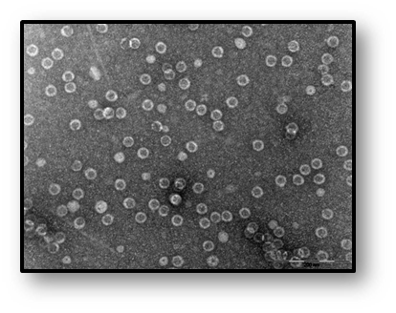 | 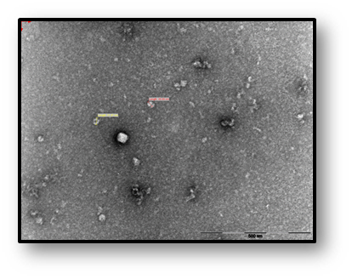 | 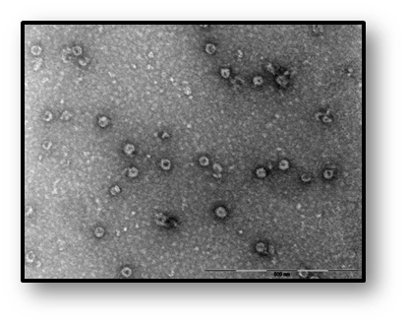
Figure 13: MS2 decomposition and re-assembly in vitro. TEM images showing (a) wild-type bacteriophage MS2 (b) wild-type bacteriophage MS2 after de-composition with glacial acetic acid (c) re-assembly of the viral proteins with artificial ssRNA. Scale bar = 500 nm.

Figure 14: DNA and RNA degradation in MS2 and the recomposed MS2-like particles. MS2 and MS2-like particles were treated with Dnase (upper gel) or Rnase (lower gel) and the nucleic acid degradation was followed in gel agarose. Treated samples with Dnase and Rnase are marked with '+'. A and E: natural MS2; B and F: Viral proteins without nucleic acids; C: Viral proteins with ssDNA; D: 'naked' ssDNA; G: Viral proteins with ssRNA. H: 'naked' ssRNA. | 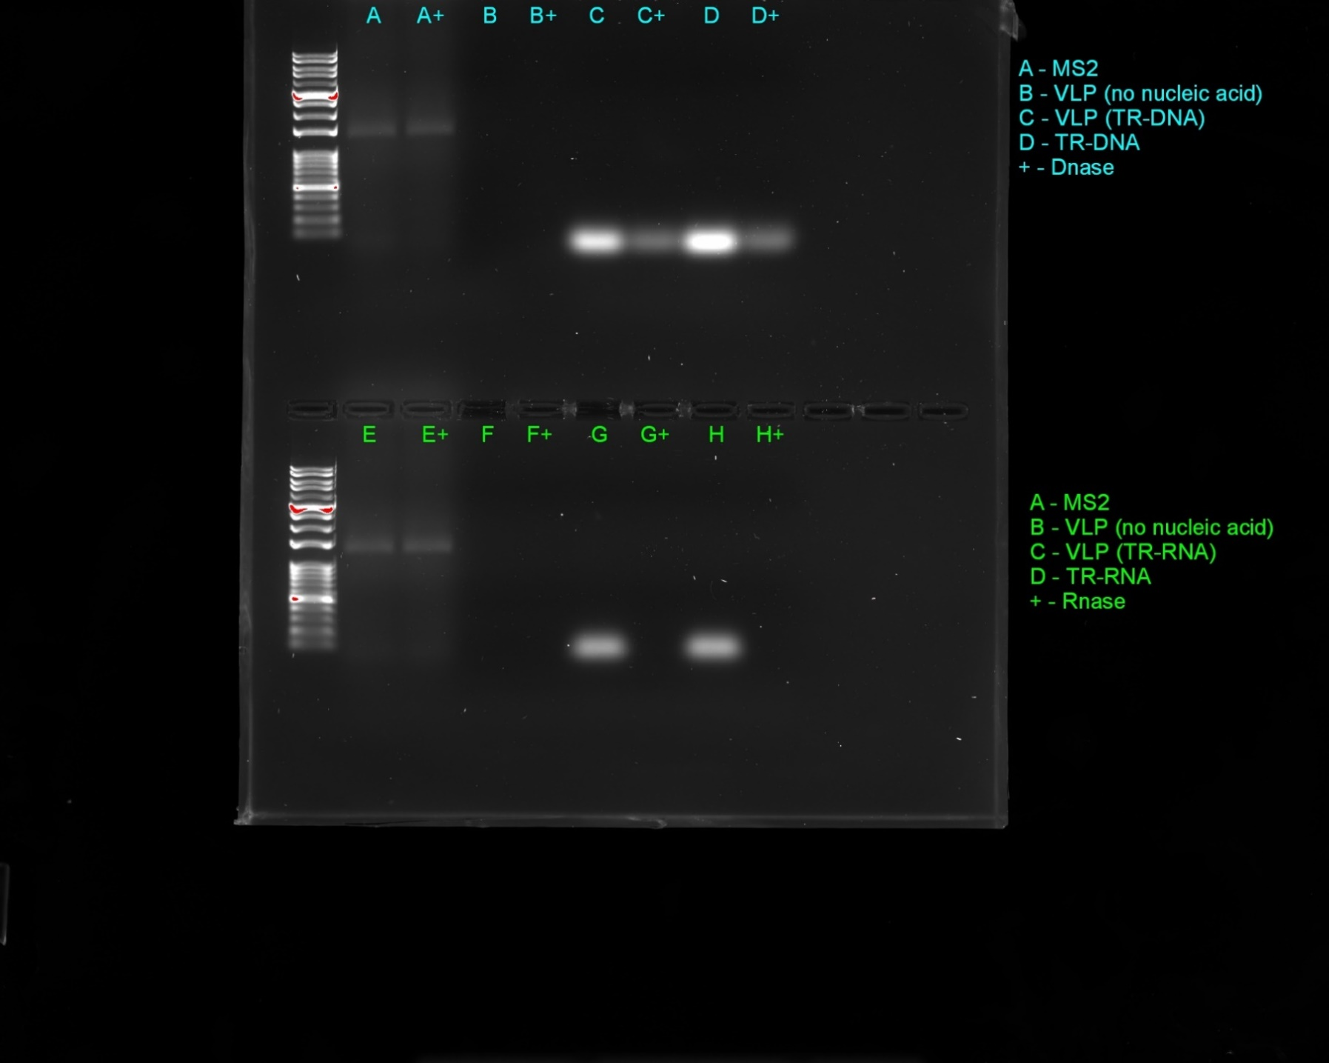

We have also built another in vitro system to express MS2 CPs in a dimer with several expression variants; with and without the expression of the maturase protein. The two CPs are linked using a His-tag, which was used for the purification step of the CP dimers, following their expression in E. coli. Following purification of CP dimers variants, using standard purification methods, we added a synthetic ssDNA sequence containing two specific sequences; (i) TR DNA and (ii) MG sequence, located downstream to the TR DNA sequence. MG is a DNA aptamer, able to specifically bind malachite green dye molecules and enhance the fluorescence of the dye when it forms a specific secondary structure. By using DNA aptamer conjugated to the TR DNA sequence we can monitor the presence of DNA in solution. Following the addition of DNA, VLPs were assembled and TEM images were taken (Figure 15), validating the formation of in vitro assembled VLPs in both variants. Then, Dnase treatment was performed to estimate the protection abilities of the VLPs against Dnase (Figure 15D). The results suggest that the assembled VLPs were able to protect the encapsulated ssDNA, in comparison to free ssDNA in solution. Furthermore, the encapsulated ssDNA molecules have kept the necessary secondary structure to bind malachite green and produce a fluorescent signal. To the best of our knowledge, this is the first-time encapsulated DNA in MS2 VLPs has retained its functionality. Producing encapsulated ssDNA with maintained functionality impose a great challenge in the synthetic biology and nanotechnology fields. We believe that this innovative and simple in vitro approach to manufacture MS2 VLPs encapsulating and protecting specific ssDNA sequences will advance the ability to use MS2 VLPs as genetic carriers and will contribute to the Nano-technology field.
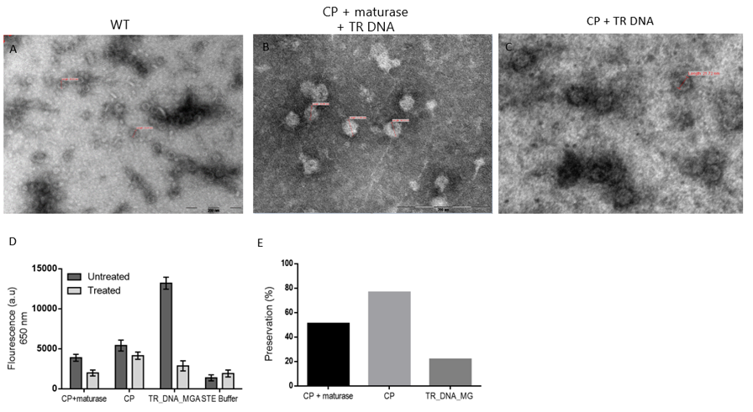
Figure 15. MS2 VLPs encapsulating functional nucleic acids. Transmission electron microscopy of A. Wild type MS2 bacteriophage. B-C MS2 VLPs encapsulating synthetic ssDNA containing the TR DNA MG sequences, where B is the variant with maturase and C is without. D. Fluorescence measurements prior and post Dnase treatment. E. Preservation of fluorescence intensity in percentages corresponded to figure D.

Our next work will include finding the optimized conditions for MS2 capsid decomposition and re-assembly in vitro, replacing the viral natural genomic element with DNA nanoscaffolds, catalytic nucleic acids (DNAzymes), and functional RNA-based machines. The DNA/RNA affinity to the coat proteins of MS2 will be compared with the natural viral RNA affinity in the extracellular media and the structural and functional stability of the encapsulated nucleic acids in the virus-like particles will be evaluated.

3.2 Genetically Engineering the encapsulation of synthetic DNA/RNA nanostructure in MS2 in living cells.
To demonstrate the ability to produce VLP’s in vivo, we expressed MS2 capsid proteins as well as RNA sequence containing the TR-RNA sequence, which interacts with the proteins and induces their self-assembly. Following purification of VLPs, samples were taken to TEM (Figure 16A), thus, validating the formation of MS2 VLPs in vivo.

By merging our in vivo production of ssDNA tool, we previously developed alongside the VLP’s expression system; we were able to in vivo produce MS2 VLP’s encapsulating ssDNA of choice. This was done by designing ssDNA containing the VLPs assembly sequence (Figure 16). Following expression, the VLPs were purified and were taken to TEM, to verify the formation of MS2 VLPs caring ssDNA (Figure 16B and C). Additionally, we preformed Polymerase Chain Reaction (PCR) onto the purified VLPs, with ssDNA specific primers, resulting in a specific band in the size of the designed ssDNA (Figure 16F). Furthermore, we sent the resulting band to sequencing, showing alignment with the original ssDNA sequence.
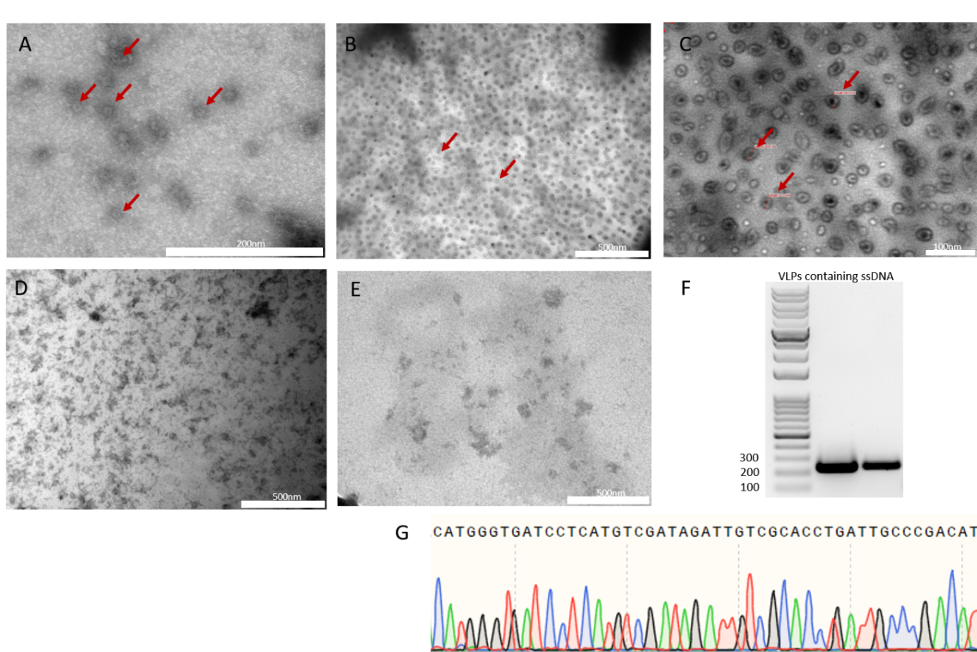
Figure 16. in vivo production of MS2 VLP’s encapsulating nucleic acids. A-E TEM images; A. MS2 VLPs containing RNA. B and C MS2 VLPs containing ssDNA. D and E negative controls; D expression of MS2 VLPs system without ssDNA (D) or with ssDNA lacking the assembly sequence (E). F. gel electrophoresis of PCR products. G sequencing chromatogram of the band in lane one from F in comparison to the designed ssDNA sequence.
Further work will combine an artificial secretion system for the developed RNA/DNA-protein functional elements in order to design and produce extracellular multi-scale patterning materials like biofilms.

Aim 4. Developing a Compartmentalized and Programmable Artificial Cell Granting High Degree of Control over Hierarchical Processes
A paper was submitted to Science Advances. The paper is attached.

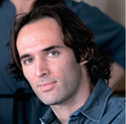
Oded Rechavi, PhD
The George S.Wise Faculty of Life Sciences,
Department of Neurobiology, Tel Aviv University

Reading and Writing Epigenetic Memories

Immediate Goal
The immediate goal of the Rechavi lab is to expose novel mechanisms at the cutting-edge of biological knowledge. In the last year, we have progressed towards that goal, and achieved significant accomplishments in several different projects.

Special Award and Grants Given:
- In February 2018 Oded Rechavi was awarded the Blavatnik Award for Young Scientists.
- In November 2018, Oded Rechavi was awarded a new ERC Consolidator grant (2M Euro), that will start January 2020.

Brief Summary of the Achievements Obtained during the Last Year:
The funds from the Adelis Foundation were absolutely vital for the studies conducted in the Rechavi lab. We allocated the funds according to the original budget plan. No major changes to the original budget were made.

We progressed very nicely and followed the aims of the grant very successfully. We published a few high impact papers and are currently in the process of publishing a few additional papers that are under review or in revision at top journals. The Adelis Foundation is already acknowledged in 8 of my papers:

Publications:
1. Sarit Anava et al. The Genome of the Dead Sea Scrolls. Under revision, Nature.

- R. Posner, I. A.Toker, O. Antonova, E. Star, S. Anava, E. Azmon, M. Hendricks, S. Bracha, H. Gingold, O. Rechavi. Neuronal Small RNAs Control Behavior Transgenerationally. Under revision, Cell.

- I. Lev, H. Gingold, O. Rechavi. H3K9me3 is required for Transgenerational Inheritance of Small RNAs that Target a Unique Subset of Newly Evolved Genes. eLife (Accepted, 2018).

- S. Bracha, K. Hassi, P. D. Ross, S. Cobb, L. Sheiner, O. Rechavi. Engineering Brain Parasites for Intracellular Delivery of Therapeutic Proteins. (Submitted, Nature Biotechnology), 2018, biorxiv doi: https://doi.org/10.1101/481192.

Abstract
Protein therapy has the potential to alleviate many neurological diseases; however, 15 delivery mechanisms for the central nervous system (CNS) are limited, and intracellular delivery poses additional hurdles. To address these challenges, we harnessed the protist parasite Toxoplasma gondii, which can migrate into the CNS and secrete proteins into cells. Using a fusion protein approach, we engineered T. gondii to secrete therapeutic proteins for human neurological disorders. We tested two secretion systems, generated fusion proteins that localized 20 to T. gondii’s secretory organelles and assessed their intracellular targeting in various mammalian cells including neurons. We show that T. gondii expressing GRA16 fused to the Rett syndrome protein MeCP2 deliver a fusion protein that mimics the endogenous MeCP2, binding heterochromatic DNA in neurons. This demonstrates the potential of T. gondii as a therapeutic protein vector, which could provide either transient or chronic, in situ synthesis and delivery of 25 intracellular proteins to the CNS.

- Dror Cohen, Meshi Volovich, Yoav Zeevi, Lilach Elbaum, Kenway Louie, Dino Jarden Levy, O.Rechavi. Bounded Rationality in C. elegans. (In revision, Nature Communication) Biorxiv: doi:https://doi.org/10.1101/257535

Abstract
Rational choice theory assumes optimality in decision-making. Violations of a basic axiom of economic rationality known as “Independence of Irrelevant Alternatives” (IIA), have been demonstrated in both humans and animals, and could stem from common neuronal constraints. We developed tests for IIA in the nematode Caenorhabditis elegans, an animal with only 302 neurons, using olfactory chemotaxis assays. We found that in most cases C. elegans make rational decisions. However, by probing multiple neuronal architectures using various choice sets, we show that asymmetric sensation of odor options by the AWC^{ON} neuron can lead to violations of rationality. We further show that genetic manipulations of the asymmetry between the AWC neurons can make the worm rational or irrational. Last, a normalization-based model of value coding and gain control explains how particular neuronal constraints on information coding give rise to irrationality. Thus, we demonstrate that bounded rationality could arise due to basic neuronal constraints.

- I. Lev, R. Bril, Y. Liu, L. I. Cere, O. Rechavi. Inter-generational Consequences for Growing C. elegans in Liquid. Accepted, (in print) Philosophical Transactions of The Royal Society B, 2018. Biorxiv: https: //www .biorxiv.org /content/early/2018/11/11/467837.1

Abstract
In recent years, studies in Caenorhabditis elegans nematodes have shown that different stresses can generate multigenerational changes. Here we show that worms that grow in liquid media, and also their plate-grown progeny, are different from worms whose ancestors were grown on plates. It has been suggested that C.elegans might encounter liquid environments in nature, although actual observations in the wild are few and far between. In contrast, in the lab, growing worms in liquid is commonplace, and often used as an alternative to growing worms on agar plates, to control the composition of the worms’ diet, to starve (and synchronize) worms, or to grow large populations for biochemical assays. We found that plate-grown descendants of M9 liquid media-grown worms were longer than control worms, and the heritable effects were apparent already very early in development. We tested for the involvement of different known epigenetic inheritance mechanisms, but could not find a single mutant in which these inter- generational effects are canceled. While we found that growing in liquid always leads to inter-generational changes in the worms’ size, trans-generational effects were found to be variable, and in some cases the effects were gone after 1-2 generations. These results demonstrate that standard cultivation conditions in early life can dramatically change the worms’ physiology in adulthood, and can also affect the next generations.

These papers were reported in the previous report:

- Lev, H. Gingold, O. Rechavi. H3K9me3 is required for Transgenerational Inheritance of Small RNAs that Target a Unique Subset of Newly Evolved Genes. eLife (Accepted, 2018). biorxiv,doi: https://doi.org/10.1101/338582.

- A. Hakim, Y. Mor, I .A. Toker, A. Levine, Y. Markovitz, O. Rechavi*. WorMachine: Machine Learning-Based Phenotypic Analysis Tool for Worms. BMC Biology,16: 8, 2018.

- O. Rechavi*, I. Lev. Principles of Transgenerational Small RNA Inheritance in C. elegans. Current Biology, Vol.27, Issue 14, 2017 (pp.R720-R730).

Impact
Thanks to the Adelis Foundation Grant, we hope to publish in the next year, a lot more papers with very high impact about “Re-Setting of Epigenetic Memories” (will be submitted to Nature Cell Biology) and about the “Rules of Epigenetic Inheritance” (will be submitted to Science).

I am very happy with the lab’s current team, especially the outstanding students that work with me. Most of the students in my lab are part of the prestigious university Ph.D. and M.Sc. programs (which are highly selective), and many were awarded scholarships, (parts of the students’ scholarships are paid by the university).

Important Advances this Year:

1. We published 2 papers (in eLife and in Philo Trans Royal Society B) about the role of chromatin modifications in transgenerational small RNA inheritance.

2. We submitted revisions to Cell on a very important paper in which we describe for the first time inheritance of neuronal responses. This paper will be a complete game-changer in the field, as it would be the first proof that neuronal activity can affect behavior.

3. We are currently revising our paper on the boundaries of rational behavior in Nature Communications. This is an extremely interesting paper on the neuronal mechanisms that limits rational choice.

4. Revisions (for Nature) of our paper on the Genome of the Dead Sea Scrolls are almost complete.

5. We submitted our paper on the use of brain parasites for delivery of proteins to the brain (see the pre-print version doi: https://doi.org/10.1101/481192). Our pre-print is ranked 46th out of >12,000,000 papers in Altamatric, and 6th all-time based on its submission time. A startup company that will translate our discovery will start in April. My student Shahar Bracha will be the company’s chief technology officer. In summary, we have progressed very nicely, according to the plan of the grant, and did not encounter any setbacks.

Specific Aims for the Next Year:
We will submit soon, two additional papers on “Re-Setting of Epigenetic Memories” (to Nature Cell Biology) and about the “Rules of Epigenetic Inheritance” (to Science).

We will finish soon, a paper on the involvement of liquid granules called “p granules” in the process of RNAi inheritance. Our results shed new light on the results publish in a recent paper on the subject in Nature (DOI: 10.1038/s41586-018-0132-0).

We will design exciting molecular tools to modulate, erase, and potentiate epigenetic inheritance. This is already working nicely in the lab in C.elegans, and we will set up next, a human cell line system to expand the generality of our approach also to humans. This could have immense therapeutic potential.





Adelis Foundation ANNUAL REPORT 2019

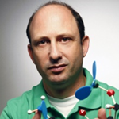
Prof Noam Shomron
Sackler Faculty of Medicine, Tel Aviv University

Digging into Breast Cancer Metastasis Models in
Order to Reveal Mechanisms of Tumor Aggressiveness

In breast cancer patients, the lungs are among the first sites of cancer metastasis, and in nearly one quarter of metastatic patients, the exclusive first event. Two common mouse models mimic breast cancer lung colonization and distal metastasis: an orthotopic model and intravenous (IV) cell injections. Gene expression analysis of pulmonary lesions from these two methods demonstrated high inter-model resemblance. However, microRNA (miRNA) expression profiles were not compared. In this study, we compared the overall miRNA expression profiles (miRNome) of the orthotopic and IV breast cancer metastasis models and identified significant miRNome changes between the two models. Overexpression of the most significant candidate, miR-96 or downregulation of its validated gene-target, ABCE1 reduced cancer cells 2D/3D cell movement and proliferation in vitro, and abated tumor growth and metastasis formation in vivo. Human data analysis further strengthened miR-96/ABCE1 role in breast cancer tumor aggression. Taken together, our results indicate that IV- and orthotopic models differ by their miRNome. Specifically in our study, breast cancer aggressiveness was dictated by miR- 96 regulating ABCE1. Overall, miRNome analysis of various metastatic cancer models may lead to the identification of candidate genes critical to metastasis development.

"identification of candidate genes critical to metastasis
development"

RESEARCH OBJECTIVES
- Modeling mice metastasis models in breast cancer and mapping the differences.
- Testing the candidate sets of genes that tell apart the breast cancer models.
- Testing successful candidate target genes in vivo (in mice) xenograft model.
- Evaluating several regulators of these genes via microRNA administration.
- Constructing a comprehensive map of genes and microRNAs involved in breast cancer metastasis.



A lecture I gave during the ‘Atnachta’ event open to the general public at Tel Aviv University in front of a crowd of 2500 people (January 2019).

EXPECTED SIGNIFICANCE
Taken together, our study should lead to potentially new understanding of breast cancer metastasis and strategies to prevent development of the metastases. Our work will: (i) decipher the mechanism by which genes control the metastasis process; (ii) present the therapeutic potential of miRNAs in regulating these genes in order to prevent cancer metastasis; (iii) identify a potential delivery vehicle enabling efficient miRNA release for reducing metastasis; (iv) serve as a model approach that integrates multiple datasets in order to reveal novel regulatory mechanisms in cancer. Importantly, understanding the profound effect of a gene expression on cancerous phenotype will permit a more effective individualized anti-metastatic therapy.

“our study should lead to potentially new understanding of
breast cancer metastasis and strategies to prevent
development of the metastases”

FINDINGS FROM YEAR 2 – A
Fig. a-ABCE1 and b miR-96 expression levels in 4T1, HS578, and MDA-231 cell lines expressing miR-96 OE or scrambled control. ABCE1 expression is reduced in all cell lines with miR-96 OE. Fig. c-ABCE1 and d miR-96 expression in primary tumors of mice injected with miR-96 overexpressing or scrambled control 4T1 cells. ABCE1 and miR-96 expression levels are inversely correlated. Fig. e-Western blot of ABCE1 in breast cancer cell lines and f calculated ABCE1 protein expression in cell lines with miR-96 OE or scrambled control. ABCE1 expression is twofold decreased in miR-96 OE cells compared to scrambled control. Fig. g-H&E and immunohistochemistry for Abce1 of resected murine primary breast tumors. Reduced Abce1 staining is seen in miR-96 OE compared to Scrambled. Fig. h-Predicted binding site (indicated by bold letters) for hsa-miR-96 on the ABCE1 3′-UTR and Luciferase activity 24 h following co-transfection of HeLa cells with hsa-miR-96 and ABCE1 WT or Mut 3′-UTR construct. Wild type (WT) and mutant (Mut) miR-96 binding sites are presented. Red nucleotides represent the three mutated nucleotides in the miR-96 seed binding site. Data are presented as mean+/− SEM. *p < 0.05, **p < 0.01.
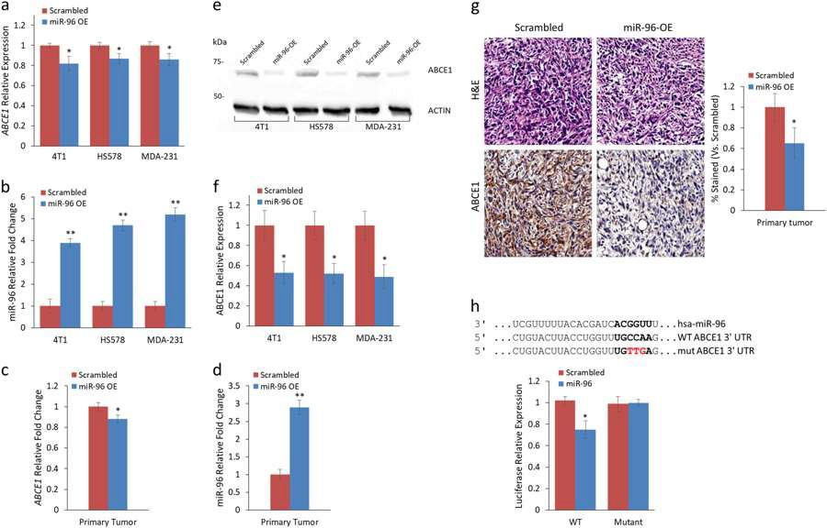

""we have identified genes that control metastasis formation"

FINDINGS FROM YEAR 2 – B
Fig a-Lung CT scans performed on day 28 (orthotopic) and day 21 (IV) post-4T1 injection (left) and quantification of LMets in microCT (right) show significantly fewer metastatic growths (indicated by red arrows) in mice that orthotopically received miR-96 OE or Abce1 KD cells compared to the scrambled control. IV injection of miR-96 OE cells resulted in fewer lung foci compared to Scrambled. Fig. b-Primary tumor volume analysis showed reduced tumor volume of miR-96 OE and Abce1 KD groups compared to Scrambled Fig. c- Kaplan-Meier survival analysis demonstrated increased overall survival of mice that received miR-96 OE or Abce1 KD cells compared to the scrambled control (p = 0.06). Fig. d-Representative images of Ki-67, α-SMA, Sirius Red, CD68, and CD31 staining in resected tumors from Scrambled, miR-96 OE, and Abce1 KD groups as indicated. At least 30 fields were analyzed from each group. n = 3 for each group. Scale bar = 100 μm. Magnification × 20. Quantifications of staining are presented as percent relative to control. miR-96 OE and Abce1 KD tumors demonstrated decreased proliferation (Ki-67) and were associated with significant reduction in activated αSMA + cancer associated fibroblasts in the tumor microenvironment, while collagen deposition (Sirius red staining) was not altered. Data are presented as mean +/− SEM. *p < 0.05.
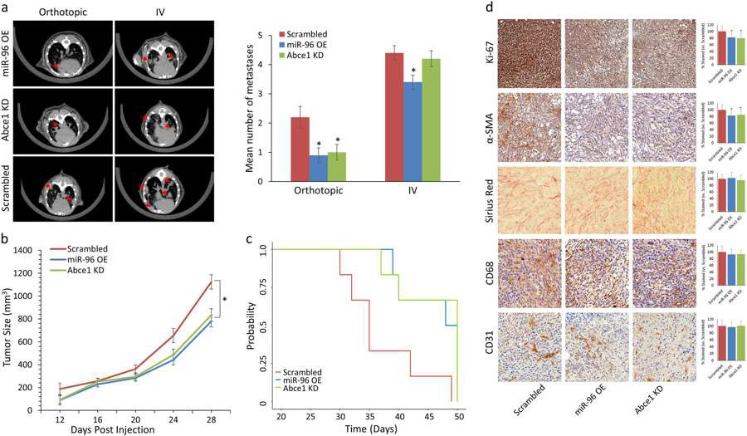
""knocking down Abce1 reduced metastasis formation"

FINDINGS FROM YEAR 2 – C
Clinical data of 1,262 breast cancer patients, of which expression levels of miR-96 and ABCE1 were available, were obtained from the METABRIC database. Fig.a-miR-96 expression was inversely correlated with tumor grade and Fig. b-basal type breast cancer. Fig. c-Kaplan–Meier survival analysis demonstrates longer overall survival of patients with breast tumors that highly express miR-96.Fig. d- ABCE1 expression was correlated with higher tumor grade and e basal type breast cancer. Fig. f-Kaplan–Meier survival analysis demonstrates longer overall survival of patients with breast tumors that lowly express ABCE1. Data are presented as mean +/- SEM. **p < 0.01, ***p < 0.001, ****p < 0.0001.
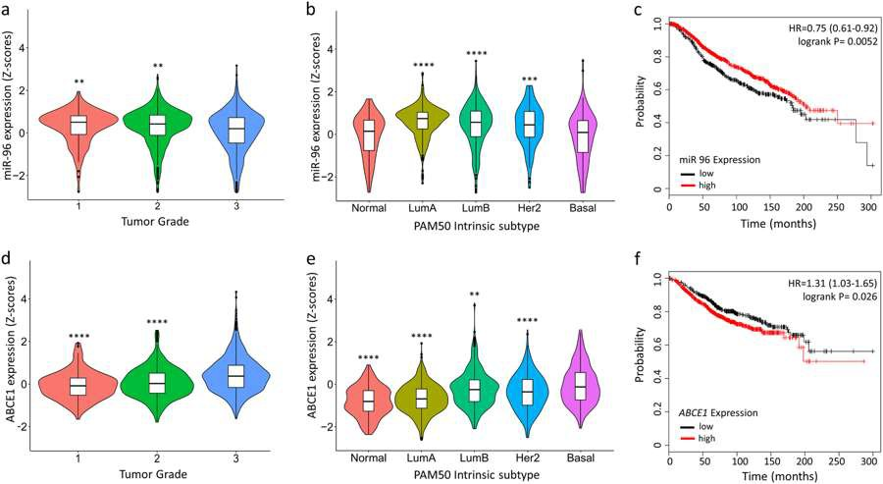

""clinical data of 1,262 breast cancer patients supports our
gene and microRNA finding in reducing breast cancer
metastasis"

FINDINGS FROM YEAR 2 – WOMENS’ HEALTH
Preeclampsia is one of the most dangerous pregnancy complications, and the leading cause of maternal and perinatal mortality and morbidity. Although the clinical symptoms appear late, its origin is early, and hence detection is feasible already at the first trimester. In the current study, we investigated the abundance of circulating small non-coding RNAs in the plasma of pregnant women in their first trimester, seeking transcripts that best separate the preeclampsia samples from those of healthy pregnant women. To this end, we performed small non-coding RNAs sequencing of 75 preeclampsia and control samples, and identified 25 transcripts that were differentially expressed between preeclampsia and the control groups. Furthermore, we utilized those transcripts and created a pipeline for a supervised classification of preeclampsia. Our pipeline generates a logistic regression model using a 5-fold cross validation on numerous random partitions into training and blind test sets. Using this classification procedure, we achieved an average AUC value of 0.86. These findings suggest the predictive value of circulating small non-coding RNA in the first trimester, warranting further examination, and lay the foundation for producing a novel early non-invasive diagnostic tool for preeclampsia, which could reduce the life- threatening risk for both the mother and fetus.

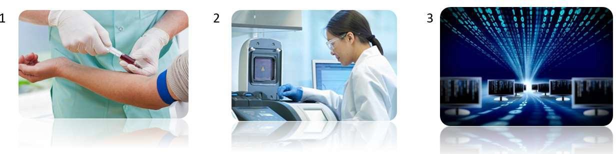
A three step approach for the analysis of Preeclampsia in week 10 pregnant women.

FINDINGS FROM YEAR 2 – D
Classification results on real and permutated data sets. Density plots of statistical measures obtained by 100 iterations of our classification procedure on real (blue) and permutated (red) data sets. Real dataset included 35 PE and 40 control samples. Permutated dataset included the same samples after random shuffling of their conditions (i.e., PE/control). Means are indicated as well. Sensitivity: true positives out of all positives; Specificity: true negatives out of all negatives; Accuracy: true classifications out of all classifications; Matthews’s correlation coefficient (MCC): a correlation coefficient between the observed and predicted binary classifications; AUC: area under the ROC curve; F1 Score: the harmonic mean of precision and sensitivity; Positive Likelihood Ratio: sensitivity/(1-specificity); Negative Likelihood Ratio: (1-sensitivity)/specificity.
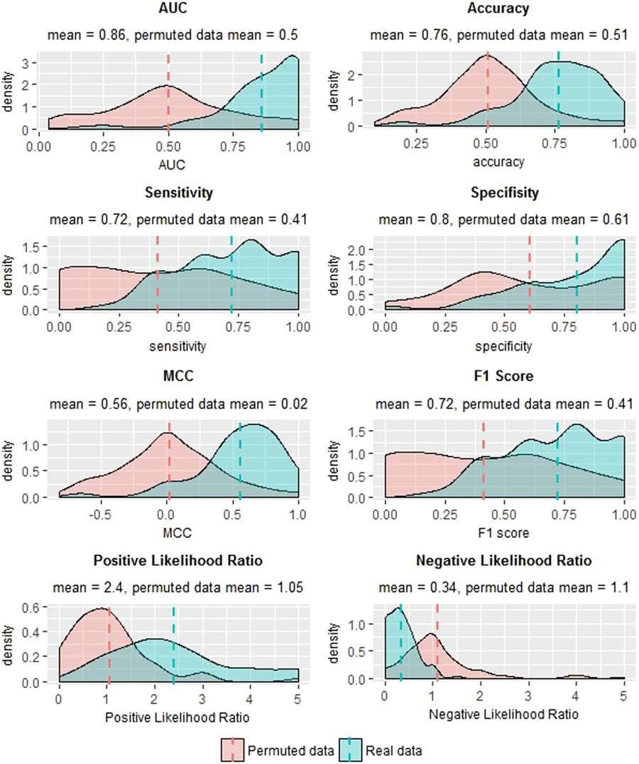

FINDINGS FROM YEAR 2 – E
Normalized counts for differentially expressed transcripts in PE vs. control samples. Each of the most highly abundant transcripts in 35 PE vs. 40 control samples was tested for differential expression, and 25 transcripts were found to be differentially expressed (adjusted p-value < 0.05). Normalized counts are presented as violin and box plots. The upper and lower limits of the boxes represent the 75th and 25th percentiles. The upper and lower whiskers represent maximum and minimum values. The median is indicated by the line in each box. Outliers are indicated by circles.
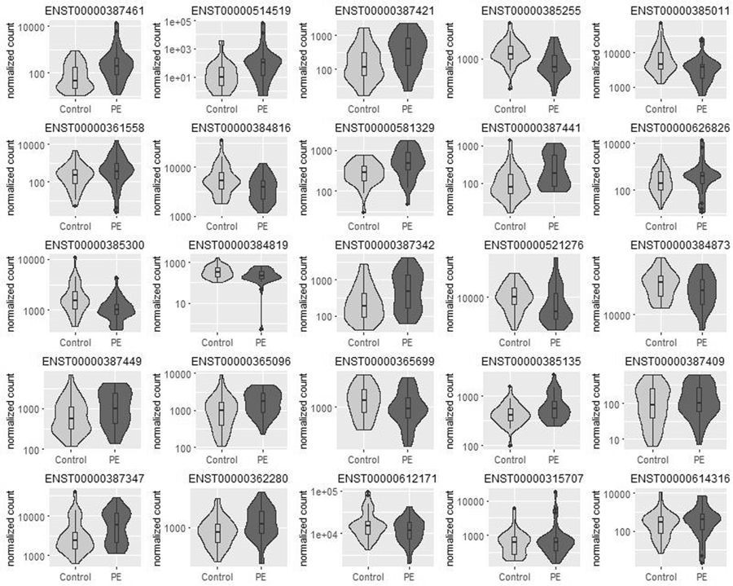

PUBLICATIONS FROM YEAR 2
- Pillar N, Polsky AL, Weissglas-Volkov D, Shomron N. Comparison of breast cancer metastasis models reveals a possible mechanism of tumor aggressiveness. CellDeathDis. 2018 Oct 10; 9(10):1040.
doi: 10.1038/s41419-018-1094-8. PubMed PMID: 30305609; PubMed Central PMCID: PMC6180100.

- Yoffe L, Gilam A, Yaron O, Polsky A, Farberov L, Syngelaki A, Nicolaides K, Hod M, Shomron N. Early Detection of Preeclampsia Using Circulating Small non-coding RNA. SciRep. 2018 Feb 21; 8(1):3401.
doi: 10.1038/s41598-018-21604-6. PubMed PMID: 29467498; PubMed Central PMCID: PMC5821867.

"Adelis Foundation's support led to two peer-reviewed
publications from our lab in the second budget year"

LECTURES GIVEN BY PROF NOAM SHOMRON
At Scientific Meetings
- Technology and Medical Information, November 2018, Information and Innovation symposium, Tel Aviv University, Israel
- Reading your DNA: Technology and Innovation in Future Medicine, November 2018, Research Symposium, Meir Hospital, Kfar Saba, Israel
- Genomics of Breast Cancer, October 2018, Koret-Berkeley-Tel Aviv Workshop, Berkeley University, CA, USA
- MicroRNA-mRNA splicing crosstalk, October 2018, Annual RNA Biology meeting in memory of Prof. Yossi Sperling, Bar-Ilan University, Israel
- Ethical Implications of Deep Genomics: Analysis Becoming Mainstream, September 2018, 24th World Congress on Medical and Law Bioethics, Tel Aviv, Israel
- Pharmacogenomics regulated by Epigenetics, June 2018, in 1st Meeting in Translational Pharmacology, 38th Spanish Society of Pharmacology meeting, 9th Spanish Society of Pharmacogenetics and Pharmacogenomics meeting, Santiago de Compostela, Spain
- Variantyx’s scope for probing your DNA, May 2018, in MIXiii-Biomed 2018 Conference, Israel
- Combining DNA and RNA information in clinical use, May 2018, Dana-Dwek Children's Hospital– Tel Aviv Sourasky Medical Center, Israel
- Filtering big data, finding small molecules, that lead to precision medicine in breast cancer, May 2018, 18th Meeting of the Cancer Biology Research Center, Ma’alot, Israel
- Big Data from Bench to Bedside, April 2018, in Merck, Innovative Data-Driven Research, Israel
- Precision Medicine: Combining DNA and RNA information, March 2018, The Azrieli Faculty of Medicine, Bar Ilan University, Sefat, Israel
- Big Data in Genomics: Stopping the Spread of Breast Cancer, February 2018, in Biomedical Engineering Annual Meeting, Haifa, Israel
- New approaches in NGS analysis, February 2018, in The Danek Gertner Institute of Human Genetics, Sheba Medical Center, Israel
- Genomics and Future Diagnostics, January 2018, Invited speaker, Neopharm Pharmaceutical, Jerusalem, Israel

For General Audience
- Big Data, Artificial Intelligence and Personalized Medicine, December 2018, China Israel Innovation Forum, Shenzhen, China
- Genomic medicine, a new paradigm and its impact on society, July 2018, France-Israel cooperation symposium, Zichron Yaakov, Israel
- Epigenetics of brain disorders, March 2018, in Zman Eshkol, Israel
- The future of genetics and medicine, January 2018, Reut middle school, Herzelia, Israel

BUDGET OF YEAR 2
We used the budget allocated to our second year project to boost our facility and to establish a working model where we can run tests on cancer, in particular breast cancer, and to follow metastatic developments. We purchased materials for high-throughput screening of small RNA molecules and gene expression. Part of it was many consumables needed for the tracking of the cells and the molecules. Additionally, we used the funding to run NGS experiments and to analyze the data. We used the funding to support students in the lab that ran the experiments. Furthermore, the funding was used to hire a dedicated research scientist with extensive expertise in the field. She is currently driving our breast cancer experiments. Finally, some of the funding went to support publication in international journals and part of it to support travel to relevant conferences in the field.

""” “We are grateful for the Adelis Foundation's support that allowed us to pursue our research"

Appendix

