**Affidavit Aversion: Public Preferences towards Honesty-based Policy Instruments that Reduce Administrative Burden**

Administrative burden is often referred to as “individual’s experience of policy implementation as onerous” (Burden et al., 2012), and individuals experience it in their interaction with the state as it exerts on them learning costs, psychological costs and compliance costs (Moynihan, Herd & Harvey, 2015). Administrative burdens elicit negative emotional responses such as frustration, stress, anger, and loss of autonomy among citizens (Herd & Moynihan, 2019; Hattke, Hensel & Kalucza, 2020). They could also restrict access and usage of state services (e.g., Wolfe & Scrivner, 2005; Brodkin & Majmundar, 2010; Heinrich, 2016; Christensen et al. 2020; Connolly et al, 2020), influence citizens’ view of public authorities and the state (Moynihan, Herd and Harvey, 2015; Jakobsen, 2016) and their attitude towards government programs (Keiser & Miller, 2020). Additionally, administrative burdens were shown to disproportionately affect individuals from marginalized groups (Schram, 2009; Heinrich, 2016; Heinrich, 2018; Nisar, 2018a). Some of these groups, such as those with low human capital or low cognitive functioning, might experience even more dramatic effects in dealing with the complexity needed to navigate such burdens (Gennetian & Shafir, 2015; Christensen, Aarøe, Baekgaard, Herd & Moynihan, 2020). The disproportionate share of administrative burdens towards disadvantaged groups may limit their access to resources and welfare, reduce their trust in the government and further exacerbate social inequality (Masood & Azfar Nisar, 2020). Therefore, reducing administrative burdenhave long been seen to entail many positive consequences for the citizen-state interaction. Indeed, countries worldwide promote various programs and policies that aim at reducing regulatory and administrative burden (Keyworth, 2006; OECD, 2008; Mascio, Natalini & Stolfi, 2015).

Reducing administrative burden, for example by relaxing some requirements and procedures, is also important to foster trust between the public and the government (Tyler, 2009; Six & Verhoest 2017). Enhancing trust is a vital function of modern regulatory approaches and is beneficial for the broader society (Fukuyama 1995). However, increasing trust through a relaxation of administrative burden can naturally put pressure on regulators to manage the increase in the risk to the public that emerges from a reduction in monitoring (Ferrin et al 2007). A potential way to deal with the need to balance trust with risk could come from the paradigm of Responsive Regulation (Ayres & Braithwaite, 1992). Responsive regulation’s starting point is that regulators can trust regulatees and rely on softer means to ensure compliance (for example, by providing information and persuasion) and only if necessary, engage in a differential escalation to less trust-based measures, based on level of compliance with earlier requests (Braithwaite & Makkai, 1994). Focusing first on regulatory means that allow people to feel trustworthy and that enable them to engage in voluntary compliance can facilitate the formation and growth of trust (Feldman, 2018; Möllering, 2006).

**Honesty-based policy instruments: Affidavits and pledges**

When states and regulators wish to minimize the requirements imposed on the regulatee, while at the same time manage the risks to the public, they may allow citizens and businesses to submit reports with a declaration of truthfulness or to allow applications for permits or licenses based on legally binding statements instead of requiring proofs and documentation. For example, public institutions can sometimes try to reduce administrative burden by using legal affidavits. An affidavit is a written sworn statement of fact that is voluntarily made by an affiant under an oath, or affirmation which is administered by a person who is authorized to do so by law*[1]*. An affidavit is sometimes used by public authorities as a substituent to the traditional bureaucratic procedures in a variety of cases, for instance, they are used for issuing various certificates (residence, marriage, etc.), endowing permits, verifying financial information relating to the affiant when applying for legal aid and for other functions such as name changes, identity theft, debt, and small estate claims (OECD, 2014, 2020).

Although affidavits are often used by public institutions, it is unclear what are the attitudes of the public towards using affidavits, as no research to date has examined them. Whether the public views affidavits as attractive, compared to traditional bureaucratic procedures, can have considerable impact on how cooperative the public will be when using affidavits. This dichotomy is usually being referred to in the literature as being either alienating or enabling (Adler & Borys, 1996) which is exactly the type of challenge with regard to affidavits. On one hand, there is reason to assume that affidavits would be favored over traditional bureaucratic procedures. It is suggested that the complexity of the bureaucratic structure lead to the perception that it is created on purpose as completely inaccessible to laypeople and that bureaucratic burden is perceived as a hurdle one cannot overcome without the help of professionals (Kaufman, 1981). Such a situation where lay people feel that they cannot overcome bureaucracy without the usage of professionals who “know” how it works, has often being associated with the emergence of corruption (Fredriksson (2014). Thus, although signing an affidavit is, in itself, a bureaucratic process, it could still be favored compared to some alternatives that could cost the citizen or business considerably more time and effort. For example, an entrepreneur wishing to open a new business might prefer providing an affidavit that its establishment meets regulatory demands, than having to wait for various inspections and approval processes before she can open her business for clients.

In addition, when dealing with bureaucracy, individuals often expect their experience to be onerous and tedious. Thus, they are likely to put effort into avoiding bureaucratic procedures whenever possible. Indeed, studies have shown that citizens are actively and strategically trying to reduce their administrative burden (Masood & Azfar Nisar, 2020). The avoidance from burdens may be preferred even at the expense of significant long-term net benefits (Moynihan, Herd & Harvey, 2015). In summary, affidavits may be perceived as a simpler way to access and receive state benefits, or receive permits and licenses, relative to common bureaucratic procedures. Therefore, it is expected that regulatees would show favorable attitudes towards affidavits.

However, there are several reasons that predict that affidavits might be undesired and even disliked by the public. First, affidavits require the involvement and affirmation of a lawyer. Evidence suggests that, on general, the public holds a negative image of lawyers. Specifically, research shows that most people show aversion towards lawyers and find them untrustworthy (Galanter, 1997; Asimow et al, 2005). For instance, when a conflict situation arises between lawyers’ own interest, their client interest and the truth, most people believe that lawyers will not prefer honesty (Bok, 1989). Data from surveys further support this notion: In surveys done by Gallup across many years (Gallup, 2020), lawyers have taken the lower places in terms of the integrity even when “notorious” occupations such as politicians were included; Data from other surveys suggests that in the more recent decades, the image of lawyers has worsened, with lawyers seen as less compassionate and ethical than in previous decades (Asimow et al, 2005). Put together, these findings suggest that peoples’ aversion from lawyers and their inability to trust them can lead to aversion from using affidavits.

Second, the use of the legalese, i.e., the language in which contracts and various legal documents including affidavits are drafted (Hunt, 1995), often results in people’s limited ability to understand them (de Stadler & Van Zyl, 2017). De Stadler et al., (2017) argue that legal semantic is mainly a means to create a common language among lawyers and arguably, an image of professionalism for both courts and lawyers. By that, the use of legalese poses language barriers that hinder public trust and cooperation. It is likely therefore that affidavits, which are often worded using in legal language, making them difficult to understand and trust, would lead people to show aversion towards affidavits.

Third, it is possible that feeling of intimidation would lead to aversion from affidavits. Across all legal jurisdictions, lying on affidavits would be seen as a fraudulent activity (e.g. Colgan 2014). It is likely that many people fear to face judicial consequences that could be imposed on them if they failed to meet all law requirement, regardless of whether the failure is the consequence of a deliberate action or made accidently. In that sense, choosing the traditional bureaucratic procedure may seem to the individual as a safer choice than choosing affidavits. Even if the affidavit offers lower costs and burdens, some might view it as also entailing a risk for a high future punishment and thus seek to avoid taking the risk and prefer to pay a higher cost now by following the full traditional bureaucratic procedure. Combined with the reasons mentioned above, there are indications suggesting that the public might show aversion towards affidavits.

An alternative to affidavits, which is also honesty-based but might not suffer from the limitations of affidavits, are **honesty pledges**, which include a promise or an agreement for the performance of an act. In contrast to affidavits, which are very formal and require a lawyer, pledges are often provided personally by individuals. Pledges are used in many situations, for example when people declare goods on customs or submit their own tax reports, when witnesses in court swear to tell the truth, when presidents and ministers vow to not abuse the power of their office, and in many other situations. Considering the simplicity, personal and direct form of making a pledge, it is likely that individuals would be more inclined to pledge that their reports are accurate or that they meet some rule or regulation, compared to having to go through traditional bureaucratic procedures. For example, when someone applies for state benefits or legal aid, many would probably prefer to provide a statement of their financials instead of having to provide numerous documents and proofs. Similarly, new business owners may prefer to pledge that their new establishment meets all required codes and regulations, instead of having to wait for a formal inspection in order to obtain a license or a permit.

**Public attitudes towards honesty-based regulation**

To date, research on administrative burden has focused mainly on the administrative side of the citizen-state interaction, whereas fewer studies examined how citizens’ attitudes, perceptions and expectations of administrative state services affect the citizen-state interaction (e.g., James, 2009, 2011). This theoretical gap in administrative burden literature was raised by several scholars, who contested that more attention should be given to the citizen side of the citizen-state interaction (Jakobsen, 2016; Masood & Azfar Nisar, 2020; Nielsen, Nielsen, & Bisgaard, 2020). Our research follows these recommendations by examining individuals’ preferences towards honesty-based regulatory tools, which aim to reduce the costs imposed on the public by administrative burdens. In our research, we focus on two types of responsive regulation tools that are commonly used by public institutions to reduce administrative burden: honesty pledges and legal affidavits. Revealing the public preferences towards these instruments could be essential to designing programs that are more responsive to citizens and to foster trustworthy and efficient citizen-state interactions (Parker, 2013).

While the public’s attitudes towards honesty-based regulation, such as using affidavits or pledges, has not been examined directly, there is some evidence suggesting that pledges could be effective in curbing dishonesty and ensuring proper compliance. Beck et al., (2018) found that dishonest reporting in an experiment decreased considerably when participants had to pledge in advance that the information they would provide regarding their performance during the experiment would conform to the principle of honesty and that they would not lie to enrich themselves. Similarly, Jacquemet, James, Luchini, Murphy, and Shogren (2019) found that a pledge reduced the rate pf participants’ lying, and the effect was significant when instructions not to lie were made explicit. Jacquemet, Luchini, Malézieux, & Shogren (2020) applied the honesty oath to a tax evasion game, finding that partial liars – those who under-reported their income in the game in order to incur less tax – behaved more honestly when they had to make an ex-ante pledge that their reports would be honest. Similarly, studies on preferences elicitations have also shown that ex-ante pledges can reduce biased responses to surveys (Carlsson et al., 2013; Kemper et al., 2016) as well as increase honest bidding in auction experiments (Jacquemet, Joule, Luchini, & Shogren, 2013). Lastly, Peer and Feldman (2020) showed that honesty pledges can reduce dishonest reporting significantly, considerably also compared to using fines, and consistently over time and sequential, repeated opportunities to cheat. While none of these studies examined how people perceive and feel about the use of pledges, the emerging evidence on their effectiveness suggests that people, at the very least, do not act-out or react negatively towards them, when these are used to ensure they behave honestly.

**The current research**

The main goal of the present study is to examine the public preferences towards two types of honesty-based instruments used by public authorities to reduce administrative burdens, namely, legal affidavits and honesty pledges. Regarding affidavits, we have presented two claims. According to one argument, people find bureaucratic procedures tedious and time-consuming and are interested in reducing their administrative burden. This aspiration to avoid burden could be manifested as a preference for using affidavits over the traditional bureaucratic procedures. According to the other argument, peoples may show aversion towards regulatory tools with a legal style, i.e., tools that involve lawyers, legal language or that entail clear legal implications. Such aversion could be expressed as a preference to choose bureaucratic procedures over legal affidavits. Given the two competing arguments, it is thus important to empirically examine public’s attitudes towards using affidavits as substitutes to the traditional bureaucratic modes. Pledges, in contrast, should be more equivocally supported as they offer the benefits of affidavits in reduced costs and burdens, without the deterring factors of lawyer involvement, legalese and perceived higher sanctions. Therefore, our general hypothesis is that people would show a greater preference towards pledges compared to traditional bureaucratic procedures, and as well as compared to affidavits.

However, there are several additional factors that should be taken into account when examining people’s preferences towards using affidavits or pledges. First, whether or not an affidavit is costly or cheap could affect people’s attitudes toward it. Similarly, whether people think they could save a relatively short or considerably long amount of time using the affidavit or pledge could make it more or less attractive. Second, as mentioned above, people might sometimes deter from affidavits (or pledges) if they also include potential sanctions imposed if the individual is caught post-hoc not abiding with their statements. Third, the situation itself – whether it is submitting an affidavit for financial benefits, to get a permit, or for some other goal – could influence people’s attitudes and preferences towards using the honesty-based options. In that, it is possible that the nature of the institution (public – a government agency, vs. private such as a business or an insurer) might elicit different reactions and preferences for affidavits and pledges. For example, one might speculate that people are more likely to fear state authorities than the fear private firm due to the ability to state authorities to rely on criminal and administrative procedures and act which is harder of course for private firms (Van Rooij 2016). This might create a situation, where the fear of using affidavits and being penalized for inaccuracies will be greater when dealing state authorities than with private firm. At the same time since almost by definition, people have greater choices when dealing with private firms, where they might be able to compete for the friendliest firm, while when it comes for state authorities, there is usually a monopoly situation, where they have to accept whatever is the bureaucratic requirement from them (Hirschman 1970).

To explore the interplay between these factors on people’s preferences, we employed a vignette-based type of research, and measured individuals’ preferences to make a pledge or an affidavit, instead of the traditional bureaucratic procedure, using a series of cases describing potential situations with various institutions. Vignettes are typically regarded as valuable in exploring perceptions, attitudes, and behavioral tendencies (Barter, 1999; Finch, 1987; Harrits & Møller, 2014) and when adequate data on actual behavior is difficult to access (Hughes & Huby, 2015). By including vignettes that describe a wide range of potential bureaucratic procedures, we aimed to test the generalizability of our findings, and understand whether participants’ preferences remain consistent across distinct bureaucratic areas. To ensure the validity of vignette-based data, it is important vignettes describe scenarios that are credible (Faia, 1980; Neff, 1979). Therefore, all vignette-cases included a realistic description of the requirements requested by institutions, simulating real-world situations with high precision. Using the vignettes also enabled us to experimentally manipulate and examine the effects of the aforementioned factors that could impact people’s preferences towards affidavits and pledges including the affidavit’s cost and the time the affidavit or pledge are expected to save, compared to the traditional bureaucratic procedure.

Additionally, in order to better understand people’s preferences towards affidavits and pledges, it would be important to consider several additional factors that might explain or shed light not just on when people prefer affidavits and pledges, but also why. Indeed understanding what could state do to enhance start have been a major focus of many of the disciplines (Glaeser et al 2000) and how trust contributes to the creation of a just and functioning society (Hardin 2002). Of course the likelihood of trust based regulatory approaches success is highly dependent on the ability of states to trust its own citizens due to parallel mechanisms to interpersonal trust related to concepts such as social capital (Putnam 2001) and pro social behavior (Luria, Cnaan, & Boehm, 2015).

Additionally, we were interested in examining whether prior experience in using honesty-based instruments is associated with favorability towards them. Individuals who have more experience with using honesty-based instruments may be more likely to focus on the benefits that these tools offer and favor them over the more time-consuming bureaucratic procedures. Prior experience could also positively influence participants perception of services. Specifically, experience with using affidavit may reduce the psychological biases assumed to be associated with it, such as aversion and fear. To better understand the link between prior experience and preferences, we examined whether individuals with greater experience in using honesty-based instruments show greater preference towards them. Similarly, we examined whether participants to whom the situation was relevant would show a greater preference to using honesty-based instruments. We hypothesize that when the situation is relevant to the individual, she would be more likely to think of the situation in practical terms, looking for the fastest and most efficient route. Therefore, according to our prediction, individuals to whom the situation is of high relevancy would be more likely to choose honesty-based instruments over the standard, bureaucratic procedure.

Lastly, we also examine an important alternative explanation to why some individuals might prefer pledges or affidavits. Specifically, it is possible that some people might prefer pledges or affidavits because they see them as an opportunity to behave dishonestly and increase their gains, or minimize their costs, without actually complying to the underlying rule or regulation. Indeed, pledges might, in some contexts, actually signal to people the possibility of behaving dishonestly without referring to the price for doing so (Tyran & Feld, 2006). One recent study even found that among students who were asked to sign a commitment form before starting their exams, their rate of cheating actually increased, as measured by their propensity to give incorrect answers that were identical to those of their neighbors (Cagala, Glogowsky, & Rincke, 2019). If people indeed choose pledges or affidavits only because they wish to exploit the system by using them, then that would pose a high concern to the implementation of honesty-based regulation, as it would obviously defeat the very purpose it wishes to promote – reducing regulatory burden without jeopardizing public risks. While this could be a complicated question, as people might not be quickly inclined to confess that they choose the pledge or affidavit because they wish to cheat afterwards, it remains an important factor that should be measured. To try and circumvent the problem of people not willing to state they plan to cheat, even if they do plan so, we examine this factor indirectly by asking people to estimate the prevalence of potential cheating when using honesty-based tools among other people, and not themselves.

In summary, we examine people’s preferences to using affidavits or pledges (instead of the traditional procedure) across different situations of interactions with public and private organizations. Using an experimental between-subject design, we explore how several important factors – including time saved, cost of affidavit, and mentioning sanctions – impact these preferences. Additionally, we measure several factors that could predict preferences – including feelings of trust, past experience with honesty-based instruments, relevancy of the situation, and expected rate of dishonesty by others – and examine how these factors interact to affect people’s preferences towards honesty-based policy instruments.

**Method**

*Participants.* We recruited 802 participants from Israel using a panel company. We excluded 111 participants due to not completing the study or for taking the study more than once. The final sample included 669 participants, of which 36% were females. Participants’ mean age was 44 (SD=16, range = 18 to 70) years. Participants received a small monetary reward for their participation.

*Design and procedure*. Participants were invited to a study about personal preferences. After providing consent and passing an attention-check question, each participant was assigned to read six vignettes that were randomly selected from a pool of ten vignettes. The vignettes presented concrete situations of potential bureaucratic procedures. For example, in the ‘Property Tax’ scenario participants were instructed to imagine that they are eligible for a property tax discount on their appartement, based on their income level. To claim the discount, they are required to submit documents attesting their monthly income. Participants were then asked to choose whether they would prefer to provide a full proof to their claim by submitting the relevant documents (*standard* procedure), or whether they wish to submit a declaration instead (*honesty-based* procedure). Other scenarios were about declaring capital gain tax after a house sell, declaring health condition for a private health insurance, or for a gym membership, declaring value of imported goods for customs, declaring donations to charity for a tax benefit, declaring academic credentials for applying to graduate school, declaring residence at a preferred national area for a tax benefit, and declaring volunteer work done for a scholarship. Each scenario included two options: to provide documents, certificates, or other proof as necessary, or to submit a separate form in which one makes a declaration instead. The full wording of scenarios and options are given in Appendix A.

In each scenario, three factors were manipulated, all randomly assigned between participants: 1) The *honesty-based* procedure type was varied, so that it was either described as a pledge (signed personally by the person), or an affidavit (signed in the presence of a lawyer who approves the declaration with their signature); 2) The time saved by choosing the honesty-based tool was described as either a long time (couple of weeks) or just a short period of time (a few days); 3) A sanction (fine) for providing inaccurate or false information was either mentioned or not. When the situation involved interactions with governmental institutions, the possible sanction was described as a large fine; when the situation involved interactions with private institutions, the possible sanction was a lawsuit. In addition, for affidavits, the cost was randomly varied, so that the affidavit was either expensive or cheap (600 or 300 NIS; the recommended fee for affidavits by the bar association in Israel was 435 NIS at the time of the study). This resulted in a design that included six conditions: 1) pledge, 2) pledge with fine, 3) cheap affidavit, 4) cheap affidavit with fine, 5) expensive affidavit, 6) expensive affidavit with fine. Each participant only received one condition in each of the different vignettes. Participants were asked to describe each situation briefly in their own words, to ensure proper understanding and then to indicate which option they would, personally, prefer in that situation: to submit all required materials (standard option) or make a pledge or affidavit (honesty-based option).

After making their primary choice, participants were asked three additional questions: a) to estimate the precent of people that would choose the honesty-based procedure at the given case, on a scale ranging from 0-100%; b) to estimate the number of people that would knowingly provide incorrect details, among those who choose the honesty-based procedure (almost none / few people / half of people / most of the people / almost all people); and c) to which extent do they feel that the situation is relevant to them personally (on a scale from 1-5, where “1” is “to a very small extent” and “5” is “to a very large extent”). Participants completed these questions for each vignette.

Afterwards, we measured participants’ general level of experience with affidavits and pledges by asking them to report how many times they have signed an affidavit in the presence of a lawyer in the past year, and how many times they signed a personal pledge (without a lawyer) in the past year, (all on a scale that ranged from never, once, few times, numerous times, to many times). This was followed by three items that were previously used to measure people tendency to trust others (Steban and Roser 2016). These questions were: “generally, do you think others can be trusted, or is there a place of doubt in relationships with others?” (on a scale from 1-10 where 1 is “there is always a place for doubt” and 10 is “most people can be trusted”), “do you think most people would try to take advantage of you if they had the chance, or try to be fair?” (on a scale from 1-10 where 1 is “try to take advantage of me” and 10 is “try to be fair”), “do you think that usually people try to help others, or do they usually take care of themselves?” (on a scale from 1-10 where 1 is “take care of themselves” and 10 is “try to help others”). Participants were also asked to rank their level of trust with various institutions, on a scale of 1 (“to a very small extent”) to 10 (“to a very large extent”). The institutions included the Israeli Defense Forces (IDF), tax authority, the police, customs, insurance companies, municipality or local authority, universities, and the courts. Finally, participants were asked to provide demographic information regarding their age, gender, and income. Data on participants’ level of education, level of religiousness and marital status were provided by the online panel company.

**Results**

*Attitude towards honesty-based* *policies.*

Figure 1 shows participants’ choice responses for the honesty-based procedure across all scenarios described in the vignettes. As can be seen, when a pledge was the honesty-based option, participants showed greater preference for the honesty-based instrument over the standard procedure. The preference for pledges is observed regardless of whether a sanction (fine) was mentioned or whether the expected saved time was long or short (preference for the honesty-based procedure in the Pledge conditions ranged between 53.9% to 64.9%; Mean across all conditions was 59%, SD=49.2%). In contrast, when an affidavit was the honesty-based option, the pattern was reversed: participants showed lower preference for the honesty-based procedure, compared to the standard procedure. This pattern was observed regardless of whether a fine was mentioned or whether the expected time saved was long or short (preference for the honesty-based procedure in the Affidavit conditions ranges between 20.6% to 33.1%; Mean across all conditions was 26.1%, SD=44%).

**Figure 1**. Share of choice responses for the honesty-based procedure across all scenarios.

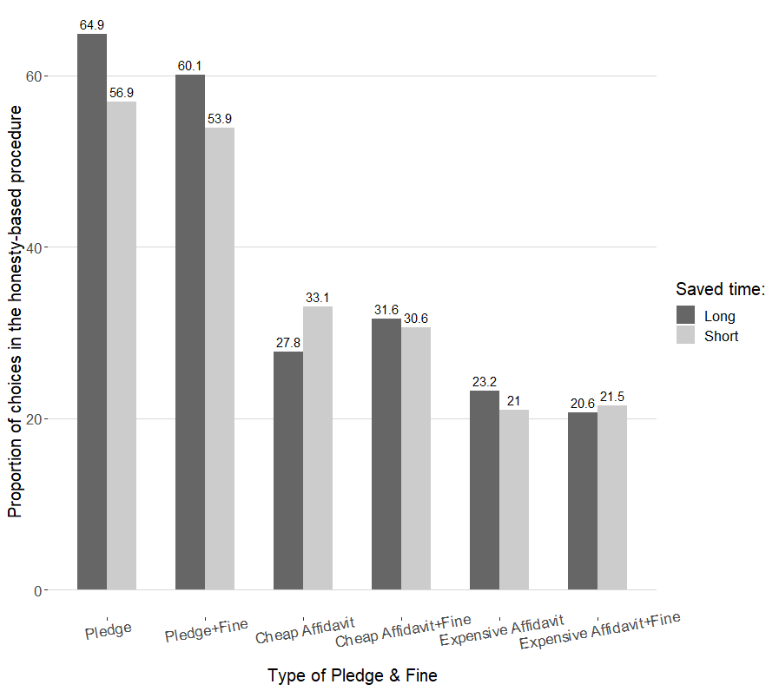

Participants’ choice responses (standard vs. honesty-based procedure) were analyzed using a generalized linear mixed model (GLMM) assuming a binomial distribution of response, i.e., a logistic mixed effect model. We included Instrument Type (0=Pledge, 1=Affidavit), Time (0=Long, 1=Short), Fine (0=without, 1=with) as fixed effects and random effects for Participant and Scenario. We found a significant effect for Instrument Type (b= -2.07, *p<.*01, OR*=* 0.13 (95%CI *=* 0.09, 0.17)), showing that affidavits reduce the likelihood of choosing the honesty-based procedure compared to pledges. We also found a significant effect for Time (b= -0.43, *p*=.01, OR *=* 0.65*,* (95% CI *=* 0.47, 0.91)), such that saving little time reduce the likelihood of choosing the honesty-based procedure compared to saving a long period of time. There was a significant interaction between Instrument Type and Time (b = 0.47, *p* =.04, OR *=*1.60 (95%CI *=* 1.03, 2.50)). The interaction result showed that, for pledges there was a significant decrease in choice response for the honesty-based procedure when the expected saved time was short than when it was long (Average Marginal Effect (AME) = -0.08, *p* < .01, (95% CI = -0.12, -0.03)); However, for affidavits, there was no decrease in choice response for the honesty-based procedure when the saved time was short vs. when it was long (Average Marginal Effect (AME) = -0.005, *p* = .79). All other interactions were not significant (all *p*s. > 0.25).

Overall, these results show that participants were sensitive to the instrument type in the honesty-based procedure (i.e., whether it is a pledge or an affidavit) and that participants were sensitive to the amount of time they can save using the honesty-based instrument. However, the effect of time saving on choice response was more pronounced for pledges than for affidavits. In a follow-up analysis we found that the affidavit’s cost affected participants choices (b = -0.55, *p* < .01, OR *=* 0.58*,* (95% CI *=* 0.39, 0.85), such that an expensive affidavit decreased the likelihood to choose the ex-ante procedure.

*Estimations of other people choices.*

As noted earlier, participants were required to estimate the precent of people that would choose the honesty-based procedure at each given case. On average, participants estimated that 69.9% (SD=22.9%) would choose pledges, vs. 55.3% (SD=26.9%) that would choose affidavits. Figure 2 demonstrates the means of participants estimations of others’ choice and own choice of the honesty-based procedure on each condition. As can be seen in Figure 2, the gap between reported own choice and others’ estimated choice of the honesty-based procedure is larger when an affidavit is included than when a pledge is included. Indeed, mean difference between estimated others’ preferences and reported own preference was 29.3% (SD=40.9%) in case of affidavits (averaged across all conditions including an affidavit), whereas it was only 10.9% (SD=42.7%) in case of pledges (averaged across all conditions including a pledge).

**Figure 2**. Means for estimated others’ choice and reported own choice of the honesty-based procedure on each condition.

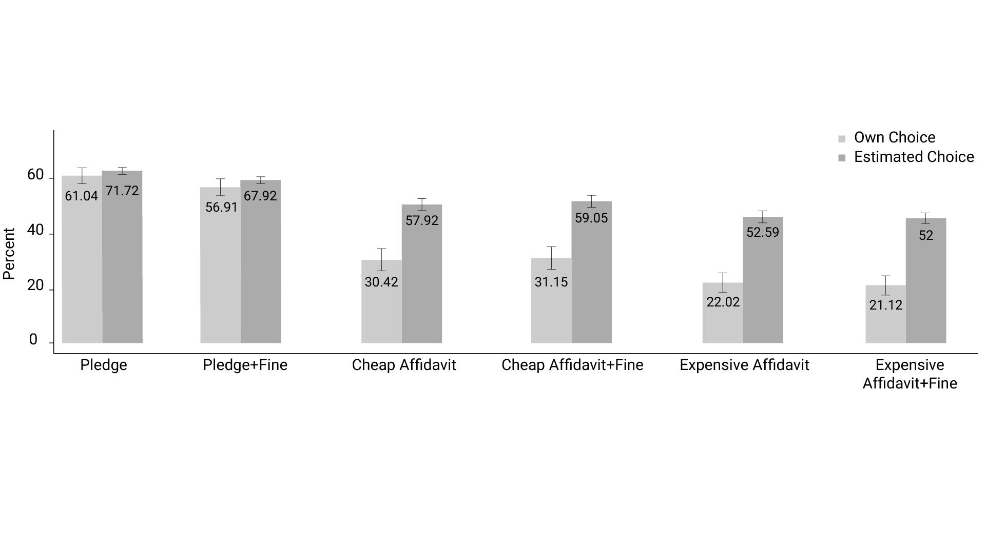

*Scenarios.*

To examine potential differences between the institutions described in the vignettes, we contrasted scenarios with public institutions (government agencies; scenarios #1, 4, 5, 6, 9) vs. private institutions (businesses or not-for-profit organizations; scenarios #2, 3, 7, 8, 10). Results show that the interaction between institution type and Instrument type was not significant, *p* = 0.24. These results indicate that participants preferences were not affected by institution affiliation, suggesting that participants attitude towards pledges and affidavits was consistent across different bureaucratic areas and situations. Mean choice in the honesty-based procedure by scenario and experimental condition is presented in **Table 2** in the appendix.

*Estimations of others’ cheating extent.*

As an indirect measure of potential cheating under the various conditions, participants were asked to estimate the percent of others to knowingly provide incorrect details in their application, for each scenario. A one-way ANOVA on this estimated cheating level showed a significant difference between scenarios (*F*(9,4004)=5.744, *p*<.001). Participants estimated that people would cheat the least in the “Gym” scenario (2.31±1.10) and the most in the “Periphery” scenario (2.64±1). Post-hoc analysis using the Benjamini-Hochberg (BH) procedure revealed that people estimated others would cheat considerably less in the “Academia” (2.33±1.02) scenario compared to other scenarios that require interacting with private institutions such as “Volunteering” (2.51±0.98, *p*=.03 *p*=.048, respectively) and “Scholarship” (2.52±0.98, *p*=.02), and compared to tax-related scenarios, including “Periphery” (2.64±1, *p*<.001), “Import” (2.60±1.01, *p*<.001) and “Property tax” (2.52±0.97, *p*=.02); and that people would cheat considerably less in the and “Donations” scenario (2.35±0.99) compared to “Periphery” (*p*<.001), “Scholarship” (*p*=.04) and “Volunteering” (*p*=.048) scenarios. In contrast, people estimated others would cheat considerably *more* in the “Periphery” and “import” scenarios compared to the “Health insurance” (2.35±0.98, *p*<.001 and *p*=.002, respectively), “Capital gains” (2.41±1.01, *p*<.01 and *p*=.002, respectively) and “Gym” (2.31±1.10, *p*<.001 in both) scenarios.

The degree to which participants estimated others would knowingly provide incorrect details (estimated cheating level) only marginally increased the odds of choosing the honesty-based procedure overall (b = -0.19, *p* =.07, OR = 0.82 (95% CI= 0.66, 1.02)). However, the interaction between estimated cheating level and instrument type was significant (b = 0.66, *p* <.001, OR = 1.93 (95% CI= 1.39, 2.67), showing that the predicted probability of choosing the honesty-based procedure rises with estimated cheating level when affidavits are offered and decreases with estimated cheating level when pledges are offered, see Figure 4.

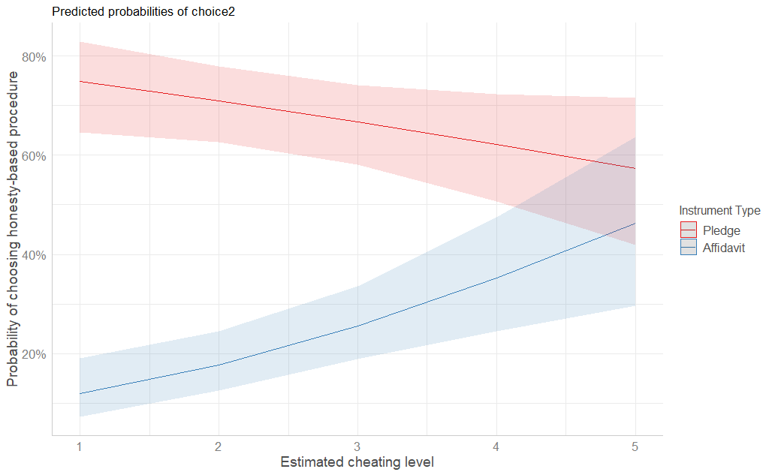**Figure 4.** Predicted probabilities and 95% confidence intervals of choice in the honesty-based procedure by instrument type and estimated cheating level.

*Relevancy.*

We found a significant effect for the degree to which participants rated the relevancy of the situation: relevancy increased the odds of choosing the honesty-based procedure (b = 0.39, *p* < .001, OR = 1.47 (95% CI= 1.25, 1.746)), see **Figure 5**. The interaction between relevancy and instrument type was not significant (*p* = 0.65) indicating that relevancy did not increase the odds of choosing pledges more than it did for affidavits. The interaction between relevancy and the other factors was also not significant (all *ps.*>.10). Overall, these results suggest that participants were sensitive to the relevancy of the situation presented to them, so that the more relevant the situation is, participants are more likely to choose the honesty-based procedure.

**Figure 5.** Choice responses for the honesty-based procedure by scenario relevancy for affidavits and pledges.

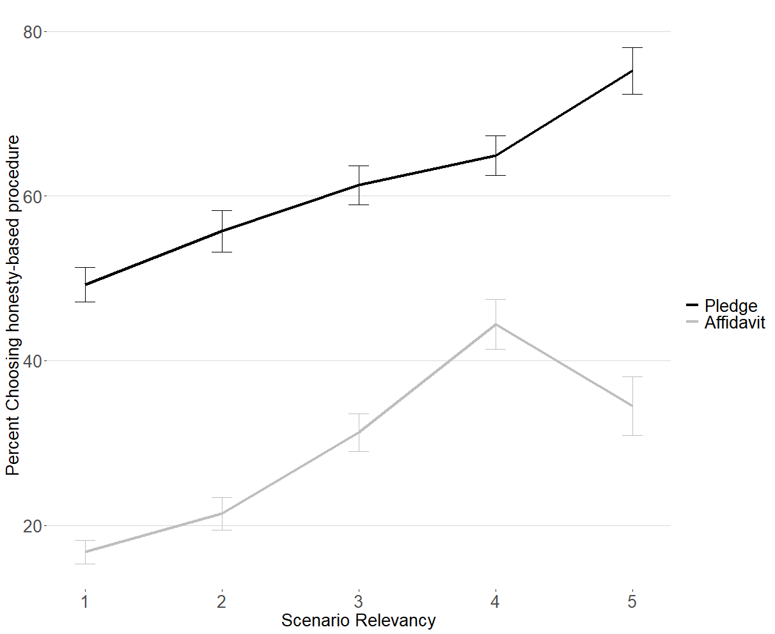

*Trust.*

We measured whether trust would predict peoples’ preference to use honesty-based instruments using two trust measures. First, we measured how trust in others is related to participants’ choice in the honesty-based procedure. The 3-items that measure trust in others were averaged to a single trust factor (Cronbach’s α = 0.79). We found that trust increased the odds of choosing the honesty-based procedure (b = 0.15, *p* = .02, OR = 1.16 (95% CI = 1.03, 1.322)). The interactions between trust and instrument type were not significant (*p* =.78), indicating that trust did not increase the odds of choosing a pledge over an affidavit. The interactions with trust and the other factors were also not significant (all *p*s*.* >.25).

In addition, we measured whether the level of trust people have towards the institution with which they are required to engage, predicts choice in the honesty-based procedure. We found no significant effect of trust for any of the institutions that were included in the analysis (scenarios #1, 2, 4, 5, 6, 7, 8, 9), all *p*s.>0.15.

*Past Experience with affidavits and pledges.*

Most (62%) of participants reported that they have never made an affidavit before, and 23% reported that they have made an affidavit only once. Only 3% of participants reported to have made an affidavit numerous times in the past year; 37% of participants reported that they did not make a pledge in the past year, yet nearly half (47%) reported that they made a pledge once or a few times in the past year, and 15% of participants reported that they have made a pledge numerous times in the past year.

For pledges, results showed that experience level with pledges predicted preferences (b = 0.23, *p* = .03, OR = 1.26 (95% CI= 1.02, 1.55)), such that the more experience a person had with pledges, they were more likely to choose the honesty-based procedure over the standard one. All other main effects and interactions were not significant (*ps.* > .3).

Similarly, for affidavits, the regression results showed that experience level with affidavits predicted choice response (b = 0.48, *p* < .01, OR = 1.61 (95% CI= 1.17, 2.22)), so that the more experience a participant had with affidavits, the more she was likely to choose the honesty-based procedure over the standard one. Figure 6 demonstrates the predicted probabilities of choosing the honesty-based procedure by past experience with affidavits, fine and time. As can be seen in the figure, when a fine was not included, past experience with affidavits was more strongly associated with choice in the honesty-based procedure when a long period of time was saved relative to just a short period of time. However, when a fine was included, prior experience with affidavits was associated with choice in the honesty-based procedure to a lesser extent when the amount of saved time was long compared to when it was short. However, the interaction between past experience, time saved and fine was only marginally significant (b=0.64, *p*=.09, OR=1.88 (95% CI=0.91, 3.87). The interaction between experience level and time was also only marginally significant (b=-0.43, *p*=.07, OR = 0.65 (95% CI= 0.41, 1.03)), and so was the interaction between experience level and fine (b = -0.44, *p* = .07, OR = 0.64 (95% CI= 0.40, 1.03)).

These findings emphasize the importance of past experience with using honesty-based instruments, as finding show that for both pledges and affidavits, high level of experience is associated with greater favorability towards these tools over the standard procedure. Possibly, past experience with using affidavit attenuates feelings of aversion that people may feel towards them. Importantly however, when experience is high, the predicted probability of participants choosing an affidavit is highest when the benefit is maximal, i.e., both when a long amount of time is saved and there is no fine. This may suggest that high level of experience with using affidavits may not be enough to encourage a wide use of them.

Figure 6. Predicted probabilities and 95% confidence intervals of **c**hoice in the honesty-based procedure by past experience with affidavits, fine and time saved.

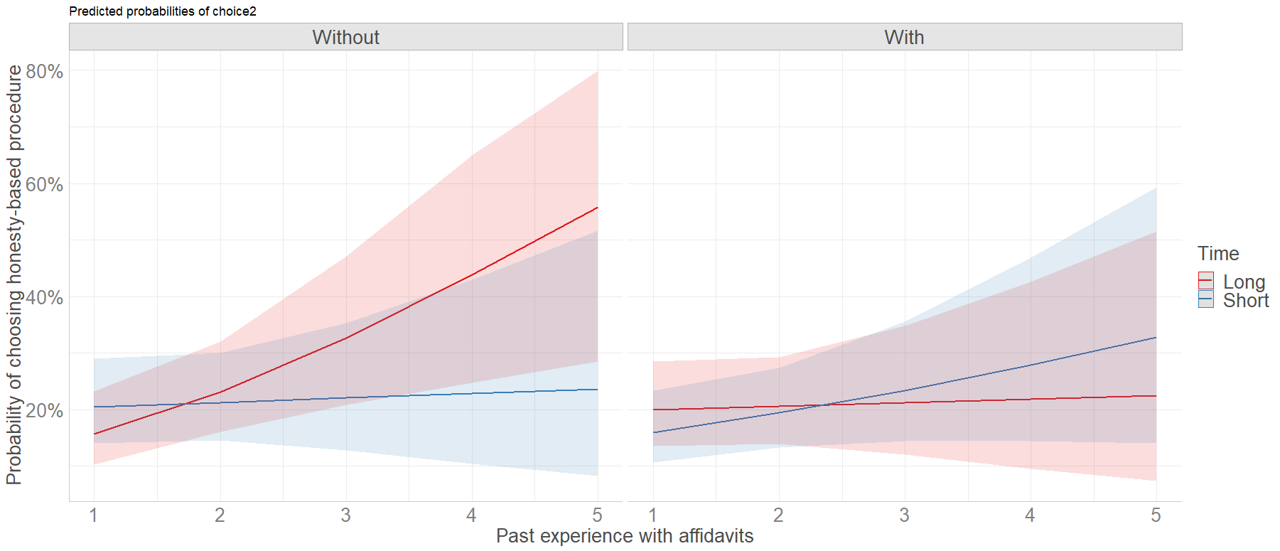

*Demographic factors*

Finally, we conducted a GLMM model on the likelihood that participants would choose the honesty-based procedure using demographic data. We found that the odds of choosing the honesty-based procedure decreased with age, (b= -0.01, *p* < .01, OR = 0.98 (95% CI = 0.97, 0.99)). The effect of all other demographic factors was not significant, all *ps.=*>.28. In addition, to examine how demographic variables interact with instrument type, we conducted a GLMM model on the likelihood that participants would choose the honesty-based procedure, separately for each demographic variable. There was no significant interaction between instrument type with gender or age (*p*=0.89 and *p*=0.43, respectively). There was a significant interaction between instrument type and income (b=-0.18, *p*=.047, OR=0.83 (95% CI = 0.69, 0.99)), such that income level showed a greater positive relationship with choice in the honesty-based procedure when the instrument type was a pledge relative to when it was an affidavit.

Figure 7. Predicted probabilities and 95% confidence intervals of **c**hoice in the honesty-based procedure by instrument type and income level.

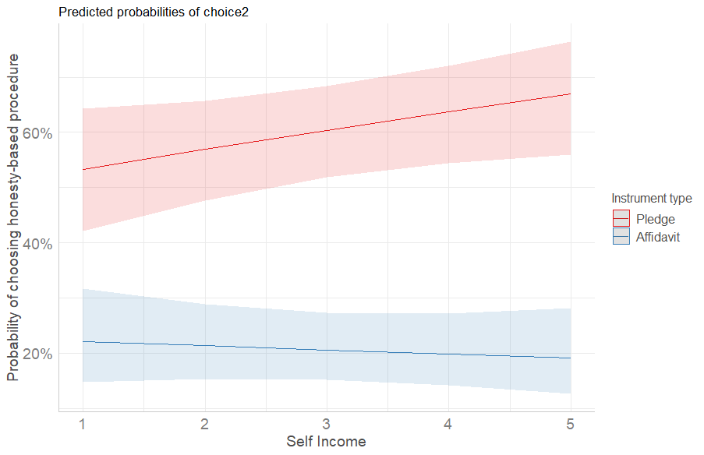

**Discussion**

The results of our study point to an important, and understudied factor that significantly determines whether people would favor honesty-based regulatory tools that reduce their administrative burden. While people show high favorability towards pledges, when asked to choose between affidavits and the more time-consuming traditional bureaucratic procedures, people favor the latter. The size of this effect was quite considerable, reducing preferences for honesty-based instruments from about 65% for a pledge that saved a high amount of time, to only around 30% for “cheap” affidavits, or close to 20% only for the more expensive affidavits. This means that more than half of people who would have favored a pledge if offered, would reject the option of an affidavit and prefer to follow the longer, more time-consuming bureaucratic process. The mere size of this effect should raise high concerns among policy makers and researchers alike. It suggests that some, or all of the factors that distinguish affidavits from pledges – the involvement of a lawyer, the use of legal language, and perceived higher sanctions – contribute negatively to the acceptability, and therefore to the potential efficacy, of honesty-based policy instruments. Thus, if policy-makers and regulators consider relaxing some bureaucratic procedures by allowing affidavits instead of requiring proofs or inspections, they might not actually achieve significant reduction of administrative burden as many people could opt-out of using affidavits. Instead, it appears that offering pledges could be a much more acceptable alternative that could indeed lead to reducing administrative burden.

Although our results do not conclusively offer a specific explanation for this large effect of “affidavits aversion”, they can be used to find support or refute some potential explanations. First, while the cost associated with an affidavit seems to matter – people preferred the cheap to the expensive ones – it does not seem to explain the full size of the effect between pledges and affidavits: Although the difference in cost between a (no-cost) pledge to a cheap affidavit (300 NIS) was similar to the difference between the cheap and expensive affidavits (300 vs. 600 NIS), the difference in preferences between a pledge and a cheap affidavit was much larger than the difference between the cheap and expensive affidavits (see Figure 1). Regarding the difference in perceived sanctions, while mentioning a fine had a significant effect among pledges, it was not significant between affidavits. Furthermore, when asked about the propensity that other people would cheat when submitting a pledge or an affidavit, people did not predict more people would cheat when making a pledge vs. an affidavit. These findings combined suggest that both instruments have similarly perceived sanctions, and these do not necessarily explain why people shy away from providing affidavits, while they are happy to pledge their honesty.

The findings also suggest that not all characteristics of the honesty-based instruments are equally weighted by individuals. As expected, we found that participants choices were influenced by the amount of time they could save by choosing the honesty-based instrument over the traditional bureaucratic procedure. However, in contrast to our hypothesis, we found that the existence of a fine did not have a significant effect on peoples’ choices. This finding may indicate that when people consider alternatives to the traditional regulatory modes, they show greater sensitivity to time savings than to financial sanctions. The significant interaction between instrument type and time-saved suggests that the benefit of time savings is differently weighted across different instruments. Specifically, we found that people were less likely to choose pledges when the benefit of time savings was small than when it was large, yet no such effect was observed for affidavits. However, it is possible that the lack of time saving effect for affidavits results from a lack of statistical power in this condition due to the tendency to avoid using affidavits in genral (i.e., a floor effect). Future studies would be therefore needed to examine the issue more thoroughly.

Surprisingly, when asked to estimate others’ preference towards honesty-based instruments, people tend to overestimate others’ preferences for using affidavits. One possible explanation for the large difference between reports on own preference and evaluations of others’ preference is that people recognize the value of affidavits in reducing the administrative burden, and thus when asked to estimate others’ preferences, they consider the situation from a more objective perspective, mostly focusing on the benefits. However, when asked to imagine themselves having to choose between affidavits and traditional bureaucratic procedures, people experience the situation more concretely, and thus may be more prone to experience aversion from using affidavits and avoid their usage. That is, it is likely that people fail to assess the influence of psychological biases on choice responses. An important implication of this finding is that policy makers may be likely to experience these same cognitive biases, hence judge the public attitude towards affidavits as more favorable than it truly is. This misperception may encourage policy makers to widely use affidavits, despite the public disinclination to use them. In the long run, such policy may lower public trust in state authorities and even increase the bureaucratic burden, especially if at the same time less resources are assigned to the operation of the traditional bureaucratic procedure.

*Factors predicting choice of honesty-based instruments.*

Research in public policy has extensively investigated the factors that influence participants choices in using government services and instruments. Much of this research has focused on trust, which was shown to play a significant role in one’s decision to use government services and adopt government initiatives (e.g. Dwi Susantoa & Aljozab, 2015; Carter & Bélanger, 2005). In the present study we provide further empirical support for the notion that trust is linked to a tendency to use government services by showing that a high-level of trust predicts participants choice of honesty-based instruments. Corroborating on previous research, we suggest that a reduction in bureaucratic burden through the use of honesty-based instruments could increase citizens’ trust in the state, and that, citizens with higher levels of trust are more likely to choose using honesty-based instruments. According to this, we recommend policy makers to use honesty-based instruments as a tool to increase and maintain high levels of public trust.

Additionally, our findings demonstrate that prior experience was found to predict choice for both pledges and affidavits. The finding is of high importance to policy makers, as it suggests that despite a general aversion of the public to using affidavits, individuals who are experienced with using affidavits are more likely to use them in the future. It is important to note that in our study prior experience may have consisted of both positive and negative experiences. It is therefore likely that the link between prior experience and preference to using honesty-based instruments is even stronger than that found in our study. However, future studies are needed to better understand the relationship between the nature of prior experiences and preference towards honesty-based regulatory tools.

Finally, we found that the relevancy of the situation to the individual predicts choice in honesty-based procedures. It is possible that individuals for which the service was more relevant tended to evaluate the instrument from a more practical perspective. That is, these individuals might have focused on the benefits obtained by a reduction in the bureaucratic burden. However, such practical considerations may play a less significant role in one’s choice when the situation is less relevant. Here too, future research is needed to examine the current proposition and gain a better understanding on the relationship between scenario relevancy and peoples’ choice of advanced regulatory tools.

While the results of this study, along with previous ones (e.g., Feldman & Peer, 2021) point to the advantages of using pledges as reduced forms of regulation, it can be argued that the lower involvement of state authorities in the regulatory process might increase the risk that citizens would behave dishonestly. When people make a pledge, it is easier for them to make a false report than when regulation is stricter. Consequently, they may receive a service or a discount that they are not entitled to, leading to an inefficient and unjust allocation of public resources. The effect can be dramatic, considering that in actual bureaucratic encounters, the choice whether to use a pledge or the alternative traditional mode is given to the individual and is not monitored by the state. It can therefore be argued that people who are more prone to cheating might choose using pledges for their own personal gain. Indeed, a recent study found that when participants could self-select one of two tasks, those who chose the task where they could lie for financial gain reported a higher number of correct predictions than those who were assigned to it at random (Houdek et al, 2021). In addition, participants who chose cheating-enabling environments were found to have unique characteristics that differed from those who avoided these environments.

To conclude, the present study provides important insights regarding public preferences towards honesty-based procedures. Our results demonstrate that pledges, but not affidavits, are largely preferred over the traditional bureaucratic procedures. Honesty pledges thus seem to be a promising and more cost effective regulatory tool for promoting more efficient citizen-state interaction, as it is both favored by the public and is assumed to increase the public trust in state authorities though greater relaxation of administrative burden. Further research should examine the contexts in which the affidavits might still be needed but this study provide great support for the ability of regulators to move forward to more behaviorally informed regulatory tools which could lead to greater enhancement of public trust without increasing the risk to the public.

**References**

Galanter, M. (1997). The faces of mistrust: The image of lawyers in public opinion, jokes, and political discourse. *U. cin. L. rev.*, *66*, 805.

Asimow, M., Greenfield, S., Jorge, G., Machura, S., Osborn, G., Robson, P., & Sockloskie,

R. (2005). Perceptions of lawyers—a transnational study of student views on the image of law and lawyers. International Journal of the Legal Profession, 12(3), 407-436.‏

Sharp, C. (2002). Scarlet Letter or Chastity Belt? What Legal Dramas of the Twenty-first

Century are “Telling” Law Students About a Career in Law. *Legal Ethics*, *5*(1), 90-

102. [https://doi.org/10.1080/1460728X.2002.11424161‏](https://doi.org/10.1080/1460728X.2002.11424161)

Gallup, I. (2017). Media Use and Evaluation.  Retrieved from: <https://news.gallup.com/poll/1663/media-use-evaluation.aspx>

Bok, S. (1989). Can Lawyers Be Trusted. U. Pa. L. Rev., 138, 913.

[https://scholarship.law.upenn.edu/cgi/viewcontent.cgi?article=3802&context=penn_law_review‏](https://scholarship.law.upenn.edu/cgi/viewcontent.cgi?article=3802&context=penn_law_review)

Daicoff, S. S. (1998). Asking leopards to change their spots: Should lawyers change?

A critique of solutions to problems with professionalism by reference to empirically derived attorney personality attributes. Georgetown Journal of Legal Ethics.‏

<https://heinonline.org/HOL/P?h=hein.journals/geojlege11&i=557>

Kaufman, H. (1981). Fear of bureaucracy: A raging pandemic. Public Administration

Review, 1-9. <https://www.jstor.org/stable/975718>

Hunt, S. (1995). Drafting: Plain English versus Legalese. Waikato L. Rev., 3, 163.

<https://heinonline.org/HOL/P?h=hein.journals/waik3&i=167>

Gennetian, L. A., & Shafir, E. (2015). The persistence of poverty in the context of financial

instability: A behavioral perspective. Journal of Policy Analysis and Management, 34(4), 904-936. <https://doi.org/10.1002/pam.21854>

de Stadler, E., & Van Zyl, L. (2017). Plain-language contracts: Challenges and opportunities. South African Mercantile Law Journal, 29(1), 95-127.

[http:C:\Users\User\Downloads\29SAfrMercantileLJ95.pdf](http://C:/Users/User/Downloads/29SAfrMercantileLJ95.pdf)

Hergueux, J., Jacquemet, N., Luchini, S., & Shogren, J. (2016). Leveraging the honor code: Public goods contributions under oath.

Jacquemet, N., Luchini, S., Rosaz, J., & Shogren, J. F. (2019). Truth telling under

oath. *Management Science*, *65*(1), 426-438.

Koessler, A. K., Torgler, B., Feld, L. P., & Frey, B. S. (2016). Commitment to pay taxes: A

field experiment on the importance of promise. *Tax and Transfer Policy Institute-Working Paper*, *10*.

Peeters, R., Trujillo Jimenez, H., O'Connor, E., Ogarrio Rojas, P., Gonzalez Galindo, M., &

Morales Tenorio, D. (2018). Low‐trust bureaucracy: Understanding the Mexican bureaucratic experience. *Public Administration and Development*, *38*(2), 65-74.

Peters, B. G. (1981). The problem of bureaucratic government. *The Journal of*

*Politics*, *43*(1), 56-82.

Burgess, D., Haney, B., Snyder, M., Sullivan, J. L., & Transue, J. E. (2000). Rocking the Vote: Using Personalized Messages to Motivate Voting among Young Adults. *Public Opin Q, 64*(1), 29-52.

Costa, M., Schaffner, B. F., & Prevost, A. (2018). Walking the walk? Experiments on the effect of pledging to vote on youth turnout. *Plos One, 13*(5), e0197066. doi: 10.1371/journal.pone.0197066

Gennetian, L. A., & Shafir, E. (2015). The persistence of poverty in the context of financial

instability: A behavioral perspective. *Journal of Policy Analysis and Management*, *34*(4), 904-936.

Bates, D., Maechler, M., Bolker, B., Walker, S., Bojesen Christensen, R. H., & Singmann, H.

(2016). Lme4: Linear mixed-effects models using Eigen and S4. R package version 1.0-6. 2014.

Halekoh, U., & Højsgaard, S. (2014). A kenward-roger approximation and parametric

bootstrap methods for tests in linear mixed models–the R package pbkrtest. *Journal of Statistical Software*, *59*(9), 1-30.

Kenward, M. G., & Roger, J. H. (1997). Small sample inference for fixed effects from

restricted maximum likelihood. Biometrics, 983-997

Mazar, N., Amir, O., & Ariely, D. (2008). The dishonesty of honest people: A theory of self-

concept maintenance. *Journal of marketing research*, *45*(6), 633-644.

Jeffreys, H. (1961). *Theory of probability* (3rd edt.): Oxford University Press.

Herd, P., & Moynihan, D. P. (2019). *Administrative burden: Policymaking by other means*.

Russell Sage Foundation.

Jakobsen,  M., James,  O., Moynihan,  D., and T.  Nabatchi. 2016. JPART virtual issue on citizen–state interactions in public administration research: introduction. Journal of

Public Administration Research and Theory 1–8. doi:10.1092/jopart/muw031

Heinrich, C. J. (2016). The bite of administrative burden: A theoretical and empirical

investigation. *Journal of Public Administration Research and Theory*, *26*(3), 403-420.

Masood, A., & Azfar Nisar, M. (2020). Administrative capital and citizens’ Responses to administrative burden. *Journal of Public Administration Research and Theory*.

Moynihan, D., Herd, P., & Harvey, H. (2015). Administrative burden: Learning, psychological, and compliance costs in citizen-state interactions. *Journal of Public Administration Research and Theory*, *25*(1), 43-69.

Brodkin, E. Z., & Majmundar, M. (2010). Administrative exclusion: Organizations and the hidden costs of welfare claiming. *Journal of Public Administration Research and Theory*, *20*(4), 827-848.)

Andersen, Simon Calmar, and Morten Hjortskov Larsen. 2016. Cognitive biases in performance evaluations. *Journal of Public Administration Research and Theory* **4**: 647–62.

Hjortskov, M. (2019). Citizen expectations and satisfaction over time: Findings from a large

sample panel survey of public school parents in Denmark. *The American Review of Public Administration*, *49*(3), 353-371.

Barter, Christine, and Emma Renold. 1999. The use of vignettes in qualitative research.

*Social Research Update* **25**.

Finch, Janet. 1987. The vignette technique in survey research. *Sociology* **21**: 105–14

Harrits, G. S., & Møller, M. Ø. (2014). Prevention at the front line: How home nurses,

pedagogues, and teachers transform public worry into decisions on special efforts. *Public Management Review*, *16*(4), 447-480.

Faia, Michael A. 1980. The vagaries of the vignette world: A comment on Alves and Rossi.

*The American Journal of Sociology* **21** (1): 105–14.

Neff, James Alan. 1979. Interactional versus hypothetical others: The use of vignettes in

attitude research. *Sociology and Social* *Research* **64** (1): 105–25.

Hughes, R., and M. Huby. 2004. The construction and interpretation of vignettes in social

research. *Social Work and Social* *Sciences Review* **11** (1): 36–51.

Nisar, Muhammad Azfar. 2018a. Children of a lesser god: Administrative burden and social

equity in citizen–state interactions. *Journal of Public Administration Research and Theory* **28** (1): 104–19. doi:10.1093/jopart/mux025

Heinrich, Carolyn J. 2018. A thousand petty fortresses: Administrative burden in US immigration policies and its consequences. *Journal of Policy Analysis and Management* **37** (2): 211–39.

Schram, Sanford F., Joe Soss, Richard C. Fording, and Linda Houser. 2009. Deciding to

discipline: Race, choice, and punishment at the frontlines of welfare reform. *American Sociological Review* **74** (3): 398–422.

Christensen, J., Aarøe, L., Baekgaard, M., Herd, P., & Moynihan, D. P. (2020). Human capital and administrative burden: The role of cognitive resources in citizen‐state interactions. *Public Administration Review*, *80*(1), 127-136.

Moynihan, Donald, Pamela Herd, and Hope Harvey. 2015. Administrative burden: Learning, psychological, and compliance costs in citizen-state interactions. *Journal of Public Administration*

Christensen, Julian, Lene Aarøe, Martin Baekgaard, Pamela Herd, and Donald P. Moynihan. 2020. Human capital and administrative burden: The role of cognitive resources in citizen-state interactions. *Public Administration Review* **80** (1): 127–36.

Nielsen, V. L., Nielsen, H. Ø., & Bisgaard, M. (2020). Citizen Reactions to Bureaucratic Encounters: Different Ways of Coping With Public Authorities. *Journal of Public Administration Research and Theory*.

*Van Ryzin, Gregg G. 2006. Testing the expectancy disconfirmation model of citizen satisfaction with local government. *Journal of Public Administration Research and Theory* **16**:599–611.

2013. An experimental test of the expectancy‐disconfirmation theory of citizen satisfaction. *Journal of Policy Analysis and Management* **32**:597–614.

James, Oliver. 2009. Evaluating the expectations: Disconfirmation and expectations anchoring approaches to citizen satisfaction with local public services. *Journal of Public Administration Research and Theory* **19**:107–23.

Parker, C. (2013). Twenty years of responsive regulation: An appreciation and appraisal. *Regulation & Governance*, *7*(1), 2-13.

Poister, Theodore H., and John C. Thomas. 2011. The effect of expectations and expectancy confirmation/disconfirmation on motorists’ satisfaction with state highways. *Journal of Public Administration Research and Theory* **21**:601–17.

James, Oliver. 2009. Evaluating the expectations: Disconfirmation and expectations anchoring approaches to citizen satisfaction with local public services. *Journal of Public Administration Research and Theory* **19**:107–23.

———. 2011a. Managing citizens’ expectations of public service performance: Evidence from observation and experimentation in local government. *Public Administration* **89**:1419–35.

*Brodkin, Evelyn Z., and Malay Majmundar. 2010. Administrative exclusion: Organizations and the hidden costs of welfare claiming. *Journal of Public* *Administration Research and Theory* **20**:827–48.

Keiser, L. R., & Miller, S. M. (2020). Does administrative burden influence public support for government programs? Evidence from a survey experiment. *Public Administration Review*, *80*(1), 137-150.

Connolly, J. M., Klofstad, C., & Uscinski, J. (2020). Administrative Burdens and Citizen Likelihood to Seek Local Public Services: The Case of Hurricane Shelters. *Public Performance & Management Review*, 1-20.

Van Ryzin, Gregg G. 2006. Testing the expectancy disconfirmation model of citizen satisfaction with local government. *Journal of Public Administration* *Research and Theory* **16**:599–611

Van Rooij, B. (2016). Weak enforcement, strong deterrence: dialogues with Chinese lawyers about tax evasion and compliance. *Law & Social Inquiry*, *41*(2), 288-310.

Burden, Barry C., David T. Canon, Kenneth R. Mayer, and Donald P. Moynihan. 2012. The effect of administrative burden on bureaucratic perception of policies: Evidence from election administration. *Public Administration Review* **72** (5): 741–51

Moynihan, D., Herd, P., & Harvey, H. (2015). Administrative burden: Learning, psychological, and compliance costs in citizen-state interactions. *Journal of Public Administration Research and Theory*, *25*(1), 43-69.

Wolfe, Barbara, and Scott Scrivner. 2005. The Devil May Be in the Details: How the Characteristics of SCHIP Programs Affect Take-Up. Journal of Policy Analysis and Management 24(3): 499–522

Ferrin, D. L., Bligh, M. C., & Kohles, J. C. (2007). Can I trust you to trust me? A theory of trust, monitoring, and cooperation in interpersonal and intergroup relationships. *Group & Organization Management*, *32*(4), 465-499.

Fukuyama, F. (1995). Trust: The social virtues and the creation of prosperity‏. New York: Free press.

Six, F., & Verhoest, K. (2017). Trust in regulatory regimes: scoping the field. In Trust in regulatory regimes. Edward Elgar Publishing.‏

Tyler, T. R. (2009). Legitimacy and criminal justice: The benefits of self-regulation. Ohio St. J. Crim. L., 7, 307.‏

Colgan, B. A. (2014). Reviving the excessive fines clause. *Calif. L. Rev.*, *102*, 277.

Gächter, S., & Schulz, J. F. (2016). Intrinsic honesty and the prevalence of rule violations across societies. *Nature*, *531*(7595), 496-499.

Chugh, D., Bazerman, M. H., & Banaji, M. R. (2005). Bounded ethicality as a psychological barrier to recognizing conflicts of interest. *Conflicts of interest: Challenges and solutions in business, law, medicine, and public policy*, 74-95.

Susanto, T. D., & Aljoza, M. (2015). Individual acceptance of e-Government services in a developing country: Dimensions of perceived usefulness and perceived ease of use and the importance of trust and social influence. *Procedia Computer Science*, *72*, 622-629.

Carter, L., & Bélanger, F. (2005). The utilization of e‐government services: citizen trust, innovation and acceptance factors. *Information systems journal*, *15*(1), 5-25.

Feldman, Y. (2018). *The law of good people: Challenging states' ability to regulate human behavior*. Cambridge University Press. Chapter 11.

Houdek, P., Bahník, Š., Hudík, M., & Vranka, M. (2021). Selection effects on dishonest behavior. *Judgment and Decision Making*, *16*(2), 238.‏

Kahneman, D. & Tversky, A. (1992). "Advances in prospect theory: Cumulative representation of uncertainty". *Journal of Risk and Uncertainty*. **5** (4): 297–323. [CiteSeerX](https://en.wikipedia.org/wiki/CiteSeerX_(identifier)) [10.1.1.320.8769](https://citeseerx.ist.psu.edu/viewdoc/summary?doi=10.1.1.320.8769). [doi](https://en.wikipedia.org/wiki/Doi_(identifier)):[10.1007/BF00122574](https://doi.org/10.1007%2FBF00122574). [S2CID](https://en.wikipedia.org/wiki/S2CID_(identifier)) [8456150](https://api.semanticscholar.org/CorpusID:8456150).

T. Keyworth, “Measuring and Managing the Costs of Red Tape: A Review of Recent Policy Developments,” Oxford Rev. Econ. Policy, vol. 22, no. 2, pp. 260–273, 2006.

OECD, “Making Life Easy for Citizens and Businesses in Portugal,” 2008.

F. Di Mascio, A. Natalini, and F. Stolfi, “The implementation of administrative burden reduction policy: Mechanisms and contexts in the study of Europeanization,” Comp. Eur. Polit., no. May, 2015

OECD (2020), *Integrating Responsible Business Conduct in Public Procurement*, OECD Publishing, Paris, <https://doi.org/10.1787/02682b01-en>. Part II.

REFORMING PUBLIC SERVICE DELIVERY SYSTEMS IN INDIA: Rationalisation of Affidavits. (2013, July). Idcindia. [http://idcindia.org/wp- ccontent/themes/idc/pbgrc_pdf/Reforming%20public%20service%20delivery%20sys%20in%20india-Rationalising%20of%20affidavits.pdf](http://idcindia.org/wp-content/themes/idc/pbgrc_pdf/Reforming%20public%20service%20delivery%20sys%20in%20india-Rationalising%20of%20affidavits.pdf)

Organisation for Economic Co-operation and Development. (2014). *Measurement and Reduction of Administrative Burdens in Greece: An Overview of 13 Sectors*. OECD Publishing.

Fredriksson, A. (2014). Bureaucracy intermediaries, corruption and red tape. *Journal of Development Economics*, *108*, 256-273.

Yang, K., & Pandey, S. K. (2011). Further dissecting the black box of citizen participation: When does citizen involvement lead to good outcomes?. *Public administration review*, *71*(6), 880-892.

Glaeser, E. L., Laibson, D. I., Scheinkman, J. A., & Soutter, C. L. (2000). Measuring trust. *The quarterly journal of economics*, *115*(3), 811-846.

H ardin, R. (2002). *Trust and trustworthiness*. Russell Sage Foundation.

Putnam, R. (2001). Social capital: Measurement and consequences. *Canadian journal of policy research*, *2*(1), 41-5.

Kweit, Robert W., and Mary Grisez Kweit. 1980. Bureaucratic Decision-Making: Impediments to Citizen Participation. Polity 12(4): 647–66.

Luria, G., Cnaan, R. A., & Boehm, A. (2015). National culture and prosocial behaviors: Results from 66 countries. *Nonprofit and Voluntary Sector Quarterly*, *44*(5), 1041-1065

King, Cheryl Simrell, Kathryn M. Feltey, and Bridget O’Neill Susel. 1998. Th e Question of Participation: Toward Authentic Public Participation in Public Administration. Public Administration Review 58(4): 317–26

Hirschman, A. O. (1970). *Exit, voice, and loyalty: Responses to decline in firms, organizations, and states* (Vol. 25). Harvard university press.

Adler, P. S., & Borys, B. (1996). Two types of bureaucracy: Enabling and coercive. *Administrative science quarterly*, 61-89.

Hattke, F., Hensel, D., & Kalucza, J. (2020). Emotional responses to bureaucratic red tape. *Public Administration Review*, *80*(1), 53-63.

steban Ortiz-Ospina and Max Roser (2016) - "Trust". *Published online at OurWorldInData.org.* Retrieved from: 'https://ourworldindata.org/trust' [Online Resource]

Kearney, R. C., & Sinha, C. (1988). Professionalism and bureaucratic responsiveness: Conflict or compatibility?. *Public Administration Review*, 571-579.

**Appendix**

**Table 1. Description of Vignettes used in the study.**

| **Description** | **Case Name** | **Case**  **Num.** |
| --- | --- | --- |
| Imagine that you have signed a contract for the sale of your apartment. In order to transfer the ownership of the property you must pay a capital gains tax on the profit you earned from the difference between the price at which you purchased the apartment, and the price at which you sold it. You will do this by reporting the capital gains tax to the tax authorities. To calculate the rate of capital gains tax that you will have to pay, you have two options:   1. Submission of all documents such as the purchase and sale contracts, and authorization of bank transfers, attesting to the profit earned. 2. Declare the profit by filling out a separate form, without being required to submit documents. | Capital Gains | **1** |
| Imagine that you are interested in purchasing private health insurance and are required to provide information about the state of your health, according to which the monthly payment for the insurance, as well as the scope of coverage will be determined. Insurance companies offer two options for reporting your health condition:   1. Undergo a series of medical screening tests based on which your health condition will be determined. 2. Declare your health condition in a separate form, without being required to undergo tests. | Health Insurance | **2** |
| Imagine that you are interested in buying a gym membership. The gym you have joined wants to make sure that physical activity does not expose you to health risks and therefore wants information about your health condition. For reporting your health condition to the gym, you have two options:   1. Bring a certificate from a family doctor stating that you are healthy. 2. Declare your health condition in a separate form, without requiring approval from your family doctor. | Gym | **3** |
| Imagine that you purchased a laptop from abroad and now you have been notified that it has arrived in Israel. To transfer the product through customs, you must report the price paid for the laptop to the tax authorities. The customs duty you must pay will be calculated according to this report. You can report to the tax authority in one of two ways:   1. Submission of the receipt and order confirmation indicating the total amount you paid. 2. Declare the total amount you paid in a separate form, without being required to submit documents. | Import | **4** |
| Imagine that you have donated to several charities this year. According to the law, anyone who donates to registered charities is entitled to an income tax rebate for that year. The larger the contribution, the higher the rebate. You can apply for a rebate from the tax authority in one of two ways:   1. Submission of documents, such as original receipts, attesting to the amount of your donation. 2. Filling out a separate form in which you report the amount of donations, without being required to submit documents. | Donations | **5** |
| Imagine that you are looking into how you can receive a property tax discount on your apartment. According to the municipality’s regulations, a tax deduction can be obtained in the case of low income. The discount on the payment of the annual property tax ranges from 20-80 percent, depending on the reported total monthly income of the occupants of the apartment. You can report your monthly income to the municipality in one of two ways:   1. Submission of documents attesting to the monthly income of the occupants of the apartment. 2. Filling out a separate form in which you independently report income, without being required to submit documents. | Property Tax | **6** |
| Imagine that you are applying for admission to graduate school. As part of the institution’s requirements, the candidate must have high academic achievements, such that the higher academic achievements the candidate reports, the more likely they are to be accepted to the program. You can report academic achievements in one of two ways:   1. Submission of documents, such as your transcript and confirmation of eligibility for a degree, indicating that you have met the threshold requirements of the admission committee. 2. Filling out a separate form in which you independently report previous academic achievements without being required to submit documents. | Academia | **7** |
| Imagine that you are an undergraduate student and can receive a monthly scholarship for students engaged in volunteer work in the community. The amount of the scholarship funding depends on the number of monthly hours you volunteer.  You can report the number of volunteer hours in one of two ways:   1. Submission of certificates from the association in which you have volunteered, specifying in detail the number of hours you worked. 2. Filling out a separate form with the amount of volunteer hours, without being required to submit documents. | Scholarship | **8** |
| Imagine that you own an apartment in a town in the north of the country, where you reside only part of the year. Residents of the town are entitled to a tax benefit. You have received a letter from the tax authority in which you are asked to report your eligibility for the tax benefit. The letter emphasizes that the size of the benefit is relative to the duration of residence in the apartment during the year. The letter lists two options for applying for the tax benefit:   1. Submit the application and wait for a visit from an inspector from the local authority who will approve your report. 2. Submit the application with a separate from in which you declare that you live in the apartment, without having to wait for the inspector. | Periphery | **9** |
| Imagine that you have won an annual scholarship that requires volunteering a certain number of hours each month. To receive the scholarship, you can choose between two options:   1. Submit an approval from the head of the association in which you volunteered, reporting the number of hours volunteered each month. Then receive the monthly portion of the scholarship. 2. Sign a separate form in which you declare that you will volunteer each month and receive the entire scholarship in advance. | Volunteering | **10** |

**Table 2. Mean choice in the honesty-based procedure by scenario and experimental condition.**

|  |  |  |  |
| --- | --- | --- | --- |
| **Condition** | **Scenario** | **Mean (%)** | **Sd** |
| Pledge | Periphery | 71.84 | 45.20 |
| Pledge | Scholarship | 70.19 | 45.96 |
| Pledge | Volunteering | 66.67 | 47.35 |
| Pledge | Capital Gains | 64.49 | 48.08 |
| Pledge | Health Insurance | 62.07 | 48.73 |
| Pledge | Gym | 60.61 | 49.11 |
| Pledge | Import | 64.58 | 48.08 |
| Pledge | Property Tax | 54.55 | 50.02 |
| Pledge | Donations | 54.46 | 50.05 |
| Pledge | Academia | 38.95 | 49.02 |
| Pledge+Fine | Periphery | 74.23 | 43.97 |
| Pledge+Fine | Scholarship | 53.70 | 50.10 |
| Pledge+Fine | Volunteering | 60.23 | 49.22 |
| Pledge+Fine | Capital Gains | 57.84 | 49.62 |
| Pledge+Fine | Health Insurance | 62.07 | 48.80 |
| Pledge+Fine | Gym | 51.92 | 50.20 |
| Pledge+Fine | Import | 64.41 | 48.08 |
| Pledge+Fine | Property Tax | 56.18 | 49.90 |
| Pledge+Fine | Donations | 48.89 | 50.27 |
| Pledge+Fine | Academia | 40.74 | 49.36 |
| Cheap Affidavit | Periphery | 40.00 | 49.54 |
| Cheap Affidavit | Scholarship | 31.37 | 46.86 |
| Cheap Affidavit | Volunteering | 37.50 | 48.92 |
| Cheap Affidavit | Capital Gains | 41.46 | 49.88 |
| Cheap Affidavit | Health Insurance | 50.00 | 50.61 |
| Cheap Affidavit | Gym | 16.67 | 37.62 |
| Cheap Affidavit | Import | 26.92 | 44.79 |
| Cheap Affidavit | Property Tax | 32.00 | 47.12 |
| Cheap Affidavit | Donations | 15.22 | 36.32 |
| Cheap Affidavit | Academia | 19.61 | 40.10 |
| Cheap Affidavit+Fine | Periphery | 52.17 | 50.50 |
| Cheap Affidavit+Fine | Scholarship | 25.64 | 44.24 |
| Cheap Affidavit+Fine | Volunteering | 28.33 | 45.44 |
| Cheap Affidavit+Fine | Capital Gains | 50.00 | 50.44 |
| Cheap Affidavit+Fine | Health Insurance | 39.62 | 49.38 |
| Cheap Affidavit+Fine | Gym | 11.36 | 32.10 |
| Cheap Affidavit+Fine | Import | 19.05 | 39.74 |
| Cheap Affidavit+Fine | Property Tax | 32.08 | 47.12 |
| Cheap Affidavit+Fine | Donations | 25.00 | 43.72 |
| Cheap Affidavit+Fine | Academia | 22.81 | 42.33 |
| Expensive Affidavit | Periphery | 22.92 | 42.47 |
| Expensive Affidavit | Scholarship | 18.97 | 39.55 |
| Expensive Affidavit | Volunteering | 21.95 | 41.91 |
| Expensive Affidavit | Capital Gains | 44.23 | 50.15 |
| Expensive Affidavit | Health Insurance | 36.59 | 48.77 |
| Expensive Affidavit | Gym | 8.51 | 28.21 |
| Expensive Affidavit | Import | 19.64 | 40.09 |
| Expensive Affidavit | Property Tax | 19.05 | 39.74 |
| Expensive Affidavit | Donations | 15.52 | 36.52 |
| Expensive Affidavit | Academia | 15.38 | 36.43 |
| Expensive Affidavit+Fine | Periphery | 38.10 | 48.95 |
| Expensive Affidavit+Fine | Scholarship | 17.50 | 38.48 |
| Expensive Affidavit+Fine | Volunteering | 14.81 | 35.86 |
| Expensive Affidavit+Fine | Capital Gains | 35.85 | 48.41 |
| Expensive Affidavit+Fine | Health Insurance | 28.81 | 45.68 |
| Expensive Affidavit+Fine | Gym | 15.91 | 37.00 |
| Expensive Affidavit+Fine | Import | 11.11 | 31.78 |
| Expensive Affidavit+Fine | Property Tax | 9.62 | 29.77 |
| Expensive Affidavit+Fine | Donations | 12.00 | 32.83 |
| Expensive Affidavit+Fine | Academia | 19.05 | 39.74 |

**Table 3. Logistic mixed-effect regression models predicting choice responses.**

|  |  |  |  |  |  |  |
| --- | --- | --- | --- | --- | --- | --- |
| ***Model 1*** | ***Term*** | ***Estimate*** | ***SE*** | ***P-value*** | ***95% CI*** | |
|  | (Intercept) | 0.78 | 0.17 | <.001 | 0.43 | 1.13 |
| Instrument Type | -2.07 | 0.16 | <.001 | -2.39 | -1.74 |
| Time | -0.43 | 0.16 | 0.01 | -0.60 | 0.06 |
| Fine | -0.26 | 0.17 | 0.11 | -0.76 | -0.09 |
| Instrument Type * Time | 0.47 | 0.22 | 0.03 | -0.18 | 0.71 |
| Instrument Type * Fine | 0.26 | 0.22 | 0.25 | 0.03 | 0.91 |
| Time * Fine | 0.12 | 0.26 | 0.63 | -0.39 | 0.64 |
| Instrument Type * Time * Fine | -0.27 | 0.31 | 0.38 | -0.90 | 0.34 |
| Random effects |  | *SD* |  |  |  |
| Participant | intercept | 1.06 |  |  |  |
| Scenario | intercept | 0.42 |  |  |  |
|  | ***Term*** | ***Estimate*** | ***SE*** | ***P-value*** | ***95% CI*** | |
|  | (Intercept) | -1.14 | 0.22 | <.001 | -1.57 -0.70 | |
|  | Cost | -0.54 | 0.19 | <.01 | -0.93 -0.15 | |
|  | Time | 0.07 | 0.18 | 0.68 | -0.29 0.44 | |
|  | Cost * Time | -0.17 | 0.30 | 0.57 | -0.77 0.42 | |
|  | Random effects |  | *SD* |  |  | |
|  | Participant | intercept | 1.22 |  |  | |
|  | Scenario | intercept | 0.56 |  |  | |
| ***Model 3*** | ***Term*** | ***Estimate*** | ***SE*** | ***P-value*** | ***95% CI*** | |
|  | (Intercept) | 1.01 | 0.20 | <.001 | 0.61 1.408 | |
|  | Instrument Type | -2.15 | 0.30 | <.001 | -2.75 -1.565 | |
|  | Institution | -0.34 | 0.23 | 0.13 | -0.8 0.110 | |
|  | Time | -0.53 | 0.28 | 0.06 | -1.09 0.015 | |
|  | Fine | -0.38 | 0.29 | 0.19 | -0.95 0.190 | |
|  | Instrument Type * Institution | 0.16 | 0.36 | 0.65 | -0.54 0.868 | |
|  | Instrument Type * Time | 0.46 | 0.41 | 0.26 | -0.35 1.287 | |
|  | Institution * Time | 0.14 | 0.32 | 0.66 | -0.5 0.781 | |
|  | Instrument Type * Fine | 0.01 | 0.42 | 0.97 | -0.82 0.861 | |
|  | Institution * Fine | 0.15 | 0.33 | 0.65 | -0.50 0.810 | |
|  | Time * Fine | 0.05 | 0.42 | 0.89 | -0.76 0.881 | |
|  | Instrument Type * Institution * Time | 0.04 | 0.50 | 0.93 | -0.94 1.032 | |
|  | Instrument Type * Institution * Fine | 0.41 | 0.51 | 0.42 | -0.59 1.423 | |
|  | Instrument Type * Time * Fine | 0.22 | 0.59 | 0.70 | -0.94 1.397 | |
|  | Institution * Time * Fine | 0.08 | 0.46 | 0.85 | -0.83 1.003 | |
|  | Instrument Type * Institution* Time* Fine | -0.71 | 0.71 | 0.32 | -2.11 0.687 | |
|  | Random effects |  | *SD* |  |  | |
|  | Participant | intercept | 1.02 |  |  | |
| ***Model 4*** | ***Term*** | ***Estimate*** | ***SE*** | ***P-value*** | ***95% CI*** | |
|  | (Intercept) | -0.21 | 0.29 | 0.45 | -0.79 0.353 | |
|  | Relevant | 0.39 | 0.08 | <.001 | 0.21 0.557 | |
|  | Instrument Type | -1.9 | 0.36 | <.001 | -2.6 -1.196 | |
|  | Time | -0.47 | 0.36 | 0.18 | -1.17 0.224 | |
|  | Fine | -0.48 | 0.35 | 0.18 | -1.16 0.211 | |
|  | Relevant * Instrument Type | -0.05 | 0.12 | 0.67 | -0.30 0.194 | |
|  | Relevant * Time | 0.01 | 0.12 | 0.91 | -0.22 0.252 | |
|  | Instrument Type * Time | -0.07 | 0.51 | 0.89 | -1.06 0.923 | |
|  | Relevant * Fine | 0.1 | 0.12 | 0.43 | -0.14 0.337 | |
|  | Instrument Type * Fine | 0.29 | 0.50 | 0.57 | -0.7 1.272 | |
|  | Time * Fine | 0.73 | 0.53 | 0.16 | -0.30 1.766 | |
|  | Relevant * Instrument Type * Time | 0.22 | 0.18 | 0.21 | -0.12 0.568 | |
|  | Relevant * Instrument Type * Fine | -0.03 | 0.18 | 0.87 | -0.38 0.319 | |
|  | Relevant * Time * Fine | -0.26 | 0.18 | 0.14 | -0.60 0.085 | |
|  | Instrument Type * Time * Fine | -0.75 | 0.71 | 0.3 | -2.16 0.656 | |
|  | Relevant * Instrument Type * Time * Fine | 0.17 | 0.25 | 0.48 | -0.31 0.659 | |
|  | Random effects |  | *SD* |  |  | |
|  | Participant | intercept | 1.08 |  |  | |
|  | Scenario | intercept | 0.48 |  |  | |
| ***Model 5*** | ***Term*** | ***Estimate*** | ***SE*** | ***P-value*** | ***95% CI*** | |
|  | (Intercept) | -0.06 | 0.39 | 0.88 | -0.83 0.71 | |
|  | Trust | 0.15 | 0.06 | 0.01 | 0.02 0.27 | |
|  | Fine | -0.53 | 0.54 | 0.33 | -1.59 0.54 | |
|  | Instrument Type | -1.92 | 0.53 | <.001 | -2.98 -0.88 | |
|  | Time | -0.37 | 0.53 | 0.49 | -1.43 0.68 | |
|  | Trust * Fine | 0.04 | 0.09 | 0.64 | -0.14 0.22 | |
|  | Trust * Instrument Type | -0.02 | 0.09 | 0.79 | -0.20 0.15 | |
|  | Fine * Instrument Type | 0.55 | 0.75 | 0.47 | -0.93 2.02 | |
|  | Trust * Time | -0.01 | 0.09 | 0.89 | -0.19 0.16 | |
|  | Fine * Time | 0.01 | 0.85 | 0.98 | -1.65 1.693 | |
|  | Instrument Type * Time | 0.81 | 0.74 | 0.27 | -0.64 2.253 | |
|  | Trust * Fine * Instrument Type | -0.05 | 0.12 | 0.68 | -0.30 0.199 | |
|  | Trust * Fine * Time | 0.02 | 0.15 | 0.85 | -0.26 0.316 | |
|  | Trust * Instrument Type * Time | -0.06 | 0.12 | 0.64 | -0.31 0.188 | |
|  | Fine * Instrument Type * Time | -0.59 | 1.06 | 0.58 | -2.66 1.486 | |
|  | Trust * Fine * Instrument Type * Time | 0.05 | 0.18 | 0.77 | -0.30 0.406 | |
|  | Random effects |  | *SD* |  |  | |
|  | Participant | intercept | 1.04 |  |  | |
|  | Scenario | intercept | 0.42 |  |  | |
| ***University*** | ***Term*** | ***Estimate*** | ***SE*** | ***P-value*** | ***95% CI*** | |
|  | (Intercept) | -0.53 | 0.43 | 0.21 | -1.37 3.09 | |
|  | Trust.Univesity | -0.12 | 0.12 | 0.3 | -0.35 0.17 | |
|  | Random effects |  | *SD* |  |  | |
|  | Participant | intercept | 0.69 |  |  | |
| ***Donations*** | ***Term*** | ***Estimate*** | ***SE*** | ***P-value*** | ***95% CI*** | |
|  | (Intercept) | -0.28 | 0.34 | 0.4 | -0.94 0.37 | |
|  | Trust.Tax | -0.15 | 0.10 | 0.15 | -0.35 0.05 | |
|  | Random effects |  | *SD* |  |  | |
|  | Participant | intercept | 0.63 |  |  | |
| ***Property Tax*** | ***Term*** | ***Estimate*** | ***SE*** | ***P-value*** | ***95% CI*** | |
|  | (Intercept) | -0.48 | 0.35 | 0.16 | -1.18 0.21 | |
|  | Trust.City | 0.006 | 0.12 | 0.95 | -0.21 0.22 | |
|  | Random effects |  | *SD* |  |  | |
|  | Participant | intercept | 0.57 |  |  | |
| ***Customs*** | ***Term*** | ***Estimate*** | ***SE*** | ***P-value*** | ***95% CI*** | |
|  | (Intercept) | 0.03 | 0.30 | 0.92 | -0.56 0.62 | |
|  | Trust.Customs | -0.11 | 0.09 | 0.24 | -0.31 0.08 | |
|  | Random effects |  | *SD* |  |  | |
|  | Participant | intercept | 0.55 |  |  | |
| ***Capital Gains*** | ***Term*** | ***Estimate*** | ***SE*** | ***P-value*** | ***95% CI*** | |
|  | (Intercept) | 0.14 | 0.29 | 0.63 | -0.43 0.72 | |
|  | Trust.Tax | -0.01 | 0.09 | 0.87 | -0.19 0.17 | |
|  | Random effects |  | *SD* |  |  | |
|  | Participant | intercept | 0.54 |  |  | |
| ***Health insurance*** | ***Term*** | ***Estimate*** | ***SE*** | ***P-value*** | ***95% CI*** | |
|  | (Intercept) | -0.15 | 0.27 | 0.57 | -0.68 0.37 | |
|  | Trust. Insurance | 0.07 | 1.07 | 0.50 | -0.14 0.29 | |
|  | Random effects |  | *SD* |  |  | |
|  | Participant | intercept | 0.54 |  |  | |
| ***Scholarship*** | ***Term*** | ***Estimate*** | ***SE*** | ***P-value*** | ***95% CI*** | |
|  | (Intercept) | -0.52 | 0.39 | 0.18 | -1.28 0.24 | |
|  | Trust. University | 0.07 | 1.09 | 0.50 | -0.14 0.29 | |
|  | Random effects |  | *SD* |  |  | |
|  | Participant | intercept | 0.55 |  |  | |
| ***Periphery*** | ***Term*** | ***Estimate*** | ***SE*** | ***P-value*** | ***95% CI*** | |
|  | (Intercept) | 0.37 | 0.34 | 0.27 | -0.28 1.04 | |
|  | Trust. City | -0.04 | 0.11 | 0.67 | -0.26 0.16 | |
|  | Random effects |  | *SD* |  |  | |
|  | Participant | intercept | 0.55 |  |  | |
| ***Model 6*** | ***Term*** | ***Estimate*** | ***SE*** | ***P-value*** | ***95% CI*** | |
|  | (Intercept) | -2.163 | 0.351 | <.001 | -2.851 -1.475 | |
|  | Experience. Affidavits | 0.479 | 0.163 | 0.003 | 0.160 0.799 | |
|  | Fine | 0.737 | 0.422 | 0.080 | -0.089 1.564 | |
|  | Time | 0.760 | 0.415 | 0.067 | -0.053 1.574 | |
|  | Experience. Affidavits * Fine | -0.442 | 0.240 | 0.066 | -0.913 0.030 | |
|  | Experience. Affidavits * Time | -0.433 | 0.234 | 0.065 | -0.893 0.026 | |
|  | Fine * Time | -1.231 | 0.648 | 0.057 | -2.501 0.039 | |
|  | Experience. Affidavits * Fine * Time | 0.631 | 0.369 | 0.087 | -0.092 1.354 | |
|  | Random effects |  | *SD* |  |  | |
|  | Participant | intercept | 1.197 |  |  | |
|  | Scenario | intercept | 0.537 |  |  | |
| ***Model 7*** | ***Term*** | ***Estimate*** | ***SE*** | ***P-value*** | ***95% CI*** | |
|  | (Intercept) | 0.288 | 0.302 | 0.340 | -0.304 0.879 | |
|  | Experience. Pledges | 0.228 | 0.106 | 0.031 | 0.021 0.436 | |
|  | Fine | -0.223 | 0.394 | 0.571 | -0.996 0.549 | |
|  | Time | -0.310 | 0.389 | 0.425 | -1.072 0.452 | |
|  | Experience. Pledges * Fine | -0.017 | 0.156 | 0.913 | -0.322 0.289 | |
|  | Experience. Pledges * Time | -0.053 | 0.153 | 0.727 | -0.353 0.246 | |
|  | Fine * Time | -0.148 | 0.620 | 0.811 | -1.362 1.066 | |
|  | Experience. Pledges * Fine * Time | 0.096 | 0.245 | 0.696 | -0.385 0.577 | |
|  | Random effects |  | *SD* |  |  | |
|  | Participant | intercept | 1.213 |  |  | |
|  | Scenario | intercept | 0.400 |  |  | |
| ***Model 8*** | ***Term*** | ***Estimate*** | ***SE*** | ***P-value*** | ***95% CI*** | |
|  | (Intercept) | 0.283 | 0.344 | 0.411 | -0.391 0.957 | |
|  | Gender | -0.093 | 0.179 | 0.603 | -0.443 0.257 | |
|  | Age | -0.015 | 0.005 | 0.007 | -0.025 -0.004 | |
|  | Income | 0.059 | 0.058 | 0.314 | -0.056 0.173 | |
|  | Conservative Jew | -0.187 | 0.172 | 0.275 | -0.524 0.149 | |
|  | Religious Jew | -0.093 | 0.298 | 0.754 | -0.677 0.490 | |
|  | Ultra-Orthodox Jew | -0.392 | 0.391 | 0.315 | -1.157 0.373 | |
|  | Random effects |  | *SD* |  |  | |
|  | Participant | intercept | 0.689 |  |  | |
|  | Scenario | intercept | 0.154 |  |  | |
| ***Age*** | ***Term*** | ***Estimate*** | ***SE*** | ***P-value*** | ***95% CI*** | |
|  | (Intercept) | 0.93 | 0.23 | <.001 | 0.007 0.68 | |
|  | Age | -0.01 | 0.004 | 0.008 | -0.08 0.45 | |
|  | Instrument Type | -1.93 | 0.23 | <.001 | -2.05 -1.51 | |
|  | Age: Instrument Type | 0.003 | 0.004 | 0.77 | -0.30 0.34 | |
|  | Random effects |  | *SD* |  |  | |
|  | Participant | intercept | 1.04 |  |  | |
|  | Scenario | intercept | 0.42 |  |  | |
| ***Gender*** | ***Term*** | ***Estimate*** | ***SE*** | ***P-value*** | ***95% CI*** | |
|  | (Intercept) | 0.34 | 0.17 | 0.04 | 0.47 1.39 | |
|  | Gender | 0.18 | 0.13 | 0.17 | -0.02 -0.003 | |
|  | Instrument Type | -1.78 | 0.13 | <.001 | -2.39 -1.48 | |
|  | Gender: Instrument Type | 0.02 | 0.16 | 0.89 | -0.005 0.01 | |
|  | Random effects |  | *SD* |  |  | |
|  | Participant |  | 1.04 |  |  | |
|  | Scenario |  | 0.42 |  |  | |
| ***Income*** | ***Term*** | ***Estimate*** | ***SE*** | ***P-value*** | ***95% CI*** | |
|  | (Intercept) | -0.009 | 0.29 | 0.97 | -0.56 0.55 | |
|  | Income | 0.14 | 0.08 | 0.06 | -0.007 0.29 | |
|  | Instrument Type | -1.21 | 0.31 | <.001 | -1.81 -0.60 | |
|  | Income: Instrument Type | -0.19 | 0.09 | 0.047 | -0.37 -0.002 | |
|  | Random effects |  | *SD* |  |  | |
|  | Participant |  | 1.03 |  |  | |
|  | Scenario |  | 0.45 |  |  | |

1. affidavit. (n.d.) West's Encyclopedia of American Law, edition 2. (2008). Retrieved March 18 2021 from <https://legal-dictionary.thefreedictionary.com/affidavit>