**Emerging markets, industries and renewable energy**

**Gil Barneaa, Itai Seneda**

a Department of Political Science, Tel-Aviv University, POB 39040 Tel-Aviv, Israel

Corresponding author:

Gil Barnea, email – [gilbarnea@mail.tau.ac.il](mailto:gilbarnea@mail.tau.ac.il)

Itai Sened, email – [sened@post.tau.ac.il](mailto:sened@post.tau.ac.il)

Abstract

Emerging markets are the home of more than 80% of the world population[[1]](#endnote-1). Economic growth is a complex process influenced by the structure of the economy, natural resources, technology and many other characteristics of the local economies. These countries, due to their profound changes, experience rapid urbanization due to massive migrations from rural areas to cities and to a more industrial economy. Hence, a steady increase in the demand for electricity. Significant reduction in the price of solar power made it affordable and available for quick-to-build solutions for on, or off grid energy in countries with growing need for additional electricity generation. Yet, many emerging markets face difficulties in developing solar energy projects. This study focuses on the implementation of solar power in India, a big emerging market, as a case study. India is the second largest emerging economy in the world with more than 1.2 billion people, fast economic growth, and low electricity consumption. In 2014, the Government of India has set an extremely ambitious goal of 100 GW solar power capacity installed by 2022 that would make India a global leader in renewable energy. This study analyzes the effect of the policy and other socio-economic variables on the solar market in India. It unveils a robust correlation between solar market proliferation, state rooftop solar regulation and economic freedom. Beyond the in-depth scrutiny of the case itself, this paper offers new insights on how policy and other variables impact the development of emerging renewable energy markets.

**Keywords**

Solar energy, India, Economic Freedom, Emerging markets

**Highlights**

* Emerging markets are the most growing and influencing on future economy
* Economic Freedom index has strong correlation to solar PV capacity in India
* States announced roof top solar regulations have better chance to reach goals
* India can reach 100 GW solar in 2022 with imbalanced distribution between states.

Table of contents

[1 Introduction 6](#_Toc501383175)

[2 Literature review 8](#_Toc501383176)

[2.1 Emerging markets 8](#_Toc501383177)

[2.2 Emerging Industries 10](#_Toc501383178)

[2.3 Renewable Energy in Emerging countries 11](#_Toc501383179)

[2.4 Energy status in developing countries 13](#_Toc501383180)

[2.5 Solar energy cost drops down 15](#_Toc501383181)

[2.6 The case of India 16](#_Toc501383182)

[3 Research question 23](#_Toc501383183)

[4 Method 24](#_Toc501383184)

[4.1 Case Study 24](#_Toc501383185)

[4.2 Data collection 24](#_Toc501383186)

[4.3 Remarks 26](#_Toc501383187)

[4.4 Multiple & Linear Regression 26](#_Toc501383188)

[5 Results 27](#_Toc501383189)

[5.1 Data Analysis 27](#_Toc501383190)

[5.2 Regulation effect 29](#_Toc501383191)

[5.3 Regulation and economic freedom 30](#_Toc501383192)

[5.4 Conclusions - India 30](#_Toc501383193)

[6 Conclusion 32](#_Toc501383194)

[End Note 32](#_Toc501383195)

[Index: Table- States of India data 33](#_Toc501383196)

[Bibliography 34](#_Toc501383197)

[מבוא 41](#_Toc501383198)

List of tables & figures

tables

[Table 1 JNNSM solar power targets 18](file:///C:\\Users\\GIL\\Dropbox\\מדיניות%20ציבורית%20תל%20אביב\\תזה\\Master_Thesis_Gil_Barnea__Emerging_markets_and_reneable_energy_draft4_edited.docx" \l "_Toc495818128)

[Table 2 2010 Indias states solar targets and the new 2014 solar targets for 2022 19](file:///C:\\Users\\GIL\\Dropbox\\מדיניות%20ציבורית%20תל%20אביב\\תזה\\Master_Thesis_Gil_Barnea__Emerging_markets_and_reneable_energy_draft4_edited.docx" \l "_Toc495818129)

[Table 3 Economic freedom for Indian states 2013 21](#_Toc495818130)

[Table 4 2016 Renewable energy reach of 2010 goals 27](file:///C:\\Users\\GIL\\Dropbox\\מדיניות%20ציבורית%20תל%20אביב\\תזה\\Master_Thesis_Gil_Barnea__Emerging_markets_and_reneable_energy_draft4_edited.docx" \l "_Toc495818131)

[Table 5 Regression correlation with solar implementation 28](#_Toc495818132)

[Table 6 multivariate linear regression 28](#_Toc495818133)

[Table 7 - Solar policy and average MW production 29](#_Toc495818134)

[Table 8 - State policy and solar PRO 2016-17 targets 30](#_Toc495818135)

[Table 9 - Economic freedom and RTS policy 30](#_Toc495818136)

[Table 10 States of India Data 34](#_Toc495818137)

figures

[Figure 1 – Human Development Index and access to electricity, 2010 7](file:///C:\\Users\\GIL\\Dropbox\\מדיניות%20ציבורית%20תל%20אביב\\תזה\\Master_Thesis_Gil_Barnea__Emerging_markets_and_reneable_energy_draft4_edited.docx" \l "_Toc495818156)

[Figure 2 Renewables and access to electricity in Afrika and south Asia, 2014 14](file:///C:\\Users\\GIL\\Dropbox\\מדיניות%20ציבורית%20תל%20אביב\\תזה\\Master_Thesis_Gil_Barnea__Emerging_markets_and_reneable_energy_draft4_edited.docx" \l "_Toc495818157)

[Figure 3 - Swanson's law learning curve (Partain et al. 2016) 15](#_Toc495818158)

[Figure 4 – Freedom & Policy 30](#_Toc495818159)

# Introduction

Douglass C. North, describes the development of economic markets and the process in which human society undergoes from primitive societies, villages and individuals to urban society, with structural institutions and organization, as a complex path influenced by believes, structure, religion, technology and more (North 1994, 393). The speed of economic change is a result of the populations’ learning curve. The diversity of literacy and education processes, produce diverse societies with various potency of success in solving the fundamental economic problems facing any such society.

Developing and Emerging Markets, the home for more than 5 billion people. According to the United Nations Foundation[[2]](#endnote-2) (UNF), worldwide, mostly in developing countries, more than1 billion people suffer from poor quality electricity supply and have access only to unreliable electricity. Lack in electricity, fuel, or gas inhibits the provision of basic energy-dependent services, such as water (desalination, purification), sanitation, health, and education. The UN has placed "energy for all" as a central goal for the next few years. Continuous and stable supply of electricity and energy has a direct positive impact on a wide range of areas that contribute to improving the health quality, and standard of living of countries around the world.

To this end, the UN has promoted the MDG and SE4ALL programs that have been implemented in recent decades and more recently the SDG, as part of the agreement signed in 2015 with a challenging goal (SDG No. 7) to bring available electricity to the world's entire population by 2030. This goal must be connected to the COP21 climate agreement in Paris, Dec. 2015 that wants to reduce the carbon footprint on the planet and produce cleaner energy for all. The growth in greenhouse-gas emissions is expected to come mainly from emerging markets (IFC 2016) which require $4 trillion per year to build and maintain infrastructure.

Renewable energy, a fast and rapidly growing emerging sector that includes solar energy, wind and biomass, has a constant price dropping and a shorter time to market compared to fossil or hydro projects. The Paris agreement and support, reduced costs of energy production from renewable sources as well as the commitment to satisfy energy needs in emerging markets offer great opportunities for this emerging industry in the next decade due to the high economic incentive in emerging markets (IFC 2016).

Many studies found and confirmed the existence of the positive relationship between energy consumption and traditional human development index, as well as a long-run connection between electricity consumption and economic growth in developed and developing countries(Chen, Kuo, and Chen 2007; Raza, Jawaid, and Siddiqui 2016; Roy, Jayaraj, and Gupta 2016).

India, for example, the most populated country, has the biggest proportion of residents who are not yet connected to the electricity grid. Over the past few years, the government has invested heavily in projects linking poor and remote rural areas to the electricity grid, but to date, a quarter of India's population, about 311 million people live in rural areas and are still not connected to an electricity grid[[3]](#endnote-3). Moreover, a significant part of the Indian population that is connected to the electricity grid does not receive stable and reliable electricity. As of 2015, India was the fourth largest producer and consumer of electricity in the world after China, the US, and Russia[[4]](#endnote-4). The process that combines inexpensive and efficient renewable energy implementation in India is of great significance for the quality of life of the people in India, but also for the human kind in general, considering the need to preserve our planet and reduce the level of air pollution.

# Literature review

## Emerging markets

Emerging markets or emerging economies are countries that are considered to be in a transitional phase between developing and developed status due to their size and growth rate. Emerging markets’ impact on the world’s economy has grown dramatically in the last decades. In fact, without the emerging markets influence, the present rate of world economic growth would be much lower than it currently is. In 2012, emerging market countries collectively accounted for 36% of global GDP (compared with only 18% in 1995), about 50% of global exports (compared with 27% in 1990), and 50% of global capital spending (compared with 26% in 1990) (Hale 2012). According to the European Central Bank, the importance of emerging economies for the development of both worldwide and European economy is likely to increase further over time. These long-term projections are based on demographic trends and models of capital accumulation and production (Central Bank 2010).

Kimberly (Amadeo Kimberly 2016), outlines five main characteristics of these markets: First, they have a **lower-than-average per capita income, i.e.,** less than $3,955 average annual income in 2016 (World-Bank 2017). Second, these countries have **rapid growth**, usually faster than the developed countries. For example, during 2015 China and India posted economic growth of 6.9 % and 7.9 %, respectively, while countries in the World Organization for Economic Co-operation and Development (OECD) experienced, on average 2.2% (World Bank[[5]](#endnote-5)). A third characteristic of emerging markets is high volatility that can come from three factors: natural disasters, external price shocks, and domestic policy instability. The global financial crisis of 2008 affected emerging markets nearly as hard as it hit rich countries, whereas in previous crises, emerging markets often suffered more than developed economies (Didier Tatiana, Hevia Constantino, and Schmukler Sergio 2011). The fourth characteristicis that emerging markets often miss basic market elements such as banks, utilities and regulations. Therefore, according to Khanna (Khanna Tarun 2010), such markets require knowledge of their structure.

The fifth characteristic is their higher-than-average return for investors, since many of these countries focus on export-driven strategy. Due to lack of demand at home, they produce lower-cost consumer goods and commodities for export to developed markets. Consequently, the companies that fuel these markets will profit more, which translates into higher stock prices for investors. Despite this fact, these markets usually do not have solid track records of foreign direct investment.

The fifth characteristic is the reason why emerging markets get so much attention by scholars and are attractive to investors. Indeed, they offer a lot of opportunities for companies that want to increase market share or reduce production costs.

India is a major emerging market, as observed by analysts and researchers, due to its immature market structure, rapid growth, large population, economic reforms, political transformation, regional economics and increasing local and foreign investments.

Mokyr (Mokyr 1988) calls the economic growth phase during the Industrial Revolution in Britain between 1760 and 1830 as a "growing-up" phase due to the annual rate of change in many fields that were far higher than in any period before. The key perception in the Industrial Revolution is the understanding that the revolution was an increase in the rate of change, not the occurrence of change itself. The Industrial Revolution, according to Mokyr, had three phases. First, a small sector experienced rapid and dramatic technological change. Second, this sector grew consequently at a rate much faster than the traditional sectors so that its share in the market increased rapidly. Third, the technological changes in the up-to-date sector gradually penetrated the membrane of the traditional sector and modernized its elements

In the same way, emerging industries today are characterized by a high growth potential rather than by actual high growth, and clearly most of their growth potential has yet to come (Forbes and Kirsch 2011).

Emerging industries and Entrepreneurship research has paid insufficient attention to the context in which new commerce starts and grows, as well as to the problems it faces (Forbes and Kirsch 2011; Low Murray B. and Abrahamson Eric 1997). The Industry sector can be explored not as a group of companies producing the same products, or in the same field (i.e. chemical, food, oil industry), but rather as a group of companies of the same stage of evolution, where emerging, growth, and mature stages correspond to the creation, exploitation and erosion phases of business.

## Renewable Energy in Emerging countries

Increased economic growth and demand for energy in emerging economies generate opportunities to increase usage of renewable energy. The renewable energy commerce is an emerging industry. According to the International Finance Corporation, a World Bank Member (IFC 2016), the global clean energy marketplace is shifting to the emerging markets. 2015 was the first year that renewable energy investments in emerging economies ($156 billion) surpassed those in developed countries ($130 billion). China and India account for more than half of these investments (36% - China and 22% - India).

Renewable energy can play a strategic role in meeting the emerging country's growing energy demands. However, large scale funding is one of the major problems in emerging markets and in emerging industries due to the risk and the fact that the business market in these countries and industries is not yet mature (Shrimali 2015).

Policy tools such as renewable obligations, feed-in-tariffs, Net-metering and other incentives have specially aided during the following years to the penetration of solar and wind energy to the markets, enabling the transformation towards large scale generation, higher efficiency and lower costs of generation (Umamaheswaran and Rajiv 2015). However, financing appears to be a significant barrier for supporting the momentum of renewable energy projects in recent years.

## Energy status in developing countries

The importance of clean energy for emerging markets and the need to jump over the fossil fuel era on their way to modern, developed and industrialized society is clear. The need to help the developing countries to move forward is crucial for all.

The World Bank’s indicators divide economies into four income groupings: low, lower-middle, upper-middle, and high. Income is measured using gross national income (GNI) per capita. The world maps taken from world bank database[[6]](#footnote-1) in , show Renewable energy production (excluding hydroelectric) compared to access to electricity in 2014. The maps show only low and lower-middle income countries in Africa and South Asia regions. The maps emphasize the low access to electricity in many countries in the developing world. The World Bank, Sustainable Energy for All (SE4ALL) database[[7]](#footnote-2) is tracking the developing countries progress. In 2014, low income countries had only 28.4% of population with access to electricity. In Sub-Saharan Africa region only 37.5% of population had access to electricity in 2014, in contrast to 79.5% in lower-middle income countries.

Most of the low and lower-middle income countries in Africa and South Asia produce less than 1% of renewable energy. Among the African and Asian countries, Kenya and India are an exception, since Kenya uses geothermal energy for many years, and India promotes renewable energy as a national governmental mission.

The 2015 UN Sustainable Development Goals to promote secure access to affordable, reliable, sustainable and modern energy for all by 2030, and the 2015 Paris Climate Conference (COP21) decision to limit the increase of global temperature to 1.5°C, emphasize the importance of promoting renewable energy in developing countries. This is particularly true for emerging countries, due to their high growth rate, increased industrial work, increased energy demands and poor utilities and infrastructure.

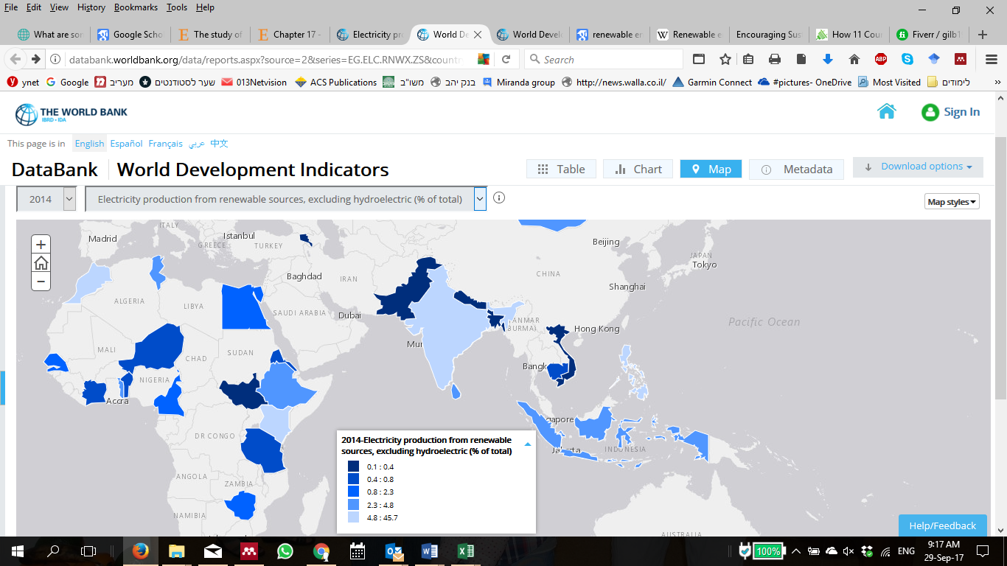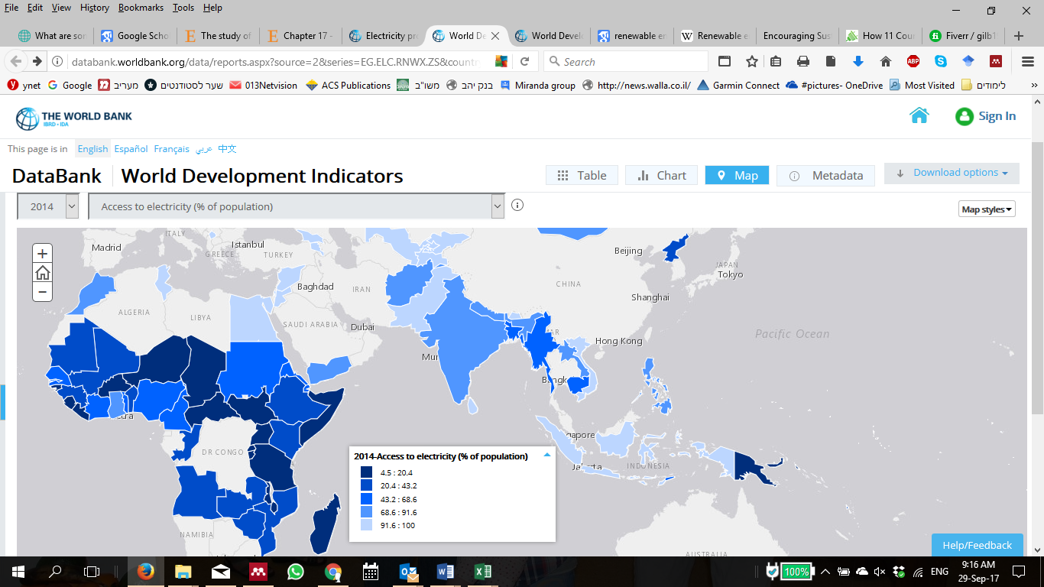

Figure 2 Renewables and access to electricity in Afrika and south Asia, 2014

## Solar energy cost drops down

The need for cheap and fast implemented energy for the citizens that are lacking stable and persistent electricity in many developed and developing countries, makes solar energy the perfect solution for these countries. In recent years, solar Photo-Voltaic (PV) panels prices dropped significantly due to the boom in production in China, much cheaper than production in Europe, Japan or the US. This boom created massive overcapacity in the world market, putting further downward pressure on prices (Crooks, 2016). The downward cost of solar power is described as “Swanson’s Law”, depicting the learning curve plot of solar cells production cost performance versus cumulative installed capacity. Swanson (Swanson, 2006) published a forecast that solar cell price would drop down according to the mathematical model called learning curve. The effect of learning curve model on production costs in the industry (Wright 1936).

Figure 3 shows Swanson's law learning curve of solar cell module production cost versus its cumulative installed capacity. The model predicts that every doubling of solar installation will result in a 20% price reduction per watt. Swanson predicted that by 2012 the production costs of solar cells would drop enough below $1/W and become cost competitive with fossil fuels in the generation of electricity for the utility grid. That indeed happened in 2014. "The Economist" began describing this "solar cell learning curve" forecast as ‘Swanson's Law’ in 2012 (Carr 2012; Partain et al. 2016; writer 2012). During the last decade, due to massive investments and push for clean energy, volumes of solar panels were doubling every 2.2 years (Quora 2016). If such trend continues, solar PV cost will be around a third of today’s cost by the year 2030.

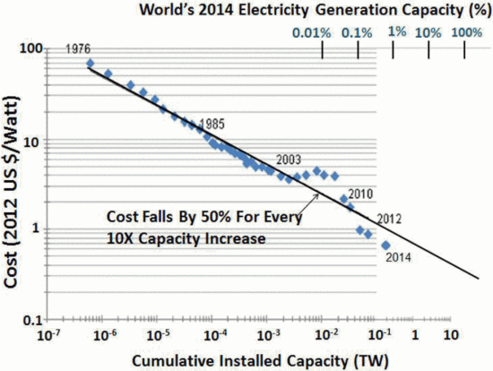

Figure 3 - Swanson's law learning curve (Partain et al. 2016)

## The case of India

### Background - Coal Out, Solar In.

Worldwide solar PV market is ramping up, while investments in coal and gas falls (Fiona, 2016). According to the International Energy Agency (IEA) outlook 2014 (Revel, 2014), world’s energy supply will split quite evenly between oil, gas, coal and renewable sources like solar, wind and hydro by 2040.

In 2015, India was the third largest electricity consumer and producer after China and the USA (Enerdata 2016). India lies in the high solar insolation region, gifted with huge solar energy potential. Most of the country has about 300 days of sunshine per year with annual mean daily global solar radiation in the range of 4 - 6 kWh/m2/day (MNRE 2016b). As a developing country with average GDP growth rate above 7% during the last decade (Worldbank 2016), electricity market growth rate of 6.21% (5 year average) (ibef 2016), population of more than 1.2 billion and rapidly growing economy, India needs access to clean, cheap and reliable sources of energy. In recent years, the solar energy sector is having phenomenal growth due to technological improvements, price reductions and government policies supportive of renewable energy development and utilization (Timilsina, Kurdgelashvili, and Narbel 2012).

The growth of India’s clean-energy market has caused significant price drops in power costs (IFC 2017). This fact inspires customers and creates the right conditions for the country to meet its target of raising the installed capacity for solar energy to 100 GW by 2022. To do so, India needs an estimated $250 billion in new investments. Most of the funding will have to come from the private sector.

### Central government initiatives to promote solar energy

The power sector is essential for India’s economic growth. The world energy outlook forecasts strong growth in manufacturing to satisfy the demand for reliable supply and ambition to bring electricity to entire population. Installed capacity demand will grow by 4.9% per year surging from around 300 GW in mid-2016 to forecasted nearly 1,100 GW in 2040 (iea and International Energy Agency [IEA] 2015).

During the last 15 years, India promoted several electricity policies to encourage renewable energy (Sharma, Tiwari, and Sood 2012). Foremost amongst them is the 2003 Electricity Act (GOI 2003) which regulates stand-alone systems including those based on renewable sources generation and distribution of grid-free systems in rural areas. The 2005 new National Rural Electrification plan and policy (Ministry of Power 2005) stresses the need for electrification as a part of the fight against poverty. The 2006 Tariff Policy (Ministry of Power, 2006) specified the minimum percentage of energy to be purchased from such sources. The Government of India [GOI] understood that a crucial part of the energy sector is the ability to develop in-house manufacturers. A 2007 semiconductor Policy encouraged semiconductor and ecosystem manufacturing, of which solar thermos and PV are essential components (Adviser 2010). The 2010 National Solar Mission policy initiative, setting a goal of solar power generation capacity of 20 GW by end of 2022, is a major act that was revised in 2015 to a target of 100 GW.

### Central Versus Local Governments: A Multi-Level Governance Analysis

The Center for policy research in India (CPRINDIA) published a paper analyzing the different actors and in India’s Electricity Sector (Kaladharan 2016), mapping the balance of power between the GOI and states. Namely, the subjects related to inter-state connections are in the Center's domain, while states are responsible for intra-state electricity policy. The GOI thrust on development of renewable energy is apparent, but the constitutional framework prevents the Center from realizing its vision without the support of the states. The GOI can facilitate and incentivize the states to achieve renewable energy targets, but cannot overstep the bounds of the state to implement or penalize non-compliance. States often use this constitutional authority to push back on GOI reforms that do not correspond with their political agenda. Therefore, the issue of electricity sector reform, which has a significant impact on the renewable energy sector, is a complex one due to constitutional and legal perspective as well as due to its political implications.

The International Energy Agency (IEA) India 2015 special report (IEA 2015) emphasizes that the provision of electricity is a shared responsibility between the central and state authorities in India: states have significant independence in electricity prices, the average subsidy level and the control over beneficiaries. The report stresses a large difference in conditions between the various states and a wide range of performance across various indicators. Part of the explanation is related to variations in income levels and population density, where low-income, densely populated states tend to perform worse than average. States also differ in their attitude to renewable or other energy sources, due to their geographical proximity to fossil fuels like coal mining areas and ports. Policy initiatives like the 2003 Electricity Act that are milestones in India's power regulation and effectiveness of implementation is also an important variable. Pargal (Pargal 2014) measured outcome-based indicators for different states in India in comparison to the activities taken by the states governments, such as regulatory commissions and utilities to implement electricity sector reforms. National governmental policy in a large country like India must be connected to local incentives. Multi-level governance studies like the one undertaken here, focus on policy strategy, implementation, and monitoring that occur at various levels of global, national, state and the local governments (Beermann et al. 2016) Bulkeley and Betsill, 2013).

### Effective Policy

Some analyses focus on financial incentive policies and on policy mechanism to achieve renewable targets (Shrimali et al. 2016). Others examine the impact of policy pathways on renewable financing in India. Financial research (Shrimali et al. 2014) finds that solar energy in India will become competitive by 2019. Prior to that, the most cost-effective policy was found to be the provision of cost-reducing of long-term debt, which can significantly reduce the total cost in comparison to accelerated depreciation that is the most cost-effective existing federal policy.

India is a [federal](https://en.wikipedia.org/wiki/Federalism) union comprising twenty-nine states and seven [union](https://en.wikipedia.org/wiki/Union_territory) territories. Each state is of a size of a mid-level country outside India. The connection between the central government and the states is raising the question whether central governmental policy would have the same effect in each state and what are the variables that effect and push the renewable energy implementation?

### Status

#### Jawaharlal Nehru National Solar Mission

In January 2010, the GOI launched a National Solar Mission with the aim of installing solar power generation capacity of 20 GW by the end of 2022. The proposal was to have 70% solar photovoltaic (PV) panels and 30% thermal solar systems, but as PV prices dropped, their share elevated. This plan was to be completed in three phases as follows:

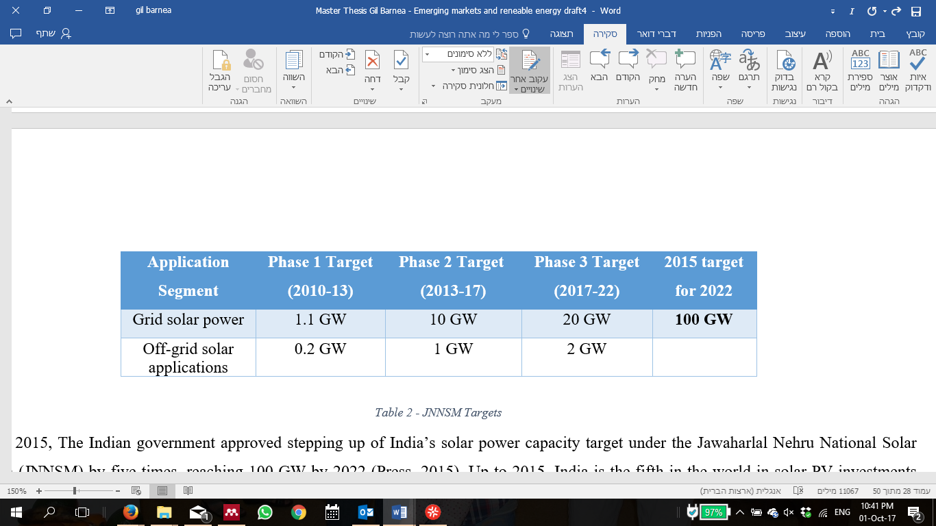

Table 1 JNNSM solar power targets

In June 2015, The Indian government approved stepping up of India’s solar power capacity target under the Jawaharlal Nehru National Solar Mission (JNNSM) by five times, reaching 100 GW by 2022 (Press 2015). Up to 2015, India is the fifth in the world in solar PV investments (Kristin Seyboth et al. 2016). If this target is achieved, India would be one of three largest green energy producers in the world.

#### State- Specific Solar RPO targets

The National Tariff Policy was amended in January 2011 to prescribe solar-specific Renewable Purchase Obligations (RPO) be increased from a minimum of 0.25% in 2012 to 3% by 2022. Central Electricity Regulatory Commissions (CERC) and State Electricity Regulatory Commissions (SERC) have issued various regulations including solar RPOs, REC framework, tariff, grid connectivity, forecasting etc. for promoting solar energy (MNRE, 2017). Along with the demand to promote Renewable Energy growth in India in view of the ongoing efforts of Central and State Governments for promoting solar energy, various states have come up with their state solar policies to provide an enabling framework for growth of RE in India.

Gujarat, for example (MNRE 2012b), enacted in 2009 the policy entitled “Solar Power Policy -2009”. The policy was the first solar specific policy introduced in the country predating the National Solar Mission.

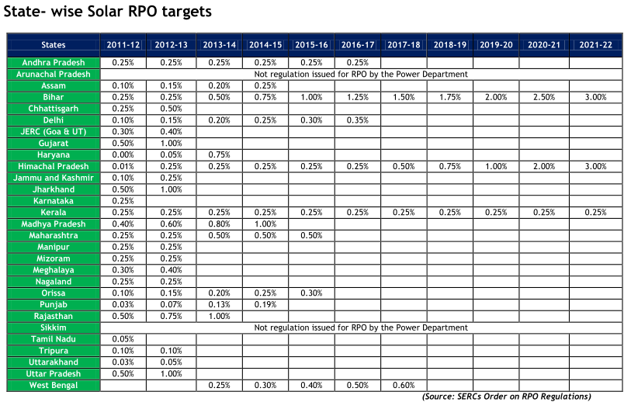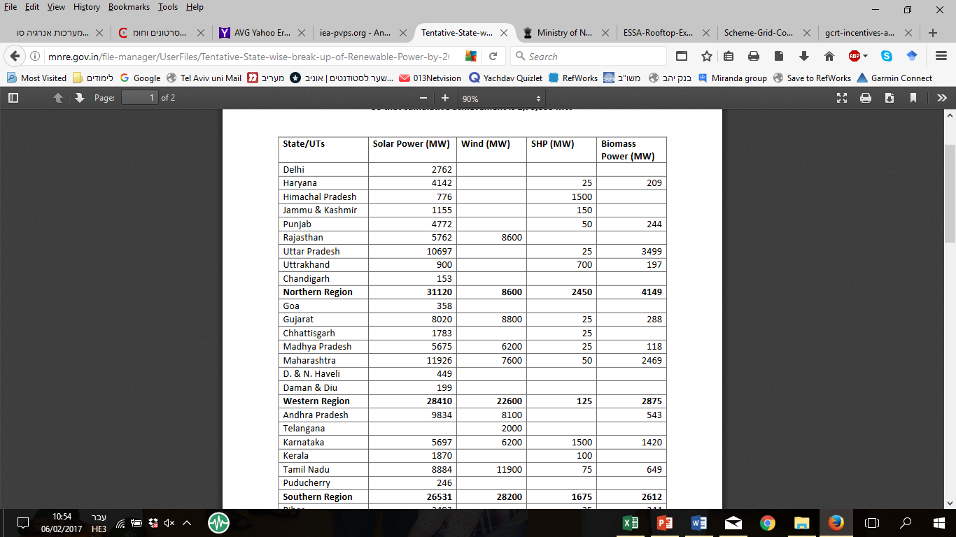

Table 2 2010 Indias states solar targets and the new 2014 solar targets for 2022

In 2011, Rajasthan published a policy for developing the state as a global hub of solar power for the next 10 years to meet energy requirements of Rajasthan and India.

**2015 New targets:** In 2014, India’s Prime Minister announced a goal to [increase solar power capacity to 100 gigawatts (GW) by 2022](http://www.wri.org/news/2014/11/statement-wri-reacts-india%E2%80%99s-100000-mw-solar-goal)—five times higher than the previous target of 20 GW. The 2022 target is extremely ambitious and would make India a global leader in renewable energy. Further to the announcement, the MNRE has released new State-Specific targets for solar systems shown in Table 2.

### Roof Top Solar regulations

Part of India's Solar program is the Rooftop Solar (RTS) project. The government of India committed to the development of 40 GW of RTS power as part of its commitment to the UN Framework Convention on Climate Change (UNFCCC). The Government has been stressing undertaking RTS projects of all building and creating state policy and regulations, including tariff for grid connected rooftop systems (MNRE 2016a).

In 2014, The MNRE published a new program for Grid Connected Rooftop and Small Solar Power Plants with the objective to promote the grid connected SPV rooftop and small solar PV power generating plants among the residential, community, institutional, industrial and commercial establishments. The program may be implemented in Urban and Rural Areas to mitigate the dependence on fossil fuel based electricity generation and, thus, encourage environment-friendly, Solar electricity generation. That creates better environment for investment in the solar energy sector by both private sector and state government. Furthermore, the program encourages installation of rooftop solar photovoltaic power generation plant for self-consumption, as well as supply/sale of electricity to the grid. Some states had grid connected RTS regulations before the new program was published, whereas others came out with a new policy. As of mid-2015, about half of India's states and union territories (UTS) had regulations supporting RTS.

### Investments in solar energy in India

In 2015, India invested $10.2 billion of public and private money in renewable energy (Shah Shreya 2017). Most of it came from private and local investments, while government financing accounted for only a small part of the total. Overall, India’s green and renewable business investment potential is estimated to $2.1 trillion in the next decades. Out of it, IFC (IFC 2016) estimates that investment in renewable energy will accounts for more than $320 billion, with nearly two-thirds of this sum ($201 billion) going to solar PV projects.

### Barriers

India's ambitious goal of 100 GW by 2022 has many obstacles.

A paper analyzing those barriers (Ansari et al. 2013) identified 13 relevant barriers to implementing solar power installations in India. The barriers are:

Financial - High initial capital cost, high pay-back period, lack of financing mechanism and a large amount of investments in many projects simultaneously.

Technical – efficiency, need for backup or storage device, lack of consumer awareness about the technology, lack of trained people and training institutes, lack of local infrastructure, and lack of research & development work.

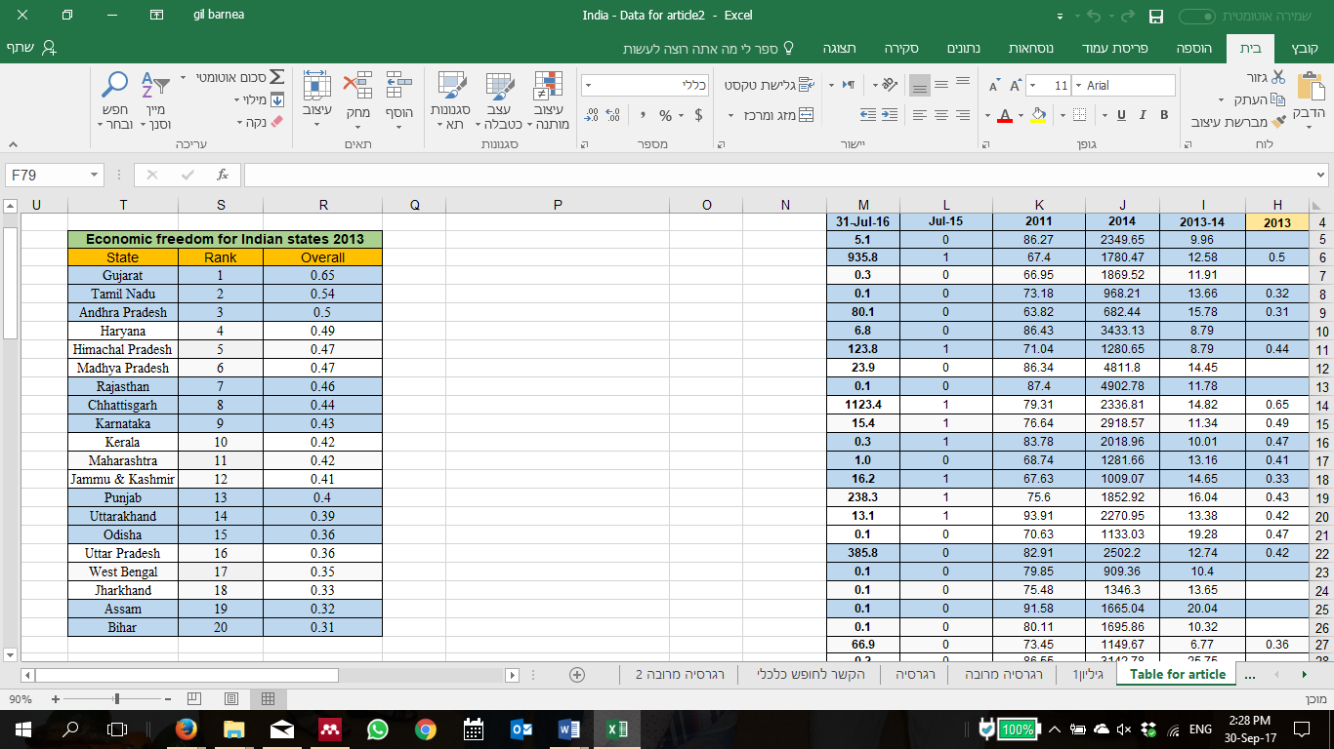Political - Lack of political commitment and adequate government policies. Khare et al. (Khare, Nema, and Baredar 2013) pointed to lack of coordination and cooperation within and between ministries, agencies, institutes and other stakeholder's delaying and diminishing progress in RE development. There is no single comprehensive policy. Policies have been issued as and when necessary to facilitate the growth of specific RETs. Moreover, plans for the development of RE often do not match these policies. The policy framework at the state level is not better. In fact, in many states policies have only created uncertainty for investments in RE. State regulation and the structure of the Indian power sector also raise significant issues regarding state-level policies including the financial weakness of the state (Nelson et al. 2012).

### Economic Freedom of the World

Table 3 Economic freedom for Indian states 2013

The Economic Freedom of the World (EFW) project begun in the 1980s by the Fraser Institute (Hall and Lawson 2014). The index shows an enduring empirical relationship between economic freedom and prosperity, growth and improvements in human well-being.

The index measures the degree to which policies and institutions of countries support economic freedom. The cornerstones of economic freedom are: personal choices, voluntary exchange, freedom to enter markets and compete, and security of person and privately-owned property. Forty-two indicators are used to construct the index to measure the degree of economic freedom in five broad areas:

1. Size of government: expenditures, taxes, and enterprises;
2. Legal structure and security of property rights;
3. Access to sound money;
4. Freedom to trade internationally; and
5. Regulation of credit, labor, and business.

The index measures economic freedom with the thought that it would lead to better economic and social outcomes. Over the years, the EFW index has been cited in hundreds of academic articles and has become an important contribution to the international policy debate. In 2014, a special report (Economic Freedom of the World: An Accounting of the Literature) examined 402 articles that had cited the EFW and found that in over two-thirds of the studies, economic freedom corresponded to “good” outcomes such as faster growth, better living standards, more happiness, etc.

#### Economic Freedom of the States of India

The Economic Freedom of the States of India Index (EFSI) (Bhandari Laveesh, Debroy, and Swaminathan S. Anklesaria 2013) was published by the Cato Institute based on the Fraser Institute’s Economic Freedom of the World. The report brings out the significant differences in economic governance between the states of India. It has thus focused the attention on state-level reforms to improve inclusive economic growth.

The Indian Index is based on three major indicators:

* Size of the government;
* Legal structure and security of property rights;
* Regulation of business and labor.

The EFSI 2013 estimates economic freedom in the 20 biggest Indian states. The scores are between 0-1 (1=most freedom). States with higher scores are expected to be wealthier, more educated, secured etc. Table 3 provides the ranking and actual scores of 20 of the 29 states of India for which values are available.

Data availability prevented scoring the other states and union territories. Furthermore, variables that would be suitable of inclusion in this index could not be included as data was not available for many states. Eventually, 21 variables covering diverse aspects of economic freedom were utilized to construct a composite freedom index.

# Research question

Due to global importance of renewable energy in general and solar power, it is an imperative to increase their utilization in emerging countries, such as India. That requires a clear understanding of various factors affecting the application of renewable energy, and creation of effective policies to generate accessible and affordable electricity through photovoltaic cells. Unfortunately, since this is a young, fast growing, changing and immature market, very little is known about specific influences on the implementation of solar power and how public policy can affect its application in developing countries.

The premise is that the great differences in the process of adoption of solar power technology between the India’s states originate from differences in geographical, economical, educational and population parameters, as well as from different public policies. These factors may affect the ability to invest and implement, build new amenities and maintain them, which is essential for the development of solar market.

The main research question of this thesis is:

***Do better structured and regulated markets foster solar energy maturation?***

The emergence of regulatory policies to promote improved directive has been an important development for public governance in developed and developing countries (OECD 2010). Many theories examined the importance of Policy and regulations to promote development, expansion and adoption of emerging technology and industry. This should go along with education and its benefits and positive impact in our ability to learn new methods and systems, economic growth influence on prosperity and investments, and proper use of nature resources to bring progressiveness.

The specific hypotheses in this thesis were:

***H1: Literacy has a positive effect on solar energy adoption.***

***H2: Better economic status is important for investments in new clean technology.***

***H3: High Solar energy potential has effect promoting solar projects.***

***H4: Regulation and supporting policy is vital to make a change on the state level.***

India's solar market, as a representative emerging country & industry, will be examined to determine the variables that affect and push the implementation of the new sector.

# Method

## Case Study

The case study technique is a well-known research method (Stake 1995; Yin 2003), that examines a human, group, event, process or other subjects of analysis to extrapolate key themes and results that can predict future trends. Case study research explores issues that can be applied to practice and provides tools for understanding the research problem. In this case, India's solar energy policy and the variables affecting the penetration pace of solar PV and process in the different states were examined.

The aim of this study of implementation of solar projects in India states, is to understand the reasons for the variance in the implementation pace in different states. The case of India is important in light of the challenging targets for solar energy assigned by the government of India and the huge investments needed to achieve this target. The methods used to study this case were quantitative. Data was gathered from a variety of sources and the analysis is using linear regression and related statistical methods.

## Data collection

This study is set to find the causes for some Indian states to reach RE implementation targets, or not. To find correlations between the amount of solar power capacity and independent variables, this study investigated the impact of various geographical, economical, educational and populations' feature parameters upon RE implementation. The variables considered in the quantitative analyses are listed below with comments on the rationale for including each of them in the analyses.

1. State area share 2014 (StatisticsTimes 2015a) (%) - Share of the state land size as a proportion of the total area of India. This can be a predictor since solar plants need space.
2. State renewable solar energy potential (MNRE 2016c) (MW) –The higher solar energy potential might lead to higher implementation.
3. State population share 2014 (StatisticsTimes 2015a) (%) – State population as a proportion of India's global population. Large population needs more electricity.
4. State Urban\Rural population share (StatisticsTimes 2015d)(%) – Urban areas use more electricity, while on the other hand, rural areas use more off-grid energy.
5. Indian states by GDP share 2014 (StatisticsTimes 2015a)(%) Share of the state’s GDP in India's global GDP in 2014. The richest states should have more capital for investment.
6. Indian states Nominal NSDP (National State Domestic Product) per capita 2014 (StatisticsTimes 2015b)($) - Per capita income of states in US dollars during 2014. People with higher income expect better life conditions.
7. Indian states NSDP growth 2013-2014 (StatisticsTimes 2015c)(%) – State’s average growth rate during 2013-2014. Capital growth needs industry and more energy.
8. State literacy rate 2011 (GOI 2011a, 2011b)(%) - The 2011 census data on total literacy rate in different states. Education can lead to adaptation of new technologies.
9. State Solar Policy support – State’s announced regulations and policy for grid connected rooftop systems. Regulations should have influence on the market.
10. State economic freedom- State grade (Bhandari Laveesh, Debroy, and Swaminathan S. Anklesaria 2013), between 0-1 (1= most freedom). This index generally correlates with growth, development and prosperity.

These variables were tested as potential predictors of the State solar capacity installed (MNRE 2016d), i.e., installed solar capacity in MW as of July 2016, that was considered as dependent variable. Since the solar market in India is growing very fast, this study examined the variables compared to the solar data during 2015 – 2016 quarterly reports[[8]](#footnote-3).

## Remarks

One inherent problem with any research is the examination of compiled variables that we expect to have a causal relationship with the dependent variable. However, there might be other variables that can better predict the implementation of solar energy in India. By failure to include such variables in the statistical analysis, their effects on the solar energy implementation will not be revealed. This work, contains the relevnt variables that can be found to the state level in India.

In addition, the major conceptual limitation of the regression technique is that one can only determine relationships, but never be sure in the causal nature of the relationship.

## Multiple & Linear Regression

Linear regression is a quantitative method to investigate correlations among dependent and independent variables, when a study requires analysis of more than two variables. This study investigates the connection between a number of variables related to GDP, population, education, demography and radiation (as **independent variables**) and implementation of solar energy in states of India (as the **dependent variable**).

The basic form of regression models[[9]](#endnote-6) includes unknown parameters (β), independent variables (X), and the dependent variable (Y). The regression model specifies the variation of the dependent variable (Y) or variables as a function of independent variables (X) and unknown parameters (β) - *Y* ≈ *f (X, β).*

The regression equation utilizes a best fit straight (regression) line to predict the values of ‘y’, if the value of ‘x’ is given, and both ‘y’ and ‘x’ are the two sets of measures of a sample size of ‘n’. The formulae for regression equation would be in the form: *y = a + bx*. the significance level that was considered statistically is 0.05.

T-test method is a statistical test used to compare the means of two populations. A t-test for two independent samples is commonly used with small sample sizes, testing the difference between the samples when the variances of two normal distributions are not known[[10]](#endnote-7). A t-test was used in this work to find the difference between the states that announced Rooftop solar policy and the ones that did not. Then, Cohen's d test was used to examine the standardized difference between two means. Cohen's d finds the effect size for the comparison between two means.

# Results

## Data Analysis

### Standing Solar PRO Targets

Since the publication of the Solar PRO targets in 2010, new regulations were introduced and the field of solar energy has changed, due to reduction in cost, improvement in production and knowledge accumulation. Up to mid-2016, only five out of 27 states reached or surpassed the target values: Rajasthan (268% of 2016-2017 target), Gujarat (132%), Tamil Nadu (132%), Andhra Pradesh (99%) and Punjab (88%). The other 22 states lag far behind the original goals. Table 4 shows the percentage of the target defined by the Ministry of New & Renewable Energy and Jawaharlal Nehru National Solar Mission, Dec. 2012.(MNRE 2012a, 48) that each state achieved in July 2016. For example, Gujarat target was 849.62MW, while its installed capacity in July 2016 was 1123.36MW, meaning that it achieved 1123.36/849.62 = 132% of the target.

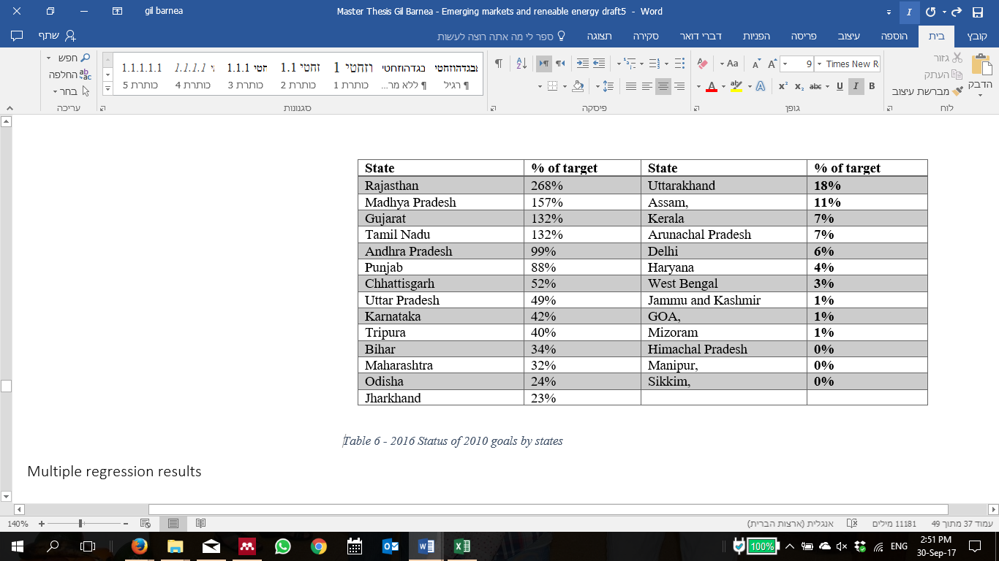

Table 4 2016 Renewable energy reach of 2010 goals

### The effects of variables upon solar implementation

While Table 4 shows that India is certainly heading in the right direction, a significant variance is evident among the states. Further statistical analysis was performed to explain the reasons for the observed variance.

Table 5 shows the results of bivariate between solar implementation and each of the nine variables. The highly significant correlation with solar implementation was revealed especially for economic freedom (r=0.697, p<0.01). Solar energy potential, GDP share, state area share and literacy rate showed lower but significant correlation. The other indicators clearly have less influence on solar implementation.



Table 5 Regression correlation with solar implementation

Multivariate linear regression including many variables and only 20-35 observations is risky due to the small number of observations. Table 6 demonstrates the dependence of installed solar capacity on five variables (P<0.05). The Correlation coefficient (Multiple R=0.818) is high and shows strong dependence of the installed solar capacity on the chosen variables. The adjusted R-square is comparatively low (0.551) because there were five variables in this regression and only 20 observations. Due to the small number of observations, the significance level for correlation of P<0.1 is accepted.



Table 6 multivariate linear regression

### The Economic freedom index

The Economic Freedom Index [EFI] is built from 21 variables. So, the next step is to try to figure out which are the variables that have a major effect on solar implementation. The result we got was a strong correlation (R-Square of 0.77 and p=0.0013) between the variable "Inverse of Violent Crimes as a Share of Total Crimes" to solar capacity in July 2016. This variable belongs to the Legal Structure and Security of Property Rights category in the index. This category measures the efficiency of the government in protecting human life and property measured by the availability of judges, completion rate of court cases and police investigations. The level of safety in the region is measured by the recovery rate of stolen property, and by the rate of violent and economic crimes. The variable measures the ratio of violent crimes, including murder, attempt to murder, etc., to total crimes under the Indian Penal Code (IPC). The inverse of this ratio relates higher economic freedom to lower incidence of violent crimes.

## Regulation effect

The data about Solar Policy (MNRE 2015) supporting grid connected RTS systems (data from July 2015) are available for 36 states and UT's of India. Since solar capacity data are available only for 30 of them, the analysis was performed only in those states.

Table 7 compares implemented solar PV between 15 states that implemented and 15 states that did not announce RTS regulations. It shows that RTS states produce, on average, 4.8 times more solar energy. A t-test found this difference to be significant (t (19) = 2.44, p = 0.012, Cohen's d=0.95). The 15 states with RTS produce, on average, (July 2016) 439 MW. The other 15 states have only 92MW capacity. 9 of the 15 states with RTS policy, have more than 100 MW. Seven states do not have data.

|  |  |  |
| --- | --- | --- |
| Solar Policy supporting grid connected rooftop systems | | |
|
| YES | NO | State announced RTS policy |
| 15 | 15 | No. of States |
| 439 | 92 | Average solar capacity installed [MW] |
| 9 | 2 | States Above 100 MW |

Table 7 - Solar policy and average MW production

Table 8 shows that the 15 states with RTS policy fulfilled, on average, 61% of the targets set in 2012, while six of them were above the level of 50%. The other 12 states reached average of 26.2% of the solar PRO target and only one state reached 50% of the target. This result shows significant different between the groups.

|  |  |  |
| --- | --- | --- |
| 2012 solar target for 2016-2017 | | |
|
| YES | NO | State announced RTS policy |
| 15 | 12 | No. of States |
| 61 | 26.2 | Average Target Completed [%] |
| 6 | 1 | Above 50% of target fulfilled |

Table 8 - State policy and solar PRO 2016-17 targets

## Regulation and economic freedom

The economic freedom index and the state rooftop solar regulation are two different variables that are not mutually related. However, looking at the correlation between them reveals that there is a link between the states that have RTS and the ones with high EF score.

|  |  |  |
| --- | --- | --- |
| No RTS Policy | Have RTS Policy | Economic Freedom |
| 1 | 8 | High (Top 10) |
| 5 | 6 | Low |
| 14 | 2 | No rank |

Table 9 - Economic freedom and RTS policy

Table 9 shows that states with high rank in economic freedom are more likely to have RTS policy, considering that among 9 states with high EF score even 8 states had RTS policy. Most of the states that do not appear in the economic freedom index do not have policy (14 against 2). Among the states ranked with low EF grade, almost number have and do not have the RTS policy. States with low economic freedom and no RTS policy are at high risk of failure to reach their solar targets. Therefore, the central government of India should pay more attention to these states to achieve the 2022 targets with more unified dispersion. In contrast, the states with high economic freedom and with RTS policy are the locomotive that promotes the solar revolution in India.

Figure 4 explains graphically the 4 different positions:

Figure 4 – Freedom & Policy

## Conclusions - India

India's central government is committed to the United Nations Framework Convention on Climate Change (UNFCCC) targets. As the fourth electric producer and consumer on the planet, the Indian government promotes renewable energy policy and regulations. The Ministry of New and Renewable Energy as a regulator and the Jawaharlal Nehru National Solar Mission from 2010 promote the Solar PV technology in India in many ways: from small to huge projects, connected and off-grid implementation, rooftop and ground panels. The central government has a limited success in some of the states, but on the other hand, some states promote the solar revolution faster than the formal goal.

The case of India shows that a determined government can make significant steps in short time and use the clean-energy market as a major accelerator to empower the economy. Promoting regulations and policy tools such as renewable obligations, feed-in-tariffs, net-metering and other incentives have specially aided the transformation towards large scale renewable energy generation, enabling higher efficiency and lower costs of generation. With almost a quarter of its population still without access to electricity, India will need billions of dollars in new investments to achieve this goal. Most of the finances will have to come from the private sector.

While insufficient financing is often a major barrier for rapid growth of a sector, there are large-scale investments in the renewable energy sector in emerging markets and they come mostly from the private sector. In India, most of the financing in 2015, came from local investments; however, they will need to attract private international investors to balance economic growth as well as environmental sustainability.

Specifically, this study revealed a strong relationship between a state's economic freedom, GDP share, solar potential, area, literacy and RTS policy to the fulfillment of the Jawaharlal Nehru National Solar Mission targets. Hence, these variables are an important factor in state’s development, promotion of new technologies and economic accelerators like green and low-priced energy. The four hypothesis questions were confirmed in this study. Specifically, it was found that literacy has a positive effect on solar energy adoption, so that better educated states had matured solar market. Better economic status and a higher GDP per capita are essential for larger investments, and high Solar energy potential is important for the promotion and implementation of solar projects in the different states of India. Regulation and supporting policy showed to be major and vital to reach the central government’s goals and make a change on the state level. Hence, states with rooftop regulations stay ahead on the solar game, compared to ones that have not implemented RTS regulations. This indicator of Solar RTS regulation is complementary in its effect with economic freedom scores and both confirm that better structured and regulated markets foster solar energy maturation. States with low scores on economic freedom are unlikely to achieve the 2022 targets related to solar energy implementation.

# Conclusion

The main contribution of this research is the understanding that emerging industries, the key for future prosperity due to their high growth rates, force the states to build structured policy based on clear regulations, strong economy and good education along with utilizing natural resources.

One of the key conclusions of this study is that central government goals setting and resource allocation is insufficient to reach those goals and that local predisposition and local policy have a significant impact on goal attainment. This conclusion is reflected most clearly in the observation that local education, economic status and economic freedom scores affect solar energy utilization.

The renewable energy emerging industry is a fast-growing sector and it is a [game changer](http://www.investopedia.com/terms/g/game-changer.asp) for developed and developing countries in the coming decades. Solar energy is an ideal solution to address energy needs of emerging markets in direct need for electricity to improve life quality, technology progression, economic growth and health demands. Solar energy is a favorite solution in matters of time to market, funding, permits, objections, environment, costs, technology and maintenance. Today, when the cost of clean technologies has fallen dramatically, solar utilities can provide a reliable supply of electricity at competitive prices. Swanson's law predicts that in coming years, solar market will become even more attractive.

# End Note

# Index: Table- States of India data



Table 10 States of India Data

# Bibliography

Adviser, Principal Scientific. 2010. India Semiconductor Association, Bangalore *Solar PV Industry 2010: Contemporary Scenario and Emerging Rends*. http://www.iesaonline.org/documents/ISA\_SolarPVReport\_May2010.pdf.

Amadeo Kimberly. 2016. “Emerging Markets: Definition, Characteristics, List.” *the balance*. https://www.thebalance.com/what-are-emerging-markets-3305927 (May 8, 2017).

Ansari, Md. Fahim et al. 2013. “Analysis of Barriers to Implement Solar Power Installations in India Using Interpretive Structural Modeling Technique.” *Renewable and Sustainable Energy Reviews* 27: 163–74.

Asha. 2013. “Emerging Sectors of Indian Economy.” *Global Journal of Management and Business Studies* 3(5): 2248–9878. http://www.ripublication.com/gjmbs.htm (September 30, 2017).

Beermann, Jan, Appukuttan Damodaran, Kirsten Jörgensen, and Miranda A. Schreurs. 2016. “Climate Action in Indian Cities: An Emerging New Research Area.” *Journal of Integrative Environmental Sciences* 13(1): 55–66. http://dx.doi.org/10.1080/1943815X.2015.1130723 (February 8, 2017).

Bhandari Laveesh, Bibek Debroy, and Swaminathan S. Anklesaria. 2013. *Economic Freedom of the States of India 2013*.

Bulkeley, Harriet, and Michele M. Betsill. 2013. “Revisiting the Urban Politics of Climate Change.” *Environmental Politics* 22(1): 136–54. http://www.tandfonline.com/doi/abs/10.1080/09644016.2013.755797 (February 8, 2017).

Business Directory. 2017. “What Are Emerging Industries? Definition and Meaning - BusinessDictionary.com.” *BusinessDirectory.com*. http://www.businessdictionary.com/definition/emerging-industries.html (October 14, 2017).

Carr, Geoffrey. 2012. “Sunny Uplands: Alternative Energy Will No Longer Be Alternative.” *The Economist*. http://www.economist.com/news/21566414-alternative-energy-will-no-longer-be-alternative-sunny-uplands (June 2, 2017).

Central Bank, European. 2010. “THE GROWING IMPORTANCE OF EMERGING ECONOMIES.” https://www.ecb.europa.eu/pub/pdf/other/mb201010\_focus01.en.pdf?5f50d0c393de0ba998715ba440c6fb70 (June 3, 2017).

Chen, Sheng-Tung, Hsiao-I Kuo, and Chi-Chung Chen. 2007. “The Relationship between GDP and Electricity Consumption in 10 Asian Countries.” *Energy Policy* 35(4): 2611–21.

Crooks, Ed. 2016. “Swanson’s Law Provides Green Ray of Sunshine for PV.” https://www.ft.com/content/d9f9f1b4-a3f0-11e5-873f-68411a84f346 (June 2, 2017).

di-Robilant Nicola. 2015. “The Paris Agreement and the Major Emerging Economies | Aspenia Online.” http://www.aspeninstitute.it/aspenia-online/en/article/paris-agreement-and-major-emerging-economies (May 29, 2017).

Didier Tatiana, Hevia Constantino, and Schmukler Sergio. 2011. “The Resilience of Emerging Markets during the Global Crisis.” *VOX, CEPR’s Policy Portal*. http://voxeu.org/article/resilience-emerging-markets-during-global-crisis (June 12, 2017).

Eliasson, Gunnar, and Alfred Marshall. 1998. “Industrial Policy, Competence Blocs and the Role of Science in Economic Development\*.” *J Evol Econ* 10: 217–41. https://link.springer.com/content/pdf/10.1007%2Fs001910050013.pdf (October 12, 2017).

Enerdata. 2016. *Enerdata\_Energy\_Statistical\_Yearbook\_2016*. Enerdata. https://yearbook.enerdata.net/#world-electricity-production-map-graph-and-data.html.

Fiona, Harvey. 2016. “Global Coal and Gas Investment Falls to Less than Half-That in Clean Energy .” *theguardian*. https://www.theguardian.com/environment/2016/mar/24/global-coal-and-gas-investment-falls-to-less-than-half-that-in-clean-energy.

Forbes, Daniel p., and David A. Kirsch. 2011. “The Study of Emerging Industries: Recognizing and Responding to Some Central Problems.” *Journal of Business Venturing* 26(5): 589–602. http://www.sciencedirect.com/science/article/pii/S0883902610000224#bbb0050 (October 12, 2017).

GOI. 2003. 1925 Government of India *Indian Electricity Act*. http://www.cercind.gov.in/Act-with-amendment.pdf.

———. 2011a. *Census 2011, Chapter 6 (State of Literacy), p.14*. Government of India. http://censusindia.gov.in/2011-prov-results/data\_files/india/Final\_PPT\_2011\_chapter6.pdf (February 11, 2017).

———. 2011b. *Ranking of States and Union Territories by Literacy Rate: 2011*. Government of India. http://censusindia.gov.in/2011-prov-results/data\_files/india/Final\_PPT\_2011\_chapter6.pdf (February 11, 2017).

Hale, David. 2012. “The Importance of Emerging Markets.” *CFA Institute x cfapubs.org*. http://www.cfapubs.org/doi/pdf/10.2469/cp.v29.n3.8 (June 3, 2017).

Hall, Joshua C, and Robert A Lawson. 2014. “Economic Freedom of the World: An Accounting of the Literature.” *Contemporary Economic Policy* 32(1): 1–19. http://onlinelibrary.wiley.com/doi/10.1111/coep.12010/abstract.

ibef. 2016. “Power Sector in India - Solar, Renewable &amp; Wind Energy Sectors.” 2017(Jan). http://www.ibef.org/industry/power-sector-india.aspx.

IEA. 2015. INTERNATIONAL ENERGY AGENCY *India Energy Outlook 2015*. INTERNATIONAL ENERGY AGENCY. http://www.worldenergyoutlook.org/media/weowebsite/2015/IndiaEnergyOutlook\_WEO2015.pdf.

iea, and International Energy Agency [IEA]. 2015. World Energy Outlook *WORLD ENERGY OUTLOOK 2015 FACTSHEET India*. FR: OECD Paris. http://www.worldenergyoutlook.org/media/weowebsite/2015/FactsheetIndia.pdf.

IFC. 2016. “Climate Investment Opportunities in Emerging Markets.” *IFC*. https://www.ifc.org/wps/wcm/connect/51183b2d-c82e-443e-bb9b-68d9572dd48d/3503-IFC-Climate\_Investment\_Opportunity-Report-Dec-FINAL.pdf?MOD=AJPERES (June 3, 2017).

———. 2017. “India’s Solar-Energy Market Set to Shine.” http://www.ifc.org/wps/wcm/connect/news\_ext\_content/ifc\_external\_corporate\_site/news+and+events/news/impact-stories/india-solar-energy-market-set-to-shine (June 2, 2017).

Kaladharan, Megha. 2016. “Renewable Energy in India : An Analysis of the Regulatory Environment and Evolving Policy Trends.” : 25.

Khanna Tarun. 2010. *How Companies Break into Emerging Markets*. https://hbr.org/2010/06/how-companies-break-into-emerg (May 8, 2017).

Khare, Vikas, Savita Nema, and Prashant Baredar. 2013. “Status of Solar Wind Renewable Energy in India.” *Renewable and Sustainable Energy Reviews* 27: 1–10. http://www.sciencedirect.com/science/article/pii/S136403211300395X (February 8, 2017).

Kimberlee Luce. 2016. “Emerging Markets: Pathways to Selection.” In *Slideshare.net*, , 29. https://www.slideshare.net/KimberleeLuce/emerging-markets-pathways-to-selection (May 8, 2017).

Klair, White, Dominy Phil, Warren Ben, and Rennie Matt. 2016. “EY Renewable Energy Country Attractiveness Index Issue 47 May 2016, RECAI.” http://www.ey.com/Publication/vwLUAssets/EY-RECAI-47-May-2016/$FILE/EY-RECAI-47-May-2016.pdf (May 29, 2017).

Kristin Seyboth et al. 2016. Global Status Report *Renewables 2016 Global Status Report*. http://www.ren21.net/status-of-renewables/global-status-report/.

Low Murray B., and Abrahamson Eric. 1997. “Movements, Bandwagons, and Clones: Industry Evolution and the Entrepreneurial Process.” *Journal of Business Venturing* 12(6): 435–57. http://www.sciencedirect.com/science/article/pii/S0883902697000013 (October 12, 2017).

Ministry of Power. 2005. *National Electricity Policy 2005 - EXTRAORDINARY*. http://powermin.nic.in/en/content/national-electricity-policy.

———. 2006. The Gazette of India *Tariff Policy*. http://powermin.nic.in/sites/default/files/uploads/Tariff\_Policy\_1.pdf.

MNRE. 2012a. *Jawaharlal Nehru National Solar Mission Phase II – Policy Document*. http://mnre.gov.in/file-manager/UserFiles/draft-jnnsmpd-2.pdf (February 8, 2017).

———. 2012b. *Salient Features – Solar Policies*. http://mnre.gov.in/file-manager/UserFiles/guidelines\_sbd\_tariff\_gridconnected\_res/salient\_features\_for\_State-wise\_solar\_policies.pdf (February 8, 2017).

———. 2015. *Grid Connected Solar Rooftop Systems Presntation*. http://mnre.gov.in/file-manager/UserFiles/Rooftop-Presentation-on-07072015.pdf (February 8, 2017).

———. 2016a. *Grid Connected and Small Power Plants Program*. http://mnre.gov.in/file-manager/UserFiles/gcrt-incentives-award-040516.pdf (February 8, 2017).

———. 2016b. “Guidelines for Development of Solar Parks.” http://mnre.gov.in/file-manager/UserFiles/Solar-Park-Guidelines.pdf.

———. 2016c. “MNRE Annual Report 2015-16.” : 2–3. http://mnre.gov.in/file-manager/annual-report/2015-2016/EN/Chapter 1/chapter\_1.htm (February 8, 2017).

———. 2016d. “Solar Power in India.” *Wikipedia*: 1–9. https://en.wikipedia.org/w/index.php?title=Solar\_power\_in\_India&oldid=740619176#cite\_note-capa-17.

———. 2017. Ministry of New and Renewable Energy *Solar RPO Framework*. http://mnre.gov.in/information/solar-rpo/ (February 8, 2017).

Mokyr, Joel. 1988. “THE NEW ECONOMIC HISTORY AND THE INDUSTRIAL REVOLUTION.” : 13–27. https://sites.northwestern.edu/jmokyr/files/2016/06/Editors-Introduction-The-New-Economic-History-1999-1thoner.pdf (October 12, 2017).

Monfardini, Erica et al. 2012. “Emerging Industries: Report on the Methodology for Their Classification and on the Most Active, Significant and Relevant New Emerging Industrial Sectors.” https://ec.europa.eu/research/industrial\_technologies/pdf/emerging-industries-report\_en.pdf (October 12, 2017).

Nelson, David et al. 2012. “Meeting India’s Renewable Energy Targets: The Financing Challenge CPI-ISB Report.”

North, Douglass C. 1994. “Economic Performance Through Timet.” 84(3): 359–68. http://www.jstor.org/stable/2118057 (June 5, 2017).

OECD. 2010. “Regulatory Policy and the Road to Sustainable Growth.” www.oecd.org (October 14, 2017).

Pargal, Sheoli. 2014. Directions in development *More Power to India*. Washington, DC: World Bank. http://www.econis.eu/PPNSET?PPN=834961296.

Partain, Larry et al. 2016. “‘Swanson’s Law’ Plan to Mitigate Global Climate Change.” In *2016 IEEE 43rd Photovoltaic Specialists Conference (PVSC)*, IEEE, 3335–40. http://ieeexplore.ieee.org/document/7750284/ (June 3, 2017).

Press. 2015. “Revision of Cumulative Targets under National Solar Mission from 20,000 MW by 2021-22 to 1,00,000 MW.” *Press Information Bureau Government of India*. http://pib.nic.in/newsite/PrintRelease.aspx?relid=122566 (February 8, 2017).

Quora. 2016. “We Already Have A Solution To Climate Change, And It Doesn’t Rely On The Government.” *Forbes*. https://www.forbes.com/sites/quora/2016/12/01/we-already-have-a-solution-to-climate-change-and-it-doesnt-rely-on-the-government/#3f16e02f7714 (June 2, 2017).

Raza, S. A., S. T. Jawaid, and M. H. Siddiqui. 2016. “Electricity Consumption and Economic Growth in South Asia.” *South Asia Economic Journal* 17(2): 200–215. http://sae.sagepub.com/cgi/doi/10.1177/1391561416649721 (May 20, 2017).

Revel, Danièle. 2014. *World Energy Outlook 2014*. http://energieclimat.hypotheses.org/?p=23160.

REW Editor. 2016. *Report: Emerging Markets More Attractive than EU, US for Renewable Energy Investment - Renewable Energy World*. http://www.renewableenergyworld.com/articles/2016/06/report-emerging-markets-more-attractive-than-eu-us-for-renewable-energy-investment.html (May 22, 2017).

Roy, Hiranmoy, Rajaiah Jayaraj, and Anshunan Gupta. 2016. “Energy Consumption and Human Development: Global Perspective.” *ECONOMICS AND POLICY OF ENERGY AND THE ENVIRONMENT* (1): 111–31. http://www.francoangeli.it/riviste/Scheda\_Riviste.asp?IDArticolo=55813 (May 20, 2017).

Sadorsky, Perry. 2009. “Renewable Energy Consumption and Income in Emerging Economies.” *Energy Policy* 37(10): 4021–28. http://www.sciencedirect.com/science/article/pii/S0301421509003176?np=y&npKey=aef93d97b1b12b599f8969710a2bc3a3952613383e63541a4883aa3f3d7efad0 (May 20, 2017).

Schoonhoven Claudia Bird, Romanelli Elaine. 2002. *The Entrepreneurship Dynamic*. Stanford press. https://books.google.co.il/books?id=97YYL-qLP2QC&pg=PA1&lpg=PA1&dq=schoonhoven+and+romanelli&source=bl&ots=QvsUzIbHY9&sig=vzwZEybgdOxQltxpEwm12FjBSg0&hl=iw&sa=X&ved=0ahUKEwju2oasiuvWAhUCZlAKHSyXAL8Q6AEIJTAA#v=onepage&q=schoonhoven and romanelli&f=fals (October 12, 2017).

Shah Shreya. 2017. “Why India Might Not Achieve Its 2020 Renewable Energy Targets - The Economic Times.” http://economictimes.indiatimes.com/industry/energy/power/why-india-might-not-achieve-its-2020-renewable-energy-targets/articleshow/56389839.cms (June 3, 2017).

Sharma, Naveen Kumar, Prashant Kumar Tiwari, and Yog Raj Sood. 2012. “Solar Energy in India: Strategies, Policies, Perspectives and Future Potential.” *Renewable and Sustainable Energy Reviews* 16(1): 933–41. http://dx.doi.org/10.1016/j.rser.2011.09.014.

Shrimali, Gireesh. 2015. “Reaching India’s Renewable Energy Targets.” https://climatepolicyinitiative.org/publication/reaching-indias-renewable-energy-targets-cost-effectively/ (February 8, 2017).

———. 2016. “Cost-Effective Policies for Reaching India’s 2022 Renewable Targets.” *Renewable Energy* 93: 255–68. http://www.sciencedirect.com/science/article/pii/S096014811630163X.

Shrimali, Gireesh, Shobhit Goel, Sandhya Srinivasan, and David Nelson. 2014. *Solving India’s Renewable Energy Financing Challenge: Which Federal Policies Can Be Most Effective? A CPI-ISB Series*. www.climatepolicyinitiative.org (February 8, 2017).

Stake, Robert E. 1995. *The Art of Case Study Research*. Sage Publications. https://uk.sagepub.com/en-gb/mst/the-art-of-case-study-research/book4954 (May 30, 2017).

StatisticsTimes. 2015a. “GDP-Population-Area Relationship of Indian States.” http://statisticstimes.com/economy/indian-states-gdp-population-area-relationship.php (February 11, 2017).

———. 2015b. “GDP per Capita of Indian States | Indian States GDP per Capita 2015.” http://statisticstimes.com/economy/gdp-capita-of-indian-states.php (February 11, 2017).

———. 2015c. “Indian States by GDP Growth 2015.” http://statisticstimes.com/economy/gdp-growth-of-indian-states.php (February 11, 2017).

———. 2015d. “Population of Indian States | Indian States Population 1901-2011.” http://statisticstimes.com/population/population-of-indian-states.php (February 11, 2017).

Swanson, Richard M. 2006. “A Vision for Crystalline Silicon Photovoltaics.” *Progress in Photovoltaics: Research and Applications* 14(5): 443–53. http://doi.wiley.com/10.1002/pip.709 (June 3, 2017).

Timilsina, G R, L Kurdgelashvili, and P A Narbel. 2012. “Solar Energy: Markets, Economics and Policies.” *Renewable and Sustainable Energy Reviews* 16(1): 449–65.

Umamaheswaran, Swarnalakshmi, and Seth Rajiv. 2015. “Financing Large Scale Wind and Solar projects—A Review of Emerging Experiences in the Indian Context.” *Renewable and Sustainable Energy Reviews* 48: 166–77. http://www.sciencedirect.com/science/article/pii/S1364032115001422 (May 29, 2017).

UNFCC. 2015. *INDCs - Intended Nationally Determined Contributions*. http://unfccc.int/focus/indc\_portal/items/8766.php (May 29, 2017).

World-Bank. 2017. “World Bank Country and Lending Groups.” *world bank*. https://datahelpdesk.worldbank.org/knowledgebase/articles/906519-world-bank-country-and-lending-groups.

Worldbank. 2016. “GDP Growth (Annual %) | Data.” http://data.worldbank.org/indicator/NY.GDP.MKTP.KD.ZG?end=2015&locations=IN&start=2005 (February 10, 2017).

Wright, T. P. 1936. “Factors Affecting the Cost of Airplanes.” *Journal of the Aeronautical Sciences* 3(4): 122–28. http://arc.aiaa.org/doi/10.2514/8.155 (June 3, 2017).

writer, Staff. 2012. “Pricing Sunshine.” *The Economist*. http://www.economist.com/blogs/graphicdetail/2012/12/daily-chart-19 (June 2, 2017).

Yin, Robert K. 2003. *Case Study Research : Design and Methods*. Sage Publications. https://books.google.co.il/books/about/Case\_Study\_Research.html?id=BWea\_9ZGQMwC&redir\_esc=y (May 30, 2017).

Zucchi Kristina. 2015. “What Are The 5 Hottest Emerging Industries In 2015? | Investopedia.” http://www.investopedia.com/articles/investing/073015/what-are-5-hottest-emerging-industries-2015.asp (September 30, 2017).

1. <https://www.ecb.europa.eu/ecb/tasks/international/emerging/html/index.en.html> [↑](#endnote-ref-1)
2. <http://www.unfoundation.org/what-we-do/issues/energy-and-climate/clean-energy-development.html> [↑](#endnote-ref-2)
3. <https://openknowledge.worldbank.org/handle/10986/20525> [↑](#endnote-ref-3)
4. [*"World energy consumption clock"*](http://www.usdebtclock.org/energy.html). US debt clock org*. 2016*. [↑](#endnote-ref-4)
5. <http://data.worldbank.org/indicator/NY.GDP.MKTP.KD.ZG> [↑](#endnote-ref-5)
6. <http://databank.worldbank.org/data/reports.aspx?source=2&series=EG.ELC.RNWX.ZS&country> [↑](#footnote-ref-1)
7. <https://data.worldbank.org/indicator/EG.ELC.ACCS.ZS?end=2014&locations=XM-ZG-8S-XN&start=2009> [↑](#footnote-ref-2)
8. Remarks about data:

   1. The data was gathered from variety sources, databases and formal reports. The study uses the most updated data found in reliable sources. All data is distributed between the years 2011 (census, education) and 2014 (of GDP). The latest data regarding solar energy is updated quarterly from 31.10/2016.

   2. **Telangana** State it a new state in India which awarded separate statehood on 2014 (split from Andhra Pradesh). Telangana is very significant in the field of solar energy (845MW in July 2016) due to it late born. Telangana GDP, population and some other indicators were available, but some others such as Economic Freedom and Literacy were missing

   3. India has 29 States and 6 Union territories such as Chandigarh and Delhi. The territories are taken into consideration in the analysis but are not very meaningful due to their small size and minor influence.

   4. Economic Freedom Index contains information on only 20 states in India due to lack of information about the others. States and territories (except Telangana mentioned above) that are not listed in this index are contributing together approximately 2% of Solar capacity, 6.5% of GDP, 3% of the population and occupy 7% of the land.

   5. Diffusion of data as shown in the attached graphs shows uneven distribution resulting from the fact that many countries are not significant in the field of solar energy. However, ANOVA test shows a clear and significant correlation.

   6. Various states in India raise mega solar energy projects providing hundreds of MW. This significant point is important since a single site may have a dominant weight of energy produced in the country. (For example, Residential Solar Power Project Kamuthi in late 2016 in Tamil Nadu will provide over 600MW). [↑](#footnote-ref-3)
9. <http://research-methodology.net/research-methods/quantitative-research/regression-analysis/> [↑](#endnote-ref-6)
10. <http://www.investopedia.com/terms/t/t-test.asp> [↑](#endnote-ref-7)