**Emerging markets, industries and renewable energy**

Journal - Renewable & Sustainable Energy Reviews

**Gil Barneaa,**

a Department of Political Science, Tel-Aviv University, POB 39040 Tel-Aviv, Israel

Corresponding author:

Gil Barnea, email – [gilbarnea@mail.tau.ac.il](mailto:gilbarnea@mail.tau.ac.il)

Abstract

Emerging markets are the home of more than 80% of the world population. Economic growth is a complex process influenced by the structure of the economy, natural resources, technology and many other characteristics of the local economy. These markets, due to their profound changes, experience rapid urbanization and massive migrations from rural areas to cities and to a more industrial economy with rapid increase in electricity demand. Significant reductions in the price of solar power make it affordable and available for quick-to-build solutions for on or off grid energy in countries with growing need for additional electricity generation. Yet many emerging markets face difficulties in developing solar energy projects. This article focuses on the implementation of solar power in the emerging market of India as a case study. India is the second largest emerging economy in the world with more than 1.2 billion people, fast economic growth, and low electricity consumption. In 2014, the Government of India has set an extremely ambitious goal of 100 GW solar power capacity installed by 2022 that would make India a global leader in renewable energy. This study analyzes the effect of the policy and other socio-economic variables on the solar market in India. It unveils a robust correlation between solar market proliferation, state rooftop solar regulation and economic freedom. Beyond the in-depth scrutiny of the case itself, this paper offers new insights on how policy and other variables impact the development of emerging renewable energy markets.

**Keywords**

Solar energy, India, Economic Freedom, Emerging markets

**Highlights**

* Emerging markets are the most growing and influencing on future economy
* Economic Freedom index has strong correlation to solar PV capacity in India
* States announced roof top solar regulations have better chance to reach goals
* India can reach 100 GW solar in 2022 with imbalanced distribution between states.

Table of contents

1 Introduction 5

1.1 Economic Freedom of the World 6

1.2 Emerging markets 7

1.3 Renewable Energy in Emerging Countries 8

1.4 Research question 8

2 The case of India 10

2.1 Background 10

2.2 Central government initiatives to promote solar energy 10

2.3 State Government Impediments to solar energy growth 11

3 Method 14

3.1 Case Study 14

3.2 Data collection 14

3.3 Multiple & Linear Regression 16

4 Results 17

4.1 Data Analysis 17

4.2 Regulation effect 19

4.3 Regulation and economic freedom 20

4.4 Conclusions - India 21

5 Conclusion 22

End Note 22

Index: Table- States of India data 23

Bibliography 24

List of tables & figures

tables

Table 2 2010 Indias states solar targets and the new 2014 solar targets for 2022. 13

Table 4 2016 Renewable energy reach of 2010 goals 17

Table 5 Regression correlation with solar implementation 18

Table 6 multivariate linear regression 19

Table 7 - Solar policy and average MW production 20

Table 8 - State policy and solar PRO 2016-17 targets 20

Table 9 - Economic freedom and RTS policy 20

Table 10 States of India Data 23

# Introduction

Douglass C. North describes the development of economic markets and the process in which human society changes from primitive societies, villages and individuals to urban societies, with structural institutions and organization, as a complex path influenced by beliefs, social and political structure, religion, technology and more (North 1994, 393). The speed of economic change is a result of the learning curve of the population.

Developing and Emerging Markets is the home for more than 5 billion people (Lagarde 2016), mostly in developing countries that have access only to unreliable or poor quality electricity (UN 2018). Lack of electricity, fuel, or gas inhibits the provision of basic energy-dependent services, such as water (desalination and purification), sanitation, health, and education. The UN has placed "energy for all" as a central goal for the next few years. A continuous and stable supply of electricity and energy has a direct positive impact on a wide range of areas that contribute to improving the health quality and standard of living in countries around the world.

To this end, the UN has promoted the MDG and SE4ALL programs that have been implemented in recent decades and more recently the SDG as part of the agreement signed in 2015 with a challenging goal (SDG No. 7) to bring available electricity to the world's entire population by 2030. This goal must be connected to the COP21 climate agreement in Paris in December of 2015 that sought to reduce the carbon footprint on the planet and produce cleaner energy for all. The growth in greenhouse-gas emissions is expected to come mainly from emerging markets (IFC 2016), which require $4 trillion per year to build and maintain infrastructure. The question about the public services, experience, education, regulation, economy and other aspects needed to promote electricity in developing countries is a major issue worldwide.

Renewable energy, a fast and rapidly growing emerging sector that includes solar energy, wind and biomass, is constantly dropping in costs and has a shorter time to market compared to fossil or hydro projects. The combined effect of the Paris agreement, reduced costs of energy production from renewable sources as well as the commitment to satisfy energy needs in emerging markets offers a great opportunity for this renewable energy industry in the next decade due to the high economic incentives in emerging markets (IFC 2016).

Many studies have found and confirmed the existence of the positive relationship between energy consumption and traditional human development index, as well as a long-run connection between electricity consumption and economic growth in developed and developing countries (Chen, Kuo, and Chen 2007; Raza, Jawaid, and Siddiqui 2016; Roy, Jayaraj, and Gupta 2016).

India, for example, one of two most populated country, has the biggest proportion of residents who are not yet connected to the electricity grid. Over the past few years, the government has invested heavily in projects linking poor and remote rural areas to the electricity grid, but to date a quarter of India's population (about 311 million people) live in rural areas and are still not connected to an electricity grid (Banerjee et al. 2015). Moreover, a significant portion of the Indian population that is connected to the electricity grid does not receive stable and reliable electricity. As of 2016, India was the third largest producer and consumer of electricity in the world after China, and the US (IEA Beta 2019). The process that combines inexpensive and efficient renewable energy implementation in India is of great significance for the quality of life of the people in India but considering the need to preserve our planet and reduce the level of air pollution, for humankind in general.

## Economic Freedom of the World

The Economic Freedom of the World (EFW) project begun in the 1980s by the Fraser Institute (Hall and Lawson 2014). The index shows an enduring empirical relationship between economic freedom and prosperity, growth and improvements in human well-being. The index measures the degree to which policies and institutions of countries support economic freedom. The cornerstones of economic freedom are personal choices, voluntary exchange, freedom to enter markets and compete, and security of person and privately-owned property. Forty-two indicators are used to construct the index to measure the degree of economic freedom in five broad areas:

1. Size of government: expenditures, taxes, and enterprises;
2. Legal structure and security of property rights;
3. Access to sound money;
4. Freedom to trade internationally; and
5. Regulation of credit, labor, and business.

The index measures economic freedom with the thought that it would lead to better economic and social outcomes. Over the years, the EFW index has been cited in hundreds of academic articles and has become an important contribution to the international policy debate. In 2014, a special report (Economic Freedom of the World: An Accounting of the Literature) examined 402 articles that had cited the EFW and found that in over two-thirds of the studies, economic freedom corresponded to “good” outcomes such as faster growth, better living standards, more happiness, etc.

### Economic Freedom of the States of India

The Economic Freedom of the States of India Index (EFSI) (Bhandari, Debroy, and Swaminathan 2013) was published by the Cato Institute based on the Fraser Institute’s Economic Freedom of the World. The report brings out the significant differences in economic governance between the states of India. It has thus focused the attention on state-level reforms to improve inclusive economic growth.

The Indian Index is based on three major indicators:

* Size of the government;
* Legal structure and security of property rights;
* Regulation of business and labor.

The EFSI 2013 estimates economic freedom in the 20 biggest Indian states. The scores are between 0-1 (1=most freedom). States with higher scores are expected to be wealthier, more educated, secured etc. The indicator of Solar RTS regulation is complementary in its effect with economic freedom scores and both confirm that better structured and regulated markets foster solar energy maturation

Data availability prevented scoring the other states and union territories. Furthermore, variables that would be suitable of inclusion in this index could not be included as data was not available for many states. Eventually, 21 variables covering diverse aspects of economic freedom were utilized to construct a composite freedom index.

## Emerging markets

Emerging markets or emerging economies are countries that are considered to be in a transitional phase between developing and developed status due to their size and growth rate. The impact of emerging markets on the world’s economy has grown dramatically in the last decades. In fact, without the influence of emerging markets, the present rate of world economic growth would be much lower than it currently is. up to 2016, emerging market countries collectively accounted for 60% of global GDP. According to the World Bank, the importance of emerging economies for the growth of both worldwide and developed countries economy is likely to increase further over time (World-bank 2019).

India is a major emerging market, as observed by analysts and researchers, due to its immature market structure, rapid growth, large population, economic reforms, political transformation, regional economics and increasing local and foreign investments (Asha 2013; Hale 2012; Luce 2016).

Mokyr (1988) calls the economic growth phase during the Industrial Revolution in Britain between 1760 and 1830 as a "growing-up" phase due to the annual rate of change in many fields that were far higher than in any period before. The Industrial Revolution, according to Mokyr, had three phases. First, a small sector experienced rapid and dramatic technological change. Second, this sector grew consequently at a rate much faster than the traditional sectors so that its share in the market increased rapidly. Third, the technological changes in the up-to-date sector gradually penetrated the membrane of the traditional sector and modernized its elements.

## Renewable Energy in Emerging Markets

Increased economic growth and demand for energy in emerging economies generate opportunities to increase usage of renewable energy. Renewable energy commerce is an emerging industry. According to the International Finance Corporation, a World Bank Member (IFC 2016), the global clean energy marketplace is shifting to the emerging markets. 2015 was the first year that renewable energy investments in emerging economies ($156 billion) surpassed those in developed countries ($130 billion). China and India account for more than half of these investments (36% - China and 22% - India). Renewable energy can play a strategic role in meeting an emerging country's growing energy demands. However, large scale funding is one of the major problems in emerging markets and in emerging industries due to the risk and the fact that the business market in these countries and industries is not yet mature (Shrimali 2015).

## Research question

Due to global importance of renewable energy in general and solar power, it is an imperative to increase their utilization in emerging countries, such as India. That requires a clear understanding of various factors affecting the application of renewable energy and creation of effective policies to generate accessible and affordable electricity through photovoltaic cells. Unfortunately, since this is a young, fast growing, changing and immature market, very little is known about specific influences on the implementation of solar power and how public policy can affect its application in developing countries.

The premise is that the great differences in the process of adoption of solar power technology between the India’s states originate from differences in geographical, economic, educational and population parameters, as well as from different public policies. These factors may affect the ability to invest and implement, build new amenities and maintain them, which is essential for the development of solar market.

The main research question of this thesis is:

***Do better structured and regulated markets foster solar energy maturation?***

The emergence of regulatory policies to promote improved directive has been an important development for public governance in developed and developing countries (OECD 2010). Many theories examined the importance of Policy and regulations to promote development, expansion and adoption of emerging technology and industry. This should go along with education and its benefits and positive impact in our ability to learn new methods and systems, economic growth influence on prosperity and investments, and proper use of nature resources to bring progressiveness.

The specific hypotheses in this thesis were:

***H1: Higher GDP and better economic status is important for investments in new clean technology.***

***H2: Regulation and supporting policy is vital to make a change in solar energy adoption on the state level.***

India's solar market, as a representative emerging country & industry, will be examined to determine the variables that affect and push the implementation of the new sector.

# The case of India

## Background

In 2015, India was the third largest electricity producer after China and the USA (Enerdata 2016). India lies in the high solar insolation region, gifted with huge solar energy potential. Most of the country has about 300 days of sunshine per year with annual mean daily global solar radiation in the range of 4 - 6 kWh/m2/day (MNRE 2016b). As a developing country with average GDP growth rate above 7% during the last decade (World-bank 2016), electricity market growth rate of 6.21% (5 year average) (ibef 2016), population of more than 1.2 billion and a rapidly growing economy, India needs access to clean, cheap and reliable sources of energy.

The growth of India’s clean-energy market has caused significant price drops in power costs (IFC 2017) as in recent years, the solar energy sector is having phenomenal growth due to technological improvements, price reductions and government policies supportive of renewable energy development and utilization (Timilsina, Kurdgelashvili, and Narbel 2012). This fact inspires customers and creates the right conditions for the country to meet its target of raising the installed capacity for solar energy to 100 GW by 2022. To do so, India needs an estimated $250 billion in new investments. Most of the funding will have to come from the private sector.

## Central government initiatives to promote solar energy

The power sector is essential for India’s economic growth. The world energy outlook forecasts strong growth in manufacturing to satisfy the demand for reliable supply and ambition to bring electricity to entire population. Installed capacity demand will grow by 4.9% per year surging from around 300 GW in mid-2016 to a forecasted nearly 1,100 GW in 2040 (IEA 2015).

During the last 15 years, India promoted several electricity policies to encourage renewable energy (Sharma, Tiwari, and Sood 2012). Foremost amongst them is the 2003 Electricity Act (GOI 2003) which regulates stand-alone systems (including those based on renewable sources generation) and the distribution of grid-free systems in rural areas. Also highly influential is the 2005 new National Rural Electrification plan and policy (Ministry of Power 2005) that stresses the need for electrification as a part of the fight against poverty and the 2006 Tariff Policy (Ministry of Power, 2006) which specified the minimum percentage of energy to be purchased from such sources. The Government of India [GOI] understood that a crucial part of developing the energy sector is the ability to develop in-house manufacturers. A 2007 semiconductor Policy encouraged semiconductor and ecosystem manufacturing, of which solar thermos and PV are essential components (Adviser 2010). The 2010 National Solar Mission policy initiative, setting a goal of solar power generation capacity of 20 GW by end of 2022, is a major act that was revised in 2015 to a target of 100 GW. India has 29 States and 6 Union territories such as Chandigarh and Delhi. The territories are taken into consideration in the analysis but are not very meaningful due to their small size and minor influence.

## State Government Impediments to solar energy growth

The GOI focus on development of renewable energy is apparent, but the constitutional framework prevents the GOI from realizing its vision without the support of the states. The GOI can facilitate and incentivize states to achieve renewable energy targets but cannot overstep the bounds of the state to implement or penalize non-compliance. The Center for Policy Research in India (CPRINDIA) analyzed the different actors in India’s Electricity Sector (Kaladharan 2016), mapping the balance of power between the GOI and states. Namely, the subjects related to inter-state connections are in the Center's domain, while states are responsible for intra-state electricity policy.

States often use this constitutional authority to push back on GOI reforms that do not correspond with their political agenda. Therefore, the issue of electricity sector reform, which has a significant impact on the renewable energy sector, is a complex one due to constitutional and legal perspectives as well as its political implications.

The International Energy Agency (IEA) India 2015 special report (IEA 2015) emphasizes that while the provision of electricity is a shared responsibility between the central and state authorities in India, states have significant independence in electricity prices, the average subsidy level and the control over beneficiaries. The report stresses a large difference in conditions between the various states and a wide range of performance across various indicators. Part of the explanation is related to variations in income levels and population density, where low-income, densely populated states tend to perform worse than average. States also differ in their attitude to renewable or other energy sources, due to their geographical proximity to fossil fuels like coal mining areas and ports. Policy initiatives like the 2003 Electricity Act that are milestones in India's power regulation and effectiveness of implementation is also an important variable. Pargal (Pargal 2014) measured outcome-based indicators for different states in India in comparison to the activities taken by the states governments, such as regulatory commissions and utilities to implement electricity sector reforms.

### Roof Top Solar regulations

Part of India's Solar program is the Rooftop Solar (RTS) project. The government of India committed to the development of 40 GW of RTS power as part of its commitment to the UN Framework Convention on Climate Change (UNFCCC). The Government has been stressing undertaking RTS projects of all building and creating state policy and regulations, including tariff for grid connected rooftop systems (MNRE 2016a).

In 2014, The MNRE published a new program for Grid Connected Rooftop and Small Solar Power Plants with the objective to promote the grid connected SPV rooftop and small solar PV power generating plants among the residential, community, institutional, industrial and commercial establishments. The program is intended to be implemented in Urban and Rural Areas to mitigate the dependence on fossil fuel-based electricity generation and, thus, encourage environment-friendly, Solar electricity generation. Furthermore, the program encourages installation of rooftop solar photovoltaic power generation plant for self-consumption, as well as supply/sale of electricity to the grid. The result has been to create better environment for investment in the solar energy sector by both private sector and state government. Some states had grid connected RTS regulations before the new program was published, whereas others came out with a new policy. As of mid-2015, about half of India's states and union territories (UTS) had regulations supporting RTS (MNRE 2016a).

### State- Specific Solar RPO targets

The National Tariff Policy was amended in January 2011 to prescribe solar-specific Renewable Purchase Obligations (RPO) be increased from a minimum of 0.25% in 2012 to 3% by 2022. Central Electricity Regulatory Commissions (CERC) and State Electricity Regulatory Commissions (SERC) have issued various regulations including solar RPOs, REC framework, tariff, grid connectivity, forecasting etc. for promoting solar energy (MNRE, 2017). Along with the demand to promote Renewable Energy growth in India (in view of the ongoing efforts of the Central Government for promoting solar energy), various states have come up with their state solar policies to provide an enabling framework for growth of solar energy in India.

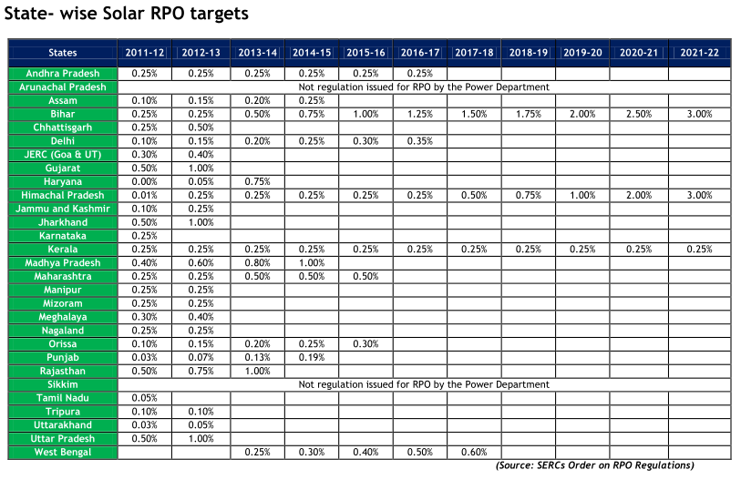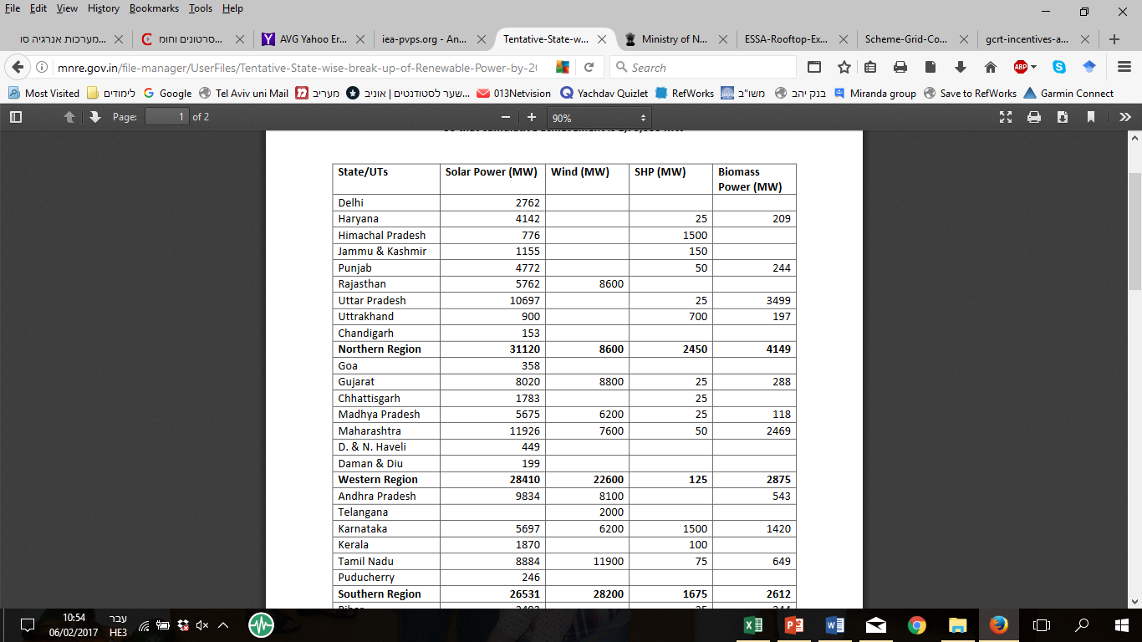

Table 2 2010 Indias states solar targets and the new 2014 solar targets for 2022.

In 2011, Rajasthan published a policy for developing the state as a global hub of solar power for the next 10 years to meet energy requirements of Rajasthan and India. In contrast, States like Mizuram and Manipur established only very modest targets of Solar penetration, and two states – Sikkim and Arunachai Pradesh did not issue any at all.

### Opportunities and Barriers to Investments in solar energy in India

In 2015, India invested $10.2 billion of public and private money in renewable energy (Shah Shreya 2017). Most of it came from private and local investments, while government financing accounted for only a small part of the total. Overall, India’s green and renewable business investment potential is estimated to $2.1 trillion in the next decades. Out of it, IFC (IFC 2016) estimates that investment in renewable energy will accounts for more than $320 billion, with nearly two-thirds of this sum ($201 billion) going to solar PV projects.

# Method

## Case Study

The case study technique is a well-known research method (Stake 1995; Yin 2003), that examines a human, group, event, process or other subjects of analysis to extrapolate key themes and results that can predict future trends. Case study research explores issues that can be applied to practice and provides tools for understanding the research problem. In this case, India's solar energy policy and the variables affecting the penetration pace of solar PV and process in the different states were examined.

The aim of this study of implementation of solar projects in India states is to understand the reasons for the variance in the implementation pace in different states. The case of India is important in light of the challenging targets for solar energy assigned by the government of India and the huge investments needed to achieve this target. The methods used to study this case were quantitative. Data was gathered from a variety of sources and the analysis is using linear regression and related statistical methods.

## Data collection

This study is designed to identify the causes for why some Indian states reach RE implementation targets and others do not. To find correlations between the amount of solar power capacity and independent variables, this study investigated the impact of various geographical, economic, educational and population parameters upon RE implementation. The data was gathered from variety sources, databases and formal reports. The study uses the most updated data found in reliable sources. All data is distributed between the years 2011 (census, education) and 2014 (of GDP). The latest data regarding solar energy is updated quarterly from 31.10/2016.

The variables considered in the quantitative analyses are listed below with comments on the rationale for including each of them in the analyses.

1. State renewable solar energy potential (MNRE 2016c) (MW) –The higher solar energy potential might lead to higher implementation.
2. Indian states by GDP share 2014 (StatisticsTimes 2015a)(%) Share of the state’s GDP in India's global GDP in 2014. The richest states should have more capital for investment.
3. State population share 2014 (StatisticsTimes 2015a) (%) – State population as a proportion of India's global population. A larger population needs more electricity.
4. State economic freedom- State grade (Bhandari, Debroy, and Swaminathan 2013), between 0-1 (1= most freedom). This index generally correlates with growth, development and prosperity. Economic Freedom Index contains information on only 20 states in India due to lack of information about the others. States and territories (except Telangana mentioned above) that are not listed in this index are contributing together approximately 2% of Solar capacity, 6.5% of GDP, 3% of the population and occupy 7% of the land.
5. State area share 2014 (StatisticsTimes 2015a) (%) - Share of the state land size as a proportion of the total area of India. This can be a predictor since solar plants need space.
6. Indian states Nominal NSDP (National State Domestic Product) per capita 2014 (StatisticsTimes 2015b)($) - Per capita income of states in US dollars during 2014. Higher income leads to better life conditions and higher electricity consumption .
7. State Urban\Rural population share (StatisticsTimes 2015d)(%) – Urban areas use more electricity, while on the other hand, rural areas use more off-grid energy.
8. State literacy rate 2011 (GOI 2011b, 2011a)(%) - The 2011 census data on total literacy rate in different states. Education can lead to adoption of new technologies.
9. Indian states NSDP growth 2013-2014 (StatisticsTimes 2015c)(%) – State’s average growth rate during 2013-2014. Capital growth needs industry and more energy.

These variables were tested as potential predictors of the State solar capacity installed (MNRE 2016d) (i.e. installed solar capacity in MW as of July 2016 was considered as dependent variable). Since the solar market in India is growing very fast, this study examined the variables compared to the solar data during 2015 – 2016 quarterly reports[1].

State Solar Policy support indicator relate to State’s announced regulations and policy for grid connected rooftop systems. This regulations should have influence on the market. This variable was examined separately

## Multiple & Linear Regression

Linear regression is a quantitative method to investigate correlations among dependent and independent variables, when a study requires analysis of more than two variables. This study investigates the connection between a number of variables related to GDP, population, education, demography and radiation (as **independent variables**) and implementation of solar energy in states of India (as the **dependent variable**).

The basic form of regression models[2] includes unknown parameters (β), independent variables (X), and the dependent variable (Y). The regression model specifies the variation of the dependent variable (Y) or variables as a function of independent variables (X) and unknown parameters (β) - *Y* ≈ *f (X, β).*

The regression equation utilizes a best fit straight (regression) line to predict the values of ‘y’, if the value of ‘x’ is given, and both ‘y’ and ‘x’ are the two sets of measures of a sample size of ‘n’. The formulae for regression equation would be in the form: *y = a + bx*. The significance level that was considered statistically is 0.05.

T-test method is a statistical test used to compare the means of two populations. A t-test for two independent samples is commonly used with small sample sizes, testing the difference between the samples when the variances of two normal distributions are not known[3]. A t-test was used in this work to find the difference between the states that announced Rooftop solar policy and the ones that did not. Then, Cohen's d test was used to examine the standardized difference between two means. Cohen's d finds the effect size for the comparison between two means.

# Results

## Data Analysis

One inherent problem with any research is the examination of compiled variables that we expect to have a causal relationship with the dependent variable. However, there might be other variables that can better predict the implementation of solar energy in India. By failure to include such variables in the statistical analysis, their effects on the solar energy implementation will not be revealed. This work contains the relevant variables that can be found to the state level in India.

In addition, the major conceptual limitation of the regression technique is that one can only determine relationships, but never be sure in the causal nature of the relationship.

### Standing Solar PRO Targets

Since the publication of the Solar PRO targets in 2010, new regulations were introduced and the field of solar energy has changed, due to reduction in cost, improvement in production and knowledge accumulation. Up to mid-2016, only five out of 27 states reached or surpassed the target values: Rajasthan (268% of 2016-2017 target), Gujarat (132%), Tamil Nadu (132%), Andhra Pradesh (99%) and Punjab (88%). The other 22 states lag far behind the original goals. Table 4 shows the percentage of the target defined by the Ministry of New & Renewable Energy and Jawaharlal Nehru National Solar Mission, Dec. 2012.(MNRE 2012a, 48) that each state achieved in July 2016. For example, Gujarat target was 849.62MW, while its installed capacity in July 2016 was 1123.36MW, meaning that it achieved 1123.36/849.62 = 132% of the target.

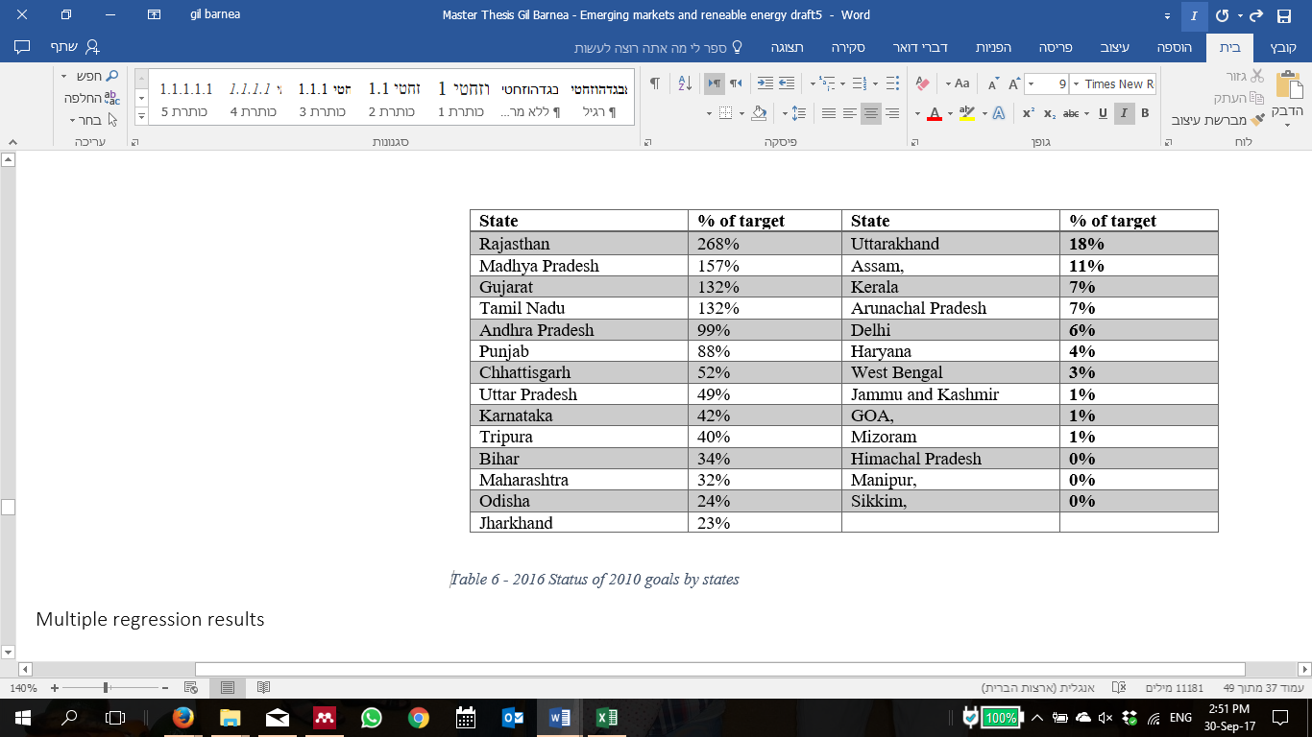

Table 4 2016 Renewable energy reach of 2010 goals

### The effects of variables upon solar implementation

While Table 4 shows that India is certainly heading in the direction for high solar implementation, a significant variance is evident among the states. Further statistical analysis was performed to explain the reasons for the observed variance.

Table 5 shows the results of bivariate between solar implementation and each of the nine variables. The highly significant correlation with solar implementation was revealed especially for economic freedom (r=0.697, p<0.01). Solar energy potential, GDP share, state area share and literacy rate showed lower but significant correlation. The other indicators clearly have less influence on solar implementation.



Table 5 Regression correlation with solar implementation

Multivariate linear regression including many variables and only 20-35 observations is risky due to the small number of observations. Table 6 demonstrates the dependence of installed solar capacity on five variables (P<0.05). The Correlation coefficient (Multiple R=0.818) is high and shows strong dependence of the installed solar capacity on the chosen variables. The adjusted R-square is comparatively low (0.551) because there were five variables in this regression and only 20 observations. Due to the small number of observations, the significance level for correlation of P<0.1 is accepted. Diffusion of data as shown in the attached graphs shows uneven distribution resulting from the fact that many countries are not significant in the field of solar energy. However, ANOVA test shows a clear and significant correlation.



Table 6 multivariate linear regression

### The Economic freedom index

The Economic Freedom Index [EFI] is built from 21 variables. The next step we took was to try and figure out which are the variables that have a major effect on solar implementation. The result we got was a strong correlation (R-Square of 0.77 and p=0.0013) between the variable "Inverse of Violent Crimes as a Share of Total Crimes" to solar capacity in July 2016. This variable belongs to the Legal Structure and Security of Property Rights category in the index. This category measures the efficiency of the government in protecting human life and property measured by the availability of judges, completion rate of court cases and police investigations. The level of safety in the region is measured by the recovery rate of stolen property, and by the rate of violent and economic crimes. The variable measures the ratio of violent crimes, including murder, attempt to murder, etc., to total crimes under the Indian Penal Code (IPC). The inverse of this ratio relates higher economic freedom to lower incidence of violent crimes.

## Regulation effect

The data about Solar Policy (MNRE 2015) supporting grid connected RTS systems (data from July 2015) are available for 36 states and UT's of India. Since solar capacity data are available only for 30 of them, the analysis was performed only in those states.

Table 7 compares implemented solar PV between 15 states that implemented and 15 states that did not announce RTS regulations. It shows that RTS states produce, on average, 4.8 times more solar energy. A t-test found this difference to be significant (t (19) = 2.44, p = 0.012, Cohen's d=0.95). The 15 states with RTS produce, on average, (July 2016) 439 MW. The other 15 states have only 92MW capacity. 9 of the 15 states with RTS policy, have more than 100 MW. Seven states do not have data.

|  |  |  |
| --- | --- | --- |
| Solar Policy supporting grid connected rooftop systems | | |
|
| YES | NO | State announced RTS policy |
| 15 | 15 | No. of States |
| 439 | 92 | Average solar capacity installed [MW] |
| 9 | 2 | States Above 100 MW |

Table 7 - Solar policy and average MW production

Table 8 shows that the 15 states with RTS policy fulfilled, on average, 61% of the targets set in 2012, while six of them were above the level of 50%. The other 12 states reached average of 26.2% of the solar PRO target and only one state reached 50% of the target. This result shows significant different between the groups.

|  |  |  |
| --- | --- | --- |
| 2012 solar target for 2016-2017 | | |
|
| YES | NO | State announced RTS policy |
| 15 | 12 | No. of States |
| 61 | 26.2 | Average Target Completed [%] |
| 6 | 1 | Above 50% of target fulfilled |

Table 8 - State policy and solar PRO 2016-17 targets

## Regulation and economic freedom

The economic freedom index and the state rooftop solar regulation are two different variables that are not mutually related. However, looking at the correlation between them reveals that there is a link between the states that have RTS and the ones with high economic freedom score.

|  |  |  |
| --- | --- | --- |
| No RTS Policy | Have RTS Policy | Economic Freedom |
| 1 | 8 | High (Top 10) |
| 5 | 6 | Low |
| 14 | 2 | No rank |

Table 9 - Economic freedom and RTS policy

Table 9 shows that states with high rank in economic freedom are more likely to have RTS policy, considering that among 9 states with high economic freedom score 8 had RTS policy. Most of the states that do not appear in the economic freedom index do not have policy (14 against 2). Among the states ranked with low economic freedom grade, almost same number have and do not have the RTS policy. States with low economic freedom and no RTS policy are at high risk of failure to reach their solar targets.

## Conclusions - India

The main conclusion that can be drawn is that the case of India shows that a determined state government can make significant steps in short time and use the clean-energy market as a major accelerator to empower the economy. Promoting regulations and policy tools such as RTS policy have specially aided the transformation towards large scale renewable energy generation, enabling higher efficiency and lower costs of generation.The central government of India on the other hand, should pay more attention to these states to achieve the 2022 targets with more unified dispersion. In contrast, the states with high economic freedom and with RTS policy are the locomotive that promotes the solar revolution in India.

Specifically, this study revealed a strong relationship between a state's economic freedom, GDP share, solar potential, area, literacy and RTS policy to the fulfillment of the Jawaharlal Nehru National Solar Mission targets. Hence, these variables are an important factor in state’s development, promotion of new technologies and economic accelerators like green and low-priced energy. The four hypothesis questions were confirmed in this study. Specifically, it was found that literacy has a positive effect on solar energy adoption, so that better educated states had matured solar market. Better economic status and a higher GDP per capita are essential for larger investments, and high Solar energy potential is important for the promotion and implementation of solar projects in the different states of India. Regulation and supporting policy showed to be major and vital to reach the central government’s goals and make a change on the state level. Hence, states with rooftop regulations stay ahead compared to ones that have not implemented RTS regulations. This indicator of Solar RTS regulation is complementary in its effect with economic freedom scores and both confirm that better structured and regulated markets foster solar energy maturation. States with low scores on economic freedom therefore appear to be unlikely to achieve the 2022 targets related to solar energy implementation.

# Conclusion

The main contribution of this research is the understanding that emerging industries, the key for future prosperity due to their high growth rates, in order to support emerging industries as of renewables, states ought to build structured policy based on clear regulations, strong economy and good education along with utilizing natural resources.

One of the key conclusions of this study is that central government goals setting, and resource allocation is insufficient to reach those goals and that local predisposition and local policy have a significant impact on goal attainment. This conclusion is reflected most clearly in the observation that local education, economic status and economic freedom scores affect solar energy utilization.

# End Note

# Index: Table- States of India data



Table 10 States of India Data

# Bibliography

Adviser, Principal Scientific. 2010. India Semiconductor Association, Bangalore *Solar PV Industry 2010: Contemporary Scenario and Emerging Rends*. http://www.iesaonline.org/documents/ISA_SolarPVReport_May2010.pdf.

Ansari, Md. Fahim et al. 2013. “Analysis of Barriers to Implement Solar Power Installations in India Using Interpretive Structural Modeling Technique.” *Renewable and Sustainable Energy Reviews* 27: 163–74.

Asha. 2013. “Emerging Sectors of Indian Economy.” *Global Journal of Management and Business Studies* 3(5): 2248–9878. http://www.ripublication.com/gjmbs.htm (September 30, 2017).

Banerjee, Sudeshna Ghosh et al. 2015. *Power for All: Electricity Access Challenge in India*. The World Bank. http://elibrary.worldbank.org/doi/book/10.1596/978-1-4648-0341-3 (April 21, 2018).

Beermann, Jan, Appukuttan Damodaran, Kirsten Jörgensen, and Miranda A. Schreurs. 2016. “Climate Action in Indian Cities: An Emerging New Research Area.” *Journal of Integrative Environmental Sciences* 13(1): 55–66. http://dx.doi.org/10.1080/1943815X.2015.1130723 (February 8, 2017).

Bhandari, Laveesh, Bibek Debroy, and S. Anklesaria Swaminathan. 2013. *Economic Freedom of the States of India 2013*.

Bulkeley, Harriet, and Michele M. Betsill. 2013. “Revisiting the Urban Politics of Climate Change.” *Environmental Politics* 22(1): 136–54. http://www.tandfonline.com/doi/abs/10.1080/09644016.2013.755797 (February 8, 2017).

Chen, Sheng-Tung, Hsiao-I Kuo, and Chi-Chung Chen. 2007. “The Relationship between GDP and Electricity Consumption in 10 Asian Countries.” *Energy Policy* 35(4): 2611–21.

Enerdata. 2016. *Enerdata_Energy_Statistical_Yearbook_2016*. Enerdata. https://yearbook.enerdata.net/#world-electricity-production-map-graph-and-data.html.

GOI. 2003. 1925 Government of India *Indian Electricity Act*. http://www.cercind.gov.in/Act-with-amendment.pdf.

———. 2011a. *Census 2011, Chapter 6 (State of Literacy), p.14*. Government of India. http://censusindia.gov.in/2011-prov-results/data_files/india/Final_PPT_2011_chapter6.pdf (February 11, 2017).

———. 2011b. *Ranking of States and Union Territories by Literacy Rate: 2011*. Government of India. http://censusindia.gov.in/2011-prov-results/data_files/india/Final_PPT_2011_chapter6.pdf (February 11, 2017).

Hale, David. 2012. “The Importance of Emerging Markets.” *CFA Institute x cfapubs.org*. http://www.cfapubs.org/doi/pdf/10.2469/cp.v29.n3.8 (June 3, 2017).

Hall, Joshua C, and Robert A Lawson. 2014. “Economic Freedom of the World: An Accounting of the Literature.” *Contemporary Economic Policy* 32(1): 1–19. http://onlinelibrary.wiley.com/doi/10.1111/coep.12010/abstract.

ibef. 2016. “Power Sector in India - Solar, Renewable &amp; Wind Energy Sectors.” 2017(Jan). http://www.ibef.org/industry/power-sector-india.aspx.

IEA. 2015. INTERNATIONAL ENERGY AGENCY *India Energy Outlook 2015*. INTERNATIONAL ENERGY AGENCY. http://www.worldenergyoutlook.org/media/weowebsite/2015/IndiaEnergyOutlook_WEO2015.pdf.

IEA Beta. 2019. “International Energy Statistics.” *2019*. https://www.eia.gov/beta/international/data/browser/#/?pa=00000000000000000000040g2&c=00000002000g000000000800000000000000000000000002&ct=0&ug=8&tl_id=2-A&vs=INTL.2-7-CHN-MK.A&cy=2014&vo=0&v=C&start=2014&end=2015 (April 26, 2019).

iea, and International Energy Agency [IEA]. 2015. World Energy Outlook *WORLD ENERGY OUTLOOK 2015 FACTSHEET India*. FR: OECD Paris. http://www.worldenergyoutlook.org/media/weowebsite/2015/FactsheetIndia.pdf.

IFC. 2016. “Climate Investment Opportunities in Emerging Markets.” *IFC*. https://www.ifc.org/wps/wcm/connect/51183b2d-c82e-443e-bb9b-68d9572dd48d/3503-IFC-Climate_Investment_Opportunity-Report-Dec-FINAL.pdf?MOD=AJPERES (June 3, 2017).

———. 2017. “India’s Solar-Energy Market Set to Shine.” *IFC*. http://www.ifc.org/wps/wcm/connect/news_ext_content/ifc_external_corporate_site/news+and+events/news/impact-stories/india-solar-energy-market-set-to-shine (June 2, 2017).

Kaladharan, Megha. 2016. “Renewable Energy in India : An Analysis of the Regulatory Environment and Evolving Policy Trends.” : 25.

Khare, Vikas, Savita Nema, and Prashant Baredar. 2013. “Status of Solar Wind Renewable Energy in India.” *Renewable and Sustainable Energy Reviews* 27: 1–10. http://www.sciencedirect.com/science/article/pii/S136403211300395X (February 8, 2017).

Kristin Seyboth et al. 2016. Global Status Report *Renewables 2016 Global Status Report*. http://www.ren21.net/status-of-renewables/global-status-report/.

Lagarde, Christine. 2016. “The Role of Emerging Markets in a New Global Partnership for Growth by IMF Managing Director Christine Lagarde.” In *University of Maryland,* IMF. https://www.imf.org/en/News/Articles/2015/09/28/04/53/sp020416 (October 2, 2019).

Luce, Kimberlee. 2016. “Emerging Markets: Pathways to Selection.” In *Slideshare.Net*, , 29. https://www.slideshare.net/KimberleeLuce/emerging-markets-pathways-to-selection (May 8, 2017).

Ministry of Power. 2005. *National Electricity Policy 2005 - EXTRAORDINARY*. http://powermin.nic.in/en/content/national-electricity-policy.

———. 2006. The Gazette of India *Tariff Policy*. http://powermin.nic.in/sites/default/files/uploads/Tariff_Policy_1.pdf.

MNRE. 2012a. *Jawaharlal Nehru National Solar Mission Phase II – Policy Document*. http://mnre.gov.in/file-manager/UserFiles/draft-jnnsmpd-2.pdf (February 8, 2017).

———. 2012b. *Salient Features – Solar Policies*. http://mnre.gov.in/file-manager/UserFiles/guidelines_sbd_tariff_gridconnected_res/salient_features_for_State-wise_solar_policies.pdf (February 8, 2017).

———. 2015. *Grid Connected Solar Rooftop Systems Presntation*. http://mnre.gov.in/file-manager/UserFiles/Rooftop-Presentation-on-07072015.pdf (February 8, 2017).

———. 2016a. *Grid Connected and Small Power Plants Program*. http://mnre.gov.in/file-manager/UserFiles/gcrt-incentives-award-040516.pdf (February 8, 2017).

———. 2016b. “Guidelines for Development of Solar Parks.” http://mnre.gov.in/file-manager/UserFiles/Solar-Park-Guidelines.pdf.

———. 2016c. “MNRE Annual Report 2015-16.” : 2–3. http://mnre.gov.in/file-manager/annual-report/2015-2016/EN/Chapter 1/chapter_1.htm (February 8, 2017).

———. 2016d. “Solar Power in India.” *Wikipedia*: 1–9. https://en.wikipedia.org/w/index.php?title=Solar_power_in_India&oldid=740619176#cite_note-capa-17.

———. 2017. Ministry of New and Renewable Energy *Solar RPO Framework*. http://mnre.gov.in/information/solar-rpo/ (February 8, 2017).

Mokyr, Joel. 1988. “THE NEW ECONOMIC HISTORY AND THE INDUSTRIAL REVOLUTION.” : 13–27. https://sites.northwestern.edu/jmokyr/files/2016/06/Editors-Introduction-The-New-Economic-History-1999-1thoner.pdf (October 12, 2017).

Nelson, David et al. 2012. “Meeting India’s Renewable Energy Targets: The Financing Challenge CPI-ISB Report.”

North, Douglass C. 1994. “Economic Performance Through Timet.” 84(3): 359–68. http://www.jstor.org/stable/2118057 (June 5, 2017).

OECD. 2010. “Regulatory Policy and the Road to Sustainable Growth.” www.oecd.org (October 14, 2017).

Pargal, Sheoli. 2014. Directions in development *More Power to India*. Washington, DC: World Bank. http://www.econis.eu/PPNSET?PPN=834961296.

Press. 2015. “Revision of Cumulative Targets under National Solar Mission from 20,000 MW by 2021-22 to 1,00,000 MW.” *Press Information Bureau Government of India*. http://pib.nic.in/newsite/PrintRelease.aspx?relid=122566 (February 8, 2017).

Raza, S. A., S. T. Jawaid, and M. H. Siddiqui. 2016. “Electricity Consumption and Economic Growth in South Asia.” *South Asia Economic Journal* 17(2): 200–215. http://sae.sagepub.com/cgi/doi/10.1177/1391561416649721 (May 20, 2017).

Roy, Hiranmoy, Rajaiah Jayaraj, and Anshunan Gupta. 2016. “Energy Consumption and Human Development: Global Perspective.” *ECONOMICS AND POLICY OF ENERGY AND THE ENVIRONMENT* (1): 111–31. http://www.francoangeli.it/riviste/Scheda_Riviste.asp?IDArticolo=55813 (May 20, 2017).

Shah Shreya. 2017. “Why India Might Not Achieve Its 2020 Renewable Energy Targets - The Economic Times.” http://economictimes.indiatimes.com/industry/energy/power/why-india-might-not-achieve-its-2020-renewable-energy-targets/articleshow/56389839.cms (June 3, 2017).

Sharma, Naveen Kumar, Prashant Kumar Tiwari, and Yog Raj Sood. 2012. “Solar Energy in India: Strategies, Policies, Perspectives and Future Potential.” *Renewable and Sustainable Energy Reviews* 16(1): 933–41. http://dx.doi.org/10.1016/j.rser.2011.09.014.

Shrimali, Gireesh. 2015. “Reaching India’s Renewable Energy Targets.” https://climatepolicyinitiative.org/publication/reaching-indias-renewable-energy-targets-cost-effectively/ (February 8, 2017).

———. 2016. “Cost-Effective Policies for Reaching India’s 2022 Renewable Targets.” *Renewable Energy* 93: 255–68. http://www.sciencedirect.com/science/article/pii/S096014811630163X.

Shrimali, Gireesh, Shobhit Goel, Sandhya Srinivasan, and David Nelson. 2014. *Solving India’s Renewable Energy Financing Challenge: Which Federal Policies Can Be Most Effective? A CPI-ISB Series*. www.climatepolicyinitiative.org (February 8, 2017).

Stake, Robert E. 1995. *The Art of Case Study Research*. Sage Publications. https://uk.sagepub.com/en-gb/mst/the-art-of-case-study-research/book4954 (May 30, 2017).

StatisticsTimes. 2015a. “GDP-Population-Area Relationship of Indian States.” http://statisticstimes.com/economy/indian-states-gdp-population-area-relationship.php (February 11, 2017).

———. 2015b. “GDP per Capita of Indian States | Indian States GDP per Capita 2015.” http://statisticstimes.com/economy/gdp-capita-of-indian-states.php (February 11, 2017).

———. 2015c. “Indian States by GDP Growth 2015.” http://statisticstimes.com/economy/gdp-growth-of-indian-states.php (February 11, 2017).

———. 2015d. “Population of Indian States | Indian States Population 1901-2011.” http://statisticstimes.com/population/population-of-indian-states.php (February 11, 2017).

Timilsina, G R, L Kurdgelashvili, and P A Narbel. 2012. “Solar Energy: Markets, Economics and Policies.” *Renewable and Sustainable Energy Reviews* 16(1): 449–65.

UN. 2018. “Goal 7 .:. Sustainable Development Knowledge Platform.” https://sustainabledevelopment.un.org/sdg7 (March 4, 2019).

World-bank. 2016. “GDP Growth (Annual %) | Data.” http://data.worldbank.org/indicator/NY.GDP.MKTP.KD.ZG?end=2015&locations=IN&start=2005 (February 10, 2017).

———. 2019. “Global Outlook - Weak Momentum, Heightened Risks.” *world bank*: 1–51.

Yin, Robert K. 2003. *Case Study Research : Design and Methods*. Sage Publications. https://books.google.co.il/books/about/Case_Study_Research.html?id=BWea_9ZGQMwC&redir_esc=y (May 30, 2017).

1. Remarks about data:

   **Telangana** State it a new state in India which awarded separate statehood on 2014 (split from Andhra Pradesh). Telangana is very significant in the field of solar energy (845MW in July 2016) due to it late born. Telangana GDP, population and some other indicators were available, but some others such as Economic Freedom and Literacy were missing

   3.

   Various states in India raise mega solar energy projects providing hundreds of MW. This significant point is important since a single site may have a dominant weight of energy produced in the country. (For example, Residential Solar Power Project Kamuthi in late 2016 in Tamil Nadu will provide over 600MW).
2. <http://research-methodology.net/research-methods/quantitative-research/regression-analysis/>
3. <http://www.investopedia.com/terms/t/t-test.asp>