**Conservative and liberal worldviews and social policy attitudes among university students: The interactions between culture and religion**

Ariela Keysar, Nurit Novis-Deutsch, Janne Kontala and Peter Nynäs

**ABSTRACT**

Religion affects social policy attitudes. The effects are both direct and indirect and involve different aspects of religion. This paper examines how the effect of religion on social policy attitudes varies by national and cultural context. We analyzed attitudes toward same-sex marriage, abortion and euthanasia of young adults using the Young Adults and Religion in a Global Perspective (YARG) study, spanning 13 countries from four continents and targeting 4,964 university students ages 18-30. By using path models, we found that among various indices of religiosity, self-identified religiosity is the aspect of religion that is the most important predictor of social policy attitudes, with a strong direct effect and an additional indirect effect through shaping value preferences, which in turn affect social policy attitudes. This was found across cultures and national groups. We also found that although religiosity consistently correlates positively with conservation values and negatively with liberal values, culture matters. Measured on a scale of individualism versus collectivism, the more collectivist the country, the less the support of liberal values and progressive social policy preferences, and more is the support of conservation, controlling for religiosity, values, and demographics. These findings have important implications for understanding the relative weight of religiosity, culture and nationality in predicting social policy attitudes.

**INTRODUCTION**

Religion affects social policy attitudes both directly and indirectly. Directly, religious traditions inform their adherents about desired social norms and how they should be pursued (Saucier, 2000). For example, many religions proscribe abortion, require that marriage be heterosexual, and prohibit euthanasia, positions that their adherents tends to adopt (Danyliv & O'Neil, 2015; Whitley, 2009; Kosmin & Keysar, 2006; Yen & Zempeli, 2017). Indirectly, religions shape value preferences and worldviews (Schwartz, 2108) which, in turn, lead to liberal or conservative social policy attitudes (Caprara et al., 2018). These direct and indirect effects imply that the robust positive correlation which is typically found between religiosity and conservative attitudes (Caprara et al. 2018; Hood, Hill & Spilka, 2009; Schwartz et al. 2012; Van der Brug et al. 2009) is driven by two sources: values and religion. Novis-Deutsch et al. (2019) found that the relative weights of the direct and indirect effects of religion on social policy attitudes depend on what aspect of religiosity is being measured (e.g., belonging or practice) and that while the direct effect of religion on social policy attitudes is the largest, a smaller but significant portion of the effect of religion on social policy can be explained by the mediating effect of values.

It remains unclear, however, to what extent the direct and indirect effects of religiosity on social policy attitudes operate similarly across national and cultural contexts. Previous studies targeted predominantly Protestant cultures, and data on non-Christian populations is particularly sparse (cf. Caprara, 2018). An important possibility to consider is that cultural surroundings have a major effect on which patterns of values can be 'contained,' managed and integrated into the identity of religious individuals and which cannot. Consider, for example, the difference between being deeply religious in Sweden and being deeply religious in Ghana. The religious Swede lives in a secular, individualist culture that emphasizes, perhaps above all else, personal choice and social equality (Kasselstrand, 2015). It is more likely that her religious faith will have found a path that accommodates liberal values. The religious Ghanaian lives in a collectivistic culture that stresses values of conservation, such as respect for authority and honoring tradition (Hunsberger, Owusu & Duck, 1999). Religion in any case typically supports and matches such values, posing no cognitive dissonance. Now imagine a non-religious Swede versus a non-religious Ghanaian. The non-religious Swede is likely to experience congruency between his liberal humanistic values and his secular worldview. Not so for the non-religious Ghanaian. She holds cultural values supporting traditionalism, but at the same time professes a non-religious worldview. It is more likely that her secular worldview will have found a way to maintain respect for tradition and authority, thus minimizing possible dissonance.

Our goal in this paper is to present and analyze cross-cultural data in a manner that can identify differences and similarities in cultural patterns of interaction between the direct and indirect effects of religion on social policy among young adults from diverse cultural contexts. Our data source is the Young Adults and Religion in a Global Perspective (YARG) study (Nynäs et al. 2019). YARG is a mixed-methods project conducted in 2016-2018 in 13 countries from four continents targeting university students ages 18-30. For these analyses we utilized data collected from 4,964 participants who completed value surveys, attitude questionnaires, extensive religiosity probes and demographic information, as well as qualitative interviews which are not used in this paper.

**LITERATURE REVIEW**

1. *The interplay between conservatism and liberalism*

The clash between liberal and conservative worldviews, or the left-right polarization (Noël & Thérien, 2008)[1] is often referred to as a “culture war” (Flanagan & Lee, 2003; Frimer et al. 2014, p. 1205; Hunter, 1991). This polarization has intensified over the past decade (Bornschier, 2010; Carmines, Ensley & Wagner, 2012; Pew Research Center, 2014). It is reflected not only in voting patterns, economic policies and foreign policies across the globe, but also in attitudes towards social inequality, arms control, environmentalism, same-sex marriage, abortion, euthanasia and more (Kriesi, et al. 2012; Sherkat, 2014) and even in daily lifestyle choices (Pew Research Center, 2014). While attitudes towards social issues are directly affected by the teachings and policies of organized religions about these issues (Hood, Hill & Spilka, 2018), an underlying route by which religion affects social ideology and is through shaping ideological worldviews. The terms *liberal* and *conservative* can be used either to connote political positions or broad worldviews. In this paper we refer to the latter meaning and consider liberalism and conservatism to reflect worldview constructs, which precede political positioning and shape voting patterns.

In their classic definitions, the ideological difference between liberalism and conservatism can be boiled down to the importance placed on the value of freedom. Liberalism, as its name implies, places an especially high worth on freedom. For classic liberals, this leads to the favoring of small governments. American-style liberals, in contrast, emphasize social justice (Gaus, Courtland and Schmidtz, 2018). Both types tend to favor autonomy, choice, and tolerance. In contrast, the conservative position values experience and authority, viewing society as held together by family, private property, and traditions. Here too we can find different political flavors. Americans often group libertarians with conservatives, while Europeans generally do not. By and large, however, conservatives emphasize stability, duty over rights and rules over reason (Oakeshott, 1991; Kekes, 1997). When translated to political ideologies this distinction becomes murkier: In Western Europe it corresponds clearly to the "left" (liberal) and "right" (conservative) political distinction; in Eastern Europe and other previously or currently Communist nations it corresponds less clearly; and in the U.S., the conservative parties often hail "freedom" while the liberal ones call for social justice.

Some scholars claim that conservatism-liberalism is a unidimensional continuum reflecting the importance of freedom (Jost, 2006). Indeed, this single construct has been shown to predict voting patterns in multiple locations (ibid.). Others argue that liberalism and conservatism are two distinct dimensions, albeit negatively correlated, which can be synthesized so that it is possible, although unusual, to be both conservative and liberal (Barnea and Schwartz, 1998; Hamilton, 2016). A bi-dimensional political space typically juxtaposes economic and cultural attitudes, and best explains voting patterns in many countries (Bornschier, 2010; Feldman & Johnson, 2014) [2]. In this paper, we will treat liberalism and conservatism as related but separate, rather than assume them to be opposites. We therefore ran all our analyses separately for conservatism and for liberalism.

1. *Religion, conservatism and liberalism*

Religiosity is strongly and consistently associated with ideological and political conservatism across countries. Caprara et al. (2018) recently found that religiosity was related to right and conservative ideologies in 15 of the 16 countries they tested, an association that did not vary with gender, age, income or education.

But what links religious beliefs to social attitudes? An obvious candidate is value preferences. According to Schwartz’s highly validated theory of Basic Human Values (Schwartz, 1992, 2001, 2006, 2012), basic values are trans-situational goals, varying in importance (e.g. rankable), that serve as guiding principles in the life of a person or group. In the most recent iteration of the Basic Human Values theory, 19 basic values, which are recognized across societies, form a circular motivational continuum (Schwartz, 2012). These values are construed as two sets of higher-order values: Conservation versus Openness-to-change and Self-enhancement versus Self-transcendence (Schwartz et al. 2012; see figure 1)

-- Insert Figure 1 here --

Values can explain why the left-right distinction does not align well with the liberal-conservative division in some countries, such as those with a history of Communism. Variation in patterns of values-political ideology occurs when “the political history of a country has imbued a particular political value with a meaning different from that in most other countries” (Schwartz et al. 2014, p. 902). Similarly, Caprara et al. (2017) found that after controlling for basic personal values, the contribution of religiosity to political self-positioning on a conservative-liberal scale was significant and substantial only in countries where religion has played a prominent role in the public sphere (e.g. Poland, Israel, U.S.), whereas other countries showed a marginal or small unique contribution of religiosity to political self-positioning.

While Caprara et al.'s study (2018) examined the three-way relation between values, religiosity and social ideology using self-reported religiosity and reported conservatism/liberalism, Novis-Deutsch et al. (2019) expanded the analytical scope by using direct and indirect scales to measure these constructs. Using Schwartz's more recent 19-value model and testing multiple facets of religiosity (e.g. religious belonging, religious identity and religious practice), they found that religion affects ideological worldviews both directly and indirectly. There was a direct relationship between religiosity and positions on issues such as homosexuality and same-sex marriage, but there was also an indirect relationship in which values mediated the relation between religiosity and social policy attitudes. These findings can be summed up in the following theoretical model (See Figure 2). This model suggests that religiosity directly decreases liberal attitudes towards social policy, while also indirectly affecting these attitudes in two complementary ways: 1) by decreasing liberal attitude values (LA values; see the *Measures* section of this paper for details on how this measure was calculated), thus lessening the positive impact of these values on liberal attitudes towards social policy and 2) by enhancing conservation values (CONS values, ibid), thus increasing the negative impact of these values on liberal attitudes towards social policy.

--- Insert Figure 2 here ---

Both studies by Caprara et al. (2018) and Novis-Deutsch et al. (2019) support such a model, but they may have overlooked important cultural differences in these universal patterns. We next conjecture how the religion-social policy relationship might be moderated by culture and nationality.

1. *The predicted role of culture and nationality in determining the effect of religion on social policy*

Broad cultural constructs have been shown to affect behaviors, attitudes, beliefs, cognitive schemas and even the basic sense-perceptions of their members (Kitayama & Cohen, 2010). For example, some cultures promote a more allocentric worldview (concerned with others) while others promote a more idiocentric one (concerned with self). This affects the way members interpret social stimuli, behave in social situations and rank values (Heine, 2015). Cultural elements such as the role of the group, level of tolerated uncertainty and the structure of cultural hierarchy tend to form interrelated and coherent structures that can distinguish the world's main 'cultural regions' (Triandis, 2010). Since the effects of culture are powerful enough to affect virtually every aspect of perception, emotion, cognition and behavior, it is likely to also affect the relation between religiosity and social attitudes.

Our study builds on Hofstede's model of national culture (2010), which consists of cultural dimensions, or aspects of a culture that can be measured relative to other cultures and reflect preferences for one state over another. Combining these dimensions forms cultural profiles that distinguish nations from one another and establishes broader cultural-regional patterns. Hofstede's model outlines six cultural dimensions: Individualism/ collectivism; low/high power distance; low/high uncertainty avoidance; long-term/short-term orientation; masculinity/femininity and indulgence/restraint. We focused on two key distinguishing dimensions: Individualism vs. collectivism and power distance.

'Individualism vs. collectivism' refers to the degree to which people in a society are integrated into groups. Individualistic societies display loose connections between persons and groups, in effect expecting individuals to look after themselves; collectivist societies bind the two much more strongly together, forming strong, cohesive in-groups ultimately expecting individuals to prioritize group needs over their own. As a rule, individualism is common in developed and Western countries, while collectivism is common in developing and Eastern countries.

Power distance is the level to which members of a society accept an unequal distribution of power in any kind of structure in that society. Power distance represents inequality as defined from the perspective of those with less power, suggesting that a society's level of inequality is endorsed by its followers as much as by its leaders. (Hofstede, 2011, p. 9). Power distance and individualism/collectivism have both been found to strongly correlate to wealth of nations, and they also correlate with one another. High power distance is typically found in East European, Latin, Asian and African countries and low power distance is more common in Germanic and English-speaking Western countries (Hofstede, 2010).

A set of studies on 76 countries resulted in a ranking in which countries were positioned relative to each other on their scores in each dimension (Hofstede, 2011.) We make use of this national-level ranking in our study.

Broad cultural dimensions aside, the role of religion in the public sphere is affected by national context too (Caprara et al. 2017). Belonging to a nation involves sharing a series of historical events, filtered through collective memory schemas (Olick et al. 2011). This means that the role and impact of religion on attitudes and outcomes is moderated through national history and ethos. For example, in Israel historical circumstances led to a confounding of the definitions of religion and ethnicity so that 40% of Israeli Jews, known as "seculars," define themselves as religiously “Jewish” but at the same time as “non-religious” (CBS Israel, 2016). To cite another example, in Finland some 71.9% of the population affiliate themselves as Christians (Tilastokeskus, 2019) but only 4% attend weekly religious services (Pew Research Center, 2018), a gap partially accountable by a combination of national-historical circumstances and identity politics (Finland's strained relations with the Soviet Union, and inter-alia, with Atheism). It is important therefore to test each national context individually to explore its effect on the relation between, religiosity, values and social attitudes, while controlling for broader cultural contexts.

This study tested the following hypotheses. We list each in general and in operationalized terms:

1. The more individualistic a culture, the more liberal values will moderate the effect of religiosity on social attitudes, whereas the more collectivist a culture, the more conservation values will moderate the effects of religiosity on social attitudes.

Operationally, the variance among young adults’ social policy preferences will be moderated by Hofstede's national ranking of "individualism/collectivism" dimension, such that those from high-individualism countries will show increased support for liberal social policy, increased support for liberal values, less support for conservation values, lower levels of religious belonging, identification and practice, and a weaker indirect effect of religion on social policy preferences than those from high-collectivism countries.

1. The greater the cultural power distance, the more equality will moderate the effect of religiosity on social attitudes, whereas the lower the power distance, the less equality will moderate the effects of religiosity on social attitudes. A parallel set of operational hypotheses was generated regarding the distinction between low vs. high power distance cultures.

Since the results were very similar to those of individualism/collectivism, and due to space limitations, we report findings only concerning the first dimension of individualism/collectivism.

In addition, we examined an exploratory question with no hypothesized directionality:

1. Which of the following ways of measuring religiosity best supports cross-cultural research questions: Religious belonging (yes/no), religious practice, or self-reported religiosity (on a scale of 1-10)?

**METHOD**

**Participants**

Participants were part of the Young Adults and Religion in a Global Perspective (YARG) study conducted by Nynäs et al. (2019). In this mixed-methods project, surveys were administered to 4,964 respondents in 13 countries. All participants were active students at the time of the study and the overwhelming majority were between ages 18-30. In-depth interview were then conducted with a nationally proportional subsample of 562 interviewees The surveys were administered in the local languages using convenience sampling with purposeful sampling schema, which targeted diverse higher-education institutions in each country. The participating countries were Canada (n=410), China (n=325), Finland (n=484), Ghana (n=420), India (n=298), Israeli Arabs (n=429) and Israeli Jews (n=332), Japan (n=324), Peru (n=321), Poland (n=299), Russia (n=343), Sweden (n=328), Turkey (n=347), and U.S. (n=304).

**Measures**

This study utilizes only some of the measures used in the full YARG project. Some of the data collected was used to form new measures specifically targeting the hypotheses of this study.

***A measure of social liberal/conservative policy preference***

To explore the relationships between liberal/conservative orientation and social policy preference, we constructed a combined measurement of social policy preferences, relating to issues on which liberals and conservatives are expected to differ. We averaged the agreement of participants (1-5 Likert scale) to statements indicating support for same-sex marriage, same-sex adoption, legal abortion under various conditions (rape, threat to the woman's health, and the woman's choice), euthanasia and medically assisted suicide. Reliability (Cronbach’s alpha) of the scale was .853.

***Value measures***

The PVQ-5X scale (Schwartz, 2012), which measures participants’ values on a 19-consruct value circle, was used in this study. For this study, we devised a novel way of grouping a subset of Schwartz’s values. The values that we propose as reflecting liberal attitudes do not make up any of the four higher-order value constructs described in the introduction (openness to change vs. conservatism and self-enhancement vs. self- transcendence). Rather, they include *two* of the *openness to change* values, namely, self-direction: thought and self-direction: action, and two additional values: universalism: concern and universalism:tolerance (we excluded universalism: environmental since it did not seem to relate to the principle of liberalism directly). We suggest this new grouping based on the core values of liberalism --freedom, equality and autonomy -- and on previous findings of consistent positive correlations between these values and liberal attitudes.

We used the PVQ-5X to measure participants’ values but aggregated the value scores differently from before, by averaging the z-scores of tradition, conformity and security values in order to obtain a “Conservation” score (CONS) and averaging the z-scores of self-direction and universalism values to obtain a “Liberal values” score (LIB). Figure 1 shows the location of LIB values (in gray) in relation to the established second-order value groups.

**Religiosity measures**

We used three measures of religiosity. *Religious belonging* was measured dichotomously by the question:

Do you consider yourself as belonging to one or more religious groups, communities, or traditions? (Yes or No).

*Religious self-identification* was measured on a 0-10 scale by the question:

Regardless of whether you consider yourself as belonging or close to a particular religious group, community, or tradition, how religious would you say you are?

*Religious practice* was measured on a 0-10 scale by answers to the question:

Apart from when you are at religious ceremonies or services, how often do you engage in private religious or spiritual practices, such as worship, praying, or meditation?

*Analytic plan*

We tested each of the 13 countries separately, and then grouped them by Hofstede’s (2011) cultural individualist/collectivist index (I/C) and power distance index (PD), creating two pairs of contrast groups (See Table 1 for ranking).

* 1. High individualism (U.S., Canada, Finland, Sweden, Poland) versus high collectivism (China, Peru, Israeli Arabs)
     + - 1. High PD countries (Ghana, Turkey, Israeli Arabs, Japan, India, Russia, China, Poland) versus low PD countries (Israeli Jews, Finland, Sweden, U.S., Canada)

In most cases the countries lined up similarly (See table 1 for ranking). The top 5-6 countries, including the Scandinavians, Canada and the USA (with the exception of Poland), rank high both on individualism and low on power distance. On the other end of both scales, representing more collective societies, we find China, Ghana, and Israeli Arabs. Discrepancies are noticeable regarding Peru, the most conservative, which ranks relatively high on the power distance scale, as well as Israeli Jews, who are lowest on power distance, yet both are only mid-level on individualism/collectivism.

-- Insert Table 1 here –

To analyze meaningful differences in our model by cultural dimensions, we used multi-variable path analysis, an extension of multivariate regression, to estimate the magnitude and significance of the hypothesized causal connections between these variables (Pedhazur, 1982). We begin with a simpler bi-variable analysis assessing the relationships between level of religiosity and culture.

**RESULTS**

* 1. Bivariate Analysis

We divided students in each country by their religiosity level: those who defined themselves as highly religious (8-10 on the 0-10 point religiosity scale), the moderate (chose 2-7 on the same scale) and those who defined themselves as non-religious (0-1 on the scale).

Overall, religious students were less likely to support liberal social policies than those who self-identified as non-religious. The differences are all highly significant at p< 0.001. However, culture matters. In China and Japan there are no religiosity differences and in India and Ghana the gaps between the religious and not religious are quite small. Especially large gaps were found among Israeli Jews, in Russia and in Poland. Overall, the differences between the 13 countries in support of liberal social policies were bigger than those within countries (both among the religious and the non-religious), suggesting a strong effect of culture (See Chart 3a).

-- Insert Chart 3a here --

At the same time, countries are not internally uniform and do not necessarily have a shared religious surrounding. Therefore, we compared countries on the gap between the most religious and the least religious students, measured by self-identification on a scale from 0 (not at all religious) to 10 (very religious). The largest gaps were found in Sweden, Ghana, Canada and Russia (See Figure 3b).

Religiosity patterns are most vividly reversed in Sweden and in Ghana. While the share of non-religious in Sweden exceeds 50%, and the very religious in Sweden are under 5%, in Ghana the share of the very religious approaches 50%, while the non-religious are under 4%.

The more collectivist the country ranks on the individualism/collectivism scale, the more likely a student from that country is to self-identify as religious (coefficient=0.258) and to engage in private religious practice (coefficient =0.212). These significant correlations explain the indirect effects of culture on social policy preferences.

Insert Chart 3b here

*Overall YARG sample model*

The most important predictor of the social policy index was religious self-identification. The negative coefficient confirms that the more religious the young adult is, the less likely he or she is to support such policies as same-sex marriage, legal abortions and assisted suicide. This religious indicator is dominant and explains most of the variance (R2  change=0.273). The second dominant factor is the country scale of individualism vs. collectivism with R2  change=0.108. Liberal values follow with a positive effect while private-religious practice has a negative effect on the social policy index; both are less important predictors, as is religious belonging. Gender was found to play only a minor role compared with religiosity, albeit a statistically significant one. (see Table 2)

-- Insert Table 2 here --

* 1. Path Models

To assess the direct and indirect effects of religiosity on social policy preferences, we conducted a series of linear regression models to evaluate the effects of gender, values, culture and religiosity on the social policy preference index. All 4,964 YARG students were included in the first analyses. In these analyses we accounted for all three measures of religiosity: religious belonging (yes/no), religious practice and self-reported religiosity scale (0-10). We ran a second parallel analysis for the same sample accounting for all of the above and replacing CONS values with LIB values. As hypothesized, in both analyses, all of the variables we tested predicted a portion of the variance in social policy attitudes (see Table 2). The full models of social policy preferences as the dependent variable are quite robust, explaining 46% of the variance (R2=0.464).

*Testing individualistic and collectivist samples for goodness of fit to general model*

Next, we added culture to the models: In the first step, religiosity (three different measures) was the dependent variable while gender and culture (the country individualism/ collectivism scale) were the independent variables. In the second step, LIB values and CONS values, in two separate models, one for each, were the dependent variable, while religiosity (three different measures), gender and country scale were the independent ones. In the third step, the Social Policy Preferences Index was the dependent variable while all the others were tested as independent variables. Thus, two path models are presented: one with liberal values and one with conservation values.

We found highly significant direct effects of both religiosity and culture on social policy preferences. Religiosity and culture also affect social policy preferences indirectly through their effects on values. The direction flips between the two models: Higher religiosity positively correlates with higher CONS values and lower (negative coefficient) support of LIB values.

The direct effects of the country/culture on preference for liberal social policies, measured as individualism vs. collectivism, are stronger than the direct effects of religiosity. For example, the coefficient of the direct effect of religious self-identification is -0.255 while the coefficient of the direct effect of the country’s individualism/collectivism scale is -0.282 (Figure 4). Similarly in Figure 5, the direct effect of religious self-identification is -0.230 and of the country’s scale -0.293. In both models the effects are highly significant (p<0.001).

In these analyses, the total effect of religiosity (adding the direct and indirect effects) is stronger than that of the other explanatory variables, which explains the domination its domination, measured by the R2 change (see p. 15). Religiosity is expressed most powerfully when it is measured as a personal identity construct, followed by religious practice, and least strongly, in terms of dichotomous religious belonging.

When considering religious self-identity and religious practice, we see the same patterns emerge for both CONS and LIB values: Religiosity affects social policy preferences directly. It also affects social policy preferences indirectly, via each of the value sets CONS and LIB. However, there are differences between the two ways of measuring religiosity: Self-reported religiosity has a stronger indirect effect than does religious practice, once again validated by the differences of the R2  change: 0.273 for self-identification verus 0.024 for religious practice (See Table 2).

Turning to the other variables in our model, students’ expression of liberal values has a significant and positive effect on progressive social policy preferences, specifically on supporting same-sex marriage, legal abortion and euthanasia. In contrast, conservative values have a negative and somewhat stronger effect on social ideology.

The more collectivist the country, the less is the (negative coefficient) support of liberal values (coefficient -0.216 for individualism/collectivism scale), and more is the (positive coefficient) support of conservation (with somewhat lower coefficient of 0.152) (See Charts 4 and 5).

Gender seems to be only a minor factor once other factors are included in the regression models, with small yet statistically significant male-female differences in liberal values (coefficient of 0.103) and in various religious aspects (coefficient of 0.084 for private religious practice).

*---Insert Figures 4 & 5 here* *---*

*Differences between countries*

Strong negative effects of religiosity level (measured by self-report) on support of liberal policies emerge in various cultures, secular and religious ones (with the exception of China and Japan).

We ran regression models for each country, separately for liberal values and conservation. The rankings of countries by the power of the model were similar regardless of the types of values, liberal and conservative, whereby Israeli Jews are at the top, followed by Finland and Poland, while Ghana and India are at the bottom.

The explanatory power of the regression models are illustrated by the large R2. They signify the magnitude of religiosity in shaping worldviews, primarily among Israeli Jews, in Finland and Poland, exceeding the effects of values, both LIB and CONS.

Consistently in every country, the effect of liberal values on social policy preferences is positive. The effect is negative for conservation. However, it is hard to find a consistent pattern. For example, we notice at the top of the ranking, weak coefficients (similar for liberal values and conservation) among Israeli Jews, while stronger ones among students in Finland and Poland. Yet these coefficients do not present a coherent pattern. They show stronger effect for liberal values than for conservation values in Poland, while in Finland the stronger effect is for conservation (See Tables 3 & 4).

*The case of Sweden versus Ghana*

We hypothesized that the worldviews of a religious young adult in Sweden would be mitigated by the cultural context, the liberal society. Similarly, a less religious or not religious young adult in Ghana would be exposed to a collectivist culture, mitigating attitudes towards support of abortions, gay marriages and euthanasia. Again, in both kinds of society they represent a small share of young adults: the religious ones in Sweden and the not religious in Ghana.

We found that the self-defined level of religiosity is consistently highly significant and negatively associated with support of liberal social policies—the more religious the less support. In Ghana only the self-identification is significant with coefficient as -0.179. In Sweden that relationship is stronger with coefficient as -0.288. Religious belonging is also significant (coefficient as -0.163), while private religious practice is only marginally significant (coefficient as -0.119). One explanation is that in Sweden the student sample was religiously more diverse than in Ghana.

Values and culture also play roles in the different settings—in both Sweden and Ghana liberal values and conservation are similar in intensity, yet in a different direction, in their association with social policy preferences, although the coefficients for liberal values and conservation are significant in Sweden (0.139 and -0.138 respectively), and similar but only marginally in Ghana (coefficients as 0.085 and -0.085 respectively).

**DISCUSSION**

By using path models to consider the relative effects of religion, culture, nationality and values on social policy attitudes, we found that culture is a key factor for explaining the relative contribution of these variables, illustrated in the model by the relative strength of the standardized coefficients (Figures 4 & 5).

In this section, we will discuss the implications of our study following the order of our hypotheses and research questions:

1. *There are both universal and culturally determined patterns in the ways in which religion affects ideology*

Our analyses demonstrated that across cultures religion affects ideology both directly and indirectly among young adults. Although the relative strength of the various religious aspects varies across national contexts, their direction is consistent. Higher religiosity is positively associated with conservation and negatively associated with liberal values and with liberal social policies, specifically with support of abortions, same-sex marriages and assisted suicide.

Beyond these general patterns, however, culture matters in shaping worldviews of young adults even after the various important aspects of religiosity are controlled for in our models. The countries represented in the YARG study encompass diverse religions and traditions—some of these countries are mainly Evangelical (Ghana), mainly Catholic (Poland), predominantly Jewish (Israeli Jews) or Muslim (Israeli Arabs), to name a few. The 13 countries also vary in the characteristics of their societies. Some of these countries are more individualistic (e.g. the USA, Canada and Sweden) while others are more collectivistic (e.g. Ghana, China and Israeli Arabs). Our findings confirm the notion of shared cultural patterns within a society (Thomson 2010). The more individualistic the country, the more the support for liberal social policies. The more collectivistic the country is, the less support for legal abortions, same-sex marriages and assisted suicide.

We noted in the introduction Caprara et al.'s (2018) finding that after controlling for basic personal values, the contribution of religiosity to political conservatism/liberalism was substantial only in countries where religion has played a prominent role in the public sphere. This highlights the role of the historical and geo-political national context. Our study, using some different societies that are more traditional than those used in Caprara et al. (2018), e.g. Ghana, Peru, India and Israeli Arabs, highlights a second important distinguishing factor: the cultural construct of collectivism/individualism. The two need not conflict with one another: It is likely that more than one factor affects the relationship between religiosity and ideological attitudes when considered cross-culturally. Specifically, it is reasonable to assume that both specific national contexts and broad cultural contexts contribute to these relations, and in that sense the two studies complete each other.

1. *Comparing the goodness-of-fit of various measures of religiosity for cross-cultural studies*

The strongest indicator of religiosity, affecting social policy preferences as well as liberal and conservative values, is self-assessment of personal religiosity, whereby participants placed themselves on a scale from ‘0 - not at all religious’ to ‘10 - very religious.’ Self-assessment of one’s degree of religiosity was found to be the most reliable indicator of religion’s impact, outperforming self-reported level of religious activity and religious belonging. It is likely that when participants are asked to place themselves on a scale of personal religiosity, they conduct an internal comparison of their own level of religiosity to that of others in their society. As their reference group is cultural, this produces a culturally contextual indicator of religiosity. This measure might also be less ambiguous for young adults across different cultures and less susceptible to social desirability bias than reporting on religious activity, such as participation in religious services, which can explain why "religious practice" was less predictive than degree of religiosity. The third measure, a yes-or-no 'Belonging' to a religion question, was found to be the least reliable indicator of religiosity. This might reflect the fact that religious belonging by a broad 'yes/no' criteria includes not only those who actively belong to specific religious communities or are members of houses of worship, but also those who nominally belong, often by default, to a religious tradition. For example, belonging to the state religion is the default status for Jews in Israel or for Lutherans in Sweden (Dencik, 2007).

The finding that self-reported degree of religiosity is the most fitting indicator of religion’s impact in cultural comparative studies should be a valuable finding for social scientists contemplating which aspects of religiosity to probe when comparing diverse populations worldwide.

**Limitations and alternative interpretations:**

In any study involving individual-level data aggregated at group levels, the importance of distinguishing between levels of analyses is paramount (Fischer & Poortinga, 2018). Hofstede has noted the importance of distinguishing between societal culture level and individual level differences (Hofstede, 2011, p. 8), warning researchers that culture and personality are linked, but only statistically; there is a wide variety of individual personalities within each national culture, and national culture scores should not be used for stereotyping individuals. Schwartz too distinguished individual-level analyses from aggregated group ones. Schwartz (1994, 2006) postulated that the cultural universe of values can be captured by seven cultural value orientations. Note that a seven-orientation model is not quite the same as a 10- or 19-set one. Two of these value orientations correspond clearly to what we are discussing here: Embeddedness is the equivalent of conservation, and egalitarianism is the equivalent of liberal values. However, As Fischer (2010) noted, in a study considering Hofstede's cultural dimensions and Schwartz's value structure, the structure of values at the individual and country levels, while not fully isomorphic, is quite similar. Values show substantial structural similarity, well beyond chance levels, across individual and country levels.

Another point worth considering and perhaps testing in future studies relates to the directionality of the effects of values and religiosity. This study follows a long tradition of value studies which consider religion to predate and predict value preferences for individuals, under the assumption that people are born into religious traditions and form their value preferences somewhat later. However, inasmuch as religion is not the default option in some cultures but can be fully chosen, switched or rejected, the directionality might be reversed. For example, in some contemporary societies in Western Europe, it would be possible for a person to choose to become involved with a religion that best harmonizes with his or her values (Nynäs & Lassander, 2010).

This study employed a cross-sectional correlational design, which is a weakness since cross-cultural correlational designs typically do not allow any conclusive evidence of causality (Fischer et al. 2018). Another point to note is the multi-level aspect of this study – there are individual, religious, national and cultural levels involved, which makes it difficult to obtain a clear picture of nested or embedded effects. However, reality is multi-leveled, and in this sense, our study attempts to parallel the complexity of today's lives, which involve multiple identities, some interrelated, others clashing (Novis-Deutsch 2015). This might be an interesting case where a quantitative study paves the way for a qualitative one: A careful qualitative inquiry following this quantitative exploration might better reveal how individuals, religious or not, of a certain cultural mindset weave all of these sources of influence to form their social attitudes and ideological worldviews.

Finally, the YARG study is based on convenience samples. However, its dataset is large and diverse, comprising Eastern and Western societies, some dominated by one religion, others more religiously pluralistic. The study also focused on one subsection of society: 18-30 year-old students. Because it focuses on young adults who are all college/university students all participants share a similar educational level and represent the millennial generation in many diverse cultures. Inevitably there are limitations to the generalizations of our findings and models for the less educated millennials worldwide.

However, choosing to focus on this population offers us a cross-cultural portrait of beliefs, values and attitudes of the Y-generation; tomorrow's leaders. Young people are often harbingers of societal trends (Keysar 2014). In addition to being the future members of society, they are less committed to past habits and beliefs; are often more educated than the previous generation; tend to be the first to reflect changes in social norms and lifestyle; and express, more than any other cohort, the anxieties and uncertainties of the current age (Berkinsher, 2014, p.440). It is important to understand the sources of their social policy attitudes because they will be soldiers in the culture wars of tomorrow.

**REFERENCES**

Barnea, Marina F. and Shalom H. Schwartz. 1998. Values and voting. *Political Psychology* 19: 17-40.

Beit-Hallahmi, Benny. 2015. *Psychological Perspectives on Religion and Religiosity.* London & New York: Routledge.

Berger, Peter L. and Thomas Luckmann. 1967. *The Social Construction of Reality*. New York: Doubleday Anchor Book.

Burkimsher, Marion. 2014. Is religious attendance bottoming out? An examination of current trends across Europe. *Journal for the Scientific Study of Religion* 53(2): 432-445.

Bornschier, Simon. 2010. The new cultural divide and the two-dimensional political space in Western Europe. *West European Politics* 33(3): 419-444.

Caprara, Gian Vittorio, Michele Vecchione, Shalom H. Schwartz, Harald Schoen, Paul G. Bain, Jo Silvester, Jan Cieciuch et al. 2018. The contribution of religiosity to ideology: Empirical evidences from five continents. *Cross-Cultural Research* 52(5): 524-541.

Carmines, Edward G., Michael J. Ensley and Michael W. Wagner. 2012. Who fits the left-right divide? Partisan polarization in the American electorate. *American Behavioral Scientist* 56(12): 1631-1653.

CBS, Israel. 2016. The population in Israel, by selected years, religion and population group. Jerusalem, Israel: The Israeli Central Bureau of Statistics.

Danyliv, Andriy and Ciaran O'Neill. 2015. Attitudes towards legalising physician provided euthanasia in Britain: The role of religion over time. *Social Science & Medicine* 128: 52-56.

Dencik, Lars. 2007. The Paradox of Secularism in Denmark: From Emancipation to Ethnocentrism? In *Secularism* *& Secularity: Contemporary International Perspectives,* Barry A. Kosmin and Ariela Keysar (eds). Hartford: Institute for the Study of Secularism in Society and Culture.

Fischer, Ronald and Ype H. Poortinga. 2018. Addressing methodological challenges in culture-comparative research. *Journal of Cross-Cultural Psychology* 49(5): 691-712.

Fischer, Ronald, C-Melanie Vauclair, Johnny RJ Fontaine and Shalom H. Schwartz. 2010. Are individual-level and country-level value structures different? Testing Hofstede’s legacy with the Schwartz Value Survey. *Journal of cross-cultural psychology* 41(2): 135-151.

Flanagan, Scott C. and Aie-Rie Lee. 2003. The new politics, culture wars, and the authoritarian-libertarian value change in advanced industrial democracies. *Comparative Political Studies* 36(3): 235-270.

Frimer, Jeremy A., Danielle Gaucher and Nicola K. Schaefer. 2014. Political conservatives’ affinity for obedience to authority is loyal, not blind. *Personality and Social Psychology Bulletin* 40(9): 1205-1214.

Gaus, Gerald, Shane D. Courtland and David Schmidtz. 2018. Liberalism. *The Stanford Encyclopedia of Philosophy* (Spring 2018 Edition), Edward N. Zalta (ed.), Retrieved on 22.6.18 from <https://plato.stanford.edu/archives/spr2018/entries/liberalism>

Hamilton, Andy. 2016. Conservatism. *The Stanford Encyclopedia of Philosophy* (Fall 2016 Edition), Edward N. Zalta (ed.), Retrieved on 22.6.18 from <https://plato.stanford.edu/archives/fall2016/entries/conservatism>

Hofstede, Geertz. 2011. Dimensionalizing Cultures: The Hofstede Model in Context. Online *Readings in Psychology and Culture*, 2(1) at: .https://doi.org/10.9707/2307-0919.1014

Hunsberger, Bruce, Vida Owusu and Robert Duck. 1999. Religion and prejudice in Ghana and Canada: Religious fundamentalism, right-wing. *The International Journal for the Psychology of Religion* 9(3), 181-194.

Jost, John T. 2006. The end of the end of ideology. *American Psychologist* 61(7): 651–670.

Kasselstrand, Isabella. 2015. Nonbelievers in the church: A study of cultural religion in Sweden. *Sociology of Religion*, 76(3), 275-294.

Kekes, John. 1997. What is conservatism? *Philosophy*, 72(281): 351-374.

Keysar, Ariela. 2014. From Jerusalem to New York: Researching Jewish Erosion and Resilience *Contemporary Jewry*, 34(2): 147-162.

Kosmin Barry A. and Ariela Keysar. 2006. *Religion in a Free Market.* Paramount Market Publishing.

Kriesi, Hanspeter, Edgar Grande, Martin Dolezal, Marc Helbling, Dominic Höglinger, Swen Hutter and Bruno Wüest. 2012. *Political conflict in Western Europe*. Cambridge University Press.

Mayer, Egon, Barry Kosmin and Ariela Keysar. 2001. *American Jewish Identity Survey. Center for Jewish Studies*, The Graduate Center of the City University of New York.

Novis-Deutsch, Nurit, Ariela Keysar, Benny Beit-Hallahmi, Slawomir Sztajer, Maria Klingenberg and Thea Piltzeker**.** (2019). Rhetorics of conservative and liberal values in relation to religiosity among Y-generation university students. in M. T. Lassander, P. Nynäs, M. Shterin, B. W. Kwaku Golo, P. Stenner, & S. Sjö (Eds.), *Young adults in higher education and religion: A global perspective on the worldviews and values of the next generation in charge*. Routledge

Nussbaum, Martha. C. 2013. *Sex and social justice*. Oxford: Oxford University Press.

Nynäs Peter and Lassander Mika (2010) *Viewpoints to the World: Faith Prototypes and Their Relation to Motivational Values and Reflective Functioning in Different Activist Groups*. Research plan, PCCR, Religionsvetenskapliga institutionen, Åbo Akademi.

Oakeshott, Michael. 1991. *Rationalism in Politics and Other Essays*. Indianapolis: Liberty Press.

Olsen Marvin R. 1962. Liberal-Conservative Attitude Crystallization. *The Sociological Quarterly* 3(1): 17-26.

Pedhazur, Elazar J. 1982. *Multiple Regression in Behavioral Research*, 2nd ed., Holt, Rinehard and Winston.

Pew Research Center. 2014. Political polarization in the American public. Accessed on 4.6.19 at <https://www.pewresearch.org/wp-content/uploads/sites/4/2014/06/6-12-2014-Political-Polarization-Release.pdf>

Pew Research Center. June 13, 2018. The age gap in religion around the world. Retrieved in 20-9-19 at https://www.pewforum.org/2018/06/13/the-age-gap-in-religion-around-the-world/.

Putnam, Robert D. and David E. Campbell. 2012. *American grace: How religion divides and unites us.* Simon and Schuster.

Rokeach, Milton. 1973. *The nature of human values*. New York: Free Press.

Schwartz, Shalom H. 1992. Universals in the content and structure of values. In M. P. Zanna (Ed.), *Advances in experimental social psychology* (Vol. 25, pp. 1– 65). New York: Academic Press.

Schwartz, Shalom H. 2012. An Overview of the Schwartz Theory of Basic Values. *Online Readings in Psychology and Culture* 2(1).

Schwartz, Shalom H. and Tammy Rubel. 2005. Sex Differences in Value Priorities: Cross-Cultural and Multimethod Studies. *Journal of Personality and Social Psychology* 89(6): 1010-1028.

Sherkat, Darren E. 2014. *Changing faith: The dynamics and consequences of Americans’ shifting religious identities*. New York University Press.

# Tilastokeskus. 2019. *Belonging to a religious community by age and sex, 2000-2018*. Finland Government. Retrieved Sept 20, 2019: http://pxnet2.stat.fi.

# Thomson, Irene Taviss. 2010. *Culture wars and enduring American dilemmas.* Michigan, MI.: The University of Michigan Press

Vassilis Saroglou and Antonio Munoz-Garcia. 2008. Individual differences in religion and spirituality: An issue of personality traits and/or values? *Journal for the Scientific Study of Religion* 47(1): 83-101.

Whitley Jr, Bernard E. 2009. Religiosity and attitudes toward lesbians and gay men: A meta-analysis. *International Journal for the Psychology of Religion* 19(1): 21-38.

Yen, Steven T. and Ernest M. Zampelli. 2017. Religiosity, political conservatism, and support for legalized abortion: A bivariate ordered probit model with endogenous regressors. *The Social Science* 54(1): 39-50.

**Figures:**

Figure 1: The 19 values in the refined Values Theory with LIB values highlighted

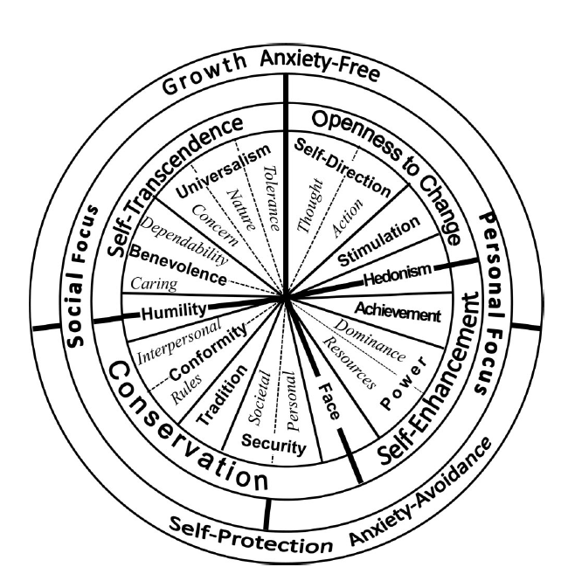

Reproduced from Schwartz, 2012, p. 669, (highlighted higher-order LIB values is our own addition).

Figure 2: Theoretical model of direct and indirect relation between religiosity, liberal and conservation values and liberal attitudes towards social policy

A picture containing text, map

Description generated with very high confidence

Figure 3a: Mean Scores of Support for Liberal Social Policies

By level of religiosity in 14 cultures

Figure 3b: Percentage of highly religious and non-religious students (n=4964) in the 13 countries the YARG Study

Figure 4: Path analysis of overall YARG sample, from individualism/collectivism cultural index to social policy preferences via gender, religion and liberal values

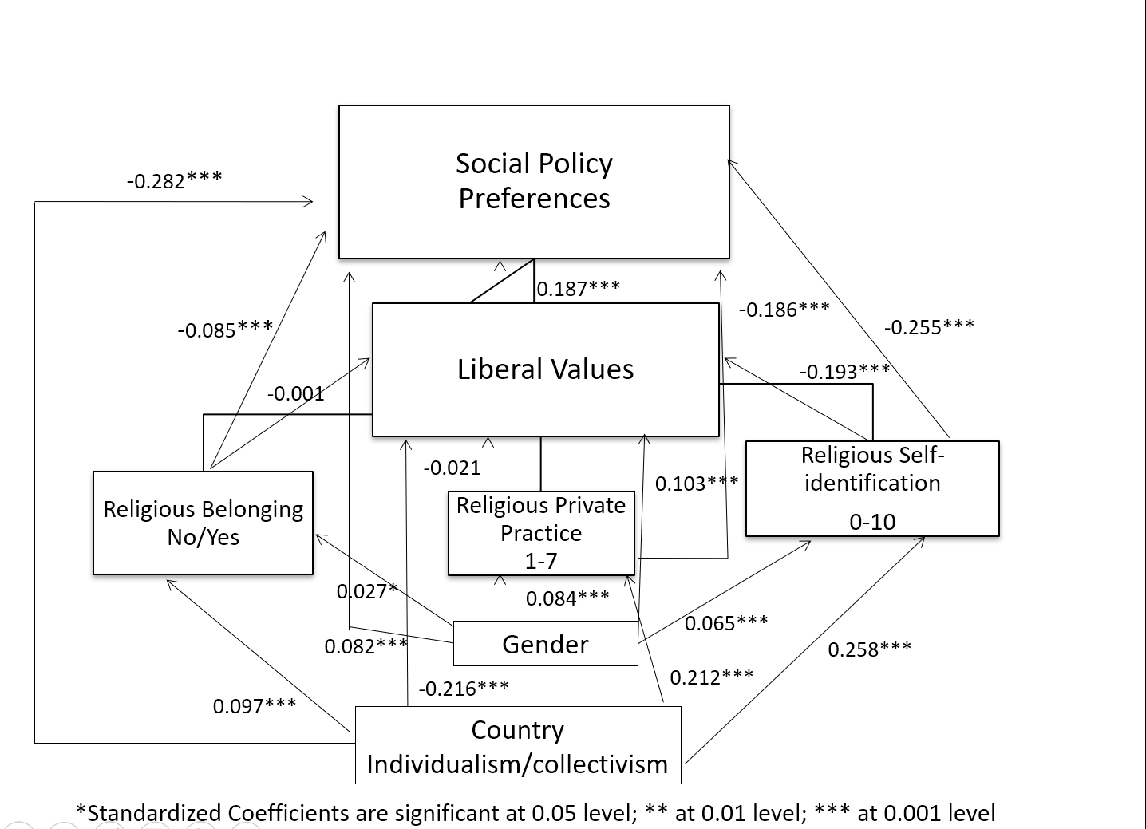

Figure 5: Path analysis of overall YARG sample, from Individualism/collectivism cultural index to social policy preferences via gender, religion and conservation values

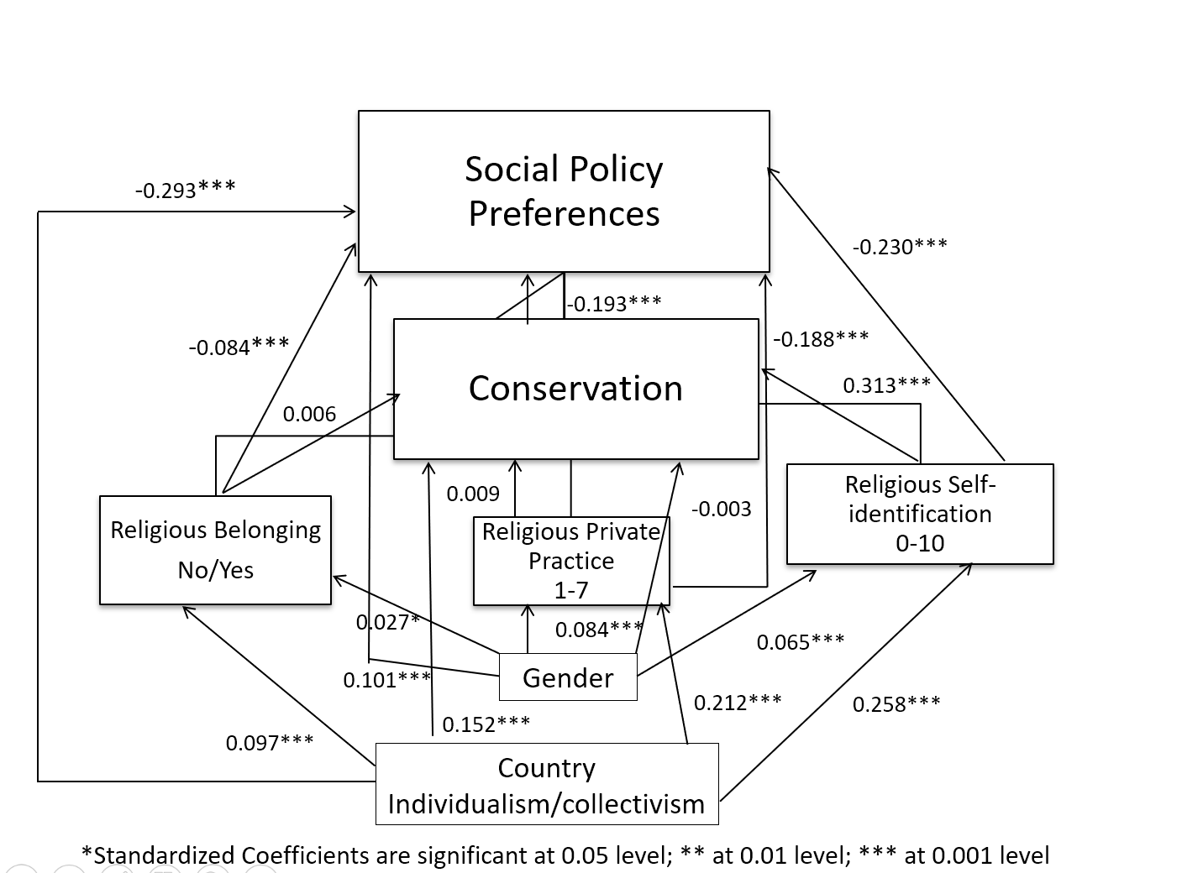

**Tables:**

Table 1: Rankings of 13 YARG countries by their location on Hofstede's (2011) ranking of 76 countries by cultural dimensions I/C and PD

|  |  |
| --- | --- |
| Individualism/collectivism | Power distance |
| Most individualism | Lowest power distance |
| 1: USA | 1: Israeli Jews |
| 2: Canada | 2: Sweden |
| 3: Sweden | 3: Finland |
| 4: Finland | 4: Canada |
| 5: Poland | 5: USA |
| 6: Israeli Jews | 6: Japan |
| 7: Japan | 7: Peru |
| 8: India | 8: Turkey |
| 9: Russia | 9: Poland |
| 10: Turkey | 10: Israeli Arabs |
| 11: Israeli Arabs | 11: India |
| 12: China | 12: Ghana |
| 13: Ghana | 13: China |
| 14: Peru | 14: Russia |
| Most collectivism | Highest power distance |

Table 2: Linear Regression - Predictors of Social Policy Preferences

|  |  |  |
| --- | --- | --- |
| **Variable** | **Standardized Beta Coefficient** | **R Square Change** |
| Religious self-identification | -0.225*** | 0.273 |
| Individualism/ collectivism | -0.276*** | 0.108 |
| LIB values | 0.126*** | 0.036 |
| Private-religious practice | -0.183*** | 0.024 |
| CONS values | -0.131*** | 0.010 |
| Gender | 0.087*** | 0.008 |
| Religious belonging | -0.085*** | 0.005 |
| *<0.05; ***<0.001 |  | **R2=0.464** |

Table 3: Support of Social Policies Regression Analysis for each Country by LIB values and Religiosity

|  |  |  |  |
| --- | --- | --- | --- |
|  | **Standard Coefficients** | |  |
| **Country** | **Religiosity** | **Liberal values** | **R2** |
| Israeli Jews | -0.688 | 0.091 | 0.508 |
| Finland | -0.584 | 0.137 | 0.366 |
| Poland | -0.51 | 0.222 | 0.364 |
| Sweden | -0.466 | 0.136 | 0.242 |
| Canada | -0.434 | 0.238 | 0.282 |
| Israeli Arabs | -0.404 | 0.186 | 0.22 |
| Russia | -0.395 | 0.313 | 0.318 |
| Peru | -0.387 | 0.271 | 0.269 |
| Turkey | -0.342 | 0.286 | 0.254 |
| U.S. | -0.327 | 0.262 | 0.197 |
| India | -0.205 | 0.165 | 0.084 |
| Ghana | -0.201 | 0.0871 | 0.048 |
| China | -0.0981 | 0.0481 | 0.011 |
| Japan | -0.0361 | 0.209 | 0.046 |

Table 4: Support of Social Policies Regression Analysis for each Country by CONS values and Religiosity

|  |  |  |  |
| --- | --- | --- | --- |
| **Country** | **Standard Coefficients Religiosity** | **Standard Coefficients Conservation** | **R2** |
| Israeli Jews | -0.666 | -0.088 | 0.506 |
| Finland | -0.516 | -0.218 | 0.39 |
| Poland | -0.488 | -0.167 | 0.339 |
| Sweden | -0.45 | -0.143 | 0.244 |
| Canada | -0.421 | -0.174 | 0.254 |
| Russia | -0.42 | -0.224 | 0.274 |
| Israeli Arabs | -0.383 | -0.216 | 0.231 |
| Peru | -0.329 | -0.258 | 0.252 |
| Turkey | -0.3 | -0.322 | 0.267 |
| U.S. | -0.291 | -0.254 | 0.19 |
| Ghana | -0.184 | -0.0841 | 0.047 |
| India | -0.172 | -0.244 | 0.113 |
| China | -0.098 | -0.142 | 0.029 |
| Japan | -0.0421 | -0.106 | 0.013 |

1 Not statistically significant

1. Some studies on values and ideology have used the conservative-liberal distinction, while others have used the left-right distinction. Typically, the former implies a broader range of attitudes on social and moral issues while the latter refers to political voting preferences. The differences between the two are often a matter of convention. In some countries such as the U.S. and the U.K., use of the terms “conservative/liberal” (consequently used in survey questions) is preferred, while most European countries prefer the left/right distinction. Often the two sets of terms are used side by side or interchangeably, with “right” mapping onto “conservative” and “left” mapping onto “liberal” (Caprara et al., 2017). We follow Schwartz in preferring the terms “conservative/liberal” because of their broader range and utility (Schwartz, Researchnet, May 2018).
2. This does not mean that liberalism-conservatism is the *only* meaningful dimension organizing political ideologies. A multi-dimensional space probably better reflects political ideology differences among individuals (Schwartz, Caprara & Vecchione, 2010), with the liberal-conservative polarity being one of them (Barnea & Schwartz, 1998).