**English in the Palestinian Linguistic Repertoire in Israel**

1. **Introduction**

The political upheavals following the 1948 war between Israel and its neighbours, the defeat of the latter and the establishment of Israel brought about far-reaching structural and functional changes in numerous domains of life in Israel, including language. The linguistic repertoire of the Palestinians citizens of Israel became more complex and diverse and the status of languages in their community changed. Hebrew and Arabic became the two official languages of the state, and English took on the status of a foreign language (Amara & Mari 2002; Saban & Amara 2002; Spolsky and Shohamy 1999a).

Today, the linguistic repertoire of Palestinian citizens in Israel is complex and diverse. Arabic is the language of personal, cultural and national identity. Hebrew is important for social mobility, higher education and shared citizenship. English, as a global language, is a window onto the wider world (Amara, 2014).

In language education, Arabic, the mother tongue of students and teachers alike, is the medium of instruction in schools for Palestinian students. Hebrew, recognized as the language of the state (Hallel & Spolsky 1993; Amara 2015), and studied mainly for instrumental purposes, is studied as a second language from the second grade on, or even earlier.[1] English, as a major international language, is taught as a foreign language from the third grade on. In addition, French is studied in a number of private religious schools as a second foreign language (Amara & Mari 2002).

For most Palestinians in Israel, Hebrew is the most important second language, even more important than English, and, at times and in some domains, even more important than Arabic (Shohamy & Donitsa-Schmidt 1998; Amara & Mari 2002). Not knowing Hebrew limits Palestinian citizens in their contacts with government offices, in employment and in higher education. Hebrew is now the main source of loanwords in Palestinian Arabic in Israel (Amara 1999; Amara & Spolsky 1986).

Hebraization is one of the most important sociolinguistic changes to occur in the Palestinian linguistic repertoire in Israel. However, there is also a place for the English language in their linguistic repertoire and landscape. That is attributable to the facts that (1) English was the official language during the British Mandate in Palestine and (2) English is currently a compulsory subject from the third grade to the twelfth grade. Moreover, English is undoubtedly the language of globalization. I will start off by discussing English teaching in Palestinian schools and continue by investigating borrowing from English and the impact of English on the pupils’ linguistic landscape in the shadow of globalization. Finally, I will examine the trend of writing Arabic using the Latin alphabet.

1. **English teaching in the Palestinian schools in Israel**

English is the most commonly-used foreign language in Israel. It plays a vital role in both the public and the private domains, in the media, in academic scholarship, in accessing knowledge in various fields, and as a lingua franca with other countries (Spolsky & Shohamy, 1999b). In addition, the country’s laws are also finally being published in English.[2]

English is the second most important language in Israel and is formally the first foreign language taught in both Jewish and Palestinian Arab schools. The study of English is subject to the same national curriculum for both Jewish and Palestinian communities, since they are both supervised by the same chief inspector who in turn is guided by the same professional advisory committee (Inbar-Lourie, 2010).

English is as important to Palestinian Arabs in Israel as it is to Israeli Jews owing to its status as the international language of science, technology, commerce, communications and tourism. There is constant pressure from both Palestinian Arab and Israeli Jewish parents on their children to study English; they are prepared to spend considerable sums of money on private lessons. The pressure is particularly evident in neighbourhoods where there are church-affiliated schools which begin to teach English in the first grade. Parents believe that proficiency in English will advance their children, especially those who are keen to pursue studies in institutions of higher education (Amara, 2014; Amara & Mar’i, 2002).

However, for Palestinian Arab students, the study of English is fraught with unique problems. While many Israelis have regular contact with English speakers such as English-speaking immigrants in the neighbourhood, English-speaking relatives in the Diaspora or English-speaking tourists who come to the cities, Palestinian Arabs, citizens of Israel, generally lack opportunities for direct contact with English-speaking communities. In addition, English is ranked as the third language that they study at school. Few members of the adult community know English, and Palestinian Arab schools have a very low proportion of teachers who speak native or near-native English.

All the above conditions render the learning of English more difficult for Palestinian Arab students.[3] However, in recent years, as a result of the internet, television, movies and music, Palestinian students in Israel have had greater exposure to English and more opportunities to use it (Mahameed, 2014). In addition, the Palestinian Arab landscape in Israel contains many English names and words, reflecting the increasing importance of English in their linguistic repertoire (Amara, 2010).

Despite their awareness of its importance, the acquisition of English is not among the main interests of the majority of Palestinian Arab students. English is relegated to second place because these students must first grapple with their own Arabic mother tongue, which is characterized by an immense difference between the spoken and the written language. They must then become familiar with Hebrew, which is vital to them in daily life. Finally, there is English, a language whose study is teacher-centred and frontal for the most part and rarely spoken by the students (Keblawi, 2006). These facts demonstrate that students must master a number of unique skills simultaneously in order to be able to absorb these three very diverse languages taught in the schools. Are these factors taken into account in the curriculum and the textbooks? What can we learn from the achievements of Palestinian Arab schoolchildren in English? The following sections will answer these questions.

**2.1 The New English Curriculum**

In the curriculum that was implemented after the establishment of the State of Israel (1948-1969), English was perceived and taught in Israeli schools as a cultural and literary subject, with the emphasis on linguistic competence rather than on the communicative functions of the language.

Major changes have occurred in the English curriculum in Israeli schools since the 1970s. There has been a shift of emphasis from teaching English as a cultural and literary subject to communicative competence (Spolsky & Shohamy 1999a, p. 174).

In 1998, a new English curriculum was approved for Israeli schools. Spolsky and Shohamy (1999a, p. 181) argue as follows:

The circumstances today, and even more in the foreseeable future, are quite different. More and more pupils have extensive contact with English before beginning formal English instruction or outside of school, whether through radio, television, computers, family, travel, or meeting overseas visitors. Most pupils, at whatever age they start learning English in school, have already learned words and phrases of the language.

Taking these developments into consideration, curriculum designers have set new standards for English. These standards are extremely flexible, giving schools and teachers freedom, for instance, to determine both the appropriate methodology to be used and the order in which to teach the elements of the curriculum.

The new curriculum differs from its predecessors in important ways. Whereas previous curricula were taught according to the four language skills, the new curriculum places greater emphasis on *what* should be achieved along with *how* the language should be acquired. According to the new curriculum, teachers are encouraged to focus on domains rather than skills. Domains are defined as ‘areas of language ability or knowledge’. Four major domains are proposed: social interaction, access to information, presentation, and appreciation of literature, culture and language. Moreover, the domains are viewed as a tapestry of interwoven areas of language learning, signifying that the four domains are interrelated and do not operate in isolation.

The English curricula in Israel were identical for both Palestinian Arab and Jewish Israeli students during the first two periods following the establishment of the state, meaning that the sociolinguistic and cultural needs of the Palestinian students were not taken into account (Abu-Salih, 2011). This was also true for other disadvantaged Israeli socio-economic groups.

In contrast, the new curriculum generates the hope that various groups will adapt English teaching to their unique sociolinguistic and cultural needs. However, this may be futile, since the English matriculation examination is uniform for all students in Israel. This may lead Palestinian Arab teachers to adopt teaching methodologies and textbooks used by the more established groups in Israel.

**2.2 Textbooks**

Language learning and teaching are, of course, associated with power. If language teaching is ideologically influenced, as reflected by the goals of the curriculum and the contents of the textbooks, it can be labelled ‘ideological language teaching’. Rahman (2001, p. 55) defines it as ‘the transmission of ideas, values, and perceptions of reality that create or influence one’s world view through language teaching, especially language texts.’

In Israel, Palestinian Arabs and Jews use the same English textbooks. There are no specific texts that are devoted to the Palestinian Arabs and this upsets the balance that exists in the curriculum. Although the Palestinian Arabs learn about Jews and Western culture, they do not learn about their own culture.

The English textbooks are well-designed and well-produced. However, the Palestinian students are invisible in these textbooks; one can barely find a picture of Arabs. And while literary texts from various cultures do appear in the readers, there are no Palestinian or Arab ones (Abu-Salih, 2011; Zaher, 2011).

An examination of the English textbooks reveals that there is a culturally-insensitive socio-cultural, faith-based defect in the learning materials (Abu-Salih, 2011). Research (e.g., Ellis, 1997; Valdes, 1987) has shown that if the learner accepts the target culture, he or she may accept its language. It has also shown that the reflection of students’ culture in various texts in the studied language facilitates the learning process (e.g., Cortazzi & Lixian, 1999).

Clearly, when it comes to the Palestinian Arab students, two of the four domains mentioned in the aforementioned curriculum (namely, social interaction and appreciation of literature, culture and language) are not reflected in the textbooks.

The curriculum explains the basic principles for selecting contents, which should be unbiased and prejudice-free and take into account different religious, cultural and ethnic backgrounds in addition to being stimulating (Ministry of Education, English Curriculum for All Grades, 2013). Contents should also be related to students’ prior experiences and knowledge so as to enable them to identify with these tasks more effectively. These principles are not reflected in the various textbooks with regard to the Palestinian Arab students.

Opinions are divided on the desirability of writing English textbooks that earmark Palestinian Arabs. Some teachers are in favour of the idea while others reject it outright. The latter believe that such books would have a deleterious effect on the level and quality of teaching. They suggest solving the problem by establishing a committee of Palestinian Arabs and Jews who would rewrite neutral contents that are relevant to both groups in the same reader (Amara & Mar’i, 2002).

**2.3 Achievements**

Having examined the English curriculum and textbooks, we will now briefly highlight Palestinian Arab students’ achievements in English as reflected in various tests and compare them to those of the Jewish students.

According to the results of the national tests administered to all students in the Israeli school system ‒ such as the *Meitzav* (growth and effectiveness measures intended for grades five and eight in mother-tongue languages and English), the *Bagrut* (matriculation exams) and the psychometric test (the university entrance exam) ‒ the achievements of Palestinian Arab students in English are extremely poor. (For more details, see Amara & Mar’i, 2002; Ministry of Education, Final Report ‒ Recommendations of the Committee Examining Achievements in Palestinian Education, 2008).

*Figure 1**Average results of the MEITZAV examinations in English for grade 5 from 2007 to 2010 according to national groups.*

Taken from RAMA (The National Authority for Measurement and Evaluation in Education, 2010, p. 14).

Figure 1 shows that Hebrew speakers achieve better results than Arabic speakers. It also shows that the disparity has increased slightly in favour of the Hebrew speakers ‒ from 28 points in 2007 to 38 in 2010 ‒ although both groups share the same school system, the same curriculum and the same textbooks.

This is also true of the matriculation examination for students in the 12th grade. Students may take the English exams at three levels: 3, 4 and 5 points. There is a disparity of almost one point and a difference of 10 marks on average between Palestinian and Jewish students ‒ again in favour of the latter (Weisblai, 2006, p. 20).

Results for the verbal section of the university entrance exam show that Hebrew speakers score 109-110 in Hebrew on average while the scores for speakers of Arabic in Arabic are 88-91. In the English section, the scores for Hebrew speakers range between 110 and 112 while speakers of Arabic score between 84 and 87 (Mustafa, 2009). In short, the achievements of the Arabic speakers in English are greatly inferior to those of their Jewish counterparts at all stages of education.

To sum up, although the English curriculum is uniform in all Israeli schools, there are crucial differences between the Palestinian Arab and the Jewish communities in terms of contact and exposure to English language and culture, with Jews having numerous opportunities for English input outside the school walls. The various tests reveal much poorer achievement levels by Palestinian students as compared to those of Jewish students.

In light of the above, it is essential that the policy governing the teaching of English to Palestinian students in the Israeli context take into account the impact of the diglossic nature of Arabic on the other languages in their complex linguistic repertoire.[4]

In a nutshell, the problems of English teaching in the Palestinian schools are evident in many aspects. The current policy of teaching English, as reflected in the new curriculum, fails to take the special needs of the Palestinian students into consideration. It is imperative that the new curriculum inspire the hope that the resounding failure of Palestinian students to learn the language can be remedied. A curriculum that could lead to a considerable change in the situation should take into account the major issues related to their language repertoire: (1) diglossia and the difficulties it causes for the Palestinian students; (2) the Latin alphabet as the third writing system learnt; (3) learning Hebrew as a priority among Palestinians; (4) the fact that the majority of Palestinian Arabs live in villages and are less exposed to English; (5) teacher qualifications; and (6) the texts, which abound with Jewish and Western contents.

**3 Borrowing from English**

Arabic in Israel has borrowed many lexical items from English since the latter was an official language of mandatory Palestine and was taught as a global language in Palestinian Arab schools from an early age.

In a study conducted by Amara and Spolsky (1986), there were 96 participants (48 males and 48 females) divided into four age groups: 6-12; 12-15; 15-22; 22-50. The study revealed extensive borrowing from English into Arabic. However, the borrowing varied according to domains. In traditional domains, such as food and kinship, the borrowing was very slight. In the domain of food, for instance, 81 words were reported: 71 Arabic, five Hebrew, three English and two foreign words. According to an availability measurement,[5] neither English nor Hebrew words appeared among the first 20 items. In other words, the contact between Arabic and other cultures in the traditional domains is negligible. As a result, there is little borrowing (Amara & Spolsky, 1986, p. 47).

In modern domains, such as electronics and transportation, there is the greatest innovation, resulting in extensive borrowing from Hebrew and English. In electronics, for instance, the participants reported 61 items: 29 Arabic, 20 English, 11 Hebrew and one from another foreign language. In other words, English and Hebrew constituted half of the total items. In this domain, Hebrew items did not appear among the first 20 words. There were, however, six English words in that group, namely: *tilvizyo:n* (TV), *ra:dyo* (radio), *la:mba* (lamp), *ifu:z* (fuse), *vidyo* (video) and *talafo:n* (telephone) (Amara & Spolsky 1986, p. 47).

As regards mixed domains such as health and construction, which existed prior to the contact with Jews, the lexicon shows evidence of increased borrowing. In the health domain, for instance, 92 items were reported. Of these items, 50 were Arabic, 31 Hebrew, 10 English and one foreign. Hebrew and English constituted half of the total items. Among the first 20 items, there were five English and three Hebrew words. The English words were: *dakto:r* (doctor), *na:rsi* (nurse), *isbirin* (aspirin), *influwanza* (influenza), *isbiTa:r* (hospital) (Amara & Spolsky, 1986, p. 48).

This was three decades ago. Unfortunately, no studies have been conducted recently indicating whether the borrowing has increased or decreased. However, we postulate that the borrowing has increased owing to the fact that Palestinian Arabs in Israel begin learning English from an early age (third grade), there is more extensive contact among young people via social networks on the internet, there is globalization, resulting in the increasing importance of English in various domains of life. The following two sections furnish more evidence of the spread of English in the Palestinian Arabic repertoire in Israel.

**4 Globalization and English**

Globalization also has linguistic consequences. Language is a means of communication and social interaction, and new technologies (e.g., internet and satellites) enable individuals ‒ regardless of their geographic location ‒ to communicate with one another. In the new reality, English is considered a global language and the international lingua franca. The ubiquity of English is one of the results of globalization. This accounts for the importance of learning and teaching English in various parts of the world. The new linguistic situation imposes the hegemony of the English language on everyone who wants to be involved in the world of scientific developments and this undoubtedly has consequences for the Arabic language in general and Arabic in Israel in particular. There is a close connection between language hegemony and cultural, technological and economic power. Language accrues power according to the power of its speakers ‒ mainly in the military and political arenas.

Globalization is the outcome of the development of technology, science, transportation and communications. The world has become a small, borderless village. One of the results of globalization is the advent of addresses of internet websites or electronic mail in English in the linguistic landscape. Even when people write in Arabic, their e-mail addresses and internet websites appear in English. These become important means of communication between consumers and commercial enterprises.

As to the Spread of English in the Arab World, Al-Anani and Barhuma (2007) describe the use of English in Jordan, which is not different from most Arab countries. The use of English is reflected in the following domains: early childhood education; legal and commercial transactions; everyday life; store signs; cookery and restaurant menus; jobs; text messages, which are written in English or at least in Latin letters; advertisements in Arabic newspapers; clothes and notebooks, and so on.

It is not only the influence of commerce, technology and science that is reflected in the Palestinian linguistic landscape. The names of international fashion companies such as Pierre Cardin, Tommy Helfinger, Lacoste, Nautica and Polo Club appear in Latin letters. This may mean that the stores prefer foreign names as a sign of prestige – perhaps because there is a dearth of high-quality Arab brands.

In the linguistic landscape, we also observed the names of stores such as ‘Roma Pizza’, ‘San Paulo’ (a restaurant), ‘Milano Pizza’ and ‘Disney Kids’ without any Arabic words on the sign (see picture 1).

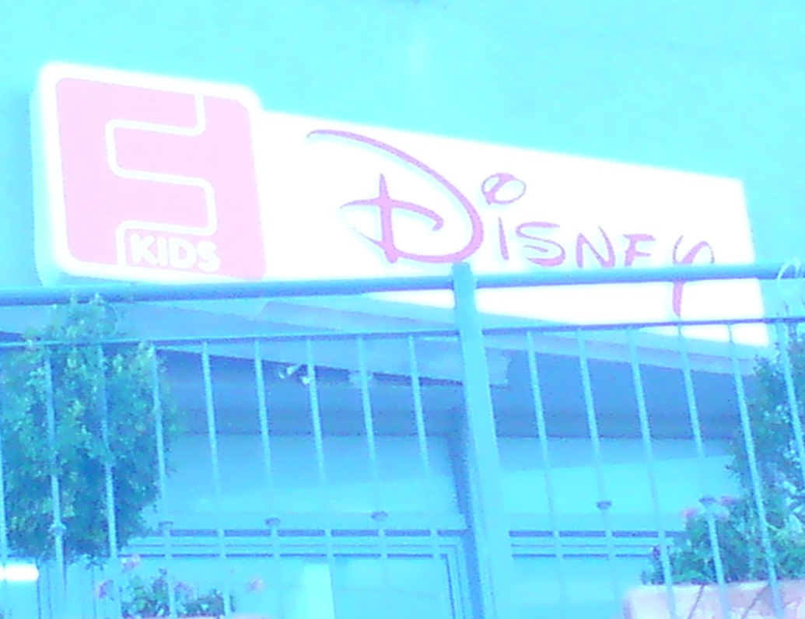

*Picture.1 English-only sign.*

Words such as ‘sale’ also occur frequently despite the fact that they could easily be replaced by the equivalent Arabic words. In other cases, English words such as ‘chicken baguette’ are used, albeit in Hebrew letters. The names ‘New York’, ‘Discount Bank’ and ‘Tours’ appeared in Arabic letters.

There are words that are translated literally from English into Hebrew, and the words appear on the linguistic landscape as מדיה סנטר [media centre], נט [net] and סטאר [star]. This demonstrates that while Arabic has not succeeded in transliterating the letters or translating the words, Hebrew has. It also shows that globalization is always not conveyed directly from English to Arabic, but rather via the Hebrew language.

**5. Writing with Latin and Hebrew letters**

Writing was one of the most important factors in preserving and propagating human languages. Language played a pivotal role in human development and in building a knowledge society. The advent of printing added more vitality to language, enhanced its usage and ensured its dissemination. Modern technology (computers, internet, satellite, cell-phones, etc.) sparked a revolution in the patterns of communication and interaction ‒ a revolution in which language played a central role. It became much easier to communicate and be exposed to different languages, dialects and texts via the new technologies, documentation, and so on. This signifies that mankind has entered a new era of knowledge in which the new technologies play a different and important role.

For centuries, the Arabic language was written in Arabic letters, mainly in the standard variety due to diglossia. During the last two decades, Arabic writing has witnessed unprecedented changes thanks to modern technological developments. Arabs have started to write in their local dialects on smart phones, sometimes in Arabic letters ‒ and, among the Palestinians in Israel, even in Hebrew letters or Latin letters with the addition of numbers in order to replace the missing letters in Arabic. For instance, the letter /ʔ/ is no. 2, /ʕ/ 3, /ɣ/ 3’, /ð/ 4, /x/ 5, /tˤ / 6, /ðˤ/ 6’, /ħ/ 7, /q/ 8, /sˤ/ 9, /dˤ/ 9’. Following is an example of a message sent by one friend to another on a smartphone:

*2ibti3rif 2innu sa7bak biddu yitjawaz 2ishahr 2ijay?* [Do you know that your friend is getting married next month?]

Writing in Latin letters began as a solution to the computer keyboards and cell-phone keypads that were initially available only in English. Arabic speakers were compelled to use the Latin alphabet for writing Arabic, and, as described above, used numbers as alternatives for missing Latin letters. This phenomenon was greatly reduced when Arabic-language keyboards became available (Younis & Lebio, 2015).

Nowadays texting among Palestinian Arabs in Israel via the internet and smartphones is conducted in various languages: local dialect, standard Arabic, Hebrew and English as well as a mixture of Arabic and Hebrew (Mar’i, 2013).

Arab speakers choose also to use the Hebrew alphabet for writing messages in Arabic. For instance, among friends, the following expressions are common in their communication: אללה יעטיקום אלעאפיה *allaha yitikum il’afiy* [Godspeed], כל עאם ואנם בכיר*kul ‘am wantum fxeir* [Happy festival] and מברוק *mabruk* [Congratulations].

These phenomena are all indicative of the dramatic change in the use of the Arabic language which, for centuries, was written only in Arabic letters in accordance with the standard variety.

**6. Conclusion**

In this paper, we have shown that English has begun to play an important role in the Palestinian Arab linguistic repertoire. Not only did it become a compulsory language for children in the early grades, but young people are more exposed to the language thanks to modern technology. Palestinian Arabs have started to recognize the importance of this language for academic purposes, economic benefits and other reasons such as communicating with people during their travels abroad.

English is no longer viewed as a foreign language but rather as a language that occupies a clear space in their linguistic landscape. Nowadays, merchants and academics understand that their advancement is contingent on their knowledge of English and that its use assigns a high status to its user. Amara (2010) shows how English has begun to occupy the third place (after Arabic and Hebrew)on road signs, and in cities such as Nazareth, English has become a prominent language. English, with its connection to globalization, is reflected in the Palestinian linguistic landscape. However, Hebrew is still the most influential language and poses the biggest challenge to the Arabic language.

1. In 2015, the Ministry of Education presented a new program aimed at improving Arabic-speaking children’s proficiency in spoken Hebrew from the kindergarten stage. The program seeks to improve pupils’ competence in Hebrew. Minister of Education Naftali Bennett explained that ‘the decision to bring forward the study of the Hebrew language to preschools in the Arab sector stems from thinking about the children’s future. We believe that since students from Arab society will be dominated more by the Hebrew language, integration into the economy, employment and society will be better and easier’ (http://www.haaretz.co.il/news/education/1.2707551).
2. This section is mainly based on Amara (2014).
3. It should be noted that similar handicaps are faced by new immigrants and by socio-economically disadvantaged Israeli Jews.
4. For greater detail, see Amara, 2014.
5. Availability is described by William Mackey (1970) as not being the same as integration; it can, however, “be described as a measure of the degree to which an item comes to mind as belonging to one code or other of the bilingual” (p. 204). In order to determine the index of availability, we first select domains. We then ask the speaker of the language to tell us the first words he thinks of in this domain.