Article

Transparent Substance in a Transnational Existence: Migration, Gender, Memory and Materiality - The Case of Israeli Artist Alina Rom Cohen

**Abstract:** The article discusses the art of Alina Rome Cohen (b. 1973), a woman artist from the Former Soviet Union who immigrated to Israel. Her glass sculptures highlight her hyphenated, multilayered and dynamic identity, illustrating identity construction processes of immigrant women under conditions of uprooting and re-grounding in the globalized era of transnationalism. The discussion feeds from theories influences by "the material turn," suggesting that artifacts "speak." I will therefore argue that the material – glass – is involved in active discussion and negotiation of power relations within society. Framed through Alfred Gell’s anthropological theory of art, first introduced in Art and Agency (1998), this approach proposes a horizon of agency for the artworks themselves, which function in the world alongside other actants operating in the field, such as human beings. The article will analyze a show case of art works and will be informed by cultural theories from migration studies and gender studies, in order to ask new questions about the dynamics of exclusion and inclusion of migrants under the ethno-national state of Israel, while offering alternative ways by which to think of concepts such as memory and time, as it brings past and present to a simultaneity.

**Keywords:** Israeli Art; Gender; Migration; Material Turn; Anthropology of Art; Glass sculpture

1. Introduction

This paper deals with identity construction processes under conditions of uprooting and re-grounding, through the case study of Alina Rome Cohen (b. 1973), a woman artist from the Former Soviet Union who immigrated to Israel. As studies show, migration is not a singular event in time, but rather an on-going process that is negotiated within the self and with various social groups in the host society (Ahmed, 2000; Baubock and Faist, 2010; Beneria et al, 2012; Jurarez et al., 2013; Dekel, 2016; Guilat, 2019). In order to critically discuss these complex issues, I will use a mixed methodology, both qualitative, interviewing the artist so that she can convey at first hand her thoughts and feelings about her migration and identity, as well as a theoretical approach, using cultural theories from migration studies and gender studies, while the entire discussion will be organized and informed by the approach known as the material turn.

The study focuses on sculpted works representing of memories affected by migration. In her glass sculptures, Rom Cohen expresses memories from the old homeland as well as thoughts about her current identity in the new country. She formalizes them in the material, while critically conceptualizing the ways in which they are constructed. This paper feeds from the postmodern approach suggesting that the artifacts themselves “speak,” thus even if the artist herself chooses to only partially articulate her experience in words, significant understandings can be drawn from the material itself, as it speaks and self-narrates. I will therefore argue that the material, glass, is involved in an active discussion of the processes of exclusion and inclusion of migration under the conditions of the ethno-national state of Israel, an immigration country in essence, established in 1948.

A wide range of questions arise from the analysis of Rom Cohen's work, and include points such as what are the ways in which objects and materials participate in the world and the political life and to what extent is agency identifiable in them? What are the means by which to discuss artifacts, whether in terms of their carrying meaning and memory or participating in social life? How does the material in works of art represent the artist’s immigration experience and memories? And finally, how can “material turn” theories be intersected with theories of gender, migration, and transnationalism in discussing the artworks of women who create objects of memory related to their immigration, and which are intertwined with feelings of exclusion and marginality as a result of their social status?

To answer these questions and explore issues of materiality and memory work, I draw on Alfred Gell’s anthropological theory of art, first introduced in Art and Agency (1998). This theoretical framework repudiates the conventional view of representations as providing cultural explanations or the exploration of creative artistic processes within social-cultural contexts. This approach proposes a horizon of agency for the artworks themselves, which function in the world alongside other actants[1] operating in the field, such as human beings (Gell, 1998: 17). Both works of art and human beings, according to Gell, act within an intricate and dynamic framework of power relations in which they are mutually influenced by one another. Thus, Gell’s theory will serve as an insightful tool of analysis of issues on identity in Rom Cohen’s work.

From this perspective, I will also propose that the material itself—glass—innately subverts the common perception of temporality and problematizes the modernist concept of “time”. Modernist thought perceives time in terms of linearity, as spanning from early to later events, in sequential continuity. In other words, the material, glass, will help substantiate my argument that immigration is a continuous process, which moves forward and backward in a fluid and dialectic manner upon the continuum of time, thereby fusing past and future, memory and present events.

Finally, I aim to show that Rom Cohens’ unique usage of material[2] expresses the artist’s hybrid and marginal position constituted in an identity split upon axes of gender and nationality. Just as the status of sculpting in glass is considered unusual and inferior in Israel’s elitist art world, relegated to its margins, so too Rom Cohen—as a woman, immigrant, and artist—has so far not received significant recognition in the art field. For Rom Cohen, glass constitutes a means to express the ways in which she navigates the multiple layers of her identity. I will suggest that Rom Cohen’s use of glass constitutes a deliberately defiant and oppositional statement—she allows the material speak in her place, to say what she cannot, or will not, say.

**2. Migration and Art in a Globalized Era**

The contemporary era of mass migration under transnational existence poses new challenges for understanding art and identities of migrant subjects, which have become increasingly complex and multi-layered, flexible and fluid, no longer answering to any single criterion (Demos 2013, Elkins *et al.* 2010, Harris 2011, Mathur 2011, Mercher 2016, Ring Peterson 2017). The effort to conceptualize and articulate this issue in art in relation to "the Israeli identity", becomes especially complex when examined in the context of the State of Israel (Avron Barak 2020, Guilat 2019, Gashinsky 2019), and the particular focus on young women immigrants from the Former Soviet Union, in particular, fits to unpack such issues.

The influx of approximately one million Former Soviet Union immigrants between 1990 and 2010 substantially altered the nature of the Israeli populace – which totaled 7.5 million at the time. As many of them arrived in Israel on the heels of the collapse of the Soviet regime, they are often perceived in Israel as straightforward "economic migrants" whose ties to Zionism and the state of Israel are instrumental rather than sincere (Philippov 2010, 3). Highly critical of this perception, the Former Soviet Union artists engage with that claim, addressing themes related to their assimilation into the Jewish-Israeli society and to their exclusion from it, with particular reference to their unique and hybrid gendered and national position.

The liminal and multi-layered positions reflected in the art of those immigrants, provides a rich case study of the shifting identities of Israelis in the transnational age, as shown in the studies conducted by scholars such as Tal Dekel and Yael Guilat (Dekel 2016, Guilat 2019). Focusing on artworks that discusses the influence of such experiences as uprooting and discontinuity caused by migration on the complex processes of their identity construction, while considering the age bracket of the so-called "1.5 generation" of immigrant women, captures a particularly rich swath of the immigrant experience and its attendant challenges (Dekel, 2018). The term designates immigrants who arrived at the destination country between early childhood and late adolescence. In the Israeli case, these immigrants, who arrived from the Former Soviet Union as girls or youths in the early 1990s, are now in their 40s. Like all 1.5 generation immigrants, they can be seen as constituting a liminal group insofar as they neither experienced the full process of uprooting like first-generation immigrants nor were born in the destination country like second-generation immigrants. Instead, they lie between the old and new worlds, their lives a distilled illustration of the formative and ongoing nature of the process of migration. Experiencing immigration at a stage of life in which extreme transitory processes of identity (including gendered, national, religious, and others) accrue simultaneously, this group of Ex-Soviet women constitutes a fascinating example of the deep and multi-faceted transformations and challenges entailed by migration.

Understanding the complexity of their position, requires attending to the original context which shaped the identity of these Former Soviet Union women immigrants and then considering the long-term processes they undergo in Israel. As they face successive challenges in their new home, from State laws to powerful cultural stereotypes among the veteran Israeli public, these women respond to their shifting identities through artistic means.

As Tal Dekel shows in her studies (2016, 2018), hybrid subjects like that presented by artist Alina Rom-Cohen are characterized by a dynamic identity and therefore their work makes an important contribution to the discourse about Israeli identity. In keeping with this, I propose to conceptualize the issue through intersectional analysis, in order to consider identities along axes of gender and additional identity dimensions.

3. The Material Turn

The material turn is one of the most significant theoretical developments of recent years in the social sciences, humanities and the arts, as it forms a response to the so-called discursive turn of poststructuralism’s crisis of representation (Barad, 2003; Barrett and Bolt, 2013; Bennet and Patrick, 2010; Lange-Berndt, 2015; Riggins, 1990; Turkel, 2007). This turn explores the roles that material objects play in various forms of praxis and aims to disclose the ways in which materiality produces and exercises complex power relations. This is not to claim that material or material objects inherently possess power, in deterministic terms; but rather they should be examined in terms of their properties of effect and agency, as they participate in complex systems of power relations (Miller, 2005).

The fundamental principles of the material turn lean upon criticisms of other turns in the contemporary postmodern era, which oppose the dualist-deterministic view of the difference between the material and the conceptual and between the material and the cultural. This position aims to blur, and even obliterate, the dichotomic distinction between the natural and the social, between the human and the nonhuman (Barad, 2008; Haraway, 2000).

Amongst the prominent thinkers in this context of understanding the dynamics of the social field and powers structures operating within it is Bruno Latour, who explains that the different actions of all the actants in the field are part of a complex and intricate system of “establishing social meaning” (Latour, 1993). The ability to think about material and objects as acting in the world—that is, the recognition that not only humans act in the world—is largely based on Latour’s philosophy. Latour emphasizes the ways in which human and nonhuman agencies are connected in the form of a complex network as a result of the fact that agency is always related to positioning and location, and is not manifested in a void but rather in a system of relationships (Latour, 2001; 2006). Additional theoreticians developed the trajectory of the material turn aim to highlight the agency of objects and materials and their active power within a system of social-cultural power relations (Appadurai 1986). In this context, the human “I” is not an independent subject but rather a player who is itself semiotic-material; it is also an element simultaneously made of the human and nonhuman, the social and physical, the material and a-material in formations that invite comprehension from a perspective other than the outdated dichotomic view. Similarly, materials also need to be liberated from the dichotomic perception of their being mere-objects, and one must understand the ways in which materials actively participate in social dynamics motivated by the agency enfolded within them.

4. Glass as Material, Glass as Art

Henrietta Eliezer Bruner claims that glass is not dichotomous, as it always challenged and enchanted artists, and even prompted philosophers to think about the affinity between the artistic object and its materiality (Eliezer Bruner, 2015: 13).[3] During the melting process, glass takes on a molten form, which as it cools, gradually hardens into its solid form. In other words, glass is a non-crystalline, often transparent amorphous solid, and is often referred to as “super-cool liquid.” The material is comprised of silicon enriched with metallic oxides, which determine its level of opacity—from completely transparent to opaque, and tonality—from mono-toned to multi-toned (Eliezer Bruner, 2015: 13). While the glass is characteristically welcoming to chemical treatments or mechanical manipulations—such as cutting, engraving, etching, sand blasting, partial or complete coloring, and printing or painting on the surface with enamel and other materials—it invariably fractures rays of light in a distinctive manner. In contrast to other solid materials, such as wood or cloth, the molecular structure of glass, like water or air, is characterized by relatively large distances between its molecules which enable the transmission of light, resulting in its transparency (Direktor, 1993: 8).

Glass—simultaneously visible and invisible—is considered a type of mediator between the interior and exterior, at once physical and metaphorical. Its diverse and contrasting properties result in artworks in which the material is the message (Eliezer Bruner, 2015: 13). The capacity of glass to diffuse and transmit light, and particularly its transparency, forge its strong linkage to light and energy, and to notions of brightness and clarity, concealment and discovery, presence and absence. According to Eliezer Bruner, these qualities of glass, and its capacity for conversion from one state to another, are what render it appropriate for the visual expression of abstract concepts, such as time, memory, body, and spirit (Eliezer Bruner, 2015: 13). In his seminal work, Art as Experience, John Dewey addresses the essence of the artistic experience (1934). According to Dewey, the totality of a work of art is constituted in the materials form which it is made. Moreover, he argues that the material is not only the means by which the artist arrives at their objective but rather an integral part of the artistic product (like pigment is the painting, notes are the music, and the body is the dance). Following Dewey, in the process of analyzing Rom Cohen’s works, one will understand how her complex installations lead to a more deep and complex understanding of glass as an independent entity that speaks and conducts a multifaceted and fruitful dialogue with its surrounding.

5. Working in Glass—A Performative Act

Rome Cohen’s installation Hamtana (Waiting) (2014) portrays a young girl (Fig. 1). The physical body is sculpted down to the waist and its lower part is a skirt made of glass pieces assembled on an iron structure. The figure is made of pre-cut slivers of glass glued together with strong adhesives. This volumetric figure, whose internal part is also filled with glass shards, has sharp and distinct facial features—lips, nose, eyes, eyebrows, earlobes—and long flowing hair. Her thin arms are seen through the singlet that stretches from the shoulders to the waist. The girl’s hands are resting on the table that doubles as her skirt.

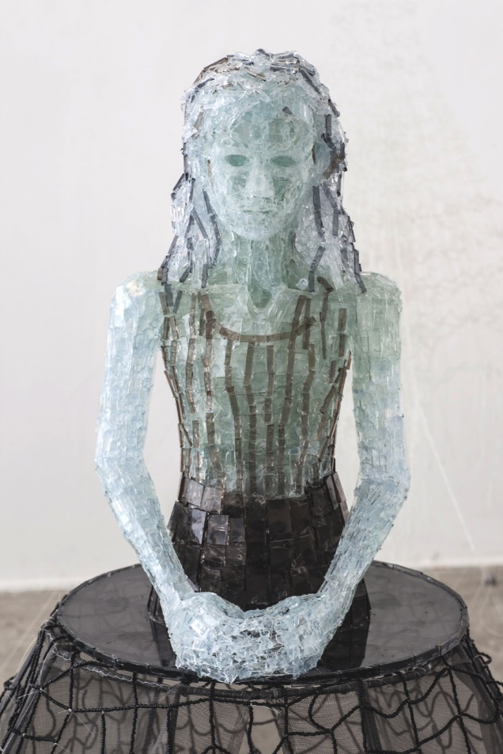

**Figure 1.** Alina Rom Cohen, Hamtana, 2014.

Like in all of her glass sculptures, here too the materials are glass and the method of using strong glue is unique in the context of the Israeli art scene.[4] In contrast to most other local glass sculptors, Rom Cohen does not melt and blow glass, but rather works with sheet glass manufactured for windows installed in residential buildings. This sheet glass is considered “pure” in the sense that its thickness is uniform, it contains no air bubbles, and is completely transparent. Rom Cohen’s technique includes cutting, breaking, and gluing together shards of glass according to a meticulously planned design. This is physically difficult and complex work, and she often cuts herself and injures her hands. Through the arduous process of connecting thousands of pieces of glass, Rom Cohen constructs figures in lifelike proportions. Despite what may appear as the jumbled assembly of glass shards, Rom Cohen follows a detailed blueprint to give the sculpture an authentic semblance of the human form. This approach of deconstruction and re-assembling is characteristic of her sculptured works, which all portray one-of-a-kind figures. At first impression, it looks like an unfinished work, as if it were abandoned on a metal cart formerly used as a worktable. The residue of glue on the glass enhances this impression of something unfinished, anticipating completion, in both the physical and metaphysical sense (Eliezer Bruner, 2015: 29). The figure, a young girl in real-life dimensions, sits and waits in anxious anticipation. The position of her body seems rigid, frozen; however, the quality of transparency allows the viewers to see the multiflorous of small pieces of glass in the inner part of the sculpture that shine in reflections of light, providing this ostensibly-frozen figure of the girl with a dynamism, which in turn, facilitates our understanding of the sculpture’s rich internal movement—light, reflections, and rhythm.

Rom Cohen immigrated alone to Israel as a young woman. She began her academic education in mathematics, however, despite her success in the field, transferred to art studies at the Kalisher Academy of Art in Tel Aviv (Dekel and Rom Cohen, 2019). She experimented with a variety of techniques and materials, and finally chose sculpting in glass. Eliezer Bruner, how curated Rom Cohens’ work, writes “The first glass sculptures by Rom Cohen were produced in 1997 as part of a series of figurative works. The qualities of glass spoke to her artistic scrutiny of various abstract concepts, such as death and human existence, and gradually, glass became the leading element in her work” (2015; 29). This raw material poses a contrast between glass shards, which perhaps imply breakage and loss of control, and the assemblage of an organized and cohesive form made of shards converging into stable and distinctive sculpture.

In my work I am constantly breaking glass. I make a line with a knife, apply precise pressure, and break it. I don’t see the breaking as the end, rather the beginning of building [...] within every sheet of glass there is such a space [...] the empty space is the transparency and the sculpture’s identity is formed from pieces of life that were erased and reconnected. (Rom Cohen, 2017)

The artist describes the unique technique she developed and explains that breaking the sheets of glass is an opportunity for her to retell life stories in a different way. She says that it was only as an adolescent, while still living in Russia, that she began to ask herself questions regarding her national and religious identities. In a statement written by the artist, Rom Cohen writes,

At age thirteen, the social order began to break, all at once articles exposing horrifying facts, contrary to everything we believed about communism, appeared. I remember standing, at this age, waiting for the trolley car to go to school. The trolley approached speedily, and it had this characteristic sound that grew louder, a sound that reminded me of breaking glass. My chest was filled with the sound and I had a physical sensation of glass breaking inside me. (Rom Cohen, 2017) [5]

Rom Cohen describes her immigration to Israel as another significant break and crisis, experienced after facing the truth about communism, but states that her art studies helped her through the difficulties, as she became familiar with fascinating materials with which to create her art, glass in particular (Dekel and Rom Cohen, 2019).

Rom Cohen believes that the glass sculptures illuminate complex, and often contrasting, social situations, or in her words, “My sculptures touch upon human situations of belonging, being an integral part of society, on the one hand, and of being a fragment, completely separate from the ‘whole,’ on the other [...] When I break the large sheets of glass into pieces, a new order comes into being. A glass sculpture constituted as an independent presence in the space, which carries within it a transparent protest” (Rom Cohen, 2017). Her attitude toward glass is explicable as well in terms of the “displaced life” she experienced as an immigrant. “In the work process, I undercut the extremely structured order around us, subvert the ‘natural’ role of glass. When we enter a museum, there is a lot of glass—vitrines, sliding doors, café counters, signs. Glass is there in excess, but not as a work of art on exhibit” (Rom Cohen, 2017). Rom Cohen claims that by reassigning the material from its original role—as window, vitrine or sign—to a different, unconventional usage, it is possible to charge it with a new meaning that communicates alternative messages.

6. Sculptures that Speak

The exhibition 1,700 Kilometers was constructed out of a 125х225cm metal frame enclosing forty-five 25x25cm transparent glass panels. It was placed on the Nulobaz gallery floor in Tel Aviv, taking up all the gallery’s space. The glass panels, some colorless, some tinted brown, were arranged alternately, like a chess board. Two human figures and two animal figures, all made of glass, were positioned upright on that surface. In addition, glass vitrines hung from the gallery walls. From the vantage point of the entrance, one initially observed an overview of the entire installation, as its many details gradually came into attention.

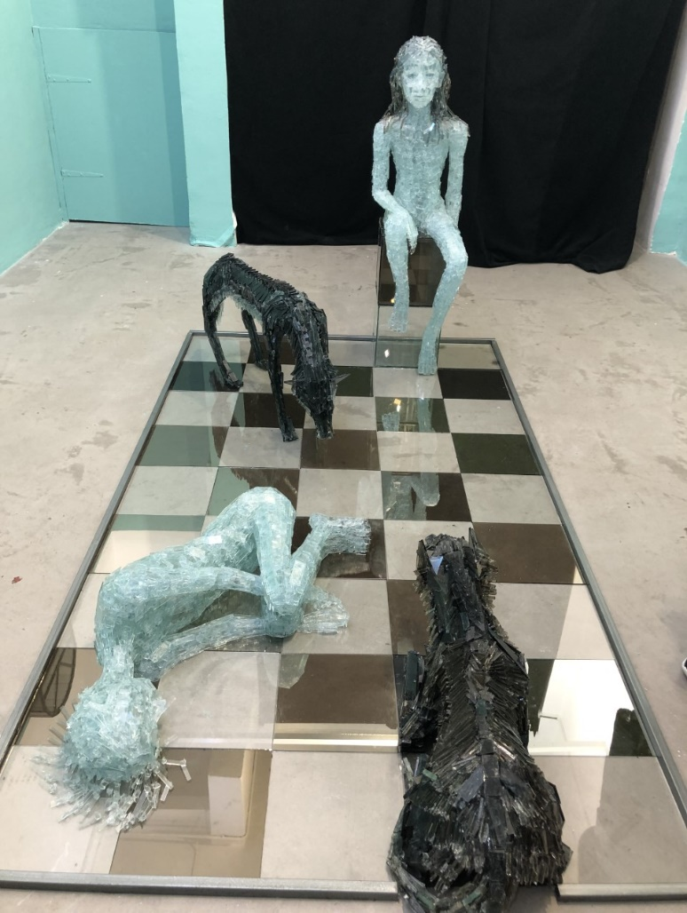

**Figure 2.** General view of installation 1,700 km, 2019.

Near the entrance, a dark figure of a wolflike animal is laying on the sheets of glass, facing three other figures. To its left, a light-toned figure of an adolescent girl lays in an embryonic position, her knees folded toward her chest, arms embracing the knees. Behind her is another dark animal, standing on all four legs. At the farthest area of the installation is a figure of a girl sitting on a stool. The figure is not looking at the other three, rather her gaze is directed toward a distant horizon. Additionally, two 16x4cm glass vitrines are hung on the walls, containing intricate structures consisting of small model houses.

5.1. The Figure of the Sitting Girl

“I was a girl who looked like all the other Russian kids. Children with light-colored eyes, blue-green-grey, which are also the colors of glass. Although my entire family was Jewish, nobody even considered talking about it. We were deep in the communist story. We believed in equality between the nations, between people [...] the experience was one of complete transparency and equality” (Rom Cohen, 2017). In her writing, Rom Cohen speaks of the image of the adolescent girl, a recurrent figure in her work, and admits that it is related to her own childhood. “The installation was created as a result of my journey into my childhood [...] it recreates childhood events of mine, which were shuffled like a deck of cards [...] this glass girl connects me to myself. From within the suppression, apathy, and silencing, she connects me to my dreams and memories” (Dekel and Rom Cohen 2019). Indeed, the sitting girl carries her head high, seeming to look forward to a distant point in time, as if reminiscing.

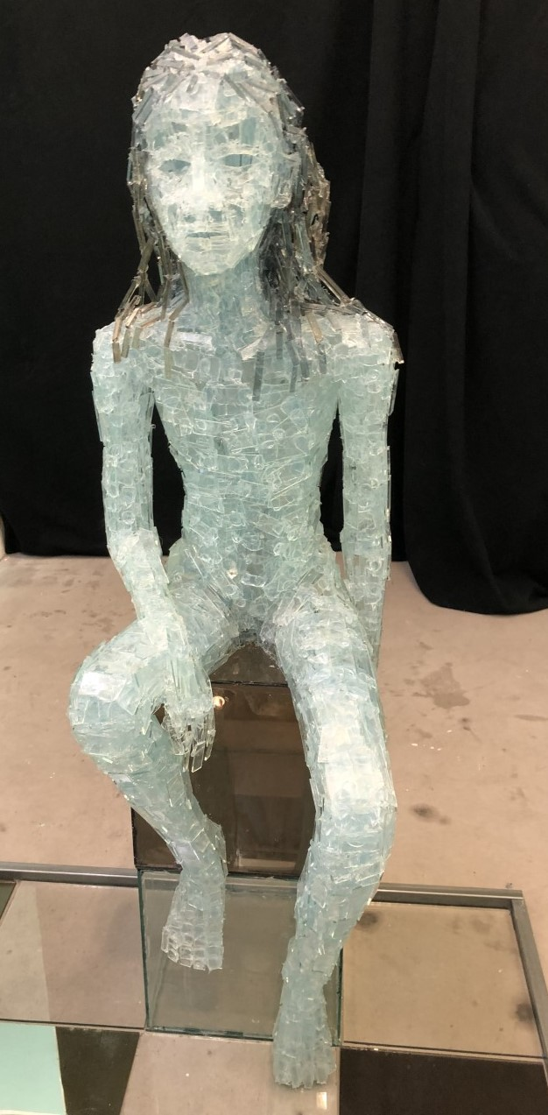

**Figure 3.** Detail.

The sitting figure represents the experience of waiting, anticipating, reflected in Rom Cohen’s own words,

To this day, I define myself as a Russian in Israel. For many years I camouflaged. At the beginning of my artistic path, I tried very hard to be an Israeli artist, that is, I constructed iron sculptures like the famous Israeli sculptor, Yehiel Shemi, and others, because they were the bon-ton, the symbol of the rough-edged Israeliness—iron, rust. Huge scaled sculptures, related to nationalism. These were my attempts to fit in. But in time, I decided to go against the grain, to sculpt real life scale human figures, in a period when it was less acceptable to create figurative sculptures. (Dekel and Rom Cohen, 2019)

In their paper “An Introduction to Visibility in Immigration: Body, Gaze, Representation,” Lomsky-Feder, Rappoport, and Ginsberg write about the immigrant’s experience of visibility while making a place for themselves vis-à-vis veteran Israelis whose hegemonic visibility is prominent within the visual cultural space (2010). The immigrant’s visibility or lack thereof is a social phenomenon that links the foreign and veteran, in various ethnic, gender, and national aspects. Visibility is something we are all concerned with, but more so, the immigrant, whose presence in the social field is a “disturbance” and who is defined as foreigner, often even in visual terms (Lomsky-Feder, Rappaport, and Ginsberg, 2010; 11-12). While leading theoreticians, such as Sigmund Bauman, perceived immigration in term of foreigners entering society, challenging its physical and social boundaries (Bauman 1990; 1991), Lomsky-Feder, Rappoport, and Ginsberg’s novelty is in their focus on the visible, on the areas in which the gaze, the body, and the representation overlap, and the notion that the gaze constructs the contours of the field of vision, thereby defining both the visible and the invisible in the context of power relations (2010). The sense of transparency Rom Cohen speaks of accords with both this innovative theory, and glass—the transparent-present—is the most appropriate for raising and exploring these issues of visibility or invisibility and social power relations in society.

5.2. The Figure of the Laying Girl and the Wolves

The figure of a girl laying on the floor, between two dark animals, appears to be unaware of the looming danger. She is as if “devoured by the male wolves,” states the artist in a text written about the installation (Rom Cohen, 2019).

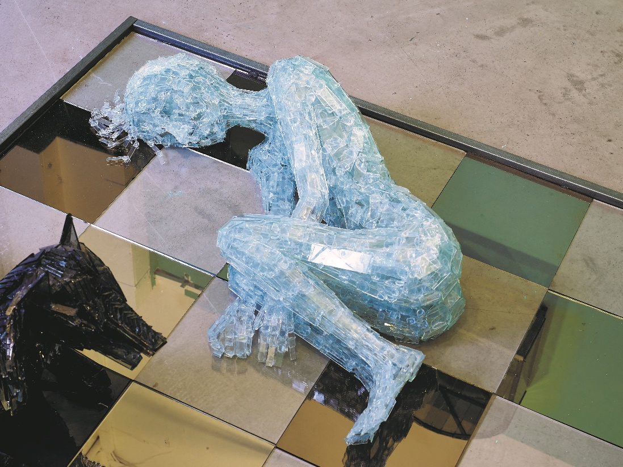

**Figure 4.** Detail.

Like in all of Rom Cohen’s works, here too gender is a significant aspect of the installation. The adolescent girl in the embryonic position reflects “body comportment,” a term coined by Iris Marion Young (1980), who distinguishes between the ways in which male and female gendered bodies conduct themselves and focuses on the social construction that causes young women to limit their bodily motions and take up less space than men, and to believe that their bodies are fragile and weak. According to Young, this perception carries ramifications in terms of women’s self-esteem and their ability to achieve agency and desired goals in the future.

In the field of gender studies and in feminist criticism, the female body receives much attention and is understood as a site upon which social powers are imposed. A gendered analysis strives to decode the ways in which these forces police the body and deny it agency. A body is, therefore, a site for control and supervision on part of the social order, as different gendered bodies are allowed into different spaces and domains: the female body ostensibly “belongs” to the personal domain, whereas the male body “belongs” to the public domain (Dekel, 2011). Female artists who conceptualize and work in view of these feminist notions strive, through their art, to expose the ways in which this policing operates, to promote the discourse surrounding it, and even endeavor to abolish it.

In the 1,700 km exhibition brochure, which was curated by Maya Cohen-Levy, the artist writes “The wolves are charged with contrasting forces: on the one hand, they are made of glass originating from windows. A window is intended to protect, its function is to envelop or surround the home; but unexpectedly, this glass stabs, revealing the teeth of a coyote” (Rom Cohen 2019). In a later interview, the artist said “The wolves symbolize for me the human condition, the idea of ‘dog-eat-dog,’ […] People act like wolves toward one another because of the difficult human condition, in general, and this is true for immigrants, in particular. People are full of anger, living in survival mode. The expression ‘lone wolf’ prompted me to create wolves because, in many ways, I am like that, a perpetual immigrant, I never really integrated into Israeli society” (Dekel and Rom Cohen 2019). The artist explains that the wolves are a metaphor for people in a state of immigration whose relationships with others are charged and most often violent. Rom Cohen explains further, about the gender aspects,

These wolves are of a distinctive gender, male. The choice to position them in this way is intentional, as if they are about to attack the girl. This girl is devoured, she embodies physical sensuality, she is the one with strong emotions, transparent, and they attack her. I genuinely believe that the pressure on men in the Israeli context is immense, there is a tendency toward violence, which is related to their uncompromising and demanding social roles. Both where I come from and also in Israel, the male roles are very demanding. Extreme pressure is put on them, and consequently, women in general, and Russian women immigrants, in particular, suffer. (Dekel and Rom Cohen, 2019)

In other words, for Rom Cohen the metaphor of the wolves about to pounce on the girl and consume her, represents the charged power relations between men and women in general, and especially in regard to Russian-speaking female immigrants in Israel (Dekel, 2016; Lemish, 2000).

Studies by Carla Rice and others dealing with the gendered development of women’s self-perception of their body demonstrate that adolescent girls and young women tend to construct the image of the female body according to the accepted standards of their society and not in accordance with their subjective feelings about it. In Rice’s words, “In childhood, girls become conscious that being looked at was associated with being female and that relating to one's body as an image was foundational to femininity […] they experience their bodies as visual emblems, as subject to outside standards” (2014: 71). Similarly to Rice’s observation, Rom Cohen describes the adolescent sculpted girl lying in the embryonic pose in similar terms, thereby she is an artist creating, as an adult person, a representation of the young girl that she once was. By so doing she aspires to understand and reconstruct her adolescence, while growing up. Moreover, following scholars such as Anita Harris (2004) and Marnina Gonick (2006) whose work focuses on gendered analyses of adolescent girls and young women, the question arises as to whether sexual behavior is indeed indicative of these girls’ strength and empowerment. Gonick’s position, for instance, is that the notion of a young woman’s autonomy and free choice is no more than a smoke screen devised by the liberal discourse to mask the fact that these young women are part of an intricate system of restrictions and oppression (2006). Other studies emphasize the gendered aspect of oppression exercised toward young women who, more than young men, become victims of sexual assault, as well as the fact that there is significantly more pressure put upon them to strive for perfection in different areas of life—in education, professional life, social behavior in peer groups, and even within the family, and especially in terms of their physical appearance (Dyhouse, 2014). Moreover, positioning young girls as sexual objects is exacerbated by the ordeal of immigration, which necessitates the disintegration of identity systems and the construction of an alternative identity, on several levels simultaneously—both gendered as well as national-communal.

5.3. The Glass Vitrines

Two glass vitrines hang on the wall to the left of the gallery entrance. They resemble windows, the upper part is arched, and the base is a straight-lined square. Contained are intricate constructs made of miniature models of classically structured houses—cube base with slanted roof.

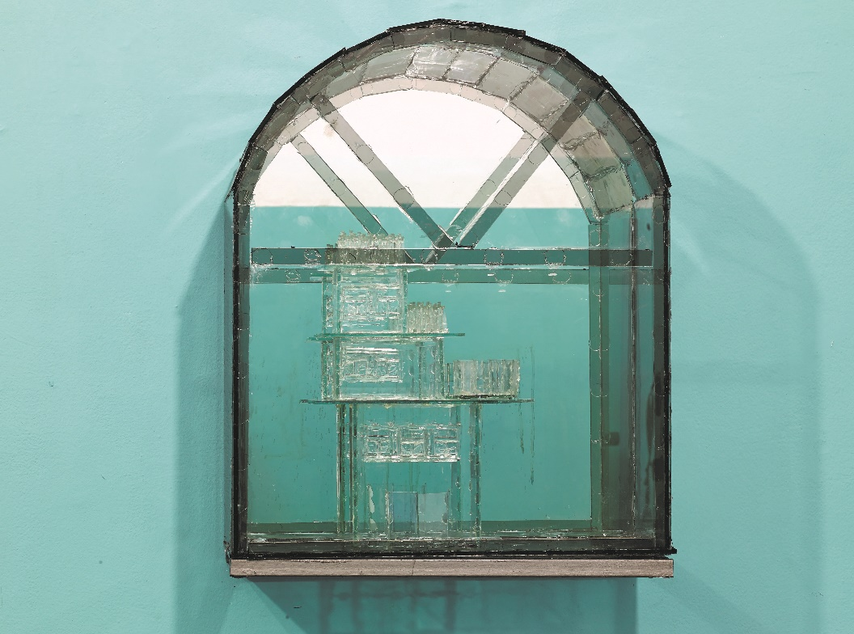

**Figure 5.** Detail.

All of Rom Cohen’s works deal with issues of gender and belonging—several including the word “house” in their titles. The house is a domain ostensibly identified as a female space associated with domesticity, as Rom Cohen writes, “If we think about the role of glass in architecture, it is to define boundaries, to preserve and protect the house against rain, wind, darkness, and all harm. Glass protects the value that is ‘home’ without enclosing it within obstructive, thick walls. Glass contains the house in a way that enables looking both inward and outward” (Rom Cohen, 2017). The artist emphasizes the house’s functionality as a shelter, a private protective space, however, against the background of the art world and with the desire to make present themes related to the house in the context of public space and social issues, she stresses aspects widely discussed in feminist criticism. Thus, for Rom Cohen, the window symbolizes the traditional division of gender roles. Her distinct interest in glass as part of residential buildings is related to the perception of the home as a female space. She writes,

Glass is transparent. A simple washing with water and everything is erased [...] all of the attributes of cleanliness, beauty, the ability to contain, to renounce identity for the benefit of the designated role, are traits that society ascribes to women. Consequently, there is in my work a feminist element: in my work process, I undermine the extremely structured social order and the “natural” role of glass. When I break the beautiful sheets of window-glass into pieces, a different order is assembled. A glass sculpture that assumes an independent presence in the space and which carries within it a transparent protest. (Rom Cohen, 2017)

In an interview, Rom Cohen elaborates more on the aspect of gender in her work:

Gender is indeed a theme featured in my sculptures, constituted in my deliberate choice of this material. Glass protects the house against the outside—rain, dirt, noise. It must be clean and aesthetic, and this is the role of women, to be responsible for cleanliness. Glass enables the penetration of light, and protects and defends like the traditional role of the wife and mother. But it is not seen, glass, it is transparent, it has no body, no presence. And we must remember that when glass is melted, its shape is completely changed, it loses the memory of its original shape, it can be used for something entirely new. Wipe it with a cloth, and all memories are erased, like cleaning dirt off a surface [...] There is a distinctive “double standard”: to a large extent, women have obtained equality, but there is still a great deal of silence surrounding gender and gendered power relations in the home, in the community, in the state” (Dekel and Rom Cohen, 2019).

Thus, the artist identifies with feminist politics that aspire to abolish gender essentialism, and argues that there is an urgent need to eliminate the identification of women with the home, given that it binds them to traditional gender roles and restricts their agency in the world.

7. Transnational Memory

For Rom Cohen, glass functions as a metonymy for her social position as an immigrant in a liminal space, an “in between” place. Through her sculptures, she strives to establish a new transnational existence (Dekel, 2016), in a position that resists classification of being either inside or out. Just like glass, which is a part diving a physical building but and at the same time it is a transparent material that one can see through, also the artist feels partially transparent and absent. Moreover, many layers of glass can simultaneously show, and even represent, different times and places, all at the same time.

Glass plays a key role in decoding the power relations involved in processes of immigrant women’s identity formation in the framework of the nation state and in terms of the logic of transnationality. Analysis of Rom Cohen’s glass sculptures help understanding the ways in which material’s agency and human body’s agency are intertwined, forging a unique power dynamic discernable in the specific context in Israel (Dekel, 2013). Moreover, they facilitate the conceptualization of social dynamics of veteran versus immigrants not only in Israel but also in other nation-states around the globe.

Immigrants’ gender identity could be also conceptualized in terms offered by Judith Butler, who argues that gendered political work, i.e., performing and exercising agency, is done by means of rendering the body present and visible—the body that is itself an intersection of identifications, identities, and identifyings (recognitions) and emphasizes the body as observed and performing at the same time (Butler, 1990). Rom Cohen effectively expresses this simultaneity by virtue of her use of glass. In this framework, glass can also be understood from the perspective of feminist criticism in terms of the complex agency it represents—fragile but strong, transparent yet solid and present. In this vein, glass also calls to mind ideas put forth by feminist theoreticians who address the material turn from a feminist perspective, including scholars such as Stacey Alaimo and Susan Hackman (2008), and Karen Barad (2003).

Rom Cohen’s glass sculptures, therefore, can be analyzed in terms of the degree of agency and power that subjects, both human and nonhuman, have. The works prompt consideration of the extent to which immigrant subjects experience and mediate silencing and exclusion. Glass is a material, which absorbs memory, while echoing and enhancing it, and also holds intrinsic agency. In Rom Cohen’s words,

I have many thoughts about silencing and censorship. Even if no one actually censors me, I feel and realize that society is asking me not to speak about my difficulties of absorption. But because I want to speak, I choose to work with material that speaks for me: glass does not hide anything. Everything is transparent. And in my sculptures, there is not only one layer, but many—achieved by way of my technique of assembling multiple shards of glass one on top of the other. I love that you can see through the sculpture, you can see the inside of the figure, so that there is nothing to hide. You see the truth, everything is out in the open [...] My sculptures remind us that many times we subject ourselves to self-censorship, it is not only the silencing imposed upon us by society. Because it is difficult for me to speak, it is good that my sculptures can [...] I chose glass because it enables me to experience distillation, a departure from censorship [...] People don’t want to hear that I feel that I don’t fit in, don’t belong. For me, the choice of this material is related to immigration, to the fact that I myself am an immigrant. I will always define myself as Russian. Even though people in Israel are not always comfortable with it. (Dekel and Rom Cohen, 2019)

Multiple theoreticians, who frame immigrants and foreignness in terms of an obstruction of “proper” order, have addressed the issue of the varying degrees of immigrants’ visibility (Schuetz, 1944; Simmel, 1950; Bauman 1990; Ahmed, 2000). It was, however, Homi K. Bahbah who argued for the disassembly of the dichotomic paradigm which distinguishes between the oppressor and the oppressed (or in our terms, the newcomer and the veteran), while proposing that they are intertwined, influenced and influencers, dependent on one another, embodying contradictions and ambiguity (Bahbah, 1994). As Lomsky-Feder, Rappoport, and Ginsberg have suggested, “Bahbah’s criticism of the dichotomy is significant for us because he proposes a way by which to view the immigrant not only as an object of observation but also as an observing subject. Taking this approach, which challenges and suspends the binary division of seer and seen, one can release visibility in immigration from the confines of local fixedness and the obstacles of essentialization” (2010: 16). Similarly, one can say that the glass used by Rom Cohen functions not only as the object of the gaze, but that it also reflects back images, like from a mirror, onto the viewer and perhaps also calls attention to the “transparency of the hegemony.” Moreover, we must not lose sight of the fact that although the immigrant’s invisibility can lead to vulnerability, at the same time, it enables flexibility, creativity, and the ability to maneuver “under the radar”. Transparent glass facilitates, therefore, scrutiny of the un-signified, the unseen, in conjunction with what is seen—of both the immigrant and the veteran society. In this regard, Rom Cohen notes,

There is something frustrating in my work. I plan, cut, build, and glue, and at the end, you can hardly see the sculptures; the exhibition looks empty because everything is transparent and you hardly see the sculptures. You have to really make an effort, to invest. You have to walk around, experience the sculptures from different angles in the space, get all of the information. I work for over two years on each sculpture and in the end, I understand that much of it is comprised of shadows, emptiness. The shadows and the nothingness are also part of the work, they also participate and create volume. The material and nonmaterial are combined [...] Glass is a hard material, not only physically but conceptually as well, you get very little feedback, you can even say that there is an erasure of the work because a significant part of it is transparent and invisible. (Dekel and Rom Cohen, 2019)

Rom Cohen, who immigrated to Israel in 1992 at age seventeen, constitutes a case study which prompts and facilitates contemplation on the ways in which female immigrants manage their hybrid identity and dynamically negotiate their simultaneous— excluded and integrated—position and visibility in narratives and memories that claim a rightful place and representation in the new nation state.

As a Jew, I grew up in a southern village in Russia, I was not really connected to my identity as a Jew. Obviously, we knew about it, but only in theory. We lived in a very communist atmosphere, which does not encourage religious identity. I was in a youth movement and all kinds of groups. First time I thought about religion at all, and my Jewish identity, was at age thirteen, that was in 1986. Soon after, things changed, then the iron curtain fell, newspaper articles were published, and we were exposed to American movies. Suddenly, we thought about other identities, we were exposed to people’s lives in other places [...] It was a crisis to discover the West. Our entire reality shattered to pieces and everything had to be rebuilt. This is why I express myself through broken glass, which I reassemble from my memories. (Dekel and Rom Cohen, 2019)

8. Memory through Material

Given the very essence of its materiality, artistic material can itself embody memories and it is perceived as a bearer of memory, as a subject of meaning and agency. Rom Cohen deliberately chose glass given its potential to communicate the experience of her excluded identity in Israeli society. In the local mainstream art field, glass is considered an “inferior” medium relative to others (such as marble, iron, and certainly photography, painting or video art). In “Glass as Periphery,” Dafna Kapman argues that glass artists were excluded from the mainstream artistic discourse because they were considered competent craftsman, albeit creating utilitarian art, but not artists of “high art” (Kapman, 2015). In a text written by Rom Cohen on the occasion of the opening of her one-woman show in 2017, she wrote,

Sculpting is working with material, and the material has a biography of its own. The time and place in which it was produced and its existence until it arrived in the studio [...] The material has a life story, into which the artist weaves their own human story. Both stories need to work together. The choice of material is a genetic matter. It is possible that sculptor and material both come from the same place, from before they met. (Rom Cohen, 2017)

The figures sculpted by Rom Cohen are always of adolescent girls, never mature women. Elsewhere, I argued that immigrant artists who arrived in Israel as young girls or teens, undergo a long process as gendered subjects through which they gradually assume a new status and hybrid identity. These women reconstruct a national and professional identity (in the case of Rom Cohen, of a professional artist), sometimes, only after establishing a new familial identity, through marriage. At a relatively late stage, while reminiscing, those grown women are free to reflexively contemplate their adolescence of many years prior, the many changes it entailed, and their distinctive status as immigrants (Dekel, 2018). According to Mirsky and Prower (1992),

The identity crisis in adolescence [comes with] the immigration crisis, but it is hard to define the absorption process in terms of time. Each immigrant experiences it differently and at an individual pace [...] a number of years are necessary to live and placate the pain of loss, to solve the inner struggle that began already in the Soviet Union and come to terms with the decision to immigrate and the Israeli reality. (1992: 15)

In a similar vein, Horowitz noted that “it is only after the mental process is over, that the immigrant is able to explore their past and Israeli society from an integrative and broad perspective, to sift and sieve, and begin to consolidate an image as human being and as Israeli” (Horowitz, 1998: 393). In my aforementioned article (Dekel 2018), I demonstrated how many years after these experiences female artists become deeply invested in contemplating reflexive memories, a belated consideration of the gendered aspects enfolded in their positioning as women who experienced a doubled and simultaneous experience—of both the consolidation and formation of their gender identity and the shaping of a new communal and national identity—as a result of their immigration. In that earlier paper, I argued that it is only when they are strong and confident enough in their identity, do they find the mental strength to face the tumultuous periods they experienced in the past as safe bystanders positioned in the relatively stable place that they have carved out for themselves. Rom Cohen exercises this in her artworks, which faithfully reflect and scrutinize her reflexive insights associated with her gendered and national identities while extracting the memories of the liminal space she has occupied since adolescence.

9. Simultaneous Temporality – Time and Memory Intermingled in Material

The material turn challenges the traditional perception of time as the sole trajectory for lineal and unilateral development. This approach stipulates that time is not unified but rather characterized by a simultaneity of times, thereby undermining the autocracy of modernism’s perception of consistent and unified concept. The material turn allows for thinking about time from a perspective of complexities, and proposes its comprehension as a system of modi facilitating an experience of temporality that is multilayered and simultaneous, even if it involves discord between different temporal contexts—past, present, future (Ross, 2014). Time can be suspended, regressive, partial, accelerated, compressed, and frozen. All this, simultaneously.

In this sense Christine Ross argues that the concept of the transnational experience is especially helpful in understanding works of art that express elements of the notion “deep time.” As Ross has demonstrated in her monograph, The Past is Present; It’s the Future too – The Temporal Turn in Contemporary Art, which focuses on the variety of times in social and transnational contexts, the temporal turn problematizes the notion of time, opening it up to new possibilities of conceptualization (Ross, 2014). For example, this critical turn advances the notion that the experience of time is not universal but rather culturally contingent and deeply impacted by life-changing events, such as migration and displacement.

In Rom Cohen’s works, time is simultaneously manifested in a variety of forms: objective, subjective, phenomenological, physical and embodied. Time can bend, expand in a fluid, non-linear manner that synergizes periods, thereby liberating past, present, and future to co-exist. This concept of flexible time serves to better understand the immigrant body through understanding of the agency of materials. By entangling the links between different times, activating the past within the present, it appears that Rom Cohen manages to connect narratives from different time frames to form new combinations. Thus, her glass sculptures speak of the simultaneity of a body concurrently existing in a number of cultural spaces and times. These are micro-narratives that teach us something about the ways in which the artist’s body is constituted as a fused form, which provokes discordance between past and present. This is a body that binds together memories from there and here, memories derived from the trauma of migration, which, although occurred decades ago, may in fact have never ended. The use of glass helps undermine the autocracy of the modernist perception of immigration as an event that takes place at a specific point in time, and advances the understanding that the immigrant continues to exist in numerous temporal spaces simultaneously. Glass enables to experience time, body, and movement in a condensed and complex manner. It tells the story of the body in immigration in the transnational era, in a pragmatic, but also inclusive and fluid, manner. As a result, there is no obligation to choose between past and present, because these are not necessarily arranged linearly—glass is the substance upon which different and simultaneous times can exist, side by side, while exchanging information and narratives.

Rom Cohen’s glass sculptures become, therefore, a site at which traumas are focalized—recent and distant traumas communicate. In terms of materiality, the visible is manifested in the material and the invisible needs to be discovered and decoded. The clues are embedded in the material and erupt from within it. The material speaks what the artist silences, what she does not or will not say. Like the glass that cuts, but which is also fragile and shatters, so too the artist’s immigrant body is vulnerable and fragile. The material’s element of transparency serves the artist as a forceful and effective metaphor for the collapse of the distinction between past and present, between private and public—that is, prior to immigration and after—between the former country and the new country, between her being a woman in a patriarchal and nationalist world and the private narrative of her gendered body. There is a simultaneity of the gaze because the material enables it, which unlike opaque material, enables vision through the different spatial layers and different times.

Rom Cohen's glass sculptures are therefore bearers of memory that tell the story first-hand. Indeed, this is a heavy burden, sometimes unbearably so to the point of causing breakage and shattering, and consequently, the redeployment and reorganization of inner strengths. By means of Rom Cohen’s treatment of the material and its various “reincarnations,” she performatively expresses her narrative as an immigrant from the Former Soviet Union. Initially, the glass was arranged as large and flat windowpanes, then they were cut precisely into multiple shards. Finally, they are reassembled as volumetric forms simulating human and animal figures. The same material, in different forms and manifestations. The same material, in its evolving and changing meanings. Just like the reincarnations of the female immigrant (Lomsky-Feder and Rappoport, 2010).

10. Conclusions

Research in memory studies which draw on material studies help understand the ways in which material can serve as a bridge between the present and past, especially the personal trauma of immigration and the shared trauma of large groups within society. In this context, Elizabeth Crooke’s work, in which she deals with the analysis of personal memory objects and how they constitute political object, as well as the processes of grieving and trauma they embody, is of special importance (Crooke, 2017). Following Crooke, I find that the private emotions of female artists in Israel who experienced immigration, find an outlet for their expression in artistic objects, which serve as agents and conveyers of a complex political narrative—a narrative about power relations—and in so doing actively participate in the social dynamics of the Israeli nation-state (Dekel, 2016). I wish to argue that the material Rom Cohen chooses does not only speak and exercise its own agency but that its speech is subversive: the sculpture says what the artist will not say. It takes the liberty to say harsh truths and also entangle times and memories and convey narratives in a condensed and non-linear manner. Thus, the agentic role in Rom Cohen’s sculptures is particularly significant.

In this study, I aimed to argue that the issue of materiality is central to the artist discussed. The raw material of her works is in fact synonymous with her biography. In Cohen Rom’s work the themes of breach and transparency are associated with the immigration experience and the attempt to speak about her hybrid and disjointed identity by means of fragments of memory literally constructed from glass that she breaks and reconstructs. The objects she endeavors to freeze in time, as memory capsules from the old homeland carried into the future, enable the existence of these memories in the new post-immigration present, in the new nation state.

The integrative theoretical discourse in this paper represents gendered views and feminist criticism that are enfolded in the works of art of female immigrants, which deal with their memories and transnational identity. Research from a gendered perspective of processes involving young women’s transition to maturity have become a focal point and topic for intense debate for many scholars from a variety of disciplines (Aspola, Gonick and Harris, 2005; Cote, 2000: Lev Ari, 1994; Rice, 2014). These studies identify that circumstances of shock and extreme change, such as extraction and immigration, catalyze young women’s processes of identity solidification. This is precisely the experience of girls who arrived in Israel during the first wave of immigration from the Former Soviet Union during the 1990s and 2000s. This paper discusses a mature female artist who is equipped with means far more sophisticated than in the past for contemplation and reflection on the period of adolescence she experienced when arriving in Israel. The discussion surrounding the artworks Rom Cohen created as a grown woman reveals the ways in which subjects that experienced immigration express the complex and continuous system of constructing identity, both in gendered terms and in national and communal terms. These include the visual expression of a system of expectations and of processes of social negotiation involved in the consolidation of their changing identity, their social criticism toward the situation, and their subsequent insights—both personal and general-political. Rom Cohen’s glass sculptures constitute windows into types of knowledge and perspectives which contribute to the understanding of the private biography of immigrants and their memory stories. While bearing the unique stamp of its subject, each female immigrant’s immigration narrative is representative of a common female immigrant experience. In Tamar Elor’s words, “The private story of a certain individual has double value: it is precise and outlines the transitory, and at the same time, is set alongside other stories, which position it in a public, social, and historical context. Thus, the importance of the private biography enhances as a source of social insight, and how social insights unravel into endless one-time stories” (Elor, 2006: 230). Indeed, in the analysis of in-depth interviews with artist Rom Cohen and while using theories informed by the material turn, the topic of the multifold of the identity crisis of women immigrants, against both a gendered and communal-national background, comes to the fore. [6]

References

Ahmed, Sara (2000). Strange encounters: Embodied others in post-coloniality, London and New York: Routledge.

Alaimo, Stacy and Susan, Heckman (eds.) (2008). Material feminisms, Bloomington: Indiana University Press.

Aapola, Sinikka, Gonick, Marnina, & Harris, Anita (2005). Young femininity: Girlhood, power, and social change. Houndmills, Basingstoke, Hampshire: Palgrave Macmillan.

Arjun, Appadurai (1986). "Introduction: Commodities and the Politics of Value," In: The Social Life of Things: Commodities in Cultural Perspective, ed. Arjun Appadurai. Cambridge University Press, 3-63.

Avron Barak, Noa (2020). "The National, the Diasporic, and the Canonical: The Place of Diasporic Imagery in the Canon of Israeli National Art", Arts 8(4).

Bahaba, Homi K. (1994). The location of culture. London: Routledge.

Barad, Karen (2003). "Posthumanist performativity: Toward an understanding of how matter comes to matter", Signs 28: 801-831.

Barrett, Estelle and Barbara Bolt (eds.) (2013). Carnal Knowledge – Towards a 'New Materialism' through the Arts, London and New York: I. B. Tauris Press.

Bauman, Zygmunt (1990). Thinking Sociology – An Introduction for Everyone. Cambridge, Mass: Basil Blackwell.

Bauman, Zygmunt (1991). Modernity and Ambivalence. Ithaca, N.Y: Cornell University Press.

Baubock, Rainer and Faist, Thomas (2010). Diaspora and Transnationalism – Concepts, Theories, and Methods. Amsterdam: Amsterdam University Press.

Beneria, Lourdes et. al. (2012). "Gender and International Migration: Globalization, Development, and Governance", Feminist Economics 18(2): 1-33.

Butler, Judith (1990). "Performative acts and gender constitution: An essay in Phenomenology and feminist theory", In: Sue-Ellen Case (ed.), Performing feminism: Feminist critical theory and theatre. Baltimore: John Hopkins University Press, 270-282.

Bennett, Tony and Patrick, Joyce (eds.) (2010). Material Powers – Cultural Studies, History and the Material Turn (eds. Tony Bennett and Patrick Joyce), London and New York: Routledge.

Cote, James, E. (2000). Arrested adulthood: The changing nature of maturity and identity. New York, NY: New York University Press.

Crooke, Elisabeth (2017). "Memory politics and material culture: Display in a memorial museum", Memory Studies, 12(6): 617-629.

Dekel, Tal (2011). Gendered – Art and Feminist Theory, Ramat Gan: HaKibbutz HaMeuhad [Hebrew].

Dekel, Tal (2016). Transnational identities: Women, art and migration in contemporary Israel, Detroit: Wayne State University Press.

Dekel, Tal (2018). Young-Adults immigrants Artists: Experiences of Liminality, Eds. Hagit Bini-Noach et. al., Young Adults in Israel. Kefar Sava: Lamerhav and Beit Berl, 251-262 [Hebrew]

Demos, T. J (2013). The Migrant Image – The Art and Politics of Documentary During Global Crisis. Durham and London: Duke University Press.

Dewey, John (1934). Art as Experience, New York: Putnam.

Direktor, Ruti (1993). Marco Polo in Murano, or the Fragility that Conquered Goliath, Glass, Landscapes, Neighborhoods. Ramat Gan: Museum of Israeli Art [Hebrew].

Dyhouse, Carol (2014). Girl trouble: Panic and progress in the history of young women. London: Zed Books.

Eliezer-Bruner, Henrietta (2015). Israeli Glass. Tel Aviv: Eretz Israel Museum [Hebrew]

Elkins, James, Valiavicharska, Zhivka and Kim, Alice (eds.) (2010). Art and Globalization, Pennsylvania: The Pennsylvania State University Press.

El-Or, Tamar (2006). Guarded Places: Gender and Ethnicity in Spaces of Religion. Tel Aviv: Am Oved [Hebrew]

Gashinsky, Emma (2019). A pattern of Non-Belonging – Immigration and Identity Stratification in Contemporary Israeli Art", Arts 8(4).

Gell, Alfred, (1998). Art and Agency: An Anthropological Theory, Oxford: Clarendon Press.

Gonick, Marnina (2006). Between 'girl power' and 'reviving Ophelia': Constituting the neoliberal girl subject. National Women's Studies Association Journal, 18(2): 1-23.

Guilat, Yael (2019). Israeli-Ness or Israeli-Less? How Israeli Women Artists from FSU Deal with the Place and Role of 'Israeli-Ness' in the Era of Transnationalism. Arts 8(4): 159-168.

Haraway, Donna, (2000). A cyborg manifesto: Science, Technology, and Socialist-feminism in the late Twentieth Century, In: D. Bell and B.M. Kennedy (eds.), The Cybercultures Reader, London: Routledge, 291-324.

Harris, A. (2004). Future girl: Young women in the twenty-first century. London: Routledge.

Harris, Jonathan (ed.) (2011). Globalization and Contemporary Art. London: Wiley-Blackwell Press.

Horowitz, Tamar (1998). Children and Youth in the Educational system. Eds. Moshe Sikron and Elazar Leshem, The Portrait of Immigration – Absorption of Former Soviet Union Immigrants, Jerusalem: Magness Press, 368-408.

Jurarez, Fatima et al. (2013). "Youth Migration and Transitions to Adulthood in Developing Countries", The ANNALS of the American Academy of Political and Social Science 648: 6-15.

Kaufman, Dafna (2015). Glass as Periphery, 1280 Degrees – Journal of Material Culture, 31 (n.p.)

Lange-Berndt, Petra (ed.) (2015). Materiality. Cambridge, Mass: MIT Press.

Latour, Bruno (1993), We Have Never Been Modern, Brighton: Harvester Press.

Latour, Bruno (2001). "When Things Strike Back: A possible Contribution of 'Science Studies' to the Social Sciences", British Journal of Sociology, 51(1).

Latour, Bruno (2006). Reassembling the Social: An Introduction to Actor-Network-Theory, Oxford: Oxford University Press.

Lemish, Dafna (2002). "The Whore and the other: Israeli images of female immigrants from the Former USSR", Gender and Society 14(2): 333-349.

Lev Ari, Lilach. (1994). Gender differences in social absorption of young immigrants from the Former Soviet Union (FSU) into Israeli society. International Migration Review, 28(4): 915-119.

Lomsky-Feder, Edna, Rapoport, Tamar and Ginzburg, Lidia (2010). Visibility in Migration, Eds. Loumsky-Feder, Edna and Rapoport, Tamar, Visibility in Migration – Body, Gaze, Visibility. Tel Aviv and Jerusalem: Van Leer and Hakibbutz Hameuhad [Hebrew].

Mathur, Saloni (ed.) (2011). The Migrant's Time – Rethinking Art History and Diaspora, New Haven and London: Yale University Press.

Mercer, Kobena (2016). Travel and See – Black Diaspora Art Practices since the 1980s, Durham and London: Duke University Press.

Miller, Daniel (2005), "Materiality: An Introduction", In: Daniel Miller (ed.), Materiality, Durham and London: Duke University Press, 1-49.

Mirsky, Yulia and Pawer, Leon (1992). To Immigrate as an Adolescent: Immigrant Youth from the Former Soviet Union. Jerusalem: Van Leer.

Rapoport, Tamar and Lomski-Feder, Edna (2010). The Evolving Body from Russia: Ready, Set, Go, Eds. Lomsky-Feder, Edna and Rapoport, Edna, Visibility in Migration – Body, Gaze, Visibility. Tel Aviv and Jerusalem: Van Leer and HaKibbutz HaMeuhad, 69-96 [Hebrew].

Rice, Carla (2014). Becoming women: The embodied self in image culture. Toronto, Buffalo and London: University of Toronto Press.

Riggins Stephen Harold, (1990). "The Power of Things: The Role of Domestic Objects in the Presentation of the Self," In: Beyond Goffman: Studies on Communications, Institution and Social Interaction, ed. Stephen Harold Riggins, Berlin and New York, Mouton de Gruyter, 342-3.

Ring-Peterson, Ann (2017). Migration into Art – Transcultural Identities and Art-Making in a Globalized World, Manchester: Manchester University Press.

Rom Cohen, Alina. Biography of Common Glass (unpublished).

Rom Cohen, Alina. 1,700 Kilometers (unpublished).

Ross, Christine (2014). The Past is the present; It’s the future too – The temporal turn in contemporary art. London: Bloomsbury.

Schuetz, Alfred (1944). "The stranger: An essay in social Psychology", American Journal of Sociology 49(4): 499-508.

Simmel, George (1950). "The stranger", The Sociology of Georg Simmel, (trans. And ed. Kurt H. Wolff). New York: Free Press, pp. 402-408.

Strathern, Marilyn (1999). Property, Substance and Effect: Anthropological Essays on Persons and Things, London and New Brunswick, NJ: Athlon Press.

Turkel, Sherry (ed.) (2007), Evocative objects: Things we think with, Massachusetts and London: MIT Press.

Young, Iris, Marion (1980), Throwing like a Girl: A Phenomenology of Feminine Body Comportment Motility and Spatiality, Human Studies, 3(2): 137-156.

1. Latour coined the term “actants,” which refers to both human and nonhuman players who take an active role in any given field.
2. Many artists around the world have applied glass in their practice because of the quality of glass as a sculptural medium. As seminal examples, one could mention Antony Gormely, Bertil Vallien, Antione Leperlier, and Ai Wei Wei, who all used the exterior and interior spaces to create dialogues between them. However, in Israel this is a rare medium for sculptural expression, mostly common among "glass artists" and not by "Fine art" sculptures. Moreover, to the best of my knowledge, Rom Cohen is the only artist in Israel who works with this specific method of glass sheets that are of second-hand usage, originating from windows that were first used in residential houses.
3. For further reading on works in glass, in general, and glass artwork produced by women, in particular, see:

   Beretta, Marco (2009). *The Alchemy of Glass: Counterfeit, Imitation, and Transformation in Ancient Glassmaking*. Sagamore Beach: Science History Publications, USA.

   Brandhan, Gail (2010). *Breaking the glass ceiling: Women working with glass*, *The Flow* (Winter, 2010).

   Ritchie, Ian (2004). Aesthetics in Glass Structure, In: *Structural Engineering International Quarterly Journal* (Switzerland).

   Morris, William and Elliot, Kate (1989). *Glass: Artifact and Art*, Seattle: University of Washington Press.

   Layton, Peter (1996). *Glass Art*, London: A & C Black Press.
4. In contrast to this technique, which is unique in the Israeli art scene, within the international scene there are many such artists who work with glue in order to build their glass sculptures. Among them one could mention artists such as Daniel Arsham, Ana Teresa Fernandez, Marta Klonowska and Joshepha Gasch-Muche.
5. In this quotation, the artist is referring to the time when the former Soviet Union was experiencing “perestroika,” which entailed all the political reforms and reorganization of the economy between 1987-1991 led by Mikhail Gorbachev. Another term related with this era is “glasnost,” which was perceived in the West as a bent toward more freedom of speech and democratization, however, Gorbachev perceived it more in terms of adopting transparency and lack of censorship in all things related to the economical restructuring and government practices (from this there was slippage to the general concept of freedom of speech and relief of censorship for all citizens).
6.