Contemporary Practices and Identities of Local Shamans in the Tsugaru Area in Japan

Aki Murakami

Komazawa University, Japan

**Abstract:** This study attempts to illustrate how local shamans in the Tsugaru area in Japan adapt to contemporary society by focusing on their practices and their identity formation processes. There are two types of shamans in this area: *itako* and *kamisama*. The number of *itako* is decreasing drastically and *kamisama* is taking over their role. In this context, it is important to examine how and to what extent local contexts affect *kamisama*’s practices and their identity formation. Conversely, it is also important to understand the extent of the effect of contexts from outside the local community such as mass media and tourism. By using the examples of two *kamisama’*s lives as case studies, we reveal that a shaman’s self-identity is neither simply a result of a divine calling nor a reflection of local shamanic traditions, but an ever changing response to the social environment.

**Keywords:** shamanism, identity, local context, *itako*, *kamisama*, *kuchiyose*

## Introduction

The Tsugaru area in Aomori prefecture located at the northern extremity of the Japanese main island is famous for heavy snow in winter and beautiful cherry blossoms in spring or for the people’s strong accent, which those from other areas find difficult to understand. This area is well-known to religious scholars as the place where “Japanese shamanism” is well “preserved.” It is true that many shamans are still active and their practices are an essential part of life for some people in this area. However, the word “preserved” is not appropriate to appreciate shamans and their practices since it overlooks the contemporary developments. There are abundant studies on shamans in this area[1], but most of them focus more on the past, that is, the “traditional” aspects. Very few are concerned about highlighting how the shamans are changing. We need to pay more attention to the changing roles of shamans to understand shamanism as lived.

This study investigates the practices and self-identity formation process of local shamans in the Tsugaru area. How and to what extent do local contexts have an effect on the practices and identity formation of shamans? Conversely, to what extent do contexts from outside of the local community such as mass-media and tourism have an effect on them[2]? By exploring the lives of two local shamans as examples, this study discerns the features of shamanic identity in the contemporary society.

## The concept of shamanism in Japan

We will begin by taking a look at the concepts of “shamanism” and “shaman.” These are controversial concepts, and are sometimes described as the products of “western imagination” (Hutton 2001). Some see shamanism “as an overly generalized, empirically flawed relic of earlier anthropological theorizing” (DuBois 2011:111). A similar argument has recurred in the study of Japanese shamanism.

The word シャマン (*shaman*), a Japanese transliteration of shaman, began to appear in Japanese academia around the 1920s (Tanaka 2013). The interest on this topic has significantly increased since the 1960s, owing to the publication in 1964 of the English translation of Mircéa Eliade’s *Shamanism: Archaic Techniques of Ecstasy*, originally written in 1951 (Satō 2007: 220)[3]. Japanese scholars eagerly tried to apply the concepts of shaman or shamanism to Japanese magico-religious practitioners and their practices (e.g., Hori 1971, Sakurai 1974, 1977 and Kusunoki 1975). Their efforts contributed toward changing the perceptions of local shamanic practices, which were earlier regarded as superstitions and omitted from academic studies. Thanks to them, shaman-like local practitioners in Japan have today become an important research subject.

However, the concepts of shamanism and shaman began to be contested in Japan. The leading figure of contemporary Japanese “shamanism” study, Yoshimasa Ikegami wrote:

… comprehending a wide variety of phenomena with a controversial concept called "shamanism" will lead to the misunderstanding that it is a completed essential substance, and one will be involved in worthless concept controversy, at the same time there is a risk of statically fixing the study (Ikegami 1999:21,22).

Ikegami used the Japanese word *fusha* (巫者) instead of *shaman* (シャマン) in his study to avoid over generalization and pay more attention to the local context in which *fusha* live. His argument was widely accepted and *fusha* has become the alternative word for shaman in contemporary Japanese “shamanism” study. This also means that the global comparison of shaman or shamanism is no longer the central subject of the study. It gave way for the domestic, context-centered study of *fusha*. This is a remarkable shift.

This study shares the basic premise of this trend but employs the words shaman and shamanism to make it easy for foreign readers to understand. It defines a shaman as “a magico-religious practitioner that holds the ability to directly communicate with a supernatural realm or beings” (Sasaki 1995: 80). This definition is the most common in the Japanese academic circle and is quite appropriate for understanding the Japanese cases. Although the concepts of shaman and shamanism are fraught with controversy, they are still heuristically useful. This is because they make it possible to open local examples to global arguments.

## Shamans in the Tsugaru area

We will now shift the emphasis to specific examples of shamans in the Tsugaru area. *Itako* (イタコ) is the local term for a shaman in Aomori prefecture and neighboring regions (the Tsugaru area is located in the western part of Aomori prefecture). *Itako* is the most popular name for a shaman in Japan and the epitome of Japanese shamans. Several studies on *itako* have been published. *Itako* also appears in popular culture in manga, animations, and movies[4]. *Itako* has gained popularity, but their number has been drastically decreasing[5]. However, it should not be understood as the end of shamanic traditions in this area as similar practitioners called *kamisama* (カミサマ) have been active here. Thus, there are two types of shamans, *itako* and *kamisama*, in the Tsugaru area. Both *itako* and *kamisama* consult on client needs through their abilities to communicate with the supernatural realm.

What makes *itako* and *kamisama* different? This has been debated for a long time. The predominant view is that a medium who practices the *kuchiyose* ritual is an *itako* and one who does not is a *kamisama* (Sakurai 1974:206, Kusunoki 1979:12)*. Kuchiyose* is a ritual to deliver messages from the spirits of the dead. *Itako* summon the dead and speak as the dead. *Kamisama* practice divination and exorcism rites, but not *kuchiyose*. Although *itako* also practice divination and exorcism rites, *kuchiyose* is considered to be their most important ritual. The popular imaginary of *itako* always signified *kuchiyose*. *Itako* have been illustrated as “a shaman in Aomori prefecture[6] who practices *Kuchiyose* ritual.” People from all corners of the country visit Aomori prefecture to hear the voice of the dead through the *kuchiyose* ritual performed by *itako*. However, as I mentioned above, the number of *itako* is drastically decreasing; thus, one might think that the *kuchiyose* ritual is on the verge of extinction. The answer is “no” so far, because *kamisama* also practice the *kuchiyose* ritual now. As we see in the next section, the *kuchiyose* ritual was only inherited through the *itako*’s apprentice system. Certain sutras and manners of *kuchiyose* were only accessible to those who passed the initiation ritual of *itako*. *Kamisama* had no access to it. This was one reason why *kamisama* did not practice *kuchiyose*. They were not authorized to do the ritual. The authority that used to come from the senior *itako* and *itako*’s strict apprentice system is almost broken. Hence, *kamisama* now feel free to practice *kuchiyose* in their own manner. They no longer use the aforementioned sutras and manners used by *itako*.

## *Itako* and *kamisama*

The category *itako* became confusing for the scholars as *Kamisama* have started practicing the *kuchiyose* ritual. However, local people still see *itako* and *kamisama* as different. What are the differences they see?

Both *itako* and *kamisama* practice *kuchiyose* today, but their styles are quite different. This is because *itako* and *kamisama* have different initiation processes. Becoming an *itako* involves a rigid disciplinary process. *Itako* originally were blind women. A blind woman would become an apprentice to an older *itako* when she was young. She learned every *itako* ritual from her master, including *kuchiyose*. There are certain rules regarding what can be said and how it should be said during the ritual. Thus, *itako*’s *kuchiyose* is a traditional art form that is inherited through their rigid apprentice system.

*Kuchiyose* performed by *itako* has a unique rhythm. What an *itako* says during the ritual is difficult to understand. Some opine that this is because of the strong accent of the local dialect. It is often said that dialects in the Tsugaru area are the most difficult to understand by standard Japanese speakers. However, the problem of dialect is only one aspect. What makes understanding *itako’*s *kuchiyose* difficult is their rhythm and words. *Itako* have specific terms that they use in their rituals. Therefore, *kuchiyose* is exceedingly difficult to understand for a beginner. To appreciate the *kuchiyose* ritual, clients must be trained through their repeated participation in the ritual.

On the contrary, *kamisama* do not have an apprentice system. Virtually, no one else besides blind females was chosen to become *itako*. However, the case of *kamisama* is different. Anyone can become a *kamisama*. A typical reason behind one becoming a *kamisama* can be a sudden illness of unknown cause. To overcome the illness, a person can visit a local *kamisama* and start ascetic training. Contrary to *itako*’s case, since there are no patterned trainings to be a *kamisama*, their ritual practices vary. When one asks a *kamisama* where and how they learned the *kuchiyose* ritual, their answer would be “Gods told me everything” or “It is all the inspiration from deities.” Each *kamisama* performs the *kuchiyose* ritual in their own manner. However, what makes them similar is their performance of *kuchiyose* without the use of the special words and unique rhythm that characterized the *kuchiyose* performed by *itako*. *Kuchiyose* performed by *kamisama* sounds just like a regular conversation. Clients need not to be trained, and a beginner can easily join and enjoy conversations with the dead[7]. Local people can clearly see the difference between how *itako* and *kamisama* perform kuchiyose. Some of them are also aware of the difference in the initiation process between *itako* and *kamisama*.

The local people who are familiar with the local shamanic traditions can still differentiate between *itako* and *kamisama*. However, because of the drastic decrease in the number of *itako*, it becomes important for them to accept *kamisama*’s new way of performing the ritual. Some do this unwillingly and with discomfort, whereas others are more tolerant and enjoy the new style. However, people from the outside of the Tsugaru area or Aomori prefecture who are unfamiliar with the local shamanic traditions do not see or even care aboutthe difference between *itako* and *kamisama*. They consider someone who performs the *kuchiyose* ritual as “*itako*.” This is because popular imagery only includes the name of *itako* and describes *kuchiyose* only as a ritual where one talks to the dead without explaining how. This ignorance cannot be disregarded, because those people who come from outside the local community to visit “*itako*” (in most cases, they visit *kamisama* mistaking them with *itako*) have a large impact on the self-understanding of local shamans.

## Case 1: Ms. Kasai

We will now explore the topic further by taking the case of one *kamisama* as an example. Ms. Ksasi[8] (born in 1942, Hirosaki city[9]) is one of the most active *kamisama* in this area. She suffered from a sudden illness of unknown cause in her twenties. She started feeling and seeing some supernatural things since then. Since the doctors could not cure her illness, she visited the local shamans, *kamisama*. She followed some *kamisama* and learned their practices. She was very eager to cultivate her new ability to communicate with the supernatural realm. She studied under a monk of the Shingon sect of Buddhism (真言宗) in Hirosaki city and obtained a teaching license from the sect. An established Buddhist sect like Shingon does not teach how to practice the local rituals of divination or *kuchiyose*; her training under the monk and the teaching license are not substantial in her daily practice[10]. She is not a monk, but a *kamisama*. If someone asks her how she learned the ritual, she says that “it is all the inspiration from deities.” However, on closely observing her rituals, one can see that they somewhat resemble how other *kamisama* in the area performs it. It is obvious that her life as a *kamisama* is deeply embedded in the local shamanic traditions and not the Shingon sect.

Ms. Kasai is a quite popular *kamisama* consulted by people in the Tsugaru area. She advises her clients on different problems including job hunting, marriage, and a discord within the family or workplace. Many clients also go to her to perform the *kuchiyose* ritual. She also visits many local communities—small village sections called *aza* (字)—to join the spring communal prayer called *harukitou* (春祈禱) every year. *Harukitou* is a ritual performed by the housewives in many *aza* in the Tsugaru area around March. They gather to listen to divination and pray for a peaceful year to the tutelary deities in the community with a shaman (Figure 1). Generally, *itako* are invited to this ritual to practice divination and pray to the deities. However, there is no *itako* around this area. This absence was filled by *kamisama* like Ms. Kasai who started to join the spring communal prayer. She has been practicing this prayer for over 20 years now and visited over 100 communities (*aza*). Her popularity increased because of this active participation in the prayer. In this case, she is an important part of the local religious practices.

Interestingly, she is also known outside the Tsugaru area, such as among tourist agencies, hotel owners, and some journalists. This is because she performs the *kuchiyose* ritual. *Itako* is almost vanishing, but many still have great interest in the *kuchiyose* ritual. Several tourist companies sell package tours offering the “*itako* experience,” that is, the experience of the *kuchiyose* ritual. Most of these are two days and one night trips to Aomori prefecture from Tokyo. After the participants enjoy sightseeing and the hot springs, the “*itako*” visits them at their hotel in the evening and performs the *kuchiyose* ritual. However, Ms. Kasai*,* who goes to these tourists and performs *kuchiyose*,is a *kamisama*. Whether Ms. Kasai is an *itako* or a *kamisama* neither concern these tourists nor the tourist agencies. In the popular imaginary, *itako* is the one who practices *kuchiyose.* Therefore, an obvious question that they may have would be why Ms. Kasai cannot be an *itako*? This trend is reflected in the journalistic writings on “shamanism in the Tsugaru area.” Ms. Kasai appears as an *itako* in the writings and TV programs (e.g., Ukai 2018, NHK WORLD JAPAN 2020).

Another interesting question in this regard is what Ms. Kasai, a *kamisama*, thinks about being called an *itako.* She said that she does not care about what someone calls her. She knows that she is a *kamisama* and does not call herself an *itako*, but when someone else does—most of them are people from outside of the Tsugaru area—she does not deny it. She knows well that such people do not see any difference between *itako* and *kamisama*. Since they do not know anything about *kamisama*, correcting them would also require a historical explanation of *kamisama*. It is easily imaginable that the people who come to visit *itako* do not want to listen to any such explanation. Moreover, being seen by others as an *itako* also benefits Ms. Kasai. *Itako* has now become a very popular brand name in Japanese culture. Being identified as an *itako* helps her in getting more clients and opportunities.

The boundary between *itako* and *kamisama* is becoming very blurred. Ms. Kasai takes advantage of this situation. Even the local people who know that she is a *kamisama* have started calling her *itako*, as they also find this easy to explain. For example, the spring communal prayer is sometimes called “*itako*’s enshrinement” (*itako*-asobaseイタコアソバセ) in certain communities, since this ritual was originally performed by *itako*. In such communities, people know that the ritual has now become “kamisama’s enshrinemt,” but they do not change the name. When people talk about the spring prayer, the conversation goes like this: “when I joined *itako*’s enshrinement last March, *itako* told me to be careful to avoid a car accident in summer …” If one wants to be more precise, they would say *kamisama* instead of *itako*. However, people do not generally do this as it will only make it more confusing for the clients.

We have already seen that Ms. Kasai’s practices as a *kamisama* are deeply embedded in the local religious practices. However, her fields of activity are not limited to the local community. Many clients from Tokyo or other areas outside of the Tsugaru area visit her for the *kuchiyose* ritual. Interestingly, she does not use the Tsugaru dialect when she performs the ritual for them, and the dead who are summoned also speak in standard Japanese. This raises her reputation, because clients want simple and easy-to-understand rituals. Tourists and the tourist agencies are impressed with how she performs the ritual. This means Ms. Kasai’s self-understanding as a shaman is always exposed to negotiation as a result of the expectations of the people from outside the local community. This is just one example of identity formation of a shaman in the contemporary society. It is a negotiating and reflexive process that concerns both local and non-local elements.

## Case 2: Ms. Nakano

Ms. Kasai is a good example of shamans living in the contemporary society. She is not only well adapted to the information-oriented society and the tourism industry, but also deeply rooted in the local community.Each *aza* cannot conduct an annual spring prayer without her. However, everyone’s story is not the same. This chapter takes another example of Ms. Nakamo, a practitioner who could not become a *kamisama*[11].

Ms. Nakano was born in 1963 in Hirosaki city. She practices divination and exorcism rites for clients at her home. Is she a *kamisama*? Some of her acquaintances say “Yes,” but very reluctantly. Some others say that “she is a *kamisama* to some extent.” However, Ms. Nakano does not consider herself a *kamisama*. Why is this so?

She runs a barber shop with her family. Her daily routine is to pray at a nearby shrine for a thriving business. Around 2005, deities started appearing in her dreams. They told her that “even though *itako* prayed at the spring communal prayer in the village, it did not reach the deities because the power of the *itako* was not real. You have to pray instead.” Since then, she has been receiving various orders from the deities. For example, the deities ordered her to go and pray at various shrines and temples, and she followed them. Gradually, rumors that she had special abilities to communicate with the deities spread, and clients started going to her for divination. This process is not uncommon as an initiation process of a *kamisama*. *Itako* have an initiation ritual that officially approves one becoming an *itako*, but *kamisama* do not. When does one become a *kamisama* is quite vague. Clients who hear rumors about these practitioners start going to them for advice. Gradually, the practitioners consciously start calling themselves *kamisama*.

Nevertheless, Ms. Nakano does not identify herself as a *kamisama*. This is because she never had the opportunity to learn from other *kamisama* and obtain a teaching license from an established religious group. A license is not necessary to become a *kamisama*. However, she was unaware of this since she never had any acquaintance with a *kamisama*. She does not consider herself a *kamisama* partly because of her lack of knowledge about *kamisama*. To some extent, this lack of local knowledge is a result of her upbringing. Her parents were active followers of a very influential *kamisama* when Ms. Nakano was small, but their relationship with the *kamisama* deteriorated for some reasons. Resultantly, her family incurred the wrath of the popular *kamisama*. This makes it difficult for Ms. Nakano to reach out to other *kamisama* and learn from the senior *kamisama*, like many other *kamisama* do in their initiation process.

Ms. Nakano need not necessarily identify herself as a *kamisama* for the people around to recognize her as one. We saw this in the case of Ms. Kasaiwho does not call herself an *itako* but people from other areas regard her as one. However, clients also do not identify her as a *kamisama*. They come to consult Ms. Nakano, but for them*,* she does not look like a *kamisama*. One reason for this is that she does not own an altar like *kamisama* (For example, see Figure 2). *Kamisama* pray in front of their altars and receive messages from the deities. What is enshrined in the altar varies from *kamisama* to *kamisama*. Some put a mirror and others hang a scroll picture of God or the high priest in the middle of the altar. Many other objects of worship are also placed in the altar such as statues of deities, stones, or woods that *kamisama* consider holy. The altar is sometimes as big as a room. It tells the clients how eagerly the *kamisama* pray to the deities every day. Such an altar is, thus, a remarkable feature of *kamisama*. Although Ms. Nakano practices divination, she does not own an altar, and this confuses the clients and people around her.

There are other important reasons behind Ms. Nakano not identifying herself as a *kamisama*. She said that she connects to the deities in her dream, which is common for *kamisama*. However, who she meets in her dreams is what makes it different from the local shamanic practices. She said that Emperor Showa once appeared in her dream and told her “forgive me.” Some other historical figures like Nobunaga Oda—one of the most famous Japanese *daimyō* of the Sengoku period— and Ieyasu Tokugawa—the first *shōgun* of the Tokugawa shogunate—also appeared in front of her and regretted their deeds, and sometimes asked her to pray for them. Although she thinks it is strange, she has an explanation­­­ to this: local *itako* and *kamisama* are not powerful enough to deal with such requests from such famous historical figures. She believes that she can manage them because she is not a “normal” *kamisama*. We can see how she differentiates herself from the local *kamisama* and considers herself superior to them.

An important point to emphasize in Ms. Nakano’s case is her deviation from local knowledge. She did not have the opportunity to learn from other *kamisama*. This made her pray and perform rituals in her own manner without an altar. Besides, the things she talked about like Emperor Showa is far beyond the local context. She herself finds it strange, but her clients find it even stranger. *Kamisama* talk about deities that normally derive from Shintō and the Buddhist tradition or local religious contexts (the best example is *Oshirasama*, a well-known twin ritual figure made of wood and widely distributed in the Tohoku region). They are common and acceptable to the local people, but Emperor Showa is not. Ms. Nakano tries to place herself as superior to other *kamisama*. However, as far as I know, this attempt does not appeal the local people because they want to consult a “normal” *kamisama*. Therefore, she can be called a *kamisama*-like practitioner. Ms. Nakano’s identity as a *kamisama* is unstable. She is unsure about what to call herself. The difficulties in living as a *kamisama* outside the local context are evident here.

## Two *kamisama* and two ways of living in the midst of change

My attempt is not to judge whose life—Ms. Kasai’s or Ms. Nakano’s—is more fruitful. What I try to illustrate is the significance of the local context in the lives of shamans in the contemporary society. A flood of information evades the local context constantly at a very rapid pace. A “local context” is always in the negotiation to the outside community. One should not expect that pure local contexts might have existed sometime in the past. Here, I want to emphasize how the speed and amount of information that affect local knowledge is increasing like never before. In this ever-changing situation, regardless of their willingness, the local shamans have to establish their identity.

Ms. Nakano’s case shows that people around her have a shared image of *kamisama*. We call this local knowledge. If she had more access to the local knowledge, she would have become a more “proper” *kamisama*. People decide a *kamisama’s* acceptability based on this local knowledge. This reveals how strongly the *kamisama* are bound to local contexts. The shared image of shaman still exists and sustains the identity of the local shamans in the Tsugaru area.

However, we have seen in Ms. Kasai’s case that the local knowledge of *kamisama* is in the midst of change. As the number of *itako* has been decreasing, *kamisama* has begun to perform the *kuchiyose* ritual. This undermines the notion that it is *itako*, and not *kamisama*,who perform the *kuchiyose* ritual. Ms. Kasai is well embedded in the local knowledge, and she is changing it from the inside.

## Conclusion

This study tries to understand the contemporary situation of local shamans in the Tsugaru area where the shamanic tradition is often said to be well preserved. In the first case we studied, Ms. Kasai takes an initiative to change the manner of the *kuchiyose* ritual. She makes good use of both the local knowledge and popular imaginary of i*tako*. On the contrary, Ms. Nakano, who is not regarded as a *kamisama*, adequately fails to adapt her words and practices to the local context[12]. Each case shows a different degree of involvement in the local context, and that defines their way of life as a shaman. One similar observation from both the cases is that these shamans are required to reflect the social expectation.

If “the self today is for everyone a reflexive project” (Giddens 1992:30), shamans cannot be an exception. Shaman’s self-identity is not just a result of a divine calling or a reflection of the local shamanic traditions, but an ever-changing reaction to the surroundings.

References:

DuBois, Thomas A. 2011. “Trends in Contemporary Research on Shamanism.” *Numen* 58: 100–128.

Gaitanidis, Ioannis and Murakami, Aki. 2014. “From Miko to Spiritual Therapist: Shamanistic Initiations in Contemporary Japan” *Journal of Religion in Japan*, 3(1), 1-35.

Giddens, Anthony. 1992. *The transformation of intimacy: Sexuality, love, and eroticism in modern societies.* Cambridge: Polity.

Hori, Ichiro 堀一郎. 1971. *Nihon no shāmanizumu*日本のシャーマニズム, Tokyo: Kōdansha.

Hutton, Ronald. *Shamans: Siberian Spirituality and the Western Imagination*, London: Hambledon and London, 2001.

Ikegami, Yoshimasa 池上良正. 1999. *Minkan fusha shinkō no kenkyū: Shūkyōgaku no*

*shiten kara* 民間巫者信仰の研究－宗教学の視点から. Tokyo: Miraisha.

Kusunoki, Masahiro 楠正弘. 1975 “Nihonteki shamanizumu no tenaki 日本的シャマニズムの展開” *Kikan gendai shūkyō*季刊現代宗教, vol.1, 115-151.

Kusunoki, Masahiro 楠正弘. 1979. “Gomiso shinkō ゴミソ信仰.” *Nihonbunka kenkyūjyo kenkyū houkoku bekkan16* 日本文化研究所研究報告別巻 16: 1-51.

Murakami, Aki 村上晶. 2011. “Fusha no kusari o tadotte 巫者の鎖をたどって.” In Gendai Shūkyō 2011現代宗教2011, ed. Kokusai Shūkyō Kenkyūsho 国際宗教研究所, Tokyo: Akiyama Shoten, 210–227.

NHK WORLD JAPAN. 2020. *Tohoku Nine Years On: Living with Ghosts*. Broadcast on March 10.

Omichi, Haruka 大道晴香. 2016. “The “Itako” as Mass Culture: The Occult Boom of the 1970s and 1980s.” Trans. Gaitanidis, Ioannis. *Journal of Religion in Japan*, 5, 22-46.

Omichi, Haruka 大道晴香. 2017. *‘Itako’ no tanjyou 「イタコ」の誕生*, Tokyo: Kōbundou.

Sakurai, Tokutarō 桜井徳太郎. 1974. *Nihon no shamanizumu* 1 日本のシャマニズム（上）, Tokyo: Yoshikawa Kōbunkan.

Sakurai, Tokutarō 桜井徳太郎. 1977. *Nihon no shamanizumu* 2 日本のシャマニズム（下）, Tokyo: Yoshikawa Kōbunkan.

Sasaki, Kōkan 佐々木宏幹. 1995. *Shūkyō jinruigaku* 宗教人類学. Tokyo: Kōdansha.

Satō, Noriaki 佐藤憲昭. 2007. “Fujoron 巫女論.” in *Minzokugaku no chihei* 民俗学の地平, ed. Sasaki Kōkan 佐々木宏幹, Tokyo: Iwata Shoin, 217–239.

Tanaka, Katsuhiko 田中克彦. 2013. “Yakusya no atogaki 訳者のあとがき” in *Shamanizumu2* シャマニズム2, by Harva, Uno. Trans. Tanaka, Katsuhiko. Tokyo: Heibonshya.

Ukai, Hidenori 鵜飼秀徳. 2018. *“Reikon” wo sagashite*「霊魂」さがして. Tokyo: KADOKAWA.

Wolf, Margery. 1990. “The woman who didn't become a shaman”, *American Ethnologist*, 17(3), 419-430.

Figure 1: Ms. Kasai in the spring communal prayer

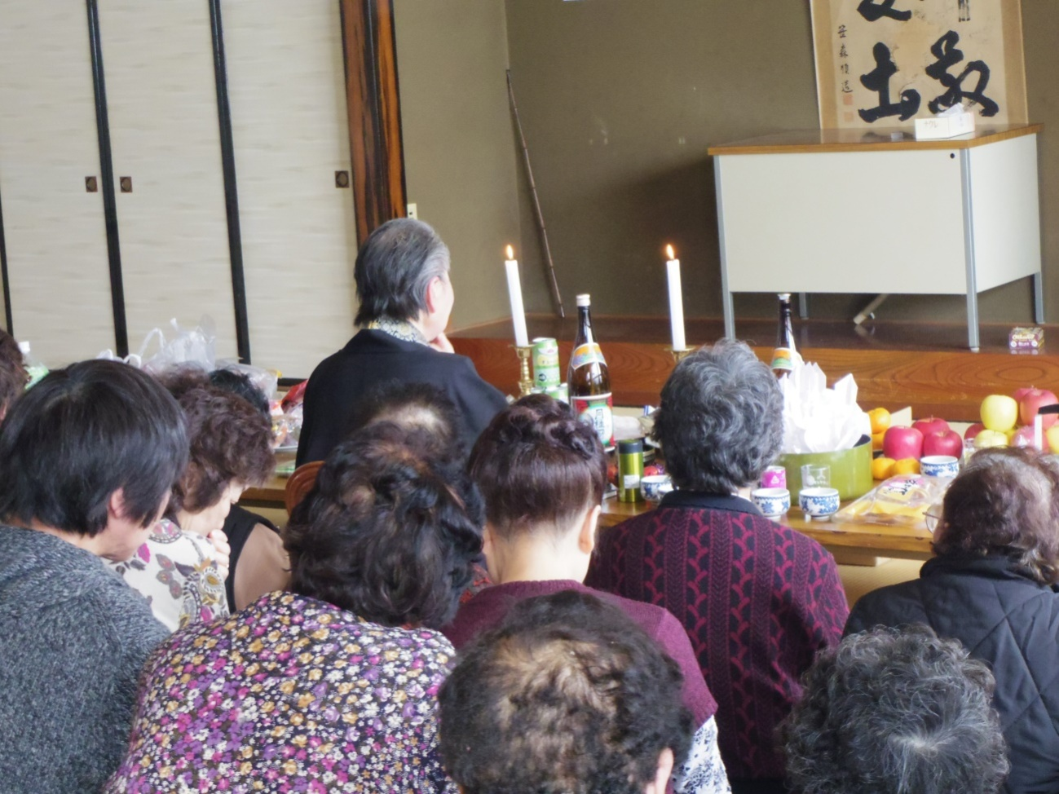

Figure 2: An altar of a *kamisama*

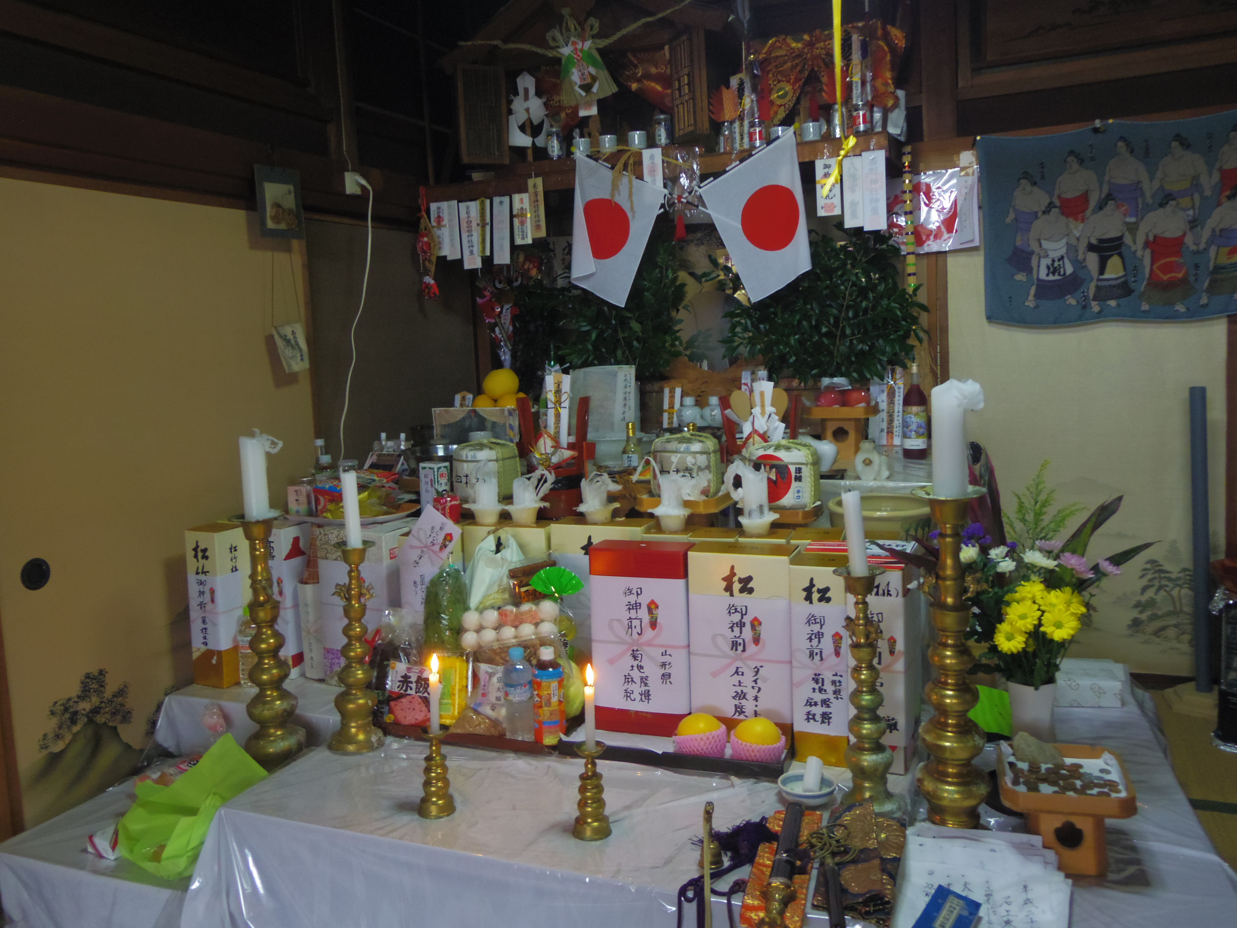

1. Works by Sakurai, Tokutarō (Sakurai 1974, 1977) and Kusunoki, Masahiro (1975, 1979), for example.
2. The distinction of local and not-local here is not a virtual but tentative one to outline shamans’ lives in the contemporary social situation.
3. The Japanese translation was published in 1974.
4. According to research, about 70 percent of the university students outside the Tohoku (northeastern) region know the name *itako* (Omichi 2017).
5. There are only a few *itako* left, and there are several reasons behind this. First, thanks to the development of schools for the blind, women who lose their sight or are born blind now have other occupational options. Second, medical advancements have led to a sharp decrease in blindness among the population. Third, *itako* novices must perform several ascetic practices to acquire the ability to communicate with the supernatural realm. It is not attractive for people in the contemporary society. Overall, becoming an *itako* is an outdated choice for most people now.
6. Especially “*itako* of Osorezan恐山,” Osorezanis the sacred site of the Shimokita region in Aomori prefecture is at the core of the image of the *itako* (Omichi 2016: 23).
7. *Kamisama*’s ritual is even suitable for the contemporary situation since the number of people who come from outside of the prefecture who are unfamiliar with *itako*’s “traditional” role is increasing.
8. All names of the informants in this paper are pseudonyms.
9. Hirosaki city is the central city of the Tsugaru area.
10. In the initiation process of *kamisama*, a teaching license from an established religion is often obtained, like in Ms. Kasai’s case. However, the license is purely nominal. This is partly because local shamans used to be targeted by regulations if they did not belong to established religious groups, mainly from the Meiji era to Pre-War time. Under the freedom of religion granted by the Constitution, they do not have to be afraid of the regulation anymore, but many of them still think a license is necessary. There are several temples and shrines in the Tsugaru area that provide a teaching license to *kamisama*.
11. Needless to say, this expression is inspired by the essay by Margery Wolf “The woman who didn’t become a shaman” (Wolf 1990).
12. Her business as shaman is not successful in the Tsugaru area. However, what will be her chance if she lives in big cities like Tokyo? As we saw in this study, people in the Tsugaru area—not all people but who are familiar with *kamisama* and *itako* and their practices—have a shared image of *itako* and *kamisama*, and the ones who deviate from this image will be excluded. This image is developed and shared in the local community; *aza* where the spring communal prayer is held is an example. Yet, in some places, for example, Tokyo, it is difficult to share one collective image because so many people with different concerns gather. Many areas in Japan can now be characterized by the loss of a locally-shared shamanistic tradition, and the tradition is being replaced by the constant accumulation of information rendered necessary by the information society in which we live (Murakami 2011:225 and Murakami and Gaitanidis 2014). Ms. Nakano could call herself a shaman more freely if she lived in such cities.