The Ancient Practice of Attributing Texts and Ideas to Moses

Ancient scribes would write as if Moses was the author, or they would claim that a tradition was originally stated by Moses, but they did not intend to convey a historical fact with this description. Instead, they meant that a given tradition was “authentically” Jewish, or God’s will and that Moses would have approved. I call this phenomenon “Mosaic Discourse.”

[Prof.](https://www.thetorah.com/author/hindy-najman)

[Hindy Najman](https://www.thetorah.com/author/hindy-najman)

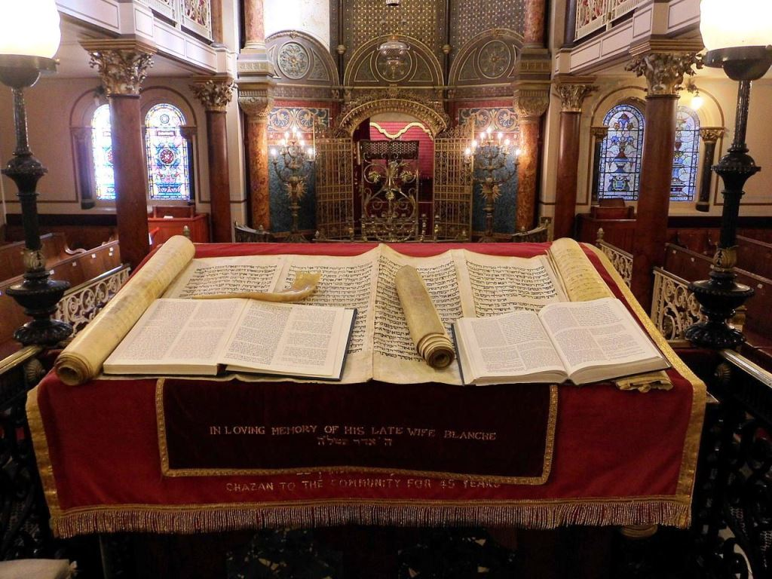

Middle Street Synagogue, City of Brighton and Hove, England. Wikimedia

Retelling and Rewriting the Biblical Story

We read the Torah every year. With this yearly reading comes new *divrei Torah*, new sermons, new commentaries. This practice keeps our story present to us but at the same time, it transforms that story in our retelling, reinterpretation, and re-presentation.

Rewritten Bible

The ancients did more than just reread the Torah. What scholars call Rewritten Bible is a body of ancient, canonical and non-canonical texts that retell narratives and reframe laws already presented in earlier scriptures, sometimes making significant alterations. The earliest and most well-known example of rewritten Bible is the book of Deuteronomy, which updates, transforms, and reworks earlier Pentateuchal narratives and laws and recontextualizes them in the framework of the Deuteronomistic history.[1]

What motivates writers to retell their past in their own words is not terribly far from why modern religious and national groups reread and reinterpret their own stories. Although the two acts are not the same, a continuum exists between what we moderns think of as *rereading* and *reinterpreting* and what the ancients participated in when they *rewrote* texts. The latter can be classified as *active* rereading.

Attaining Authority for Reworked Scripture

Under what authority can a person or a community rework, reread, or even rewrite sacred scripture and authoritative traditions? The answer appears to be by tying the new work in with an ancient figure. Deuteronomy, for example, goes to great length to emphasize that none other than Moses produced this rewriting. Early in the book, (some scholars believe it to have been the original opening), the text states:

דברים ד:מד וְזֹ֖את הַתּוֹרָ֑ה אֲשֶׁר שָׂ֣ם מֹשֶׁ֔ה לִפְנֵ֖י בְּנֵ֥י יִשְׂרָאֵֽל:

Moses is a prophet like no other, he is called man of God, and is able to speak directly with God. Thus, Moses is an ideal choice for a later author to whom to attribute his work.

Varying Mosaic Attributions

Attribution to Moses takes different forms, and Deuteronomy’s approach—to claim Mosaic Authorship—is just one example.[2]

Attribution to the Torah of Moses

A different kind of attribution to Moses can be found in traditions cited in Ezra-Nehemiah or Chronicles that are said to be Mosaic. One such example concerns the order and divisions of priests and Levites.

עזרא ו:יח וַהֲקִ֨ימוּ כָהֲנַיָּ֜א בִּפְלֻגָּתְה֗וֹן וְלֵוָיֵא֙ בְּמַחְלְקָ֣תְה֔וֹן עַל עֲבִידַ֥ת אֱלָהָ֖א דִּ֣י בִירוּשְׁלֶ֑ם **כִּכְתָ֖ב סְפַ֥ר מֹשֶֽׁה**:

No description of Levitical or Priestly “courses and divisions” (i.e., when each group would serve, in rabbinic parlance מעמדות) exists in the Torah. Moreover, the book of Chronicles, quoting the very same prescription, ascribes it to David as opposed to Moses:

דברי הימים ב לה:ד [וְהָכִ֥ינוּ] לְבֵית אֲבוֹתֵיכֶ֖ם כְּמַחְלְקוֹתֵיכֶ֑ם **בִּכְתָ֗ב דָּוִיד֙ מֶ֣לֶךְ יִשְׂרָאֵ֔ל וּבְמִכְתַּ֖ב שְׁלֹמֹ֥ה בְנֽוֹ**: לה:הוְעִמְד֣וּ בַקֹּ֗דֶשׁ לִפְלֻגּוֹת֙ בֵּ֣ית הָֽאָב֔וֹת לַאֲחֵיכֶ֖ם בְּנֵ֣י הָעָ֑ם וַחֲלֻקַּ֥ת בֵּֽית אָ֖ב לַלְוִיִּֽם:

Thus, we see that ascription to Moses may be less about “proper sourcing of quotations” and more about placing the proper authoritative weight on a given law; Moses is the authority of highest significance for law.

Jubilees – A Second Revelation on the Mountain

The book of Jubilees takes a similar approach to Deuteronomy. Jubilees, which was written in the second century B.C.E., claims to be written by Moses on Mount Sinai at God’s dictation:

Then [God] said to the angel of the presence: “Dictate to Moses from the beginning of the creation until the time when my temple is built among them throughout the ages of eternity” (Jub 1:27).

*Halakha Le-Moshe Mi-Sinai*

A different kind of example comes from the rabbis, who discuss a category of laws that are said to originate with Moses at Sinai. Some examples of such laws are:

* The shin on the outside of *tefillin* worn on the forehead, and the *tefillin*’s black straps (b. *Shabbat* 28b),
* The practice of using a willow on Shavuot (t. *Sukkah* 3:1),
* In the lands of Ammon and Moab, the poor person’s tithe should be taken even on a Sabbatical year (m. *Yadayim* 4:3).

The list of such laws even includes things that it would seem impossible for Moses to have said, such as what Elijah the prophet will do when he returns to earth (m. *Eduyot* 8:7), since Moses died well before Elijah was born. In any event, none of these laws appear in the Torah.

The difference between the rabbinic version of Mosaic Discourse and that of earlier works like Deuteronomy or Jubilees lies in the fact that the rabbis are not claiming that the words they use or their books are written by Moses. Rather, their assumption is that the tradition was passed down through the ages from Moses to them.

Understanding Ancient Attributions in Context

How are we to make sense of interpretive legal developments that we know to have originated in late antiquity that are said to have originated at a much earlier time? How about the challenge of Deuteronomy itself? Modern scholarship understands that virtually all of what ancient authors have attributed to Moses were not written by him. Even certain rabbinic interpreters were aware of the most obvious problem of Mosaic attribution in Deuteronomy, how could Moses’ end of life account have been composed by Moses?[3]

How are we to relate to these ancient attributions?

Spinoza’s “Pious Fraud” Theory

To be sure, we can simply charge our ancient writers with forgery or duplicity. We can talk of our ancient authors and interpreters as pulling the wool over the eyes of our ancestors and committing a “pious fraud”: the priestly craft of deceiving the masses for the sake of a religious ideology that masked political interests.

I have never found this approach to be particularly compelling. Aren’t most if not all ancient texts falsely attributed? Suggesting that some ancient writers committed “pious fraud” implies that there are definitive “authentic” works in antiquity, a claim I believe to be overwhelmingly anachronistic. What figures and which texts can we speak about with the kind of historical facticity that we speak about contemporary historical developments?

Rethinking Attribution in Ancient Times

Instead, we have to rethink the way we understand historical narrative and authorial attribution in ancient times. This is not because there is no history, but because we need to learn how to listen to different ways in which the ancients told the story of their past to authorize their own present.

Discourse Tied to Founders

Michel Foucault has characterized Freudian psychoanalysis and Marxist theory as “discourses tied to founders”: discourses whose continuity requires unceasing reference to a founding figure. In such cases, what might be seen as innovations by later theorists in those schools had to be presented and understood as attempts to retrieve “what the founder really thought.” Building on this concept, I have developed my own version of this idea relevant to the phenomenon of attribution to Moses, which I call “Mosaic discourse.”[4]

Mosaic Discourse

The ancient practice of Mosaic Discourse was a process of thinking and writing that developed over several centuries, producing such works as Deuteronomy and Jubilees. Writing as Moses can be understood as an early method for accomplishing that repeated revitalization that continues to be the heart of scriptural communities.[5] In Judaism, the practice continued into rabbinic literature, culminating in midrash.[6]

The Four Features of Mosaic Discourse

I identify four features of this discourse:

* **Authority** – By reworking and expanding older traditions through interpretation, a new text claims for itself the authority that is already associated with the older traditions.
* **Torah** – The new text ascribes to itself the status of Torah. It may portray itself as having either a heavenly or an earthly origin, but in any event describes itself as an authentic expression of the Torah of Moses.
* **Sinai**– The new text/tradition is said to be a re-presentation of the revelation at Sinai. There is repeated emphasis on gaining access to revelation through a re-creation of the Sinai experience. This strategy emphasizes the presentness of the Sinai event, even in the face of destruction and exile.
* **Moses** – The new text is said to be associated with, or produced by, the founding figure, This claim serves to authorize the new interpretations as divine revelation or dictation and as prophecy or inspired interpretation. The new text can then be seen as an extension of earlier ancestral discourse.

In short, Mosaic Discourse means that the ancient scribes would write as if Moses was the author, or they would claim that a tradition was originally stated by Moses, but they did not intend to convey a historical fact with this description. Instead, they meant that a given tradition was “authentically” Jewish, or God’s will and that Moses would have approved.

Conclusion: Attributing the Pentateuch to Moses

Mosaic Discourse came to play an increasingly important role in the development of ancient Israelite and also Jewish literature. This would continue well beyond Deuteronomy, and, indeed, into the nascent periods of rabbinic Judaism and early Christianity.[7]

Ironically, the attribution of Deuteronomy to Moses had an exceedingly important side effect for later Judaism. Once Deuteronomy became incorporated into the Pentateuch as one work, the entire Torah became, ipso facto, Mosaic discourse, even though nowhere in the Torah, except for Deuteronomy, is there a claim that Moses wrote it.[8]

Prof.Hindy Najman, University of Oxford

Prof. Hindy Najman is the Oriel and Laing Professor of the Interpretation of Holy Scripture at the University of Oxford. She holds a Ph.D. from Harvard University. She is the author of Seconding Sinai, Past Renewals and Losing the Temple and Recovering the Future, and is currently completing a book titled, Ethical Reading: Rethinking Philology in Biblical Studies.

1. For a basic example of how Deuteronomy rewrites narratives from earlier texts, see Zev Farber’s TABS essay, [“The Opening of Devarim: A Recounting or Different Version of the Wilderness Experience?”](http://thetorah.com/devarim-recounting-different/)
2. For more on how Deuteronomy describes its own formation, see Itamar Kislev’s TABS essay, [“Understanding Deuteronomy on Its Own Terms.”](http://thetorah.com/understanding-deuteronomy-on-its-own-terms/)
3. See *Sifrei Devarim* 357; b. *Baba Batra* 15a; b. *Menachot* 30a.
4. To understand Mosaic Discourse, we are required to historicize some of the central terms of biblical philology: terms such as “rewriting,” “ascription” and “scriptural authority”.  The result is an approach that is at once more historicist than much of biblical scholarship, and at the same time more sensitive to the ongoing vitality of biblical traditions, both canonical and non-canonical.
5. As James Kugel and others have argued, such works reflected the fact that, long before the rabbinic conception of “oral Torah” had come to fruition, ancient Israel had read scriptures within a dynamic interpretive context.  Often, motifs found within ancient texts – either non-canonical or canonical within “sectarian” or some Christian communities, but apparently not within later rabbinic communities – could also be found in rabbinic midrashim.  The continuities were striking.  But so were the discontinuities.  Ancient texts often ascribed their retellings, not to sages, but to prophetic figures of the past, or to angels, or even to God.  Did this mean that these works were not proto-midrashic, but rather proto-supersessionist?
6. Early Christianity also adopted many of the texts and traditions which were originally part of this Mosaic discourse.
7. To be sure, we see this repetition of Sinai as well as of rewritings throughout the biblical and extra biblical traditions.  So, for example, Joshua, Chronicles, Jubilees, as well as works such as 4Ezra, Ben Sira, Ezra-Nehemiah and other wisdom and legal texts participate in rewriting and in the re-presentation of the Sinai event.
8. See David Glatt-Gilad’s TABS essay, “[Deuteronomy: The First Torah.](http://thetorah.com/deuteronomy-the-first-torah/)” Admittedly, quotations of what God said to Moses do appear consistently throughout Exodus, Leviticus, and Numbers, but these are meant to be third person quotations from an “omniscient” author who could well have lived hundreds of years later. This too is a form of Mosaic Discourse, perhaps the earliest form.