**Background on The News Items Under Investigation**:

Nash’at Milḥim: An Arab Israeli who carried out a shooting attack in Tel-Aviv in January, 2016. Three Israelis were dead as a result of the attack. He was shot dead in a firefight with police forces in his hometown of Arara in northern Israel[1].

Israa’ Abed: An Arab resident of Israel, accused of a stabbing intent of Israeli soldiers at a bus station in the Israeli city of A’fula. The soldiers shot her immediately, leaving her badly wounded. Israeli press claimed she held a knife, while other Arab media platforms claimed she was holding her sun-glasses[2]. The incident took place in October, 2015.

The touting of Member of Knesset Bezalel Smotrich (Bayit Yehudi- right wing) of segregation between Jewish and Arab women in Israeli maternity wards: A firestorm of controversy erupted between Arabs and Jews on the social networks, specifically, Facebook[3]. The segregation backing was announced by Smotrich in April, 2016.

**Methodology**

Facebook has become a documenting arena where whatever is “said” is documented through posts, comments, links, and even screenshots. Before the presence of Facebook, documenting attitudes and real discourse reactions was a very difficult mission to do. The advent of Facebook and other social media utilities has made the task easier. For the purpose of this study, content analysis to 539 Facebook comments was conducted. The comments were screenshotted randomly from different Israeli Facebook pages, including comments of both Jews and Arab Palestinians living in Israel as a response to controversial news items which present the Israeli-Palestinian Israeli (Palestinians living in Israel) conflict through the social networking platform.

In total, 296 comments by Jewish Israelis, and 243 comments by Palestinians living in Israel were screenshotted. Then, frequencies of comments including obscene, immoral, flaming words were categorized as comments with “offensive reactions”; comments with obvious friendly reaction, were categorized as “friendly comments/reactions”; and comments with no indication of neither a positive nor a negative reaction were categorized as “neutral reactions”.

**Findings**

As stated previously, attitudes of Jews vs. Israeli Arabs at a time of crisis were gathered for the purpose of this study. The attitudes are divided into two groups: Offensive vs. Friendly. Neutral and defensive comments were put together under the category of friendly comments. In this section I present a sample of the comments posted on each incident with their translation, and then a table with the findings for each incident.

The following are samples of the comments posted by different FB users after the incident of shooting of Israa Abed.

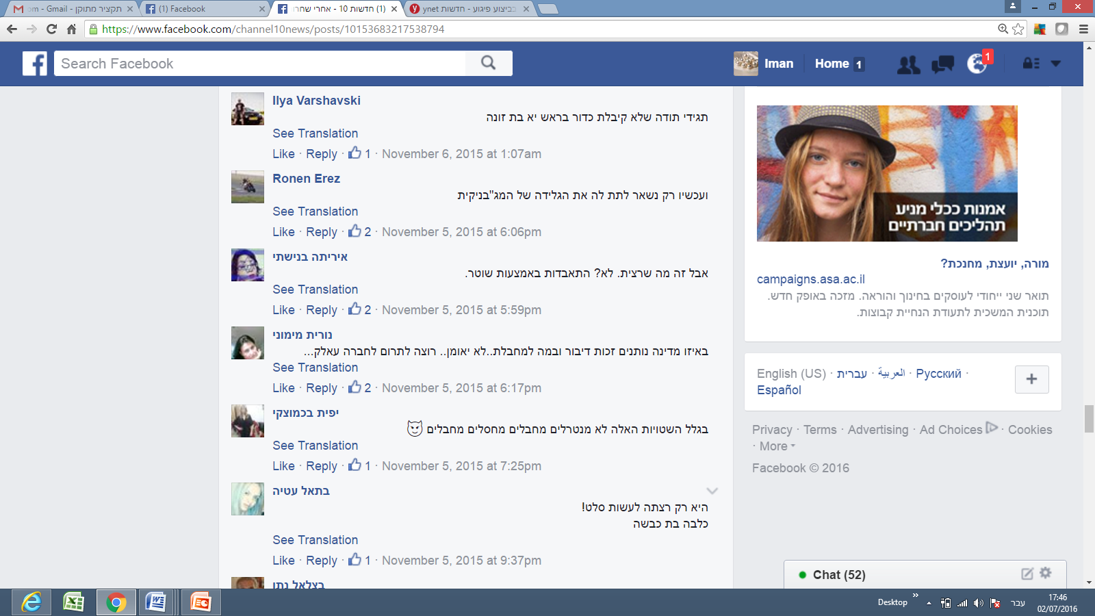

Translation: Just say thanks you did not get a shot in your head you bitch

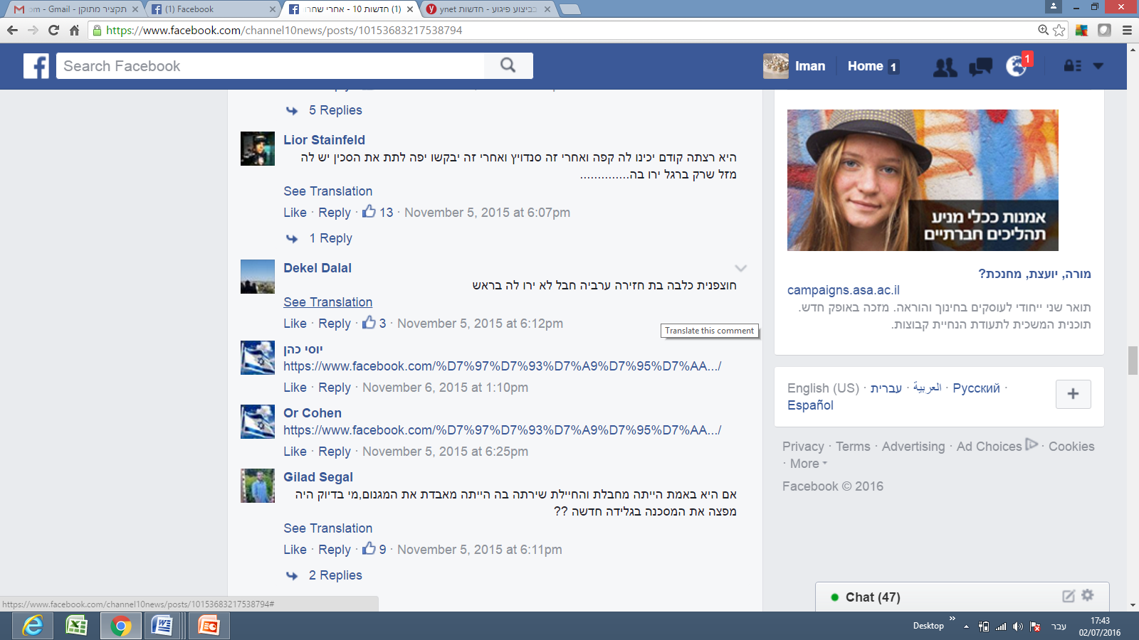

Translation: You are a daughter of a pig, a bitch, an Arab, it’s too bad you were not shot in the head

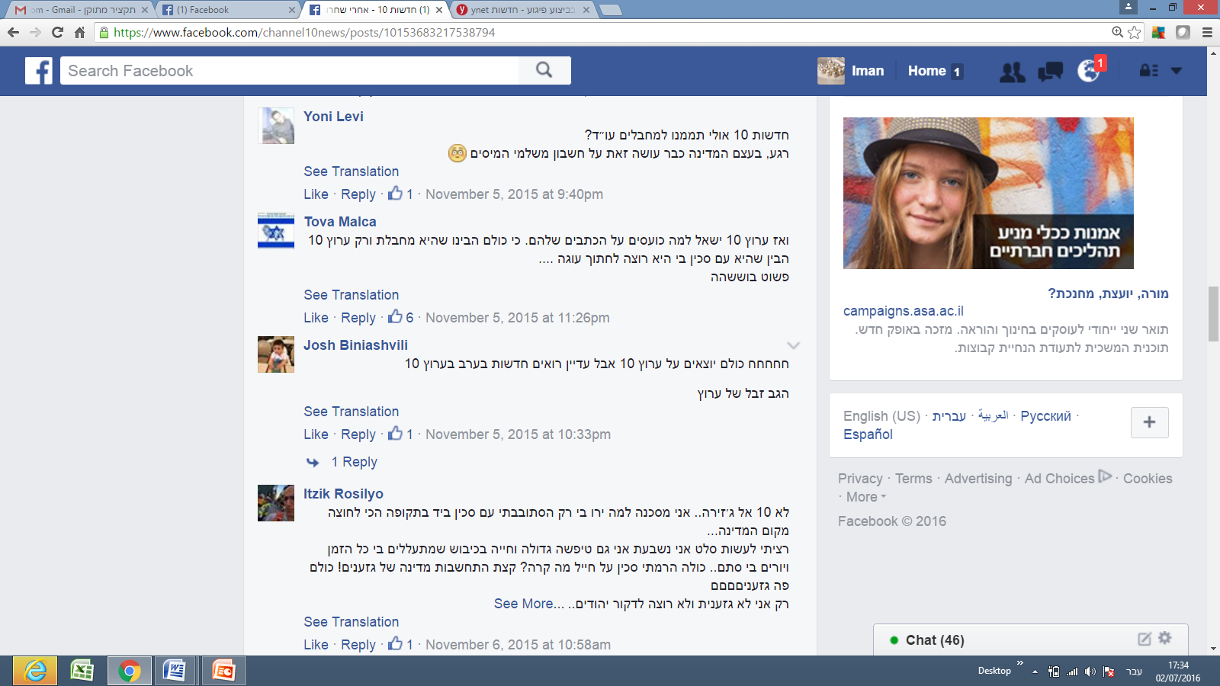

It’s not channel 10.. you can call it AlJazeera. [as if quoting Israa Abid:]I am a poor girl, why have they shot me? I was only wandering in the street with a knife in hand at one of the most loaded times in the history of the country [sarcastically]…

I only wanted to prepare salad [with the knife- sarcastically] I swear.. I am a big idiot living under occupation. They abuse me all the time, and they shot me without a reason [sarcastically].. Oh, what have I done? All I have done is to raise a knife on a soldier! So, what?! [sarcastically].. Just show a bit of consideration, you country of racists! You are all racistsss!

I am the only one who is not racist, and I do not want to stab Jews.. [being sarcastic]..

The following table summarizes the attitudes of Jewish and Arab Israelis towards each other after the shooting of Israa Abed’, as appears from the comments gathered:

|  |  |  |  |
| --- | --- | --- | --- |
|  | Jewish Israelis | Arab Israelis | Total |
| Offensive comments | 45: 48  **94%** | 26: 50  **52%** | 56: 98  **73%** |
| Friendly/ Neutral Comments | 3: 48  6% | 24: 50  48% | 42: 98  28% |

Table 1: Attitudes of Jews and Israeli Arabs towards each other as understood from posts and comments after the shooting of Israa A’bed.

Now, let’s consider some sample comments that were posted by Israeli Jews after the incident of Nash’at Milhim:

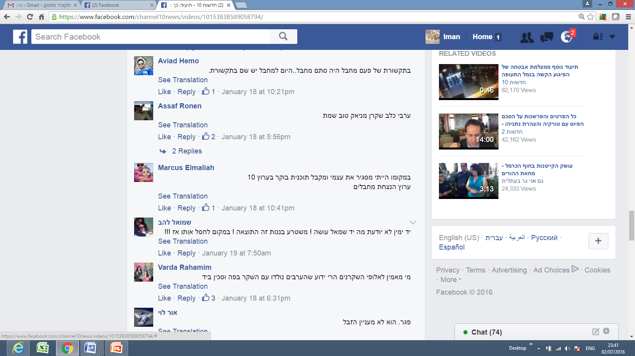

An Arab dog, liar, maniac, good that he’s dead

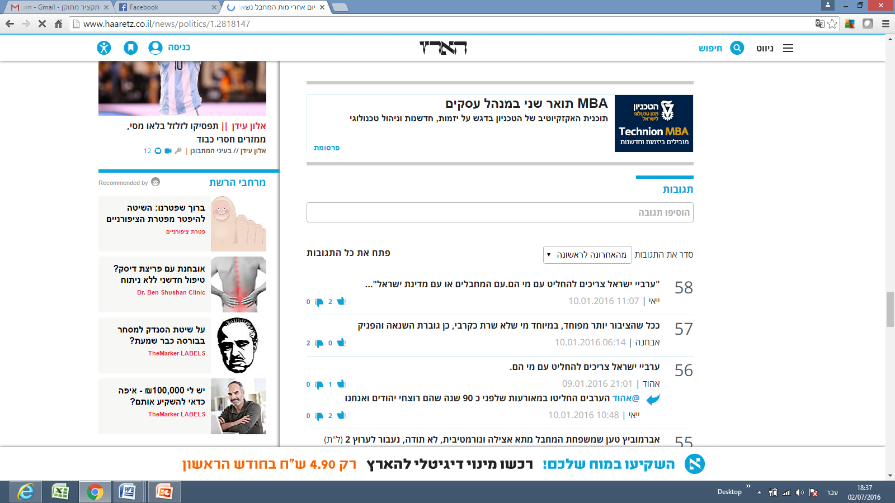

“Israeli Arabs should decide to where they belong. Are they with the terrorists or with the country of Israel?”



Who would believe the champions of lies [meaning Arabs]! Everyone knows that Arabs are born with a lie in the mouth, and a knife at hand.

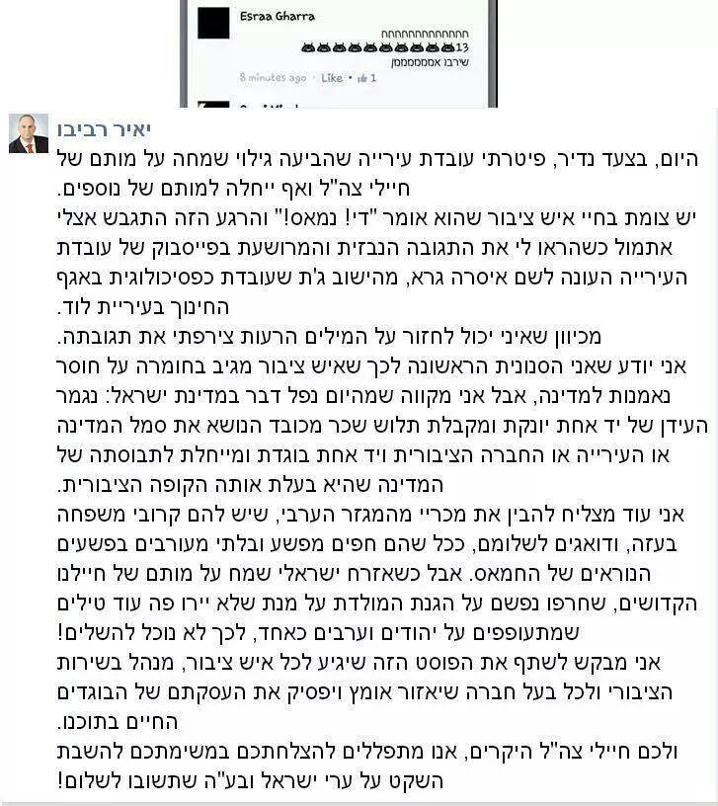

|  |  |  |  |
| --- | --- | --- | --- |
|  | Israelis | Arab Israelis | Total |
| Offensive | 128:150  **85%** | 19: 93  **20%** | 147: 243  **60%** |
| Friendly/ Neutral/ defensive | 22:150  15% | 74: 93  80% | 96: 243  40% |

Table 2: Attitudes of Jews and Israeli Arabs towards each other as understood from posts and comments after the killing of Nash’at Milhem

**Segregation of Arab women from Jewish women in delivery rooms:**

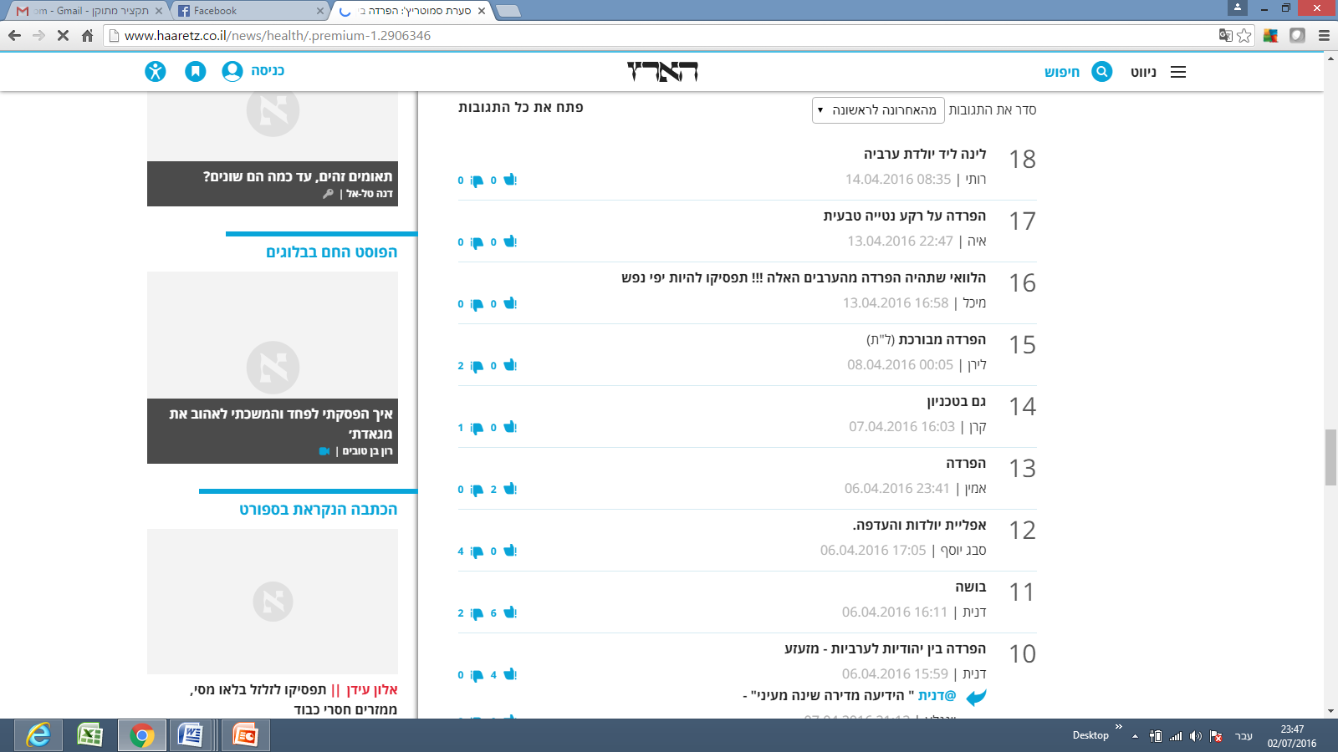

I wish there would be segregation from those Arabs!!! Stop being bleeding hearts!

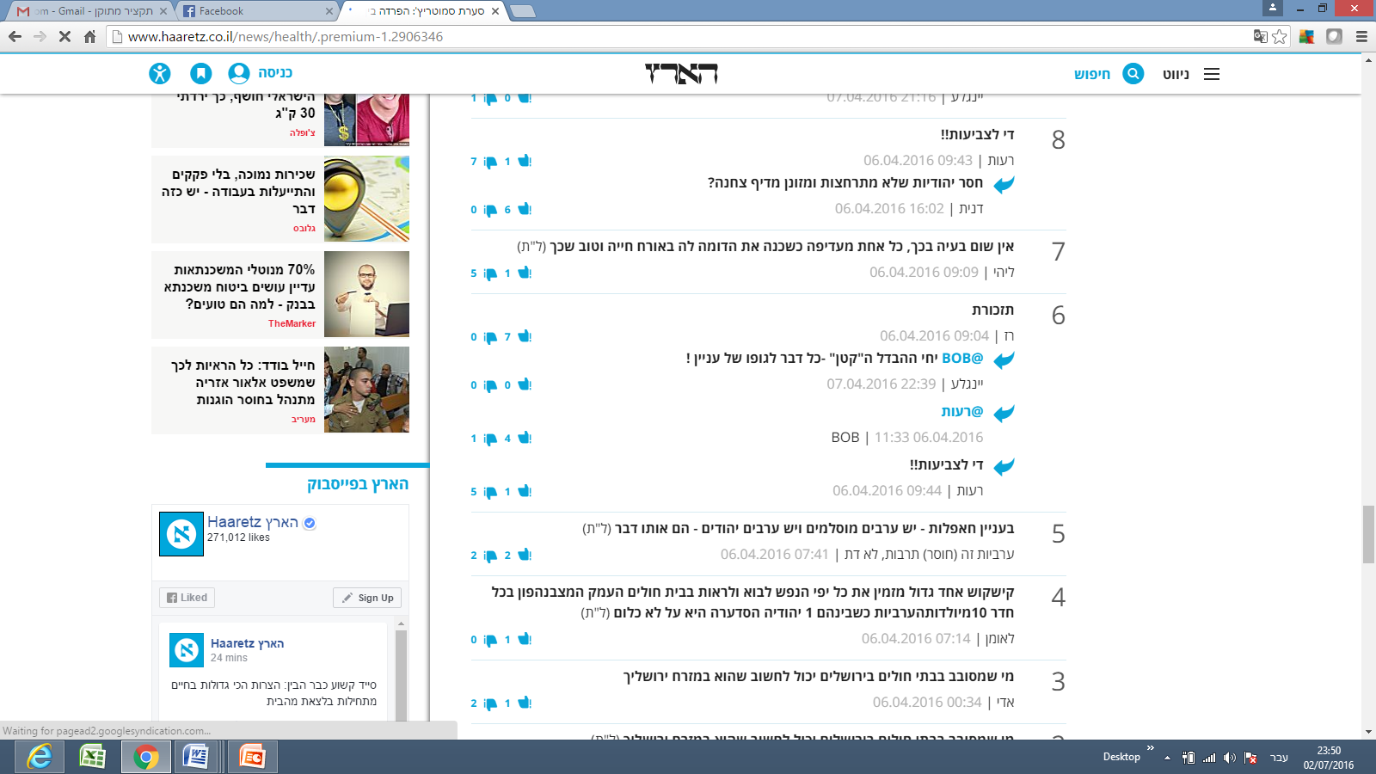

Regarding parties- There Are Arab Muslims, and Arab Jews [referring to the Jews who say the call for segregation is immoral]- they are both the same.

Arabness is a (lack) of culture, it’s not a religion.

|  |  |  |  |
| --- | --- | --- | --- |
|  | Jewish Israelis | Arabs | Total |
| Offensive | 47: 98  **47%** | 92: 100  **92%** | 139: 198  **70%** |
| Defensive/ Neutral | 51:98  52% | 8:100  8% | 59: 198  30% |

Table 3: : Attitudes of Jews and Israeli Arabs towards each other as understood from posts and comments after call to segregate Arab women from Jewish women in delivery wards.

The final findings show a very high percentage of negative attitudes from both parties under study towards each other, at a time of crisis. 220: 296 comments by Jewish Israelis were with negative attitude, ending at a percentage of 74%, while 137:243 comments by Israeli Arabs, ending at a percentage of 56% of negative attitude towards Jews. All negative comments from both parties constitute 66% of the total number of the comments gathered for the study (357:539).

**Discussion**

The frequencies of offensive language from both sides towards each other, and their attitudes towards the issues under consideration, reveal a fragmented and polarized landscape with lots of flaming. It also supports the argument that peaceful communication channels between Israelis and Palestinians living in Israel are few and far in-between. It is obvious from the findings presented that Jewish commentators on Facebook are more daring to use offensive words.

This scenario may be explained by the fact that Israelis feel more secure in expressing their true opinions, regardless of how offensive they are, because of the perception that they are less likely to face legal or security consequences. In contrast, Arab Israeli commentators are more reluctant to express their views freely as they feel more prone to be arrested by security apparatuses than their Jewish counterparts.

A closer look at the findings of the Jewish scene may raise the question, where are left wing people? The answer to this question may have to do with mass communication theories, specifically Noelle Neumann's (1979) spiral of silence theory, which stipulates that some people are not willing to state their real opinions due to fear of isolation from the overwhelming majority opinion. According to Noelle-Neumann (1979), public opinion is essentially "pressure to conform". Public opinion is in essence a general social climate, a prevailing moral and aesthetic trend in society that monitors human activity much as a "public eye" from which nobody can withdraw (Noelle-Neumann, 1985, p.84). Furthermore, she posits that the essential meaning of the term lies in "the interaction between the inclinations, abilities, and convictions of the individual and the agreement of the many, to which the individual has to subordinate himself if he does not want to place himself in isolation outside society (1979, p.151) As Noelle-Neumann puts it, it is through the media of mass communication that people in modern societies come to know public opinion. This is true of-course for social networks context. And this in fact can explain that in some posts the overwhelming majority of the Jewish comments are against Arabs.

~~she posits, it is through the media of mass communication that people in modern societies come to know public opinion. the mass media, given their ability to portray trends and shifts in the climate of opinion, can bring its compelling force, its threat of isolation, to bear on their audiences. the media in this way serve as the principal conduits (and not entirely neutral ones, in her view) for conveying the inescapable social pressure of public opinion.~~

~~. However, the original spiral of silence theory may account for the abscence of "left wing" or say "less extreme" responses from the Jewish commentators: Apparently, most of the comments by the Jewish commentators are against Arabs living in Israel, and thus the "left-wing" commentators may feel under pressure should they reveal their true opinions, because they fear to be rejected by the majority status. Noelle Neumann claims that people~~

because of the fact that they are a minority in the country. Aside from this, many cases of Arab Israelis of people who revealed their negative attitudes towards the Jewish community ended in an “uncomfortable” way[4] - to say it mildly-. The link in footnote 8, refers to one of these incidents for example, where an Arab woman was fired from her work at a Jewish Municipality because she expressed her happiness on Facebook, after Jewish soldiers were killed.

Another very popular incident, which was very frequently quoted, and shared on Facebook pages, as well as other media platforms (including AlJazeera Tv, all Israeli main media, like Channel 2, and 10) was the incident of the well-known Arab journalist, who has written a Facebook post on a satirical manner, and the post was “Google-Translated” without the very obvious satirical meaning of the post, and ended up in the arrest of Abu-Daabes[5]. These incidents made Arabs reluctant to reveal their true attitudes towards Jewish people, specifically at a time of crisis. It is obvious for other Arab Facebook users that their Facebook posts are taken more seriously by security apparatuses than the Jewish counterparts. In the case of Abu Daabis, for example, many Arab Facebookers screenshotted other comments by Jewish Facebookrs and shared them on their Walls, which are obvious call for arson[6]:

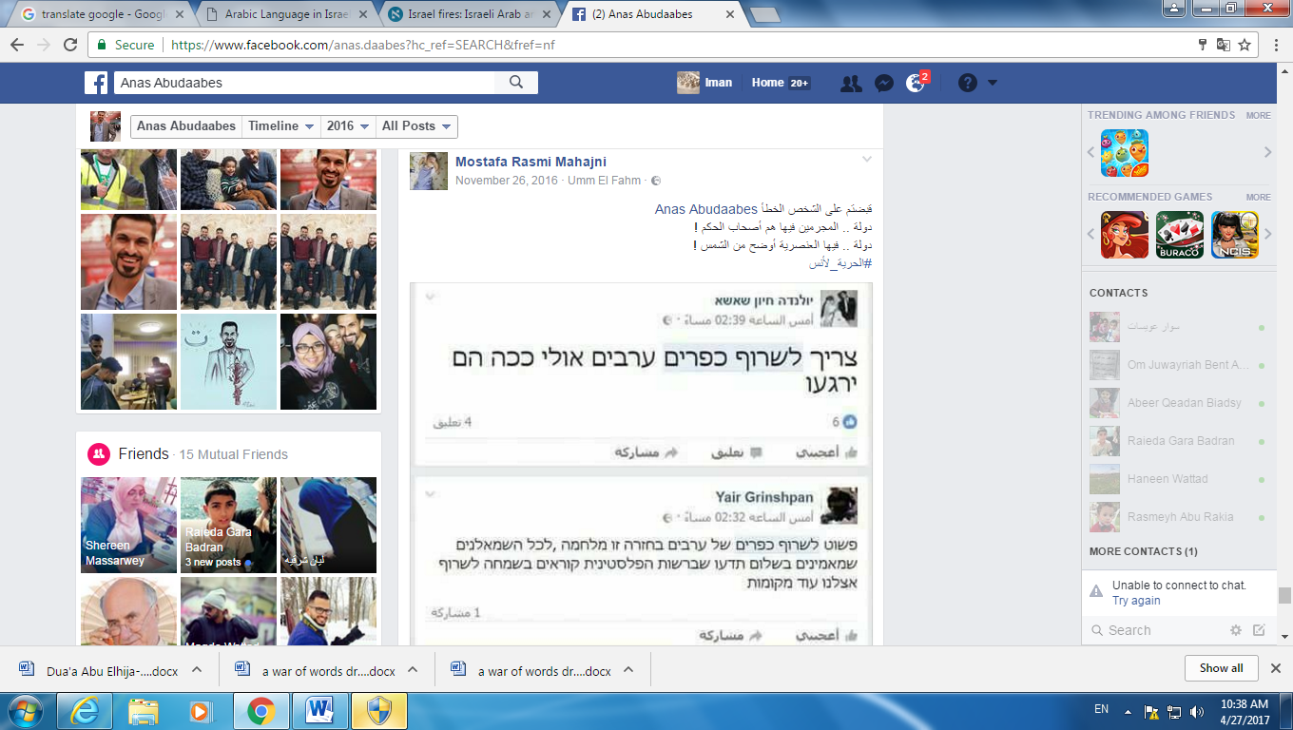

Post translation:

You have arrested the wrong person Anas Abudaabes

In this country the criminals are the governors!

In this country racism is as clear as the light of the sun!

#Freedom to Anas

Screenshots of posts by Jewish people: We have to burn all Arab villages, maybe this way they will calm down

2nd screen shot by a Jew: We simply need to cutn Arab villages back. This is a war, and to all leftists who believe in peace, you should know that in the Palestinan authority they are calling happily for more fires in our country.

It is obvious that there is a difference in the attitudes of Jewish people at a time of ‘war’ crisis vs. their attitude from an ideological, human attitude, with ‘less physical war involved’, as in the case of segregation of Jewish women from Arab women. Here, it was obvious that less offensive comments were written. However, the content of the comments here revealed a sub-category of attitudes, were Jews have written comments against Jews who affiliated with Arabs.

In the same context, Arabs were more courageous to comment and participate with their opinions on the segregation issue as it is obviously considered a more of racist demand, and less ‘bloody’ one.

1. <http://www.haaretz.com/israel-news/1.696321> Last access 17.04.2016
2. <http://www.haaretz.com/israel-news/1.682928> vs. <http://www.aljazeera.com/news/2015/10/terrorist-state-151011084548356.html> Last access 17.04.2016
3. <http://www.jpost.com/Israel-News/Report-Various-Israeli-hospitals-separate-pregnant-Jewish-Arab-on-request-450271> Last access 17.04.2016
4. See for example: <http://hasa.co.il/?p=305466>. The link is a news item published in a local news website, which reports on the firing of an Arab Israeli woman, because of what she has written on her wall that she wishes more Jewish soldiers were killed.
5. Anas Abu-Daabes has written a Facebook post when wildfires blazed across Israel, and was accused of inciting Arabs to light forest fires. However, at the end of the post he tagged [#satire_not_serious](https://www.facebook.com/hashtag/satire_not_serious?source=feed_text&story_id=10210042404830148) and  [#the_smoke_is_blinding_the_eyes_and_heart](https://www.facebook.com/hashtag/the_smoke_is_blinding_the_eyes_and_heart?source=feed_text&story_id=10210042404830148). See the link to the original post which was mistranslated: <https://www.facebook.com/anas.daabes/posts/10209996280477068>

   Link to Haaretz commenting on the story: <http://www.haaretz.com/israel-news/.premium-1.755367>
6. See link here: <https://www.facebook.com/permalink.php?story_fbid=1248838305139564&id=100000402186492>