**Cognitive Reappraisal Reduces the Influence of Negative Emotions on the Desire to Eat**

Gili Barzilay1, Noga Cohen1,2, and Noam Weinbach3

1 Department of Special Education, University of Haifa, Haifa, Israel

2 The Edmond J. Safra Brain Research Center for the Study of Learning Disabilities,   
 University of Haifa, Haifa, Israel

3 School of Psychological Sciences, University of Haifa, Haifa, Israel

Corresponding Author: Noam Weinbach, School of Psychological Sciences, University of Haifa. Abba Khoushy Ave 199, Haifa, Israel, 3498838 Email: [nweinbach@psy.haifa.ac.il](mailto:nweinbach@psy.haifa.ac.il)

Declarations of interest: none

**Abstract**

Accumulating evidence suggests that emotions can modulate eating behaviors. Recent studies proposed that the way individuals cope with emotional experience may be more important in modulating eating than the emotion itself. The current study examined whether the use of an adaptive emotion regulation strategy, namely, cognitive reappraisal, can influence the effect of threat-provoking stimuli on the desire to eat. We also examined whether this effect is modulated by the levels of trait emotional eating. The sample included 81 women who completed a task in which neutral and threat-provoking pictures appeared prior to food pictures. Participants rated their desire to eat the food depicted in pictures. In some trials, participants were asked to reappraise the threat-provoking content by reinterpreting the content to reduce negative feelings. In other trials, they were asked to observe the pictures without trying to change their emotions. Additionally, emotional eating was assessed via self-report. The findings showed that the participants' desire to eat was reduced following the presentation of threat-provoking pictures. However, instructing participants to reappraise the threat provoking stimuli increased their desire to eat compared to when they were instructed to watch the pictures without reappraising. Furthermore, the results showed that higher levels of emotional eating were associated with a greater desire to eat when presented with threat-provoking stimuli. This association was eliminated when reappraisal was used. The findings suggest that reappraisal can reduce emotional reactivity that is associated with exposure to threat-provoking stimuli and by doing so reduce appetite-inhibitory effects of threat exposure. Furthermore, using reappraisal may eliminate the association between emotional eating and the desire to eat while experiencing negative emotions.

**Keywords****:** emotion regulation, cognitive reappraisal, emotional eating, desire to eat.

# **1. Introduction**

Food provides essential nutrients for our survival. However, eating is not only driven by physiological needs. Eating is also driven by multiple socio-cultural and psychological factors (Torres & Nowson, 2007), including our emotions. Research has shown that emotions can influence both physiological and behavioral aspects related to eating (Macht & Simons, 2000). While much have been learned in recent years about the relationship between emotions and eating behaviors, recent reviews and meta-analyses emphasized that we still know very little about the mechanisms that can influence the relationship between emotions and eating (Devonport et al., 2019; Evers et al., 2018). Moreover, studies have shown that the ability to regulate emotion plays a detrimental role in modulating eating behaviors (Evers et al., 2018). Nevertheless, the direct causal effect of emotion regulation strategies on eating has been understudied.

At the basic level, it has been found that emotional reactions impact the desire to eat. For example, in response to immediate threat, individuals eat less (e.g., Torres & Nowson, 2007). This is because threat increases the release of the corticotropin-releasing-hormone (CRH) immediately after a person is exposed to the threat-provoking stimulus (George et al., 2010). The functional role of this effect is to divert resources to a “fight or flight” mode during acute stress, rather than to food seeking behaviors (Sominsky & Spencer, 2014). Ongoing experience of negative emotions, however, may increase eating in individuals who have difficulty regulating their emotions.

Emotional eating is characterized by overeating or binge eating in response to negative emotions (Cardi et al., 2015; Devonport et al., 2019; Evers et al., 2013). However, recent evidence suggests that is it not necessarily the negative emotion that drives emotional eating, but the use of maladaptive emotion regulation strategies in an attempt to cope with negative emotion (Evers et al., 2010, 2018; Taut et al., 2012; Vandewalle et al., 2014). This notion stems from affect regulation theories that refers to overeating in response to negative affect as means to regulate negative emotions in the absence of more adaptive ways of coping (Cardi et al., 2015; Devonport et al., 2019; Evers et al., 2013; Racine & Horvath, 2018).

Emotion regulation is defined as the ability to influence which emotions we have, when we have them, and how we experience and express them (Gross, 1998). Empirical evidence suggests that emotion regulation skills have an important role in shaping a person's eating behavior (Evers et al., 2018; Evers et al., 2010; Taut et al., 2012) and difficulties in emotion regulation are associated with eating disorders symptoms (Prefit & Szentagotai-Tătar, 2018; Sloan et al., 2017; Svaldi et al., 2010, 2012). For example, Evers and colleagues (2010) have shown that when people who are high on emotional eating use maladaptive emotion regulation strategies, such as suppression (i.e., attempting not to expose their emotions), they tend to overeat comfort foods that are rich in sugar and fats.

If maladaptive emotion regulation strategies result in dysregulated eating behaviors, it could be that adaptive emotion regulation strategies may promote more balanced eating behaviors during the experience of negative emotions. One adaptive emotion regulation strategy that has been extensively studied is cognitive reappraisal. Cognitive reappraisal involves giving an unpleasant situation a different interpretation or perspective to reduce distress (Gross, 1998). Higher use of reappraisal is associated with better psychological health, such as a greater well-being, better social adjustment, and fewer symptoms of anxiety and depression (Garnefski et al., 2002; Gross & John, 2003; Hopp et al., 2011; Joormann & Gotlib, 2010; Kelley et al., 2019). Laboratory studies have shown that when participants are asked to reappraise the content of negative emotional stimuli, these stimuli are rated as less negative compared to when participants are presented with these stimuli without reappraising them (Ochsner et al., 2012).

Given the role reappraisal plays in reducing negative affect, it could be that reappraisal may also prove beneficial for attenuating emotion-driven eating behaviors. However, there are mixed findings regarding the causal effect of reappraisal on eating behaviors (Evers et al., 2010; Taut et al., 2012). For example, Taut and colleagues )2012) have found that healthy women who were asked to reappraise their emotions in response to negative movie clips started to eat later compared to those who were not instructed to use reappraisal. However, there was no difference between the amount of food consumed between the reappraisal and control groups. Evers et al. (2010) also did not find a difference in food consumption between a reappraisal and a control group. However, a group of participants who were instructed to suppress their emotions while watching the films ate more than both the reappraisal and control groups.

The purpose of the current study was to shed more light on the role played by reappraisal in modulating the desire to eat following the experience of negative emotions using a trial-by-trial experimental design. This procedure allowed assessing a direct causal impact of reappraisal on the desire to eat. We have done so by adapting the classic cognitive reappraisal task with a food rating task. In the cognitive reappraisal task (Ochsner et al., 2012), participants were instructed rethink the content of negative emotional stimuli in some of the trials. Subsequently, they reported their desire to eat a high- or low-calorie food item depicted in a picture. Furthermore, we also examined whether the effect of reappraisal on the desire to eat is modulated by levels of emotional eating.

We hypothesized that threat-provoking stimuli (compared to neutral stimuli) will reduce the desire to eat. However, using reappraisal would attenuate the reduction in the desire to eat. Moreover, we expected that higher levels of emotional eating would be associated with a greater desire to eat following exposure to threat-provoking stimuli. Additionally, we explored whether reappraising threat-provoking content would modulate the relationship between emotional eating and the desire to eat.

# **2. Methods**

*2.1 Participants*

For the study 82 women were recruited. Inclusion criteria included women with an age range of 19-35, with no special diet (not vegetarian or vegan). One participants was excluded due to incomplete data. The final sample included 81 participants with a mean age of 25.6 year (*SD =* 3.67) and a mean body mass index (BMI) of 23.22 (*SD* = 4.3). Participants were native Hebrew speakers.

*2.2 Procedure*

The study was approved by the local IRB committee (333/20). Participants were asked to choose a convenient time for them to perform the 50-minute online experiment. As commonly used in previous studies (e.g., Taut et al., 2012), participants were asked to avoid eating 3-hours prior to the study, in order to reduce potential differences between the participants in the degree of hunger during the experiment. After giving consent, the participants received instructions regarding the task during an online ZOOM meeting with the experimenter (detailed below). Then, they completed that task and filled in self-report questionnaires. Lastly, participants were debriefed and received a monetary compensation of 40 NIS.

*2.3 Measures*

*2.3.1 Cognitive reappraisal-food rating task.*

Each trial within the task started with a fixation cross that was presented at the center of the screen for 1,000 ms (see a typical trial and sequence of events in Figure 1). Then, a cue appearing for 1,000 ms instructed the participant how to respond to an upcoming threat-provoking or neutral picture. Two instruction cues were used: "IMMERSE" or "RETHINK”. “IMMERSE” trials were used as control trials in which participants were asked to feel the emotions they experience while viewing the picture. They were asked to imagine what they would see, hear, and feel if the scene were happening right now (Doré et al., 2018). In “RETHINK" trials, the participants were asked to change the way they think about the event shown in the picture or change the meaning of the event so that they will feel fewer negative emotions (i.e., reappraisal condition). Then, a threat-related or a neutral picture appeared for 7,000 ms, allowing participants to implement the instructions of the trial’s cue. Following the threat-provoking image, a picture of a low or high-calorie food was presented and participants were asked to rate their desire to eat the depicted food on a scale from 1 (have no desire to eat) to 5 (very high desire to eat). The food picture remained on the screen until the participant’s response. The task consisted of 120 trials. Prior to the beginning of the task, participants received instructions from the experimenter in a 10-minute ZOOM meeting. During the practice phase, the experimenter explained what to do when seeing the reappraisal and immerse cues. Then, they were asked to implement the rethink and immerse instructions on 8 images to ensure they understood the task and were given feedback and corrected if necessary.

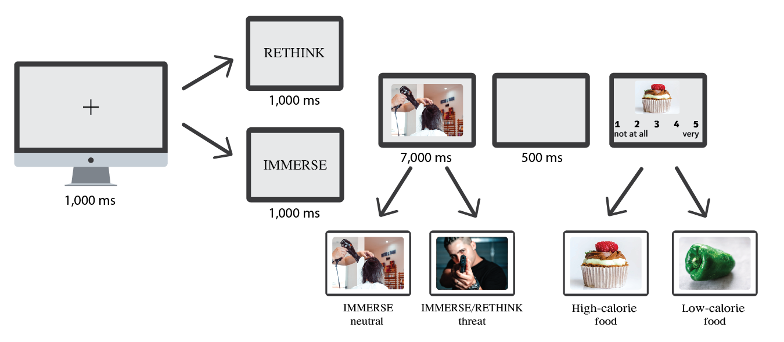

**Figure 1**. A typical trial and sequence of events of the cognitive reappraisal-food task.

*2.3.2 Threat-provoking and neutral pictures.*

Because stress is one of the most common emotions used in experimental studies on emotional eating (Bongers & Jansen, 2017), the task included 80 threat-provoking pictures. The pictures were divided equally between the “IMMERSE” and “RETHINK” conditions and 40 neutral pictures which appeared only in the “IMMERSE” condition. All 120 pictures were chosen from the International Affective Picture System (IAPS; Lang et al., 1997) and The Nencki Affective Picture System (NAPS; Marchewka et al., 2014). The pictures size was 1024 X 768 pixels. The threat-provoking pictures were chosen based on high ratings of fear (Moyal et al., 2018).

*2.3.3 Food pictures.*

The food pictures were taken from a food pictures database (Blechert et al., 2014). The study contained 60 pictures of high-calorie foods (30 sweet and 30 savory foods) and 60 pictures of low-calorie foods.

*2.3.4 Emotional eating assessment*

Emotional eating was assessed using the Dutch Eating Behavior Questionnaire(DEBQ; Tatjana van Strien et al., 1986). The DEBQ assess three distinct eating behaviors: emotional eating, external eating, and restrained eating. It contains 33-items with 13 items assessing emotional eating.

2.5 Statistical analyses

The analytic plan was pre-specified and any data-driven analyses are clearly identified and discussed appropriately. To examine the effect of emotion regulation on the desire to eat, we performed an analysis of covariance (ANCOVA) with cue type (RETHINK-threat, IMMERSE-threat, IMMERSE-neutral) and food type (high calorie, low calorie) as within-subject factors and the emotional eating subscale of the DEBQ as a covariate.

# **3. Results**

The ANCOVA revealed a main effect for cue type, *F*(1, 79) = 15.48, *p* < .001, ƞ2p = .164, demonstrating a reduced desire to eat in the IMMERSE-threat condition (*M* = 2.32, *SD* = 0.64) compared to the IMMERSE-neutral condition (*M* = 3.08, *SD* = 0.67), *t*(80) = 9.6, *p* < .001. Furthermore, higher desire to eat was observed in the RETHINK-threat (*M* = 2.67, *SD* = 0.52) compared to the IMMERSE-threat condition, *t*(80) = 4.41, *p* < .001 (see Figure 2), indicating that reappraising the threat-provoking content increased the desire to eat.

The results also showed a main effect of food type, *F*(1, 79) = 11.72, *p* < .005, ƞ2p = .12, indicating that the desire to eat high-calorie food (*M* = 3.34, *SD* = 0.59) was higher compared to low-calorie food (*M* = 2.04, *SD* = 0.65).

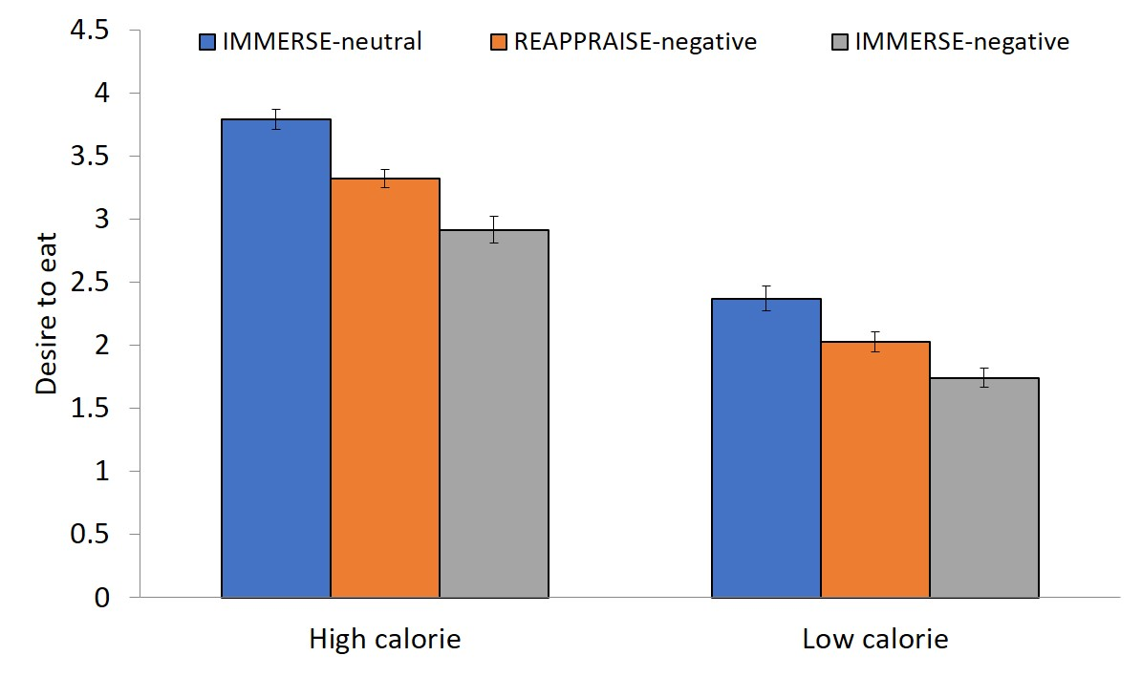

**Figure 2*.*** The desire to eat high and low-calorie foods in the different task conditions.

The three-way interaction between food type, cue type and emotional eating was not significant, *F*(2, 158) = 1.62, *p* = .20, ƞ2p = .02. However, we did find an interaction between cue type and food type, *F*(2, 158) = 4.85, *p* = .009, ƞ2p = .05, indicating that the effect of cue type on the desire to eat was larger for high- compared to low-calorie foods. In addition, the interaction between food type and emotional eating was also significant, *F*(1,79) = 4.26, *p* =.04, ƞ2p = .05, indicating that emotional eating levels were differently associated with the desire to consume low-calorie vs. high-calorie foods. In order to understand the source of this interaction we examined the correlation between emotional eating and the desire to eat high- and low-calorie foods, separately. The results showed that higher levels of emotional eating were associated with a greater desire to eat high-calorie foods (*r* = .22, *p* =.049), but not low-calorie foods (*r* = 093.-, *p* = .40(.

Furthermore, there was an interaction between cue type and emotional eating, *F*(2, 158) = 3.16, *p* = .04, ƞ2p = .03, indicating that the desire to eat as a function of cue type was modulated by levels of emotional eating. To understand this interaction, we examined the correlation between emotional eating and the desire to eat in each cue type, separately. The results showed that higher levels of emotional eating were associated with a greater desire to eat in the IMMERSE-threat condition (*r* = .228, *p* = .04; see Figure 3a).

In contrast, no correlations were found between emotional eating and the desire to eat in the RETHINK-threat (*r* = -.07, *p* = .51; see Figure 3b), nor in the IMMERSE-neutral condition (*r* = -.008, *p* = .94; see Figure 3c).

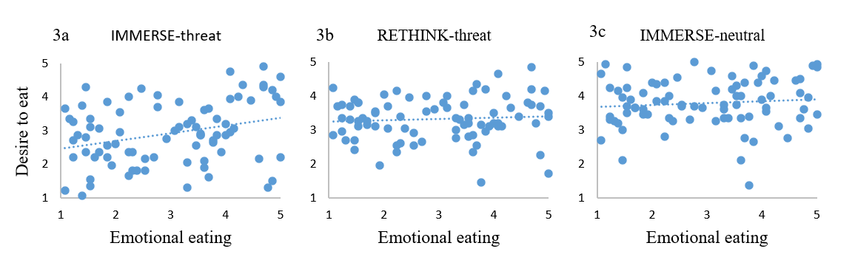

**Figure 3*.*** Correlations between the emotional eating subscale of the DEBQ and the desire to eat after IMMERSE-threat cue (3a), RETHINK-threat cue (3b), and IMMERSE-neutral cue (3c).

**4. Discussion**

The aim of the present study was to examine how reappraisal modulates the effect of threat-provoking stimuli on the desire to eat. The study also assessed how this effect is modulated by levels of emotional eating. In line with the hypotheses, the results showed that threat-provoking stimuli reduced the desire to eat. However, when participants used reappraisal, the influence of threat-provoking stimuli on the desire to eat was reduced. Additionally, higher levels of emotional eating were associated with a greater desire to eat when watching the threat-provoking content, but not when reappraising it.

Previous studies have shown that immediate threat elicits an automatic physiological response that reduces appetite (Torres & Nowson, 2007). This phenomenon is thought to represent a “fight or flight” reaction during acute stress (Sominsky & Spencer, 2014). Specifically, corticotropin-releasing-hormone (CRH) which is released immediately when exposed to threatening stimuli, affects the body's response and inhibits the need to search for food (Torres & Nowson, 2007). In line with these results, the present study revealed that exposure to threat-provoking stimuli reduced the desire to eat. In our study, this reduction was nonspecific to food type and occurred both for high- and low-calorie foods.

The main goal of the present study was to assess whether using an adaptive emotion regulation strategy, namely, cognitive reappraisal can attenuate the appetite-inhibiting response of threat-provoking stimuli. The results confirmed that when participants reappraised the threat-provoking content, the desire to eat increased compared to when reappraisal was not required. It should be noted that participants were asked to reappraise the threat-provoking content so that the reappraisal manipulation was not directed to think differently about the subsequently presented food stimuli. Thus, modulation of the desire to eat can only be attributed to the effect of reappraisal on the emotional reaction to threat-provoking content.

To date, only two studies examined the influence of reappraising negative content on eating behaviors (Evers et al., 2010; Taut et al., 2012). These studies did not report an influence of reappraising negative content on food consumption. However, Taut et al. (2012) did show that eating is delayed following a reappraisal manipulation. Several methodological differences between these studies and the current study are noteworthy. First, in our study we assessed the desire to eat rather than actual food consumption after a reappraisal induction. Second, Evers and colleagues as well as Taut et al, manipulated an emotional state using a mood-induction, which involved video clips presentation. In the current study, however, emotional state and the use of reappraisal were manipulated on a trial-by-trial basis using presentation of threat-provoking images. A trial-by-trial design may induce an experience of immediate threat and in this case, the desire to eat is automatically reduced as we have shown. This assumption is supported by previous theories posing that immediate threat results in reduction of eating while chronic stress results in increased eating (Roberts et al., 2014). In that sense, it could be that when the emotional experience leads to appetite-inhibiting reactions, reappraisal will attenuate the emotional effect in a way that would increase eating. However, when the emotional experience leads to appetite-increasing reactions, reappraisal will attenuate this effect and reduce eating. However, this assumption should be tested directly in future studies.

The current study also assessed the associations between individual differences in levels of emotional eating and the effects reported. It has been argued that emotional eaters use food to regulate their unpleasant emotions (Cardi et al., 2015; Devonport et al., 2019; Evers et al., 2013), especially foods that are rich in sugar and fats (Jiang et al., 2014). The current study supports previous findings demonstrating that higher levels of emotional eating were associated with a greater desire to eat high-calorie foods when experiencing negative emotions (Wood et al., 2016). Importantly, the results demonstrated that the desire to eat was associated with emotional eating only when participants were watching threat-provoking stimuli, but not when reappraising it. This finding strengthens the notion that it is not the negative emotions that drives emotional eaters to overeat, but the use of maladaptive emotion regulation strategies (Evers et al., 2018).

With respect to clinical implications of the current study, the results validate the rationale behind clinical interventions that aim to treat disordered eating by improving emotion regulation skills (Clyne et al., 2010; Sloan et al., 2017). The current study provides the scientific basis for using cognitive reappraisal of negative content in order to influence attitudes toward food. Furthermore, the study also showed that when using reappraisal, the link between emotional eating and the desire to eat high-calorie foods is abolished. These findings contribute to the growing evidence demonstrating that treatments that focus on improving emotion regulation, such as dialectical behavioral therapy, can be useful for treating disordered eating (Hill et al., 2011; Safer et al., 2009, 2018).

Several limitations of the study should be acknowledged. First, the study examined the participants' desire to eat and not food consumption. Thus, gaps between the desire to eat and actual food consumption may exist. Also, because the experiment was structured on a trial-by-trial basis, the nature of the effects reported is short lived. Thus, conclusions about long-term effects of reappraisal and exposure to threat-provoking stimuli on eating could not be drawn. For example, it is possible that prolonged exposure to threat results in increased, rather than reduced, desire to eat and this may result in different effects as discussed above. Lastly, the current study assessed the effect of threat-provoking stimuli, but not other types of emotional stimuli. A wide range of emotional experiences may influence eating behaviors (e.g., sadness, anger, disgust) and these may also be related to emotional eating. Future studies should extend findings from the current study by examining how reappraising a variety of emotional content can influence the desire to eat.

To conclude, the study demonstrated that threat-provoking stimuli result in an immediate reduction of the desire to eat, but less so when reappraising the threatening content. Also, the use of reappraisal eliminated the association between emotional eating and the desire to eat following the experience of threat. Future studies should further assess ways to utilize cognitive reappraisal with the aim to ameliorate disordered eating patterns that are driven by emotion dysregulation.