Three Episodes Of Basilar Tip Occlusion Necessitating Thrombectomies In A Patient With Subclavian Artery Dissection Distal To The Vertebral Artery Origin – A Case Report And Literature Review
Nadav Bitton, Anat Horev

Introduction

The subclavian arteries give rise to the vertebral arteries before continuing to supply the upper limbs. This anatomy places the subclavian arteries in a unique position, and when compromised, might produce injuries of both brain and (respective) arm³.

Although uncommon^{1, 2}, dissection of the subclavian artery have been associated with anomalies of the aortic arch, iatrogenic injury, and blunt trauma^{10, 18, 19}. Previous research has implicated proximal injuries of the subclavian as progenitors of stroke^{4, 8, 9}, specifically basilar artery stroke. In contrast, subclavian dissection distal to the vertebral artery origin has never been described in association with stroke.

Basilar artery stroke entails a poor prognosis, with death or severe disability reaching 90% of cases¹³. Repeat basilar strokes and treatment (from thrombectomies to recurrent TPA administration) were reported several times in the past^{12,14,15,16, 17}, with varying degrees of residual disability. To the best of our knowledge, no study to date has reported of three or more basilar artery occlusions treated with mechanical thrombectomies resulting in a successful outcome.

We present a rare case of a 56-year-old female who presented with three episodes tip-of-basilar artery stroke ,all occurred within a motnh ,following distal subclavian artery injury. This case was successfully managed with endovascular thrombectomy and eventual right vertebral artery sacrifice. Our patient has returned to a fully-functional state, and is free of repeat strokes to date.

Case Report
We present here a case of recurrent tip-of-basilar stroke, secondary to proximal subclavian occlusion. A 56-year-old none smoker, and an amateur volleyball player, with no other significant stroke risk factors. This patient was presented with an acute homonymous hemianopia and left sided numbness. Physical examination demonstrated a left sided facial palsy, left sided 4/5 weakness, decreased sensation in the right arm and leg, and a left sided dysmetria. A non-contrast head CT (NCCT) did not demonstrate an infarct or any other finding. CT angiography of the head and neck (CTA) suggested a distal right PCA (posterior cerebellar artery) occlusion, no other vascular findings were reported. The patient was treated with IV-TPA and admitted to the neurological department. Tenhours from the time IV-TPA was started, the patien became mute and uncooperative. An acute right occipital infarct was seen this time on NCCT without any other significant findings. CTA demonstrated a basilar tip occlusion, and a thrombectomy quickly ensued. The thrombectomy included a one pass with stentriever with full recanalization TICI3 achieved. Post thrombectomy, the patient’s condition improved significantly. A mild left-sided weakness was added to the neurological deficits she was admitted with.

During her hospitalization, the following tests were completed: transthoracic cardiac echo, transesophageal cardiac echo, 24 hour holter, a full hypercoagulopathy workup (including APLA, LAC), tumor markers and rheumatic markers, total body C.T., HBA1C and lipidogram. All studies were within normal limits. Since no clear etiology for the recurrent stroke was found, after a team discussion – coumadin treatment was empirically started with a recommendation to repeat some of the studies in the near future, during and after the in-house rehabilitation.

Less than a month into in-house rehabilitation, the patient acutely became mute and developed a severe left sided weakness. NCCT did not demonstrate a new infarct or hemorrhage, CTA suggested an acute basilar tip occlusion. Thrombectomy with a stentriever was performed quickly, with resulting full recanalization after one pass. Post thrombectomy, the patient returned to previous neurological status, with mild worsening of her left sided weakness.

During the second agiography and thrombectomy, a right subclavian artery occlusion was noted, less than one centimeter distal to the origin of the right vertebral artery. A reviwedof previously performed CTA tests and angiographies for this finding showed that this occlusion was present from the first day ofpatients admission, probably misdiagnosed due to its rarity (and so not routinely searched for). A strong suspicion was raised if the subclavian artery occlusion distal to the vertebral artery can be the source for the reccurent embolic events.

A multidisciplinary team discussion was assembled, consisting of a neurologist, neuroradiologist, hematologist, and vascular surgeon. A decision was made not to treat the occlusion endovascularly or surgically due to unclear significance of the finding at that time, and due to limited data on the subject.

Coumadin treatment was continued , and Aspirin was added again empirically. Since the left vertebral artery was codominant and patent, a tentative decision was made by the team that in the case of another stroke to the same territory – we will sacrifice the right vertebral artery at its origin. This decision was supported by the idea that the subclavian artery occlusion, although located distal to the origin of the right vertebral artery is less than one centimeter far, it probably causes a turbulence of flow at the area – being the source of embolic events.

Five days later the patient deteriorated again – losing consciousness. C.T. angiography again suggested basilar artery tip occlusion, and the patient underwent a third angiography and a thrombectomy (the third time in one month). A single-pass stentriever thrombectomy from the basilar tip full recanalization was achieved (TICI3)(picture 1). After the thrombectomy an investigative angiography was made attempting to cross the occlusion of the subclavian artery, with no success. In addition, an aspiration attempt with Sofia 6 (microvention) was made from the proximal area of the occlusion with minimal recanalization achieved (picture 2). We noticed multiple large clots in the catheter which supported our impression that the subclavian occlusion was the source for the recurrent strokes. At this point, a decision was made to completely occlude the origin of the right vertebral artery with coils in order to prevent further embolic events through this path. A successful occlusion of the vessel was performed. After the sacrifice of the vessel, a run from contralateral vertebral artery showed an excellent filling of the basilar artery and its branches with a retrograde filling of the right vertebral artery down to V2 cervical part (picture 3). After the procedure, the patient woke up with no significant new deficits.

The patient completed her rehabilitation and discharged home with minor deficits. Currently, four months free of new strokes since last episode. An ultrasound of the shoulder showed the shoulder has sustained trauma to soft tissues, which may explain the damage to the subclavian artery and nearby tissues. When asked, the patient mentioned an injury to the right shoulder sustained during a volleyball game, thereafter suffering a mild tendernesss in that region (but not severe enough to necessitate a medical workup).

Discussion
We report here a very unusual case of a healthy 56-year-old woman, who suffered three life threatening strokes at the same territory in less then one month. The fact that this patient was able to survive three basilar tip occlusions and subsequent thrombectomies (and remained independent, with MRS of 2) is very unusual. In addition, the etiology underlying these strokes is extremely unusual. We speculate that an occlusive dissection of the subclavian artery secondary to micro-trauma, slightly distal to the vertebral artery origin, was the source of these embolic episodes.

Spontaneous or minimally traumatic subclavian dissection is rare and was therefore researched and studied in a small number of publications⁴⁻¹¹. Another possible reason this diagnosis is rare may lay in the fact it may spontaneously resolve and its minor-to-no symptoms. These factors may cause subclavian dissection to be underdiagnosed. The precise pathogenesis of any arterial dissection is unclear; however, it has been associated with hypertension, trauma, vasculopathy, migraine, drug abuse, or minimal trauma associated with sports¹⁰.

Garewal et al. Described a none occlusive subclavian dissection proximal to the vertebral artery origin that caused multiple strokes. It was treated with conservatively with anticoagulation, not needing thrombectomy⁴.

Ananthakrishnan et al. described a case of a 62-year-old who spontaneously developed left-arm pain, mild dizziness, and absent distal left-sided pulses secondary to a dissection of the proximal subclavian artery and vertebral artery root⁹. The patient was treated successfully with a subclavian stent.

Scheffler et al. presented a 58-year-old female with left-upper-extremity paresthesia after playing golf secondary to proximal subclavian artery none-occlusive dissection. A good outcome was achieved with fibrinolysis, anticoagulation, and a slow return to activity⁸.

Winblad et al. described a case of a 54-year-old male presented with posterior circulation strokes secondary to subclavian dissection that involved the vertebral artery origin. In this case also, thrombectomy was not indicated. The patient recovered well by conservative treatment with anticoagulation¹⁰.

These four cases were the only cases we were able to find in the literature describing spontaneous or minimally traumatic subclavian dissection presenting with ischemic symptoms. Small number of cases described events of subclavian artery dissection, presenting as a focal or radiating pain in the shoulder and arm area¹¹.

We could not find a case that described a large cerebral artery occlusion necessitating a cerebral thrombectomy, nor did we find a case describing an occlusion distal to the vertebral artery origin as the cause of strokes. Regardless of the specific etiology, no cases were found in the literature describing patients who underwent three cerebral thrombectomies in one month.

In the case we describe here, the subclavian occlusion was overlooked in the first two CTA and thrombectomy that was performed. The subclavian occlusion was distal to the vertebral artery origin and therefore we are not sure whether early diagnosis of the subclavian artery occlusion would have changed our initial management. After three episodes of Basilar artery occlusion in one month (two of whom under full anticoagulation treatment) and after a full workup without other possible etiology, we decided on vertebral origin vessel sacrifice.

This report depicts a rare case of a very unusual stroke etiology that was first overlooked. We thought its important to share this unusual pathology as a probable explanation for recurrent basilar occlusive stroke.

Bibliography

1. Cox CS Jr, Allen GS, Fischer RP, Conklin LD, Duke JH, Cocanour CS, Moore FA. “Blunt versus penetrating subclavian artery injury: presentation, injury pattern, and outcome”. J Trauma. 1999 Mar;46(3):445-9. doi: 10.1097/00005373-199903000-00017. PMID: 10088848.

2. Elkbuli, Adel, Saamia Shaikh, Mark McKenney, and Dessy Boneva. “Subclavian Artery Avulsion Following Blunt Trauma: A Case Report and Literature Review.” International Journal of Surgery Case Reports 61 (January 1, 2019): 157–60. https://doi.org/10.1016/j.ijscr.2019.07.061.

3. Assenza, Marco, Leonardo Centonze, Lorenzo Valesini, Gabriele Campana, Mario Corona, and Claudio Modini. “Traumatic Subclavian Arterial Rupture: A Case Report and Review of Literature.” World Journal of Emergency Surgery 7, no. 1 (June 18, 2012): 18. https://doi.org/10.1186/1749-7922-7-18.

4. Garewal, Mandeep, and John B. Selhorst. “Subclavian Artery Dissection and Triple Infarction of the Nervous System.” Archives of Neurology 62, no. 12 (December 1, 2005): 1917. https://doi.org/10.1001/archneur.62.12.1917.

5. Funada, Akira, Hidekazu Ino, Noboru Fujino, Kenshi Hayashi, Katsuharu Uchiyama, Eiichi Masuta, Yuichiro Sakamoto, Toshinari Tsubokawa, Akihiko Muramoto, and Masakazu Yamagishi. “Idiopathic Dissection from Left Subclavian Artery to Brachial Artery: Spontaneous Repair with Conservative Management.” Journal of Cardiology Cases 1, no. 1 (February 1, 2010): e49–51. https://doi.org/10.1016/j.jccase.2009.07.002.

6. Williams, Samantha, Ana Pagan Jaramillo, Marie-Louise Posch, Sean-Patrick A. Prince, and Leonard Hamera. “Idiopathic Left Subclavian Artery Dissection.” Cureus 12, no. 12 (December 18, 2020). https://doi.org/10.7759/cureus.12151.

7. Onishi, Hidenori, Osamu Yamamura, Seiya Matsuo, Tokuharu Tanaka, Satoshi Daitoku, Shizuka Konokawa, Hiromasa Tsubouchi, et al. “Localized Right Subclavian Artery Dissection Detected by Accident on an Ultrasound Examination: A Case Report and Literature Review.” Internal Medicine 58, no. 1 (2019): 73–78. https://doi.org/10.2169/internalmedicine.1451-18.

8. Scheffler, Peter, Michael Uder, Joerg Gross, and Gerhard Pindur. “Dissection of the Proximal Subclavian Artery with Consecutive Thrombosis and Embolic Occlusion of the Hand Arteries after Playing Golf.” The American Journal of Sports Medicine 31, no. 1 (February 2003): 137–40. https://doi.org/10.1177/03635465030310010801.

9. Ananthakrishnan, Ganapathy, Rajesh Bhat, and Ian Zealley. “Spontaneous Subclavian Artery Dissection Causing Ischemia of the Arm: Diagnosis and Endovascular Management.” Cardiovascular and Interventional Radiology 32, no. 2 (March 2009): 326–28. https://doi.org/10.1007/s00270-008-9380-y.

10. Winblad, James Bret, Timothy Grolie, and Kamran Ali. “Subclavian Artery Dissection.” Radiology Case Reports 7, no. 4 (January 1, 2012): 626. https://doi.org/10.2484/rcr.v7i4.626.

11. Marik, Paul, and Matthew Mclaughlin. “Spontaneous Subclavian Artery Dissection: A Pain in the Neck Diagnosis.” BMJ Case Reports 2013 (November 21, 2013). https://doi.org/10.1136/bcr-2013-201223.

12. Khan A, Itrat A. Safe Readministration of Intravenous Thrombolysis in Recurrent Basilar Thrombosis. J Stroke Cerebrovasc Dis. 2018 Mar;27(3):e48-e49. doi: 10.1016/j.jstrokecerebrovasdis.2017.09.066. Epub 2017 Oct 31. PMID: 29100857.

13. “Therapy of Basilar Artery Occlusion | Stroke.” Accessed January 14, 2021. https://www.ahajournals.org/doi/10.1161/01.STR.0000202582.29510.6b.

14. Qureshi, Adnan I., Amir M. Siddiqui, Stanley H. Kim, Ricardo A. Hanel, Andrew R. Xavier, Jawad F. Kirmani, M. Fareed K. Suri, Alan S. Boulos, and L. Nelson Hopkins. “Reocclusion of Recanalized Arteries during Intra-Arterial Thrombolysis for Acute Ischemic Stroke.” American Journal of Neuroradiology 25, no. 2 (February 1, 2004): 322–28.

15. Chiti A, Pizzanelli C, Terni E, Gialdini G, Cosottini M, Puglioli M, Orlandi G. A case of recurrent basilar artery occlusion successfully treated with repeated intravascular procedures. Neurologist. 2011 Mar;17(2):95-7. doi: 10.1097/NRL.0b013e3181e5ec33. PMID: 21364363.

16. Taylor, Robert A., Gregory F. Wu, Robert W. Hurst, Scott E. Kasner, and Brett L. Cucchiara. “Transient Global Amnesia Heralding Basilar Artery Thrombosis.” Clinical Neurology and Neurosurgery 108, no. 1 (December 1, 2005): 60–62. https://doi.org/10.1016/j.clineuro.2004.11.004.17. Klepanec A, Harsany J, Haring J, Mako M, Hoferica M, Rusina M, Cisar J, Krastev G. Endovascular treatment of acute ischemic stroke in patients with recurrent intracranial large vessel occlusion. Interv Neuroradiol. 2020 Aug;26(4):376-382. doi: 10.1177/1591019920911532. Epub 2020 Mar 17. PMID: 32183596; PMCID: PMC7446596.

18. Hirose H, Temes RT. Acute subclavian artery occlusion by blunt trauma: a case report. Heart Surg Forum. 2005;8(6):E412-4. doi: 10.1532/HSF98.20051155. PMID: 16239190.

19. Myers SI, Harward TR, Cagle L. Isolated subclavian artery dissection after blunt trauma. Surgery. 1991 Mar;109(3 Pt 1):336-8. PMID: 2000567.

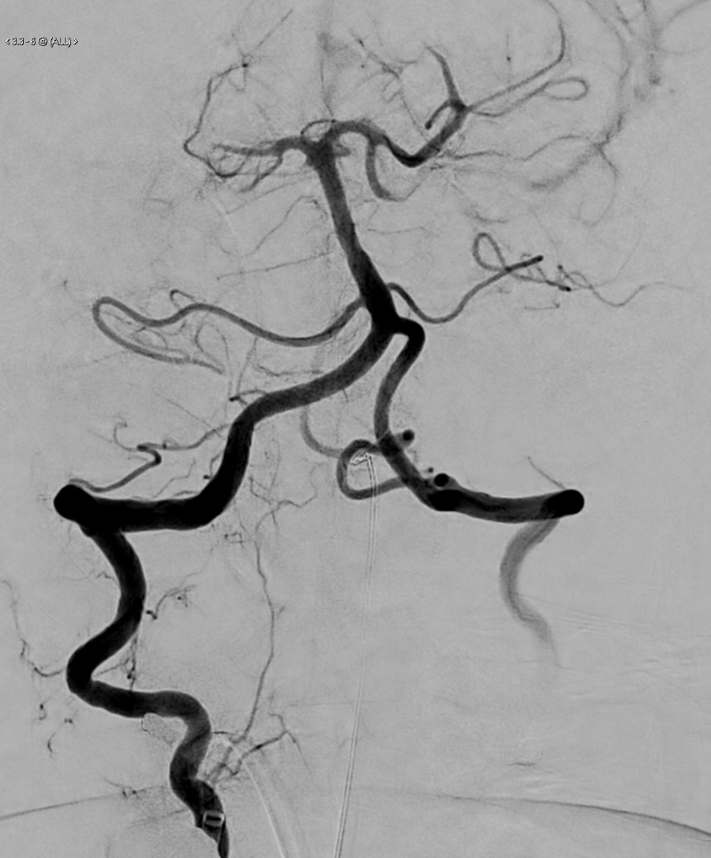 | 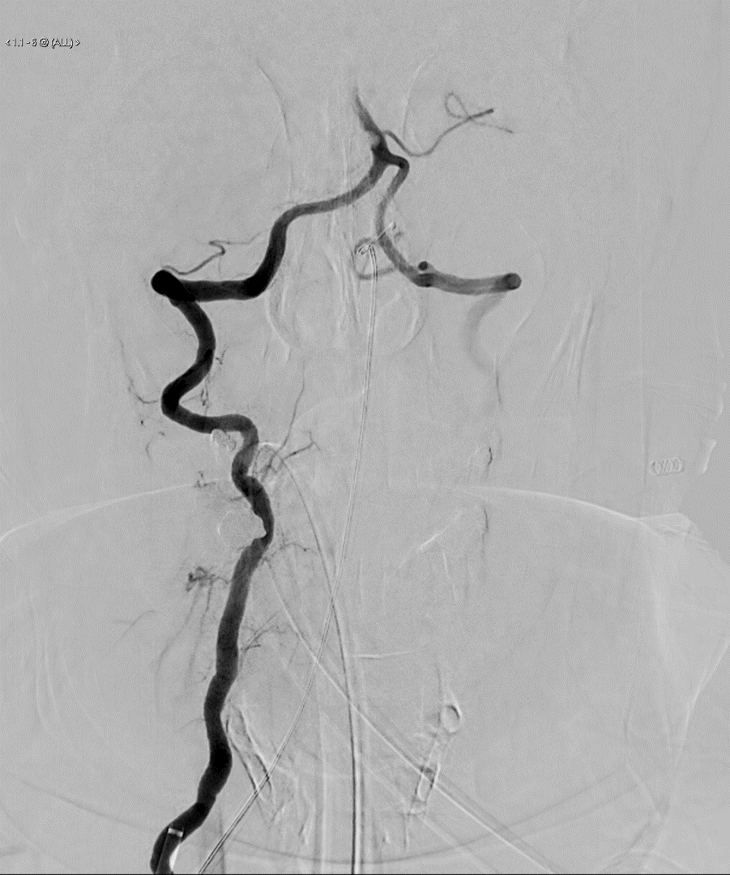
Figures 1 and 2: Pre (on the left) and post (on the right) thrombectomy

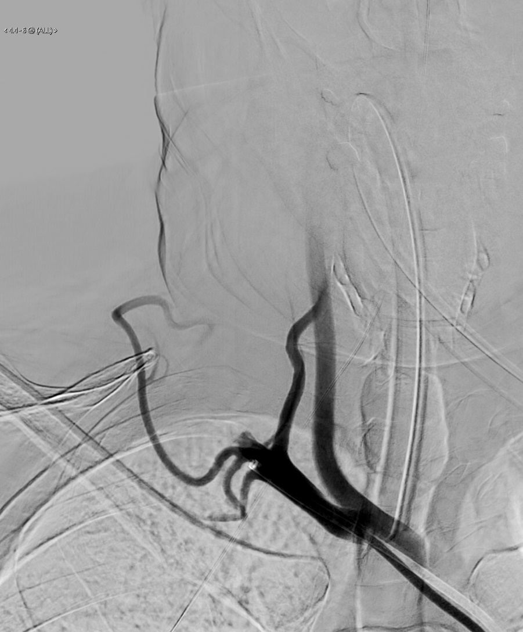  (A) | 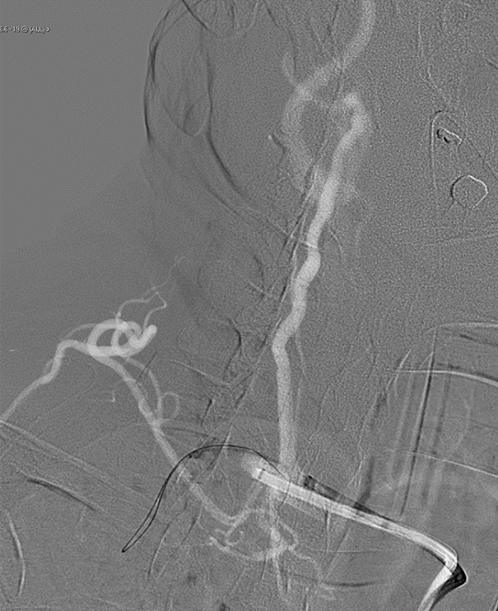(B)
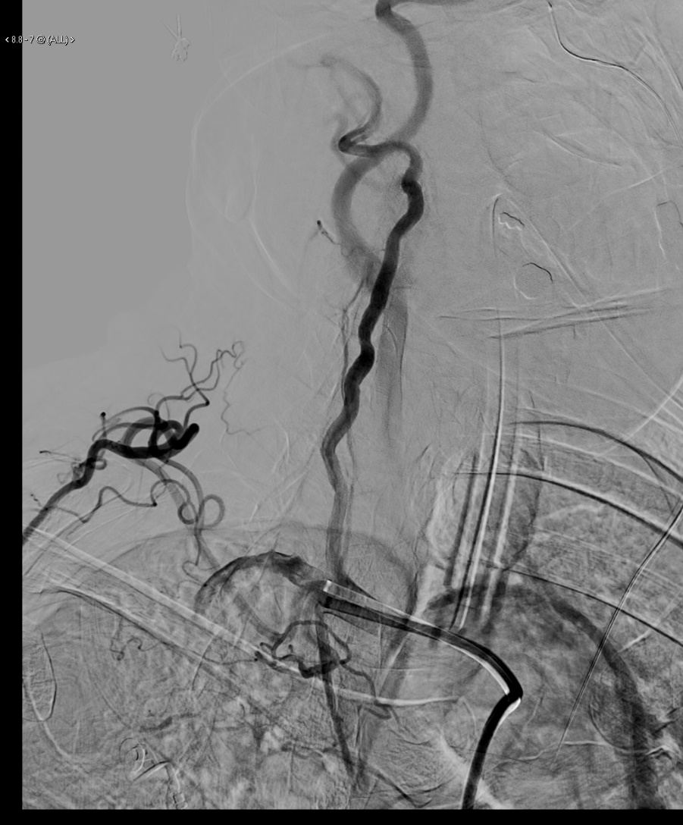
(C)
Figure 2: Pre (A), during (B), and post (C) thrombectomy

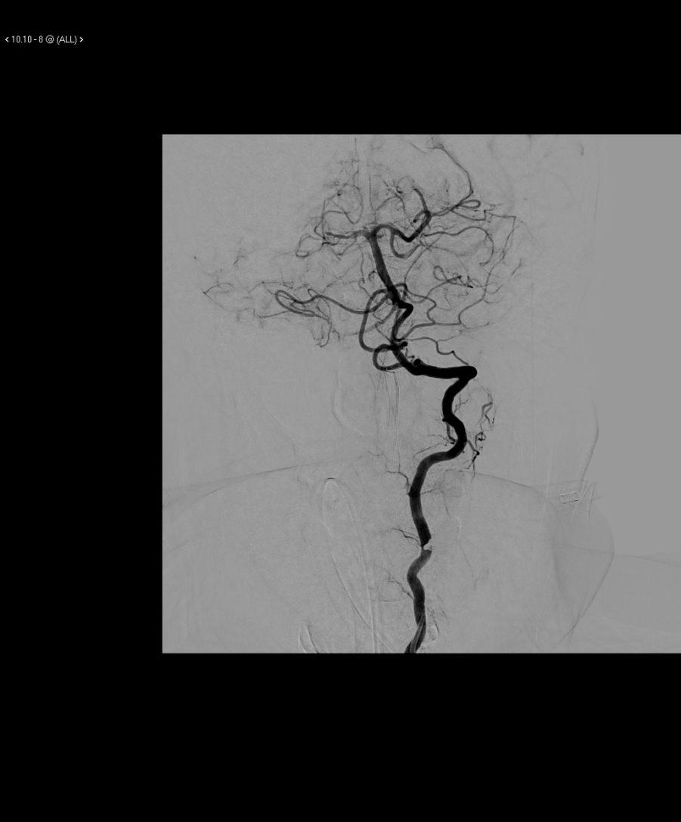  (A) | 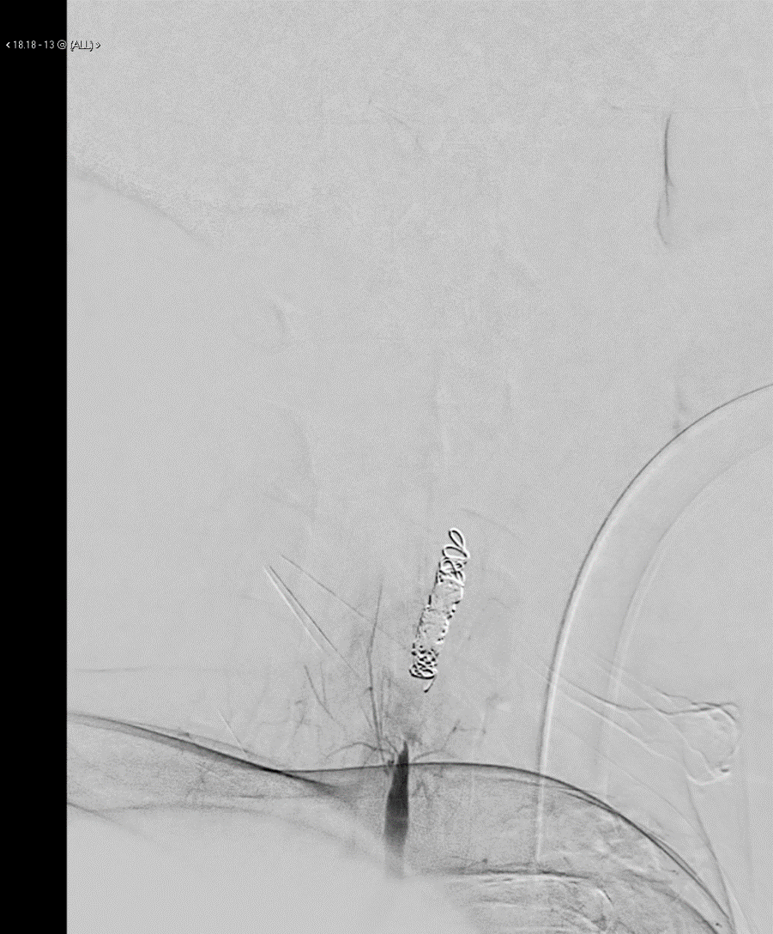  (B)
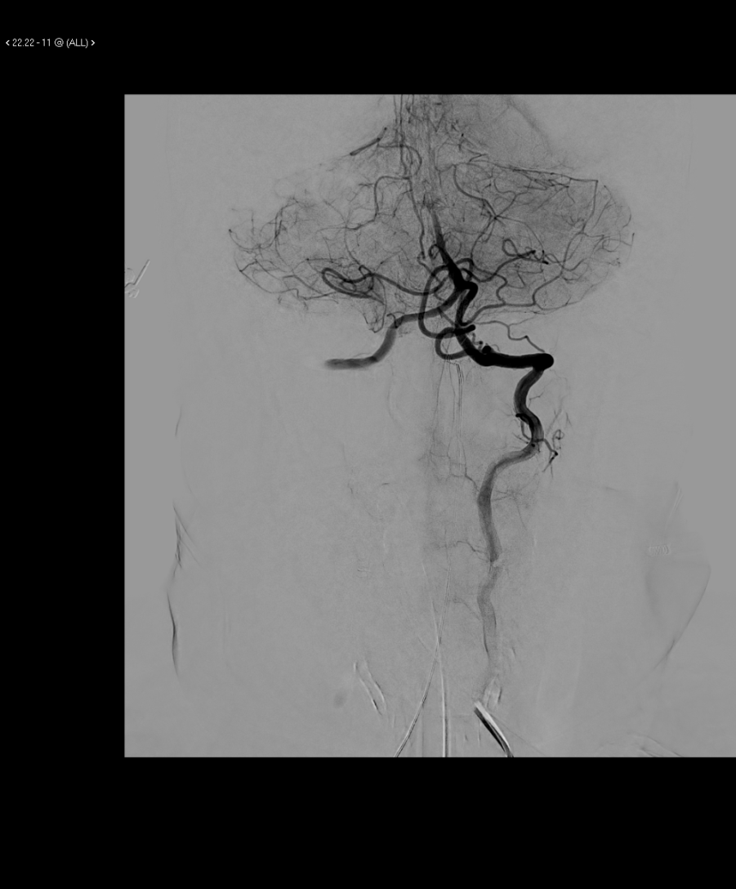
(C)
Figure 3: (A) right vert run pre left vert occlusion, (B) left vert origin run post occlusion, and (C) right vert run post left vert occlusion

