Design patterns for teaching in academic settings in future learning spaces (FLS)

Liat Eyal[1]* and Einat Gil[2]*

Levinsky College of Education

*Contact details:

Email—liate@levinsky.ac.il; einat.gil@levinsky.ac.il

Tel +972-506887171; +972-506558695

**Liat Eyal, PhD** is a and a senior faculty member at Levinsky College of Education, Tel-Aviv, Israel. Dr. Eyal is also the head of program for teachers' educators specializing in learning design in the information age at the MOFET Institute, a center for the research & development in teacher education.

**Einat Gil, PhD** is a researcher of the learning sciences and a faculty member at Levinsky College of Education. Dr. Gil is the head of teaching innovation division within the Center for Innovation & Excellence in Teaching (CIET). She led the establishment of Future Learning Spaces and its integration in the college curriculum and culture.

# Abstract

A Future Learning Space (FLS) is a dynamic and a technology-rich learning environment that enables teaching and learning with innovative pedagogical methods. However, introducing innovation and technology into an educational setting, be it in k-12 or higher education, is known to be challenging. This paper introduces design patterns for teaching in FLS. The patterns have emerged from creative teaching in a college of education, which was preceded by mentoring for some of the lecturers. The patterns relate to hybridity in the sense of formal and informal social structures and the combination of physical and digital tools mediating individuals' interactions with colleagues.

Based on mining patterns process, we extracted four design patterns for teaching in academic FLS. The patterns, which encapsulate threads of hybridity, are: Groups convergence; Teaching in Interactive Orchestrated learning space; Presentation fair; Think-Join-Share. These patterns can be used as learning design scaffolds in a social constructivist approach were pedagogy, technology and space are interplay.

**Keywords**: Future learning space (FLS), design patterns, collaborative learning, technology-enhanced learning, higher education, hybrid learning environment

# Practitioner notes

What is already known about this topic

* With the increasing numbers of future learning spaces (FLS’s) in higher education institutions, lecturers are expected to teach in a way that apply active learning approaches and methods.
* Several pedagogical frameworks for teaching in FLS are suggested in the field, such as: Pedagogy-Space-Technology (PST; Radcliffe, 2009), TPeCS (Kali et al. 2019), KCI (Slotta, 2010) that integrate considerations about technology pedagogy and space.
* At the activity level, there are pedagogical design pattern (DP) repositories, which aim to facilitate active learning, some of which could be related to FLS indirectly.

What this paper adds

* This paper introduces four novel design patterns for teaching in FLSs. The patterns relate to hybridity in two dimensions: formal and informal social structures in learning processes and the combination of physical and digital tools mediating individual and groups' interactions.
* The design patterns include context, forces, solutions, limitations and examples, in a way that can be easily adopted by novice lecturers.
* In the discussion we suggest how these DPs promote indirectly educational and pedagogical values such as transparency, inclusion and equality.

Implications for practice and/or policy

* The presented DPs can serve as a scaffold for assimilation of innovative pedagogical practices at FLSs by lecturers in higher education institutions.
* They can stimulate the desire of lecturers in higher education institutions to adopt a set of values ​​that meet the learners' needs in the information/data age and technology saturated environments to enhance learning engagement.

# Introduction

Since a virtual learning environment has become a response to the need for knowledge construction, more and more attempts have been made to maximize the benefits of the physical encounters and direct interaction among learners. Lecturers in academic settings who try to apply innovative teaching and learning methods find the traditional classroom to be an obstacle when organized in rows of static chairs, with or without tables, facing the teacher and the white board. This fixed setting class structure does not encourage lecturers to challenge themselves with new methods. Since the mid-1990s, documentation of alternative class design is seen in the K-12 education system and in the last decade, in the higher education system as well. The emphasis is on flexible technology-enhanced classrooms, equipped with portable and aesthetic furniture that invites active, learner-focused and collaborative learning.

Some studies have documented the importance and benefits of teaching and learning in these classrooms, such as enhancing learners' interaction with the teacher as facilitator, promoting equitable learning for disadvantaged populations, enhancing learning outcomes, and increasing student satisfaction (Beichner, 2014; Chiu & Cheng, 2017).

Space shapes expectations about teaching and learning (Gaffney, Gaffney & Beichner, 2010; Baeplar et al. 2016). Baeplar and collogues (2016) suggest three ways by which space is important to teaching and learning. The first serves as "mediator and moderator of instructor and student behavior" (p. 18). The second emphasizes the way the space is being used as a designed activity by the lecturer (e.g. lecture, inquiry-based activity etc.). The third relates to the physical characteristics of the space such as size, layout, colors that instill potential and meaning for how the space might be used. Our approach strives from a design pattern theoretical approach and looks at the interplay between the space and activity design.

The FLSs at the Levinsky College have been operating for a year and a half, where dozens of lecturers have taught and conducted hundreds of activities, and a great deal of knowledge has accumulated and documented in a variety of ways. However, the accumulating knowledge was shared informally and is still covert. This paper will present design patterns for activities in an FLS.

We will start with a literature review showing the characteristics of FLS pedagogical models and principles for teaching in the FLS space. Then we will present the unique characteristics of the space established at the Levinsky College of Education and the method by which we explored teaching activities in the space. Four design patterns selected for teaching in the space will be presented and finally we will discuss insights arising from the process, its products and the implications of extracting design patterns as a means of implementing teaching in the FLS space.

# What are future learning spaces (FLS)?

FLS is a new theoretical concept and an emergent reality in the landscape of higher education and schools (Freeman, Becker & Cummins, 2017). It describes the changing educational environments by combining innovative pedagogy and technology. It enables teaching and independent learning while experiencing collaborative, interactive learning and the use of diverse technologies, in which learners can share responsibility for content, technology and space (Hod et al., 2016).

Traditional classrooms are designed to be teacher-centric instructional spaces, where students preserve their role as consumers of lectured knowledge and teachers maintain their historically authoritative role (Beichner, 2014). In contrast, FLS puts learners at the center of learning, while at the same time perceives learning as a social process. Learners become co-producers and are not just consumers of learning content (Punie, 2007).

FLS or active learning classrooms (ALC) aim to facilitate interactions among students while working collaboratively on interesting tasks. Using the space, versatile furnishings as well as other features, enable students to meet instruction goals that correspond with 21st century skills (Beichner, 2014). One of the learning goals can emphasize building knowledge and the use of mobile and/or interactive technology. It can serve multiple purposes as an anchor for teaching, students' learning and a course design; pre/in-service teachers' education; academic staff workshop, and simulation of teaching in those spaces (Gil & Mor, 2017).

One of the differences between FLS to ALC is that in the later, there is a layout design with usually fixed tables matched with interactive whiteboard to facilitate group work (Baeplar et al., 2016; Charles, et al., 2015). There are evidences of increased conceptual understanding, success rate and motivation for students studying in ALC. As the Levinsky FLS is different than the described design (none of the furniture is fixed) we take into account the ALC theoretical and practical knowledge and proceed with FLS, where space might come to play in additional ways (Charles, Lasry, & Whittaker, 2011). Further to that, no design patterns where found in the literature relating to ALC.

Painter et al. (2013) asserted that a redesign of formal spaces can influence class practices. Furthermore, comparative studies suggest a more involved students' dialogue in FLS than in traditional spaces (Nordquis 2016), and a greater student satisfaction (Painter et al, 2013).

An interesting concept emerge in the intersection between architecture and pedagogy - value mediated space that translate the interior design and accessibility of technology into values (Argaman & Asa, 2017). Classroom design can reflect equality in students' participation e.g. in accessing technology and information.

# Pedagogical models for teaching in FLS

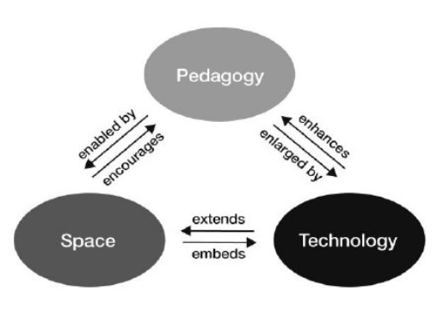Ellis and Goodyear (2016) related to three dimensions of learning in academic institutions: physical-hybrid-virtual, informal-formal and personal-academic. They suggested a model highlighting an activity-focused analytical framework in which the physical space is one of the two dimensions where the activity takes place alongside the social dimension. The axis Task-Process-Product is weaved through these dimensions. The Pedagogy-Space-Technology framework (PST; Radcliffe, 2009; Fig 1) is another model that was conceptualized during a large scale FLS assimilation in Australia. This model looks at the three main constituents for the process with an active learning space and the relations between them. The relations are described as enhancing, extending etc. (Radcliffe, 2009).

Figure 1- A Pedagogy-Space-Technology framework for designing and evaluating learning spaces (Radcliffe 2009, p. 13)

Regarding teachers' education, Kali et al. (2019) suggested adding the S (spaces) for the TPACK model: Technological Pedagogical and Content Knowledge (Koehler & Mishra, 2009) to become Technology, Pedagogy, Content and Space (TPeCS); therefore 'space' becomes an important design consideration in class design for

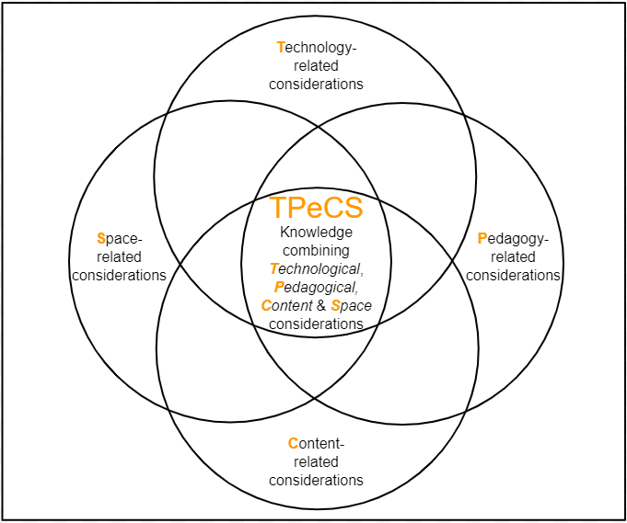lecturers) Kali, et al., 2019). Knowledge community and inquiry (KCI; Slotta, 2010) is a significant pedagogical model for the design of activities suited for FLS. Among its design principles are inquiry activities design, building collaborative community knowledge, the role of a teacher as an expert, facilitator and orchestrator and accommodating inquiry activities that are happening simultaneously across the space (Slotta, Tissenbaum, & Lui, 2013).

Figure 2- The TPeCS framework (Kali et al., 2019)

For the purpose of integrating the FLS in the college, we chose the PST framework (Radcliffe, 2009) as a reference point for the activity at the Levinsky College FLS. The model was briefly presented to lecturers, to allow a threefold prism (Pedagogy-Space-Technology) that might be useful as part of the lecturers' activity. We did not present the relations among the components (e.g. enhances, extends) in order to simplify it and yet not to restrict the innovation of the course lecturers.

# FLS activity design, principles and patterns

Recently, there is growing awareness of FLS design for schools and informal educational settings (Sutherland & Fischer, 2014). Nevertheless, design principles and activity patterns for those spaces in higher education and/or teacher training are yet in their initial stage.

Hod (2017) attempted to synthesize insights from the learning sciences to school FLS, which relates to content-specific vs content-flexible: Content-flexible spaces are dedicated for instruction or open learning, while content-specific spaces are used as a stage for learning or as sources of content (e.g. science). He also described eight FLS design principles including: flexibility, dynamic usage of space sensitive to the emergent needs of the learners and lightweight infrastructure technology solutions like cloud computing, and free software. These principles are mainly directed at organization decision makers, suggesting how to build a more useful FLS with a flexible design to accommodate the perspectives of the different stakeholders. They are less suited to the pedagogical aspects of teaching and learning. Yet, we know that introducing a studio space alone is not enough to ensure improvements in learning; These renovated classrooms need to be accompanied by research-based pedagogical techniques (Beichner, 2014). Our aim is to relate to the design considerations, which lecturers need to consider, and to suggest practical tools for effective teaching.

In terms of hybridity supported by FLS, we are looking at shifts between stages of activity, transitions between formal and informal social structures in the space, and the combination of physical vs digital tools mediating individuals and group's interactions (Cook et al., 2015; Ellis & Goodyear, 2016).

# Design patterns

Design Patterns (DPs) are action patterns of practical knowledge (know-how) that are formulated by experts to be repeatedly used in different contexts and shared with novices (Warburton & Mor, 2015). Originated in Architectural sciences in the 1970s, design patters were later applied in other disciplines including pedagogical design of teaching and learning (Laurillard, 2012; Iba, 2014).

DPs create a language that has the potential to generate an infinite number of forms (Alexander, Ishikawa & Silverstein, 1977). Didactic organization of the class stages does not seem to limit creativity, but rather promote it – allowing different contents to be taught in various ways: "Each individual pattern is formatted in a manner that makes it possible for others to evaluate and possibly modify it without losing the essence of it" (Köppe, Nørgård, & Pedersen, 2017, p.3).

In this study we harness the pedagogical design pattern format accepted by the ‘Plop’ community (Pattern Languages of Programs)[3] (e.g., Kussmaul, 2016; Bergin, 2000). Also, we develop some design patterns of "Pattern Language for Hybrid Education" which is a product of the 'EduPLoP16' and present the pattern categories for 'hybrid education' (Köppe, Nørgård, & Pedersen, 2017).

Increasing our knowledge about DPs in the FLS environment and making this knowledge public will assist in scaffolding teaching in both k-12 and higher education. This, in turn, can be leveraged into creating fluency and expertise of lecturers as teaching innovation leaders in current changing times.

# Context

The FLS space at Levinsky College was established in 2018 for the purpose of designing a hybrid, dynamic spatial arrangement for teaching and learning with a variety of pedagogies, integrating interactive technologies and a variety of sources of information, providing a broader place for visualization, collaboration and communication for students and faculty members (Gil & Mor, 2017). The space is also designed to allow relatively large groups of students to focus on learner-centered learning as well as to experience and introduce a model for pre-service teachers on how to implement innovative methods.

Levinsky FLS has three connected rooms. Each space is designed to allow specific yet versatile pedagogy: FLS1 – Collaborative learning space has 5 large screens connected to mini-pcs to enable visualization, communication and group work (Image 1). FLS2 – Oriented to kinetic/play, has an interactive ceiling projector connected to a kinetic game platform (Wizefloor). FLS3 – Multi-purpose and 'light'-makers'[4] oriented space. All rooms have movable furniture, thus versatile in their arrangement. Since its establishment in March 2018, it has accommodated more than 70 courses from different disciplines and hundreds of course activities taught by over 60 lecturers who voluntarily applied to teach there. Most of the classes were taught in a non-traditional way. Lecturers could receive mentoring for activity design by a staff member of the Division of Teaching Innovation.

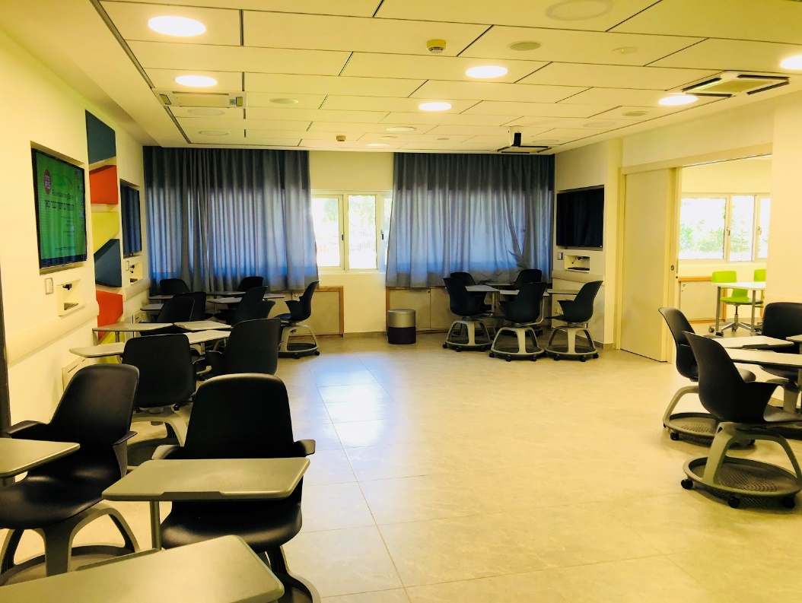

Image 1 FLS1 – Collaborative space - the central room at the Levinsky College of Education

# Methodology

This study forms a design-based research (DBR) that included mining patterns process: analyse, design, develop, test and refine four activity design patterns for teaching and learning in FLS According to Amiel and Reeves (2008) phases as followed. DBR is appropriate method for studying innovative learning environments including new educational technologies (Sandoval and Bell, 2004) and in order to improve teaching through close collaboration between researchers, designers and practitioners (Amiel and Reeves, 2008; Wang and Hannafin, 2005). Table 1 below shows the detailed DBR phases as they were practiced in this study:

|  |  |  |  |
| --- | --- | --- | --- |
| Phase  (Amiel and Reeves (2008) | Data collection method | Participants | Outcomes |
| 1. Analysis of practical problems | Literature review  (informal Interviews with course lecturers | Researchers and lecturers; teaching innovation team | Development of the theoretical and conceptual framework; defining teaching in FLS problems and challenges |
| 1. Development of solutions | conversations with course lecturers | Researchers and lecturers; teaching innovation team | development of solution/interventions |
| 1. Iterative cycles of testing and refinement of solutions in practice | Selective Observations during the activities; field notes; conversations with participants during activities | Researchers and lecturers; teaching innovation team; students | Process of design patterns, testing and improvements at 3 cycles |
| 1. Reflection | Interviews (formal & informal) with course lecturers; | Researchers and lecturers; -teaching innovation team | Final design pattern and enhance solution implementation |

Table 1: Research instruments used for the different phases and outcomes

1. Analysis of practical problems by researchers and practitioners in collaboration; They were collected via literature review and informal interviews with course lecturers who taught in the space, and mentored by the teaching innovation team. The descriptions of the implementation of innovative teaching and learning in the space and challenges inherent to processes of activity and teaching design, ways of coping with them, and insights.
2. Development of solutions in formed by existing design patterns and technological innovations; In the next stage, the process of mining and extracting practices (Warburton & Mor, 2015) was carried out, in with emphasis of those proved to be suitable for the FLS goals description and goals- involving teaching that promoted collaborative, interactive learning, included the use of technologies in which learners can share responsibility for the content, technology and space (Hod et al. 2016). The authors generalized elements, defined the patterns and design principles resulting from them on a theoretical level (Courey, Tappe, Siker & LePage; 2013). These elements were organized into uniform design patterns according to a pattern template (Bergin et al., 2012; Iba, 2014) that can be transferred and applied in the field. Each template includes: the *context* of the situation in which the pattern should be used, *forces* which make the context challenging, the *solution* to the problem, the *limitations* of the proposed solution, *implementation* that explain some concrete actions, an *example* from experience and *Resource requirements*. The patterns were selected according to the following criteria:
3. Generic - can be applied in a variety of contexts.
4. Varied - with a high variance
5. Involving Innovative pedagogy – active learning and collaborative learning.
6. Combines relevant characteristics of the space: movement in space, unique technology, and visualization, relative to a regular classroom.
7. Time unit for academic teaching - adjusted to 90 minutes.
8. Three Iterative cycles of testing and refinement of solutions in practice for each DP; the lecturers (authors included) applied the design patterns in their own courses, and integrate them in the process of further mentoring of new lecturers, in order to test and refine them to other contexts and disciplines.

4) Reflection to produce design patterns and enhance solution implementation. and based on observations and individual Interviews, we sharpened the Limitations of each DP, the Implementation process and resource requirements. We emphasized the generalization and eloquence of each activity design pattern to allow integrate them into new contexts and publish them.

# Findings

We hereby describe four selected activity design-patterns for teaching and learning in FLS. Following that, in the discussion section, we address how these DPs might promote indirectly educational and pedagogical values such as transparency, inclusion and equality.

## Activity Design Pattern 1: Convergent groups[5]

### Context

A lecturer aims to conduct an activity in which every student has an opportunity to participate in the discussion, present her position/opinion and meet/be exposed to other students' positions/opinions, while constructing her knowledge in the topic.

### Forces

Difficulty in creating groups due to restrictive environmental organization; Not everyone takes an equal part in the group discussion; There is no record of the discussion; Need to concentrate insights in a non-teacher-focus (front-led).

### Solution

Splitting the class to several inquiry groups that work simultaneously on a task with large screens; When finished, each group presents its findings from their physical location.

Activity stages (Fig. 3):

1. Opening remarks and providing instructions in the plenary session;
2. Collaborative group inquiry includes documenting using a wireless keyboard and large screens;
3. Convergence of groups to plenary, presentations of each group from their physical location and reviewing the findings of the other teams facilitated by the collaborative platform and large screen.
4. Discussion.

### Limitations

The ideal number of participants in the group is 3-5. The activity is suitable for a class with 12-35 participants.

In a large classroom, when there are over 5 groups, it will be difficult to allow each group to present. The teacher might divide the groups into ‘in class’ and ‘out-of-class', might suggest hybrid or multi space learning, or divide the class into two separate groups week after week sessions.

The discussion should be led by the teacher, based on the information gathered.

### Implementation

The lecturer must plan a topic or a case-study for discussion that is relevant to the learners and that allows observation from a variety of aspects. She must also provide soft scaffolding for the purpose of organizing the accumulated knowledge in the discourse between the groups. The discourse that takes place when the groups converge should relate to information that was collected directly to allow critical, reflective thinking.

### Example

A class of third-year pre-service teachers received a case-study in the field of class management. Each group had to analyze the case from a different perspective such as: learner's motivation, teacher planning, children's social climate, and teacher authority. They were required to complete a table explaining the case and provide an appropriate solution. The proposed solutions were collected and then voted on. The activity was conducted through the 'Tricider[6]' application.

### Resource requirements

* A large class over 30 participants is preferred.
* Projectors connected to laptops and/or large screens according to the number of the groups.
* A laptop computer/tablet/smartphone for every group to be used for voting.
* Accompanying website/application with task and embedded forms or voting if needed.

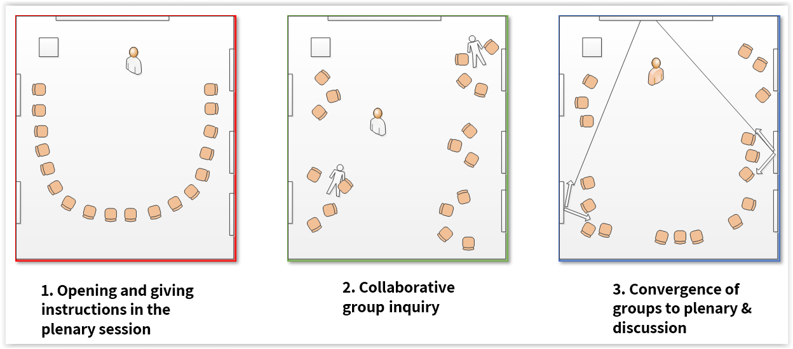

Figure 3- Activity Design Pattern 1: Convergent groups in FLS (similar to Sharan & Sharan, 1990)

## Activity Design pattern 2: Teaching in an Interactive Orchestrated learning space[7]

### Context

When there is a need to study a topic or phenomenon from multiple perspectives and/or experience in a short time frame, while gathering knowledge from the participants at the same time.

### Forces

To facilitate experiential and inquiry learning in parallel locations for each different facet of the content learned; To overcome the difficulty of managing a class in an orchestrated learning; The need to gather information from several groups learning experiences in a short timeframe, into a class database.

### Solution

Creating learning stations with exploratory tasks while each group works separately and in parallel to the other groups on different aspects of the subject. Each group advances through all the stations, documenting the data into one general repository.

Activity stages (Figure 4):

1. Start: The lecturer briefly explains how the activity is conducted
2. Work at the stations: The class is divided randomly into groups, with each group exploring a station. The activity at the station includes a task that involves data collection and documentation on an online form using a mobile device, an activity website and a large screen/projector. The group-stations rotate every 15-20 minutes within the physical space of the class.
3. Reflection on experience, learning and knowledge base and discussion

### Limitations

A short inquiry/learning experience. Not all groups finish the task within allocated time or at the same time.

### Implementation

There needs to be a relatively high diversity between the tasks in the different stations in order to create variety and interest.

The short time at each station needs consideration, since it disallows a long, deep process.

A signal for changing stations needs to be decided upon.

### Example

Learning about big data with a class of 30 students moving between four stations with an accompanying activity website. The students explore different aspects of big data from open sources on the internet, inquire and discuss at each station and answer four questions. Their answers accumulate and are embedded back into the website to serve as a knowledge board (Gil & Slotta, 2015).

#### Resource requirements

* A larger class than the usual is preferred.
* Three to four projectors connected to laptops or 3-4 large screens (depending on the number of stations/groups in accordance to time allocated to group activity in the station).
* A laptop computer or tablet for each group to populate the online form.
* An accompanying website with a page for each task and embedded forms.
* A station rotation plan within the physical space.

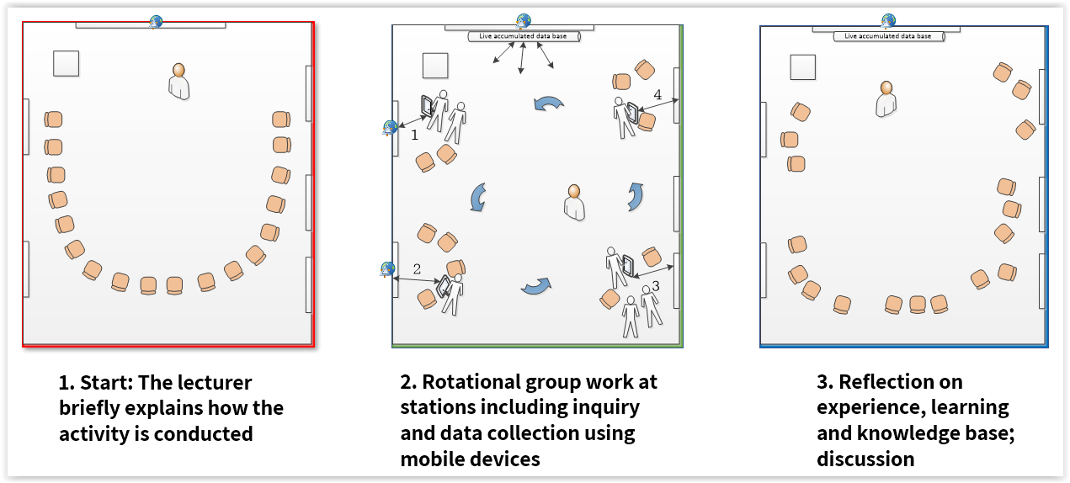

Figure 4 Activity Design pattern 2: Teaching in Interactive Orchestrated learning space (based on Gil & Slotta, 2015)

## Activity Design pattern 3: Presentation Fair

### Context

The instructor aims to facilitate students' presentation of their products / projects / seminars at the end of the course and allows for engagement and assessment.

### Forces

The accepted formal academic format for presenting students' products in the plenum requires a long period of time; It requires prolonged sitting and is characterized as procedurally static; It does not allow learners the freedom to choose what they would like to listen to or on what to expand their knowledge.

### Solution

A class design based on visual and parallel representations of learning outcomes and peer assessment in two rounds.

Activity stages (Figure 5):

1. The students are divided in two halves.
2. During the class, while the first half (composed of individuals or teams) presents digital infographic posters simultaneously in several locations within the space using large screens, the second half participates as the audience, and performs peer assessment using digital form, preferably anonymously (See also [‘Peer Review’ DP](https://www.learningenvironmentslab.org/openpatternrepository/Peer_Review/OG): <https://tinyurl.com/y3o4gkdl>).
3. Halfway through the session, the groups exchange roles.

### Limitations

Since the presentations are parallel a situation may develop in which students present to a large audience, while others are left without an audience.

Not all students are able to see all potentially interesting presentations as they might have to present at that time.

Although anonymous assessment is generally authentic its result may be superficial.

More students in the class improves the probability of a successful activity but more screens/projectors are required.

### Implementation

The lecturer must prepare the event by assigning time for designing the digital posters, time management of the event and setting the groups so each student will know which cohort s/he participates in, in advance and prepare the assessment form with a QR code.

At the beginning of the meeting the lecturer should present the instructions for the activity and request the students to ensure that all presenters receive an audience.

It is useful to establish criteria regarding the quality of the visual design of the poster / presentation and the quality of oral presentation. It is recommended to combine closed and open-ended questions.

After the activity, the lecturer needs to send the digital accumulated assessment data to each presenter privately by mail or LMS.

### Example

A course for second-career, pre-service teachers with 22 students. They conducted research activities on the subject of 'Innovative pedagogies'. In the last lesson they were asked to present the main insights of their research in an infographic poster, created in one of the digital tools offered (e.g. Canva, Venngage, Piktochart). Each 1-2 student/s group presented the poster using a large screen. In total we used 8 screens in the two spaces including the lecturer's podium. While half of the group was presenting the other half served as an audience. They were required to choose at least 3 presentations to assess using a QR code.

Peer assessment for posters designed with Google Form included the following questions:

1. Assessment for [student's name-from list]

2. Closed Questions on a scale of 1-5 (Very low to Very high):

* The poster is aesthetically designed
* The poster clearly outlines the main project / study unit
* The poster incorporates visual representations that support content
* The explanation given orally is interesting and accompanied by examples
* The presenter demonstrates proficiency in the content

3. Open ended questions: ?

Notes for preservation: [ ]

Notes for improvement: [ ]

#### Resource requirements

* Space devoid of chairs and tables that will allow free transitions among ‘podiums’ (screens & podium).
* At least five large screens on which the students display their digital posters.
* Mobile phone / tablet for each student for peer assessment using a digital form.

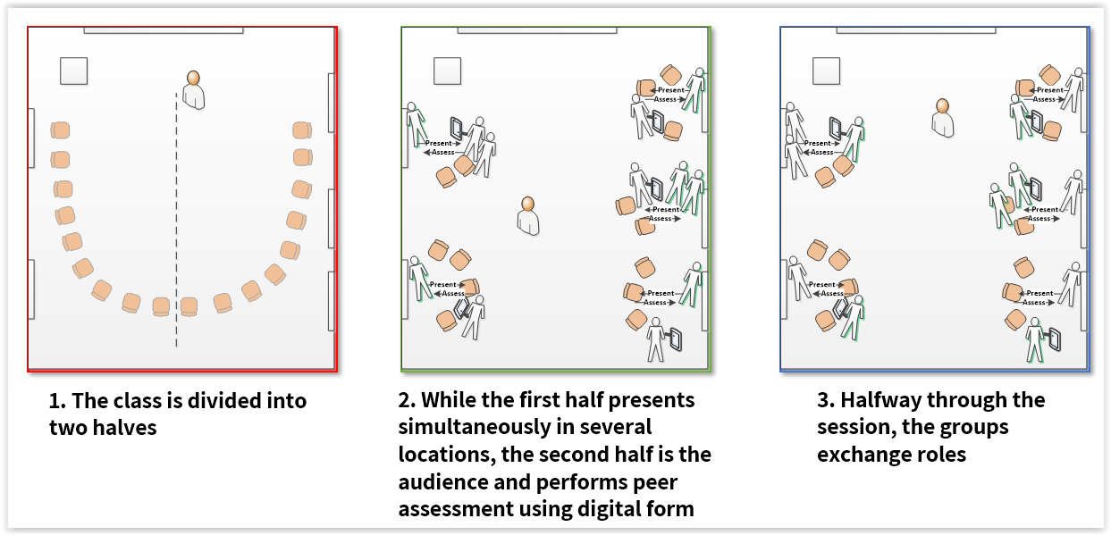

Figure 5- Activity Design pattern 3: Presentation Fair

## Activity Design pattern 4: Think-Join-Share[8]

### Context

When the instructor wants to allow students to form a position on a certain topic without social pressure, allow the establishing of a position by each individual and with it to become acquainted with the viewpoints of other individuals.

### Forces

Formulating an independent position without facing peer pressure is challenging in the classroom; The need to be exposed to the positions of others in a way that allows seeing a variety of viewpoints; The need to break a static sitting in a classroom when only some of the students are discussing their opinions.

### Solution

Offering the time and an opportunity to establish a personal position, finding colleagues whose position is similar and formulating the joint position while exposure to colleagues whose position is different.

Activity stages (Figure 6):

1. Individual work in which each student decides or formulates a position regarding a presented dilemma. Digital survey or personal digital platform can be used.
2. Each student joins physically to a group of peers whose position is similar, and they formulate arguments of their choice. Digital sources and a collaborative platform can be used (e.g. Google docs/Padlet). Each group works in front of a large screen.
3. Each group presents its position and arguments in the plenary from its seat/screen location using their large monitor. Optional: Review the positions of the other group members and write a summary position paper

### Limitations

There should be at least two different positions as points of view regarding a dilemma.

Possible positions are provided in advance. Lecturer might use this [DP: Student Debate](https://www.learningenvironmentslab.org/openpatternrepository/Student_Debate/alx): <https://tinyurl.com/y4eff3zw>

### Implementation

When groups that split up into positions are too large, they should be split into sub-groups

It is important that groups also have reference materials (theoretical articles, laws, videos, etc.) to help them formulate the arguments for the position they choose.

The instructor may want to supply scaffolds for writing an argument.

The instructor should ask the students whether they have changed their position following the presentations of their colleagues and discuss this process.

### Example

A group of in-service teachers was presented a dilemma about using social networks as part of a teacher-parent relationship. Each participant was required to personally decide on the position that agrees with her: the parents' position, the teacher's position, the school principal's position and the Ministry of Education's position. The various positions appeared on the large screens. Each participant stood near the screen on which the selected position was recorded. Each group drafted a position paper containing the arguments in a collaborative document and presented it to the plenary. Next, learners were required to draft a one page document containing the entire range of positions.

### Resource requirements

* Projectors connected to laptops or large screens, one for every group.
* A laptop computer/tablet/smartphone for every group to write the arguments.
* An accompanying website with a sharing platform (e.g. Google doc/slides / Padlet).

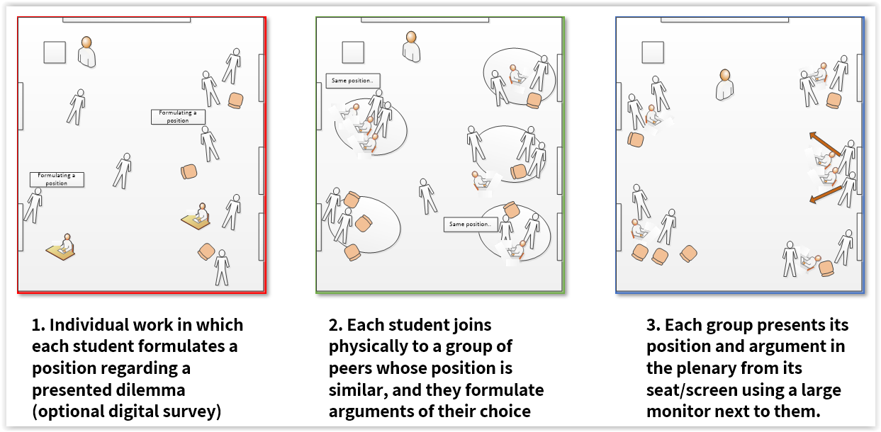

Figure 6- Activity Design pattern 4: Think-Join-Share (based on Kagan, 1989)

In closing this section, we realize that it could be argued that the patterns are situated in specific physical arrangements. Nevertheless, it is possible to adapt it flexibly according to a given space and available resources, using a suitable pedagogical approach. Adaptation of these patterns into new environments, could lead to further validation and insight.

# Discussion and conclusions

In this paper we aim to advance the activity design discourse about teaching and learning in future learning spaces. We offered four active design patterns as a representation of best practices. The design patterns that emerge from a variety of rich teaching activities reflect some of the advantages of learning in future learning space (FLS) by providing flexible use of space, technology and pedagogy (Hod et al. 2016).

In this hybrid learning environment (Ellis & Goodyear, 2016), the DPs are "viewing space as a component within a dynamic system in which design decisions in each component require adjustments in all others (Hod, 2017, Ellis & Goodyear, 2016). They

describe and support dynamic shifts between stages of activity, characterized by fluid transitions between formal and informal social structures such as group-led and teacher-led plenary in different modes of activities such as inquiry and discussion. Alongside it, the DPs contain the combination of physical encounters and digital tools mediating individuals' interactions with colleagues (Cook et al., 2015), such as in presentations, peer assessment and group rotation etc.

Using these DPs, we addressed a variety of challenges in the context of implementing innovative pedagogy: equal participation, documentation of learning, focusing attention and concentration in learning, constructing collaborative knowledge, coping with peer pressure, looking at a variety of perspectives and dynamism in class management. These DPs enable linkink and putting into practice pedagogical principals and nurturing educational values, rising from the value mediated space or activities therein (Argaman & Asa, 2017; Baeplar et al. 2016). Further to Argaman and Asa (2017) that mentioned values of equality and justice in an active learning environment design, we identified also: transparency, in discourse, inclusion, aesthetics, inviting to choose, encouraging learners' independence and extending respect to each learner.

Table 1 is an example of how values promoted by pedagogical solutions might be related to environmental facilities of the FLS.

Table 1 Values promoted by pedagogical solution and possible related environmental FLS facilities

|  |  |  |
| --- | --- | --- |
| **Pedagogical solution** | **Values promoted** | **Facility in the FLS** |
| Smaller open spaces that encourage learners' choice of location and promote diverse types of activity and group/self-regulation | Transparency Independence  Autonomy  Informality | An internal division of the space |
| Allows convenient group-work, involves the learners, focuses attention, allows viewing from different locations in the space | Equality | The screen size |
| Allowing for egalitarian participation by transferring "control" from one student to another in adjusted distances | Inclusion | Wireless keyboard |
| Allowing dynamic change between the different stages of lessons with ease and speed to organize the class according to the different needs | Dynamics  Liberty | Mobile furniture |
| Suitable for activities based on dialogue in groups of learners | Inclusion | Good acoustics management |
| Respects the learners and creates a warm atmosphere that encourages learning | Respect | Aesthetics |

This study has implications into three areas: (A). Assimilation of learning spaces, pedagogical innovation and the development of lessons in a socio-constructivist approach in academic institutions; (B). Impact on novice lecturers and teacher training for the future, by allowing modeling for active learning instruction for higher education FLS, or for school FLS; (C.) Research and development of teaching and learning processes in a variety of spaces and opportunities according to different goals.

Further validation of these patterns could be part of a future work in other academic institutions, course context and/or other FLS / ALC design. Whether they yield similar or different results and whether they need to be refined for better learning process and/or suggested values is to be further investigated.

# Acknowledgments

The study was funded by the Levinsky College of Education. We would like to thank the EC-TEL reviewers and our shepherd, Christian Köppe for insightful comments on earlier versions of the paper.

# Statements on ethics and conflict of interest

There are no conflicts of interest involved in this study. We followed ethics rules and regulations.

# References

Alexander, C. Ishikawa, S. & Silverstein, M. (1977). *A Pattern Language: Towns, Buildings, Construction*, Oxford University Press, New York.

Amiel, T., & Reeves, T. C. (2008). Design-based research and educational technology: Rethinking technology and the research agenda. *Journal of educational technology & society*, *11*(4), 29-40.

Argaman, E. & Asa, Z. (2017). Equality and justice in the classroom as reflected in architectural language. *Israel Studies in Language and Society*, 10(*1*), 11-34.

Baeplar P., Walker J. D., Brooks D. C., Saichaie K. & Petersen C. I. (2016). *A guide to teaching in the active learning classroom: History, research and practice*. Sterling, VA: Stylus Publishing, LLC

Beichner, R. J. (2014). History and evolution of active learning spaces*. New Directions for Teaching and Learning,* 2014(137), 9-16.

Bergin. J. (2000). Fourteen Pedagogical Patterns. *In Proceedings of the European Conference on Pattern Languages of Programs (EuroPLoP).* Retrieved from: http://csis.pace.edu/~bergin/PedPat1.3.html

Bergin, J., Eckstein, J., Volter, M., Sipos, M., Wallingford, E., Marquardt, K., ... & Manns, M. L. (2012). *Pedagogical patterns: advice for educators*. Joseph Bergin Software Tools.

Charles, E. S., Lasry, N., & Whittaker, C. (2011*). Scaling up socio-technological pedagogies:* PAREA report. Montreal, Canada: Dawson College.

Charles, E. S., Whittaker, C., Dugdale, M., & Guillemette, J. (2015). College level active learning classrooms: Challenges of using the heterogeneous ecology. In *Proceedings of the orchestrated collaborative classroom workshop* (pp. 39-44).

Chiu, P. H. P., & Cheng, S. H. (2017). Effects of active learning classrooms on student learning: a two-year empirical investigation on student perceptions and academic performance. *Higher Education Research & Development, 36*(2), 269-279.

Cook, J., Lander, R., & Flaxton, T. (2015, September). The zone of possibility in citizen led ‘Hybrid Cities’. Paper presented at *Workshop on Smart Learning Ecosystems in Smart Regions and Cities*, co-located at EC-TEL, Toledo, Spain, September 2015.

Courey, S. J., Tappe, P., Siker, J., & LePage, P. (2013). Improved lesson planning with universal design for learning (UDL). *Teacher Education and Special Education, 36*(1), 7-27.

Ellis, R. A., & Goodyear, P. (2016). Models of learning space: integrating research on space, place and learning in higher education. *Review of Education*, *4*(2), 149-191.

Iba, T. (2014). *Collaboration patterns: a pattern language for creative collaborations*. Japan: CreativeShift Lab.

Freeman, A., Becker, S. A., & Cummins, M. (2017). *NMC/CoSN horizon report: 2017*. The New Media Consortium.

Gaffney, J. D., Gaffney, A. L. H., & Beichner, R. J. (2010). Do they see it coming? Using expectancy violation to gauge the success of pedagogical reforms. *Physical Review Special Topics-Physics Education Research*, *6*(1), 010102.

Gil, E. & Mor, Y. (2017). *Program - learning spaces and a simulation center and learning from cases*. Levinsky College of Education (In Hebrew).

Gil, E., & Slotta, J. D. (2015, June). Knowledge Community and Inquiry about big data among high school students with Interactive Orchestrated Learning Space. *Proceedings of the Eleventh International Conference on Computer Supported Collaborative Learning* *(CSCL)*, June 2015, Gothenburg, Sweden.

Hod, Y. (2017). Future Learning Spaces in Schools: Concepts and Designs from the Learning Sciences. *Journal of Formative Design in Learning*, *1*(2), 99-109.

Hod, Y., Ben-Zvi, D., Charles, E., Kali, Y., McDonald, S. P., Rook, M. M., Slotta, J. D., Weiss, P. T., Whittaker, C., Zhang, J. (2016). Challenges and Opportunities for Research and Design of Future Learning Spaces. In Y. Eshet-Alkalai, I. Blau, A. Caspi, N. Geri, Y. Kalman, V. Silber-Varod, (Eds.), *Proceedings of the Eleventh Chais Conference for the Study of Innovation and Learning Technologies: Learning in the Technological Era* (pp. 117-122). Ra’anana, Israel: The Open University.

Kagan, S. (1989). The structural approach to cooperative learning. *Educational leadership*, *47*(4), 12-15.

Kali, Y., Sagy, O., Benichou, M., Atias., A., Levin-Peled, R. (2019). Teaching expertise reconsidered: The Technology, Pedagogy, Content and Space (TPeCS) knowledge framework. *British Journal of Educational Technology*, *50*(5), 2162-2177.

Koehler, M., & Mishra, P. (2009). What is technological pedagogical content knowledge (TPACK)?.*Contemporary issues in technology and teacher education*, 9(1), 60-70.

Köppe, C., Nørgård, R. T., & Pedersen, A. Y. (2017, March). Towards a pattern language for hybrid education. In Proceedings of the VikingPLoP 2017 Conference on Pattern Languages of Program (p. 11). ACM.

Kurti, R. S., Kurti, D. L., & Fleming, L. (2014). The philosophy of educational makerspaces: part 1 of making an educational makerspace. *Teacher Librarian*, *41*(5), 8–11.

Kussmaul, C. (2016). Patterns in classroom activities for Process Oriented Guided Inquiry Learning (POGIL). In Proceedings of the Conference on Patterns Languages of Programs (PLoP).  
Retrieved from: https://www.hillside.net/plop/2016/papers/proceedings/papers/kussmaul.pdf

Laurillard, D. (2012). *Teaching as a design science: Building pedagogical patterns for learning and technology*. London: Routledge.‏

Nordquist J. 2016. Introduction to Learning Spaces. In Taylor, I. (ed). *Future Campus: Design Qualities of University Buildings*. RIBA Publishing, London

Painter, S., Fournier, J., Grape, C., Grummon, P., Morelli, J., Whitmer, S., & Cevetello, J. (2013). *Research on learning space design: Present state, future directions*. Society of College and University Planning.

Painter, S., Fournier, J., Grape, C., Grummon, P., Morelli, J., Whitmer, S., & Cevetello, J. (2013). Research on learning space design: Present state, future directions. Society of College and University Planning.

Punie, Y. (2007). Learning Spaces: an ICT‐enabled model of future learning in the Knowledge‐based Society. *European Journal of Education*, *42*(2), 185-199.

Radcliffe, D. (2009). A pedagogy-space-technology (PST) framework for designing and evaluating learning places. In Radcliffe, H. Wilson, D. Powell & B. Tibbetts (Eds), *Proceedings of the Next Generation Learning Spaces 2008 Colloquium, University of Queensland, Brisbane* (pp. 11-16).

Sandoval, W. A., & Bell, P. (2004). Design-based research methods for studying learning in context: Introduction. *Educational psychologist*, 39(4), 199-201.

Sharan, S. (1990). *Cooperative learning: Theory and research*. New York: Praeger Publishers.

Slotta, J. D. (2010). Evolving the classrooms of the future: The interplay of pedagogy, technology and community. In K. Mäkitalo-Siegl, F. Kaplan, J. Zottmann & F. Fischer (Eds.). *Classroom of the Future. Orchestrating collaborative spaces* (pp. 215-242). Rotterdam: Sense.

Slotta, J. D., Tissenbaum, M., & Lui, M. (2013, April). Orchestrating of complex inquiry: three roles for learning analytics in a smart classroom infrastructure. In *Proceedings of the Third International Conference on Learning Analytics and Knowledge* (pp. 270-274). ACM.

Sutherland, R., & Fischer, F. (2014) Future learning spaces: design, collaboration, knowledge, assessment, teachers, technology and the radical past. *Technology, Pedagogy and Education*, *23*(1), 1-5.

Wang, F., & Hannafin, M. J. (2005). Design-based research and technology-enhanced learning environments*. Educational technology research and development*, 53(4), 5-23.

Warburton, S., & Mor, Y. (2015). Double loop design: Configuring narratives, patterns and scenarios in the design of technology enhanced learning. In Y. Mor, M. Maina, & B. Craft (Eds.), *The art and science of learning design* (pp. 93–104). Rotterdam: Sense.

1. * Both authors have contributed equally to this manuscript 
2.
3. <https://www.hillside.net/plop/2019/>
4. Makers space is a collaborative workspace for learning, constructing and sharing products and process that involve physical products. It might include new technology and toys beside simple materials that can act as an opportunity to explore learners' own interests and develop creative projects in a constructivist approach (Kurti, Kurti, & Fleming, 2014).
5. Similar to Sharan & Sharan (1990)
6. Tricider.com is an internet platform for decision making that allows brainstorming, collecting ideas or solutions collaboratively and quick voting.
7. Gil & Slotta (2015)
8. Based on Kagan (1989)