brain

C bRE

THE CENTER FOR COGNITIVE DECLINE

Dementia Care

For us, it’s personal.

**BRAIN** The day center for people living **CARE** with cognitive decline



* Professional day care for those with cognitive impairment due to Dementia, Alzheimer’s, brain injury or stroke.
* Therapeutic activities including Torah  
  classes, music therapy, arts & crafts.
* Nutritious Mehadrin lunch.
* Multi-sensory Snoezelen Room.
* Home visits and family advisory service.
* Customized development plan to maximize every participant’s capabilities, with dignity and respect.



Call BrainCare today if your loved ones are experiencing memory o

loss, personality change, loss c

of language, time or location E

confusion, impaired judgment, or mood and behavioral changes.

brain

THE CENTER FOR COGNITIVE DECLINE

Dementia Care

For us, it’s personal

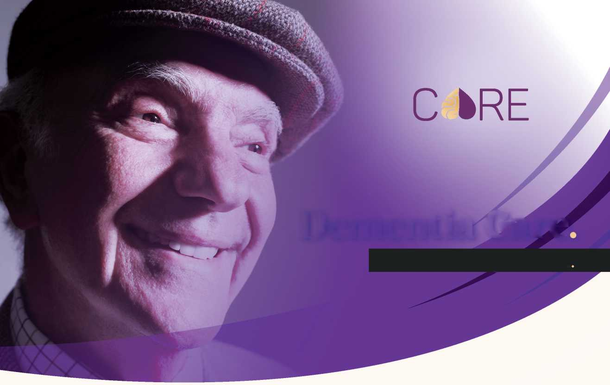

**BRAIN** The day center for people living **CARE** with cognitive decline

* Professional day care for those with cognitive impairment due to Dementia, Alzheimer’s, brain injury or stroke.
* Therapeutic activities including Torah  
  classes, music therapy, arts & crafts.
* Nutritious Mehadrin lunch.

• Multi-sensory Snoezelen Room.

* Home visits and family advisory service.
* Customized development plan to maximize every participant’s capabilities, with dignity and grace.



1W D’n

Towel Ha'ir Residence

Call BrainCare today if your loved ones are experiencing memory loss, personality change, loss of language, time or location confusion, impaired judgment, or mood and behavioral changes.