**Name of Lesson Plan** **Chag HaBikkurim (Festival of the First Fruits)**

**Lesson Information**

|  |  |
| --- | --- |
| Introduction of Lesson  (for lesson homepage and top of lesson) | This lesson begins by familiarizing the students with texts describing how Shavuot was celebrated during Temple times . With the help of these texts, students will be able to analyse an illustration depicting the bringing of *bikkurim* (first fruits) to Jerusalem. The students will then compare this tradition with its modern Zionist interpretation as expressed in a poster published by the Keren Kayemet L’Yisrael (KKL-JNF). The lesson will conclude with the students writing a letter inviting a friend to a *bikkurim* ceremony. |
| Enduring Understanding | The *bikkurim* ceremony described in the Torah was embraced by early settlers in Israel and adapted to reflect their Zionist perspective. |
| Learning Outcomes | * Students will be able to explain the *bikkurim* ceremony as described in the Torah and Mishnah. * Students will understand how the *bikkurim* ceremony became a modern Zionist tradition. |
| Age Group | * Primary school |
| Length of Activity | * Two lessons |
| Materials, Equipment, and Preparations | * Printed copies of the texts and resources. * Printed copies of the comparison worksheet. * Printed copies of Bikkurim Activity – Primary Sources |
| Primary Sources from the NLI Collections | * Bikkurim, JNF Poster, <http://bit.ly/2VEqNTz> * Bringing Bikkurim to Jerusalem, 1730 <http://bit.ly/2VuJ7hD> * Bikkurim Celebration, Twentieth Century <http://bit.ly/2ZLGnQs> * Bikkurim Ceremony, 1940 <http://bit.ly/2VyM0xW> * Shavuot in Cyprus, 1940s <http://bit.ly/30wYxFK> |

**Lesson Plan**

**Lesson One**

1. **Introduction – Class Discussion and Instructions**

In this lesson we will be learning about Shavuot as Chag HaBikkurim, the Festival of the First Fruits and examining texts, first from the Torah and then the Mishnah, that explain how *bikkurim* were brought to the Temple.

* Start off by asking students whether they know other names for Shavuot.
* Ask students the following questions:
* What are First Fruits (*bikkurim*)?
* What were done with the *bikkurim*?

1. **Chevruta (Pair) Activity**

Study the texts describing how *bikkurim* were brought to the Temple and answer the questions.

Read the texts and answer the questions on the worksheet <link> provided.  
 Review the students’ answers together when everyone has finished.

**Lesson Two**

* 1. **Class/Chevruta Activity – Analysing the illustration titled, “Bringing Bikkurim to Jerusalem, 1730.”**
* Project the illustration on the board or provide students with printed copies of the illustration.
* Explain to the students that the illustration was created in 1730, around 1700 years after the destruction of the Second Temple in Jerusalem.
* Students work with their chevruta (partner) to fill out the column of the Comparison Worksheet <link> according to the illustration.
* After students have filled out the worksheet, discuss the following questions together.
  + How do you think the artist knew how to depict the scene?
  + Do you think that you can rely on the illustration to accurately depict how *bikkurim* were brought to the Temple? Explain your answer.
  + Which details in the picture seem reliable to you and which don’t? Explain your answer.
  + What, in your opinion, does the picture reflect?
  1. **Class/Chevruta Activity – Analysing the KKL-JNF poster**
* Project the poster on the board or provide students with printed copies of the poster.
* Explain to the students that the poster was published by the Keren Kayemet L’Yisrael - Jewish National Fund (KKL-JNF) in the twentieth century.
* Before filling in the appropriate section on the worksheet, you might want to remind the students of the origins of the *bikkurim* ceremony that is illustrated on the poster and to explain the evolution of this ceremony in the twentieth century.

The Zionist movement renewed the traditional biblical ceremony of bringing the *bikkurim (*first fruits) to the Temple and gave it new meaning. In the new ceremony, the *bikkurim* were not brought to the Temple, but rather they became a way to express the renewed connection to the ancestral land. The *bikkurim* were brought to the KKL-JNF in festive processions and used to prepare meals or sold. The proceeds were transferred to the KKL-JNF for the purchase of land. The ceremony expressed the desire to preserve Jewish tradition but to adapt its content to the modern values ​​of Zionism. The caption at the bottom of the poster is a quote from a children’s Shavuot song written in 1933 by Yitzhak Shenhar called, “A Song of Thanks.” The quote says, “*Bikkurim*, the fruit of our thanksgiving. We have brought a gift, a gift to the people.”

* Students complete a table on the worksheet comparing the two images that have been analysed:
  + [Bikkurim, JNF Poster](http://bit.ly/2VEqNTz),
  + [Bringing Bikkurim to Jerusalem, 1730](http://bit.ly/2VuJ7hD)

1. **Class Discussion – Comparing the two pictures**

* Describe both images (figures, background, depicted events, colours, details, texts, etc.)
* When was each image created?
* Use the chart to help answer the question: What differences are there between how *bikkurim* were brought at the time of the Temple and during the early years of Zionist settlement of the Land of Israel?
* How can you explain these differences?

1. **Creative Activity – Writing a letter to a friend (class activity or homework assignment)**

* Show students additional photographs of *bikkurim* ceremonies from the NLI collections. You can project them on the board or provide printed copies or links to the items.
* Imagine that you live on a kibbutz or moshav. Write a letter to a friend who lives in the city, encouraging them to attend a *bikkurim* ceremony that your community is holding. Describe what the event will be like and why it will be fun.

<separate page , logo, organise layout>

**How Were Bikkurim Brought to the Temple?**

One of the names of Shavuot in the Torah is the Festival of the First Fruits. These first fruits (*bikkurim)* are traditionally of the “seven species” – the special agricultural produce of the Land of Israel: wheat, barley, grapes, figs, pomegranates, olives, and dates (Deuteronomy 8:8). According to Jewish tradition, the *bikkurim* were brought to the priests in the Temple in Jerusalem, as described in the verse below.

**Text #1**

|  |  |
| --- | --- |
| [**Exodus 23:19**](https://www.sefaria.org/Exodus.23.19)  The choice first fruits of your soil you shall bring to the house of the LORD your God... | [**שמות כ״ג:י״ט**](https://www.sefaria.org/Exodus.23.19)  רֵאשִׁ֗ית בִּכּוּרֵי֙ אַדְמָ֣תְךָ֔ תָּבִ֕יא בֵּ֖ית ה' אֱלֹקֶ֑יךָ ... |

**Text #2**

Additional information about how to bring the *bikkurim* to Jerusalem is provided in the following verse.

|  |  |
| --- | --- |
| [**Deuteronomy 26:2**](https://www.sefaria.org/Deuteronomy.26.2)  (2) you shall take some of every first fruit of the soil, which you harvest from the land that the LORD your God is giving you, put it in a basket and go to the place where the LORD your God will choose to establish His name. | [**דברים כ״ו:ב׳**](https://www.sefaria.org/Deuteronomy.26.2)  (ב) וְלָקַחְתָּ֞ מֵרֵאשִׁ֣ית ׀ כָּל־פְּרִ֣י הָאֲדָמָ֗ה אֲשֶׁ֨ר תָּבִ֧יא מֵֽאַרְצְךָ֛ אֲשֶׁ֨ר ה' אֱלֹקֶ֛יךָ נֹתֵ֥ן לָ֖ךְ וְשַׂמְתָּ֣ בַטֶּ֑נֶא וְהָֽלַכְתָּ֙ אֶל־הַמָּק֔וֹם אֲשֶׁ֤ר יִבְחַר֙ ה' אֱלֹקֶ֔יךָ לְשַׁכֵּ֥ן שְׁמ֖וֹ שָֽׁם׃ |

**Text #3**

The procedure is further described in the Mishnah in Tractate Bikkurim.

The text talks about the cities of the *maamad*. To facilitate a rotation of priests serving in the Temple, the country was divided into twenty-four districts (*mishmarot* or *maamadot*). The city of the *maamad* was the city where the head of the *maamad* lived. When bringing the *bikkurim*, the inhabitants of the entire district would gather in the city of the *maamad* and together travel to Jerusalem.

|  |  |
| --- | --- |
| [**Mishnah Bikkurim 3:2-3**](https://www.sefaria.org/Mishnah_Bikkurim.3.2-3)  (2) How were the bikkurim taken up [to Jerusalem]? All [the inhabitants of] the cities of the maamad would assemble in the city of the maamad, and they would spend the night in the open street and they would not enter any of the houses. Early in the morning the officer would say: “Let us arise and go up to Zion, into the house of the Lord our God” (Jeremiah 31:5).  (3) Those who lived near [Jerusalem] would bring fresh figs and grapes, while those who lived far away would bring dried figs and raisins. An ox would go in front of them, his horns bedecked with gold and with an olive-crown on its head. The flute would play before them until they would draw close to Jerusalem. When they drew close to Jerusalem they would send messengers in advance, and they would adorn their bikkurim. The governors and chiefs and treasurers [of the Temple] would go out to greet them, and according to the rank of the entrants they would go forth. All the skilled artisans of Jerusalem would stand up before them and greet them saying, “Our brothers, men of such and such a place, we welcome you in peace.” | [**משנה ביכורים ג׳:ב׳-ג׳**](https://www.sefaria.org/Mishnah_Bikkurim.3.2-3)  (ב) כֵּיצַד מַעֲלִין אֶת הַבִּכּוּרִים. כָּל הָעֲיָרוֹת שֶׁבַּמַּעֲמָד מִתְכַּנְּסוֹת לָעִיר שֶׁל מַעֲמָד, וְלָנִין בִּרְחוֹבָהּ שֶׁל עִיר, וְלֹא הָיוּ נִכְנָסִין לַבָּתִּים. וְלַמַּשְׁכִּים, הָיָה הַמְמֻנֶּה אוֹמֵר (ירמיה לא), קוּמוּ וְנַעֲלֶה צִיּוֹן אֶל בֵּית ה' אֱלֹקֵינוּ:  (ג) הַקְּרוֹבִים מְבִיאִים הַתְּאֵנִים וְהָעֲנָבִים, וְהָרְחוֹקִים מְבִיאִים גְּרוֹגָרוֹת וְצִמּוּקִים. וְהַשּׁוֹר הוֹלֵךְ לִפְנֵיהֶם, וְקַרְנָיו מְצֻפּוֹת זָהָב, וַעֲטֶרֶת שֶׁל זַיִת בְּרֹאשׁוֹ. הֶחָלִיל מַכֶּה לִפְנֵיהֶם, עַד שֶׁמַּגִּיעִים קָרוֹב לִירוּשָׁלָיִם. הִגִּיעוּ קָרוֹב לִירוּשָׁלַיִם, שָׁלְחוּ לִפְנֵיהֶם, וְעִטְּרוּ אֶת בִּכּוּרֵיהֶם. הַפַּחוֹת, הַסְּגָנִים וְהַגִּזְבָּרִים יוֹצְאִים לִקְרָאתָם. לְפִי כְבוֹד הַנִּכְנָסִים הָיוּ יוֹצְאִים. וְכָל בַּעֲלֵי אֻמָּנִיּוֹת שֶׁבִּירוּשָׁלַיִם עוֹמְדִים לִפְנֵיהֶם וְשׁוֹאֲלִין בִּשְׁלוֹמָם, אַחֵינוּ אַנְשֵׁי הַמָּקוֹם פְּלוֹנִי, בָּאתֶם לְשָׁלוֹם: |

**Discussing the Texts**

* What are *bikkurim* ?
* Who brings *bikkurim*?
* Where are *bikkurim* brought to? Who are they given to?
* What are the *bikkurim* put in?
* Describe the trip to Jerusalem. If you had been there, what would you have seen and heard?
* What questions do you have about the *bikkurim* ceremony?

**<separate page, logo> Chag HaBikkurim (Festival of the First Fruits)**

**Comparison of Illustrations**

Complete the table comparing the two images of the *bikkurim* ceremony from the National Library of Israel collections:

* Bringing Bikkurim to Jerusalem, 1730
* Bikkurim, JNF Poster, twentieth century

|  |  |  |
| --- | --- | --- |
|  | Bringing Bikkurim to Jerusalem | KKL-JNF Shavuot Poster |
| Who brought the *bikkurim*? |  |  |
| Who receives the *bikkurim* from those who brought them? |  |  |
| Where does this take place? |  |  |
| What is the atmosphere at the event? |  |  |
| What items are brought in the baskets? |  |  |
| Who are the people bringing the *bikkurim* thanking? |  |  |

<- Bikkurim Activity - Primary Sources - separate pages, correct orientation, logo, add links and logo>

**Bringing Bikkurim to Jerusalem, 1730**

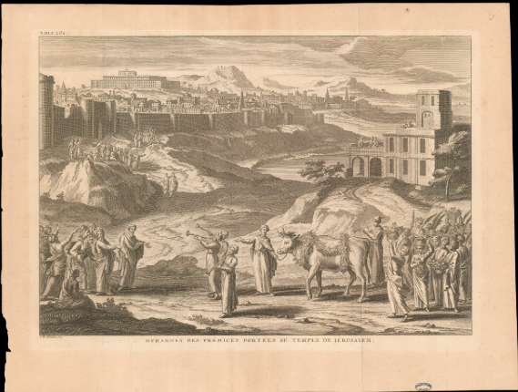

**Bikkurim, JNF Poster**

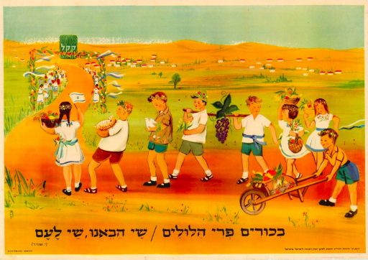

**Bikkurim Celebration, Twentieth Century**

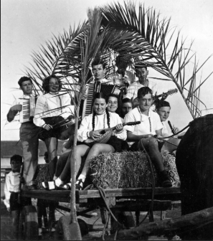

**Bikkurim Ceremony, 1940**

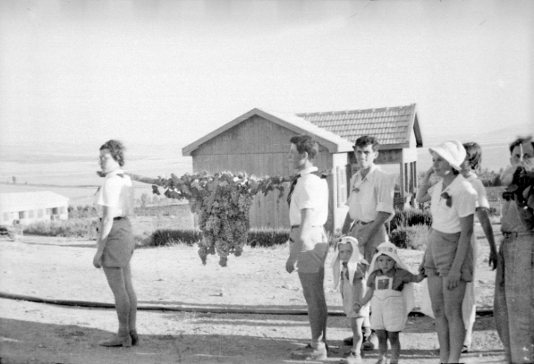

**Shavuot in Cyprus, 1940s**

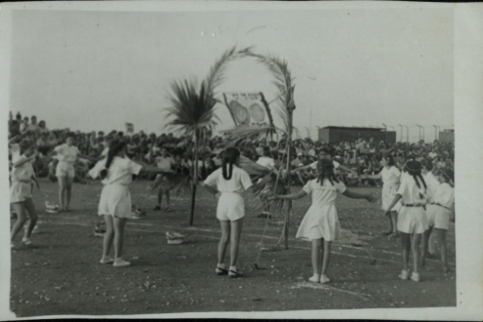

**Girls Dancing in Shavuot Ceremony, Tel Aviv, 1970**

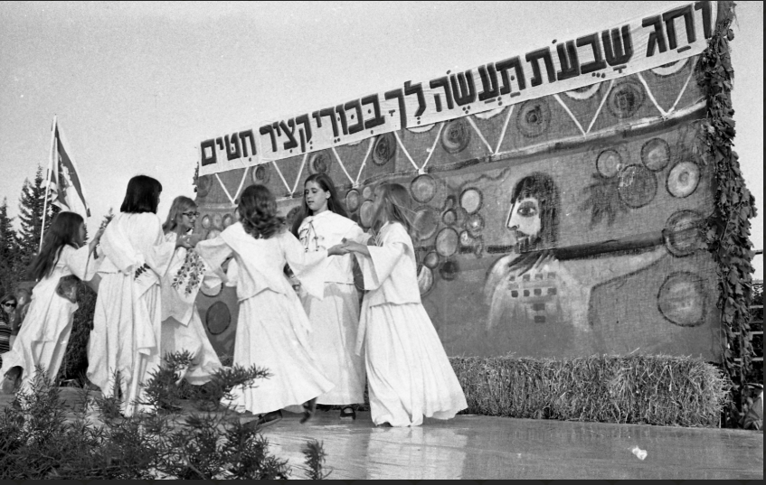

**Children Participating in a Play at a Shavuot Celebration, Tel Aviv, 1970**

