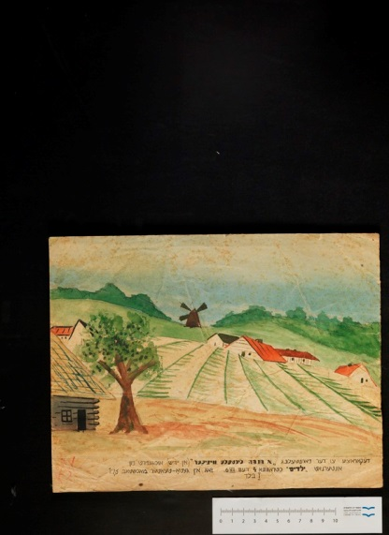**Resource Name**

Invitation to a children's Chanukah play in the Vilna Ghetto, 1942

**Link to resource in the library ­­­­­­­­­­­­­­­**<http://aleph.nli.org.il:80/F/?func=direct&doc_number=003466057&local_base=NNL01>

**Original name of item in NLI catalogue**

ציור הזמנה להצגה

**NLI system number** 003466057

**Original Collection -** אסף תעודות על גיטו וילנה

**Short text**An invitation to a Chanukah play in the Vilna Ghetto from the Sutzkever collection at the National Library of Israel

**Translation**

Scenery for *One Chanukah Candle Less* by the children’sdormitory, 4, Strashun Street, this December 6, 1942 in Ghetto Theatre, scale 1:1.5, 1 picture

**Year (Hebrew)** 5703

**Year (non-Jewish)** 1942

**<Detailed description of the resource>**

This is a colour painting of a pastoral scene including fields, houses with red slate roofs, and a windmill. Underneath the drawing there is text in Yiddish.

This painting was used as scenery in a play performed by children at a dormitory in the Vilna Ghetto. It is unclear whether the dormitory at 4 Strashun Steet was used as an orphanage or as another kind of school or children's institution. Next door to this building, at 6 Strashun Street, there was a well-known Jewish library and school.

Jews in the Vilna Ghetto, as in other ghettos in Nazi Europe, engaged in many cultural activities such as theatre, music, art, and literature. This was intended as a distraction from the difficulties of daily life and gave both participants and audiences something to look forward to. It was also an attempt to defy the Nazis, a type of spiritual resistance. Children's theatre was seen as a way of shielding children from the horrible realities of ghetto life by allowing them a creative outlet. This scenery may perhaps allude to the dreams of the ghetto children; the open fields and sunny skies certainly do not reflect their cramped and dark living conditions. The play *One Chanukah Candle Less* was created by children in a children’s home. These children had probably been orphaned or their parents could not care for them under the harsh ghetto conditions.

This painting underwent a fascinating journey from the forests of Lithuania to Moscow and finally to the National Library in Israel. Abraham Sutzkever, a Yiddish author and poet, managed to escape from the Vilna Ghetto, carrying a number of artefacts from the ghetto with him. He joined the partisans, and the Jewish Anti-Fascist Committee in the Soviet Union managed to convince the Soviet authorities to airlift him into Moscow. The first plane sent to bring him was brought down by the Nazis, and Sutzkever fashioned a suitcase from the fragments of the plane. The second attempt was a success, and Sutzkever was flown to Moscow along with his suitcase filled with his writings and rembrances of the war from the Vilna Ghetto. Among the many documents in the suitcase was this drawing of the scenery for the Chanuka play. Sutzkever eventually moved to Israel in 1947 and donated the suitcase and its contents to the National Library of Israel for safekeeping.

**Discussion Points**

**Observations**

* What is this?
* Describe what you see:  
  Where is this?

What buildings can you see?

What language/s can you identify?

**Reading Between the Lines**

* This is a picture of scenery used in a children’s Chanukah play performed in the Vilna Ghetto in 1942.
* In which country is Vilan? Find it on a map.

What was happening in Vilna, and Europe in general, at the time that this play was performed?

* What is a ghetto?
* Did you know that children performed plays while living in the ghetto?   
  What does this tell us about life in the ghetto?   
  Do you think it was important for cultural events to take place in the ghetto? Why?   
  Watch [this video](https://www.youtube.com/watch?v=o31FI40yrWU) for more information.
* The play was called *One Chanukah Candle Less*.   
  What do you think the play was about?
* The text on this picture is in Yiddish.   
  What does this tell us about Jewish life in Vilna at the time?
* We know that this picture is a smaller image of the scenery used in the play and includes information about the play.   
  What could this have been used for? (e.g., invitation, poster)
* Who would the audience have been at this play?   
  How might they have reacted?

How do you think the children might have felt performing this play?

* The play was performed at the children’s home.   
  Based on what you know about life in the ghetto, what do you think was the purpose of this home?
* Based on your knowledge of the Jews of Vilna during World War II, what do you think might have happened to the child who drew this picture or the children who played in this play?
* This image was preserved because Abraham Sutzkever took it with him when he escaped the ghetto. Sutzkever took a number of other documents as well.   
  Why would he choose to keep something like this?   
  Why is it significant?

**Connections**

* The text on this image is in Yiddish, and the play was also performed in Yiddish.   
  What language is Yiddish?   
  Yiddish uses Hebrew letters but is a combination of German and Hebrew. What Yiddish words do you know?   
  Who speaks Yiddish today? Is it a dying language? Why or why not?
* Do you act or perform?   
  How do you think being in a stressful situation might affect a performance?
* The scenery from 76 years ago was hand-drawn, and the invitation was hand-written. How has technology changed the way we see plays today?
* If this was designed as an advertisement for the play, how is it different to advertisements for plays today? What information is missing?
* Do you know of any other examples of Jewish cultural activities during the Holocaust? Why do you think it was important for people to continue doing these kinds of things even at the risk of getting caught and punished?
* Is there a Jewish community in Vilna today? Research it online.

**Creative ideas**

* Imagine you are one of the children participating in this play.   
  How do you feel before and after your performance?   
  How else do you spend your days?
* Create a play with the same title. What is it about? Who are the characters?
* Using this picture as background, create a scene from the play.