**COMPARISON OF OCULAR MANIFESTATIONS BTWEEN TWO DIFFERENT GROUPS OF CONGENITAL INSENSITIVITY TO PAIN**

**BAKER ELSANA, LIBE GRADSTEIN, AHED IMTIRAT, RONIT YAGEV, EREZ TSUMI**

*`*

Ophthalmology Department, Soroka University Medical Center and Clalit Health Services, Beer Sheva, Israel. Affiliated to theFaculty of Health Sciences, Ben-Gurion University of the Negev, Beer Sheva,

Israel.

Pediatric ambulatory services, Saban Pediatric Medical Center for Israel, Soroka University Medical Center.

Inquiries to:

Baker Elsana, Ophthalmology Department, Soroka University Medical Center

Ben-Gurion University of the Negev, Beer-Sheva 84101, Israel.

Email: [bakerelsana1@gmail.com](mailto:bakerelsana1@gmail.com)

**Abstract**

**Purpose:** To describe ocular manifestations in children with CIP (Congenital insensitivity to pain) and analyze natural history of their ocular disease.

**Design:** Retrospective observational case series.

**Methods**: children with CIP syndromes. The diagnosis was established by clinical criteria and by genetic analysis. Collected data included demographic information, medical history, ocular surgeries, genetic analysis, and ocular examination results including visual acuity, cycloplegic refraction, ocular surface findings, corneal sensitivity, tear film production and fundoscopy results. Corneal tomography and slit lamp photography were performed for some patients.

**Results**: 6 CIP patients, 3 with mutations in *PRDM12* and another 3 in *SCN9A*. Mean follow-up time was 56 months for the PRMD12 and 130 for the SCN9A patients. Corneal opacities were seen in 5 eyes of PRDM12 and in 2 eyes with CIP. The majority of PRDM12 patients had diffuse and dense SPKs (superficial punctate keratopathies), while in SCN9A group SPKs were dense in 4 eyes and no SPKs in 2 eyes. Schirmer was normal in PRDM12 patients but reduced in all eyes in the SCN9A group. Corneal reflex was absent in all PRDM12 patients but was positive in both eyes of 2 patients with SCN9A. Visual acuity was ≤ 20/40 in the majority of PRDM12 patients, while in SCN9A group it was 20/30 in most eyes.

**Conclusion:** CIP PRDM12 have more serious corneal involvement than patients with SCN9A.

congenital insensitivity to pain (CIP) are a group of extremely rare autosomal recessive neuropathies characterized by the inability to perceive noxious stimuli as pain and heat. They belong to the group of hereditary sensory and autonomic neuropathies (HSAN).1the classification is now made up on genetic analysis and includes several entities. The exact prevalence of these disorders remains poorly known.2 The CIP patients are predisposed to multiple self-inflicting injuries such as lips and finger biting and self extraction of teeth. They also have bone fractures and burns. They often develop orthopedic complications such as charcot joints, bone fractures and poorly healing injuries and abscesses that may cause permanent orthopedic devastating disabilities. They have normal intelligence and sweat function.2 Mutations in several genes can lead to different types of CIP. Among them are missense mutation in voltage-gated sodium channel type IX α subunit (SCN9A*)* that cause loss of function of voltage-gated sodium channels in sensory neurons, phenotypically characterized with insensitivity to pain and anosmia. The other sensory modalities are intact3 and mutations in the epigenetic regulator PR domain zinc finger protein 12 (*PRDM12* ) that lead to CIP through defect in the normal development of nociceptive sensory neurons4.

The ocular manifestations of CIP are thought to be related to impaired corneal innervation and may include dry eye syndrome, SPKs (superficial punctate keratopathies), corneal opacities, neurotrophic keratopathy and corneal ulcers.5 Very sparse studies mentioned ocular findings in patients with CIP. In patients with PRDM12 they are mentioned as reduced lacrimation, corneal abrasions and possibly absent corneal reflex, leading to keratitis and corneal scarring.4, 6 In SCN9A there are no conclusive information regarding ocular findings, one study mentioned corneal reflex as decreased or absent and normal tear production.3Another study reported conserved corneal reflex in 3 patients with SCN9A CIP.7 Moreover, to the best of our knowledge there is no study that compares the ocular manifestations of CIP patients.

Here we followed up since 2007 patient with PRMD12 CIP and SCN9A CIP. The aim of this study is to describe ocular findings in a series of CIP patients followed in our institution for up to 11 years and to compare the natural history of the disease in these conditions.

**Methods**

This study was conducted at the Soroka University Medical Center (SUMC), a tertiary medical center located in Southern Israel and included a total of 6 patient with CIP. All patients were followed by an ophthalmologist and a pediatrician at the CIPA outpatient unit at SUMC during the period of 2007-2019. Demographic data, as well as medical history were obtained from patients' medical records. The collected ophthalmic data included visual acuity, cycloplegic refraction, presence of corneal opacities, SPKs, corneal sensitivity (estimated by cotton thread method), tear breakup time (TBUT), Schirmer test results and posterior segment findings. The data of ancillary exams, such as corneal tomography and anterior segment photos were included if performed. Visual acuity (VA) was evaluated by Snellen chart. SPKs were measured according to the SPKs grading method.14 The area and density of the lesions were used as parameters to quantify SPKs, where A represents the area of the lesion ranging from A0 – no staining to A3- area occupies more than two thirds of the cornea, and D represents the density ranging from D0- no punctate staining to D3- high density and lesions overlap.

Corneal sensitivity was assessed by using a cotton thread. Schirmer test was performed by Tear Flow test strip (TearFlo®) which was inserted in the lower fornix after local anesthesia by Oxybuprocaine hydrochloride 0.4% drops. The length of the wet strip was measured after 5 minutes. Corneal opacity was assessed by three parameters: location (central, eccentric or peripheral), diameter (less than 2mm, between 2 and 4 mm or more than 4mm), and depth (subepithelial, stromal- superficial or deep). Active corneal ulcer was defined as a corneal infiltrate with epithelial defect and was described by location, diameter and depth. All patients were genetically diagnosed with CIP. Genetic analysis was performed at the Institute of Human Genetics at SUMC by real time PCR technique. The research was approved by SUMC Institutional Review Board and Ethics Committee and adhered to the tents of the Declaration of Helsinki.

**Results**

Results are summarized in table 1. 6 patients genetically diagnosed with CIP, 3 with mutation in PRDM12 from 2 unrelated families aged 11, 3 and 6 years old and 3 sisters with mutations in SCN9A causing CIP aged 24,16 and 13 years old. Demographic data are shown in table 1, In the PRDM12 group the mean follow up time was 56 months (23-94 months). 2 patients are first degree siblings and were the offspring of a consanguineous marriage. The SCN9A group included three sisters of the same nuclear family. Two of the girls were the offspring of one wife and another patient was the daughter of the second wife to the same father. Mean follow up time was 130 months (121-143 months)

In the PRMD12 group 3 patients, two of the same nuclear family, the sister 11 years old had recurrent corneal ulcer in her left eye, the first at one year old and was treated with subconjunctival antibiotic injection, topical fortified antibiotics and lateral tarsorrhaphy (LT), second episode at 10 years old was treated with topical fortified antibiotics drops. She had bilateral punctal occlusion and lateral tarsorrhaphy to the right eye to treat and prevent sever dry eye signs . at last visit she had visual acuity 20/30 and had corneal opacity in her left eye and uses eye lubricants. She has absent corneal reflex in both eyes and SPK are diffuse and very dense, tear production is conserved. The brother 3 years old had severe ocular involvement, he presented with right eye corneal ulcer at 1 year old where he was treated with topical antibiotic drops a long with amniotic membrane (AM) and bilateral LT, there after he had repeated A.M. transplantations and tarsorrhaphies to treat non healing corneal ulcers, 6 AM transplantations and 7 tarsorrhaphies in his right eye and 5 AM transplantations, 8 tarsorrhaphies in the left eye moreover he had 2 covering graft due to descemetocele in his left eye, there after he had bilateral entropion repair to treat lower lid entropion and punctal cautery in his both eyes. At the last visit visual acuity was light perception in right eye and in the other eye it could not be determined. He had deep corneal opacities in both eyes, absent corneal reflex and very dense SPK he is treated with eye lubricants. The third child from a different family 6 years old had right eye corneal ulcer at 1 year old and had LT. At 2 years old he developed left eye corneal ulcer and was treated with SC antibiotics and LT. At the last visit his vision was 20/200 in the right eye and 20/40 in the left eye. he has corneal opacities in both eyes. Corneal reflex could not be determined.

In the SCN9A group, 3 sisters, the first 24 years old had right eye corneal ulcer at 1 year old, she was treated with fortified antibiotic drops and had 3 LT due to poor healing corneal ulcer. She developed deep amblyopia in this eye and at the last visit she had visual acuity 20/200 in her right eye and 20/30 in the left eye, she has corneal opacity and high astigmatism in her right eye. her corneal reflex is conserved, she uses artificial tears. the middle sister age 16 years old have conserved vision 20/30 and clear corneas, she has absent corneal reflex and decreased Schirmer test and tear break up time. The younger sister 13 years old had right eye corneal ulcer at age 1 year old that was treated with LT and subconjunctival antibiotics, she underwent tarsorrhaphy addition due to poor healing corneal ulcer. At age 7 years she had opening of tarsorrhaphy and electric epilation of districhiasis, at the last visit she had visual acuity 20/80, corneal opacity was seen in the right eye and corneal reflex was conserved, also she has high astigmatism in the right eye and hypermetropia in both eyes, uses artificial tears. SPK were limited to one third of the cornea but were very dense in all eyes TBUT was short and Schirmer test was decreased in all eyes.

**Discussion**

Congenital insensitivity to pain is a rare disorder, little is known about the disease course regarding ocular manifestation among patients with CIP and comparison between ocular manifestations of the different groups have not been made yet. In this study we included a series of 6 patients, 3 diagnosed with mutation in PRDM12 gene and 3 with mutation in *SCN9A*. The patients were followed in our department for a period up to 11 years. Here we present the disease course and comparison between the two groups in term of ocular involvement. All patients are Bedouin from the Negev region in the south of Israel, most patients came of a consanguineous family. First they presented with typical manifestation of CIP and after that a genetic analysis was made to confirm the diagnosis.

.

We noted that patient with PRDM12 had a more severe disease course. Corneal opacities and SPK grade were more pronounced and they had refractory corneal ulcers where more surgical procedures were needed to treat non healing corneal ulcers. Final VA was worse in these patients. All had absent corneal reflex and tear production was normal in one patient where it was measured. In one patient corneal reflex could not be determined. Similar results were shown in previous studies including absent corneal reflex, corneal scaring and impaired tear production.4,6

In patients with SCN9A final VA was better than patients with PRDM12 and all but one patient had intact corneal reflex, corneal opacities were present in one eye of two patients, SPK grade was milder but they had decreased tear production. High astigmatism was found in one eye of two patients. Ocular findings in patients with SCN9A mutation are variable, in one series of 3 patients corneal reflex was intact.7 Meanwhile a previous study that included 4 patients, three of them are included in this study, they were examined at age 15, 5 and 3 years and then they had decreased corneal reflex and lacrimal product was normal.3 A case report of patient that had hyper and hypoalgesia due to a mutation in *SCN9A* reported the development of bilateral sterile corneal ulcer that was healed with final VA of 20/30. in this patient corneal reflex was absent and the corneal ulcer was attributed to neurotrophic keratopathy.8

It is known that mutation in SCN9A gene cause non function of nociceptive sensory neurons in dorsal root ganglia (DRG) and trigeminal ganglia (TG) throw a defect in the voltage gated sodium channels. In PRDM12 CIP is caused due to undeveloped nociceptive neurons namely Aδ and C nerve fibers. This may also involve corneal innervation leading to corneal hypoesthesia or anesthesia. Corneal nerves also play a role in the homeostasis and the normal regeneration of corneal epithelium by secreting various neuropeptides, among them NGF and substance P (SP). Moreover, corneal nerve impairment is responsible for epithelial defects, ulcerations, corneal perforations, and reduced function of corneolimbal stem cells as part of neurotrophic keratopathy.9

In our study patient of both groups developed corneal ulcers that did not heal needing surgical procedure in all cases to achieve resolution. In PRDM12 corneal ulcers were more difficult to treat and the outcomes are worse than in SCN9A patients. Those it might be that patients with PRDM12 have more pronounced corneal anesthesia due to the lake of corneal innervation. All cases of corneal ulcer were before 2 years old, in one case of PRDM12 there were recurrence at 10 years old. One explanation could be that parents were not aware of the disease complication at the beginning.

In conclusion we noticed that patient with PRDM12 have a more serious ocular involvement, although patients with SCN9A also can have corneal ulcer but the final outcome are better than PRDM12 in our series. It is probably because some degree of preserved corneal sensitivity in SCN9A patients. We think that ocular manifestations in both groups are variable degrees of neurotrophic keratopathy and the different manifestations are due to a variable degree of corneal hypoesthesia or anesthesia. Our series included a small number of patients, more studies are needed to determine the genotype phenotype correlation in these disorders.

**References**

1. Dyck PJ, Mellinger JF, Reagan TJ, et al. Not “indifference to pain” but varieties of hereditary sensory and autonomic neuropathy. *Brain*. 1983;106(2):373-390. doi:10.1093/brain/106.2.373

2. Katherine Schon, MB ChB, MRCP, MA, Alasdair Parker, MBBS, MRCP, MD, MA, and Christopher Geoffrey Woods, MB ChB, FRCP Fm. Congenital Insensitivity to Pain Overview. *GeneReviews® [Internet]*. 2018.

3. Cox JJ, Sheynin J, Shorer Z, et al. Congenital insensitivity to pain: Novel SCN9A missense and in-frame deletion mutations. *Hum Mutat*. 2010;31(9):1670-1686. doi:10.1002/humu.21325

4. Chen YC, Auer-Grumbach M, Matsukawa S, et al. Transcriptional regulator PRDM12 is essential for human pain perception. *Nat Genet*. 2015;47(7):803-808. doi:10.1038/ng.3308

5. Mimura T, Amano S. In Vivo Confocal Microscopy of Hereditary Sensory and Autonomic Neuropathy. 2008:940-945. doi:10.1080/02713680802450992

6. Zhang S, Sharif SM, Chen Y, et al. Clinical features for diagnosis and management of patients with PRDM12 congenital insensitivity to pain. 2016:533-535. doi:10.1136/jmedgenet-2015-103646

7. McDermott LA, Weir GA, Themistocleous AC, et al. Defining the Functional Role of Na V 1.7 in Human Nociception. *Neuron*. 2019;101(5):905-919.e8. doi:10.1016/j.neuron.2019.01.047

8. Jarade EF, El-Sheikh HF, Tabbara KF. Indolent corneal ulcers in a patient with congenital insensitivity to pain with anhidrosis: A case report and literature review. *Eur J Ophthalmol*. 2002;12(1):60-65. doi:10.1177/112067210201200112

9. Shaheen BS, Bakir M, Jain S. Corneal nerves in health and disease. *Surv Ophthalmol*. 2014;59(3):263-285. doi:10.1016/j.survophthal.2013.09.002

Table 1- Demographic data and ocular findings of patients with CIP.

|  |  |  |  |  |  |  |  |  |  |  |  |  |  |  |  |  |  |  |
| --- | --- | --- | --- | --- | --- | --- | --- | --- | --- | --- | --- | --- | --- | --- | --- | --- | --- | --- |
|  |  | **Age** | **Gender** | **Consanguinity** | **mutation** | **FU** | **EYE** | **visual acuity** | | **CO** | **CS** | **Refraction** | **SPK Grade**  **A D** | | **TBUT** | **Schirmer** | **Corneal abscess** | **other** |
| **family 1** | **1** | **11** | **F** | **+** | **PRDM12** | **94** | **RIGHT** | **6/7.5** | **6/9** | **-** | **-** | **+2.25-3.50X175** | **3** | **3** | **NA** | **25** |  | **LT, PO** |
|  |  |  |  |  |  | **LEFT** | **6/21** | **6/9** | **+** | **-** | **+3.50-3.25X40** | **3** | **3** | **NA** | **30** | **2,10 YO** | **LT, PO** |
| **2** | **3** | **M** | **+** | **PRDM12** | **23** | **RIGHT** | **NF** | **LP** | **+** | **-** | **NA** | **3** | **3** | **NA** | **NA** | **1 YO** | **6AM+7LT, , PO** |
|  |  |  |  |  |  | **LEFT** | **NF** | **NA** | **+** | **-** | **NA** | **3** | **3** | **NA** | **NA** | **1 YO** | **5AM+8LT, 2CCG, PO.**  **ET, TRICHIASIS** |
|  | **3** | **6.06** | **M** | **NA** | **PRDM12** | **53** | **RIGHT** | **CSM** | **6/60** | **+** | **NA** | **NA** | **NA** | **NA** | **NA** | **NA** | **1 YO** | **LT** |
|  |  |  |  |  |  |  | **LEFT** | **CSM** | **6/12** | **+** | **NA** | **+3.25-2.00X15** | **NA** | **NA** | **NA** | **NA** | **2 YO** | **LT** |
| **family 2** | **4** | **24.05** | **F** | **+** | **SCN9A** | **143** | **RIGHT** | **NF** | **6/60** | **+** | **+** | **-0.75-4.50X145** | **2** | **3** | **7** | **3** | **1 YO,3LT** | **amblyopia** |
|  |  |  |  |  |  | **LEFT** | **NF** | **6/9** | **-** | **+** | **+1.00-0.50X14** | **1** | **3** | **7** | **7** |  |  |
| **5** | **16.01** | **F** | **+** | **SCN9A** | **128** | **RIGHT** | **6/9** | **6/9** | **-** | **-** | **PLANO** | **0** | **0** | **3** | **<1** |  |  |
|  |  |  |  |  |  | **LEFT** | **6/9** | **6/9** | **-** | **-** | **PLANO** | **0** | **0** | **7** | **<1** |  |  |
| **6** | **13.06** | **F** | **+** | **SCN9A** | **121** | **RIGHT** | **6/18** | **6/24** | **+** | **+** | **+5.25-5.00 X40** | **1** | **3** | **2** | **<1** | **1 YO, LT,** |  |
|  |  |  |  |  |  | **LEFT** | **6/12** | **6/9** | **-** | **+** | **+4.25-1.00X179** | **1** | **3** | **2** | **<1** |  |  |

FU= follow up; CO= corneal opacity; CS= corneal sensitivity; CT= cotton thread; SPK= superficial punctate keratopathy; TBUT (seconds)= tear break up time; M= male; F= female; mm= millimeters; yo= years old; LT= lateral tarsorrhaphy; CXL= cross linking; AM= amniotic membrane; CCG= corneal covering graft; PO= punctal occlusion; ET= esotropia; NA= not applicable; NF= not found; CSM= Central, Steady, Maintained; LP= light perception. Visual acuity: referred as best corrected visual acuity at first visit and last visit. SPK grade- represented by area (A) ranging from A0- no staining to A3- diffuse staining. and density (D) ranging from D0- no staining to D3- lesions are dense and coalescent. Visual acuity is referred as first available VA and VA at the last visit.

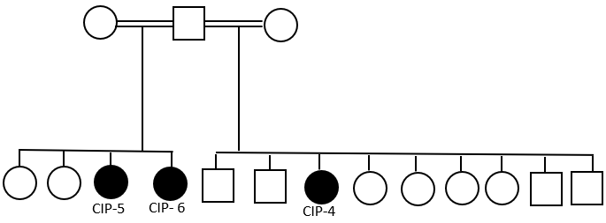

Figure 2: Pedigree of Family with CIP (right. Filled symbols indicate affected individuals. Small round filled symbols indicate abortions. Squires indicate males, circles – females. Diagonal lin across the symbol – deceased individual.

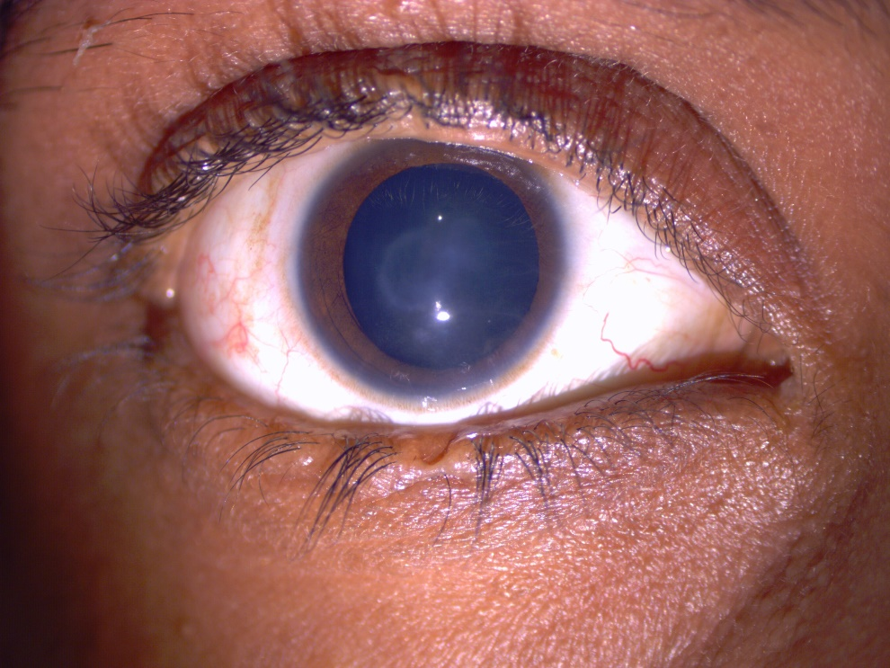

Figure 1: right eye of patient CIP 5. Central corneal opacity. note the notch in upper and lower eyelids where tarsorrhaphy was mad.

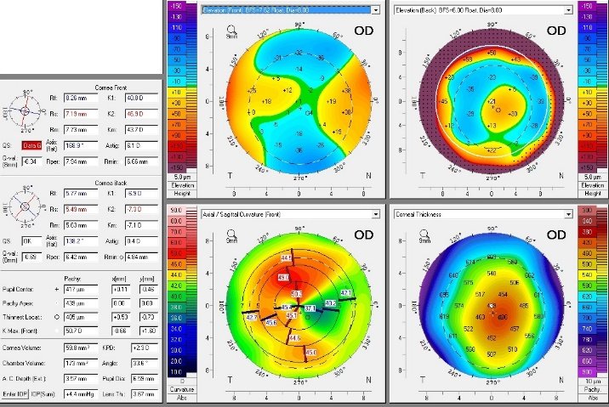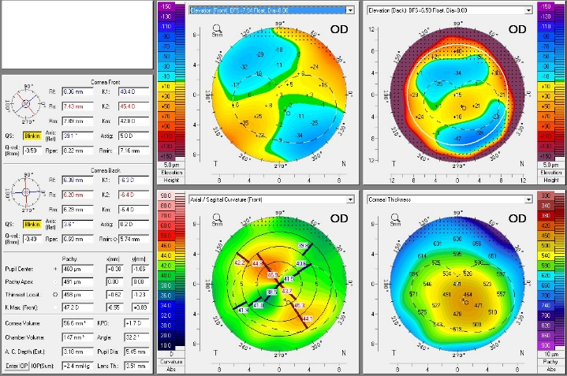

Figure 3: PENTACAM® tomography, right eye of patients CIP4 and CIP5 respectively showing high with the role astigmatism.