**OCULAR MANIFESTATIONS OF CONGENITAL INSENSITIVITY TO PAIN: A LONG TERM FOLLOW UP**

**BAKER ELSANA, LIBE GRADSTEIN, AHED IMTIRAT, CHIYA BARRETT, RONIT YAGEV, GALINA LING, EREZ TSUMI**

*`*

Ophthalmology Department, Soroka University Medical Center and Clalit Health Services, Beer Sheva, Israel. Affiliated to theFaculty of Health Sciences, Ben-Gurion University of the Negev, Beer Sheva,

Israel.

Pediatric ambulatory services, Saban Pediatric Medical Center for Israel, Soroka University Medical Center.

Inquiries to:

Baker Elsana, Ophthalmology Department, Soroka University Medical Center

Ben-Gurion University of the Negev, Beer-Sheva 84101, Israel.

Email: [bakerelsana1@gmail.com](mailto:bakerelsana1@gmail.com)

**Abstract**

**Purpose:** To describe ocular manifestations in children with CIPA and CIP (Congenital insensitivity to pain with and without anhidrosis) and analyze natural history of their ocular disease.

**Design:** Retrospective observational case series.

**Methods**: children with CIPA and CIP syndromes. The diagnosis was established by clinical criteria and in few patients by genetic analysis. Collected data included demographic information, medical history, ocular surgeries, genetic analysis, and ocular examination results including visual acuity, cycloplegic refraction, ocular surface findings, corneal sensitivity, tear film production and fundoscopy results. Corneal tomography and slit lamp photography were performed for some patients.

**Results**: 39 children, 32 clinically diagnosed with CIPA and 7 with CIP. 11 CIPA patients had mutations in *NTRK1 (1926 Tins*). 3 CIP patients with mutations in *PRDM12* and another 3 in *SCN9A*. Mean follow-up time was 49 months for the CIPA and 85.2 for the CIP patients. Corneal opacities were seen in 31% of eyes in CIPA and in 85% with CIP. The majority of CIPA patients had no SPKs (superficial punctate keratopathies), while in CIP group SPKs were marked in 66% of eyes. Schirmer was normal in 83% of CIPA patients’ eyes but reduced in 75% of eyes with CIP. Corneal reflex was present in 52% of eyes in CIPA and in 33% of eyes in CIP. Visual acuity was ≥ 20/25 in the majority of CIPA patients, while in CIP group it was 20/30 in 5 eyes and ≤ 20/40 in 9 eyes.

**Conclusion:** Children with congenital insensitivity to pain are prone to develop ocular complications, primary corneal scarring. CIP patients tend to have more severe ocular surface disease than those with CIPA, likely due to more pronounced loss of corneal sensation. However, the affected children may develop normal vision and should have routine follow-up to early identify ocular surface disease and prevent vision loss.

Congenital insensitivity to pain with anhidrosis (CIPA) and congenital insensitivity to pain (CIP) are rare autosomal recessive neuropathies characterized by the inability to sense noxious stimuli as pain and heat. Both belong to the group of hereditary sensory and autonomic neuropathies (HSAN).1 The exact prevalence of these disorders remains poorly known, CIPA is relatively common among Israeli Bedouins and the Japanese population.2 Haga et al estimated a prevalence of CIPA as 1 in 600,000–950,000, and CIP as 1 in 2,200,000–4,200,000, respectively.2 Both CIPA and CIP patients are predisposed to multiple self-inflicting injuries such as lips and finger biting, especially with eruption of first teeth, therefor they routinely have surgical extraction of incisors. Sometimes there are spontaneous loss or self extraction of teeth. They also have bone fractures and burns. They often develop poorly healing injuries and abscesses that may cause permanent devastating disabilities.3,4 CIPA is characterized by reduced sensitivity to pain with anhidrosis and variable degree of mental retardation. Indo et al found that mutations in neurotrophic receptor tyrosine kinase1 (NTRK1) gene are responsible for CIPA by causing failure to support survival of nerve growth factor (NGF) dependent sympathetic ganglion neurons and nociceptive sensory neurons derived from the neural crest.5 CIP patients differ from those with CIPA by having normal intellect and sweat function.6 Mutations in several genes can lead to different types of CIP. Among them are missense mutation in voltage-gated sodium channel type IX α subunit (SCN9A*)* that cause loss of function of voltage-gated sodium channels in sensory neurons7 and mutations in the epigenetic regulator PR domain zinc finger protein 12 (*PRDM12* ) that lead to CIP through defect in the normal development of nociceptive sensory neurons8 . Another less frequent form of CIP is due to mutation in the nerve growth factor B (*NGFB*) gene that lead to loss of small myelinated fibers.9

The ocular manifestations of CIPA and CIP are related to impaired corneal innervation due to loss of NGF-dependent neurons responsible for corneal innervation and may include dry eye syndrome, SPKs (superficial punctate keratopathies), corneal opacities, neurotrophic keratopathy and corneal ulcers.10 Yagev et al. described 15 Bedouin children with CIPA and found corneal opacities in ten children and corneal ulcers in seven children.11

Amano et al. examined 18 Japanese patients with CIPA. The most frequent abnormality was SPKs with no corneal ulcerations.12 Ocular findings in patients with CIP were reported as reduced lacrimation, corneal abrasions and possibly absent corneal reflex, leading to keratitis and corneal scarring.8,13 Little data exist on a long-term ocular sequela of CIPA and very sparse studies mentioned ocular findings in patients with CIP. Moreover, to the best of our knowledge there is no study that compares the ocular manifestations of CIPA and CIP patients. The aim of this study is to describe ocular findings in a large group of patients with CIPA and CIP, followed in our institution since 2008 (up to 11 years) and to compare the natural history of the disease in these conditions.

**Methods**

This study was conducted at the Soroka University Medical Center (SUMC), a tertiary medical center located in Southern Israel and included a total of 39 patients, 32 were diagnosed with CIPA and 7 with CIP. All patients were followed by an ophthalmologist and a pediatrician at the CIPA outpatient unit at SUMC during the period of 2008-2019. Pediatric evaluation included sensitivity to painful stimuli, thermal sensation, sweat production and intelligence level. Demographic data, as well as medical history were obtained from patients' medical records. The collected ophthalmic data included visual acuity, cycloplegic refraction, presence of corneal opacities, SPKs, corneal sensitivity (estimated by cotton thread method), tear breakup time (TBUT), Schirmer test results and posterior segment findings. The data of ancillary exams, such as corneal tomography and anterior segment photos were included if performed. Visual acuity (VA) was evaluated by Snellen chart. For non-verbal children and those with cooperation difficulties or developmental delay, evaluation of fixation by the central, steady, maintained (CSM) method was used. SPKs were measured according to the SPKs grading method.14 The area and density of the lesions were used as parameters to quantify SPKs, where A represents the area of the lesion ranging from A0 – no staining to A3- area occupies more than two thirds of the cornea, and D represents the density ranging from D0- no punctate staining to D3- high density and lesions overlap.

Corneal sensitivity was assessed by using a cotton thread. Schirmer test was performed by Tear Flow test strip (TearFlo®) which was inserted in the lower fornix after local anesthesia by Oxybuprocaine hydrochloride 0.4% drops. The length of the wet strip was measured after 5 minutes. Corneal opacity was assessed by three parameters: location (central, eccentric or peripheral), diameter (less than 2mm, between 2 and 4 mm or more than 4mm), and depth (subepithelial, stromal- superficial or deep). Active corneal ulcer was defined as a corneal infiltrate with epithelial defect and was described by location, diameter and depth. All patients were diagnosed with CIPA or CIP based on clinical characteristics and few of them had a genetic analysis. Clinical criteria for diagnosis of CIPA included insensitivity to painful stimuli and impaired temperature perception manifested as self mutilation and repeated traumatic injuries, anhidrosis that manifested as recurrent episodes of unexplained fever, and mental retardation of variable degree. CIP patients were diagnosed by the same criteria, except anhidrosis, and reduced intelligence.

Some patients had their blood sampled for genetic analysis, which was performed at the Institute of Human Genetics at SUMC by real time PCR technique. The research was approved by SUMC Institutional Review Board and Ethics Committee and adhered to the tents of the Declaration of Helsinki.

**Results**

39 patients were included, 32 patients with CIPA from 26 unrelated families and 7 patients with CIP from 4 unrelated families. Demographic data are shown in table 1, In the CIPA group the mean age was 14.58y ± 7.6 SD (2.6-29 years) and mean follow up time was 49 (0-129 months). All patients were of Bedouin origin,15 (46.8%) of them came from consanguineous families and 15 patients had one or more affected siblings. In the CIP group the mean age was 11y ± 7 SD (3-24 years) and mean follow up time was 85.2 (23-143 months). Consanguinity was found in 71% of patients with 5 of them having one or more affected siblings. All but one patient were of Bedouin origin. In the CIPA group all were diagnosed according to the clinical criteria and of them 11 had a genetic diagnosis of mutation in the NTRK1 gene with the pathogenic variant of 1926 T ins. In the CIP group 3 patients had a mutation in the PRDM12 gene, 3 had a mutation in SCN9A gene. and one patient was diagnosed with CIP based on clinical criteria. (Table 1).

Visual acuity at the end of the follow up in the CIPA group was 20/25 or better in 23 eyes, 20/30 to 20/50 in 12 eyes, and 20/100 or worse in 5 eyes. In 24 eyes visual response was obtained by a CSM method and in one patient (2 eyes) the VA could not by determined. In the CIP group VA was 20/30 in 5 eyes, 20/40 or worse in 7 eyes, one patient had VA of light perception in one eye and it could not be determined in the other eye. (Table 2) Ocular surface findings revealed no active corneal ulceration in the most recent exam in both groups, though, during the follow up period 8 CIPA patients and 5 CIP patients had one episode of corneal ulcer. One CIPA patient had two episodes of corneal ulceration in both eyes. Corneal ulcers were more frequent during early childhood, ≤10 years old in both groups. Surgical interventions such as tarsorrhaphy and amniotic membrane transplantation were required due to poor healing corneal ulcers in 3 and in 8 eyes of CIPA and CIP patients, respectively. One CIP patient had 8 surgeries of amniotic membrane transplantation combined with tarsorrhaphy, 2 corneal covering grafts and permanent punctual occlusion due to exposure keratopathy and poor healing recurrent corneal erosions.(Appendix table1)Corneal opacities were found in 10 out of 32 patients with CIPA (31%) and in 6 out of 7 patients with CIP (85%). Of the 32 patients with CIPA, 5 (15%) had bilateral opacities, whereas in the CIP group 2 of the 7 patients (28%) had bilateral opacities. In both groups the opacities were mainly in the deep stroma and measured more than 4 mm in width. In the CIPA group the lesions were located mostly in the periphery (53%) whilst in the CIP group the opacities were mainly central (75%). Corneal reflex was evaluated in 26 of 32 patients with CIPA and in 6 of 7 patients with CIP. It was present in 52% of eyes in the CIPA group and 33.3% of eyes in the CIP group. Schirmer test was performed in 18 of 32 patients with CIPA and in 4 of 7 patients with CIP. It was above the lower limit (10 mm) of the normal range in 83.3% of eyes in the CIPA group, while in the CIP group it was below the lower normal limit in 75% of the eyes.

Tear break up time (TBUT) was measured in 24 of 32 patients in the CIPA group and in 4 of 7 patients in the CIP group. It was above the lower limit of normal value (5 seconds) in 73% and 63% of eyes in the CIPA and CIP group respectively. The majority of the CIPA group showed no SPKs findings (A0D0) with some having a mild grade of SPK (A1D1). In the CIP group SPKs were confined to less than 1/3 of the cornea (A1) in 41%, were diffuse (A3) in 33% of the eyes and extremely dense (D3) in 66% of the eyes. Strabismus was found in four patients in the CIPA group (three with monocular esotropia and one with monocular exotropia) and in one patient in the CIP group, who had monocular esotropia. High astigmatism was found in one patient in the CIPA group, who had keratoconus with corneal hydrops in one of his eyes and in 2 patients in the CIP groups (one eye each). Posterior segment was normal in all patients.

**Discussion**

Our study included patients with CIPA syndrome, 11 of whom had a genetically confirmed diagnosis of a mutation in the NTRK1 gene (1926 T insertion) and patients with CIP syndrome that have mutations in *SCN9A* or *PRDM12*. To the best of our knowledge, the ocular manifestation in CIP patients have not been specifically addressed in the literature. Both groups presented with unique but similar ocular manifestations that are mainly restricted to the ocular surface. In the CIP group corneal involvement showed a propensity towards severity as shown by SPKs density and the presence of corneal opacities. Among CIPA patients, almost half of the examined eyes had intact corneal reflex, and corneal opacities were present only in 10 of 32 patients. As opposed to that, a previous series of 15 Bedouin CIPA patients by Yagev et al. corneal reflex was absent in all eyes and corneal opacities were present in 10 out of 15 patients.11 In the study of Amano et al. among 18 Japanese CIPA patients, corneal reflex was positive in both eyes of one patient, extremely diminished in both eyes of 7 patients and absent in both eyes of 3 patients.12 According to Jarade et al., only 14 patients out of 52 worldwide showed corneal involvement including lack of corneal sensitivity and absent corneal reflex, neurotrophic corneal ulcers with poor healing which predispose to repeated corneal infections and subsequent scaring. Normal corneal reflex was reported in two patients.15 Shatzky et al. reported that some CIPA patients were shown to have conserved sensitivity, as pain sensation response to pin prick was elicited in patchy areas over the bridge of the nose, behind the ears at the external auditory meatus, over the posterior cervical skin area, and on the palms.16 Hence, preserved corneal reflex may be found in CIPA patients that do not present full spectrum of the syndrome and have some residual corneal sensation. Tear production was normal in the majority of CIPA patients. Similar results were published in previous study by Amano et al.12 As opposed to that, the corneal reflex was absent and tear production was decreased in the majority of CIP patients, consistent with findings in previous studies by Chen et al. and Zhang et al.8,13 In our study TBUT measurements were similar in CIPA and CIP groups and were above the lower limit in most eyes. Yagev et al, also showed that TBUT was normal in all patients.11 Contrary to that, Amano S. et al. found that TBUT was decreased in all eyes of CIPA patients leading to dry eye likely due to increased evaporative loss.12 However, in this study TBUT was measured only in 7 patients out of 18. Also, the pathogenic variant affecting NTRK1 gene leading to CIPA in our Bedouin population is different from that of the Japanese CIPA patients.16,17 Hence, the differences could be explained by different phenotypic expression. Our study includes the largest number of CIPA and CIP patients ever reported with a long follow up period. The study shows that some patients of both groups developed corneal ulcers at least once during their lifetime especially during childhood, among them, CIP patients are more prone to develop corneal ulcers, which are difficult to treat and commonly required surgical interventions. It was shown that mutations in PRDM12 and NTRK1 cause PRDM12-CIP and CIPA, respectively, through absence of nociceptive sensory neurons, and in CIPA also through the lack of sympathetic innervation of sweat glands.4,8 Recently, PRDM12 was found to be responsible for the expression and maintenance of NTRK1 during the development process of nociceptive sensory neurons in dorsal root ganglia (DRG) and trigeminal ganglia (TG).18 Thus both PRDM12-CIP and CIPA syndromes have the same common final pathway of abnormal development of nociceptive sensory neurons. As mentioned earlier, one study demonstrated the lack of central corneal innervation by confocal microscopy which is consistent with the loss of Aδ and C nerve terminals in corneas of CIPA patients.10 Given the same pathophysiological mechanism, ocular manifestations in both diseases are expected to be similar and it is due to lack of corneal sensation. It is unclear therefore why in our study PRDM-12 dependent CIP tended to have poorer outcome than those with CIPA caused by NTRK1 mutation, and it is possible that a small number of CIP patients was responsible for the bias. Corneal nerves also play a role in the homeostasis and the normal regeneration of corneal epithelium by secreting various neuropeptides, among them NGF and substance P (SP). Moreover, corneal nerve impairment is responsible for epithelial defects, ulcerations, corneal perforations, and reduced function of corneolimbal stem cells as part of neurotrophic keratopathy.19 This factor may have impaired healing of corneal ulcers in our patients. Congenital insensitivity to pain is a group of rare disorders. Long-term prognosis of CIPA patients has not been established so far, and little data exist in ophthalmic literature regarding ocular manifestations of CIP. Due to paucity of the data it is hard to draw valid conclusions regarding the natural history of these disorders. Our study is unique in its sample size and length of follow up thus enabling to estimate the prognosis and suggest the management of these diseases. According to the results of our study, patients with CIPA and CIP may present with or without ocular involvement. Significant corneal opacities were noticed mostly in patients who lack corneal reflex and corneal sensitivity. In patients with intact corneal reflex, good vision was preserved in most eyes.Yet, there is wide phenotypic variability between various types of disorders causing congenital insensitivity to pain and even among individuals with the same pathogenic variants, suggesting that interaction with other genetic and environmental factors may contribute to the phenotype. We found that CIPA patients had noticeably less frequent ocular involvement and relative vision conservation compared to CIP patients after long follow up period. Patients in both groups may develop normal vision especially if corneal sensitivity is not severely affected , however, these children should be closely followed by an ophthalmologist, to early identify and treat ocular surface disease, in order to prevent vision loss due to corneal ulceration and scarring. This is especially true for those who lack corneal reflex. Because of the impaired pain sensation, the symptoms of corneal ulceration or infection can be easily missed, and the parents should be advised to seek an urgent consultation with an ophthalmologist in any case of red eye, secretions, or blurred vision.

**Reference**

1. Dyck PJ, Mellinger JF, Reagan TJ, et al. Not “indifference to pain” but varieties of hereditary sensory and autonomic neuropathy. *Brain*. 1983;106(2):373-390.
2. Haga N, Kubota M, Miwa Z. Epidemiology of hereditary sensory and autonomic neuropathy type IV and V in Japan. *Am J Med Genet Part A*. 2013;161(4):871-874.
3. Katherine Schon, MB ChB, MRCP, MA, Alasdair Parker, MBBS, MRCP, MD, MA, and Christopher Geoffrey Woods, MB ChB, FRCP Fm. Congenital Insensitivity to Pain Overview. *GeneReviews® [Internet]*. 2018.
4. Indo Y. Congenital Insensitivity to Pain with Anhidrosis. 2008 Aug 5 [Updated 2014 Apr 17]. GeneReviews® [Internet].
5. Yasuhiro Indo. Congenital insensitivity to pain with anhidrosis (CIPA): effect of TRKA (NTRK1) missense mutations on autophosphorylation of the receptor tyrosine kinase for nerve growth factor. *Hum Mol Genet*. 2001;10(3):179-188.
6. Houlden H, Blake J, Reilly MM. Hereditary sensory neuropathies. *Curr Opin Neurol*. 2004.
7. Cox JJ, Sheynin J, Shorer Z, et al. Congenital insensitivity to pain: Novel SCN9A missense and in-frame deletion mutations. *Hum Mutat*. 2010;31(9):1670-1686.
8. Chen YC, Auer-Grumbach M, Matsukawa S, et al. Transcriptional regulator PRDM12 is essential for human pain perception. *Nat Genet*. 2015;47(7):803-808.
9. Einarsdottir E, Carlsson A, Minde J, et al. A mutation in the nerve growth factor beta gene (NGFB) causes loss of pain perception. *Hum Mol Genet*. 2004;13(8):799-805.
10. Mimura T, Amano S. In Vivo Confocal Microscopy of Hereditary Sensory and Autonomic Neuropathy. Current Eye Research 2008:940-945.
11. Yagev R, Levy J, Shorer Z, Lifshitz T. Congenital insensitivity to pain with anhidrosis: ocular and systemic manifestations. *Am J Ophthalmol*. 1999;127(3):322-326.
12. Amano S, Fukuoka S, Usui T, et al. Ocular Manifestations of Congenital Insensitivity to Pain With Anhidrosis. *Am J Ophthalmol*. 2006;141(3):472-477.
13. Zhang S, Sharif SM, Chen Y, et al. Clinical features for diagnosis and management of patients with PRDM12 congenital insensitivity to pain. J med genet 2016:533-535.
14. Miyata K, Amano S, Sawa M, Nishida T. A Novel Grading Method for Superficial Punctate Keratopathy Magnitude and Its Correlation With Corneal Epithelial Permeability. *Arch Ophthalmol*. 2003;121(11):1537-1539.
15. Jarade EF, El-Sheikh HF, Tabbara KF. Indolent corneal ulcers in a patient with congenital insensitivity to pain with anhidrosis: A case report and literature review. *Eur J Ophthalmol*. 2002;12(1):60-65.
16. Shatzky, Moses, Levy, Pinsk, Hershkovitz, Herzog, Shorer, Luder, and Parvari. Congenital Insensitivity to Pain with Anhidrosis (CIPA) in Israeli-Bedouins: Genetic Heterogeneity, Novel Mutations in the TRKA/NGF Receptor Gene, Clinical Findings, and Results of Nerve Conduction Studies. *Am J Med Genet* 92.5 (2000): 353-360.
17. Indo Y. Molecular basis of congenital insensitivity to pain with anhidrosis (CIPA): Mutations and polymorphisms in TRKA (NTRK1) gene encoding the receptor tyrosine kinase for nerve growth factor. *Hum Mutat*. 2001;18(6):462-471.
18. Desiderio S, Vermeiren S, Van Campenhout C, et al. Prdm12 Directs Nociceptive Sensory Neuron Development by Regulating the Expression of the NGF Receptor TrkA. *Cell Rep*. 2019;26(13):3522-3536.e5.
19. Shaheen BS, Bakir M, Jain S. Corneal nerves in health and disease. *Surv Ophthalmol*. 2014;59(3):263–285.
20. McDermott LA, Weir GA, Themistocleous AC, et al. Defining the Functional Role of Na V 1.7 in Human Nociception. *Neuron*. 2019;101(5):905-919.e8SS

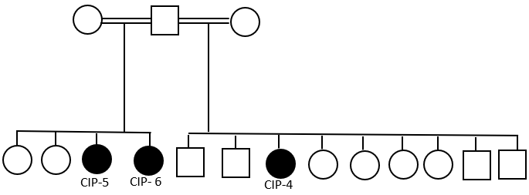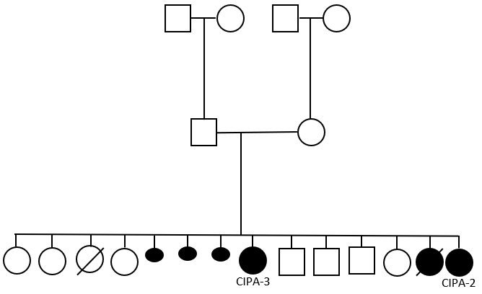

**Fig. 1.** Pedigree of Family 2 with CIPA (left) and Family 7with CIP (right. Filled symbols indicate affected individuals. Small round filled symbols indicate abortions. Squires indicate males, circles – females. Diagonal lin across the symbol – deceased individual.

Table 1- Demographic data of patients with CIP and CIPA.

|  |  |  |
| --- | --- | --- |
|  | CIPA (n=32) | CIP (n=7) |
| Gender |  |  |
| Male, n (%) | 19 (59%) | 2 (29%) |
| Female, n (%) | 13 (41%) | 5 (71%) |
| Mean Age, years ± SD | 14.58 ± 7.6 SD | 11 ± 7.0 SD |
| Mutation | 12 NTRK1 (1926 T insertion) | 3 SCN9A, 3 PRDM12 |
| Ethnic group |  |  |
| Bedouin, n (%) | 32 (100%) | 6 (85.7%) |
| Jewish, n (%) | 0 | 1 (14.3%) |
| Consanguinity, n (%) | 15 (46.8%) | 5 (71%) |
| Family history n, (%)  (> 1 affected member) | 15 (46.8%) | 5 (71%) |
| Mean Follow up period ±SD  (Months) | 49.3 ± 43.2 SD | 85.2 ± 44.6 SD |

Table 2- Visual acuity at last visit

|  |  |  |
| --- | --- | --- |
| Visual Acuity | CIPA (eyes) | CIP (eyes) |
| 20/20 | 18 | 0 |
| 20/25 | 5 | 0 |
| 20/30 | 5 | 5 |
| 20/32 | 1 | 0 |
| 20/40 | 4 | 1 |
| 20/50 | 2 | 0 |
| 20/63 | 0 | 1 |
| 20/80 | 0 | 1 |
| 20/100 | 2 | 0 |
| 20/200 | 1 | 2 |
| FC | 1 | 2 |
| HM | 1 | 0 |
| CSM | 24 | 0 |
| NA | 2 | 1 |
| LP | 0 | 1 |

Table 3- ocular findings in patients with CIP and CIPA

|  |  |  |  |  |  |  |  |  |
| --- | --- | --- | --- | --- | --- | --- | --- | --- |
|  | Ocular Finding |  | No. (%) of Patients | |  | | No. (%) of Eyes | |
|  | |  | CIPA | CIP |  | | CIPA | CIP |
| Corneal opacities | |  |  |  |  | | 15 | 8 |
|  | One eye |  | 5/32(15.6%) | 4/7(57%) |  | |  |  |
|  | Two eyes |  | 5/32(15.6%) | 2/7(28.5%) |  | |  |  |
|  | Location |  |  |  |  | |  |  |
|  | Diffuse |  |  |  |  | | 1/15 (6.66%) | 2/8 (25%) |
|  | Central |  |  |  |  | | 6/15 (40%) | 6/8 (75%) |
|  | Eccentric |  |  |  |  | | 8/15 (53%) | 0 |
|  | Depth |  |  |  |  | |  |  |
|  | Subepithelial | |  |  |  | | 2/15 (13.3%) | 1/8 (12.5%) |
|  | Superficial  stromal | |  |  |  | | 6/15 (40%) | 2/8 (25%) |
|  | Deep stromal | |  |  |  | | 7/15 (46.6%) | 5/8 (62.5%) |
|  | Diameter (mm) | |  |  |  | |  |  |
|  | <2 |  |  |  |  | | 5/15 (33.3%) | 1/8(12.5%) |
|  | 2-4 |  |  |  |  | | 4/15 (26.6%) | 3/8 (37.5%) |
|  | >4 |  |  |  |  | | 6/15 (40%) | 4/8 (50%) |
| Schirmer I | |  |  |  |  | |  |  |
|  | NA |  | 14/32 (43.75%) | 3/7 (42.8%) |  | | 28/64 (43.75%) | 6/14 (42.8%) |
|  | >10 |  |  |  |  | | 30/36 (83.3%) | 2/8 (25%) |
|  | ≤10 |  |  |  |  | | 6/36 (16.6%) | 6/8 (75%) |
| Corneal Reflex | |  |  |  |  | |  |  |
|  | NA |  | 6/32 (18.75%) | 1/7 (14.2%) |  | | 12/64 (18.75%) | 2/14 (14.2%) |
|  | Positive |  |  |  |  | | 27/52 (52%) | 4/12 (33.3%) |
|  | Negative |  |  |  |  | | 25/52 (48%) | 8/12 (66.6%) |
| TBUT1 | |  |  |  |  | |  |  |
|  | NA |  | 8/32 (25%) | 3/7 (42.8%) |  | | 16/64 (25%) | 6/14 (42.8%) |
|  | >5 |  |  |  |  | | 35/48 (73%) | 5/8 (63%) |
|  | ≤5 |  |  |  |  | | 13/48 (27%) | 3/8 (37%) |
| SPK2 | |  |  |  |  | |  |  |
|  | NA |  | 5/32 (15.6%) | 1/7 (14%) | |  | 10/64 (15.6%) | 2/14 (14%) |
|  | A0 |  |  |  |  | | 20/54 (37%) | 2/12 (16.5) |
|  | A1 |  |  |  |  | | 13/54 (24%) | 5/12 (41.5%) |
|  | A2 |  |  |  |  | | 2/54 (3.7%) | 1/12 (8.3%) |
|  | A3 |  |  |  |  | | 5/54 (9.3%) | 4/12 (33.3%) |
|  | D0 |  |  |  |  | | 22/54 (40.7%) | 2/12 (16.5) |
|  | D1 |  |  |  |  | | 9/54 (16.6%) | 1/12 (8.3%) |
|  | D2 |  |  |  |  | | 3/54 (5.5%) | 1/12 (8.3%) |
|  | D3 |  |  |  |  | | 8/54 (14.8%) | 8/12(66.6%) |

**1 TBUT - Tear breakup time**

**2 SPK - Superficial punctate keratitis**

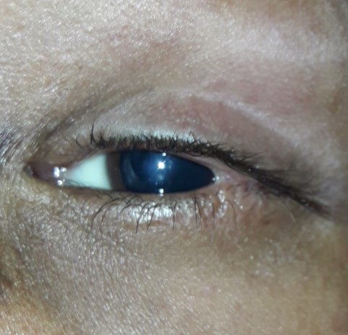

figure 2: left eye of patient CIPA 1. Showing permanent lateral tarsorrhaphy and central corneal opacity due to resolved corneal ulcer.

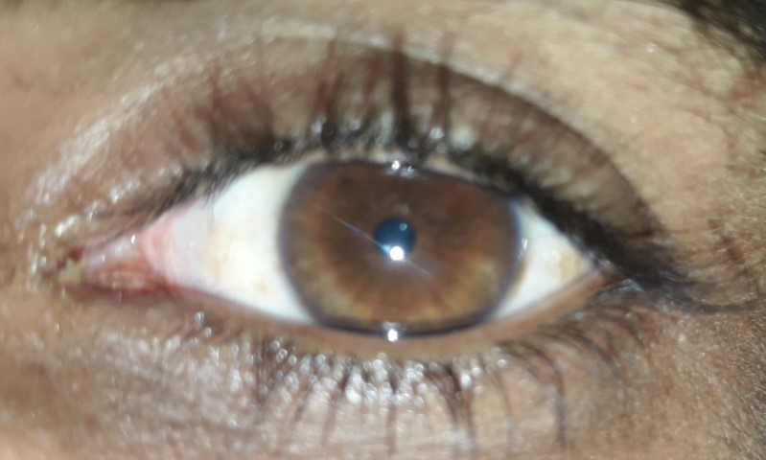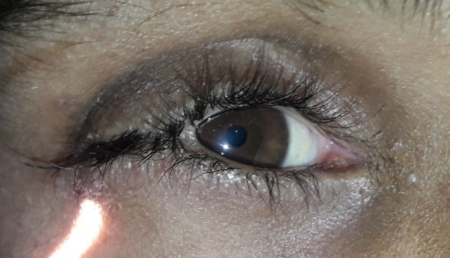

Figure 3: both eyes of patient CIPA 2 (brother of patient CIPA1). Right eye with 2/3 permanent lateral tarsorrhaphy and minimal central corneal opacity. Left eye appear normal.

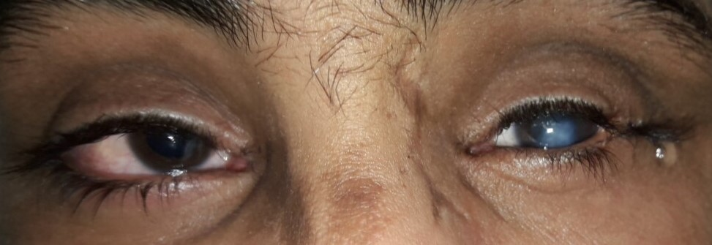

figure 4: both eyes of patient CIPA 5. Left eye with permanent lateral tarsorrhaphy and central corneal opacity. Right eye with clear cornea and looks normal.

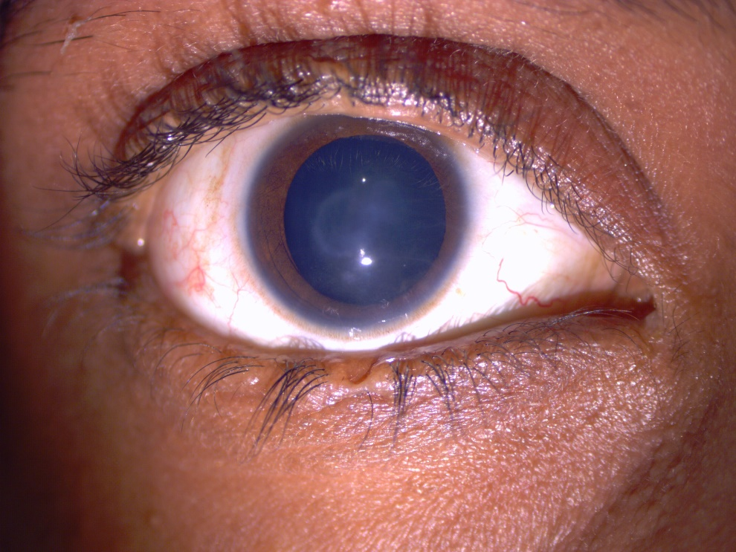

Figure 5: right eye of patient CIP 5. Central corneal opacity. note the notch in upper and lower eyelids where tarsorrhaphy was mad.

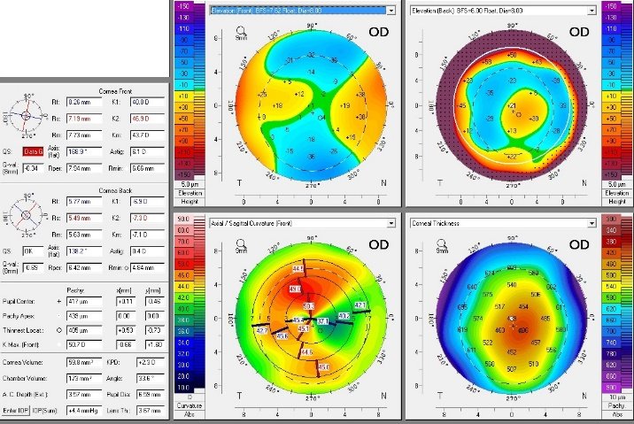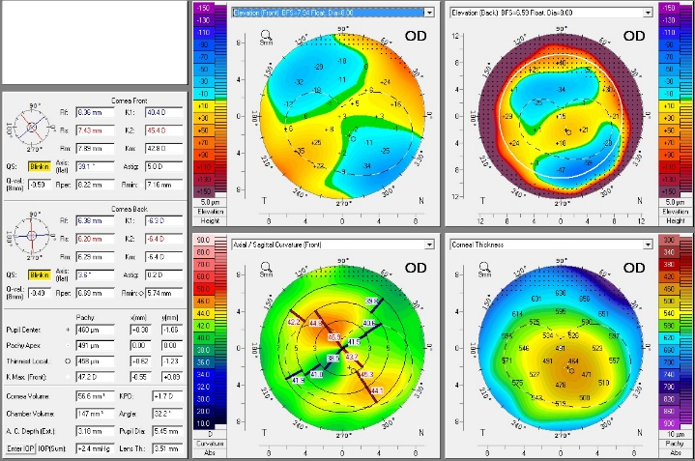

Figure 6: PENTACAM® tomography, right eye of patients CIP4 and CIP5 respectively showing high with the role astigmatism.