**JNF-KKL Initiative for Long-Term Research   
on the Effects of Climate Change on Natural Ecosystems in Israel**

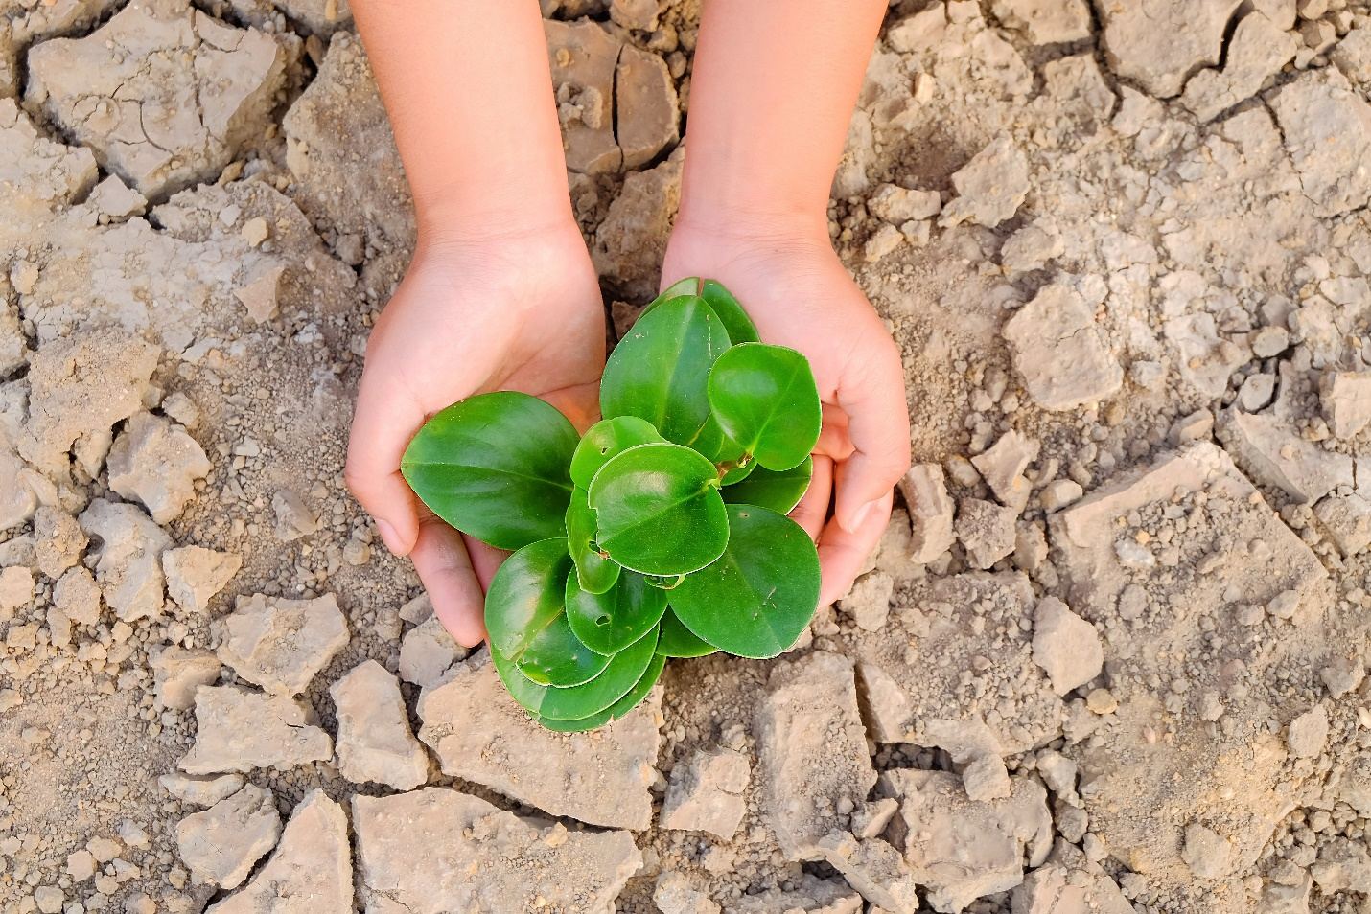

*State-of-the-art R&D to enhance Israeli preparedness for the impact of climate change on natural ecosystems*

August 2019

**JNF-KKL Initiative for Long-Term Research**

**on the Effects of Climate Change on Natural Ecosystems in Israel**

**Introduction: A Vital Initiative**

Tel Aviv University (TAU) seeks to establish a vital new partnership with the JNF-KKL dedicated to studying the effects of global climate change on Israel’s natural ecosystems and, ultimately, to generating environmental policy recommendations that will enable JNF-KKL and governmental agencies to best prepare for such effects. The idea is for the Initiative to serve as a broad, nationwide framework that unites top scientists from across Israel to address the field from multidisciplinary perspectives and approaches.

The Urgent Need for Research in the Field

The sustainability of natural, forested and agricultural ecosystems is critical for human well-being, which depends on the efficient functioning of these ecosystems. Yet, the benefits provided by these ecosystems are in great peril due to climate change, loss of biodiversity, and land use changes. In order to preserve or improve how ecosystems function, we must first understand and forecast how ecosystems will respond to current and future changes, including new management approaches and potential environmental tipping points. Without a deep understanding of the sensitive interdependencies between ecosystems and the environment, the Middle East region will be unable to assess the impact or control the risks of anticipated major changes in ecosystem structure and function.

Climate change models for the Middle East predict an increase in temperatures combined with drought. These changes will alter the functioning of natural and agricultural ecosystems, directly impacting on human, plant and animal life that depend on them. Clearly, solutions are urgently required to prepare for these changes.

Despite vast experimental research efforts that have been invested around the world in understanding the effects of global warming and CO2 atmospheric enrichment on ecosystem functioning, very little attention has been focused on predicting the responses of terrestrial ecosystems to potential changes in precipitation. This lack of knowledge represents a major hindrance to predicting the future of our natural systems in the face of global climate change, particularly in a country such as Israel characterized by strong water deficit.

Tel Aviv University Response

Experimental approaches combined with long-term monitoring and ecosystem modelling offer the ideal means to deepen understanding and provide evidence for future interventions. In particular, experimental facilities that allow ecosystems to be manipulated on different levels of biological organization and time scales will provide the understanding required to underpin the development of predictive models and policy recommendations.

Against this backdrop, Tel Aviv University (TAU) proposes establishing the ***JNF-KKL Initiative for Long-Term Research on the Effects of Climate Change on Natural Ecosystems in Israel***, which will pursue the following goals:

1. Establish and further develop the leading experimental research platforms in Israel.
2. Help scientists and JNF-KKL managers to deepen understanding of ecosystem processes under ongoing changes by producing data, methods and models.
3. Support Israel’s preparedness for such changes by providing decision-support tools to environmental policymakers and JNF-KKL managers.

**The Proposed Initiative: Overview**

The Initiative will support – and expand – the research of TAU’s Prof. Marcelo Sternberg of the School of Plant Sciences and Food Security, George Wise Faculty of Life Sciences. Sternberg’s research is the **only scientific project** **of its kind** across the Middle East and western Asia to address the potential effects of climate change on natural ecosystems. His studies involve monitoring and manipulating rainfall using large-scale rainout shelters that his team has set up to test two extreme climate change scenarios: winters with drought and changes in rainfall distribution.

The Initiative will focus on the effects of soil nutrient enrichment and changing patterns of rainfall on ecosystem functioning, with a view to helping predict the impact of future climatic scenarios on areas in the Middle East and other regions with similar environmental conditions. Such information will be crucial for JNF-KKL forest managers as well as environmental policymakers at the Ministries of Environmental Protection, of Science and Technology, and of Agriculture and Rural Development. It will achieve this by conducting the following:

1. Augmenting and employing test sites to generate empirical data for modeling and predicting ecosystem responses to climate change in environmentally sensitive areas such as Israel, a country located on the cusp of two very different climate zones – one humid and one arid – whose ecosystems are particularly vulnerable to the effects of climate change. The idea is for the resulting data to serve as a model for other similar regions around the world.
2. Analyzing the factors that control ecosystem composition, structure and functioning in the face of global climate change.
3. Formulating recommendations – based on the empirical work done at field research stations – for adapting to and mitigating against climate change, to be submitted to the environmental policymaking community, including JNF-KKL managers.

Augmenting test sites

The Initiative will support the creation of three experimental research stations along the north-south steep climatic gradient in Israel. It will draw on the facilities of Sternberg’s team at an existing research station located in the *Judean Hills*, and expand that site by adding new and more sophisticated rainout shelters for testing the effects of rainfall distribution changes on the functioning of natural ecosystems. The Initiative will also create two new experimental research stations:The first will be constructed in the *northern Negev* region, representing desert natural ecosystems, while the second will be built in the *Galilee region*, representing the natural Maqui forests. **These new experimental stations will strengthen the scientific community in Israel’s periphery and reinforce the goals of JNF-KKL Israel 2040.**

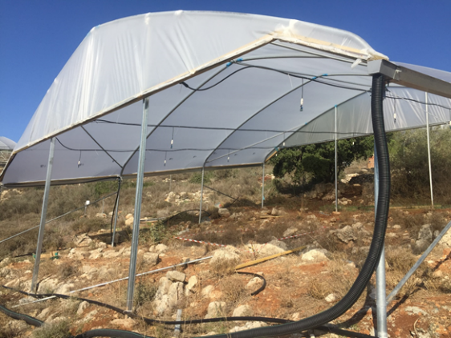The research stations will be fitted with new rainfall manipulation infrastructures featuring state-of-the-art technologies. The new infrastructures will simulate changes in climatic and rainfall conditions for the various ecosystems considered. New high-tech meteorological stations featuring various sensors will be installed at each research station to measure changes in environmental conditions at the manipulated plots. Advanced equipment for measuring soil biogeochemical fluxes and changes in plant cover will also be acquired. All stations will be fenced to prevent grazing livestock from entering the study sites.

*Pictured: Research infrastructure at the Judean Hills research station.*

Training a new generation of climate change specialists

The Initiative will help train the next generation of ecologists, forest managers and climate change experts by providing fellowships for research students at the master’s, doctoral and post-doctoral levels. These young researchers will be responsible for operating and maintaining the three research stations, including studying the effects of climate change manipulations on natural ecosystems along the aridity gradient.

Nationwide Dissemination

The Initiative will establish a database of measured parameters using state-of-the art information management to ensure that all decision and policymakers who require the data have access to it. Collected data will also be made available to researchers at other Israeli universities and to JNF-KKL managers via sophisticated online data portals. The anticipated new knowledge will be presented at JNF-KKL meetings, and at national and international conferences and workshops.

**Anticipated Impact**

The establishment of the Initiative is anticipated to be influential on several levels:

Bridging the scientific knowledge gap: The Initiative is anticipated to close significant knowledge gaps and help secure the sustainability of natural ecosystems in Israel and the Middle East upon which agricultural production – natural pastures, dairy products, vegetables and grains – depends.

Informing national policy: The Initiative will respond to an Israeli national priority to plan for, adapt to and mitigate the effects of climate change in the decades to come, and will position Israel as a world leader in climate change research. Further, online data and periodical reports generated by the Initiative will be published on the website of the JNF-KKL Chief Scientist – thereby ensuring further dissemination of critical data among relevant decision and policymakers.

Leveraging the Initiative to bring in additional grant funding: The establishment of the Initiative will enhance the ability of Israeli scientists to compete for – and secure – external research grants from international and national competitive funding agencies.

**Administration**

Head of the Initiative

******Experimental ecologist ***Prof. Marcelo Sternberg*** heads the biodiversity component of the Israel Center for Climate Change Information, created by the Ministry of Environmental Protection to serve as the basis for Israeli climate change research policy. He investigates the effects of human activities on natural ecosystems, addressing questions relating to plant community ecology and ecosystem functioning in topics including global climate change, grazing effects on natural systems, climatic gradients, biodiversity, plant invasion, seed ecology and forest ecology. He is the former President of the Israel Society of Ecology and Environmental Sciences.

National Executive Board

In order to secure a broad national representation of additional research partners to this Initiative, an Executive Board will be established. The Board will include JNF-KKL staff and academy scientists working on terrestrial ecology and climate change related topics, and will include representatives from various Israeli universities and research centers. The Board will be led by Prof. Sternberg who will seek out the most suitable research partners in complementary fields in cooperation with JNF-KKL, including experts in plant ecology, plant ecophysiology, forest management, soil ecology, soil biogeochemical processes, geomorphologists, entomologists, plant molecular biologists, simulation and mathematical modelers and remote sensing. Strong emphasis will be given in bringing in researchers with balanced academic representation in order to secure broad national coverage. The Board will potentially expand the activities at each research station and will seek out additional external funds to expand the scope of the Initiative at both the national and international levels.

**Tel Aviv University: Ideally Positioned to Operate the Initiative**

With its strong multidisciplinary research culture, location in Israel – a hot spot for global innovation – and the resources, expertise and experience already in place, Tel Aviv University is uniquely positioned to lead the proposed Initiative. TAU is Israel’s academic leader in biodiversity and climate change research, with more faculty and students in the field than any other Israeli university. These include internationally recognized scientists working on pioneering meteorological climate change models that will be crucial for making accurate predictions regarding the future of Israel’s natural environment.

In particular, the Initiative will draw on the expertise and resources at TAU’s *School of Plant Sciences and Food Security*, Wise Faculty of Life Sciences, one of the largest and most comprehensive of its kind in Israel. School researchers form a dynamic and collaborative community that is united in its goal of advancing knowledge in plant biology, from the basic research level through to the development of applications in biotechnology, agriculture, environmental conservation, and more.

**Funding and Donor Recognition**

Tel Aviv University requires a visionary gift of US$4.5 million over 10 years to establish and operate the ***JNF-KKL Initiative for Long-Term Research on the Effects of Climate Change on Natural Ecosystems in Israel***. Funding will be allocated toward the upgrade, construction and operation of three research stations according to the budget on page 8 (Appendix I). The budget features costs relating to each individual station (set-up, supplies & materials, travel), alongside resources that will serve all three stations – equipment, personnel and conferences.

To express its appreciation for the donation, the University will name the Initiative according to the wishes of JNF-KKL, and the Initiative will be known by this name for the duration of the support. The University will inaugurate the Initiative in a festive ceremony during which JNF-KKL representatives will be honored. All events, publications and activities associated with the Initiative will bear its designated name for the duration of the support, and a prominent sign acknowledging the gift will be displayed at the supported research stations, testifying to an inspired act of vision and environmental commitment.

**Appendix I: Detailed 10 Year Budget in US$**

|  |  |  |  |  |  |  |  |  |  |  |  |  |  |  |  |  |  |  |  |  |  |  |  |  |
| --- | --- | --- | --- | --- | --- | --- | --- | --- | --- | --- | --- | --- | --- | --- | --- | --- | --- | --- | --- | --- | --- | --- | --- | --- |
|  | **Year 1** | **Year 2** | | **Year 3** | | **Year 4** | | **Year 5** | | **Year 6** | | **Year 7** | | **Year 8** | | **Year 9** | | **Year 10** | | **10 Y Total** | | | | |
| **1. Negev Research Station** |  |  | |  | |  | |  | |  | |  | |  | |  | |  | |  | | | | |
| ***Set-up of field sites*** |  |  | |  | |  | |  | |  | |  | |  | |  | |  | |  | | | | |
| Construction of new rainout shelters incl. irrigation systems and fences | 200,000 |  | |  | |  | |  | |  | |  | |  | |  | |  | | 200,000 | | | | |
| ***Supplies & Materials*** |  |  | |  | |  | |  | |  | |  | |  | |  | |  | |  | | | | |
| Sampling material |  | 6,000 | | 6,000 | | 6,000 | | 6,000 | | 6,000 | | 6,000 | | 6,000 | | 6,000 | | 6,000 | | 54,000 | | | | |
| Soil and vegetation chemical analyses | | | 13,000 | | 13,000 | | 13,000 | | 13,000 | | 13,000 | | 13,000 | | 13,000 | | 13,000 | | 13,000 | | 117,000 | | | |
| Office material |  | 2,000 | | 2,000 | | 2,000 | | 2,000 | | 2,000 | | 2,000 | | 2,000 | | 2,000 | | 2,000 | | 18000 | | | | |
| Publication and editing |  | 6,000 | | 6,000 | | 6,000 | | 6,000 | | 6,000 | | 6,000 | | 6,000 | | 6,000 | | 6,000 | | 54000 | | | | |
| Internet interface |  | 2,000 | | 2,000 | | 2,000 | | 2,000 | | 2,000 | | 2,000 | | 2,000 | | 2,000 | | 2,000 | | 18000 | | | | |
| Laboratory and field work supplies | | | 6,000 | | 6,000 | | 6,000 | | 6,000 | | 6,000 | | 6,000 | | 6,000 | | 6,000 | | 6,000 | | 54000 | | | |
| Annual maintenance |  | 10,000 | | 10,000 | | 10,000 | | 10,000 | | 10,000 | | 10,000 | | 10,000 | | 10,000 | | 10,000 | | 90000 | | | | |
| ***Travel*** |  |  | |  | |  | |  | |  | |  | |  | |  | |  | |  | | | | |
| Travel for field work |  | 6,000 | | 6,000 | | 6,000 | | 6,000 | | 6,000 | | 6,000 | | 6,000 | | 6,000 | | 6,000 | | 54,000 | | | | |
| Attendance at international conferences | | | 7,000 | | 7,000 | | 7,000 | | 7,000 | | 7,000 | | 7,000 | | 7,000 | | 7,000 | | 7,000 | | 63,000 | | | |
| **2.** **Judean Hills Research Station \*** | | |  | |  | |  | |  | |  | |  | |  | |  | |  | |  | | | |
| ***Set-up of field sites*** |  |  | |  | |  | |  | |  | |  | |  | |  | |  | |  | | | | |
| Upgrade construction of rainout shelters incl. irrigation systems and fences | 150,000 |  | |  | |  | |  | |  | |  | |  | |  | |  | | 150,000 | | | | |
| ***Supplies & Materials*** |  |  | |  | |  | |  | |  | |  | |  | |  | |  | |  | | | | |
| Sampling material |  | 6,000 | | 6,000 | | 6,000 | | 6,000 | | 6,000 | | 6,000 | | 6,000 | | 6,000 | | 6,000 | | 54,000 | | | | |
| Soil and vegetation chemical analyses | | | 13,000 | | 13,000 | | 13,000 | | 13,000 | | 13,000 | | 13,000 | | 13,000 | | 13,000 | | 13,000 | | 117,000 | | | |
| Office material |  | 2,000 | | 2,000 | | 2,000 | | 2,000 | | 2,000 | | 2,000 | | 2,000 | | 2,000 | | 2,000 | | 18000 | | | | |
| Publication and editing |  | 6,000 | | 6,000 | | 6,000 | | 6,000 | | 6,000 | | 6,000 | | 6,000 | | 6,000 | | 6,000 | | 54,000 | | | | |
| Internet interface |  | 2,000 | | 2,000 | | 2,000 | | 2,000 | | 2,000 | | 2,000 | | 2,000 | | 2,000 | | 2,000 | | 18,000 | | | | |
| Laboratory and field work supplies | | | 6,000 | | 6,000 | | 6,000 | | 6,000 | | 6,000 | | 6,000 | | 6,000 | | 6,000 | | 6,000 | | 54,000 | | | |
| Annual maintenance |  | 10,000 | | 10,000 | | 10,000 | | 10,000 | | 10,000 | | 10,000 | | 10,000 | | 10,000 | | 10,000 | | 90000 | | | | |
| ***Travel*** |  |  | |  | |  | |  | |  | |  | |  | |  | |  | |  | | | | |
| Travel for field work |  | 6,000 | | 6,000 | | 6,000 | | 6,000 | | 6,000 | | 6,000 | | 6,000 | | 6,000 | | 6,000 | | 54,000 | | | | |
| Attendance at international conferences | | | 7,000 | | 7,000 | | 7,000 | | 7,000 | | 7,000 | | 7,000 | | 7,000 | | 7,000 | | 7,000 | | 63,000 | | | |
| **3. Galilee Research Station** |  |  | |  | |  | |  | |  | |  | |  | |  | |  | |  | | | | |
| ***Set-up of field sites*** |  |  | |  | |  | |  | |  | |  | |  | |  | |  | |  | | | | |
| Construction of new rainout shelters incl. irrigation systems and fences | 200,000 |  | |  | |  | |  | |  | |  | |  | |  | |  | | 200,000 | | | | |
| ***Supplies & Materials*** |  |  | |  | |  | |  | |  | |  | |  | |  | |  | |  | | | | |
| Sampling material |  | 6,000 | | 6,000 | | 6,000 | | 6,000 | | 6,000 | | 6,000 | | 6,000 | | 6,000 | | 6,000 | | 54,000 | |
| Soil and vegetation chemical analyses | | | 13,000 | | 13,000 | | 13,000 | | 13,000 | | 13,000 | | 13,000 | | 13,000 | | 13,000 | | 13,000 | | 117,000 | |
| Office material |  | 2,000 | | 2,000 | | 2,000 | | 2,000 | | 2,000 | | 2,000 | | 2,000 | | 2,000 | | 2,000 | | 18000 | |
| Publication and editing |  | 6,000 | | 6,000 | | 6,000 | | 6,000 | | 6,000 | | 6,000 | | 6,000 | | 6,000 | | 6,000 | | 54,000 | |
| Internet interface |  | 2,000 | | 2,000 | | 2,000 | | 2,000 | | 2,000 | | 2,000 | | 2,000 | | 2,000 | | 2,000 | | 18,000 | |
| Laboratory and field work supplies | | | 6,000 | | 6,000 | | 6,000 | | 6,000 | | 6,000 | | 6,000 | | 6,000 | | 6,000 | | 6,000 | | 54,000 | |
| Annual maintenance |  | 10,000 | | 10,000 | | 10,000 | | 10,000 | | 10,000 | | 10,000 | | 10,000 | | 10,000 | | 10,000 | | 90000 | |
| ***Travel*** |  |  | |  | |  | |  | |  | |  | |  | |  | |  | |  | |
| Travel for field work |  | 10,000 | | 10,000 | | 10,000 | | 10,000 | | 10,000 | | 10,000 | | 10,000 | | 10,000 | | 10,000 | | 90,000 | |
| Attendance at international conferences | | | 7,000 | | 7,000 | | 7,000 | | 7,000 | | 7,000 | | 7,000 | | 7,000 | | 7,000 | | 7,000 | | 63,000 | |
| **4. Shared resources for all 3 stations** | | |  | |  | |  | |  | |  | |  | |  | |  | |  | |  | |
| ***Equipment*** |  |  | |  | |  | |  | |  | |  | |  | |  | |  | |  | |
| Fully equipped meteorological station | 21,000 |  | |  | |  | |  | |  | |  | |  | |  | |  | | 21,000 | |
| Soil moisture and temperature sensors | 18,000 |  | |  | |  | |  | |  | |  | |  | |  | |  | | 18,000 | |
| Phenological observation systems | 15,000 |  | |  | |  | |  | |  | |  | |  | |  | |  | | 15,000 | |
| Soil gas flux equipment | 48,000 |  | |  | |  | |  | |  | |  | |  | |  | |  | | 48,000 | |
| Computers | 5,000 |  | |  | |  | |  | |  | |  | |  | |  | |  | | 5,000 | |
| Remote sensing drone + sensors + software | 14,000 |  | |  | |  | |  | |  | |  | |  | |  | |  | | 14,000 | |
| ***Personnel*** |  |  | |  | |  | |  | |  | |  | |  | |  | |  | |  | |
| Research project coordinator (post-doctoral researcher) | | | 26,500 | | 26,500 | | 26,500 | | 26,500 | | 26,500 | | 26,500 | | 26,500 | | 26,500 | | 26,500 | | 238,500 | |
| Database manager |  | 8,000 | | 8,000 | | 8,000 | | 8,000 | | 8,000 | | 8,000 | | 8,000 | | 8,000 | | 8,000 | | 72,000 | |
| Senior field technician |  | 23,000 | | 23,000 | | 23,000 | | 23,000 | | 23,000 | | 23,000 | | 23,000 | | 23,000 | | 23,000 | | 207,000 | |
| PhD fellowship # |  | 24,000 | | 24,000 | | 24,000 | | 24,000 | | 24,000 | | 24,000 | | 24,000 | | 24,000 | | 24,000 | | 216,000 | |
| PhD fellowship # |  | 24,000 | | 24,000 | | 24,000 | | 24,000 | | 24,000 | | 24,000 | | 24,000 | | 24,000 | | 24,000 | | 216,000 | |
| PhD fellowship # |  | 24,000 | | 24,000 | | 24,000 | | 24,000 | | 24,000 | | 24,000 | | 24,000 | | 24,000 | | 24,000 | | 216,000 | |
| Field and lab assistants # |  | 8,000 | | 8,000 | | 8,000 | | 8,000 | | 8,000 | | 8,000 | | 8,000 | | 8,000 | | 8,000 | | 72,000 | |
| ***Conferences*** |  |  | |  | |  | |  | |  | |  | |  | |  | |  | |  | |
| Student conference and workshop attendance | | | 5,000 | | 5,000 | | 5,000 | | 5,000 | | 5,000 | | 5,000 | | 5,000 | | 5,000 | | 5,000 | | 45,000 | |
| National conference |  |  | |  | | 25,000 | |  | |  | | 25,000 | |  | |  | | 25,000 | | 75000 | |
| **Sub-total** | **671,000** | **320,500** | | **320,500** | | **345,500** | | **320,500** | | **320,500** | | **345,500** | | **320,500** | | **320,500** | | **345,500** | | **3,630,500** | | | |
| TAU Administrative Costs 20% | 167,750 | 80,375 | | 80,375 | | 80,375 | | 80,375 | | 80,375 | | 80,375 | | 80375 | | 80,375 | | 80,375 | | 891,125 | | | |
| **Total requested** | **838,750** | **400,875** | | **400,875** | | **425,875** | | **400,875** | | **400,875** | | **425,875** | | **400,875** | | **400,875** | | **425,875** | | **4,521,625** | | | |

* The research infrastructures already present at this site have an estimated value of US$ 500,000 and will serve as **partial matching funds toward the KKL-JNF donation**