**Correlation between the role of the quality engineer and the corporate culture**

Sharon Anker1

1Department of Management, Ben-Gurion University of the Negev, Beer-Sheva 8410501, Israel

*Corresponding author. Email: [sharon_anker@hotmail.co.il](mailto:sharon_anker@hotmail.co.il)

Sharon Anker has an MSc in Environmental Engineering from Ben-Gurion University of the Negev. He is currently Manager of Quality/Organizational Excellence at the Shimon Peres Negev Nuclear Research Center. He holds certifications from the Israel Society for Quality (ISQ) and the American Association of Quality (ASQ)

# ABSTRACT

This is the third article about the status of a quality engineer considering the quality events that occurred in Israel and around the world that affected. The first article examined the tension between expertise on the one hand and authority on the other in the role of a quality engineer (Anker. 2019). The Second article examined the impact of the COVID-19 Crisis on Quality Management in Organizations (Anker. 2020). In this, article I examined the basic assumptions that emerged in the previous two studies that there is a correlation between professionalism and the degree of success in the job and the characteristics of the job (Anker, 2019; 2020). the previous articles it has been written that its success relies heavily on the support of management, since the results of quality processes in the organization are long-term, as in the safety profession (it is difficult to measure success).

This article examines the assumption that the role of a quality engineer depends on the corporate culture in lite of Israel. The article assumption that the profitability of companies is harmed by the existence of a poor-quality culture.

Frome The results of the survey of the attitudes and verbal comments of the participants, it can be learned that the participants think that there is a correlation between professionalism and the degree of success in the job. The characteristics that reflect the role of the quality engineer are ability to pay attention to details, teamwork skills, analytical ability. On the other hand, knowledge in the field of quality and relevant knowledge in the field of occupation received low evaluation. Most participants think that the success and added value of the quality engineer is, raising awareness of quality among all stakeholders when savings, improving motivation among employees helps management in reflecting the quality picture.

The variance in hypotheses is stems from fact that although its success depends very much on its professionalism, it depends more on the organizational culture, and the application of different communication styles across the organization.

**KEYWORDS**: quality; quality engineer; organization culture.

# INTRODUCTION

In recent years, the field of quality engineer has received a great deal of attention, in light of a number of non-quality incidents that have intensified the difficulty of quality practitioners in performing their role. It was found that in some of the incidents, those involved in the quality of Israel were afraid of losing their jobs and therefore refrained from talking to external parties (for example, the recent incidents in the food industry in Israel, see article in The Marker, Amit, August 20, 2016). These events have raised weighty issues regarding the professional ethics of those involved in quality - there is an understanding that their status varies from one organization to another, and depends on the organizational culture.

The results that published at 2019, 2020 (Anker) Introducing that the most participants think that the role of a quality engineer depends on the organizational culture regardless of the role in the type of organization.

This study is intended to confirm the hypothesis that there is a dependence between professionalism and success in the role of quality engineer. In previous articles we have found that it stems from changing and raising awareness of quality, savings, improving motivation among employees and helping management reflect the image of quality. A change in corporate culture

# Aim

The research hypothesis was formulated basis of a literature review, in the context of key terms: organizational culture, job success and quality engineer. The theoretical basis of the discussion as to status, will be examined based on recognition, and professional experience.

This study is intended to confirm the research hypotheses that there is a dependence between professionalism and success in the role of quality engineer.

In previous articles we have found that it stems from changing and raising awareness of quality, savings, improving motivation among employees and helping management reflect the quality picture. A change in corporate culture

Until the date of publication of this work, the degree of success and characteristics of the role of the quality engineer in organizations in has not yet been examined

The research hypothesis was formulated on the basis of a literature review, in the context of key terms: organizational culture, job success and quality engineer. The theoretical basis of the discussion as to status, will be examined based on recognition, and professional experience. Hypotheses we examined in this study:

1. **First hypothesis**: There is a correlation between professionalism and success in the role of quality engineer.
2. **Second hypothesis**: there is a correlation between the characteristics in the role of a quality engineer in Israel and abroad.

And What is success / failure and the added value "glasses" of quality engineers.

The research hypothesis was examined in a quantitative part and is based on a questionnaire sent in 2021 to quality practitioners through the various media: the Israeli Quality Association website (iasq), an email and sharing the questionnaire collaborative media (Facebook, LinkedIn WhatsApp).

**Quality Engineers**

The strict requirements of the customers to quality standards urged the large organizations in Israel to appoint a quality engineer even though they were not required to do so, when since then, the minimum requirements for the position of quality engineer at the national level have not been defined.

To date, no criteria have been defined for the position of quality engineer. we can find professional articles that define that one should choose the most suitable person, with characteristics that will allow him to perform the role in the best way (Anker 2019, 2020). The quality engineer is responsible for the inputs of the organization (building an organizational culture for quality, giving the tools to employees to produce a quality product) and the management and employees are responsible for the outputs (working according to the established quality infrastructure).

In a survey conducted in 2012 by Liat Milo and Moshe Ekroni, which examined how the respondents came to the position in quality, it can be learned that most of the respondents answered, "I rolled into the field" (I did not come from the field of occupation to the field of quality). Although they did not grow from the field of quality many came to the position by chance or lack of choice and not necessarily because they saw it as a real vocation they chose as part of the development of their personal career. Some of them developed long-term careers in the business or operational field and were department heads with all the aura and authority associated with their position. When they reached the role of quality, they felt a regression in both the image and the authority they had (see Figure 1).

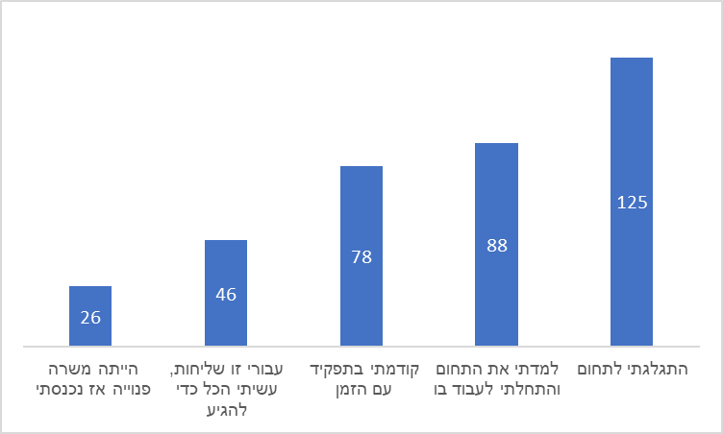

Figure number 1: How you came to engage in quality management

## **Success in the job**

Researchers around the world have been trying for many years to crack the riddle: what is success, and how can it be achieved. We will first define the terms "success" and "failure" are two opposites. The two possible outcomes on the way to the goal:

* **Success** - Achieving a pre-defined goal within the time frame set for achieving it.
* **Failure** - Failure to achieve a pre-set goal within the time frame set for achieving it.

If we ask ten different people what success is for them in the results, we will probably get different answers from each person: one will say that for him success is winning the lottery, another will say that for him success is being the CEO of the company he is employed, and so on. Defining success varies from person to person in her perception and that it is not possible to define on the basis of our results or those of others (achievements and accomplishments) in a sweeping way what success is.

Success refers primarily to the professional knowledge and experience gained over time. For example: an expert in chess, music, sports, the correlation is between professionalism and success. This means that expertise in the field is tested according to three criteria: (1) the results of his work yield concrete results; (2) his performance consistently exceeds that of his peers; (3) Expertise can be replicated and measured (Ericsson, 2007).

If we look at the field of quality, we do not really have control over our results, if we look at the world of quality, it is very difficult to measure success in the world of quality, difficult to quantify preventive activity and this is the essence of the world of quality. As exists in the safety profession, and therefore there is difficulty in examining its success in the short term. The challenge of the quality dealer is long-term success. We need to measure ourselves, see where we stand in front of the goals we have set for ourselves and see if we have been able to meet them.

You can learn from the words by Amnon Margalit's words: "More than once I experience a 'conflict' between the implementation of quality solutions and compliance with the system delivery system." These barriers limit his authority and impair his ability to perform his role and be a partner in the organization's business success. "

Regarding the correlation between his professionalism and success in the role of quality engineer, we can learn from a lecture given by Roni Khamtian, Afcon Group Quality Engineer, 'found that the quality engineer does not necessarily affect business results, given that the difficulty From the fact that the organizational culture, the relevant knowledge and the appropriate techniques for dealing with the problems they have developed and that its role is multidisciplinary '(Roni, 2019).

You can learn what success in a job dealing with quality is from the survey conducted by Moshe Ekroni, 2012. Most participants think that "a quality engineer can be measured on compliance, standard quality tasks, or organization performance - this measurement is done even though he is not directly responsible for achieving goals. And its activities contribute and influence "indirectly" by focusing on helping to improve the organization's business processes (see Figure 2)..

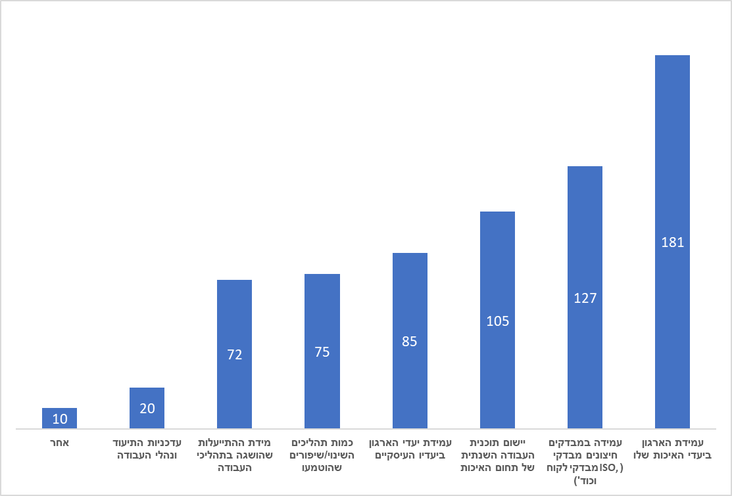

Figure 2: How success is measured Your success in the job

# EMPIRICAL RESEARCH

# Methods

The present study examined whether there is a correlation between professionalism and success in the role of quality engineer. Also, examine what are the characteristics in the position of quality engineer, and what is success / failure in the position.

The questionnaire was built using Google Forms and was passed on to participants as a link via: the Israeli Quality Association website, email, Facebook, LinkedIn WhatsApp. Completing each questionnaire took an average of 10 minutes. The data analysis is done using SPSS software and is based on a Chi-squared split.

# Study Participants

49 quality personnel responded to the survey, According to the following division: 25 men (58%) and 18 women (42%). It was found that the survey was answered by quality personnel from a variety of positions: VP of Quality / Global Quality Manager, Quality Engineer, Quality Manage.

# General finding

From the analysis of the position survey, it can be learned that we can still find that some of the engaged in quality did not grow from the field of quality, but "rolled" into it from another field (Engineer, I was promoted by the CEO, a friend brings a friend, a coincidence, a personal recommendation, a project management way, a managerial career.

Although they did not grow up in the field of quality, they see the position as a real vocation that they chose as part of the development of their personal career. When they came to the position, they did not feel a regression in both the image and the authority they have - a trend that changed from the survey conducted in 2012 by Moshe Ekroni and Liat Milo.

# Results

**First hypothesis**: there is a correlation between his professionalism and the degree of his success as a quality engineer.

We will examine using the following questions (Appendix A):

* Do you think there is a correlation between your professionalism and the degree of your success in the job?

An analysis of the position survey found that over 86% (see Figure 3) of the respondents believe that as their professionalism increases and their success in the position increases, success can be expressed in the authority given to them in front of stakeholders to prevent quality events, as it exists in the professions. The characteristic of expertise is that it is not innate but is acquired over time through practice and the accumulation of knowledge, attributed mainly to the knowledge of professional experience. For example: an expert in chess, music, sports, the correlation is between professionalism and success. The results are in line with the results obtained in at 2019 (Anker) which found that over 62% of the respondents agreed: that the quality role requires knowledge in the field of quality.

A strong correlation was found between those who answered that there was a correlation between professionalism and the degree of success and the question of how you came to the position. It was found that those who did not grow from the quality and "rolled" into the job think that professionalism is required to be successful in the job. There is also a correlation in the questions of how you came to the position and what your added value is in the organization.

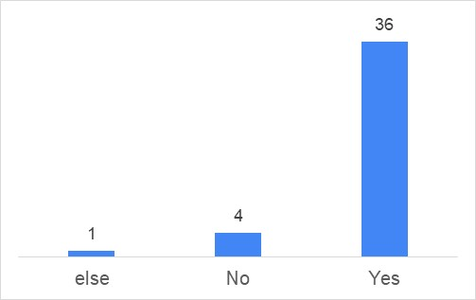

Figure 3: Correlation between his professionalism and the degree of his success as a quality engineer

**In conclusion**, it can be seen, the more the quality dealer specializes in quality then he will be more successful in the field (Anker. 2019)

**Second hypothesis**: there is a correlation between the characteristics in the role of a quality engineer in Israel and abroad.

We will examine using the following questions (Appendix A):

* Which characteristics reflect your role in the organization:

An analysis of the attitudes survey found that over 70% of practitioners think that teamwork skills and critical thinking were rated higher than the characteristics relevant knowledge in the field of occupation (59%), relevant knowledge in the field of quality and authority to perform the job (59%). Softness is more important than relevant knowledge in the field of quality and authority to perform the job (see Figure 4).

These results are in line with the previous hypothesis "Do you think there is a correlation between your professionalism and the degree of your success in the job" that most respondents think that specializing in quality increases their success in the job. Although the respondents believe that specialization in the field of quality is required, the quality engineer must be familiar with and apply different communication styles at work across the organization, when his success depends on motivating people to implement necessary changes, when in matrix management he is required to 'take' authority as a leader and supporter (Anker. 2019).

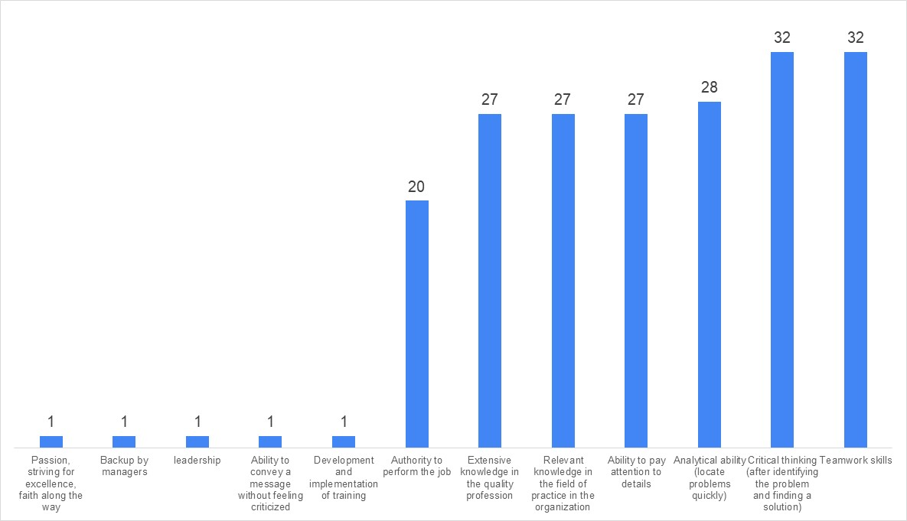

Figure 4: What characteristics reflect your role in the organization[1]

**In conclusion**, the results of the data comparison test clearly show that the participants think that teamwork skills, critical thinking skills, are an important characteristic of the job performance, when knowledge in the quality profession and knowledge in the field of occupation received a lower assessment.

**What is the success / failure and the added value of the quality practitioners from the "glasses" of the quality practitioners?**

We will examine using the following questions (Appendix A):

* How would you define success in the job?
* How would she define failure in a job?
* What is your added value in the organization?

From the analysis of the attitude survey it can be said that in the opinion of those engaged in quality success refers to motifs repeated several times, with change and improvement of quality through the organizational culture repeated most often (a result consistent with what was obtained in the study: Anker, 2019). And raising awareness of quality, harnessing management to the issue and using it as an information and knowledge person for the organization, all management and employees are partners and understand and care about quality "(repeats 11 times); Examination and improvement of processes from data collection and analysis: assimilation of work processes as a way of life, reduction of invalidities and customer complaints, failure to repeat a mistake (repeated 4 times); Meeting customer requirements, for example: that the customer returns and not the product, customer retention, reduction of customer complaints, zero malfunctions (repeats 6 times); Achieve the goals and objectives of the organization, for example: involvement and influence in achieving the goals of the organization (repeats 4 times); Colleague discourse, for example: field inquiries and open discourse, peer inquiries for advice and help, achieving goals and objectives (repeated 3 times).

In analyzing the attitude survey on the issue of failure we are supposed to see the exact opposite of success. It can be said that in the opinion of those who deal with the quality of failure, it refers to motifs that have been repeated several times, here it can be seen that "organizational culture" is repeated the most times. Here are the main things that were written: lack of recognition of quality, quality out of fear. Authority from the positioning and not from the meaning that quality is important, when the voice of quality is not heard in management and organizational decisions, performing the tasks required by law / standard only, management that sees no value in you (repeats 10 times); Many disqualifications, defective product that goes out to the customer due to a failure in quality processes that were not identified by the quality department within the framework of internal audits, a decrease in production yields, multiple customer complaints, (repeated 5 times); Failure to meet the goals of the organization / customer (repeats twice); Quality is perceived as something "interfering", lack of influence, failure to provide value to stakeholders, to be perceived as an interfering factor or as paperwork officials (repeated 4 times).

From the analysis of the position survey, it can be said that in the opinion of those involved in value-added quality refers to motifs that have been repeated several times, here it is possible to notice improved processes and reduced repetitive costs most often. Here are the main things that were written: saving, improving motivation and satisfaction among employees (repeated 9 times); Work across the organization, introducing an issue and the importance of quality, assists management in reflecting a quality picture in processes and identifying and flooding gaps (repeated 6 times); Contribution to the business goals of the organization (repeats 4 times); Improving processes and reducing costs, savings, flowing processes, business achievements, improved employee experience, with high potential to bring the organization to new heights and worlds with the help of creative thinking outside the box, requires the results of apartments with fewer resources.

**In conclusion**, the findings of the study show that in the opinion of the respondents, engaging in quality requires knowledge and professionalism in the field of quality. It has also been found that this success depends on "soft" traits and organizational culture.

# Conclusions

This is the third article written about the status of the quality dealer, in light of the non-quality events that took place in Israel and around the world that affected the trust of customers and consumers and as a result, weighty issues regarding the professional ethics of quality dealers were discussed. In this study, I re-examined the basic assumptions of the previous two studies that the role of a quality engineer depends on the organizational culture (Anker, 2019; 2020), meaning that its success depends largely on management support in light of the long-term results of quality processes in the organization. Safety, and therefore there is difficulty in examining its success in the short term and therefore we can find unsubstantiated statements that a professional and authoritative quality engineer can reduce and / or prevent incidents of non-quality.

From the analysis of the results of the survey of the attitudes and verbal comments of the participants, it can be learned that most of the participants think that there is a correlation between professionalism and the degree of success in the job. The characteristics that reflect the role of the quality engineer are: ability to pay attention to details, teamwork skills, analytical ability on the other hand knowledge in the field of quality and relevant knowledge in the field of practice received low evaluation. Most participants think that success for them is: changing and raising awareness of quality, working partners and understanding quality. In the aspect of failure: quality out of fear, and authority and not out of the meaning that quality is important and the added value is: savings, improving motivation and satisfaction among employees, introducing the issue and importance of quality, helping management reflect quality and identifying and flooding gaps.

The difference obtained between the research hypotheses is due to the fact that although in the opinion of the respondents knowledge and professionalism in the field of quality is required. He is required to know and apply different communication styles at work across the organization, when his success depends on motivating people to implement necessary changes, so in the opinion of the participants, it is very difficult to measure success in the world of quality and this is the essence of the world of quality.

# REFERENCES

Abbott, A. (1988). *The System of Professions: An Essay on the Division of Expert Labor*. Chicago, IL: University of Chicago Press.

Halevi. A. (2017*). Assimilation of knowledge and quality methods in industry*, the 35th annual conference of the Israeli Tel Aviv Quality Association, November 2017

Gal. M & Nir T. (2020)

[The future of automation is not? (Corona condition)](https://automation.co.il/%d7%a2%d7%aa%d7%99%d7%93-%d7%94%d7%90%d7%95%d7%98%d7%95%d7%9e%d7%a6%d7%99%d7%94-%d7%a2%d7%aa%d7%99%d7%93-%d7%94%d7%91%d7%93%d7%99%d7%a7%d7%95%d7%aa-%d7%9c%d7%90%d7%9f/)

In principle, and in full (2012). With the face forward. Quality: Journal of Quality and Excellence of the Israeli Quality Association, 51, 26–29.

In principle, and in full, (2012). Challenges and ways to empower the quality manager. Journal of Quality and Excellence of the Israeli Quality Association, 50, 12–14.

Anker, S. (2019) Expertise and authority in the work of a quality engineer. Thesis submission work.

Anker, S. (2020) The Impact of the COVID-19 Crisis on Quality Management in Organizations.

Ekroni, M. (2012). ‘Facing Forward to Quality’, *Quality and Excellence Journal of the Israeli Society for Quality*, 51: 26–9 [Hebrew].

Ekroni, M. (2012). ‘Challenges and Ways to Empower the Quality Manager’, *Quality and Excellence Journal of the Israeli Association for Quality*, 50: 12–14 [Hebrew].

Etzioni, A. 1969. *The semi-professions and their organisation*: Teachers, nurses, social workers. New York: Free Press

Parker, M. (2000). Organizational culture and identity. London: Sage.

Giddens, A. (1984). *The Constitution of Society: Outline of the Theory of Structuration*. Cambridge: Polity Press.

Ronen, Z. (2013). ‘Does Your Company Need Quality Management?’ *Business Excellence*, May 5 <https://business-excellence.co.il/blog/126-do-you-need-a-quality-manager> accessed 7 September 2019.

State of Israel v. Bar-Ilan et al. (2000). <[shalhevetold.co.il/pub//psak%20din/psak_makabiya.doc](https://www.google.co.il/url?sa=t&rct=j&q=&esrc=s&source=web&cd=1&ved=2ahUKEwi3tfqf0vfdAhXRMewKHcuYBI0QFjAAegQIAhAC&url=http%3A%2F%2Fshalhevetold.co.il%2Fpub%2F%2Fpsak%2520din%2Fpsak_makabiya.doc&usg=AOvVaw0KpnL6wMbHbnK2eBEv3gY1)> accessed 7 September 2019.

Schein, E. H. (2004)."Organizational culture and leadership", 3th edition. San Francisco: Jossey Bass.

Schein, E.H. (1990). "Organizational Culture". American Psychologist.

Schein, E.H. (1990). "Organizational Culture". American Psychologist.

Weber, M. (1968). *Economy and Society*. Berkeley, CA: University of California Press.

Zonnenschein, A. (2016). ‘We Must Uproot the Culture of the Loose Slapdash in the Food Industry’, *The Marker* <https://www.themarker.com/opinion/1.3103885> accessed 7 September 2019.

A survey to examine success in a job that deals with qualit

<https://docs.google.com/forms/d/e/1FAIpQLSc5FY8uzMkLUDtZG0-oMhWfpWsans_a0Eh4yDlWUuRzpBkxHw/viewform?usp=sf_link>

1. [[Top 10 Characteristics of Quality Managers (accountlearning.com)](https://accountlearning.com/top-10-characteristics-quality-managers/)](https://www.infinityqs.com/blog/january-2019/11-skills-your-quality-team-needs-to-have) 