Article
An Explainable Machine Learning Model for Predicting the Severity Level of COVID-19 Diagnosed Patients
Freddy Gabbay ^{1, *}, Shirly Bar-Lev ² Ofer Montano and Noam Hadad ³
Citation: Lastname, F.; Lastname, F.; Lastname, F. Title. Appl. Sci. 2021, 11, x. https://doi.org/10.3390/xxxxx
Academic Editor: Firstname Lastname
Received: date
Accepted: date
Published: date
Publisher’s Note: MDPI stays neutral with regard to jurisdictional claims in published maps and institutional affiliations.

Copyright: © 2021 by the authors. Submitted for possible open access publication under the terms and conditions of the Creative Commons Attribution (CC BY) license (https://creativecommons.org/licenses/by/4.0/).
¹ Computer and Information Science Department, Ruppin Academic Center, Emek Hefer, 4025000, Israel; freddyg@ruppin.ac.il
² Dror (Imri) Aloni Center for Health Informatics, Ruppin Academic Center, Emek Hefer, 4025000, Israel; barlevsh@ruppin.ac.il
³ Computer Engineering Department, Ruppin Academic Center, Emek Hefer, 4025000, Israel; ofer.montano@ruppin365.net, Noam.hadad@ruppin365.net
* Correspondence: freddyg@ruppin.ac.il
Abstract: The fast and seemingly uncontrollable spread of the novel coronavirus disease (COVID-19) poses great challenges to an already overloaded health system worldwide. It thus exemplifies an urgent need for fast and effective triage. Such triage can help take the necessary measures to prevent patient deterioration and conserve strained hospital resources. We examine two types of machine learning models, deep neural networks (DNNs) and decision trees, to predict the severity level of illness for patients diagnosed with COVID-19, based on their medical history and laboratory test results. In addition, we combine the DNNs with an explainable artificial intelligence (XAI) model to provide explainability of the model prediction. Our experimental results indicate that the model can achieve up to 80% prediction accuracy for the dataset we used. Finally, we integrate the explainable machine learning models into a mobile application to enable the usage of the proposed models by medical staff everywhere.
Keywords: COVID-19, Machine learning, Deep learning, Explainable AI

1. Introduction
On January 30th 2020, the World Health Organization (WHO) declared the COVID-19 pandemic to be a public health emergency of international concern. As of September 2021, WHO had reported more than 232 million confirmed cases of COVID-19 worldwide and more than 4.7 million deaths (https://covid19.who.int). COVID-19 is characterized as a severe acute respiratory syndrome that is caused by the SARS-CoV-2 virus. While the epidemiological and clinical characteristics of COVID-19 are increasingly understood, risk factors underlying the transition from mild to severe disease in patients remain poorly understood [1].
The severity of COVID-19 disease varies considerably among patients, ranging from asymptomatic infection, to mild upper-respiratory tract illness, to severe viral pneumonia with acute respiratory distress, respiratory failure, and thromboembolic events that can lead to death [1]. Therefore, evaluating a patient’s likely severity of illness remains an important concern for both clinicians and policy makers. Such an understanding would assist practitioners in performing rapid, early, and effective triage, help conserve strained hospital resources, and deepen our understanding of the disease [2]. Evidence obtained before the introduction of the COVID-19 vaccine suggests that 6–10% of infected patients are likely to become critically ill, most of whom will require mechanical ventilation and intensive care [3]. However, currently there are few prognostic markers to forecast whether a patient with COVID-19 is likely to deteriorate to a critical condition and require intensive care. We thus suggest that data-driven risk evaluation based on machine learning approaches, such as deep neural networks (DNNs) and decision trees, can and should play an important role in the prediction of morbidity and illness severity.
Machine learning [5] techniques are rapidly being employed for diverse medical applications [10], such as predicting diabetes and liver diseases, detecting and predicting cancer, personalizing treatments, drug discovery, radiology, and many more. Such techniques employ statistical methods to identify complex relationships among patient medical attributes and outcomes, using large datasets. Two major medical domains that currently leverage machine learning usage are diagnosis and outcome prediction. In particular, machine learning can be a highly valuable tool for identifying individuals at high risk of health deterioration.
Clinical reports of COVID-19 suggest that age, sex, and underlying comorbidities, such as renal diseases, hypertension, cardiovascular disease, and diabetes, can adversely affect patient outcomes [1]. To date, most machine learning applications for the COVID-19 pandemic have focused on patient diagnosis [11] and projecting the number of infected individuals and mortality rates [12]. Very few studies [13] have leveraged machine learning to systematically explore risk factors to assess the likely severity of disease in patients diagnosed with COVID-19 and to predict patient outcomes based on early clinical data.
In this study, we introduce two types of machine learning models, DNN [5] and Random Forest (RF) decision trees [14], to predict the level of severity of illness in patients diagnosed with COVID-19. The level of severity can be described as one of multiple clinical stages of a patient’s hospital stay, such as admission to intensive care, the need for invasive mechanical ventilation, and in-hospital mortality. Our machine learning models were trained, validated and tested using an open dataset provided by the Mexican Federal Health Secretary through the General Director of Epidemiology [4]. The database contained data collected during patients’ initial presentation at the emergency department (ED) starting from May 2020 up until October 2020 and comprises more than 50,000 cases.
Despite their growing use in the field of medicine, machine learning models remain extremely difficult to interpret, as they often lack explainability. When explainable models are offered, they tend to prefer simplicity over prediction accuracy. In this study, we introduce a combined model that integrates explainability method with DNN [6]. The combined model can explain the predictions of the DNN classifiers in an interpretable and accurate manner. More importantly, our explainability model introduces two main benefits. First, it supports physicians’ decision-making with regard to individual patients. Second, it may help physicians to identify the factors that most influence a patient’s severity of illness. These properties would help medical staff to take preventive measures (when possible) to reduce a patient’s risk of deterioration.
We summarize the contribution of this study as follows:
- Applying the proposed machine learning models can assist medical staff in performing fast, early, and effective triage and thereby take the necessary measures to prevent patient deterioration and conserve strained medical resources.
- The proposed explainability model can provide further insights into an individual patient’s medical condition and can identify the factors that most contribute to the patient’s illness severity.
- Finally, integration into a mobile application makes the proposed models accessible and easy-to-use by medical staff everywhere.
The rest of this paper is organized as follows: Section 2 reviews prior related works, Section 3 describes the dataset of patients diagnosed with COVID-19 that we used for our study, Section 3 presents our machine learning model, Section 4 introduces the explainability method that has been combined with our DNN model, Section 5 presents our mobile application design, and Section 6 summarizes our conclusions and suggestions for future studies.

2. Prior works
Various prior studies used machine learning techniques to fight the COVID-19 pandemic. All studies experienced a common challenge: the availability of a high quality COVID-19-related medical dataset, which could be straightforwardly processed by machine learning models. Related prior works can be divided into two main group: pandemic behavior forecasting ad diagnosis application.

2.1. COVID-19 Pandemic Behavior Forecasting
Ref. [25] suggested a hybrid machine learning approach of adaptive network-based fuzzy inference system to predict time series of infected individuals and mortality rate. Deep learning models to predict the exponential behavior and reachability of COVID-19 pandemic across the nations by utilizing the real-time information from the Johns Hopkins dashboard was proposed by [26]. Ref. [27] suggested an autoregressive integrated moving average model to predict the spread of COVID-19 for the next two days. A time series method to analyze COVID-19 outbreak by performing statistical analysis to explore the trends of the outbreak was introduced by 28. Linear regression, multilayer perceptron and vector autoregression methods to predict the spread pace of COVID-19 in India were presented by [29]. All these studies attempt to predict the behavior of COVID-19 at the macro level in order to assists governments and public health officials in managing the pandemic strategies.

2.2. Diagnostic Applications
Several studies [16-18, 22] monitored chest X-ray and CT image changes prior to the COVID-19 symptoms and found that such technique play an important role in early diagnosis and treatment of the COVID-19 pandemic. [19] suggested machine learning based sensor for facial thermal scans to detect COVID-19 patients. [20] developed a machine learning speech processing method for detecting COVID-19 patients from cough recordings. Machine learning and AI-based smartphone sensors were used by [21] to detect COVID-19 symptoms. [23] attempted to predict the risk of a patient being diagnosed with COVID-19 using a machine learning model which was trained based on routinely collected data from emergency care admission exams. The most related work to our study was presented by [24] which suggested a machine learning model to predict patients at risk for developing acute respiratory distress syndrome (ARDS), a severe outcome in COVID-19. Their models achieved 70-80% prediction accuracy. It should be noted that their focus was only one type of severity level. In addition, their model did not include any explainability methods.

3. Dataset of Patients Diagnosed with COVID-19
Our study is based on an open dataset provided by the Mexican Federal Health Secretary through the General Director of Epidemiology. The dataset comprises anonymous records for both patients diagnosed with COVID-19 as well as non-COVID-19 patients, which were collected starting from May 2020 up until October 28th, 2020. The dataset has been publicly released for online download [4]. Of the dataset records, we extracted only those patients diagnosed with COVID-19; all non-COVID-19 records were excluded. The dataset was also preprocessed to remove any corrupted records or records with missing fields. The dataset (following postprocessing) comprised 50,000 patients diagnosed with COVID-19.
Each records of a patient diagnosed with COVID-19 consists of two parts:
- Patient’s medical history and symptoms upon arrival at hospital which is described in Table 1. All the fields in ‎Table 1 are used as input features for our machine learning models.
- Patient’s clinical outcome which is summarized in Table 2. All fields in ‎Table 2 are combined to create labels that represented the severity of COVID-19 morbidity.
Table 1. COVID-19 Dataset Record Feature Fields
Filed number | Feature field | Feature field values
1 | Patient sex | Female / Male
2 | Patient has cardiovascular disease | Yes/No
3 | Lag of symptoms | The lag in days from appearance of symptoms to hospital admission
4 | Entry date | Hospital admission date
5 | Date of symptoms | Date of first symptoms
6 | Patient has other background diseases | Yes/No
7 | Patient is obese | Yes/No
8 | Patient had pneumonia | Yes/No
9 | Patient has asthma | Yes/No
10 | Patient has chronic renal failure | Yes/No
11 | Patient has a history of smoking | Yes/No
12 | Patient exposed to other COVID-19 patients | Yes/No
13 | Patient age | Age
14 | Patient is pregnant | Yes/No
15 | Patient has diabetes | Yes/No
16 | Patient has Chronic obstructive pulmonary disease (COPD) | Yes/No
17 | Patient has immune system suppression | Yes/No
18 | Patient has hypertension | Yes/No

Table 2. COVID-19 Patient Clinical Outcome
Filed number | Field | Field values
1 | Patient type | Outpatient / inpatient
2 | Patient intubated | Yes/No
3 | Patient admitted to ICU | Yes/No
4 | Patient died | Yes/No
The dataset was partitioned such that 60% of the records were used for the machine learning training process, 20% for validation with the remaining 20% used for testing. Every record in the dataset represents one anonymous patient and includes the fields shown in Table 1 and Table 2.

4. Machine Learning Model
In our study we examine two types of machine learning models, DNN [5] and RF decision trees [14], which are presented in detail in this section. Our machine learning models are trained using the COVID-19 dataset (described in Section 3). 60% of the dataset records are used for model training, 20% are used for validation and the remaining 20% were used for model testing.

4.1. DNN Models
As part of our analysis, we examined various fully connected DNN models and hyperparameters and found that the two DNN models, illustrated in Figure 1, possessed the highest prediction accuracy for the examined dataset. Each model is a fully connected network which consists of three layers: An input layer with 24 neurons, each connected to the input features described in Table 1, an intermediate layer with 16 neurons and an output layer. The output layer in the first model (DNN model A) has a single neuron which provides a binary prediction (low or high) for a COVID-19 patient’s level of disease severity. For the second mode (DNN model B), the output layer has three neurons that provide prediction is based on three levels of severity (low, medium or high). Each neuron in our DNN models uses and sigmoid activation function.

Figure 1. DNN models for predicting patients’ level of disease severity and deterioration.
The mapping of severity levels to medical conditions for each model is summarized in ‎Table 3, based on the dataset fields shown in ‎Table 2. ‎For DNN model A, the low severity level includes patient hospitalization or discharging, while DNN model B embraces hospitalization only. The high severity level includes intubation and death in both models, while DNN model A also includes ICU admission. The medium severity level is available only in DNN model B and includes patient’s hospitalization or ICU admission. To avoid any biasing on the models training process, the number of records used for each class is equal.
Table 3. Severity Levels Predicted by the Model
Severity level | DNN Model A | DNN Model B
High | ICU admission, intubation, or death | Intubation or death
Medium | n/a | Hospitalized or ICU admission
Low | Hospitalized (mild symptoms) or discharged | Discharged

Our experimental analysis examined a range of hyperparameters and used those that achieved the highest prediction accuracy. Through the training process the learning rate was 0.002, the batch size was 20 and the number of used batched was 200 for model A and 1000 for model B. We used the Adam gradient-based optimizer [15] for the model training. The list of all DNN model hyperparameters is summarized in ‎Table 4.
Table 4. DNN Model Hyperparameters
Hyperparameter | Value
Number of layers | 3
Number of nodes | Input layer: 24  Hidden layer:16  Output layer:  Model A: 1  Model B: 3
Learning rate | 0.002
Optimizer | Adam
Batch size | 20
Number of batches | Model A: 200  Model B: 1000

4.2. Random Forest Model
Decision trees are widely used as predictive models that use a set of binary rules to calculate a target value. There are two types of decision trees, classification and regression trees. Classification trees includes categorical target variables that are divided into categories that are represented by the tree leaves. Tree branches represent conjunctions of features that lead to the class labels. Unlike classification trees, in regression trees the target variable has continuous values. In our study we use Random Forest (RF) classification trees [14]. RF is an ensemble of multiple classification trees, where the prediction is produced by a voting process of all the decision trees.
Through our experimental analysis we examined various RF models and a broad range of hyperparameters and values and used those that achieved the highest prediction accuracy. Similar to the DNN models, we suggest two type of RF trees. The first model (RF model A) has two output classes which correspond to the severity levels of DNN model A, while the second RF mode employs three classes which correspond to DNN model B outputs. The RD models have been trained, validated and tested on the same datasets used for the DNN models. The hyperparameters values that produce the optimal prediction accuracy for the used dataset are summarized in Table 5. Our RF models used 50 trees in the forest. The model used bootstrap samples to build the trees. The minimum number of samples required to be at a leaf node was 3. The minimum number of samples required to split an internal node was 10. The number of features considered when looking for the best split was the square root of the number of model features. The maximum depth of a tree is 6. There was no limit on the number of leaf nodes.
Table 5. Random Forest Model Hyperparameters
Hyperparameter | Value
Bootstrap | True
Minimum samples leaf | 3
Number of trees in the forest | 50
The minimum number of samples required to split | 10
The number of features considered when looking for the best split | SQRT
Maximum depth of a tree | 6
Limited leaf nodes | False

4.3. Experimental Results
Figures 2 (a) and (b) illustrate the prediction accuracy for each of the DNN models through the training process. In the test phase, the overall prediction accuracy achieved by DNN model A was 80%, while DNN model B achieved approximately 78% accuracy. Figures 3 (a) and (b) depict the confusion matrixes of the two DNN models. It can be observed that DNN model A achieved 92% and 72% prediction accuracies for patients diagnosed with COVID-19 with a low and a high level of severity, respectively. Model B achieved a prediction accuracy of 90%, 74%, and 77% for patients diagnosed with COVID-19 with a low, medium, and high level of severity, respectively.
- (b)
Figure 2. Training accuracy: (a) Model A and (b) Model B
The RF models produce 80.0% prediction accuracy for RF model A and 65% for RRF model B. Figures 3 (c) and (d) present the confusion matrixes of the RF models. RF model A achieved 75% and 85% prediction accuracies for patients with a low and a high level of severity of illness, respectively. RF Model B achieved a prediction accuracy of 92%, 33%, and 71% for patients diagnosed with COVID-19 with a low, medium, and high level of severity, respectively.

(a) (b)

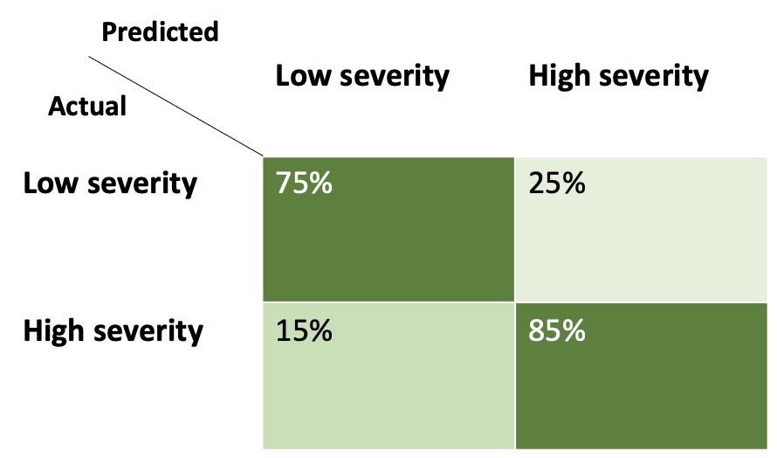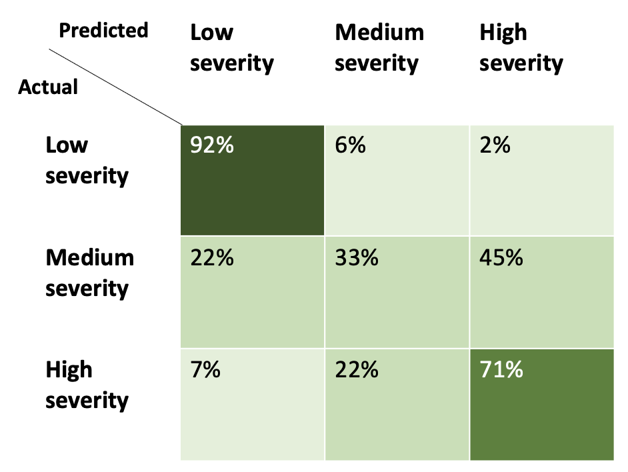
(c) (d)

(e)
Figure 3. Confusion matrix: (a) DNN Model A, (b) DNN Model B, (c) RF Model A, (d) RF Model B and (e) Binary regression
We compare the accuracy of the machine learning model to a binary regression model applied to the same training, validation and testing datasets respectively. Figures 3 (3) illustrates the confusion matrix of the binary regression model. The overall prediction accuracy of the binary regression model is 76.3%, 3.7% lower than the machine learning model. For low severity patients, the binary regression model accuracy is 79.3%, whereas the machine learning model achieves 92% accuracy. For the high severity patients, the binary regression model accuracy is lower by 2.2% than the machine learning model accuracy. The prediction accuracy of all the models which have been examined is summarized in Table 5.
Table 5. Prediction Accuracy Summary
Model | Prediction accuracy
DNN Model A | 80.0%
DNN Model B | 78.0%
RF Model A | 80.0%
RF Model B | 65.0%
Binary regression | 76.7%

5. Explainable AI (XAI) Model
Recent studies have introduced new explainability methods [6] that can explain the predictions of machine learning classifiers in an interpretable and accurate manner. As part of this study, we extended our machine learning model by using the Local Interpretable Model-agnostic Explanations (LIME) model [7]. The LIME model can explain inferences produced by machine learning models by performing a local approximation of the inference point. The LIME algorithm builds a linear regression in proximity to a specific inference point (that needs to be explained). Features with high positive weight in the linear regression approximation support the prediction decision, while features with negative weight oppose the decision.
We demonstrate the usage of the LIME model on the DNN model A by choosing a rather complex case for analysis. Figure 4 exemplifies an explanation of a patient diagnosed with COVID-19. The patient’s medical history and symptoms on arrival at the hospital are summarized in Figure 4 (a). The patient is over 70 years old with a medical history including pneumonia, diabetes, chronical renal failure, and cardiovascular disease. Our machine learning model (DNN model A) predicts the patient’s severity of illness to be high. The LIME explanation is illustrated in Figure 4 (b). The blue bars illustrate the medical background and symptoms that have significant weight in supporting the prediction, while the green bars illustrate factors that comprise evidence against it. The explanation indicates that at the time of the prediction, the patient’s main symptoms and medical history that most contribute to the prediction are pneumonia, age, diabetes, chronical renal failure, cardiovascular disease, asthma, other diseases, and exposure to other patients diagnosed with COVID-19.
We compare the explanation provided by the LIME model with our binary regression model in Section 4. The independent variables in the binary regression equation are presented in Figure 4 (c) with their corresponding weights (B) and statistical significance (Sig.). Figure 4 (c) indicates that sex, pneumonia, age, diabetes, asthma, immunity system suppression and obesity are significant contributors to high severity level of illness. One may notice that factors, such as chronical renal failure, cardiovascular disease and exposure to other COVID-19 patients, have not been considered as major contributors to severe illness by the binary regression model. This is in contrast to our explainable machine learning model which has identified these factors to support high severity level of illness in the described case analysis. This example demonstrates the limitation of binary regression in explaining complex morbidity. While the LIME model provides explainability per individual patients, the binary regression model provides a global statistical explainability which applies to the entire model and thereby might be less comprehensive.
We summarize this discussion by identifying two main benefits that can be leveraged from our explainable machine learning model. First, the model can support physicians’ decision-making with regard to individual patients. Second, it may help physicians identify the factors that most influence a patient’s severity of illness and deterioration.
(a) (b) (c)
Figure 4. Example of a patient diagnosed with COVID-19: (a) Patient’s medical history, (b) explanation of the prediction and (c) binary regression variables in equation.

5. Application Design
As part of this study, we integrated the explainable machine learning models into a mobile application. The mobile application is accessible for medical and healthcare staff to assess the severity of illness of patients diagnosed with COVID-19. The application development environment is based on the Kivy open-source platform [8] and can run on Android operating systems. The machine learning model was coded in Python using the Keras framework [9]. The application can be run offline, i.e., a network connection is not necessary to run the model. The application’s user-interface (UI) is shown in Figure 5 and includes the home page, patient background details form (including all the background information summarized in ‎Table 1), the model prediction result, and an explanation of the prediction.

- (b) (c)
(d) (e)
Figure 5. COVID-19 application user-interface (UI): (a) Home page (b) patient details form, (c) and (d) prediction of a patient’s severity of illness for models A and B, respectively, and (e) an explanation of the prediction.

6. Conclusions
This study introduced machine learning models for predicting the severity of illness in patients diagnosed with COVID-19. The prediction is made based on a patient’s medical history and symptoms on arrival at the hospital. The DNN machine learning models achieved 78–80% prediction accuracy while the models produced 65-80% prediction accuracy. Our machine learning models were combined with the LIME explainability model and then integrated into a mobile application. The integrated mobile application can support medical staff in performing effective triage to reduce the risk of patient medical deterioration. In addition, out explainability model can further extend the understanding into an individual patient’s medical condition and help identifying the factors with critical impact on the patient’s illness severity. The machine learning models and the mobile application are provided as an open-source code which make them accessible everywhere and allows further development and extension. The explainable model and mobile application source code is accessible through GitHub repository: https://github.com/freddygabbay/covid19explainableML.
We highly encourage future work to extend and enhance this study in the following aspects:
- An exploration using another high-quality dataset is suggested to further understand the models’ performance and limitations.
- We also encourage a further examination of transfer-learning methods, which can adapt the learning process from one dataset to other datasets.
- Due to the structure of the database, the model is unable to predict deterioration or amelioration (i.e., a transition from one level of severity to another) based on demographic variables, medical history, and type of intervention. This is beyond the scope of this paper but should be attempted in future studies.
- Future studies are also encouraged to develop models that can generate a timeline depicting the progression of illness.

Supplementary Materials: This research uses an open dataset provided by the Mexican Federal Health Secretary through the General Director of Epidemiology: https://www.gob.mx/salud/documentos/datos-abiertos-152127
Author Contributions: Conceptualization, F.G. and S.B-L.; methodology, F.G.; software, N.H, O.M. and F.G.; validation, N.H and O.M.; formal analysis, N.H, O.M. S.B. and F.G.; investigation, N.H, O.M. S.B. and F.G.; resources, F.G. and S.B.; data curation, F.G. and S.B.; writing—original draft preparation, F.G. and S.B.; writing—review and editing, F.G. and S.B.; visualization, N.H, O.M. S.B. and F.G.; supervision, F.G. and S.B.; project administration, F.G.; funding acquisition, F.G. All authors have read and agreed to the published version of the manuscript.
Funding: This research received no external funding.
Institutional Review Board Statement: This study is based on an anonymized, publicly available database. The study was conducted according to the guidelines of the Ruppin Academic Center Research.
Informed Consent Statement: Patient consent was waived since the used dataset was anonymized and publicly available on behalf of the Mexican Federal Health Secretary, General Director of Epidemiology.

Conflicts of Interest: The authors declare no conflict of interest.

References
- Heldt, F. S., Vizcaychipi, M. P., Peacock, S., Cinelli, M., McLachlan, L., Andreotti, F., ... & Khan, R. T. (2021). Early risk assessment for COVID-19 patients from emergency department data using machine learning. Scientific reports, 11(1), 1-13.
- Shamout, F. E., Shen, Y., Wu, N., Kaku, A., Park, J., Makino, T., & Geras, K. J. (2021). An artificial intelligence system for predicting the deterioration of COVID-19 patients in the emergency department. NPJ digital medicine, 4(1), 1-11.
- Zheng, S., Fan, J., Yu, F., Feng, B., Lou, B., Zou, Q., ... & Liang, T. (2020). Viral load dynamics and disease severity in patients infected with SARS-CoV-2 in Zhejiang province, China, January-March 2020: retrospective cohort study. bmj, 369.
- Mexican Federal Health Secretary, General Director of Epidemiology, open dataset. https://www.gob.mx/salud/documentos/datos-abiertos-152127
- Charu C. Aggarwal. Neural Networks and Deep Learning. Springer Edition, ISBN 978-3-319-94462-3.
- Scott M. Lundberg and Su-In Lee. 2017. A unified approach to interpreting model predictions. In Proceedings of the 31st International Conference on Neural Information Processing Systems (NIPS'17). Curran Associates Inc., Red Hook, NY, USA, 4768–4777.
- Marco Tulio Ribeiro, Sameer Singh, and Carlos Guestrin. 2016. "Why Should I Trust You?": Explaining the Predictions of Any Classifier. In Proceedings of the 22nd ACM SIGKDD International Conference on Knowledge Discovery and Data Mining (KDD '16). Association for Computing Machinery, New York, NY, USA, 1135–1144. DOI:https://doi.org/10.1145/2939672.2939778.
- Ahmed Fawzy Mohamed Gad, Building Android Apps in Python Using Kivy with Android Studio: With Pyjnius, Plyer, and Buildozer. Apress edition. ISBN-13: 978-1484250303.
- Antonio Gullì and Sujit Pal, Deep Leaarning With Keras. Packt Publishing Limited. ISBN10 1787128423.
- Sidey-Gibbons, J., Sidey-Gibbons, C. Machine learning in medicine: a practical introduction. BMC Med Res Methodol 19, 64 (2019). https://doi.org/10.1186/s12874-019-0681-4
- Y. Song et al., "Deep learning Enables Accurate Diagnosis of Novel Coronavirus (COVID-19) with CT images," in IEEE/ACM Transactions on Computational Biology and Bioinformatics, doi: 10.1109/TCBB.2021.3065361.
- Gergo Pinter, Imre Felde, Amir Mosavi, Pedram Ghamisi and Richard Gloaguen. COVID-19 Pandemic Prediction for Hungary; A Hybrid Machine Learning Approach. MDPI Mathematics 2020, 8, 890; doi:10.3390/math8060890
- Zoabi, Y., Deri-Rozov, S. & Shomron, N. Machine learning-based prediction of COVID-19 diagnosis based on symptoms. npj Digit. Med. 4, 3 (2021). https://doi.org/10.1038/s41746-020-00372-6.
- Breiman L. Random forests. Journal Machine Learning archive, 45(1), pp. 5–32, 2001.
- Kingma, D.P. and Ba, J., 2014. Adam: A method for stochastic optimization. arXiv preprint arXiv:1412.6980.
- Chan, JFW et al., (2020). A familial cluster of pneumonia associated with the 2019 novelcoronavirus indicating person-to-person transmission: A study of a family cluster. TheLancet, 395(10223), 514–523, https://doi.org/10.1016/S0140-6736(20)30154-9
- Yin, S, N Zhang and H Dong (2020). Preventing COVID-19 from the perspective of industrialinformation integration: Evaluation and continuous improvement of information networksfor sustainable epidemic prevention. Journal of Industrial Information Integration, 19,100157, https://doi.org/10.1016/j.jii.2020.100157.
- Zu, ZY, MD Jiang, PP Xu, W Chen, QQ Ni, GM Lu and LJ Zhang (2020). Coronavirusdisease 2019 (COVID-19): A perspective from China. Radiology, 200490, https://doi.org/10.1148/radiol.2020200490
- Kumar, V (2020). Healthcare centers are turning to AI to combat COVID-19. AnalyticsInsight. https://www.analyticsinsight.net/healthcare-centers-turning-ai-combat-covid-19.
- J. Laguarta, F. Hueto and B. Subirana, "COVID-19 Artificial Intelligence Diagnosis Using Only Cough Recordings," in IEEE Open Journal of Engineering in Medicine and Biology, vol. 1, pp. 275-281, 2020, doi: 10.1109/OJEMB.2020.3026928.
- Maghdid, HS, KZ Ghafoor, AS Sadiq, K Curran and K Rabie (2020). A novel ai-enabledframework to diagnose coronavirus covid 19 using smartphone embedded sensors: Designstudy, 1–5, http://arxiv.org/abs/2003.07434.
- Wang, L and A Wong (2020). COVID-net: A tailored deep convolutional neural networkdesign for detection of covid-19 cases from chest x-ray images. 1–12, http://arxiv.org/abs/2003.09871.
- de Moraes Batista, A.F., Miraglia, J.L., Donato, T.H.R. and Chiavegatto Filho, A.D.P., 2020. COVID-19 diagnosis prediction in emergency care patients: a machine learning approach. medRxiv.
- Jiang X, Coffee M, Bari A, et al. Towards an artificial intelligence framework for data-driven prediction of coronavirus clinical severity. Computers. Materials & Continua2020;63:537-51doi:10.32604/cmc.2020.010691
- Pinter, G.; Felde, I.; Mosavi, A.; Ghamisi, P.; Gloaguen, R. COVID-19 Pandemic Prediction for Hungary; A Hybrid Machine Learning Approach. Mathematics 2020, 8, 890. https://doi.org/10.3390/math8060890
- Punn, N.S., Sonbhadra, S.K. and Agarwal, S., 2020. COVID-19 epidemic analysis using machine learning and deep learning algorithms. MedRxiv.
- Benvenuto, Domenico, Marta Giovanetti, Lazzaro Vassallo, Silvia Angeletti, and Mas- simo Ciccozzi. ”Application of the ARIMA model on the COVID-2019 epidemic dataset.” Data in brief (2020): 105340.
- Deb, Soudeep, and Manidipa Majumdar. ”A time series method to analyze in- cidence pattern and estimate reproduction number of COVID-19.” arXiv preprint arXiv:2003.10655 (2020).
- Sujath, R., Chatterjee, J.M. and Hassanien, A.E., 2020. A machine learning forecasting model for COVID-19 pandemic in India. Stochastic Environmental Research and Risk Assessment, 34, pp.959-972.

https://github.com/freddygabbay/covid19explainableML

