CURRICULUM OVERVIEW

In recognizing the challenge that engagement with technology presents for our community and our community’s children and particularly its impact on social, psychological and behavioral functioning, the need for student education in digital citizenship becomes evident. This program has been designed to inform and guide students, teachers and educators in benefits and risks of technology engagement and what can be done to promote healthy and responsible digital citizenship.

All lessons can be adapted to fit in with your school community’s norms and guidelines.

LESSON 1 **Introduction to Digital Citizenship *........................................................ Page 1***

***Objective:*** *This lesson serves as an overview to the concept of awareness responsibility in the online realm. It highlights both the individual’s accountability and the responsibility of others in regard to technology engagement.*

*Defines the concept of Digital Citizenship as the norms of appropriate, responsible behavior with regard to technology use.*

LESSON 2 **Disinhibition *............................................................................................................... Page 9***

***Objective:*** *To educate how the medium of technology promotes a sense of anonymity and disinhibition where, individuals are more likely to engage in behavior that they would not otherwise engage in or use language that they would not otherwise use.*

LESSON 3 **Impulsivity *.................................................................................................................. Page 15***

***Objective:*** *To educate how the medium of technology promotes a sense of impulsivity where individuals have the tendency to act without forethought or consideration of consequence. The availability of technological resources, provide an avenue for potentially profound and permanent negative outcomes.*

LESSON 4 **Dependence and Compulsivity *............................................................... Page 23***

***Objective:*** *This lesson empowers students to recognize how continued engagement with technology can be at the expense of positive life experiences and subjective well-being. This engagement leads to distraction where attention is given to technology, rather than the primary chosen object or person.*

LESSON 5 **Miscommunication *............................................................................................. Page 31***

***Objective:*** *This lesson serves as the gateway to social drama. Communication in the digital realm can promote a greater misunderstanding than traditional communication. Students are given proactive tools to communicate more effectively in the digital realm.*

LESSON 6 **Cyber bullying and online aggression *.............................................. Page 39***

***Objective:*** *Students identify the differences between traditional bullying and cyber bullying, the difference between bullies, victims and bystanders, and how the roles can quickly change in the digital realm. They will also learn how to effectively use bystander empowerment in a positive way.*

LESSON 7 **Privacy and the public and permanent nature of the digital experience *.................................................................................................................. Page 53***

***Objective:*** *Students learn how to use their digital footprint to promote a positive online presence. They discover the public and permanent**nature of the World Wide Web and how nothing is truly private.*

LESSON 8 **Exposure and desensitization *.................................................................. Page 63***

***Objective:*** *Early exposure to inappropriate websites and graphic violence can result in emotional distress that can impact the psychological well being of children and young adolescents. Students learn to identify the effects of desensitization and how the Internet can normalize dangerous and dysfunctional teen behavior.*

LESSON 9 **Mindfulness *............................................................................................................... Page 71***

***Objective:*** *To Identify how mindfulness enhances one’s daily experiences, and how technology interferes with individual’s achieving their highest level of internal and external awareness.  Developing a strategy of mindful practices can help students improve their social and emotional well-being.*

LESSON

1

INTRODUCTION TO

DIGITAL CITIZENSHIP

**OBJECTIVE:** This lesson serves as an overview to the concept of awareness and responsibility in the digital realm. Digital Citizenship highlights both the individual’s accountability for their actions and behaviors, as well as their responsibility toward others while engaging in the use of digital technology.

NOTES

* **It is critical to convey that Digital Citizenship is not exclusively about inappropriate content on the Internet.**
* Understand the need for the importance of consistent language and vocabulary. One of the overarching goals is to promote an ongoing dialogue with a shared language.
* Having the language necessary to do so is a prerequisite.
* Vocabulary should be written up on the board prior to the lesson.
* All sentences in *italics* indicate interactive questions, which should facilitate discussion.
* All sentences in red indicate an action on the part of the teacher.

VOCABULARY

|  |  |
| --- | --- |
| Digital | involving or relating to the use of computer technology; this includes devices such as digital cameras, gaming devices, cellphones, home and portable computers, tablets and more |
| Citizenship | the state of being a part of a larger community with common/shared values, interests and responsibilities |
| Appropriate | suitable or proper for the situation, community norms and values |
| Responsible | having an obligation to act in a defined manner as part of ones role expectations |

INTRODUCTION

*What does it mean to be a citizen of our country?*

*What other things can you be a citizen or a member of?*

*What does it mean to be a citizen or member of those groups?*

As a citizen of a country there are certain communal expectations we have from our government. They include safety, security and laws to govern our lives to maximize our existential experience. There are also responsibilities we have towards our country – to abide by those laws to protect the interests, rights and liberties of those around us.

On January 20, 1961 at the inauguration of John F. Kennedy, the 35th president of our country, at the eastern portico of the United States Capitol in Washington, DC he so eloquently said:

“Ask not what your country can do for you, but what you can do for your country…”

Kennedy’s speech served as a call to action for individuals to do what is appropriate and responsible and in the interest of the greater good; In other words, be a good citizen.

|  |
| --- |
| This is the theme of Digital Citizenship. It is defining our roles and responsibilities within a greater digital community and how our actions and behaviors must be in our own best interest as well as that of the greater good. The challenge of thoughtless, inappropriate and malicious online behavior mandates us to learn how to make responsible decisions when we must engage in the digital world. |

DAY-TO-DAY IMPACT

*What do you think are some responsibilities you have towards others when utilizing digital technology?*

*What are some responsibilities you have towards yourself?*

Chart the answers on large chart paper – you will come back to this discussion.

Define the concept of **Digital Citizenship as the norms of appropriate and responsible behavior with regard to the use of technology.**

Make a large T (pro / con) chart on the board or on chart paper. Label the two columns PRO and CON.

*What are some of the benefits that technology can offer?*

*Try to categorize their answer by the following larger categories:*

|  |  |
| --- | --- |
| **PRO** | **CON** |
| Connectivity | Behavior |
| Accessibility | Psychological functioning |
| Productivity | Social engagement |
| Information | Day-to-Day experiences |
| ***78%*** *of teens report at least one good outcome as a result of personal interactions on social networking sites.* | ***41%*** *of teens report at least one negative outcome as a result of personal interactions on social networking sites.* |

“It was the age of wisdom, it was the age of foolishness”

*A Tale of Two Cities,* Charles Dickens, 1859.

What meaning can you glean from this quote as it relates to technology today?

*Discuss*

HISTORY

The advancements, affordability and proliferation of technology have greatly broadened our ability to stay connected with friends and family.

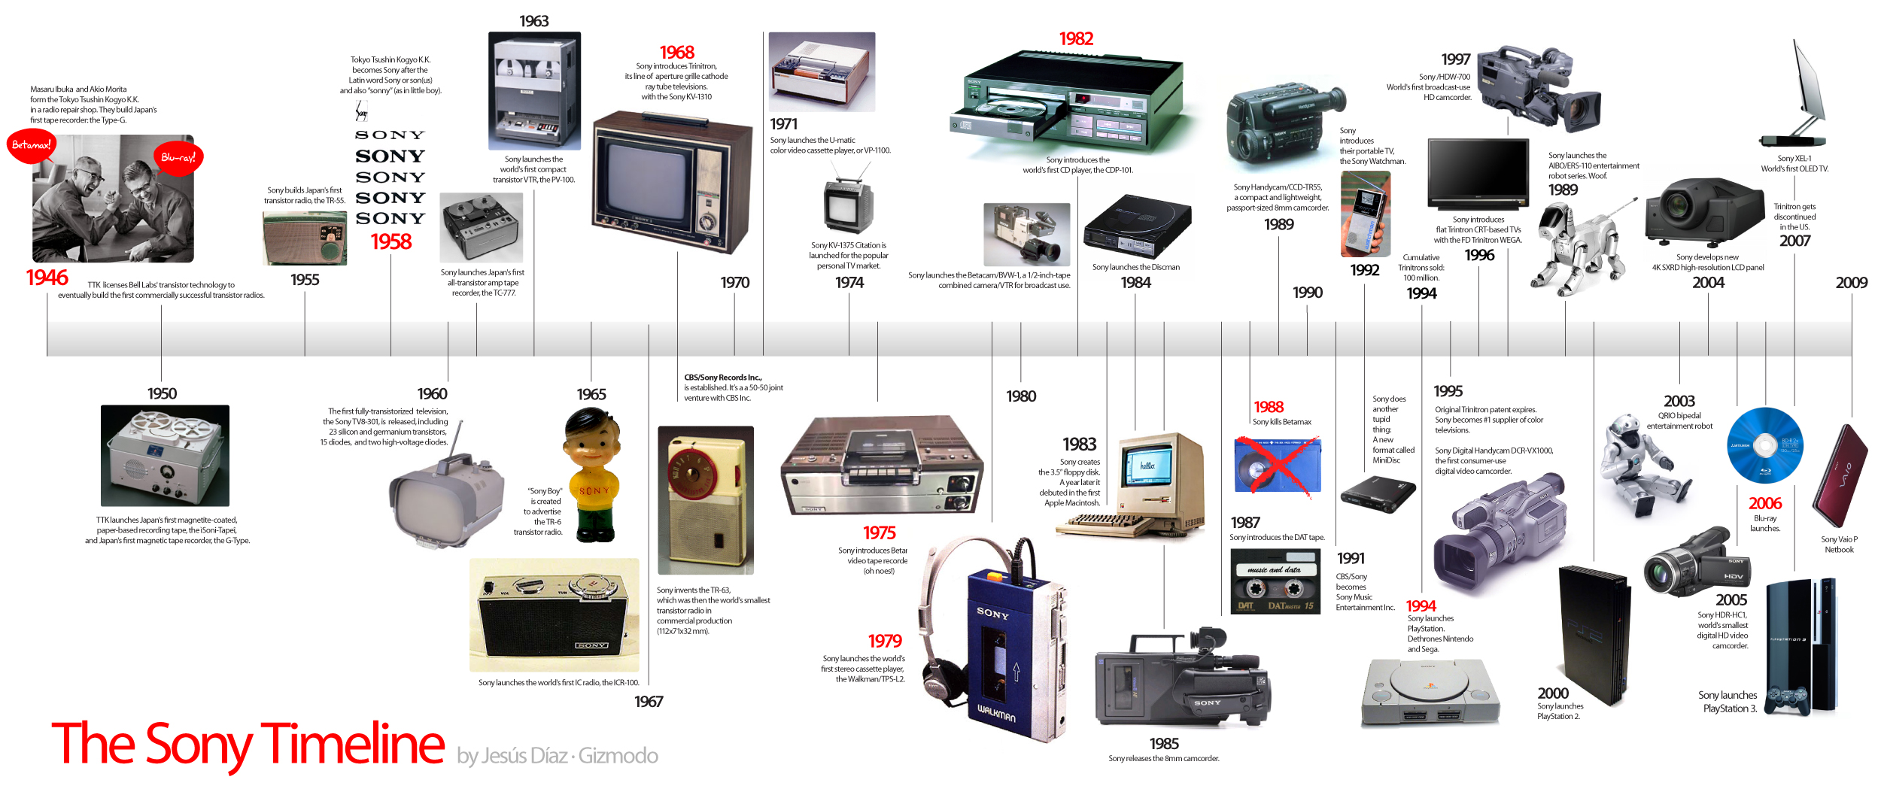



Whether it is through cell phones, texting applications, email, social networking web sites, video conferencing, and more, the degree of connectivity we have with one another is unparalleled. It wasn’t too long ago that long distance phone calls were designated for family members and only the closest of friends and generally occurred a pre arranged day and time. And then in the 1970’s came call waiting. This technological convenience allowed users to engage on a phone call without the risk of missing another, potentially more important phone call.

The advent of home computers brought in a new way of communicating through email. Some rules of engagement were established, such as ALL CAPS BEING CONSIDERED YELLING.

Enter 1975, and IBM introduced the first portable computer (see image below.) There were a limited number available for purchase.



With the advent of laptops and cellphones one does not have to be tethered to a singular location to connect, but can literally be anywhere in the world. While this access serves as a wonderful convenience, it also has a price.

We have come a long way from 1975 – 2015.   
(Optional video clip: <https://www.youtube.com/watch?v=X84muuaySVQ> )

The first text message was sent on December 3, 1992 from Neil Papworth, a 22-year-old test engineer for Sema Group (now Airwide Solutions), from his personal computer to the Vodafone network to the phone of Richard Jarvis. The message simply read, “Merry Christmas.”

Today, over 20 years later it is nearly impossible to even count or measure the number of texts sent per day. On average according to [Forrester Research](http://blogs.forrester.com/michael_ogrady/12-06-19-sms_usage_remains_strong_in_the_us_6_billion_sms_messages_are_sent_each_day" \t "_blank), and over 2.2 trillion are sent a year. (That averages 6 billion SMS texts a day.) Globally, 8.6 trillion text messages are sent each year, according to [Portio Research](http://www.portioresearch.com/en/home.aspx" \t "_blank). In the United States, 75% of teenagers text, sending an average of 60 texts a day. According to [Pew Internet research](http://www.pewinternet.org/Reports/2012/Teens-and-smartphones/Summary-of-findings.aspx" \t "_blank).

[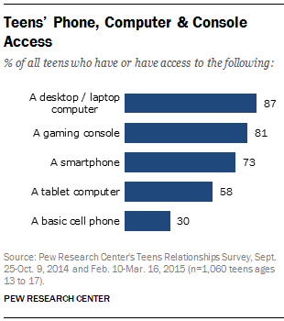](http://www.pewinternet.org/2015/04/09/teens-social-media-technology-2015/pi_2015-04-09_teensandtech_06/)

* 95% of all teens, ages 12-17 are engaged in online activity.
* Nearly 75% of teens have or have access to a smartphone.
* 91% of teens go online from a mobile device at least occasionally.
* Of the mobile teens 94% go online daily or at least often.
* 71% of teens use more that one social networking site.
* 33% of teens with phones have messaging apps like Kik or What’s App.
* Girls more than boys are more likely to engage in social media.
* 47% of teens use video calling.

Pew, 2015

|  |
| --- |
| Although they overlap, Internet safety and digital citizenship are not synonymous terms. While Internet safety identifies ways of steering clear of potentially damaging content on the Internet, digital citizenship seeks to educate on ethical and socially acceptable norms of interactions in the digital realm. Internet safety has traditionally focused on exposure to graphic content, loss of privacy and vulnerability to individuals with fraudulent intent. Digital Citizenship addresses how we interact with our technology, how it impacts us, and influences our social experience. |

Much in the same way we don’t hand over car keys to teenagers without teaching the rules of the road through required safety classes and practice runs, we should not be handing over the keys to technology without doing the same.

SUGGESTED READINGS

Adir, C.. & Barker, T. *The big disconnect: Protecting childhood and family relationships in the digital age.*

## *A Majority of American Teens Report Access to a Computer, Game Console, Smartphone and a Tablet;* by, Amanda Lenhart. April 2015

## <http://www.pewinternet.org/2015/04/09/a-majority-of-american-teens-report-access-to-a-computer-game-console-smartphone-and-a-tablet/>

## *Digital citizenship: Developing an ethical and responsible online culture; by, Cathy Oxley. http://files.eric.ed.gov/fulltext/ED518512.pdf*