**Financial market behavior during the covid-19 crises – a comparison between countries with many infected and few infected.**

Sharon Teitler-Regev[1], *Department of Economics and management, The Max Stern Yezreel Valley College, Israel 1930*

Tchai Tavor, *Department of Economics and management, The Max Stern Yezreel Valley College, Israel 19300*

**Introduction**

The year 2020 will be remembered in the history as a year of health crises caused by the covid -19 virus that has led to one of the biggest economic crises the world has known. The health crises and the extreme measures that were used to slow down its spread led to economic crises that its size and end is not known yet. This event is unique as it quickly spread around the world and effected almost all countries. The crises that started on December as affecting specific industries like: hospitality industry, restaurant and culture events expended to the whole market. In many countries employees were fired or forced to go on vacation, schools were closed and switched to distant learning, while many employees work from their homes. There is a direct effect on the supply side as well since many of the supply chains were blocked or slow down. This leads to a decline in private consumption and the investments. The effect of the covid-19 on the stock market in U.S resembles the effect of major economic crises in 2008, 1987 and 1929, and not the effects of other infectious disease (Baker et al., 2020).

There are many academic researches that focus on how the stock market is effected by negative or positive events, for example: news announcements (Hussain and Ben Omrane, 2020), major sports event (Curatola *et al.*, 2016), environmental events (Guo *et al*., 2020), political uncertainty (Hillier and Loncan, 2019) and the effect of disasters.

Recently, a lot of research has focused on how the media effect the stock market (Raimondo, 2019). Part of the research used text analyses of media content (Lu, Shen, & Wei, 2013). Wu and Lin (2017) divided news items into positive news and negative news. The researchers determined that the quality of news announcements had an effect on the trading behavior of investors. In addition, the results showed that there is a significant positive correlation between positive and negative tones in media coverage with abnormal returns in the market reaction test.

Focusing on news data from the *Wall Street Journal* with short time intervals, Tetlock (2007) found that the tone reported by the media can predict movements on several stock market activity indicators a few days ahead, and that severe optimism or severe pessimism in the media sentiment predicts high trading volume the next day. Strycharz, Strauss and Trilling (2018) Focused on three companies listed on the Amsterdam exchange index (ING, Philips and Shell) and tested the relationships between closing prices of those companies and online media coverage. They used automated methods of content analysis to investigate sentiment and found a positive correlation between the amount of coverage and emotions associated with stock prices. Similarly, Wu and Lin (2017) characterized news items based on the nature of the content: positive or negative. The results indicated that investor-trading behavior is affected by the quantity and the quality of news announcements. Moreover, regarding the market reaction test, the results indicated that positive and negative tones in media coverage are significantly and positively associated with abnormal returns. Likewise, Chan (2003) found that news regarding a specific company leads to a momentum in its stocks, and bad news leads to a longer negative drift.

The impact of natural and health disasters as well as terrorist events on various economic activities increase significantly due to the increase in the number of such events. For example, Tavor & Teitler-Regev (2019) studied the effect of different types of disasters on the stock market and concluded that natural disasters inflicted the largest damage to the economy, whereas terrorism causes the least damage. In addition, natural disasters show the highest level of severity, while artificial disasters have the lowest severity. In Taiwan, Chen (2011) showed that extreme incidents like earthquake, the 9/11 terrorist attacks and the SARS outbreak had a strong effect on hotel sales and a smaller negative effect on the stock prices of hotel companies.

The effect of diseases and pandemic on the stock market was researched as well. Donadelli, Kizys, & Riedel (2017) tested whether World Health Organization (WHO) alerts and media news on dangerous infectious diseases effect investors mood and the pharmaceutical companies' stocks prices in the United States. The result indicated that news related to diseases have a positive and significant sentiment effect among investors on Wall Street. Similarly, Bai et al. (2020) researched the effects of infectious disease pandemic on volatility of the stock markets in U.S., China, UK and Japan during January 2005 to April 2020. They found that infectious disease pandemic has significant positive impacts on the permanent volatility of international stock markets up to 24-month lag, even after controlling the influences of past-realized volatility, global economic policy uncertainty and the volatility leverage effect. The different actions taken by the countries lead to a different effect on the stock market.

Focusing on the Foot‐and‐Mouth Disease Outbreaks in Korean Pendell & Cho (2013) studied its effect on the stock market and found that the five outbreaks between 2000 and 2010 caused both expected and unexpected reactions in the stock market to individual companies in different industries. The markets reactions was more gradual than immediate as the statistically significant cumulative abnormal returns (CAR) was higher than single-day abnormal returns (AR). Chen, Jang and Kim (2007) studied the effect of the SARS outbreak, on Taiwanese hotel stock prices using an event-study approach. The results showed that seven publicly traded hotel companies experienced sharp declines in earnings and stock prices during the period of the SARS outbreak. The Taiwanese hotel stocks showed significantly negative cumulative mean abnormal returns on and after the day of the SARS outbreak. Likewise, Ali et al. (2010) found that the SARS outbreak had a dramatic effect on the Malaysian stock market. On the other hand, Nippani & Washer (2004) who studied the effect of SARS on the stock markets of Canada, China, Hong Kong, Indonesia, Philippines, Singapore, Thailand and Vietnam, found that only China and Vietnam were affected. Ichev and Marinč (2018) studied the Ebola outbreak effect on the U.S. stock market. They found that the effect is strongest for the stocks of companies with exposure of their operations to the West African countries (WAC) and the U.S., and for the events located in the WAC and the U.S.

The covid -19 outbreak draw a lot of research to its effects on the economic and the stock markets. For example, Albulescu (2020) researched the effect of official announcements regarding new cases of infection and death ratio on the financial markets volatility index (VIX) 40 days after the break of the Covid-19. The results showed that while new cases reported in China and elsewhere have a mixed effect on financial volatility, the death ratio positively influences VIX, and that reported cases outside of China triggering important impact. In addition, the higher the number of affected countries, the higher the financial volatility is.

Looking at global financial markets Ali et al. (2020) studies the correlation between spread of COVID-19 and the markets. According to their findings the global financial markets have gone into freefall, while, the Chinese market has stabilized during the later phase of COVID-19 crisis. Similarly, Zhang et al. (2020) illustrate that the COVID-19 pandemic has significant impacts on global financial markets.

Focusing on the U.S. stock market, Baker et al. (2020) researched the effect of the covid-19 and found that from 24 February to 24 March 2020, in a period of 22 trading days there were 18 market jumps – more than any other period in history with the same number of trading days. They looked at several explanations for the effect. For example, the severity of the flu, which they claim is not a good explanation since the Spanish flu which was as severe did not have such effect on the stock market. Another explanation they offer is the availability of information regarding the covid -19. Yet another explanation is the construction of modern economy which is based on services and travel and countless face to face interactions. In addition, the preventive behavior which include social distancing and travel restriction which cause severe economic damage. They claim that the policy responses to the COVID-19 pandemic provide the most compelling explanation for its unprecedented stock market impact. Also focusing on the U.S. stock market but using the event study approach Chowdhury & Abedin (2020) found that the U.S. stock market reacts negatively toward confirmed cases and death numbers of Covid-19. Similar results on the Chinese stock market were found by Al-Awadhi et al. (2020) who used panel data analysis to examine the impact of COVID-19. They found that both the daily growth in total confirmed cases and in total cases of death caused by COVID-19 have significant negative effects on stock returns across all companies.

Focusing on the effect of the media, Haroon and Rizvi (2020) showed the reactions of financial markets in the world to news announcements during COVID-19 pandemic. They found that media has great contributions towards the investment climate uncertainty; specifically the panic generated by the news is associated with increasing volatility in the equity markets. However, sentiment and quantum of media coverage had little to moderate association with volatility of prices.

Taking another aspect, Zaremba et al. (2020) focused on government intervention and found that those interventions significantly and robustly increase the volatility in international stock markets. The effect is based mainly on the role of information campaigns and cancellations of public events.

This research is unique by combining the effects tested by previous researchers. This study tests the effects of many variables from different aspects. It includes the effect of news such as governance limitations, public obedience, news about vaccine or new medications and VIP infections as well as the effect of actual number of infected and dead people on stock market. In addition, this research covers 16 countries and does not focus on a single or limited number of countries. The period in this research includes the first wave of Covid-19 outbreak, so the data collected for this research cover a period of 6 months.

**Research method and design**

This research included daily data from 2.1.20 until 30.6.20. The research covered the following 16 countries: UK, U.S., Spain, Italy, Germany, Austria, Sweden, Slovenia, France, Israel, Argentina, Brazil, China, Taiwan, Singapore and New Zealand.

Data were collected from several websites and included confirmed number of Infected people (Infected), the number of dead people (Dead), the number of tests for covid-19 performed in the country (Tests), number of people that were healed (Healed), closure and travel bans are included in the variable restrictions that indicate the level of restrictions in the relevant country (Restrictions). This variable includes limitation on citizen movements, limitations on tourists coming into the country, closure and isolation. The value receives a negative value when there is a new limitation, zero when there is no change and positive when limitation is removed. The education situation in the country (Education) is a variable that receives a negative value when there is new limitation in the education system, zero when there is no change and positive when limitations regarding the education system are removed. The variable VIP represent the level of infection among VIP's in the country including infection of seniors, infection of medical teams and security personal (VIP). The variable receives a negative value when there is a new infection and zero otherwise. The public behavior is a subjective variable that represent the public responsiveness to the government instructions (Public behavior). The variable receives a negative value when the public does not respond to the government instructions, zero when there is no change and positive when there are publications regarding advertisement of the public despondence to government instructions. The positive measures the country is doing facing Covid-19 includes advertising economic measures, developing a vaccine, new trial in experimental medicine and publishing an increase in the number of tests for the citizens are included in the variable Dealing (Dealing). This variable receives a positive value when there is announcement of a positive step and zero when there is no new announcements. The limitations on work in the country (Working) receives a negative value when there is new limitation regarding work places, zero when there is no change and positive when limitations regarding work places are removed.

The details of the data sources for those variables are detailed in appendix A. Data regarding each country’s major financial indexes were collected from Investing.com, which serves as the main source of information regarding the major capital market indexes around the world. Those data are used to build a variable that represent the daily return for the main index of 16 countries (Return). The indexes included are: UK (FTSE 100), U.S. (S&P 500), Spain (Madrid 35), Italy (Milano 40), Germany (DAX), Austria (ATX), Sweden (Stockholm 30), Slovenia (SBITOP), France (CAC 40), Israel (TLV-35), Argentina (Argentina General), Brazil (Brazil INDEX 50), China (SSEC), Taiwan (TPEX 50), Singapore (FTSE Singapore) and New Zealand (NZX 50).

In addition, several rations between the variables were calculated. Those ratios include: Dead per Infected (DPI) - index that represent the ratio between the number of dead and the total number of infected ; Healed per Infected (HPI) - index that represent the ratio between the number of people that were healed to the total number of infected; Test per Infected (TPI) - index that represent the ratio between the number of tests to the total number of infected people; Test per Dead (TPD) an index that represent the ration between the number of tests to the total number of dead people.

The countries in this research are divided into two groups. Countries with few infected, and countries with many infected. The countries with many infected include UK, Italy, Spain, Sweden, France, Germany, U.S., and Brazil. The countries with few infected includes: New Zealand, Austria, Slovenia, Argentina, China, Taiwan, Singapore, and Israel.

This research includes descriptive statistics on the variables in both groups and an OLS regression analysis on the effect of the different variable on the return of the stock indexes for each one of the groups separately.

In order to test the effect of the Covid-19 on the stock markets in countries with many infected and countries with few infected two separate regressions were performed.

The first regression is performed for the different variables that influence the stock indexes. The regression models are:

1. *AR_FC = α + β1⸱infected + β2⸱Dead + β3·Healed + β4·Restrictions +β5·Public_behavior + β6·VIP + β7·Dealing + β8·education + β9·Working + β10·Tests + ε.*

and

1. *AR_MC = α + β1⸱infected + β2⸱Dead + β3·Healed + β4·Restrictions + β5·Public_behavior + β6·VIP + β7·Dealing + β8·education + β9·Working + β10·Tests + ε.*

Where AR_FC represents the average return in countries with few infected and AR_MC represents the average return in countries with many infected.

The second regression is performed testing the effects of the ratio variables on the return of the indexes. The regression models are:

1. *AR_FC = α + β1·DPI + β2·HPI + β3·TPI + β4·TPD + ε*

and

1. *AR_MC = α+β1·DPI + β2·HPI + β3·TPI + β4·TPD + ε*

**Results**

*Descriptive Statistics*

This section presents the descriptive statistics of the data. Table 1 describes the copulative data of the index return, the number of infected, the number of dead, the number of people that healed and the number of tests performed in each country. The data were normalized for million resident (except for the return) to be comparable. The countries in the table are divided into two panels. Panel A include 8 countries with lower number of infected (Few infected), and panel B include 8 countries with the highest number of infected (Many Infected). The average for each variable was calculated and an independent t-test was performed to tests whether the differences between the groups are significant.

Table 1: Descriptive statistics for the sample

|  |  |  |  |  |  |  |  |  |  |
| --- | --- | --- | --- | --- | --- | --- | --- | --- | --- |
| **Panel A: Few Infected** | | | | | | | | | |
|  | **Israel** | **Austria** | **Slovenia** | **Argentina** | **China** | **Taiwan** | **Singapore[2]** | **New Zealand** | **ALL** |
| **Return** | -20.75% | -30.43% | -8.72% | -8.36% | -3.26% | 2.45% | -12.50% | -5.64% | -9.42%** |
| **Infected** | 2,823.74 | 1,961.49 | 762.41 | 1,377.45 | 58.90 | 18.77 | 7,462.98 | 244.29 | 1636.53*** |
| **Dead** | 36.86 | 78.06 | 53.39 | 28.32 | 3.22 | 0.29 | 4.44 | 4.56 | 23.27*** |
| **Healed** | 2003.46 | 1829.59 | 665.73 | 487.39 | 55.33 | 18.35 | 6580.81 | 240.74 | 1,329.64*** |
| **Tests** | 115,648.56 | 68,035.62 | 48,933.32 | 7,797.23 | 0[3] | 3,228.05 | 02 | 83,363.81 | 47,176.38*** |
| **Panel B: Many Infected** | | | | | | | | | |
|  | **UK** | **Spain** | **Italy** | **Sweden** | **France** | **Germany** | **U.S** | **Brazil** | **ALL** |
| **Return** | -18.69% | -25.38% | -18.67% | -7.98% | -18.30% | -8.03% | -4.84% | -19.80% | -15.21% |
| **infected** | 4,595.42 | 5,331.46 | 3,976.66 | 6,700.19 | 2,516.49 | 2,318.57 | 7,826.38 | 6,436.77 | 4,962.74 |
| **Dead** | 641.89 | 606.46 | 574.64 | 525.78 | 456.74 | 107.10 | 381.09 | 274.34 | 446.00 |
| **Healed** | 02 | 3,216.3 | 3,146.6 | 02 | 1,098.67 | 2,125.7 | 2,177.12 | 3,708.69 | 2,578.84 |
| **Tests** | 87,243.06 | 74,219.79 | 89,148.98 | 02 | 14,375.51 | 02 | 97,578.04 | 6,956.51 | 61,586.98 |

*** 99% significance level

** 95% significance level

* 90% significance level

The results in table 1 indicated that the indexes (return) that had the lowest decline belong to Austria (-30.43%) and Israel (-20.75%) in the groups with few infected. In the group of many infected there are five countries for which the indexes declined sharply. UK (-18.69%), Spain (-25.38%), Italy (-18.67), France (-18.30%) and Brazil (-19.8%). Out of the seven indexes that declined five belong to countries in Europe. When comparing both groups, it can be seen that the average of the cumulative number of infected people for million people is significantly lower in the group of few infected (1636.53) compare to the countries with many infected (4962.74). The counties with the lowest number of infected in the sample were Taiwan (18.77), and China (58.9) and the countries with the highest number of infected were USA (7926.38), Brazil (6436.77) and Sweden (6700.19).

The number of dead per million in countries with few infected (23.27) is significantly lower than the number of dead in the countries with many infected (446). The countries with the lowest number of dead are Taiwan (0.29) and china (3.22), and the countries with the highest number of dead were UK (641.89), Spain (606.46) and Italy (574.64).

The number of healed per million people in countries with few infected (1329.64) is significantly lower than the number of healed in countries with many infected (2578.84). The highest number of healed was in Brazil (3708.69), Spain (3216.3) and Italy (3146.6) and the lowest number of healed were in Taiwan (18.35) and China (55.53). The average number of tests for million people in countries with many infected was significantly higher (61,586.98) than the number of tests in countries with few infected (47176.38). The countries with the highest number of tests were Israel (115648.56), and U.S. (97578.04), while the countries with the lowest number of tests were Taiwan (3228.05) and Brazil (6956.51).

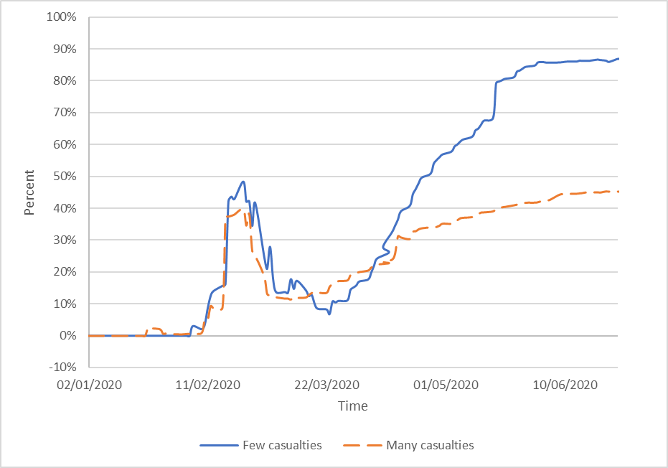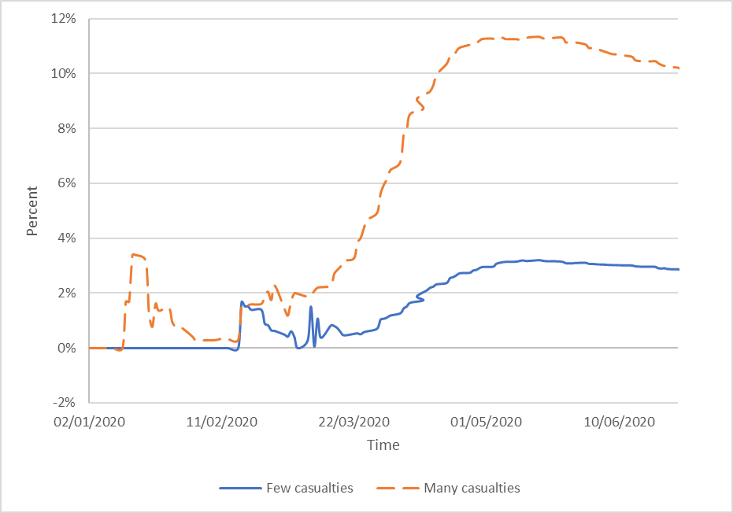

Figure 1.2: Performance of the HPI index according to the test time

Figure 1.1: Performance of the DPI index according to the test time

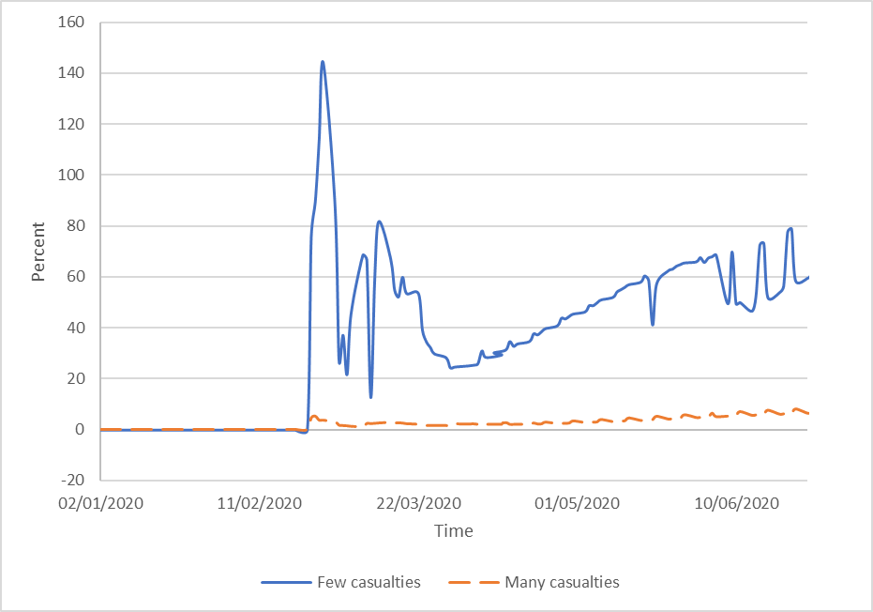

Figure 1.3: Performance of the TPI index according to the test time

Figure 1.1 to 1.3 represent the indexes behavior during the test period for both groups: countries with few infected (continues line) and countries with many infected (dotted line). Figure 1.1 represent the ration between the number of dead people to the number of infected people (DPI), figure 1.2 represent the ratio between the number of healed to the number of infected (HPI) and figure 1.3 represent the ratio between the of tests to the number of infected (TPI).

Looking at figure 1.1 the test period can be divided to three phases: initial phase until the middle of March 2020, the spread-out phase from the middle of March until the end of April 2020, and the containing phase from the beginning of May 2020 to the end of June.

During the initial phase the DPI was low for both groups, although for the group with many infected the DPI is much higher. During this phase, in January, the first massive wave of dead people occurred in the Asian countries with many infected. This wave declined and the DPI declined until the middle of March. During the spread-out phase, a gap in the DPI between the groups is created. While in the group with many infected there is an exponential increase in the DPI, in the group with few infected the increase is moderate. During the containing phase, the DPI in both groups decline. This is probably because of the limitation on the citizens that the countries used.

Analyzing figure 1.2 it is clear that during the initial phase there is no difference between the groups. The HPI increase sharply until the middle of February and then declines (this effected only Asian countries). In the two phases afterwards, the spread out and containing, there is a sharp increase in the HPI in the group with few infected and a moderated increase on the group with many infected. A possible explanation is the sharp increase in the number of infected people in the countries with many infected compare to the slower increase in the number of infected in countries with few infected.

Figure 1.3 analysis the number of tests compare to the number of infected. As can be seen in the figure, the number of tests were only published from the beginning of February 24th and therefore the graphs starts on that date. The figure indicate that the TPI increase in both groups, but it is much higher in the group with few infected compare to the group with many infected. A possible explanation can be found in table 1. While the number of tests in countries with many infected increase slightly more than the number of tests in countries with few infected, the number of infected people is much higher, therefore the TPI increases more in countries with few infected.

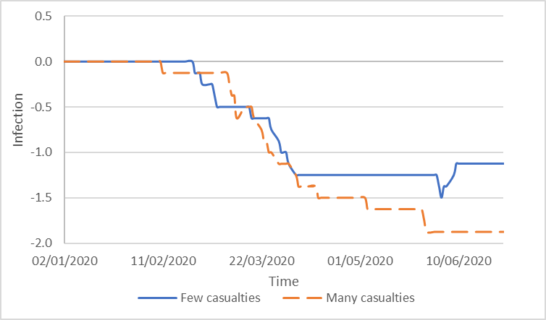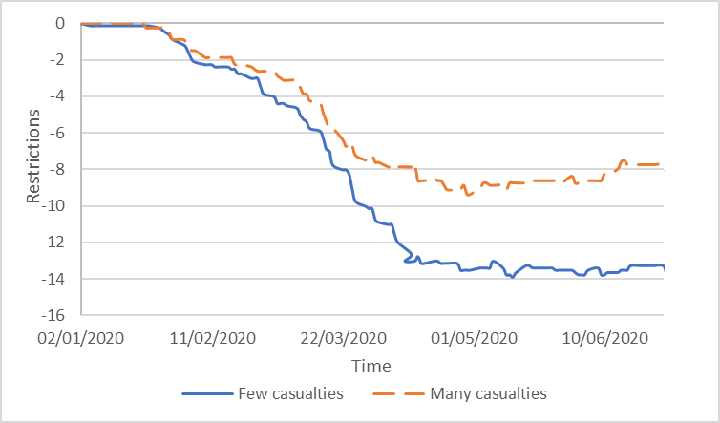

Figure 2.2: Description of the VIP variable according to the test time

Figure 2.1: Description of the Restrictions variable according to the test time

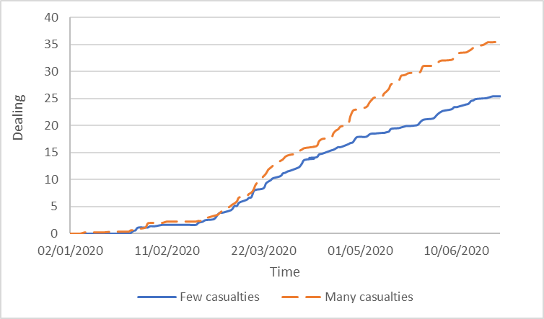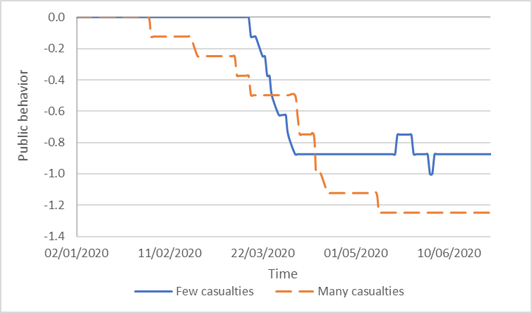

Figure 2.4: Description of the Dealing variable according to the test time

Figure 2.3: Description of the Public behavior variable according to the test time

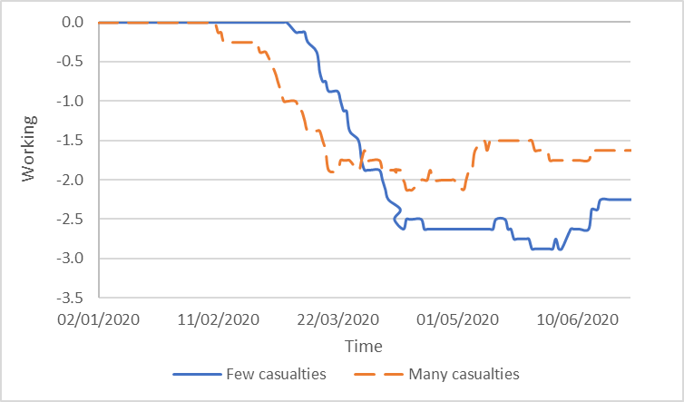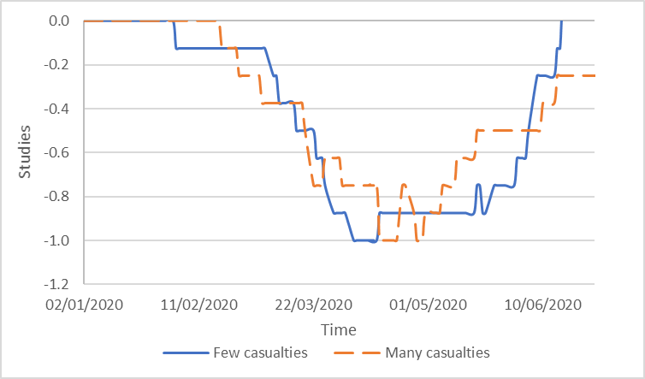

Figure 2.6: Description of the Working variable according to the test time

Figure 2.5: Description of the Education variable according to the test time

Figures 2.1-2.6 analyze the private and public behavior during the test period for both groups: countries with many infected (dotted line) and countries with few infected (continues line). Figure 2.1 describes the average in each group of the limitations at the countries. The restrictions include, movement restriction, limitation in incoming international tourists to the country, isolation and quartile on the citizens.

The figure indicate that until the beginning of February, there is no difference between the groups and there were hardly any limitations. At the beginning of February, the governments started to limit the public. In countries with few infected, there were strong limitations that prevented the spread of the virus, while in countries with many infected there were fewer limitations that made it easier for the virus to spread. In mid-April both groups reached balance and steady state as can be seen in the horizontal part of the figure.

Figure 2.2 describes the average in each group of the level of infection by VIP's. The variable is based on infection of VIP's, health crews and security forces in the country. The figures indicate that until mid-February there were hardly any infections in both groups. Later on until the beginning of April, there are many infected people in both groups. From the beginning of April, there are hardly any reports on infection in the countries with few infected, while in countries with many infected, the spread of the virus continues, but the trend is moderated. A possible explanation is the limitations on the population in countries with few infected that prevented the spread of the virus to the VIP's.

Figure 2.3 describes the way the public response to the government instructions. The public behavior is characterize by behavior cycle of obeying the government, and then weakening in obeying, back to strict obeying and so on. The longer the period of obeying the government, the lower is the infections rate. Looking at the figure it can be seen that the level of weakening in obeying the orders is much lower in countries with few infected (mid-March until the beginning of April) compare to countries with many infected (beginning of February until mid-May). This variable indicate that in countries with many infected there is a responsibility of the virus spread is divided between the government (as can be seen in figure 2.2) and the public.

Figure 2.4 describes the positive actions the countries in both groups used in order to deal with Covid-19. The variable includes information regarding economic measures, vaccine development, use of experimental medications, and advertisement of the increase in tests to the citizens. The figure shows similar trend in both groups. Until the end of February, there were hardly any involvement of the government in both groups. Afterwards, due to the virus spread and the major effect on the public in the health and economic situation, the governments started to take actions to support the public. These steps were stronger in countries with many infected compare to countries with few infected. A possible explanation is that in countries with many infected the economic and health damages are larger and therefore, action that is more massive is needed.

Figure 2.5 describes the education situation in the country in both groups. The level of limitation of the education system is similar in both groups and 4 phases can be identified. In the first phase, there are hardly any limitations of the education system, as can be seen in the horizontal line in the figure. In this phase, it is clear that the limitation on the education system in countries with few infected started about two weeks before the limitations in countries with many infected. In the phase afterwards, due to the increased fear of infections in education system, there were gradual steps of limiting the education system. In the third phase in both groups, the limitations were at their maximum level. The last phase the governments started to ease the limitation. Although the trend is similar in both groups, the maximum limitation phase is much longer in countries with few infected (mid-April to the end of May) compare to countries with many infected (mid-April to the end of April). This might be the reason for the low level of infections in the countries with few infected.

Figure 2.6 describes the working situation in both groups. From analyzing the figure, it can be seen that the working situation is similar in both groups and can be divided to three phases. In the first phase, there are hardly any limitations on the work situation in the countries as can be seen in the horizontal line in the figure. In the next phase due to the increase fear of being infected in the work place the government initiated gradual steps to limit work places in the country. In this phase, it can be seen that the limitations on work places in the countries with many infected started three weeks before the limitations in the countries with few infected. During the third phase, the countries reached maximum limitations and preserve the current situation in the work places. Comparing both groups, it can be seen that the limitations in the countries with few infected were more intense than the limitations in the countries with many infected.

*The effect of the variables in the model on the indexes return*

In this section, the research tests the effect of the variables on indexes return in countries with many infected and with few infected.

*Table 2: Regression Estimate*

*The regression models are:*

1. *AR_FC = α + β1⸱infected + β2⸱Dead + β3·Healed + β4·Restrictions + β5·Public_behavior + β6·VIP + β7·Dealing + β8·education + β9·**Working + β10·**Tests + ε.*
2. *AR_MC = α + β1⸱infected + β2⸱Dead + β3·Healed + β4·Restrictions + β5·Public_behavior + β6·VIP + β7·Dealing + β8·education + β9·Working + β10·Tests + ε.*

AR_FCrepresents the average return of countries with Few Infected. AR_MC represents the average return of countries with Many Infected. *Infected* represent the total number of infected people. *Dead* represent the total number of dead people. *Healed* represent the total number of people that healed. *Restrictions* represent a variable that indicate the level of restrictions in the relevant country. *Public_behavior* a subjective variable that represent the public resonance to the government instructions. *VIP* represent the level of VIP among VIP's in the country. *Dealing* a variable that describes the positive measures the country is doing in facing Covid-19. *Education* a variable that represent the education situation in the country. *Working a* variable that represent limitations on work places in the country. *Tests* represent the number of tests for covid-19 performed in the country.

|  |  |  |  |  |  |  |
| --- | --- | --- | --- | --- | --- | --- |
| **Variable** | **Panel A: Few Infected** | | | **Panel B: Many Infected** | | |
|  | R Square = 0.929, F = 168.731 | | | R Square = 0.896, F = 102.085 | | |
|  | *Coefficient* | *Std. Error* | *t-Statistic* | *Coefficient* | *Std. Error* | *t-Statistic* | |
| *C* | 0.018*** | 0.006 | 2.924 | 0.029*** | 0.008 | 3.609 | |
| *infected* | -1.04E-05*** | 0 | -2.484 | 0 | 0 | -0.136 | |
| *Dead* | -2.06E-07*** | 0 | -3.438 | -1.02E-05*** | 0 | -3.125 | |
| *Healed* | 5.91E-05*** | 0 | 7.148 | 0 | 0 | 0.216 | |
| *Restrictions* | -0.023*** | 0.005 | -4.119 | -0.030*** | 0.012 | -2.582 | |
| *Public_behavior* | -0.434*** | 0.063 | -6.838 | -0.215*** | 0.076 | -2.816 | |
| *VIP* | -0.081*** | 0.033 | -2.451 | -0.137*** | 0.048 | -2.878 | |
| *Healing* | 0.048*** | 0.004 | 10.789 | 0.032*** | 0.006 | 5.759 | |
| *Education* | 0.073** | 0.038 | 1.927 | -0.075 | 0.055 | -1.371 | |
| *Working* | 0.065*** | 0.025 | 2.649 | 0.144*** | 0.031 | 4.607 | |
| *Tests* | 5.64E-07*** | 0 | 2.799 | 4.26E-08 | 0 | 1.067 | |

*** 99% significance level

** 95% significance level

* 90% significance level

The results in table 2 indicate that in general Covid-19 effect the indexes return in both groups: countries with few infected (F = 168.731, R Square = 0.929 (and countries with many infected (F = 102.085, R Square = 0.896). In countries with few infected all the variable effect the return of the stock market. As the number of dead or infected increase than the decrease in the stock market is larger. In addition, when the number of healed or the number of tests increase, the stock marker react positively. Among the continues variable the number of healed has the strongest effect on the stock indexes. The reason might be that it indicated good news compare to the other variables that represent bed news. Limitations of the government and public unresponsiveness to the instruction lead to a decline in the indexes, on the other hand positive steps leads to increase in indexes returns. When the limitation of the work market and education system are eased, than the return of the indexes increase. The variable VIP lead to a decrease in the indexes. The categorize variable with the strongest effect on the stock indexes is the public responsiveness, maybe because people realize that out of all the government limitation , public responsiveness is a key factor in dealing with the epidemic.

For countries with many infected analyzing the effecting variables, it is clear that the effects are weaker. The number of dead has negative effect on the indexes, but the number of healed, the number of infected and the number of tests has no effect on the indexes. Similarly, to countries with few infected, government limitations, public behavior, VIP's infection has a negative effect on the indexes, while positive steps, and work has a positive effect on the indexes. The variable education has no effect on the indexes.

*The effect of the indexes in the model on the indexes return*

In this section, the effect of the indexes calculated in this research on the return of the stock indexes in countries with few infected and many infected are tested. The indexes that were calculated for the regression were: the ratio between the number of dead to the number of infected (DPI), the ratio between the number of healed to the number of infected (HPI), the ratio between the number of tests to the number of infected (TPI), the ratio between the number of tests to the number of dead (TPD).

*Table 3: Regression Estimate*

*The regression models are:*

1. *AR_FC = α + β1·DPI + β2·HPI + β3·TPI + β4·TPD + ε*
2. *AR_MC = α + β1·DPI + β2·HPI + β3·TPI + β4·TPD + ε*

AR_FCrepresents the average return of countries with Few Infected. AR_MC represents the average return of countries with Many Infected. *DPI* is an index that represent the ratio between the number of dead to the total number of infected. *HPI*  an index that represent the ratio between the numbers of people that healed to the total number of infected. *TPI* an index that represent the ratio between the numbers of tests to the total number of infected people. *TPD* an index that represent the ratio between the numbers of tests to the total number of dead.

|  |  |  |  |  |  |  |  |  |
| --- | --- | --- | --- | --- | --- | --- | --- | --- |
| **Variable** | **Panel A: Few Casualties** | | | | **Panel B: Many Casualties** | | | |
|  | R Square = 0.564, F = 47.693 | | | | R Square = 0.553, F = 34.011 | | | |
|  | *Coefficient* | *Std. Error* | *t-Statistic* | *Coefficient* | | *Std. Error* | *t-Statistic* |
| *C* | -0.049*** | 0.013 | -3.769 | -0.051*** | | 0.013 | -4.186 |
| *DPI* | -1.10E+01*** | 1.48E+00 | -7.432 | -1.652 | | 1.307 | 1.264 |
| *HPI* | 0.635*** | 0.054 | 11.759 | 0.219*** | | 0.098 | 2.237 |
| *TPI* | 2.08E-03*** | 0 | 8.501 | 0.005 | | 0.006 | 0.768 |
| *TPD* | 1.39E-05*** | 0 | 3.371 | 0.002*** | | 0 | 5.894 |

*** 99% significance level

** 95% significance level

* 90% significance level

Table 3 indicated that generally even by using the indexes there is a significant effect of Covid-19 in the return of the stocks in both groups: countries with many infected (F =34.011, R Square = 0.553) and countries with few infected (F = 47.693, R Square = 0.564). Analyzing the effect of the indexes in countries with few infected, it can be seen that all the indexes effect the stock indexes return. That is, as the ratio of the number of dead to the number of infected (DPI) increases so the stock indexes return decreases. On the other hand, as the ration between the numbers of healed to the number of infected (HPI), the ration between the number of tests to the number of infected (TPI) and the ratio between the number of tests to the number of dead (TPD) increases than the return in the stock indexes increases. Similar to the results of the regression with the actual numbers, the variable with the strongest effect on the stock indexes is the ration between the numbers of people that healed to the number of infected (HPI).

Analyzing the indexes for countries with many infected, it can be seen that the effects are weaker, and only two indexes have positive significant effect on the stock indexes. That is, as the ratio between the numbers of healed to the number of infected (HPI) and the ratio between the numbers of tests to the number of dead (TPD) increases, so does the return on the stock indexes.

To summarize, it can be seen that testing the variables or the indexes effect on the return of the stock indexes lead to similar results. In both cases, more variables have an effect in countries with few infected than in countries with many infected. The reason might be that in countries with few infected the government took stages at initial stages of the pandemic and each of those steps or changes effected the stock indexes. On the other hand, in countries with many infected, the government only took action in a later stage. At this time, the market has already adjusted to the situation and therefore were less effected by the different variables.

**Summery and conclusions**

The health crises caused by the covid -19 virus has led to one of the biggest economic crises the world has known. The pandemic started in December 2019 in China and quickly spread around the world and effected almost all countries. Covid-19 effected all areas in life, and the focus of this research is its effect on the stock market.

This research tests the effects of different variables on the stock indexes on 16 different countries grouped to countries with few infected and countries with many infected. The affecting variables includes the effect of news such as governance limitations, public obedience, news about vaccine or new medications and VIP infections as well as the effect of actual number of infected, number of people that healed, number of tests and the number of dead people. The period in this research includes the first wave of Covid-19 outbreak, so the data collected for this research cover a period of 6 months.

The countries in this research were divided to countries with few infected and countries with many infected. The descriptive statistics analyzes of the data reveals significant differences between the groups for all the variables. Analyzing the variables along the time line reveals differences in the occurrences of the events, specifically in countries with few casualties the government took preventive measures earlier, which probably effected the health results (number of infected). However, the figures indicate that the test period can be divided to three phases: initial phase until the middle of March 2020, the spread-out phase from the middle of March until the end of April 2020, and the containing phase from the beginning of May 2020 to the end of June.

The initial phase started in Asia and expanded to the rest of the world. During the first phase, in January, the first massive wave of dead people occurred in the Asian countries with many infected. The spread-out phase is characterize with extended spread out of the virus, and the difference between the groups starts to appear. Some countries experience high infection rate and some contained it more successfully. In the third phase most of the countries were able to contain the virus and the market gradually opened.

The regression analysis reveals that in countries with few casualties all the variables effected the return of the stock indexes, while in countries with many infected, only a few of the variables effected the return of the stock indexes. This is true for the regression with the actual numbers and for the regression with the calculated indexes. The variable with the strongest effect among the continues variable is the number of people that healed. The reason might be that it indicated good news compare to the other variables that represent bad news. This is the case in the regression with the indexes as well. Among the categorize variable the variable with the strongest effect on the stock indexes is the public responsiveness, maybe because people realize that out of all the government limitation , public responsiveness is a key factor in dealing with the epidemic.

The results of this paper regarding the effect of positive and negative news on the stock market for countries with few infected or many infected resembles the results of previous studies (Wu and Lin 2017, Tetlock 2007, Lin 2017) who found a significant positive correlation between positive and negative tones in media coverage with abnormal returns.

Similarly, to the results of Bai et al. (2020) who found that different actions taken by the countries lead to a different effect on the stock market, the results of the current study shows that government limitation including limitation of the work places and education system effect the stock indexes both in countries with few infected and in countries with many infected.

The results of the current research resembles the results of Albulescu (2020) regarding the effect of new cases of infection and death ratio on the financial markets volatility index (VIX). He found that new cases reported in China and elsewhere have a mixed effect on financial volatility, while the death ratio positively influences VIX. In this research, the results indicate that the number of dead effected the stock indexes for both countries with few and with many infected, while the number of infected effected the stock indexes only in countries with few infected.

The current research deals with the effect of the Covid-19 epidemic that has a great impact on daily life and the economy of all countries around the world in 2020. This research focus on the effect of on the stock indexes. Many researchers studied the effect of Covid 19 in general and on the stock indexes specifically, but this research is unique in many ways. The first is the length of time it covers (6 months) compare to other studies. Another aspect is the number of countries its covers (16) compare to other studies that usually cover one country or at the most five countries. In addition, this study includes a wide variety of variables some regarding data on number of people that were infected, number of dead and number of healed and on the other hand categorical variables regarding public behavior and government restrictions. However, this research has some limitations, as there are many more countries that suffered from covid-19 and are not covered on this research. In addition, this research is based on the data reported by the different countries. Not all the countries report all the data and sometimes the measures are not the same. This might influence the comparison. Future research should be expended to more countries and might be expended to include the second wave of covid -19.

# References

Albulescu, C., 2020. Coronavirus and financial volatility: 40 days of fasting and fear. arXiv preprint arXiv:2003.04005.

Al-Awadhi, A. M. *et al.* (2020), ‘Death and contagious infectious diseases: Impact of the COVID-19 virus on stock market returns’, *Journal of Behavioral and Experimental Finance*, Vol. 27, Article No. 100326.

Ali, N., Nassir, A. M., Hassan, T., & Abidin, S. Z. (2010). Short run stock overreaction: Evidence from Bursa Malaysia. *International Journal of Economics and Management*, *4*(2), 319-333.‏

Ali, M., Alam, N., & Rizvi, S. A. R. (2020). Coronavirus (COVID-19)–An epidemic or pandemic for financial markets. *Journal of Behavioral and Experimental Finance*, 100341

Bai, L., Wei, Y., Wei, G., Li, X., & Zhang, S. (2020). Infectious disease pandemic and permanent volatility of international stock markets: A long-term perspective. *Finance Research Letters*, 101709.‏

Baker, S., Bloom, N., Davis, S. J., Kost, K., Sammon, M., & Viratyosin, T. (2020). The unprecedented stock market reaction to COVID-19. *Covid Economics: Vetted and Real-Time Papers*, *1*(3).‏

Chan, W. S. (2003). Stock price reaction to news and no-news: drift and reversal after headlines. *Journal of Financial Economics*, *70*(2), 223-260.‏

Chen, M. H. (2011). The response of hotel performance to international tourism development and crisis events. *International Journal of Hospitality Management*, *30*(1), 200-212.

Chen, M. H., Jang, S. S., & Kim, W. G. (2007). The impact of the SARS outbreak on Taiwanese hotel stock performance: an event-study approach. *International Journal of Hospitality Management, 26*(1), 200-212.‏

Curatola, G. *et al.* (2016) ‘Investor Sentiment and Sectoral Stock Returns: Evidence from World Cup Games’, *Finance Research Letters*, Vol. 17, pp. 267–274

Chowdhury, E. K., & Abedin, M. Z. (2020). COVID-19 Effects on the US Stock Index Returns: An Event Study Approach. *Available at SSRN 3611683*.‏

Donadelli, M., Kizys, R., & Riedel, M. (2017). Dangerous infectious diseases: Bad news for Main Street, good news for Wall Street?. *Journal of Financial Markets*, *35*, 84-103.‏

Guo, M., Kuai, Y. and Liu, X. (2020) ‘Stock market response to environmental policies:

Evidence from heavily polluting firms in China’, *Economic Modelling*, Vol. 86, pp. 306–316

Haroon, O. and Rizvi, S. A. R. (2020) ‘COVID-19 : Media coverage and financial markets behavior — A sectoral inquiry’, *Journal of Behavioral and Experimental Finance*, Vol. 27,

Article No. 100343

Hillier, D. and Loncan, T. (2019) ‘Political uncertainty and Stock returns: Evidence from the Brazilian Political Crisis’, *Pacific Basin Finance Journal*, Vol. 54, pp. 1–12

Hussain, S. M. and Ben Omrane, W. (2020) ‘The effect of US macroeconomic news

announcements on the Canadian stock market: Evidence using high-frequency data’,

*Finance Research Letters*, In Press, Article No. 101450

Ichev, R. and Marinč, M. (2018) ‘Stock prices and geographic proximity of information: Evidence from the Ebola outbreak’, *International Review of Financial Analysis*, Vol. 56,pp. 153–166

Lu, Y. C., Shen, C. H., & Wei, Y. C. (2013). 'Revisiting early warning signals of corporate credit default using linguistic analysis'. *Pacific-Basin Finance Journal*, *24*, 1-21.‏

Nippani*, S., & Washer, K. M. (2004). SARS: a non-event for affected countries’ stock markets?. *Applied Financial Economics*, *14*(15), 1105-1110.‏

Pendell, D. L., & Cho, C. (2013). Stock Market Reactions to Contagious Animal Disease Outbreaks: An Event Study in Korean Foot‐and‐Mouth Disease Outbreaks. *Agribusiness*, *29*(4), 455-468.‏

Raimondo, C. (2019). 'The media and the financial markets: A review'. *Asia-Pacific Journal of Financial Studies, 48*(2), 155-184.

Strycharz, J., Strauss, N., & Trilling, D. (2018). 'The role of media coverage in explaining stock market fluctuations: Insights for strategic financial communication'. *International Journal of Strategic Communication*, *12*(1), 67-85.‏

Tavor, T., & Teitler-Regev, S. (2019). The impact of disasters and terrorism on the stock market. *Jàmbá: Journal of Disaster Risk Studies*, *11*(1), 1-8.‏

Tetlock, P. C. (2007). Giving content to investor sentiment: The role of media in the stock market. *The Journal of finance*, *62*(3), 1139-1168.‏

Zhang, D., Hu, M. and Ji, Q. (2020) ‘Financial markets under the global pandemic of COVID-19’, *Finance Research Letters*, In Press, Article No. 101528

Wu, C. H., & Lin, C. J. (2017). The impact of media coverage on investor trading behavior and stock returns. *Pacific-Basin Finance Journal*, *43*, 151-172.‏

Zaremba, A., Kizys, R., Aharon, D. Y., & Demir, E. (2020). Infected Markets: Novel Coronavirus, Government Interventions, and Stock Return Volatility around the Globe. *Finance Research Letters*, 101597.‏

Data sources

Bundesministerium für Gesundheit. (2020). Retrieved from Coronavirus: https://www.bundesgesundheitsministerium.de/coronavirus/chronik-coronavirus.html

Investing.com. (2020). Retrieved from - Investing.com: https://il.investing.com/indices/major-indices

administracion.gob.es. (2020). Retrieved from Nueva normalidad. Crisis sanitaria COVID-19: https://administracion.gob.es/pag_Home/atencionCiudadana/Nueva-normalidad-crisis-sanitaria.html#-bb7ad21ed1cf

Argentina.gob.ar. (2020). Retrieved from nuevo coronavirus COVID-19: https://www.argentina.gob.ar/salud/coronavirus-COVID-19

Bundeskanzleramt . (2020). Retrieved from Bundeskanzleramt - Bundesregierung: https://www.bundeskanzleramt.gv.at/bundeskanzleramt/die-bundesregierung.html

Congress.gov. (2020). Retrieved from Current Legislative Activities: https://congress.gov/

Gouvernement.fr. (2020). Retrieved from Les actions du Gouvernement: https://www.gouvernement.fr/les-actions-du-gouvernement

Gov.il. (2020). Retrieved from חדשות: https://www.gov.il/he/departments/news?limit=10

gov.sg. (2020). Retrieved from Latest update: https://www.gov.sg/features/covid-19

GOV.UK. (2020). Retrieved from Coronavirus (COVID-19) - News and communications : https://www.gov.uk/search/news-and-communications?level_one_taxon=5b7b9532-a775-4bd2-a3aa-6ce380184b6c

Governo do Brasil. (2020). Retrieved from Legislação COVID-19: http://www.planalto.gov.br/CCIVIL_03/Portaria/quadro_portaria.htm

Governo Italiano. (2020). Retrieved from Coronavirus, le misure adottate dal Governo: http://www.governo.it/it/approfondimento/coronavirus/13968

HDX. (2020). Retrieved from Novel Coronavirus (COVID-19) Cases Data: https://data.humdata.org/dataset/novel-coronavirus-2019-ncov-cases

New Zealand Legislation. (2020). Retrieved from COVID-19 legislation: http://www.pco.govt.nz/covid-19-legislation/

Regeringen styr Sverige. (2020). Retrieved from Regeringsförklaringen: https://www.regeringen.se/tal/20192/09/regeringsforklaringen-den-10-september-2019/

Republike Slovenije. (2020). Retrieved from Vlada Republike Slovenije: https://www.gov.si/drzavni-organi/vlada/novice/

World Health Organization. (2020). Retrieved from WHO Coronavirus Disease (COVID-19) Dashboard: https://covid19.who.int/

- Israel Ministery of Health. (2020). Retrieved from: https://govextra.gov.il/ministry-of-health/corona/corona-virus/?gclid=CjwKCAjw0_T4BRBlEiwAwoEiAaeH0-sYUL95P5WMn0ThqucoCRlSMvw662XArQJRI6OkaaZGK5ZlsRoCNLYQAvD_BwE

中国政府. (2020). Retrieved from 中国政府: http://www.gov.cn/

台湾政府. (2020). Retrieved from 台湾政府: https://www.president.gov.tw/

|  |  |
| --- | --- |
| **usage** | **Source** |
| Germany | *Bundesministerium für Gesundhei* |
| Stock index | *Investing.com* |
| Spain | *administracion.gob.es* |
| France | *Gouvernement.fr* |
| Israel | *Gov.i*l |
| UK | *GOV.UK* |
| Italy | *Governo Italiano* |
| number of people that healed | *HDX* |
| Covid-19 data | *World Health Organization* |
| Israeli data | *Ministry of Health Israel* |
| Sweden | *Regeringen styr Sverige* |
| Austria | Österreich |
| Slovenia | Vlada Republike Slovenije |
| U.S and Vix | U.S.gov |
| Brazil | Gov.br |
| Argentina | Argentina.gob.ar |
| China | 中国政府 |
| Taiwan | 台湾政府 |
| Singapore | New Zealand Legislation |
| New Zealand | New Zealand Legislation |

Appendix A: list of data sources

1. Sharon Teitler-Regev, Department of Economics and management, The Max Stern Yezreel Valley College, Israel 1930 , 972-543176758, sharont@yvc.ac.il
2. Singapore is one of the countries that were least affected from Covid-19, and therefore is part of the group with few infected, however, since it is relatively a small country, the number of infected people for a million is relatively high.
3. Missing data