*You might like to have the students dress up before they come to sit down to hear the story.   
For pre-readers, this story also lends itself to being acted out using puppets.*

**Dressing Up**

Today started out just like any other day, but it didn’t finish that way. It finished as a GREAT day.

It started when the teacher brought in a big box of material and old clothes and told us all we could dress up and then, at the end of the day, we would make up a play out of the characters we had created.

You see, I love to dress up. If I could, I would dress up all the time.

I knew immediately what I wanted to be. I took some black material, a big colored shirt and a purple scarf and started putting it all on.

“Sam, what are you dressing up as?” asked Jesse.

“I am dressing up as Sam” I said.

“But you can’t do that because you already *are* Sam” Jesse replied.

“Ah, wait and see”, I said, “this Sam will be different.”

Normally I keep my thoughts to myself, but *this* Sam was going to say exactly what she thought. The inside and the outside were going to match. That is what I like most about dressing up - it lets me be something that I would never be just as myself.

I needed some more things, but they weren’t all in the dress-up basket. I went to get my ruler and put it in my belt, then I took a magnifying glass from the science kit and put it in a plastic envelope and hung it from my neck.

Next I asked Ari to come over to the book corner with me and we picked out a paper flower from the vase of flowers there and I put it in the fold of the scarf.

Then I changed my shoes over so the right foot was in the left shoe, and my left foot was in my right shoe.

And finally I went to the recycling basket and took out some old used paper, smoothed it out, and made it into a hat.

Now I was ready.

The first thing I did was go up to Sarah to tell her to stop being so bossy.

Sarah had dressed up as a queen. That was no surprise. She is really smart and she knows it. The problem is that she always thinks her ideas are better than ours, and isn’t afraid to say so. It was time someone told her to stop.

Sarah looked me straight in the eyes “Who says I’m bossy” she said up close. I just pointed to my magnifying glass and told her “Sam says things as she sees them, and you are.” She turned away, but the kids she was with were grinning at each other – I knew I was on the right track.

As I walked away I tripped in my shoes and I fell down. That made me laugh really really hard. Jesse came to see what I was laughing about. “I tripped!” I said.

“But why are you laughing?” he asked.

“Because I trip-up in my thoughts all the time, only no one sees it. Tripping up like this, after a moment of being cool and brave, is so *me.*”

He nodded. “Yes it is”, he said with a grin.

Ari was listening to our conversation. “If you are being Sam, then what is the flower for?”

“It is for our friendship, silly” I answered. “That is why I asked you to help me to select it, it needed both of us.” And then I gave him a hug.

Anyway, the day just got better and better from then on. Only I don’t have time now to tell you what all the other things were for. I wonder if you can figure it out for yourself?

**Things to Think about together:**

**Expressing who we are**

* What is the difference between getting dressed and dressing up?
* Can your smile show something about yourself?  
  *Do you have different smiles that show different thoughts/feelings? If so, show them and explain.*
* Are there things you show about yourself through your actions?
* Could you be *more yourself* when you are engaged in a game of make-believe/lets pretend than when you are just being yourself? Explain.
* Is it possible to hide something about yourself from others?

**Inside and outside**

* Can you be angry on the inside but appear calm on the outside? If so, how is this possible?
* Can your face express what you are feeling on the inside? Explain
* Do your clothes say anything about who you are on the inside? If so, what?
* Can you appear bored on the outside but be curious on the inside?
* Can you appear curious on the outside but be bored on the inside?
* Can you tell what someone else is feeling by looking at what they do? explain

**Activity:**

*Dressing up as yourself.*

Find 2 objects (or draw two pictures) that tell us something about who you are on the inside and wear them (or attach them to the outside of your clothes). Choose someone and tell them what they tell about you, or have people guess.

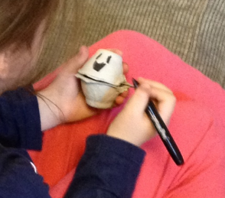**Activity: Expressing who we are on the inside.** (Equipment: egg cartons, tape, pens, paper and scissors)  
*Activity created by Asher* [*Litchwartz*](http://engagingtexts.com/members/alitschwartz/)*, Edah Berkeley.*

Attach two ‘cup’ pieces of an egg carton together on one side with tape to hollow ball that opens and closes. Make one for each student. They will then draw a face on the top half and cut out and attach some feet to the bottom one. This ‘little person’ is a little replica of themselves. Ask them to draw or make 2 things that say something about who they are and put them inside their little replica. Have the class share their ‘little people’ with each other – then invite them to take the things they have on the inside out and attach them to the outside.

*What do you think these hands tell us about the person?*

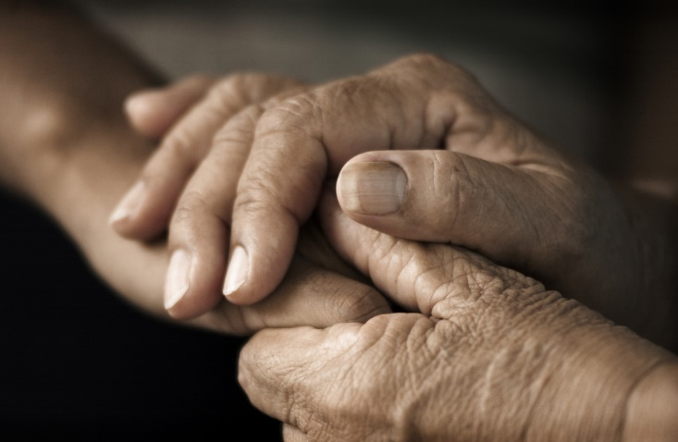

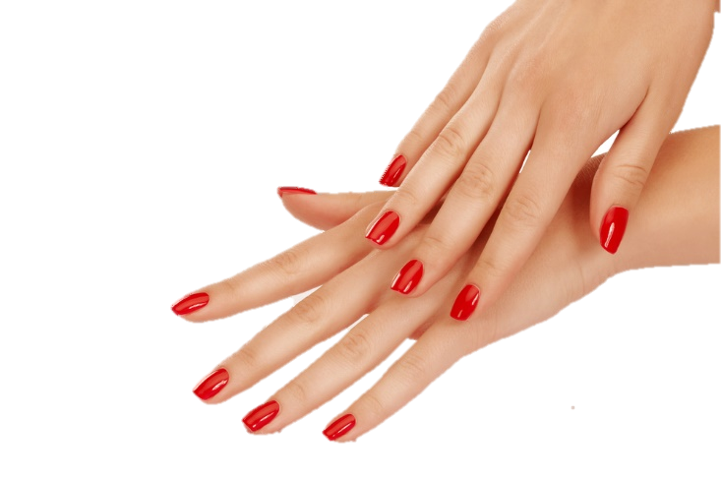





**Hidden and revealed in the Purim story***(this assumes familiarity with details of the story – you might want to retell it before you start)*

***For K-2***

* Which of these words would you use to describe the following people: Haman, Mordecai, Ester, King Ahashverosh.   
  *(Cut out versions of these characters and have the words written on card. As you read the words with the children, ask them to attach them to the character they think expresses this quality)*

Honest, Kind, Mean, Caring, Royal, Smart, Happy, Bully, Brave, Loyal, Interested in other people, Helpful, Confident, Clever, Doesn’t give up easily, Wise

As they place the words on a character, ask them how they think the characters showed this in the Purim story.

* Going back to each of these qualities – think together about how we have expressed these qualities in our own lives. (share examples).
* Are there times when you think people *hide* something about themselves in the Purim story and when they *show* something about themselves in the story?
* Do you think Ester ever showed us something about herself through *what she did* rather than by *what she said*? If so, what?

*Take it in turns to act out one of the characters from the story – but don’t tell us who you are acting. Can the rest of the class guess?*

***For Primary upwards***

**Hidden and revealed in the Purim story -Discussion questions.**

* When do you think people *hide* something about themselves in the Purim story and when do they *reveal* something about themselves in the story? (Name the ones you first think of… then do a second round – are there less obvious things that are hidden or revealed?).
* If the key figures (Haman, Mordecai, Ester, the King) were to wear three things on the outside that would reveal something about who they were on the inside, what do you think they would wear?
* If you were to wear three things on the outside that would reveal something about who you are on the inside, what would you wear?
* Is it possible that it was easier for Ester to do what she did because she was ‘dressed up acting a part’ rather than being herself?
* Do you think Ester revealed things to us about herself through her actions rather than by what she said? If so, give some examples.