DYNOMYCO™ is the result of 25 years of scientific research at Israel’s Volcani Center (ARO). DYNOMYCO™ was designed and formulated by a team of biologists, agronomists and soil and plant health scientists to help medical cannabis cultivators reach their plant’s full potential. Cannabis cultivators who use DYNOMYCO™ achieve higher yields, higher cannabinoid levels and higher terpene content. Plants treated with DYNOMYCO™ develop a more extensive root system and can thus take full advantage of the growing media.

DYNOMYCO™ contains 900 propagules per gram of two endomycorrhizal fungi: *Glomus intraradices* and *Glomus mosseae*. The combination of these two species is the result of extensive bio-assays which explored the effects of numerous sets of fungal genetics on various cannabis cultivars. DYNOMYCO™ has been tested in medical and recreational cannabis cultivation facilities in USA and Israel. When adding DYNOMYCO™ to the growing media, a 10-45% yield increase was observed compared to untreated plants.

Following are some of the benefits growers have experienced using DYNOMYCO™:

* Accelerated plant growth and time-to-harvest
* Improved nutrient uptake
* Increased levels of cannabinoids and terpenes
* Increased crop yields
* Fertilizer reduction
* Increased oil production
* Suitable for use in various growing media (soil, coco, rockwool)
* Easy application - at the start of the grow cycle and upon transplantation
* Suitable for use with synthetic and organic fertilizers
* Plant tolerance to suboptimal pH levels
* Plant resistance to stress
* Plant tolerance to salinity

(*Heading of graph):* DYNOMYCO Increases Cannabis Yields

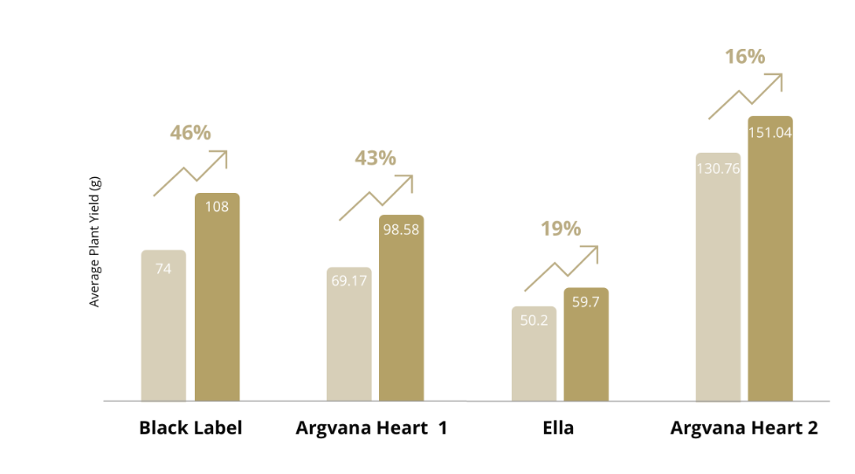

**DYNOMYCO™ Products**

DYNOMYCO is available in the following sizes for the home grower or large-scale cultivator:

100 grams - treats up to 20 plants

750 grams - treats up to 150 plants

20 kg - treats up to 4,000 plants

**DYNOMYCO™ Application Instructions**

DYNOMYCO™ is to be applied as a soil amendment.

1. Thoroughly mix DYNOMYCO™ into the soil until it’s spread uniformly.
2. Upon transplantation, apply DYNOMCYO™ by spreading at the bottom and sides of the planting hole.

|  |  |  |
| --- | --- | --- |
|  | CONTAINER SIZE | APPLICATION RATE |
| Seeds, clones or seedlings | 0.5 L | 1 tsp (5 gr) |
| 1 L | 2 tsp (10 gr) |
| 6 L | ¼ cup (52 gr) |
|  |  |  |
| Transplanting | 4 L | 1 tsp (5 gr) |
| 11 L | 1 Tbsp (13 gr) |
| 28 L | 2 Tbsp (26 gr) |

Do you have a question, request or would you like to try the product?

Send us an email to [info@dynomyco.com](mailto:info@dynomyco.com) or fill in the form below and we will be in touch shortly:

Last Name

First name

Telephone

Email

Message content

Submit request