**The effect of cluster’s size on intra-cluster ionic polymerization process**

Estefania Rossich Molina1 and Tamar Stein1

Fritz Haber Research Center for Molecular Dynamics, The Hebrew University of Jerusalem, Jerusalem Israel, 9190401

*Corresponding author: tamar.stein@mail.huji.ac.il, tel: +972-2-658-6108

**Abstract**

Polyaromatic hydrocarbons (PAHs) are widespread in the interstellar medium (ISM). Their abundance and relevance call for a clear understanding of their formation mechanisms, that are up to date not completely deciphered. Of particular interest is the formation of benzene, the basic building block of PAHs. It has been shown that ionization of neutral clusters can lead to intra-cluster ionic polymerization process that result in molecular growth. *Ab initio* molecular dynamics (AIMD) studies in clusters consisting of three to six units of acetylene modeling ionization events under ISM conditions, have shown maximum aggregation of three acetylene molecules forming bonded C6H6+ species: the bigger the number of acetylene molecules, the bigger the C6H6+ production. Those results open the question of whether clusters bigger than the ones studied so far, promote aggregation beyond three units of acetylene and whether larger clusters can result in higher values of C6H6+ production. In this study, we report results from AIMD simulations modeling ionization of ten and twenty acetylene clusters. The simulations show aggregation of up to four acetylene units producing bonded C8H8+. Interestingly, C8H8+ bicyclic species were identified setting precedent for their astrochemical identification. Ten and twenty acetylene clusters showed comparable reactivity rate.

**Keywords:** acetylene – polycyclic aromatic hydrocarbons – interstellar medium – molecular growth – benzene – *Ab initio* molecular dynamics – van der Waals clusters – ion-molecule reactions – astrochemistry

**Introduction:**

Polyaromatic hydrocarbons (PAHs) are widespread in the interstellar medium1-3. PAHs are believed to be ubiquitous and abundant in space, with interstellar IR spectra providing evidence for their presence in different areas by means of identifying their characteristic features in the spectra.4-7 PAHs are serving as a bridge between small organic molecules and large carbonaceous materials8 and thus play an important role in the chemical evolution of the ISM.

The routes for forming PAHs and other organic molecules known to be present in the interstellar medium are, however, not thoroughly grasped. Different mechanisms for PAHs formation and growth have been suggested, based for example on radical reactions9-15. One such example is the well-known hydrogen abstraction C2H2 addition (HACA) mechanism which is based on two steps: the first one is the formation of the aryl radical; the second one is the addition of acetylene. A repetition of these two steps causes PAHs to be formed. Other studies suggested the formation of naphtalene via reaction of phenyl radical and vinylacetylene, or, alternatively, via the formation of naphtalene ion through ion-molecule reactions between benzene cation and ethynyl radical16. The formation of benzene, namely the basic building block of PAHs, has drawn a great deal of attention, and different pathways for its formation have been proposed depending on the physical and chemical conditions17-20. Jones et al., suggested a barrierless route for benzene formation via reaction of ethynyl radical and 1,3-butadiene that is relevant to areas such as Taurus Molecular Cloud (TMC-1).21 In several astrochemical models, routes for the formation of benzene are based on ion-molecule reactions15, 22-25. Recently, Zhao et al. showed that molecular growth processes can occur via reaction between two stabilized propargyl radical at high temperature and diluted environments. Such reaction can lead to the formation of benzene molecule among other species.26

A number of experiments have demonstrated that the molecular growth can occur via intra-cluster ionic polymerization process.27-40 Acetylene clusters have been the starting point of multiple experiments, and upon ionization of these clusters, covalently bonded structures , such as benzene and cyclobutadiene cations, have been observed. In addition, molecular growth was also observed experimentally for a cluster of ethynylbenzene, where ionization lead to the formation of larger covalently bonded structures.32

To understand the intra-cluster ionization process at the molecular level, several studies performed *ab-initio* molecular dynamics (AIMD) simulations modeling different neutral clusters compositions. In agreement with experimental work, AIMD simulations demonstrated that molecular growth process occurs and that covalently bonded structures are formed.38, 41-43 It has been shown, that upon ionization, part of the cluster forms covalently bonded core structures, while the remaining molecules serve as spectators to the process. The role of the spectator molecules is important for the growth process as they change the potential energy surfaces and thus have catalytic role to the formation of various core structures. Moreover, they enable stabilization routes, as they can dissipate the excess energy via evaporation.38, 42 E.g., upon ionization of acetylene clusters containing up to six acetylene units, formation of bonded C4H4+ and C6H6+ including benzene cation was also observed.38 Ionization of small clusters (up to five units) containing acetylene and hydrogen cyanide also lead to molecular growth, in which three and four units bonded to form structures on the potential energy surfaces of C6H6+, C5H5N+, C7H7N+ and C8H8+. Likewise, when the clusters are built from acetylene and cyanoacetylene units, building blocks that can be found in TMC-1, the ionization process lead to bonding between three and four units.41 Many of the structures that are formed are aromatic structures and contain nitrogen atom within the ring or as a side chain, thus the structures are important from astrobiology point of view. Among the formed structures we observed benzonitrile cation, which was recently identified in its neutral form in TMC-1.44

AIMD results from previous studies, demonstrate the importance of the composition and size of the cluster in promoting aggregation to give chemically bonded structures.

Referring to pure acetylene clusters in particular, it has been demonstrated that the larger clusters (five and six acetylene units) enable higher rates of bonded C6H6+ formation in comparison to the smaller ones (three and four acetylene units). 38 Here, we devote our efforts to the study of pure acetylene clusters to understand the influence of a large number (ten and twenty, significantly bigger than the six studied up to date) of acetylene molecules in the aggregation process that produces (C2H2)n+ species following ionization of the van der Waals clusters. Specifically, we want to study the effect of the clusters size on the percentage of C6H6+ produced in the larger clusters versus the smaller ones. Additionally, we examine the extent of molecular growth in the larger clusters.

**Results:**

In order to answer the aforementioned questions, we studied large van der Waals clusters containing ten and twenty units of acetylene. We built forty structures: twenty decamers and twenty eicosamers (ten and twenty acetylene units, respectively), considering different relative orientations of the acetylene molecules that maximize the CH- $π$ interaction between hydrogen and the $π$ clouds of neighboring acetylenes, and then optimized them to obtain minima on the neutral potential energy surface (PES).40 In Fig. 1, we show examples of a decamer (Fig. 1 (a)) and an eicosamer structures (Fig. 1 (b)). The complete set of coordinates corresponding to the optimized AIMD starting structures are available in the SI. In order to model the ionization process, the optimized neutral structures were utilized as starting structures in the molecular dynamics’ simulations on the cationic PES.

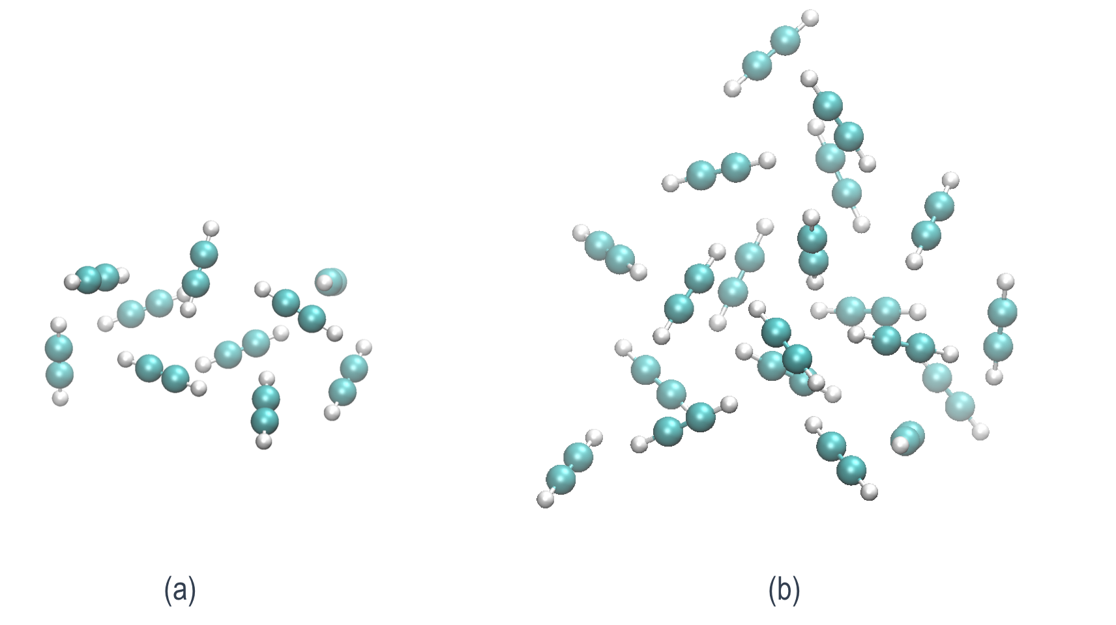

Fig. 1. Pure neutral acetylene clusters consisting of a) ten units of acetylene (decamer) and b) twenty units of acetylene (eicosamer).

The neutral cluster geometries are nonoptimal after vertical ionization, and they relax on the cationic PES giving place to bonded structures. Fig. 2, presents the structures after optimization on the cationic PES. In both cases (decamer and eicosamer), the clusters relax to core bonded structures in the C4H4+, C6H6+ and C8H8+ PESs (Fig. 2(a), (b), and (c), for the decamer and Fig. 2(d), (e), and (f) for the eicosamer) without any barrier. The core structures are solvated by additional non-bonded acetylene molecules. We note that the largest core structure that is formed upon optimization is a bonded C8H8+. The coordinates of all the 40 optimized cationic isomers are reported on the SI.

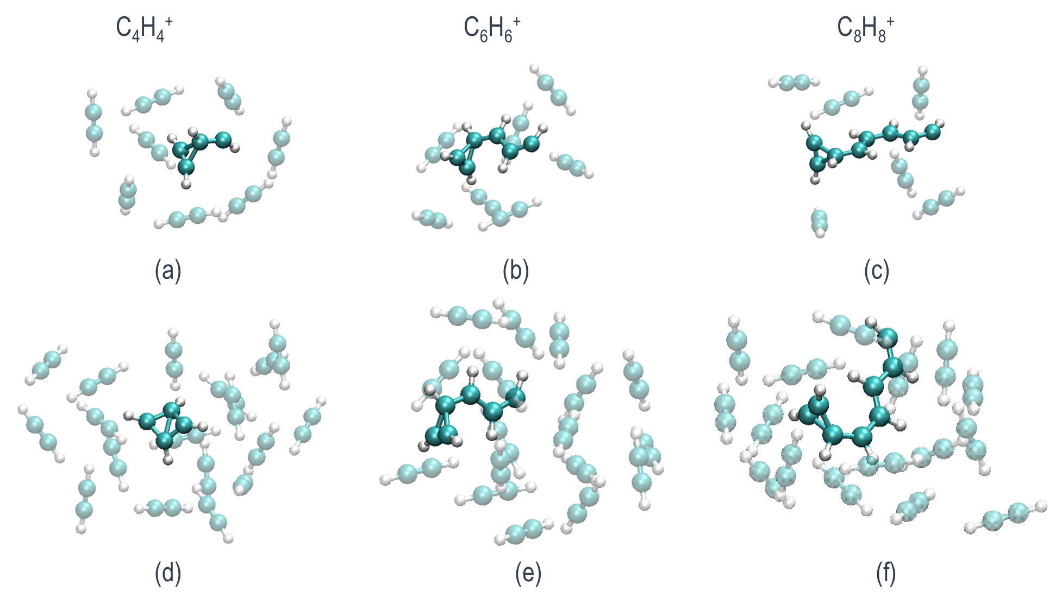

Fig. 2. (a), (b), and (c) are decamer clusters optimized on the cationic PESs with C4H4+, C6H6+ and C8H8+ core bonded structures, respectively. (d), (e), and (f), correspond to the eicosamer clusters that also show C4H4+, C6H6+ and C8H8+ core bonded structures.

**AIMD Simulations**

After ionization of the system and formation of the core structures take place, the system contains large amount of excess energy (~5 eV) that can be utilized to cross barriers on the PES. In order to study the evolution of the systems in time, and the potential formation of different products upon ionization, we us AIMD. The results of the AIMD simulations shed light on the structures that can be formed at the end of this process, and the relative probability for their formation. We present the structures of the most relevant mono and bicyclic molecules obtained and make a comparison between the decamers and the eicosamers as well as with smaller acetylene van der Waals clusters previously studied by means of AIMD under similar conditions.38 We analyze the extent of the molecular growth as a function of the number of acetylene molecules in a cluster, and conclude the relevance of the present results in the understanding of PAHs formation routes and astrochemical identification of cyclic molecules.

**AIMD of the acetylene decamer clusters**

For each of the twenty starting structures, 30 trajectories were run giving a total of 600 trajectories. All the trajectories were performed for 2.4 ps. For trajectories ending in structures where further potential rearrangements or growth were suspected, simulation time was extended up to 4.8 ps. The resulting core structures are shown in Fig. 3. From the 600 trajectories for this cluster size, we find that 56.5% of the trajectories lead to molecules product of the reaction of 2 units of acetylene to give bonded C4H4+. The vast majority of the C4H4+ species produced correspond to cyclobutadiene (Fig. 3 a), while a minor percentage is methylenecyclopropane (Fig. 3 b). In other trajectories, which represent a 40.8% of the trajectories, three units of acetylene react to give bonded C6H6+. Multiple C6H6+products were identified. Among them benzene (Fig. 3 h) and its conformational isomers fulvene (Fig. 3 e), dewar-benzene (Fig. 3 f) and benzvalene (Fig. 3 g) that are all known to easily interconvert into benzene. These products, were also identified in the products from the ionization of clusters up to hexamer in previous study, although in smaller percentages.38 Interestingly, here we observe higher percentage of the trajectories leading to bonded C6H6+, which reinforce the important role played by the cluster environment. In the remaining ~ 2.7 % of the trajectories we observe the aggregation of four acetylene molecules to give bonded C8H8+. While other clusters composition (namely mixed acetylene with HCN and cyanoacetylene) enable bonding between four units,41, 43 C8H8+ species were not obtained from acetylene hexamers previously studied and this clearly demonstrate that more than six acetylene units are required to observe aggregation beyond C6 structures from a pure acetylene cluster.38, 42 Once again, this emphasizes the role of the cluster environment not only for stabilization of the products but also in their formation.

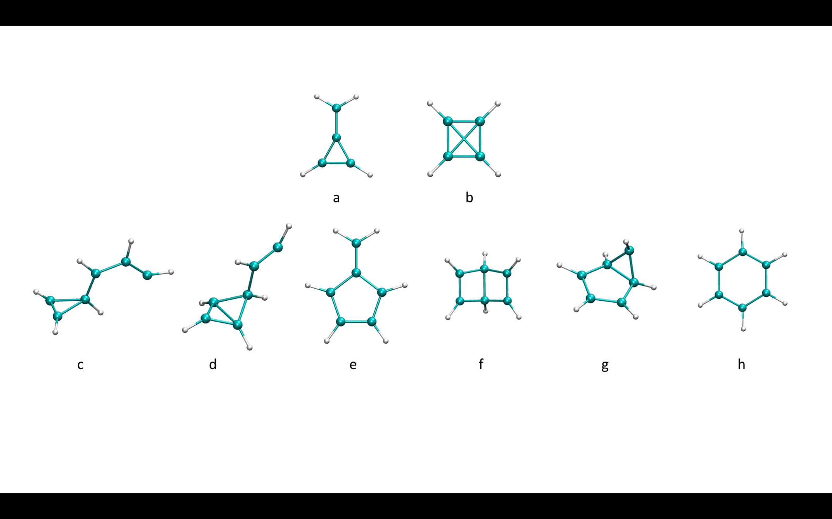

Fig. 3. Optimized bonded C4H4+ and C6H6+ core structures.

The biggest bonded structures obtained, correspond to the aggregation of four acetylene units to give C8H8+ isomers, shown in Figure 4. Among these products, we observe structures that contain a three (Fig. 4 (a)) or a four members ring (Fig. 4 (b)), as observed in C4H4+ and C6H6+ structures. Trajectories leading to C8H8+ where extended for an additional 2.4 ps. At these longer times, C8H8+ products further react giving bicyclic products with five-three (Fig. 4 (c)), five-four (Fig. 4 (d)), five-five (Fig. 4 (e)) and six-four (Fig. 4 (f)) members rings structures. C8H8+ is attributed in the literature to a benzene cation complexed to an acetylene molecule, which was also observed in our simulations.33 The PES for the formation of the structure in Fig. 4 (f), is presented in Fig. 5 along with the corresponding time of occurrence of each structure during simulation time. At the first stages of the simulation, two acetylene molecules are bonded together and a three-member ring structure (Fig. 5, 252 fs) which resembles the association product of acetylene and its cation observed by Bera et al. is formed. 45 Afterwards, an additional bond forms with a neighboring acetylene molecule and it results in a bicyclic structure (Fig. 5, 584 fs), which later reorganizes to a three member cyclic structure with a long chain (Fig. 5, 1067 fs). Similar structure is also observed when all four acetylene molecules are bonded (Fig. 5, 1592 fs). We observe a transition to a four-member ring (Fig. 5, 1729 fs) which reorganizes to give the final product.

A bicyclic C8H8+ molecule with five and three member rings (Fig. 4 (c)) was observed in two of the trajectories. One of the dissociates in a later stage into C5H5 and c-C3H3+ which was experimentally detected46 and its direct observation in the ISM is only feasible via ro-vibrational transitions due to the absence of pure rotational transitions46.

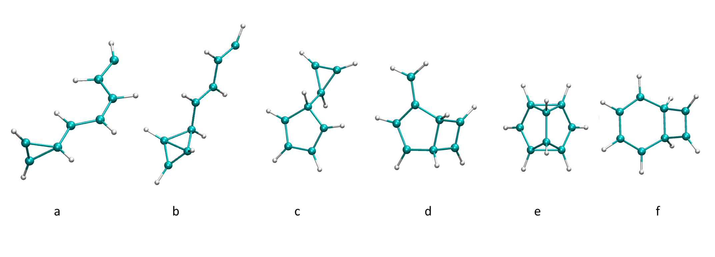

Fig. 4. Optimized bonded C8H8+ core structures.

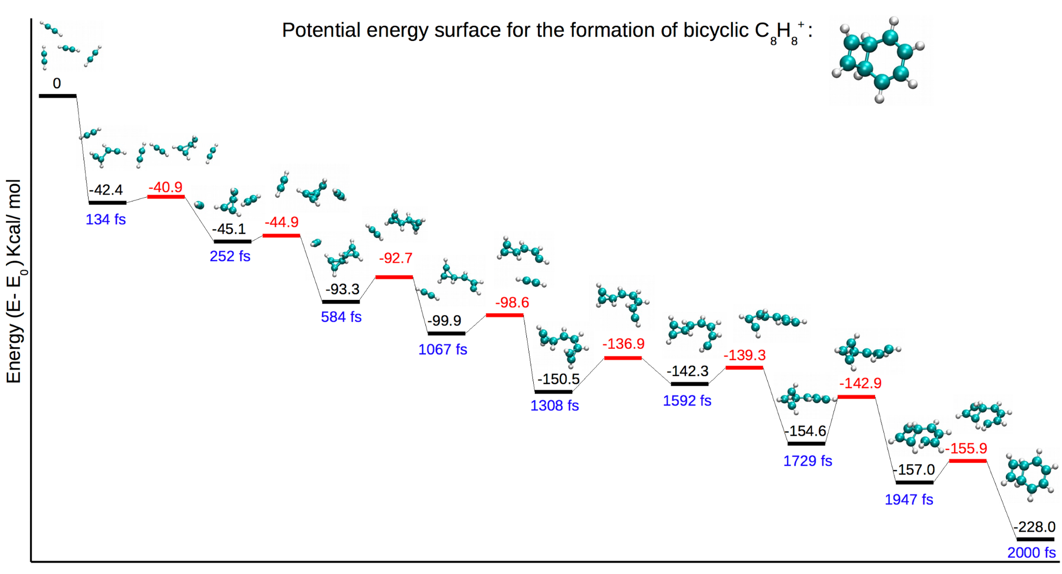

Fig. 5. Potential energy surface for the production of bicyclic C8H8+ structure containing a four and a six-member ring. The minima energies are reported in black, and the transition states energies in red. The corresponding time of each structure during molecular dynamics trajectory is noted in blue.

**Comparison of the growth process in different clusters sizes:**

Starting from twenty eicosamer optimized structures, we run a total of 600 trajectories of 2.4 ps. The results for this cluster size, are similar to the results obtained for the decamers clusters, no additional structures were found when the AIMD starts from eicosamer clusters. Fig. 6, shows a comparison of the amount of core structures obtained at the end of the AIMD simulations of different clusters sizes consisting of six, ten and twenty acetylene units. It can be seen in the figure, that in the case of hexamer clusters the majority of trajectories formed C4H4+ core structures, while the rest of the trajectories formed C6H6+ core structure. No C8H8+ structure was observed. In the case of decamer and eicosamer clusters, more C6H6+ was obtained with respect to the hexamer clusters. Additionally, these clusters sizes enable the formation of C8H8+ structures that were not observed in the smaller clusters. In fact, a previous photoionization mass spectrometry study, demonstrates that C8H8+ can be obtained from acetylene and it is identified by a peak at *m/z* = 104.38 The percentages for the formation of different structures result similar for decamers and eicosamers, no significant difference is observed between them.

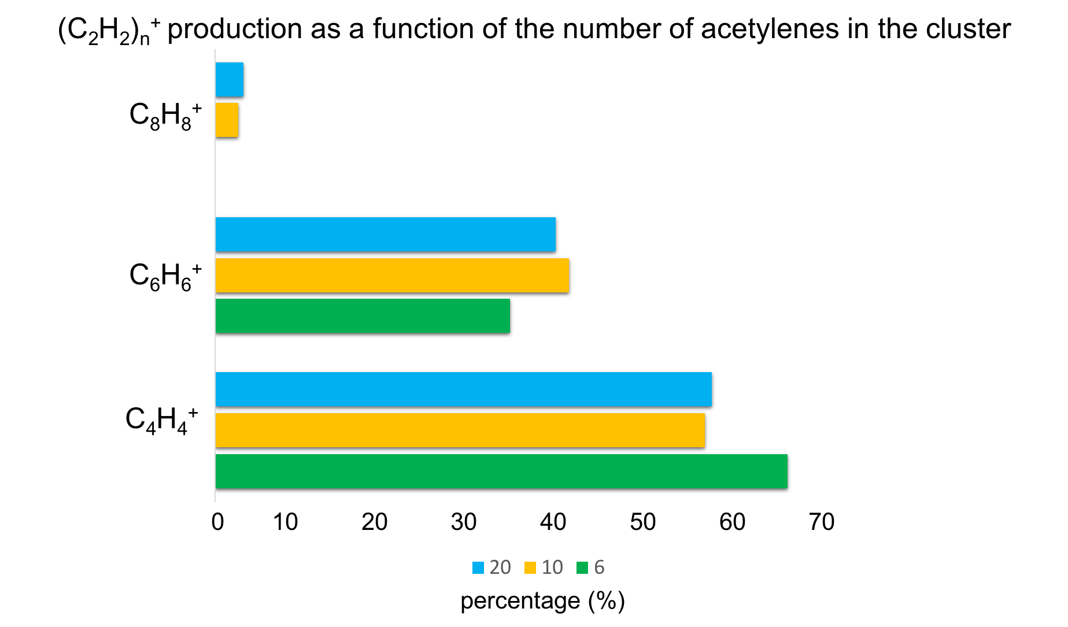

Fig. 6. Histogram of the percentage of (C2H2)n+ n = 2 – 4 bonded structures obtained upon ionization of the clusters as a function of the number of acetylene molecules in them. Percentages for six acetylene molecules were taken from the literature.38 Percentages for ten and twenty acetylene molecules correspond to the results of the present work.

C6H6+ /C4H4+ ratio is a way of expressing the capacity of molecular growth in acetylene clusters. Previous study found that C6H6+ /C4H4+ is ~ 0.3 for acetylene dimers and trimers, and C6H6+ /C4H4+ ~ 0.5 for tetramer and pentamer.38 Here, we find that C6H6+ /C4H4+ = 0.7 for decamers and also for eicosamers. Fig. 7, summarize the trend of the C6H6+ /C4H4+ ratio for pure acetylene clusters as a function of the number of acetylenes adapting the figure in a previous work,38 to add the results from the present study. The results demonstrate once again that a growing number of acetylene spectator molecules in a cluster promote molecular growth process by the process described above. As can be seen from the figure, decamers and eicosamers present comparable reactivity; eicosamers do not lead to further aggregation (e.g. C10H10+ and beyond) despite having double number of acetylenes. This suggests that the addition of acetylene molecules to the large clusters’ environment (beyond the decamers studied here) does not affect the environment substantially, and does not prompt additional growth. We note, however, that it is also plausible that clusters containing species other than acetylene can be involved in catalyzing the formation of structures bigger than C8H8+.

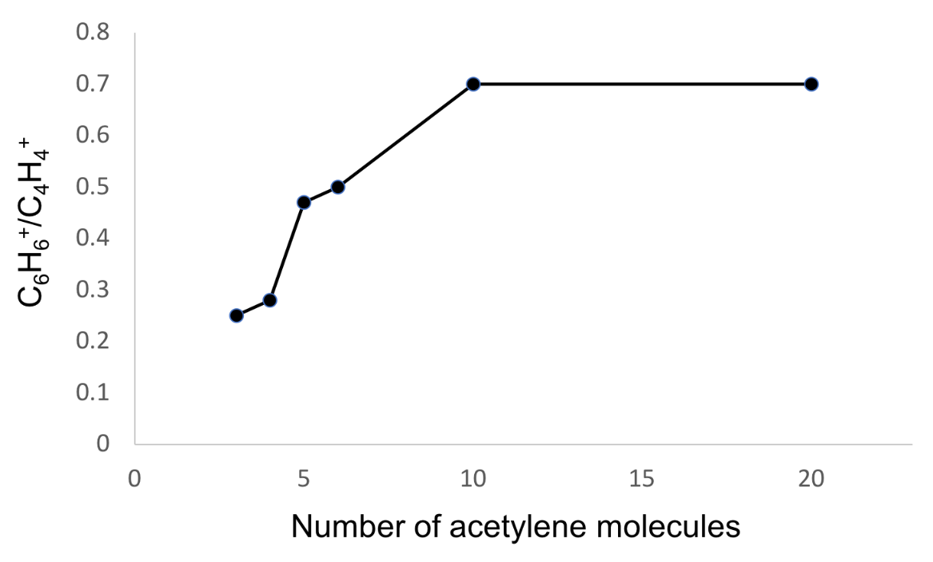

Fig. 7. C6H6+/C4H4+ ratio as a function of the number of acetylene units in the cluster.

**Conclusion**

We studied ionic polymerization processes on large clusters containing ten and twenty acetylene molecules in conditions relevant to the ISM by means of AIMD. Our results reinforce the observations of previous studies on clusters consisting of three to six acetylene units, that an increased number of spectator acetylenes promote molecular growth. We observe a larger C6H6+ /C4H4+ ratio for decamers and eicosamers, than what was previously found for acetylene clusters up to hexamer. Additionally, we observe C8H8+ structures, which were not obtained from smaller clusters (consisting of three to six units of acetylene). Eicosamer clusters exhibit results similar to the decamers clusters demonstrating that the additional ten acetylene molecules do not significantly influence the environment to promote further growth. Moreover, we predict the formation of mono and bicyclic structures with formulas (C2H2)n+ n = 2- 4 produced by ionic polymerization processes, that can serve as a guide for the search of new molecules in the ISM by astronomers.

**Materials and Methods:**

Every calculation in this manuscript was performed using Q-Chem 5.1 software.47 Optimizations of neutral and cationic structures were done with the wB97X-V functional48 and the cc-pVTZ basis set49. Using the same level of theory, we did vibrational frequency calculations to categorize the structures as minima or saddle points on the PESs.

Starting from the optimized minima structures of isomers of clusters consisting of ten or twenty units of acetylene, we ran AIMD simulations on the cationic PES utilizing ωB97 functional50 and 6-31G* basis set.51 The initial velocities for the dynamics were the corresponding thermal ones to the randomly sampled temperatures in the range 30– 80 K. Each of the 30 trajectories for each isomer was run for ~ 2.4 ps (time step= 1.21fs) unless otherwise stated. Twenty different starting structures were considered per system size (decamer and eicosamer) giving a total of 1200 trajectories.

**Conflicts of interest**

The authors declare no conflicts of interest.

**Acknowledgments**

This work was supported by the Israel Science Foundation, Grant number 1941/20.

**Graphical Abstract**

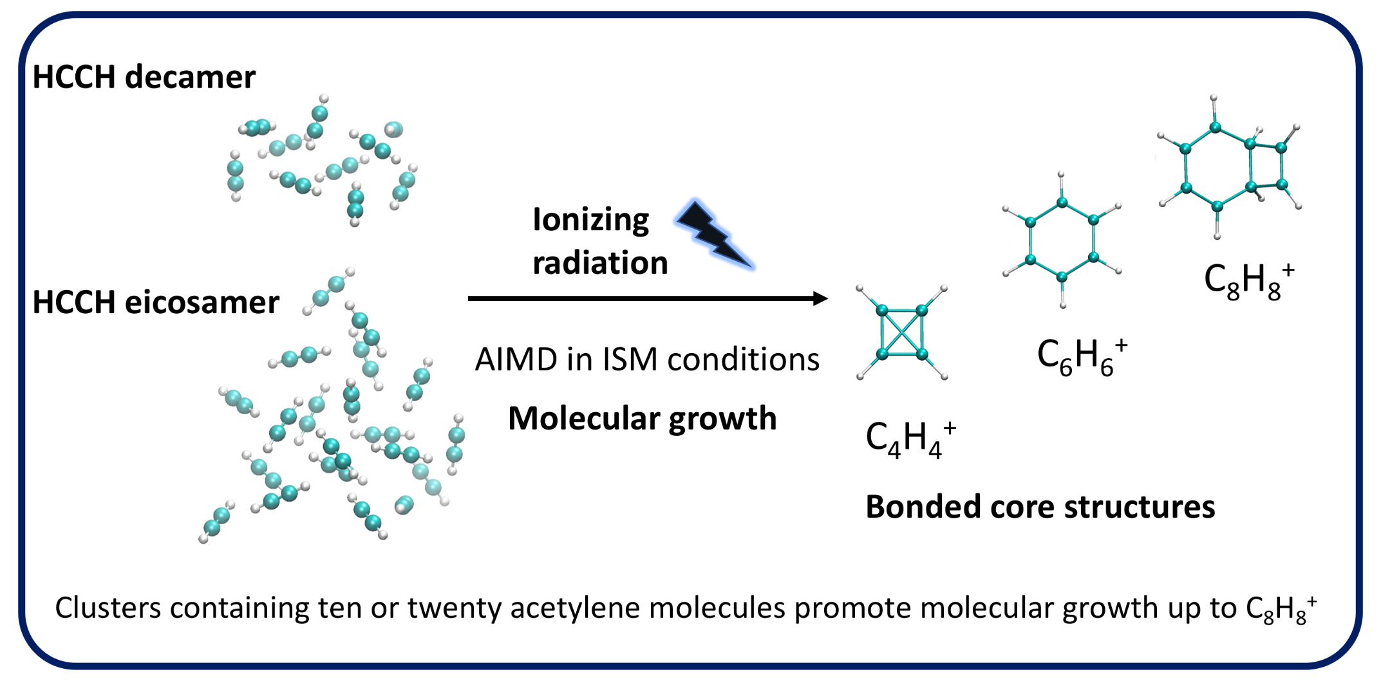

**References**

1. Ehrenfreund, P.; Sephton, M. A., Carbon molecules in space: from astrochemistry to astrobiology. *Faraday Discussions* **2006,** *133* (0), 277-288.

2. Rhee, Y. M., et al., Charged polycyclic aromatic hydrocarbon clusters and the galactic extended red emission. *Proceedings of the National Academy of Sciences of the United States of America* **2007,** *104* (13), 5274-5278.

3. Joblin, C.; Mulas, G., Interstellar polycylic aromatic hydrocarbons: from space to the laboratory. *Eas Publications* **2009,** *35*, 133-152.

4. Leger, A.; Puget, J. L., Identification of the 'unidentified' IR emission features of interstellar dust? *Astronomy and Astrophysics* **1984,** *137* (1), L5 - L8.

5. Allamandola, L. J., et al., Interstellar polycyclic aromatic hydrocarbons - The infrared emission bands, the excitation/emission mechanism, and the astrophysical implications. *Astrophysical Journal Supplement Series* **1989,** *71*, 733-775.

6. Tielens, A. G. G. M., Interstellar Polycyclic Aromatic Hydrocarbon Molecules. *Annual Review of Astronomy and Astrophysics* **2008,** *46* (1), 289-337.

7. Sellgrem, K., The near-infrared continuum emission of visual reflection nebulae. *Astrophysical Journal, Part 1* **1984,** *277*, 623-633.

8. Puget, J. L.; Léger, A., A new component of the interstellar matter: small grains and large aromatic molecules. *Annual Review of Astronomy and Astrophysics* **1989,** *27* (1), 161-198.

9. Frenklach, M.; Wang, H., Twenty-Third Symposium (International) on CombustionDetailed modeling of soot particle nucleation and growth. *Symposium (International) on Combustion* **1991,** *23* (1), 1559-1566.

10. Bittner, J. D.; Howard, J. B., Eighteenth Symposium (International) on Combustion Composition profiles and reaction mechanisms in a near-sooting premixed benzene/oxygen/argon flame. *Symposium (International) on Combustion* **1981,** *18* (1), 1105-1116.

11. Wang, H.; Frenklach, M., Calculations of rate coefficients for the chemically activated reactions of acetylene with vinylic and aromatic radicals. *The Journal of Physical Chemistry* **1994,** *98* (44), 11465-11489.

12. Marinov, N. M., et al., Aromatic and polycyclic aromatic hydrocarbon formation in a laminar premixed n-butane flame. *Combustion and Flame* **1998,** *114* (1–2), 192-213.

13. Parker, D. S. N., et al., Hydrogen abstraction/acetylene addition revealed. *Angewandte Chemie International Edition* **2014,** *53* (30), 7740-7744.

14. Hopf, H., From acetylenes to aromatics: novel routes – novel products. In *Modern Arene Chemistry*, Wiley-VCH Verlag GmbH & Co. KGaA: 2004; pp 169-195.

15. Peverati, R., et al., Nucleophilic Aromatic Addition in Ionizing Environments: Observation and Analysis of New C–N Valence Bonds in Complexes between Naphthalene Radical Cation and Pyridine. *Journal of the American Chemical Society* **2017,** *139* (34), 11923-11932.

16. Ghesquière, P.; Talbi, D., On the formation of naphthalene cation in space from small hydrocarbon molecules: A theoretical study. *Chemical Physics Letters* **2013,** *564*, 11-15.

17. Paul, M. W.; Karen, W., Benzene formation in the inner regions of protostellar disks. *The Astrophysical Journal Letters* **2007,** *655* (1), L49.

18. Woods, P. M., The formation of benzene in dense environments. *EAS Publications Series* **2011,** *46*, 235-240.

19. C. Brown, R. F., Some developments in the high temperature gas phase chemistry of alkynes, arynes and aryl radicals. *European Journal of Organic Chemistry* **1999,** *1999* (12), 3211-3222.

20. Hopf, H., et al., Formation of isobenzenes by thermal isomerization of 1,3-hexadiene-5-yne derivatives. *Angewandte Chemie International Edition in English* **1997,** *36* (11), 1187-1190.

21. Jones, B. M., et al., Formation of benzene in the interstellar medium. *Proceedings of the National Academy of Sciences* **2011,** *108* (2), 452-457.

22. Murray, J. M., et al., New H and H2 reactions with small hydrocarbon ions and their roles in benzene synthesis in dense interstellar clouds. *The Astrophysical Journal* **1999,** *513* (1), 287.

23. Paul, M. W., et al., The synthesis of benzene in the proto-planetary nebula CRL 618. *The Astrophysical Journal Letters* **2002,** *574* (2), L167.

24. Kaiser, R. I., et al., Reaction dynamics in astrochemistry: low-temperature pathways to polycyclic aromatic hydrocarbons in the interstellar medium. *Annual Review of Physical Chemistry* **2015,** *66* (1), 43-67.

25. Yang, Y., et al., Mechanism for the formation of benzene in the Titan’s atmosphere: A theoretical study on the mechanism of reaction. *Computational and Theoretical Chemistry* **2012,** *991*, 66-73.

26. Zhao, L., et al., Gas-phase synthesis of benzene via the propargyl radical self-reaction. *Science Advances* **2021,** *7* (21), eabf0360.

27. Tzeng, W. B., et al., A study of the unimolecular decomposition of the (C2H4)+3 complex. *The Journal of Chemical Physics* **1985,** *83* (6), 2813-2817.

28. Ono, Y.; Ng, C. Y., A study of the unimolecular decomposition of the (C2H2)3+ complex. *Journal of the American Chemical Society* **1982,** *104* (18), 4752-4758.

29. Shinohara, H., et al., Photoionization mass spectroscopic studies of ethylene and acetylene clusters: intracluster excess energy dissipation. *The Journal of Physical Chemistry* **1990,** *94* (17), 6718-6723.

30. Booze, J. A.; Baer, T., The photoionization and dissociation dynamics of energy‐selected acetylene dimers, trimers, and tetramers. *The Journal of Chemical Physics* **1993,** *98* (1), 186-200.

31. Coolbaugh, M. T., et al., Intracluster polymerization reactions within acetylene and methylacetylene clusters ions. *The Journal of Physical Chemistry* **1992,** *96* (23), 9139-9144.

32. Momoh, P. O., et al., Formation of covalently bonded polycyclic hydrocarbon ions by Intracluster polymerization of ionized ethynylbenzene clusters. *The Journal of Physical Chemistry A* **2014,** *118* (37), 8251-8263.

33. Momoh, P. O., et al., Structure of the C8H8•+ radical cation formed by electron impact ionization of acetylene clusters. Evidence for a (Benzene•+·Acetylene) complex. *The Journal of Physical Chemistry Letters* **2011,** *2* (19), 2412-2419.

34. Momoh, P. O., et al., Structure and hydration of the C4H4•+ ion formed by electron impact ionization of acetylene clusters. *The Journal of Chemical Physics* **2011,** *134* (20), 204315.

35. Momoh, P. O.; El-Shall, M. S., Stepwise hydration of ionized acetylene trimer. Further evidence for the formation of benzene radical cation. *Chemical Physics Letters* **2007,** *436* (1–3), 25-29.

36. Momoh, P. O., et al., Polymerization of ionized acetylene clusters into covalent bonded ions:  evidence for the formation of benzene radical cation. *Journal of the American Chemical Society* **2006,** *128* (38), 12408-12409.

37. Relph, R. A., et al., Structural characterization of (C2H2)1–6+ cluster ions by vibrational predissociation spectroscopy. *The Journal of Chemical Physics* **2009,** *131* (11), 114305.

38. Stein, T., et al., Ab initio dynamics and photoionization mass spectrometry reveal ion-molecule pathways from ionized acetylene clusters to benzene cation. *Proc Natl Acad Sci USA* **2017,** *114* (21), E4125-E4133.

39. Ahmed, M.; Kostko, O., From atoms to aerosols: probing clusters and nanoparticles with synchrotron based mass spectrometry and X-ray spectroscopy. *Physical Chemistry Chemical Physics* **2020,** *22* (5), 2713-2737.

40. Bandyopadhyay, B., et al., Probing Ionic Complexes of Ethylene and Acetylene with Vacuum-Ultraviolet Radiation. *The Journal of Physical Chemistry A* **2016,** *120* (27), 5053-5064.

41. Jose, J., et al., Molecular dynamics reveals formation path of benzonitrile and other molecules in conditions relevant to the interstellar medium. *Proceedings of the National Academy of Sciences* **2021,** *118* (19), e2101371118.

42. Stein, T.; Jose, J., Molecular Formation upon Ionization of van der Waals Clusters and Implication to Astrochemistry. *Israel Journal of Chemistry* **2020,** *60*, 1-9.

43. Stein, T., et al., Molecular growth upon ionization of van der Waals clusters containing HCCH and HCN is a pathway to prebiotic molecules. *Physical Chemistry Chemical Physics* **2020,** *22* (36), 20337-20348.

44. McGuire, B. A., et al., Detection of the aromatic molecule benzonitrile (c-C6H5CN) in the interstellar medium. *Science* **2018,** *359* (6372), 202.

45. Bera, P. P., et al., Association mechanisms of unsaturated C2 hydrocarbons with their cations: acetylene and ethylene. *Physical Chemistry Chemical Physics* **2013,** *15* (6), 2012-2023.

46. Zhao, D., et al., LABORATORY GAS-PHASE DETECTION OF THE CYCLOPROPENYL CATION (c-C 3 H 3 + ). *The Astrophysical Journal* **2014,** *791* (2), L28.

47. Shao, Y., et al., Advances in molecular quantum chemistry contained in the Q-Chem 4 program package. *Molecular Physics* **2015,** *113* (2), 184-215.

48. Mardirossian, N.; Head-Gordon, M., [small omega]B97X-V: A 10-parameter, range-separated hybrid, generalized gradient approximation density functional with nonlocal correlation, designed by a survival-of-the-fittest strategy. *Physical Chemistry Chemical Physics* **2014,** *16* (21), 9904-9924.

49. Dunning , T. H., Jr, Gaussian basis sets for use in correlated molecular calculations. I. The atoms boron through neon and hydrogen. *The Journal of Chemical Physics* **1989,** *90* (2), 1007-1023.

50. Chai, J.-D.; Head-Gordon, M., Systematic optimization of long-range corrected hybrid density functionals. *The Journal of Chemical Physics* **2008,** *128* (8), 084106.

51. Rassolov, V. A., et al., 6-31G* basis set for atoms K through Zn. *The Journal of Chemical Physics* **1998,** *109* (4), 1223-1229.