**Measurements of the overall heat transfer coefficient of several layers of insulation materials: an application to of greenhouse insulation with multilayer thermal screens.**

Abstract

The total energy saving effect of different types of insulation materials and their integration with greenhouse covers is determined by measuring of the total heat transfer coefficients through single and several layers of the thermal screens using the hot box method. The goal is to examine the different types of screen materials with a wide range of thermal radiation properties and their combinations incorporated with a dehumidification system in order to improve greenhouse insulation. It is shown that a high amount of IR radiation can be blocked by a cover combined with moveable thermal screens. The results indicate that with only one layer, the heat transfer coefficient is reduced by around 70% compared to covers without screens, while the contribution of additional layers containing aluminum foil strips may increase the performance to about 90%. The effect of IR radiation rejection on heat loss rate is examined, and it is found that low-emissivity materials have a greater effect on reduction of heat transfer coefficient than the material with IR reflective properties.

Key-words: overall heat transfer coefficient, thermal screens, heat losses, greenhouse insulation

1 Introduction

One of the major objectives of intensive greenhouse production is to provide environmental conditions conducive to maintaining the growth cycle throughout the year and in different regions around the world. Crop cultivation industry in greenhouses as in open fields, faces problems in resisting strong winds, rain, hail, snow, and other devastation risks. Despite all these obstacles, the crop industry must supply high quality products on a daily basis, according to market commitments. In order to receive predicted yields throughout the year, seedlings are planted continuously in different environmental conditions (sprouts are usually grown in isolation and transplanted in a greenhouse). In the modern greenhouse, round-the-clock automated cultivation processes are involved to increase productivity from each square meter of the greenhouse and minimizes risks in the production process.

The temperature of the air and soil in the greenhouse is very important for the cultivation of any crop and therefore, it is necessary to know not only the temperature limits for specific plants but also how to adjust the indoor conditions to the local climate outside at different seasons and periods of day. Day treatment is completely different from night care. During the day, photosynthesis is emitted along with an excess of heat. At night, it is cold (the day/night temperature difference is about 10º-15ºC) with high humidity (in desert areas, humidity can reach up to 70% in summer and 90% in winter). In warm countries, cultivation in a greenhouse usually occurs in winter, while screen-houses are used in summer. This growth process is not optimal, and methods for improving production are needed.

Analysis of conventional environmental control treatments within the greenhouse can help to determine the ways to advance the production process. Thus, in the winter, during the regular season, natural or forced ventilation is usually sufficient at daytime, however, heating is required at night (as in Europe as in Mediterranean region). In its turn, heating cause to intensive plant evaporation during night raises the need for a dehumidification process. In the summer, it is necessary to use cooling system during daytime; however, it is assumed that ventilation is sufficient at night. Traditionally, in cold regions natural ventilation systems are applied, air is supplied through openings in the facade, and is released through openings in the roof. Usually, a greenhouse is heated with fan heater pipes or heated sleeves and cooled using evaporative cooling systems (known as fan and pad cooling), and active dehumidification systems [1-8]. It is common to install vents for additional air circulation in order to unify flow conditions, release air stuck in the corners, and remove excess of moisture.

In total, contemporary systems are very energy-intensive, reducing cost effectiveness and increasing the amount of environmental pollution. Thus, a farmer today has two alternatives: keep the greenhouse as closed as possible using climate control systems or use the described above ventilation system. Both methods cause high fuel consumption, reduce cost effectiveness and increase amount of environmental pollution. This trend is reflected by the long-term status of the global energy resources on the one hand, and the growing awareness of environmental pollution and global warming problems, on the other hand. Moreover, lack of awareness for use of low-grade fuel that cause environmental pollution, which contributed to outbreak development of diseases due to high humidity. To remove the excessive humidity, ventilation of the greenhouse was increased, and as a result, fuel consumption was also increased, striking cost effectiveness.

As a substitute approach, moveable energy-savings screens, or thermal screens, are commonly used in closed greenhouses. These screens roll in and out easily in order to provide stable climatic conditions, such as internal shading and insulation. Starting from 70s, comprehensive studies have been carried out to evaluate the energy saving efficiency of movable thermal screens and shows that such systems are capable of about 40% energy saving with single layer of low-cost film or woven screens, and up to 60% saving with thermally opaque screens [Roberts (1970), Mears et al, 1974 , Roberts et al, 1981, Hüseyin, 2003]. Insulation of the greenhouse may be also obtained through various combinations of multi-layer covers and thermal screens. For example, adding the thermal screen reduces the heat transfer coefficient in the range from 38% up to 60% (HTFF[11], [12], [13], and [14]) for transparent and reflective sheets, respectively. This means that the heat loss transmitted through the thermal screens can be reduced by 80-90% using the materials available today.

Desired climate conditions are expressed in terms of thermal radiation, leaf temperature, plant transpiration, level of CO2 and dry foliage (HTFF [1] and [2]). Temperature and air humidity control in the greenhouse are required to ensure foliage temperature and transpiration rates at desired levels on one hand, and for the sake of plant health maintain foliage to be dry, on the other hand HTFF[3]. It is required to satisfy the uniform climate conditions at 18-23°C and 60-80% humidity to avoid physiological diseases for most of the plants. In most greenhouses, the acceptable foliage temperature is about 18ºC and the transpiration is about 40 gr/m2 per hour. The basic assumption of most studies considered humidity control greenhouse is that drying systems should not be used (HTFF[2] and [4]). However, the system, that incorporate a heating/cooling+dehumidification devises with proper combination of thermal screens, provides both, uniform indoor conditions and energy conservation. Minimize heat losses, the heating is used only to compensate heat losses through the covering materials, while ventilation, in order to remove the excess humidity and eliminate vapor condensation, is completely excluded using dehumidification system. In this way, the system provides a simplified and efficient infrastructure that is much easier to install and maintain. Moreover, the use of the system allows to extend the suitability period of the cover material due to the absence of condensation.

The main objective of this paper was to evaluate the properties of multilayer thermal screens in terms of resistance to infrared radiation and to determine the total energy saving under defined conditions. In order to compare the performance of a system that incorporate dehumidification with different combinations of screens, the heat transfer coefﬁcient of various commercial screens has been investigated using the hot box method.

In Chapter 2 provides discussion about energy saving screen materials were used in this study with the specific focus on IR opaque materials and their combinations. Measurement procedure of overall heat transfer coefficient is presented. Chapter 3 presents the overall heat transfer coefficient (U-value) for different combinations of commercial thermal screens. Conclusions are derived in Chapter 4.

2 Materials and methods

2.1 Energy saving screen materials.

In general, the energy saving properties of thermal screens are related to buoyancy, diffusion and convection heat transferring, the air permeability and the humidity transport [9-11]. However, using a dehumidification system allows to avoid condensation due to humidity excess, and therefore eliminates the need for air permeability and extensive ventilation [12-14]. In this case, knitted permeable screens are no more required, it is possible to use whole sheets of materials that are much cheaper and easier to manufacture. Thus, the material emissivity becomes the main factor for reduce energy loss when choosing a thermal screen. The energy losses are depending on the exchange of heat radiation between crop, dehumidification system, greenhouse screens and coverings, and the sky [15]. Depending on the time of day and weather conditions, unrolled screens layers with a sun/sky reflecting outer layer provide efficient insulation, particularly, keeping cool in summer (during the day) and warm in winter (overnight). At the same time, with using IR reflecting inner layer, part of the thermal radiation from inside of the warm greenhouse could be absorbed and emitted by the screen material.

To maintain steady state conditions (constant temperature and humidity) inside the greenhouse, the heat losses through the cover surfaces may be significantly reduced by using multilayer thermal screens. Multilayered thermal screens cause shading stripes, therefore, their use can be effective during times when there is no sun, including night time, as well as it may contribute to insulation of the greenhouse during extra heating hours in the afternoon. Obviously, different regimes of climate control in the greenhouse are needed for different climatic conditions. For cold climate regions, heating and dehumidification are required over the night time and natural ventilation over daytime is sufficient throughout the year. For Mediterranean climate region there are two energy-intensive periods: winter night time (heating and dehumidification) and summer daytime (cooling using chiller). During the winter daytime and summer night time the ventilation with/without dehumidification are only required. In tropical regions with hot and humid climate during almost the entire season, cooling (with dehumidification) regime is required throughout the whole period. Besides, the thermal transparent covering materials (with no thermal screens) are desired in order to transfer photosynthesis active radiation inside and remove excess heat out of the greenhouse. Thus, combining (collapse or expand) the different types of screens depending on the external weather conditions, afford proper control of light, temperature and humidity, maintaining the optimal levels for growing, prevent condensation in the greenhouse due to low outside temperature, and significant saving in energy.

Different types of commercial screens and their combination were tested in this work. Screens are made of polyethylene with stabilized UV protection (UVA) properties was used for both, top cover and screens. In order to inhibit thermal radiation, screen materials contain infra red reflected additives (IR) or, comprised of polyester film strip with a thin layer of aluminum strip. The aluminum strips reflect over 90% of the solar radiation. The amount of aluminum strips determines shading efficiency. For example, Aluminet IC-100, IC-30, IC-0 have shading factors 99%, 30% and "clear", respectively. In addition, Aluminium foil (FoAl) sheet was used as most IR reflective material. Thus, using different combination of covering with thermal screens allows control of shading ratio required for the plant development. As well as, using several layers of double-sided aluminized film provide almost 99% insulation in the summer, reducing solar gain and guarantees excellent insulation.

2.2 Measurement of heat transfer coefficient.

Thermal properties of insulation materials intended to use as thermal screens in greenhouse have been evaluated using hot box methodology by measure total heat flux passing through several layers of materials (Vitoshkin *et al*., 2019). This method is commonly used to determine the thermal properties of insulation materials for building design, but it is less suitable for greenhouses which are affected by unstable outside conditions (Feuilloley and Issanchou 1996, Papadakis 2000, Lu and Memary 2018). Here, assumptions of thermal equilibrium and homogeneous thermal properties are strictly required. This method does not consider the dynamic behavior of ambient conditions, low sky temperatures, or the effect of condensation. However, even with these limitations, the method can be efficiently utilized to determine the steady-state thermal properties of screens and to validate and compare the performances of the method under different conditions. Moreover, the results of this study will provide a wide range of empirical data for future development and validation of numerical simulations including dynamic models and modeling of thermal radiation in various geometries.

The overall thermal transfer coefﬁcient, U (W/m2ºC), is generally employed in calculating the rate of heat transfer passing through a single layer or through several layers of insulating material per unit area and per unit of temperature difference between the center of the box’s internal volume and the outside room temperature [18, 20, 23-25]. The U-value integrates the thermal conductivity of tested material; the convective fluxes from the interior of the box toward the room, including the air between the layers; and the radiative fluxes of long wave radiation through the several layers of materials and other elements of the box; the air current speed outside the box; and the sky temperature. All heat transfer mechanisms are interdependent, and the system ultimately reaches thermal equilibrium on each side of the screen. By assuming a stationary regime and uniform radiation properties of all surfaces (gray diffusive surfaces with uniform temperature and incident energy), the heat transfer passing through the screens can be calculated with the simple formula:

|  |  |
| --- | --- |
| $$U=(Q-Q_{l})/S(T_{in}-T_{out})$$ | (1) |

where Tin (ºC) and Tout (ºC) are an average bulk inside and outside air temperatures, respectively, S (m2) is the area of the screen surface, Q (W) is the energy provided by resistance, and Ql (W) represents side walls heat losses which was calculated from the following equation:

|  |  |
| --- | --- |
| $$Q_{l}=U_{w}A(T_{in}-T_{out})$$ | (2) |

Where A (m2) is the envelope surface area excluding the heated bottom surface. The hot box apparatus was built for empirical evaluation of the overall heat coefficient of the several layers of screen materials (Figure 1). To assess the U-value of the combined thermal screens, two insulated boxes were involved simultaneously in order to maintain the same external conditions for comparative measurements of different types and combinations of screens. The experiment was carried out during the 2015-2016 years in the central region of Israel. The measurements took place in a shelter in order to minimize the effect of unstable ambient conditions and also reduce the influence of direct solar and night sky radiation. The inside dimensions of the box are 1m×1m×1m (length×width×height), with layers set of 0.3m height above. The side walls of the boxes consist of polyurethane foam panel of 0.1m thick coated by thick wood covers for structural stiffness and additional insulation. The screen layers are assembled under the interior of a unit volume, with distance between each layer set of 5cm height (according to Nijskens et al. (1984), this is a sufficient distance to establish stable thermal conditions). The screens where installed between squares polyurethane frames with inner opening of 1m2 and thickness of 10cm, and clipped by springs. It is possible to install up to six frames in different material combination. The bottom of the box was heated with uniform electrical resistance by multi-pass s-shape flexible heating wire and covered with steel plate in order to provide uniform heat flux through the 1m2 surface.

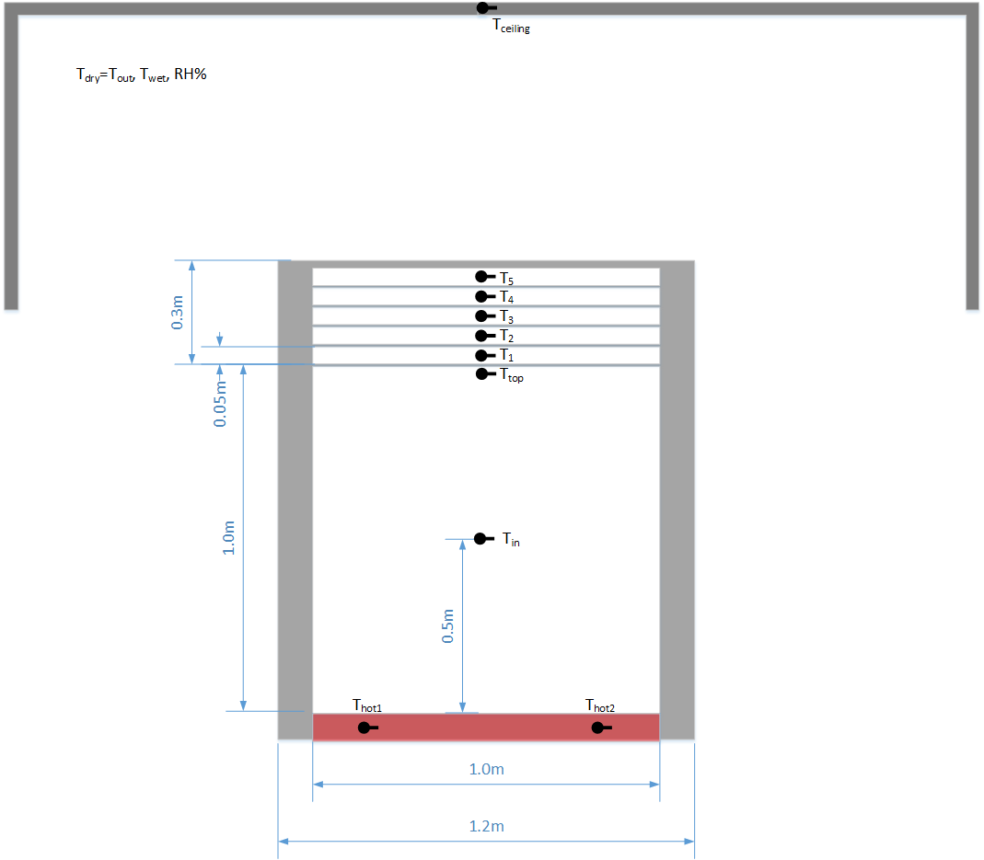

Figure 1: Schematic view of the hot box under the shelter, the box cross section and dimensions, locations of thermocouples.

Heat loss through the hot box side walls was calculated by measuring the internal and external temperatures of the box using a 0.1m thick polyurethane plate on the upper frame. The heat losses through the four walls were measured during the whole period of the tests, calculated using Equation 2 and averaged over eight measurements. The heat transfer coefficient, Uw, was taken as 0.4W/m2ºC for each box with about 3% of relative uncertainty.

Power of the resistance heater was regulated by changing the voltage of a variable power transformer (24 Watt) using stepper motor controlled by programmed data-logger, which allowed incremental change of power with high accuracy. It usually took two hours to balance the system. After stabilization, the power value remains constant with standard error up to 5%. The measurements were managed by a cellular application. Such arrangement enabled incremental change of power with high accuracy.

The temperature measurements were made using copper-constantan thermocouples of T-type. The precision of the temperature measurements was about 0.05ºC and it is due to time averaging and thermocouple precision. The locations of all thermocouples are illustrated on Figure 1: two thermocouples were installed at the heated bottom plate, one thermocouple measured inside temperature, Tin, was located in the center of the internal volume of the box, the thermocouple measured the temperature of the top of the box, Ttop, was located right under the first layer of the screen, and five thermocouples were inserted inside the air layer between each screen. The ambient temperature, Tout, was recorded by a meteorological station. The ambient indicators (Tdry=Tout, Twet, RH%) was mostly followed by outside indicators, whereas the values obtained during stable periods were taken for U-value calculations during the test period. The measured parameters, relating to the hot boxes temperatures and the external climate conditions, are indicated in Figure 4a.

2.3. Measurement procedure.

The inside temperature was established by six set-point temperatures and maintained for 8 hours accordingly. The set point temperatures were increased from 40ºC up to 55ºC in steps of 3 degrees. The measurements were conducted during two days under the conditions of each test. Temperature and supplied energy were recorder every 8 hours, however, the averaging (the calculations of heat transfer coefficient) was performed only for the last 2 hours when the stable heat flux through the system after initiating heat supply was established. The measurement readings were scanned every second and averaged over every 1 minute via data-logger. Figure 4 illustrates the results were obtained when the boxes were covered by polystyrene foam representing insulation case. For the system with several layers of thermal screens, the inside temperature stabilizes within one hour, while, for case without thermal screens (or a single screen), up to four hours is required to attain equilibrium. The outside temperature was varied between 25-32°C depending on the time of day and outside environmental conditions. Since the heat transfer coefficient can be determined in short term period when all environmental parameters are held stable and uniform, the following calculations have been employed, only for the measurements taken during the period of stable inside and outside temperatures. Figure 4a shows the typical test results of inside and outside temperature measurements of both boxes, corresponding to two set points 49ºC and 52ºC during the last two hours chosen for further data processing. It can be seen that the internal temperatures are in good agreement with the set temperatures for both boxes. The standard deviations of averaged values are σ=0.15-0.2 and σ=0.012-0.015 for Tout and Tin correspondently. Figure 4b illustrates the corresponding temperature differences between inside and outside temperature which are kept constant during the considered time period; and calculated U-values as function of time. The time averaged temperature differences are dT=31.2ºC and 37.2ºC with σ=0.15-0.19, the time averaged heat transfer coefficient is U=0.37 W/m2 ºC with σ=0.03-0.04 for all cases. This high accuracy of the results justifies the use of the current hot box methodology for measuring the overall heat transfer coefficient.

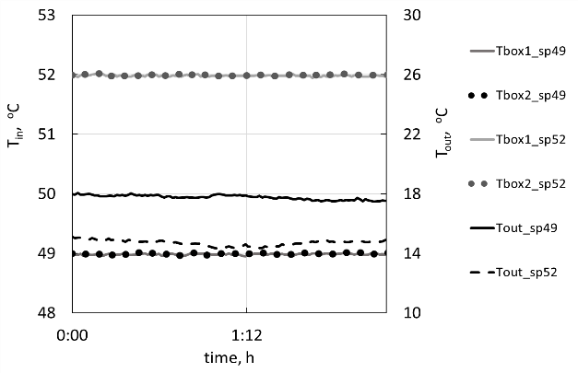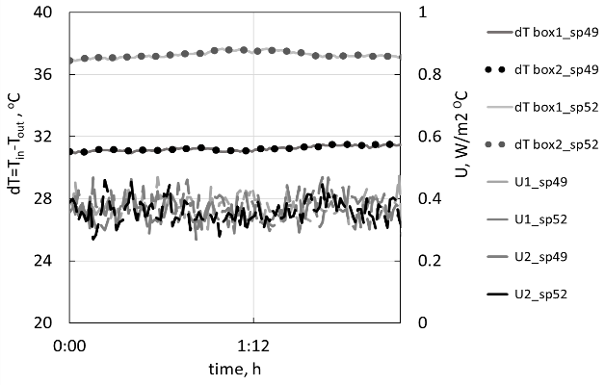

Figure 4: Typical test results for box covered by polystyrene foam for two set points 49ºC and 52ºC: a) time variations of outside temperature and inside temperature for two boxes; b) calculated time differences and heat transfer coefficient.

3 **Results**

The overall heat transfer coefficients as a function of thermal screens number are presented in Figure 5. The presented results correspond to experiments with polyethylene cover (UVA) and added several layers of IR screens, thermal screens of type IC-100, IC-30, IC-0 (IC-100 contains maximum aluminum strips, IC-30 gives 30% shading, IC-0 is a clear screen), and FoAl film. The figure shows that the heat transfer coefficient decreases rapidly for all screen types. The reduction of the overall heat coefficient can reach 30% by addition only one clear screens such as IR and IC-0, and up to 70% for aluminum-containing screens such as IC-100 and FoAL. Following the adding of screens, the coefficient decreases by approximately 10%. General approximation can be described by power law *U*(*n*)=8*n*-*m*, while the values of decay index, *m*, ranged from 0.6 to 1.4 depending on insulation properties of tested materials. These results are in good agreements with results for three screens with IC-100 coatings (representing strong insulation case) obtained by Euilloley *et* *al*., 1989. According to our results, the overall heat transfer coefficients can decrease by less than 90% when five layers of FoAl film are used.

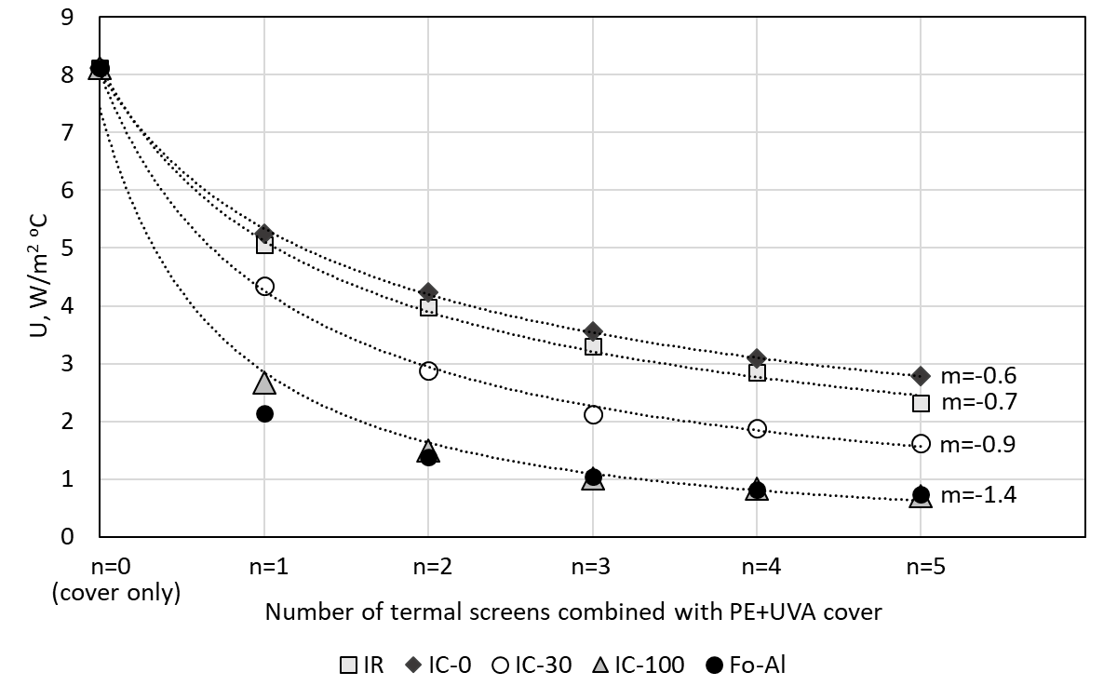

Figure 5. Overall heat transfer coefficient for UVA (polyethylene) cover and added thermal screens of type FoAl, IC-100, IC-30, IC-0 and IR; *m* represents decay index of power law trend lines *U*(*n*)=8*n*-*m*.

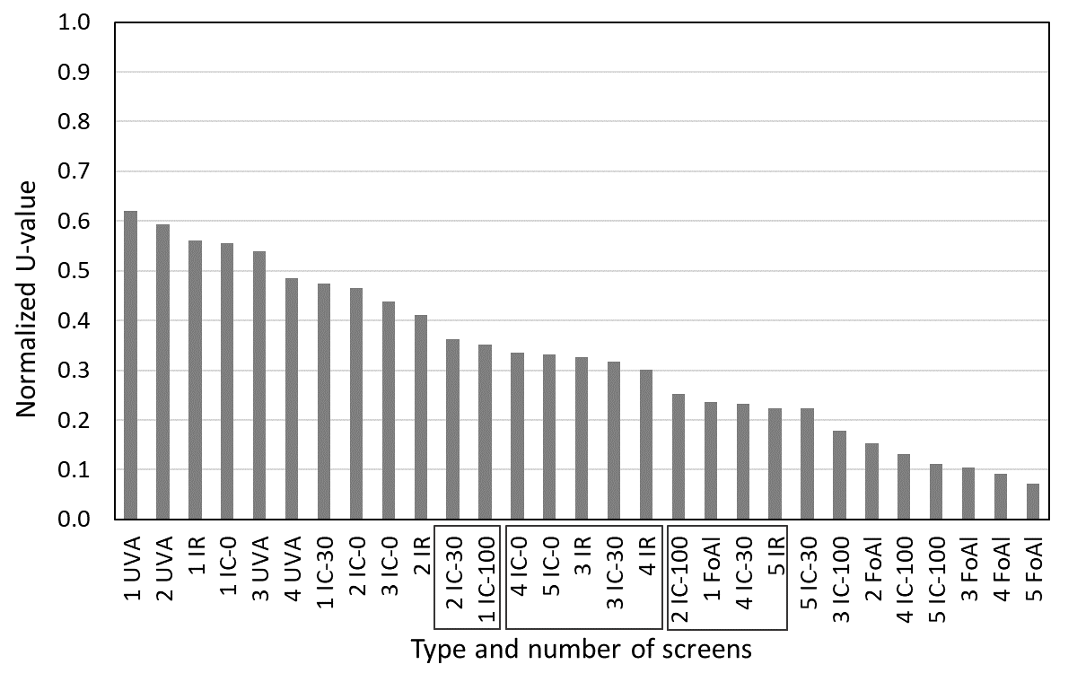

Figure 6: Normalized overall heat transfer coefficient for IR (infrared reflective) cover and different types of thermal screens (UVA, IR, IC-0, IC-30, IC-100, FoAl) with one to five layers. Rectangles on x-axis denote the sections with similar U-values.

The values of heat transfer coefficient for different number of layers (from one to five layers) and types of thermal screens are normalized by the value measured using one IR cover (*UIR*= 7.44W/m2C, σ=0.39, averaged over six set points and ten experiments) are presented on Figure 6. In order to compare different material sets and identify the relative insulation performance of each set of material layers, the results of all tested sets were organize in descending order.

It is shown that most effective insulation provide set of three to five FoAl layers, as expected, while U-value for four IC-100 layers (containing maximum amount aluminum strips) is higher about 30%. Regardless of monotonic behavior of U-value, there are three sections having close to equal values. These section are denoted by rectangles on x-axis. It is seen, for example, that one FoAl layer is permutable with two IC-100 layers or four IC-30, or 5 IR layers, depending on the availability of materials and/or shading requirements.

It is also seen that even for clear screen materials, the reduction of overall heat coefficient varies between 40% and 60% approximately. This conclusion is relevant if both, insulation and transparence properties are important simultaneously, for example, heat conservation during day time.

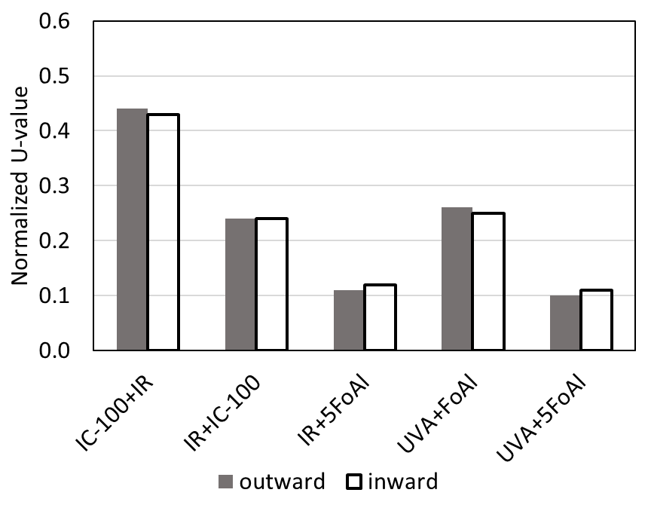

Figure 7: Normalized overall heat transfer coefficient for different combinations of low emissivity materials. The x-axis labels indicate: cover material + screen with reflective surface facing inwards/outwards to hot-box interior.

Figure 7 illustrates the series of tests were performed in order to evaluate the effect of radiometric properties of materials. According to results of theoretical investigation by Nijskens *et* *al*., 1984, the transmittance has prevailing effect on thermal screen losses comparing to the reflectance and emissivity. Therefore, the low-emissivity materials IC-100 and FoAl (ε=0.04) with highest thermal insulation properties were examined in different combination with UVA (ε=0.31) and IR (ε=0.64) covers and with reflective (glossy) surface facing inwards/outwards to the hot-box interior. It is shown that the heat losses can be reduced by 50% when the inner IC-100 layer is placed under IR cover compared to the case when the inner IR screen is below the IC-100 cover. These results are in a good agreement with theoretical predictions of Nijskens *et* *al*., 1984. The following increasing of the insulation by adding five FoAl screens reduces the heat transfer coefficient by an additional 50%, as described above. The same results are obtained for UVA cover. These results indicate that IR reflectance, as well as reflective direction, has no effect on the U-value.

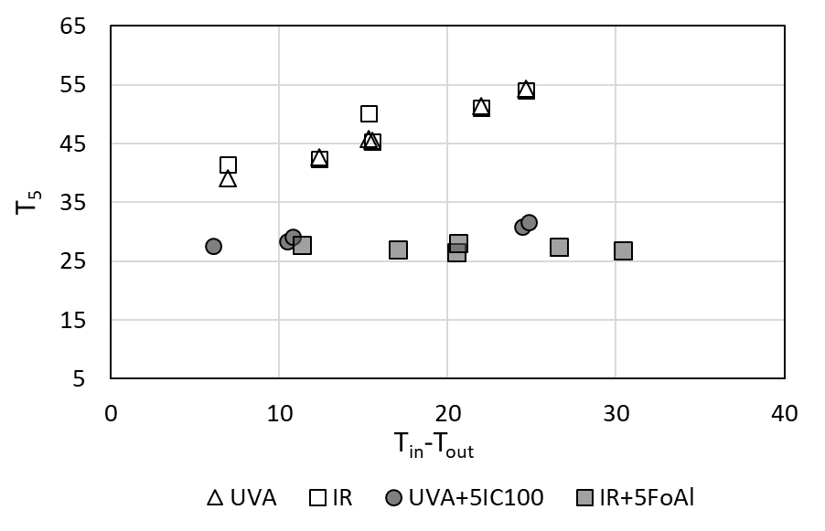

Figure 8: Temperature of air under a cover material installed on the top of the hot-box.

Considering the above observations, we examine the effect of insulation and reflectance on the temperature under the cover. Figure 8 show the variation of temperature measured under the cover, *T5* on Figure 1, as a function of difference between inside and outside temperature for two types of cover material, UVA and IR. It is seen that in the absence of insulating screens the temperature is linearly increasing with the temperature differences, while is remain constant when strong insulation is installed. Similar behavior are observed for both types of materials.

**4. Conclusions**

The hot-box method has been employed for measurements of overall the heat transfer coefficient with high accuracy. The method allow evaluation of heat losses through different types of multi-layer thermal screens and comparisons between different combinations of the screens. The multi-layer thermal screens technology could be further extended to provide improved greenhouse insulation.

Use of the screens can reduce the overall heat coefficient from 70% (for one layer) up to 90% (for multi-layer screens), thus reducing energy consumption in the greenhouse, accompanied with smaller environmental impact, as well as providing optimal breeding conditions.

The results show that best insulation performance is provided by the set of three to five FoAl screens. It is also shown that there the sets of materials that can be replaced by other sets with similar U-value, depending on the availability of materials and/or shading requirements.

The results show that using the low-emissivity materials installed under the cover can reduce the heat transfer coefficient by 50%, while reflective direction has no effect on the U-value. These results are in accordance with theoretical predictions as well as demonstrate the availability of the presented measuring method. The presented results are also can be used for validation of theoretical and numerical (CFD) models, which allow comprehensive comparison between various material combination and different environmental conditions in order to improve performance for cooling/heating and dehumidification systems. By significantly reducing year-round energy consumption, the system contributes to sustainability as well.