Exelot - Exit-Valley Campaign
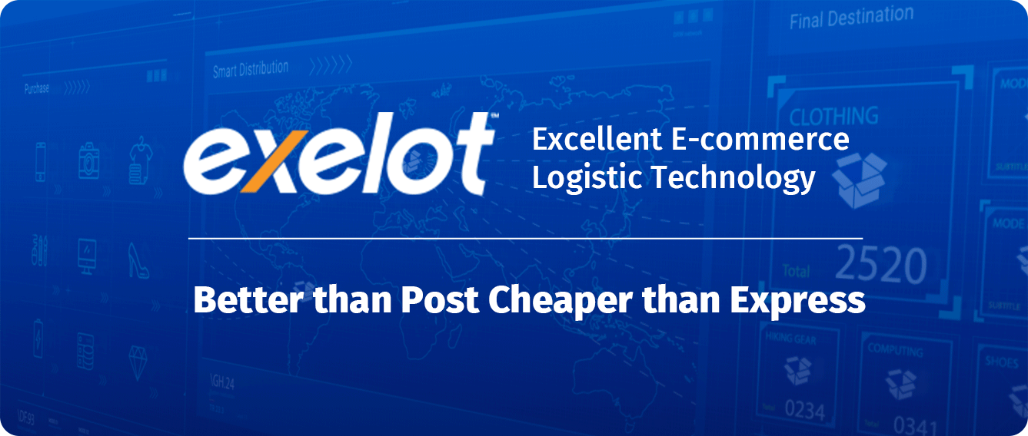

- Exelot has developed a breakthrough / pioneering digital platform (SaaS) for shipping and delivering e-commerce products to cross border markets.
- Exelot platform serves e-commerce marketplaces, online retailers and forwarders, making the logistic chain quick, reliable and affordable.
- Exelot team is highly experienced, the company is growing 200%-300% YoY, and is penetrating a rapidly growing market, valued at 60 billion $.

Campaign highlights

A Breakthrough global shipping technology
The international shipping market often faces a “bottleneck” in the form of outdated, slow postal services or overpriced shipping services, which make purchasing less attractive for buyers, and do not offer a suitable solution for sellers. Exelot disrupts this market by allowing online platforms and e-commerce stores a service which is faster and more reliable than post services. Furthermore, it is a far more affordable than express rates. The platform developed by the company offers a first of its kind system, specializing in cross-border B2B2C shipping, and offering a far superior alternative, both tech-wise and financially, in the market niche between post services and express companies (Fedex, UPS, DHL).

Answering the need of a huge and quickly growing market
Worldwide, online purchasing is rapidly taking over the place of physical store sales. This global shipping market, estimated at around 60 billion dollars in 2019, is growing at an exponential rate each year. Purchasing online from foreign countries has grown from 44% in 2014 to 77% by 2018. This growth is expected to continue in the next decade and turn Exelot’s unique technological solution attractive for both e-commerce sites and logistics suppliers, as well as giant companies from the fields of shipping and e-commerce, who are searching for advanced logistical tech solutions.

An end-to-end logistic solution
Exelot’s system’s uniqueness lies in offering an innovative digital solution, within one platform, for all steps of the international logistics chain. The platform supports: pick-up’s, smart consolidations, AI and machine learning technologies for optimizations, and a smart multi-vendor based method. The platform combines shipping options via land, air and sea, and accompanies all steps of shipping, from pickup via warehouses, terminals, customs clearance - and especially at the distribution, delivery and tracking. This way, Exelot provides e-commerce marketplaces and e-retailers with a complete solution, allowing them to not waste time and money on logistics, as well as to increase their sales in new target countries.

Investing in an already operational, quickly growing company
Since its establishment, Exelot has shown a growing rate of x2.5 - x4 times every year, in the scope of sales and shipments carried out by the platform. The activity has grown so far from 500 shipments a month in March 2017, to a monthly volume of over 50,000 shipment in the summer of 2018 and is expected to reach over 500,000 shipments yearly by the end of 2019. The company provides service through its platform to AliExpress suppliers, to other small-mid marketplaces, e-retailers and forwarders from China and Hong Kong directly to Israel. It currently serves 18 e-commerce sites, both directly and via a frontal boned-hub in Cyprus. Exelot is currently operating towards extending activity to other countries, including: Greece and the Balkan, Romania, Italy, Sweden, Denmark, Ukraine and Belarus; During 2020, the company will also enter to additional countries in Europe, the US, par ts of East Asia and Africa.

IP with great potential for value rise and leading the global B2C shipping market for e-commerce
The logistics market is considered technologically conservative. Exelot’s technology has large scale benefits in this field for users of the system. From sellers and shippers, to forwarders, customs brokers or logistics warehouses. Exelot’s technology addresses an ecosystem characterized by great needs for investments, mergers and acquisitions. It is expected to appeal to various segments of the logistics, shipping, e-commerce and software markets. This might include marketplaces such as Alibaba and JD or Wish of China, Amazon, Ebay, Lazada, the Indian FlipKart etc., as well as service platforms for e-commerce sites such as Shopify, Magento, Shopware and others, software giants such as SAP and Salesforce. Furthermore, the major maritime shipping players have recently started to develop their international e-commerce shipping, doing so after realizing the huge market potential of e-commerce, especially with the expected rise in shipping larger and heavier products overseas by sea freight.

A team of experts in the fields of shipping, logistics and e-commerce
The company is comprised of an experienced and solid team led by CEO Daniel Cohen. Daniel has a vast experience in business development, marketing and sales, in high tech and commercial companies (LocatioNet, Aerialink, Mey-Eden and others). Daniel served as the VP of Business Development and Strategy for the Israel Post. Daniel has extensive experience working with overseas markets, including Europe, Asia and the US, and in innovative technological projects overseas. Exelot’s director of technology (CTO), Yitzhak Varsanno, served as Chief Programmer at "MAANA" in the IDF (formerly part of Mamram) and has experience in both large companies (Partner, Applied Materials) and as part of startups. Eli Koretsky, Exelot’s Business Development & Sales Manager for China, has 10 years of experience in logistics dealing with China and has served as the Israeli market manager for the Chinese Alibaba / AliExpress group; The company’s distribution and customer service manager has extensive experience in distribution and customer service including FedEx. Mariano Ptacsinsky, the CFO, has many years’ experience in large financial companies, securities, financing IT and international projects including with Peninsula and Leumi Card in Israel.

The Need

In recent years, online shopping is increasingly replacing physical sales in stores, and the volume of e-commerce shipments is growing accordingly. In Israel, for instance, existing fashion store chains have sustained a significant decrease in business, due to the rise in scale of fashion shipments ordered online from overseas. American fashion giant GAP will soon recommence its operation in Israel, but this time not by operating stores - a model that has previously failed for the brand in the local market - but through an e-commerce website only. This choice signifies just how much the future of commerce lies online and is in fact dependent on logistics and shipping services.
Despite this, over 90% of e-commerce shipments are still distributed worldwide via old-fashioned postal services, most of which are characterized, as anyone who has ever shopped online knows, with inefficiency, poor speed and relatively low credibility, with many shipments falling “between the cracks”, generating financial damages or lack of potential income for sellers, and of course, dissatisfaction and lack of trust among end users, which hurt future sales.
In Israel, for example, in a harsh report issued by the State Comptroller, around 80% of the people surveyed claimed to have experienced some damages due to the poor functioning of the postal service. A specific report regarding this issue by the Universal Postal Union (UPU), from 2018, shows a greater figure of 25% of all customers, who demand better shipping times.
This frustrations expressed by both sellers and buyers has good basis: currently, transfer times for deliveries via postal services range from 10-30 days and sometimes more, with low satisfaction rates among both shippers and customers, out of which – according to postal sector inquiries - a third has complained about the shipping timeframes, the delivery method, and limited or non-existent tracking options.
E-commerce retailers suffer from this reality as they would like to shorten the delivery times between countries as much as possible, to an ideal standard of 4-7 days per shipment - including the times of flight, customs handling and distribution. Various express service shippers do offer a fast 3-7 days service, but usually at a very high cost, which many times exceeds the price of the product itself, and therefore not affordable.
In addition, the logistics market suffers from outdated, old-fashioned technological systems, which are mainly suitable for the B2B market, but not developed enough to meet the needs of the B2C market. These systems rely on the use of printed shipping documents, do not allow proper tracking along the whole logistics chain, and require manual handling, high fees for handling VAT and customs duty payments, when transporting products across borders.

. Fix the headline of the slide below – Domestic Delivery Vs. International Experience

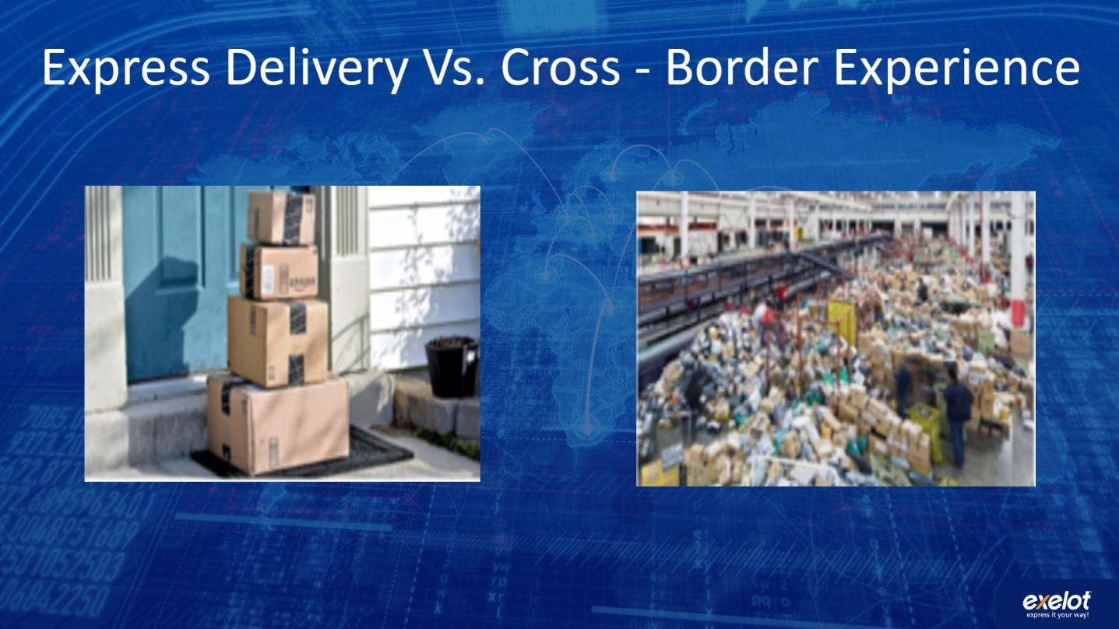
The Solution
Exelot provides a system which answers a significant need within the market, for a smart and advanced logistics platform of cross-border e-commerce shipments, through a model based on multiple logistic service suppliers. The development include the combination of a comparison tool for shipping and delivery options, algorithms which carry out optimizations of the service providers, and measurements of suppliers’ performance, in order to improve efficiency and service times. These factors and algo-calculations allow lowering the costs in general and especially according to the rising volume of shipments by Exelot system.
How does it work?
Exelot’s system is based on its proprietary, fully independently developed digital platform. For the service Exelot does not rely on solutions offered by the postal sector or express shipping companies (Fedex, UPS, DHL), but instead supplies the sellers with a premium private route. For this purpose, it cooperates with private suppliers throughout the entire logistics chain - from airlines, logistics warehouses, forwarders, customs brokers, and delivery companies in the last mile. Through these, Exelot takes advantage of the worldwide demand for additional logistics work by suppliers, full flexibility by performance and capacity, improves the flow of data to and from sellers, and dramatically improves the speed and reliability of the entire service, as well as the tracking abilities and total costs of shipments.
The Exelot systems also gathers info regarding the product’s various data, automatically calculates VAT additions in various destination countries, and allows automatic billing without the need for phone calls and manual billing. The system also supports product return-to-supplier processes, and even the returned product’s destruction, when needed.
Exelot supplies e-commerce platforms and the rest of its clients with accessible, reliable online information, and allows tracking of every shipment on all levels, including all of the package information, and tax or VAT payments for billing, as well as various logistical reports.

Flow chart - A shipment’s journey on the Exelot system:
צריך לתקן את המלל בתוך הסלייד – שפה לא מתאימה – לדוגמא client buy a product... להחליף ל Order created
אחכ 2-מספיק Pick & Pack, 3 –בסדר, 4 – Air/Ocean Freight, 5 – Bonded facility 6- בסדר, 7- בסדר, 8 - Delivery,
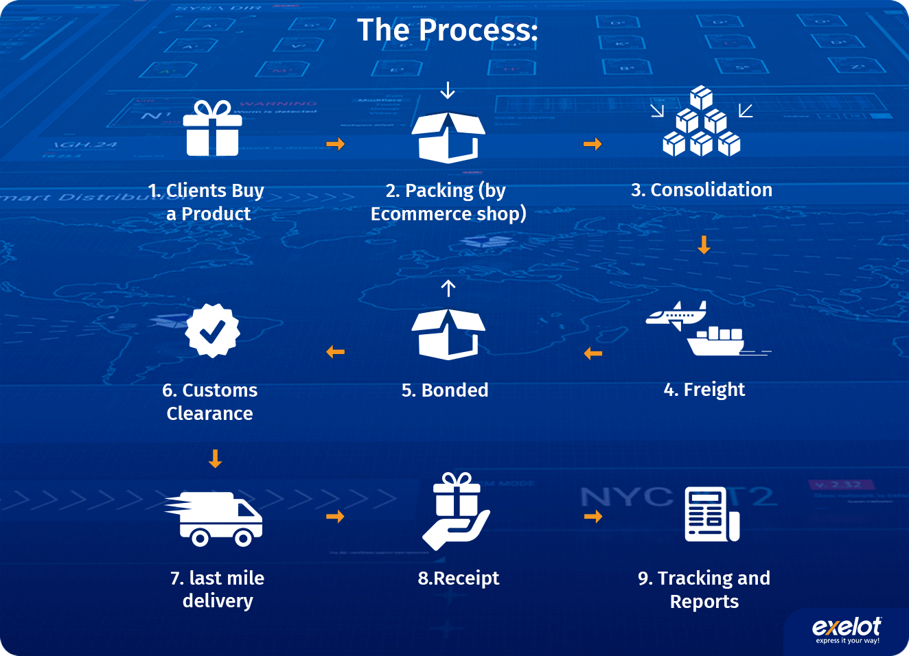
With its system, Exelot creates a market niche which allows for a much faster and more reliable shipment than the postal services, while ensuring a significantly lower cost compared to the express rates. The platform allows a major improvement of the end customers’ satisfaction rate, in transit times and tracking, and accordingly helps sellers to gain more sales in additional target countries. For customs brokers and forwarders, Exelot also speeds up the process and allows them to manage billing and shipments digitally using the Exelot system.
The world of e-commerce is gradually developing towards much greater scales of shipping and delivery, also of larger and heavier products, and Exelot already offers today a complete solution for shipping such packages, with a combination of shipping methods over land, air and sea (soon, trains will be added), and between front bonded processing warehouses in various destination countries.
Exelot will be ready in due time, with the entry of autonomous vehicles and drones into the shipping market, to offer these services to customers in locations where such means will be approved for e-commerce shipping purposes.

The Technology

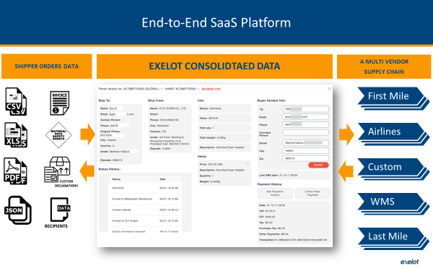
The company has developed a cloud-based SaaS platform, which is connected to e-commerce marketplaces, e-retailers, or logistical companies who serve them. The system handles packages right after an order is made by the end user. From the point of the seller’s warehouse the system manages and tracks each step of the package’s logistics chain. For sorting according to the shipping method, destination country, and suitable means of distribution (such as, shipping from door to door, or to distribution centers, or automated pickup locations), while also using the package value for customs declarations such as VAT payments, adjusting the shipment in that regard to each destination country and relevant data format. According to need, the system consolidates packages based on various parameters, and addresses the issue of marine, aerial or land transport. The system also supports shipping via short-term warehouses which are used as a bonded space for storing, collecting and packaging for shipment - a process known as fulfillment (such as the FBA tag, meaning “Fulfilled By Amazon”, which is well known in the e-commerce industry, or in the near future “By Alibaba”). The system controls all stages of shipping to warehouses, inventory on store shelves and inventory taken for the preparation of shipments, while informing the various sellers of any need to restock items.
The system uses AI and machine learning modules to analyze the package’s data, and specifically to compare the performance of various partners within the shipping process – Air freight by the airline companies customs agents and especially the “last mile” delivery vendors. The platform compares performances, abilities, overloads and deviation from the supplier’s service demands (SLA), and accordingly calculates how to route shipments to alternate options. It also provides relevant alerts in irregular cases and deviations off schedule, along with reports regarding each shipment and consolidated cargo.

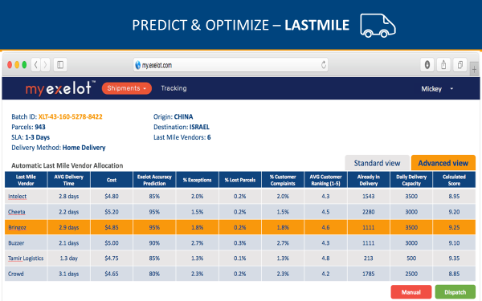
For the customs issues the system calculates the requested VAT for relevant packages - when it is not paid in advance at the time of purchase (a normal situation when buying from China and usually India as well, unlike purchases made from the US), notifies customers according to the destination country, collects VAT automatically via various means, and sends the suitable invoices and receipts to the end client.
The system allows full tracking of the package’s journey, for both sellers and end customers, from the moment the shipment leaves the supplier’s warehouse, and until it reaches the customer, including dozens of status types required by logistical companies who support the stores. It also provides the e-commerce platform or stores with reports and online access to tracking at all required levels - from the cargo’s documentation and the original file sent, and up to the level of any single package or client.
This way, both sellers and end customers enjoy full transparency in the entire logistics process, while Exelot platform is monitoring the entire process online. In addition, optimization and shipment consolidation assist in lowering the transfer time to a few days, lowering the shipping costs, and creating incredible added value for suppliers. In the future the company intends to increase its big data capabilities, both for generally improving the logistics processes, increasing the company’s profitability, and for the purpose of supplying marketing recommendations and different data insights based on logistics data.

The Market
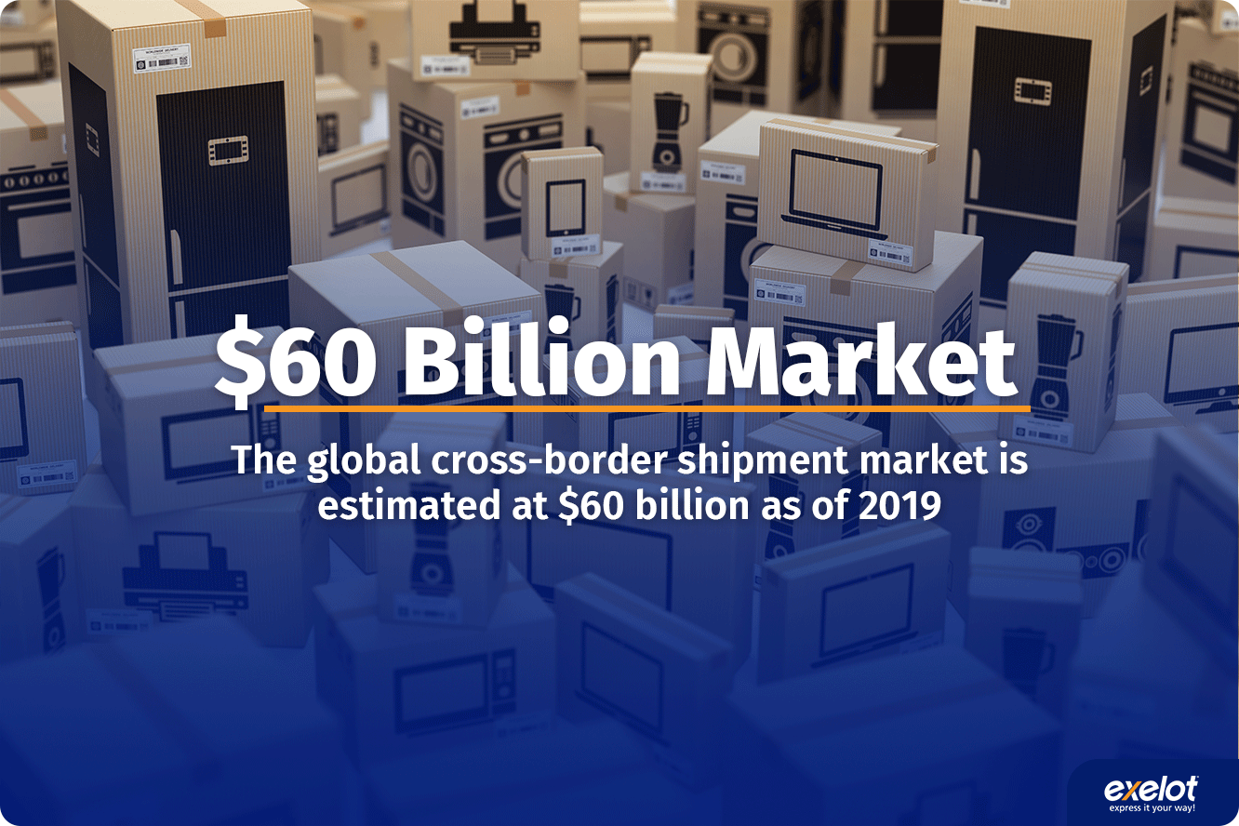
The global shipping market for e-commerce products has grown from 45% of buyers in 2014, to 77% in 2018, in shipments of items between country borders. In Europe alone, 72% out of 260 million online shoppers (about 186 million buyers), have already made a purchase outside their home country in 2016. The Scandinavian Post - PostNord e-Commerce in Europe 2017 report also forecasts the continued growth of the cross border shipping trend.

Out of all online shoppers, 75% order at least one product every month which arrives via shipping from another country. In the last 2 years, the share of online shoppers via smartphones has doubled, from 14% in 2016, to 29% by 2018.
Out of this market, the share relevant to Exelot is comprised of items valued at over 35$-40$ (starting at this price, it’s more beneficial for sellers to pay for improved shipping rather than use standard post services) and is valued at 20 billion dollars, with most of the market held and handled by Postal services, and the rest by the express companies (Fedex, UPS, DHL) and smaller logistics integrators.

Online purchasing between countries
A research conducted at the end of 2018 in 41 countries and among 33,500 people, regarding the origin countries of e-commerce shipments, has found that China (a market which Exelot already specializes in) has grown in export scales considerably, compared to other countries, who have lost market share since 2016:

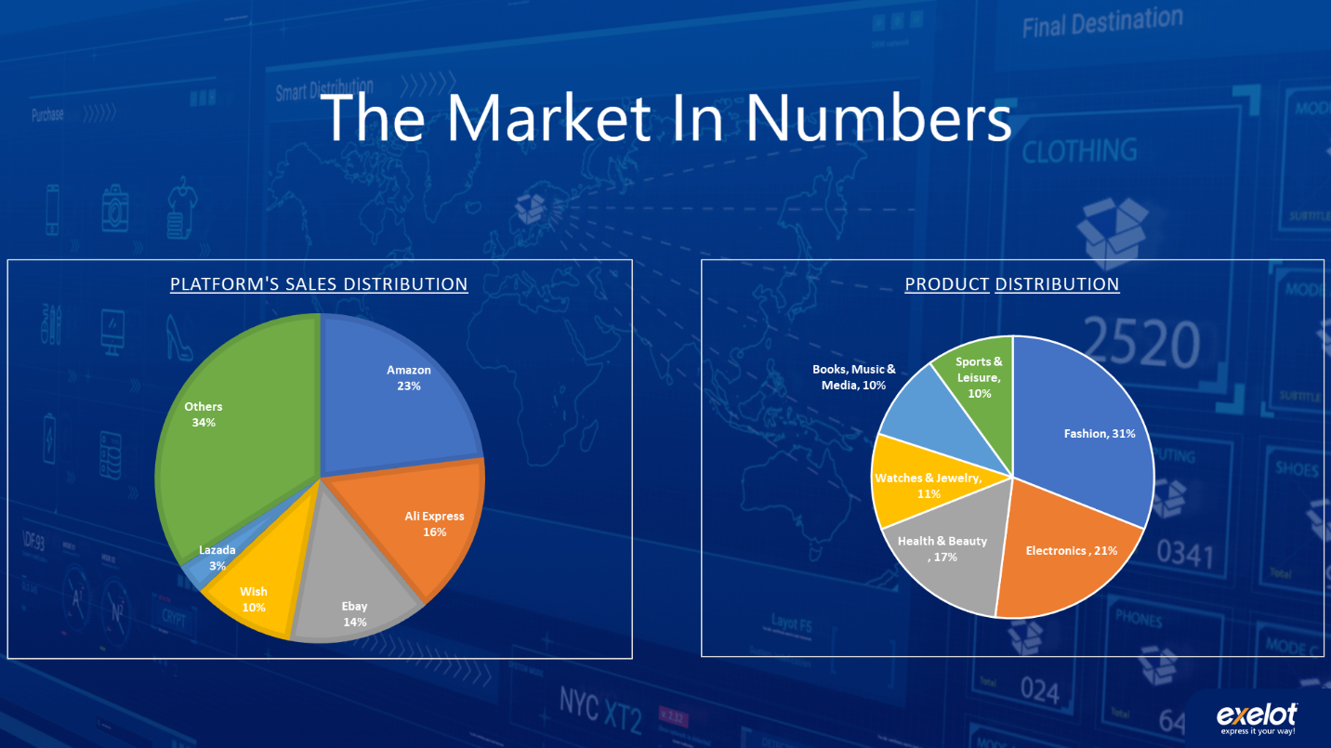
According to the study, on average, 36% of international buyers placed orders with shipments arriving from China (up from 26% in 2016), 11% from the US (down from 15% in 2016), 13% from Germany (down from 16% In 2016), 12% of the UK (down from 15%), 3% from France (down from 5%), and the rest, about 25% of buyers, made orders shipped from other countries (Japan, Korea and Russia).
This means China, where Exelot is already fully deployed, is the most popular source country, for international orders made by US and European buyers, with Europe itself growing in total scale of orders, from 33.2% in 2016, to 38.7% in 2017.
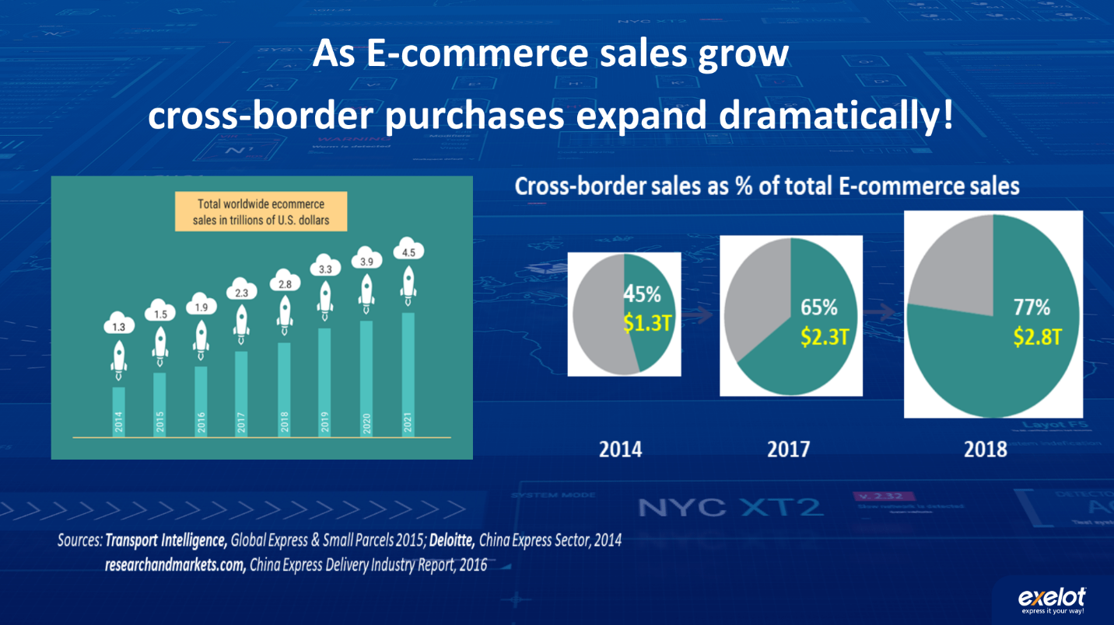
Main obstacle: shipment times and reliability of reports
Past surveys have shown that up to 50% of the barriers preventing online purchasing are due to logistical reasons such as delivery times, costs of shipping and the inability to return or insure products.
Over 41% of shipments require more than 10 days, with 26% delivered in a timeframe of 15-30 days. In fact, only 46% or products are delivered in less than 10 days, and there’s a real need and thirst for a solution to this problem, by both customers and suppliers, while maintaining reasonable pricing. In countries such as Brazil, Mexico, Russia, Hungary, Australia and New Zealand, as well as in many African and Arab countries, the percentage of shipments taking over 15 days is even higher and shipment times significantly surpass even 30 days.
As a result, 25% of online shoppers have complained about lengthy shipping times, and an additional 10% complained about inconvenient hours of delivery. In Europe, about 35% of shoppers were willing to pay an additional cost for faster shipments.
In many countries the issues of customs and VAT present another obstacle, with 16% of all buyers, required to pay tax and/or VAT for the product they purchased abroad. In some countries this number is much higher: India - 72% of buyers, Vietnam - 52%, Morocco - 40%, China - 50%, and Brazil - 40%.
In addition, small and medium sized shipping operations do not maintain the required minimum amount of shipments, for them to be able to allow a faster delivery. Exelot answers their need through consolidations and optimizations of shipments.

Competitors

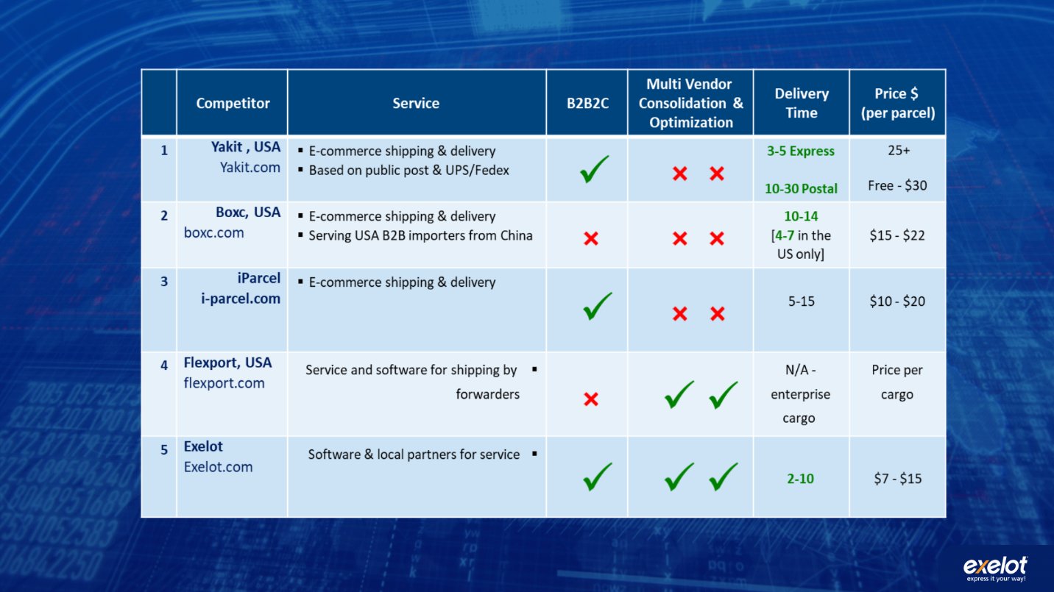

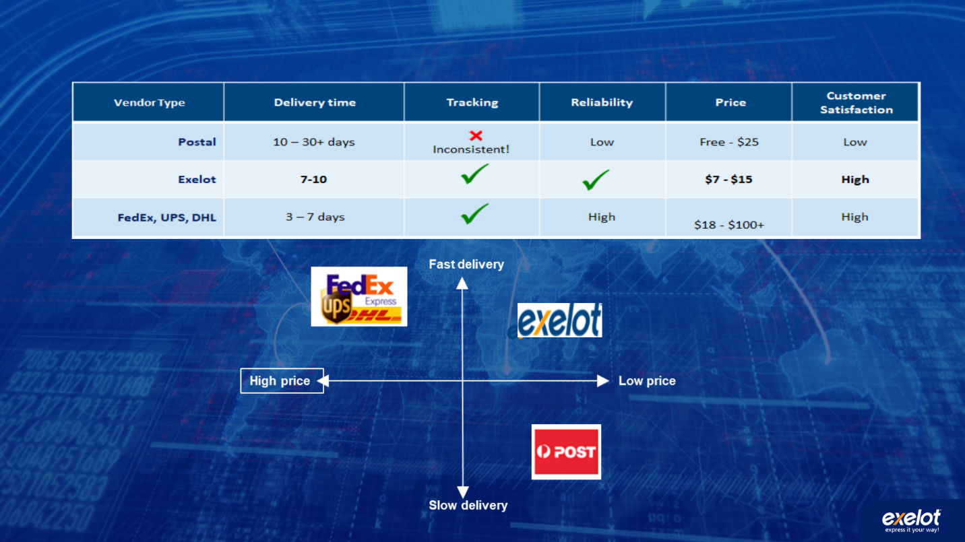

Business Model

Exelot operates in a unique B2B2C model, based on several channels through which the company creates income:
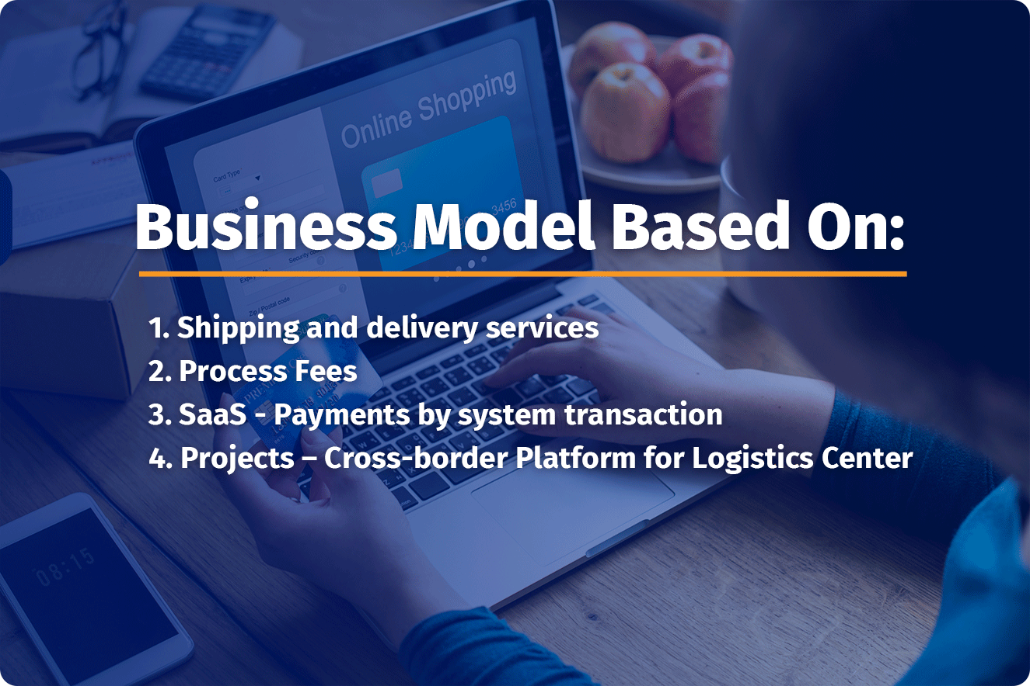
- Shipping and distribution services - payments from e-commerce stores for all shipments, paid on a monthly basis
- Process Fees - additional payment for customs and VAT costs.
- SaaS - sales of the system’s services by use of modules (for example: collection, consolidation and preparation for flight, calculation and process of tax and VAT payment of, customs brokers and release, preparation and routing for distribution, tracking and reports.
- Projects - establishing a logistical system for e-commerce in logistical centers - such as the ones planned by the company in China, India and Singapore, Africa and the Ukraine - including an installation fee, yearly subscription fee, and services provided via the platform with payment for transactions made.

Timeline
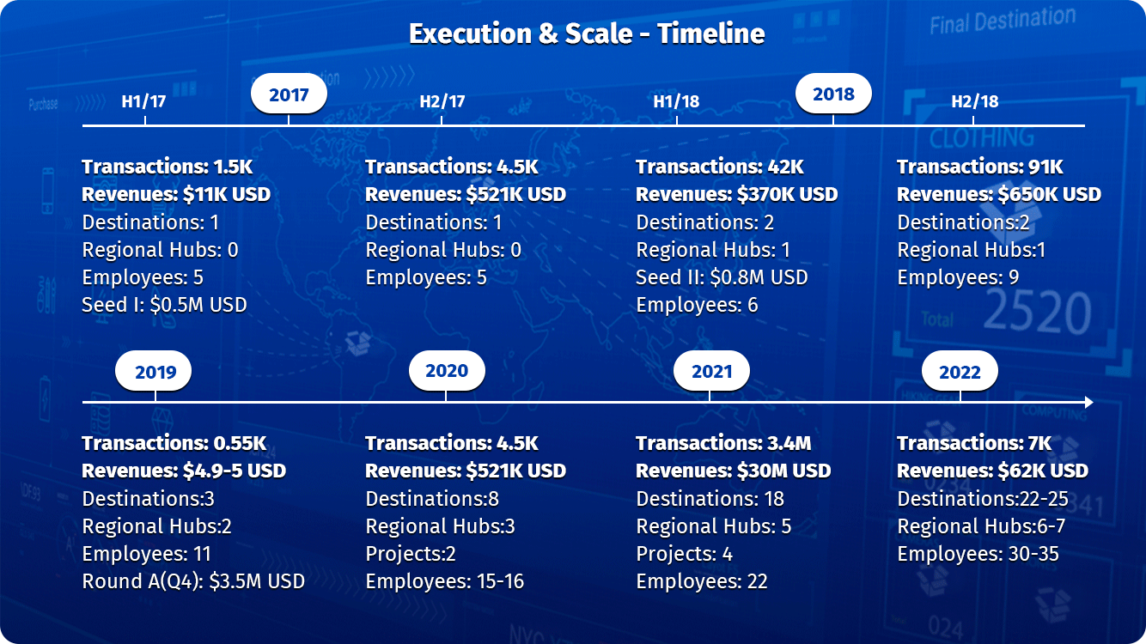

Revenue forecast

Sales Cycles:
Detailed in terms of amounts of deliveries / transactions, and sum of customer invoices:
Month (2019) | shipments made | invoices for clients $USD
January | 19,184 | 214,414$
February | 16,752 | 185,532$
March | 25,307 | 233,798$
April | 30,105 | 293,927$
May | 44,853 | 456,345$
June | 45,927 | 473,090$
July | 49,270 | 463,700$
August | 52,200 | 492,143$
September | 53,400 | 503,300$
Q4 Expectations | 190,000 | 1,660,000$
Total | 526,998 | 4,976,249$

Total amount of deliveries in the system for previous years:

Year | Amount | Balance Sheet Revenue
2017 - March to Dec. | 47,737 | 1,583,014 NIS / 445,919$
2018 | 132,872 | 3,469,573 NIS / 977,344$

Delivery forecast for 2020:
Israel - 825,000; Overseas 375,000 - Total for 2020: 1,200,000 shipments via the Exelot's platform.

Go To Market
The company’s Go-To Market strategy is based on a multi-channel and multi-layered B2B2C model, regarding product and service, divided into main origin countries and destination countries:
- Products:
  - Software and total service (end to end or partially, without air freight).
  - Software only with an option for full monitoring and customer service.
  - Project-based, for the embedment of the platform (Turn-Key with transaction fees or a JV model).
- Client segmentation:
2.1 Marketplaces / E-commerce platforms
2.2 E-commerce websites (e-retailers/ "stores")
2.3 Forwarders & Customs brokers
- Geographical distribution according to progress:
Origin countries: China and Hong Kong, East Asia and India,
Europe (with an emphasis on England, Germany) and the US.
Target countries: Growing from 3 target countries in mid 2019 to 25 target countries serviced by the end of 2022.

Country blocks / Clusters – 2020-2021:
1) Israel, Turkey, Greece and Cyprus
2) Scandinavia
3) Balkans
4) Eastern Europe and several former USSR countries (Ukraine, Belarus, Latvia, Estonia)
5) East Africa
6) Mexico, Brazil and Chile.

Existing service agreements and strategic cooperation
- Exelot serves AliExpress suppliers for the Alibaba group to Israel and through the Cyprus hub at the request of AliExpress to extend the sales to additional foreign countries. Exelot shipping option is embedded at Ali’s system for the sellers through this Cypriot hub.
- Exelot works in tight cooperation with Overseas Commerce, a public company traded in Israel and the largest and leading marine container terminal operator in the country. "Overseas Commerce" also operates an air cargo terminal in Israel, where it provides services to Exelot, and it also owns a large new maritime terminal in Africa. The company is considering entering additional countries in the fields of cargo terminals and supply warehouses. "Overseas Commerce" is also a holder of an investment option in Exelot, as part of a loan converted to shares that was given to Exelot
- The company works in tight cooperation with the Wel Com company in China, offering logistics services to online suppliers - consolidating and routing their products to various terminals, optimized by the Exelot system.
- Exelot has close cooperation with the Euro freight logistics company based in Cyprus, which operates a fulfillment and bonded center with custom broker capabilities for the EU. This cooperation is used by Exelot to expand its activities to neighboring countries, such as Greece, Bulgaria, Romania, additional Balkan countries and in the future to near Arabic countries.
- Exelot has a close cooperation with the "Bansard" company, which operates in France and Hong Kong - supplying maritime and aerial shipping services in China, Hong Kong and Europe.
- Cooperation with Cal Cargo Airlines for shipping Exelot’s e-commerce freight to Israel, Cyprus and Greece, and by the end of 2019, few more European countries
- Cooperation with I-Pack Express in the US, to receive Exelot’s shipments, carry out custom clearance processes, as well as labeling and distribution across the US. Both companies intend to broaden this cooperation in 2020, to include the shipment of cargo to the US by sea in containers from China and Hong Kong.
- Exelot has signed an LOI (letter of intent) with the Rwandan government to form a JV, in which the company is given 51% of the e-commerce platform activity for importers and exporters in Rwanda, with a joined expansion of activities to 5 additional East African countries (Kenya, Tanzania, Uganda, Burundi) as well as maritime, aerial and land service. This cooperation entails further cooperation with the following entities: DP World, the franchise holder and operator of Rwanda's main logistics center in the capital city Kigli, with a space of 100,000 square meters (DP owns and operates around 82 container terminals worldwide), The Kenya Ports company, RwandAir, and the leading mobile payments company in Rwanda.

Exit Strategy
Exelot has the potential to be sold or merge, in the future, with companies from various sectors , who are related to the field of international e-commerce shipping. Another option is going into IPO.
Numerous players already show interest in investing in the company, with the possibility of purchasing its unique technology in the growing Cross-Border market, as well as for its clientele database and existing orders. Another interest is in its forwarding and distribution system, set in various target countries.
The company might also be attractive companies from the software for organizations sector, such as Salesforce, Service Now, SAP and others.
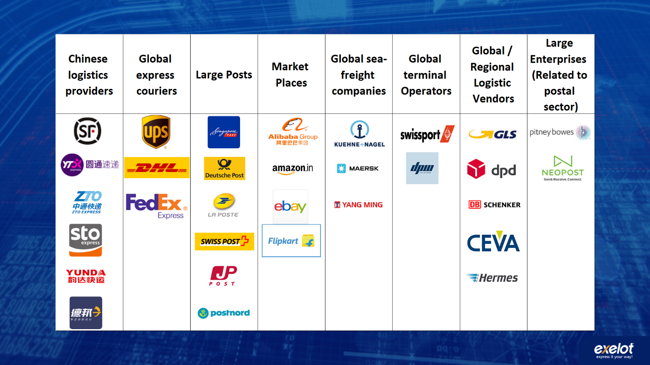
Related examples:
- Israeli company “Flying Cargo” was sold in two stages to international shipping giant DHL, for an estimated 190 million dollars
- https://www.themarker.com/markerweek/.premium-MAGAZINE-1.6872304
https://www.ynet.co.il/articles/0,7340,L-3460510,00.html

- In the US, I-Parcel was sold to UPS for appx. 70 million dollars
- https://www.port2port.co.il/article/%D7%A9%D7%A8%D7%A9%D7%A8%D7%AA-%D7%90%D7%A1%D7%A4%D7%A7%D7%94/%D7%A9%D7%99%D7%9C%D7%95%D7%97-%D7%91%D7%99%D7%A0%D7%9C%D7%90%D7%95%D7%9E%D7%99/UPS-%D7%A8%D7%95%D7%9B%D7%A9%D7%AA-%D7%90%D7%AA-i-parcel-%D7%A9%D7%9E%D7%90%D7%A4%D7%A9%D7%A8%D7%AA-%D7%9E%D7%A1%D7%97%D7%A8-%D7%90%D7%9C%D7%A7%D7%98%D7%A8%D7%95%D7%A0%D7%99-%D7%91%D7%9E%D7%98%D7%91%D7%A2-%D7%95%D7%91%D7%A9%D7%A4%D7%94-%D7%9E%D7%A7%D7%95%D7%9E%D7%99%D7%99%D7%9D/

- Border Guru, a digital platform for logistics, and Seko, a forwarding company, were acquired and merged by the giant logistics vendor Hermes, in Germany
- https://www.crunchbase.com/organization/borderguru
- https://postandparcel.info/98032/news/hermes-germany-reveals-new-acquisition-and-international-aims-of-the-group/

- Softbank has invested a huge sum of 1 billion dollars in the Flexport company
- https://www.flexport.com/blog/flexport-secures-usd1-billion-in-funding-led-by-softbank-vision-fund
Bordefree – חברה ישראלית במקור הפועלת בתחום הרחבת יכולות הסחר המקוון של מוכרים מקומיים למדינות רבות ברחבי העולם (ללא פתרון לוגיסטי משלה), הונפקה תחילה ונמכרה לאחר מכן ל Pittney-Bowsספק ציוד, מכשור ותוכנות מהמובילים בעולם לתחום הדואר ושרשרת האספקה, תמורת 395 מליון דולר.
https://en.globes.co.il/en/article-pitney-bowes-to-acquire-borderfree-for-395m-1001033968

Use of funds
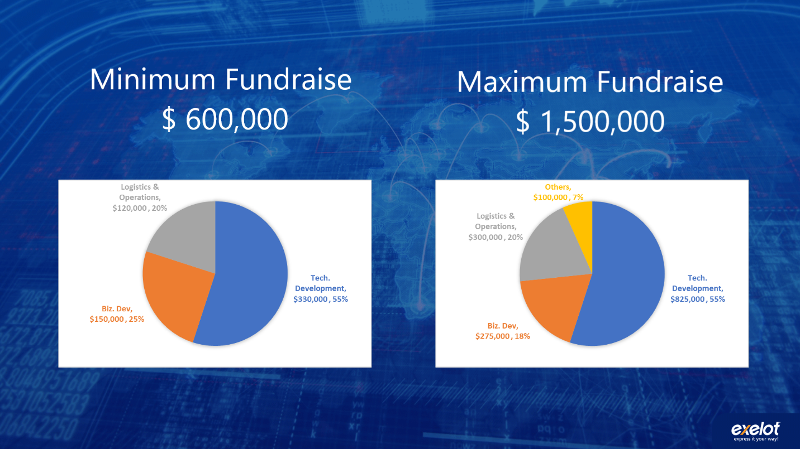
- based on a 24 months plan.
- Funds will be used for technological development and opening of new markets. As much as it’ll be possible, funds will also be used to strengthen operations.
- In a minimal recruitment scenario, an additional "A round" will be planned.

Minimal funding - 600,000 $
Technological development:
- Goals: developing version 3 of the platform, including additional modules
- Adding a full time Head Programmer (who will serve as #2 to the company’s CTO)
Marketing & Business Development:
- Goals: Adding 12 target countries within 24 months. Including traveling abroad
Logistics Supervision and Operations:
- Goals: Expanding the logistics supervision and customer service

Maximum Recruitment: 1,500,000 $
Technological development:
- Adding a full time Head Programmer (who will serve as #2 to the company’s CTO)
- 2 additional programmers (1 Backend and 1 Frontend or 2 Full Stack developers)
- Outsourcing according to need
- Salary increase for the CTO
Marketing & Business Development:
- Additional sales manager for China / East Asia
- Additional European Business Development - opening target countries and logistics partners
Logistics Supervision and Operations:
- Goals: appointing 2 overseas logistics supervisors, international customer service

The Team

שם | תפקיד | תיאור | תמונה
דניאל כהן  Daniel Cohen | מנכ"ל  CEO | Entrepreneur and VP of Buis. Dev & Strategy, at the Israel Post company. VP Business Development & Marketing at High-Tech (LocatioNet, Aerialink) and Industrial companies.  Over 20 years of management & international business experience (LLB, MBA).  Leading European projects with large worldwide teams estimated at tens of millions of Euros, and close relations and projects in Asia.  Experienced with Startups and large enterprises. | 
יצחק ורסנו  Izack Varsanno | מנהל פיתוח טכנלוגי / CTO  Founder & CTO | Over 25 years of experience with programming and managing programmers in the military, private sector and the start-ups arena. 7 year service as Chief Programmer / Chief Architect for the IDF logistics unit at MAANA (retired as Major of IDF) with extensive experience in managing and programming. Pioneer in cloud-based systems, years of experience with both startup companies (Precise, Always-On) and large enterprises such as Partner in Israel (IT Infrastructures manager) and Applied Materials. | 
אלי קורצקי  Eli Koretsky | מנהל פיתוח עסקי ומכירות, סין  VP Business Development & Sales, China | B.A. in Economics and East Asian Studies from HUJI, China. Previously, Eli has served as the Israeli market manager for the Chinese AliBaba / AliExpress group.  7 years of experience with e-commerce operations, marketing, logistics and user experience.  An expert in cross-cultural business development and fluent in Chinese, Russian, English and Hebrew. Extensive experience with on-line retailers and logistic vendors for the online industry. | 
יעקב גזית  Yaacov Gazit | סמנכ"ל פיתוח עסקי  VP Business Development | A married father of 4, with a BA in Economics and Business Administration alongside an MBA specializing in finance. Yaakov has extensive experience in financial consulting for companies, corporations and individuals, as a freelancer. Served for almost 5 years in senior positions in the Israel Post company, with experience in business development and foreign trade management of an annual 400 million NIS budget, with dozens of employees.  Seven years of experience as a privatization coordinator in the governmental companies authority of the Ministry of Finance. Yaakov has previously handled the privatization of IAI, the Bank for Industrial Development, the Company for Automation and others. Previously, he has also served as a Jewish Agency representative in Pittsburgh, USA, as chair of the Hebrew University Student Union, and as a member of the board of directors of cooperative associations in the Jerusalem area.  נשוי ואב ל-4, בוגר תואר ראשון בכלכלה ומנהע"ס לצד MBA עם התמחות במימון. בעל ניסיון רב, בייעוץ פיננסי לחברות, אגודות שיתופיות ופרטיים כעצמאי. שימש קרוב ל-5 שנים בתפקידים בכירים בדואר ישראל, עם ניסיון בפיתוח עסקי וניהול סחר חוץ בהיקף שנתי של כ-400 מיליון ש"ח ועשרות עובדים. 7 שנות ניסיון כרכז הפרטה ברשות החברות הממשלתיות במשרד האוצר. טיפל בעבר בהפרטת תע"ש, הבנק לפיתוח התעשיה, החברה לאוטומציה ועוד. שימש דירקטור בחברות מובילות במשק: רפא"ל, תע"ש , קרן קיסריה והחברות הבנות ועוד, וכמנהל תחום נכסים מניבים בחברת נדל"ן מדווחת. בעבר שימש שליח הסוכנות היהודית ב Pittsburgh, USA, יו"ר אגודת הסטודנטים באונ' העברית, וחבר וועד מנהל באגודות שיתופיות באזור ירושלים. | 
מריאנו פטסינסקי  Mariano Ptascinsky | מנהל כספים  CFO | Mariano has more than 20 years of experience in the field of financing, credit and credit insurance. Until recently, he served as director of the Consumer Credit Department, managing over 8 billion NIS at Leumi Card (Max). Prior to that, he was VP of Credit and Risk Management at the largest car importer in the country, and a credit manager in the defense industry responsible for financing deals worth tens of millions of dollars. He has also served as an entrepreneur and CEO of a financial startup, sold to Meitav Dash, and as entrepreneur and VP of a financing company - led from the concept stage to the stock exchange In Tel Aviv. Mariano holds a BA in Economics from Tel Aviv University, an MBA from the Technion, a graduate of Risk Management (FRM), and is also a certified mediator. | 
עינת מזמר  Einat Mezamer | מנהלת שרשרת לוגיסטית ושירות לקוחות | Over 12 years of experience in the world of logistics and international shipping in the business and private sectors, including for Fedex and other private companies.  Extensive knowledge of supply chain with leading companies in the world.  Management experience in a variety of areas: from service and operations to sales. | 

Cross Border Shopper Survey 2018 – IPC Global Postal Industry Report & IPC Carrier Intelligence Reports, January 2019. (33,000 respondents, 41 Countries). Researchandmarkets.com, China Express Delivery Industry Report, 2016 Cross-Border Magazine, Aug. 2018 WIK Consult, Dynamic Development of Cross-border E-commerce through Efficient Parcel Delivery, 2018 (16,400 respondents, 30 countries)

