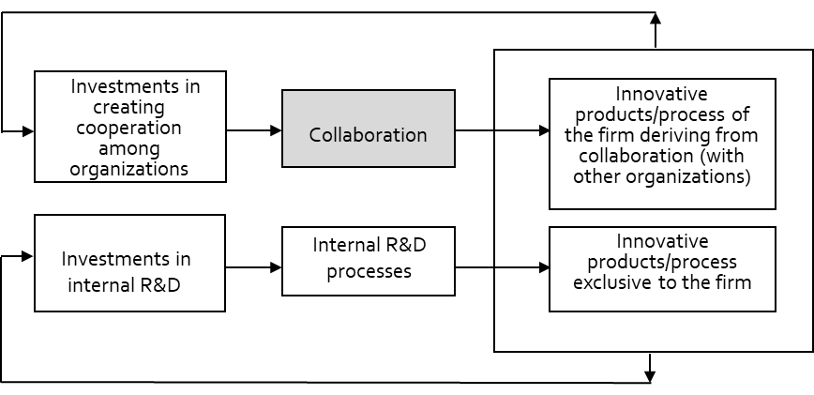

**Fig. 1: The hypothesized model: Creating innovation**