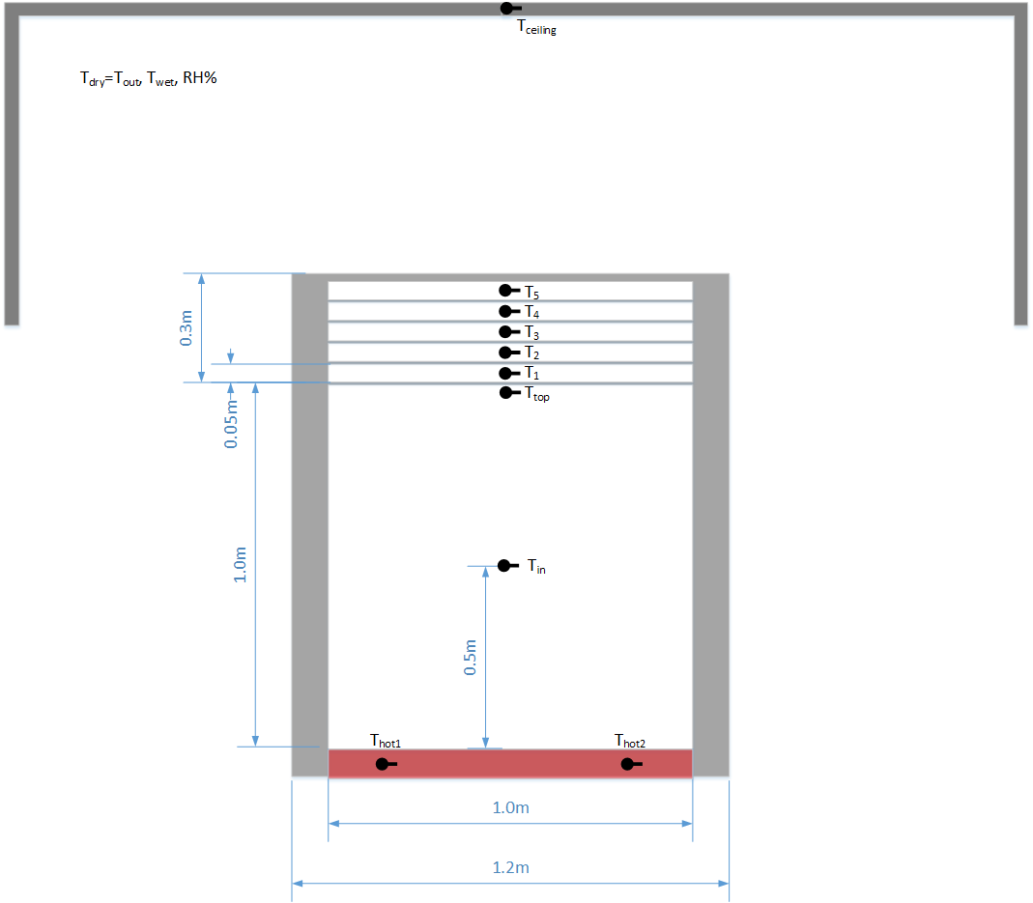

Screens

Cover

Heater

Shelter

Figure 1: Schematic view of the hot box under the shelter, the box cross section and dimensions, locations of thermocouples.

 

Figure 2. Two experimental setups (two hot boxes under the shelter) to measure heat transfer coefficient flow at Department of Agricultural Engineering, ARO.

Velocity boundary layer

Thermal boundary layer

Fully developed turbulent convection

Outside air convection,

Sky radiation

Controlled heat flux

Adiabatic wall

Adiabatic wall

Heat flux through the multilayer screens

(radiation and convection, Equation 4)

Figure 3. Sketch of the problem for mathematical formulation. Heat transfer by conduction and radiation must be taken into account everywhere. In the case of semi-transparent ad/or opaque screens a model of radiation in participating media has to be included.

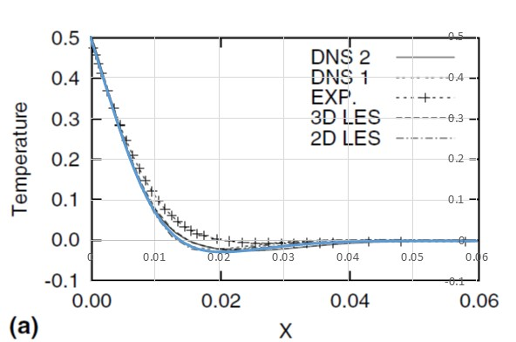 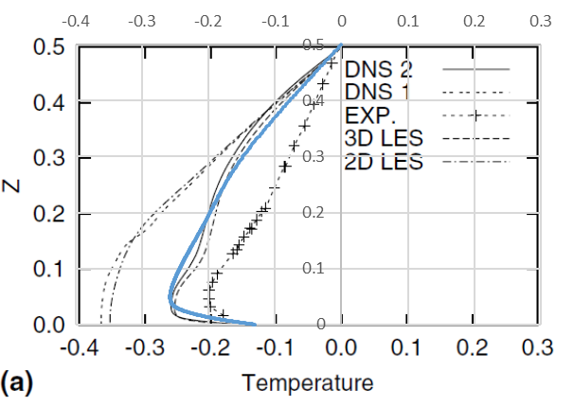

(b)

(a)

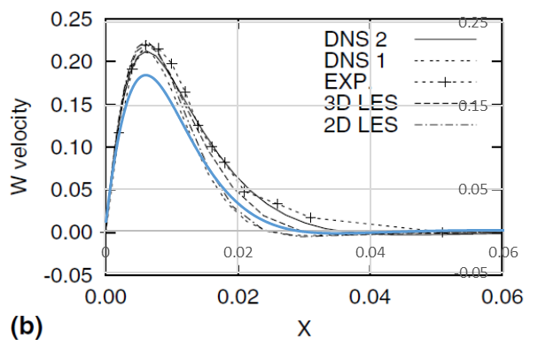 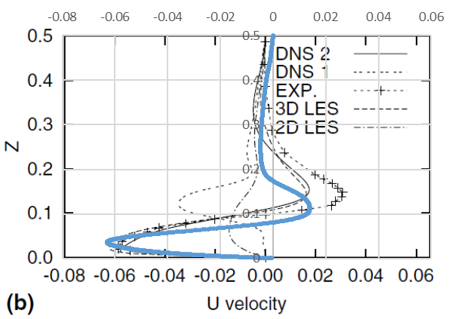

(d)

(c)

Figure 4. Validation of our numerical model (blue lines) with results published by Salat *et al*, 2004. These results correspond to numerical and experimental investigation of turbulent natural convection inside a cubic cavity with temperature differences between vertical walls. Example of temperature and velocity profiles at mid-height (a,c) and mid-width (b,d) planes of the cavity for *Ra*=1.5×109.

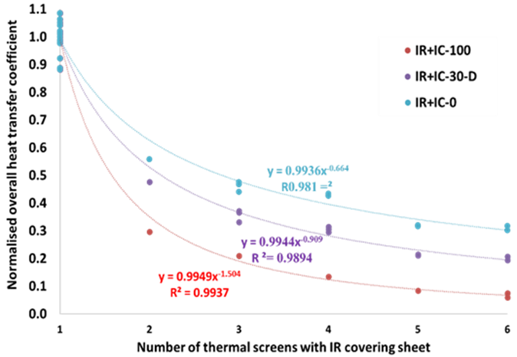 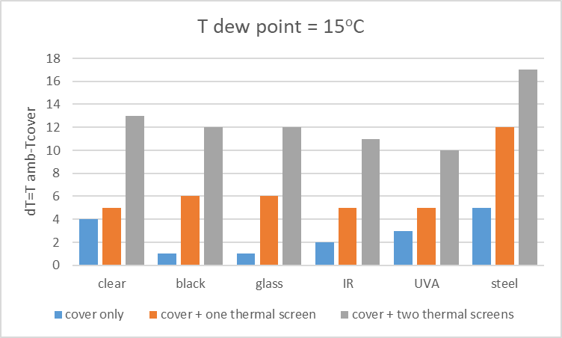

Figure 5. Results of laboratory measurements: a) Normalized heat transfer coefficient for infrared (IR) reflective cover and added thermal screens of type IC-100, IC-30, IC-0, with shading factors 98-99%, 30-35% and "clear", respectively. b) Temperature differences are required to reach dew point temperature over different types of screen matereals.